PERU
Machu Picchu & Manu Biosphere Reserve
Trip Report
August 20 - Sept. 6, 2011

Disclaimer: This report is as accurate as possible using limited notes taken in the field. Species have been reported on the proper day(s) but, with multiple sites visited on the same day and individual participants visiting different areas, it is possible that some species are listed as being seen at the wrong location. Any such errors are unintentional.
Species seen by group: 433
Additional subspecies seen: 2
Additional species heard: 38
Birding guide: Eduardo Ormaeche
Tour leaders: Cindy and Jim Beckman (Cheepers! Birding on a Budget owners)
Group: 8 + 2 tour leaders and guide
Highlights: 34 Hummingbird species, including Rufous-crested Coquette, Gould's Jewelfront, and Wire-crested Thorntail, Andean Cock-of-the-Rock (male and female), Amazonian Umbrellabird, Sungrebe, Sunbittern, Orange-eared Tanager, Great Potoo, Golden-collared Honeycreeper, Blue-naped Chlorophonia, Razor-billed Curassow, Horned Screamer, Pale-winged Trumpeter, Humboldt Penguin, Buckley’s Forest-Falcon, Tui and Rose-fronted Parakeets (and 19 other Psitticids), Curl-crested Aracari, Bamboo Antshrike, Striated Antbird, Many-colored Rush-Tyrant, White-cheeked Tody-Flycatcher, Yungas Manakin, Purplish Jay, Black-goggled Tanager, Paradise Tanager, Black-billed Seedfinch, Torrent Ducks with ducklings.
This trip report was written by co-leader Cindy Beckman

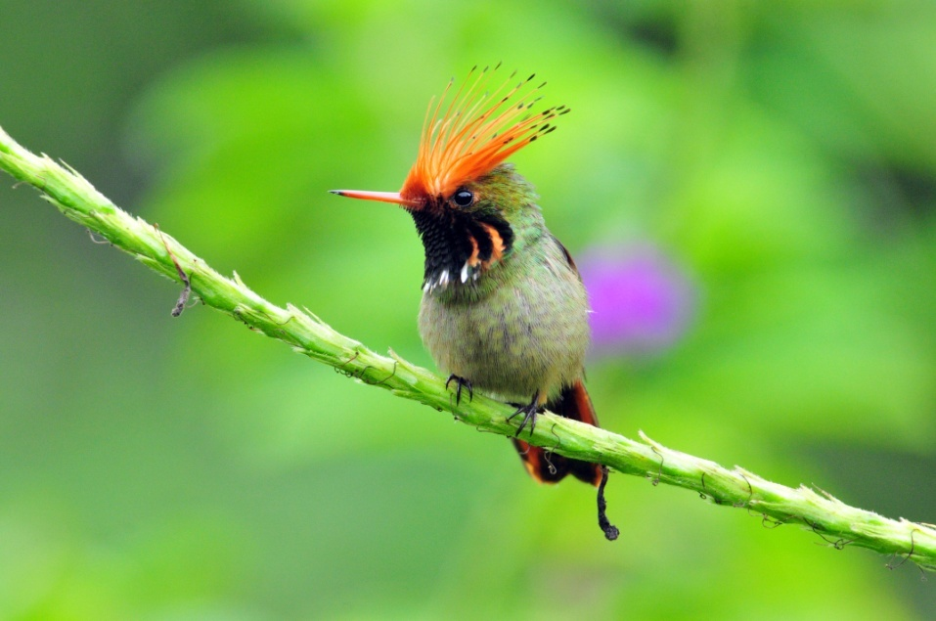
Above: Rufous-crested Coquette
Below: Andean Cock-of-the-Rock

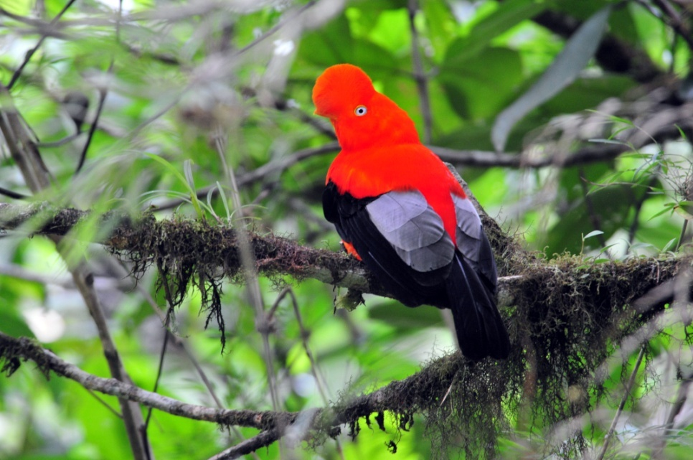
Andean Cock-of-the-Rock

DAY 1, Saturday, August 20: LIMA (Pretrip) and Arrival
Lucy, Penny, Jim and I arrived last night and stayed at the Costa del Sol near the airport. Mark and Jackie were scheduled to arrive at around 5:00 AM, so we grabbed a quick bite to eat, met Eduardo, Mark and Jackie in the lobby, and headed out to do some birding at around 6:00 AM. Our first stop was along the Pacific Coast in Lima. All of us were surprised by the barren landscape – dry cliffs of dirt without much growing and with no rock outcroppings to speak of. The weather was cool and gray with a light drizzle most of the morning, and Eduardo scoffed when Lucy and I told him the weather forecast for Lima was warm and sunny for the next few days. “Sunny? In Lima?!” was the gist of his response. We laughed when we saw a road sign that pointed west toward the ocean with just one word on it – Waikiki. The “beaches” here were mostly stone, but the dismal surroundings and cold wet weather didn’t stop surfers from practicing their sport. We even saw one group of people in swim suits with beach towels, behaving for all the world as if they were on a sunny beach somewhere.

Birds seen along the coast included Inca Terns, probably the prettiest terns I’ve ever seen. Gray Gulls allowed close approach, but I really wanted to get closer to some Inca Terns for photographs. I could see dozens of them flying around at the end of a long dock, but none were flying close to us. A security guard at the dock, which led to some shops and a restaurant, allowed me to go part way down the dock, but I was stopped short of the area where it seemed like hundreds of Inca Terns were resting on rooftops. I did see two Blackish Oystercatchers on the rocks part way down the dock, but I couldn’t get the attention of the rest of the group to call them over before the birds flew away. Eduardo assured me that we would get closer looks at the Inca Terns tomorrow. We had good looks at Belcher’s and Kelp Gulls, similar but easily told apart by observing the tails (Belcher’s was once called Black-tailed). Neotropic Cormorants were common everywhere on this part of the coast. Peruvian Pelicans cruised by over the water, but we couldn’t see the details that separated them from their northern neighbors. Peruvian Boobies were identified by Eduardo, but we all wanted better, closer looks.

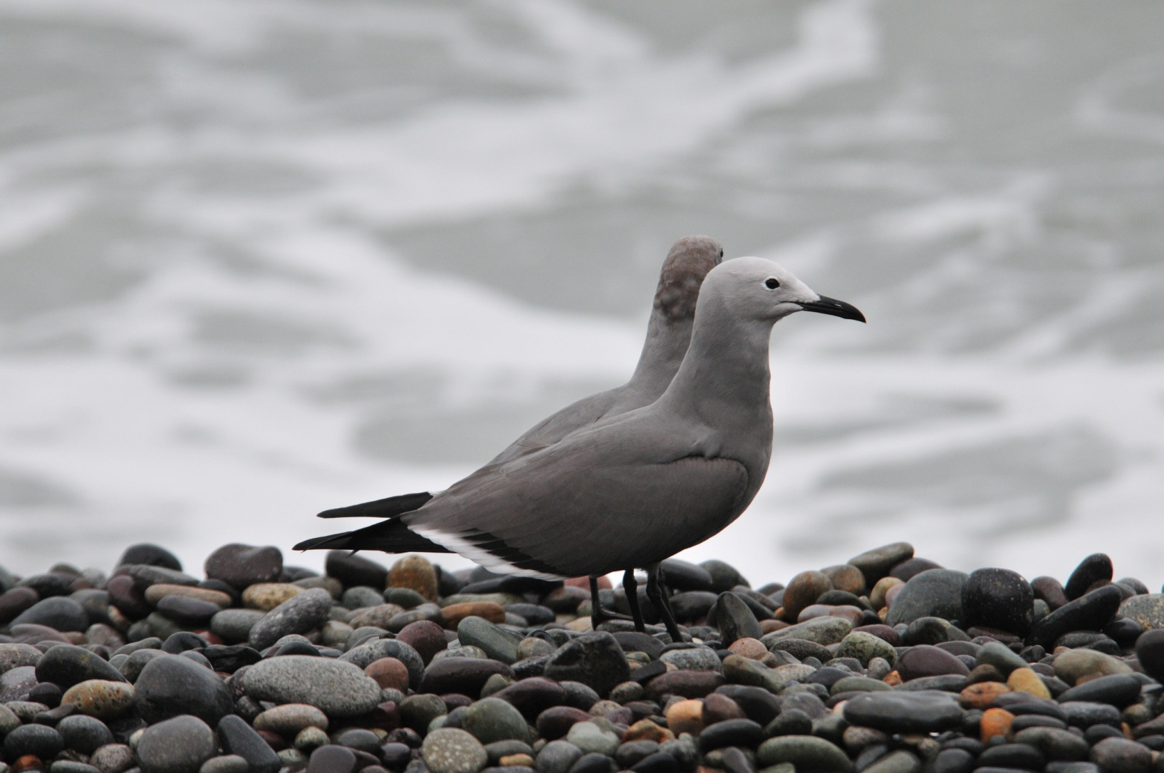
Gray Gulls

City birds included West Peruvian Doves, which look very much like White-winged Doves, and we officially counted Rock Pigeons for the trip.

We next visited Olivera Park, an area where many embassies are located. It was interesting to see the variety of architecture here, but we came for birds, not buildings. The first “special” bird we saw was the Sooty morph of the Vermilion Flycatcher. If Eduardo had not been there to tell us what we were seeing, this bird would have caused us some confusion as we searched through the flycatchers in the field guide, most certainly not looking for anything with red on it! The very common Rufous-collared Sparrow was present, as well as Long-tailed Mockingbirds that moved about in small groups. Eduardo caught a glimpse of an Amazilia Hummingbird but no one in the group got on the bird before it zipped away. Other very common birds included Tropical Kingbird, Blue-and-white Swallow, and House Wren. Eduardo pointed out a Scrub Blackbird among the Shiny Cowbirds. We saw more doves and pigeons and added Croaking Ground Dove and Eared Dove to the list for that family. Although it wasn’t a new species for the day, seeing a typical RED Vermilion Flycatcher was a pleasure. A small group of Pacific Parrotlets flew into a tree nearby and we all had great looks before they flew away. We heard a raptor screaming in the vicinity and found a pair of Harris’s Hawks in separate Norfolk Pins calling to each other. Someone joked that our first Blue-gray Tanager looked more like a Gray-Gray Tanager in the poor lighting. We spotted several Southern Beardless Tyrannulets, more than one of them in the process of building a nest.

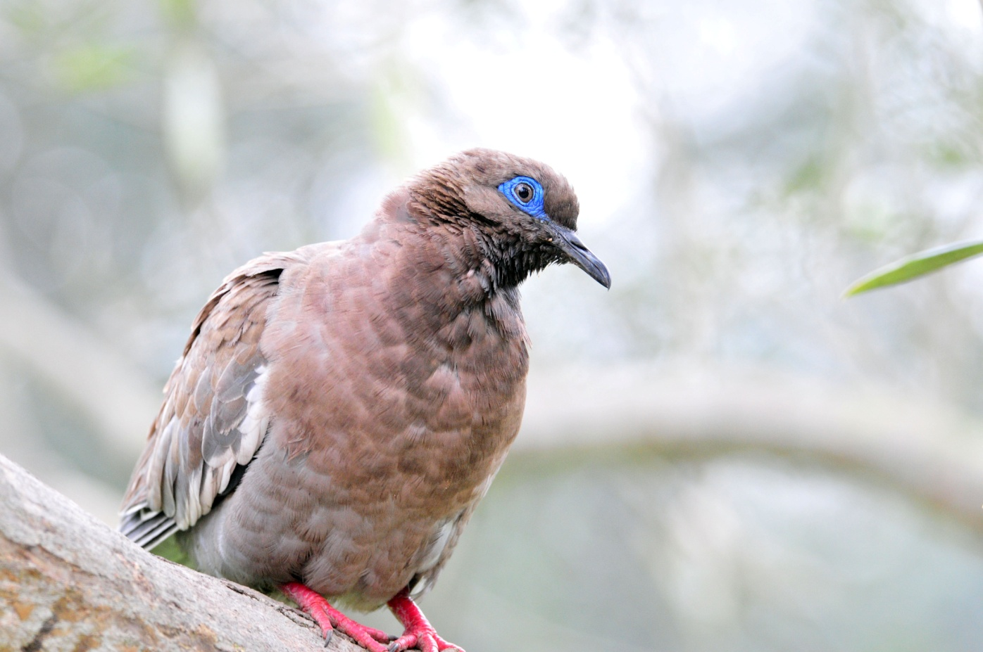
West Peruvian Dove

We left the park to take a city tour. We visited an elegant ancient church where we not only observed the opulence of the ornate decorations, but also saw skeletal remains in the catacombs below our feet. Eduardo was a fountain of information about the history of Lima. As we looked over the remains of a rock wall built around the city in the 1700s to protect it from pirates, Eduardo explained that Lima got its name from the mispronunciation of the Rimac River that flows through it. Our attention to the history lesson ended when some Blue-Gray Tanagers landed in a Bottle-brush tree nearby and were soon joined by a beautiful male Amazilia Hummingbird – this time we all got to see it, and in very good light! Other birds seen today included Black Vulture, Great Egret, and Blue-black Grassquit.
Eduardo had the driver and van only until 1:00 PM, so we were dropped off at the Hotel Faraona and left on our own for dinner and the remainder of the evening. The hotel restaurant offered a wide variety of entrees and we were all satisfied with the service and our meals. We went over the checklist as a group and learned that we finished the day with 32 species – nothing to write home about, but a good start with some good birds. We retired early to be ready to meet the rest of the group and embark on our adventure first thing tomorrow morning. The last four people, Brad, Becky, Barbara and John, would all arrive later this evening and Eduardo would pick them up at the airport and bring them to the hotel.

Day 2, Sunday, August 21:
We met the new arrivals in the lobby of the hotel at 7:30. As we pulled away from the hotel, Lucy asked, “Does everyone have their binoculars?” , which seemed like a silly question until Jim hopped up and said he needed to go back and get his bins from the room! We drove along the coast on our way to a village called Pucusana. This was the first of many small towns and villages we drove through where the buildings seemed to be coated with dust. Our driver maneuvered the bus through the narrow streets up to a cliff overlooking the ocean. There, after just a few minutes, we spotted Humboldt Penguins. John, a friend of ours who took the position of another friend who had to cancel at the last minute, is an accomplished photographer who uses a 500mm lens, often with a 1.4 or 2.0 multiplier. With this equipment, he was able to get some fairly good shots of the small group of penguins as they lounged in the surf. In the coming days, John was able to record many of the species we saw, and often we used his photographs, zoomed in to the tiniest details, to verify the identification of some nondescript bird. From this cliff, in about 30 – 40 minutes, we were able to observe Red-legged Cormorants, Peruvian Boobies, Inca Terns, Blackish Oystercatcher, Wilson’s Phalarope, and Belcher’s and Kelp Gulls. Unfortunately, the Inca Terns were not any closer than they had been the day before, so I would have to depend on John’s photographs rather than capturing my own images.

We went down to the harbor in Pucusana next, where we got excellent close-up looks at a Peruvian Pelican in breeding plumage with its sky-blue pouch. On the far side of the bay was a Guanay Cormorant, giving us a sweep of all three possible cormorant species in the same day and in the same town. We spotted some easily-identified Ruddy Turnstones, Spotted Sandpipers, and Snowy Egrets as they foraged along the shore where dozens of small fishing boats sat idle.

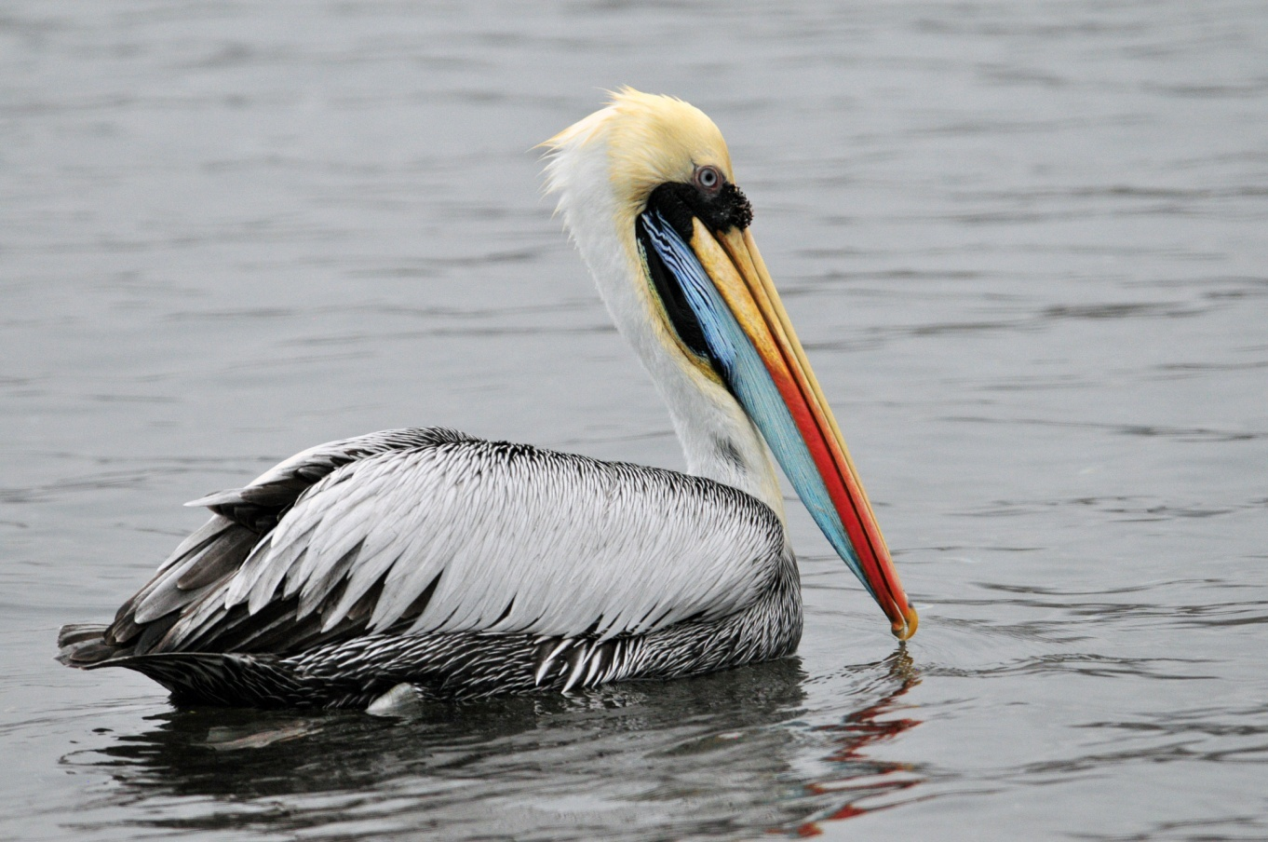
Peruvian Pelican
Our next stop was along a busy stretch of highway where Eduardo thought we could find Peruvian Thick-knee. Blending perfectly with the tan soil, the Thick-knees were not initially obvious to anyone. Once the first bird was spotted, we put the scope on the area and immediately identified several more birds. There was an unfriendly-looking dog in the area, so Eduardo did not want us to walk across the barren field to get closer looks. After sizing the dog up, several of us advanced and were able to observe the birds from closer range.

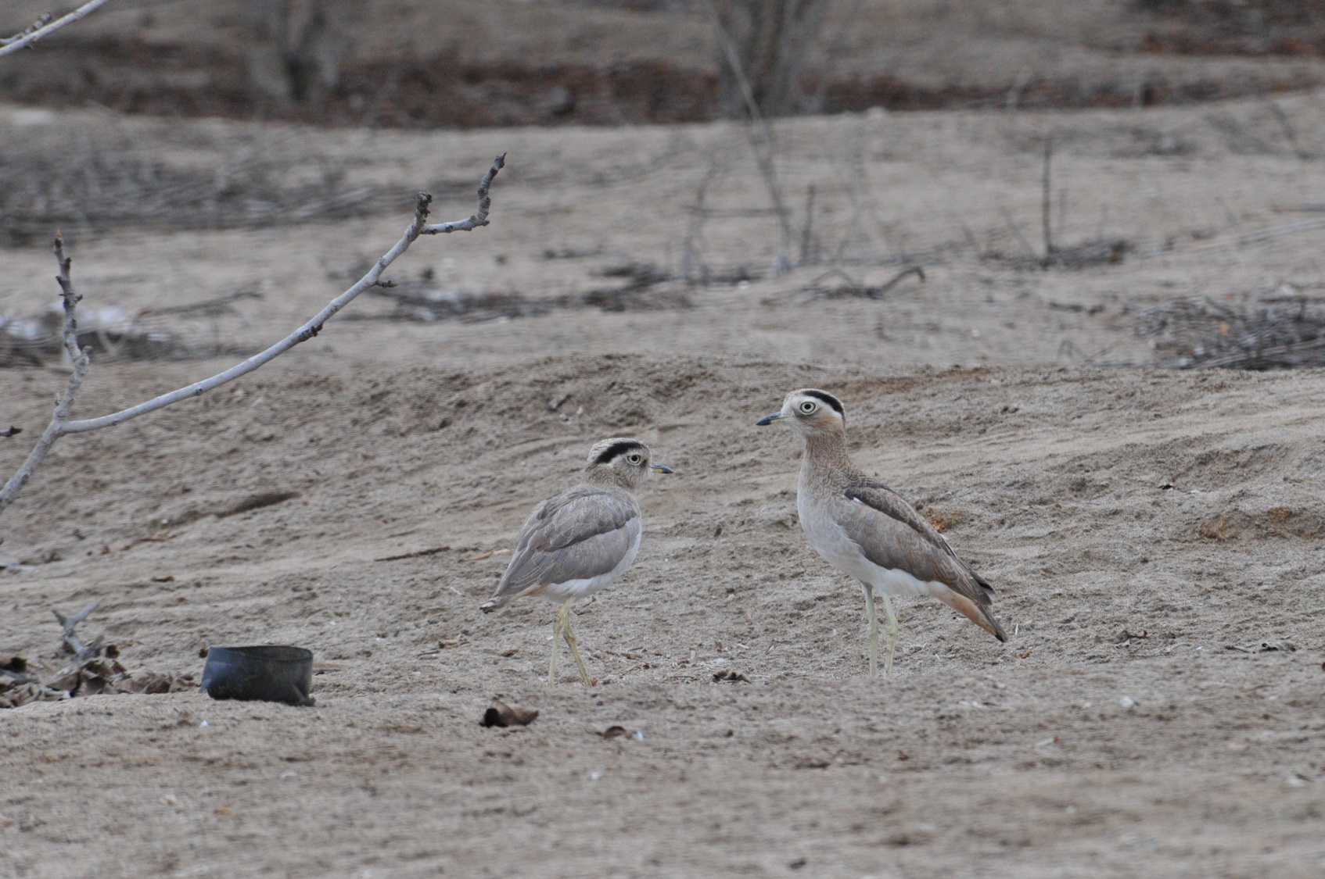
Peruvian Thick-knees

We next drove on to a wetland that was situated in one of the most uninviting places I’ve ever seen. Devoid of vegetation and extremely arid, this desert made our western deserts all look like oases. Right in the middle of the desolation, though, was a wetland that provides habitat for a wide range of birdlife. As we approached the wetland, a Gray-hooded Gull flew lazily by and I contemplated how much more I liked gulls and terns in Peru than anywhere else – truly beautiful. Easily found floating on the water were Cinnamon Teal, Common Moorhen, Andean Coot, Pied-billed Grebe, and White-cheeked Pintail. Eduardo knew there were some skulkers in the reeds that would be difficult to see, so he gathered us all together before playing the taped voice of a Wren-like Rushbird. The Rushbird didn’t appear at first, but one of the birds that impressed everyone with its beauty and remained one of the highlights of the trip did pop up – Many-colored Rush-Tyrant. This diminutive bird is a splash of so many colors –yellow, orange, red, blue, green, black, and white - all packed on a 4-inch bird! As the birds scooted from one reed to another gleaning food from the vegetation, we were all eventually able to get terrific looks, but with the speed of the birds and the density of the vegetation, trying to get a good photograph was an exercise in futility.

Peruvian Meadowlarks made multiple appearances, allowing all to get good looks at its brilliant red breast. The Wren-like Rushbird popped up and down, in and out of sight, enough times that everyone finally was able to see it. A pair of Great Grebes floated out of the reeds as a Grassland Yellow-Finch made the first of many fly-bys that provided brief looks that were enough to identify but not satisfy. White-tufted Grebes were also spotted, resembling a small version of an Eared Grebe but with white "ears". Another bird that blended perfectly with the sand was found on a dune, dropping in and out of sight. After struggling to get everyone on the bird, we turned to walk away and found two of the same endemic Coastal Miners practically under our feet!

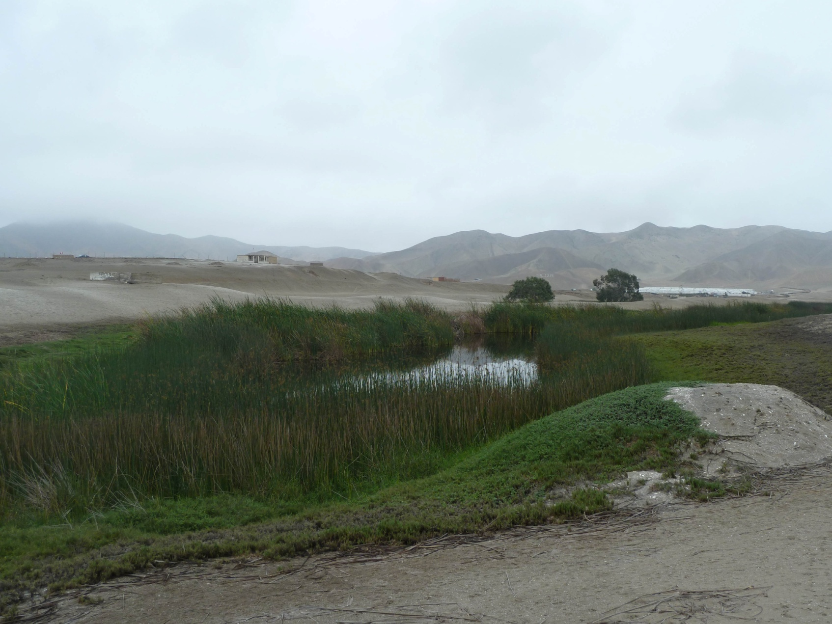
Wetland amid desert near Lima

We left the wetland and drove to a beach where Eduardo hoped to find another endemic, the Surf Cinclodes. Along the way we saw Little Blue Herons and Cattle Egrets in fields. After enjoying our box lunch of Chicken Empanadas in the bus, we climbed out and immediately identified Semipalmated Plover and Whimbrel on the beach. As we worked our way down the shoreline, I enjoyed trying to get photos of the Blackish and American Oystercatchers that allowed a reasonably close approach. Finally, on a sandy spot between two rocky islands Eduardo spotted our target species, the Surf Cinclodes. As we enjoyed the views of this nondescript species through the scope, we marveled at the number of cormorants passing by. Guanay and Neotropic were interspersed in numbers that were too large to estimate. Line after line of the cormorants flew by just beyond the rocky islands, and each time we thought we had seen the last of them, a new line appeared.

Eduardo had pointed out a wetland called Villa Marsh earlier in the day as we drove away from Lima, noting that it was excellent for birding but considered unsafe due to some incidents that had occurred there recently. As we approached the
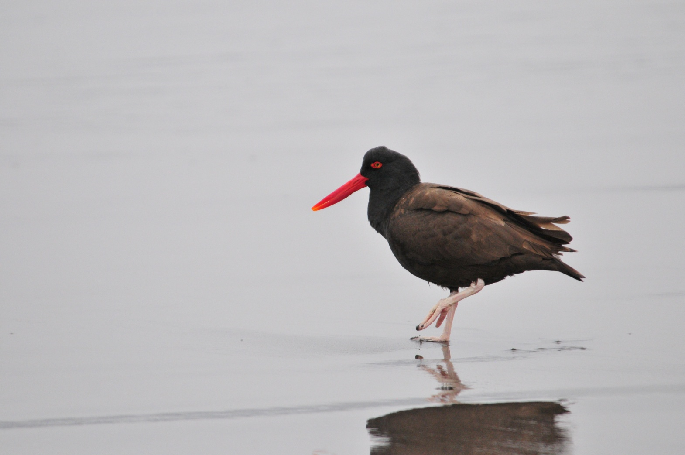
Blackish Oystercatcher

city, he instructed the driver to pull over at the side of the highway where we could scan the wetland safely from our position in the bus. There we saw many species we had seen at the other wetland and added Black-necked Stilt, Puna Ibis, and Andean Ruddy Duck to the list for the day. We arrived back at the hotel at around 3:00 PM, and even though he looked very tired, Eduardo agreed to take the group of newcomers to Olivera Park so they could see the Sooty morph of the Vermilion Flycatcher and the Amazilia Hummingbird, two species that would not be possible at other stops on our tour. All four of the new arrivals went to the park with Eduardo, but none of the people who had been there the day before went along. When everyone came together at dinner, we learned that the group who had walked to the park had seen not only the Amazilia Hummingbird and the odd flycatcher, but had also seen Peregrine Falcon and White-winged Parakeet, two species that were new for the trip and would not be seen again during our time in Peru. We were told that wheels would roll at 4:30 AM tomorrow, so we all returned to our rooms to retire early.

Other birds seen today included American Kestrel and Killdeer, both birds seen by only part of our group of birders. We finished the day with 52 species, 32 of them new for the trip bringing our trip total to 64 at the end of day 2.

Day 3, Monday, August 22:
Everyone was on time for our early departure, and we left the hotel at 4:30 as planned. We had plenty of time for breakfast in the airport with time to spare for our 7:00 AM flight to Cusco. Unfortunately, our flight was delayed for 30 minutes, but some of us made good use of the extra time by shopping for some souvenirs and gifts in the shops in the airport. After an uneventful flight to Cusco, we boarded a bus to drive about an hour to Huacarpay Lake and the adjacent wetland where we stopped to bird for awhile. We had Andean Gull before we even left the airport, with many more to be seen throughout the day.
The driver parked the bus near a small restaurant across the road from the Huacarpay Lake. As soon as we disembarked, we saw Mountain Caracara soaring overhead and Yellow-winged Blackbird flying low in and out of the reeds. Our target species for this area was the Bearded Mountineer that was reported to frequent the tobacco flowers along the road, but the only hummingbird we spotted was the very aggressive Sparkling Violet-ear.

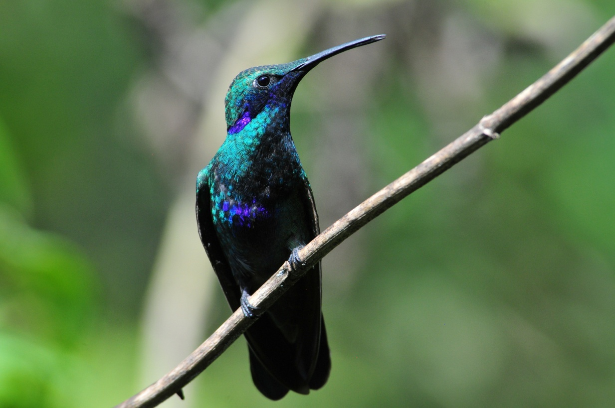
Sparkling Violet-ear

Chiguanco Thrush was common at this elevation, as was Rufous-collared Sparrow and Band-tailed Seedeater. Bare-faced Ground-Doves moved quickly but everyone was able to get good views in the end. Part of the group observed a Cinereous Harrier and everyone got good looks at both adult and immature Blue-and-yellow Tanagers. In the scrub on the hillside we found White-browed Chat-Tyrant, Streak-throated Thornbird, and Hooded Siskin. In the water were some new birds and better looks at some of the waterfowl we saw yesterday, including Yellow-billed, Speckled, and Puna Teals. In the tall grasses around the lake we found Andean Lapwing and Puna Ibis. Most of the group followed Eduardo through the tall grasses to a blind where he thought we might be able to find Plumbeous Rail. Although we flushed one, only Mark, who was right behind Eduardo, caught a glimpse of the rail as it darted into cover. From the blind we saw White-tufted Grebe and Black-crowned Night-Heron, but no rail. When we returned to the bus, we learned that the three people who had stayed behind had had perfect views of a Plumbeous Rail from their seats, and John gleefully showed us the photos he took of said rail.

We left the lake and wetland and drove toward Ollantaytambo, a town located at about 10,000 feet in elevation. On the way we stopped at a lovely spot for a buffet lunch, but I was unable to eat anything. The road to this point had been so hilly and curvy that I was suffering from motion sickness and the idea of eating was not at all appealing. It appeared that the drive had not affected anyone else and all enjoyed a scrumptious lunch. In the gardens at this spot, we saw Spot-winged Pigeon.

After checking in to our hotel in Ollantaytambo, which was located behind the train station, we birded some high elevation areas above the city with hopes of finding some specialty birds such as Sierra Finch. From the edge of a road we scanned the treetops, which were at eye level from our position. Creamy-crested Spinetail was vocalizing a lot from the opposite side of the road, and we were able to get everyone on the bird for some wonderful looks. The Peruvian Sierran Finch showed up, but before everyone could get the bird in their binoculars, John scared it away by using the flash on his camera. As people walked along the road’s edge, some saw Giant Hummingbird and others spotted Shining Sunbeam. A target species for this area, the White-tufted Sunbeam was first spotted by Jim. He had taken a photo and even though the shot was not clear, the bird was unmistakable. After a lot of time and effort, we were able to relocate the bird and I think everyone finally got good looks of it. Violet-throated Starfrontlet was also seen repeatedly, often to the dismay of the person who thought they might have the target hummer in view. Another target species, Golden-billed Saltator, was clearly seen and photographed. Also seen was Cinereous Conebill and Tyrian Metaltail.

At some point today, someone saw Rust-and-yellow Tanager and Golden Tanager, but I didn’t know about either sighting until we went over the list before dinner. We finished the day with just 43 birds, most of which were new for the trip, bringing our trip count to 94.

Day 4, Tuesday, August 23:
Today we were to meet at 6:00 AM for breakfast so we could bird the grounds of our hotel before boarding the train that was scheduled to take us to Aguas Calientes, the stepping-off point for Machu Picchu, at 8:00 AM. We needed to reorganize our luggage and leave almost everything checked at the El Embargue Hotel because of luggage restrictions on the train. We would spend one night in Aguas Calientes and then retrieve our luggage before going on to Manu.

The train schedule was modified a bit, so we had breakfast at 6:00 and still had time to bird for an hour before going to the station at 7:30. In the gardens of the hotel, we saw Black-tailed Trainbearer, Azara's Spinetail, and Rusty Flowerpiercer, all new species for the trip. Many other common birds were seen, including Chiguanco Thrush, Blue-and-Yellow Tanager, Golden-billed Saltator, and Band-tailed Seedeater.

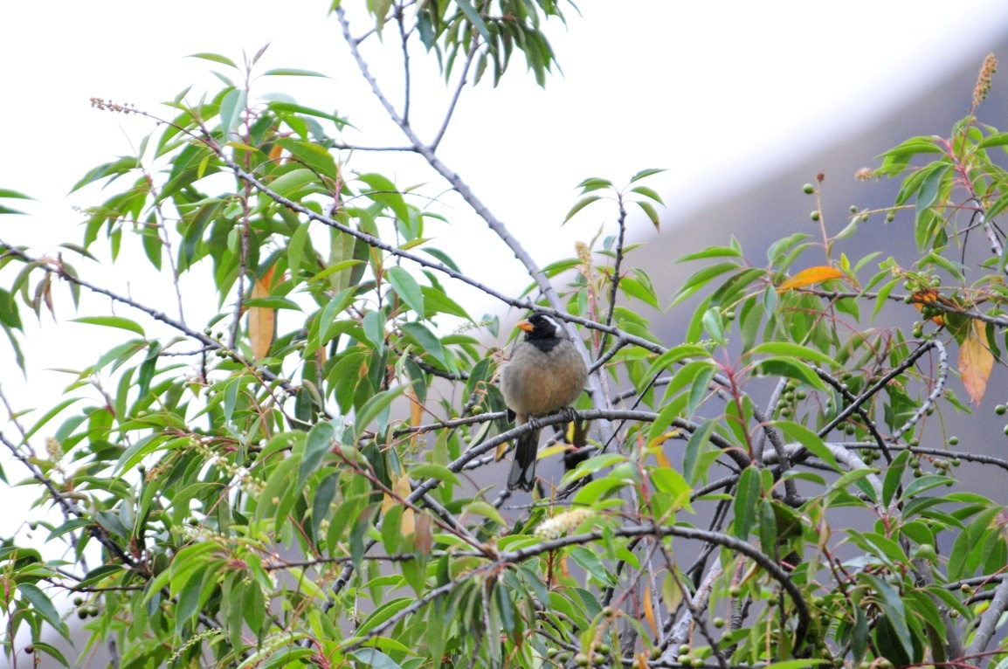
Golden-billed Saltator

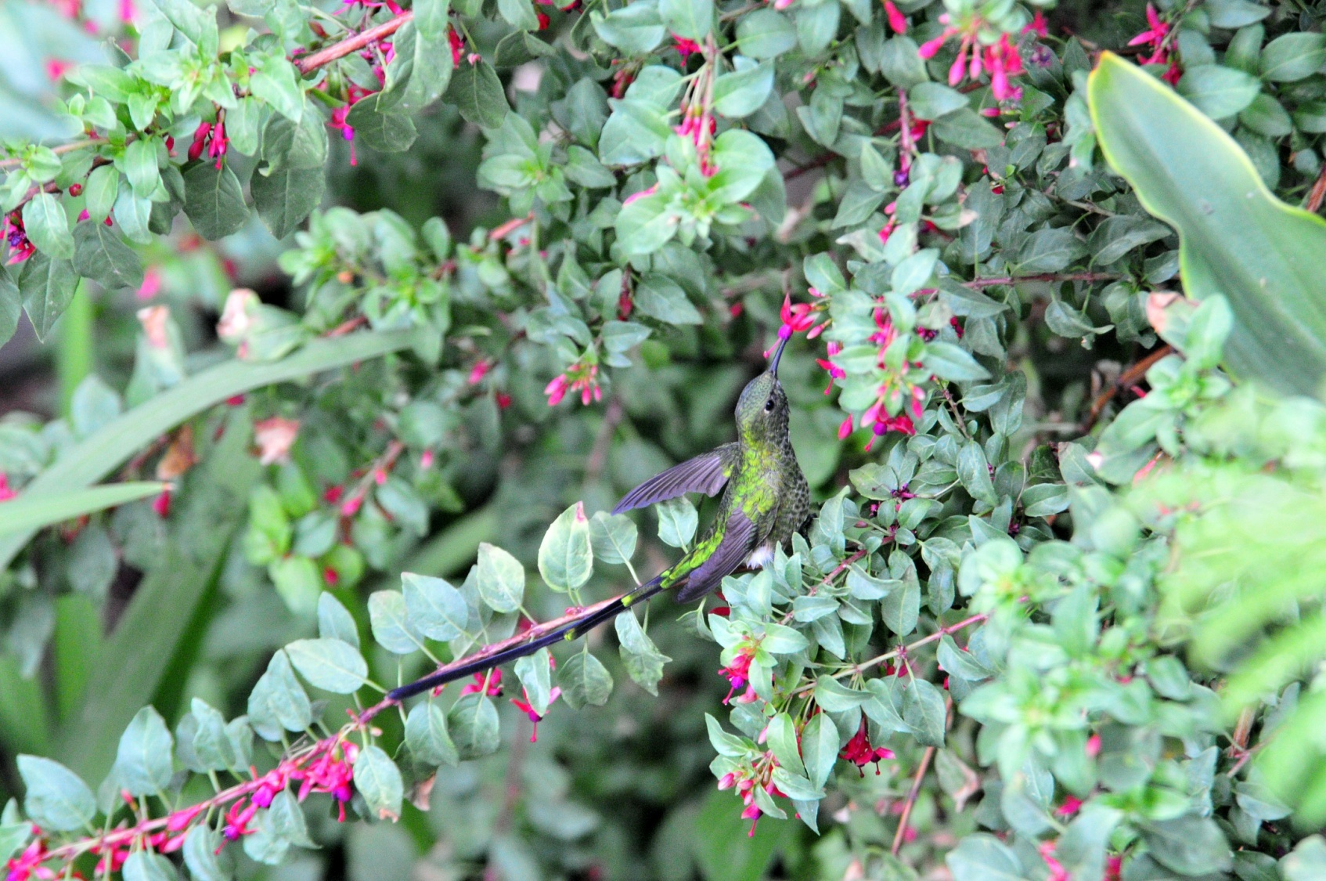
Black-tailed Trainbearer

From the train, Mark spotted a Black-backed Grosbeak before we left the station. Enroute to Aguas Calientes, people seated on the side of the train that had a view of the river were able to observe White-capped Dipper, Torrent Duck, Torrent Tyrannulet, Highland Motmot, Dusky-green Oropendola, Black Phoebe, and White-tipped Swift. When we arrived in town, Blue-and-white Swallows were common. We took our things to the El Presidente Hotel, but it was too early to check in. We checked our bags and walked a short distance to the bus stop where we boarded a bus that took us to Machu Picchu. As the group went with an interpretive guide to tour the ruins, Eduardo, Mark and I set off to find an Inca Wren, the only species of any consequence that we needed to find at the ruins. Eduardo thought that, if he could locate a bird while people were taking the tour of the ruins, we could then lead them back to the spot and easily refind it for the group. I followed as Eduardo moved at a rapid place from one spot of bamboo at the edge of the ruins to another. By the time we gave up on the search, my heart was pounding from the high elevation exercise we had done. No Inca Wren was found, but as we approached the exit, Eduardo played a tape and got a response. As we all gathered at the edge of a drop-off, the bird moved in and out of sight in the bamboo below us. Only a few people got satisfactory looks at the Inca Wren, and I consider myself lucky to have been among that group. I ducked into the restroom near the bus station as the group made one last attempt to find the Inca Wren. When I came out, I learned from Jim that the others were walking down a path for one more last chance. On this trail, a Chestnut-capped Brush-Finch was seen, along with several previously-seen species, but they were unable to find another Inca Wren.

We boarded the bus to return to Aguas Calientes at around 1:30 PM. When we arrived in town, we gathered our things from storage, checked into the hotel, and headed for Eduardo's favorite restaurant for lunch ("linner"?). After our meal, we returned to the hotel, grabbed our binoculars and walked outside of town to bird between the railroad tracks and the river. With the sound of the water and an occasional train, we couldn't hear any but the loudest of bird sounds.
Everyone in the group got to view White-capped Dipper, seen only by those on one side of the train this morning. Also along the river was a Torrent Tyrannulet and a Black Phoebe, showing much less white on the lower belly than we are accustomed to seeing in the US. Across the river a Highland Motmot posed for long scope views. Jim spotted a Slate-throated Redstart but it flew before others saw it. We heard the first of many Gray-breasted Wood-wrens, saw the first of many Tropical Kingbirds, and had two fly-by species that were not seen well enough to count even though Eduardo could positively identify them: Speckle-faced Parrots and Mitred Parrots. More White-tipped Swifts were seen overhead and we had back-lit views of Golden-crowned Flycatcher and White-bellied Hummingbird. Just as we got to the edge of town and the light was fading we found another Golden-crowned Flycatcher that positioned itself with leaves behind it so we all had good views of the last bird of the day.

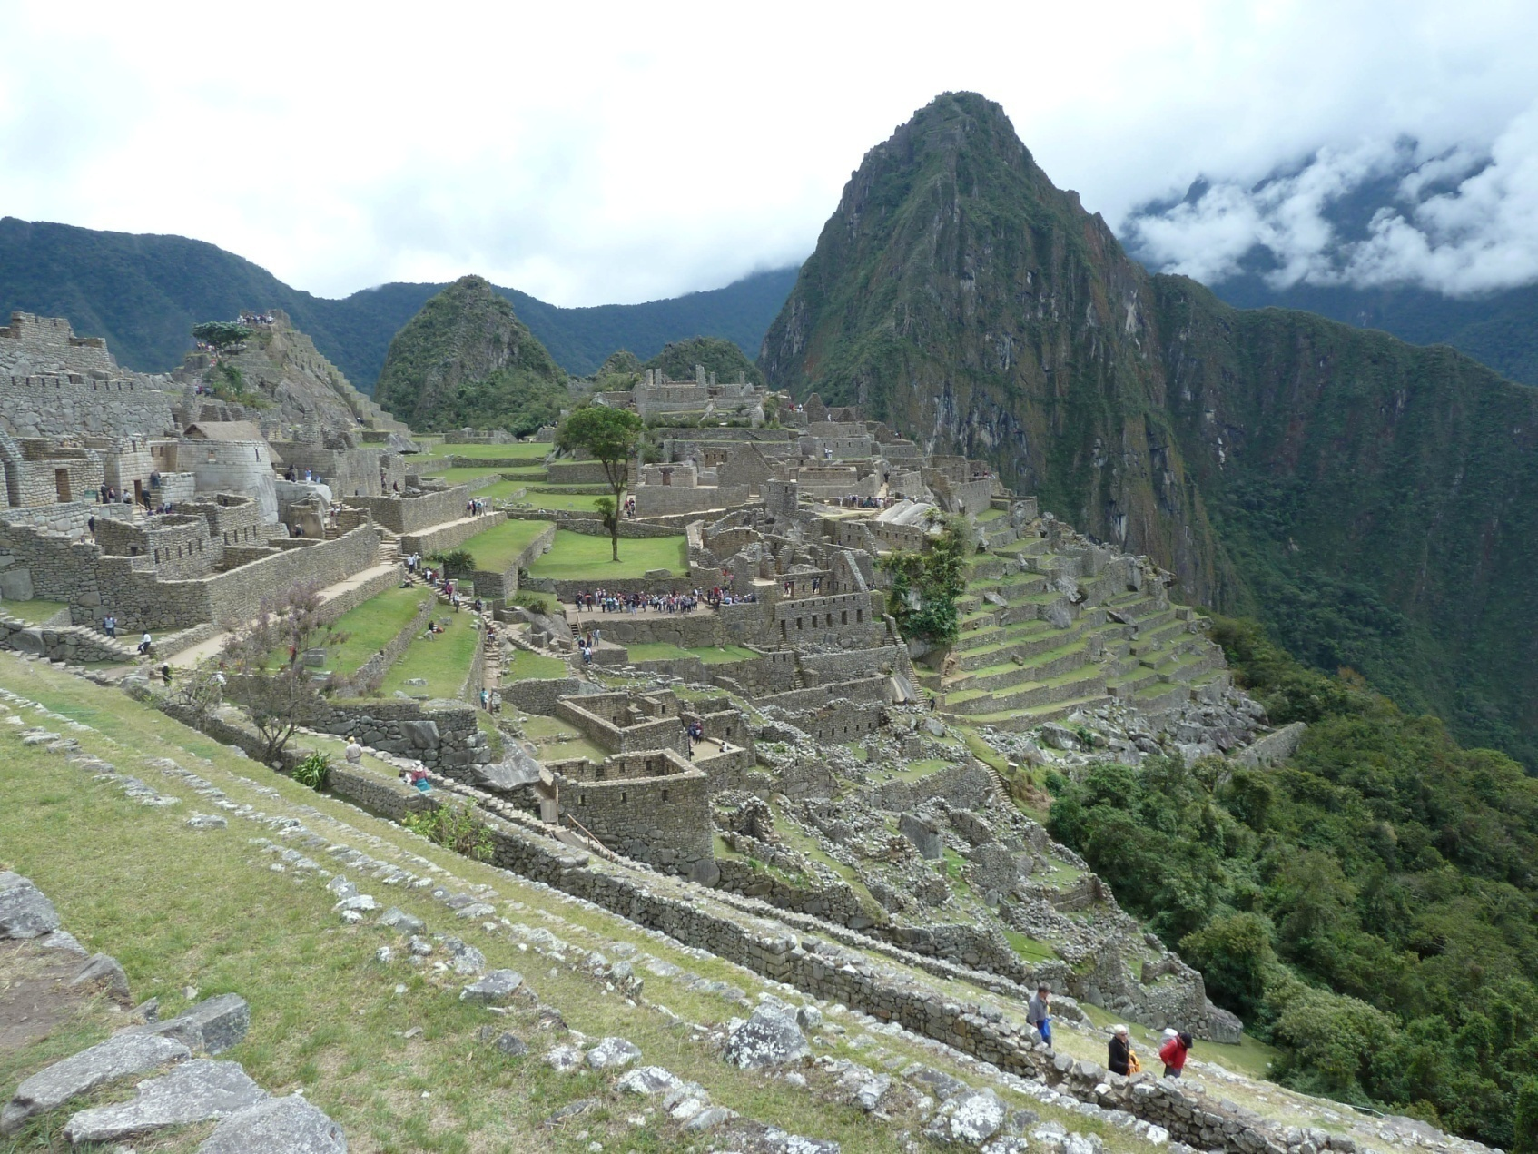
Machu Picchu

With such a large lunch so late in the day, none of us wanted to have a full meal when we got back to town. Instead, we opted to stop at a small place that specialized in desserts. We all enjoyed calorie-laden, decadent desserts that, in all likelihood, none of us would have indulged in following a regular meal. A great finish to a wonderful day!

Other new species seen today included Roadside and Variable Hawks. Our count for our Machu Picchu day was 35 species, with 18 of them new for the trip, bringing our trip total to 112. Before the trip, I would have expected a number in this range for a single day of birding in Peru. I was looking forward to birding in the lowlands where the numbers would surely be better.

Day 5, Wednesday, August 24:
The plan for this morning was breakfast at 5:30 AM with departure on foot at 6:00 AM to bird along the Urubamba River on the other side of town. We would be without transportation until we return to Ollantaytambo late in the afternoon. As Jim and I were getting our things ready to leave, we spotted two White-capped Dippers in the river right outside the window of our hotel room. When we joined the others and began our walk, the Dippers were still there for everyone to see. This was undoubtedly the best view of White-capped Dippers Jim and I had ever had, but it was nothing compared to the show that a pair of Torrent Ducks put on just a bit further up the river. With two ducklings in tow, the adults dove in and out of the rapidly-moving water and jumped on huge boulders in the river. We watched in awe as the tiny youngsters emulated their parents. It didn't seem possible that something so tiny could maneuver against such a strong current. We had time to put the birds in the scope and everyone enjoyed seeing the intricate pattern in the adults' plumage.

We watched for birds as we walked along the river, but Eduardo was encouraging us to hurry so we could arrive early at a place where there would likely be lots of tanagers and other birds and where we would not be bothered by the traffic on the road. It's pretty hard to hurry when you have birds like Mottle-cheeked Tyrannulet, Yellow-bellied Seedeater, Chivi (Red-eyed) Vireo, Mitred Parakeets (group of at least 20), Fawn-breasted Tanager, Variable Antshrike, Blue-necked Tanager, Streaked Xenops, White-bellied Woodstar, Gray-breasted Wood-wren, and Tropical Parula all presenting themselves for your viewing pleasure!

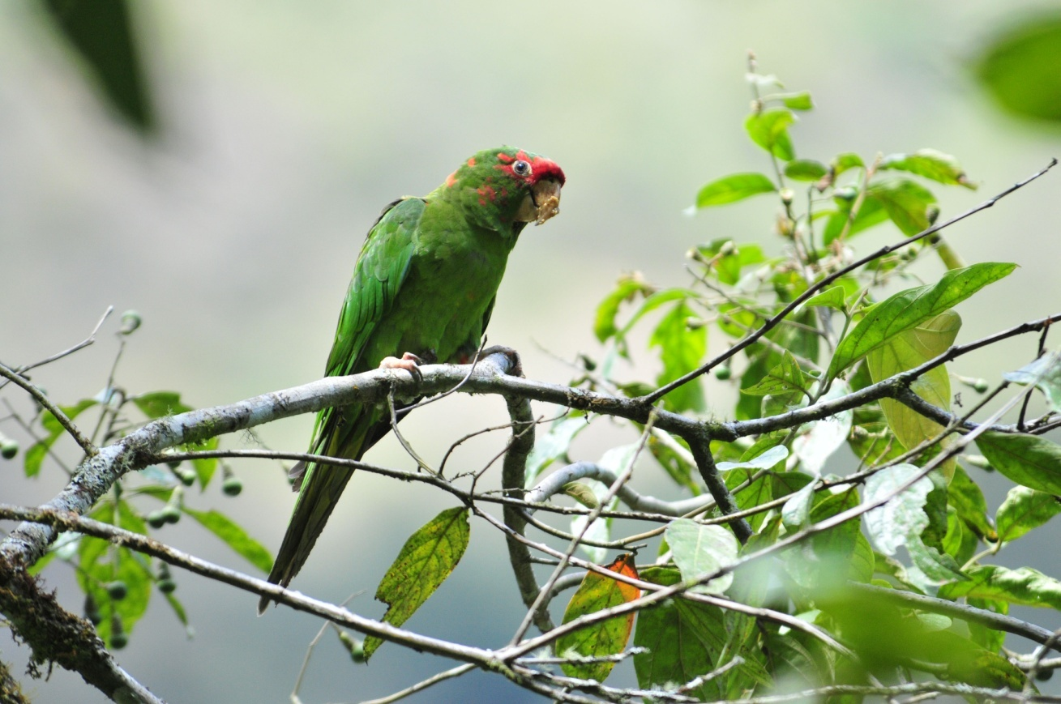
Mitred Parakeet

Our first "real" stop was near a garbage dump. Not as bad as it might have been, but a bit on the smelly side. Here we saw many birds we had seen before, and we managed to separate Green-and-white Hummingbird from its very similar and more common relative, White-bellied Hummingbird. Eduardo heard Eared Solitaire on the hillside, but Lucy and I were the only two who managed to get on the distant bird. It was so far up the hill that we could barely see the distinguishing white patch on its face, and it was impossible to direct anyone to it before it disappeared into the brush.

As we left the area near the dump to walk along the railroad tracks and river, we saw Black-breasted Buzzard-Eagle soaring overhead with nice views for all. A bit further down the tracks, we found a White-eared Solitaire that not only came closer to the group but practically posed for us. Unfortunately, I was trying to set up the scope for the group and missed the shot with my camera - note to self: two types of optical equipment is your limit! Anything more than that, and nothing is used effectively.

We had stopped to identify some hummingbirds when I caught a glimpse of a Booted Racket-tail. Unlike the birds that we see in Ecuador on the western slope of the Andes, this little beauty was sporting orange "boots" instead of white. This was only the second time I had seen this race of the Booted Racket-tail, which is one of my favorite tropical species. We took some time to try to find the bird again, but we finally had to move on with just a few people seeing it. Eduardo assured us that we would see plenty of these little jewels at Cock-of-the-Rock Lodge. Most of the group did get good views of the Chestnut-breasted Coronet that was among the other hummers we had already seen.

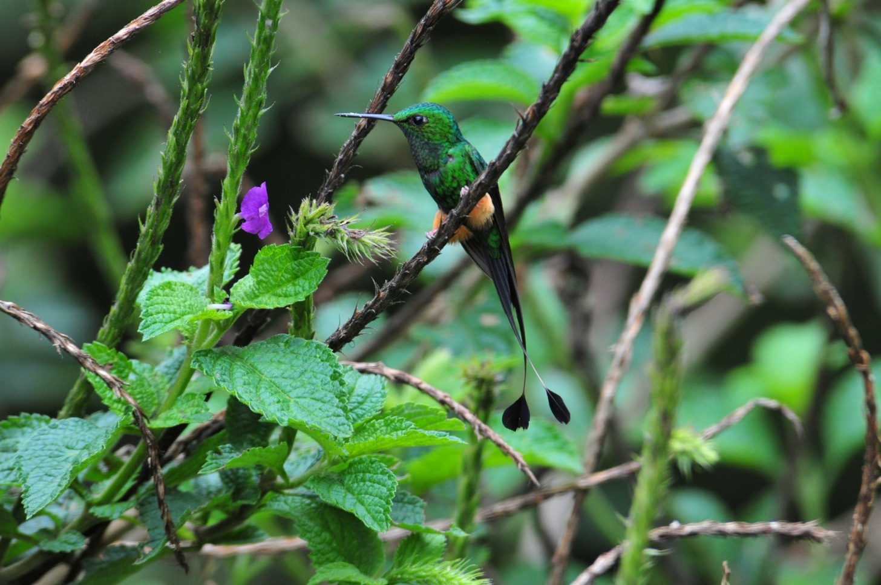
Booted Racket-tail

We were now in the area where Eduardo had said there would be lots of tanagers, and we were not disappointed. Saffron-crowned, Silver-backed, Beryl-spangled, Golden-naped, Silver-beaked, and Highland Hepatic Tanagers appeared multiple times in mixed flocks. At one point, a female Cock-of-the-Rock flew across the tracks in front of us. We all scurried to get better views, and just as everyone got on the bird - - - - - - a TRAIN came by! Eduardo was excited for us to get to see the female because he said it is easier to see the males since they are such bold performers at leks. Females, on the other hand, are not seen as often.
As we approached the area near a small museum, some Olive-green Oropendolas came down for close views as they fed on Heliconia, giving those who missed them yesterday great views. The Mitred Parakeets were so numerous in this area that they were keeping many of the smaller birds away, and many of us found ourselves wishing that the parakeets, the very ones we had been so excited to see just a short while ago, would fly away. Some of the women walked a short distance to the museum to use the restroom (not permitted) and found a pair of fledgling Mottle-cheeked Tyrannulets being fed by their parents in low trees next to the building. They were at eye level and sat patiently as I photographed them.

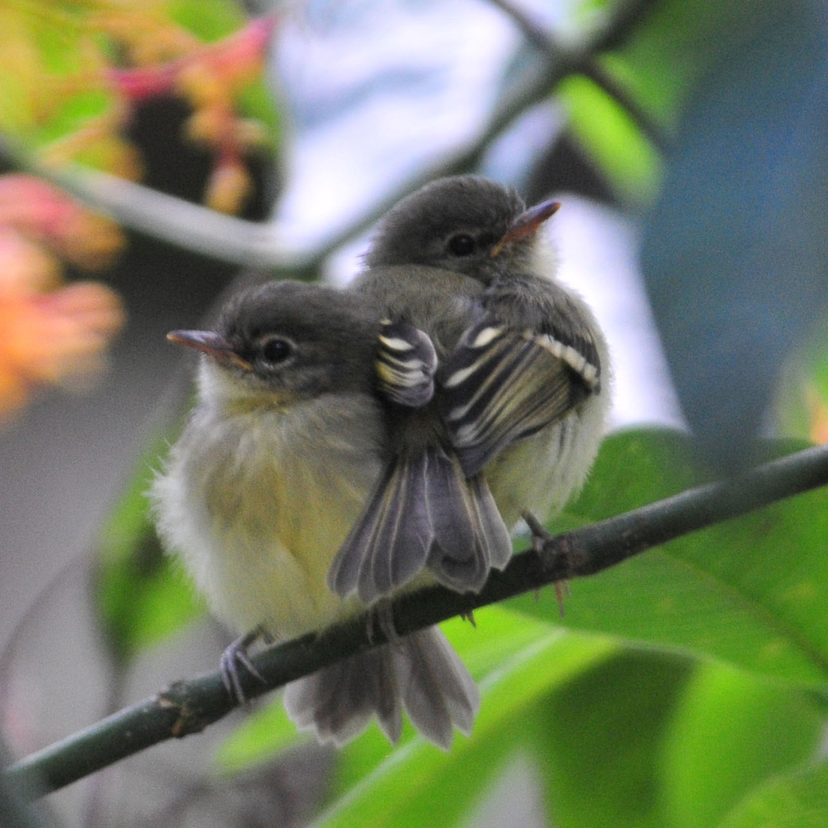
Mottle-cheeked Tyrannulet fledglings

Other new species seen along the railroad tracks included Sclater's Tyrannulet, Pale-legged Warbler, Glossy-black Thrush, Capped Conebill, Andean Guan, Blue-naped Chlorophonia, Speckled Hummingbird, and Oleaginous Hemispingus (the name is bigger than the bird). A second Streaked Xenops was found, allowing people who missed it earlier in the morning a chance to view it well. We returned to town and had lunch at Eduardo's favorite restaurant and then walked to our hotel, where we had again stored our things when we checked out this morning. It would be 3-4 hours before our train departed for Ollantaytambo, so we had the option to bird along the river some more or to visit some of the many shops in Aguas Calientes. Some went shopping and others opted to bird on their own, with Mark reporting a Fasciated Tiger-Heron and Green Hermit and Becky and Brad reporting a Dusky-capped Flycatcher when we met at the hotel to complete our list before leaving for the train station later in the day. Our list was comprised of 57 species, a good number but still not quite as good as I had anticipated. More than half were new for the trip, so our trip total stood at 146.

We carried/dragged our luggage to the train station at around 5:00 PM for a 5:30 departure. Eduardo had ordered some empanadas for our dinner on the train, and we enjoyed them as we traveled back to Ollantaytambo. On the way, we were entertained by a traditional dance performance and a fashion show featuring alpaca garments. Brad, Lucy and John each had a turn at "dancing with the devil". Once we arrived in Ollantaytambo, we gathered our stored luggage from the El Embargue Hotel (was that just two days ago?) and carried/dragged them up to where our bus was waiting. Luckily, some of the heavier items were loaded on a dolly and the bus driver transported them up the hill for us. We loaded our things and headed to the Munay-Wasi Hotel in Cusco. As we were leaving Ollantaytambo we encountered a traffic jam caused by a large bus that had parked in a way that blocked a very narrow road. Drivers had to maneuver around the bus, taking turns getting through a spot that was not large enough for two vehicles to pass at one time. Consequently, we arrived later than expected, at around 9:30 PM.

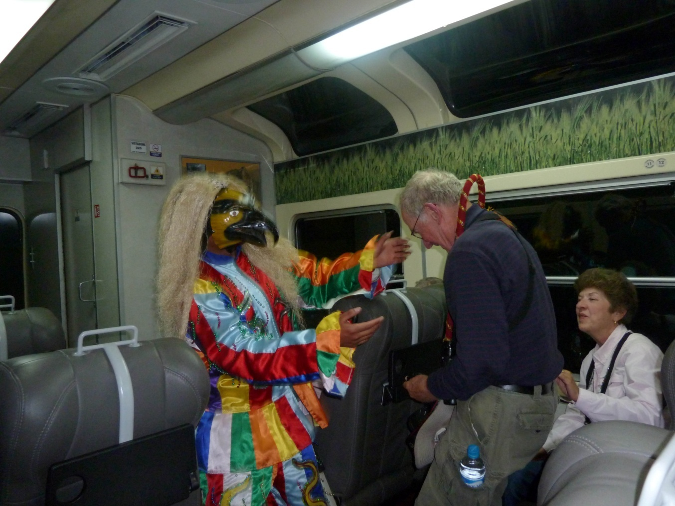
"El Diablo"

Day 6, Thursday, August 25:
We enjoyed a hot buffet breakfast at 6:00AM and had all of our luggage in the lobby ready to go at the scheduled departure time of 6:30. The bus driver, Mario, was late, so we were not able to leave until shortly before 7:00 AM. We planned on a quick stop at Huarcapay Lakes to make one more effort to find the Bearded Mountaineer, an endemic species that we would not be able to see on the remainder of the tour. Approaching the lake, Mario spoke rapidly in Spanish to Eduardo and then stopped the bus. He had seen Flamingoes on the lake! We examined the birds through the scope, waiting for them to change positions so we could tell if they were Andean or Chilean Flamingoes. Each person who stepped up to the scope watched for a few moments until finally someone said, "Red knees!" and Eduardo responded, "Chilean!"

Most of the birds we had seen when we visited this spot a few days ago were still present. As we watched the Flamingoes and abundant waterfowl, a Guinea Pig scampered across the marsh. We reminded Eduardo that we also wanted to try to see the Plumbeous Rail that only Jim, John, and Jackie had seen when they stayed on the bus and the rest of us walked to the blind that first day. It wasn't long before our goal was achieved. And achieved again. And again. As we worked our way around to the far side of the marshy area, it seemed the rails were everywhere. From the road, we were looking down on the marsh and we watched in amazement as one after another of the rails sauntered in and out of cover. Obviously not as shy as the rails we are accustomed to seeing in the US, these birds are bigger than our Virginia Rails but smaller than King Rails and sport a colorful bill of green, blue and red. Beautiful!

We found no Mountaineers near the restaurant as we had hoped and went on to a drier area to search for Rusty-fronted Canastero. As we walked through an apparent archaeological site overlooking some ruins, we watched our step to avoid cacti. The group got spread out, and some people missed the Aplomado Falcon as it flew over us on the hillside, while those of us who had climbed above the road missed the Cinereous Harrier that flew low over the marsh. White-browed Chat-Tyrant was seen by the group on the hill. After a while, we moved back to the road and walked near Eduardo as he attempted to call the birds out. A group of us was standing on the road, looking down toward the sound of a Canastero responding to Eduardo's tape when I saw a small nondescript bird. It matched its surroundings perfectly, so I had to wait for it to move to be able to help others see it. Eduardo identified it as a Spot-billed Ground-Tyrant. As we watched this bird, the bird we were looking for, Rusty-fronted Canastero popped into view right in front of us.

By now, we had spent much more time in this area than Eduardo had planned, and we needed to move on to Manu Road, reportedly one of the best birding spots in Peru. We made one last stop at a bridge for one more chance at the Mountaineer, but none were to be found. We settled for a Black-throated Flowerpiercer as a consolation prize and moved on toward Manu Road. The road was pretty good at first, gravel in fairly good condition. We climbed in elevation for quite some time before Eduardo told Mario to stop so we could get out and do some birding. Near the road, we found Peruvian Sierra-Finch (this time everyone got to see them), Mourning Sierra-Finch, Mountain Sierra-Finch, Chestnut-breasted Mountain-Finch, and the best views yet of Giant Hummingbird as it hovered over nearby bushes. Walking along the road, Penny looked up to see an Andean Tinamou walking on a trail on the hillside above her. She alerted the group quickly, but not quickly enough for us to catch a glimpse of this shy bird. Driving on, we saw Andean Flickers from the bus. We added Creamy-winged Cinclodes and noted that it had recently been split from Bar-winged Cinclodes, making it a lifer for everyone in the group.

We arrived in a town called Paucartambo, where Mario wanted to buy fuel. Unfortunately, it's not as simple as driving up to a gas station when you're in this part of Peru, and after a bit of effort, he was unable to find any gas. Luckily, he had enough to get us to our destination, Cock-of-the-Rock Lodge, and was only trying to fill up for the convenience of not having to do it later. While we waited, we turned our attention away from birds and did some people-watching. Seeing the traditional clothing of the people who live in the Andes and the children as they walked home in their school uniforms was interesting, and we approached one group to see if it would be all right to take some photos. I gave the woman a few Soles after snapping some photos, but someone suggested that the kids might like some candy. I retrieved some mints from the bus and was immediately surrounded by children with their small hands thrust toward me. I laughed as I handed out the candy, realizing that some of those little hands had been filled multiple times. As the group got larger, and I could see that the children were going to stay as long as I continued to place mints in their hands, I tossed some candy in the air, sending the group scrambling to retrieve it. As I climbed back into the bus, a few children who hadn't received any candy approached, and I made sure they got some. We drove away from smiling faces, and we were smiling too.

As we continued to drive up the winding road, I began to get more and more nervous. The gravel road was narrow with a wide spot every once in awhile, presumably places where two cars would be able to pass each other. As we approached blind curves, Mario would sound his horn, but he didn't do it every time and I wondered what his criteria for horn-blowing was. Being a flat-lander, I know I'm sometimes unreasonably fearful on roads like this, so I withheld any comments about the road and how it looked like we were going to go flying off into space at every turn. After all, no one else was complaining, so maybe it was just that sitting up front made it look worse that it was. Then we rounded a blind curve where Mario had not sounded his horn and came nose-to-nose with a big (huge!) truck coming from the opposite direction. Truck and Bus came to a screeching halt (OK, no screeching on gravel, but they stopped really fast). Mario carefully backed the bus to a spot where he could "pull over" and allow the truck to pass. (OMG - pulling to the side of the road makes you feel like you're going to go tumbling over the edge, so pulling “OVER" takes on new meaning here) I think it was then that I turned to the others and said, "I don't know about the back of the bus, but the front of the bus could use a change of underwear!" As we drove away, I leaned forward and said to Mario one of the few Spanish phrases I know: "Mas despachio, por favor!" I'm sure Mario appreciated the advice.

It wasn't long after the truck "near-incident" that we arrived at the entrance to Manu Biosphere, where Eduardo had planned to stop to bird for a while. By now, everyone was pretty vocal about the scary road, mostly with lots of nervous joking, and you could feel the tension in the bus as we watched heavy fog descend around us. I guess the fog didn't descend around us as much as we ascended into it, but either way visibility was getting worse. As we stood in a small clearing trying to get views of a Moustached Flowerpiercer, I suggested to Eduardo that we should move on. It was getting late, we couldn't see any field marks unless a bird came and landed right in front of us, and the foggy conditions would require that we go much more slowly (mas despachio) than we had been. In fact, I instructed Eduardo to tell Mario that I insist that we go slower. Turns out, I really needn't have said anything about speed. The road was in such poor condition for the remainder of the drive that Mario couldn't have driven fast if he had wanted to. Deep ruts, huge holes, waterfalls that ran across the road at inside curves, places where it looked like huge chunks from the side of the road had fallen into the chasm below . . . . . . words cannot describe this treacherous stretch of road, nor can photographs give you the full picture.

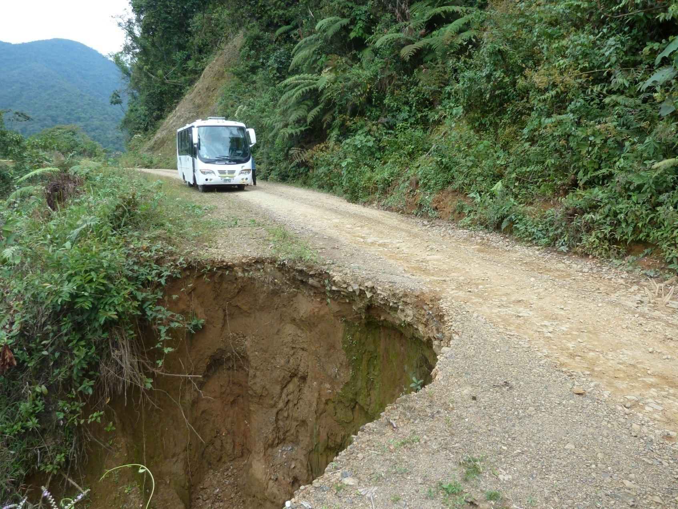
Manu Road
We drove for hours in these conditions, but after a while we dropped in elevation and visibility improved. We were scared, but we're birders, and this is supposed to be one of the premier birding spots in the world - we had to "suck it up"! We stopped to see our first Great Thrush and lucked into an Amethyst Sunangel. At another stop where we allowed ourselves ten minutes to bird, we found a mixed flock with Rust-and-Yellow Tanager, Great Thrush, Black-faced Brush-finch, Citrine Warbler, White-banded Tyrannulet, Montane Woodcreeper, Spectacled Warbler, and an unidentified Hemispingus. We heard Red-and-white Antpitta but could not allow ourselves the time to try to call it in.

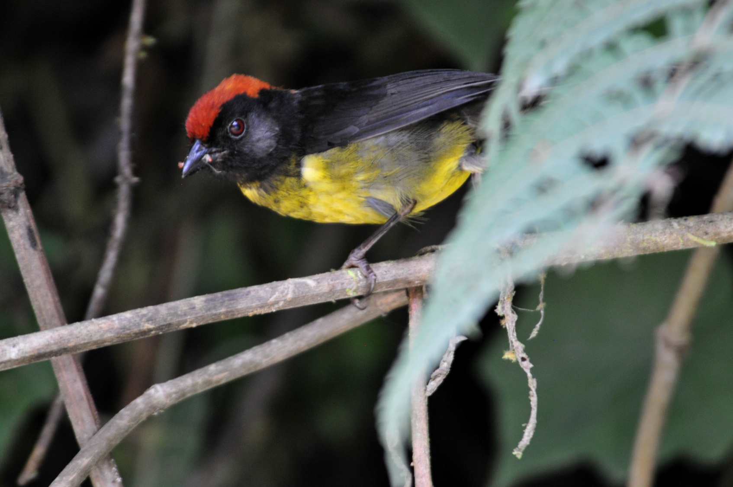
Black-faced Brush-finch

As the sun went down, we were still driving, but at least now we could see the headlights of approaching trucks. The trucks were usually in groups of three, and we assumed they traveled in caravans because there was no way to reach anyone if you encountered a problem out here - no cell phone access, probably not even radios for communication since radio signals can't travel through mountains. We could see a group of trucks on the road on the mountainside below us and we knew we would soon encounter them, so we thought we were prepared and steeled ourselves for the pass. The trucks were quite a distance away, and Mario didn't want to pull off on the first wide place he came to but instead waited until they were closer. When he did pull over, the space remaining on the road for the trucks to pass through was not large enough and he had to maneuver the bus into a better position. Better for the trucks, that is, because as he pulled over, we could all feel the ground give way under one of the tires. I don't know how many of us shrieked, but it might have been unanimous. The truck driver even sounded an alarm. At this point, Penny came forward and asked to get out of the bus. I empathized completely and don't know why I didn't go with her!

No one wanted to continue on this road, but we had no other option. We finally arrived at Cock-of-the-Rock Lodge at around 7:00 PM, badly shaken and exhausted, thankful that this part of the trip was behind us. We put our things in our cabins and went straight to dinner, saving the checklist for later. When we completed our list that evening, we tallied 59 birds, about a third of which were new to the trip, bringing our trip total to 167. Going over the next day's plans, Eduardo told us that he would like to go back up Manu Road to a place where soaring eagles are usually seen, usually about 2 hours away. His suggestion was not met with enthusiasm.

Day 7, Friday, August 26:
Eduardo's plan for us today was to begin by meeting in the dining room at 6:00 AM to bird the feeders. Because some participants emphatically stated that they would not go back up Manu Road in the bus, the plan was to bird Manu Road on foot in both directions from the lodge.

I could hear it raining during the night, and there was light rain as I dressed to meet the others at the dining room. When everyone arrived, we learned that some cabins were without water; this would be a recurring problem throughout our stay. The feeders were humming with activity. Although there were some feisty Sparkling Violet-ears at the feeders, the dominant species here seemed to be Violet- fronted Brilliant. Both of these species of hummingbird were present in large numbers. By the time breakfast was ready, we had also seen Wire-crested Thornbill, Many-spotted Hummingbird, Green Violet-ear, and White-bellied Woodstar at the various hummingbird feeders stationed around the dining room.

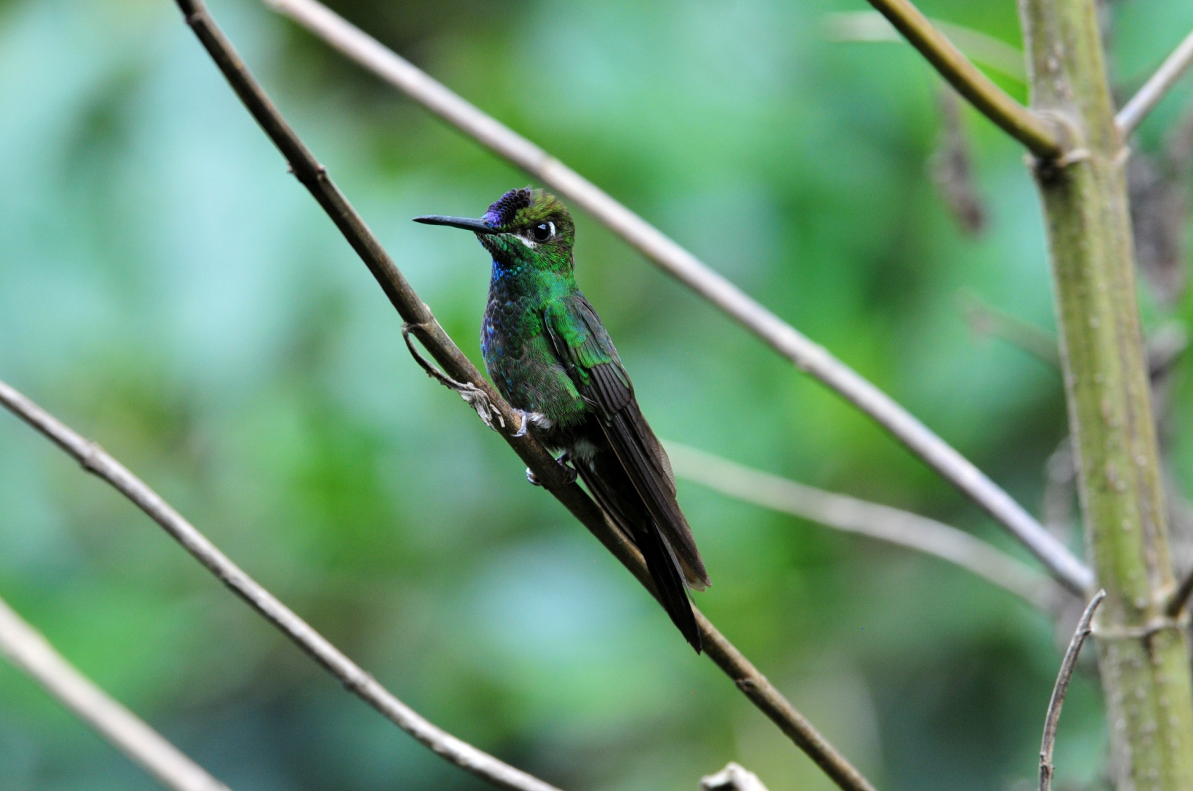
Violet-fronted Brilliant

As the morning rain came to an end, the birding activity picked up and we had a hard time keeping up with the birds as they moved through in a loose mixed flock. Palm Tanager, Silver-beaked Tanager, Buff-throated Saltator, Plumbeous Pigeon, White-tipped Dove, Orange-bellied Euphonia, Marble-faced Bristle-Tyrant, Paradise Tanager, Orange-eared Tanager, Golden Tanager, White-crested Elaenia, and Blue-gray Tanager were all seen, but few came to the platform feeder. Maybe they didn't want to share a meal with the Bolivian Squirrel that was hanging around the feeders. As Mark and I stood in front of a Fern tree where a brilliant Orange-eared Tanager landed - just 10-20 feet in front of us at eye level - we gasped, "Oh, my God!" in unison. The beauty of this bird was truly breathtaking - its green body a color and a quality I've never seen, a deep rich purple belly, a bright splash of red (not orange) on its face and a touch of bright yellow on its crown. We both stared at the bird, trying to take in every inch, every millimeter of its stunning beauty through our binoculars - - - - - - and neither of us thought to lift the cameras hanging at our sides to photograph this perfect subject in perfect diffused lighting just a few feet away at eye level. I guess this proves we're birders who like to take photographs, not photographers who like to photograph birds! Paradise Tanagers wowed everyone with their kaleidoscope of colors, but nothing I saw on this trip came close to the beauty of that Orange-eared Tanager.

After breakfast, we began our walk going uphill on Manu Road, back in the direction from which we had arrived last night.
There was a lot of activity in the trees lining both sides of the road, and we saw more individuals of many of the species we had seen from the dining room plus Bay-headed Tanager, Yellow-throated Bush-Tanager, Scale-crested Pygmy-Tyrant, and Blue-and-white Swallow. After walking a short distance uphill, we came to a privacy fence on one side of the road and Eduardo told us that was where the Cock-of-the-Rock lek used to be. Due to a landslide a few years ago, the birds moved and a new viewing platform had been built further up the mountain, beyond the area where he had wanted to take us to find eagles. In a small tree that stood near the fence, several birds were moving about. As we watched this tree for the next half hour or so, we saw a good number of birds come through: Golden-collared Honeycreeper, Orange-eared Tanager, Yellow-throated Tanager, Versicolored Barbet, Purple Honeycreeper, Golden-olive Woodpecker, Golden-naped Tanager, Black-eared Hemispingus, Saffron-crowned Tanager, and Blue-naped Chlorophonia appeared for awhile and then moved on. I saw a bird I didn't recognize and tried to point it out to Eduardo, but with birds hopping all over the tree, I knew we were looking at two different birds when he said it was the Hemispingus. I had seen the Black-eared Hemispingus, and this bird was different - the color on its breast and stomach was a soft buffy color, not rufous, and it had no trace of a superciliary above its black mask. I tried to commit the details to memory in hopes of finding the bird in the field guide when I returned to my cabin later. Right now, there was too much action to stop to look in a book!

We moved a bit further up the road and found Gray-mantled Wren, Olive-backed Woodcreeper, Montane Foliage-gleaner, Golden-eared Tanager, Dusky-green Oropendola, Three-striped Warbler, Black-faced Brushfinch, and Masked Tityra. We heard Yungas Manakin, a bird I very much wanted to see, but it would not respond to calls. After a while, we retraced our steps and walked downhill past the lodge. Some of the group returned to the lodge and a few of us continued on. We came across a couple of birds foraging on the hillside and I recognized them as my mystery bird from earlier. This time, Mark and Eduardo got on the bird, and we watched them for several minutes before consulting the field guide. We were able to identify the bird as a Black-goggled Tanager. Things got relatively slow after that, but we were able to add quite a few birds to the day's list: Black Phoebe, Southern Rough-winged Swallow, Variegated Flycatcher, Streaked Flycatcher, Streak-necked Flycatcher, Lemon-browed Flycatcher, Social Flycatcher, Squirrel Cuckoo, Olivaceous Siskin, White-collared Swift, and Tropical Kingbird. We returned to the lodge for a short rest before lunch. At the feeders, we were able to add Long-tailed Sylph and Chestnut-breasted Coronet and we found Stripe-chested Antwren in the foliage at the back of the garden. Spotted Tanagers were also "spotted".

During the lunch break, I hung around the lodge in hopes of getting some good hummingbird shots, and I kept hearing the Yungas Manakins calling from the forest. I walked a short way on the forest trail and was immediately surrounded by the sounds of several manakins. It took a few minutes, but I was finally able to see one of the male birds. I walked a bit further, and I began to hear lots of chips and call notes, all sounds I didn't recognize, but enough different sounds that I knew a mixed flock was moving through. It was frustrating to be able to find and identify only a few of the dozens of birds that were around me, but mixed flocks of tropical birds have the same effect on me that a school of fish or a herd of zebra must have on a predator - I want them all, so I don't seem to be able to focus on one long enough to get it!

After lunch, we planned to bird along the trail I had been walking, but it appeared that rain would spoil our plans. At around 3:00 PM, the group started down the trail, but they didn't go far before stopping to look for the Manakins that were still calling. I came up at the end of the line and saw a male sitting on the edge across an open patch. I chastised myself for not having the scope with me as he sat still for quite a long time and scope views would have been wonderful. The trail was pretty dead, so after awhile I turned back, as did Barbara and John. I was back in my cabin shortly after 4:30, and I could hear everyone else return soon after that. So our morning of birding was outstanding, but the afternoon was almost a total bust.

When we completed the list before dinner, Mark added some species that he had seen while walking on his own during the lunch break, including Greater Yellow-headed Vulture and Chestnut-collared Swift. Our day's count came to 68, the best daily count of the trip so far. Two-thirds of them were new for the trip, bringing our trip total to 213.

Day 8, Saturday, August 27:
With the active Cock-of-the-Rock lek so far up Manu Road, Eduardo did some investigating to see what our other options might be. The manager of the lodge told him that four males still perform each morning at the old lek, and although it's not as good as the new lek, at least we would see the birds. Our plan for this morning was to leave for the lek at 5:45 AM and then come back for breakfast at 7:00. As we approached the viewing platform at around 6:00 AM, we could hear the birds. Such a harsh sound for such a beautiful bird! I guess if you look that good, you don't need to be able to sing. We waited and strained to see the birds, but the sounds were coming from an area that wasn't visible to us. A few people saw one male fly in and out briefly, but we weren't able to get good views of the birds for everyone. We decided that, since they were already performing when we got there at 6:00, we would be there earlier tomorrow. While we were waiting, a few
Speckled Chachalacas flew in. An Olive-backed Woodcreeper was spotted by Jackie, who was always finding good stuff for us although she isn't an avid birder herself. We heard Chestnut-breasted Wren and would come to know the song well as we heard it again and again for the remainder of our stay.

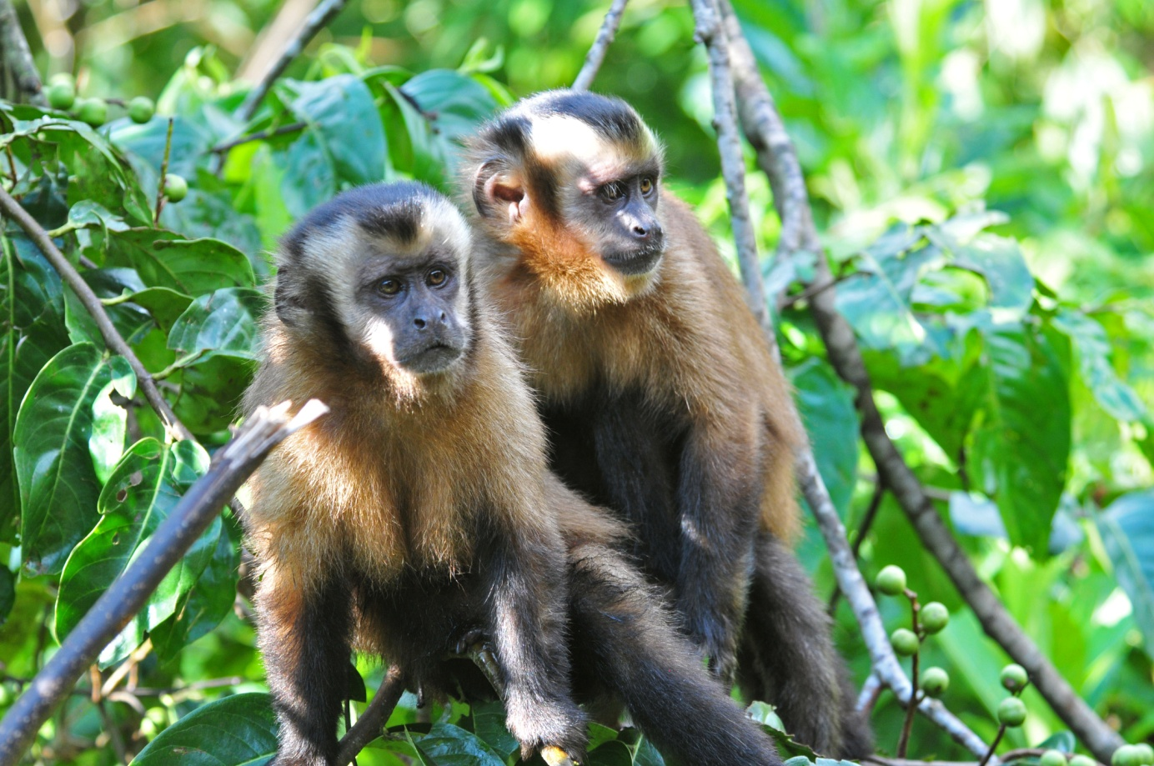
When we got back to the lodge for breakfast, we were greeted by a troop of Brown Capuchin Monkeys who were waiting for a chance to steal some food from the tables. As soon as the table next to us was vacated, a brave Capuchin leaped across the railing, grabbed some bread, and dashed off. We all enjoyed their antics as we ate.

After walking along Manu Road and seeing it from a different angle in broad daylight the day before, the group decided they would risk taking the bus up the road to the area where we might find eagles - on the condition that we would walk through any spots that looked particularly unsafe to cross in our large bus with tiny wheels. Mario must have thought we are all crazy each time I announced, "Time to get out and walk!" as we came to one of the aforementioned spots. At first everyone got out, but eventually Jim and John started staying aboard the bus, unless we were birding along the road. For the most part, that's what we did. The second time we got out of the bus for a bad spot, we found a small flock of Three-striped Warblers and observed White-collared and Chestnut-collared Swifts overhead. Mario spotted a brilliant male Cock-of-the-Rock near the road's edge, just about at eye level. He stopped for us to take a look, and we all piled out of the bus (and it wasn't even a bad spot!) We were enjoying this especially good view of the bird when Jackie spotted another special bird nearby. It blended so well with its surroundings that it took a bit of time for everyone to find the Blue-banded Toucanet sitting at eye level, looking for all the world like a large leaf until it moved a bit.

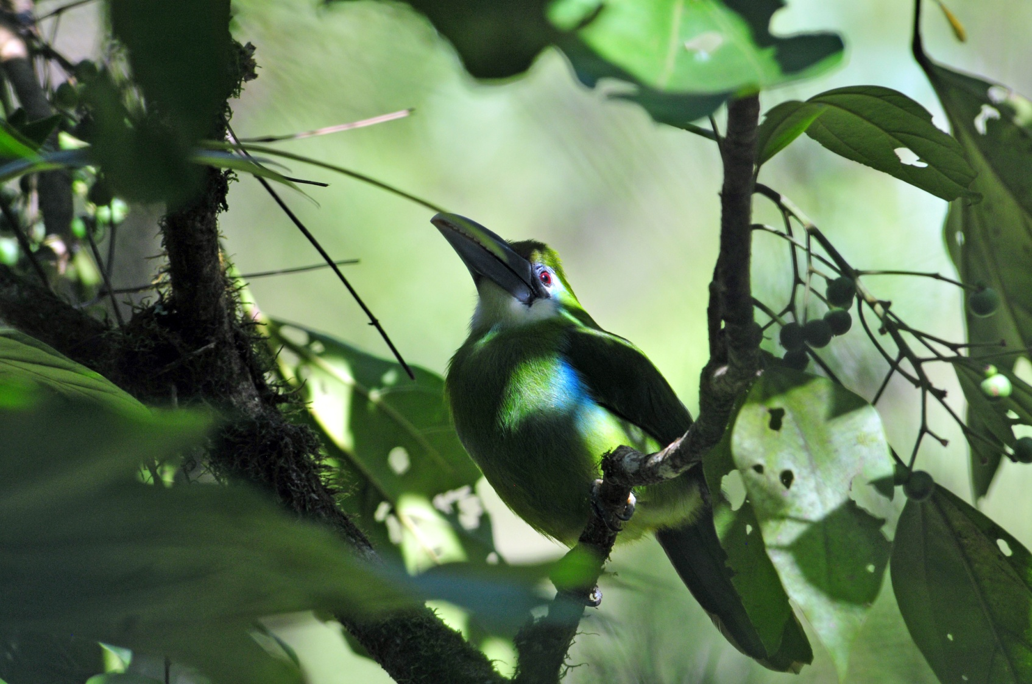
Blue-banded Toucanet

On our way back down the mountain, we encountered another male Cock-of-the-Rock. Again, it was Mario who saw the bright red bird alongside the road. Although we had seen it very well before, I asked if I could get out to try for a better photo. I'm not sure how many people got out of the bus, but this was the best look at a Cock-of-the-Rock EVER! It stayed for quite awhile and didn't seem to mind the clicking and whirring of the cameras or the humans that were standing mere feet away from it.
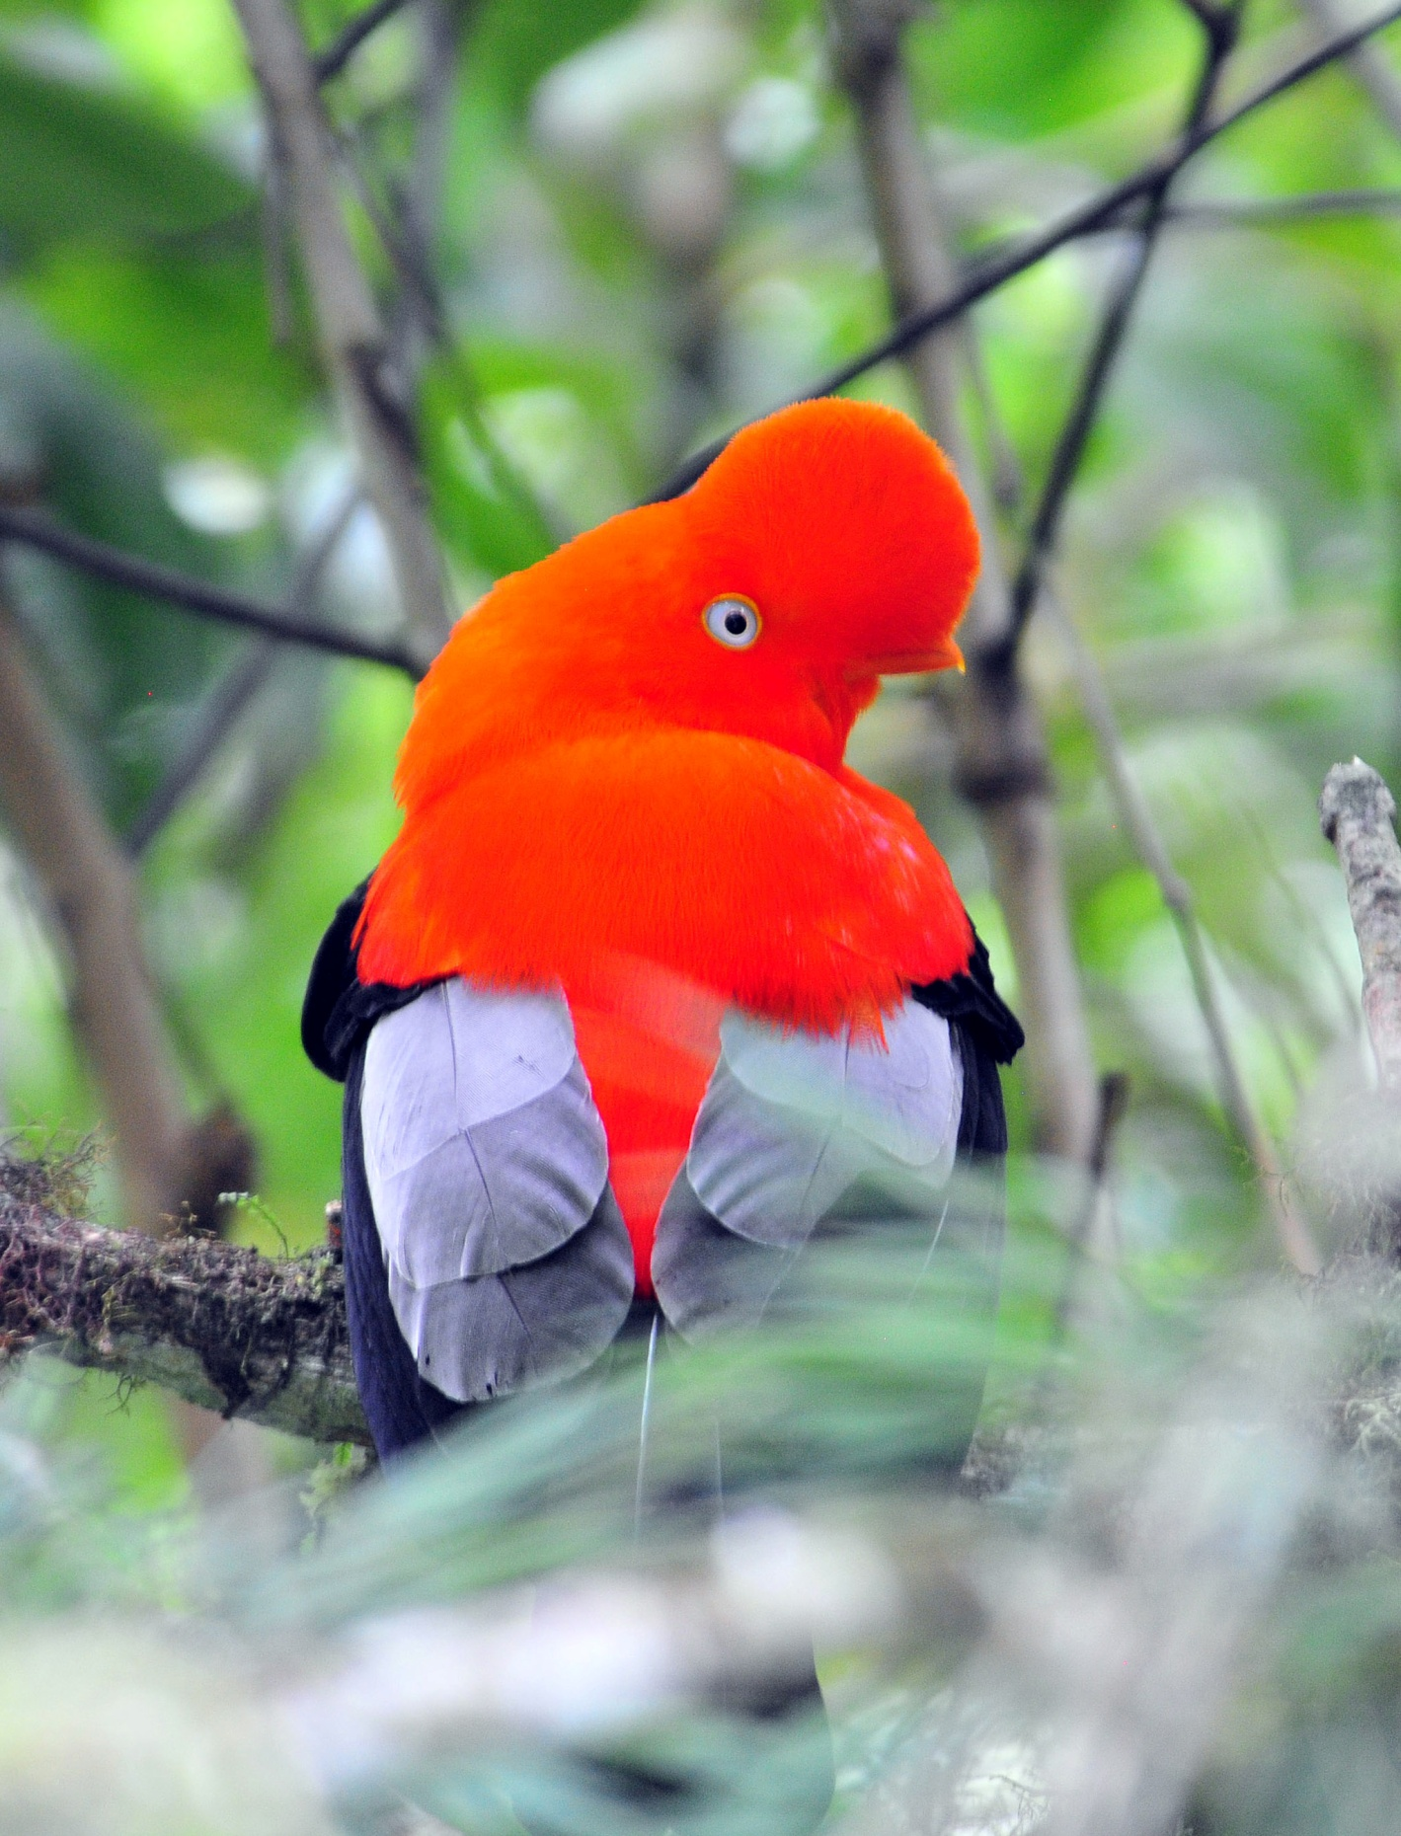
Andean Cock-of-the-Rock

At another bad spot, Cinnamon Flycatchers seemed to be everywhere, drawing our attention with their buzzy sounds. We didn't get out of the bus to walk just because of the road conditions - we did occasionally disembark to bird a spot that looked or sounded good. At one such spot Eduardo heard Golden-headed Quetzal, but it seemed pretty far away. As he was trying to call it in, he spotted a Masked Trogon in a nearby tree. We all watched as the Trogon called without opening its beak, seeming to separate its head from its body each time it vocalized.
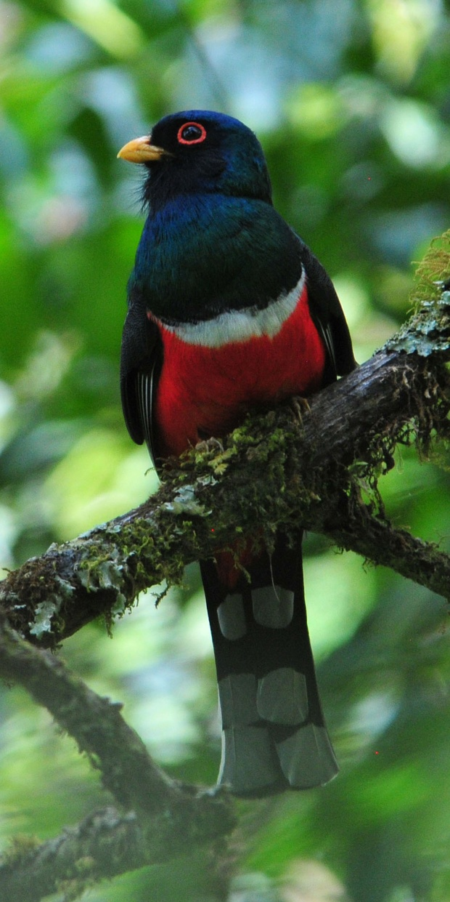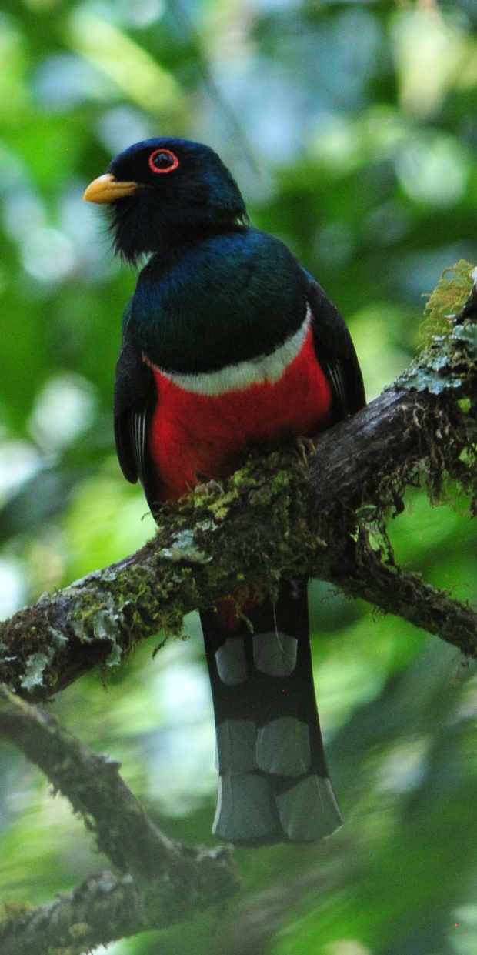
Masked Trogon

I was able to find the Quetzal on the far side of the valley below us, but the bird was so far away, there was no way to get anyone on it. I watched as it flew from its perch as I was trying to describe to Eduardo where it was. We did not find any eagles, but we did find male and female Slaty Tanagers in a small mixed flock that also included Capped Conebill.

During the lunch break, we had Russet-backed Oropendola and Peruvian Warbling Antbird. After our midday break, we got back in the bus, this time to go further downhill on Manu Road. The only new bird we had spotted was Smooth-billed Ani by the time we came to a spot that was so bad that Mario had to attempt to reshape the road. As he started hacking at the raised center of the road with a pickaxe, we walked ahead to look for birds. This was serendipity at its finest - a mixed flock entertained us for quite some time - Lemon-browed Flycatcher, Streak-throated Flycatcher, Paradise Tanager, Swallow Tanager, Golden Tanager, and other previously-seen birds tested our skills as they flew in and out of view. We found a group of five Lemon-browed Flycatcher fledglings sitting side by side on a large leaf and watched as the parents came to feed them. Among the birds in the mixed flock, we spotted a Cinnamon-faced Tyrannulet that proved to be a bit difficult to isolate in the crowd of paharos. The birds were still coming in when we realized that we needed to start back or we would be driving through some of the worst spots on Manu Road in the dark. We returned to the lodge at about 5:30 and a few people wanted to walk with Eduardo along the entrance before quitting for the day. As I walked down the path toward the cabins, I heard a bird vocalizing nearby. I stopped and tried to get a good look at it, and finally succeeded. I could see Eduardo and the others on the far side of the small wooded area, looking down at the same spot from the road. We were watching the same bird, a Black-billed Treehunter.
We met before dinner to go over the day's list. We finished the day with 61 species, but with only 11 of them new for the trip, we increased our trip count to just 224. A few of the group took Eduardo up on his offer to go owling after dinner. They agreed they would try again in the morning if they weren't successful tonight.

Day 9, Sunday, August 28:
When I stepped out of my cabin at 5:10 AM, I could hear a Band-bellied Owl calling. At first I thought it might be Eduardo's tape, but it soon became apparent that it was, indeed, an owl. It was calling consistently from trees right next to the path, and I hurried back to get Jim. Our combined flashlights were too weak to be able to see anything in the dim light, so we hurried up to the entrance where we thought the owling group from last night might be giving it a second try. Sure enough, Lucy, Penny, Mark, and John had met at 5:00 AM because they had dipped on the owls last night. When we got there, I told Eduardo about the Band-bellied Owl calling and asked if he might be able to call it out or find it with a spotlight. They had already seen the Band-bellied Owl and Eduardo was now playing the call of a Rufescent Screech-Owl in hopes that one might be in the vicinity. With daylight approaching and the larger owl still calling, I urged Eduardo to play its call again so that we might have a chance to see it. He was reluctant to play it, but he did finally play it one time. Shortly after, the owl flew across the road and appeared to have landed in the small wooded lot next to the road. When I tried to get Eduardo to call it again, he said we would try again tomorrow since he was sure it would be there. I was thinking "bird in the hand" kind of thoughts, but I let it go.

By now, the rest of the group was arriving since our agreed-upon meeting time was 5:20. We arrived at the Cock-of-the-Rock lek at 5:30 as planned. The birds soon began to call and, just like yesterday, were probably performing for the females, but not where we could see them. After several minutes of listening to the birds, I went back up to the road to see if there might be a different vantage point to use. I found a narrow path that led down a steep embankment, under a branch that was about knee high, and onto a spot that looked out over a ravine. There, in the darkness, were two Cock-of-the-Rock males calling and flashing their wings. I tried to take a photo but there was not enough light. I used my pocket camera to attempt to get a video clip, but it wouldn't register anything at all. I taped for a few minutes just to try to get the sounds, and then I scrambled back up the embankment to tell others. I knew that not everyone would want to attempt to navigate such a miserable path, and there wasn't room for more than two people, but I wanted to at least let the others know the opportunity existed. Penny and John followed my directions to the spot, but the performing was mostly finished for the morning. The three of us had some good laughs about the different techniques we used to reach that spot - Penny and I went under the branch, limbo-style, while John climbed over. With a pretty steep drop-off on the other side, I probably would have hit the bottom of the ravine if I had tried that move!

We had requested a late breakfast so we could bird after visiting the lek, rather than waste prime birding time with a meal. The birding wasn't as good as it had been on previous mornings, so we were back at the lodge by 8:30. The staff scurried and got our breakfast as quickly as possible once they saw we were ready. After breakfast, only three of the group - Mark, Penny, and Lucy - opted to walk down Manu Road with Eduardo. John decided to hang around the lodge for some photo ops, Brad wasn't feeling well so he rested while Becky birded from their balcony, Jackie relaxed in her cabin, Jim read a book, and Barbara and I enjoyed some time to visit and watch birds from the dining area. When the group of 4 returned from their walk, they had seen only two new birds, but what birds they were - Chestnut-backed Antshrike and Solitary Eagle!

After lunch, the group opted to try the trail behind the dining area again. Someone we met at the lek had said they saw Cock-of-the-Rock in the afternoon on this trail, and I had encountered a mixed flock after lunch here a few days ago, so it seemed like a good bet for the afternoon. We started out at 3:30 and the group separated quickly, with some going back to the lodge. It looked like it would rain soon, and with the birding as poor as it was today, it seemed like a wise decision. The skies opened up a little after 4:00 and everyone who was still on the trail came hurrying out of the forest to the shelter of the dining area - except Lucy. Apparently, the group had followed the trail to a steep hill that led to where the Cocks-of-the-Rock were supposed to be - right up by the road! They had merely taken the long and difficult route to the old lek. Lucy had started up the steep hill and thought the others were behind her, but they decided it wasn't worth the effort and turned back. I worried about Lucy as we watched the downpour, but Eduardo assured me that she was OK, under the shelter of the viewing platform and in the company of another group of birders. When it stopped raining, Lucy reappeared and reported that there was lots of activity on the road, so we all walked up to see if the afternoon rain had improved the birding activity.

Only 5 of the 57 birds seen today were new for the trip, bringing our trip total to 229. All of the new birds were seen by only the group that went owling in the morning and/or accompanied Eduardo down the road after breakfast. Thanks to Mark, Lucy, Penny and John we were able to add the Band-bellied Owl, with Turkey Vulture, Crested Oropendola, Chestnut-backed Antshrike, and Solitary Eagle seen after breakfast by Mark, Penny, and Lucy.

Day 10, Monday, August 29:
I had been awake quite a bit during the night because of rain. It wasn't that the rain was so loud that I couldn't sleep - rain on the roof is a sound that usually relaxes me. Rather, it was the thought of what effect such a rain might have on the road we were about to travel that made me restless. Would more of the road wash away? Would places that had been passable now be covered in mud? Or worse, would there be more places where the edge of the road had simply fallen off? It was easy to get out of bed early to meet Eduardo at 5:00 AM to see the Band-bellied Owl. Unfortunately, the rainy night affected owl activity and we didn't hear any calls when we left the cabin. We stood on the road and waited as Eduardo played the call, but no owl was to be seen today.

Breakfast was early today - 5:30 - so we could leave by 6:00. Mario had spent the day yesterday checking the road between our lodge and the village below where we would board a boat to take us to our next lodge. He reported that there were two really bad spots, one that he would have to modify by placing rocks in strategic places, and then it wasn't too bad. Once we reach the village, the road was pretty good for about 30 minutes of the 45-minute drive to the river, and then it deteriorated to the point that our bus could not get through. Mario had hired a driver to take us from the point where the road became unpassable to the river in a smaller 4WD vehicle. Five of the group would go first, along with Eduardo and most of the luggage, while the remaining five would stay with Jim and me on the bus. We would eat a box lunch on the bus while we waited for the 4WD to return to get us in about 30 minutes. The first group would eat their lunch at the river while they waited for the driver to fetch us.

As we drove down Manu Road, we got off the bus at the spots we had identified as really scary on our previous forays downhill. ("really scary" versus just "scary", which described the entire road) Each time there was an opportunity, Mario collected large rocks and put them in the back of the bus so he would have them where he knew he would need them a bit further down the road.
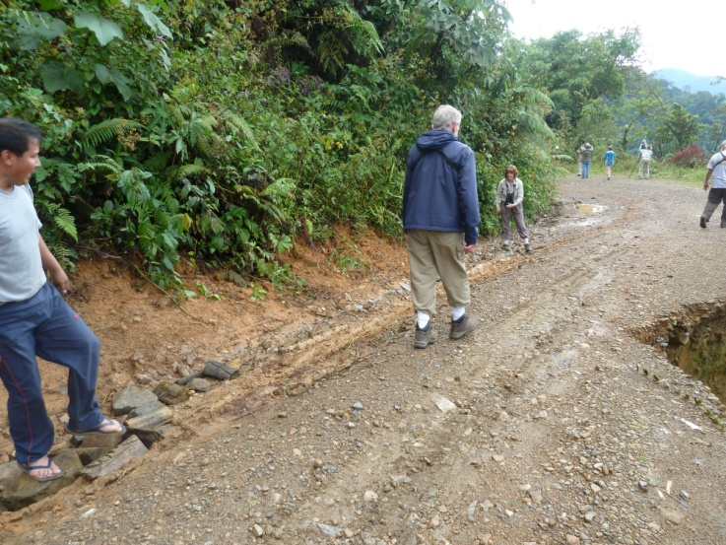
"Repairing" Manu Road
People pitched in and helped him find appropriate rocks and load them into the bus. When we approached the worst spot, Mario stopped the bus and carefully placed the rocks to provide enough lift under the wheels to make it through without scraping the bottom of the bus on the road. We birded on the way, seeing many of the species we had seen before. Although everyone always wants to see new species, it's good to get to see some of the same birds over again so you can identify them yourself. We were lucky to find a Cinnamon-faced Tyrannulet in the area where we had seen it earlier since only a few people had seen it when it was found a few days ago. Jackie was a bit ahead of the group at one point and spotted a Peruvian Piedtail, one of our target endemic species. I don't think anyone else was able to see the bird when she did, and we were unable to relocate it. As we got lower, new species began to appear: White-eyed Parakeet (found by Mario), White Hawk, Slaty-capped Flycatcher, Yellow-crested Tanager, Scaly-naped Parrot, Emerald Toucanet, Bluish-fronted Jacamar, Long-tailed Tyrant, Sulphury Flycatcher, Plumbeous Kite, Blue Dacnis, Black-faced Dacnis, Green Honeycreeper, Giant Cowbird, and Fork-tailed (Neotropical) Palm-Swifts were seen. We stopped in a dry area to look for some specific grassland birds, and I spotted a small bright yellow bird with black wings flitting about in a low bush. There was a lot of bird activity and people were looking at lots of different birds in lots of different places, so not everyone tried to find the bird when I called out that I had something different. It was difficult to give directions, and it was too far and too bright to use a laser pointer. Mark immediately found the bird, and we noted other field marks: yellow all the way to throat with a black line in middle of the throat, a cap of an odd shade of green. Eduardo identified our bird as a Yellow-browed Tody-Tyrant, but Mark and I knew he couldn't be on the same bird - this was not a Tody-Tyrant. I quickly noted all the field marks on my recorder, and when we got back on the bus, I checked the field guide page by page, looking for that odd green cap that I felt certain would be diagnostic. Finally I found our bird - Yellow-bellied Dacnis. I showed the illustration to Mark, and he concurred.

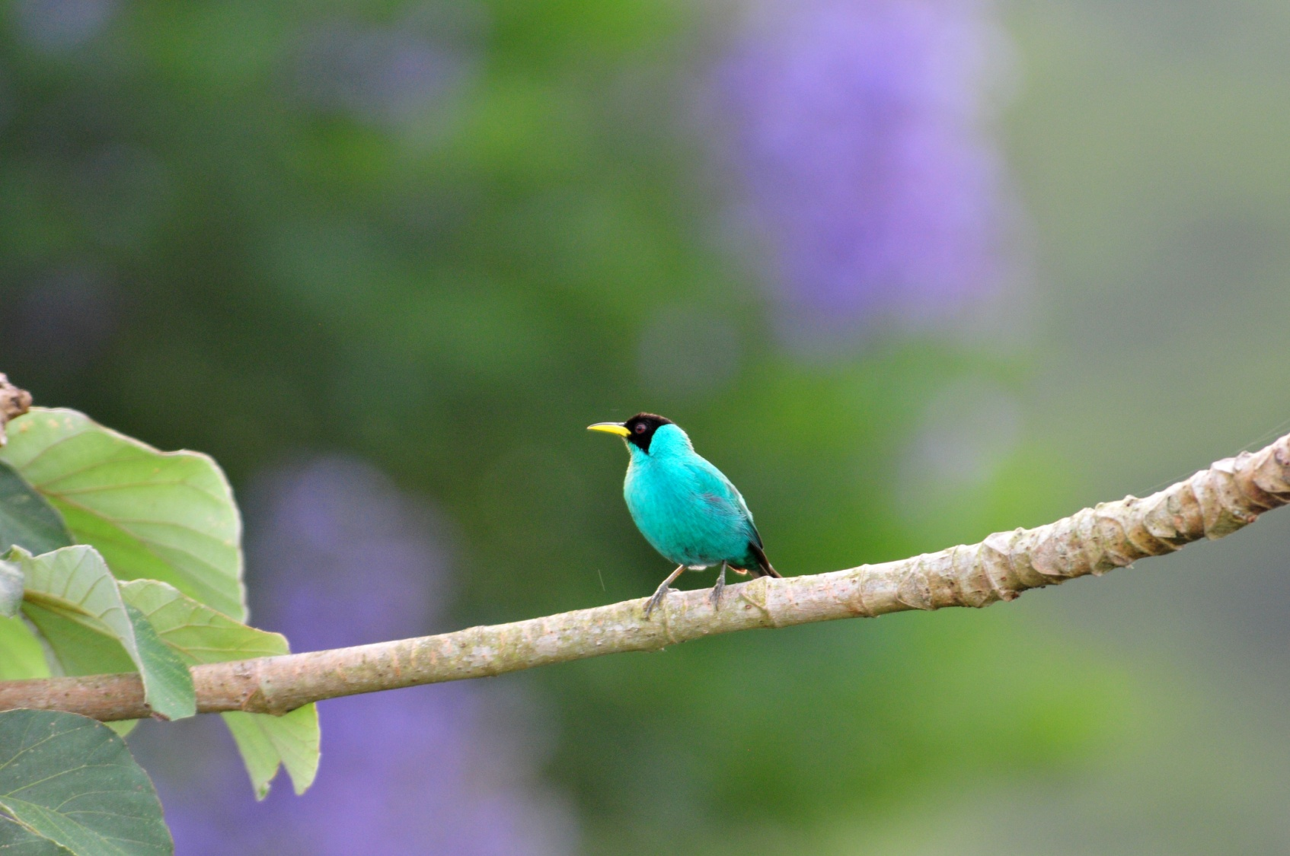
Green Honeycreeper

We finally reached the area where the group would split and Mario parked the bus. At this spot, we found Magpie Tanager and Black-tailed Trogon. The 4WD showed up on time, the first group loaded in, and the remaining group started to eat lunch. With half of the group and most of the luggage, Eduardo was relegated to the roof rack for the short trip. It was very hot at this elevation, and the ac on the bus wasn't producing cool air. I told Mario he could turn the bus off and we opened the windows. About 45 minutes later, the 4WD returned and we piled in. As we were driving through some pretty rough terrain, I saw a flash of bright blue on the dirt road ahead. Penny and I called out at the same time for the bus driver to stop. A Bluish-fronted Jacamar sat on the road in front of us for several seconds before flying off.

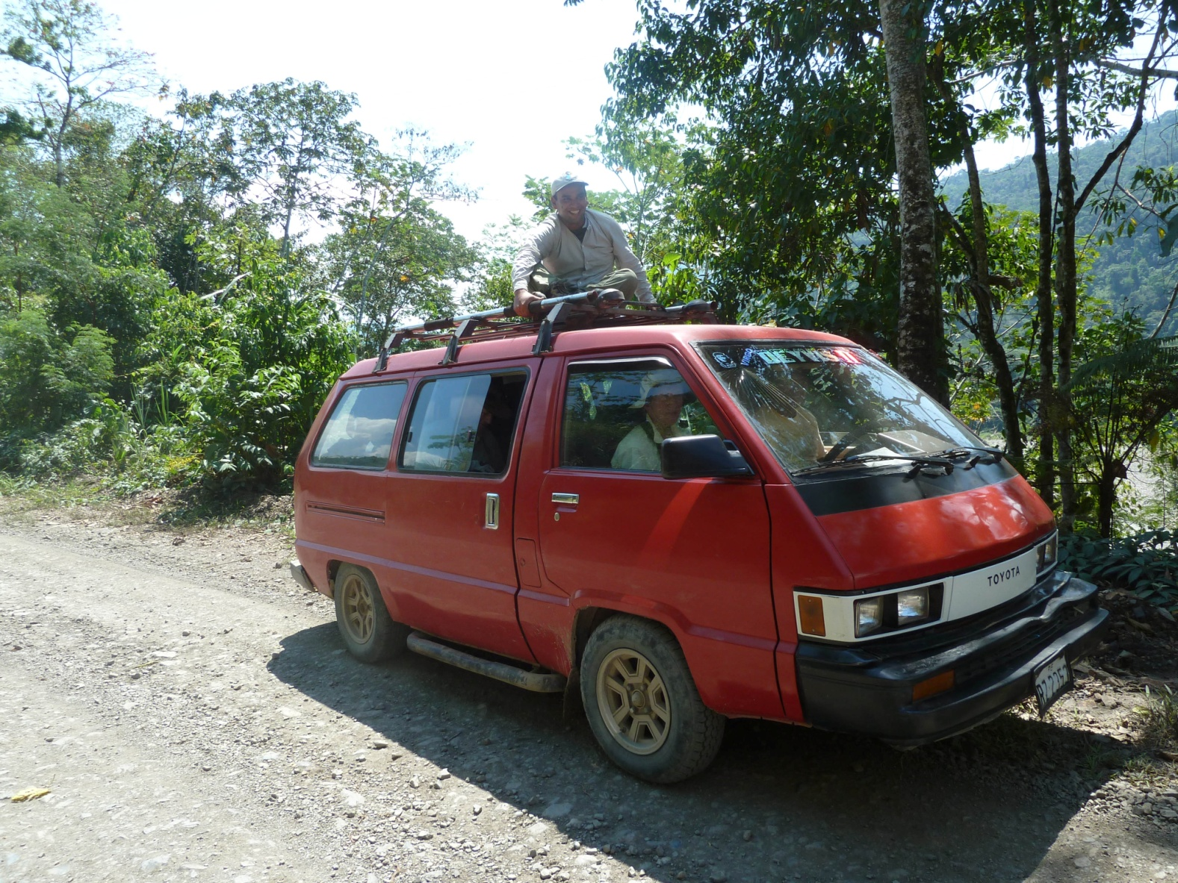
When we reached the river, the other group had already loaded most of the luggage onto the boat. They had seen Golden Plover, Yellow-rumped Cacique, and Swallow-tailed Kites along the river, with the kites putting on quite a show as they swooped down low over the water in swallow fashion. We boarded the small boat quickly and started down river to our next stop, Amazilia Lodge. The river was low and we immediately hit some rapids, but someone saw a Fasciated Tiger-Heron on the shore and asked the boat driver to turn around. He looked at us as if we were crazy, but he turned the boat around and maneuvered it toward the Heron. The bird flew before everyone got a good look, but Eduardo was certain we would have more opportunities for this bird. We saw lots of familiar herons and egrets as we traveled downstream, and we added Collared Plover, Greater yellowlegs, Spotted Sandpiper, White-winged Swallows swooped over the water and a Swallow-wing (Puffbird) was seen at the edge of the river.

The trip down the river was brief, no more than 30-40 minutes. As we approached a bank covered with smooth rocks, Mark pointed out a parrot of some kind. Eduardo looked at the shape and thought it was a White-eyed Parakeet, but Mark thought it looked larger. On closer inspection, it was identified as a Chestnut-fronted Macaw. As we were looking at the Macaw, the boat got closer to shore and we realized that this was where we would disembark, although we saw nothing that resembled a dock. As the boat reached water too shallow for the motor to operate, one of the boatmen got out in knee-deep water to position the boat near shore and produced a plank for us to climb from the boat to the shore. With a bit of trepidation, we managed to get ourselves out of the boat without banging our heads and crossed the plank onto the rocky bank. Workers from the lodge came and loaded our luggage into wheelbarrows, and we all started walking toward the lodge. Amazilia Lodge is in a beautiful setting with lush forest surrounding a garden that hosts several species of hummingbirds, tanagers, and parrots. A huge veranda provides a comfortable spot for birding the garden area. The rooms were clean and comfortable with 24-hour electricity, but bathrooms were in a bath house about a hundred steps away. Single rooms were in a separate building that had three bathrooms, so with no other guests at the lodge, our singles each had a bathroom to themselves, although not in their own rooms.

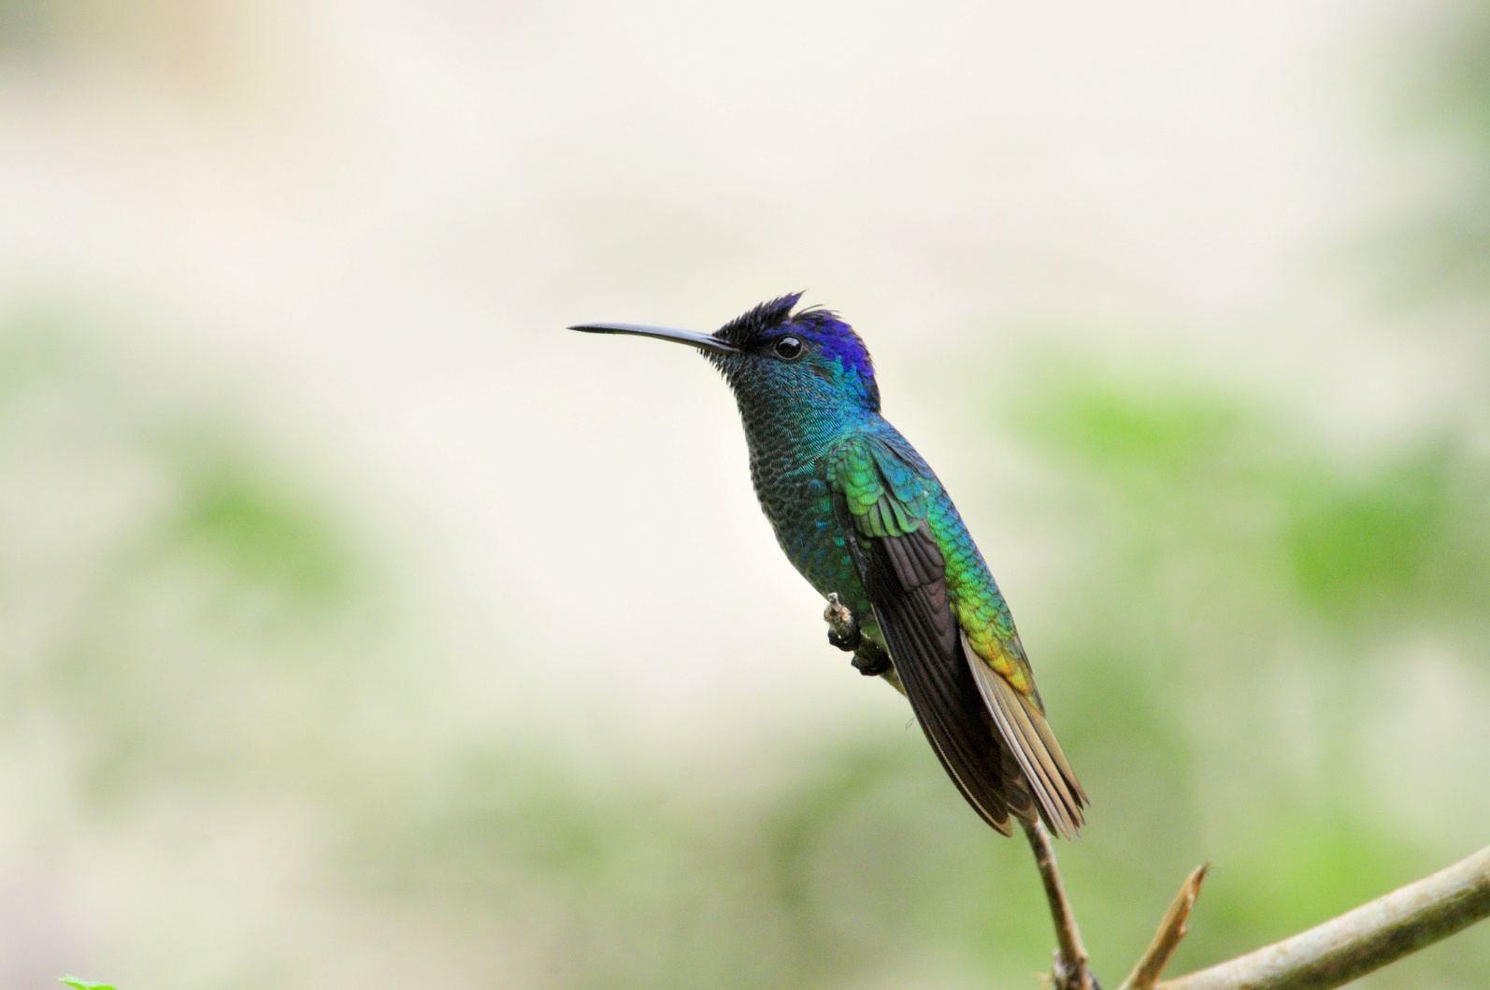
Golden-tailed Sapphire

As soon as we arrived, we saw a Cinnamon-throated Woodcreeper, but our attention was drawn to the hummingbird feeders: Gray-breasted Sabrewings, Golden-tailed Sapphires, Sapphire-spangled Emeralds, Fork-tailed Woodnymphs, Blue-tailed Emeralds, and Violet-headed Hummingbirds could be seen among the now-familiar Sparkling Violet-ears, Many-spotted Hummingbirds, and Violet-fronted Brilliants. Tiny Rufous-crested Coquettes buzzed in and out of the porter weed, which seems to be a favorite hummingbird food wherever we travel. Eduardo had told John that he wanted him to get a really good photo of this little gem, and John was beside himself as he gleefully took advantage of one opportunity after another to "shoot" this guy. I had told John that an even more difficult target that was just as beautiful and just as flashy is the less common Gould's Jewelfront, and I was excited when one flew in and landed on a low feeder in front of the porter weed. As predicted, this bird was not so easy to photograph during our stay at Amazilia, coming in fast, leaving quickly, and almost always seen on the feeder. A brilliant blue and white male White-necked Jacobin also preferred one specific feeder and was seen less often than other species. We found the nest of a Pale-legged Hornero near the bath house, and it didn't take long to locate the birds as they foraged on the ground. At the platform feeders were some familiar tanagers along with a few new species, including Masked Crimson Tanager, another bright red and black bird with a huge "WOW" factor. Black-billed Thrush appeared briefly. As light faded, two Blue-headed Parrots flew in, and Eduardo identified the small swifts overhead as Short-tailed Swifts.

Of the 87 species seen today, a whopping 42 were new to the trip. This brought our trip total to 271, and we felt sure we would pass 300 tomorrow as we explored this new habitat further.

Day 11, Tuesday, August 30:
We started with an early breakfast so we could begin to bird at 6:00 AM. Everyone in the group was together when
Black-faced Antthrush, Chestnut-tailed Antwren, Blue-crowned Trogon, White-shouldered Tanager and White-browed Antbird were seen. Barbara was the first to leave the group to go back to the lodge. The rest of us walked on and found Short-crested Flycatcher and Long-tailed Tyrant near a small stream. Looking up and walking to try to position myself to photograph the Tryant that was overhead, I stepped into deep hole. Nothing was injured but my pride, but the crashing and ensuing laughter scared the bird away. We observe a female Green Kingfisher in the same area and heard but couldn't find Buff-rumped Warbler. As we started walking back toward the lodge, Eduardo identified the raucous calls we heard as that of a Red-throated Caracara. While watching and photographing the Caracara, we met up with Barbara, who had taken a wrong turn on her way back to the lodge. We next spotted a Straight-billed Woodcreeper, and Mark caught a glimpse of a large hermit, but he and Eduardo could not determine which species it was. A few Squirrel Monkeys entertained us for a bit before we headed back to the lodge shortly before 9:00 AM. John had stayed back at the lodge to photograph birds in the open area, and he had not been disappointed with the birds there. He had great shots of many species, among them one we had not seen, Yellow-tufted Woodpecker. We allowed ourselves a short break and observed some new birds while waiting for everyone to be ready to head back out on the trail. Red-capped Cardinals joined the tanagers at the platform feeder and a Gray-necked Wood-rail ran across an open area in the back of the garden.

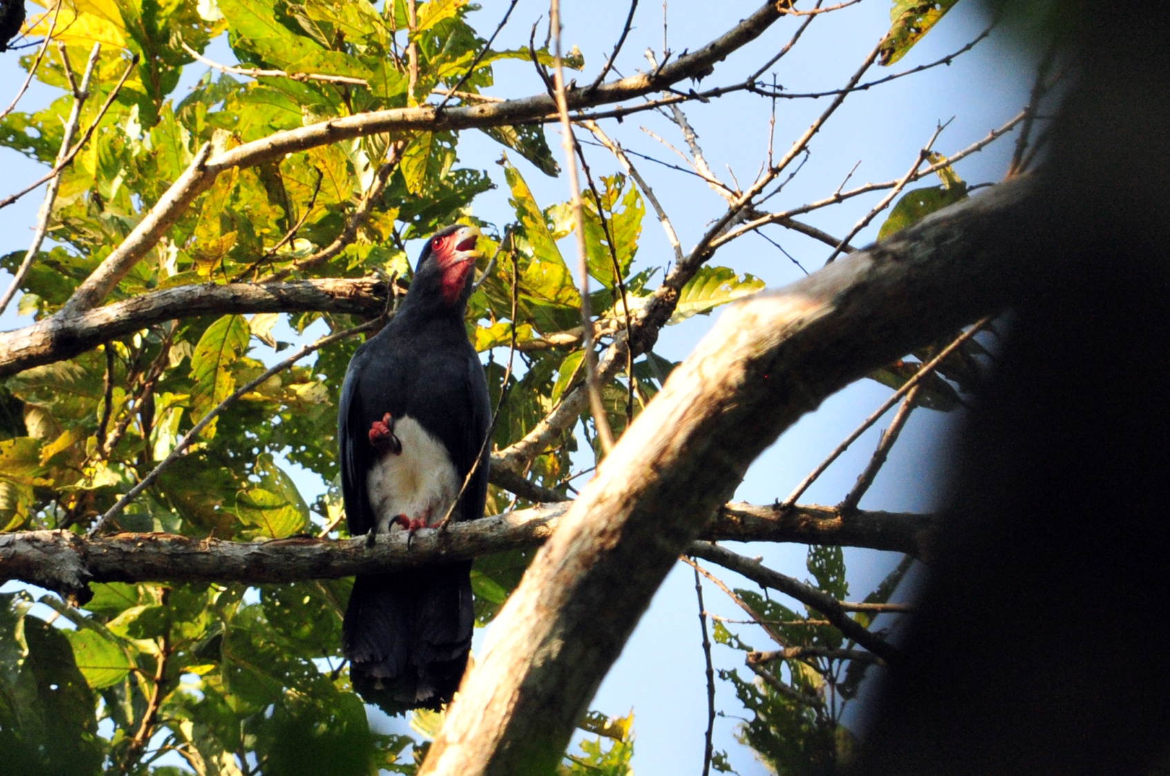
Red-throated Caracara
It was pretty hot by now, and Eduardo suggested that we go to make a brief search for the Round-tailed Manakin, noting that we would be back by 10:00. Some opted to stay on the veranda, others went with Eduardo down the jeep path. While searching for the manakins, we found Dusky Titi Monkey and Chestnut-eared Aracari, but not much else in the first half hour or so. Since the group was supposed to return to the lodge at around 10:00 AM, I decided to start my way back to the lodge a bit early, expecting the others to turn around at any moment. But, birders being birders, they didn't return until
around 11:45. They reported that they had found a Hoatzin and a few other species that they would report at the checklist meeting.

Meanwhile, back at the lodge, we were finding nests: Pale-legged Hornero, White-winged Becard, Blue-gray Tanager, Gray-capped Flycatcher, and Straight-billed Woodcreeper all had nests within a few feet of the lodge. I joined John to photograph male and female White-winged Becards near their nest, and I found an Amethyst Woodstar feeding on the porter weed behind the lodge. Not knowing that this bird would be so difficult to see in the coming days, I later regretted that I hadn't called everyone from the veranda to see it. John was nearby, trying to photograph Jacobins, so I was able to motion to him to come before the bird flew away.

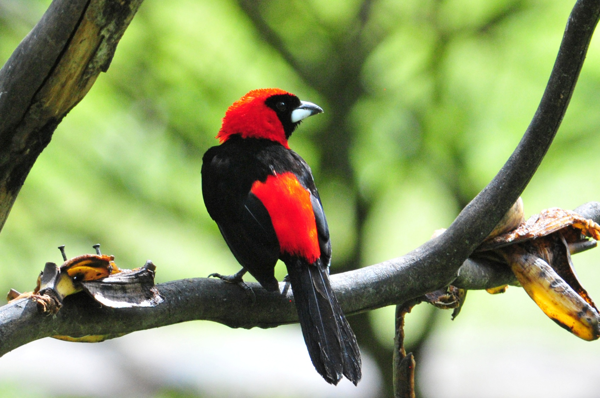
Masked Crimson Tanager

After lunch, people went off in all directions, some alone, some with Eduardo. This was a new experience for me, as groups usually want to stick as close to the guide as possible. When we tallied the list at the end of the day, I could hardly keep up with who saw what, but I can tell you we finished the day with 83 species for the group and increased our trip total to 311. Good numbers, but individual lists varied widely depending on how each person opted to spend the afternoon. Mark seemed to have fared the best with an impressive list of ant -bird, -wren,- shrikes.

Birds that were new to the group list included Spix's Guan, Starred Wood-quail, Purple Gallinule, Gray-fronted Dove, Scarlet Macaw, Tawny-bellied Screech-owl, Common Paraque, Violaceous Trogon, Chestnut-capped Puffbird, Black-fronted Nunbird, Lineated Woodpecker, Wedge-billed Woodcreeper, Elegant Woodcreeper, Plain-winged Antshrike, Bluish-slate Antshrike, Pygmy Antwren, Amazonian Streaked Antwren, Long-winged Antwren, Manu Antbird, Blackish Antbird, Red-billed Tyrannulet, Slender-footed Tyrannulet, Bare-necked Fruitcrow, Dusky-capped Greenlet, and Hauxwell's Thrush.

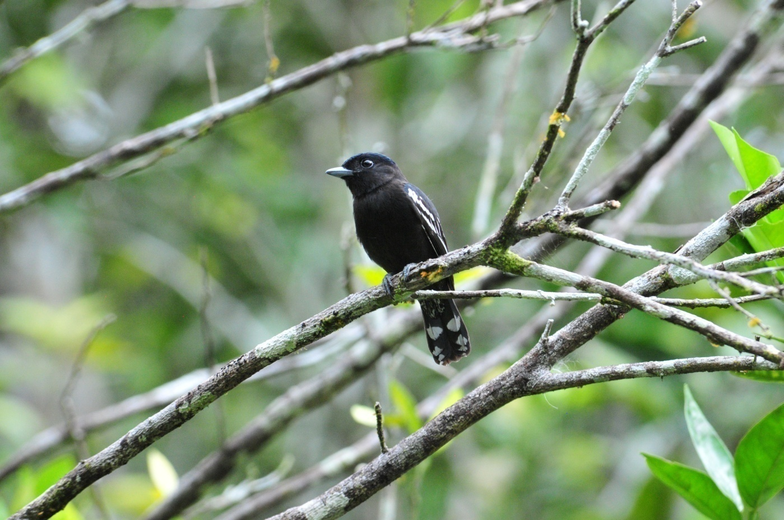
White-winged Becard

Day 12, Wednesday, August 31:
There was a big storm overnight with thunder so loud that the buildings shook. At one point, I woke up wondering if there might be a landslide or earthquake, the vibrations in the building were so strong. We had scheduled breakfast at 6:00, with our morning birding outing to begin 6:30, but it was still raining at 6:30 and the light was very dim, so we took our time at our morning meal. As the others finished breakfast, I stepped outside to see if I might be able to photograph the Macaws that I thought sounded really close. A huge Blue-throated Piping Guan flew into a Cecropia tree just as the rest of our group was walking out of the dining hall. I called to them, and we all enjoyed unobstructed, if not well-lit, views of the bird. The Piping-Guan remained long enough to get the scope on it, and while we were looking through the scope, some Blue-headed Parrots flew in and allowed us enough time to view them through the scope as well.
By now, the rain was very light, so we started walking to an area where we might be able to find Uniform Crakes. A couple of Gray-necked Wood-rails ran across the trail in front of us. It wasn't long before the rain picked up, so we returned to the lodge. When it looked like the rain was going to lighten up again, some wanted to go back out on the trails and others wanted to stay and bird from the veranda. Barbara, Jackie, Jim, John and I decided to remain while Brad, Becky, Lucy, Penny, and Mark followed Eduardo into the forest. From the comfort of the veranda, we watched Chestnut-fronted Macaws in nest holes along with the regular cast of hummers and feeder birds. When it stopped raining, John walked a short distance into the beginning of jeep trail where he was able to photograph Black-capped Donacobius and Hoatzin.

The only new species seen by the group that braved the wet conditions was a Drab Water-Tyrant. Lucy and Eduardo were fortunate to catch a glimpse of a Cinereous Tinamou.

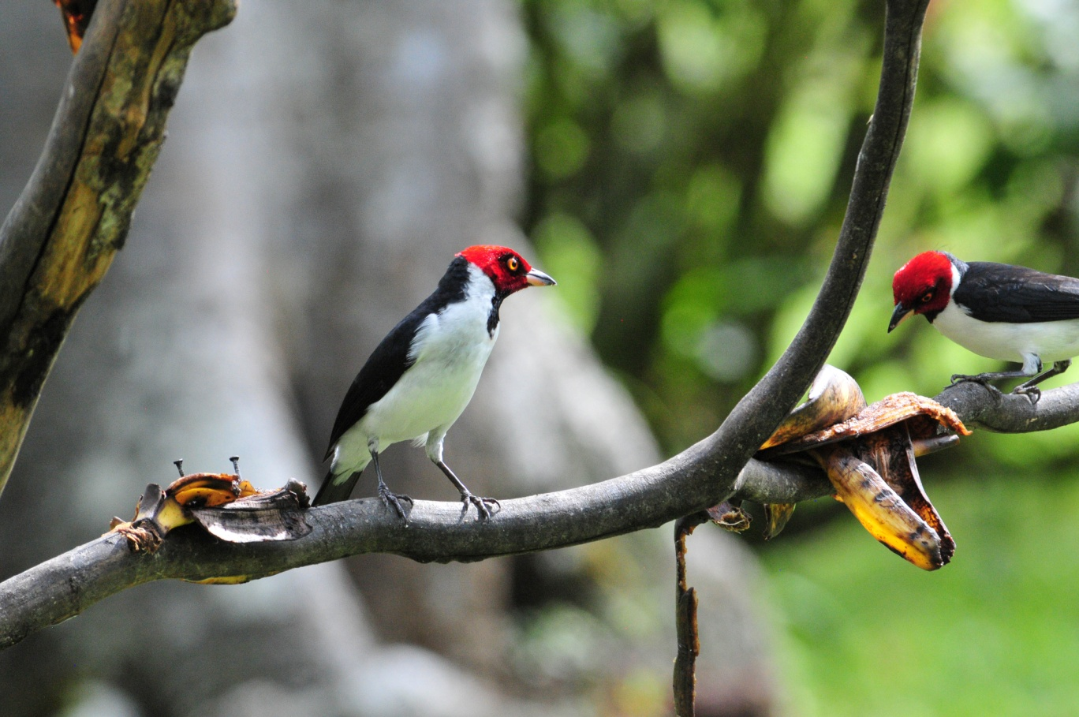
Red-capped Cardinals at feeders

In the afternoon, we chose to bird a trail behind the lodge. John decided to stay in his room to work on photos, and it made me a little crazy when we found Speckled Spinetail and Slender-footed Tyrannulet in a low bush before we even left the yard, just 50-60 feet from John's room. He could have had some terrific shots of these little guys! Shortly after we entered the trail, we heard some bird activity. We quickly identified a Chestnut-tailed Antbird, but more importantly, we could see that we were in the middle of a huge ant swarm! Eduardo pointed out the call of a Hairy-crested Antbird, a species we all very much wanted to see. Black-spotted Bare-eye was also vocalizing, but Mark was the only one who was able to get the bird in his binoculars. We waited awhile and decided that our presence might be keeping the birds away, so we walked on to allow time for more birds to find the ant swarm. We didn't find much as we walked further down the trail, and we returned after a short while to the area with the ants to see what might have come in. The only bird we saw there was a Plain Brown Woodcreeper. As we walked away toward the lodge, some Cobalt-winged Parakeets landed in a tree overhead.

Again, the group splintered with some going back to the trails off the jeep trail and others hanging out at the feeders. On their afternoon walk, Eduardo, Jim, Mark, Lucy, and Penny found an Amazonian Umbrellabird, a life bird for Eduardo! At the end of the day, Eduardo came running back to the lodge to tell everyone that they had found a Great Potoo along the jeep trail. We hurried down to where the rest of his group was waiting and didn't think about the scope until we saw where the bird was located. Luckily, Jim had thought of it and had followed Eduardo back to the lodge (at a slower pace). Within a few minutes, he appeared with the scope over his shoulder, and we all had excellent views of the Potoo.

Other birds seen today, but I can't begin to tell by whom, included Dusky-headed Parakeet, Crimson-crested Woodpecker, Olivaceous Flatbill, and Grayish Saltator. The group count for the day was 75 with 15 new birds bringing the trip count to 326.

Day 13, Thursday, September 1:
Breakfast was served at 5:30 so we could begin our walk to the river by 6:00. Our goal was to be in the boat and gone by 6:30. Everyone was up and about much earlier than necessary, and we listened to the resident Tawny-bellied Screech-owl and Band-bellied Owl calling as we made final preparations to leave. We had wonderful looks at a perched Double-toothed Kite on the short walk to the river. A troop of Squirrel Monkeys seemed to be saying goodby as we walked away from the forest. As the group was boarding the boat, people who had not seen the Drab Water-tyrant earlier were able to watch one as it scampered about on the rocky shore.

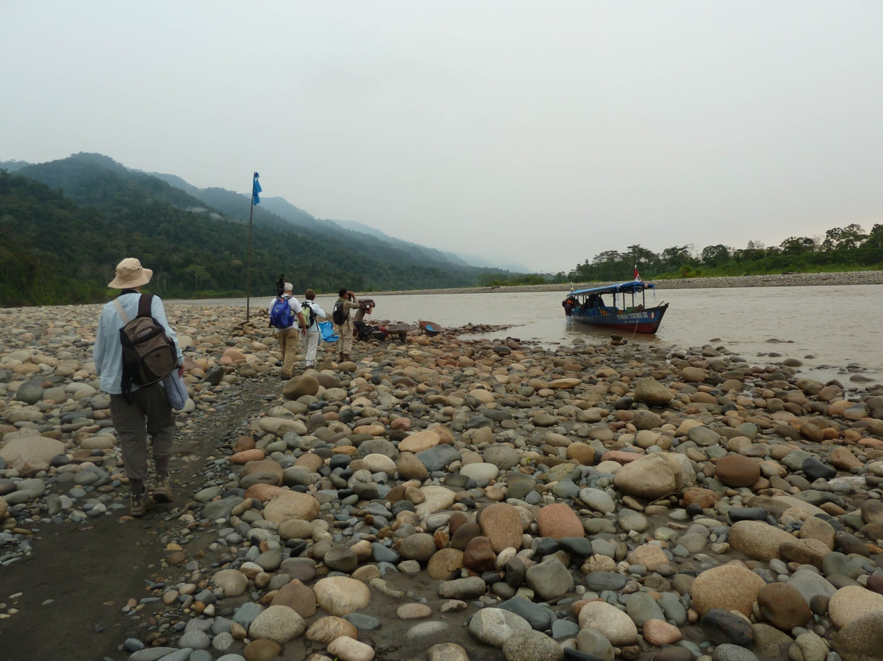

We expected the boat trip to take about 6 hours, so we settled in to do some boat birding. I sat near the back of the boat, which I thought would be OK even though I'm prone to motion sickness because rivers are usually not rough enough to pose a problem. It didn't take long to realize I had made a mistake: the combination of the fumes from the motor and the fumes from the leaking drum of gas in the front, along with the movement of the water, made for a miserable day for me. Penny was sitting in front of me, and she was so enthralled by our day on the river that I was able to recognize that this was not unpleasant for everyone - just me.

Boat birding wasn't half bad. We saw many species we'd seen previously, but as I said before, we enjoy practicing our identification skills. The list of "old birds" seen on the river included White-winged Swallow, Neotropic Cormorant, Snowy Egret, Turkey Vulture, Greater Yellow-headed Vulture, Roadside Hawk, Cattle Egret, Black Vulture, Spotted Sandpiper, Great Egret, and Giant Cowbird. "New birds" were in pretty good numbers as well: Amazon Kingfisher, Fasciated Tiger-heron, King Vulture, Pale-vented Pigeon, Black Caracara, Cocoi Heron, Osprey, Bat Falcon, Large-billed Tern, Great Black Hawk, Yellow-billed Tern, and Black Skimmer. Blue-and-yellow Macaws flew across the river in front of us - WOW!. When Eduardo spotted Sand-colored Nighthawks, John wanted photos and asked if we could stop. By this time everyone was tired, but no one complained when we turned back, although I suspect some wanted to (I know I did). As he was getting his photos, someone spotted Orinoco Geese on a sandbar in a channel, so the boatman maneuvered the boat to a spot where we could all see them. While everyone else was enjoying the geese, Becky found a Pied Lapwing on the same sandbar! You gotta love serendipity! Further downstream, Mark called out, "Those aren't Black Vultures!" and most of us responded by looking in the air for a raptor in flight. The two Horned Screamers he had seen on the riverbank took us all by surprise. Jim spotted a Capped Heron, but we were unable to turn around at that point, so Eduardo promised we would see one later in the trip. Some Purplish Jays flew by, but I really couldn't use my binoculars without getting sick, so I was counting on getting better views later.

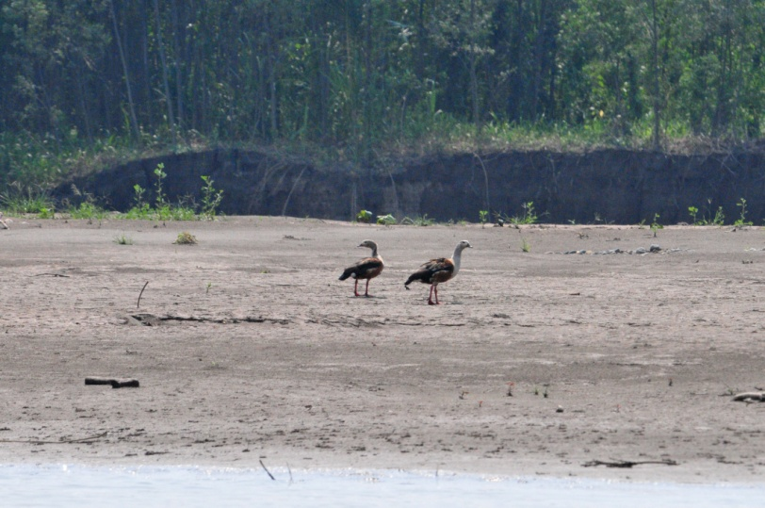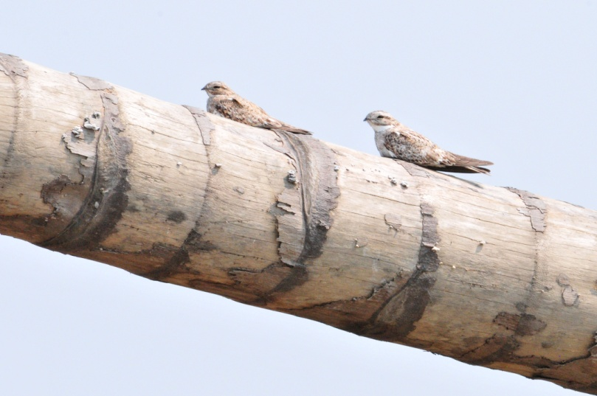
Orinoco Geese Sand-colored Nighthawks

We arrived at Amazon Manu Lodge at around 3:00 PM - our 6-hour boat trip had taken 8 1/2 hours because, in spite of the recent rains, the water level in the river was quite low. We were all tired, even though we had been sitting for the entire day except for a brief restroom stop in a small village. As soon as we got out of the boat, we noticed the biting sand flies. I had been waiting for everyone to gather to walk to the lodge, but as my head began to itch and I could feel the tiny insects biting my arms, I bolted for the trail. The lodge wasn't far from the river, but the sand flies were not as numerous there. We were put in temporary quarters because a group that was already there had one more night before checking out, so our cabins would be available the next morning. Penny and Lucy were put in the only empty cabin and the rest of us went to a building that housed 4 double rooms. The bathrooms were en suite, but the rooms were quite rustic - wooden floors, mattresses on frames of rough-hewn lumber, mosquito nets over the beds. We were told the electricity would be on from 6:00 - 9:00 PM. The bathrooms were tiled, and we had a flush toilet and hot and cold water in the shower, so our needs were met, if not in the most luxurious manner. We would be in these rooms for one night, and then all of the people in double-occupancy rooms would be moved to the cabins. Those in single occupancy would remain in these rooms, along with Eduardo and John who were spending the first night in tents because the lodge had been overbooked. I could see that people were not thrilled with their accommodations, and I hoped they would be happier with the cabins. At dinner, we made arrangements for Barbara to be moved to the cabin that was designated for us because she was so dissatisfied with her single room.

After putting our things away, we headed for a lake a few kilometers away. On the trail we spotted Black-fronted Nunbird,
White-shouldered Tanager, Squirrel Cuckoo, Broad-billed Motmot, Red Howler Monkeys, Swallow Tanager, and White-throated Toucan. When we arrived at the lake, the sun was low in the western sky and this was the direction we needed to look to find birds on the lake or on the opposite side where all the activity was. We did manage to find and identify a few birds (Hoatzins, Smooth-billed Ani, White-banded Swallow) before we decided to leave and come back in the morning when the lighting would be good. Becky, Brad, Jim and I were at the end of the line, and as we were leaving, Becky spotted a pair of Swallow Tanagers, then a Black-tailed Trogon female, then a bird we couldn't identify. I took a few photos of the mystery bird - very poor, with the bird facing away, me shooting from underneath - but the photos were good enough to finally conclude that it was a female Plum-throated Cotinga.

Other birds seen today by only part of the group included Dusky-billed Parrotlet, Blue-crowned Motmot, and Thrush-like Wren. Our count for our day on the river was 83 with a new trip total of 351.

Day 14, Friday, September 2:
As we prepared to leave on our morning bird walk, the staff of Amazon Manu asked us which rooms should be moved, and to where. We instructed them to move Barbara's things into one of the now-vacant cabins and then asked the others to identify their rooms so the workers would know where to move things. Everyone decided that they would rather just stay where they were and save the staff the trouble of moving and changing bed linens. Barbara moved into a cabin and two of the vacant cabins were used by John and Eduardo. As we were discussing the moves, Penny spotted a Blue-throated Piping-Guan in the trees right outside the cabins. We could hear a very vocal Chestnut-crowned Foliage-gleaner nearby and we took a few minutes to make sure everyone got good looks at the bird. As we walked down the trail, a raptor flew in and landed. At first Eduardo thought it was a Barred Forest Falcon, a fairly common species that would be expected here. When he took a closer look, he was very excited to announce that we were looking at a very rare Buckley's Forest Falcon. He took time to point out the field marks that separate this species from other Forest Falcons. As we walked toward the lake, we walked around the edge of an agricultural field planted with some type of small tree. At the edge of the cultivated area, we watched a small mixed flock move through. We identified Spot-breasted Woodpecker, Green-and-gold Tanager, Swallow-wing, Yellow-bellied Tanager, Vermilion Flycatcher, and Masked Tanager. Across the field, sitting high in a tree, were a group of White-throated Toucans.

When we arrived at the lake, bird activity was high. Purplish Jays were seen in perfect light and through the scope (yeah, I can count THAT!). The list of birds grew quickly: Yellow-rumped Cacique, Speckled Chachalacas, Pale-eyed Blackbird, Ruddy Pigeon, Plumbeous Kite, Smooth-billed Ani, Russet-backed Oropendola, Yellow-crowned Parrot, Red-bellied Macaws, Hoatzin, Chestnut-eared Aracari, Chestnut-bellied Seedfinch, Pale-vented Pigeon, Mealy Parrots, Black-tailed Tityra. There was so much going on, it was difficult to decide which bird activity you wanted to watch. A pair of Yellow-tufted Woodpeckers worked on a nest. Parrots of assorted kinds preened each other. Black-capped Donacobius played hide-and-seek in the tall reeds (with us, not each other). Eduardo got very excited when he identified a Black-billed Seedfinch, a bird he had only seen once before, and then had a fleeting look. As he looked at the bird through the scope, he commented that, although this wasn't a life bird, it was a "serious upgrade". Mark very calmly interrupted everyone's birding conversations and told us to all turn s l o w l y to the right because there were two Sungrebes in view. Red-and-green Macaws flew over, easily distinguished from the Scarlet Macaws that had flown by earlier. Our morning at this lake was one of the best of the trip.

John had not gone to the lake with us, but had instead gone to the tower with the two men who had operated the boat on our trip in. When they got there, they found an active wasp nest under a loose panel. Each time they stepped on that panel, it would bend and the wasps would swarm them. I asked Eduardo to ask the staff if they could remove the nest before our group went to the tower the next morning, and they obliged. In spite of the wasps, John saw and photographed many species from the tower, including some we hadn't seen such as Black-bellied Cuckoo, Pied Puffbird, White-fronted Nunbird, and Golden-collared Toucanet.
On our way back to the cabins, most of the group took the shorter, steeper route at the very end while Lucy, Penny, and I took the slightly longer more gentle slope to reach the cabins. As we walked slowly down that last small section, I spotted a
hermit feeding on a large red flower. We observed it for quite awhile and eventually identified it as a Rufous-breasted Hermit.

After lunch, Eduardo and the local guide, Roger, led us to the Bamboo forest. Eduardo explained that there are many bamboo specialists - birds that only live in bamboo. It was quite a hike, and Becky had to turn back early for a restroom stop. Jim went with her so he could accompany her back to the group when she was ready. After we came to a fork in the path, Brad decided he should go back also so he could show them which way to go to find us. Luckily the long and hot hike was very productive. We got great looks at a bird I had missed earlier, Bluish-slate Antshrike. Other birds seen included Green-and-gold Tanager, Striated Antbird, Flammulated Tody-Tyrant (old name Flammulated Bamboo Tyrant), Moustached Wren, Ruddy Spinetail, Brown-rumped Foliage-gleaner, Paradise Tanager, Chivi Vireo, Straight-billed Woodcreeper, and Black-tailed Trogon. My favorite of the afternoon was the White-cheeked Tody-Tyrant, a tiny bird, less than 4 inches, with bold white spots on its face that stood out between the rust cap and black nape. Yellow, green, black, white, rufous - at first I just got flashes of color as it dashed from branch to branch. It approached us and scolded as if it had no fear and we all were able to view it well. A close second place for favorite bird was the Bamboo Antshrike, which reminded me of some of the other black and white Antshrikes, but had a crest that came to such a sharp point that, when excited, it could never be mistaken for anything else.

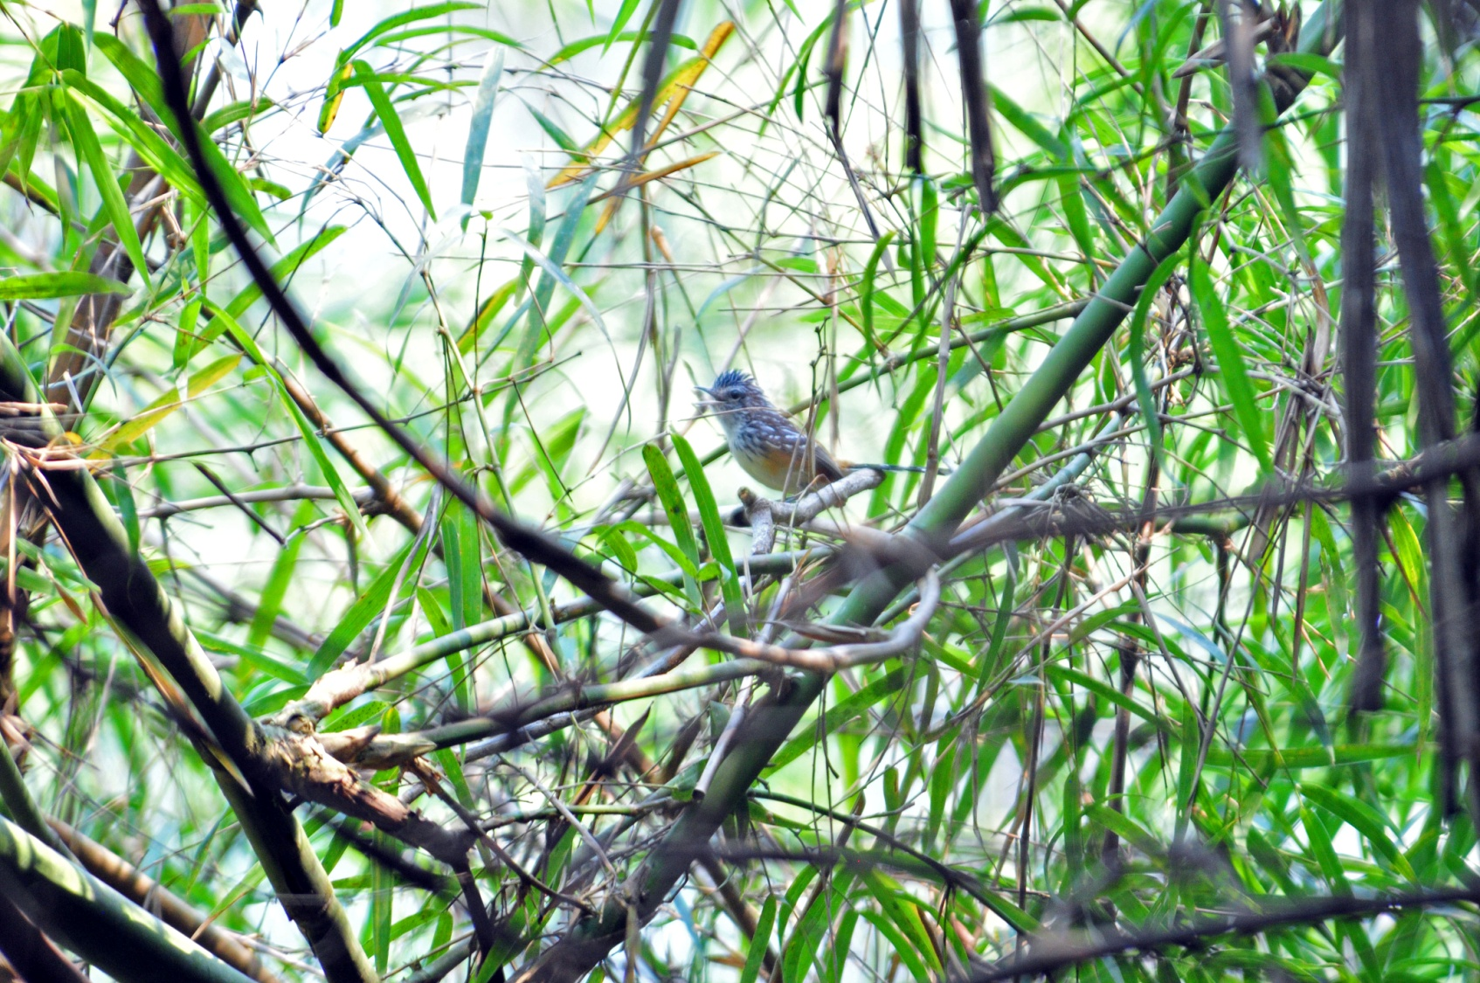
Striated Antbird, bamboo specialist
We were back at the lodge by 2:00 PM and Eduardo suggested that we rest until 5:00 when it would be cooler and bird activity might pick up again. Some of us followed his advice, but others kept on birding on their own.
Near the river a few people saw Rufescent Tiger-Heron, and Penny found a family of Pale-winged Trumpeters near the houses above her cabin. Eventually, we all made our way to the area she described, until the family living there had had enough of the intrusion and put a rope across the path that led to their house, giving us a clear message to stay away. One by one, we all got to see the Trumpeters, although not everyone saw the chicks. Mark reported several good birds from his afternoon outing, including Rufous Motmot, Rufous-rumped Foliage-gleaner, Yellow-breasted Antwren, Fiery-capped Manakin, Dusky-headed Parakeet, Cinereous Mourner, White-winged Shrike-Tanager, and White-vented Euphonia.
Mark also thought he had seen a tapir on trail, but he only saw the rear end as it scurried away, making Eduardo think it could have been a javelina instead.

We completed our list before dinner and learned the group had seen 86 species for the day, with 37 new species for the trip bringing the trip total to 388. Surely we'll hit 400 tomorrow!

After dinner we walked to a blind overlooking a Tapir lick. The group that had just left the lodge as we arrived had been successful in seeing the Tapirs at around 7:00 PM, so we timed our outing to arrive at that time. Using our flashlights to negotiate the path in total darkness, we arrived at the lick a bit after the 7:00, and the guides could see that a Tapir was already there. As we climbed into an elevated structure to view the lick, we were unaware that the animal was already there and that we were causing it to leave. In the elevated structure was a line of sleeping bags protected by mosquito nets. Without talking, we were motioned into the sleeping bags one by one, and we obediently took our places in the stifling hot cocoons that had been prepared for us. As I laid on my stomach, facing the tapir lick, I could see nothing. So I raised that end of the mosquito net, put my head and shoulders outside, and rested on my elbows to wait for the show. We waited in silence (except for John who couldn't keep still on his very noisy plastic mattress) for about an hour before giving up and walking back to the cabins. The following day, some people walked to the lick during free time to see what the structure looked like in the daylight, and Jackie took this photo:

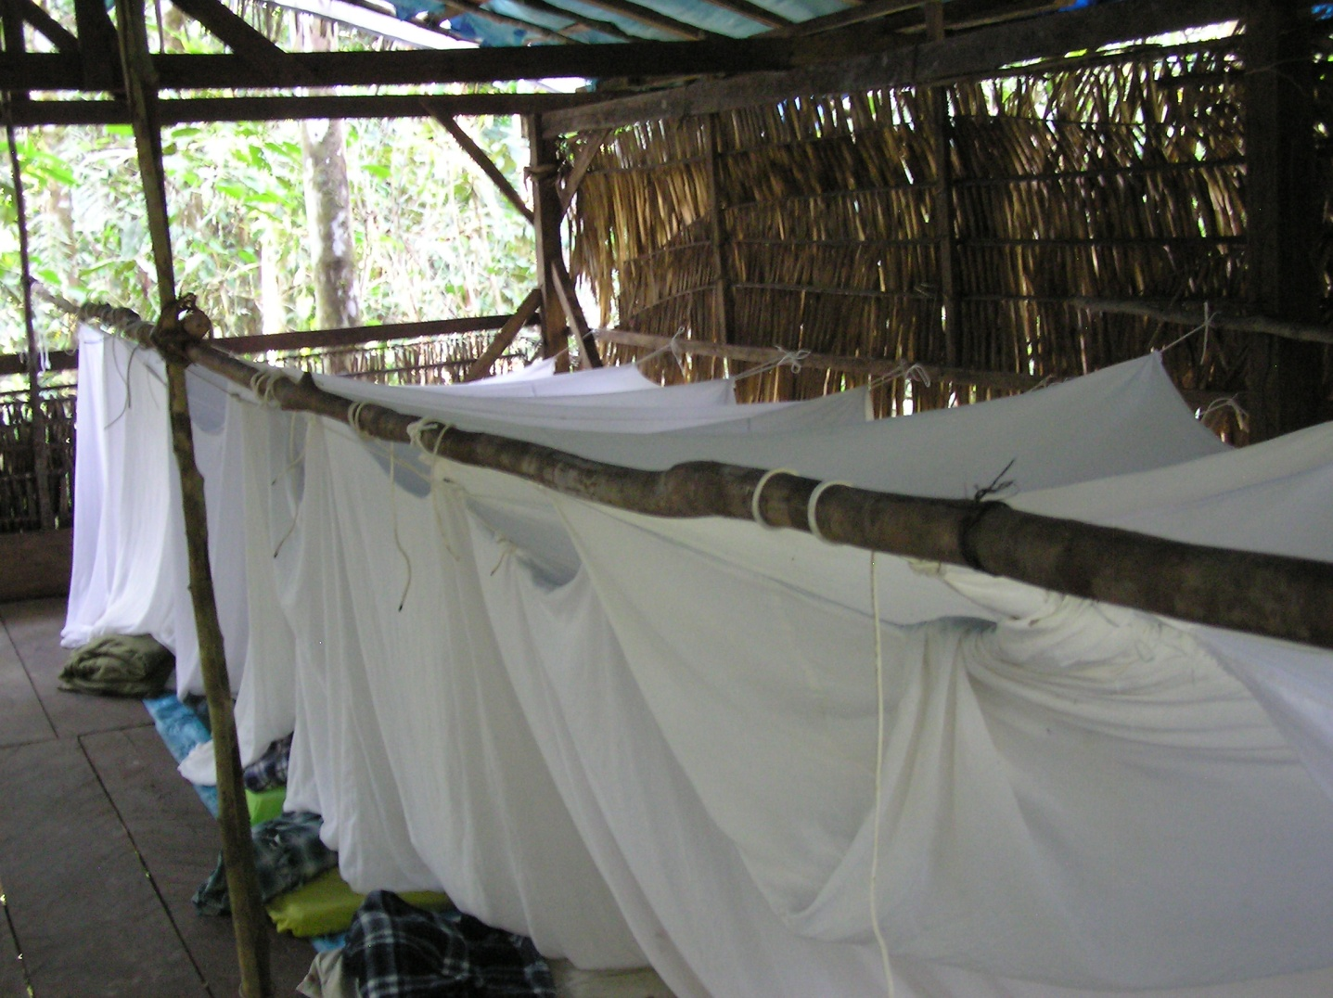

Day 15, Saturday, September 3:
When we discovered shortly before the trip began that there would be an additional charge of $70 to visit the famous Manu Parrot Licks, only four people opted to participate - Penny, Lucy, John, and Me. This was our day to take the optional outing, and we were scheduled to depart in a boat at 5:45. We would be taken downstream for about 45 minutes and have breakfast when we got there. All of us were ready early, and we were asked to leave right away because the manager had learned that another group would be there, and she wanted to make sure we got there first so we would be well-positioned to see the birds. The rest of the group planned to go to the canopy tower and were eating breakfast when we left at 5:20.

We boarded the boat in twilight and headed downstream for about 45 minutes. We observed several species along the way, including a pair of Pale-winged Trumpeters on the river bank. When the boat driver pulled our boat over to the bank at the spot where a trail led to the parrot licks, it was already daylight and another boat was already there. We could hear parrots as our drivers worked to move the other boat to allow us access to the “dock”, and I began to worry that our arrival was timed wrong – clearly the parrots were already there; how many people might be ahead of us? As soon as our feet met the ground, I took off at “Eduardo speed” – what I had been referring to the past few days as the speed of a scalded dog. Penny and Lucy hurried along with me, but John had a more difficult time with all of his heavy camera equipment and a sore ankle. When we got to the lick, I was surprised to see that only two of the nearly 40 seats were occupied. Their guide cautioned us to be very quiet, and we all settled in to enjoy the Psittacid show.

We were not disappointed. At first the parrots were all in the trees above the clay cliff, but they soon started moving down to partake of the mineral-laden clay. There was definitely a pecking order – the Mealy, Yellow-crowned and Blue-headed Parrots were the most numerous and came down to the clay first. Orange-cheeked Parrots, in much smaller numbers, joined them. While this group was feeding, the Macaws were gathering in the trees above. At first there were just a few, but eventually we counted at least forty Red-and-green Macaws. They seemed to be much more cautious than the smaller parrots and were easily spooked. Blue-and-yellow Macaws and Chestnut-fronted Macaws came and perched in the trees for a while, but we never saw them come down to the clay. Other species that came included White-eyed Parakeet, Tui Parakeet, and Cobalt-winged Parakeet. Ten species of parrots!

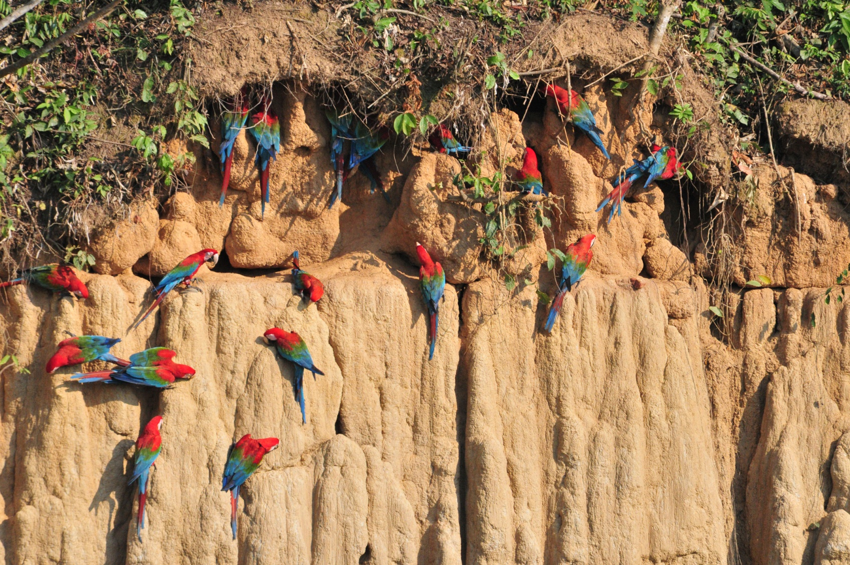
Red-and-Green Macaws at Manu parrot lick

We watched the interaction between individual birds and between species – one Mealy Parrot was a real bully who bit at any other bird that came near “his” spot on the clay. Some non-parrot species came into view, mostly species we had seen before, but the best was a Slate-colored Hawk. We were fortunate to get good views of the diagnostic orange beak so we could help the guide with the identification of the hawk.

When we returned to the lodge, the others reported a splendid morning on the tower. Lunch was served at 1:00 with a few hours to rest before our afternoon walk at 3:30. Most people didn’t rest, and I could hear Mark and Becky and Brad talking excitedly on the porch, so I knew they had something good. I learned later that a Maguari Stork had flown down the river right in front of our rooms. John walked down to the lake, disappointed that he had missed the Sungrebe when the group saw it on the lake when he was at the tower. Not only did he get the Sungrebe, but a Sunbittern as well! Others went off on trails, and I’m not sure who saw what, but several new birds were reported at the end of the day: White-throated Woodpecker, Lineated Woodcreeper, Eastern (striped) Woodhaunter, Dusky-throated Antshrike, Forest Elaenia, Grayish Mourner, Purple-throated Fruitcrow, Spangled Cotinga, Round-tailed Manakin, Yellow-backed Tanager, and Turquoise Tanager.
Eduardo led a partial group on the scheduled 3:30 walk on a couple of the lodge’s trails, but our efforts yielded absolutely nothing! At the end of the day, we had 94 species for the day, 407 for the trip.

Day 16, Sunday, September 4:
Lucy, Penny, Barbara, Jim and I went to the canopy tower with Eduardo while most of those who had already spent a morning there opted for other birding spots. John and Mark walked to the lake, Jackie was not feeling well and stayed at the lodge to rest. Brad and Becky were feeling energetic and headed out the Bamboo Trail.

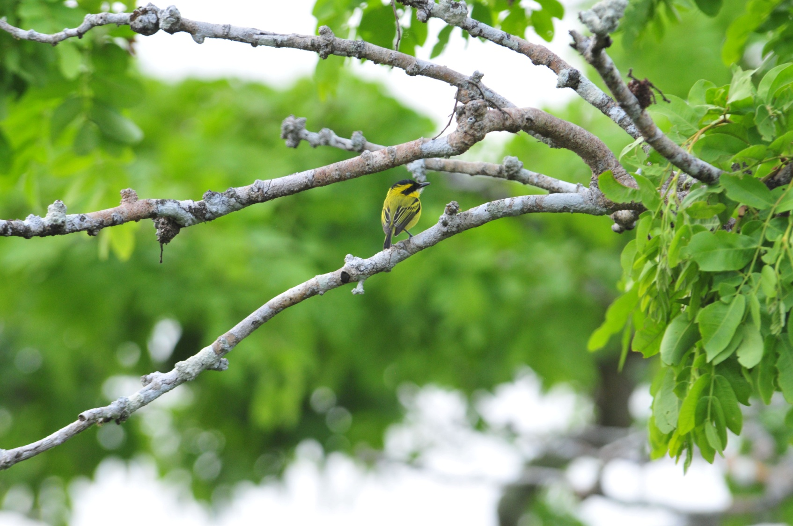
Yellow-browed Tody-Tyrant

Before we began our hike to the tower, we saw Spix's Guan and Vermilion Flycatcher near the cabins. Jim remembered something he forgot in the room (his hat, I think) and had to go back, so I waited for him. After a while, I started slowly down the trail without him, but came back when he didn't catch up with me. While I was waiting for him, I caught a glimpse of two Pale-winged Trumpeters (sans babies). When we arrived at the tower, the others had already seen three of my target species, Curl-crested Aracari, White-bellied Parrots, and Olive Oropendola. Luckily, two of the three would return while we were there and the oropendola was the only bird I missed by being late.

We saw Black-faced Dacnis on our way up the steps of the tower, and found Golden-collared Toucanet as soon as we got up to the top. During the hours we spent on the tower, we saw several pairs of Blue-and-yellow Macaws fly by. Jim found a White-browed Purpletuft in the distance and we all enjoyed good views through the scope. Other birds seen from the tower included Lineated Woodcreeper, White-fronted Nunbird, Paradise and Opal-rumped Tanagers, Yellow-tufted Woodpecker, Rose-fronted Parakeet, Black-bellied Cuckoo, Ivory-billed Aracari, Yellow-crested Tanager, Yellow-browed Tody-Tyrant (Flycatcher), Buff-throated Saltator, Forest Elaenia, Spangled Cotinga (Jim), Opal-crowned Tanager, Green Honeycreeper, Yellow-bellied Dacnis, White-necked Jacobin, Blue Dacnis, Red-throated Caracara, and White-throated Toucan. A large group of Red-bellied Macaws flew by, as well as a Black Caracara. Red Howler Monkeys put in an appearance before we left at around 10:00 AM.

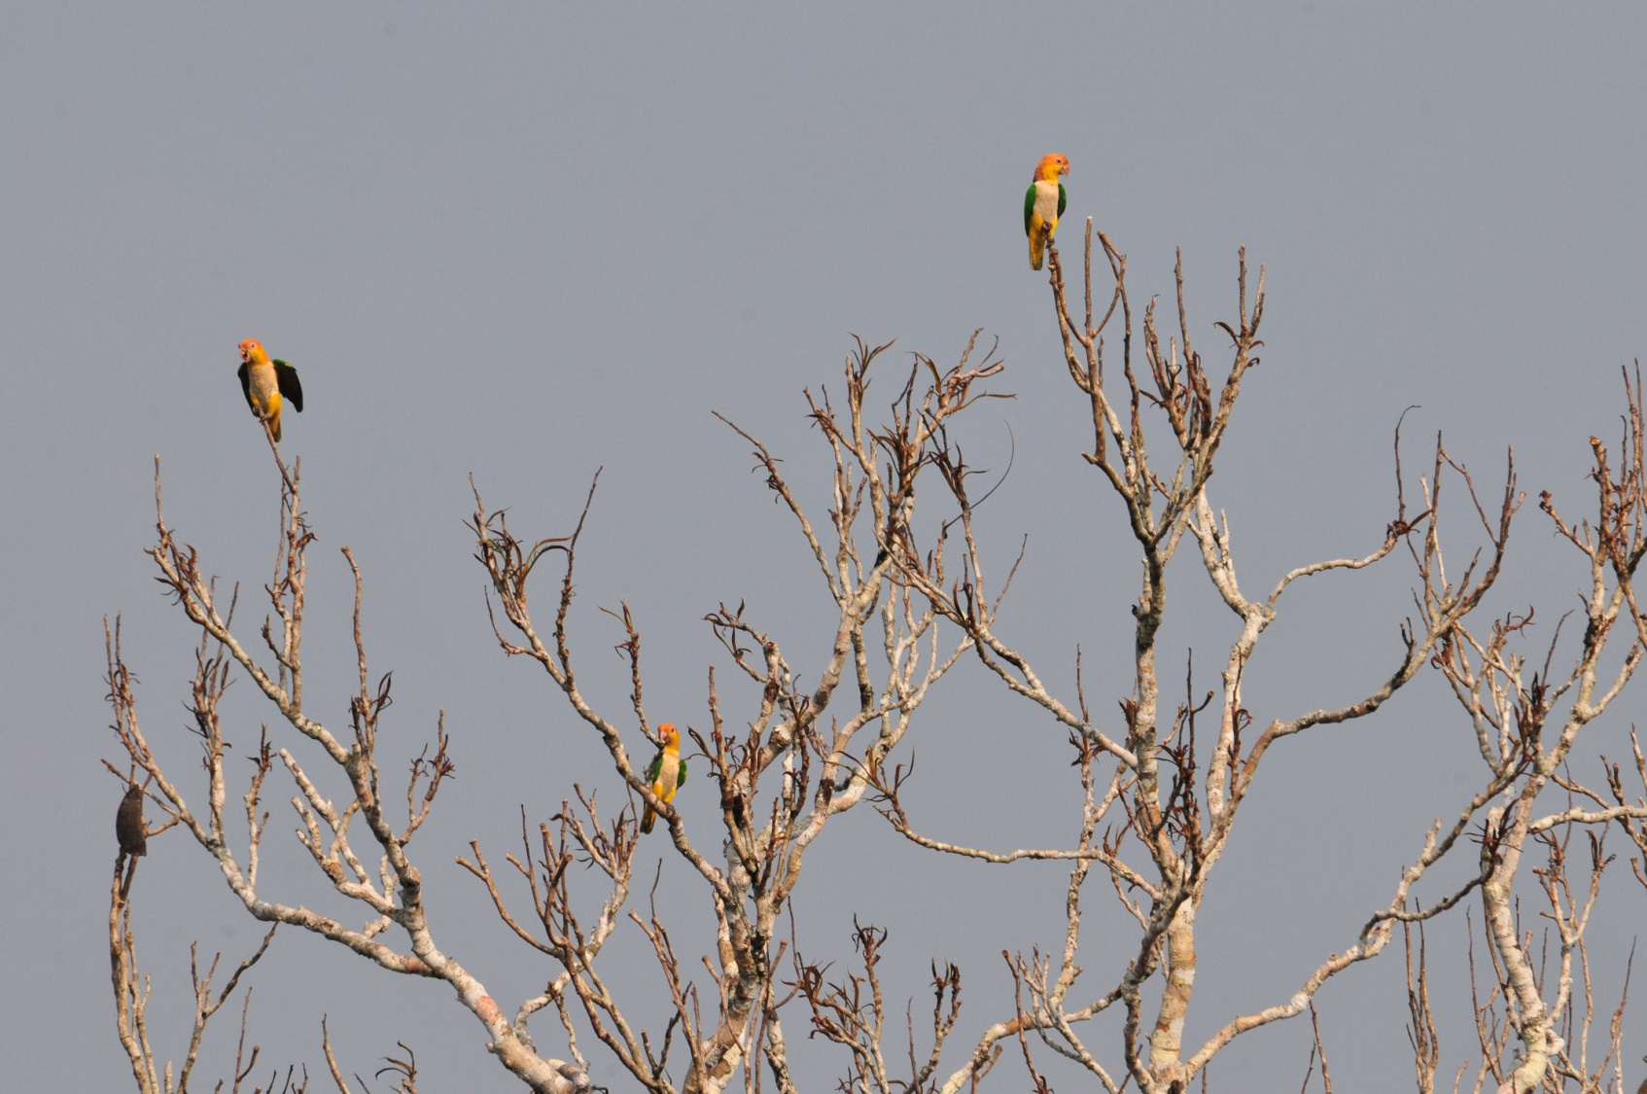
White-bellied Parrots

The wasps were still present, and we had been careful to avoid them, but Eduardo and Lucy had both been stung. After Bite was applied, and no severe reaction was noticed, but when Eduardo grabbed the scope to begin the descent to the forest floor, he inadvertently grabbed a wasp and was stung a second time. As he proceeded down the stairs, he began to feel like he had chiggers on his legs, and immediately ripped his shoes off when he got to the bottom and began to scratch his ankles frantically. He noted that he felt very odd, beginning to itch all over even though he appeared to be chigger-free, and soon experienced nausea and stomach cramps. By now, it was clear to us that he was having an allergic reaction, and none of us had anything with us that might help. When he began to have difficulty breathing, Jim took off running through the forest to get the Benadryl pills that were in our medical bag. After he left, Lucy, Penny and I discussed how we would be able to get Eduardo back to the lodge and regretted not telling Jim to bring help (as if he needed to be told). Lucy and Penny started off on the trail to get help and I stayed with Eduardo. There was really nothing I could do for him but watch and check every few minutes to see that he was still conscious - he was now lying flat on the pavement at the base of the tower. Thoughts of how long it would take us to get medical attention for Eduardo were not comforting as I waited with him.

When Jim reached the lodge, he began calling for Roger as he ran to our room, but got no response. He crossed paths with the manager and told her what was going on and that we needed Roger to assist in getting Eduardo back to the lodge. She gently called his name and Roger immediately appeared. The pills and water were given to him and he ran quickly through the forest to Eduardo's side. By the time he got there, Eduardo was breathing easier but had broken out in hives all over his back and arms (and other places, too, I imagine). He took the Benadryl and sat quietly, waiting for the symptoms to subside. Soon, Jim showed up with wet cloths and portable fans to make Eduardo comfortable. What he really needed was some relief for the itching, so Jim, Mark, and Roger paused in the forest a couple of times on the way back to the lodge to scratch his back. We were all quite relieved to see that Eduardo was able to walk unassisted, although more slowly than normal, back to the lodge.

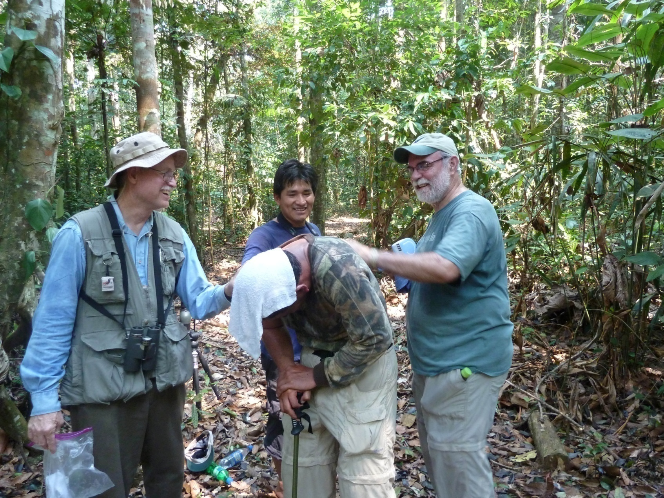
We didn't schedule an afternoon walk for the group for obvious reasons. After a few doses of Benadryl and an afternoon of rest, Eduardo recovered nicely and was back in good form by dinner. Everyone used the down time during daylight hours to organize luggage for tomorrow morning's departure.

In addition to the birds seen by the group on the tower, other people saw several new birds for the trip in assorted locations: Limpkin, Bicolored Hawk, Ash-colored Cuckoo, White-browed Cuckoo, Ringed Kingfisher, Red-necked Woodpecker, Sclater's Antwren, Gray Antwren, Ihering's Antwren, Silvered Antbird, Rufous-tailed Flatbill, Ruddy-tailed Flycatcher, Lesser Kiskadee, and Violaceous Jay were all reported.

The combined group list consisted of 103 birds for the day, bringing the trip total to 427. Our first 100+ day for the trip!

Day 17, Monday, September 5:
I was out of bed earlier than necessary because my "alarm clock frog" that lived in the bathroom began serenading us at 3:20 AM. The alarm was set for 3:45, so I just stayed up and began to prepare for our departure. Breakfast was served at 5:00 and everyone was in the boat by 5:30, allowing us to depart at 5:40, 20 minutes ahead of schedule. We were told we would be on the river for about seven hours. We would disembark at a small village and then be transferred by bus to nearby Puerto Maldonado, where we would spend the night and then catch a plane back to Lima the following morning.

From the boat, we saw lots of species we'd seen before, but we also found some birds that were new for the trip, or at least new to some who had missed previous sightings: Capped Heron, Razor-billed Curassow, Muscovy Duck, Anhinga, Wood Stork, Roseate Spoonbill, Jabiru, and Slate-colored Hawk. We also lost a species from the trip list when Mark changed his id on Maguari Stork after seeing a juvenile Wood Stork. Everyone was thrilled to see a Capybara at the river's edge.

At 7:10, the boat collided with a big log that was submerged just below the surface of the water. The boat sprang a leak, and as the water flow increased, the driver maneuvered so that the boat would lean to the left to keep the leaky spot on the right side from allowing more water to enter. This made for some pretty uncomfortable seating, and we were all relieved when the boatmen used some stones to pound the leaking board back into place when we stopped to stretch a few hours later.
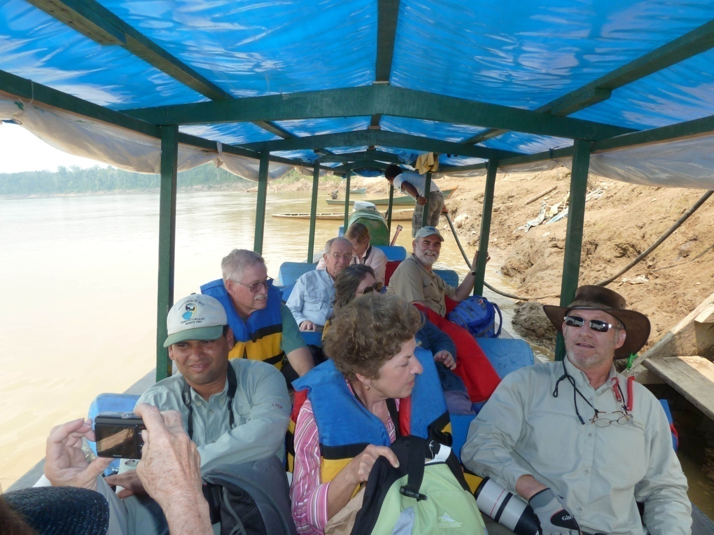

As we traveled down the river, we began to grow weary of the limited movement and most of us were experiencing some level of discomfort, not the least of which was lack of bathroom breaks. At around 1:15, with almost 8 hours of river travel under our belts, we asked how much longer we might be on the river, expecting to hear that we were almost there. The response was "an hour and a half". At 2:15, we asked again and were once more told that we had another hour and a half of travel time. By now our discomfort was extreme, so I told Eduardo that we would need a "bushroom" break as soon as a likely spot was seen. To my dismay, he instructed the boatmen to pull over right then, and the women were dropped off on a sandy bank where there were no bushes or shelter of any kind! We used Jim's poncho as a curtain for some privacy as the men in control of the boat didn't seem to comprehend our lack of enthusiasm for the spot they chose for our bushroom break. Some Burrowing Owls were present on the sand bar, so at least the stop gave us ample time to observe them. We continued on our journey, relieved but not happy.

We finally arrived at the village of LaMarintos at about 4:00 PM - 10 1/2 hours after we departed! What a day! The bus driver was waiting for us, and had been for some time since he was given the original ETA of 12:30 - 1:00 PM. We loaded as quickly as we could and headed for the hotel in Puerto Maldonado. When we completed the list at dinner, we had a count of 58 for the day and a final trip total 432.

Day 18, Tuesday, September 6:
We were transported to the Puerto Maldonado airport for a morning flight to Lima, where we would catch our flights home that evening. From the airport, Mark spotted a Gray-breasted Martin, the last new bird for the trip, bringing our final final total to 433. Most of us had late evening or red-eye flights back to the states, so we had to spend the entire day in the airport. Mark and Jackie's flight was scheduled for the following day, and we all envied them as they walked to the hotel across the street where they had booked a room for the night.

Overall, while the trip did not meet my expectations in number of species seen, it was quite an adventure, one that I will remember for a long time. We visited places that most people only dream of seeing, walked in the footsteps of ancient civilizations, and witnessed nature far from the average tourist tracks. We couldn't have asked for a better group of birders with whom to travel and we enjoyed the camaraderie of our little band of intrepid trekkers who we now have the privilege of calling friends.

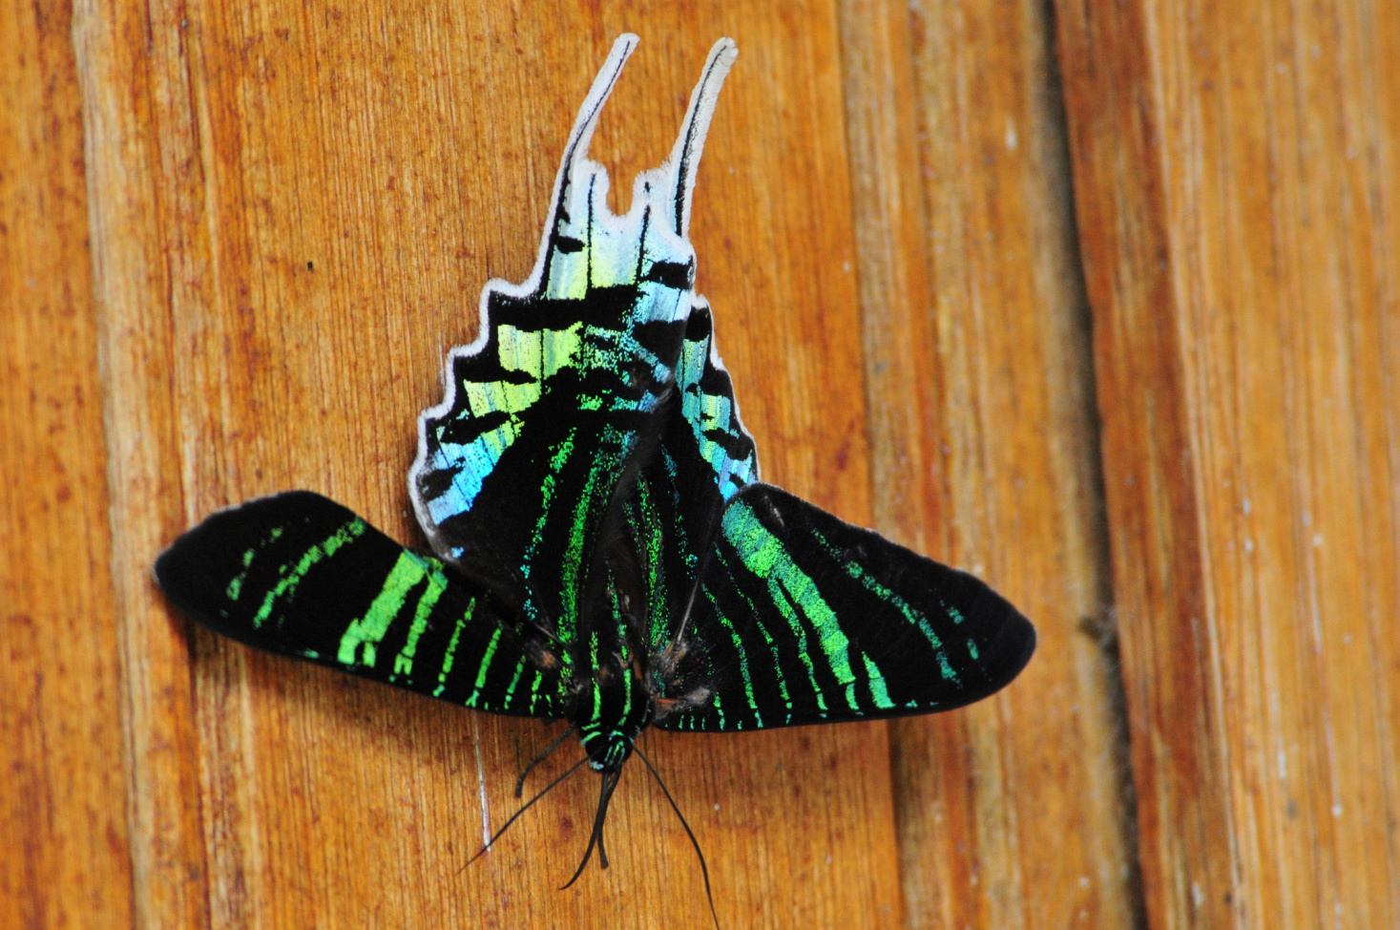
Diurnal Moth seen at Amazonia Lodge

