Panama
Canal Zone & Chiriqui Highlands
January 7 - 16, 2012
TRIP REPORT

Disclaimer: This report is as accurate as possible using limited notes and recordings taken in the field; any errors regarding species seen at specific sites are unintentional. Species are often listed only on the day they were first seen unless the subsequent sighting involves something significant. All photos are by the author, Cindy Beckman.

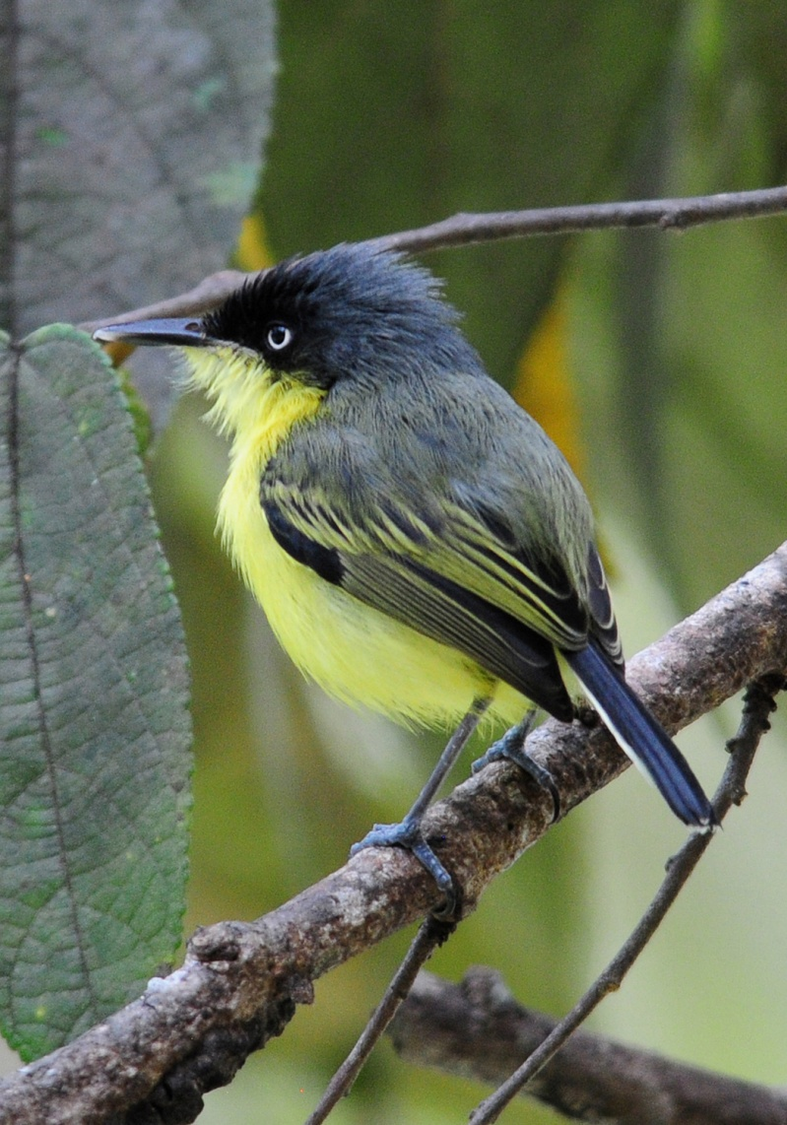
Species seen by group: 342
Additional Species heard: 27
Birding guides: Guido Berguido & Michael Castro
Tour leaders: Cindy and Jim Beckman,
Cheepers! Birding on a Budget
Group: 10 + 2 tour leaders and 2 birding guides
Highlights: Crested Guan, Boat-billed Heron, Spectacled Owl, Gray-headed Kite, Pearl Kite, White Hawk, Laughing Falcon, Bat Falcon, Gray-necked Wood-Rail, Blue Ground-Dove, Mangrove Cuckoo, Pheasant Cuckoo, Rufous-vented Ground-Cuckoo, Tropical Screech-Owl, Green-fronted Lancebill, Veraguan Mango, Violet Sabrewing, Resplendent Quetzal, all 6 species of Kingfisher including Green-and-Rufous Kingfisher, 5 species of Puffbird, Great Jacamar, Streak-breasted Treehunter, Scaly-throated Leaftosser, Chestnut-backed Antbird, Ocellated Antbird, Black-faced Antthrush, Streak-chested Antpitta, Black-capped Pygmy-Tyrant, Great Potoo, Long-tailed Tyrant, Barred Becard, Blue Cotinga, Red-capped Manakin, Rufous-browed Peppershrike, Black-chested Jay, Rufous-and-white Wren, Long-billed Gnatwren, Black-faced Solitaire, Orange-billed Nightingale-Thrush, Long-tailed Silky-Flycatcher, Golden-winged Warbler, Townsend's Warbler, MacGillivray's Warbler, Kentucky Warbler, Wren Thrush, Speckled Tanager, Flame-colored Tanager, Slate-colored Grosbeak, Yellow-thighed Finch, Large-footed Finch, White-winged Tanager, Orange-crowned Oriole.
Common Tody-Flycatcher

Day 0, Friday, January 6: TRAVEL DAY
Jim and I arrived in Panama City shortly after 3:00 PM and were greeted by Michael, one of our birding guides, as we exited the airport. Paul and Joe came out of the airport shortly after. Michael drove us to the lodge in Gamboa and we spent some time watching the feeder birds before dinner. All of the regular suspects were present: Palm Tanager, Blue-gray Tanager, Buff-throated Saltator, Plain-colored Tanager, Red-legged Honeycreeper, Green Honeycreeper, Rufous-tailed Hummingbird, Clay-colored Thrush (Robin). Agoutis were running all over the place. We had the place to ourselves because Guido had been in the Darien for a few days with some college students. They were to return tonight and Guido would be our guide for the remainder of the tour. I expected the college kids to be on their way home and was very surprised to learn that they would be staying for another week or so. In a few days, a second group would arrive from the Darien, and there would be 39 people staying in the lodge, some of the students housed 9 per room. I was apprehensive about what this might mean in terms of noise level when we might be trying to sleep or complete our bird list, but there was absolutely nothing I could do about it at this point.

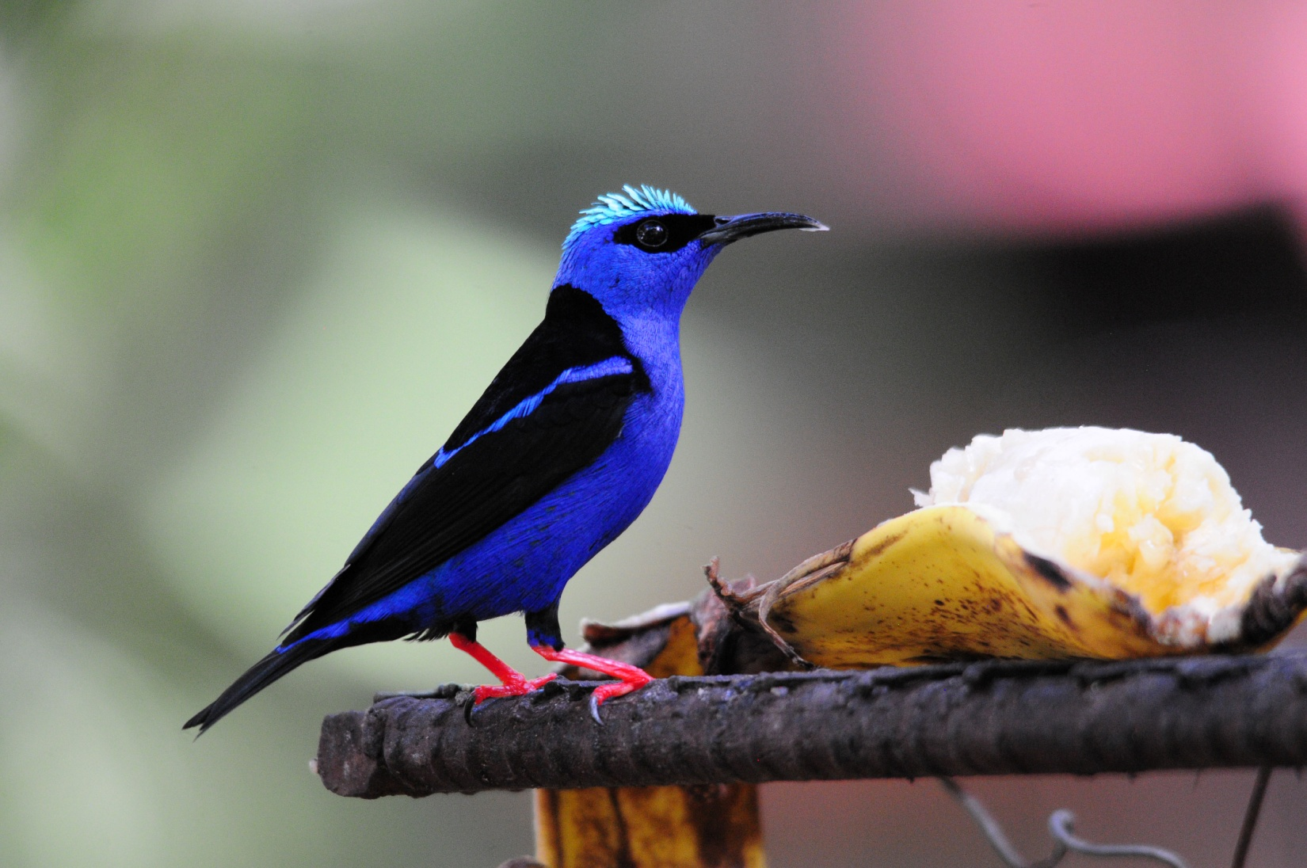
Red-legged Honeycreeper at feeders

Later that evening, Don and Clotilde arrived and were quietly escorted to their room. Six of our group of 12 had arrived one day early to allow ourselves some time to acclimate to the weather and rest from the long day of travel before our first long day of birding.

Day 1, Saturday, January 7: PRE-TOUR DAY AND TRAVEL DAY
Today, Joe and Paul planned to go birding at Metropolitan Park with Michael, and then they would take a city tour in the afternoon. Don and Clotilde wanted to take it easy at the lodge, so I stayed with them while Jim accompanied the men on their trip to the city.

The guys had a 5:45 breakfast and left at 6:15 for the city. Don and Clotilde had asked for a wake-up call (actually a knock on the door since there are no phones in the rooms) at 6:45, but they were already eating by the time I went looking for them at 6:40. In front of the lodge we saw Red-fronted Amazon in a bare tree and Black Vultures roosting in a different tree across the street. Several species were seen from this vantage point, including Keel-billed Toucan, Southern Beardless Tyrannulet, Masked Tityra, Thick-billed Euphonia, Crimson-backed Tanager, and Panama Flycatcher. A group of Orange-chinned Parakeets flew by and a Blue Dacnis landed on the mirror of a car in the driveway. At the feeders, we had all of the regulars plus Gray-headed Chachalacas. One of the groups of college students had gathered in the dining area for a meeting, so it was difficult to watch feeder birds without interfering with their activities. We watched the feeders for a short while, and then decided to meet at 8:00 AM to take a short walk in the neighborhood. Guido offered to let us go to the banding station with the college group, but Clotilde and Don passed on that opportunity, wanting a low-key day to rest up for the next day. When we met to take our walk, we saw
Magnificent Frigatebird flying overhead, along with Turkey Vultures. We didn't make it far before Don decided to take a short rest. Clotilde and I went back to the feeders and observed Blue Dacnis, Red-crowned Woodpecker, Whooping Motmot, and all of the regular feeder birds before Clotilde went upstairs to rest until lunch. While they rested, I saw a White-necked Jacobin and both male and female Crimson-backed Tanagers. As I walked along the street in front of the lodge, I heard a familiar call that I couldn't place. I followed the sound to the wooded area at the end of the street and found a Slaty-tailed Trogon. Not much new was showing up by then, so at around 11:00, I also went upstairs for a short rest and a shower. We joined the college kids for lunch at 12:30, and the group left shortly before 2:00 PM. At that point, Don, Clotilde and I walked to the Rainforest Resort a few blocks away.

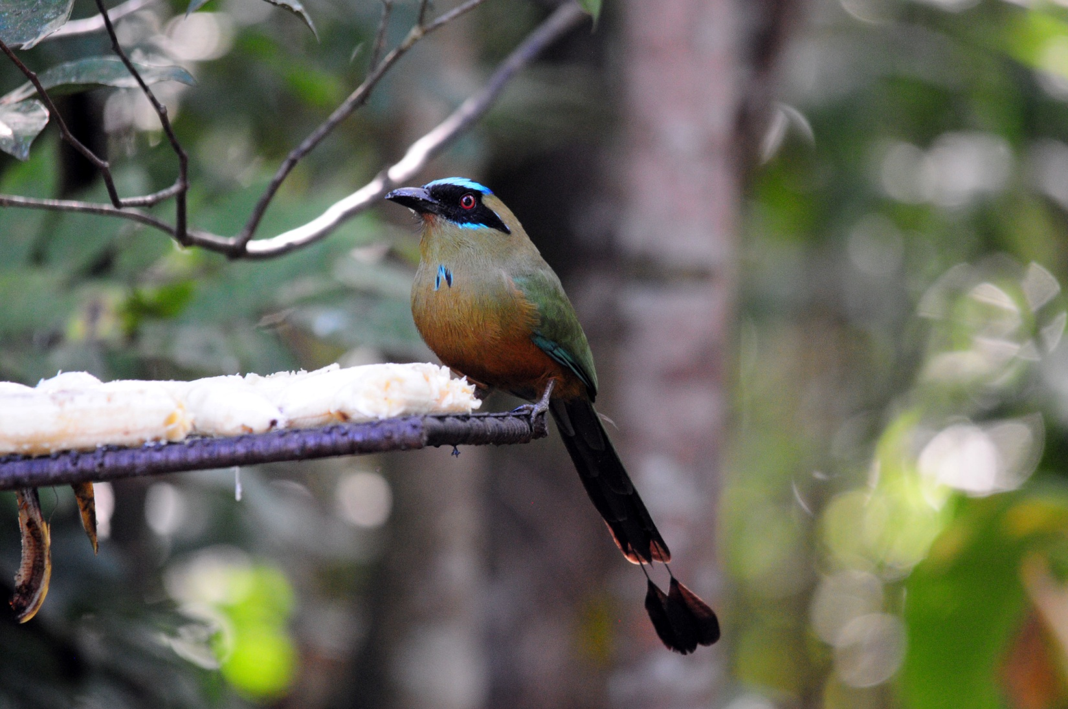
Whooping Motmot at feeders

At the Gamboa Rainforest Resort, we had Tropical Mockingbird in a palm tree near the pool. Walking back to Soberania Lodge, we started down a path called Sendero Laguna, where we saw Slaty-tailed Trogon and Barred Antshrike. There were a couple of large wrens at the entrance to the trail that flew away too fast to be identified. Along the road on the way back to the lodge, we saw Great Kiskadee and Boat-billed Flycatcher.

We were back at Guido's lodge at about 3:20 and spent the remainder of the day alternating between resting and watching the feeder birds. A group of Geoffrey's Tamarins came in to raid the feeders, along with a very stubborn Coati Mundi. All in all, it was a very relaxing day. When the men returned from their outing to Panama City, they told us they had had a very good day of birding and touring. We didn't complete an official group bird list for today since the tour actually begins tomorrow, but individuals kept their own lists of personal sightings. The group at the lodge had seen 44 species, and the three who went with Michael to Metropolitan Park and the mudflats had seen 94 species. The rest of our group, George & Susan, Fran & Arlene, and Gene & Gail, arrived between 7:15 and 7:30 PM.

Day 2, Sunday, January 8:
We planned to have breakfast at 6:00 AM for a 6:30 departure, but breakfast ran a little late due to the number of people being served. We enjoyed most of the usual feeder birds first thing in the morning and added Violet-bellied Hummingbird and White-necked Jacobin (I was the only person who saw the Jacobin yesterday). In front of the lodge, we once again found a nice selection of birds, including Golden-fronted Greenlet, Short-tailed Swifts, Keel-billed Toucan, Cinnamon Becard, and Gray-headed Chachalaca.

Once everyone was ready, we loaded our group in a comfortable 22-seat Toyota Coaster to visit some good birding sites in and near Gamboa. Our first stop was on a nearby street where Bat Falcons can usually be found perched at the top of one of a row of several dead trees in a boulevard in the middle of a short street. What we found was a pair of Red-lored Parrots at a nest tree near the "Falcon trees". Keel-billed Toucans were seen in a distant tree, and Southern Lapwings were found in the open grassy area at the end of the road. As we drove on to the Ammo Dump Ponds, we noted
Gray-breasted Martin and Pale-vented Pigeons on the wires along the canal. Yellow-bellied Seedeaters were spotted as we were pulling in to park next to the main Ammo Dump pond, and then we found a Thick-billed Seed-Finch (aka Lesser Seed-Finch) and Blue-black Grassquit in the same tall grasses. Great Egret and Wattled Jacana were obvious at the pond, as were Smooth-billed Anis. A pair of Barred Antshrikes was calling from the brush at the edge of the pond, and we quickly found them. Overhead, a female Black-throated Mango was perched on a bare twig. We could hear the call of a White-throated Crake but could not find anything but a Great Egret and Green Heron as we searched the area from which the sound emanated. Some of the group saw a Rufescent Tiger-Heron before it disappeared into the tall reeds at the opposite side of the pond, and everyone saw the Mangrove Swallows swooping over the pond and a Neotropical Cormorant as it flew down the canal.

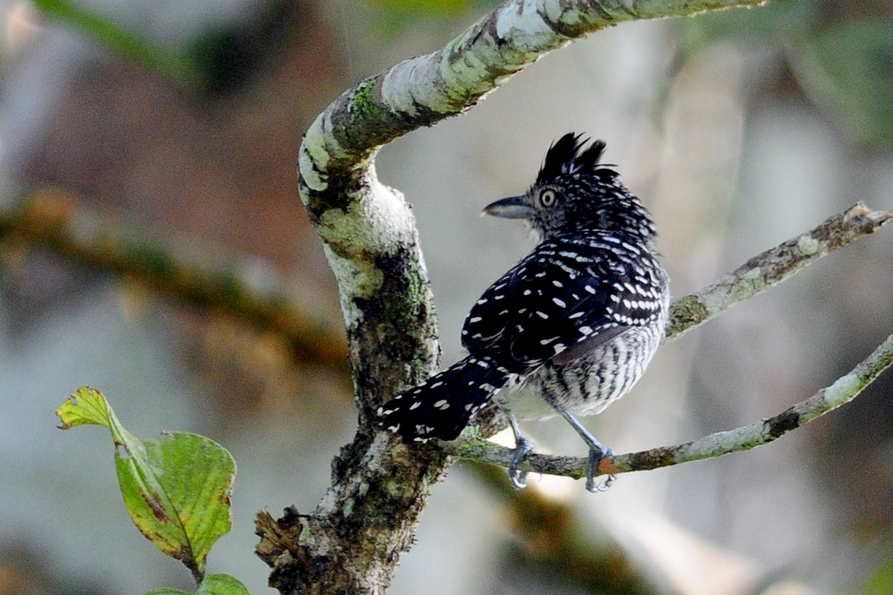
Barred Antshrike

We backtracked just a bit before going to the entrance to Pipeline Road to get some bottled water. Jim and I had forgotten that we had run out of water bottle labels when we mailed the welcome package to this group a few months ago. We had intended to bring water bottles for everyone, but since we forgot that we hadn't already sent them . . . So we went a few minutes out of our way to get bottles of water for everyone before continuing.

At the entrance to Pipeline Road, Guido and the bus driver pulled out some lawn chairs that had been tied to the roof of the bus. A couple of people sat down immediately, but most were too excited to sit and chose to walk around a bit. There was quite a bit of activity in the low bushes and trees right in front of us, and after awhile more people sat and enjoyed the comfort of birding from a chair. In this area, without moving more than 30 feet in any direction, we saw Golden-hooded Tanager, Plain Xenops, Ochre-bellied Flycatcher, Chestnut-sided Warbler, Lesser Greenlet, Dot-winged Antwren (female), Tropical Gnatcatcher, Long-billed Gnatwren, Fasciated Antshrike (female), and Black-and-white Warbler. We heard some Song Wrens, but they would not respond to Guido's tape when he played it. All the time we were watching for birds at this spot, the incessant call of the Green Shrike-Vireo could be heard overhead. Guido joked about the bird being "invisible" or "mythical" because this bird is heard almost constantly when birders are in the proper habitat, but is not often seen.

After awhile the bird activity slowed a bit and we moved further in to the entrance of Pipeline Road. Guido and the group moved to a right fork while I and a few others were distracted by some movement to the left. As the group was enjoying a show put on by both Howler and Capuchin Monkeys, I was pointing out some birds to a few people on the other fork: White-shouldered Tanager, Bay-breasted Warbler, Western Slaty Antshrike, Shining Honeycreeper, Thick-billed Euphonia. When the activity increased, I called to Guido to come and bring the group because it looked like we had a small mixed flock. The others were able to see most of the birds that had been there and added Prothonotary Warbler, Buff-throated Saltator, Lesser Greenlet, Cocoa Woodcreeper, Paltry Tyrannulet, Blue Dacnis, Tennessee Warbler, Baltimore Oriole, and Yellow-olive Flycatcher.

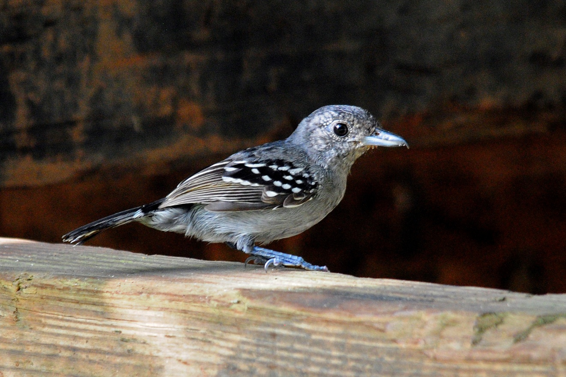
Western Slaty Antshrike

When the activity died down, we moved on to the shores of the Chagres River near the marina of the Gamboa Rainforest Resort. When we arrived there shortly after 10:00 AM, we immediately saw Social Flycatcher, Mangrove Swallows, and Yellow-crowned Tryannulet. Both Rusty-margined Flycatcher and Lesser Kiskadee were present, allowing us to compare these two similar species with the Social Flycatchers that were common. Common Gallinules floated on the water, and Yellow Warblers flitted about in the bushes along the shore. A Summer Tanager and a House Wren were found on the crossbeams of a storage building. We found a Fasciated Antshrike female. The day was growing quite warm by now, and the bird activity was slowing, so we decided to move on. Walking back to the bus, we stopped to watch and photograph a very cooperative Common Tody-Flycatcher, and noted American Coot and Green Heron in the water as we walked by. Great-tailed Grackles were seen on the drive back to the lodge.

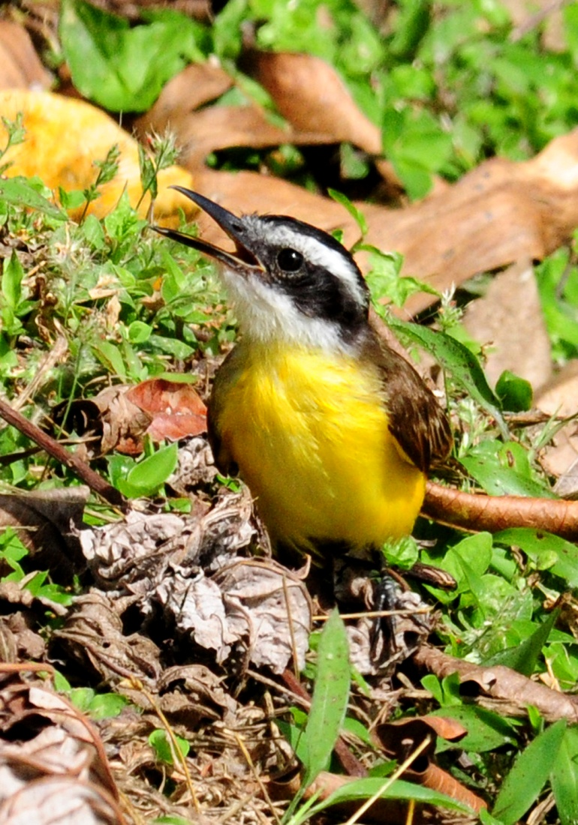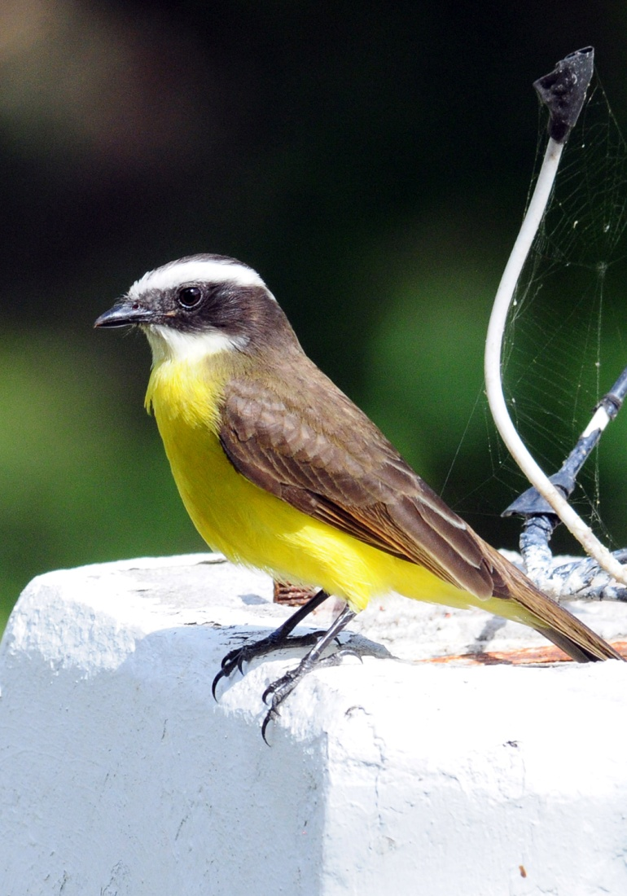
Lesser Kiskadee Rusty-margined Flycatcher

We arrived back at the lodge at 11:00, a bit earlier than usual, but we knew the feeders would offer more opportunity to see birds than anywhere else with the weather so hot. Most of the group had only enjoyed a few minutes of watching the feeder birds this morning, so everyone was pleased to have the opportunity to relax in the shade of the dining area and have the birds come to them. All of the regular feeder birds appeared (Palm Tanager, Blue-gray Tanager, Buff-throated Saltator, Plain-colored Tanager, Red-legged Honeycreeper, Green Honeycreeper, Rufous-tailed Hummingbird, Clay-colored Thrush (Robin), Red-crowned Woodpecker, Crimson-backed Tanager) and we added Violet-crowned Woodnymph to the list. A Coati Mundi returned several times to rob the platform feeders, which was at first entertaining but quickly became annoying when he emptied the feeders again and again.

After a nice lunch and a midday siesta, we went back out to bird at 2:30 on another part of the Gamboa Rainforest Resort property. Southern Rough-winged Swallows were the first birds sighted as we got off the bus. As we walked along the road, we tried to keep ourselves in the shade when at all possible. Ruddy Ground-Doves were common, but bird activity wasn't impressive in this heat. As we walked by a small stream, Guido stopped suddenly, putting his arm out to signal everyone else to stop. There, sitting on a small branch over the water was a Green-and-rufous Kingfisher! The bird was in the shadows, which made photography very difficult, but he was very close and everyone got outstanding views through their binoculars. Guido commented that we had gotten the most difficult kingfisher out of the way first, since most trips end without seeing this little beauty. When we got to the end of the road, there was a small pond at the bottom of a hill where we found Pygmy Kingfisher - the second most difficult kingfisher to find!

The area at the end of the road where the Rainforest Resort Tram station is located is often a flurry of bird activity, but this afternoon things were a bit slow due to the heat. We found a Black-throated Mango, a Cinnamon Becard, and not much else before starting back down the road to return to the bus. On our way back, a second Pygmy Kingfisher was seen sitting on the branch where the Green-and-rufous Kingfisher had been. We saw a Peregrine Falcon overhead and noted a large Green Iguana resting in a tree. As we continued down the road, another surprise popped into view - a White-necked Puffbird. As puffbirds often do, the bird sat quietly for quite some time as we observed and photographed it. In some tall grasses near a wetland, we found Variable Seedeater and a Basilisk (aka Jesus Christ Lizard). In tall trees on the opposite side of the wetland was a Two-toed Sloth. Also seen from this area were two Keel-billed Toucans, a Southern Beardless Tyrannulet, and both Thick-billed and Yellow-crowned Euphonias.

We piled into the bus to return to the lodge, but I suggested that we make a stop at the entrance to the Ammo dump where a tall fence keeps unauthorized persons from entering the property. A short road leading to this fence is often a good spot for birds, and we sometimes see Capybaras in the marsh that surrounds the ammo dump. On the way, we drove by the street where we had looked for Bat Falcons this morning. This time, a beautiful Bat Falcon was perched there, and everyone got excellent views and good photos in perfect lighting with a beautiful blue sky as a background. While we were enjoying the cooperative falcon, some Orange-chinned Parakeets flew in to land in a nearby tree. As we were photographing the parakeets, a Tropical Mockingbird came and landed in a short tree between the falcon and the parakeets.

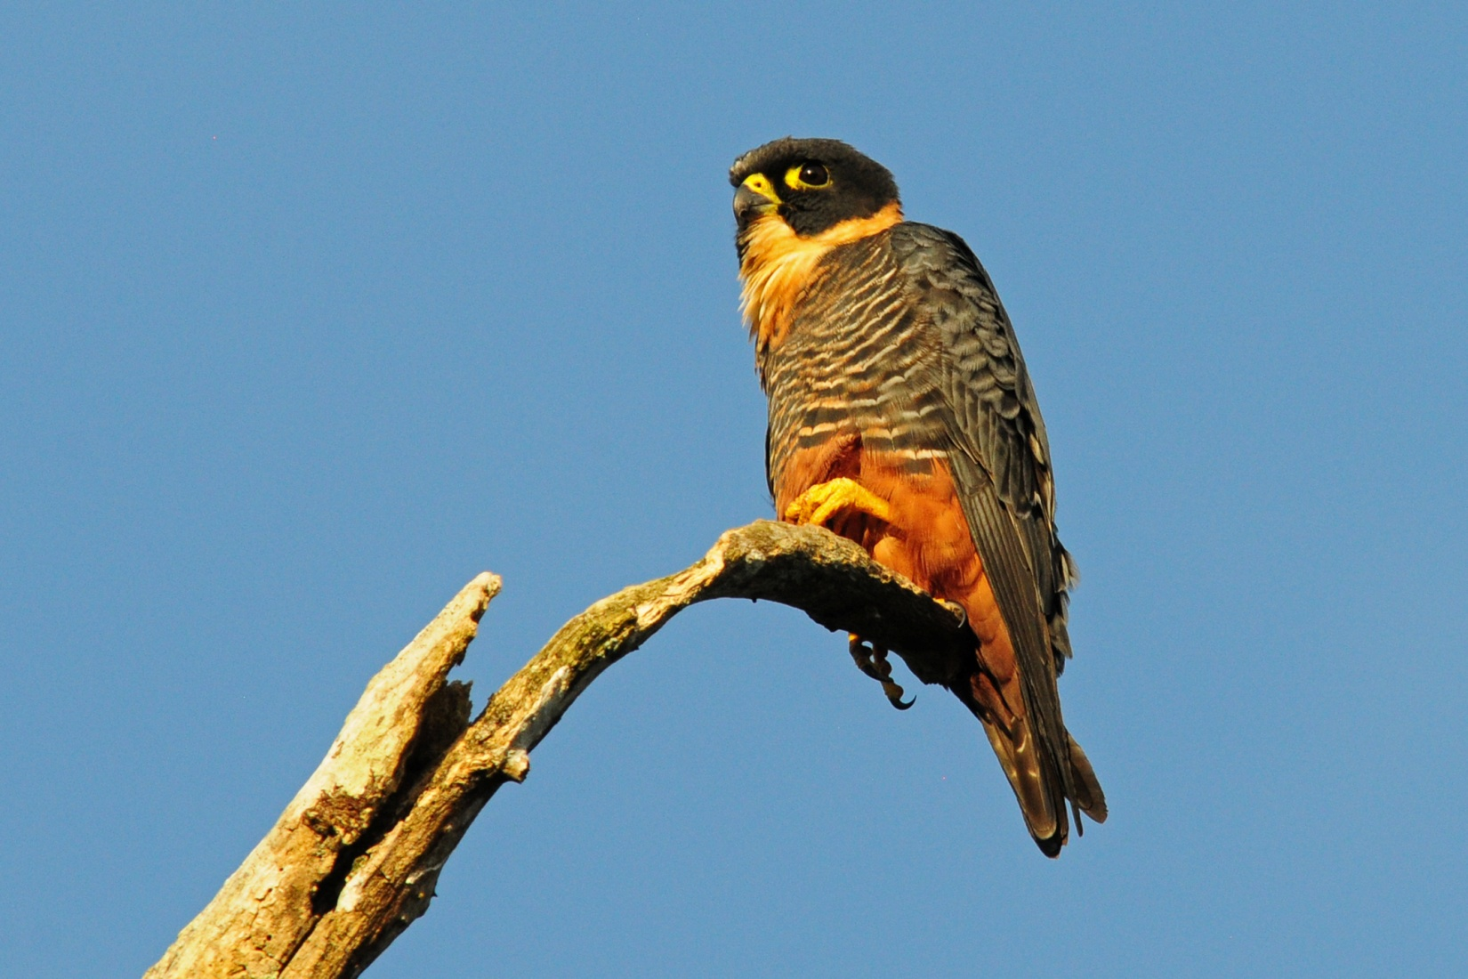
Bat Falcon

As we pulled up to park near the fence at the Ammo Dump, a Gray-necked Wood-Rail ran across the road in front of us. It was still hanging around when we got out of the bus and everyone got great looks. The group spread out a bit once on the road because there seemed to be movement in every direction. A Lineated Woodpecker landed in a tree at the road's edge, Crimson-backed Tanagers seemed to be everywhere, and Tropical Kingbirds kept forcing us to look at them as they hawked insects from overhead perches. In addition to seeing many individuals of several species we had already seen, we added Yellow-tailed Oriole and Northern Waterthrush to the list. A Ringed Kingfisher was found perched low in the marsh, and a Streaked Flycatcher was seen near the road. Red-lored Parrots flew over as we boarded the bus to return to the lodge.

When we went over our list at dinner, we recorded 96 species for the day with an additional 10 species heard only. Some additional new species seen today included Barn Swallow, Fasciated Antshrike, Brown Pelican, Gray Hawk, Squirrel Cuckoo, Short-tailed Swift, and Blue-chested Hummingbird. What a great start!

Day 3, Monday, January 9:
We had breakfast at 5:45 to depart at 6:30 for Pipeline Road. I cautioned Guido that breakfast had been late yesterday due to the number of guests at the lodge, and he arranged for the morning meal to be staggered today. Although his schedule didn't work as planned, we were able to leave on time. We were going back to Pipeline Road, but today we would walk in as far as possible rather than just birding the entrance.

From the bus we saw White-tipped Dove and a Great Blue Heron flew in front of us as we approached the Ammo Dump Ponds on our way to Pipeline. Great Egrets were on the pond, and although we had not planned to stop there, we simply had to when a Rufescent Tiger-Heron presented itself right at the edge of the road. Other common birds were drawing our attention, but we needed to move on so we could bird Pipeline Road as early as possible.

As soon as we stopped the bus inside Pipeline Road, we heard a Barred Forest Falcon calling. We couldn't find the falcon, but we did find the Bright-rumped Attila that had also been vocalizing. Paul pointed out a Double-toothed Kite flying overhead, the first of many times that Paul would find a bird for the group on this trip. A Violet-crowned Woodnymph zipped in and out of view quickly. Guido found a pair of Bicolored Antbirds in a depression that ran along the trail's edge and we followed the birds for quite awhile until everyone had good views. While a few of us were still trying to photograph the antbirds, the group found a Violaceous Trogon a bit further down the road, sitting high in the canopy. A Black-tailed Trogon was also found perched high in the canopy rather than midlevel where we normally see trogons.

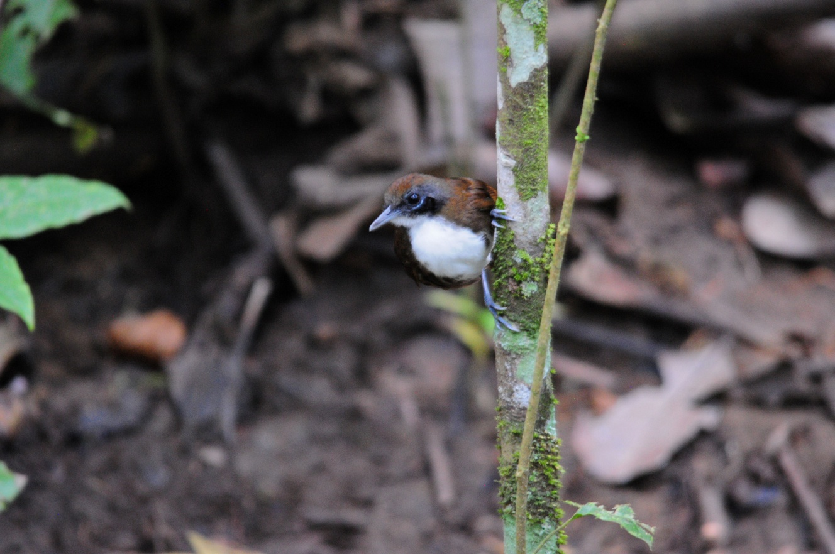
Bicolored Antbird

We made our way to the Rainforest Discovery Center, where we saw a Long-billed Hermit perched in the bushes, chirping away. We stopped near the parking area to look for a Pheasant Cuckoo that had been reported in the area. It took only a short time to locate the bird, but it took quite awhile to get everyone on the bird long enough to be satisfied with the views. While we were there, an Ocellated Antbird came into view briefly. Unfortunately, Jim had gone to the visitor's center where the hummingbird feeders are located when we found this life bird.

We moved on to the tower at about 8:30, which is a bit late for activity in the canopy on a sunny day. On the trail to the tower, Paul spotted a Broad-billed Motmot. Also along this trail we found Forest Elaenia, Greater Ani, and Southern Bentbill. When the group went up to the tower, I returned to the visitor's center to try to get some photos of hummingbirds. As I walked the lower path to the center, a Spotted Antbird flew across the trail and landed where I could see it. I located a perched Long-billed Hermit that was vocalizing. I enjoyed the photographic opportunities until the group returned from the tower, where they reported seeing Zone-tailed Hawk, Snail Kite, Double-toothed Kite, both vultures, White-tailed Trogon (part way up the tower), and male and female Blue Dacnis.

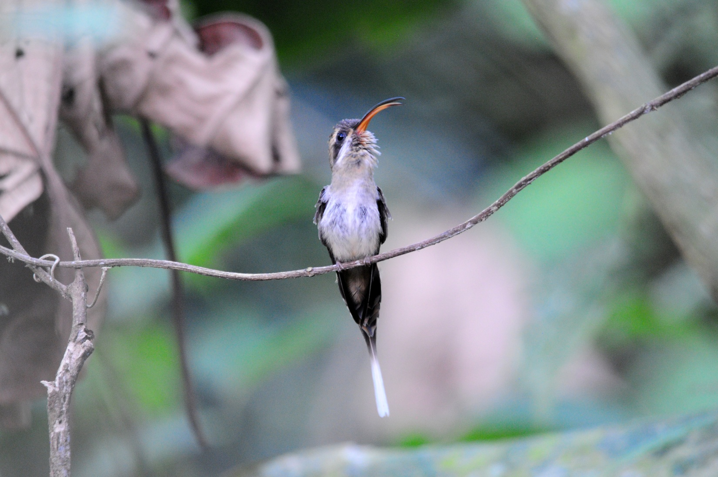
Long-billed Hermit

Paul spotted a Checker-throated Antrwren but it disappeared before the group could get on it. Other birds seen on the walk back to the point where the entrance road of the Rainforest Discovery Center meets Pipeline Road included Brown-capped Tyrannulet, Pygmy Antwren, Black-capped Pygmy-Tyrant, Song Wren, Western Slaty Antshrike, and Scaly-throated Leaftosser. When we arrived back at the intersection with Pipeline Road, a pair of White-tailed Trogons were seen. In addition, both male and female White-shouldered Tanagers were seen here, the two genders looking so different from each other that you could easily mistake them for two different species. We noted a Yellow-margined Flycatcher before we drove a short distance to a small stream, but there wasn't much activity there. It had been a great morning, but we had to get back to the lodge for lunch.

We were back at the lodge shortly after noon, and lunch was waiting for us. As we sat down to eat, a couple of- Orange-chinned Parakeets flew in and landed on the feeders. Some Gray-headed Chachalacas came to join the other feeder birds while we ate. We had just a little over an hour to rest before we left for the Canopy Tower, where we would tour the facilities and bird along Semaphore Hill and the entrance to Plantation Road before returning in the evening. Some of the participants had asked if it might be possible to visit the Canopy Tower, and we were able to finalize arrangements to do so with our good friend Carlos Bethancourt when we ran into him earlier in the day. As we were boarding the bus, someone noticed a Barred Antshrike in shrubs next to lodge, so everyone piled out for better looks.
Another of Guido's guides came along with us, and we welcomed the additional pair of trained eyes.
We birded along Semaphore Hill before going up to the tower, but this normally birdy site was pretty quiet at this time of day. The other guide went to tell the bus driver that we were ready to go on up the hill, and he came and picked us up and transported us to the entrance to the famous Canopy Tower. After a brief tour, we were offered cold drinks and enjoyed visiting with Carlos while everyone looked around. I had asked Carlos earlier if the Great Potoo was still roosting in the spot where we had seen it in April, and he now told me that he had placed a stick on the ground to point to the spot where the bird was roosting today.

As we exited the Canopy Tower, we saw Blue-chested Hummingbird, Violet-bellied Hummingbird, and White-necked Jacobin at the feeders, but only a few hummingbirds were present rather than the dozens we usually see there when we visit in April. Coming down the road from the tower, we saw Violaceous Trogon and Scarlet-rumped Cacique. When we got to the end of the road, I got out to look for the stick that Carlos said he had placed to help us find the potoo. Sure enough, there on the ground was a stick about as big around as my forearm. If I stood at the end and looked in the direction it was pointing, a gorgeous Great Potoo came into view, looking for all the world like a part of the tree. We would probably never have found this bird without the help of our good friend.

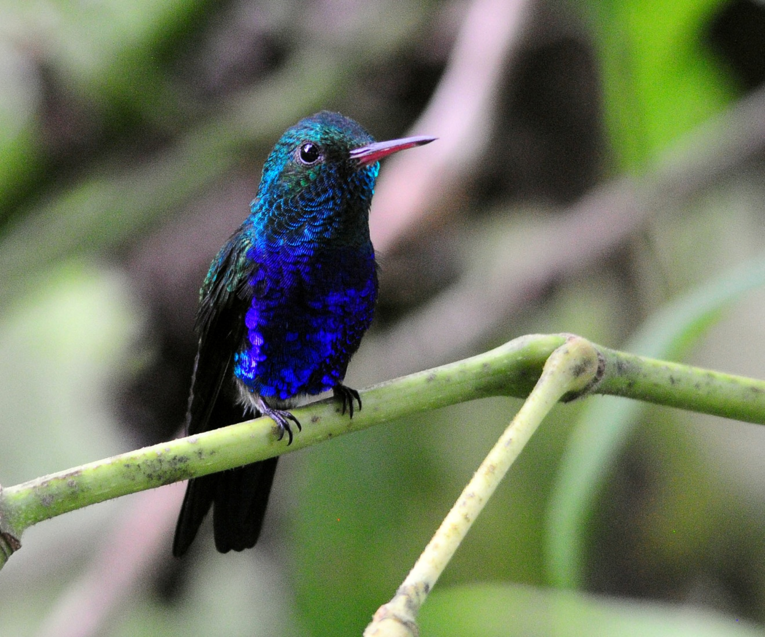
Violet-bellied Hummingbird

When we stopped to wait our turn to cross the one-lane bridge to Gamboa, we saw Fork-tailed Flycatcher and Tropical Mockingbird. After a nice dinner, we went back to the area near the marina to look for owls and frogs. Michael, another of Guido's guides and one of my favorite people in Panama, imitated the calls of the Tropical Screech Owl to perfection, and it took only moments for an owl to fly in and for Michael to have him in a spotlight.

Other birds seen today that were new for the trip included White-vented Plumeleteer, Pied Puffbird, Moustached Antwren, Ruddy-tailed Flycatcher, Slate-colored Grosbeak, and Chestnut-headed Oropendola. Our daily count for the group was 80 species, plus 9 heard, 2 guide-only, and 1 "fly-by". Our two-day trip total stood at 129.
Day 4, Tuesday, January 10:
We departed the lodge shortly after 5:00 AM to drive to Bayano Lake and Forest, an area to the east where we might find some Darien specialties, even though we would not drive all the way into the Darien Province. On the way, we saw many common species and added several new ones such as Crested Caracara, Plain-breasted Ground-Dove, Savannah Hawk, Eastern Meadowlark, Yellow-headed Caracara, White-tailed Kite, and Red-breasted Blackbird.

We stopped for a restroom break at about 7:30. The small restaurant was next to a river, so some of us took a few minutes to search for birds while others were using the facilities. The timing was perfect, and we found many species we'd already seen plus Yellow-green Vireo, Blue-headed Parrot, House Wren, Cinnamon Becard, and Cattle Egret. We heard but could not find Buff-breasted Wren. We made a brief stop at Lake Bayano to look for Cocoi Heron from the bridge and also found Ruddy Ground-Dove there. Further on, at Mono Bridge, we could look into the tree tops at eye level. The first bird we saw here was a Bat Falcon, but Michael and Guido could hear Cinnamon Woodpecker in the distance. Michael imitated the sound perfectly and kept calling and calling until the woodpecker finally came in. Shortly after that, a Barred Puffbird could be heard vocalizing in the distance, and once again Michael called and called until it came and landed right in front of us with its mate close by.

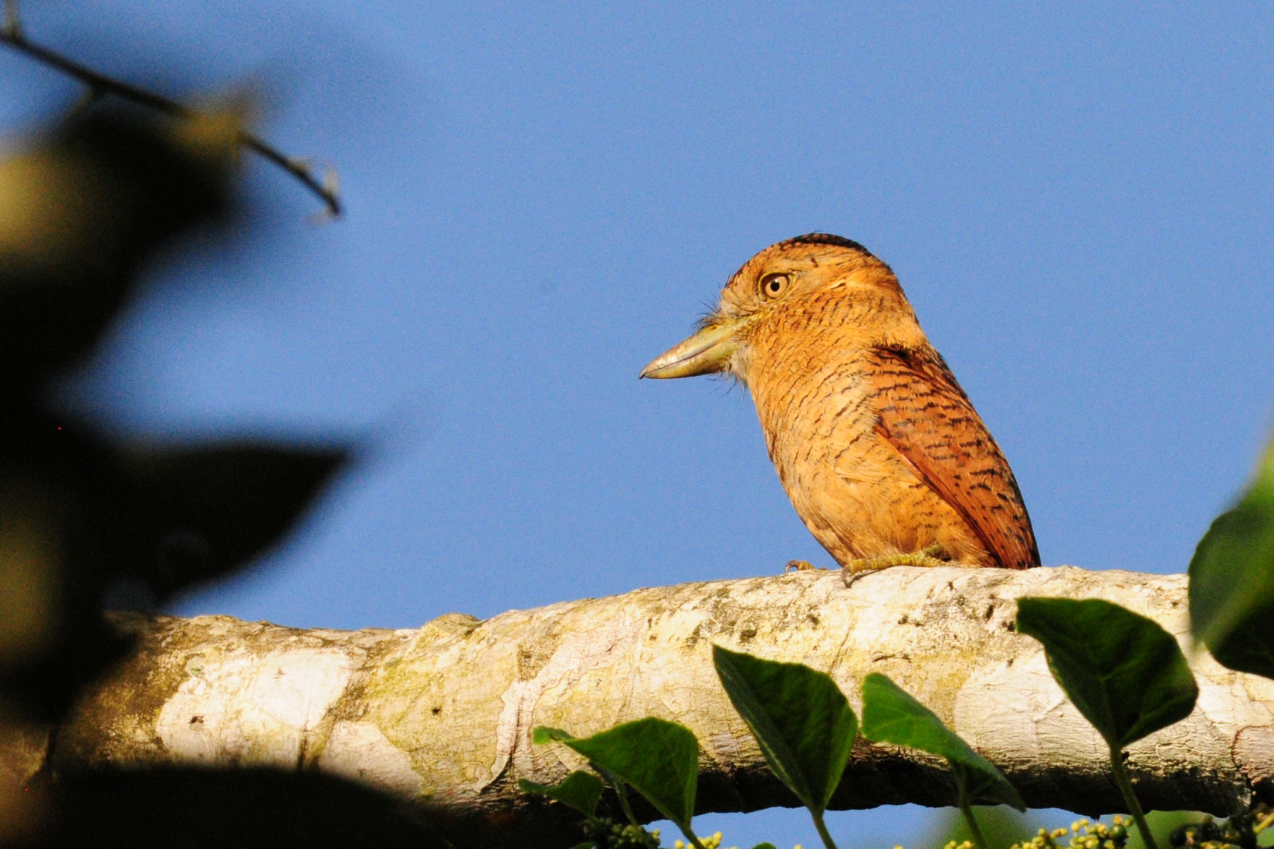
Barred Puffbird

While at the bridge, some Mealy Parrots flew by, and some other common birds put in brief appearances, such as Thick-billed Euphonia, Golden-headed Tanager, Pied Puffbird, Streaked Flycatcher, Palm Tanager, and Dusky-capped Flycatcher. It was again very hot, and we thought the weather was affecting bird activity, so we drove on to find some cooler spots in the shade, hoping that there would be more activity. At our first stop we found Black-headed Tody-Flycatcher, Yellow-throated Vireo, and Tropical Gnatcatcher. We walked a short distance down a pretty quiet trail and Guido finally suggested we return to the van. Michael continued a bit further with part of the group, and just a short distance down the trail they found Golden-collared Manakin, Cocoa Woodcreeper, two frogs, and onetoad.

We stopped at a new hotel in Torti for lunch and ate outside on a nice covered porch. From there, we saw Scaly-breasted Hummingbird, Stripe-throated Hermit, Yellow-bellied Elaenia, an assortment of common tanagers, Lesser Elaenia, Piratic Flycatcher, and Short-tailed Hawk. We made a stop to fill the tank and noted Rock Pigeons at the gas station. Guido was talking about driving back at this point, but I convinced him that we should make a stop at the nearby San Francisco Reserve. We had driven a long way, and the afternoons can sometimes be as good as mornings once things begin to cool down. It didn't take long to convince Guido and Michael that we should continue birding for awhile, and we drove to the reserve. Before we even got inside the reserve, we had a Gray Hawk eating something in a tree near the entrance road. An American Kestrel was also seen from the bus, as was Red-breasted Blackbird.

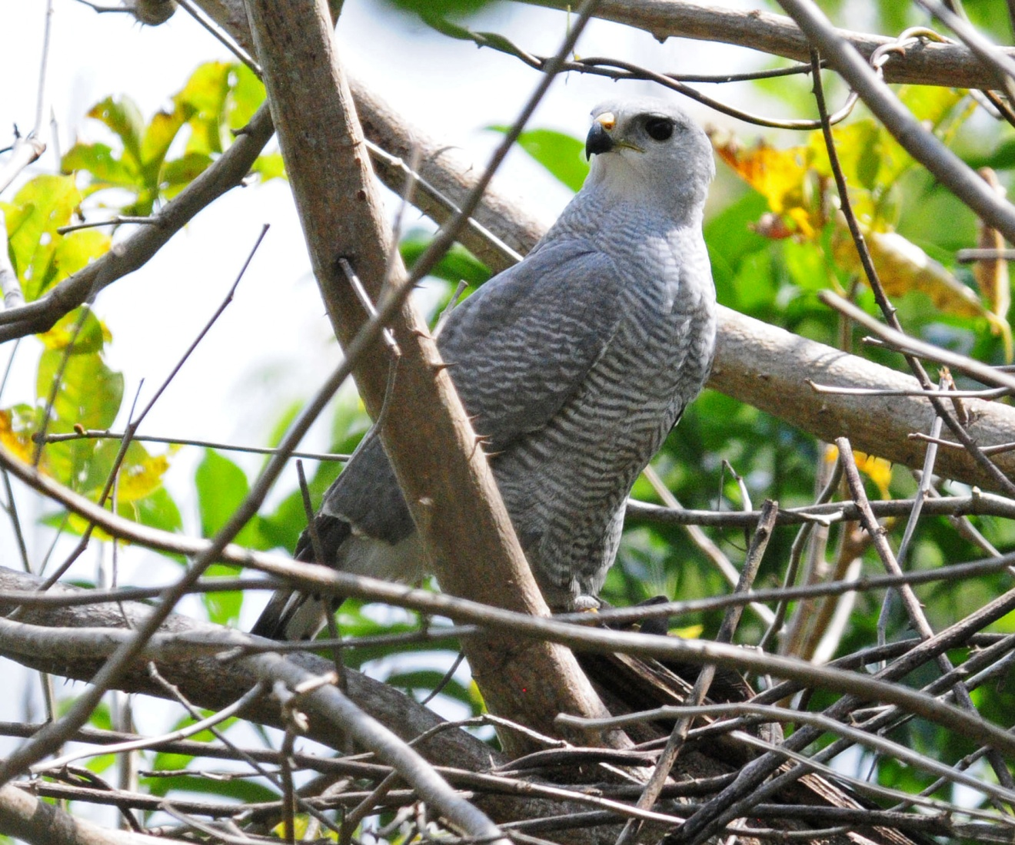
Gray Hawk

As soon as we exited the bus we found a Three-toed Sloth, and when we turned to look in the opposite direction, we could see a Zone-tailed Hawk soaring overhead with some vultures. Paul spotted a White Hawk in the distance - beautiful bird! Near a small pond that was difficult to see because of all the tall plants growing around the edge, we saw Bananaquit, Least Grebe, and Purple Gallinule. As we walked on down the trail, the birding just got better and better. White-winged Becard, Long-tailed Tyrant, Short-tailed Hawk (dark morph), Purple-crowned Fairy, Blue-chested Hummingbird, Tropical Gnatcatcher, Bay-breasted Warbler, Boat-billed Flycatcher, One-colored Becard, Dusky-capped Flycatcher, Keel-billed Toucan, Black-cheeked Woodpecker, Blue Ground-Dove, Tropical Pewee, Summer Tanager, Forest Elaenia, Red-rumped Woodpecker were all seen in rapid succession, among others. The best bird in this group of sightings was probably the gorgeous Blue Cotinga seen flitting about in a tree very near our position on the trail. Not every bird was cooperative, though, and we only got to hear the Black-bellied Wren that was nearby. We had a UFO Tyrannulet that wouldn't come out from behind leaves to give us a look at its field marks, and some Orange-chinned Parakeets flew over quickly. While observing a group of fledgling One-colored Becards, we got great looks at a pair of Orange-crowned Orioles.

Some people started back to the bus, tired from a long day of travel and birding, while others stuck around for a while longer and were rewarded with good looks at Sooty-headed Tyrannulet, White-vented Plumeleteer, Black Antshrike, Collared Aracari, and Dusky Antbird. As we walked back to the bus, we came across a large troop of White-faced Capuchins. At the edge of a wide open field, Paul spotted a perched Laughing Falcon (This guy is some spotter!).
Back at bus, Gail had spotted a Long-billed Starthroat that was still around for the late-comers to see. We made one final stop at a bridge where we sometimes see water tyrants and some waders, but the only birds spotted there were Cocoi Heron, Green Heron and Spotted Sandpiper. We all leaned back and relaxed for the drive home. We were late for dinner, but no one minded. We had seen a whopping 108 species of birds today, with an additional 15 heard only and 7 seen only by the guides. Of the 108 species seen, 53 were new for the trip, bringing our trip total to 182 species. What a day!

Day 5, Wednesday, January 11:
Today we drove to Madden Dry Forest in Chagres National Park. When we arrived shortly after 7:00 AM, the gate was still locked, so we exited the bus and began to bird the entrance road. Right away, we found Snowy-bellied Hummingbird and Scrub Greenlet. We were surrounded by bird song and our expectations were high. We first heard and then saw a Lance-tailed Manakin along the road, but I think Guido and I were the only ones who saw it. We saw a Bright-rumped Attila just before the caretaker arrived and unlocked the gate. We drove the rest of the way to the parking area, where we quickly chalked up Red-lored Amazon, Tropical Kingbird, Squirrel Cuckoo, Variable Seedeater, and Blue-gray Tanager. We wandered back to a picnic shelter and spotted birds from the edge of the forest. From this vantage point, we located Black-tailed Trogon, Red-throated Ant-Tanager, Clay-colored Thrush (Robin), and Blue-crowned Motmot. A female Summer Tanager was being observed when a Gray-headed Kite flew in and landed in a tall tree where it remained visible for quite some time. We heard the incessant calls of the Green Shrike-Vireo along with the intermittent voices of the Slaty-tailed Trogon and Yellow-green Vireos. We walked a short distance down a gravel road and observed Greenish Elaenia, Band-tailed Swift, and Rufous-and-white Wren before our attention was drawn to a Squirrel Cuckoo being chased by a much smaller (unidentified) bird. Multiple Lance-tailed Manakins were seen in this area, but they moved about so quickly that not everyone was able to get a good look. Before leaving the road to walk the forest trail, we also saw Great Crested Flycatcher, Lesser Greenlet, Collared Aracari, and Dusky Antbird.

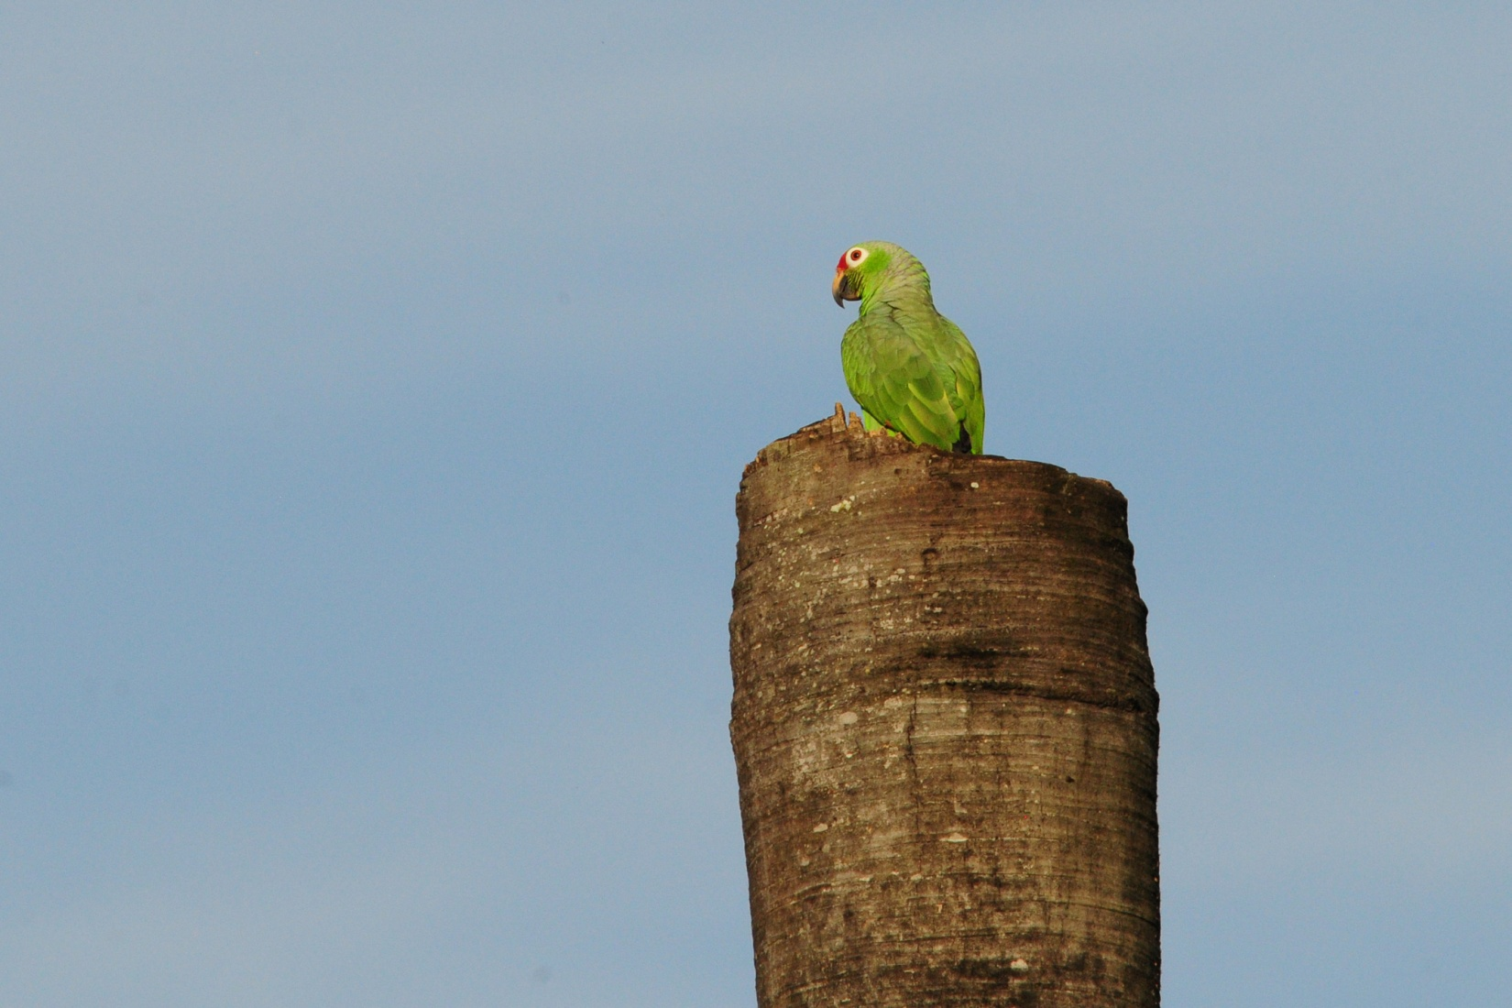
Red-lored Parrot
The forest trail was pretty quiet by now, since the sun was getting high and the day was getting warm. Don and Clotilde had opted to walk more quickly and headed down the trail to a pond. As the rest of the group sauntered down the trail, we found Yellow-olive Flycatcher, Plain Xenops, White-tipped Dove, Rufous-breasted Wren, White-whiskered Puffbird, and Lesser Elaenia. Coming back, we hit a small feeding flock. We identified White-shouldered Tanager, Cocoa Woodcreeper, and Lesser Greenlet before the biggest surprise of the day appeared - Green Shrike-Vireo! Not in the very top of the canopy where you can hear, but not see, it - this bird was flitting about in the branches directly over our heads! The invisible, the mythical had now become a bonafide sighting. By now Don and Clotilde had caught up with the group again, and I think everyone got to see the beautiful green and yellow bird as it moved about the leaves that it so perfectly matched. Before we left Madden, we picked up Panama Flycatcher and some Acadian Flycatchers were seen in the same area with some more Lance-tailed Manakins.

We arrived back at the lodge for lunch shortly before noon, where the group immediately began to observe the feeder birds. It started to rain as we ate, and a Rufous-tailed Hummingbird delighted everyone by bathing in the falling rain. A pair of Gray-headed Tanagers had joined the regular feeder birds. I went upstairs for a short break after I ate, but I had been in the room for only a few minutes when Jim came up to tell me that a Crested Guan had just walked into the yard, along with some Gray-headed Chachalacas. I ran downstairs with my camera and was able to get some decent shots of both birds.

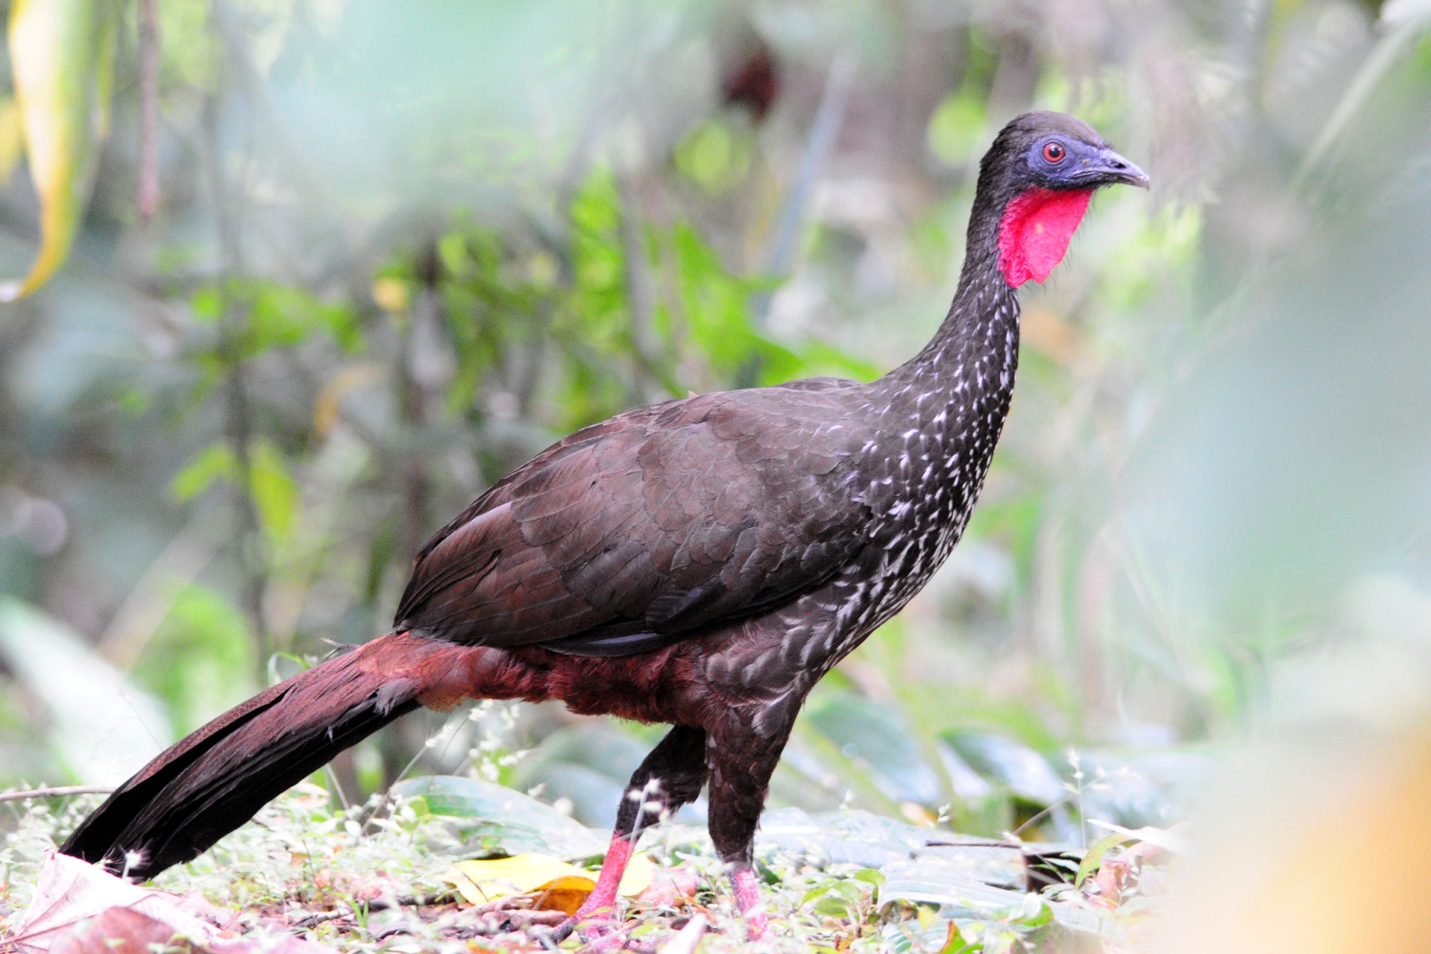
Crested Guan

In the afternoon, we drove to Panama City to check out the mudflats and some other good birding spots, as well as the ruins of the old city. It began to rain again at about 1:45, but it stopped just as we boarded the bus at 2:15. Guido had gone ahead to take care of some business in the city, and we would meet him there. We had to sit for awhile in a parking lot to wait Guido to arrive, but once he was there, it was just a few blocks to the police station which was to be our first stop. The police station borders a small stream where we often find a good variety of water birds, and today was no exception. All of the regular suspects were present and accounted for: Black-bellied Plover, Short-billed Dowitcher, Neotropic Cormorant, Cocoi Heron, Great Egret, Snowy Egret, Little Blue Heron, Green Heron, Black-crowned and Yellow-crowned Night-Herons, Tricolored Heron, Cattle Egret, White Ibis, Solitary Sandpiper, Black-necked Stilt, Willet, Whimbrel, and Spotted Sandpiper. From there, we drove on to the mudflats. An Osprey was seen perched on a construction crane. On the mudflats, we found Long-billed Curlew, Southern Lapwing, and Western Sandpiper along with many of the species we had seen at the Police Station. There were plenty of Brown Pelicans and a few people saw Brown Booby. A Yellow-headed Caracara provided us with the best views yet of this species as it sat on a light post. As we walked up to the ruins of Old Panama City, we noticed a Peregrine Falcon perched on the corner. Some Yellow-headed Amazons flew by as we searched the grass for Saffron Finches. When we left the old part of the city, we probably should have headed for the lodge, but we went instead to a causeway that is often good for specific birds. As we crossed the land bridge, we saw both Royal and Sandwich Terns on a pier. A Belted Kingfisher could be seen perched over the water on the other side of a fence that prevented us from getting closer. Coming back across the causeway, I called out for Guido to stop to see Ruddy Turnstones. The traffic was kind of heavy, and I don't think everyone got to see the birds that were partially hidden by boulders along the edge of the water.

Today was another stellar birding day with almost as many species seen today as yesterday - 106. With 42 of them new to the trip, our trip total now stood at 223. Species seen today that were new to the trip that haven't already been mentioned are Laughing Gull, Band-rumped Swift, Chestnut-mandibled Toucan, Olivaceous Woodcreeper, and Greenish Elaenia.

Day 6, Thursday, January 12:
We awoke early this morning to drive to the Panama City Domestic airport in time for our 7:00 AM flight. The flight was on time and we were out of the David airport and on the bus, ready to begin birding, by 8:00 AM. The airport offers some pretty good birding, and this was to be our first stop. We drove all of 100 yards before finding a stunning Pearl Kite perched in a tree right next to the exit road.

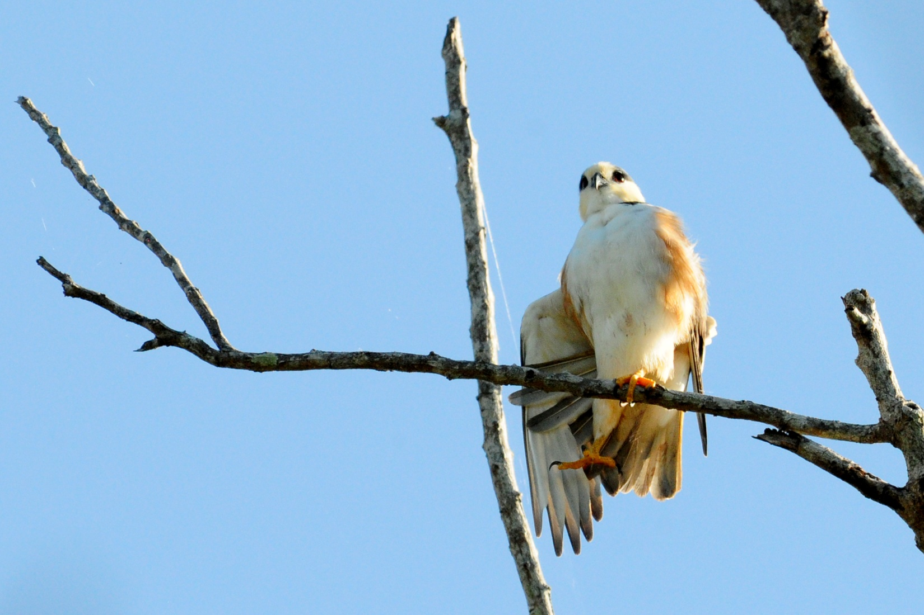
Pearl Kite

In a small pond nearby was a Solitary Sandpiper and a Purple Gallinule. A Green Kingfisher watched the water below from its perch over a small stream on the opposite side of the road. The trees were filled with many of the birds we'd already seen, giving us an opportunity to test our ID skills on Common Tody-Flycatcher, White-tailed Kite, Yellow Warbler, Buff-throated Saltator, Panama Flycatcher, Orange-chinned Parkeets, Ruddy Ground-Dove, Rufous-tailed Hummingbird, and Roadside Hawk. Birds seen here that were new for the trip included Sapphire-throated Hummingbird, Brown-headed Parakeet, Mouse-colored Tyrannulet, Yellow-bellied Elaenia, Yellow Tyrannulet, Streak-headed Woodcreeper, Veraguan Mango (female), and Mangrove Cuckoo. Guido worked to call a Plain Wren out of undergrowth, and although it took a bit of time, almost everyone got to see the bird. Later, near the same spot, a Black-bellied Wren sat still in the open for longer than any wren I think I've ever seen.

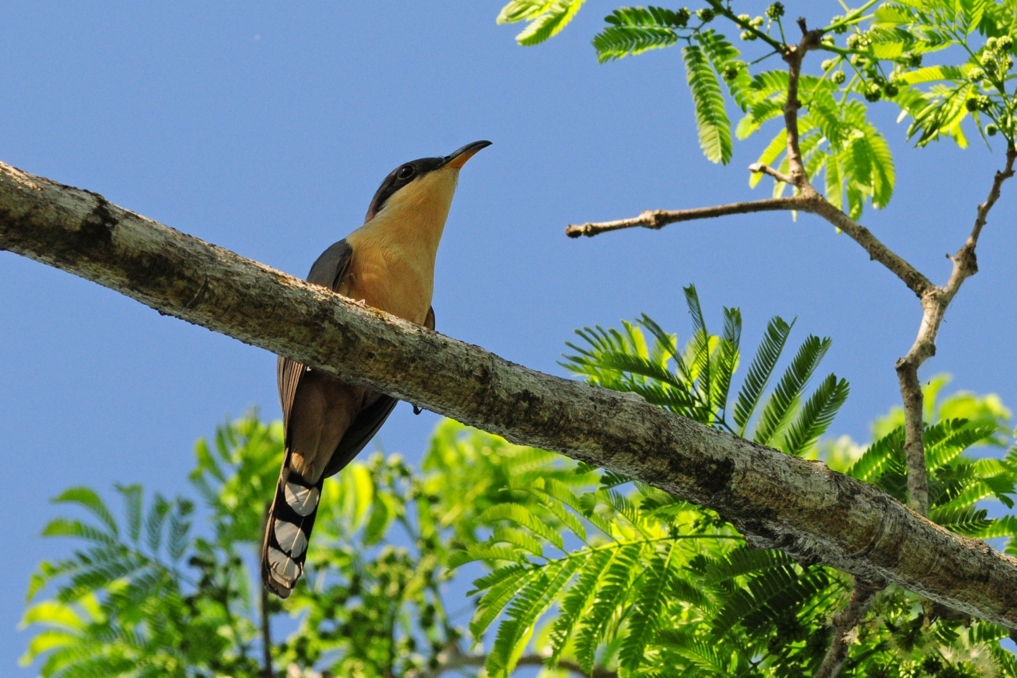
Mangrove Cuckoo

After getting permission to go back to a restricted area, we followed Guido to a forested area a short distance away. Along the way we found Bananaquit and observed Tropical Gnatcatchers building a nest. When we got to the trailhead, it was very overgrown with weeds as high as my shoulders closing in on both sides. It looked like a good place to get chiggers, so Jim and I and George and Sue stayed on main trail while the others explored further. On that trail, the group found a Mangrove Black Hawk and got good views of Lance-tailed Manakin.

We left the airport at around 9:30, noting the Roadside Hawk on the way out, made a quick grocery store stop for water and snacks, and headed to our next birding site. This site features a pond, a small gorge and stream at the bottom of a steep valley near the town of Cuestra de Piedra. Some non-native pines grow near the road here that often harbor some warblers and other neotropical migrants. On the way there, we saw Crested Oropendula and Yellow-faced Grassquit. Lesser Goldfinch was seen in and around the pines as soon as we got out of the bus. For a moment, it felt like spring in the states as Philadelphia Vireo, Townsend's Warbler and Black Phoebe all made an appearance, but then a Green Honeycreeper, Tropical Parula, and Golden-hooded Tanager flew in to remind us of the wide variety of birds that can be seen in Panama. Blue-and-white Swallows were common near the water.

We enjoyed a pizza lunch at Dos Rios Hotel at 12:30. We planned to go back out birding at 2:00PM to go to Volcan Lakes. Don and Clotilde, Fran, and Gene and Gail all decided to stay at the hotel, so I offered to stay with them and try to help them find some birds on the grounds while the others were gone. We agreed to meet at about 3:00 PM, but when I went to get Don and Clotilde, they were sound asleep, so I left them alone. Fran and I began to walk around the grounds, and although we didn't find much, we had a nice afternoon getting to know each other better. We found a Bananaquit building a nest, Wilson's Warbler, Thick-billed Euphonia, and lots of Rufous-collared Sparrows. After a while, Gene and Gail joined us and the four of us walked around the back of the property and then to the front where we found Red-crowned Woodpecker and several Philadelphia Vireos. We walked the short distance to a nearby wetland where egrets come to roost every night. I was sorry to see that the wetland was almost completely choked out by vegetation, but that didn't stop the Cattle Egrets from coming in to roost on schedule. Near this area, we saw an Orange-billed Nightingale-Thrush feeding on bananas. This was a life bird for me, and I was quite excited to have such good looks at a bird that had been very elusive in the past. Several Louisiana Waterthrushes made their presence known in the area around the wetland, as well as in the streams at Dos Rios.

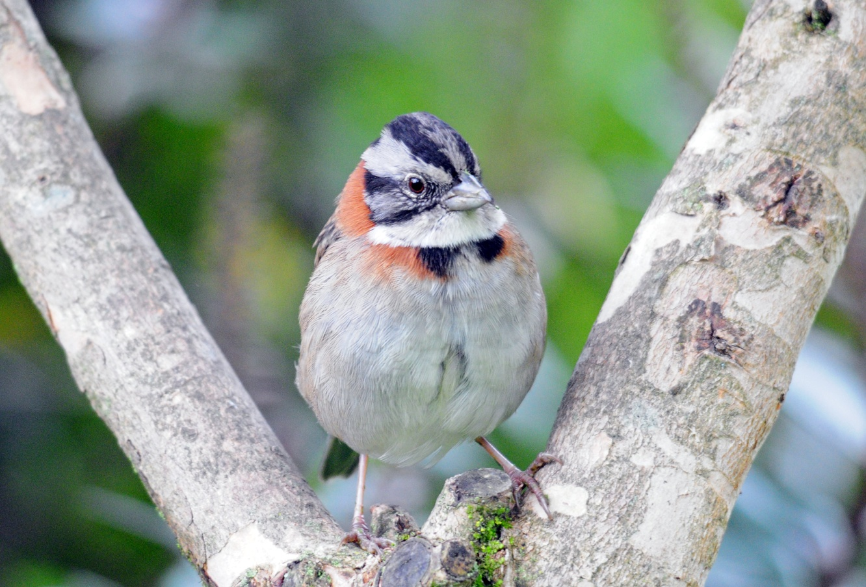
Rufous-collared Sparrow

We went over the day's list in the dining room at Dos Rios Hotel before dinner, and learned that we had seen, as a group, 107 species today - three days in a row with 100+ birds! Our trip total now stood at 264 (41new species today!). Other species new to the trip included Swallow-tailed Kite, White-collared Swift, Vaux's Swift, Green Hermit, Scintillant Hummingbird, Fiery-billed Aracari, Smoky-brown Woodpecker, Red-faced Spinetail, Plain Antvireo, Yellow-bellied Flycatcher, Black-chested Jay, Golden-winged Warbler, Slate-throated Redstart, Cherrie's Tanager, Silver-throated Tanager, Chestnut-capped Brush-Finch, and Elegant Euphonia.

Day 7, Friday, January 13:
Before leaving for La Amistad International Park this morning, we spent some time birding the grounds of Dos Rios. When it grew light enough at around 6:30 AM, we went out front to the area surrounding the light post in the parking lot. Here, dozens of moths and other insects had been attracted to the light, and now the birds were treating the area like a breakfast buffet. Within minutes we saw Baltimore Orioles, Cherrie's Tanager, Blue Diademed Motmot, Tropical Parula, Tennessee Warbler, White-winged Tanager (male and female), Flame-colored Tanager (male and female), Rose-breasted Grosbeak, Philadelphia Vireo, Tropical Kingbird, Palm Tanager, Black Phoebe, Buff-throated Saltator, Common Tody-Flycatcher, Yellow-throated Vireo, Blackburnian Warbler, Brown-capped Vireo, and White-winged Tanager. It was difficult to leave this spot, even when the activity died down a bit, but our primary birding site was La Amistad, and we knew we needed to arrive early enough to hit the most bird activity (but at that altitude, you didn't need to be there at the crack of dawn to see the highest level of activity). We arrived at the small restaurant just inside the gate and began birding as we walked between the van and the front door. We knew we were going to eat breakfast first, but how does a birder ignore Yellow-thighed Finches, Collared Redstart, Ruddy-capped Nightingale Thrush, Spot-crowned Woodcreeper, and Hairy Woodpecker when they practically walk up and introduce themselves? We enjoyed a hot hearty breakfast, watching birds the whole time we ate, adding a female Purple-throated Mountain Gem to the list. As we walked away from the restaurant, we found in one small area Black-cheeked Warbler, Flame-throated Warbler, Yellow-thighed Finch, Ochraceous Wren and a hummingbird that remained unidentified. A bit further up the trail, we found a Streak-breasted Treehunter foraging in the company of a Collared Redstart. As we were watching a Zeladonia (aka Wren Thrush), a Buffy Tufted-cheek flew into view. Jim had a Ruddy Treerunner at about the same time we heard Gray-breasted Wood-wren.

Some in our group found it difficult to walk all the way to the top of the hill, so the Van picked us up half way up and drove us to the top, where Blue-and-white Swallows swooped low over the vegetation. There, we saw a Yellowish Flycatcher sitting at the edge of the clearing and multiple Wilson's Warblers flitting about in the brushy edges. Some of us continued up the next trail which was steeper and narrower, while others stayed at the shelter to see what might come in. As we continued up the hill, we got good views of a Common Tufted Flycatcher perched in the sun. A White-throated Mountain Gem was seen nearby. A Yellowish Flycatcher was seen just as we rounded a corner to continue up a small hill to what appeared to be an old dairy barn, a site that is to be refurbished so it can be used by scientists as they conduct rainforest research in the future. We walked around inside the old buildings and found that the open-air design made a perfect bird hide as we watched a photographed a Black-capped Flycatcher.

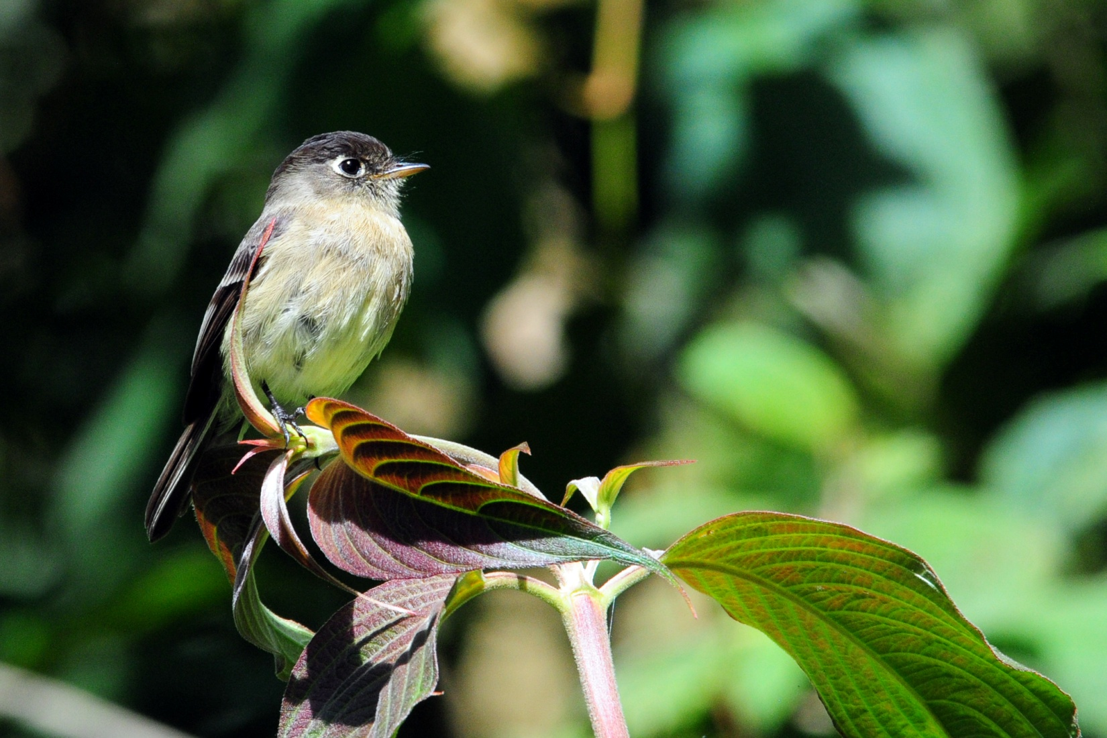
Black-capped Flycatcher

We returned to the same little restaurant for lunch and enjoyed a nice hot meal of chicken, rice, beans, and dessert as we watched birds from the outdoor dining area. We watched a Magnificent Hummingbird land on the railing and lap sugar water that had dripped from the feeder above. Paul spotted a Mountain Robin from the deck. We walked to a bridge near the entrance to the park after lunch in hopes of finding a White-capped Dipper, but we couldn't find any dippers. We started back toward Volcan, making a few stops to take some photos of the agricultural fields that utilized every square inch of land available, including some incredibly steep hillsides. While we were stopped at one point, a Red-tailed Hawk flew by with a lizard in its mouth - while most of us have seen Red-tails with prey, none of us could remember ever seeing one flying with its meal in it beak rather than it talons. A Yellow-headed Caracara was spotted sitting on the ground in a farmer's field. Yellow-faced Grassquits were seen multiple times along the edge of the road.

Our next stop was at a lovely B&B called Ceilito Sur near Volcan. The owner graciously allows us to come to view the feeders there and to bird in his gardens. In the trees near the area where some caged birds are kept, we saw Flame-colored Tanager and Rose-throated Grosbeak. At the hummingbird feeders, we had Violet Sabrewing, Green Violet-ear, Snowy-bellied Hummingbird, Rufous-tailed Hummingbird, Stripe-tailed Hummingbird, and Magnificent Hummingbird. At a feeder that offers oranges and bananas we saw Speckled and Silver-throated Tanagers, but it was a bit difficult for them to compete with the abundant Clay-colored Thrushes and Rufous-collared Sparrows.

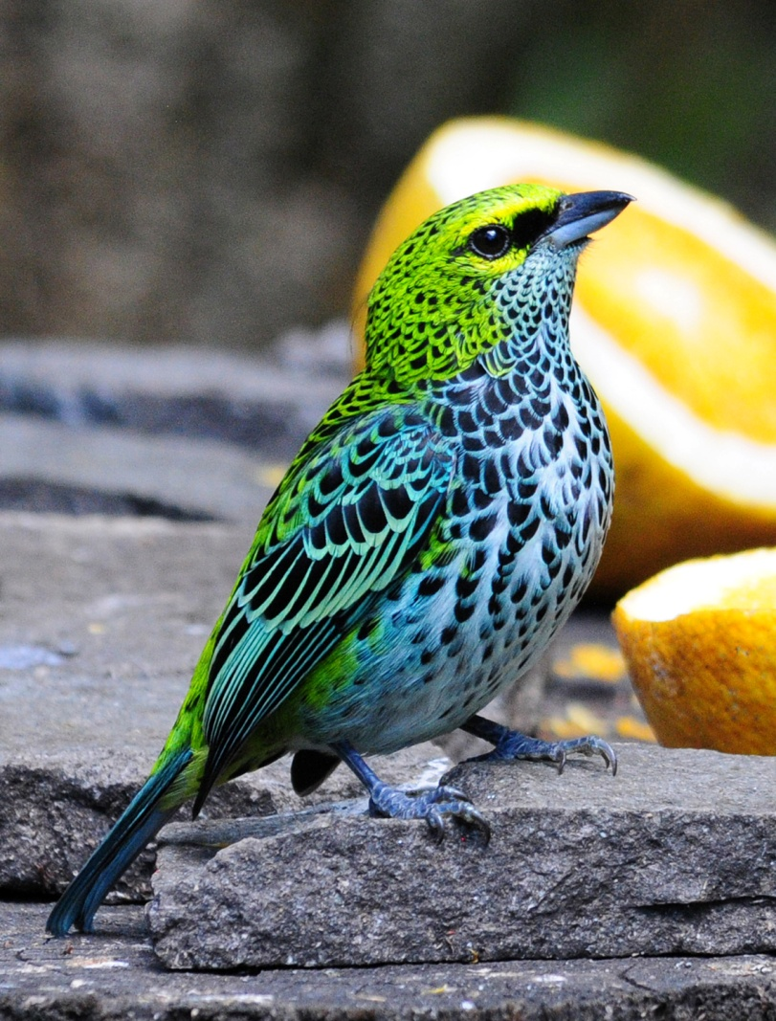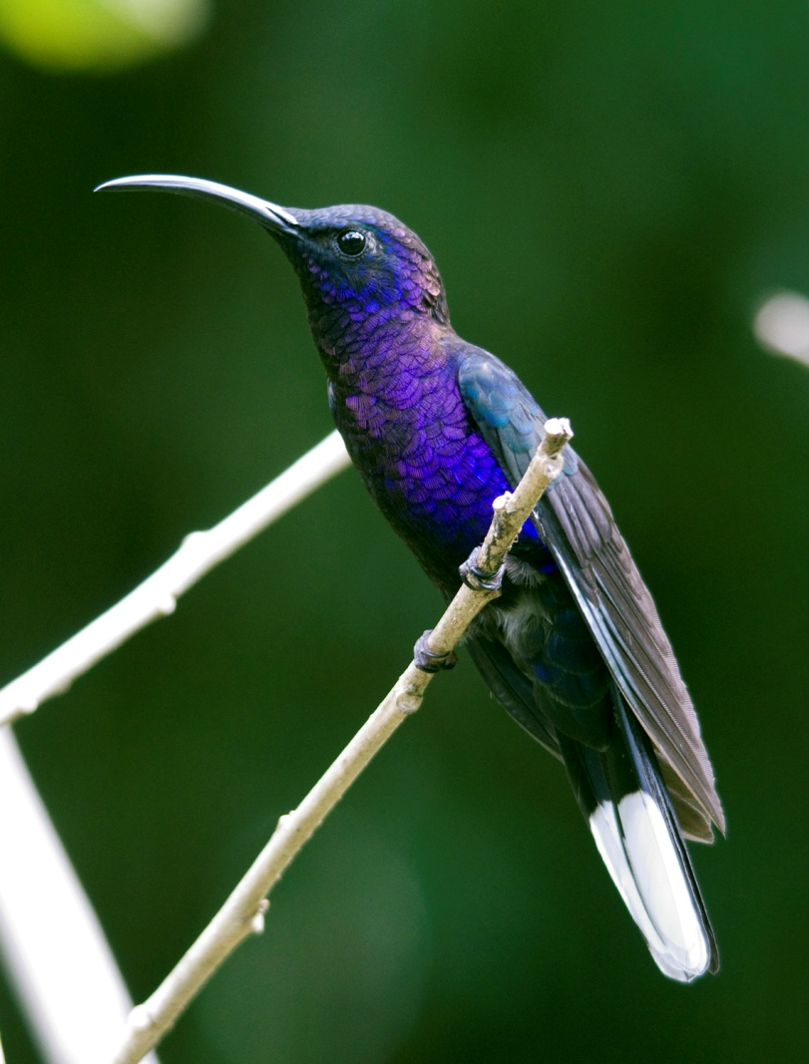
Speckled Tanager Violet Sabrewing

We decided that our next destination would be Santa Clara, an area near Volcan where we could search for some higher elevation species. From there, we would enjoy a good vantage point to see canopy birds at eye level as we looked over a valley. This is also good place to see raptors soaring. Part of the group was tired from our long day of birding and asked to be dropped off at the hotel. When we arrived at Santa Clara, there wasn't much bird activity. We walked through a coffee plantation where we spotted Bay-headed Tanager and a Scarlet-thighed Dacnis female, and not much else.

Our count for today was 84 species seen and 9 heard only, bringing our trip count to 298. The second new species we find tomorrow will be our 300th bird. Other new species seen today that haven't already been mentioned included Black-faced Solitaire, Ochraceous Wren, Yellow-winged Vireo, Green-fronted Lancebill, and Broad-winged Hawk.

Day 8, Saturday, January 14:
This morning we left Dos Rios at 6:00, which didn't allow for any time for us to bird around the lamp post that had been so productive yesterday. We drove to Las Orchaedias B&B near the entrance to Baru Volcano National Park. It was still dark when we arrived at "Mama Jenny's", a lovely B&B owned and operated by a Chinese family who prepare and serve wonderful meals for their guests. We enjoyed a hot breakfast before going on to the park, leaving just as the day was getting bright enough to see well. As we were leaving, we saw Yellow-faced Grassquit and Wilson's Warbler in the front yard. I was trying to get a better look at a warbler in some bushes near the front door when Paul walked up behind me and identified the bird as a MacGillvray's Warbler. The warbler was bird # 299 - the next new species would be our 300th bird. We all piled in the bus and headed for Baru.

As soon as we arrived at the entrance to Baru Volcano NP, we saw first one, then another, male Resplendent Quetzal moving about in the trees right next to the road. Magnificent! Not only did we get stunning views of the target species for today, but it was our 300th species for the trip! We watched as the two males, now joined by a female, sallied out from branches to grab fruit, their long tails flowing behind them. What a sight!

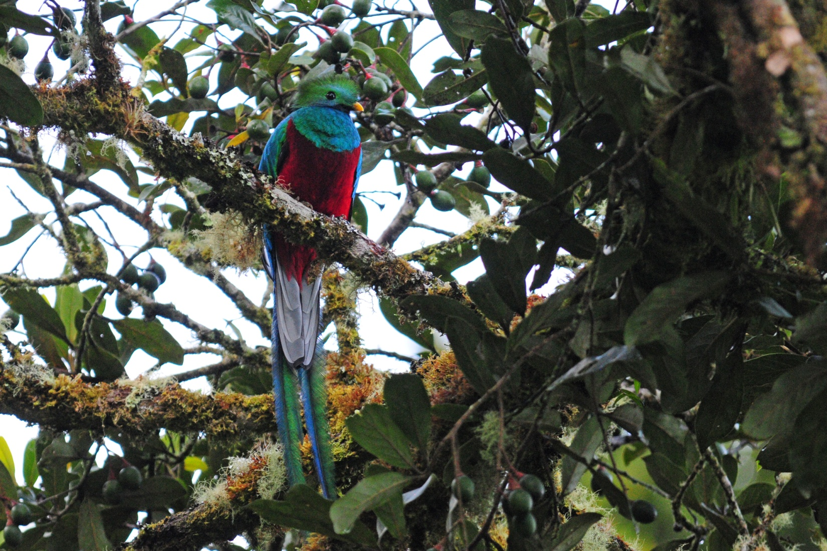
Resplendent Quetzal

As we were watching and trying to photograph the Quetzals, Guido spotted bird #301, a Long-tailed Silky Flycatcher, but everyone was so absorbed with the Quetzals that he was the only one who got a look at the bird. Luckily, we found more Silky-Flycatchers later. Guido also saw a Slaty Flowerpiercer, but again, no one stopped enjoying the star performers to take a look. He heard a Blue-throated Toucanet calling, but there was no use in trying to divert anyone's attention away from the Quetzals - he just had to be patient and let us have our fill of this wondrous creature.

Finally, Guido forced us to stop looking at the Quetzals long enough to check out a Rough-legged Tyrannulet in the branches over our heads. Once the spell was broken, we also paid attention to the Silky-Flycatchers that had come back into view. We moved on up the trail and had a steady stream of birds as we moved uphill: Gray-breasted Wood-wren, Acorn Woodpecker, Slaty Flowerpiercer, Barred Becard, Yellow-winged Vireo, Volcano Hummingbird, Black-throated Green Warbler, Black-billed Nightingale-Thrush, Rufous-browed Peppershrike, Ruddy Treerunner, Large-footed Finch, as well as many of birds we saw yesterday such as Wilson's and Black-cheeked Warbler and Yellow-thighed Finches. Guido identified a Black-throated Trogon that was in the wrong elevation for its range, but after checking the cooperative bird out through the scope and taking some photos so we could zoom in, there was no doubt that this was a Black-throated Trogon.

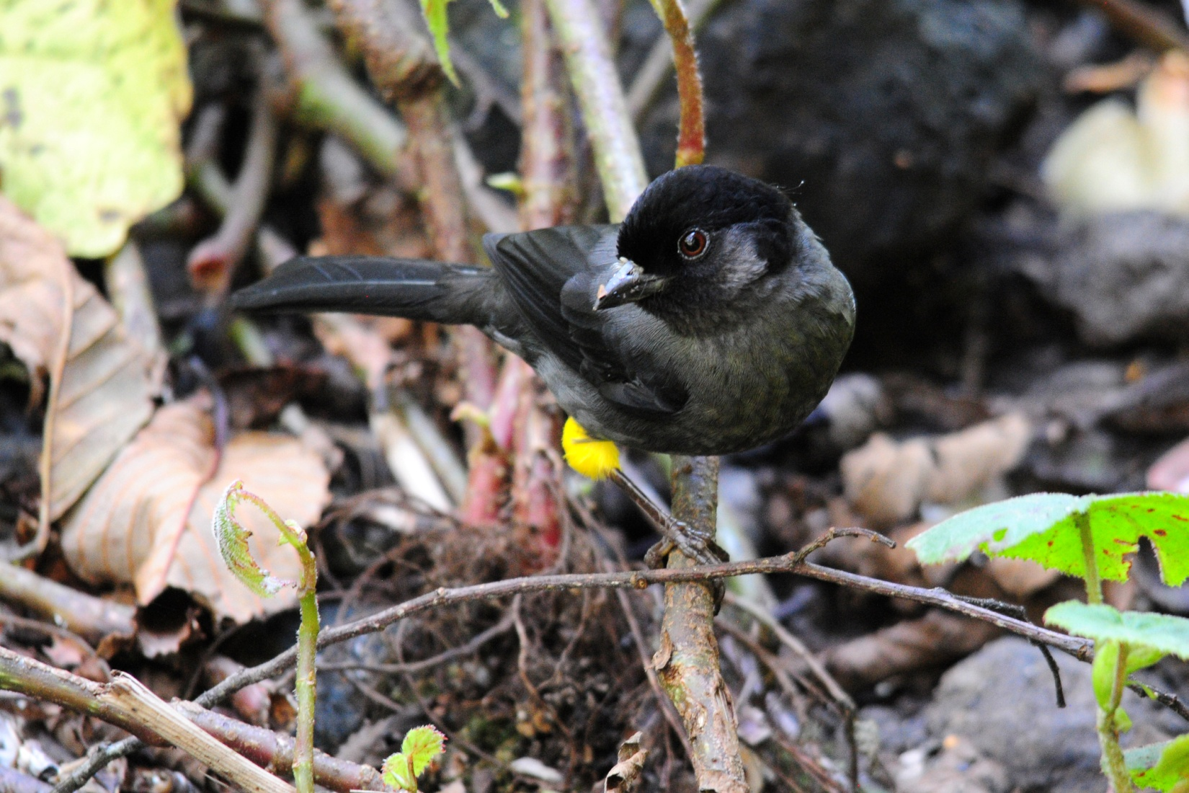
Yellow-thighed Finch

We returned to Mama Jenny's for lunch of fabulous Chinese dishes - a marinated cabbage appetizer, Sweet & Sour Chicken, Broccoli & Beef, tortillas, rice, and ice cream for dessert. It's a good thing we're getting some exercise on a day that Mama Jenny is feeding us! The B&B sat on a hill overlooking a stream below, and we had nice views of this area from the breakfast room. After eating, some of the group went outside to look around the grounds. Paul walked to the stream and found a couple of Torrent Tyrannulets hunting in the rapids. We also found Chestnut-capped Brush-Finch before leaving the B&B.

We made a brief stop at Cielito Sur B&B on the way back to Dos Rios for some people to purchase coffee. I took the opportunity to grab some last hummingbird photos, and then we gathered our things from the hotel and made our way to the David Airport to fly back to Panama City and then on to Gamboa.

The bird count for the day was just 64 species, but high elevation birding days are often about quality rather than quantity. Our trip total now stood at 316. Other birds seen today that were new for the trip included Ruddy Pigeon, Sulfur-winged Parakeet, Mountain Elaenia, and Sooty-capped Bush-Tanager.

Day 9, Sunday, January 15:
For our last day, we decided to go back to Pipeline Road. This is one of the very best birding sites in Panama, and we hadn't gotten very far on our first morning there, so we hoped to pick up a few species that we might have missed.
In the afternoon, we planned to visit Summit Ponds, Old Gamboa Road, and Summit Gardens before going to Miraflores Locks for a brief tour before having dinner at the restaurant overlooking the locks. Our final day was going to be a busy one!

We had breakfast at 6:00 AM for a 6:30 departure. As soon as we exited the bus, we saw Little Hermit and heard Purple-throated Fruit Crows. As we walked down Pipeline Road, we were impressed with the amount of bird activity. We saw Lineated Woodpecker, and Paul found a Keel-billed Toucan. We had been hearing Chestnut-mandibled Toucans just about every day, but we had not yet seen one. Today, we saw a pair of them grooming each other in a tree not too far from the trail. A couple of people got on a Bright-rumped Attila. We followed two Chestnut-backed Antbirds as they foraged at the side of the road until everyone in the group was satisfied with the views they got. A Black-faced Antthrush came in, and we walked off the main trail to see a Streak-chested Antpitta. The list grew as we walked on: Scarlet-rumped Cacique, Chestnut-headed Oropendola, Cinnamon Woodpecker, Broad-billed Motmot, Western Slaty Antshrike female, and Black-striped Woodcreeper. We found Great Jacamar and Pied Puffbird and heard Brownish Twistwing and Violaceous Trogon calling.

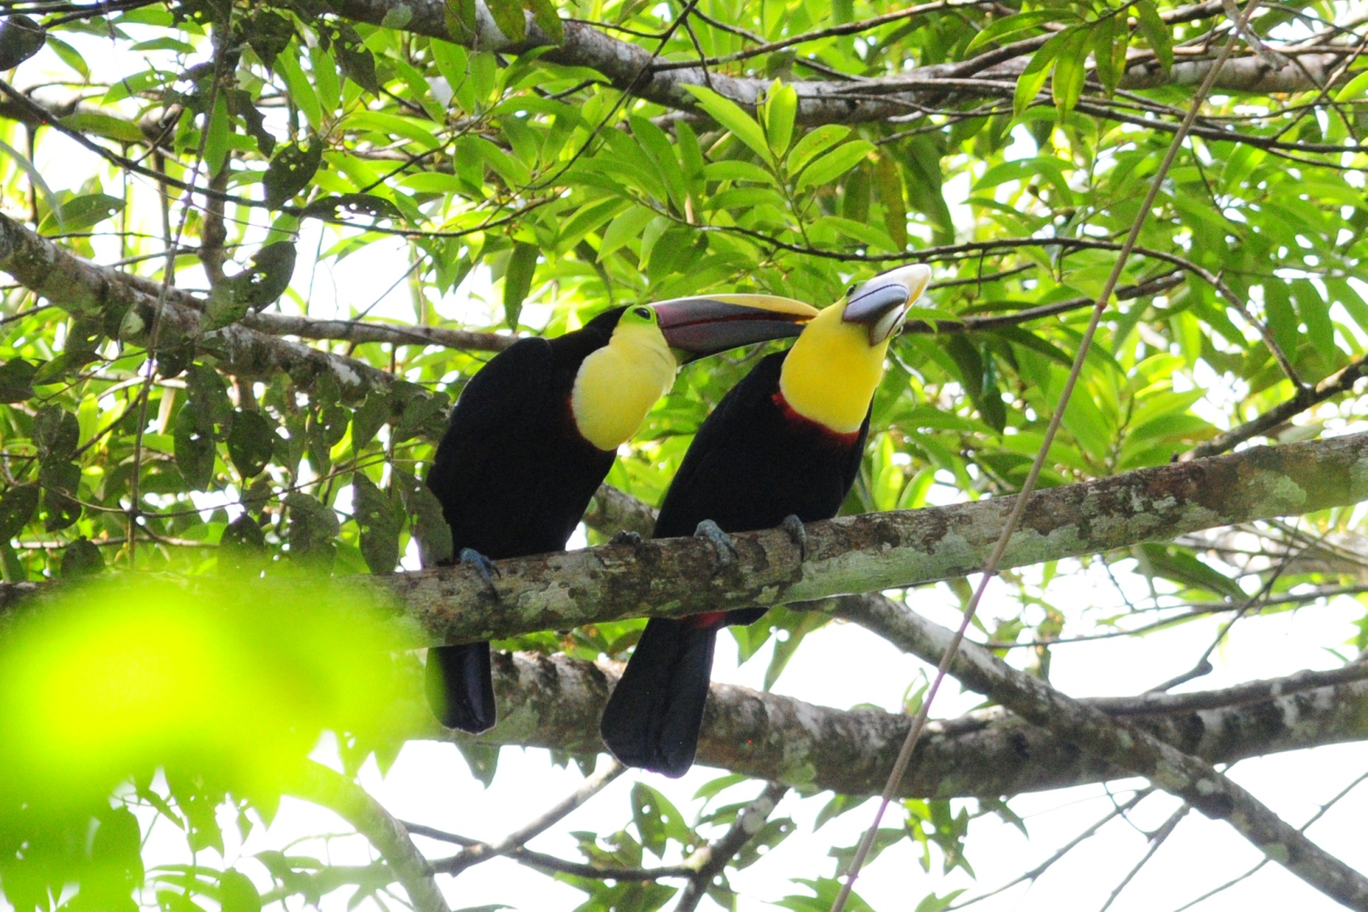
Chestnut-mandibled Toucans

We came across multiple mixed flocks, the first one yielding male and female White-flanked Antwren, Dot-winged Antwren, Checker-throated Antwren, Black-striped Woodcreeper, Olivaceous Flatbill, Plain Brown Woodcreeper, Gray Elaenia, White-shouldered Tanager, Bay-breasted Warbler, and Sulfur-rumped Flycatcher. In the midst of all this, we got a fleeting glance at some Lesser Swallow-tailed Swifts and heard Red-capped Manakin.

We walked quite a ways down Pipeline Road before turning back. This had been the best morning I've ever had on Pipeline, and I hated for it to end. Walking back to the bus, we came upon our second mixed flock containing Ruddy-tailed Flycatcher, White-flanked and Dot-winged Antwrens, Sulfur-rumped Flycatcher, Lesser Greenlet, White-shouldered Tanager, Plain Xenops, Yellow-margined Flatbill, a couple of Woodcreepers, Tropical Gnatcatcher, Chestnut-sided Warbler, and Southern Bentbill. We had stopped to marvel at the beauty of a Malachite Butterfly when Guido spotted a White-whiskered Puffbird which sat still long enough for us to view it through the scope. A group of Song Wrens shot back and forth across the road.

When we got back to the van, Jim was pointing out a Little Tinamou to our bus driver, Marcos. Clotilde had been resting on the bus when she saw it run across the road. As we were preparing to board the bus, another mixed flock appeared, this time with Checker-throated Antwren, Cocoa Woodcreeper, Red-throated Ant-tanager, Plain Xenops, Fasciated Antshrike, Western Slaty Antshrike, and Black-bellied Wren. Guido wanted to head back to the lodge for lunch, but we wouldn't hear of it! Jim spotted a Black-breasted Puffbird perched over the van and a Black-tailed Trogon flew in and landed right over our heads.

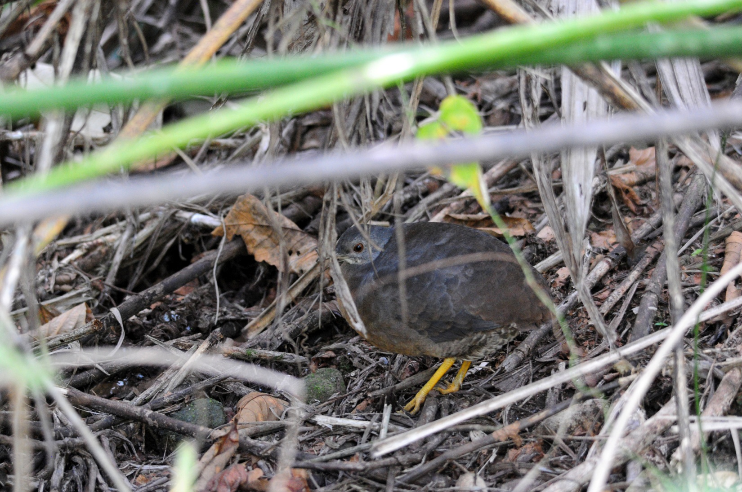
Little Tinamou

We finally pulled ourselves away, but as we were driving out, Guido noticed an ant swarm and its attendant birds off to the left. Here we saw three different species of woodcreepers, Barred, Plain Brown, and Cocoa, along with Gray-headed Tanager, Spotted and Bicolored Antbirds, and Checker-throated Antwren. In the background, a
Rufous-vented Ground-Cuckoo was so well-camouflaged and stealthy that it was seen only by a few people.

Again, it was difficult to leave Pipeline - it had lived up to its reputation this morning! Went back to the lodge for lunch and a short break, then on to Summit Gardens. It was Sunday, so the park was crowded when we arrived, and we couldn't drive through the gate without talking to someone in authority who wasn't available, so we went to Summit Ponds first. This was as simple as crossing the highway, and we were lucky to be able to drive back and park near ponds instead of walking in. There, we found Boat-billed Heron, Amazon Kingfisher, Prothonotary Warbler, and Fulvous-vented Euphonia before walking a short distance to find the Spectacled Owls that usually roost in the area. We found two fledging owlets, and they were much more skittish than the adults we usually see. Guido had asked the group to stay back and have only a few people advance at a time. Unfortunately, those who were last didn't get to see the owls except as they were flying away. We tried to find the owls again, but finally had to move on. As we were boarding the bus, we saw a Three-toed Sloth in a nearby tree.

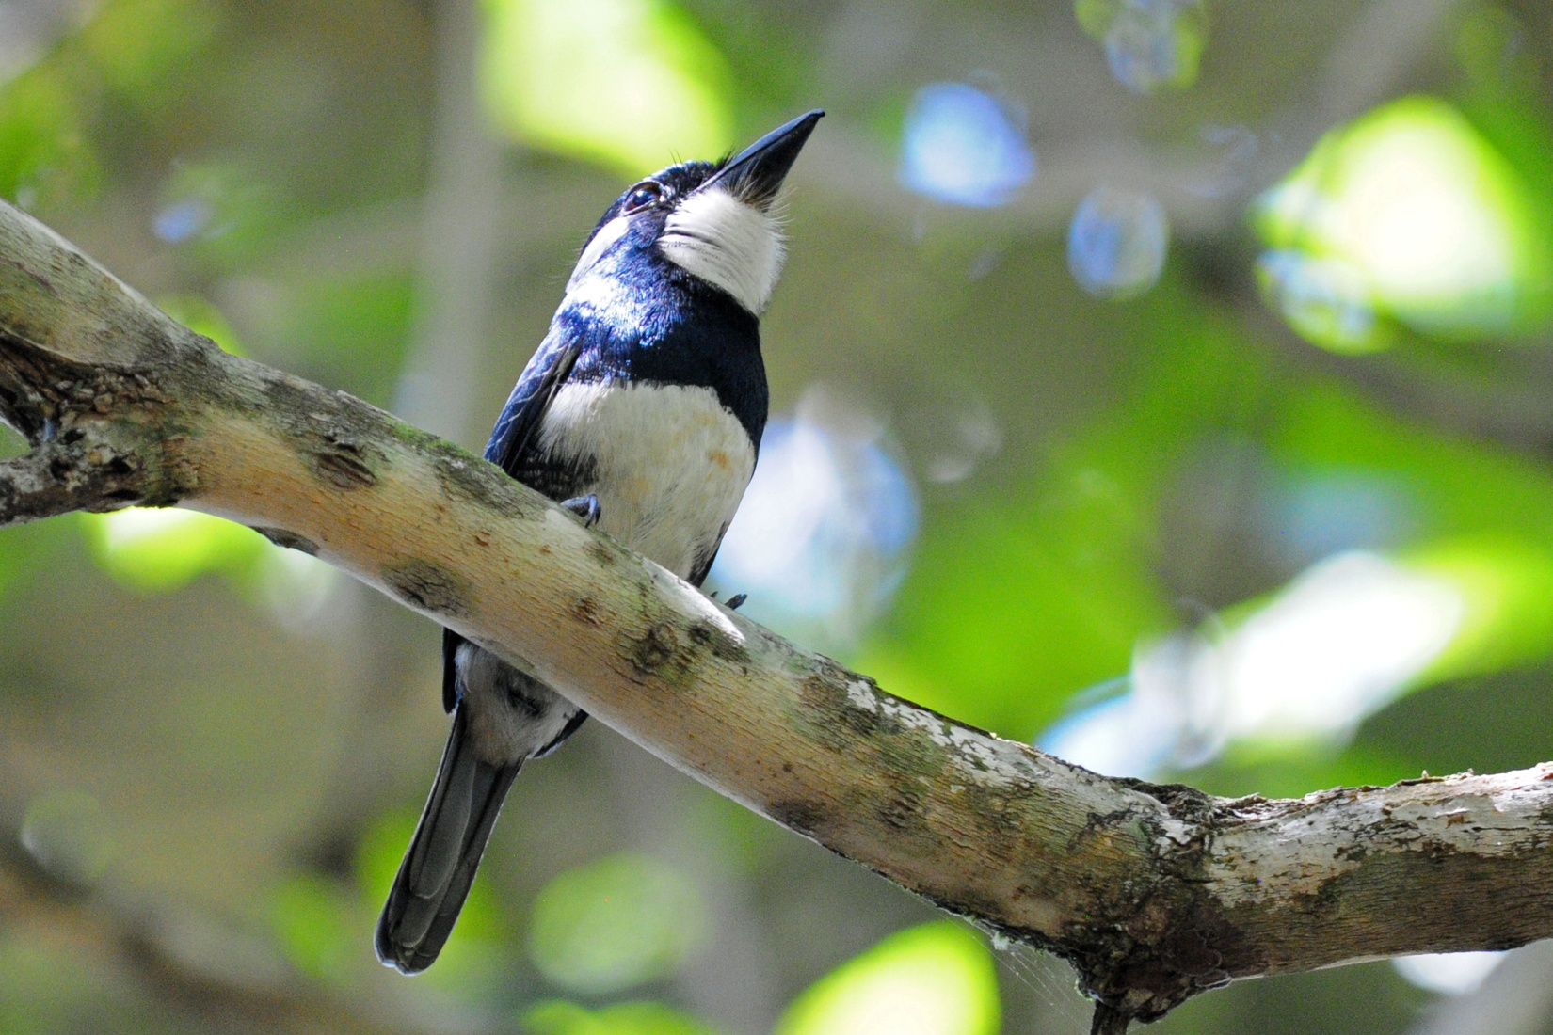
Black-breasted Puffbird

We had to make a very fast stop at Summit Gardens so we could get to the Miraflores Locks in time to tour the museum. Guido called and got the latest information so we knew that we could enter the museum as long as we arrived by 4:00 PM. We drove straight to the Harpy exhibit, allowed time for people to go around back and see the bird, and then headed for the locks. When we got there, we were told we were too late to tour the museum, even though we approached the ticket booth well before 4:00 PM. Some of the group wanted to relax and get a drink at the restaurant, while a few of us went with Guido to get in some final birding nearby. Guido was unhappy to see a development being built in the area he wanted to bird. We didn't add anything new to the trip, but we did get some good looks at some familiar birds.

Everyone enjoyed a wonderful buffet dinner overlooking the MIraflores Locks. Guido's lovely wife Naomi joined us, as did our friend from the Canopy Tower, Carlos, and his wife Evelyn, and our bus driver Marcos and his son. We returned to the lodge and quickly went over the checklist before going to our rooms to organize our things for tomorrow's departure. We observed 26 new species today, which is quite unusual for the final day of a trip. In addition to species already mentioned, other new species included Gray-chested Dove, Rufous Motmot, Gray Elaenia, Purple-throated Fruitcrow, Red-capped Manakin, and Kentucky Warbler. We finished the day with 109 birds seen and 17 additional species heard only. Our official trip total stood at 342 species.

Day 10, Monday, January 16:
Each group was transported to Tocumen Airport in Panama City at the appropriate time for their flights.

cheepersbirding.com

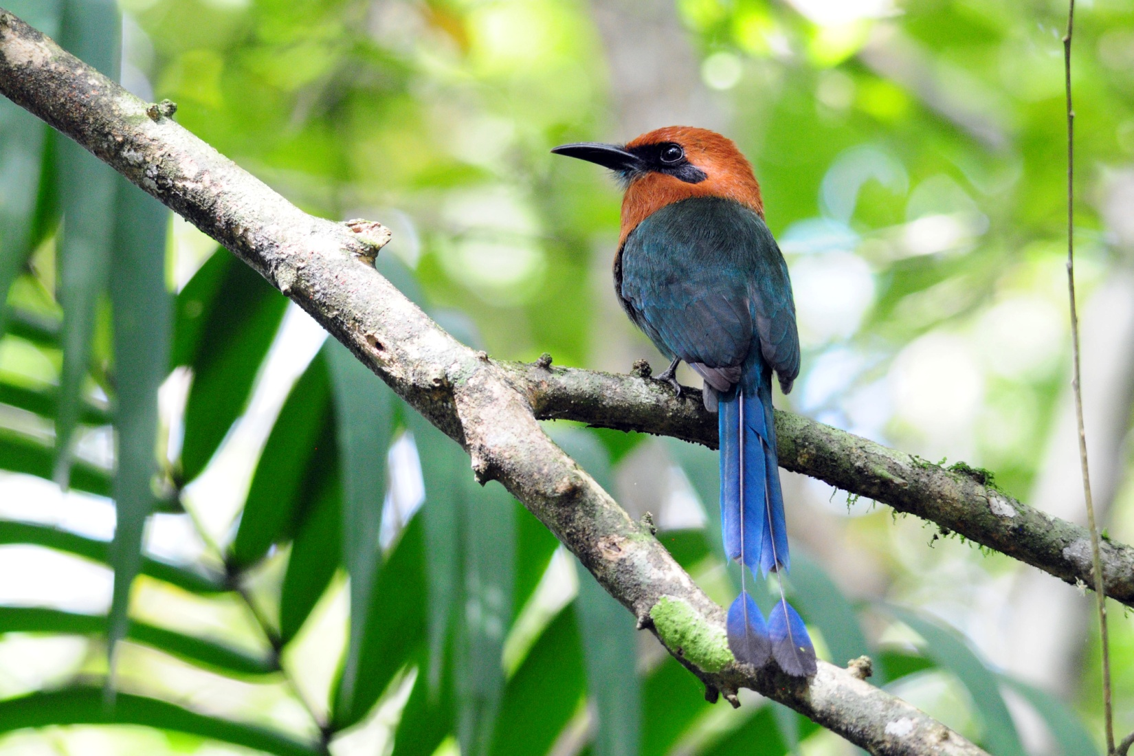
Broad-billed Motmot

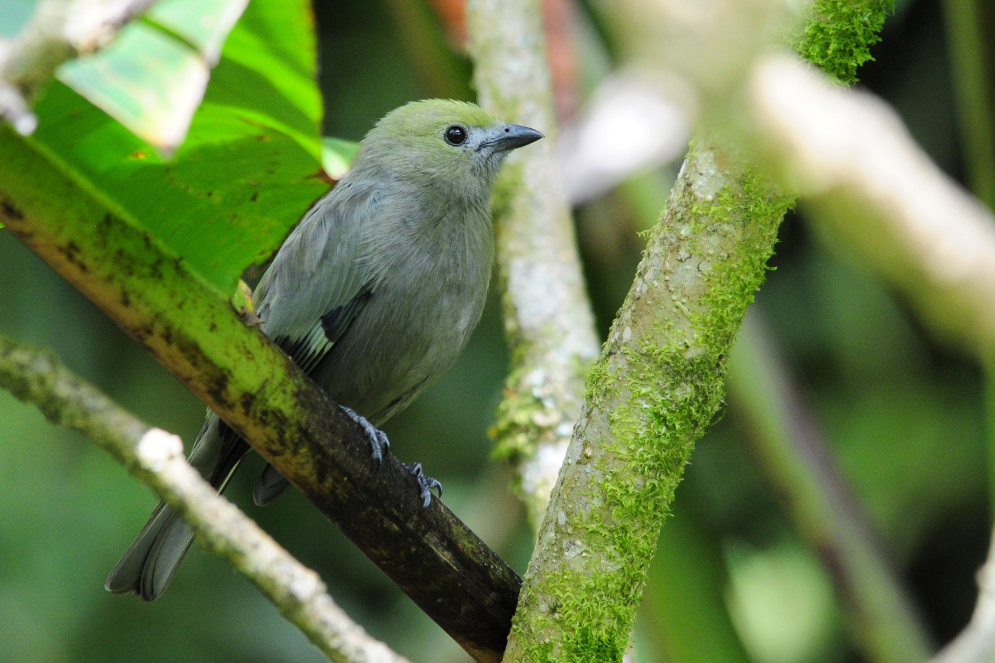
Palm Tanager

