Northern Ecuador
with Amazon Basin Extension
Trip Report
November 19 – Dec. 4, 2011
Extension Dec. 3 - 8, 2011

Disclaimer: This report is as accurate as possible using limited recordings and notes taken in the field. Species have been reported on the proper day(s) but, with multiple sites visited on the same day, it is possible that some species are listed as being seen at the wrong location. Any such errors are unintentional. All photos were taken by the author.

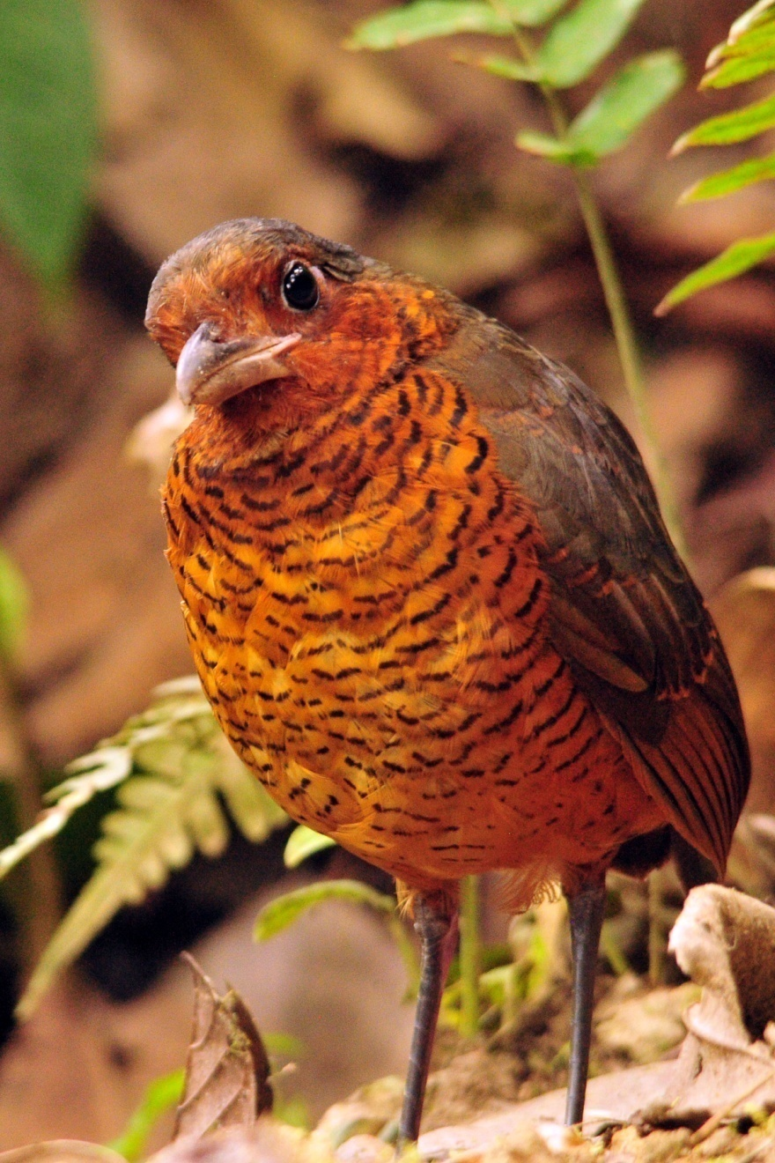
Species seen by group: 525 + 18 subspecies
Species heard only: 61
Total reported species, all observations: 604, including 62 Hummingbird species
Birding Guides: Marcelo Andy and Galo Real
Tour Leaders: Jim & Cindy Beckman, owners of
Cheepers! Birding on a Budget
Group: 12 + 2 Tour leaders and 2 guides
Highlights: Zigzag Heron, Capped Heron, Agami Heron, Andean Condor, Black-chested Buzzard Eagle, Black-and-white Hawk-Eagle, Black-and-chestnut Eagle, Collared Forest-Falcon, Sungrebe, Rufous-bellied Seedsnipe, 21 species of Parrots and Macaws, including Scarlet Macaw, Hoatzin, 8 species of Owl including Spectacled, Black-banded and Band-bellied, Oilbird, 62 species of Hummingbirds including Olive Spotted, all 5 of the possible Kingfisher species, White-chinned, White-eared, Coppery-chested, and Purplish Jacamars, Chestnut-capped Puffbird, 5 of 7 possible Barbets including Toucan Barbet, Lafresnaye's Piculet, Long-billed Woodcreeper, White-bellied and Parker's Spinetails, Uniform and Black-billed Treehunters, Long-tailed Antbird, Rufous-capped Antthrush, 7 species of Antpitta, Black-necked Red Cotinga, Scaled and Green-and-black Fruiteaters, Spangled and Plum-throated Cotingas, 9 species of Manakins inlcuding Club-winged and Wire-tailed, Cerulean Warbler, Blue-naped Chlorophonia, 35 species of Tanager including Guira and Paradise, Oriole Blackbird, Red-breasted Blackbird, Golden-eared Toucanet, Great Tinamou
Giant Antpitta Report written by Cindy Beckman
Day 1, Saturday, November 19: Some of our group of 12 arrived a day early to allow some time to acclimate to the altitude before our first day of real birding. Jean arrived two days early and stayed at the San Jorge Lodge near Quito, where Richard and Joan met her on Nov. 18 for one night’s stay. All three will meet us for dinner at the Sebastian tonight. Peter & Joan, Barbara, Margaret, and Marion all arrived on the same flight with us on the evening of the 18th. Our guides, Galo and Marcelo, picked us up at the airport and took us to the Sebastian Hotel in Quito. Matt & Cathy and Walt & Jackie were scheduled to arrive this morning and will join us for lunch and a tour of the historic part of the city.

We enjoyed a leisurely breakfast before departing the Sebastian at around 9:00 AM. We were happy to see Luis, who had been our driver for our last two Ecuador trips. He is not only an excellent driver, he’s a really nice guy whose company we enjoy. The group of six boarded the 22-passenger bus for the short drive to the Botanical Gardens. We started seeing some common city birds before we entered the gardens, including Great Thrush and Eared Dove. As soon as we entered the gate, we could hear the persistent chirp chirp chirp of a Sparkling Violet-ear and Marcelo quickly located the large hummingbird in a tree. We enjoyed better looks at some Great Thrushes before proceeding down the walkway. We hadn’t gone far when Marcelo alerted us to the presence of a life bird for Jim and me (and, of course, everyone else). It was remarkable that Marcelo could say to us, “You have seen that bird before” or “This is a life bird for you” at times when we weren’t 100% certain ourselves. He remembered from our three previous trips with him exactly which birds we had seen and which birds we had not seen. This time, however, I didn’t need his help with the life list because I knew when I looked up at the Scrub Tanager that I had never seen it before. As we strolled through the gardens, we found Black-tailed Trainbearer, Rufous-collared Sparrow, Hooded Siskin, Black Flowerpiercer, and Cinereous Conebill.

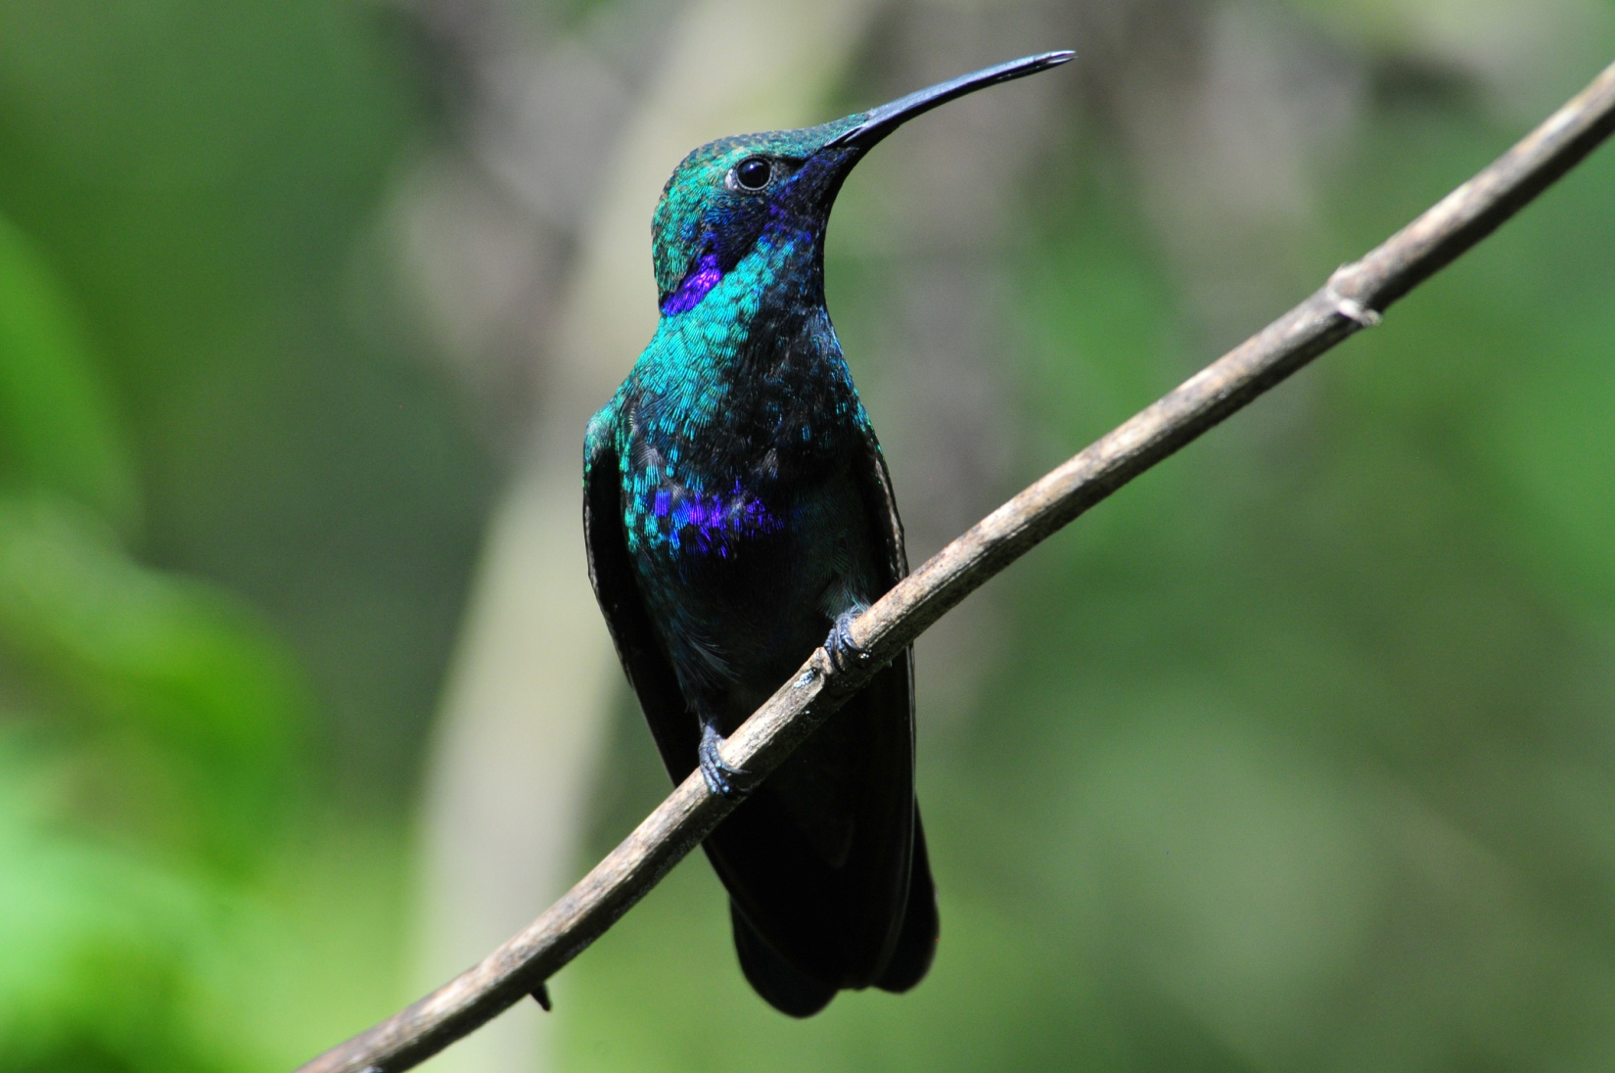
Sparkling Violet-ear

We enjoyed viewing the gorgeous flowers in the Botanical Gardens as well as some of the cultural displays, and it felt like we had barely arrived when Galo announced that we should get back to the hotel to pick up the new arrivals. We thought they might like to have some time to freshen up a bit and maybe even rest for awhile, but when we pulled up to the Sebastian, Matt and Cathy were standing in front, binoculars in hand, ready to find some birds. In fact, they had already walked around the neighborhood and found the common species with Walt and Jackie. We loaded up the bus and proceeded to Pim’s, a nice restaurant overlooking Quito, for lunch. The group appreciated the 360 degree views at Pim’s as Galo and Marcelo pointed out the volcanoes that were visible and landmarks in the city below. After enjoying a wonderful meal, we went on a short tour of the historical parts of Quito. When we returned to the Sebastian, Jeanne, Joan and Richard were there, and we took a few minutes to pre-order our dinner before going to our rooms for a short rest. We had encountered long waits for our meals at the Sebastian the year before, and we wanted to avoid that on this tour. We were back at the Sebastian in time for an early dinner that was served quickly, thanks to our pre-ordering.

We finished the day with a mere 12 species, but since this wasn’t really a birding day, we were all happy to have had a leisurely introduction to some of Ecuador’s most common species. The little taste we had made us very excited to start bright and early the next morning for some real birding.

Day 2, Sunday, November 20: We set our alarm at 5:00 for a 6:00 AM breakfast with plans to leave the Sebastian between 6:30 and 6:45 to drive to Yanacocha. Only part of the breakfast food was out when we arrived at 6:00, and it took quite awhile for the staff to begin preparing our omelets and eggs, so our departure was delayed until a little after 7:00. It was almost 9:00 AM by the time we arrived at Yanacocha. As some of us walked to the back of the small building to use the restroom before beginning our hike, a Tawny Antpitta hopped into view. I called out softly to alert the people who were close enough to see the bird. I know NY Joan and I got great looks, but I can't say who else saw the bold Antpitta. Before we left the parking area, we saw Great Sapphirewing (both male and female), Buff-winged Starfrontlet, Cinereous Conebill, and some people spotted Tufted Tit-Tyrant. As we walked away from the parking area, people shed the extra layers they had brought for this high-elevation day. The sky was blue, the sun was warm, and we were comfortable in just long-sleeved shirts.

It wasn't long before Marcelo heard a mixed flock. It was difficult to keep up with the birds as he and Galo called out the names of the species before us: White-throated Tyrannulet, Black-chested Mountain-Tanager, Streak-throated Bush-Tyrant, Blue-backed Conebill, White-browed Spinetail, Rufous Wren, Red-crested Cotinga, Scarlet-bellied Mountain-Tanager. Brown-bellied Swallows flew overhead in the midst of all the excitement. A bit further down the road, we found Spectacled Redstart (Whitestart) and Superciliaried Hemispingus. Galo pointed out a Carunculated Caracara overhead, but we kind of wish he hadn’t since we knew we would see many more at much closer proximity on our day at Antisana.

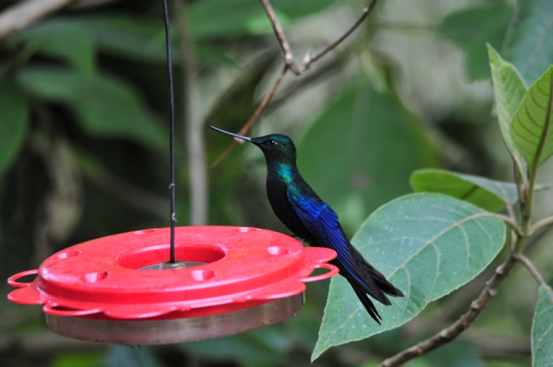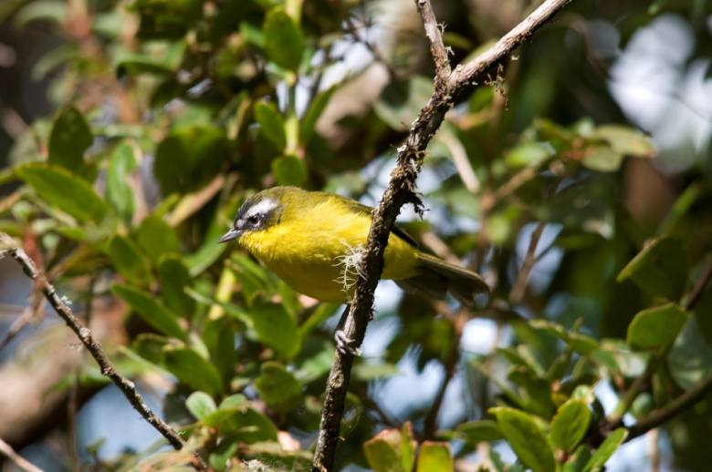
Great Sapphirewing Superciliaried Hemispingus
As we walked higher, we didn't see as many birds as we have in previous years. We thought that perhaps the unusually nice weather had warmed things up earlier than normal and the activity had slowed down earlier than usual. At the feeders at the end of the road we found Tyrian Metaltail, Sword-billed Hummingbird, Sapphire-vented Puffleg, Great Sapphirewing, Buff-winged Starfrontlet, Golden-breasted Puffleg, and Masked and Glossy Flowerpiercers. The real attraction at these feeders isn't so much the number of species but the number of individuals. It's great fun to watch the action and try to learn your first batch of Ecuadorian Hummers.

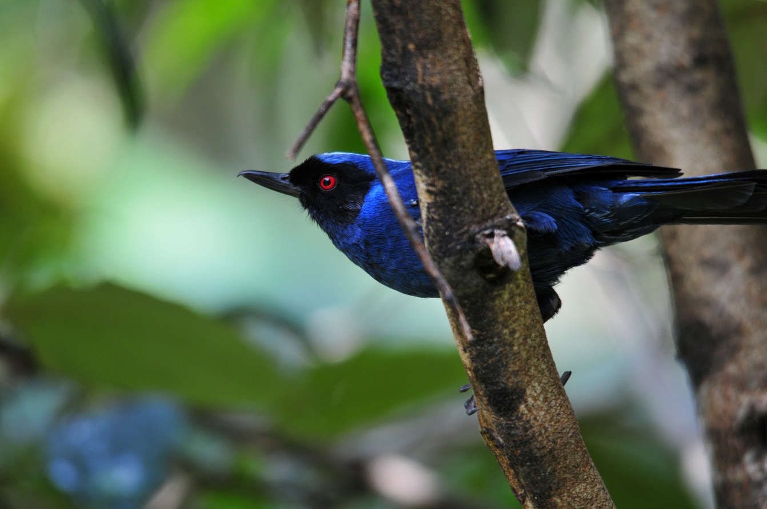
Masked Flowerpiercer

Walking back down the road, the line of birders had spread out quite a bit as people got reacquainted as we walked. Most of the group was from New York and had traveled with us to Panama in 2010, most were friends before they took that trip, and we were all happy to be together on this amazing birding adventure. As we walked and chatted, we heard some excitement from the front of the group and hurried forward to see what was happening. There in the sky above us were two Andean Condors! We had never seen condors here before, always finding them on the day we go to Antisana, up at 13,000 – 14,000 feet. What a thrill to have them on the very first day of the tour!

We returned to the parking area where we followed the caretaker of the reserve to a spot where he offered worms to a very tame Tawny Antpitta, probably the same bold bird a few of us had seen when we first arrived. No wonder he showed no fear of humans! We enjoyed a hearty lunch provided by the Sebastian Hotel, continuing to watch birds as we ate at the picnic tables near the visitor’s center.

Before we left for the Tandayapa Valley, Marcelo found a Brown-backed Chat-Tyrant and put it in the scope for better views. As the last few people were boarding the bus, someone said they had found a Shining Sunbeam nearby, so everyone hurried off the bus to get good views and some photos. By the time the bus pulled away, we all had that warm glow from a morning of wonderful birding and fellowship, as well as full tummies from a very satisfying lunch, and we settled in to rest while Luis drove us to our next birding destination. I asked Galo how long the drive would be, and he told me we were taking a short cut so it wouldn’t be too long. He said he was pretty sure it was the same route we had taken last year, so I settled back to relax. As we drove along, I mentioned that the road didn’t look familiar to me. Galo and Jim both insisted that we had been here before, so I chalked it up to sleeping through this part of the route on previous trips - until we came to an area where the road became noticeably narrower and the steep drop-offs closer, and then I knew we were taking a route I had never been on before. As I was joking about being duped, we came to an area where some locals told us we wouldn’t be able to pass a short distance ahead. We waited in the bus while Luis, Galo, and Marcelo walked out of sight to inspect the area that had experienced a small landslide a few days before. It was Sunday, so work on clearing the road had stopped for the weekend. We interacted with some children and some locals while they were gone, but without our translators we weren’t able to communicate very much. When the guys returned, they said they thought we could get through, so we all piled back on the bus and moved on, waving good-by to the children. Remembering our recent experience on Manu Road in Peru where the treacherous road and sheer drop-offs had everyone biting nails and saying silent prayers, I told Galo that we might want to get out and walk through the landslide area if it looked especially scary. When we reached the point where we could look down the hill in front of us and see how narrow the passage would be, everyone opted to exit the bus. We all watched as Luis drove the bus to the point where the road curved just as the debris from the landslide covered half of the road surface. He braked as he approached the 90-degree curve, and the bus slid forward on the loose gravel and dirt, heading for the drop-off ahead. Marcelo and Galo placed some larger rocks in strategic places, and Luis was able to steer the bus around the curve to safety, where we all climbed back on to continue on our journey. I told Galo I thought we might want to take the long way around next time, and I think he agreed.

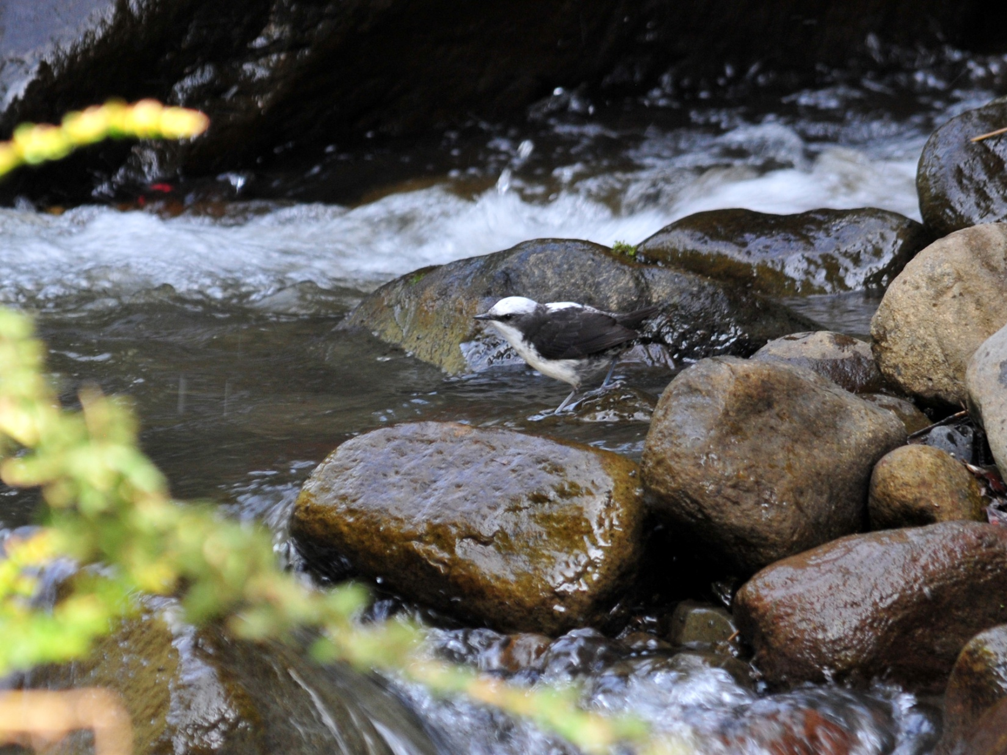
White-capped Dipper

As we drove on Nono-Mindo Road approaching the village of Tandayapa, we kept our eyes on the fast-flowing river on our left, and it wasn’t long before someone in the back of the bus called out, “Dipper!” Luis stopped quickly and we all hurried out to the river bank to get a look at this target species. A few people got a good look right away, but others had to follow the bird down the river and then back up the river before they were satisfied with their views. Eventually we all had wonderful views of not one, but two White-capped Dippers. While we were watching the Dippers, a Masked Trogon flew into view and we spotted our first Blue-gray Tanagers and Black Phoebes. A short distance up the road, Marcelo called out for Luis to stop - he had seen Toucan Barbets from the window (the man's eyes are amazing!). We all climbed out for great looks at this sought-after species.

We continued on our journey and soon came to a small tree that was blocking the road. It was about 6 - 8 inches in diameter and was forming an arch over the road, with its loosened roots about 15-20 feet uphill on the left-hand side of the road and the top resting on the ground on the right-hand side of the road. The path below it was too short for our tall bus to pass, so Marcelo and Galo used a machete to chop the trunk into two pieces. Once the tree was apart, the part coming from the hillside was still hanging there blocking the road. They pulled and pulled, hung from the trunk with all of their weight on it, and it wouldn't budge. Finally, with the help from some locals who had a strong rope with them, the men tied the tree to the bus and Luis backed up until it came loose enough to move out of the way. Quite an exciting day, our first official day in Ecuador - a landslide followed by a fallen tree, and then there's that small earthquake that I forgot to mention that people with rooms on the upper floors of the Sebastian felt last night.

We made a short stop in Tandayapa and came upon a small flock at the edge of town. Blackburnian Warbler, Rufous Spinetatil, White-browed Spinetail, Bananaquit, and Tropical Parula were among the species feeding together in the trees at the road's edge. Not part of the flock but seen in the area were Smoke-colored Pewee, Blue-and-white Swallows, White-colored Swifts, and Tropical Kingbird. By now, it was after 6:00 PM and we needed to move on to Sachatamia Lodge, even though we felt there was more to see in this area.

When we arrived at Sachatamia, the hummingbird feeders were humming (literally) with activity. Velvet-Purple Coronets and Booted Racket-tails were the most numerous , along with our first Long-tailed Sylphs. There were other hummers coming in to feed, as well as a Black Flowerpiercer, but we didn’t stay at the feeders very long because we needed to get checked into our rooms and report to the dining room for dinner.

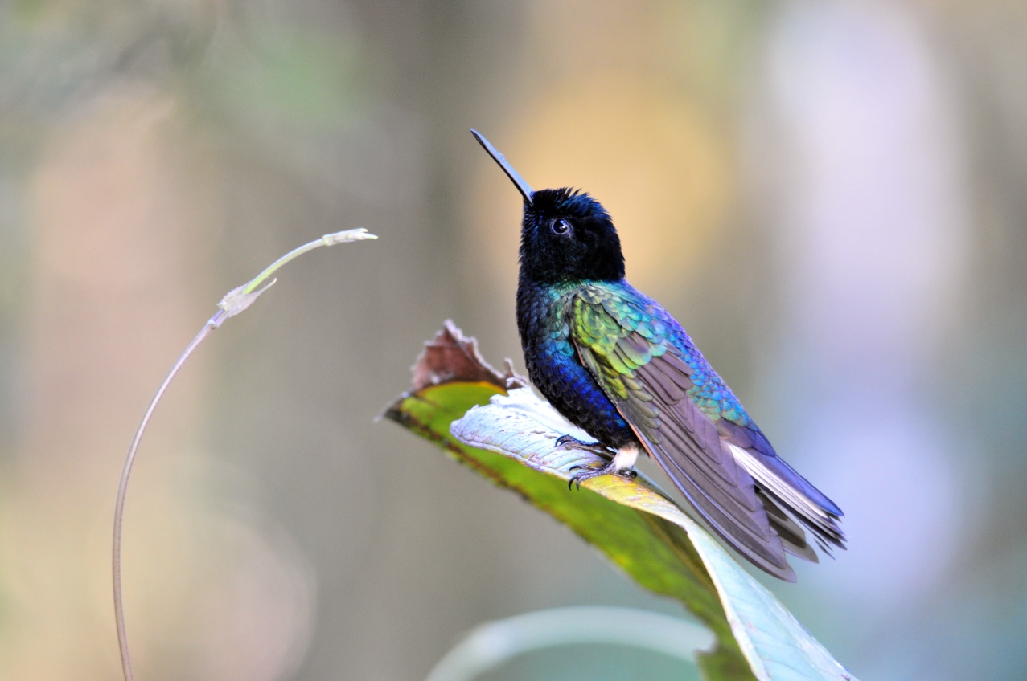
Velvet-purple Coronet
Other birds seen today included Black Vulture, Brown-bellied Swallow, Rock Pigeon, and Lemon-rumped Tanager, to bring our total for the day to 51 species, a bit short of expectations but you would never know it judging from the smiles on everyone's faces at the end of the day. Our total for the trip stood at 56 species counting the 5 species seen on the pre-tour day that weren't seen today.

Day 3, Monday, November 21: We had breakfast at 6:00 AM this morning and then planned to leave at 6:30 to go to Bellavista Research Road. Before breakfast, part of the group saw some super birds at the feeders, including
Beryl-spangled, Flame-faced, Lemon-rumped, and Golden Tanagers. Strong-billed Woodcreepers foraged in the trees along the edge of the open area. A Rhinoceros Beetle seemed to be greeting everyone on the covered porch as people arrived for breakfast. Velvet-purple Coronets were again the most numerous hummingbirds at the feeders, and a Purple-throated Woodstar was seen, but we would have plenty of time later to observe feeder birds. Let's eat and get to some primo birding spots!

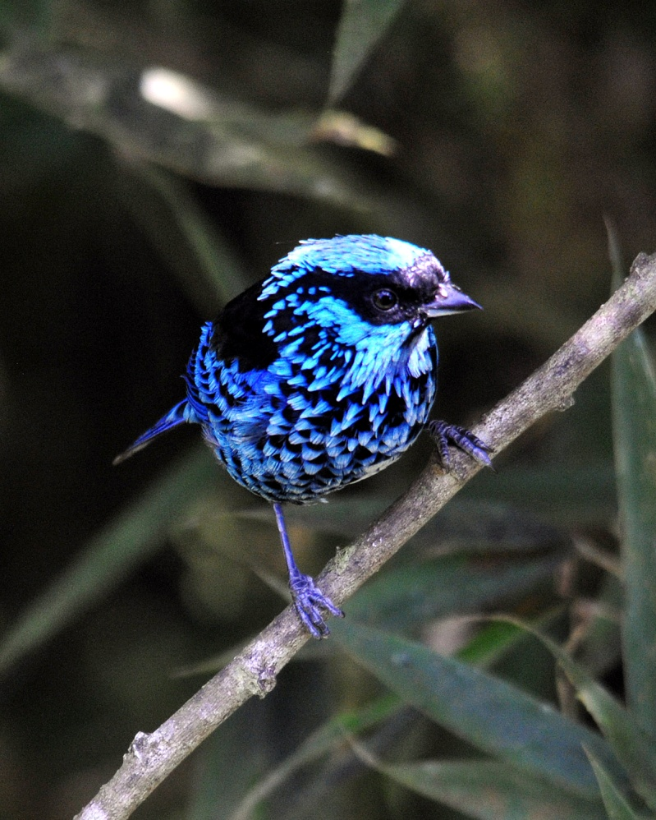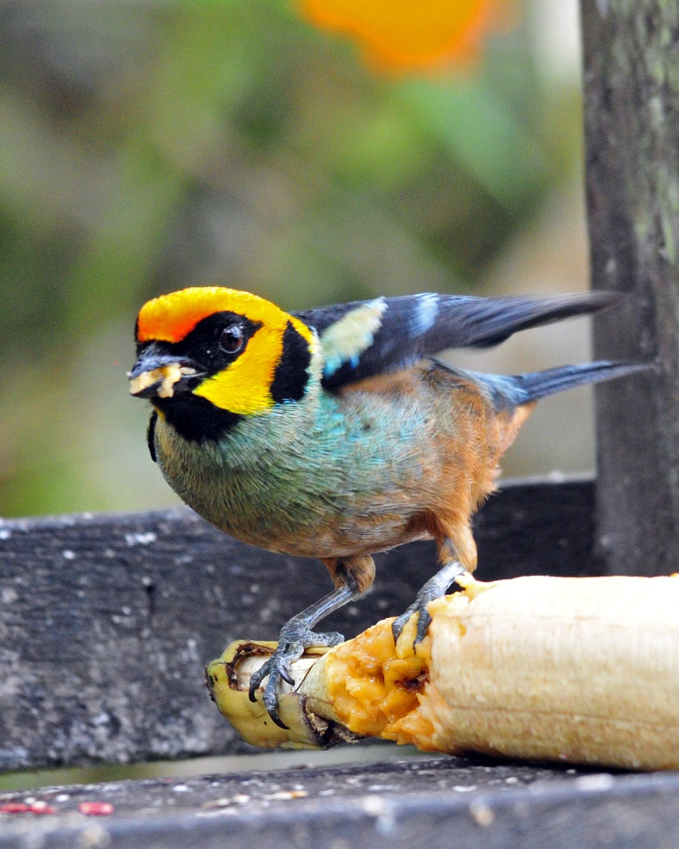
Beryl-spangled Tanager Flame-faced Tanager

As we left the dining room, our intentions for a speedy departure were good, but the parking area was so active that we found it difficult to leave. In just one small stand of trees, several species were found, including Blackburnian Warbler, Azara's Spinetail, Slate-throated Redstart, Rusty-margined and Golden-crowned Flycatchers, Beryl-spangled, White-lined and Golden Tanagers, Scrub Blackbird, Cattle Egret, Strong-billed Woodcreeper, Summer Tanager, Red-eyed Vireo, Swainson's Thrush, House Wren, Tropical Parula, Thick-billed Euphonia, Blue-and-black Tanager, and Blue-winged Mountain-Tanager. Whew! It was difficult to keep up with the activity!

It took awhile, but we finally got everyone on the bus. Just as we were about to leave, through the front window of the bus, I spotted a Fawn-breasted Tanager in the same group of trees. I called it out, and Galo saw it, but we didn't want to get everyone out of the vehicle again lest we never get to Bellavista Road. We didn't see another one until 9 days later at San Isidro, and I had some moments when I really regretted not taking the time to get everyone on that bird.

One of our first stops was at a curve in the road where the very rare and local Tanager Finch is known to exist. After a bit of time, all were able to see the bird pretty well. It stays back in the shadows most of the time even when it's visible, making it very difficult to get an acceptable photograph.

One of the birds on everyone's "must-see" list is the stunning Plate-billed Mountain-Toucan that's featured on the front of the Field Guide to the Birds of Ecuador. It didn't take long for Marcelo and Galo to hear the raucous call of the brightly-colored bird, but it was probably the third or fourth time we heard it before we actually saw this beauty.

As we walked along the road, we saw Red-faced Spinetail, Lineated Woodcreeper, Sierran Elaenia, Streak-necked Flycatcher, Glossy-black Thrush, Orange-bellied Euphonia, Blue-capped Tanager, Dusky Bush-Tanager, and Black-winged Saltator. White-tipped Swifts flew overhead and a Broad-winged Hawk made a brief appearance. Marcelo heard a White-throated Quail-Dove and followed the sound onto a narrow trail, but in the end he was the only one able to lay eyes on the bird. Two birds that really "wowed" the group were a Green-and-black Fruiteater and a resting Cloud-forest Pygmy-Owl, which was such an unusual sighting that it had everyone joking about how our guides must have planted the bird for our enjoyment.

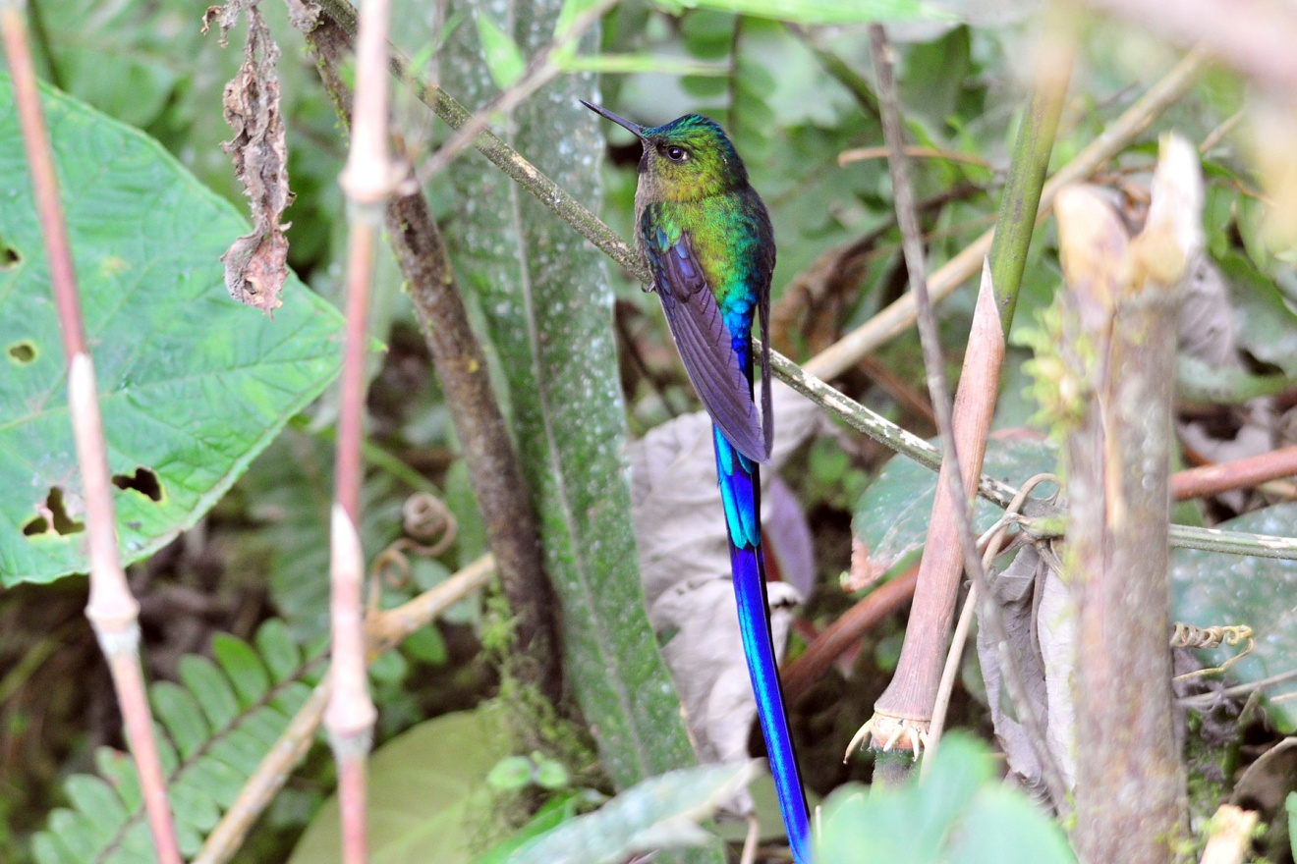
Violet-tailed Sylph

As the morning heated up and the bird activity slowed down, we decided to return to the lodge for some feeder birding. The feeders near the entrance weren't very active, but the feeders near the pond where it was cool and shady were buzzing with activity. As much as we were enjoying the beautiful (dry and sunny) weather, it was definitely affecting the bird activity. At the feeders at Sachatamia, we had White-necked Jacobin, Brown Violet-ear, Green Violet-ear, Sparkling Violet-ear, Rufous-tailed Hummingbird, Andean Emerald, Purple-bibbed Whitetip, Empress Brilliant, Fawn-breasted Brilliant, Brown Inca, Buff-tailed Coronet, Velvet-purple Coronet, Booted Racket-tail, Violet-tailed Sylph, and Purple-throated Woodstar.

After lunch and a short break, we went back out on the road at about 3:00 PM. The first bird spotted was a Crimson-mantled Woodpecker. We moved on to Bellavista Lodge where we enjoyed a nice cup of tea, coffee, or hot chocolate as we watched the hummingbirds at their feeders. In addition to many of the species we saw at Sachatamia, we added Speckled Hummingbird, Green-crowned Brilliant, Collared Inca, and Gorgeted Sunangel to our list. When Matt wandered off to see what else was nearby, Luis approached him near the parking area and asked if he would like to see a trogon. Thinking he was going to point out a bird in the top of a (probably far-away) tree, Matt was shocked when he turned to see a pair of Masked Trogons at eye level just a few feet away! He graciously called the rest of the group over so we could all enjoy the birds (and the photo op). As we were watching the Trogons, a couple of Turquoise Jays flew in over the parking area.

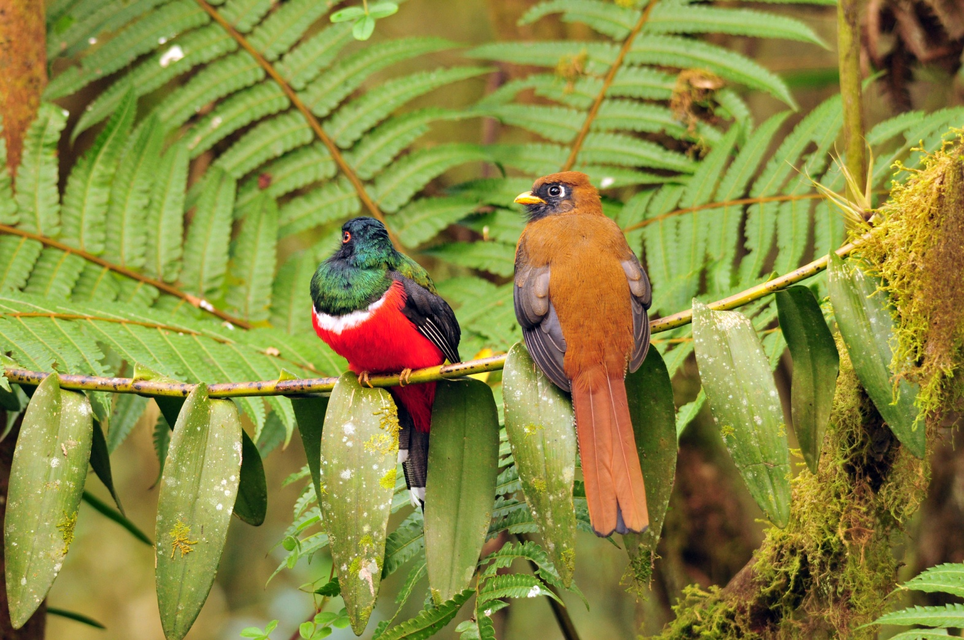
Masked Trogons

Light was already starting to fade when Galo suggested we leave, but I asked that we walk the short distance to the compost pile to see if we might find any birds there. We walked silently behind Marcelo as he led us down the trail leading to the compost pile, but nothing was moving around there but a White-tipped Dove.

As usual, we completed our bird list for the day before dinner. Unbeknownst to us, Luis had been outside looking for the resident Black-and-white Owl as we worked on our list. When he came inside and motioned to Marcelo that he had found the bird, it took only a few seconds for us to abandon the task at hand and hurriedly follow him to the owl. What a sight! There's something about owls that instills a feeling of wonder, and this species is one of the most beautiful in its family.

Also seen today was our first Turkey Vulture of the trip, just one of the 68 species seen today. Most of the birds seen today were new for the trip, bringing our 2-day (plus a partial first day) trip total to 108.

Day 4, Tuesday, November 22: Today we got up very (extremely, unbelievably) early to leave at 4:30 AM to drive to a very special place. Our exceptionally early departure was necessary in order to visit one of the most special spots on the trip, Angel Paz's famous refuge featuring "tame" Antpittas, a Cock-of-the-Rock lek, and fabulous feeders. Several years ago, when Angel was cutting a trail in his forest so birders could come to see his Cock-of-the-Rock lek, he started seeing Antpittas as they came to eat the worms that were exposed as he excavated the ground. With a lot of patience and hard work (and a lot of worms), he succeeded in training these normally secretive Antpittas to respond to the sound of his voice - they actually come when he calls their names! The first bird he "trained" was Maria, a Giant Antpitta who has since brought her offspring to take the worms offered by Angel. What a sight it is to see Angel stand on the trail with his container of worms calling, "Maria! Maria!". Unfortunately, Maria is no longer with us, most likely the victim of a predator, so he now calls the names of her offspring and grand-offspring, including her son Manuelo and her grandson Panchito. Other birds who have learned to trust Angel include Willie, a Yellow-breasted Antpitta; Susan, a Moustached Antpitta; and Shakira, an Ochre-breasted Antbird who was so named because she "shakes her tail".

We needed to be in a blind deep in the valley of the forest before daybreak in order to see the Cock-of-the-Rock males as they performed on their lek at sunrise. We took a snack along since we knew that breakfast wouldn't be served until about 10:00 AM. The bus was unusually quiet as Luis drove us to our destination, where we emerged in total darkness to walk down a forest trail by the light of our headlamps or flashlights. We made it to the blind just as the Cock-of-the-Rock males began to vocalize. Quite an unusual sound and very un-birdlike in tone, it took awhile for all of the birders to realize this sound emanated from our target bird. In the dim light we could see some bright red males posturing and calling, but it was too dimly lit to take photographs. Angel has wisely prohibited flash photography, and we were happy to abide by the rule to protect this wonderful lek. The birds performed off-and-on for quite awhile, and we were all able to see them well.

On the way to the lek, a few people in the front of the line were lucky to see a Rufescent Screech-Owl just as the darkness gave way to dim light. Now, as we were leaving the blind to bird in other places in "Refugios de las Aves", Galo and Marcelo went down a steep hill to see if they could find another owl. They came back without a sighting, and we proceeded on a short detour to see Angel feed a group of Dark-backed Wood-Quails. A few members of the group went on to the feeding station rather than take the detour, and by the time we got there, Jim had found a Scaled Fruiteater. One of the Giant Antpittas had already shown up for his morning meal, and shortly after the rest of us arrived, a Crimson-rumped Toucanet put in an appearance, along with the aforementioned Fruiteater.

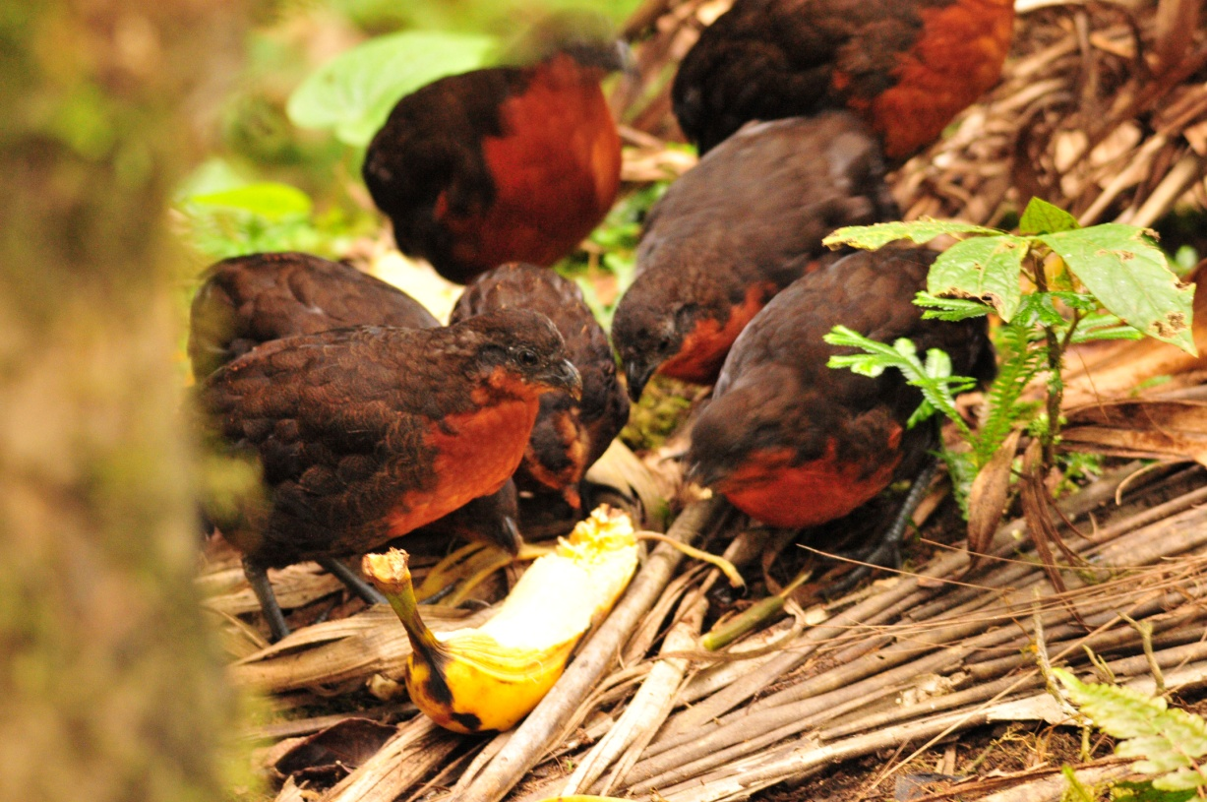
Dark-backed Wood-Quails
One of the best spots on Angel's property is a trail that overlooks a fruiting tree. On previous trips, we have seen Golden-headed Quetzals and female Cocks-of-the-Rock feeding in this tree. Today, there would be no Quetzals or COTR, but we did find Crimson-rumped Toucanets and Pale-eyed Thrush. Marcelo put the Thrush in the scope, but people commented that they couldn't see the identifying field mark, the pale eye. He moved down the trail a bit (where I couldn't even see the bird from the new perspective), re-found the bird quickly and put it in the scope at an angle where all could see the pale eye - what a guy! Because the Cocks-of-the-Rock put on quite a show and we lingered to watch every minute of it, we didn't have time to stop at the fruit feeders this morning. We followed Angel from one spot to another where he first fed the Giant Antpitta, then the Ochre-breasted Antpitta, who showed us her moves. A bit further down the trail, he showed us a nesting Olivaceous Piha. A short distance further, Susan the Moustached Antpitta, finally appeared as she came out for her morning meal. Once we have seen all of the target Antpitta species, we moved on to the hummingbird feeders for a quick look at some familiar species. This gave us a good opportunity to test our skills at identifying the hummingbirds we had already seen while taking a needed rest after climbing out of the valley below, as well as getting some good photos in excellent light.

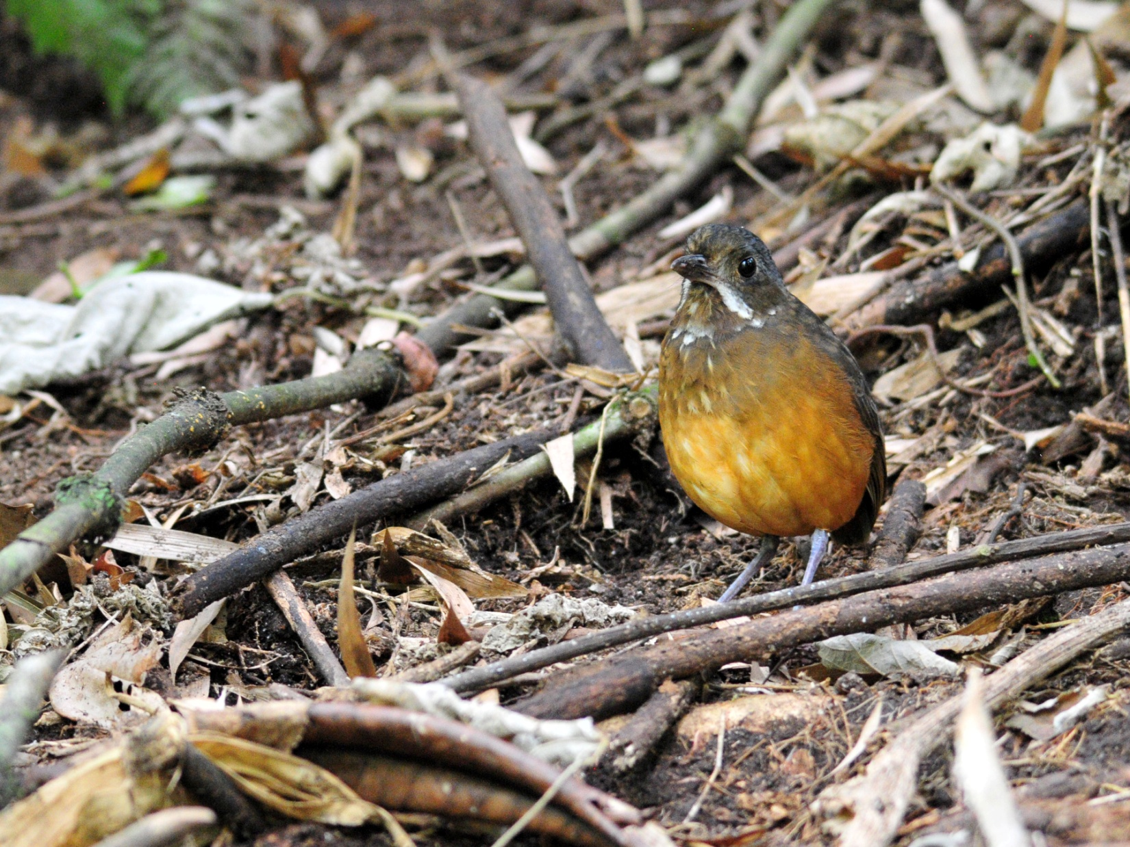
Moustached Antpitta

After a short while, we walked back to our starting point where we took seats on a covered deck overlooking the fields and forests below. While we waited for coffee, tea, and hot chocolate to be served, we found Yellow-faced Grassquit among the grasses nearby. Breakfast is one of the highlights of the day when you visit Paz de las Aves. A traditional Ecuadorian dish called "Bolones de Verde" was served first. Made from green plantains which are fried over medium heat until very tender, then mashed into dough, stuffed with chicken and/or cheese, and then fried again until crispy, the bolones were especially delicious when dipped in the hot salsa provided. Angel's home-made salsa is so delicious that we had to ask for multiple refills to keep everyone happy. (Bolon is a slang term that means large ball, so you could translate the name of this dish as big green balls) The bolones were quite large and filling, but just as we finished Angel brought out the next course, Empanadas de Queso. Freshly made and hot off the fire, these were absolutely wonderful! Our guide a few years ago showed us the best way to eat them - smash them, put sugar in the depression you made, and yum! Even better!

After breakfast, Angel went with us in the bus to drive to an area where we could find his Yellow-breasted Antpitta, Angelito. While searching for the Antpitta we saw many of the common birds such as Tropical Kingbird and Rufous-collared Sparrow. A couple of new species for the trip were Flavescent Flycatcher and Sepia-brown Wren

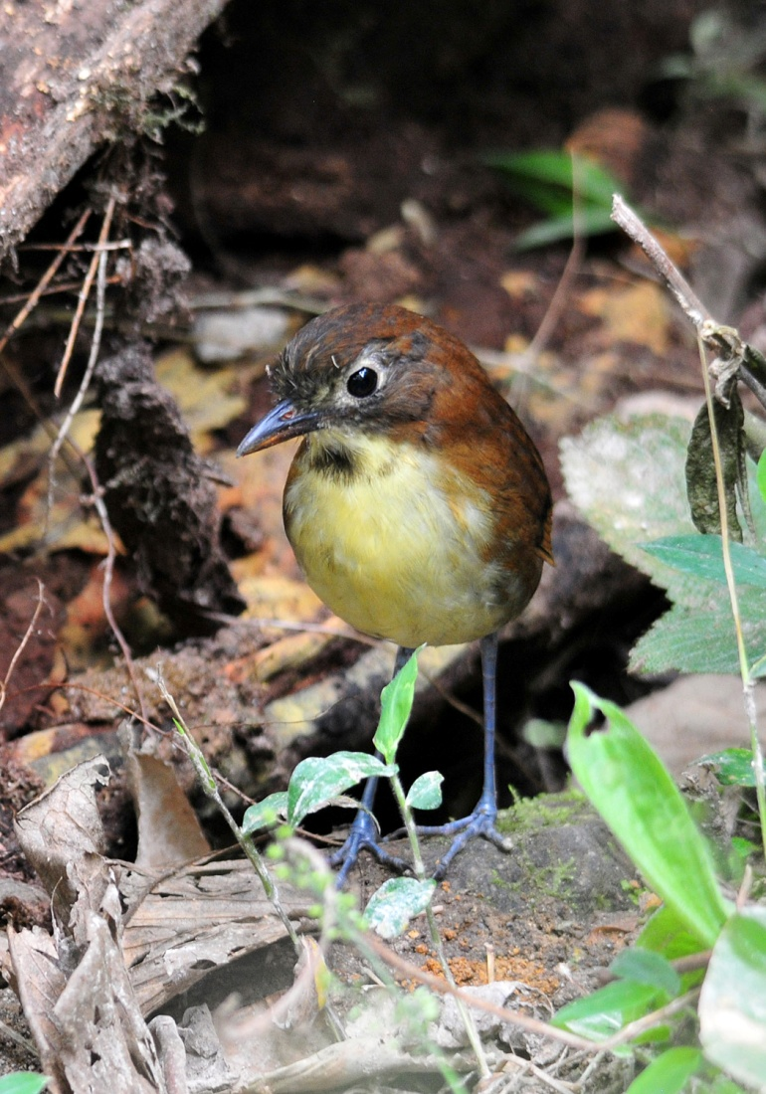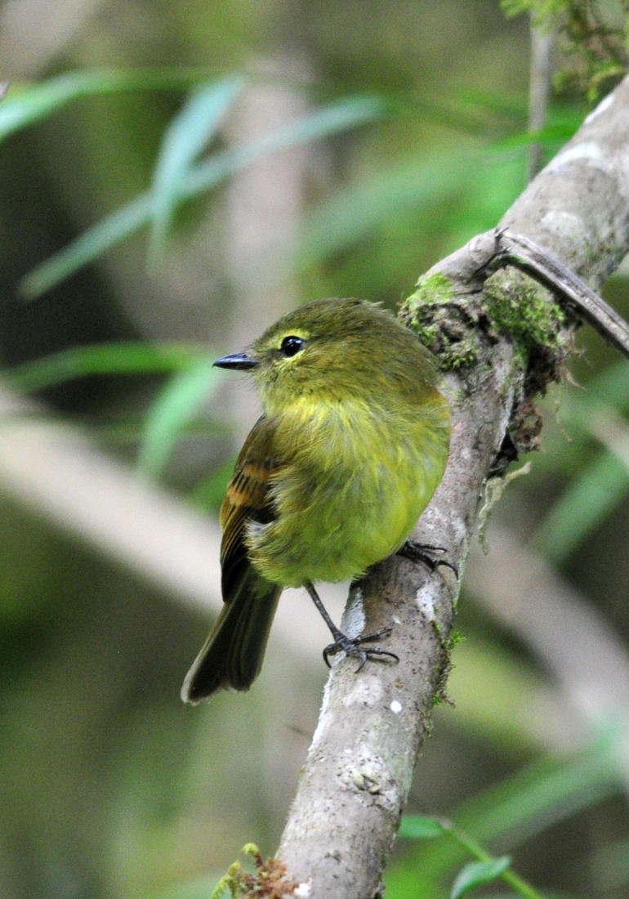
Yellow-breasted Antpitta Flavescent Flycatcher

We returned to Sachatamia and spent some time birding around the grounds and at the feeders before lunch. After such a huge breakfast so late in the morning, most of us weren't really very hungry when lunch was served, but the food at Sachatamia is so good, most of us ate the entire meal anyway. Next, we drove to the farm of Hugo Morales, arriving at about 1:15. Pacific Horneros were seen in the driveway as we entered the property. We were expecting to be taken by a tractor-drawn wagon to the spot where some Oilbirds roost during the day, but there was no wagon waiting for us. We learned that the grandfather of the family had died the day before, and the family was preparing for the arrival of friends and relatives. They sent one family member with us to show us the way to a different roosting spot where the Oilbirds could be seen from the road. It was disappointing to miss out on the experience of climbing down the bamboo ladders into the gorge where the Oilbirds could be seen, but we understood and sympathized with the family. Luis drove the bus as far as he could, and when the road became too steep and narrow with a severe switchback, he pulled over and everyone climbed out to follow our guide to the spot where the birds could be seen. It was a pretty good walk down a steep road with loose gravel, making our footing a bit precarious, but everyone made it and everyone got good looks at the Oilbirds through the scope. As most of the group started to hike toward the Oilbirds to get even better looks and some photos, I started back toward the bus. On the way back, I spotted a few birds, including a few Bay-headed Tanagers, but otherwise mostly species we'd already seen. I could hear a White-beardedManakin, but couldn't find it. When I got to the bus, I heard a lot of birds on the hillside on the opposite side of the road. I searched the greenery for activity and found Dusky-faced Tanager, Choco Tyrannulet, Black Phoebe, Blue-black Grassquit, and Lemon-rumped Tanager. The group found Canada Warbler and some of the same birds I had seen on my way back. Luis and I told them about the Dusky-faced Tanagers, and the whole group began to scan the hillside for birds. In addition to the Bay-headed and Dusky-faced Tanagers, we found Green Honeycreeper and Golden-olive Woodpecker.

Driving back to the farm, we saw Smooth-billed Anis. As the farmer was writing a receipt for Galo, we spotted a large group of Black and Turkey Vultures on the ground. A Swallow-tailed Kite soared over us, and a Bat Falcon was spotted.

Other birds seen today included Hook-billed Kite, American Kestrel, Red-billed Parrot, Southern Rough-winged Swallow, Sickle-winged Guan, Masked Tityra, and Tri-colored Brush-Finch. We finished the day with 74 species, plus an additional 8 that were heard only, bringing our trip total to 141 species seen.

Day 5, Wednesday, November 23: My alarm was set for 4:40, with breakfast scheduled for 5:30. We left as soon as everyone was finished but by the time we arrived at Milpe Bird Sanctuary, another group was already birding the area around the entrance. Using our best birder etiquette, we decided to bird the road first so we wouldn't crowd the other group. Yellow-tufted Dacnis and Silver-throated Tanager were seen as people were getting off the bus, which meant those of us who exited slowly missed one or both of these birds (I missed the Dacnis). This road is always a good birding spot, and it did not disappoint today as new species were seen in rapid succession: Sooty-headed Tyrannulet, Common Tody-Flycatcher, Black-and-white Warbler, Golden Tanager, Blue-necked Tanager, Orange-bellied Euphonia, Blackburnian Warbler, Bicolored Hawk, Ornate Flycatcher, Swainson's Thrush. Cathy drew our attention to a bird that was pretty far away, but even at that distance she knew it was something different: Swallow Tanager! A few of us had fallen a bit behind the group when Jim called me to look at a bird that he and NY Joan had spotted simultaneously. I tentatively identified the bird as a Guira Tanager but I wasn't 100% positive that I was correct. Even with a badly backlit

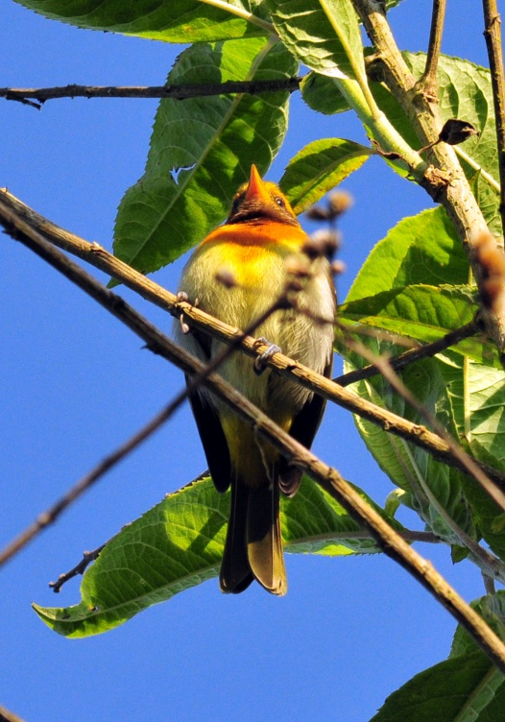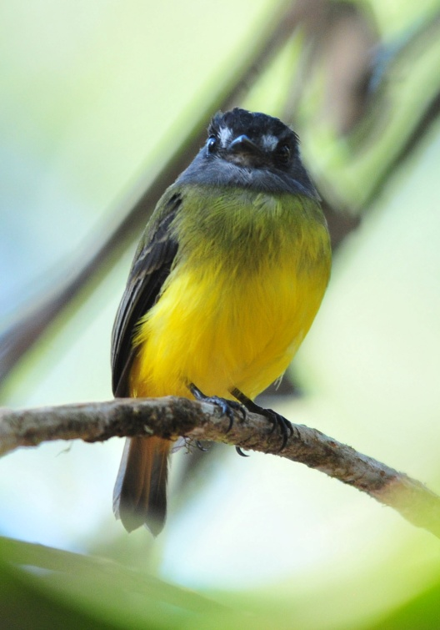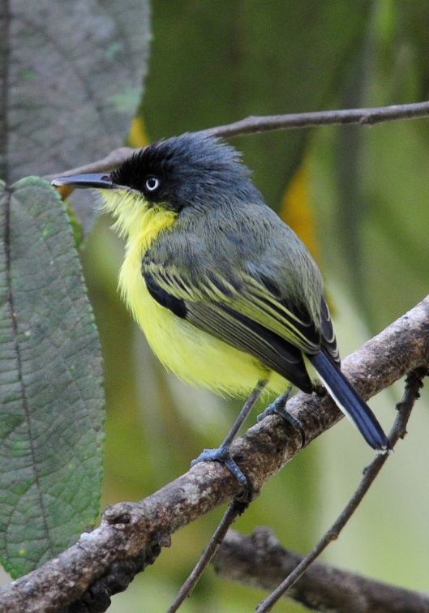
Guira Flycatcher Ornate Flycatcher Common Tody-Flycatcher
view of the underbelly, I knew this bird was special and we immediately called for the others to come back to see it. As we walked down the gravel road, we saw Guayaquil Woodpecker and Maroon-tailed Parakeet. Galo and Marcelo had both scopes on some Bronze-winged Parrots when some Ruddy Pigeons flew by. A One-colored Becard was at first confused with Cinnamon Becard, but there was no mistaking the White-shouldered Tanager with its large white patch showing prominently on the solid black bird.

At about 9:45, we entered the reserve through a rear entrance and walked a new path in that part of the park. The birding was a bit more challenging in the forest, but we managed to find Choco Trogon, Buff-fronted Foliage-Gleaner, Glistening Green Tanager, Yellow-throated Bush-Tanager, Uniform Treehunter, Ochre-breasted Tanager, Three-striped Warbler, Purple Honeycreeper, and Slate-colored Grosbeak before returning to the bus. Luis drove us to the entrance where we spent a few minutes at the feeders before going down the trail where we hoped to find a manakin lek. At the feeders, we observed many species of Hummingbird we had seen at other sites and added three new species: Green Thorntail, Green-crowned Woodnymph, and White-whiskered Hermit.

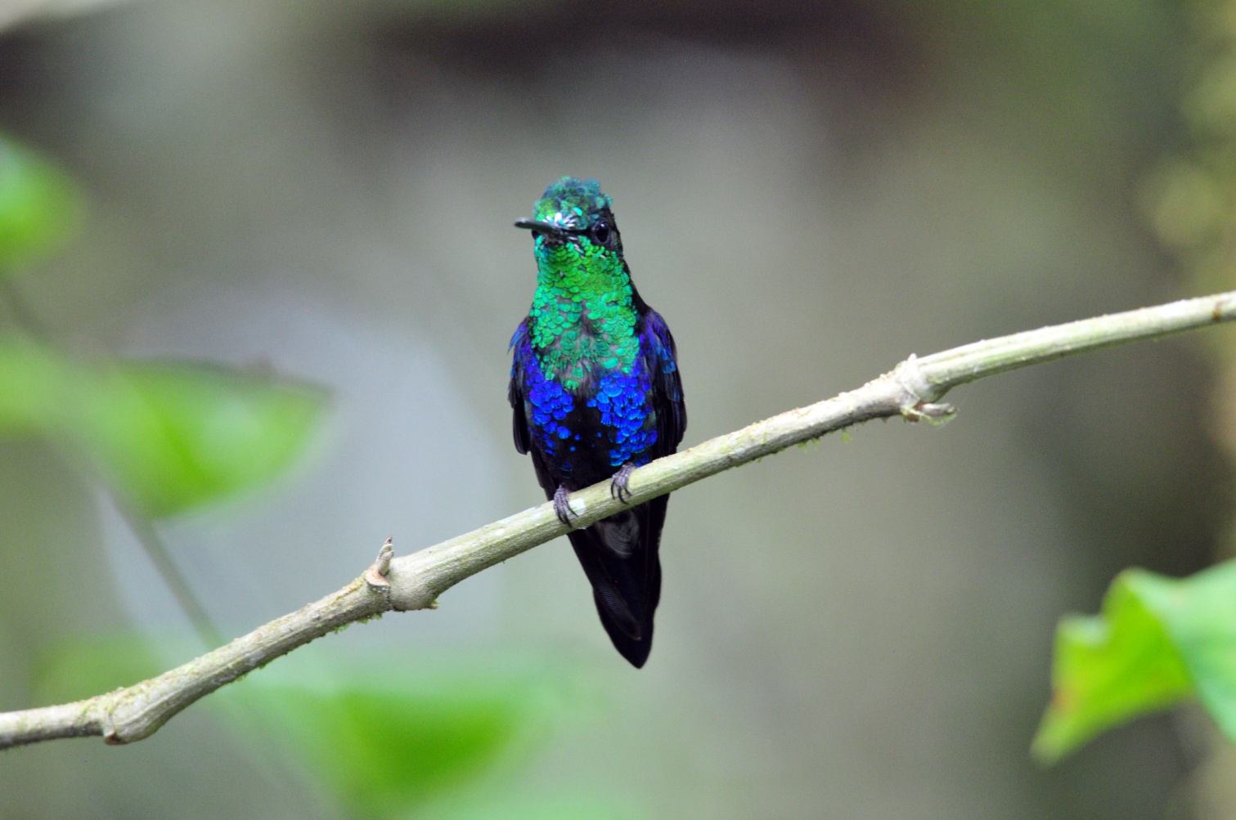
Green-crowned Woodnymph

Walking down the forest trail, we saw Blue-winged Mountain-Tanager, Spotted Woodcreeper, Orange-billed Sparrow, and Scaly-throated Foliage-Gleaner. Some people spotted Immaculate Antbird before we started down the hill that led to the area where the manakins have their lek. A Chestnut-backed Antbird responded to calls, giving us all great looks at it blue fleshy eye-ring. Finally, Marcelo and Galo found our target species - Club-winged Manakin! We saw a single male, not performing its cute little dance for any lady manakins, but we got great looks at the brilliant red cap, rufous body and black wings with white edges. These tiny birds use their wings for stridulation, a rubbing mechanism commonly used by insects such as crickets. One feather on each wing has seven ridges along its central vane. The stiff, curved tip of an adjacent feather strikes the ridges every time the bird raises it wings over its back and shakes its feathers. The repeated striking causes adjacent clubbed feathers to vibrate at high speed (1500 cycles per second), creating the unique high-pitched courtship song. While not believed to be part of the attraction to females, the movement needed to create the sound is entertaining in itself. Although many insects do this, manakins are unique among vertebrates in using stridulation.

We returned to Sachatamia at 1:00 for lunch. We had requested that lunch be served on the new covered patio where we could enjoy the birds as we ate, and the staff at the lodge graciously complied. We were sorry to be leaving Sachatamia, but eager to move on to our next adventure. Another group arrived as we were finishing lunch, and we left as soon as all of our luggage was loaded into the bus. We drove to Ayalir Hosteria near the town of Pedro Vicente Maldonado and checked in shortly before 3:00 PM. In the parking lot we saw Ruddy Pigeons; some Parakeets that we thought were Maroon-tailed flew by. House Wrens scolded as we wheeled our luggage to our rooms. Some people went for a swim in the pool (where Matt and Cathy saw Pied Water Tyrant), others went to their rooms to settle in and rest, and others did some birding on the hotel grounds. Lemon-rumped Tanagers, Bananaquits, and Rufous-tailed Hummingbirds were the prevalent species in the garden, but we hoped to find some other species on the path that led

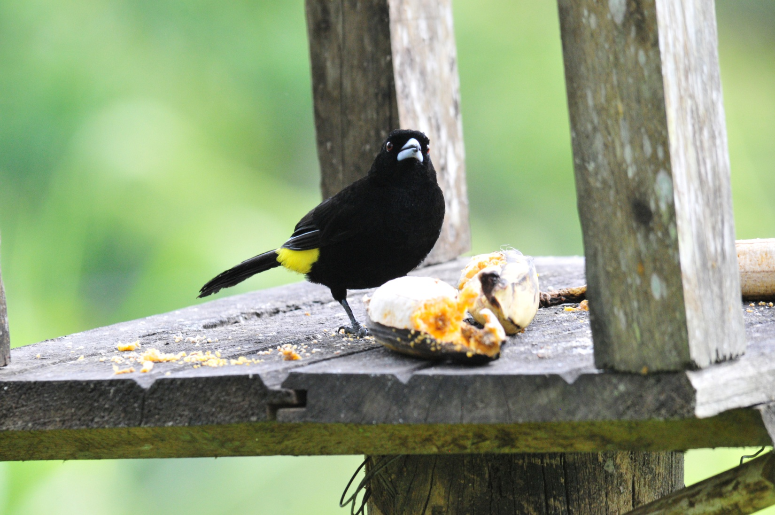
Lemon-rumped Tanager

through pastures and woods behind the hotel. We met at 4:15 to bird the back part of the property and immediately saw Choco Tyrannulet and Western Wood-Pewee. The activity was not remarkable, but we did find Pied Water Tyrant for the whole group, as well as some common species like Blue-gray Tanagers and Tropical Kingbirds. Other species seen on this walk included Sooty-headed Tyrannulet, Common Tody-Flycatcher, Yellow-bellied Siskin, Buff-throated Saltator, Gray-rumped and Lesser Swallow-tailed Swifts, White-tailed Kite, and Pacific Parrotlet. As we approached the buildings, we saw Pacific Horneros on their oven-like mud nest. On one of the roofs were Scrub Blackbirds and Shiny Cowbirds.

We finished the day with 95 birds, and our trip total went to 192. Other birds seen today that were new for the trip included Dusky Pigeon, Wedge-billed Woodcreeper, Dusky-capped Flycatcher, Ecuadorian Thrush, and Variable Seedeater.

Day 6, Thursday, November 24: This morning we met at 5:00 AM for a continental breakfast so we could leave by 5:30 in order to arrive at Silanche before any other birding groups so we would have the opportunity to bird from the observation tower there. We arrived at Silanche shortly after 6:00 AM and were positioned on the observation tower by 6:15. The first bird spotted was a Choco Toucan, seen through a light mist that felt almost like rain (but not quite). This was the first day we had encountered precipitation in any form, but the heavy fog/mist wasn't enough to dampen our spirits. We concentrated on finding any movement in the treetops around us, but the lighting made it difficult. At first, the activity was slow, but as the day warmed up it improved a bit. Both male and female Red-headed Barbets cooperated for quite awhile, followed by a female Yellow-tufted Dacnis. An Ochre-breasted Tanager landed in the branches of the tree nearest the tower and a Pale-mandibled Aracari landed in a tree farther in the distance, but it dropped down too fast so everyone didn't get on it. In the poor light, we identified Buff-throated Saltator, Dusky-capped Flycatcher, Choco Tyrannulet, Blue-headed Parrot, , Scale-crested Pygmy-Tyrant, Rose-faced Parrots, Lesser Greenlet, and Golden-hooded and Bay-headed Tanagers. A large group of White-collared Swifts flew by, not in normal erratic fashion but flying together in a straight line as if they had a destination in mind. Luckily, the Aracaris and Toucans returned and positioned themselves in full view for quite awhile. After a few hours, when it appeared that the fog wasn't going to lift any time soon, we decided to go down to bird the trails and road because we thought the birds might be staying lower because of the weather. At the base of the tower, we found Purple-chested Hummingbird. It appeared that this area had had more rain than we had been experiencing, and the trails were pretty muddy, so we
decided to stick by the road. In the grasses along the road we saw many Variable and Yellow-bellied Seedeaters. Walt spotted a large raptor in the distance that proved to be a Crane Hawk that sat long enough for everyone in the group to see it through the scope. A Black-striped Sparrow was spotted and responded to Marcelo's tape, posing on open branches of a low tree where everyone was able to get good looks. Even through the fog we could see the small patches of bright yellow at the front of his wings.

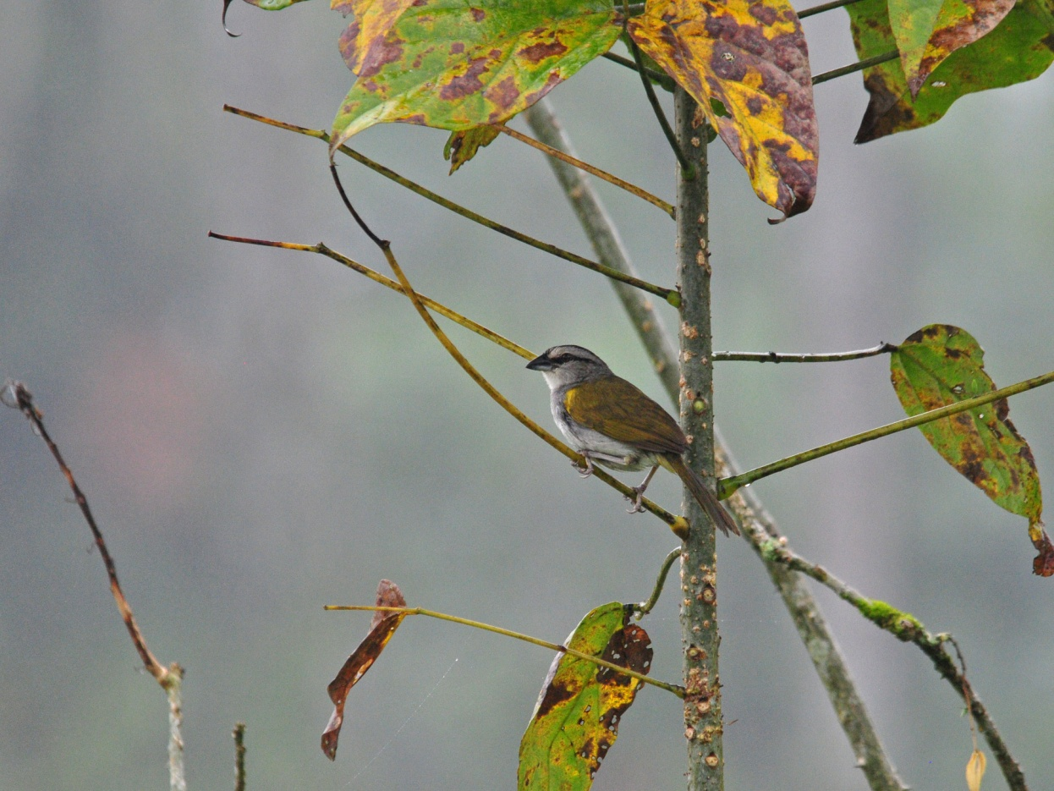
Black-striped Sparrow
A very vocal Slaty Spinetail entertained us and a Roadside Hawk and Ruddy Pigeon were seen. As the group moved forward, I hung back a little to see if I might be able to photograph one of the many Seedeaters we heard as we walked down the road. I caught some movement out of the corner of my eye and was really surprised to find a Little Cuckoo in the trees that lined the road. I didn't know how far ahead of me the group had gone, so I took a few minutes to snap some photos. When the bird stuck around for longer than expected, I made note of some landmarks and sprinted ahead to see if they might be able to get back in time to see the cuckoo. When I caught up with the group, I showed the photos to Galo to confirm my ID, and the group quickly made its way back to the spot where I had seen the bird. It took only a few moments for Marcelo to relocate the cuckoo, and everyone got on the bird. As if on cue, as Galo was describing the differences between the Little and Squirrel Cuckoos, a Squirrel Cuckoo flew in to land in a tree on the opposite side of the road. A White-bearded Manakin female was seen flying across the road by part of the group. The day was growing brighter and warmer by now, so we made our way back to the tower. By now, it was going on 10:00 AM and we had eaten a small breakfast almost five hours ago, so we took a few minutes at the bus to have a snack. As the group was reforming after eating and taking restroom breaks, I walked back to an area behind a building where we had seen some birds the year before. There, I found a gorgeous Rufous Motmot. Nearby, in a group of tall flowering bushes, were Violet-bellied Hummingbirds.

When we went back up the tower, we didn't even make it to the top before we began seeing the birds of a mixed flock:
Black-striped Woodcreeper, Streak-headed Woodcreeper, Western Slaty Antshrike, Checker-throated Antwren, White-flanked Antwren, Dot-winged Antwren, Wedge-billed and Stripe-headed Woodcreepers, and Sulfur-rumped Flycatcher, along with some other species we had already seen today. From the top, the group saw Slate-throated Gnatcatcher and White-shouldered Tanager while I was still making my way up the steps. We had great views of Purple-throated Fruitcrow, Cinnamon and Black-cheeked Woodpeckers.

We descended from the tower shortly after 11:00 AM, planning to leave, but Marcelo and Galo heard an Orange-fronted Barbet vocalizing nearby, so we had to go find it. Shortly afterward, a beautiful White-tailed Trogon elicited a chorus of "oohs" and "aahs". We followed sounds further down the road a bit where we found another Barbet and a Rufous-tailed Jacamar. I think everyone saw the Jacamar, but not all got to see it through the scope before it flew away. Before we got back to the bus, we also found White-vented Euphonia, and some people spotted a Band-tailed Barbthroat.

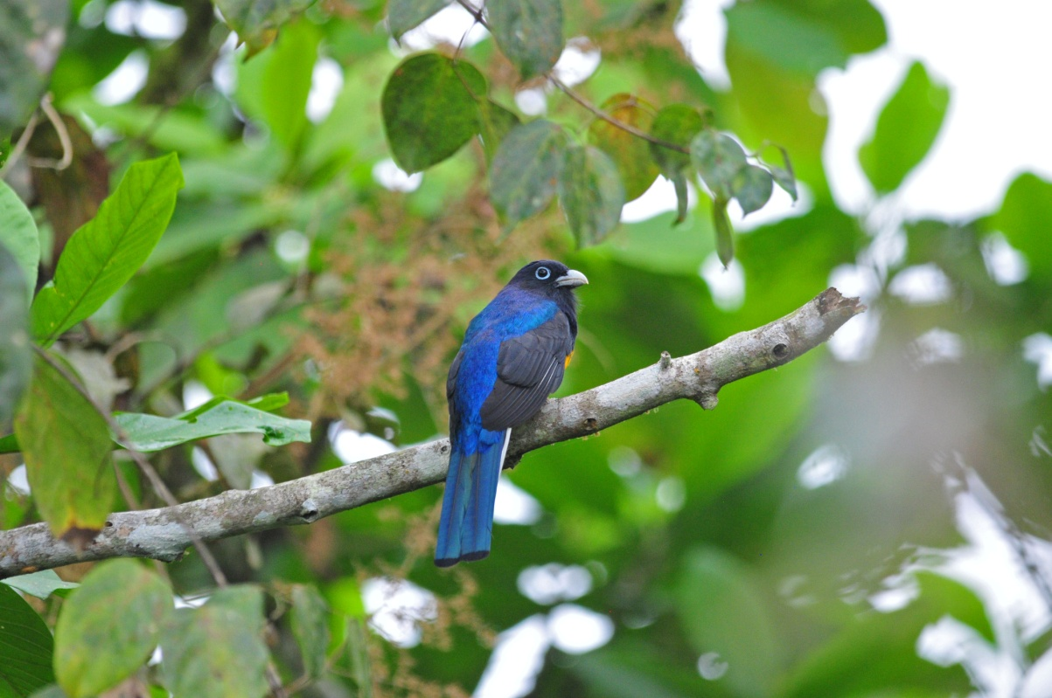
White-tailed Trogon
As we drove back to Ayalir, Galo and Marcelo kept their eyes peeled for a particular species we had missed by not taking the wagon through Hugo's fields. It wasn't long before Luis got the command to stop the bus for us to see a Striped Cuckoo. In the field near the cuckoo was a pair of Masked Water Tyrants and a couple of Pacific Horneros. I couldn't decide which bird to photograph, so I kept switching back and forth between the Cuckoo and the Water Tyrants. Other birds seen today included Lineated, Red-rumped, and Guayaquil Woodpeckers, bringing our Woodpecker count to five different species for the day. Gray-headed Kite and Swallow-tailed Kite added to our raptor count for the day. Some common flycatcher species seen today were Great Kiskadee, Streaked Flycatcher, and Boat-billed Flycatcher.

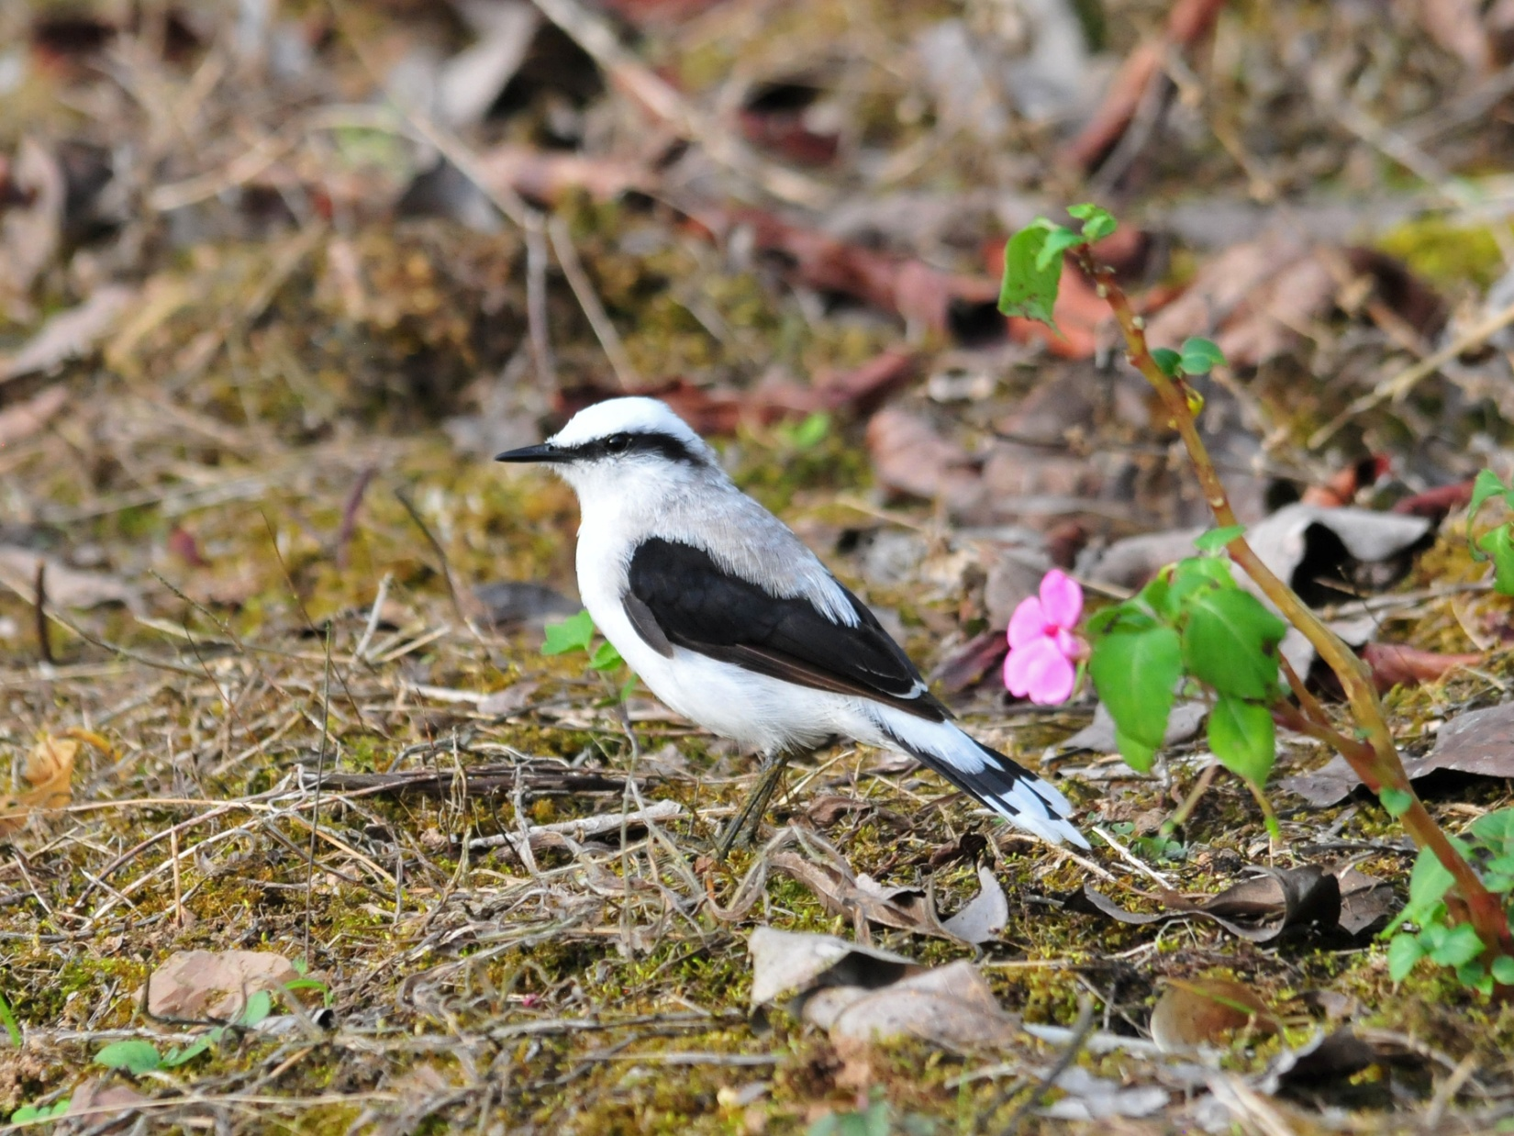
Masked Water-Tyrant

In the afternoon, the group decided to drive a short distance to bird for awhile, but I decided to stay back at the hotel to try to get some photos of the common birds there. A pair of very noisy Band-backed Wrens proved to be difficult subjects to photograph as they moved from tree to tree fussing at each other. Judging by their behavior, I thought they might have a nest nearby and hoped we would be able to find them before we left in the morning.

Today's count was 94, with 39 new species bringing the trip total to 231.

Day 7,Friday, November 25: We had breakfast at 7:00 AM, with departure scheduled for 8:00 to head for Calacali for a mostly non-birding day visiting the Equator Monument and museum and then driving on to Quito to stage for the next part of our tour, the eastern slope of the Andes. As we drove along the highway, Galo spotted a Black Deer, an animal that he reported is rarely seen. We attempted to find the Band-backed Wrens before we left the hotel, but there was a very light rain, and we needed to move on without finding the birds (although Matt and Cathy found them on their own earlier that morning). We drove out of the light rain within a half hour, made a stop at Linda Loma to drop off a key that someone had forgotten to turn in, and then made a quick stop at Sachatamia to see if Marcelo's sunglasses were there.
A few people got off the bus to use the restrooms before moving on. It's always frustrating to use the morning hours, the best time of day for birding, for travel, and I made a mental note that Linda Loma might be a good birding stop next time if we leave Ayalir earlier in the morning, maybe 6:30 or so.

When we arrived in Calacali, the area where we birded in previous years had been blocked off for some sort of police or military training exercise. We drove through some side streets, where we found Vermilion Flycatcher and then proceeded to a pull-off on the highway where we could enter a hillside trail to bird for awhile. We had to walk through a pile of trash that had been thrown on the trail to access the site and needed to be careful of the prickly desert plants as we walked the narrow path. From our position high on a hill overlooking the area where the police were conducting their activities, we had just spotted a Tufted Tit-Tyrant when a loud explosion from below drew our attention. We added a new hummingbird to the list, Green-tailed Trainbearer, just before a pair of magnificent Black-chested Buzzard-Eagles flew low overhead. An American Kestrel was perched on a low bush about half way down the hillside. Only a few who were standing near Marcelo when he spotted it were able to see the Plain-colored Seedeater before it flew away. A nice Variable Hawk soared by.

There was some confusion about the entrance to the museum, and Luis dropped us off at the front gate to purchase tickets while he went around to park in the area for buses. We walked to the rear of the property to find the bus (noting the Common Ground-Doves along the way), where we were supposed to eat our box lunches. This was without a doubt the worst boxed lunch I've ever seen, so I ate only the grapes and then followed others as they went to find other food within the Equator Monument complex. There were all sorts of Ecuadorian dishes being served at a number of different restaurants, and the prices were surprisingly low. I lost Jim and had no money on me, so I sponged off of Jeanne when I caught up with her, Matt, and Cathy at a cute little restaurant called Calima. I made a mental note that we would not ask for box lunches from Ayalir next time and would instead eat at one of these delightful places.

We enjoyed touring the Equator Museum, but we had to do so without a guide because they were all at lunch when we arrived. After about an hour, we had seen enough, so we went to the bus to proceed to the other part of the museum where all of the demonstrations and more "tourist -y" exhibits (like shrunken heads, guinea pigs, etc.) can be found. Galo had not understood that we wanted to do both parts, and we didn't have time to make it to the more entertaining side of the complex. Another mental note for next year. We drove on to Quito, checked in at the Hotel Sebastian, and pre-ordered our evening meal. After taking time to reorganize our luggage for the next leg of the tour, we enjoyed a nice dinner in the hotel's restaurant and got to bed early.

Our bird count for the day was a mere 37 species, but as I said, it wasn't a real birding day. Only 5 of the species were new for the trip, bringing our trip count to 236.

Day 8, Saturday, November 26: Everyone was ready to leave at 6:45 AM with luggage lined up in front of the Sebastian, but no Marcelo! Galo called him on his cell phone, but couldn't reach him right away (we think he was too sound asleep to hear his phone). Finally, at 7:10, an embarrassed Marcelo came rushing in, and we showed no mercy as we taunted him about oversleeping. With the late start, we didn't make many stops as we headed for Antisana Ecological Reserve, one of the most extraordinary places on Earth. At elevations of 1400 - 5700 meters above sea level, the reserve covers 120,00 hectares. It is home to diverse plant communities such as lower montane evergreen forest, montane cloud forest, upper montane evergreen forest, grassy moor, heath and grassland pads, high mountain lake, and numerous wetlands. The atmosphere here is difficult to describe - breathtaking views, clean crisp air, plants unlike anything I've seen anywhere else. We made one quick stop where we found Streak-throated Bush-tyrant and then moved on to a bridge that usually gives us our first look at Ecuadorian Hillstar, a remarkable Hummingbird that lives only on high arid slopes above the treeline. A female Hillstar was found, but everyone did not get to see the bird. Also near the bridge was Bar-winged Cinclodes and Plumbeous Sierra-Finch, two more species that live only at high elevations. A juvenile Carunculated Caracara and Brown-bellied Swallows were seen overhead, and someone spotted a Tufted Tit-Tyrant, giving us better views than we had had at Calacali. Before we left, a second Ecuadorian Hillstar made an appearance, and a few more would show up throughout the day, allowing everyone to see the bird before we left Antisana. Brown-backed Chat-Tyrant was one of the birds seen as we drove the road through Antisana. Through the windshield, I spotted a Stout-billed Cinclodes sitting on concrete post at the side of the road and called out to Luis to stop. Rather than exiting the bus, everyone came forward to view it through the windshield so as not to scare it away. We stopped near a deserted dwelling made of mud bricks and topped with a thatched roof. I went up the hill and became absorbed with photographing some Sierra Finches behind the little house and missed the two Aplomado Falcons that came racing past the group standing on the road. In this area, we also had Paramo Ground Tyrant. One of the Aplomados returned, allowing those of us who missed it to appreciate its beauty. As we drove on, Cathy spotted the first Carunculated Caracara on the ground and excitedly pointed it out. A stunning bird, indeed, but after seeing something like a thousand more in the next hour or so, our enthusiasm for this bird quickly waned. We spotted Black-winged Ground-Doves just before we stopped at a good spot for a group photo in front of the snow-covered volcano. As we were taking the photos (using every available camera, so it took awhile), two Andean Condors flew over! Perfect! Just before we reached the lake, we saw some Andean Gulls in a field. At the lake, we chalked up Andean Coot, Andean Ruddy Duck, Silvery Grebe, and American Golden Plover before we ate our box lunch on the bus. Our original plans called for us to have lunch at a Hacienda within the reserve, but the Ecuadorian government has taken control of all previously

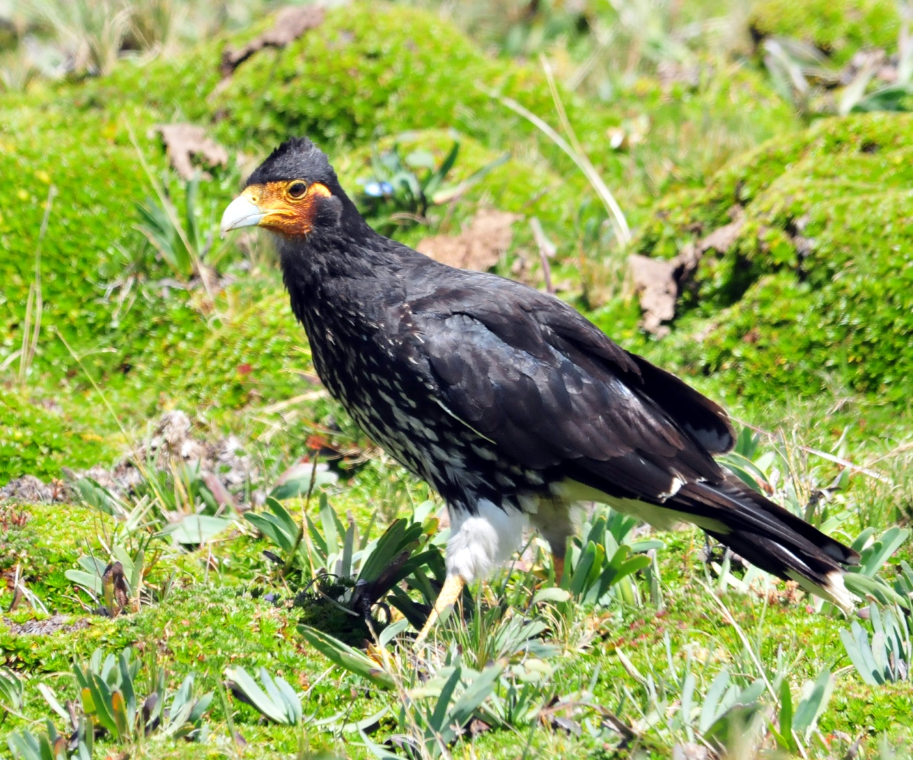
Carunculated Caracara
privately-owned land at elevations of over 3000 MASL, so the services at the Hacienda are no longer available. This was one of my favorite parts of this day of the tour, not only because the food was delicious, but also because we were able to get a glimpse of traditional life in the high Andes. I hope they will be able to resume this service some time in the future. While we were eating, I saw an Andean Teal fly in and land on a small island just off the shore. We all got out and viewed the teal through the scope. We noticed a family who had locked their keys in their car, and it wasn't long before Jim, Galo and Marcelo went to help. While the guys attempted to break into the car, FL Joan came in the bus to say they had Yellow-billed Pintail in the scope. We all got out to look, but it was so far away it was just a speck, even through the scope. Driving away from lake, NY Joan spotted another Andean Condor. Eventually, American (aka Jim's) ingenuity got the door open, and we drove away from the parking lot, waving good-by to a happy and relieved family.

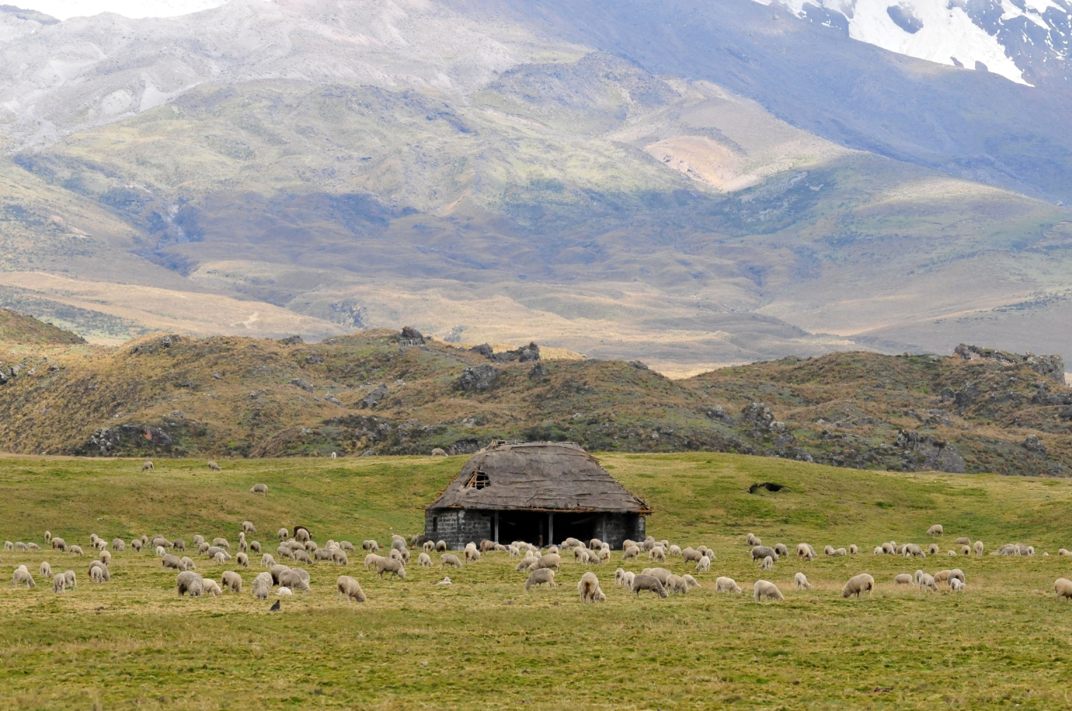
The High Andes

Luis and Galo had been scanning the fields for Black-faced Ibis as we drove away from the lake, but they hadn't found any. Marcelo was taking a break in the back of the bus, using the drive time to rest his eyes (What had he been doing last night, anyway?). When Cathy asked if we could stop to take photos of some nearby Andean Gulls, Luis stopped the bus, which made Marcelo open his eyes. In about a millisecond, he announced, "Ibis!". Galo joked about how good Marcelo is at spotting things, even with his eyes closed!

We had not yet seen one of our target species, Giant Hummingbird, so the guys watched for the kind of Agave they like to feed on. When a likely spot was found, we stopped and got out to bird. We dipped on the Giant Hummingbird, but Cathy found Glossy Flowerpiercer and other Hummers kept us entertained as we searched, including Shining Sunbeam, Tyrian Metaltail, and Black-tailed Trainbearer. Once we gave up on the Giant Hummingbird, we headed for Guango Lodge.

We arrived at Guango at around 5:00 PM. The light was fading but the Hummingbirds were still busy. Among several "old" species, we immediately found five new Hummers: Long-tailed Sylph, Chestnut-breasted Coronet, Tourmaline Sunangel, White-bellied Woodstar, and Mountain Velvet-breast. Collared Inca and Sword-billed Hummingbird were two of the more impressive "old" species we saw as our rooms were being assigned. With a group of 14 plus the guides, four of us needed to be housed in a cabin that was a short walk from the main lodge and closer to the road, which could be pretty noisy. The guides would be staying in a nearby town. I asked for volunteers to share the cabin with Jim and me, and after some hesitation among the group, Walt and Jackie stepped forward. As it turned out, the walk was not long, the road was not noisy during the night, and the rooms in the cabin were more spacious than those in the lodge proper, so everyone was satisfied.

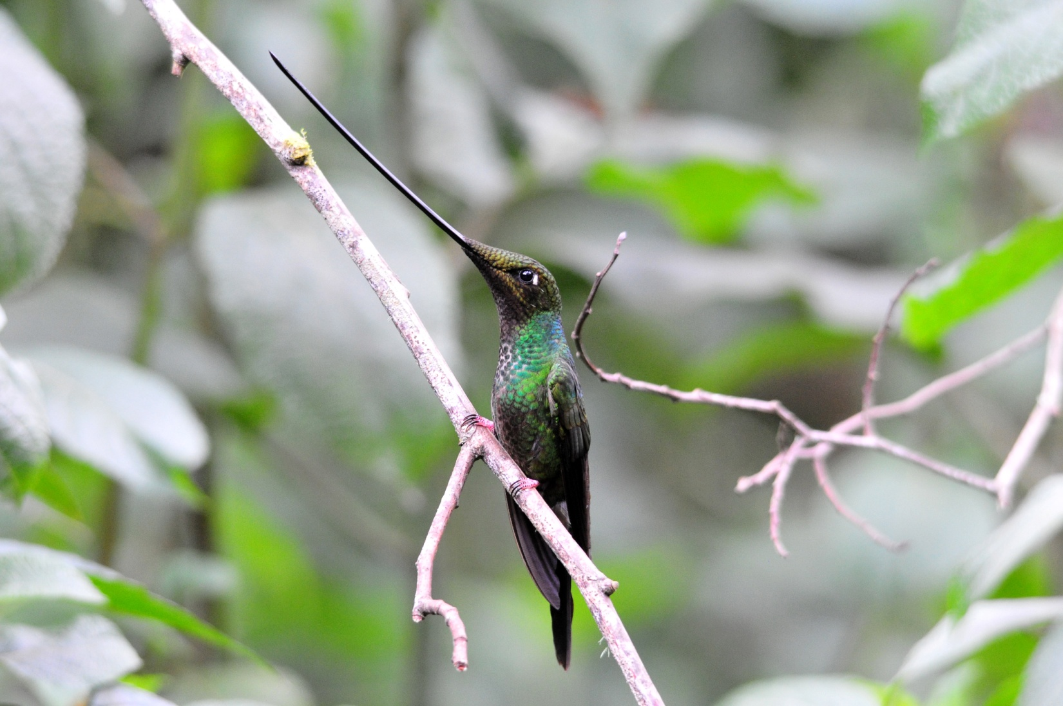
Sword-billed Hummingbird

Other birds seen today included Hooded Siskin, Russet-crowned Warbler, and Andean Guan. We finished the day with just 44 species, but no one was disappointed. This was a day to find high elevation specialties that can't be found in other places rather than a day to rack up high numbers. Half of the birds we saw were new for the trip, giving us a count of 258 for the tour thus far.

Day 9, Sunday, November 27: We had breakfast at 6:00 and left the lodge by 6:35. Within minutes of our departure, Marcelo called out for Luis to stop for an Andean Guan. We drove past the Termas de Papallacta Spa and Hotel and drove up the mountain behind it on a gravel road. Our first sighting once we got out and started walking downhill was a Scarlet-bellied Mountain-Tanager, quickly followed by Red-crested Cotinga, Paramo Seedeater, and Shining Sunbeam. As we stood at the edge of the road near a waterfall looking for a Paramo Tapaculo, someone found a Glossy Flowerpiercer, and then Jim noticed a White-capped Dipper at the edge of the waterfall. Unexpected treat! As we meandered down the road, we saw Spectacled Redstart, Veridian Metaltail, and more Scarlet -breasted Mountain Tanagers joined by Masked Mountain-Tanagers. Further down the road we found Tawny Antpitta, Pale-naped Brush-Finch, Brown-bellied Swallow, Andean Gull, Rufous-breasted Chat-tyrant, and both White-banded and White-throated Tyrannulets.

We went back to Guango Lodge for lunch, and did a bit of birding around the lodge, yielding Northern Mountain-Cacique, Cinnamon Flycatcher, Torrent Tyrannulet, Pearled Treerunner, a new subspecies of the Masked Trogon (Highland Trogon), Mountain Avocetbill, Band-tailed Pigeon, and Torrent Duck. I passed on the bird walk, preferring to try my luck with my camera at the feeders and was able to finally see a Gray-breasted Wood-wren, a heretofore "heard only" species.

Our plans called for us to go back out to bird more in the highlands at 3:00. Galo talked to another guide who brought his clients to lunch at Guango and learned the that a Rufous-bellied Seedsnipe was seen at its usual spot near the antennas. This site was originally on our itinerary, but the latest information on the location of the Seedsnipes indicated that some of them had been killed by hunters and no one had been finding them at their usual spot for several weeks. Assuming that the birds were not present, we replaced the outing to the antennas with an afternoon at Guacomayas Ridge. We were thrilled to hear we might have a chance to see them after all, and we decided to depart as soon as everyone could get ready. Matt and Cathy had gone out to bird and no one knew where to find them, so we were delayed a short time while we waited for them to return. These two never waste a minute of time that could be spent birding, so no one was surprised that they had gone off alone, and no one was bothered by the short wait. We headed up a steep, narrow road toward the antennas. Luis's driving ability shined on the difficult drive, which involved sharp switchbacks, steep grades, narrow passage with sheer drop-offs, and a poorly-maintained surface. The scenery on the way up was amazing with mountain lakes and ponds and low vegetation in all shades of green.

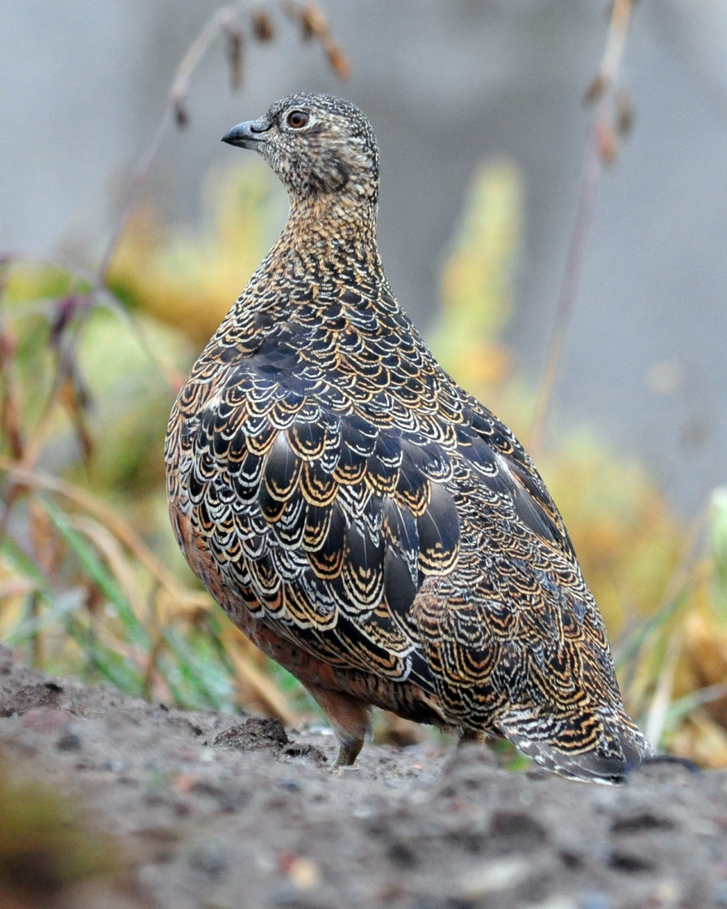
Rufous-bellied Seedsnipe

As soon as we stopped at the antennas, Luis spotted a Rufous-bellied Seedsnipe from the bus. Not everyone heard the news, though, as people rushed off the bus. Peter and Joan were the last to get out of the bus, and did not get to see the target bird, which was very upsetting to all of us. There was just one bird, unlike previous trips when we saw multiples, and when it flew, it disappeared over the hill.

A light rain began to fall and fog began to thicken as we searched the area for other high-elevation specialties. We found a Many-striped Canastero, but even as I was taking photographs, I was thinking about how treacherous the road would be on the way down. We walked part of the way down the mountain, rode part of the way, but Margaret was so nervous about the road she decided to walk. An avid hiker in excellent condition, Margaret had expressed her relief that this birding trip hadn't proven to be too sedentary, and she often took advantage of opportunities to do some extra walking. This road gave her yet another reason to want to walk. Cathy and Matt joined her, and we picked them up at the base of the mountain. It was a relief to be off that road, but we were all glad we had done it - great birds, wonderful (almost surreal) scenery, and a wonderful sense of accomplishment.

We finished the day with 55 species; the trip total now stood at 274. Will we reach 300 tomorrow?

Day 10, Monday November 28: Today we spent the morning on Guango Lodge trails before driving to our next stop, San Isidro Lodge. We spotted Turquoise Jays before we met at 6:00 AM for coffee or tea, and made an attempt to call out the Gray-breasted Wood-wren as we left the dining room, but it would not cooperate. We headed toward the bridge that spans the fast-flowing Guango River at the back of the property. As we walked down an open grassy hill with trees lining both sides, the birds appeared in rapid succession: Blue-and-black Tanager, Black-crested Warbler, Cinnamon Flycatcher, Blackburnian Warbler, Spectacled Redstart, Pearled Treerunner, Canada Warbler,
Northern Mountain Cacique, Hooded Mountain-Tanager, Lacrimose Mountain-Tanager, Turrquoise Jay, Blue-backed Conebill, Gray-hooded Bush-Tanager, Buff-breasted Mountain-Tanager, Black-capped Hemispingus, Black-eared Hemispingus, and White-banded Tyrannulet.

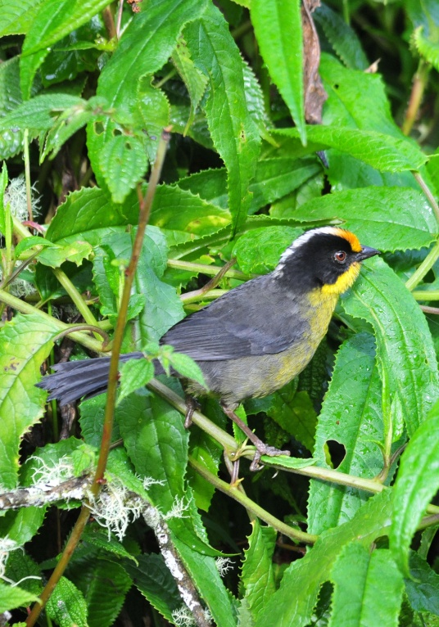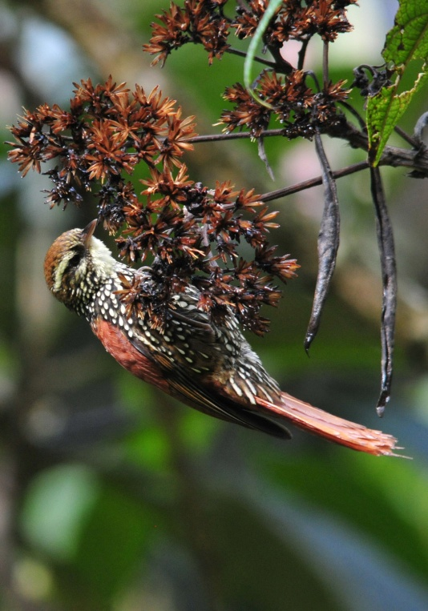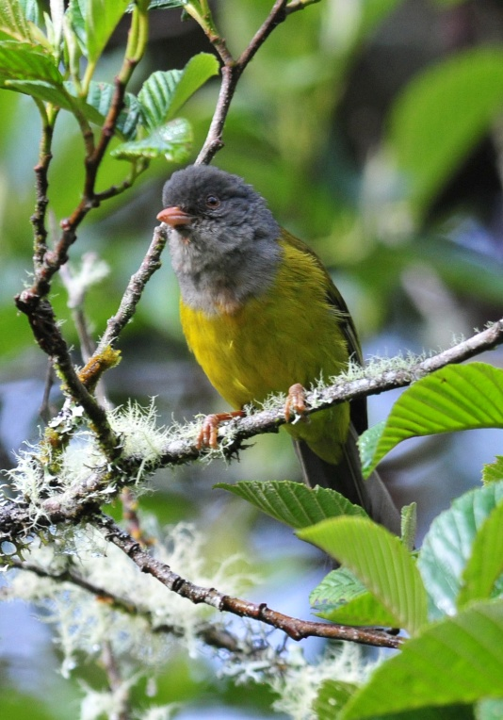
Pale-naped Brush-Finch Pearled Treerunner Gray-hooded Bush-Tanager

Breakfast at 8:00, back out at 9:15. The first bird we saw, again before we made it to the bottom of the hill, was a Scaly-naped Amazon, at first thought to be a White-capped Parrot because that Amazon is not supposed to be at this elevation. Once the bird was in the scope, there was no question as to its identity, and both guides digiscoped the bird for records. We worked our way down the hill that had been so busy a few hours earlier but didn't find anything new other than Slaty Brush-Finch. We crossed the highway and entered a trail that leads to a waterfall where Slaty-backed Chat-Tyrant is reliable. The Chat-Tyrant was where he was expected to be, and we also found Torrent Tyrannulet and Spotted Sandpiper.

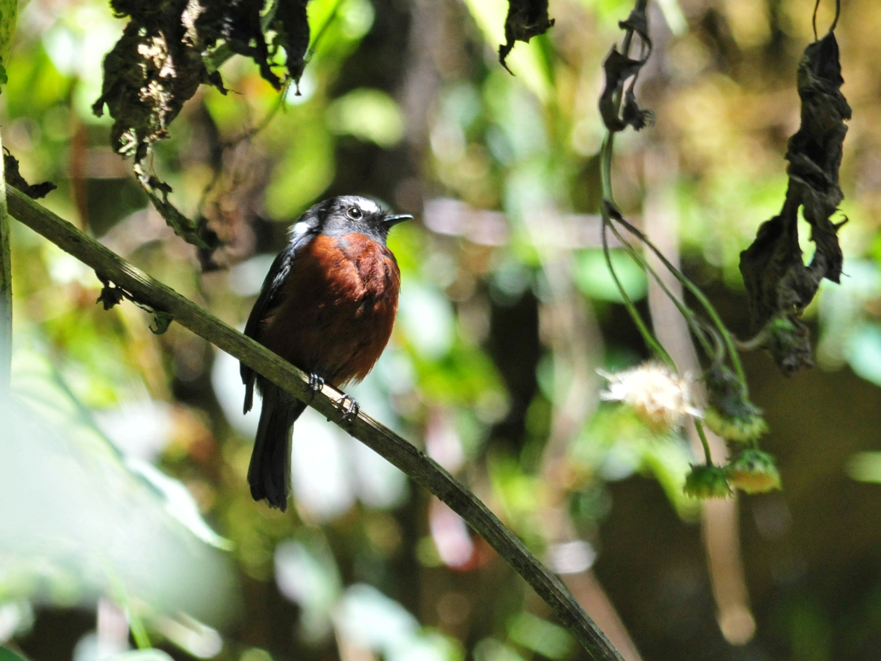
Slaty-backed Chat-Tyrant

The skies became cloudy and it began to rain lightly, so we returned to the lodge and asked if we might have lunch earlier than planned so we could move on to San Isidro. We left by 1:30 and headed for a lower elevation with new vegetation and new birds awaiting us. Just a few miles down the road, we came upon a serious accident that had traffic backed up in a long line, and we could do nothing but wait. Some of us got out and did a little birding from the roadside, but it wasn't very productive. After about an hour's delay, we were able to proceed, thankful that we were only inconvenienced and not involved in the accident. We arrived at San Isidro at around 4:00 PM.

After checking in and getting our things to our rooms, the group scattered a bit with some resting in their rooms, some exploring our new environment, and some gathering on the observation deck on the roof of the Mirador Lounge, a common room with a pool table, TV room, comfortable seating, and a deck overlooking hummingbird feeders and the forest beyond. There, a small flock moved through and we found it difficult to keep up with the birds, much less identify them, without Galo or Marcelo to help. After a short while, Marcelo joined us and we were able to confirm our IDs of Marble-faced Bristle-Tyrant, Barred Becard, Orange-bellied Euphonia, Glossy Black Thrush, and Subtropical Cacique. A Woodcreeper remained unidentified and Marcelo pointed out an Ashy-headed Tyrannulet for us. As others came to join us, the bird activity slowed and finally seemed to come to a stop.

I went with Jeanne to see her cabin, which was one I had never been inside located near the dining room. As we crossed the path that led from the cabins to the dining room, we heard a bird vocalizing and followed the sound to an adorable Rufous-capped Tody-Flycatcher. Next we were distracted by a vocalizing (and invisible) Gray-breasted Wood-wren that was quickly replaced by an Azara's Spinetail that was working its way down the path, first in the open, then disappearing, then in the open, and repeating the sequence all the way down the path and half way up the other side. We followed it, trying to get a photograph in the low light, until finally some Inca Jays showed up and demanded our attention. I never did make it to Jeanne's cabin and instead returned to our cabin via the parking lot, where I was delayed by a couple of Russet-crowned Warblers and a Golden-crowned Flycatcher.

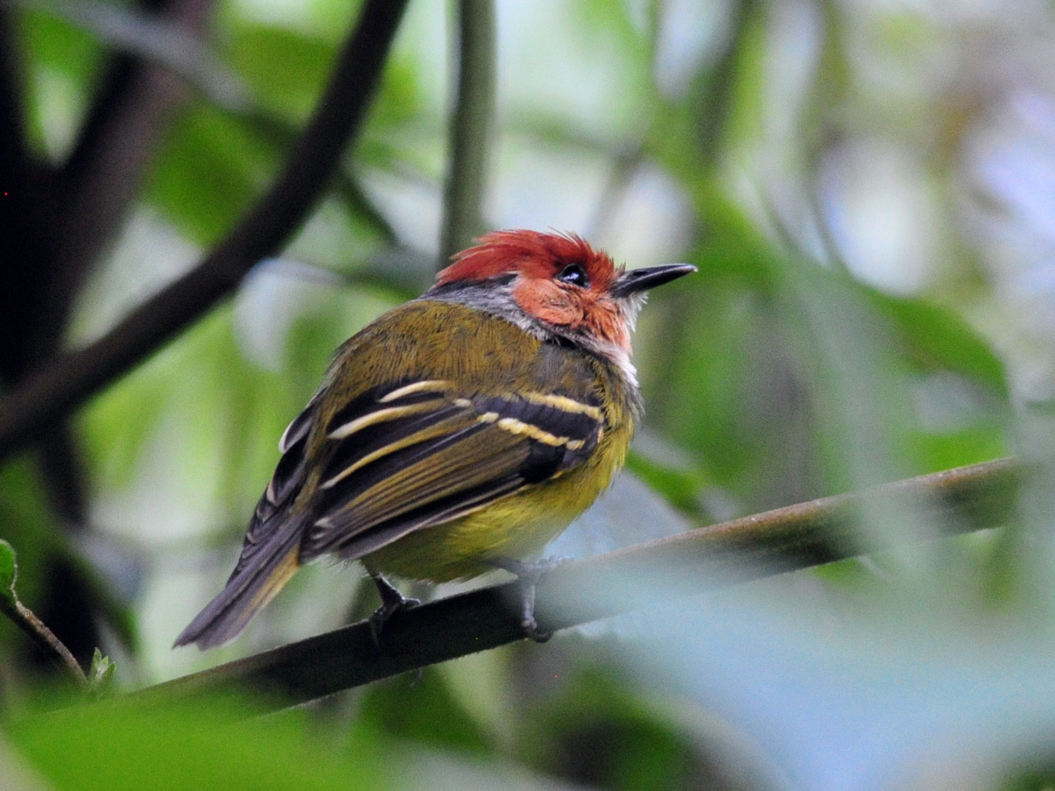
Rufous-crested Tody-Flycatcher

I finally made it back to our cabin to get Jim so we could report to the common room to complete the list before dinner. As we were gathering the list, pen, computer, etc, someone came to the cabin and said they had the "San Isidro Owl". We hurried out to see the owl, well-known for having characteristics of both Black-banded and Band-bellied Owls and at one time thought to be a new species. It has since been identified as a Black-banded Owl even though that species is not normally present at this elevation. After completing the list, we learned that we saw 71 birds today, with 25 new species, bringing our trip total to 299! NO! Wait! Let's go out and find a nightjar or an owl or something to bring our count to 300! Did anyone see something we forgot to mention?

Birds seen today that were new for the trip and not mentioned include Russet-backed Oropendola, Saffron-crowned Tanager, White-sided Flowerpiercer, Capped Conebill, Montane Woodcreeper, Bronzy Inca, and Common Paraque.
Day 11, Tuesday, November 29:
Breakfast at 5:30, walk around San Isidro after breakfast until it's time for the resident Antpittas to be fed. A light post that attracts insects that in turn attract birds is an excellent place to find a lot of birds, but the light bulb was burned out, so we didn't wait there long before walking down the path to the parking area. There we found Montane Woodcreeper, Black-billed Peppershrike, Pale-edged and Golden-crowned Flycatchers, Spectacled Redstart, Blackburnian and Canada Warblers, White-tailed Tryannulet, Subtropical Cacique, Smoke-colored Pewee, Gray-breasted Wood-wren, Rufous-crested Tody-Flycatcher, and Masked Trogons. As I was trying to photograph a Slate-throated Redstart, I noticed a bird that I didn't recongize and called Marcelo over to identify it for me - Rufous-breasted Flycatcher.

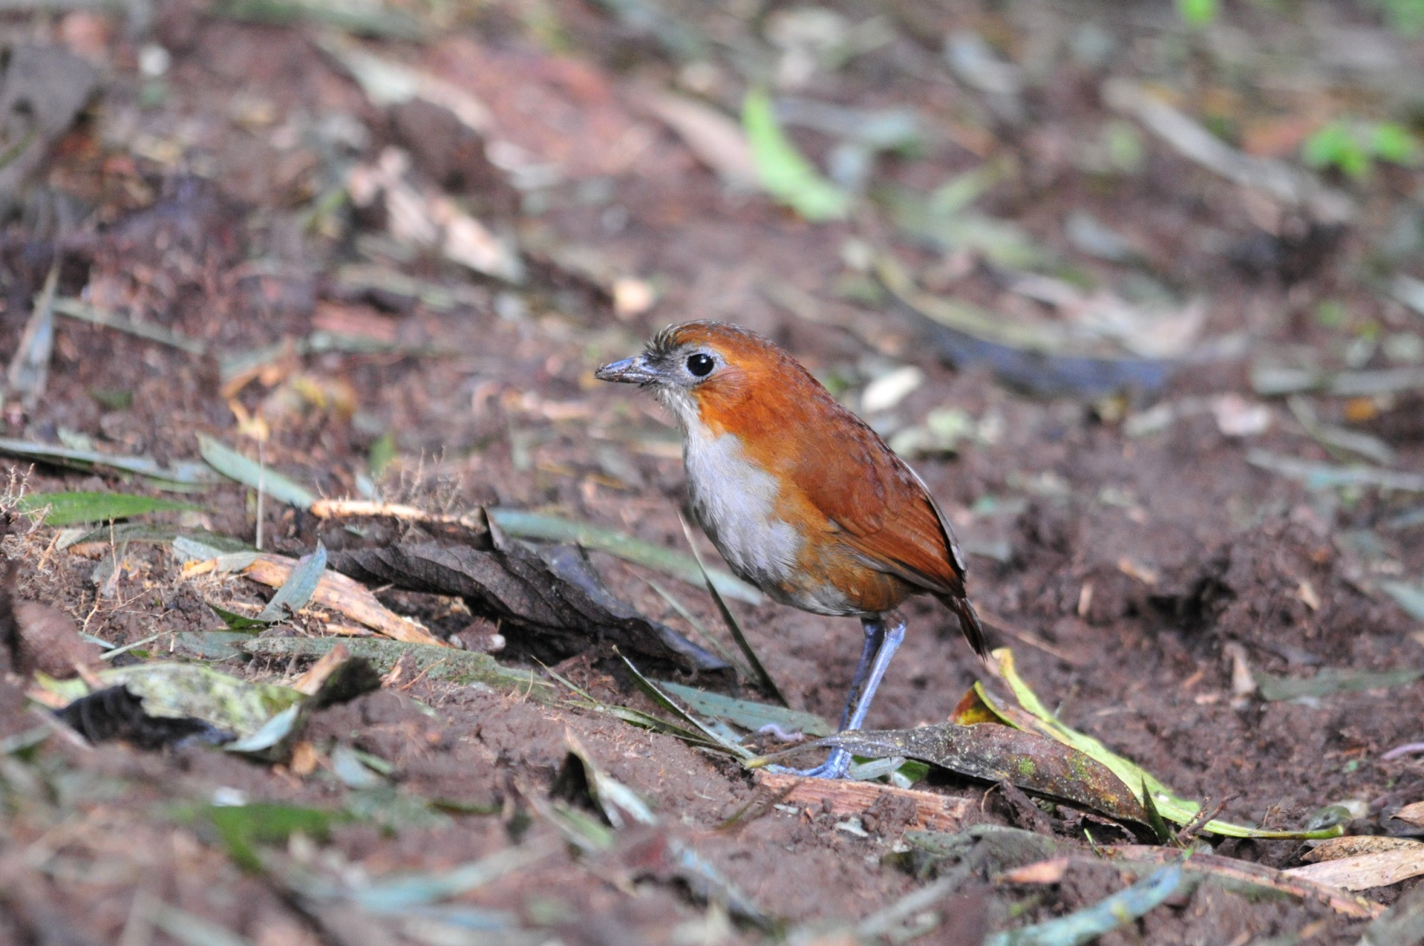
White-bellied Antpitta

After a quick restroom break, we reported to an area just past the dining room to watch the Antpittas being fed at 7:30. Like Yanacocha, San Isidro has tried to replicate the success of feeding Antpittas as Angel Paz has done. They've been feeding White-bellied Antpittas for a few years now and have just begun to train Peruvian Antpitta to come for worms. A few people were late, so after I took some quick photos of the White-bellied Antpitta, I went back up the hill to give directions and encourage the late-comers to hurry. Luckily, these birds have been acclimated to humans for some time and they took their time eating so everyone got to see the birds. A few other people had joined us, which made it a bit crowded, so Galo suggested that we split into two groups to see the Peruvian Antpitta, which was fed at a spot deeper in the forest. Half of us would go today, the other half tomorrow morning. Marcelo didn't like this plan since the weather was perfect this morning, but he reluctantly agreed. He went with the first group, and Galo would go with the second group tomorrow. This would be a life bird for both of them, so obviously it was a life bird for all of us. Those of us who went this morning were fortunate to have stellar looks at the diminutive Peruvian Antpitta, but he didn't stick around for long. The group that stayed back on the observation deck had Red-billed and White-capped Parrots and a Broad-winged Hawk. We met again at 8:40 to bird along the entrance road, where our first bird sighting was a Bluish Flowerpiercer. Galo and Marcelo heard a Forest Falcon, but I think we were too noisy and scared the bird away before they could find it. The activity was slow, with only a Golden-collared Honeycreeper to show for our efforts to find new species, so we decided to drive to an area where we might find some grassland birds.

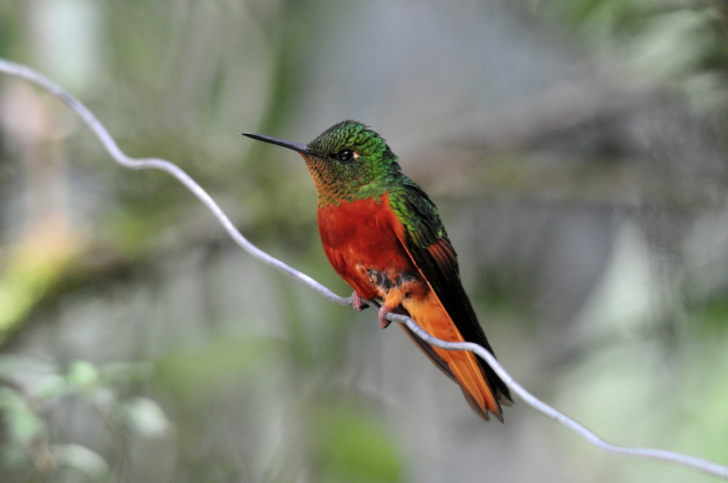
Chestnut-breasted Coronet

Birding along the road, we stopped to see a couple of Southern Lapwings and also saw Black-and-chestnut Eagle overhead. At a small pond, we spotted a female Blue-winged Teal that was more impressive to Galo than to our US group since we see them far more often at home than he does in Ecuador - he said this was the first time he saw it in his own country!

We drove back to the lodge and walked back down to the bridge where we spotted White-capped Dipper and Torrent Tyrannulet, but we did not locate a Torrent Duck. Our plan was to return to Guacomayos Ridge, but that spot had not been very productive the day before and Luis provided us with a tempting alternative. His brother, a well-known birding guide, had called to tell him where some White-capped Tanagers were nesting nearby. This heaviest of the tanager species lives in flocks only at elevations of 1600 - 3200 MASL. Not a common bird and not easily found, it would be a life bird for everyone but the guides. We left at 3:30 to drive to the site, which proved to be almost as bad as the drive to the antennas a few days ago. We went up an awful hill - narrow dirt road with plenty of holes, steep drop-offs, just the kind of road I'd like to avoid. But for White-capped Tanagers? No problemo; proceed.

After what seemed like a very long drive, we stopped at a bridge that was impassable for the bus. It was here that the reported nest should be found, but we could find no White-capped Tanagers in the area. Luis, Galo, and Marcelo concurred that the nest was now unoccupied and the young had most likely fledged. We began to walk down the road, birding along the way. We found Torrent Duck on the river, Emerald Toucanets in a distant tree, and Golden-rumped Euphonia near the road. Finally, we heard Galo and Marcelo call out the name of our target species - White-capped Tanager! Not one or two but a whole group of tanagers were in a mostly-bare tree on the opposite of the river. We watched them through the scope until they flew, luckily to an even better spot for viewing. We all enjoyed watching the birds, taking turns looking through the scopes and trying to digiscope some decent photos. The tanagers were still hanging around when I walked a short distance down the hill. It was after 5:00 PM and I didn't want to be going down that road in the dark, much less in the dark and the rain. I could hear thunder in the distance, so I thought it a good idea to encourage some forward movement. I caught some movement in a large tree on the other side of the river. Thinking I had a Lineated Woodpecker, I watched until the bird came back to the side of the tree where I could see it. When I could finally see the Powerful Woodpecker, Matt was the only one close enough to see it when I called. Again, I could hear the thunder - we need to get off this hill.

We returned to San Isidro Lodge, met to complete the check list and had our evening meal. We had a total of 70 species today, bringing our trip total to 317. Other birds that were seen today for the first time on the trip included Blackpoll Warbler, Mountain Wren, and Crimson-mantled Woodpecker.

Day 12, Wednesday, November 30: We had breakfast at 6:00 and, since the birding there was so good yesterday, we decided to meet in the parking lot at 6:30. In very short order, we saw Masked Trogon, Russet-crowned Warbler, Common Bush-Tanager, Olive-backed Woodcreeper, Montane Woodcreeper, lots of Blackburnian Warblers, Canada Warbler, Cinnamon Flycatcher, Smoke-colored Pewee, and Pale-edged Flycatcher, among others. While the group who stayed behind yesterday went with Galo to watch the Peruvian Anpitta being fed, those of us who had already seen it went to the observation deck with Marcelo. There was quite a bit of activity in the trees, but most of it was stuff we'd

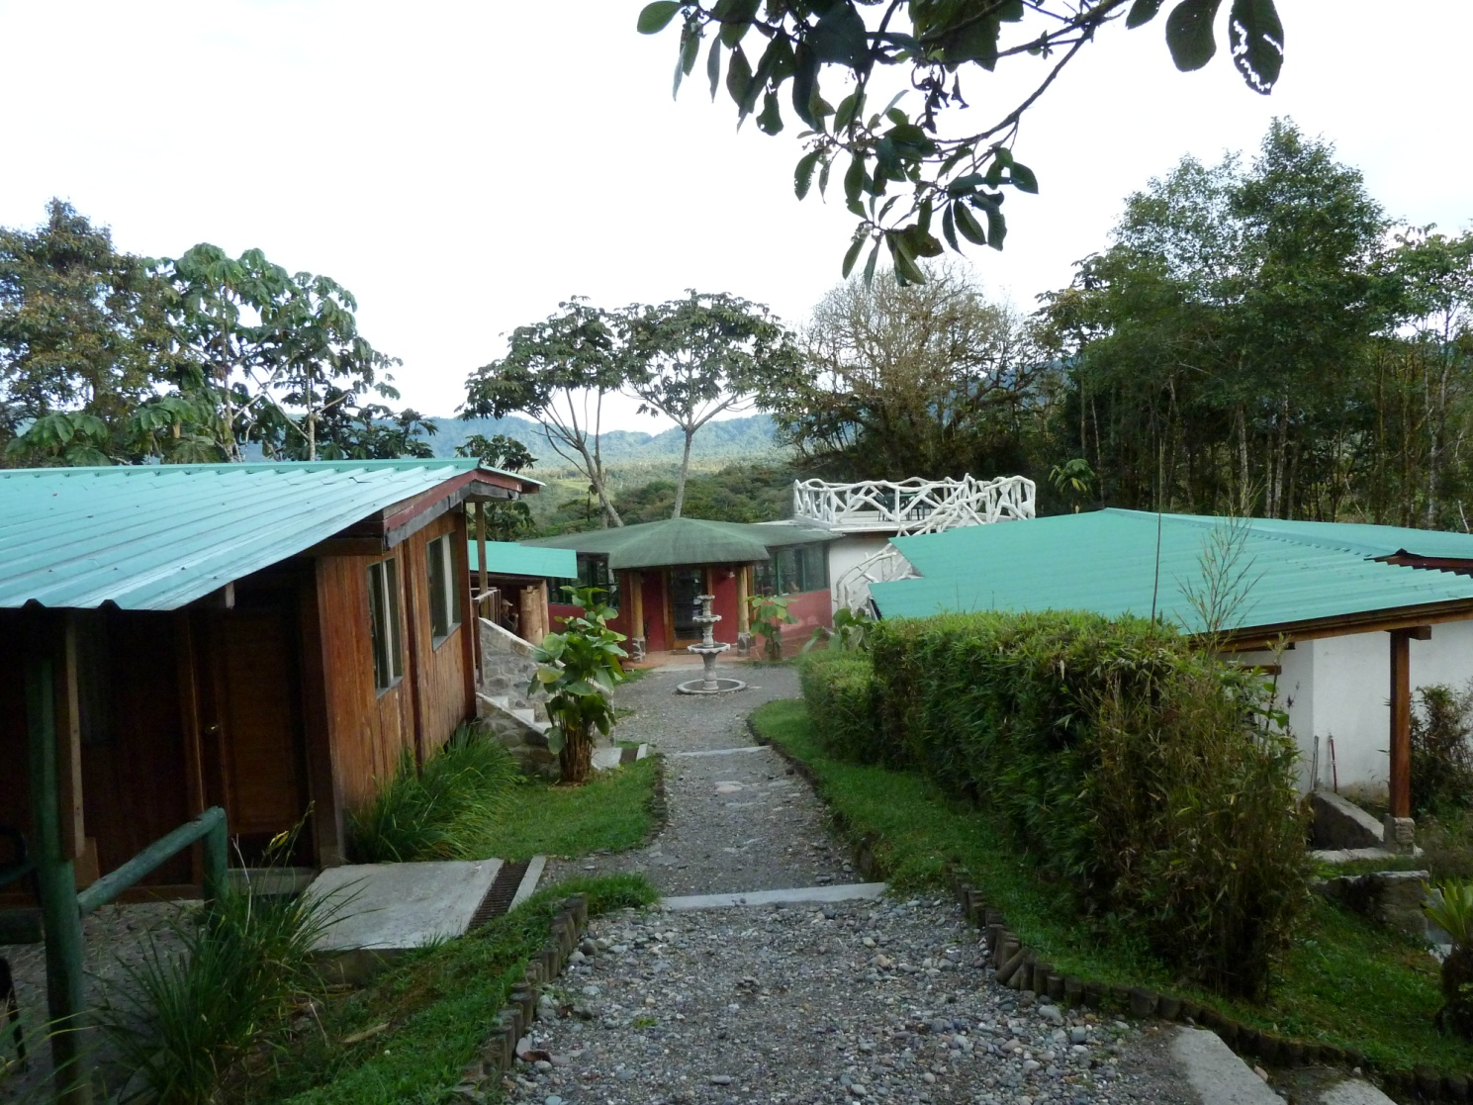
San Isidro's cabins and rooftop observation deck
already seen until Marcelo spotted a large shape in the distance that turned out to be a Collared Forest-Falcon. The Forest-Falcon sat in the scope for a long time as we added White-capped Parrot, Fawn-breasted Tanager, Rufous-breasted Flycatcher, and Bluish Flowerpiercer to the day's list. We were hoping that the other group would return soon and that the Forest-Falcon would still be there for them to see, but a lot of time was passing. Marcelo went part way down the trail to see if he could find the other group. We thought they might have gone further into the forest to bird after seeing the Antpittas, perhaps following some bird calls with one leading to another, leading to another, etc. He couldn't see any sign of the group, and we joined him at the entrance to the trail when he said he heard a Long-tailed Antbird. At first, we had to "get" the bird in pieces - first a tail, then a crest, then finally the whole bird popped into view. It immediately became one of Matt's hundred-or-so "Top ten birds". By now, the Forest-Falcon was long gone and the bird activity had died down. A bit later, the group returned and we could tell by the looks on their faces that the Peruvian Antpitta had been a no-show this morning. They had stood for hours waiting for the bird to appear, and hadn't seen much of anything else during the time they were in the forest. There was a huge "I told you so" on Marcelo's face, but he didn't say a word.

Shortly after the group was reunited, they went to Guacomayos Ridge and I stayed back to play with my camera and the feeder birds again. It takes a lot of time to get decent photos, even when the birds are obliging. Neither the group that went nor I had much luck, so when they returned early, we had about an hour and a half of down time before lunch at noon. We used the time to get organized so we could depart right after lunch. We pulled out at 1:00 PM for Wild Sumaco

We stopped to look for a Coppery-chested Jacamar and found Lesser Seedfinch and Olive-sided Flycatcher, but no Jacamar. An Eastern Wood-Pewee flew in and chased the Flycatcher away. Also seen at this stop were Silver-beaked Tanager, Chestnut-bellied Seedeater, White-lined Tanager, and Caqueta Seedeater, the eastern subspecies of Variable Seedeater. Our next stop was near a rock wall where we almost always find Cliff Flycatchers. As we were watching the Flycatchers doing their thing, flying out from the cliff to catch insects, a Roadside Hawk was spotted on the other side of the road and a Lesser (Chestnut-bellied) Seed Finch (not to be confused with the Chestnut-bellied Seedeater) posed for us.

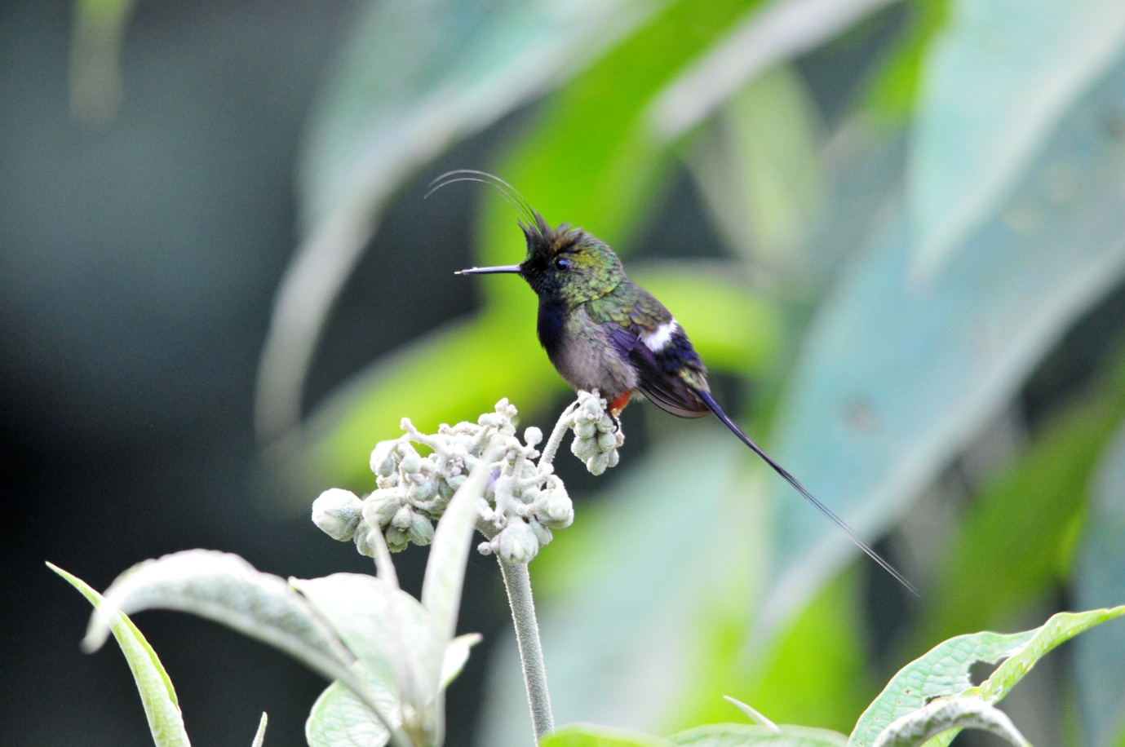
Wire-crested Thorntail
We arrived at Wild Sumaco Lodge at around 4:00 PM and immediately went to the feeder-lined deck that overlooked the valley below. In addition to the regular cast of Hummingbird characters, White-shouldered Tanager, Swainson's Thrush, and Black-mandibled Toucan were seen. Wire-crested Thorntails, which were very difficult to see on our last visit because they refused to come to the feeders and only fed on the Porter Weed bushes at the sides of the building, were much more obliging this time. Multiple males were among the first hummingbirds we saw at the feeders! Golden-tailed Sapphire, a real gem among the common Hummingbirds with its golden tail and brilliant blue head and neck was one of the most numerous hummers, next to the Sparkling Violet-ear that proved once again to be the bully of the crowd, pushing its cousin, the Brown Violet-ear out of place each time it came zooming in. Violet-headed Hummingbird was identifiable not by the violet on its head that usually presented as black, but by its large post-ocular spot. Many-spotted Hummingbird looked rather drab next to some of the others until you took the time to observe the delicate beauty of the markings on its chest. The tiny Amethyst Woodstar can be a fooler - it's very similar to the more common White-bellied Woodstar and Gorgeted Woodstar. The Booted Racket-tail, one of my favorites, is even cuter on the eastern slope with its orange socks. Violet-fronted Brilliant, Andean Emerald, Fork-tailed Woodnymph, and then, perhaps the most beautiful of all, a bird that wasn't even seen from the lodge last year, Gould's Jewelfront. WOW! Bright orange across the chest, brilliant blue throat and violet crown , sparkling green body - what a bird! My camera was going to get a work-out here!

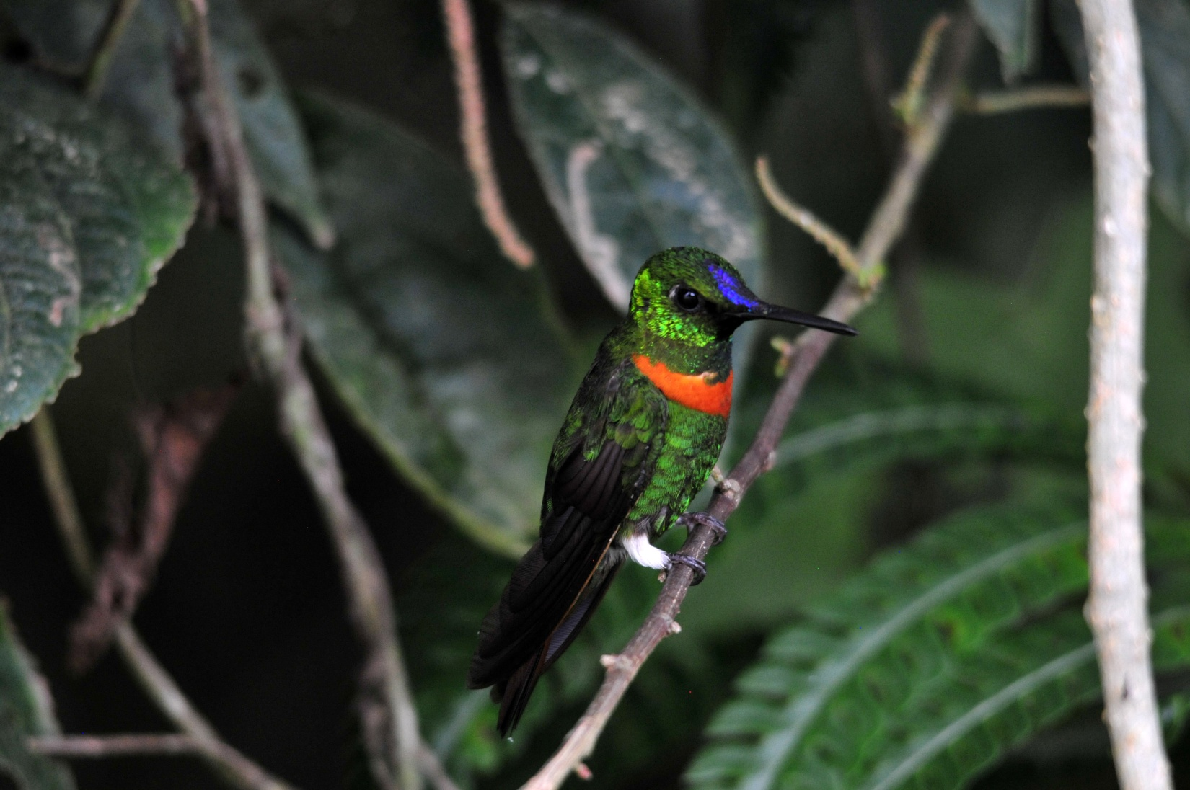
Gould's Jewelfront

We enjoyed the feeder spectacle until about 6:00 PM when we met to do the list. We tallied 86 species, our best count since day 6 when we had 94 for the day. This brought our trip total to 339, and for the first time we voiced the desire to hit 400 by the end of the main tour. Other birds seen today for the first time for the trip included Silver-beaked Tanager, Scarlet Tanager, Gray-rumped Swift. We also had the eastern subspecies of Southern Rough-winged Swallow and Flame-faced Tanager.
Day 13, Thursday, December 1: I heard a Band-bellied Owl shortly after 5:00 AM, but when I went to investigate it stopped calling. We met early to bird the entrance road. The activity was impressive, with Olivaceous Greenlet, Blue-necked Tanager, Palm Tanager, Silver-beaked Tanager, Yellow-browed Sparrow, Blue Dacnis, Sooty-headed Tyrannulet, and Grayish Saltator coming in quick order. The garishly beautiful Paradise Tanager presented itself for our viewing pleasure. Chestnut-fronted Macaws and Red-billed Parrots flew by. Channel-billed Toucan, Golden-olive Woodpecker, Blue-gray Tanager, Magpie Tanager, Red-rumped Cacique, Black-and-white Seedeater, Black-billed Thrush, Yellow-tufted Woodpecker, and then more Paradise Tanagers appeared. Marcelo had a Spotted Tanager but it left before he could get anyone on the bird. Next came Scaled Pigeons, Plumbeous Pigeon, Crested Oropendola, Social Flycatcher, Spot-breasted Woodpecker, Blue-naped Chlorophonia, and a controversial Golden-faced Tyrannulet. Galo and Marcelo had a brief debate over the identity of the tyrannulet that was settled by using zoomed-in images on my camera. Apparently, a Red-billed Tyrannulet was calling in the area at the same time we saw the Golden-faced Tyrannulet, and the two species are similar enough that they are easily confused without a good look at eye color.

When the group entered a forest trail, the path became steep and muddy pretty quickly. Marion was concerned about being able to make it the entire way, so I offered to go back to the bus with her. When we got back to the road, Luis graciously offered to take us back to the lodge where we would be able to bird from the deck. When we got there, we took a walk on a short nature trail where we were told we might find some Blue-rumped Manakins. We didn't see much of anything on the trail, and when we came out in the parking area, Luis was there looking for us. He had found the nest of a Yellow-tufted Woodpecker and took us back up the road to see it. We returned to the deck and saw a Bananaquit, both Red-headed and Gilded Barbets, Bay-headed and Palm Tanagers, and a Masked Tityra. Looking straight down from the deck, I saw an odd hummingbird and later discerned that it was an Ecuadorian Piedtail. Unfortunately, Marion missed that one. The group on the trail worked hard for a few good birds, including Scale-backed Antbird, Fulvous Shrike-Tanager, and Blue-rumped Manakin.

After lunch, we took a two-hour break while it rained. As soon as the rain stopped, we went back out on the deck to bird. Our first species of the afternoon was a new bird, a stunning Golden-eared Tanager. The birding from the deck was pretty good, with Blue-necked Tanager, Channel-billed Toucan, Golden-faced Tyrannulet, Magpie Tanager, Golden-collared Honeycreeper, and Lined Antsrike, but as soon as it looked like the rain had stopped for good, we went back to the road that had been so active this morning. After just a short walk on the road, it began to rain again, so we went back to the lodge for a short time. As soon as it let up again, we drove down the road a short distance to a trailhead that led to a small cabin with several Hummingbird feeders. By now it was going on 5:00 PM, so we couldn't linger too long. These feeders provided us with some new hummingbirds, including Gray-chinned Hermit, Green Hermit, Fork-tailed Woodnymph, Violet-fronted Brilliant, Black-throated Mango, and Black-throated Brilliant, in addition to some of the hummers that were common at the Lodge feeders.

Other birds seen today for the first time but not mentioned included Chestnut-collared Swift and Highland Motmot, a species recently split from Blue-crowned Motmot. For our checklist we marked 86 species seen today. With 32 of them new for the trip, our new trip total was 371. Can we find 29 new species in a day and a half to make 400 by the end of the main tour?

Day 14, Friday, December 2: The final full day of birding on the main tour - how time flies when you're having fun!
We started off shortly after 6:00 AM at the parking lot. There, where a light attracted insects, a host of birds appeared for their morning feast. I got there before the others, and as soon as I saw how active things were, I hurried back to tell everyone to get down there, pronto! There wasn't too much in the way of new birds, but boy-oh-boy was it active! Canada and Blackburnian Warblers, Tropical Parula, Cerulean Warbler, Montane Foliage-gleaner, Lined Antshrike, Lafresnaye's Piculet, Dusky-capped Flycatcher, Sooty-headed Tyrannulet, Marble-faced Bristle-Tyrant, Tropical Kingbird, Streaked Flycatcher, House Wren, Golden Tanager, Blackpoll Warbler, Blue-necked Tanager, Olivaceous Greenlet, Golden-crowned Flycatcher, all seen about as quickly as you could say their names. As a bonus, a Channel-billed Toucan flew by, and then Swallow-tailed Kites appeared in the sky. A Blue Dacnis was seen while I was off telling Jim and Joan to come before this spectacle ended. Right after the three of us returned, a group of 17 Chestnut-fronted Macaws flew by. We slowly made our way closer to the road and picked up more birds: Golden-faced Tyrannulet, Scaled Pigeon, Magpie Tanager, Band-tailed Pigeon, Variable Seedeater, Scale-crested Pygmy-Tyrant. The activity was slowing when we went inside for breakfast, but it was still difficult to leave.

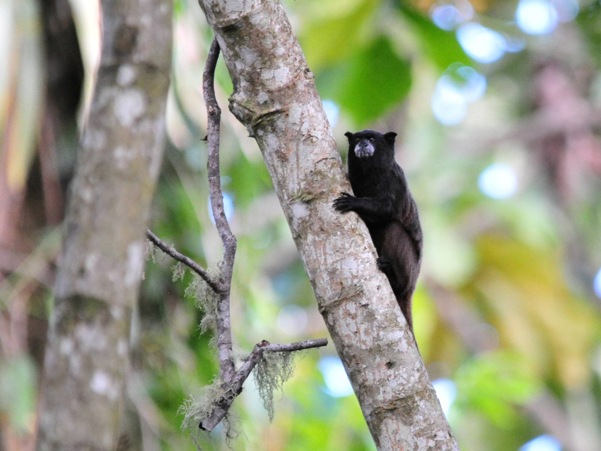
Black-mantled Tamarin

During breakfast, there were six Swallow-tailed Kites flying at eye level in front of the deck, and we could see some of them feeding on the wing. Some people saw Black-mantled Tamarin and more Chestnut-fronted Macaws flew by, this time close enough to get color and field marks. Right after breakfast, we left to visit a spot that overlooks a valley, giving us eye-level views of a pretty good birding area. On the way, we had Roadside Hawk, Spotted and Paradise Tanagers, a female Scarlet Tanager, Blue-necked Tanager, and Masked Tityra. At the overlook, a Black-eared Fairy flew by so quickly that Marcelo was the only one who saw it. We got a Swallow Tanager in the scope right away, and then a Grayish Saltator flew in while we were looking for a Dark-breasted Spinetail. Some Black-billed Thrushes flew in to one of the tall trees in front of us. From this spot we had a good view of the volcano (Sumaco), but as the minutes passed, clouds began to obscure the volcano and soon it started to rain lightly. This site had been excellent on previous trips, but this time the grass was tall and wet, which made it difficult to move about and raised the concern for chiggers. Taking this into account, along with the impending rain and not particularly good birding this day, we decided to go back to the feeders at the cabin where we would have some shelter if the rain increased. On the trail leading up to the cabin, Walt saw a Chestnut-bellied Thrush. Most of the group got on the Plain Antvireo that was calling near the path, and then we found a Gilded Barbet and Blue-naped Chlorophonia in trees as we approached the cabin. The rain had stopped, so Marcelo and Galo led the group down a short path where they were able to add Thrush-like Wren to the day's list. I stayed back to get some photos, but the lighting was terrible. I did get some good shots of Black-mantled Tamarins and verified that I had seen a Napo Sabrewing on the previous day when I saw it again. Ecuadorian Piedtail was seen by all, and a gorgeous Black-throated Mango showed us his best side as he quarreled with another bird.

Driving back to the lodge, we saw a lot of activity along the road so we stopped and got out. More Thrush-like Wrens were in the group, allowing me to see the bird I missed by staying back at the feeders. Other birds found at this stop included White-winged Becard, Yellow-browed Sparrow, Magpie Tanager, Crested Oropendola, and a few people saw Orange-eared Tanager. The best bird of this group was definitely the Coppery-chested Jacamar. As we boarded the bus to leave, we saw Speckled Chachalaca. Further down the road, we stopped to wait for it to get dark enough to see a Band-bellied Owl. While we were waiting, we saw a Common Paraque fly up from the road. After a bit of coaxing with taped calls, the owl finally flew in.

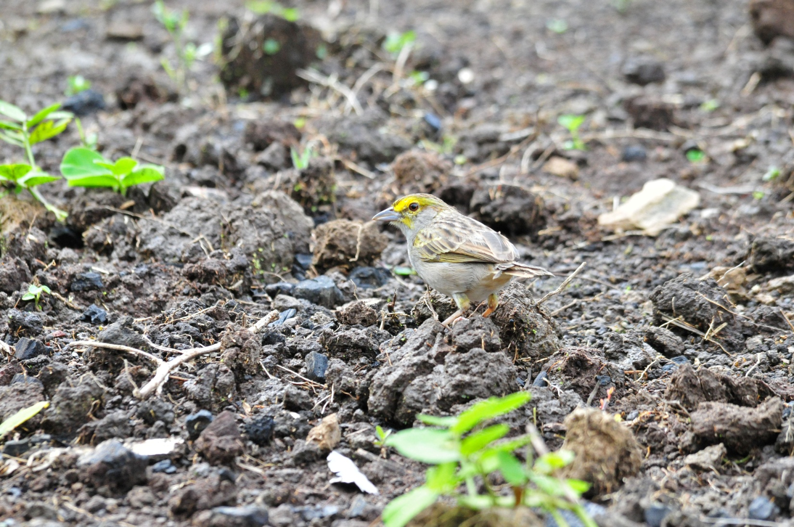
Yellow-browned Sparrow

Other new-for-the-trip birds seen today were Plain-breasted (Sharp-shinned) Hawk, Amethyst Woodstar, and Montane Foliage-gleaner. In addition, Maroon-tailed Parakeets were promoted from "fly-by" status to "seen". Our count for today was 92 species, bringing our trip total to 386. The pressure was on to find 14 new species before we officially ended the main tour and began the extension, which would be marked by the moment we delivered the two people who weren't going on the extension to the airport in Coca, scheduled for 10:00 AM.

Day 15, Saturday, December 3: We returned to the area around the lights again this morning, where we saw many of the birds seen there yesterday and added Black-billed Treehunter - only 13 to go! We were trying to count down to our 400th bird as we proceeded through this last half day of the main tour. A Lafresnaye's Piculet was again present, and a few people still needed better looks at this species, but Jim and I were the only ones who saw it before it disappeared. The trees were alive with Blackburnian and Canada Warblers, not something you get to see every day. A female Lined Antshrike stayed out in the open for quite awhile, also not a common occurrence. Both male and female White-lined Tanagers were busy collecting insects, so strikingly different from each other they almost looked like different species. We made our way out to the road quickly today. As much as we enjoyed seeing the high level of activity near the lights, we were after new birds today, and these were mostly species we had already seen.

We didn't walk far before we had Lineated Woodpecker, Magpie Tanager, and Golden-collared Toucanet - 12 to go!
Paradise Tanagers, whether you've seen them once or a thousand times, always deserve another look. Marion, in particular, was wowed by this beauty as she looked through the scope and repeated, "Oh, that BIRD!" a couple of times.
Spot-breasted and Smoky-brown Woodpeckers, Band-tailed Pigeon, Golden-collared Honeycreeper - we enjoyed seeing them all, but none helped our count.

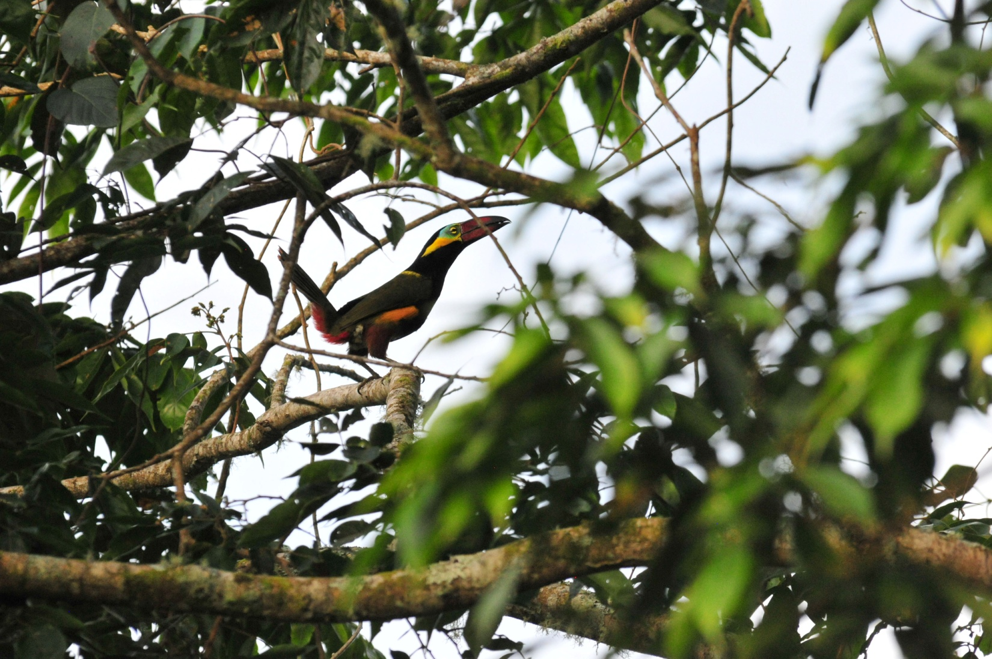
Golden-collared Toucanet

Driving down the entrance road, Marcelo spotted a Long-tailed Tyrant from the back of the bus. Not only was this a new bird for the trip, but also a species you definitely want to see on any tropical birding tour, a real cutie - just 11 to go!
As we were taking photographs of a Roadside Hawk, a flock of Maroon-tailed Parakeets flew by. And then- Black-and-white Hawk-Eagle! Just 10 more species needed to make 400. Ringed Kingfisher - now we're talking! We're in single digits to make it to our goal now.

We departed the lodge after breakfast to head for Coca where Marion and Barbara would board a plane for Quito while the rest of us would begin the extension. We really wanted to find 9 more birds so they would go home with a list of 400 for the trip. As we drove through Loreto, Marcelo spotted a Black Caracara from the bus. Just 8 to go now. We're willing to take House Sparrows at this point, which we normally try to avoid having on our list. As Luis was filling the tank with diesel, we spotted Ruddy Ground-Doves near the gas station. We need just 7 birds, but time is running low.
Also seen at the gas station were Blue-black Grassquits, Smooth-billed Anis, Blue-gray Tanagers, and Black-billed Thrush. No new species, but not a half-bad gas stop! Yellow-rumped Cacique, trip bird # 394. Marcelo spotted Red-breasted Blackbirds in a field as we passed at 60mph, so we stopped, backed up and took a better look. Just 5 to go now. Violaceous Jays flew by the bus, normally the quality of look that we would classify as "fly-by", but we were getting a little desperate now so we counted them as trip bird #396. When we got to Coca, we stopped in town where Galo said we could take 15-20 minutes to look around, get ice cream, go into internet hot spot. I wasn't quite sure why we stopped there when we were getting so close to our goal, but I managed to spot a House Sparrow, so it wasn't a total waste. The sparrow was bird # 397, so we need to find just 3 species at the airport to make it. We could count the woodpecker we saw earlier, because whether it was a Little or a Smoky Brown, it would be new. Now we're at 398. Maybe a Cattle Tyrant or some obscure bird we've never heard of would show up. . . . .

Unfortunately, we didn't add any more birds to the list before we had to say our good-byes to Marion and Barbara. We left them at the airport and went on the boat dock to catch our ride to Napo Wildlife Center. Marion and Barbara would visit the Artisans' Market near the Sebastian in Quito, have dinner at the hotel, and then depart for home tomorrow.

We made it to the boat dock with some time to spare and had our sack lunch overlooking the Napo River. Some of the tame birds and animals owned by a hotel there were entertaining as we ate, most notably a Channel-billed Toucan that liked to bite everyone's feet and a Spider Monkey that drank juice from a juice box. Jeanne, who had on sandals, seemed to be the favorite target of the foot-biter, and it grew tiresome after awhile. Florida Joan had a good rapport with the monkey, especially after she shared her juice with him. At the dock, we had White-winged Swallow - bird #399. We found some Martins, but we couldn't identify them without Marcelo or Galo's help, and they were getting things ready for us to leave.

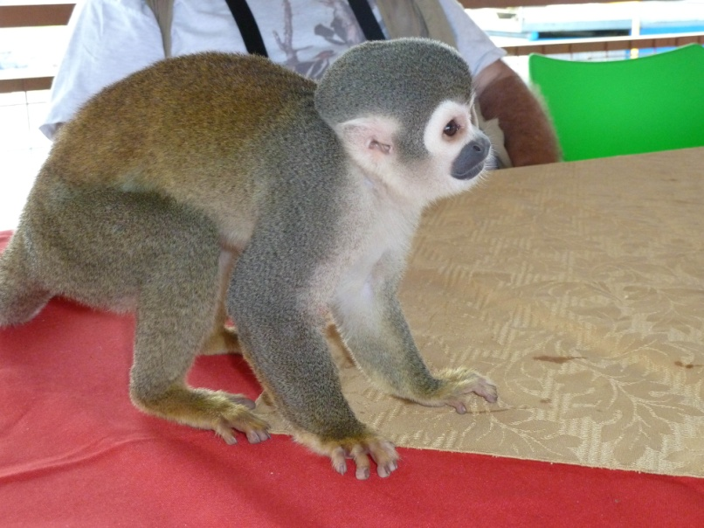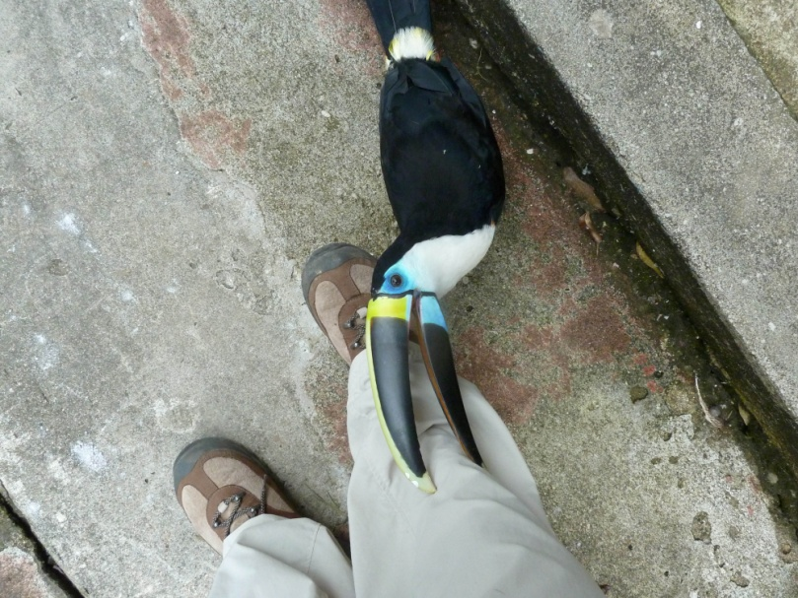
Lunch-sharing Squirrel Monkey Shoe-biting Channel-billed Toucan

I was disappointed when I saw the boat we were assigned to, which had wooden seats with pads instead of the cushy seats we'd had on last year's boat. The more comfortable boat also went faster and seemed to produce fewer fumes, but no one complained (but me). Going down the river, we saw many species new to the trip. When we saw the first, which was a Great Egret, Marcelo and Galo announced "That's 400!", but I don't think they understood the goal had been to reach it before we dropped off two of the members of our group.
Greater Yellow-headed Vulture, Swallow-wing Puffbird, Eastern Kingbird, White-banded Swallow, Long-tailed Tyrant; we stopped so much that people started joking that we were never going to get to the lodge, but no one minded the delays. The lodge had provided water bottles and snacks for us, and people settled back and enjoyed the ride for awhile. The river was high enough that we didn't have to do too much zig-zagging and we made pretty good progress.
We stopped to look at a Black Caracara that was perched along the bank, providing a much better view than the one we had seen earlier. Cathy spotted an Osprey sitting on one of the islands, Jim spotted Yellow-billed Terns, Marcelo pointed out some Pale-vented Pigeons flying by. We checked every sandbar along the way, and were rewarded for our efforts: Spotted Sandpiper, Anhinga, Cocoi Heron, and Little Egret. Greater Anis in the low branches at the river bank,

After about two and a half hours, we arrived at the tributary that would take us to Napo Wildlife Center. The pilot of the boat carefully steered the large vessel into the stream and went a short distance upstream to a dock where we got off to switch to smaller canoes for the remainder of the journey. As we got off the larger boat, we noticed a group of butterflies "mudding" along the bank. Bright chartreuse, turquoise, black, and white, we were surprised to hear they were actually moths, perhaps the only species of moth that is active during the day. There was a nice bodega that we would return to in a few days for lunch, some restrooms with running water. We took a quick restroom break and then boarded our canoes to go deeper into the forest and to our final destination. Each canoe seated six of the twelve birders with a boatman in the back, a native guide in the front, and one of our two guides right behind him. I was expecting three canoes for our group of 12, so I was surprised by the seating arrangement. I spoke to Galo about it, and he said we would have three boats tomorrow and for the rest of the trip if that was what we wanted. By the time we made it to the lodge, I realized that we had plenty of room for six people in each canoe and that adding a third canoe would just make it more difficult to maneuver the boats to positions where everyone could see.

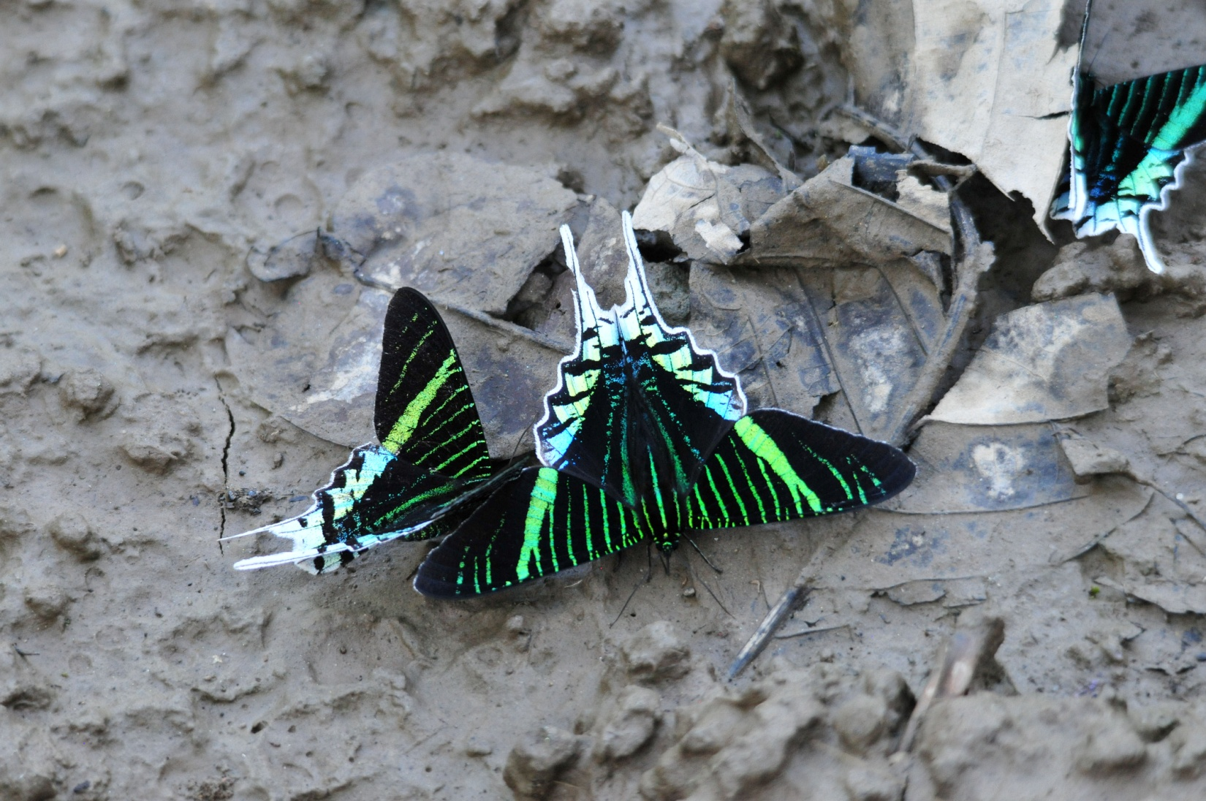
Diurnal Moths

It's difficult to describe the trip up this stream. Without a motor, we moved almost silently through the water (other than soft conversation). The dense vegetation on both sides and overhead, the soft splash of the oars as they entered the water, knowing that we might see almost anything along the banks - this is paradise, truly an experience of a lifetime. It took a couple of hours to make it up to the lake where the lodge is located because we stopped each time one of the guides found a bird, maneuvered the canoes around so everyone could see each bird, and we did this many times. We found four more heron species: Rufescent Tiger-Heron, Striated Heron, Capped Heron, and Boat-billed Heron. Overhead, we saw Fork-tailed (Neotropical) Palm Swift, MIlitary Macaws and Orange-winged Parrots. We were thrilled to see White-eared Jacamars, and even more so when just a few yards downstream we found White-chinned Jacamars. Two trogan species, Black-tailed Trogon and Amazonian White-tailed Trogon, were seen well. We added another Kingfisher, American Pygmy Kingfisher as well as more sightings of Ringed Kingfisher. Lineated Woodpecker was not new for the trip, but this was our first sighting of the eastern subspecies, which we noted in case it is given species status sometime in the future. The appropriately-named Long-billed Woodcreeper drew our attention by constantly vocalizing while Silvered Antbird and White-shouldered Antbird provided a bit more challenge to find them. Rufous-tailed Flatbill Black-fronted Nunbird, Scarlet-crowned Barbet , and then a real surprise finding - Ferruginous Pygmy-Owl! Luckily, we saw both Brown-chested and Gray-breasted Martins since we hadn't had time to get a positive ID on the martins we saw back at the boat dock in Coca.

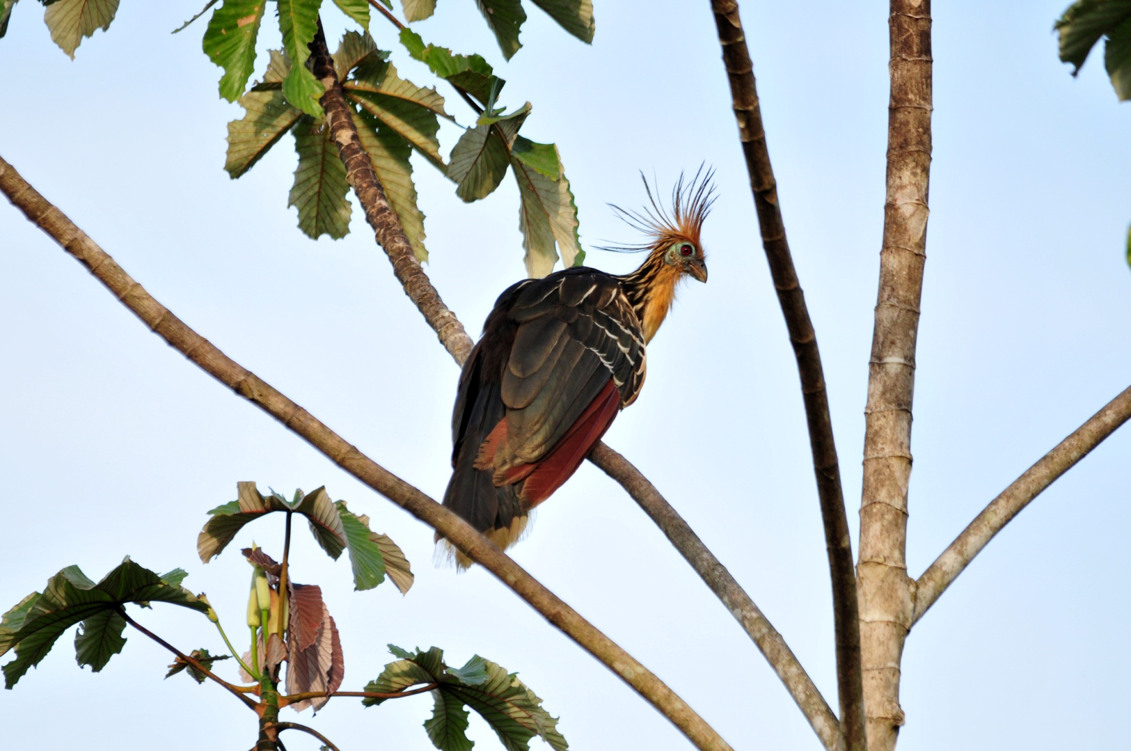
Hoatzin

As we neared the lake that would lead us to our lodge, we saw Lesser Kiskadee and Black-capped Donocobius, two species that are nearly always found near quiet water. A favorite for everyone (except the guides who consider it a "trash bird"), the extraordinary Hoatzin was seen numerous times before we paddled into the lake. This bird is as interesting as it is odd in appearance. Unlike most birds, Hoatzins eat the leaves of plants, and to a lesser degree the fruits and flowers. The Hoatzin’s digestive system is unique among birds in that they use bacterial fermentation in the crop to break down the green leafy materials they consume, much like cattle and other ruminants do in their specialized stomachs. The aromatic chemicals produced by fermentation smell bad – giving the bird its common name "Stinky Turkey", as well as a low ranking on the desirability scale for local native hunters. Another interesting fact about the Hoatzin is that the chicks have claws on their wings. This allows a chick who is threatened by a predator in the nest to jump to safety and then use the claws to climb back into the nest. This is a throw-back to the dinosaurs, and something I've always found very interesting about these birds. And, since the nests are usually built over water, the chicks actually have the ability to swim underwater to avoid predation! How can you not like a creature as unusual as this?!

How can I relate our feelings when we spotted the thatched roofs of the cabins that would be our homes for the next few days? Such an idyllic spot, we felt so very fortunate to be having this experience.

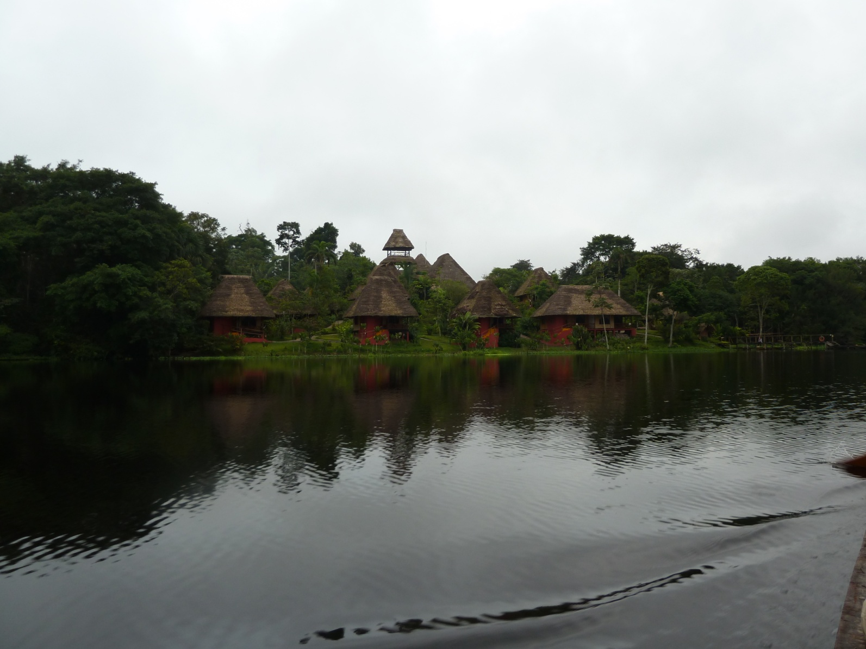Napo Wildlife Center

As we pulled in to the dock, a pair of Red-capped Cardinals were seen under the dock. They would be part of our greeting committee each time we returned to the lodge during our stay. I say "part of" the greeting committee because, as with our initial arrival, someone would be there to welcome us with a glass of fresh fruit juice each time we pulled in to the dock after a birding outing.

Today's count was, not surprisingly, the highest of the trip so far - 109! With 49 of them new for the trip, our trip total now stood at 435. We were able to identify the woodpecker species seen earlier as Little Woodpecker by consulting the field guide and the group's cumulative memories of field marks.
Day 16, Sunday, December 4: It was almost like being on the first day of a new trip, our surroundings were so different from any so far on the trip. We boarded our canoes just before dawn and enjoyed the quiet ride to the trailhead that would lead us to the lodge's canopy tower. When we reached the trailhead, we walked for about a half mile to the base of the tower. Along the way, Great Tinamou was spotted in a tree - what's he doing up there? We took our time going up the 130-foot high tour (210 steps!). Once we got to the top, things were really hopping for pretty much the entire morning.

Right off the bat, some Mealy Amazons flew by, then landed in a treetop where we all got good views in the scope. Still looking at the Amazons, Marcelo called out, "Red-bellied Macaws!" as they flew by. In "our tree", an enormous Ceba (aka Kapok) tree that supported the deck on which we stood, were Blackpoll Warbler, Blue Dacnis, Gilded Barbet, Crested Oropendola, White-necked Puffbird, and Yellow-rumped Cacique. Even though there was a bit of fog, we were able to get good looks at several birds through the scope, including Spangled Cotinga, Ivory-billed Aracari , White-throated Toucan, Blue-and-yellow Macaws, Giant Cowbird, Yellow-crowned Parrots, Channel-billed Toucan, and Maroon-tailed Parakeet. The fog cleared pretty quickly, and we enjoyed clear views for the rest of the morning. More birds seen through the two scopes, sometimes with two different birds lined up in the two scopes at the same time, including White-lored (aka Yellow-bellied) Euphonia, Cobalt-winged Parakeet, Slender-billed Kite, and Black-headed Parrot. Yellow-tufted and Lineated Woodpeckers were seen in the same scope view. Closer in, a nice Orange-footed Tarantula and Thorny-tailed Lizard paid us a visit.

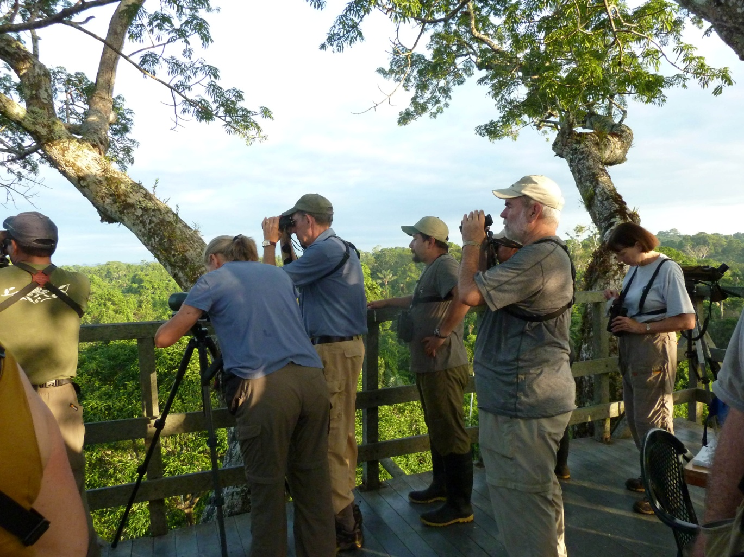
Napo Wildlife Center's canopy tower

We were fortunate to have two expert guides, each with a high-quality scope, as well as the two native guides to help spot birds for us. Because I've been on this trip a couple of times, meaning most of the birds are not life birds for me, I usually hang in the back of the line and go to the scope after I'm sure everyone else has seen the bird. This morning, the birds were appearing in such rapid succession that Marcelo kept moving the scope before I had a chance to look!

Marcelo and Galo knew that most of us could identify only a few trees in the rain forest, so they began to give some of the trees descriptive names. We observed a Violaceous Jay and a Spix's Guan sitting together in "Broccoli Tree" as first a pair of Yellow-crowned and than a group of Orange-winged Parrots flew by. Walt spotted some Red Howler Monkeys in a distant tree. Two Blue-and-yellow Macaws flew by, and we had a Many-banded Aracari in same tree with an Ivory-billed Aracari, allowing for good comparison through the scopes. Some of the other birds seen from the tower included Russet-backed Oropendola, Masked Tanager, Lettered Aracari, White-fronted Nunbird, Pygmy Antwren, Yellow-browed Tody-Flycatcher, Bare-throated Fruitcrow, Black-crowned Tityra, Paradise Tanagers, Squirrel Cuckoo, Black-tailed Tityra, and Greater Yellow-headed Vulture.

We descended from the tower and followed Marcelo through the brush to a spot where he knew Wire-tailed Manakin could be seen. Before the end of the line even arrived, he had the target bird, a nice male, in the scope. We walked back to the canoes and made our way back to the lodge in time for lunch with not too much birding on the way. We had spent so much time on the tower that time was running short. When we arrived back at the lodge, as we made our way to our cabins, Marcelo hurried back to get those of us he could still find to tell us he had found Golden-mantled Tamarins feeding at the side of the dining hall. He had been on his way back to his room located at the rear of the property with the other guides and workers' rooms when he spotted the group of tamarins, which are endemic to Yasuni National Park. During our lunch break, we found several birds, two of which were new for the trip, Ochre-bellied Flycatcher and Buff-throated Woodcreeper. I can't for the life of me remember where, but I noted on the recorder a
Dwarf Tyrant Manakin that was spotted before our 3:30 departure.

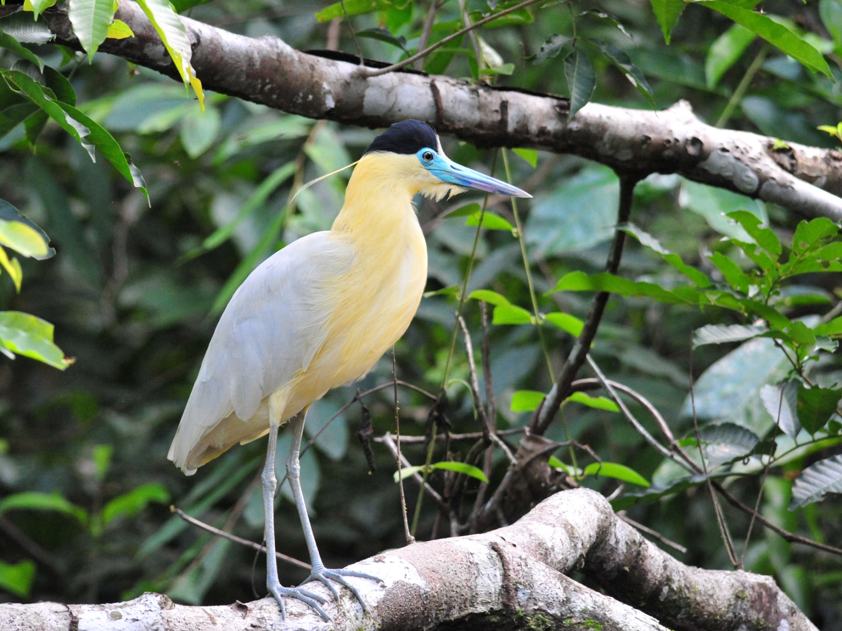
Capped Heron
Back out on the boats, the first bird sighted was an Osprey, followed by White-winged Swallows, Greater Ani, and Great Kiskadee. Along the lake's edge we found Amazon Kingfisher and Striated Heron, and as soon as we entered the stream, we got great looks at Capped Heron and Green-and-rufous Kingfisher, although a few people in the back of the second canoe didn't get the kingfisher, so we knew we would need to pay attention the next time we found one and make sure those who missed it were put in a good position to see it first. We had some repeats, like Long-billed Woodcreeper and Lineated Woodpecker, before we decided to turn around because the forest seemed pretty quiet.
We paused briefly to take some photos of the two Capped Herons who were now in a better position for photography. As we emerged from the forest into the lake, Galo and Marcelo heard a Least Bittern, so we quietly paddled over to the edge of the water where tall reeds were growing. We spent some time looking for the bittern, watching the grasses at the left side o f the boats. From the corner of my eye, I saw movement and turned to see a Least Bittern fly from one spot and drop back into the reeds on the right side of the boats. Luckily, Richard had seen it, too.

Four Orange-winged Parrots and a single Red-bellied Macaw flew by as we crossed the edge of the lake to try a different part of the forest. The lighting was good and the birds were low enough for us to get good color and some field marks even though they were in flight. As we re-entered the forest, we saw Black-capped Donocobius and Little Cuckoo. Once inside the forest, we immediately had Green Kingfisher, then Agami and Boat-billed Herons. A bit further in, we saw White-eared Jacamar, Scarlet-crowned Barbet, a female Amazonian White-tailed Trogon, White-chinned Jacamar, and American Pygmy Kingfisher, among many others. As the sun began to set, we went back upstream to return to the lodge. The guides spotted a Silvered Antbird in the dim light, so Marcelo used a spotlight to provide great views, not to mention making it easier to find. Rowing back in near-darkness, we saw a Night Monkey peering from its nest cavity in a tree at the edge of the stream. By around 6:00 PM, the Fishing Bats began to swoop over the water. The last bird of the day was a roosting American Pygmy Kingfisher that Marcelo spotlighted for us.

Other birds seen today include Double-toothed Kite, Common Piping-Guan, Limpkin (fly-by), Pale-vented Pigeon, Short-tailed Swift, Chestnut Woodpecker, Striped Woodcreeper, Dusky-throated Antshrike, White-flanked Antwren, Citron-bellied Attila, Short-crested Flycatcher, and Red-eyed Vireo. It was a magnificent day with 99 species of birds, 40 of them new for the trip, making our trip count 475. We had been hoping to reach 500 by the end of the extension, but now we were starting to set our sights a bit higher.

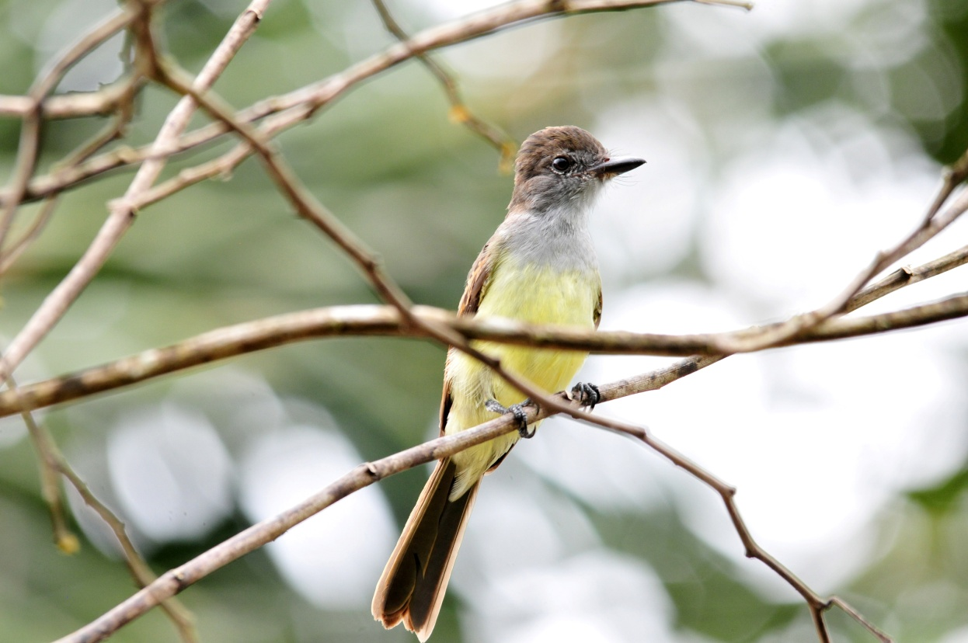
Short-crested Flycatcher
Day 17, Monday, December 5: We had breakfast at 4:30 and departed at 5:00 to take the canoes to the Napo River to board a larger boat to go upstream to visit the famous Yasuni National Park parrot licks and some river islands that are home to species who live nowhere else. We made our way across the lake in silence, enjoying the surreal atmosphere in this paradise. As we made our way along the stream, Jim suddenly called out in surprise - a small fish had jumped in our boat and landed right at his feet!

Marcelo found a perched Sungrebe in the dim light. As the sun began to rise, a Cinnamon Atilla began its repetitive, monotonous call. Next, we found Hoatzins that were just starting to move around. At around 5:45 we had a very uncooperative Zigzag Heron that didn't allow satisfactory views for everyone. Some Mealy Parrots flew by as we tried for a Currasow in an area where it's usually found, but we didn't even hear one. Rufous-headed Woodpecker,
Green-and-rufous Kingfisher, Black-fronted Nunbird, and a few other birds showed up while we waited for a sign of the Curassow, but we finally had to give up and go on.

When we arrived at the dock, as some people walked up the hill to the restroom and others reorganized in preparation for boarding the larger boat, I noticed some movement in a large tree on the other side of the stream. Some weasel-like mammals were robbing Oropendola nests! I yelled for everyone to look, and Marcelo identified the thieves as Tayras. We watched in amazement as the long slender animals crawled head-first into the pendulous nests as the parent birds helplessly stood by.

We were only about 7-10 minutes down the river when Marcelo spotted an Amazonian Umbrellabird. The pilot of the boat pulled the boat over quickly and we all got out on the bank to get scope views. This was too good a sighting to settle for binoculars-from-a-rocking-boat view! Shortly after we got back on board, we saw Yellow-headed Caracara and Cocoi Heron. As we approached the first clay lick, we could hear the parrots long before we saw them. Mealy, Yellow-crowned and Blue-headed Parrots, along with Dusky-headed Parakeets, were perched all over the steep bank - on the clay cliff, in the trees and bushes, flying in and out, squawking the whole time. We went a little past the clay lick, cut the motor, and then drifted slowly by a couple of times. For several minutes, the engine idled at the appropriate speed to keep us stationary in front of the area so we could take photos. We spotted a Violaceous Jay in with the parrots and the guides pointed out a Drab Water Tyrant near the water's edge. As we drove away, we stopped for a better look at a Neotropical Cormorant and a Chestnut-fronted Macaw flew by.

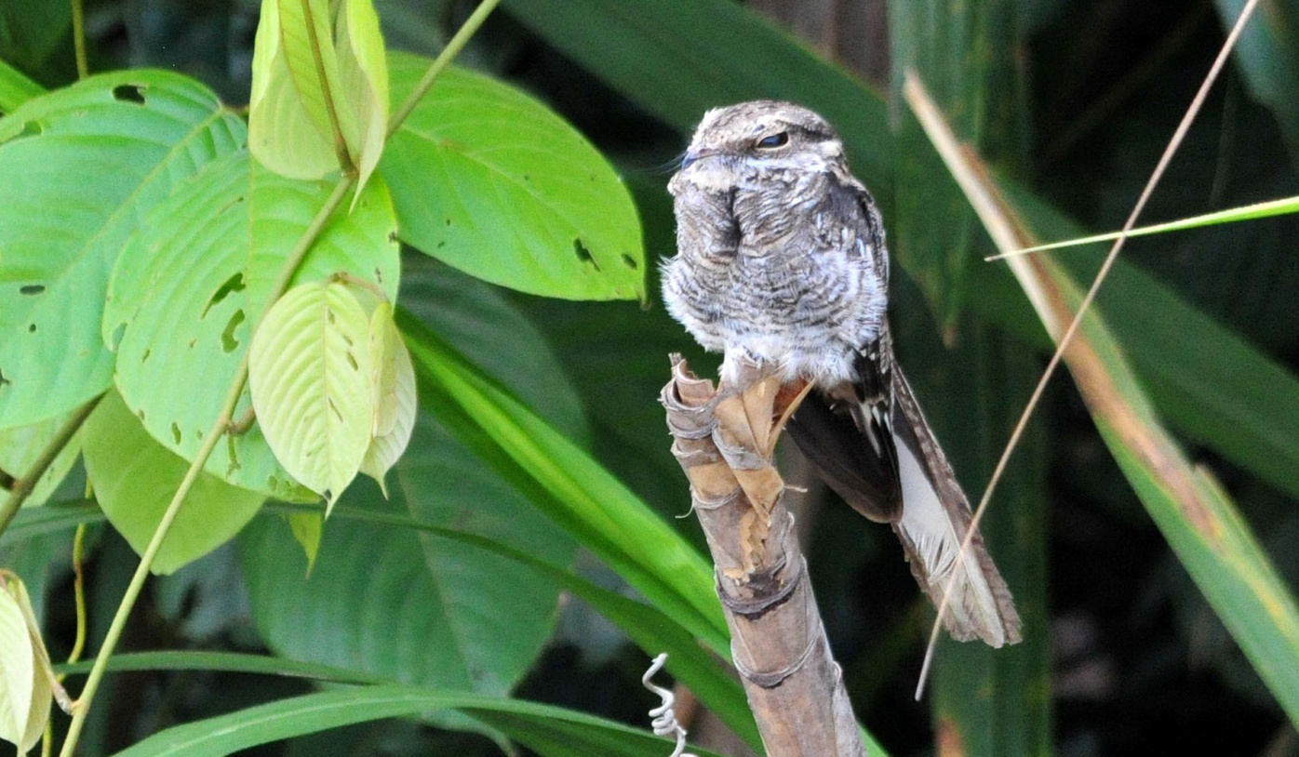
Ladder-tailed Nightjar
We had several target species in mind when we arrived at our river island: Olive-spotted Hummingbird, Parker's Spinetail, Fuscous Flycatcher, White-bellied Spinetail, , Gray-breasted Crake. We got them all pretty quickly, except for the Crake which eluded us. We also saw Oriole Blackbird and Pale-vented Pigeon while on the island.

We got back into the boat and soon found another new species for the trip, Ladder-tailed Nightjar. We finally got out of the boat to walk to the next parrot lick. On the walk to the lick we found many "old" species and added Brown Nunlet, Blue-crowned Manakin, and Great-billed Hermit to the list. There were several of the Hermits calling loudly from a lek where they were trying to impress females. Interestingly, this hermit is the only hummingbird that exhibits lekking behavior. When we reached the second clay lick, we could hear hundreds, if not thousands, of parrots in the trees overhead, but none were coming to the clay yet. Another group of birders arrived and we all waited for awhile in a shelter overlooking the cave-shaped clay lick. Occasionally we could hear the louder, deeper squawk of a Scarlet Macaw among the voices of the smaller parrots, and from outside the shelter, down the path a ways, the guides were finally able to locate one and put it in the scope. We invited the other group to take a look, and then our group decided to walk a trail that went up a steep hill to look for some manakins and other birds that Marcelo knew could be there. Walt and Jackie, NY Joan, Jim and I stayed in the shelter, partly because we wanted to be there if the parrots began to come down to the clay lick, and partly because the thought of hiking up a steep hill in this heat wasn't very enticing.

Jorge, one of our local guides, was there with us, and he pointed out a Green Manakin perched near the shelter. We could see Cobalt-winged Parakeets feeding in the tree tops by walking a short distance on the boardwalk and looking in an area that was obscured by the roof of the shelter when we were inside. At the top of the hill, the group was finding a good selection of new species: Striped Manakin, Golden-headed Manakin, White-chested Puffbird, Red-necked Woodpecker, and Great Jacamar.

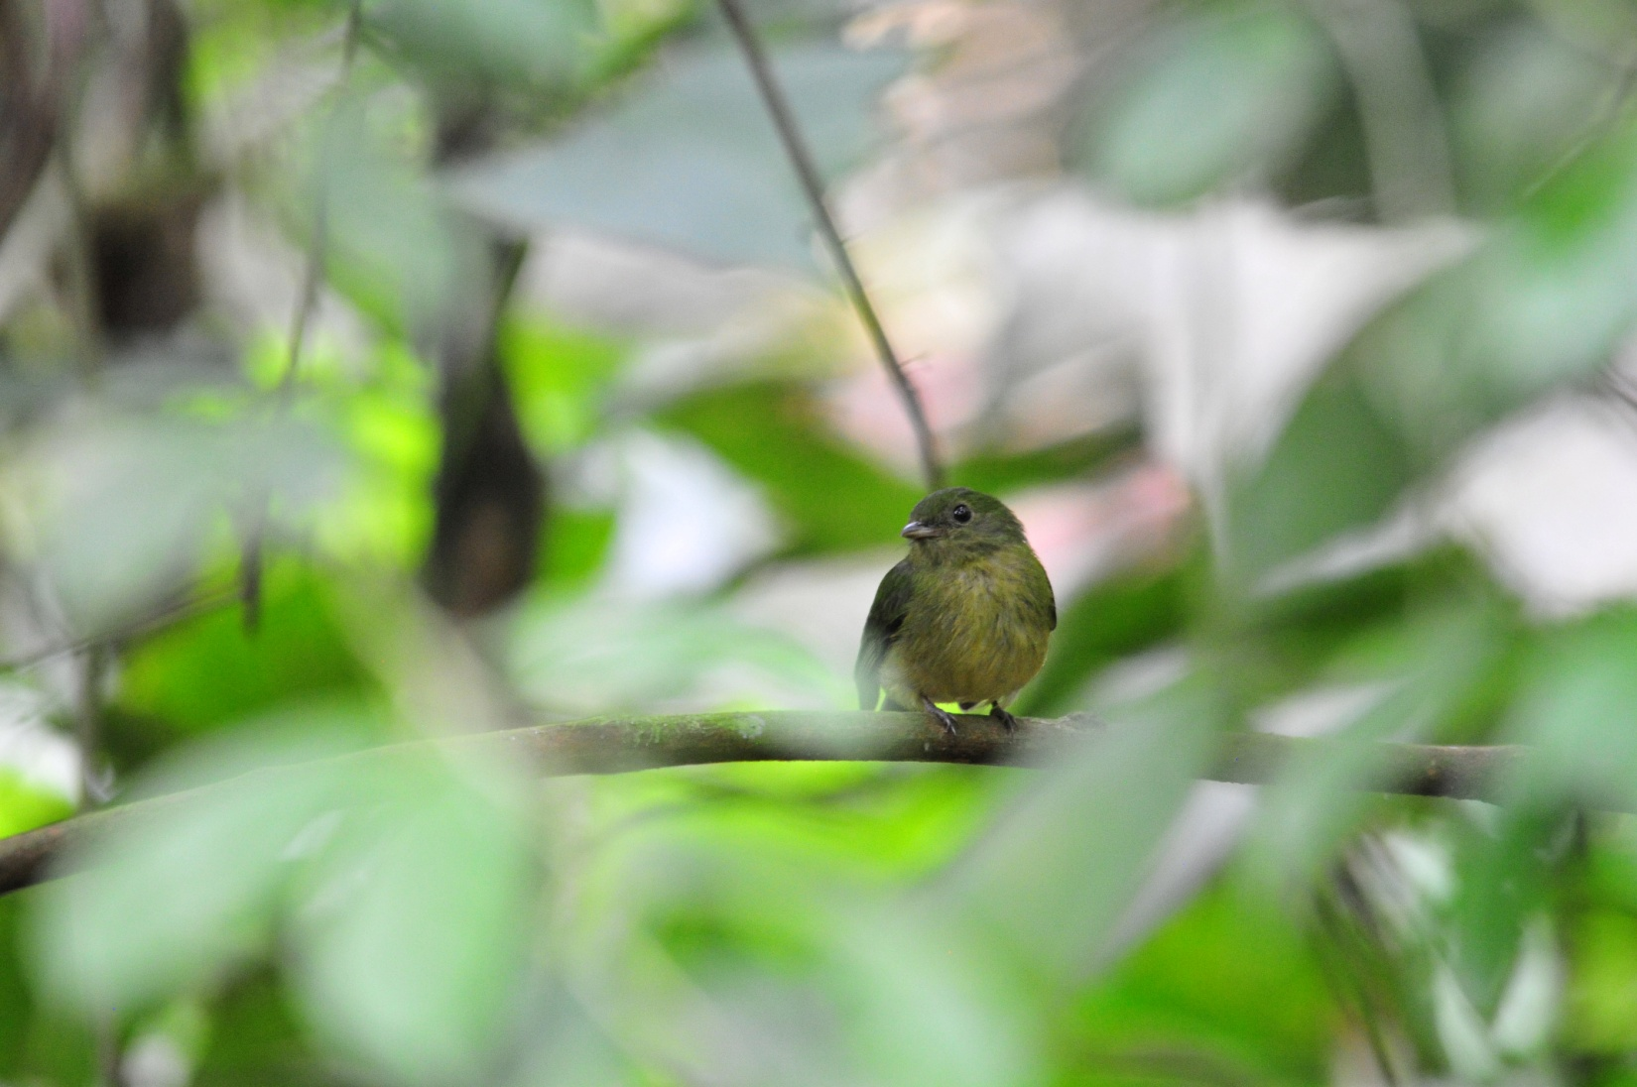
Green Manakin
When the din of the parrots became more intense and it looked likely that they would come to the clay soon, Jorge radioed Galo that the group should come back. They arrived just as the parrots began to come down. There were hundreds of Cobalt-winged Parakeets, among them a single Orange-cheeked Parrot and a single Scarlet-shouldered Parrotlet. Soon, more Orange-cheeked came, but we had a hard time getting others on the one and only Parrotlet. The
Scarlet Macaws were the last to come down, and when one of them sounded an alarm, the entire group of birds disappeared in a matter of seconds. Walking back to the bodega where we would have lunch, we heard a Rufous-capped Antthrush but only a few people got to see it. We enjoyed watching a family of Red Howler Monkeys for a few minutes before we moved on to the lunch spot.
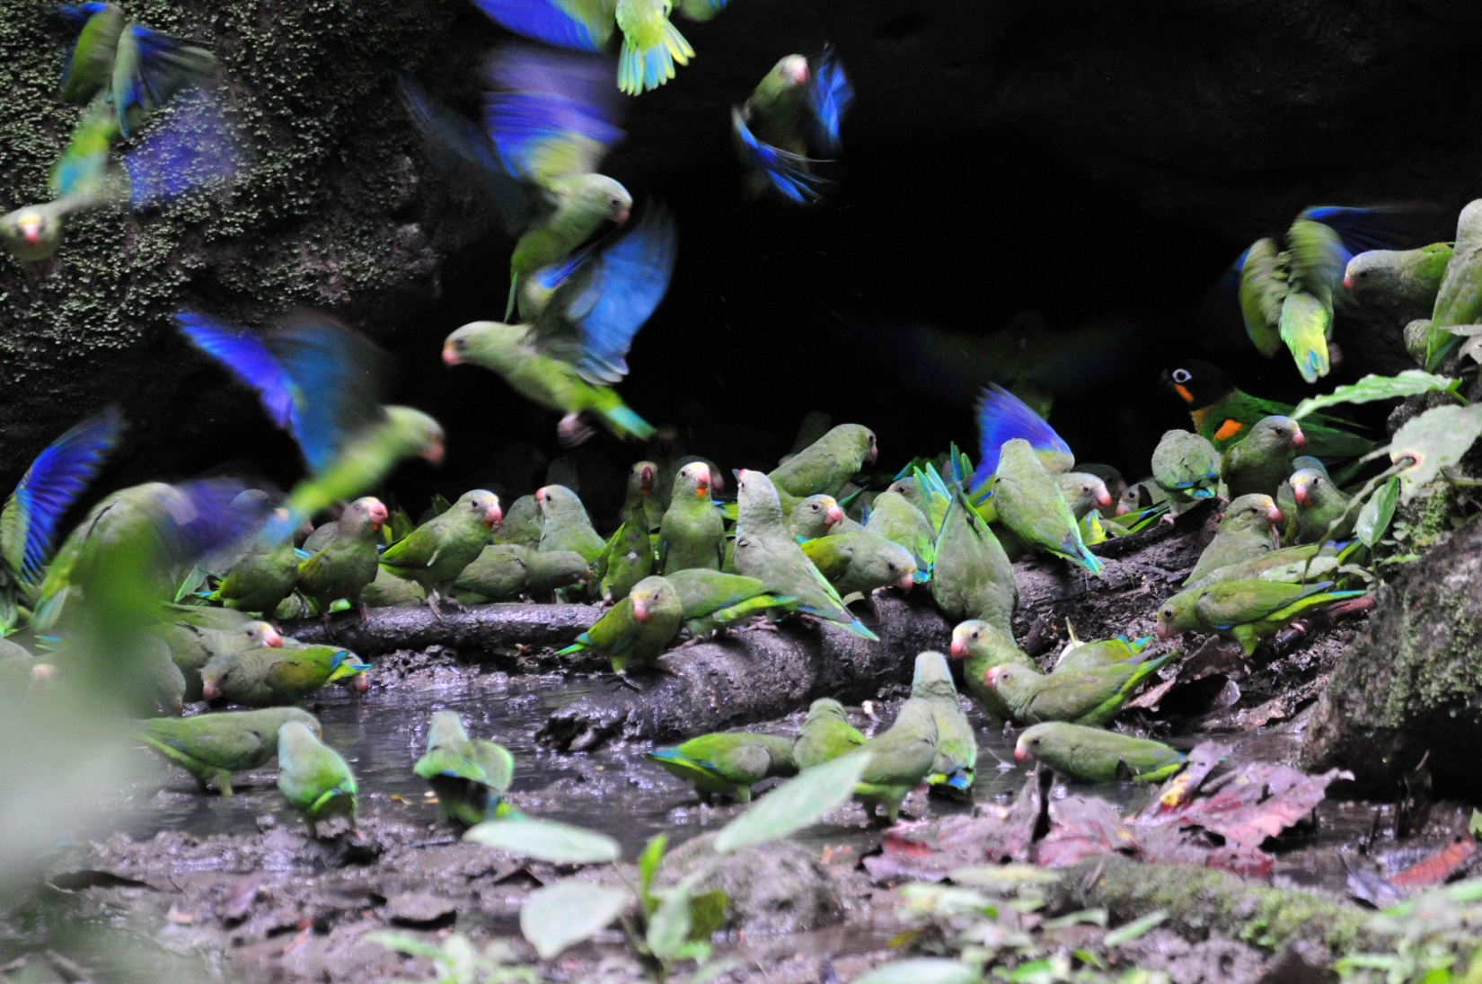
Clay Licks with Cobalt-winged Parakeets and one Orange-cheeked Parrot

After a nice hot lunch at the bodega, we climbed back into our canoes to go back to the Kichua interpretive center. Here, the locals have built a traditional house where the women provide demonstrations about native customs and folklore. We visited a small gift shop before climbing back into the boats to return to the lodge. We transferred to the small canoes when we reached the dock at the bodega. The first canoe got a bit ahead of the second canoe, and they were able to find Chestnut-capped Puffbird and Buff-breasted Wren before our canoe caught up with them. Other birds seen on the way back to the lodge included Striped Woodcreeper, Black-fronted Nunbird, and Amazonian Barred Woodcreeper, among others.

Other new birds seen today were Short-tailed Nighthawk and Gray-headed Tanager. We heard not one, but three, different species of Tinamou today: Great, Cinereous, and Undulated; also heard Gray-winged Trumpeter. There were 24 species heard today in all - way too many! The total number of species seen today was 85, with 32 of them new for the trip, bringing our trip total to 507.

Day 18, Tuesday, December 6: Brakfast 5:30, meet at 6:00 - 6:15 to leave, but cloudy skies and lightening delayed our departure until 7:00, or if it's still looking bad at 7:00, we'll go to the tower near the dining room to see what we might find there. It was raining at 7:00, so the group met at the tower, where we saw Yellow-crowned Tyrannulet, Piratic Flycatcher, Purple Honeycreeper, Ringed Kingfisher, Short-crested Flycatcher, and a bunch of stuff we've already seen. We got great looks at Yellow-headed Vulture as it perched at eye level.

As soon as it looked like the weather was clear, the group left for the Tiputini Trail, a place that provides opportunities to see two really special birds - Striped Manakin and Black-necked Red Cotinga. I opted out of this activity, mostly because I needed to get some computer work done, but also because it had rained earlier and I remembered the boot-sucking mud from last year's experience. They got both target species as well as Red-throated Caracara, White-crowned Manakin, Marbled Wood-Quail, Sungrebe, Gray-fronted Dove, Tawny-bellied Screech-Owl, Rufous-breasted Hermit, Crimson-crested Woodpecker, Buff-rumped Warbler, Plain-brown Woodcreeper, Plain-throated Antwren, White-lored Tyrannulet, Gray Elaenia, Screaming Piha ,Plum-throated Cotinga, Spangled Cotinga, and Great Tinamou. Some of these birds were seen on the Tiputini Trail, others were seen when part of the group went back to the tower for one last time in the afternoon. Because I opted out of both activities, I'm not sure where individual species were seen. While the group was gone, I tried to snap some last photos of the most common birds around the cabins.

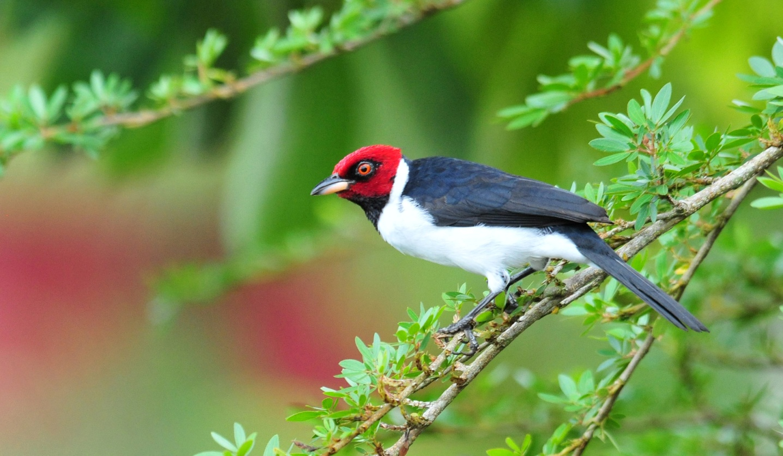
Red-capped Cardinal

We finished the day with 77 species, 16 of which were new, bringing the trip total to 523.

Day 19, Wednesday, December 7: We were up at 4:00 AM for a 5:00 breakfast and a 5:30 departure to go back to Coca and then on to Quito. We didn't do a lot of birding on the way out, but we did find two new species, Plumbeous Antbird and Spot-winged Antbird, just as it got light enough to see. This brought the total for the trip to 525. We had seen nearly a third of Ecuador's bird species, including 62 of the 131 species of Hummingbirds, in just 17 birding days.

When we landed in Quito shortly after 1:00 PM, Luis was there to take us to the Hotel Sebastian. We took a few minutes to freshen up and then met in the lobby to walk to a nearby Artisans' market. It was raining lightly, but it had stopped by the time we came out of the huge market about an hour and a half later. Everyone enjoyed this opportunity to find some souvenirs of our incredible trip. We enjoyed our last dinner at the Sebastian with Marcelo, Galo and his lovely wife RhoAnn and their two adorable children. It was a wonderful meal, not because the food or service was remarkable, but because of the friendships that had been strengthened through this wonderful experience we had just shared.

Day 20, Thursday, December 8: Everyone had flights that left between 11:15 and 11:45, so we all needed to go to the airport at the same time. We had a leisurely breakfast at the Hotel Sebastian and then rode to the airport in a comfortable bus driven by one of Luis's friends - Luis was already off on another job. We arrived at the airport at around 9:00 AM and moved to our respective gates, already talking about when and where we might travel together next.

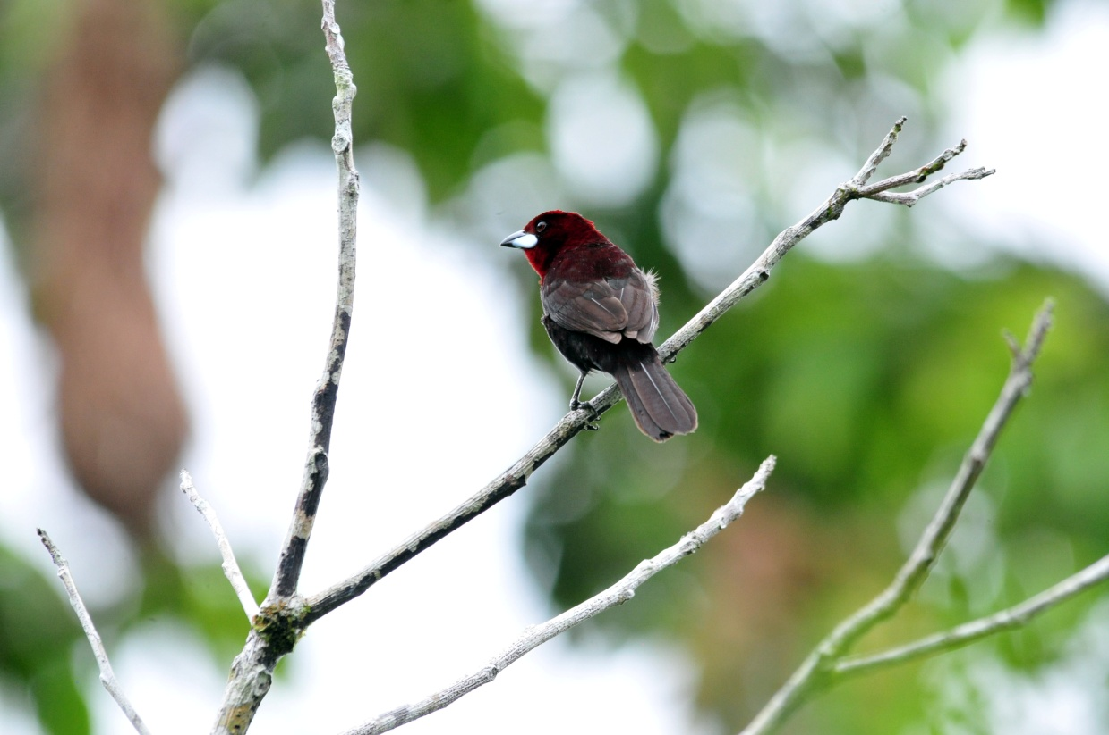
Silver-beaked Tanager

