Northern Ecuador
with Amazon Basin Extension
Trip Report
February 11 - 25, 2012
Extension Feb. 24 - 29, 2012

Disclaimer: This report is as accurate as possible using limited recordings and notes taken in the field. Species have been reported on the proper day(s) but, with multiple sites visited on the same day, it is possible that some species are listed as being seen at the wrong location. Any such errors are unintentional. All photos were taken by the author, Cindy Beckman. Some photos were taken on previous trips (date indicated).
Species seen by group : 506
Subspecies seen: 18
Birding Guides: Marcelo Andy and Galo Real
Tour Leaders: Jim & Cindy Beckman, owners
of Cheepers! Birding on a Budget
Group: 10 + 2 Tour Leaders & 2 Birding Guides
Highlights: Plate-billed Mountain-Toucan; 5 species of Antpitta including Rufous and Plain-backed; Ocellated Tapaculo; Great and Undulated Tinamous; Capped Heron; Salvin's Curassow; Gray-winged Trumpeter; Andean Condor; Orange-breasted Falcon; Band-bellied, Black-banded, and Black-and-white Owls; Oilbird; Swallow-tailed Nightjar; 62 species of Hummingbirds including Sword-billed, Giant, Ecuadorian Hillstar, Booted Racket-tail, Long-tailed and Violet-tailed Sylphs, and Ecuadorian Piedtail; Golden-headed and Crested Quetzals; Gilded, Red-headed and Toucan Barbets; Gray-breasted and Black-mandibled Mountain-Toucans; Chestnut-eared Aracari; Golden-collared Toucanet; 15 species of Woodpeckers including Cream-colored Woodpecker; 9 species of Woodcreepers; Andean Cock-of-the-Rock; Black-necked Red Cotinga; 9 Manakin species ; Amazonian Umbrellabird; Golden-collared Honeycreeper; Yellow-tufted Dacnis; 30 species of Tanagers including Rufous-necked; 7 species of Mountain-Tanager

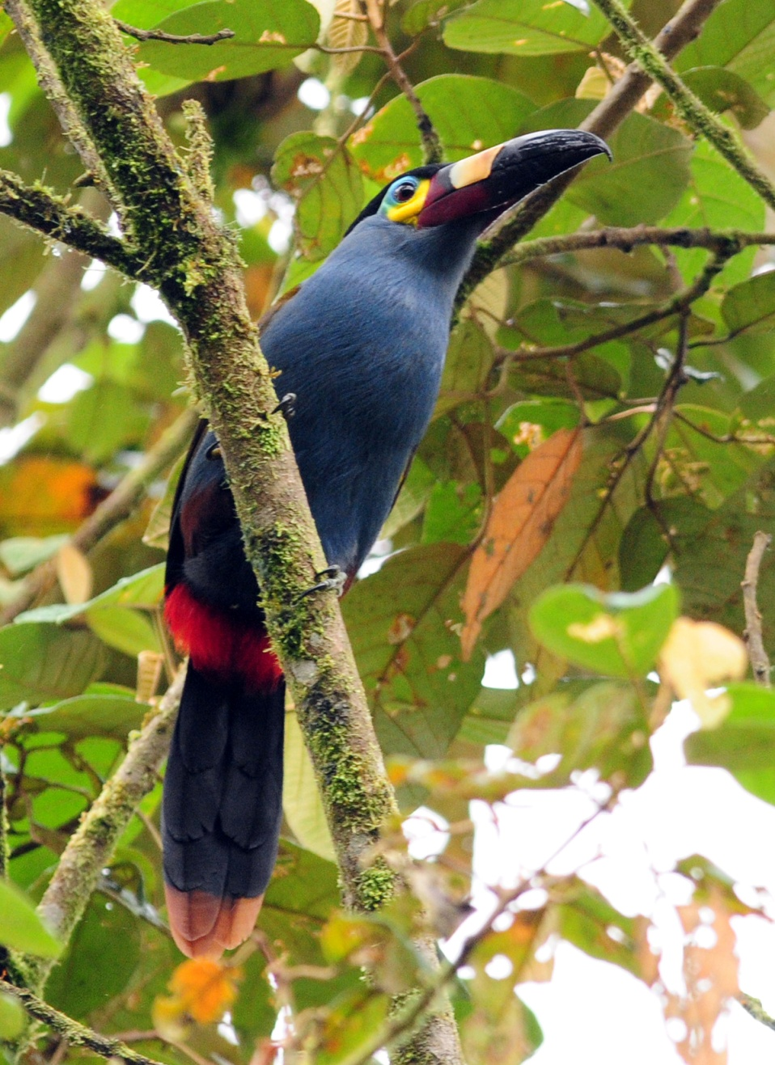
Plate-billed Mountain-Toucan
Day 0, Friday, February 10: TRAVEL DAY
Charley and Peggy, Susan, and Jim and I arrived on the same flight at 7:55 PM and made it through immigration quickly, but after standing at the luggage carousel until every last bag had come through, Jim and I had just the one bag that had been gate-checked in Chicago. We sent the others through customs and went to file a report. We were told our luggage was on the midnight flight and they would deliver it to us the next day at the Sebastian. We decided that a better option would be for Jim to return to the airport when Galo went back to pick up the late arrivals, one of whom would be on the same flight with our luggage. The early arrivals were in their rooms by 10:00 PM, and Jim left with Galo and Luis to return to the airport. They were to call me when Luis left the airport with Bob, Georgene, Lance, Rosanne, John, and Terry so I would know when to go down to the lobby to meet them and make sure they got checked in OK. Jim and Galo would wait at the airport for the latest arrival, Pat, and then take a taxi to the hotel. I did some computer work and checked email before I finally laid down at around 11:00, but I didn’t turn the lights off so I wouldn’t fall sound asleep and be in a fog when they arrived, probably some time around midnight. I caught some “airplane sleep” naps but checked the clock often – midnight came and went, and by the time 1:00 AM rolled around, I was wondering if the group had decided to just wait for Pat and come in together. Finally, at about 1:45, I began to look for Galo’s phone number so I could call to see what was going on when I heard voices in the hall. I opened the door and saw Jim saying goodnight to Pat. The others had arrived at the hotel at around midnight as planned, but no one called to tell me they were on their way. I guess Jim thought I would be asleep and decided not to bother me since the check-in process was so easy, but by not calling what he actually did was keep me (mostly) awake until almost 2:00 AM! No harm done - everyone was in their rooms, most already sleeping, and tomorrow would be a relatively easy day with no early wake-up and a leisurely schedule that would allow us to acclimate to the change in elevation.

Day 1, Saturday, February 11: Pre-tour day; QUITO BOTANICAL GARDENS, PIM’S AT ICHIMBIA PARK, OLD CITY TOUR
We had a late breakfast and were ready to leave when Galo and Luis came to pick us up at 9:30 AM. Eared Dove and Great Thrush were noted before we left the hotel. We could hear the constant chipping from a Sparkling Violet-ear as we drove away, but we didn’t bother to look for it as we knew we would see many during our tour. Our first stop was to view an exhibit of 45 hummingbird statues in Carolina Park. We got out and took several photos of the uniquely decorated sculptures before heading to the Botanical Gardens. We admired a group of Eared Doves and Great Thrushes feeding on the ground as gardeners weed-whacked the grass in front of the Gardens. Just before we entered, we made note of the very common Rufous-collared Sparrow. Our first bird inside the gardens was a Black-tailed Trainbearer, seen just inside the gate. A Sparkling Violet-ear rushed in and chased the bird away as we were photographing it. As we walked around the small pond near the entrance, Galo pointed out a Blue-gray Tanager in a tree on the other side of the pond and Brown-bellied Swallows in the sky above us. As we moved on, Galo came hurrying back from the front of the line to tell us to go back to where we could see a Purple Gallinule. The bird was a juvenile, not as impressive in coloration as adults, but still a lifer for many in the group. As we walked down the path, we could still hear the incessant chip chip chip of Sparkling Violet-ears. Do they never stop? Jim spotted a Black Flowerpiercer and later we found a Masked Flowerpiercer. Neither bird was close enough to see the tiny hook on the end of the bills, so we’re looking forward to getting closer looks in the coming days. Cinereous Conebills flitted in and out of a tree on our left and managed to elude most of our binoculars, but eventually the birds were seen well by all. I saw a small flycatcher with an Elaenea-type crest but it got away before Galo could see it to tell if it was a White-crested Elaenea or a Southern Beardless Tyrannulet.

When we left the Botanical Gardens, we made a stop by the hotel so we could leave our big lenses in our rooms. They wouldn’t be appropriate for the city tour, and we didn’t want to make targets of ourselves by carrying expensive equipment through the old part of town where the crime rate is a bit higher. We then drove to Ichimbia Norte Park where we enjoyed an incredible lunch at Pim’s. As we sat chatting and waiting for our food to come, Rosanne called out, ”What’s that bird?!” I glanced out the window in the direction she pointed but didn’t have my binoculars with me. Size and shape could have been a Rufous-collared Sparrow, but she said, “Definitely not – look at that bright yellow beak!” I used her bins and called Galo over to identify the bird that I didn’t recognize - Band-tailed Seedeater. A group of very frustrated photographers tried to get shots of the seedeater with tiny pocket cameras as it flitted from bush to bush, landing on top and in the open a couple of times. As we were getting into the bus to leave, an American Kestrel was seen cruising over the parking lot.

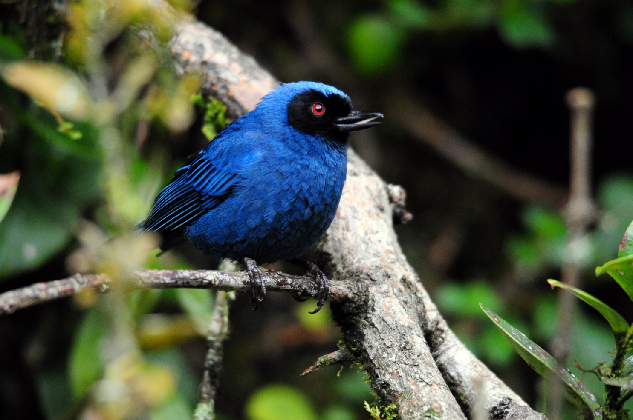
Masked Flowerpiercer

After lunch, we went on to tour the old part of the city, with stops at the Basillica and San Francisco Convent, where we walked through the shops that occupy the centuries-old tunnels beneath the structure. Rock Pigeons were everywhere
and duly noted for the day’s list. We returned to the hotel at around 4:15 and pre-ordered our evening meals to avoid long delays when we came down for dinner later in the evening. With just a handful of species (14) for a non-birding day, we decided to take care of the checklist tomorrow.

Day 2, Sunday, February 12: YANACOCHA, NONO-MINDO ROAD, SACHATAMIA
We arranged to have breakfast at 5:45 so we could leave by 6:30. Not loading the bus at 6:30, but wheels rolling by 6:30. Everyone was ready and waiting to go by 6:15, but no bus. That’s OK; it only takes about 5 minutes to load up. 6:20, no bus. 6:25, no bus. This was definitely not like Luis and Galo to be late! At 6:30 Marcelo arrived with the news that Luis and Galo were delayed because of an accident. At first it appeared they were blocked in traffic backed up due to an accident on the road they took, but soon we learned that a taxi had hit Luis and the holdup was because the taxi driver was trying to get out of paying for the damage even though he was at fault. Within another 5 minutes, we learned that it had happened just a few blocks away, so most of us went down to the accident site to see first-hand what was going on. The taxi had run a red light and slammed into the side of the bus. Although the taxi driver tried to blame Luis, some pedestrians and the passenger who had been riding in the taxi all agreed that Luis had the green light and the taxi driver was at fault. The driver had contacted his insurance company, who said they would pay for repairs on only one vehicle – the taxi if it was Luis’s fault, or the bus if it was the driver’s fault. Because the taxi was heavily damaged, perhaps totaled, he wanted Luis to agree that it was his fault so his huge repair bill would be paid rather than the estimated $600 it would take to repair the bus. Luis said he didn’t care as long as he was given the money up front. If they called the police, both men would be arrested and both vehicles would be impounded, so it looked like the taxi driver thought he could avoid paying Luis by delaying him, knowing that he had a group waiting for him and needed to be on his way. We all agreed we didn’t want Luis to suffer financially and went back the hotel to wait for the two men to reach an agreement. After a delay of about an hour, we were able to leave when Luis secured a promise from the other driver that he would pay for the repairs to the bus. Luis was going to have his wife follow up the next day rather than wait until he finished the 15-day tour with us.

So we departed the Sebastian at 7:30 instead of 6:30 and arrived at Yanacocha at around 9:00 AM. Visibility was good and we stopped a few times for volcano photos on the way. A Southern Yellow Grosbeak flew by as we took scenic shots, and later Galo spotted another Grosbeak perched near the road so we stopped for photos. Also on the way he spotted Scarlet-bellied Mountain-Tanager, but not everyone was able to see that bird. As soon as we exited the bus at the entrance to Yanacocha, hummingbirds drew everyone’s attention. With seven of the twelve birders shooting with lenses in the 400 – 500 mm range and four of the remaining five taking photos with point-and-shoot cameras, it was difficult to convince people that it was best to move on to see more birds and find better opportunities for photographs. At the entrance, we saw Great Sapphirewing, Tyrian Metaltail, Buff-winged Starfrontlet, Golden-breasted Puffleg, and Sword-billed Hummingbird.

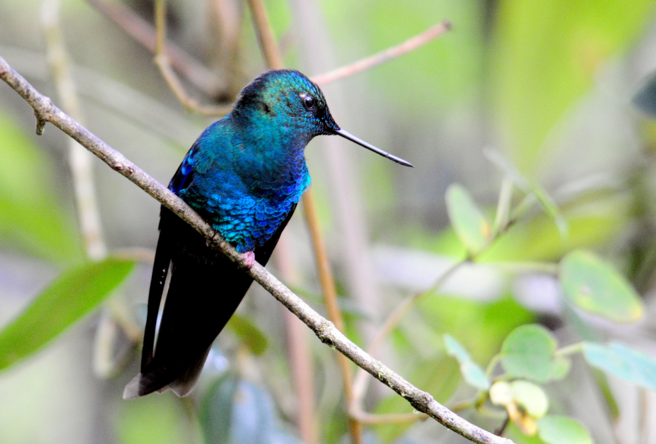
Great Sapphirewing

We had barely left the parking area when Terry spotted a small bird which Galo identified as a White-throated Tryannulet. Blue-hooded Mountain-Tanager was the next bird spotted. We heard several different Undulated Antbirds as we walked up the road, but could not see any of them as they remained hidden in the undergrowth, as usual. Glossy Flowerpiercers were common and an Azara’s Spinetail was seen by a few of us. The road was not as active as we had hoped for, perhaps because of the late start, so we made our way to the feeders fairly quickly. There, the cameras were in rapid-fire mode as Sapphire-vented and Golden-breasted Pufflegs, Tyrian Metaltail, Great Sapphirewing, Buff-winged Starfrontlet, and Glossy and Masked Flowerpiercers were all seen in good numbers. The Sword-billed Hummingbirds were not as cooperative as the photographers among us would have liked, but they were seen by all. I told some people that there were more feeders at the top of the hill, and Peggy went to investigate. She was gone quite awhile, which made us think there must be something worthwhile up there, so Bob and Georgene followed her. As Peggy descended the hill, she found and photographed a Rufous Antpitta. We all hurried back to the spot where she had seen it, and to everyone’e delight, the Antpitta returned. It was still in the open when Bob and Georgene came back down the hill, but I think they missed the Stripe-headed Brush-Finch that popped out while we were watching the Rufous Antpitta.

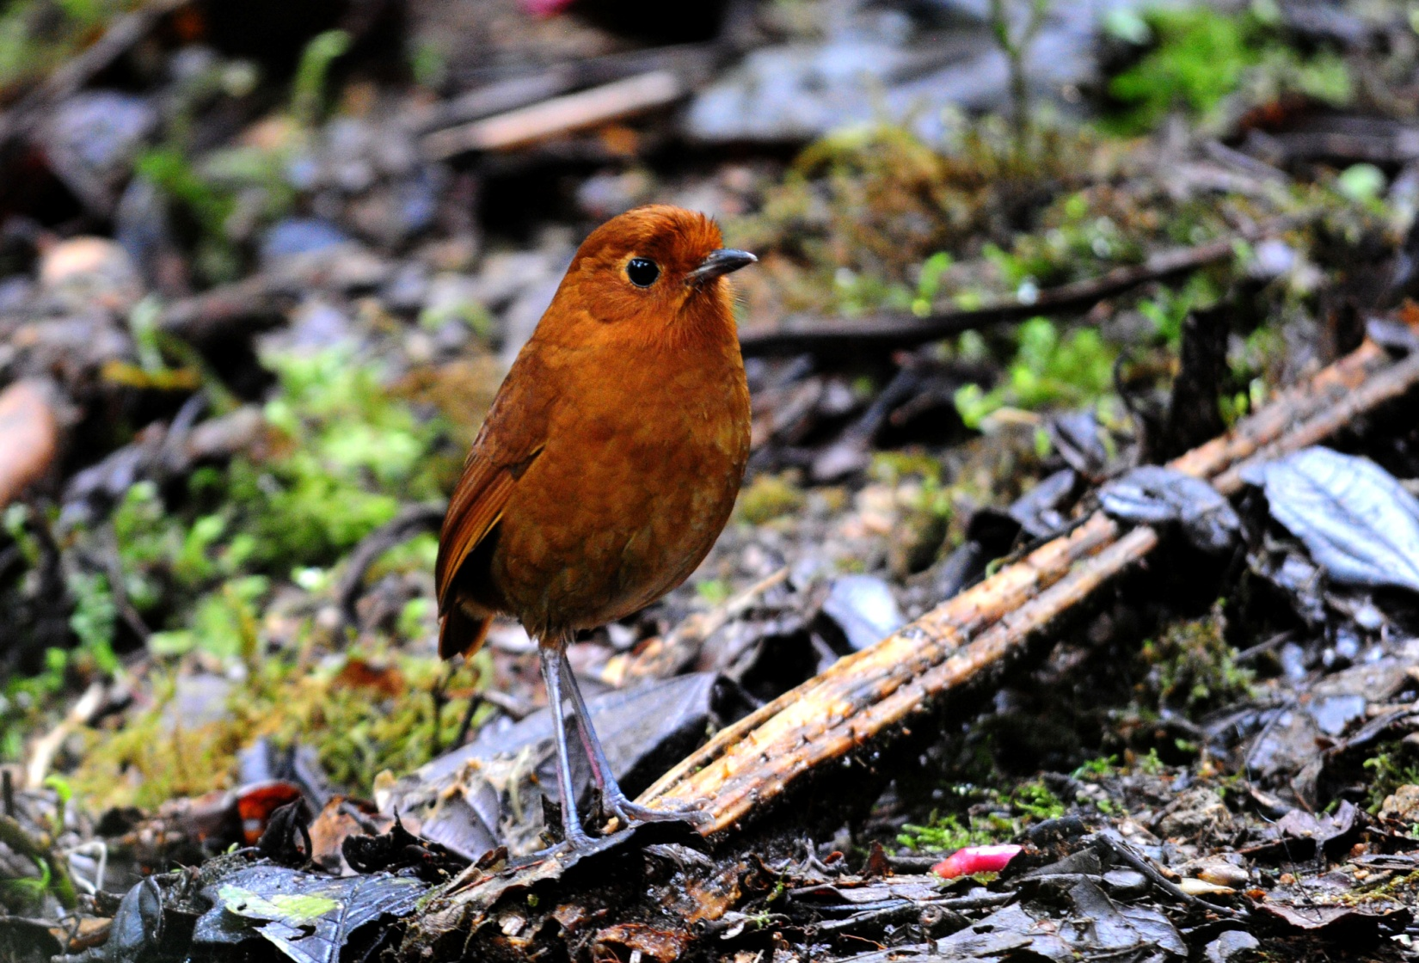
Rufous Antpitta

As everyone was enjoying the spectacle at the hummingbird feeders, someone saw a small bird in the trees near the bathroom. When Galo and Marcelo went to look, they called everyone over to see a small mixed flock that was moving through. We found Yellow-breasted Brush-finch (aka Rufous-naped), Spectacled Whitestart, Blue-backed Conebill, Pearled Treerunner, Superciliaried Hemispingus, and White-throated Tyrannulet before the flock moved on.

By now it was already noon, so we needed to head back. I was trying to get a few last photos of Sapphire-vented Puffleg at the end of the little bridge when a Mountain Velvetbreast zoomed in for a brief second, just long enough to see the broad white bands on either side of the tail that allowed Galo to identify it for me.

There was some bird activity as we were walking back, first a group of Rufous Wrens, then a Scarlet-bellied Mountain-Tanager that was much more cooperative that the first one seen from the bus on the way in. Black-chested Mountain-Tanager was seen sitting low at the road’s edge, but by now the fog was settling in so the views, although close, weren’t perfectly clear.

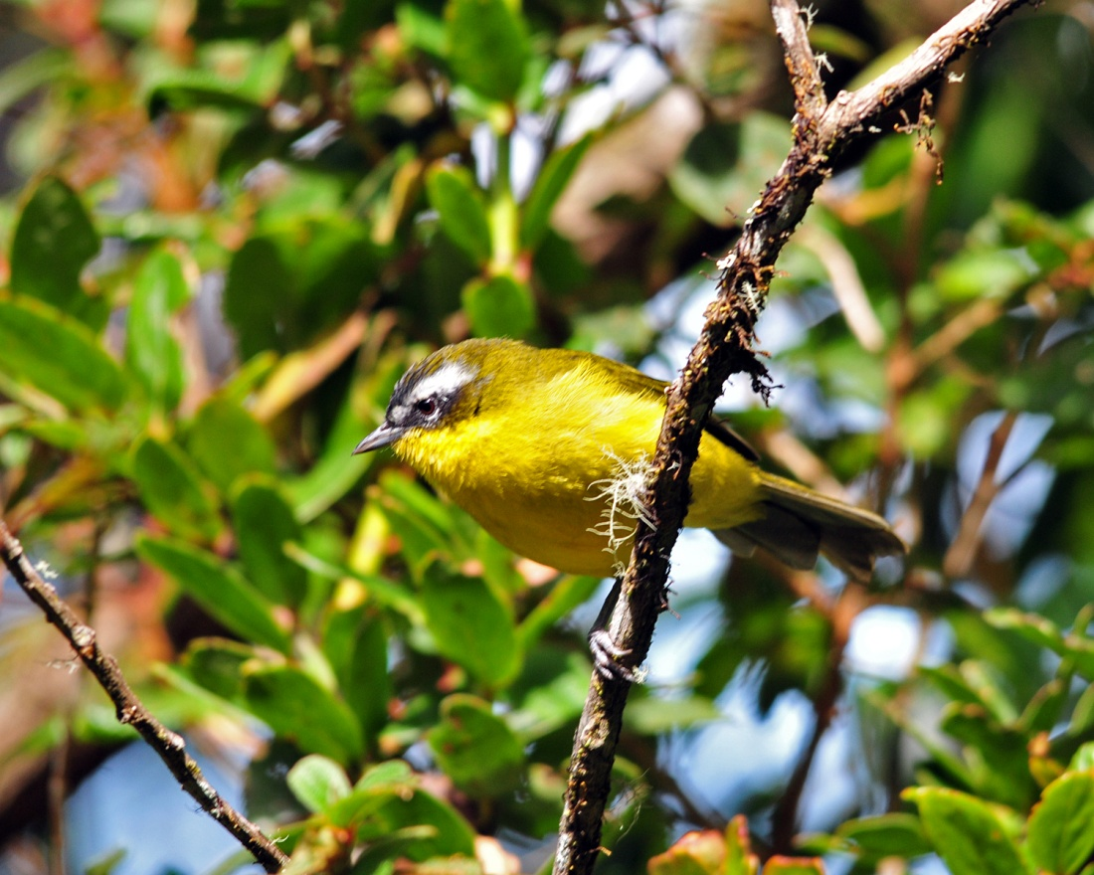
Superciliaried Hemispingus (2011)

It was 1:00 PM by the time we got back to the entrance for our box lunch and everyone was really hungry. Unfortunately, the Sebastian had packed sandwiches that had chicken salad with a lot of onions on them, and Rosanne could not eat one because of an allergy to onions. I had gone to the desk at the hotel the night before to double-check on the two vegetarian lunches, but it didn’t occur to me to check about onions because we have never been served onions in any form in a box lunch from the Sebastian. Galo and I felt terrible about this, and we tried very hard to make sure it didn’t happen again.

After lunch, we watched the caretaker feed worms to a Tawny Antpitta. Again, it was difficult to tear the photographers away from the feeders, and we didn’t leave Yanacocha until shortly before 3:00 PM. We normally make several stops along Nono-Mindo Road, but we had to limit our stops this time in order to arrive at Sachatamia before dark. Just after we crossed the bridge over the Rio Alambi, we spotted White-capped Dipper in the rapids. We pulled over and everyone got out quickly, but we had to move up and down the river quite a distance before everyone was able to get good looks (and photographs). I straggled behind the group, and at one point when I caught up with them, they had seen a Slaty-backed Chat-Tyrant that had unfortunately left the scene before I got there. As we drove along the famous Old Nono Road, Galo cried “Pare! Pare! Pare!” for Luis to stop. Luis backed the bus up to the spot where Galo had seen a female Andean Cock-of-the-Rock, but the bird had flown away. He also spotted a Golden Tanager from the road and I alerted everyone as they shot photos of the distant bird that it would be a yard bird at our next destination.

We arrived at Sachatamia and got everyone settled in their rooms just in time to meet at 6:45 to complete yesterday’s list before dinner. At the feeders on the front porch, we noted Velvet Purple Coronet and Fawn-breasted Brilliant before going inside. People who went past the lower hummingbird feeders on the way to their cabins saw Booted Racket-tail and Violet-tailed Sylph among many other hummingbirds that they couldn’t identify. After dinner, we completed today’s list, finishing the day with 41 species, of which 9 had been seen on the first “non-birding” day, bringing our trip total to 46 species.

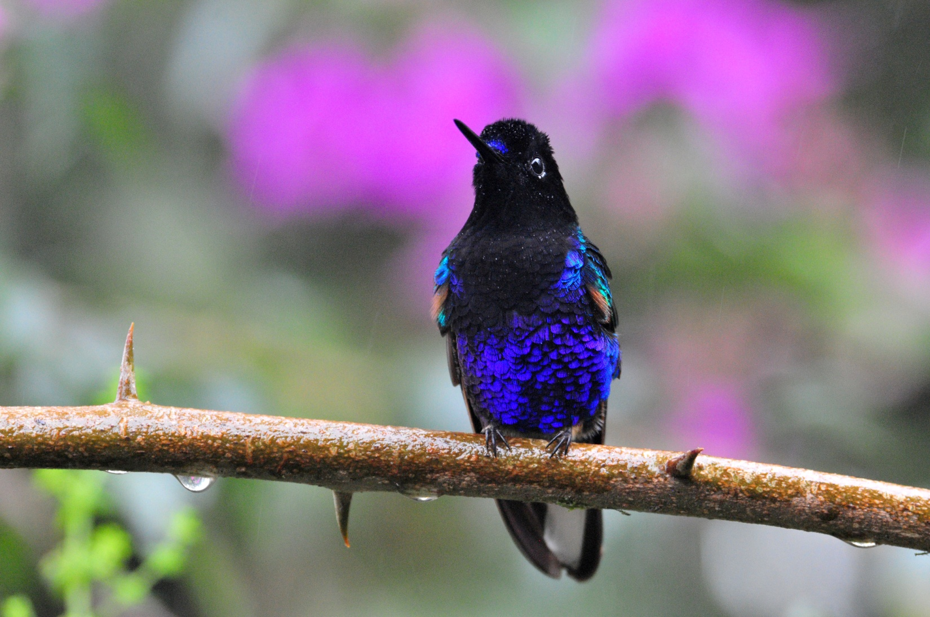
Velvet-purple Coronet (2011)

Day 3, Monday, February 13: SACHATAMIA LODGE, OLD NONO-MINDO ROAD, BELLAVISTA LODGE
It rained a bit during the night, and everyone heard the owl sounds as we fell asleep (or one of the times we woke up during the night). Even though it seemed we were hearing multiple owls, Galo said it was three of the vocalizations of the Black-and-white Owl that we heard.

We set our alarms for 4:45 so we could be in the dining room at 5:30 for breakfast. Our plan was to depart at 6:00 to go to Bellavista Research Station Road, but I warned Galo that we might be late if the birds were as active in the parking lot as they had been on our last trip in November. A light there attracts insects which in turn attract birds just as it’s getting light. This morning the area around the light was spectacular! Golden-crowned Flycatcher was the first bird on the scene, swooping out to catch insects before it was even daylight. We stood side-by-side along the edge of the parking lot and tried to keep up with the birds as names were called out: Blue-winged Mountain-Tanager, Montane Woodcreeper, Slate-throated Whitestart, Brown-capped Vireo, Golden Tanager, Black-capped Tanager, Tropical Kingbird, Beryl-spangled Tanager, Dusky Bush-Tanager, Scrub Blackbird, Lemon-rumped Tanager, Blue-gray Tanager, Azara’s Spinetail, Palm Tanager, Golden-naped Tanager, Tropical Parula, Blackburnian Warbler. Galo, Marcelo, and Jim were busy with their laser pointers and we all helped each other as much as we could. In the end, I think most birds were seen by most birders.

One of the guides called out, "Barbet!" when they heard the familiar "cluck, cluck, cluck" of the approaching birds. The
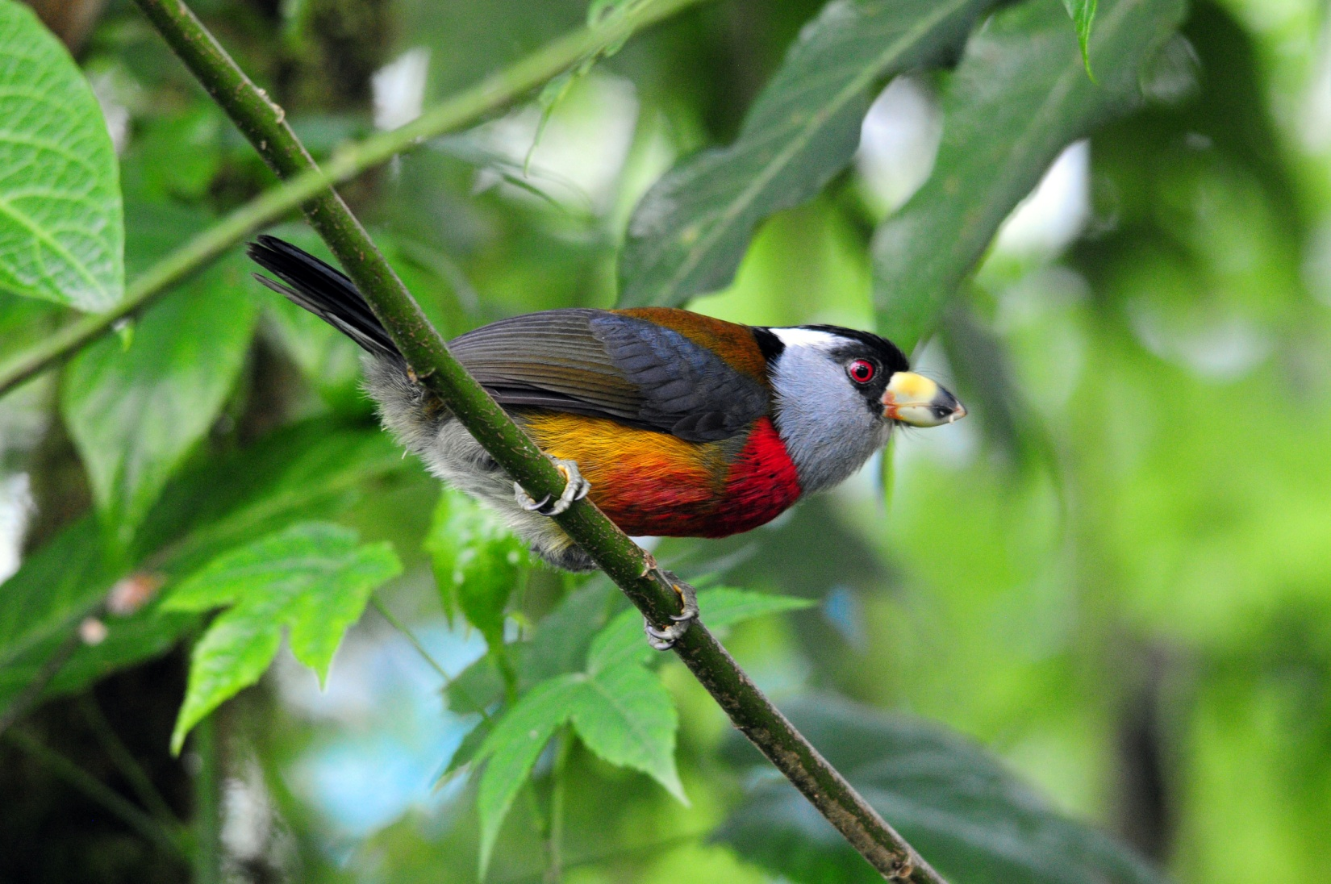
Toucan Barbet

birds perched in the branches close to the feeders before coming down to feast on bananas, giving everyone exceptional views of an exceptional bird. It wasn’t long before the Pale-billed Aracaris did the same, and we commented again and again that we had never seen this bird so close in such good light. Every tiny detail could be seen at this range. From the shelter overlooking the valley below we saw Swallow-winged Kite, Roadside Hawk, and both Turkey and Black Vultures soaring. The feeders there, in addition to the Barbets and Aracaris, hosted Black-winged and Buff-throated Saltators, Lemon-rumped and Blue-gray Tanagers, Thick-billed and Orange-bellied Euphonias, Flame-faced Tanagers (WOW!), and both male and female White-lined Tanagers, which are so different from each other they look like different species. A Sickle-winged Guan moved through the area below the feeders, but didn’t actually come to the feeder. A White-sided Flowerpiercer was observed piercing the top of a red flower near the shelter.

Finally, we pulled ourselves away from the parking area and made our way to the hummingbird feeders near the pond. Booted racket-tail, Violet-tailed Sylph, Velvet-Purple Coronet, Green-crowned Brilliant, Fawn-breasted Brilliant, Empress Brilliant, Purple-bibbed Whitetip, Brown Inca, White-necked Jacobin, Brown Violet-ear, Andean Emerald, Rufous-tailed Hummingbird, and Purple-throated Woodstar were all in abundance.

The group was enjoying the birding at the lodge so much that I suggested to Galo that we change our plans and stay here through lunch. With so much opportunity for photography, it was obvious that no one wanted to leave. We decided to ask for an early lunch on the deck, after which we could go to Bellavista Road to bird and then to the lodge to see the feeders, making it necessary to make the drive only once, which would increase our birding time by about an hour and a half. The staff at the lodge accommodated our request, and we spent the remainder of the morning wandering about the grounds, taking advantage of each photographic opportunity and adding some birds to the day’s list. A Slaty Spinetail was seen in the row of bushes along the road leading back to the cabins. As I was photographing hummingbirds at the feeders, I heard what sounded like a woodpecker behind me. I turned to see a Strong-billed Woodcreeper pounding a huge Cicada on a tree just a few feet from me. The others weren’t far away, so I called to them. The bird flew but landed in clear sight on the opposite side of the driveway and was photographed and videoed as it continued to struggle with the extra large breakfast it had caught.

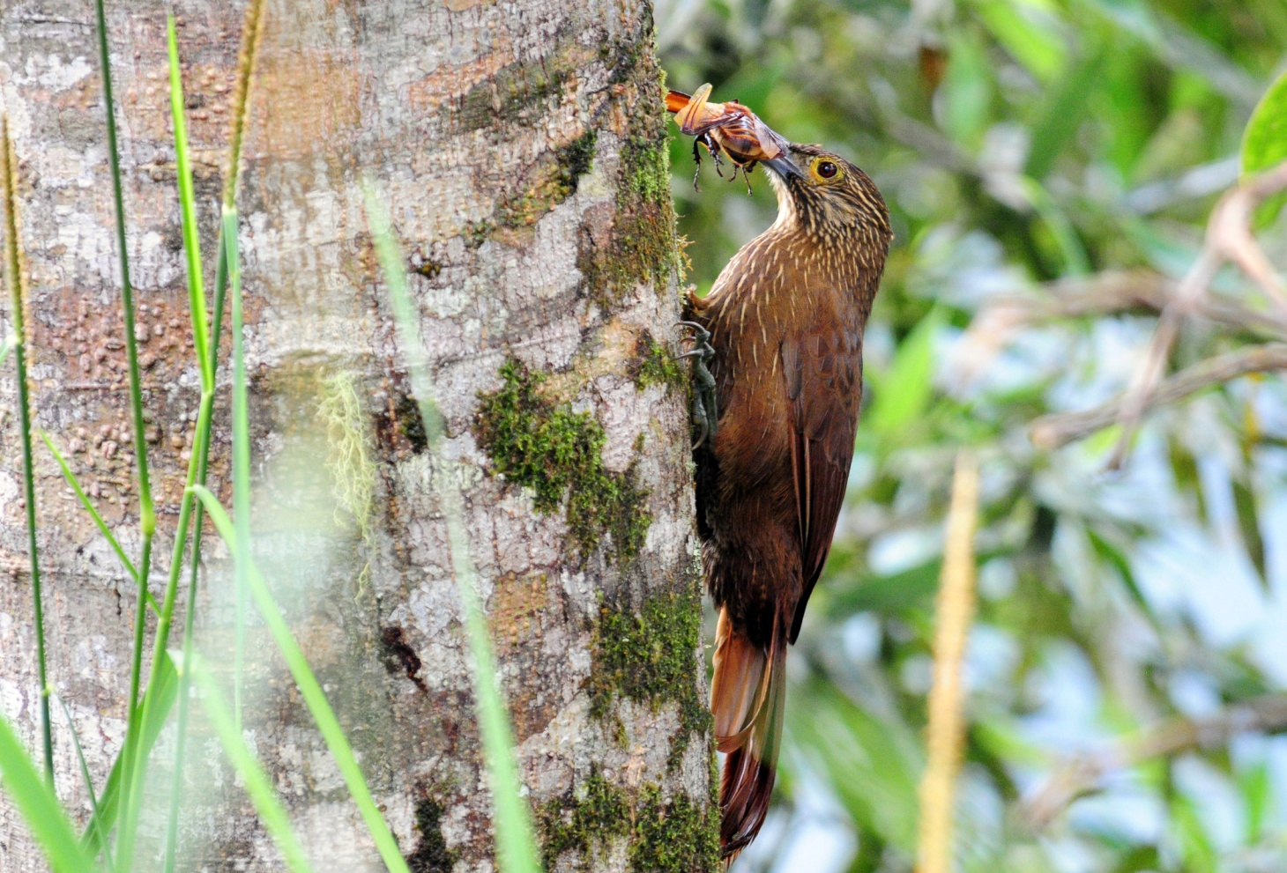
Strong-billed Woodcreeper

After a nice al fresco lunch overlooking the Mindo Valley, we loaded the bus to go to Bellavista. Our first stop was to search for the very rare and local Tanager Finch. Although we were able to hear the birds responding to the taped calls, they did not show themselves to us. There are no more than ten of these birds in the area, and their range is restricted to just this spot in northern Ecuador. The birds have been called into the open with tapes so frequently that they are becoming “played out” and no longer respond every time the tapes are played. While we searched for the Tanager Finch, we saw Streaked Tufted-cheek. We moved on, walking along the road with Luis following us in the bus. Turquoise Jays were loud but not easily seen, and Collared Forest Falcon was only heard. Marcelo heard and then found a Green-and-black Fruiteater. Although perched close to the road, the Fruiteater was well-camouflaged behind several layers of brush and was not easily seen. A Gorgeted Sunangel landed briefly but was badly backlit. As we arrived at the intersection of Old Nono and Bellavista Research Station Roads, it began to rain lightly, so we decided to go on to the feeders rather than walk on the road. As soon as we started toward the lodge, Marcelo again called out, “Pare! Pare! Pare!” – he had seen a Plate-tilled Mountain-Toucan! We exited the bus quickly and followed him back down Old Nono Road a short distance to attempt to find the bird. Just as we got out of the bus, a Collared Inca was seen; shortly after that we saw Masked Trogon. Marcelo played the call of the Mountain-Toucan, but the response was from far away. As always, we were distracted by other birds, including a Choco Toucan, as we searched for the target species. Finally, the Plate-billed Mountain-Toucan was heard much closer and Marcelo again tried to call the bird in. This time, it flew into a tree fairly close to the road and everyone got excellent looks at the “Cover Bird” of Ecuador. We got back in the bus and happily moved on to the feeders at Bellavista Lodge. As we entered the property, someone pointed out a pair of Plate-billed Mountain-Toucans at eye level in a Cecropia tree a short distance away. Even though these birds were closer and at eye level, the view was not as good as the one we enjoyed earlier because fog had settled in around the tree.
We enjoyed coffee and tea under cover as we watched the feeders in a light rain. The birds didn’t mind the wet conditions, and we added some new hummers to the list here, including Speckled Hummingbird, Collared Inca, and Buff-tailed Coronet, and we got better looks at Gorgeted Sunangel. Of course, there were plenty of “old species” to allow us to practice our ID skills. The rain stopped and started several times while we were on the lodge grounds. Jim and I walked to the back of the lodge and found a small mixed flock that included Metallic-green Tanager. Marcelo walked to the compost pile and called Galo on his cell phone when he found White-throated Quail-Dove there. We hurried to see the bird, and also saw Glossy Black Thrush there. Some of us lingered at the compost pile while Marcelo tried (unsuccessfully) to call in Powerful Woodpecker; others went back to the parking area where they found Azara’s Spinetail. When the group got back together at the entrance, we found White-tailed Tyrannulet, another new species for the trip.

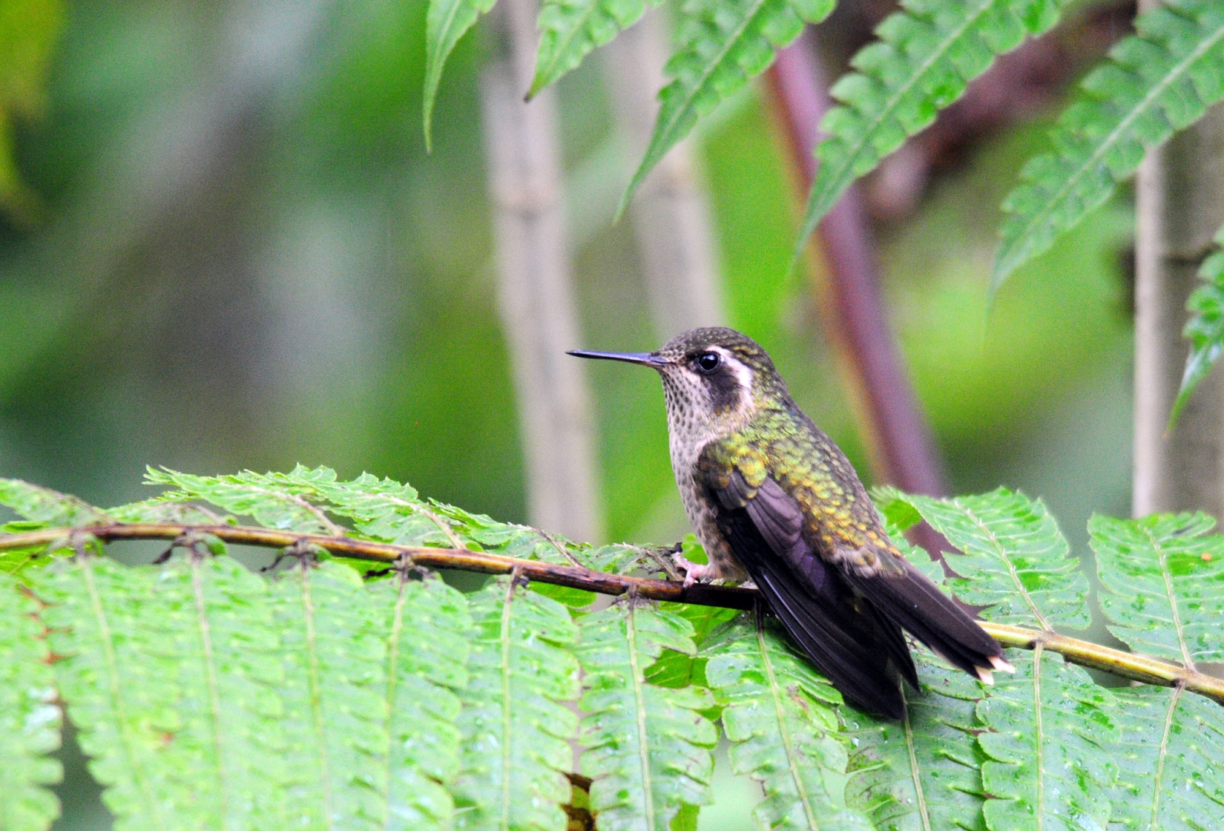
Speckled Hummingbird

We drove back to Sachatamia with just a few minutes of free time before meeting to complete the day’s list. While we waited on the others to arrive, a few of us spotted Chestnut-capped Brush-Finch outside the rear window of the dining room. Other birds seen today included Band-tailed Pigeon, White-tipped Dove, Maroon-tailed Parakeets (flying overhead), Pacific Hornero, Red-faced Spinetail, Blue-and-white Swallows, House Wren, Masked Flowerpiercer, Yellow-bellied Seedeater, and Rufous-collared Sparrow. We had 73 species for the day, most of them new and a high percentage of them “quality” sightings, bringing our total to 110 for the trip. As we were finishing dinner, someone said the Black-and-white Owl had been spotted so we all ran out to see it. Right in the parking lot, near the light that had given us so many birds this morning, sat this gorgeous creature. Marcelo shined the spotlight on him for excellent views, but no one had their binoculars with them! Luis got his bins from the bus, and we all took turns using Galo’s and Luis’s binoculars. Luckily, this owl is a very stoic bird. John ran back to his cabin to get his camera equipment while Marcelo waited patiently for him in the light rain. When John returned, Marcelo provided light for him to take some great photos. No one else had their gear with them, so John’s are the only photos of this fantastic sighting. Make that 74 species for the day, 111 for the trip.

Day 4, Tuesday, February 14: PAZ DE LAS AVES, OILBIRD CAVE
We were up at 3:20 to leave at 4:00 to go to Refugio de Paz (Paz de las Aves). Ordinarily, we leave at 4:30, but Jim suggested that we needed to allow some extra time, both for the bus drive and the walk to the hide due to the recent heavy rains that might make both the driving and the walking a bit more difficult and time-consuming. The drive wasn’t any worse than normal, and we arrived at Angel Paz’s place at around 4:45. We had a box breakfast in the bus while we waited for Angel to get ready to lead the group down the trail. Charley and Peggy had decided to stay back at the lodge to photograph plants and birds, and Susan and Pat decided to forego the walk down into the valley in the dark. I stayed on the bus with them so we could do a little birding (once the sun came up) while we waited for the group to return for the traditional Ecuadorian breakfast that would be served at around 10:00 AM. As the group walked off in the darkness, we settled in to wait for sunrise. About 15 minutes after the group left, it began to rain lightly, and as I listened to the rain tapping on the tin roof next to the bus, I hoped it wouldn’t turn into a real rain. Luckily, it stopped after about 10 minutes and didn’t affect the birding for the group below.

When the sun came up, Susan, Pat and I exited the bus and began to look for the Yellow-faced Grassquit that was calling. Just as we were getting ready to walk to the hummingbird feeders, Angel’s brother Rodrigo came over and spoke to us in Spanish. Luckily, Susan could understand more than I, and we figured out that he wanted us to follow him to the feeding station where they put out bananas and grapes that attract such birds as Toucan Barbet, Crimson-rumped Toucanet, and Sickle-winged Guan, among others. At first I thought he was going to put out food so we could watch these birds, but then he said the food would go out at 8:00 when the group arrived at the feeders. I think. Really, I need to learn to speak more Spanish! He said we should wait at the hummingbird feeders until 8:00 and then follow the trail to the other feeders. We sat down to watch the hummingbirds, where it quickly became obvious that the feeders were empty. One after another hummer flew in, tested a feeding port, and flew away. I started to walk back to the house to ask for some sugar water when I saw a small flock of birds moving through. I went back to get Pat and Susan, but by the time we got back to the spot, most of the birds were gone. We saw Montane Woodcreeper, an unidentifiable flycatcher, House Wren, and not much else.

We walked back to the house, thinking the road might be more productive. I told someone, either Angel or Rodrigo’s wife, I think, that the feeders were empty. She said they would fill them in ten minutes. Rodrigo’s daughter Emily appeared soon after with a bucket of sugar water and invited us to walk with her to fill the feeders. She is a beautiful and delightful child, and she chatted all the way back to the feeders. Unfortunately, we didn’t understand most of it (but I did catch something about a Tapaculo we might see). As she filled the feeders, the hummingbirds were buzzing around her, some of them landing on the feeders while they were still in her hand. She offered to take us to the lower feeding station, and we gladly followed her. It was amusing to watch her navigate down the steep muddy trail in her white dress shoes, knowing that we had been instructed to wear waterproof rubber boots for the trek. Because we hadn’t expected to walk this trail, the three of us had our regular hiking shoes on, but there were only a few spots that were exceptionally muddy. We made it to the feeders shortly before 8:00 and “talked” to Emily for a few minutes before she said she had to go back to help with breakfast. Immediately, we spotted Toucan Barbets – two of them, poised to come to the feeders as soon as food was presented. Then the Crimson-rumped Toucanets showed up, also waiting for their morning feast. Susan spotted some toucans high in a tree that turned out to be a pair of Plate-billed Mountain-Toucans. (!!) We sat and waited for the group, and I explained that it could be a long time or just a short while, depending on the bird activity. If it was good, we could have a bit of a wait because birders don’t stop birding when there’s action. Watching the Toucan Barbets and the Crimson-rumped Toucanets as they waited for the Paz brothers to feed them, I worried that they might leave before the others showed up. I took four grapes from the bag that Rodrigo had hung on the shelter and carefully tossed them out onto the feeding platform. Within seconds, a Crimson-rumped Toucanet swooped down to retrieve a grape. Next, a Toucan Barbet grabbed a grape and flew off to consume it. Another Toucanet came down and grabbed a grape, knocking the last one off the platform. A bird we couldn’t identify came in and landed right in front of us, close enough for a decent photo which Angel later identified for us as an Olivaceous Piha.

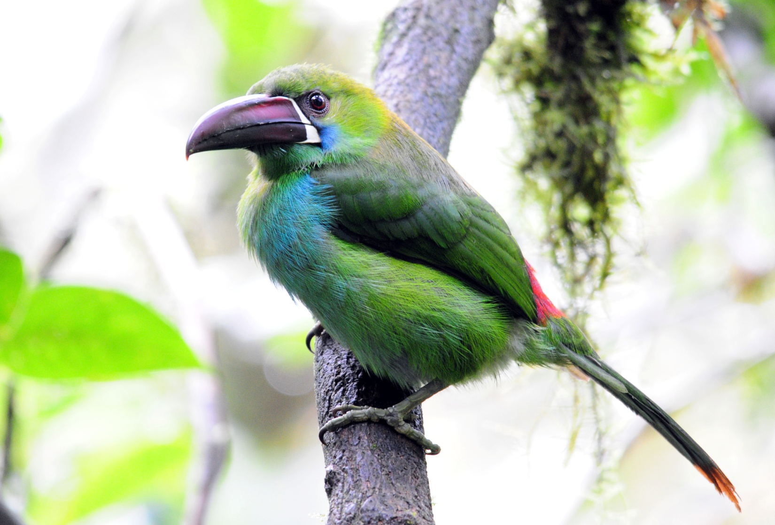
Crimson-rumped Toucanet

We continued to wait, as did the hungry birds. I eventually put two more grapes out, much closer than before but also much safer than leaning out to toss them on the platform. The birds weren’t as quick to come for food that was so close to the humans, but a Toucan Barbet finally came and got them. A Sickle-winged Guan joined the waiting party, and I finally said if the group didn’t arrive by 9:00, I would go ahead and put the bananas out. After all, breakfast is at 10:00 and I know sometimes this feeding station gets skipped if too much time is spent on the birds below. Then I began to wonder if Rodrigo was telling us we should put the food out at 8:00 for the group, but that didn’t really make much sense. So we waited. A few minutes before 9:00, just as I was about to put the food out (on Pat’s orders because Pat is such a nice guy no one could ever get mad at him), the group arrived. As Angel cut the grapes in half (oops – I didn’t do that), we learned that none of the Antpittas had shown up this morning. Apparently, when they are nesting they are less likely to put in an appearance. We surmised that all of the rain that had fallen in January might have influenced the birds to nest a bit earlier this year. Very disappointing, indeed, but the Cock-of-the-Rock males had put on a good show. Once the food was out, the birds appeared. In addition to the Toucan Barbet, Crimson-rumped Toucanet and Sickle-winged Guans, a flock of Blue-winged Mountain-Tanagers and their rarer cousins, Black-chinned Mountain-Tanagers came in. Lance spotted a White-tailed Tyrannulet in a tree a few hundred feet out. There was still food on the table, so to speak, when Rodrigo said we should go to breakfast. We followed him up a steep hill to the hummingbird feeding station and sat briefly to watch the hummers, but this stop was really more to rest since the species here can all be seen at Sachatamia. Along the way, Marcelo pointed out a Long-tailed Antbird to those of us who were nearby. While we rested, Angel told Galo about the Ocellated Tapaculo he has been training. Tapaculos are notoriously difficult birds to

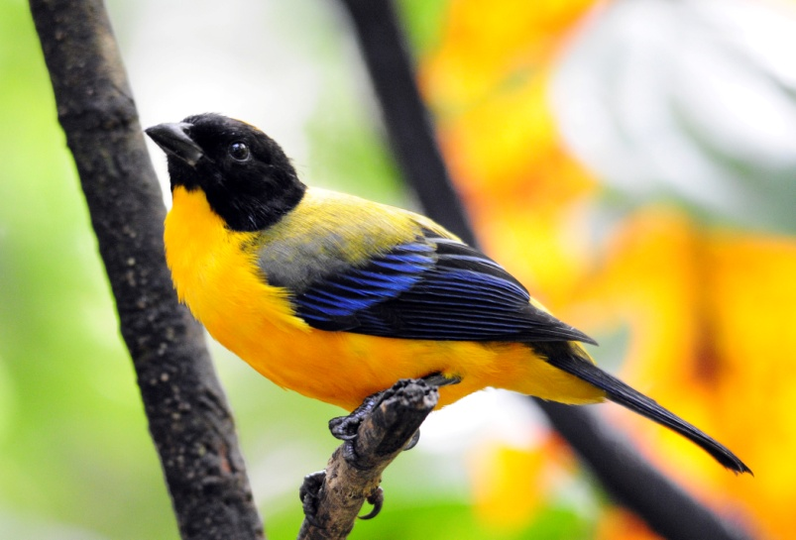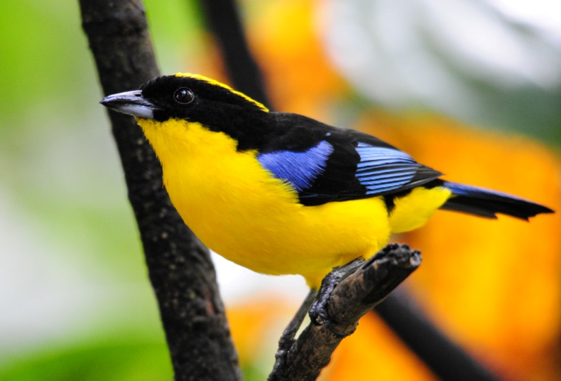
Back-chinned Mountain-Tanager Blue-winged Mountain-Tanager

see, regularly heard but rarely seen. He offered to take us to this spot for free since none of his Antpittas had shown up for the group. This would involve a short drive in a 4WD pick-up truck, men in the back and women in the cab, and then a walk of about 100 meters. He thought it would take just 30 minutes, and then we would have our breakfast afterwards. None of the hungry birders hesitated a moment in agreeing to this, and we all piled in the truck. I suggested that Pat should ride up front since he was suffering from a painful knee and hip and hanging on in the back of a truck could prove extremely uncomfortable for him. I offered to ride in the back, but Rosanne insisted that she wanted to do it, so I took my seat in the back of the cab. It was a short drive, but the walk to the spot where the Tapaculo would be fed was anything but easy. Through slippery mud, down a steep hill decorated with cow manure, we made our way to a viewpoint at the forest’s edge. We all assumed our positions, and Angel began to call the bird by whistling. We could hear the bird responding far below us. After several minutes (that felt more like 20), the bird appeared. And what a bird! The largest of the Tapaculo family, this bird has bold markings, unlike most other Tapaculos. Once the Tapaculo appeared, the only sound was that of the bird still calling and the clicking of shutters. The Tapaculo was still there when Angel motioned for us to leave as he threw the rest of the worms down to reward the bird for its appearance.

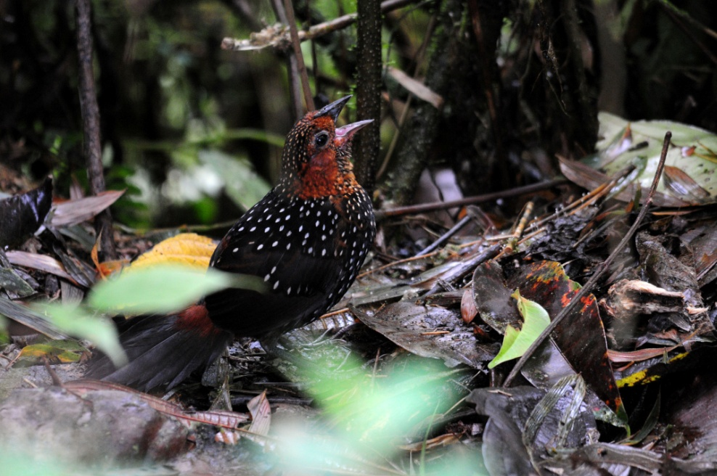
Ocellated Tapaculo
After tramping back up the muddy trail to the truck, our feet were too muddy to get into the cab. By the time I got there, several people had begun to walk back, so I climbed into the bed of the truck along with Jim, Susan, Pat, and Angel to drive back to the house. The road was quite steep and quite bumpy and it felt like I would bounce off the edge of the truck bed at any minute. I turned to Angel, who doesn’t speak English, and said, “Feel free to grab any part of my body that’s necessary to keep me in this truck.” He laughed much too hard for me to believe he didn’t understand it.

Breakfast was, as always, wonderful. A traditional Ecuadorian dish called "Bolones de Verde" was served first. Made from green plantains which are fried over medium heat until very tender, then mashed into dough, stuffed with chicken and/or cheese, and then fried again until crispy, the bolones were especially delicious when dipped in the hot salsa provided. Angel's home-made salsa is so delicious that we had to ask for multiple refills to keep everyone happy. (Bolon is a slang term that means large ball, so you could translate the name of this dish as big green balls) The bolones were quite large and filling, but just as we finished Angel brought out the next course, Empanadas de Queso. Freshly made and hot off the fire, these were absolutely wonderful! Our guide a few years ago showed us the best way to eat them - smash them, put sugar in the depression you made, and yum! Even better! As we ate, a light rain fell, but it stopped just as we finished and prepared to leave. Although we had encountered rain several times, so far it had been well-timed: during lunch at Pim's, while we traveled in the bus from Yanacocha to the Mindo Valley, as we ate breakfast at Angel's place. As long as it continued like this, we wouldn't miss any birding at all! (famous last words . . . . ) Once we stuffed ourselves, we prepared to leave. Because we had taken so much time with the Tapaculo, we didn’t have time to bird other areas of Angel’s property as we normally do. We drove straight to our next destination with just one strategic stop for a Swallow-tailed Nightjar. Luis knew the area where the Nightjar had been seen by his brother, who is one of the top birding guides in Ecuador. He slowed and stopped at the designated area, where Galo and Marcelo both quickly spotted the bird that was perfectly camouflaged in front of a cliff. Surely we would have driven right by had Luis not known where to look. This bird was a magnificent male with the longest tail I’ve ever seen. We were so close that no one could use their long lenses!
The Swallow-tailed Nightjar (Uropsalis segmentata) is one of only two species in the genus Uropsalis. It ranges from Colombia to Bolivia, inhabiting temperate forest edges, clearings, and paramo on both slopes of the Andes, and is typically encountered at elevations between 2200 and 3600 msal. This nightjar is heard within its range, but not often seen due to its nocturnal habits. Its brown-mottled plumage keeps it well camouflaged during the day, when it is also usually hidden away sleeping. Their cryptic appearance blends perfectly into their habitat and they are very difficult to spot during the daytime, when they are usually hidden away sleeping.

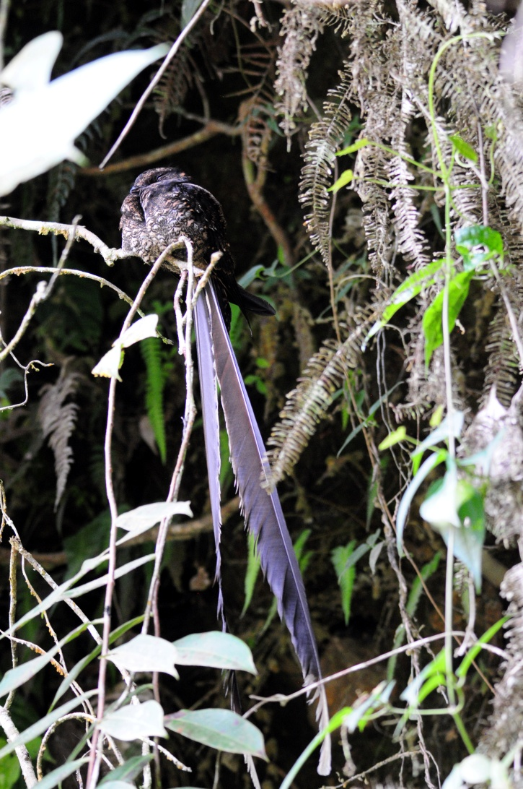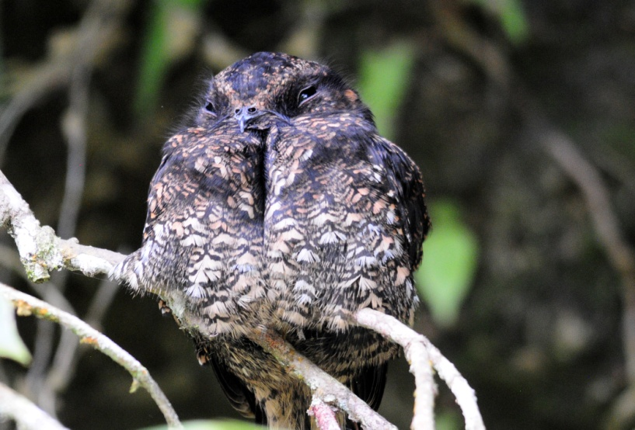
Once we had our fill of the Nightjar, we moved on to the farm of Hugo Morales where we would see the enigmatic Oilbirds. When we got to Hugo’s place on our last trip, there had been a death in the family. Instead of visiting the gorge where we climb down ladders, we were taken to a spot very near a road to see some other Oilbirds. This was much less time-consuming and quite a bit easier, but it didn’t provide the amazing experience of descending into the gorge and seeing the birds eye-to-eye in their environment. Weeks prior to our departure, I communicated with Galo’s wife, RhoAnn, who handles the arrangements for our tour, to request that we have the gorge experience, not the road show. She had confirmed with Hugo that we would be taken to the gorge, so I was surprised when we arrived shortly before 2:00 PM to find no tractor and wagon waiting for us. Galo spoke to Hugo’s wife, who said another group was at the gorge now, and she could go with us to the other site or we could wait for them to return. But when would they return? She could send someone to get the wagon, but then we would be at the gorge with another group of birders, making it very crowded. Galo suggested that we eat lunch while we waited, but no one was hungry because our breakfast had been so late and so plentiful. Four of our group wanted to climb down into the gorge and four wanted to go to the site on the roadside, so I suggested that instead of just sitting around waiting, we should all go see the birds by the road and then when we got back, the four who wanted to have the other experience could go while the rest of us birded around the farm. Galo agreed, and we proceeded to the alternate site. On the way, someone spotted a woodpecker from the bus. We stopped to observe a Black-cheeked Woodpecker at its cavity in a dead tree. When we arrived at the road that led to the Oilbirds, Luis got out to check to make sure the bus could navigate the sharp turns and steep hill, and that there was a suitable place to turn around. When we came to this spot last year, he parked the bus on the main road and we walked the rest of the way. This made the “easy” viewing anything but easy as the road was very steep and covered with loose gravel that made you lose your footing periodically as you walked downhill. He decided it was OK, and delivered us to a spot just a few hundred yards from where we entered a rocky area with a waterfall. In the short walk, we saw Hook-billed Kite and Yellow-bellied Seedeater. There was a slight challenge with footing, but the distance to the spot where everyone got good looks of this very special bird was short.

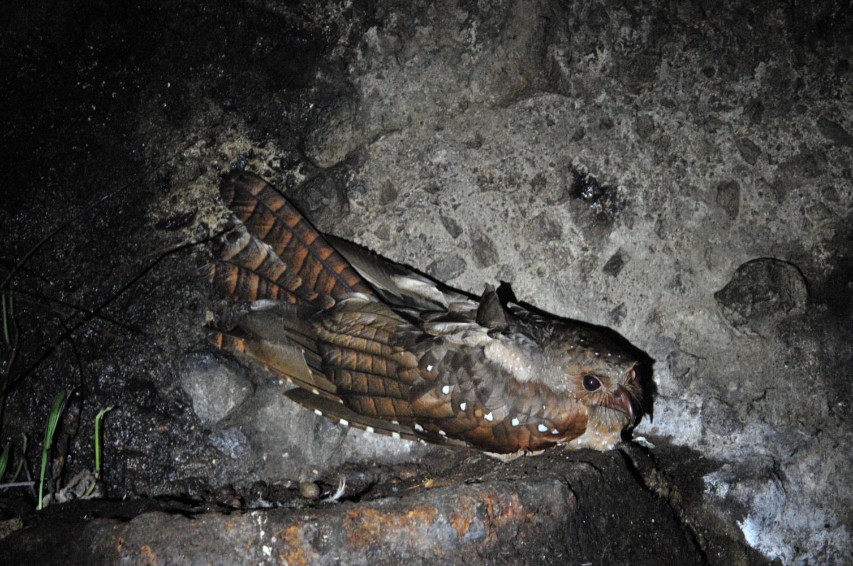
Oilbird (2011)

When we got back to the bus, Galo suggested eating lunch, but I said we needed to get back to the farm. I had a feeling that we would be given another excuse as to why they shouldn’t take our group of four to the gorge, and I didn’t want it to be that we were too late, although I didn’t state that. Even though I was angry about the Morales family not keeping the appointment we had made with them, I was trying to be positive. I suggested that Mrs. Morales should not have to sit there and wait for us to eat when we could just as easily take her home first and eat our box lunches at the farm. When we arrived back at the farm, the tractor and wagon had still not returned. Sure enough, we were told that it was getting pretty late to take the other group. So much for maintaining a positive attitude. Now I instructed Galo to tell Mrs. Morales just how displeased I was with this service, and if this is the way they do business that we won’t be bringing more clients. Since I could not communicate with her myself, I asked him to be very blunt about this as I wanted her to understand the level of my displeasure. I even offered to stand behind him and make faces. Just (mostly) kidding about that part :)

It was obvious to me that Galo wanted to go on since we had seen the birds, and Rosanne and Lance and Terry were very gracious in saying that they were willing to forego the experience. John was more like a child who had just been told we cancelled Christmas, and I empathized. When the wagon finally arrived and Galo looked at me for a decision, I told him that this experience is what we promised, so we needed to deliver. We loaded the group on the wagon, snapped some quick photos and waved as they drove off across the farm field.

While they were gone, Galo and I commiserated for a few minutes about a competitor who uses unethical practices to discourage competition in Ecuador, ate a few bites of our lunch, and then Bob, Georgene, Pat, Susan, Galo and I went birding on the road. We had super views of a pair of Band-backed Wrens as we made our way toward the sounds of a Striped Cuckoo in the distance. We observed Smooth-billed Anis as they worked the road in large groups, joined for awhile by a Shiny Cowbird. A Plain-breasted Hawk soared in circles overhead for a few minutes, long enough for Galo to put him in the scope to get a positive ID. When the Striped Cuckoo finally flew in where we could see it at the top of a tree, we were distracted by a Golden-olive Woodpecker that appeared in the same area. We followed two Slaty Spinetails in the bushes at the edge of the road for some time, trying to get clearer views than we had with earlier individuals of this species. Other birds we saw as the sun began to sink included Ruddy Pigeon, White-crested Elaenia, Common Tody-Flycatcher, Ecuadorian Thrush, Black-striped Sparrow, Southern Rough-winged Swallow, Blue-black and Yellow-faced Grassquits, and Variable Seedeater. When we returned to the farmhouse, there was a Pale-mandibled Aracari feeding low in a tree next to the house.

When the “Oilbird Gorge Group” arrived back at the farmhouse, they were ecstatic. Their faces were beaming, their clothing muddy, their muscles sore, and their spirits soaring. As they enthused about the experience they had just had, I knew I had made the right decision about insisting that they be taken to the gorge. Sometimes stubbornness is a good thing.

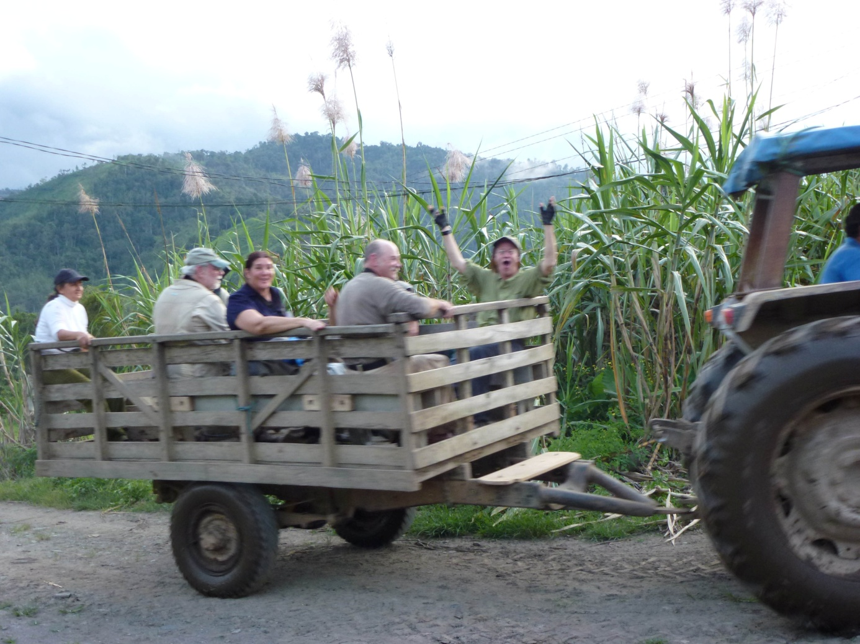
Back from the Oilbird roost!
It was going on 6:00 PM by the time we left the Morales farm. We all settled back to rest while Luis drove us back to Sachatamia in the light rain that had begun to fall as we loaded the bus. Once again we had rain, but the timing was impeccable. We arrived at 7:30 and immediately went in to do the checklist and have dinner. Other birds seen today that were new for the trip included Bronze-winged Parrot, Squirrel Cuckoo, White-collared Swift, Pacific Antwren, Black Phoebe, Social Flycatcher, Rusty-margined Flycatcher, Gray-capped Flycatcher, Swainson’s Thrush, Gray –breasted Wood-wren (John only), and Bay-headed Tanager. Although we saw 13 species of hummingbirds today, none were new to the trip. Our daily tally was 82, with an additional 5 heard only and another two that were seen only by one of the guides. The trip total now stood at 148 plus 13 heard.

Day 5, Wednesday, February 15: MILPE BIRD SANCTUARY, AYALIR HOSTELERIA
We scheduled breakfast for 5:45 so we could leave at 6:15 to visit Milpe Bird Sanctuary. The staff at Sachatamia helped Luis and our guides pack everything in the bus. Before we left, Charley reported that he had lost his passport while birding on the lodge grounds the day before, so Galo asked the staff if someone could go out and walk the trails he had been on to try to find it. If they found it, we would stop on our way back to Quito to pick it up. If they didn’t find it, we would need to file a police report and visit the Embassy to get the proper paperwork for his departure from Ecuador. Peggy and I hoped that they would be able to find it buried in their things when we got to our next lodge, so I tucked that worry in the back of my mind as we left for a day of birding.

It was a short drive to the turn-off to Milpe, and Luis dropped us off shortly after he turned on the entrance road. We birded along this road for a couple of hours before even entering the reserve, which made for easy walking, great birding, and plenty of room for everyone in the group to position themselves to see each bird as it was spotted. It was a little misty but visibility was good. The first bird sighted when we got out of the bus was a Slate-throated Whitestart. Bronze-wnged Parrots were seen through the scope. Sitting in the same bromeliads were male Thick-billed and Orange-bellied Euphonias, allowing for comparison between these two similar species. Flame-faced, Golden-naped, and Bay-headed Tanagers elicited some “oohs” and “aahs”.

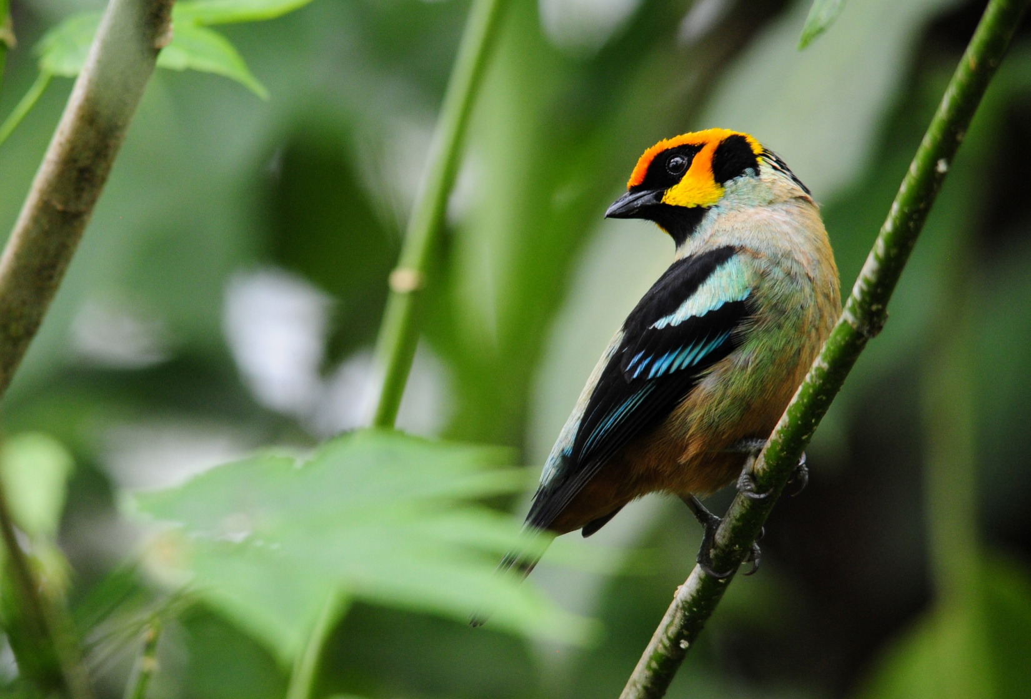
Flame-faced Tanager
A Rufous-necked Tanager was spotted by Marcelo but flew away before he could get any of us on the bird. Later, he found another Rufous-necked Tanager that everyone was able to see. Unfortunately, I didn’t get more than a 2-second look at this life bird before Marcelo instructed me to move, so I didn’t get to see the field mark for which it is named. By the time I repositioned myself a bit farther down the road and relocated the bird, I was unable to snap a photo before it flew. I saw a bright blue and black bird in the distance and initially thought I had a Dacnis, but it turned out to be a Blue-necked Tanager. While people were looking at a Roadside Hawk through the scope, I spotted a couple of small birds in a tree. They were moving about, so it was easy for everyone to find the two Olivaceous Piculets. Galo and Marcelo were able to get one or the other of them in the scope multiple times until everyone got to see this tiniest of woodpeckers through the scope. Jim spotted a One-colored Becard, either a female or young male, that was soon joined by another. A Olive-crowned Yellowthroat gave Marcelo a hard time, but it finally showed itself to everyone. Band-tailed Pigeons sat at the top of a distant tree for good scope views. Jim described a bird he was seeing, blue with a black mask and white stomach that Marcelo quickly dismissed as a Blue-necked Tanager because we had just seen that species in the area where Jim was looking. I questioned him about the white tummy and he changed his ID to Swallow Tanager just before the bird flew over us and out of sight. The birds kept coming all morning: Variable Seedeater, Fawn-breasted Tanager, Yellow-bellied Seedeater, Tropical Parula, Golden Tanager, Blackburnian Warbler, Blue-and-white Swallow, Slaty Spinetail, Yellow-collared Chlorophonia, Beryl-spangled Tanager, Bananaquit, Pale-mandibled Aracari, Bay-headed Tanager, Red-faced Spinetail, Dusky Bush-Tanager, Silver-throated Tanager, Buff-fronted Foliage-Gleaner, Summer Tanager, Rufous-throated Tanager, Blue-gray Tanager, Sooty-headed Tyrannulet, Brown-capped Vireo, Yellow-throated Bush-tanager, and finally a bird that got everyone excited (except me), Golden-headed Quetzal. It’s not that the bird isn’t impressive, but I consider it the ugly duckling of the Quetzal family.

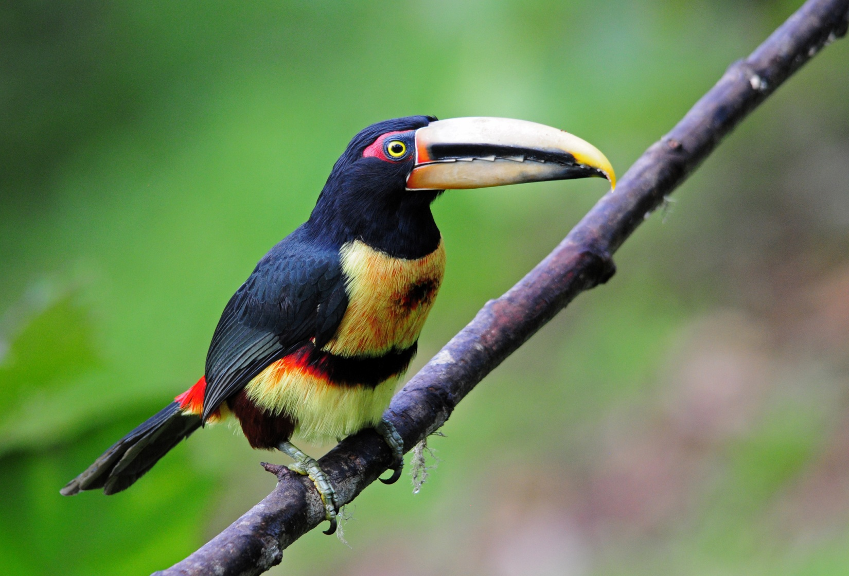
Pale-mandibled Aracari

We moved on to entrance of Milpe and took a few minutes for a restroom break and to check the hummingbird feeders. There were a lot of familiar species there, and we added Green Thorntail, Green-crowned Woodnymph, and White-whiskered Hermit to our list of Hummingbirds. While we were watching the feeders, Marcelo spotted first a Smoky-brown Woodpecker, then a pair of Red-headed Barbets (male and female) near the platform feeders on the other side of the trail.

Galo and I had a brief discussion with Charley about what options we might have if his passport wasn’t found. None of it sounded desirable, but we were confident we could work things out if he couldn’t find it. A short time later, Charley walked up to me, passport in hand – he had found it in a different pocket of his pants! Galo called Sachatamia so they wouldn’t waste time looking for it, and we decided that the best sighting of the day might well be the American Blue-fronted Passporterine. (You must have a 4-word hyphenated name for a tropical “bird”!)

We had planned to move straight to the area known for the lek of Club-winged Manakins, so after a short time at the feeders, we moved on. A Buff-throated Saltator was seen as we walked away from the feeders. The group stopped at a small shelter before going down the steps to the manakin lek, where they saw Swainson’s Thrush, Buff-fronted Foliage-gleaner, Red-headed Barbet, Three-striped Warbler, Golden-olive Woodpecker, Scaly-throated Foliage-Gleaner, and a juvenile Flame-faced Tanager that at first was thought to be a Metallic Green Tanager. We could hear the Club-winged Manakins performing for the females with the sound they make with their wings. These tiny birds use their wings for stridulation, a rubbing mechanism commonly used by insects such as crickets. One feather on each wing has seven ridges along its central vane. The stiff, curved tip of an adjacent feather strikes the ridges every time the bird raises it wings over its back and shakes its feathers. The repeated striking causes adjacent clubbed feathers to vibrate at high speed (1500 cycles per second), creating the unique high-pitched courtship song. While not believed to be part of the attraction to females, the movement needed to create the sound is entertaining in itself. Although many insects do this, manakins are unique among vertebrates in using stridulation.

The group moved on down the steps to find the Club-winged Manakins, but I was still stinging from the missed opportunity to better see and photograph the lifer tanager, so I lingered at the shelter. I managed to find a male Manakin, but the lighting was too poor and distance too far for a good shot. At the manakin lek, the birds put on a good show for the group and Susan spotted a life bird on her own, an Ornate Flycatcher.

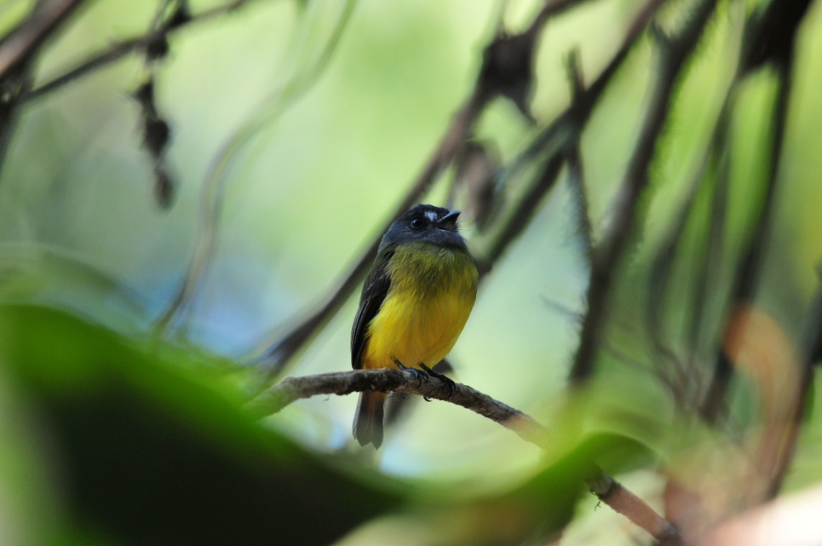
Ornate Flycatcher (2011)
Just after I rejoined the group, Galo announced that we would go back up to the parking lot and then walk along the road to the rear entrance where the trail is wider and easier while offering the same birding opportunities. We stopped for a brief moment to rest at the shelter after climbing the hill. As soon as the group left the shelter, they saw an Orange-billed Sparrow. There were lots of Swainson’s Thrushes in the area, so many that it became annoying when you realized you had one in your binoculars. A Pale-eyed Thrush was seen on the way back to the entrance, as well as another Ornate Flycatcher. On the road, more Yellow-collared Chlorophonias were seen, and this time Marcelo and Galo were able to get some of the birds in the scopes.

As we entered the new trail, John spotted a White-collared Manakin female while the guides were calling for two different trogons. John’s color-blindness makes him very good at spotting little dull birds in places where others find it difficult to see them – just don’t ask him where the red birds are! A White-throated Quail Dove was seen soon after. Jim and I were at the end of the line, lagging behind a bit, when we saw a small group of birds moving about. Among the flock were two Plain Xenops. As we were catching up with the group, I caught some movement from the corner of my eye and saw a gnatwren. I wasn’t sure which species, but I recognized the distinctive shape of a gnatwren and I did catch the eyebrow before the bird darted out of sight. We were at a sharp curve in the trail and Marcelo was at the opposite side of the valley with the first part of the group. Galo called to him to tell him what we saw and Marcelo began to play the call of the Tawny-faced Gnatwren, which eventually came out where almost everyone got to see it. A Lesser Greenlet was seen in the same area, along with our first Blue Morpho Butterfly. Everyone got good looks at a perched Broad-billed Motmot, and then the best bird of this trail was found - Golden-winged Manakin.

We drove a short distance to have lunch at Mirador Rio Blanco where there were nice feeders for us to watch while we waited for our food. The food was delicious, but the wait was long. Even so, it certainly beat the option of having a box lunch. At the restaurant’s feeders we saw nothing new but were nonetheless entertained by Silver-throated, Blue-necked, Palm, Golden, and Blue-gray Tanagers, Ecuadorian Thrush, Orange-bellied and Thick-billed Euphonias, and a Slate-throated Whitestart that repeatedly hit the window. The Hummingbird feeders hosted Green Thorntail, Green-crowned Brilliant, Green-crowned Woodnymph, Rufous-tailed Hummingbird, and Bananaquit. The view of the valley and river below was wonderful.

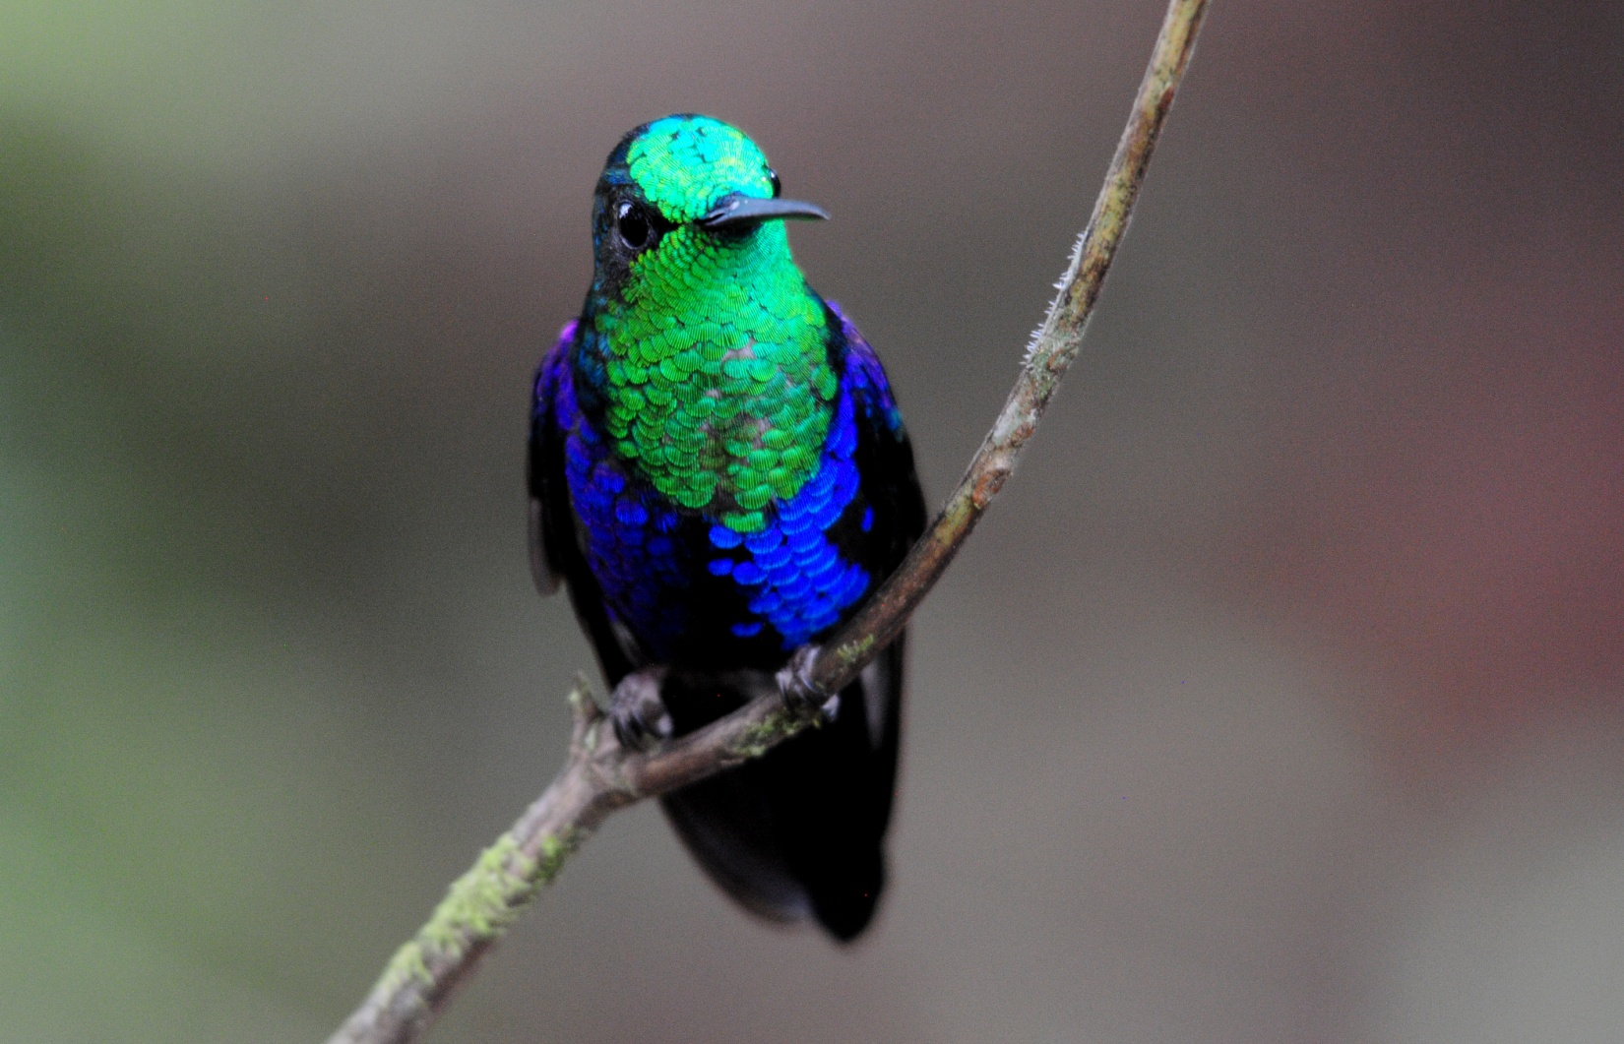
Green-crowned Woodnymph
Rosanne checked and re-checked to make sure the food she ordered wouldn’t have onions in it. They served her a different soup and told her the Pineapple-Coconut Chicken she ordered was onion-free. Famous last words. After eating, we went back to Milpe to visit the gift shop, just a 10-minute drive. By the time we got there, Rosanne was ill.

We checked into Ayalir at around 4:00 PM. Poor Charlie’s luck was just not good today. He had given a helper at Sachatamia a black trash bag filled with shoes and fleeces to take to the bus with the other luggage. He told the young man what was inside, but with the language barrier, the message apparently didn’t get through. The bag with his belongings didn’t make it to Ayalir with the rest of our things, so once again Galo had to call Sachatamia and ask them for a favor - please look for the bag. We feared it had been put in the trash and hoped that the trash had not yet been collected.

After getting everyone settled, some of us decided to rest until 6:30 when we would do the day’s checklist, others walked around on their own, and a small group of us took a walk to the back of the property to look for birds while Luis took Galo and Marcelo to town to get a new jug of water and some other items. We found Masked Water-Tyrant in the first field as we walked away from the hotel. Variable Seedeaters were seen multiple times as we walked along the dirt road. Pacific Horneros seemed to be common, and Rosanne found a Hornero nest just off the deck before we left. Some parakeets flew by and we saw where they went in to a tall tree to land but couldn’t find the birds in the distance. The call they gave was unlike the calls we heard from other parrots we’ve seen. Later, another flock of parrots flew in, larger and louder, with a more familiar sound. This group we found, but I hadn’t asked Galo to leave a scope, so our only way of identifying them was to take some really poor photos and zoom in. I couldn’t tell they were Bronze-winged Parrots until I had my camera inside the room where lighting allowed me to see the diagnostic color on the wing. A Black-cheeked Woodpecker landed on a long stalk at the top of a palm tree. A group of four Buff-throated Saltators played at the bottom of a bush behind the buildings and we backtracked a bit to try to photograph them. A Band-backed Wren made it very difficult for everyone to see it, but we worked hard and managed to get everyone on the bird. A short distance farther down the trail, the Wren landed in the open at the top of a tree at eye level. As we walked down hill, I could hear soft parrot sounds, the kind they make when they’re feeding rather than calling to each other. Rosanne and I approached the tree and found a parakeet above us. Red on the face, white beak, red in front of

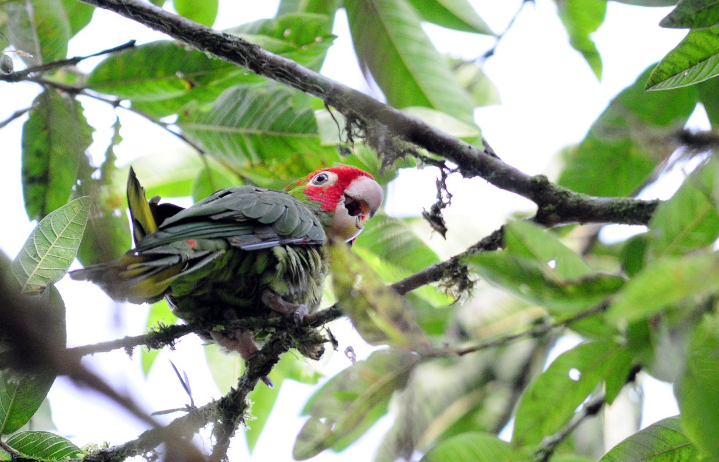
Red-masked Parakeet

the wing – we were making note of all the field marks we could see. It turned and faced away from us so that when the others joined us, all they could see was parakeet butt. I mimicked the sound (very badly) and the bird turned and looked down at us. We went through all the field marks again and then consulted the field guide that Lance was carrying – Red-masked Parakeet! It was probably a juvenile because the red on its head wasn’t fully developed, and it seemed to be calling like a fledgling that wants a parent to come feed it. The book noted that this species is rare, so we consulted the guides when we did the checklist. Marcelo suggested it might be an escaped pet, but when I told him we had seen and heard the flock before we saw this single bird, he agreed that our ID was correct. At about 5:30 it started to rain lightly and we could hear some thunder, so I said we should turn back before it opened up on us. We noted a Social Flycatcher on the way back and got in our rooms before the rain got too heavy.

When we went to the pool house at 6:30 to do the checklist, it wasn’t raining, but we took our umbrellas because the sky looked threatening. We worked quickly because light was fading and the mosquitoes were hungry. Our count was the best so far – 86 for the day with nearly half of them new for the trip. Our four days of birding had yielded us 187 species seen, 18 heard, and 2 seen by the guides only. When we finished the list, we crossed over to the dining room in a gentle shower, but within a few minutes it was raining so hard that we couldn’t hear each other talk at the dinner table. By the time I excused myself to go back to the room to download photos while the others were still eating dessert, the torrential rain had turned the sidewalk into a stream. I rushed across the road under an umbrella that was doing little to keep me dry, trying unsuccessfully to avoid the little rivers that ran across the driveway. The steps leading down to the parking lot looked like a rushing waterfall. The water was so deep on the sidewalk that I took the dirt paths that cross through the middle of the garden instead. By the time I reached my room, the back side of my shirt and pants looked as if they had been dunked in a swimming pool and the mud that had been on my waterproof shoes had been washed away. Jim came to the room shortly after I got back, carrying his socks and pants legs so they wouldn’t get soaked. Luckily, he had put sandals on before dinner for comfort, but they came in really handy for walking through the temporary streams as he came back to the room. I wondered if everyone else made it back to their rooms without a serious incident.

As I finished backing up the photos I had downloaded onto an external hard drive, I started to feel funny. My throat was scratchy, as if I had a piece of the dry turkey we had for dinner stuck there. My eyes itched as if I had been in contact with an allergen, and I felt slightly dizzy. I gave the command for the downloading to begin, covered the screen with the computer sleeve to block the light and climbed into bed.

Day 6, Thursday, February 16: SILANCHE RESERVE, AYALIR HOSTERIA
I woke to a 4:20 alarm to be ready for breakfast at 5:00. We were going to Silanche, and if you want to bird from the tower, you have to arrive earlier than other birding groups. I had awakened in the night with a sore throat that felt much worse now. As soon as I sat up in bed, the room started spinning. I stumbled like a drunk into the bathroom to get ready to go but quickly returned to the bed. I tried a couple more times to get up, but each time the dizziness drove me back to bed. There would be no birding for me today. This was very disappointing to me because I love birding at Silanche. The tower provides an opportunity to see the canopy species well, and it’s a very birdy spot. I asked Jim to bring the medical kit from the bus along with some salt from the dining area when he came back from breakfast. I had no idea what was causing the dizziness, which I’ve never experienced like this, but thought it must have something to do with sinuses. When he got back, I gargled with salt water, took a Sudafed, and returned to bed.

It rained off and on today, but the birding at Silanche was reported to be good for the group. They returned shortly after noon, had lunch at 1:00 and then returned to Silanche at 3:00 to pick up any species they might have missed. It began to rain at the hotel at around 4:00, so I hoped that the weather was different at Silanche. One bird that was seen would have been a lifer for me, Scarlet-browed Tanager. It’s painful to do the bird list when it’s a “birds missed list”. Since I couldn’t participate in today’s activities, I’ll just provide a list of the 30 species that were new for the trip: Plumbeous Kite, Dusky Pigeon, Blue-headed Parrot, Mealy Amazon, Gray-rumped Swift, Purple-chested Hummingbird, Rufous-tailed Jacamar, Orange-fronted Barbet, Red-rumped Woodpecker, Black-striped Woodcreeper, Western Slaty Antshrike, Checker-throated Antwren, Dot-winged Antwren, Scale-crested Pygmy-Tyrant, Black-headed Tody-Flycatcher, Bran-colored Flycatcher, Dusky-capped Flycatcher, Boat-billed Flycatcher, Cinnamon Becard, Masked Tityra, Bay Wren, Purple Honeycreeper, Green Honeycreeper, Yellow-tufted Dacnis, Scarlet-thighed Dacnis, Gray-and-gold Tanager, Thick-billed (Lesser) Seed Finch, Yellow-tailed Oriole, Yellow-bellied Siskin, and the aforementioned Scarlet-browed Tanager. Today’s count was 73, bringing the trip total to 217.

After dinner, we had a small birthday celebration for Jim. Before leaving the dining area, the group was given two options for tomorrow: sleep in and enjoy a leisurely day at the Equator Monument or get up early to revisit Milpe before driving back to Quito. We want to visit the Equator Monument, but it seemed like such a shame to be driving during the best birding hours when we took the leisurely route last time. On the other hand, after so many days of very early wake-ups, a morning of extra rest might be just what we need. The vote was unanimous to leave early and do some birding before heading to Calacali. What a great group!

Day 7, Friday, February 17: MILPE BIRD SANCTUARY, EQUATOR MUSEUM
Reporting for breakfast at 6:00 AM almost felt like sleeping in when compared with our schedule the last few days. Everyone was asked to bring their own luggage to the bus so we wouldn’t have another mix-up like the one with Charlie’s shoes and fleeces a few days ago. I opted out of breakfast, still feeling a bit “off”. It was raining lightly when Jim left for breakfast, and then the rain eased up quite a bit, so I took that window to wheel some suitcases up to the parking lot. I left them under shelter and went back to the room to wait until everyone was ready to load the bus, scheduled for 6:30 with departure at 6:45. With all of the luggage and dodging raindrops, it was closer to 7:00 when we pulled out. Just a few hundred yards down the road we heard the familiar thump thump thump that indicates a flat tire. When Luis pulled over, all of the tires were completely inflated. Apparently, as we exited the parking lot, the bus had picked up a large rock that was now wedged between two of the rear tires. Marcelo and Galo positioned a metal bar under the solidly-wedged rock while Luis slowly moved the bus forward a few inches at a time. It took only a few minutes before Galo stepped into the bus, triumphantly holding the 6-8 inch rock in his hands.

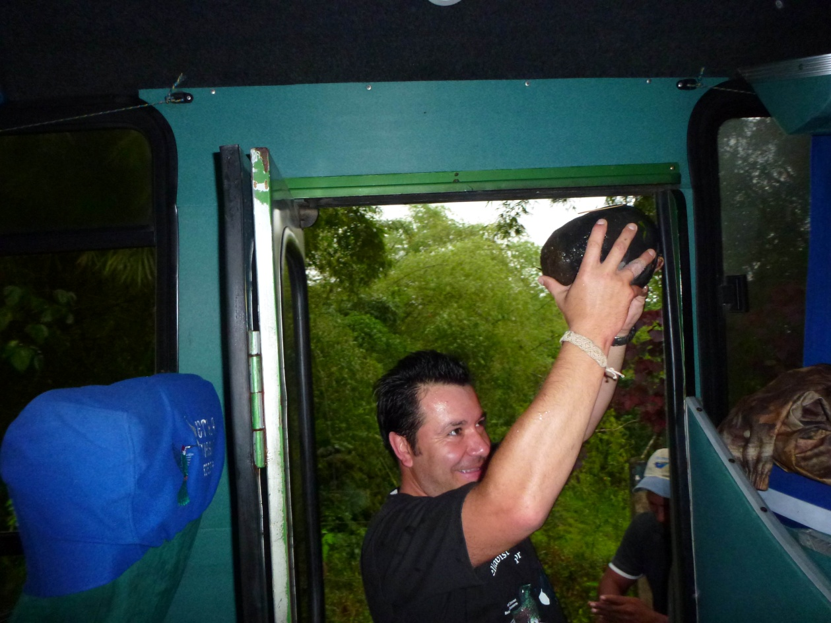
Luckily, the rain stopped shortly after we arrived at Milpe and we were able to get a good couple of hours of birding in before we departed for San Antonio del Pichincha, where we’d visit the Equator Monument. Before everyone was off the bus, Lance spotted a group of five Pale-mandibled Aracaris. Soon after, Rosanne pointed out a Western Wood Pewee. A group of Bronze-winged Parrots flew over and then landed at the top of a tree, allowing for good scope views. Many now-familiar birds appeared in rapid succession: Bay-headed Tanager, Choco Tyrannulet, Silver-throated Tanager, Gray-rumped and White-collared Swifts, Yellow-collared Chlorophonia, Golden-olive Woodpecker, Montane Woodcreeper, White-thighed Swallows, Golden Tanager, Swainson’s Thrush, Flame-faced Tanager. A cooperative Yellow-tufted Dacnis was put in the scope for better views than previously had. I told Galo and Marcelo that I’d like a better view of Rufous-throated Tanager but the first one they found was up high in a tree with very bad backlighting. Luckily, another individual was found and Jim and I were able to observe all the field marks of this life bird, including the one for which it is named. We were observing an immature Green Honeycreeper when Rosanne called out for us to look in the other direction at a bird on the road - Orange-billed Sparrow. Next we found Purple Honeycreeper, first a female and then a male. Galo and Marcelo pointed out the calls of a Barred Forest-Falcon so we took some time to search for it. Unfortunately, only the guides saw it fly out of sight. A Choco Toucan and Pale-billed Aracari were sitting in the same tree so we had both in the same scope view. An immature male Summer Tanager confused us for a moment with red only on its throat. Jim and I fell behind the group for a short while and had two Scarlet-rumped Caciques but they flew out of sight before others could get back to us. Other birds seen along the entrance road to Milpe included White-shouldered Tanager, Roadside Hawk, Ruddy Pigeon, Hook-billed Kite, Tropical Parula, House Wren, Ecuadorian Thrush, Green Thorntail, Slate-throated Grosbeak. Luis turned the bus around in a parking area near the home of the caretaker where some hummingbird feeders produced all of the usual suspects, including White-whiskered Hermit.
A Guayaquil Woodpecker flew in and landed low on a tree on the opposite side of the road and stayed long enough for everyone to get good photos. Even though we were all enjoying this great morning of birding, we knew we needed to board the bus and head east or we wouldn’t have time to enjoy the Equator Museum and Monument. We all settled back and rested as Luis drove us to our next destination.

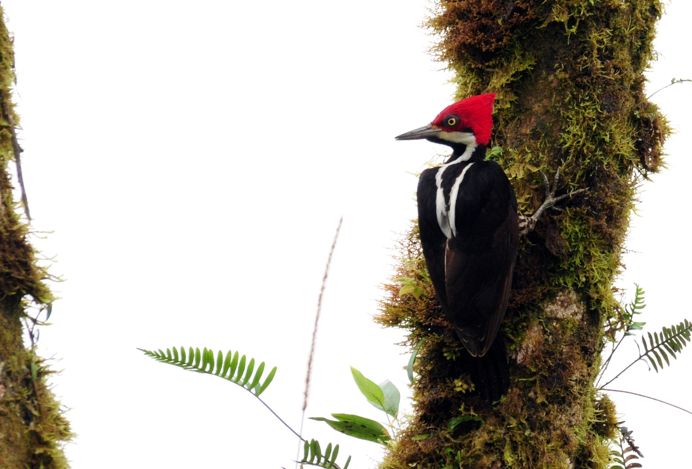
Guayaquil Woodpecker
Our first stop was a lovely restaurant near the museum where we had an excellent meal. Next, we were off to the Equator Museum, the section of the complex that I call the “fun part” because a guide leads you through several exhibits, including one on shrunken heads, one about Amazonian wildlife including the infamous “Penis fish”, and a well-preserved native structure built in 1875. At the end, our guide gave an informative and entertaining presentation about the equator and some of the strange effects that occur when you stand at the middle of the Earth. By moving a pan of water with a drain a mere 10 feet away from the line that marked the Equator, she demonstrated the Coreolis Effect with leaves that swirled counterclockwise when positioned north of the line, clockwise when positioned south of the line, and no swirling at all when directly on the line. She explained how ancient people knew they were at the middle of the Earth, why for 3 minutes you have no shadow on the spring and fall equinoxes, why you are able to balance a raw egg on its end more easily on the Equator, how sun dials work on the Equator, and much more. Peggy’s favorite demonstration involved being able to out-muscle Charlie while standing directly on the Equator. A good time was had by all, and everyone was quite pleased with our one cultural day of the trip. As we loaded the bus to depart, I spotted a brilliant male Vermilion Flycatcher perched at the side of the road.

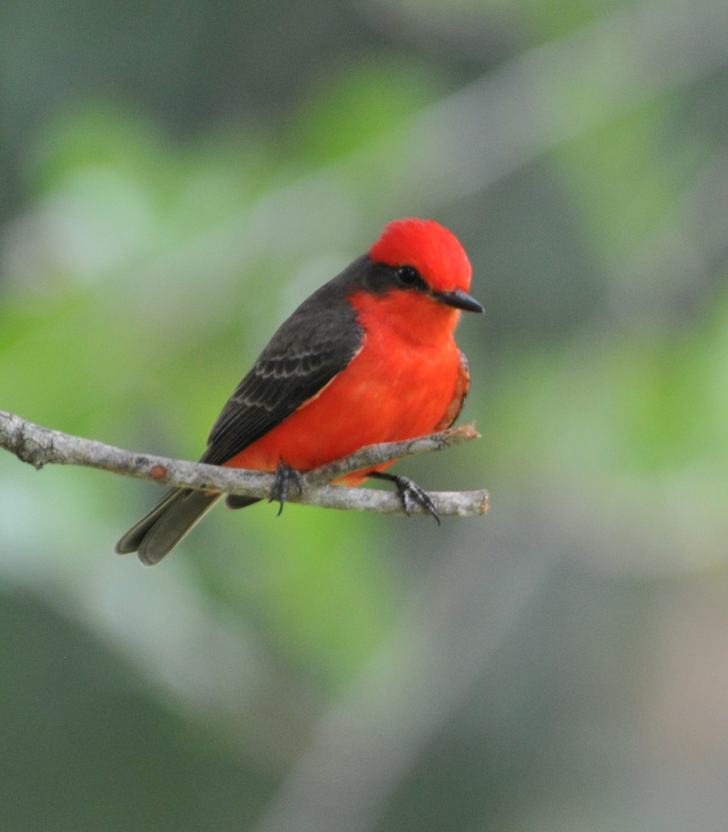
Vermilion Flycatcher (2010)

Galo reminded me that today was the first day of Carnival, and we warned everyone to be aware of people along the side of the road who might throw water at the bus – better to keep your windows closed, or at least protect your camera from a potential drenching. We arrived in Quito unscathed and used a bit of time before dinner to pick up our stored luggage and rearrange things for the next leg of the trip. Our lunch had been so late and so large that I asked that we be allowed to order from the full menu rather than the abbreviated one because I thought many people might want a lighter meal than the three-course options on the shorter menu. Choices ranged from just a milkshake to a salad to a full helping of ribs and all the trimmings, so having more options was great. We completed the list while we waited on our food to be served and retired early so we would be ready for our full day at Antisana the next day. I just hoped that we could sleep well on the first night of Carnival in Quito, where it’s often quite noisy just on an average weekend, much less with all the celebrations going on for the holiday.
We completed the day's list without our fearless leaders and, with everyone helping, we managed to do a reasonably good job of it. We had 65 birds for the day bringing out trip total to 224. And when we checked with Galo the next day to see if we missed any species or made any mistakes, he said our list was accurate. Team work!

Day 8, Saturday, February 18: ANTISANA, TRANSFER TO SAN ISIDRO LODGE
We had breakfast at 5:45 for a 6:30 departure. It was raining when we awoke, and apparently it had been doing so all night, thus explaining the quiet night we enjoyed at the Sebastian. We departed on time in a light rain that stopped for awhile and then started again. Galo suggested that we head straight for the lake because of the rain, and I was hoping that it would be clear enough when we climbed to higher elevation that we would be able to see condors in the sky and have decent views of the volcano. Luckily, things cleared off pretty quickly as we ascended and our first stop was to look for some target species on a hillside, including Tufted Tit-Tyrant and Cinereous Conebill. Still not feeling 100%, I stayed in the bus as the group walked uphill. A trainbearer flew overhead as I watched several Great Thrushes on the hillside. I could hear Marcelo’s voice excitedly giving directions, so I knew one or both of the target species had been found. I slowly made my way toward the group, and saw the Grass Wren they had located. I learned they had Yellow-breasted Brush-Finch, Spectacled Whitestart, and Great Thrushes in addition to the two target species. A Tawny Anpitta and Black-crested Warbler were calling, and eventually we found the Antpitta sitting in a low bush about halfway up the hillside. As we drove on up to the bridge where we often see Ecuadorian Hillstar, some Andean Gulls flew by. We stopped to watch a pair of mating American Kestrels; by the time we drove away, we had also seen Variable Hawk, Black-chested Buzzard-Eagle, Carunculated Caracara, Andean Gull, and Aplomado Falcon.

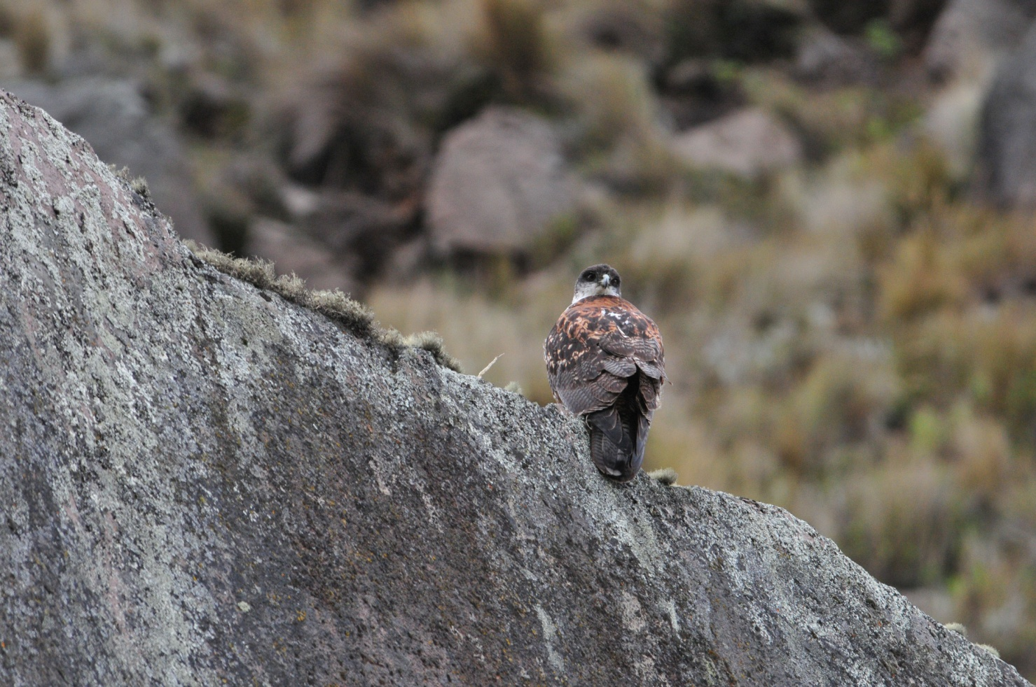
Variable Hawk (2011)

Shortly after we drove away from this productive spot, Luis found our first Andean Condor in the air! Everyone piled out quickly and got good looks at the flying bird, but I didn’t see a lot of white on the back, making me wonder if the bird was an immature or female. With this sighting out of the way, the guides could breathe a little sigh of relief. No one wants to leave Antisana without a condor sighting. Pressure off. As we were starting to get out of the bus near the bridge, Jim asked everyone to stop – he had spotted a Paramo Ground Tyrant and was afraid that by exiting the bus we would scare it away. We all dutifully waited and looked at the bird from the bus before getting out. At the bridge, a female Ecuadorian Hillstar was seen almost immediately, but unfortunately did not return in the time we spent there. Plumbeous Sierra-Finch was found quickly, and as Pat and I were looking for the bird that was singing on the hillside, we found a juvenile Many-striped Canastero sitting in a low bush. Another Tawny Antpitta was seen from the bridge as a group of Brown-backed Chat-Tyrants flew in and out of bushes at eye-level from our vantage point on the bridge. A Bar-winged Cinclodes was seen from the bus, but it swooped away too quickly for photographs. At a regular stop near a deserted thatched-roof dwelling, we found the usuals: Stout-billed and Bar-winged Cinclodes, Plumbeous Sierra Finches, Black-winged Ground-Doves, and Ecuadorian Hillstar (another female – where are the males?).

As we drove away, Marcelo called out loudly – he had spotted a mature male Andean Condor on the ground! Less than 500 feet from the road, the bird looked absolutely enormous. It was feeding on carrion, and we all had time to photograph it on the ground before it flew away. The views as this magnificent creature soared past us as it gained altitude simply could not have been better. The skies had cleared, the light was perfect, and the cameras were smoking. This moment surpassed any sighting we’ve ever had or would have ever expected to have. Birdwatching perfection!

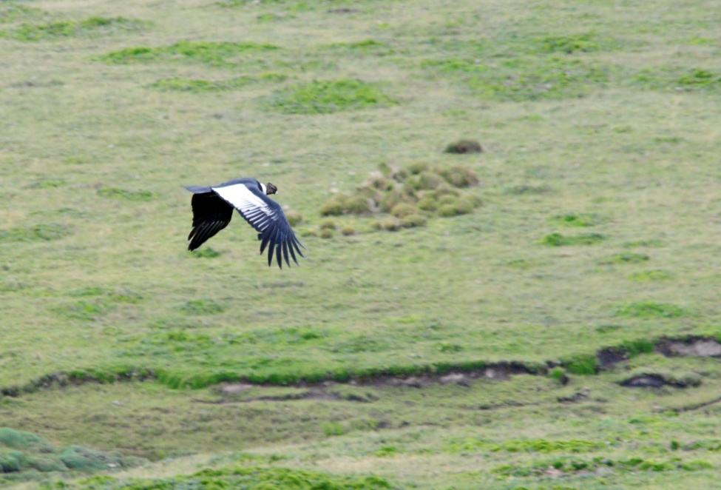
Andean Condor

As we got back in the bus, everyone was giving kudos to Marcelo for this wonderful sighting. We all expressed our admiration for his skills and thanked him profusely. As we drove away, I understood bits of the conversation between Galo and Luis in the front of the bus, Galo grinning the entire time, occasionally saying something louder to Marcelo in the back, who then also giggled. I asked if I was understanding the few words of Spanish that I could pick out to mean that someone other than Marcelo had spotted the bird first. Apparently, Galo and Marcelo had spotted the bird simultaneously, but Marcelo’s verbal alert was so much louder and stronger, that no one realized that Galo had also called out the sighting. He just laughed about it, happy that every one of his clients had enjoyed this incredible sighting. Egotism is not part of Galo’s character, and he didn’t need to receive credit for the sighting to gain satisfaction from it.
Now everyone was on the look-out for the black and white spot on the ground that could prove to be another Andean Condor (birders are never really satisfied, are we?). It wasn’t long before Jim called out “Condor!” In the distance, there was the familiar black and white pattern, and the guides needed to use binoculars to ascertain that it was a “cowdor”. A black and white spotted cow was lying in just the right position that it could easily be mistaken for a condor. Jim took some good-natured ribbing as we drove on. We did enjoy a few more condors in the air before lunch, but no more were seen on the ground.

As we drove through open areas higher up, we noticed the absence of sheep that were once seen grazing in this area, apparently the result of more of the new government regulations designed to restore this high-altitude environment. Here, the Carunculated Caracaras feeding on the ground could be counted in scores. Among them we found some Black-faced Ibis.

When we arrived at the entrance to the lake, Galo had a bit of trouble talking our way through the new red tape involved with allowing the bus to drive through. This lake, along with the historic hacienda where we once enjoyed lunch, has been acquired by the water works which has apparently instigated new rules that strictly limit the number of vehicles that are permitted near the lake. We took advantage of the delay and used the time to use the facilities at the entrance. Stout-billed Cinclodes were very common near the buildings. Galo finally gained access for us, but Luis was not permitted to park the bus at the lake’s edge as in previous trips. Instead, he had to drop the group off and then park a short distance away. We quickly found most of the target species for this lake: Andean Coot, Andean Teal, Silvery Grebe, Andean Ruddy Duck. However, Yellow-billed Pintail was not seen.

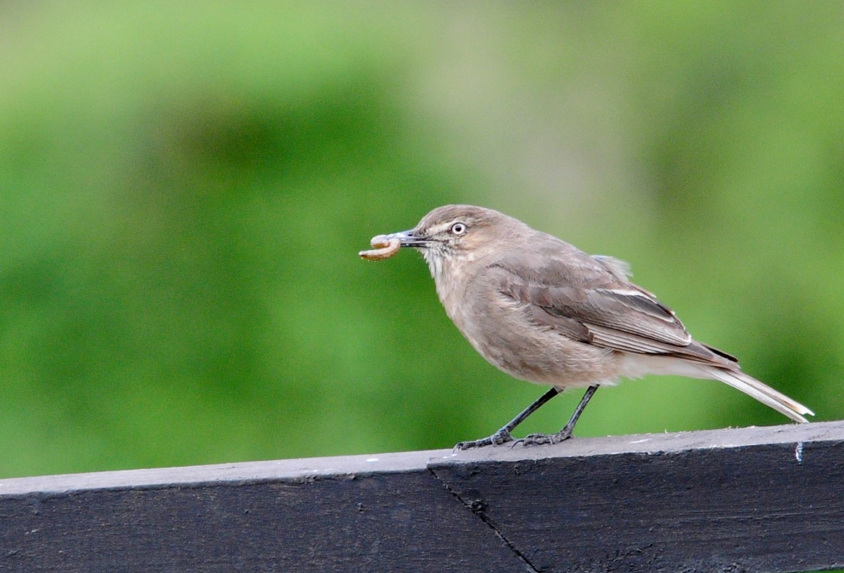
Black-billed Shrike-Tyrant

As we drove away from the lake to make our way to the mountain lodge where we would have lunch, it began to rain lightly. We were already late for our reservation, so we didn’t stop for anything but some Andean Lapwings with a young chick. When we exited the bus at the restaurant, a Black-billed Shrike-Tyrant was seen with a large worm in its beak. Later, as we ate lunch, we observed the bird as it flew to a hanging flower basket on the porch multiple times and delivered meals to fuzzy white chicks. A Giant Hummingbird visited the feeder and then landed on a wire near some playground equipment where everyone could see it clearly. Not a looker, this hummingbird, but a unique bird indeed.

We departed the restaurant at about 2:30 to head for San Isidro, which is supposed to be about three hours away. Our original plans called for us to stay at Guango first, then San Isidro, but we had to reverse the order because of overbooking at the lodges. It was pretty annoying to drive past Guango at 5:00 PM, knowing that if our reservations had been kept for us we would have had at least an hour of daylight left to enjoy the feeders there instead of driving farther to San Isidro, where we would surely arrive late enough that birding would not be an option. We had a short delay in a small town that had blocked off the main road for some kind of soap-box derby as part of their Carnival celebration, so we didn’t arrive at San Isidro until around 6:45. I tried to expedite the process of assigning rooms and asked that Jim and I be put in the nearest cabin. I had started to feel pretty bad at the restaurant and had gotten steadily worse as we quickly descended to this altitude. The ear popping had gone from annoying to painful and now it sounded like I was hearing through a tunnel. I just wanted to climb into bed and try to get warm. As the rest of the group was getting their cabin assignments, they saw Inca Jays.

Everyone got settled in their rooms, had a nice dinner, and completed the day’s checklist after dinner. The resident owl was seen – the famous San Isidro Owl that was once thought to be a new species because it has characteristics of both Black-and-white Owl and Black-banded Owl. It has since been identified as a Black-banded Owl even though that species is not normally present at this elevation. Unfortunately, I missed dinner and the checklist as I laid under two wool blankets and a double layered quilt trying to get warm. We finished the day with just 38 species, but what special species they were! Our trip total now stood at 251.

Day 9, Sunday, February 19: SAN ISIDRO LODGE AND ENVIRONS
Today I spent the entire day under the covers trying to eliminate the chills I was experiencing. The people at San Isidro were very accommodating, bringing a small space heater to warm the area. It rained off and on all day today, keeping the temperature lower than normal for this area. The rest of the group went after breakfast to see the White-bellied Antpitta being fed, but unfortunately the Peruvian Antpitta didn’t come for the worm offering today. ,

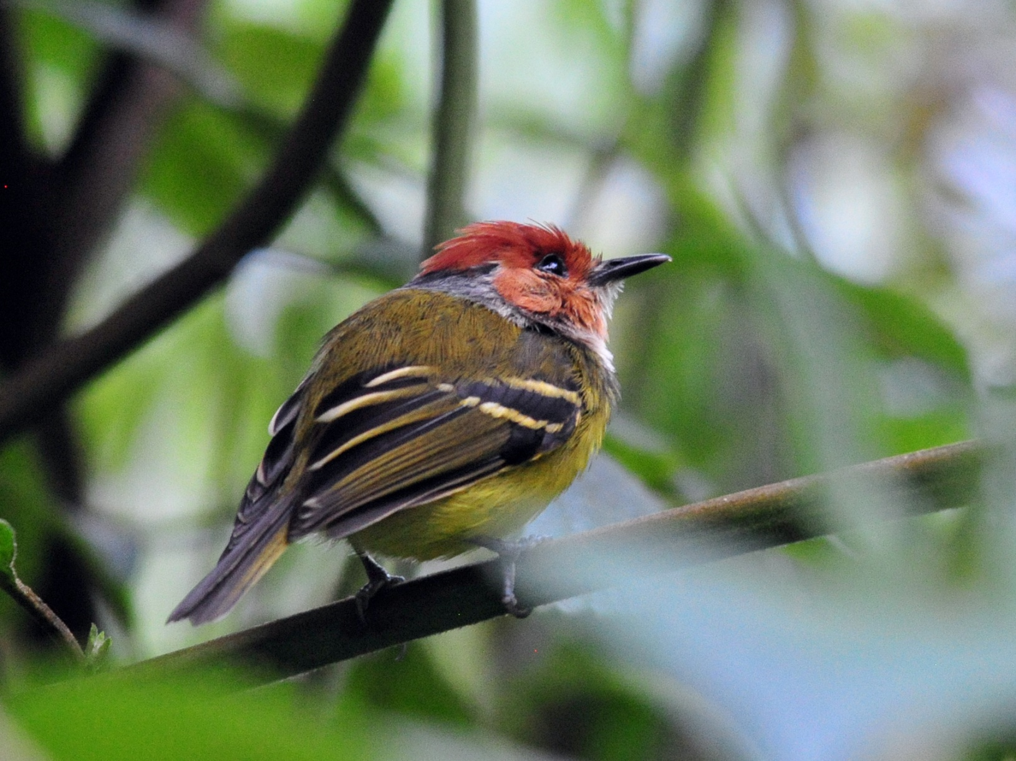
Rufous-crowned Tody-Flycatcher (2011)
They birded on and around San Isidro’s property and found 27 new species for the trip: Rufous-crowned Tody-Flycatcher, Osprey, Broad-winged Hawk, Southern Lapwing, Bronzy Inca, Chestnut-breasted Coronet, Long-tailed Sylph, Crested Quetzal, Masked (Highland) Trogon, Highland Motmot, Emerald Toucanet, Black-billed Mountain-Toucan, Crimson-mantled Woodpecker, Powerful Woodpecker, Whte-bellied Antpitta, Rufous-breasted Flycatcher, Cinnamon Flycatcher, Smoke-colored Pewee, Pale-edged Flycatcher, Black-and-white Warbler, Canada Warbler, Black-crested Warbler, Bluish Flowerpiercer, Saffron-crowned Tanager, Common Bush-Tanager, Black-eared Hemispingus, and Subtropical Cacique. Our trip total stood at 278 at the end of Day 9.

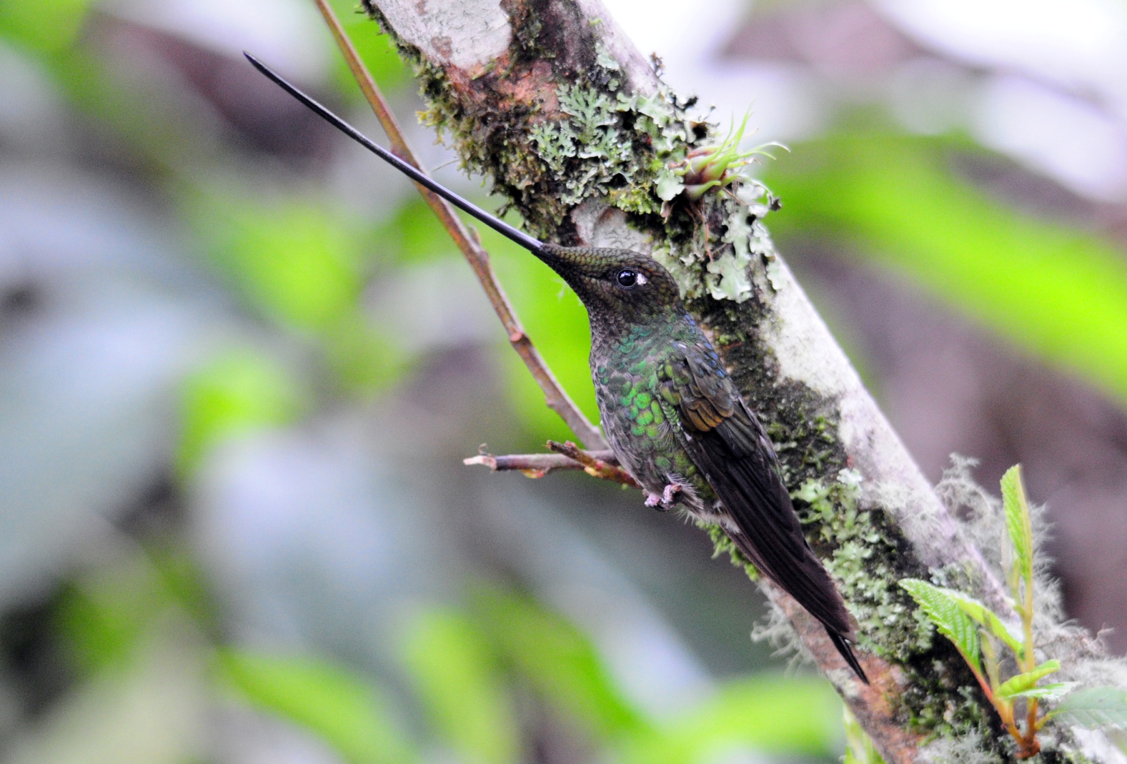
Sword-billed Hummingbird

Jim, Galo and I had a conversation about whether I should see a doctor and discussed the options. Luis was getting a replacement bus for the next day so he could drive his bus to Quito to have some work done on the brakes. I could go with him, visit a clinic, and then rejoin the group when he returned to Guango later the next night. While I was somewhat concerned that the flu-like symptoms could be malaria since I had been exposed several times in the last three or four months, I was starting to feel a little better. I suggested that perhaps if I could just stay at San Isidro and have another day of rest to let this bug, whatever it was, run its course rather than moving on to Guango with the rest of the group, maybe that would be enough to get me up and moving again. Galo made the request and the folks at San Isidro graciously complied. During the night, the chills and fevers returned with a vengeance and by morning I had decided I should visit a doctor. If Luis was going to Quito anyway and I was still a bit concerned because of the severity of the symptoms and the exposure to malaria, it would be best to be tested and be done with it (although I would have much preferred another day of bedrest). Jim and I prepared quickly and were ready to go by the scheduled departure time.

Day 10, Monday, February 20: TRANSFER TO GUANGO LODGE, THERMAS PAPALLACTA
Luis, Jim, Galo and I went to the town of Cumbaya on the outskirts of Quito where Luis dropped us off at a hospital. I had originally thought we could do this without depriving the group of Galo’s services because, surely, a big city hospital would have someone who speaks English. Galo asked for an English-speaking doctor when he checked us in, but I’m afraid we would have been hopeless (and helpless) without Galo. The doctor spoke English kind of like I speak Spanish – long sentences of the native language with a few words of the other language thrown in. It took only five minutes after our arrival for them to take me back to the exam room - quite unlike an ER is the US. There, a female doctor examined me, took blood for tests, administered electrolytes, and after about an hour and a half cleared me with a precaution to eat and drink plenty and “I know you tourista, but you must rest.” The total bill for all the lab work and exams was $82.60 - also quite unlike the US! We took a taxi to a nearby mall where we filled the prescription I was given and had a sandwich before hiring a driver to take us back to Guango. It would be several hours before Luis would be ready to return and we needed to get Galo back to the group. By the time we got to Guango, I was feeling pretty bad again with chills. Our room had not been cleaned because another group had just vacated and I was amazed at how quickly the staff cleaned the room. I climbed into the frigid bed and tried to get warm. After a short time, they came in with a space heater and a bit later Jim brought a hot water bottle (boy, would I have liked to have had that a few hours ago!) By this time, the chills had been replaced with fever. I rested the remainder of the day and evening and thought it best not to expose the others by going to have dinner with them. As Jim was leaving for dinner, I told him I thought I could eat some mashed potatoes if they should have any on the table. He came back a short while later carrying a bowl of mashed potatoes that they had made just for me – this staff is incredible! I admonished Jim a bit for allowing them to go to that much trouble, as that had not been my intent, but I have to admit the warm potatoes made me feel a little better.

While we had been traveling to and from Cumbaya, the group had gone with the substitute driver and Marcelo to Thermas Papallacta. They didn’t stay as long as usual because of the rain, but they did pick up Andean Guan, Shining Sunbeam, Great Sapphirewing, Viridian Metaltail, Andean Tit-Spinetail, White-chinned Thistletail, Red-crested Cotinga, Mountain Wren, Blue-and-black Tanager, Scarlet-bellied and Masked Mountain-Tanagers, Gray-hooded and Black-backed Bush-Tanagers, Pale-naped Brush-Finch, and Northern Mountain Cacique.

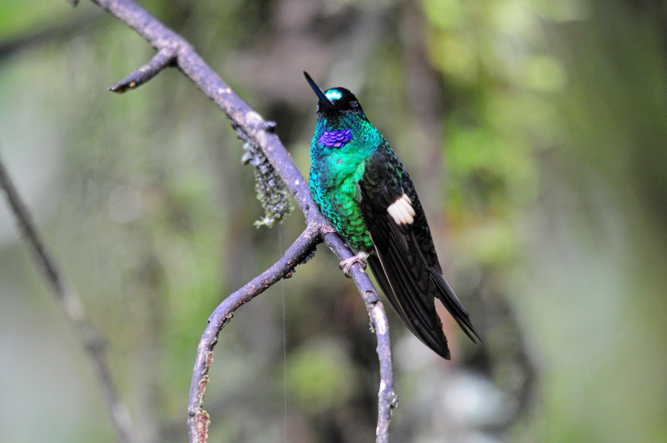
Buff-winged Starfrontlet
After a box lunch, they returned to do some birding around Guango, including a walk to the river to see Torrent Duck and White-capped Dipper (6 of them!) At the feeders at Guango they found Sword-billed Hummingbird, Tourmaline Sunangel, White-bellied Woodstar, Long-tailed Sylph, Chestnut-breasted Coronet, Tyrian Metaltail, Speckled Hummingbird, Mountain Velvetbreast, Collared Inca, Buff-winged Starfrontlet, and Buff-tailed Coronet. Shortly after the bus returned, I could hear excited shouting outside my door – Gray-breasted Mountain-Toucan! I couldn’t drag myself out from under the covers, so I was quite thankful that this stunning bird was not a lifer for me.

The daily count was 45 species, 16 of which were new for the trip, bringing out trip total to 294. What species will our 300th bird be? We must keep track of the 6th new species tomorrow.

Day 11, Tuesday, February 21: ANTENNAS, PAPALLACTA PASS AND LAKE, GUANGO FEEDERS AND GROUNDS, TRANSFER TO WILD SUMACO LODGE
The group got up early and drove with Luis, who had arrived at Guango at about 9:00 PM last night, to the high-elevation antennas near Papallacta that are located at a reliable site for Rufous-bellied Seedsnipe. The weather deteriorated as they made the ascent, and they did not enjoy the spectacular views that are seen on clear days. When they got to the antennas, there were no seedsnipes, but there was snow. The weather was so bad they didn’t even take the time to search for other high elevation species but proceeded to Papallacta Lake instead where the target species Yellow-billed Pintail was found without difficulty.

Back at Guango, I got up at about 8:00 AM and went with Jim to the dining room for some toast and hot chocolate. As we left our cabin we could hear Gray-breasted Wood-wrens singing and saw movement, so we went back inside to get our binoculars. It took just a few minutes for both of us to get good looks at these often-heard, rarely-seen birds. As soon as Jim and I walked through the door of the dining room, Nancy came out to see if we wanted eggs. The leftovers from breakfast were being kept warm for us and they were willing to cook fresh eggs for us as well. These lodges certainly know how to treat their customers! We both declined on the eggs and went back to the room. I was determined to remain upright today, so I put on my warm coat, got my camera and stood at the wall of the shelter near the parking lot where hummingbird feeders provide photographic opportunities. In addition to all the regulars, I was fortunate to see Glowing Puffleg, one of the more rare species at Guango. Periodically I would go back inside the cabin

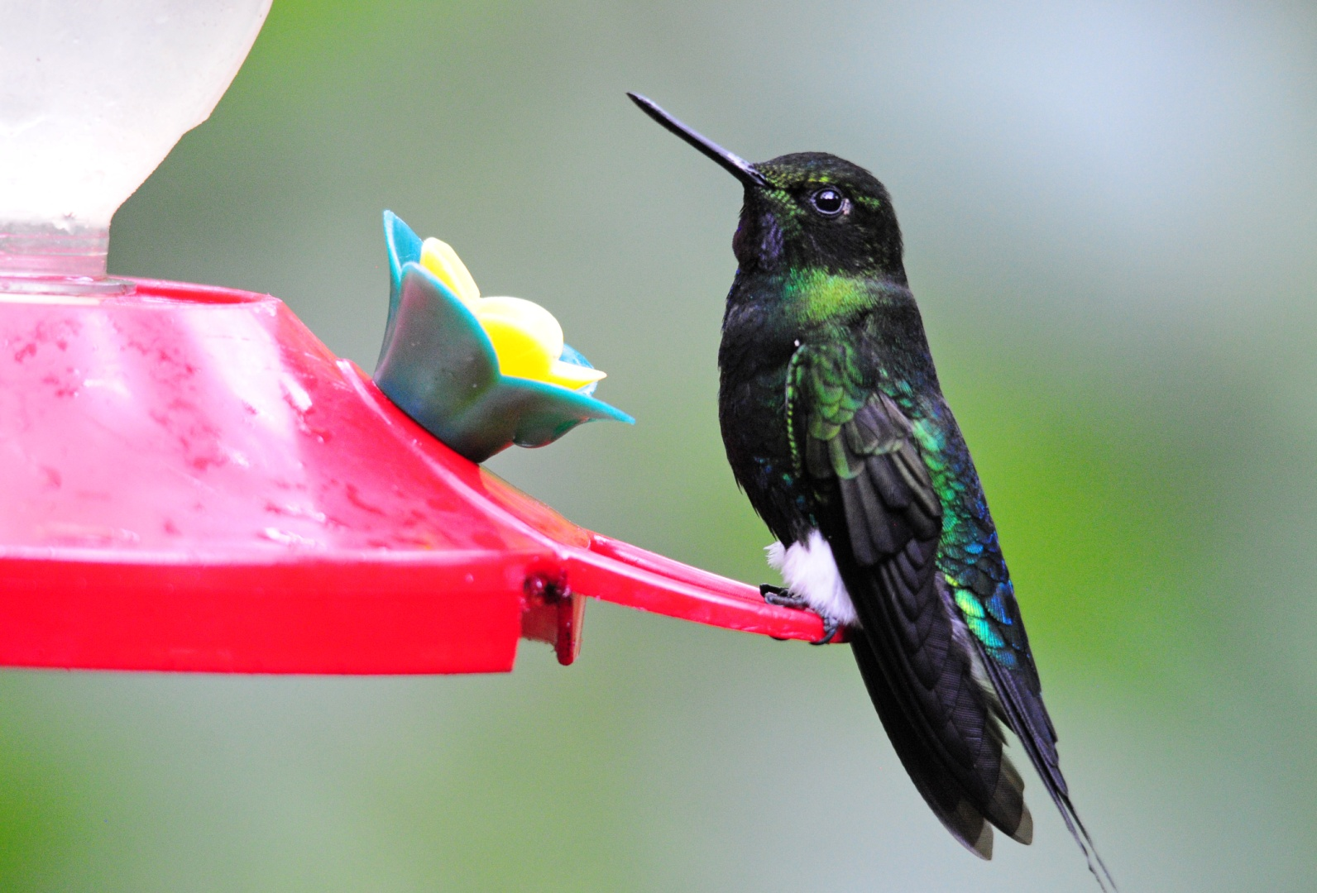
Glowing Puffleg
to warm up near the space heater, but I was beginning to feel like I was recovering. I thought about how fortunate it was that, if someone had to be ill on a trip of this magnitude, it was one of us instead of one of the people who only get to experience this fantastic tour once. I would hate for any of our clients to miss a minute of the fantastic birding that is Ecuador.

The group was back at noon for lunch and then we packed up and headed for Wild Sumaco, again a longer drive than it would have been had our original reservations been honored. With the level of services provided for me while I was sick at both San Isidro and Guango, it was impossible for me to express any displeasure about the reservation system. (But we’ll discuss it before we come back in 2013). On the way to Wild Sumaco, we saw several raptors, including Black Caracara, Orange-bellied Falcon (spotted by our favorite bus driver in the world, Luis), Swallow-tailed Kite, Roadside Hawk, Broad-winged Hawk, and both Turkey and Black Vultures.

We had quite a few new birds from the deck of Wild Sumaco Lodge before it started to rain again, including Speckled Chachalaca, Maroon-tailed Parakeet, Squirrel Cuckoo, Green Hermit, Violet-headed Hummingbird, Wire-crested Thorntail, Gould’s Jewelfront, Black-throated Brilliant, Many-spotted Hummingbird, Fork-tailed Woodnymph, Golden-tailed Sapphire, Violet-fronted Brilliant, the eastern subspecies of Booted Racket-tail wearing its orange boots, Gorgeted Woodstar, and Eastern Wood-Pewee.

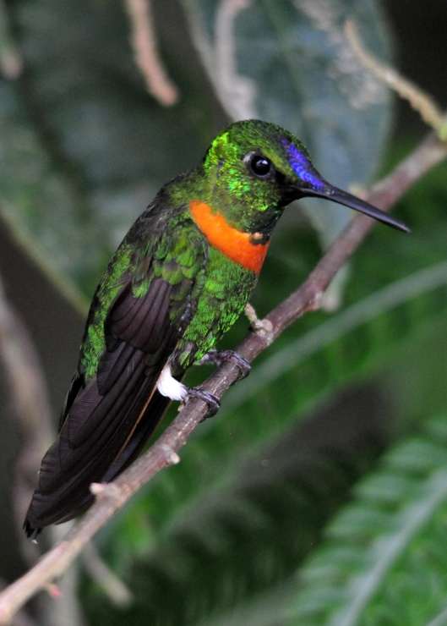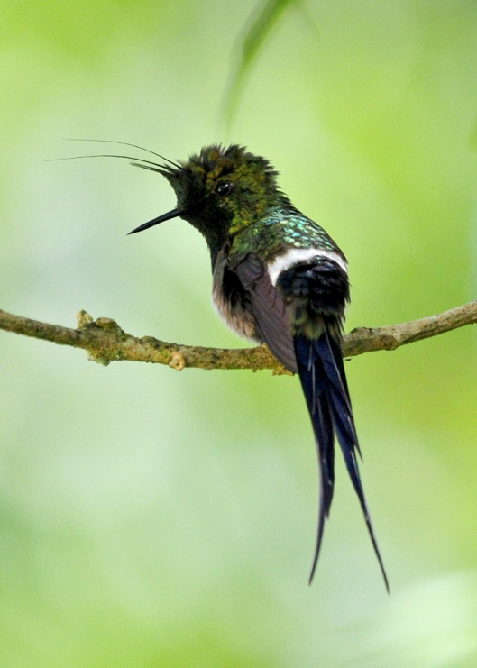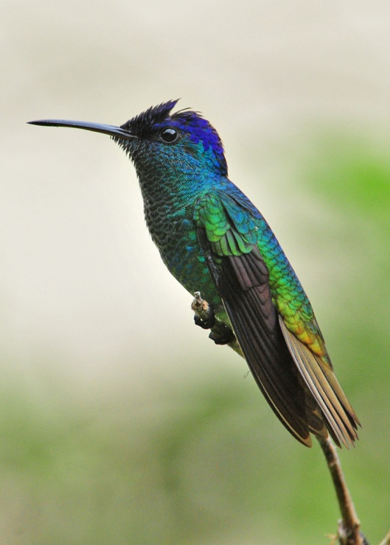
Gould's Jewelfront (2011) Wire-crested Thorntail (2011) Golden-tailed Sapphire (2011)

As we were getting ready for bed, we heard the distinctive call of the Band-bellied Owl and rushed outside in time to see it as Marcelo shined a light on it. Most of the group got on the bird, but Rosanne was in the shower and Terry and Pat didn’t hear it from inside their room on the other side of the lodge. Susan was also unaware that the group was watching an owl, and the bird was gone before we could tell them. We hoped it would make a repeat appearance tomorrow evening.

Since I wasn’t with the group this morning, once more I can’t give details on the day’s experience other than to report the new birds seen: Neotropical Cormorant, Blue-winged Teal, Rufous-breasted Chat-Tyrant (number 300!), Black-billed Thrush, Southern Rough-winged Swallow, Buff-breasted Mountain-Tanager, Magpie Tanager (seen by John and Rosanne from the bus), and Yellow-browed Sparrow.

At dinner, we drew coins from a basket to determine who would go to see the antpittas being fed over the next 3 days. Only two of us could go tomorrow with another group of four guests, five of us and one guide on Thursday, and the remaining five and the other guide would go on our final morning prior to departure. Each group would leave at 7:15 for the 45-minute experience that includes two species of Antpittas being fed, Plain-backed Antpitta and Ochre-breasted Antpitta. I drew one of the dollar coins that indicated I should go tomorrow, but I traded with Charley so he could go with Peggy. The group on Thursday would be Lance and Rosanne, Bob and Georgene, and John along with Marcelo. Galo would go on Friday with Susan, Pat, Terry, Jim and me. This suited me fine since I was still not back to full speed.

Today’s total showed a dramatic improvement over the last three days, although no one was complaining about having
the low-quantity, high-quality days. We finished with 68 species, bringing our trip total to 319. We have two full days of
birding plus the drive to Coca to reach 400 for the main tour. Can we get 81 birds to reach 400 in just 2 full days and one morning?

Day 12, Wednesday, February 22: WILD SUMACO LODGE FEEDERS & ENVIRONS
The plan was for breakfast at 5:45 so we could be at the area around the light post by 6:15. Unfortunately, it had rained all night and continued into the morning, so plans were changed. We started by birding from the deck in a light rain for awhile. From the deck, we quickly spotted two Spotted Tanagers (pun intended) in the tallest Cecropia tree in the center of the valley below the deck, but the light was so poor that field marks and color could be seen only through the scope. Unfortunately, the birds flew immediately after Galo “scoped them out” and no one else got to see the birds through the scope. Blue-naped Chlorophonias landed in the same tree, but again the lighting was so miserable that color and field marks could not be seen. Some Chestnut-fronted Macaws flew by and a Speckled Chachalaca landed in the “main” Cecropia tree. There are several Cecropias in the area, but this tree seems to attract the most birds. Luckily, the light had improved a lot by the time a male and female Golden-collared Aracari landed in the same Cecropia tree. When it was time for Peggy and Charley to leave to view the antpittas, it was barely raining. We cautioned them that the sky could open up on them en route but both were eager to go. With only one pair of shoes after the incident with the shoes in the garbage bag at Sachatamia, they gladly accepted the rubber boots provided by the lodge. After they left, the rain picked up a bit and we hoped they would be successful without being too uncomfortable.

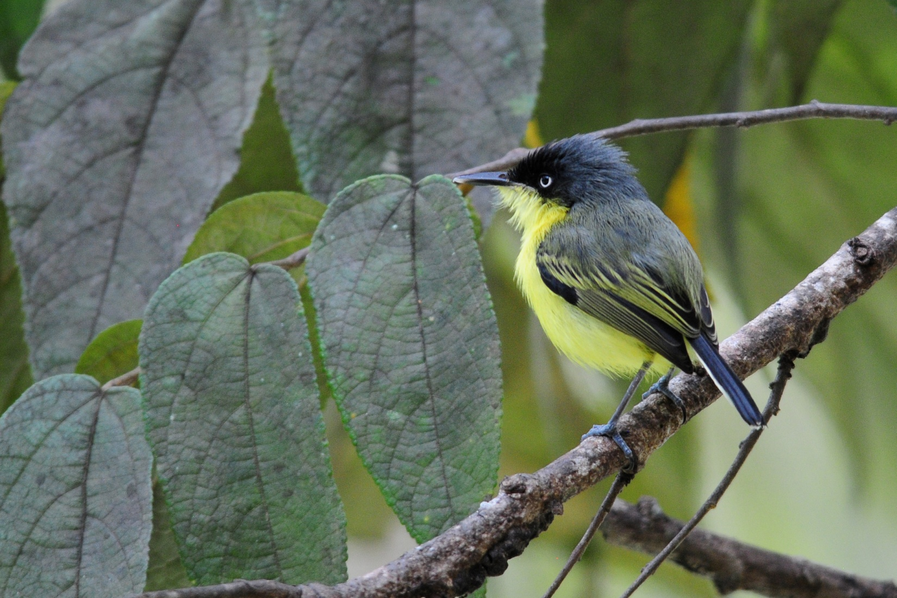
Common Tody-Flycatcher (Panama 2012)
The rain eased up about ten minutes later and I walked down to the light to see if any birds were feeding on the moths there. I could hear bird activity before I even reached the first step. I hurried back to the lodge, opened the door and told Galo and Marcelo that the birds were getting busy on the steps and the guides gathered everyone from the deck to go see what we might find there. We saw Golden-crowned Flycatcher, Dusky-capped Flycatcher, Blackburnian Warbler, Canada Warbler, Common Tody-Flycatcher, Marble-faced Bristle-Tyrant, Montane Foliage-Gleaner, and Black-billed Treehunter before the rain started again and we returned to bird from the shelter of the deck. There, we picked up Swainson’s Thrush, Bananaquit, Grayish Saltator, Red-headed Barbet female, one male and two female Golden-collared Honeycreepers, Blue-necked Tanager, most of them in the same Cecropia. Red-billed Parrots flew over. The Olivaceous Greenlet that had been calling constantly for several minutes responded to Marcelo’s tape and we all got good looks at this tiny paharo. Much to everyone’s delight, the male Red-headed Barbet came to that one wonderful tree and two Gilded Barbets soon joined him.

At around 8:00 AM, we started to walk the road. I hurried to get something in the room and was surprised to see the group already at the gate when I came back out, since there was still some activity around the light post. It was starting to rain again and looked like it might rain hard, so I went to the deck where John had stayed to take photographs. We birded from there and had Tropical Parula and female Silver-beaked Tanager and not much else that was new. We went back to the light post and found just a few birds, most impressively a breeding plumage Canada Warbler and a Yellow-tufted Woodpecker. We decided to go on down the road after I commented that the group was probably getting about 50 new species, and we were moving in that direction when, at about 9:15, Peggy and Charlie returned from their antpitta adventure. They had seen both species but the 45-minute experience that was supposed to include a 15-minute walk had actually taken two hours with a very long walk that involved steep slippery trails. They were wet and tired, but beaming from the experience. We followed them to the deck and quickly found a Squirrel Cuckoo and Channel-billed Toucan. A hawk landed on a snag that we could not identify, so we snapped photos for later identification – White-rumped Hawk juvenile. Thick-billed and Orange-bellied Euphonias landed in the “hot” tree.

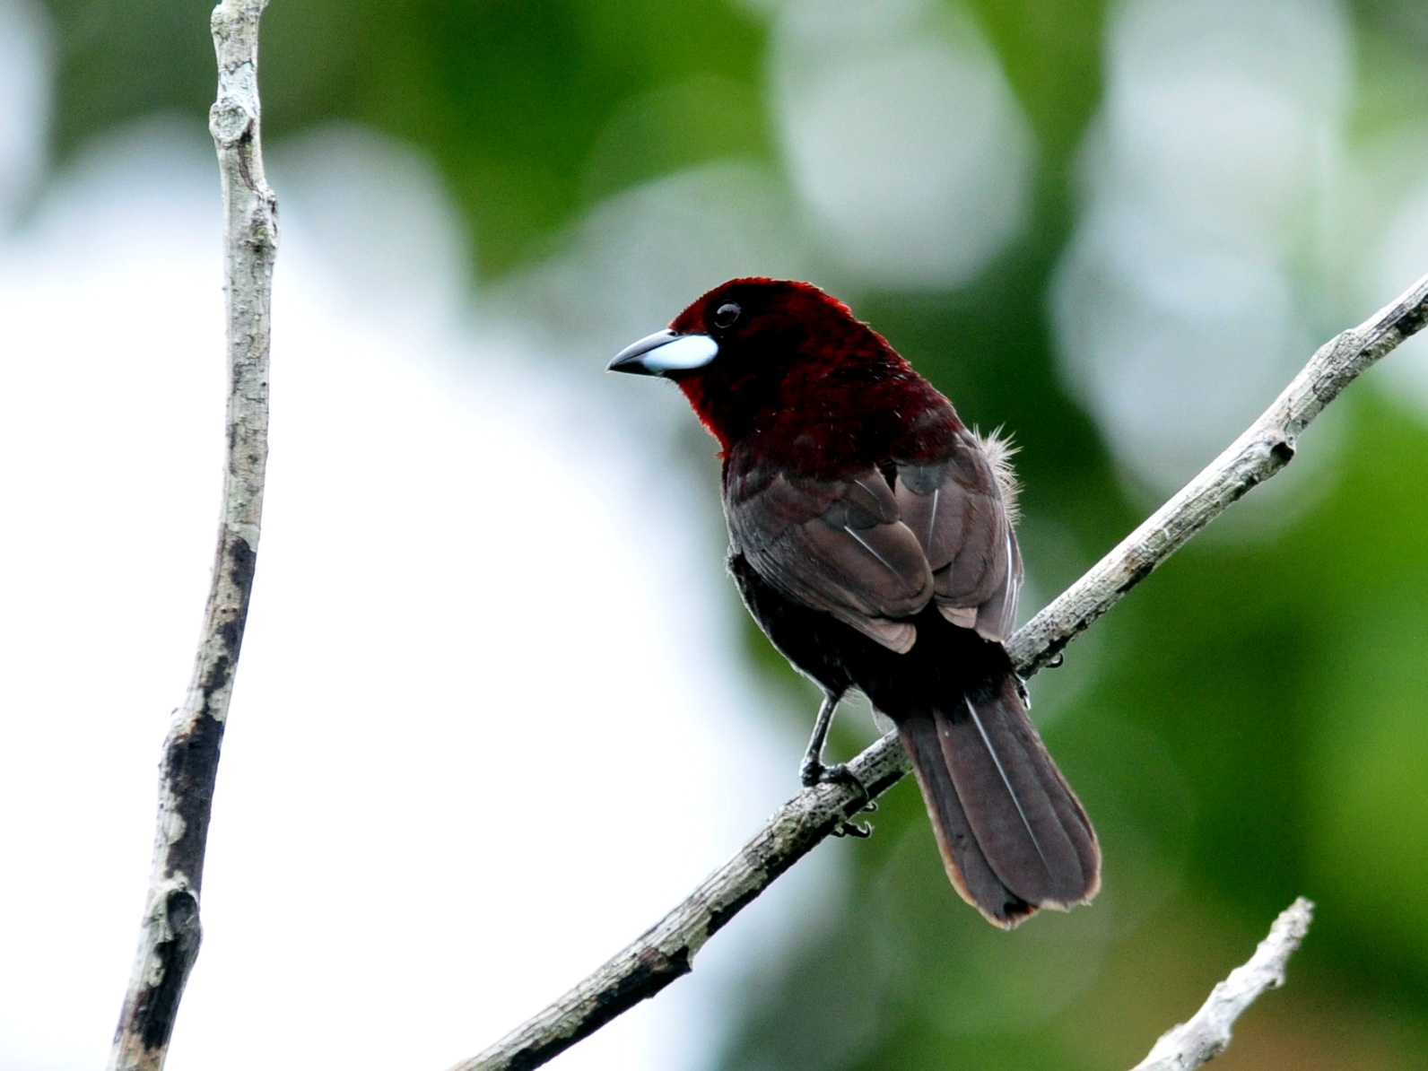
Silver-beaked Tanager (2011)
The others arrived back at about 11:00 AM, very pleased with the morning’s birds. Galo reported Chestnut-tipped Toucanet, Red-billed and Blue-headed Parrots, White-eyed Parakeet, Chestnut-fronted Macaw, Crimson-crested and Yellow-tufted Woodpeckers, Blue-necked, Magpie, Silver-beaked and Paradise Tanagers, Grayish Saltator, Scaled and Dusky Pigeons, Masked Tityra, Tropical Kingbird, House Wren, Red-billed Tyrannulet, Eastern Wood-Pewee, Chestnut-bellied Seedeater, Social Flycatcher, and Roadside Hawk. We birded some more from the deck until lunch. Several Swallow-tailed Kites put on a show, one of them landing on a dead snag in full view. Two Golden-faced Tryannulets chased each other like miniature fighter jets, but no other unusual behavior was noted. During lunch, I spotted a Golden-eared Tanager but it flew before I could get anyone else on the bird. After lunch and a short break we left for more birding at 2:30. John was the last person on the bus, and as he hurried to get in, his camera body fell to the ground. The multiplier he had been using was defective and the camera simply slipped off the lens, which was attached to the tripod. The camera was not damaged, but the cord that he uses to connect the flash to the camera was broken, forcing him to forego using the flash for the rest of the day. Without elevating the flash, it resulted in red-eye on the birds in his photographs.

Luis drove us to the feeding station where we could sit under the shelter of a cabin while watching the birds. When we climbed the stepped trail to the cabin, Susan and I took extra time to make sure neither of us overdid it. Susan had a touchy knee and I was not at full strength. After we reached the cabin and found spots to sit where everyone could see, a long and confusing numbering system for the feeders was explained. Once everyone understood the order – three sections called 1, 2, and 3 with feeders labeled A, B, or C within each section – Marcelo immediately began using the system we had used in November, which was three sections labeled A, B, and C with feeders numbered 1, 2, 3. We all got a big kick out of the whole system (Who’s on first?) and finally agreed to just call the feeders 1 – 7. The lighting is always poor here in the shady forest, but today it was particularly bad.

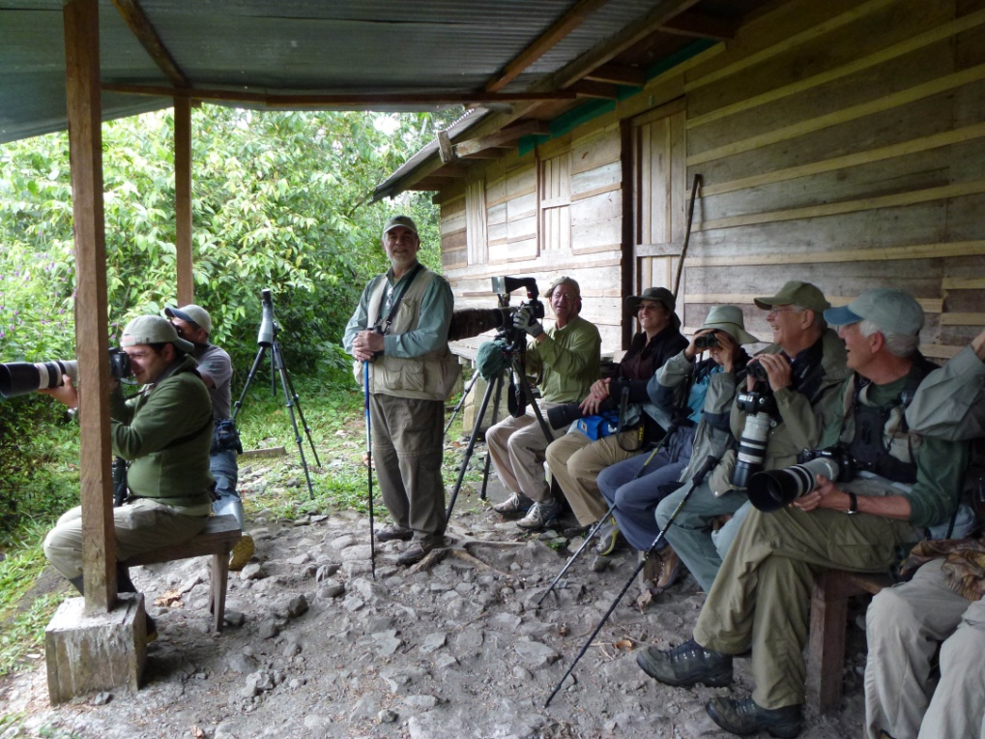
Shelter at second set of feeders, Wild Sumaco

It wasn’t long before someone asked me to identify a bird, and when I reached for my binoculars, they were not on my shoulder! Thinking I had left them on the bus, Jim went back down the hill to retrieve them for me, ignoring my protests. He came back up a few minutes later and reported that they were not on the bus. The day had warmed up a bit by the time we were getting ready to go on our afternoon outing, but I had thought it wise to take my raincoat in case it cooled down as it got later (or rainier). I had hurried to put the coat on, put my vest back on top of it, and then put my camera over my shoulder. And left my bins on the bed!

Without optics, it was impossible to identify anything less distinctive than a Racket-tail in this light. Some new hummers were seen here, including Ecuadorian Piedtail, Violet-fronted Brilliant, and Rufous-vented Whitetip. After hearing the name of a life bird called out (the Whitetip), I decided the frustration was too great and walked back down the trail to see if maybe I could at least take some photos in better light by the road. I left my walking stick with Pat, figuring he with his bad knee needed it much more than I, and went back down to the bus. Not much was moving as I walked down the road in one direction and then the other. After awhile Jim appeared and a short while later the group came down to bird along the road. Susan joined Jim and me in the bus and reported that she wouldn’t walk with the group because something had snapped in her knee when she was coming down the hill. She didn’t want anything to interfere with her Napo Wildlife Center trip that was to start in a few days, so she was going to take it easy. Jim said he was going to rest in the bus and offered me the use of his binoculars. Susan had also offered the use of her bins when Galo appeared at the door. I asked him, “What kind of a dumb-@#! leaves to go birding without their binoculars?” He looked down to one side as if he didn’t want to criticize my moronic behavior and then looked up at me and said, “And you the leader.” Smack! He said Luis could drive Susan and me back to the lodge where she could get some ice for her knee and I could retrieve my binoculars. Then Luis would drive me back to the group. We took him up on this offer and the three of us rode back to the lodge. Susan and Jim both went to their respective rooms to rest and I went back to join the group, which was already at the overlook when we caught up with them. This overlook was very good the first time we came here a few years ago, but now it is overgrown with only one narrow muddy path to stand on, making it difficult to allow everyone in a group of our size to find a good vantage point to scan the canopy at eye level, much less the valley below. Unless you are willing to enter the chigger-infested weeds or are at least six feet tall, it’s very difficult to see and very frustrating to try. I didn’t know when we left that we were going to do anything besides the feeders and the road, so I had not sprayed my ankles and legs with insect repellent. I carefully made my way along the path to where the group stood, and they pointed out some Maroon-tailed Parakeets perched at the top of a tree. John was standing in hip-high weeds to get photographs, and all I could see was the little invisible mites that must be crawling up his legs by now. I had to look through weeds to get a view, decided this wasn’t for me, and went back to the bus. When Galo led the group out, I told him to stay as long as he wanted, but I really didn't want to risk getting chiggers. Another new species seen from the overlook was Chestnut-bellied Seedeater.

As the group walked away from the overlook to move toward the “owl spot”, we walked into a small mixed flock: Bananaquit, Bay-headed Tanager, Olive-backed Woodcreeper. Spotted Tanagers, seen only by Marcelo, were quickly becoming a nemesis bird with so many sightings by so few people. The guides heard Amazonian White-tailed Trogon and brought both the male and female closer by playing the call. Rosanne spotted what Galo identified as an Olive-sided Flycatcher hawking insects, but Bob and Georgene thought it was a Pewee instead. As we waited near the spot where we would be likely to find the owls, Marcelo found a White-backed Fire-Eye. It took quite a while for him to get everyone on the bird as it flitted from place to place in the undergrowth, but he finally succeeded. (Life bird!)

Some of us sat on the bus and had a small snack as we waited for "owl o’clock". Finally, Marcelo and Galo said it was time and we followed them a short distance down a path at the side of the road. Marcelo gave everyone positions and instructed us all to stand still and stay quiet, and then Galo began to play the calls of a Band-bellied Owl. It was only a few minutes before we heard the Band-bellied Owl respond, and then we heard a Foothhills Screech-Owl's voice in the mix. We stood in the dark for quite awhile, straining our eyes to see each time Marcelo shined the light in the direction of the sounds. When vocalizations shifted in position and Galo and Marcelo proceeded down the path toward them, Peggy and I turned in the opposite direction and headed back to the bus. None of us had brought our flashlights because when we left we thought we were just going to the lower hummingbird feeders for a short while. After staring into the darkness for so long, I felt quite dizzy again when I started to move. Luckily, Peggy also thought it best to go to the bus when the others proceeded in the darkness and she helped me gain my balance as we walked toward the road. We waited for the group on the bus for several minutes and learned when they returned that neither owl had shown itself.

We learned today that our schedule for the antpitta feedings wasn't going to work. Because there was another group on the boat we would take to Napo Wildlife Center (NWC) on Friday, we needed to leave earlier than previously planned. Galo had learned that the other group would arrive on an early flight and they were complaining about having to wait on us, so NWC had asked us to be at the dock at 10:30 instead of 12:00. To do this, we would need to leave Wild Sumaco by 8:00 AM. Since the antpitta experience was taking so much longer than we originally thought, we needed to make some revisions. At best, the people who would go on Friday would get to see only the Plain-backed Antpitta and then return for departure without trying for the Ochre-breasted Antpitta.

I asked Galo how many were in the other group, and then wanted to know why the needs (actually, desires) of a group of 6 superseded those of a group of 13 paying clients. I had a feeling it had something to do with one of the head guides at NWC who somehow always manages to get the best situation for his group, sometimes at the expense of other groups. (Last year his group boarded a plush boat while our group took the slower boat with wooden bench seats.) Galo asked RhoAnn to call and see if we could back off our departure, if not all the way to noon like originally planned, at least until 11:00 or 11:30. John was the only person not going on the extension, but he didn't need to be at the airport until 11:00 AM for a noon flight. For us to be at the dock at 10:30, we would have to drop John off at the airprt at 10:00, a half an hour before the counter would even open.

While we waited for a response from NWC, we began to consider our options. Our original schedule called for Charlie and Peggy to go with the group of four other guests at the lodge this morning, which they had done (and saw both birds). On Thursday, Bob & Georgene, Lance & Rosanne, John, and Marcelo would go, and on the last day, the day we needed to change, Susan, Pat, Terry, Jim, and I were to go. At this point, neither Susan nor Pat wanted to negotiate the steep muddy trail and Rosanne had expressed reservations about it. I had seen the Ochre-breasted Antpitta on previous trips and knew I would have other opportunities to see the Plain-backed on future trips. The idea of getting sweaty and muddy right before leaving for a full day of travel combined with not feeling all that well made the allure of the Antpitta very weak and I was more than willing to defer the experience to a future trip. Jim also agreed to forego the walk to the Antpittas, but Terry really wanted to see both of them. Luckily, Rosanne decided against going, so Terry was able to move to the spot she vacated on Thursday's outing. We would be able to satisfy everyone and be able to leave at any time on Friday morning. Still, I did not want to depart so early that John would have a longer wait at the airport; plus, we wanted to get some new species before leaving Sachatamia and along the way to Coca, which meant we needed to take it slowly with frequent stops for birds. We finally got word from NWC that 11:30 AM would be early enough.

The rainy day had yielded 82 species of birds, plus 11 subspecies and 12 heard only. With 42 of them new for the trip, our total now stood at 376 + 18 subspecies. Our goal of 400 seemed both impossible and reachable - 39 birds in one full day plus a morning of travel to Coca. We experienced this same dilemma on our last trip, when we needed 13 new species on the final half day of the main tour to reach 400 before we dropped the people who were not going on the extension off at the Coca Airport. We found 11 that morning, and we would have more time to spend birding this time, which meant that if we could find 25-28 species tomorrow (our last full day of birding on the main tour), we had a chance to reach 400 before we went to the Coca Airport on Friday.

Day 13, Thursday, Feb. 23:WILD SUMACO AND ENVIRONS
We had rain most of the morning but the Antpitta group successfully viewed both Plain-backed and Ochre-breasted Antpittas as the birds came out for worms. The rest of us were birding from the deck along with another group of birders, which proved to be too crowded for me so I returned to our room to organize things for tomorrow's departure. Some things, such as warm clothing, dirty clothes, and anything else we wouldn't need at NWC, were to go in the large suitcases for Luis to take back to the Sebastian for storage. We would use two duffle bags to take the items we needed for the Amazon.

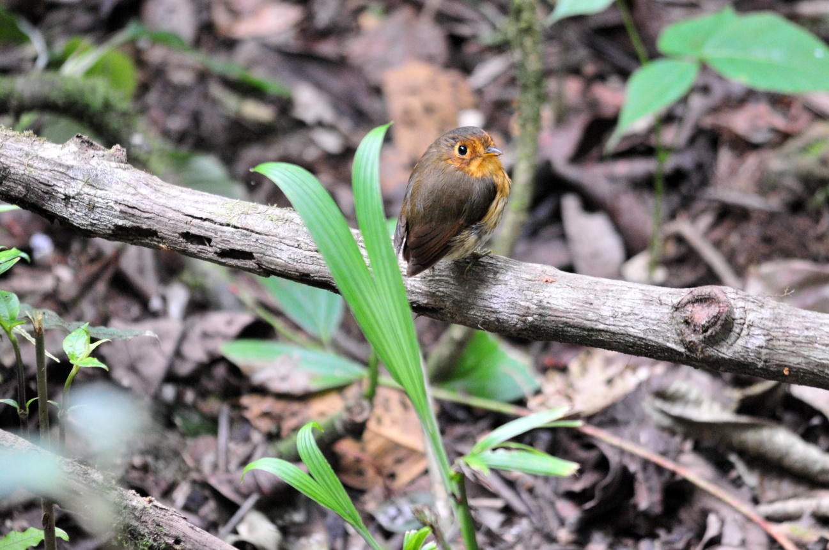
Ochre-breasted Antpitta (2011)

Susan's knee injury kept her from participating today. She kept her knee up and had ice packs on it, hoping that it would feel better before leaving for the Napo extension tomorrow. As a precaution, RhoAnn made some calls and learned that she could get Susan on the flight to Quito with John and then on to Tampa the next day on American Airlines. Susan spent most of the day agonizing over the decision, but finally decided that the wise thing to do was to go home early. The hills at NWC, the 121 steps up to the canopy tower, getting in and out of canoes - all of this made the decision obvious, but it was a very difficult one to make.

We finished the day with just 15 of the 90 species seen being new birds for the trip, bringing our trip total to 376. Getting 24 birds by the time we drop John and Susan off at the airport didn't seem likely to any of us, but we were going to give it a try!

Day 14, Friday, Feb. 24: WILD SUMACO TO COCA TO NAPO WILDLIFE CENTER
We had breakfast at 6:00 AM, after which I was expecting to bird around Wild Sumaco before leaving since we had arranged for an 11:30 AM departure from Coca. But this was an hour earlier than originally planned, so we still had less time than we thought we would have to bird this morning. Galo thought we had a better chance of finding new birds on the drive since we would be going farther east and lower in elevation, so we departed at 6:45 AM.

It had not rained during the night, there was just a light sprinkle as we went to breakfast, and we drove away under cloudy skies with no rain, all of which added to my frustration over our early departure. With all the rain we'd had on this trip, I felt like we should be birding every minute of dry weather. I had checked out the area around the lights as the bus was being loaded and people were gathering their things and found Blackish Antbird, Golden-crowned Flycatcher, Olivaceous Woodcreeper, and Canada Warbler. We had heard but not seen a Lafresney's Piculet here a few days ago, and I was hoping one would show up, but we had to board the bus so I couldn't wait long.

Shortly after turning onto Loreto Road, Susan called out that she had seen a group of birds on the ground. Luis stopped quickly and backed up in time for all of us to see one of the Undulated Tinamous she had spotted. New bird #1. We spotted lots of birds along the way, but most were not new for the trip: Roadside Hawk, Blue-headed Parrot, Swallow Tanager, Palm Tanagers, Chestnut-bellied Seedeater. A Violaceous Jay flew by quickly - New bird #2. Now we had traveled far enough that we were beginning to find some new birds such as Black-capped Donocobius (#3) and Red-breasted Blackbird (#4). Someone spotted a Black-fronted Nunbird (New bird #5) as we were crossing a bridge with a large truck following us, so we had to go on and then put the scope on the bird once we could stop. Here, we also found Yellow-rumped Cacique (#6). Two Yellow-headed Caracaras (#7) came flying toward us down the middle of the road, but only a few people near the front saw them well. A Black Caracara was seen being chased by a Tropical Kingbird. One of the best new birds seen on the drive was the incredibly gorgeous Cream-colored Woodpecker (#8). A Great Kiskadee (#9) was seen at the side of the road. When we arrived in Loreto we stopped at the gas station. There we found Gray-breasted Martin (#10) and enjoyed a better look at a Violaceous Jay. Galo pointed out a Ruddy Ground-Dove (#11) on the wire as we started to drive away, as well as a Swallow-tailed Kite soaring overhead.

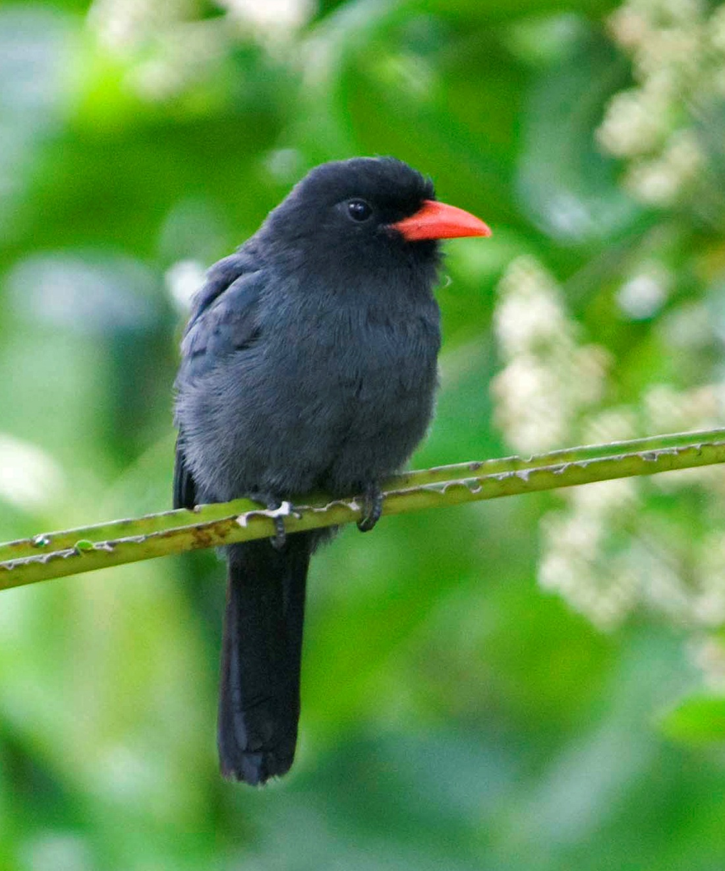
Black-fronted Nunbird (2010)

We arrived in Coca at 9:45, and Galo asked if we should go into town for a bit of shopping and to use the internet since the counter at the airport where John and Susan must check in wouldn't open for another 45 minutes. I could see no use in spending time on the internet since we would have access for the next 5 days at NWC, but I checked with the group to make sure no one wanted to go into town. I told Galo that we would rather go to find some new birds, perhaps a Cattle Tryant, which I knew from previous trips could be found in the area. Luis drove to an area near the river where the group got out to walk to a spot where Marcelo thought a Cattle Tyrant (#12) could be located. They returned about 25 minutes later, mission accomplished. They had also seen an additional new bird, White-winged Swallow - our last new bird of the morning, new bird #13, bringing the group total for the 15-day main tour to 389, just 11 shy of our goal of 400. We drove on to the airport where Marcelo and Galo accompanied John and Susan inside to make sure they got checked in properly. We were at the dock by 10:45, which I'm sure made the other group happy (if not me, but I have to admit that traveling in such poor weather for so many days and not feeling well for most of those days had shortened my temper significantly).

The drive down the Napo River was the most unpleasant I've ever had. We were in the fast boat with the cushy seats, but there was so much weight in the boat that the entire left side was sprayed constantly for the two hours that we sped down the river. We maintained a fast pace and made none of the usual stops for birds. Apparently the people in the other group were not birders, so there was no need to stop. (Sarcasm intended) We arrived at the NWC Bodega in just under two hours, also the fastest trip I've ever made down the Napo. When we arrived, the group that was in such a hurry boarded their canoes and departed for NWC. We took restroom breaks and discussed how we would rotate seats on the canoes before we boarded our canoes and started up the creek toward Napo Wildlife Center.

Just 10 minutes up the Anangu Creek, we saw two Giant River Otters, one with a big fish, the other looking on hopefully. The otter with the fish was a bit larger and had no intention of sharing his treasure with the smaller otter. We sat in silence for quite a few minutes as one otter crunched through the bones of the fish and the other rested its head on a stick in the water. We delighted in the sounds they made, and would have been content to watch longer, but the otters decided to move on.

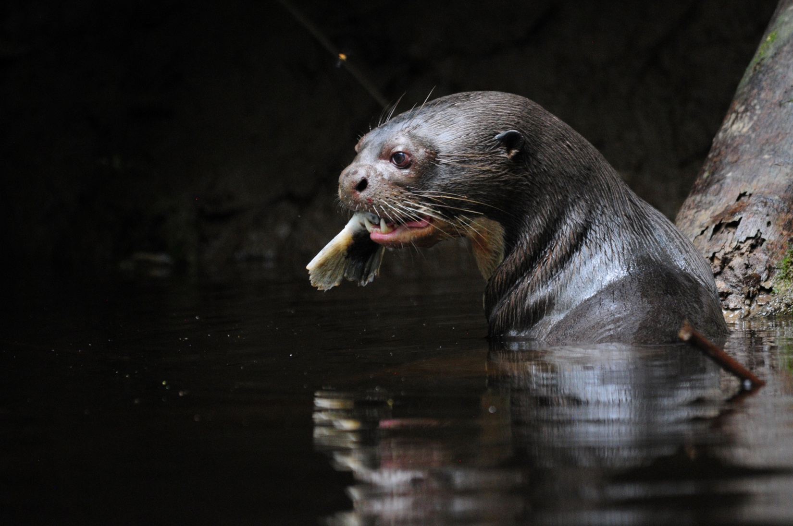
Giant River Otter
As we traveled up the creek, we saw many new species: White-fronted Nunbird, Amazonian White-tailed Trogon, Chestnut Woodpecker, Slate-colored Hawk, Slender-billed Kite, Black Caracara, Lunulated Antbird, all in rapid succession. We saw a Black Caiman stretched out in the water with only its head visible, and we estimated it to be about 13 feet long judging by the size of its snout. Soon, we heard and then saw groups of Greater Anis and Hoatzins, that oddest of birds that we were all eager to see and that the guides considered "trash birds".

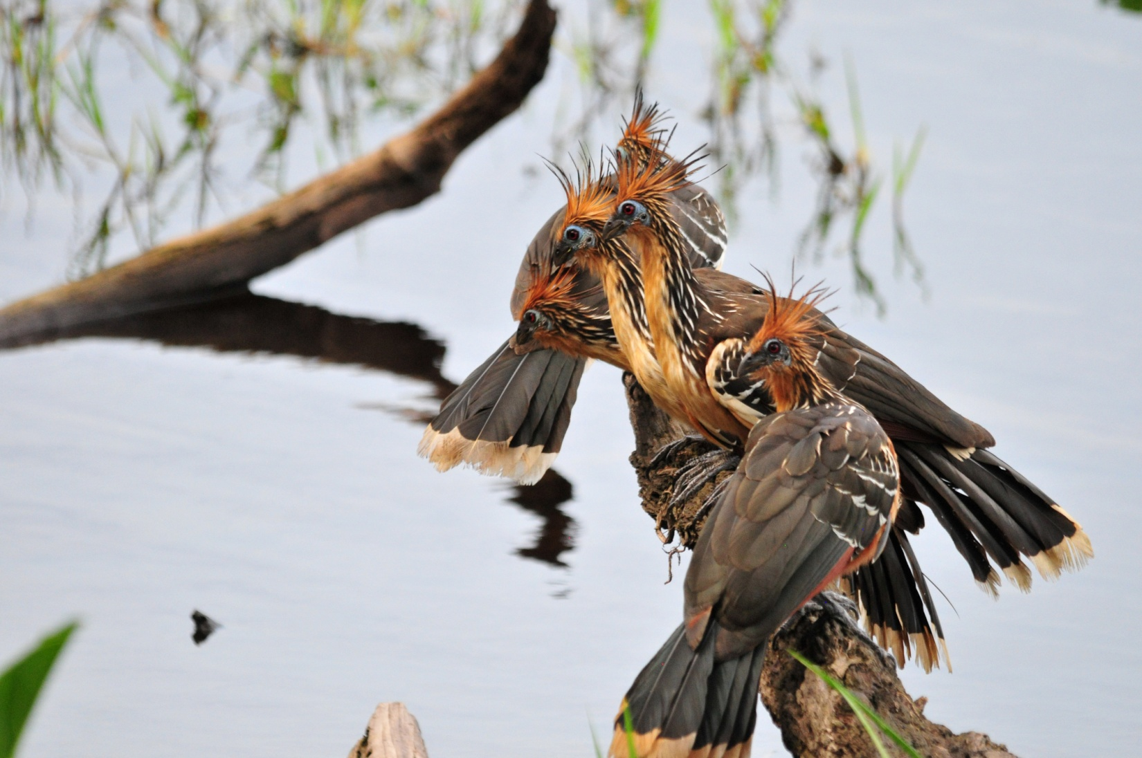
Hoatzins (2011)

This bird is as interesting as it is odd in appearance. Unlike most birds, Hoatzins eat the leaves of plants, and to a lesser degree the fruits and flowers. The Hoatzin’s digestive system is unique among birds in that they use bacterial fermentation in the crop to break down the green leafy materials they consume, much like cattle and other ruminants do in their specialized stomachs. The aromatic chemicals produced by fermentation smell bad – giving the bird its common name "Stinky Turkey", as well as a low ranking on the desirability scale for local native hunters. Another interesting fact about the Hoatzin is that the chicks have claws on their wings. This allows a chick who is threatened by a predator in the nest to jump to safety and then use the claws to climb back into the nest. This is a throw-back to the dinosaurs, and something I've always found very interesting about these birds. And, since the nests are usually built over water, the chicks actually have the ability to swim underwater to avoid predation! How can you not like a creature as unusual as this?! Trash bird, indeed!

Farther along the creek, the guides spotted a Great Tinamou - two tinamous in one day! Ordinarily, I would consider myself fortunate to see two tinamous in an entire birding trip! We continued slowly, stopping each time one of the guides spotted a bird or animal, and our list kept growing: Long-billed Woodcreeper, Green Kingfisher, Cinnamon Attila, White-chinned Jacamar, Capped Heron, Rufescent Tiger-Heron, Anhinga, Ringed Kingfisher, Great Kiskadee, Snail Kite, Amazon Kingfisher. As we approached the dock, an Osprey flew over. Red-capped Cardinals hopped about in the bushes at the water's edge as we approached the dock. Yellow-rumped Caciques nosily greeted each other near their colony of pendulous nests in the trees near the shore. White-winged Swallows swooped over the water and landed on sticks protruding from the lake, allowing for better views of the lovely teal blue in their wings. Other new birds seen between Coca and Napo Wildlife Center included Short-tailed Swift, Dusky-headed Parakeet, Pale-vented Pigeon, Snail Kite, Slender-billed Kite, Great Egret, and Anhinga.

Today was a stellar day, even if every little detail didn't go as planned. The day's count was 68 species, over half of which were new to the trip, bringing the trip total to 413. So now we have a new goal. Can we make it to 500 by the end of the extension?

Day 15, Saturday, Feb. 25 - Day 17, Monday, Feb. 27: NAPO WILDLIFE CENTER
The flu (or whatever it was) that had been keeping me either down or slowed down for most of the trip finally asserted itself on the first day of the extension. I didn't make it to dinner the first night, or any night before we departed. Chills and fever, nausea - you've all been there some time in your life, so you have an idea of how I was feeling. I crashed in the cabana the entire time and did not go on a single birding outing or to a single meal until departure day. Because I missed all of the action, I'll just give a summary of the events of those four days.

The group went out in canoes most mornings, returned to the lodge (or Bodega) at midday for lunch and a break, and then went back out for a second birding outing in the afternoon. They went twice to the 120-foot tower that is built into a towering Ceiba tree, walked the Tiputini Trail in search of some specialty birds, visited the famous Yasuni National Park Parrot Licks, searched for endemics on islands of the Napo River, and visited a cultural center run by the Quichua Indians. During one morning of rain, they birded from the tower at the lodge, and they had at least one outing where they birded from canoes around the lake and creeks.

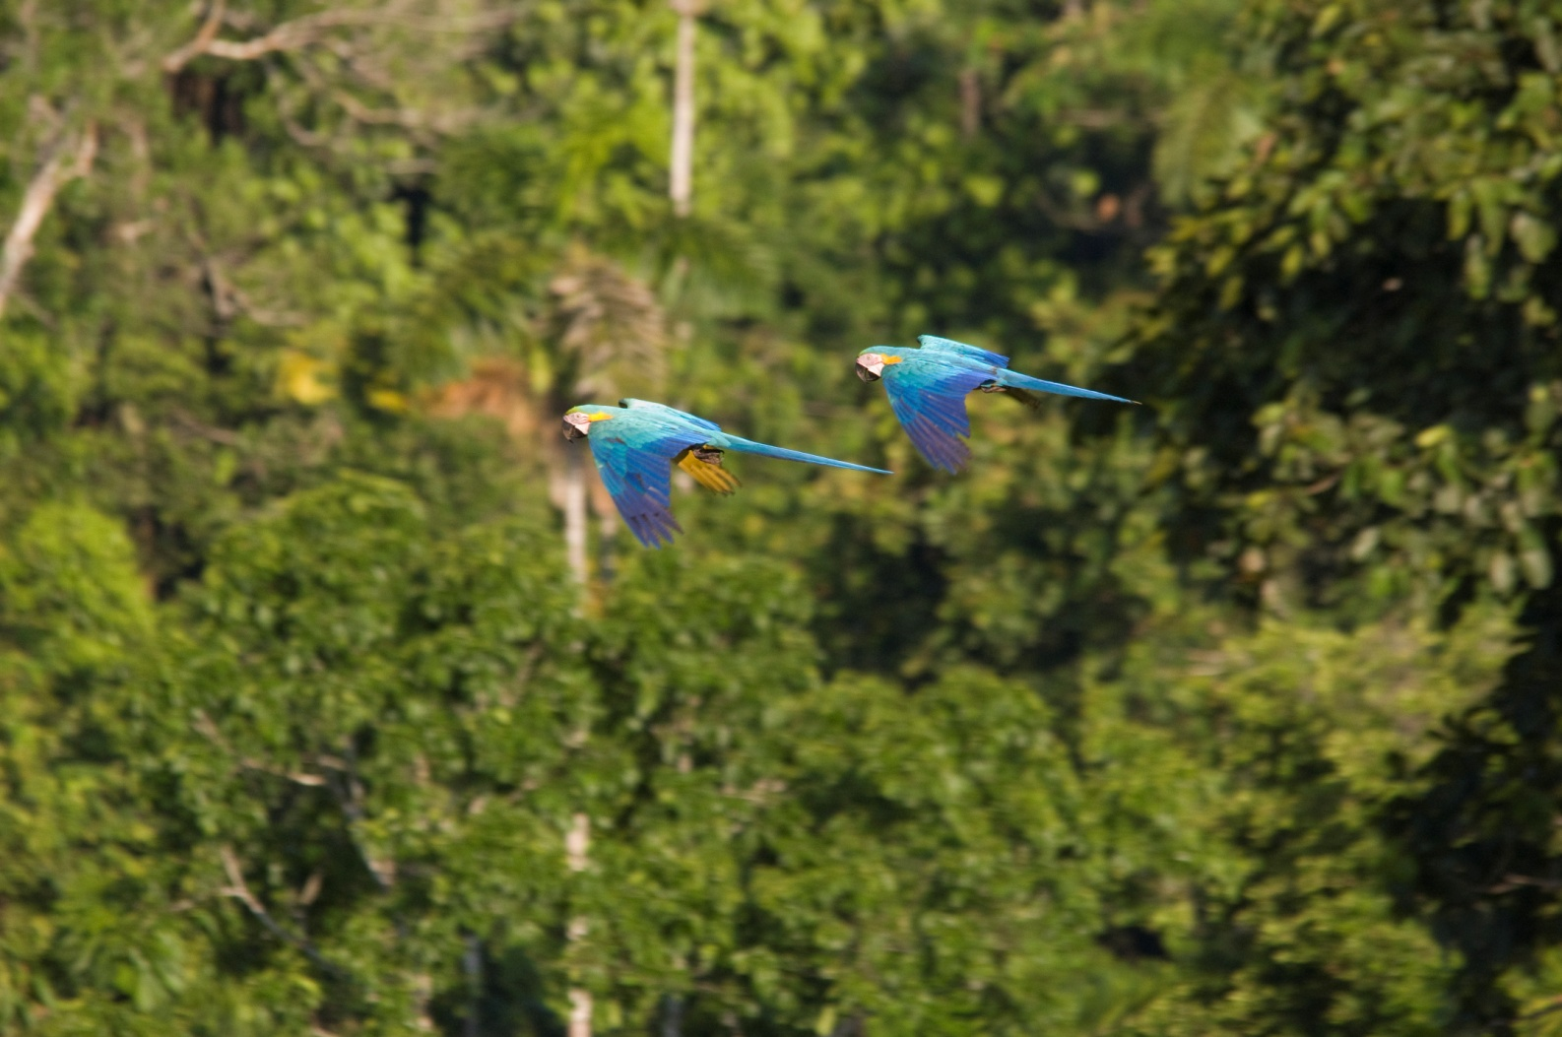
Blue-and-yellow Macaws (2011)

Bird count for Saturday, Feb. 25, when the group went to the tower, was 74. Of that number, 39 were new, bringing the trip total to 452. New species recorded that day: Black-and-white Seedeater, Opal-rumped Tanager, Golden-bellied (White-lored) Euphonia, Black-faced Dacnis, Blackpoll Warbler, Thrush-like Wren, Dwarf Tyrant-Manakin, Wire-tailed Manakin, Bare-necked Fruitcrow, Spangled Cotinga, Plum-throated Cotinga, Black-crowned Tityra, Black-tailed Tityra, Black-capped Becard, Eastern Sirystes, Pygmy Antwren, Dusky-throated Antshrike, Ringed Woodpecker, White-throated Toucan, Ivory-billed Aracari, White-necked Puffbird, Green-and-Rufous Kingfisher, Black-tailed Trogon, Long-billed Starthroat, Orange-winged parrot, Yellow-crowned Parrot, Black-headed Parrot, Red-bellied Macaw, Blue-and-yellow Macaw, Marbled Wood-Quail, Bat Falcon, Laughing Falcon, Red-throated Caracara, Crane Hawk, Double-toothed Kite, Greater Yellow-headed Vulture, Striated Heron, Fork-tailed (Neotropical) Palm-Swift.

Some comments from people who were there:

The Evening of Feb 25th, we stayed until after dark at the canopy tower and called and looked for owls. We arrived back to the canoes and rode back to Napo Wildlife Center in the dark. It was a magical ride back. The frogs and night life were making their sounds, the canoe path down the narrow stream was lit up with thousands of tiny lights from fire-fly larvae along the banks, the skies were lit up with stars but most notable was the crescent moon with bright Jupiter next to it, the lapping of the water on the canoes and the soft paddle of the oars. Everyone commented on it being a most memorable night. (Terry)

The Pygmy Kingfisher. The bird was seen by those in one canoe early the 25th of Feb. Those in the other canoe including myself really wanted to see that bird. Later the same day the Galo and Marcelo made a special effort to locate another Pygmy Kingfisher. They found one! A really nice bird. (Terry)

The most memorable event at Napo(other than the many birds and beauty of the area) was the fun day we climbed the tower twice and the slippery slope we encountered behind the 2nd parrot lick (Pat)

In spite of how great the rest of the trip was, the Napo was the highlight for us. The canoe rides were special, and the evening we came back after dark from the canopy tower, with the night noises and the thousands of lightning bugs lighting up the edge of the water, was simply magical. (Bob)

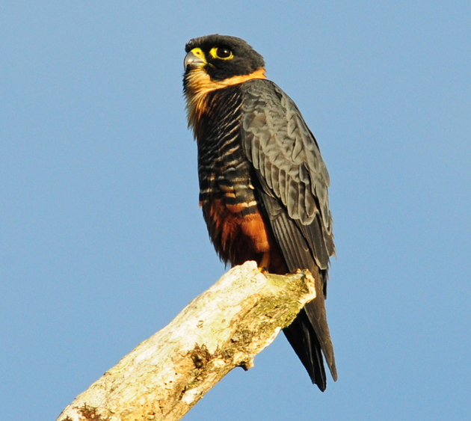
Bat Falcon (Panama 2012)
Bird count for Sunday, Feb. 26, when the group went to the river islands and parrot licks and visited the Quichua cultural center, was 80. Of that number, 37 were new, bringing the trip total to 489. New species recorded that day:
Cocoi Heron, Snowy Egret, Boat-billed Heron, Salvin's Curassow, Wattled Jacana, Greater Yellowlegs, Least Sandpiper, Pied Plover, Collared Plover, Scarlet Macaw, Cobalt-winged Parakeet, Great Potoo, Ladder-tailed Nightjar, Great-billed Hermit, Straight-billed Hermit, Blue-tailed Emerald, Olive-spotted Hummingbird, American Pygmy Kingfisher, White-eared Jacamar, Chestnut-eared Aracari, White-bellied Spinetail, Wedge-billed Woodcreeper, Cinereous Antshrike, Gray Antwren, Spot-winged Anbird, Silvered Antbird, Plumbeous Antbird, River Tyrannulet, Fuscous Flycatcher, Drab Water-Tyrant, Riverside Tyrant, Amazonian Umbrellabird, Golden-headed Manakin, Blue-crowned Manakin, Orange-headed Tanager, Lesson's Seedeater, and Oriole-Blackbird.

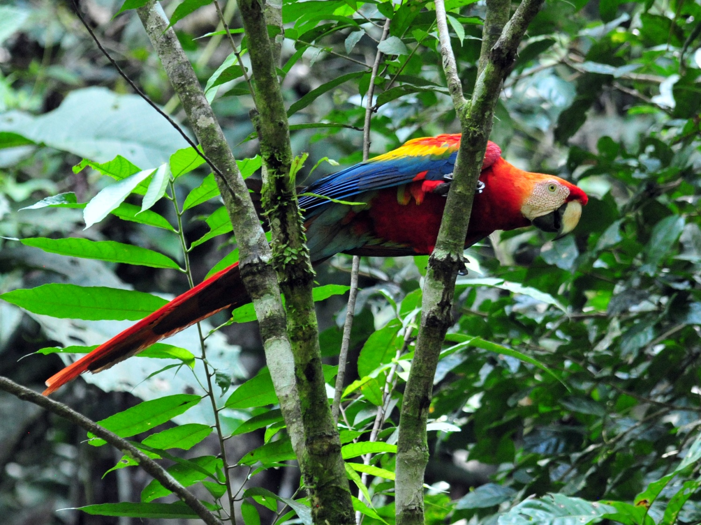
Scarlet Macaw (2011)

Comments from people who were there:
The Parrot clay lick was certainly very interesting. Seeing several dozen parrots clinging to the bank of the Napo River was a highlight. I believe there were at least 3 different species all together on the lick. (Terry)

Bird count for Monday, Feb. 27, when the group went to the Tiputini Trail, was 58. Of that number, 16 were new, bringing the trip total to 505. This trail is difficult to walk with lots of mud and some stream crossings. The primary target here is the Black-necked Red Cotinga, which the group was successful in finding. Other new species for this day included Screaming Piha, Pink-throated Becard, Ochre-bellied Flycatcher, Yellow-crowned Elaenia, Dot-backed Antbird, Warbling Antbird, Buff-throated Woodcreeper, Striped Woodcreeper, Chestnut-capped Puffbird, Great Jacamar, Amazonian Motmot, Rufous-breasted Hermit, Tawny-bellied Screech-Owl, Ruddy Quail-Dove, and Gray-winged Trumpeter.
Some comments from people who were there:
The trip looking for the Black-necked Red-Cotinga. A warm humid morning slogging thru mucky mud. I am sure glad we had our knee-high rubber boots on. My boots were a bit too large and one was sucked off by the mud. Luckily I was able to balance on one foot until Galo pulled my boot out of the mud and handed it to me. A short time later both boots sank in the mud to the very top of the boots. Reaching down to free myself my Swarovski binocs slid off my shoulder into the mud. I handed my binocs to Bob and pulled myself free. Bob told me Swarovskis are water proof so he suggested I take them back to my cabana and rinse them off under the sink faucet. I did and they are just fine. It took us a while to find the Red-Cotinga but after searching around for a while one of the canoe paddlers who training to be a guide found the beautiful bird. Marcelo digiscoped the bird with my little camera. (Terry)

Day 18, Tuesday, February 28: I was still not feeling well and did not relish the thought of traveling all morning and then for 16 hours the next day, but there was really no choice. We reported to the dock before daybreak and began our way down Anangu Creek in the dark. Just after we started down the creek, we paddled into a tree that had fallen and was now lying across our path. Our native guides used their machetes to clear the way for us. As we continued in our canoes to the Napo River to return to Coca and then on to Quito, we added a Limpkin to the list, bringing our grand total to 506. We didn't stop to do a lot of birding on our way down the creek, but we did see several "old" species once the sun came up.

The boat ride back to Coca was uneventful. There, we were taken via bus to the Coca Airport where we boarded our plane for Quito after a wait of about an hour. At the Sebastian Hotel in Quito, we took a few minutes to gather our stored luggage and settle in before meeting in the restaurant for lunch. At 3:30 the group met to walk to the nearby artisan market to shop for souvenirs. I used that time to reorganize and rest. Everyone was pretty enthusiastic about their shopping experience when I asked about it at dinner. We made sure that everyone had the necessary arrangements for getting to the airport tomorrow morning and said our goodbyes. Everyone agreed that, although the weather could have been better, the trip was a smashing success. Friendly people, gorgeous scenery, great food and accommodations, terrific guides, and most of all, incredible birding - we departed Quito with wonderful memories, not to mention a boatload of fantastic photos!

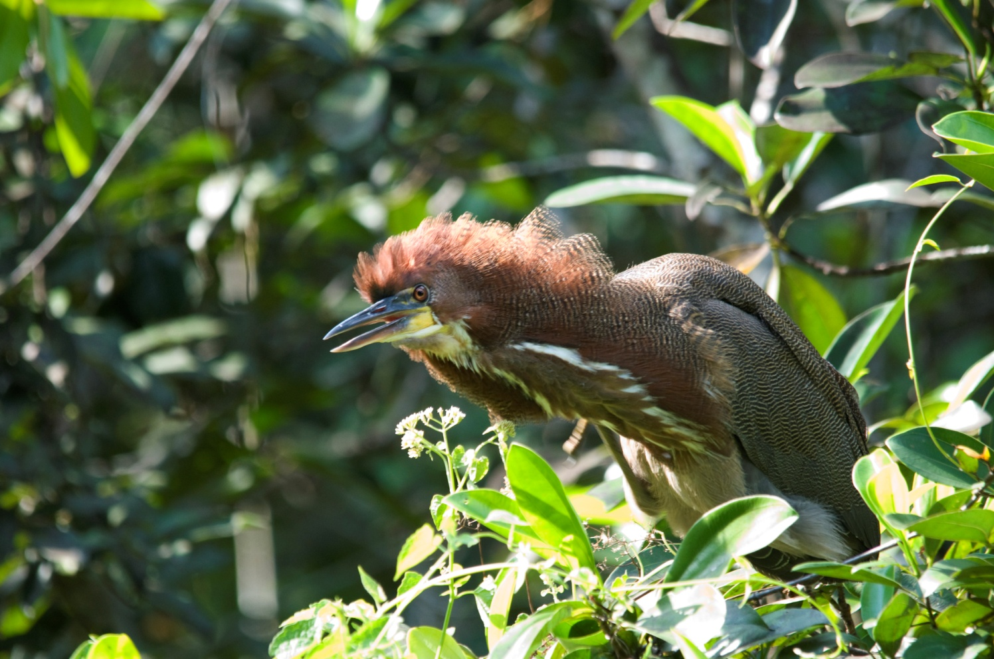
Rufescent Tiger-Heron
Day 19, Wednesday, February 29: Almost everyone got out of Quito without a hitch, but Bob and Georgene ran into a problem. It seems one of the concession trucks had run into their plane and their Continental flight had been cancelled! Georgene was scheduled for eye surgery on March 2, with some preparation scheduled for March 1. Now it appeared that they wouldn't even be able to leave Quito today, so they would not be able to maintain their schedule for the next few days. After waiting in a long line, they were finally put on the same American flight as Charlie, Peggy, Jim, and me, but with no guarantee that there would be a connecting flight to get them home from Miami. In the end, they had to spend the night in Miami that night, but they were able to get all of the preliminaries out of the way after they got home the next day and Georgene was able to have the surgery as planned. She is doing quite well, as is Susan, who had knee surgery when she got home.

Our next trip to Ecuador is planned for November - December 2012. I can't wait to go back!

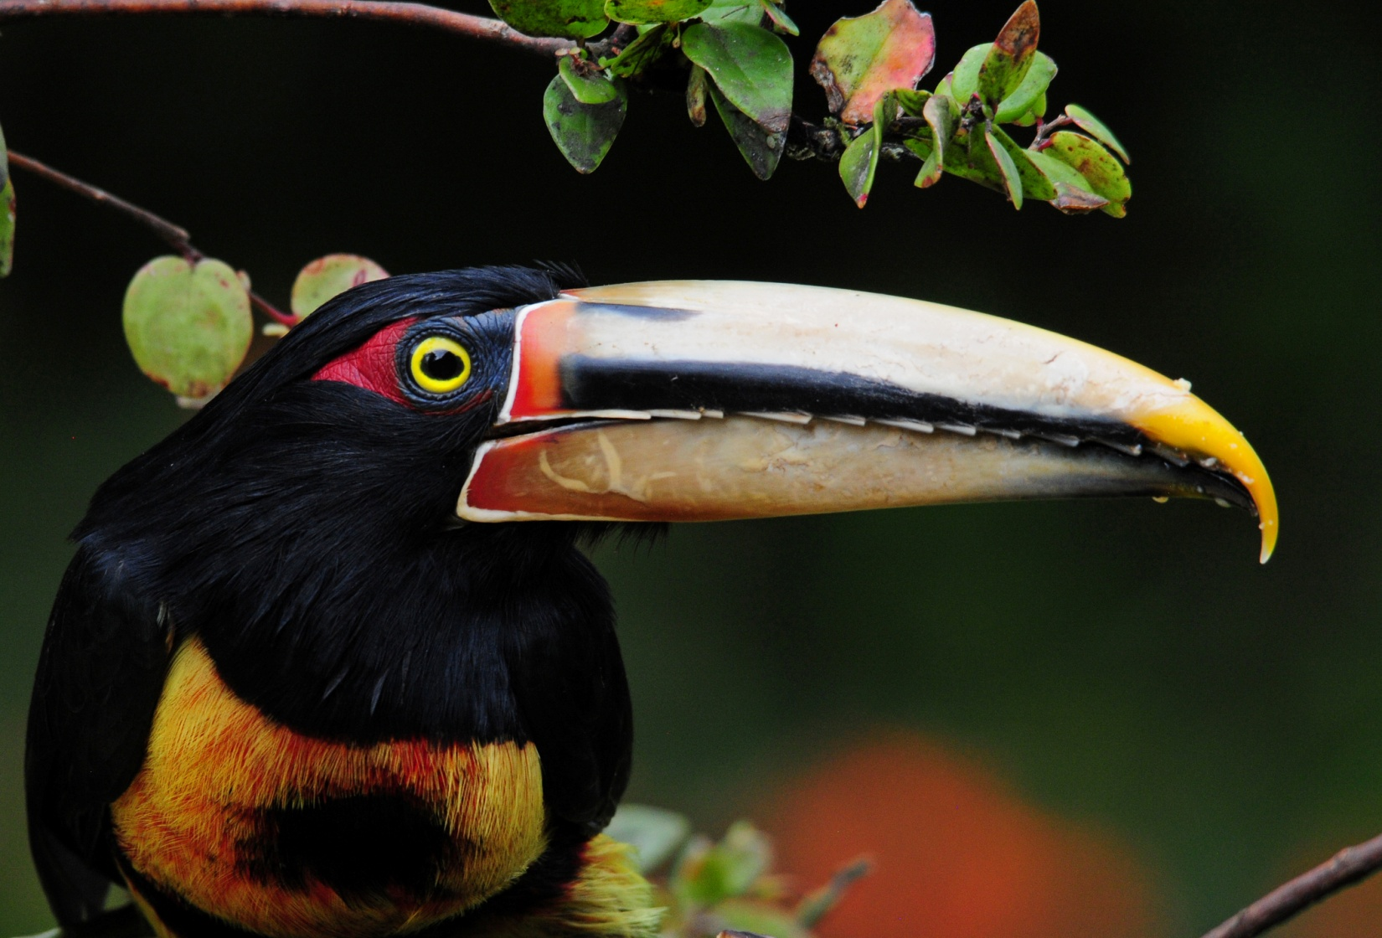
Pale-billed Aracari

www.cheepersbirding.com
cheepers@sbcglobal.net

