HONDURAS
Cerro Azul & Pico Bonito
February 2 - 9, 2013
TRIP REPORT

Disclaimer: This report is as accurate as possible using limited notes and recordings taken in the field; any errors regarding species seen at specific sites are unintentional. Species are often listed only on the day they were first seen unless the subsequent sighting involves something significant. All photos are by the author, Cindy Beckman.

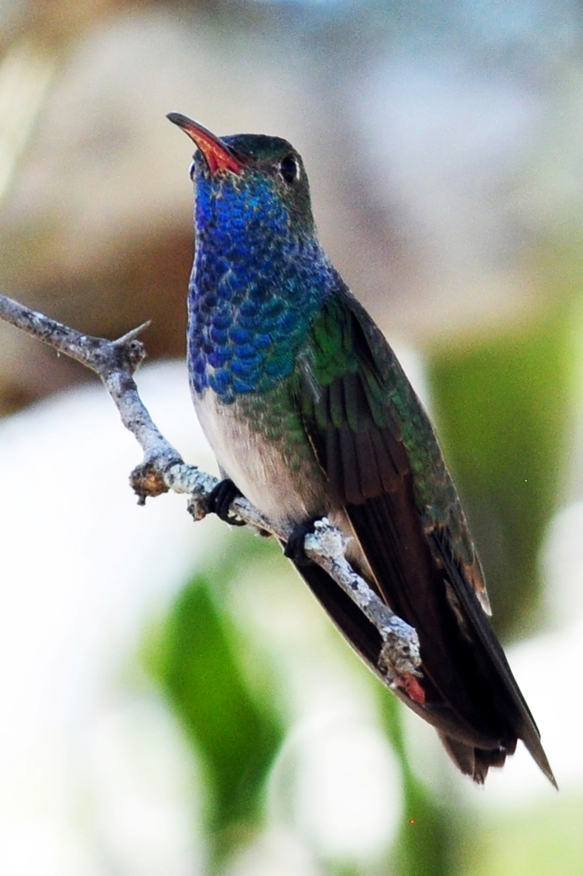
Species seen by group: 238
Additional Species heard: 21
Group: 13 birders + 2 tour leaders and 2 local guides
Birding guides: Alex Alvarado, Jose Plinio, Jose Santos
Tour leaders: Jim &Cindy Beckman,
CHeepers! Birding on a Budget
Highlights: Lovely Cotinga, Keel-billed Motmot, Honduran Emerald, Resplendent Quetzal, Bushy-crested Jay, Slate-colored Solitaire, White-lored Gnatcatcher, Black-crested Coquette, Little Tinamou, White-crowned Parrot , Mangrove Cuckoo, Lesser Roadrunner, Middle American Screech-Owl, Great Potoo, Violet Sabrewing, Turquoise-browed Motmot, Rufous-tailed Jacamar, Amazon Kingfisher, American Pygmy Kingfisher, Olivaceous Piculet, Smoky-brown Woodpecker, Chestnut-colored Woodpecker, 5 species of Woodcreeper, Great Antshrike, Barred Antshrike, Northern Bentbill, Slate-headed Tody-Flycatcher, Eye-ringed Flatbill, Bright-rumped Attila, Fork-tailed Flycatcher, White-collared Manakin, Red-capped Manakin, Passerini's Tanager, Yellow-winged Tanager, Cinnamon-bellied Flowerpiercer, Orange-billed Sparrow, Prevost's Ground Sparrow, Rose-throated Becard, Yellow-backed Oriole, Spot-breasted Oriole, Olive-backed Euphonia
Honduran Emerald
Day 1, Saturday, February 2: Travel Day
We were late leaving Atlanta, where we sat first at the gate, then on the plane for nearly an hour and a half to wait on a group of about 30 people who were on an incoming flight that was late. We made up some time in the air, so our arrival, which was scheduled for 12:20, was delayed until about 1:20. The lines at immigration were short and our luggage came out quickly, but others on the same flight weren't so lucky. John's luggage did not show up and we would have to return on our way to Pico Bonito on Monday to retrieve it. Other participants had arrived on schedule at around noon and had been waiting for nearly two hours by the time we made arrangements for John's missing luggage and loaded our luggage into the bus. By this time, we were very close to the time our last participants were scheduled to arrive. It didn't make sense to leave the airport without them, so I sent the others out to bird around the airport while I waited for Andre and Jean to arrive. Once they arrived at around 2:30, we drove south to Panacam Lodge. We arrived at the lodge shortly after 4:00 PM, and the light was already starting to fade. We followed our guide, Alex, up a trail to the spot where he knew we could find Keel-billed Motmot. It took awhile to locate the bird as it responded to Alex's calls, but we were all able to get decent looks of the Motmot in the low light before we started back down the trail. A lifer for everyone within an hour of arriving at our first birding location - what a great start! Also seen on this trail were Northern Barred Woodcreeper, Blue-crowned Motmot, Keel-billed Toucan, Red-throated Ant-Tanager, and Smoky Brown Woodpecker. At a brief stop at the hummingbird feeders at Panacam Lodge we saw Western Long-billed Hermit, Violet Sabrewing, White-bellied Emerald, and Rufous-tailed Hummingbird. We were escorted to our cabins, but not before Alex took us to the spot where a Black-crested Coquette roosts. We settled into our rooms, then met to compile our daily list and have dinner. As we made our way back to our cabins after dinner, we were treated to wonderful looks at a pair of Mottled Owls. We listened to them and watched them for several minutes, at one point even observing the pair mating in the spotlight! Even though the day was mostly spent in travel, the group managed to see 40 species. Some common species seen at the airport included Black and Turkey Vultures, Roadside Hawk, White-

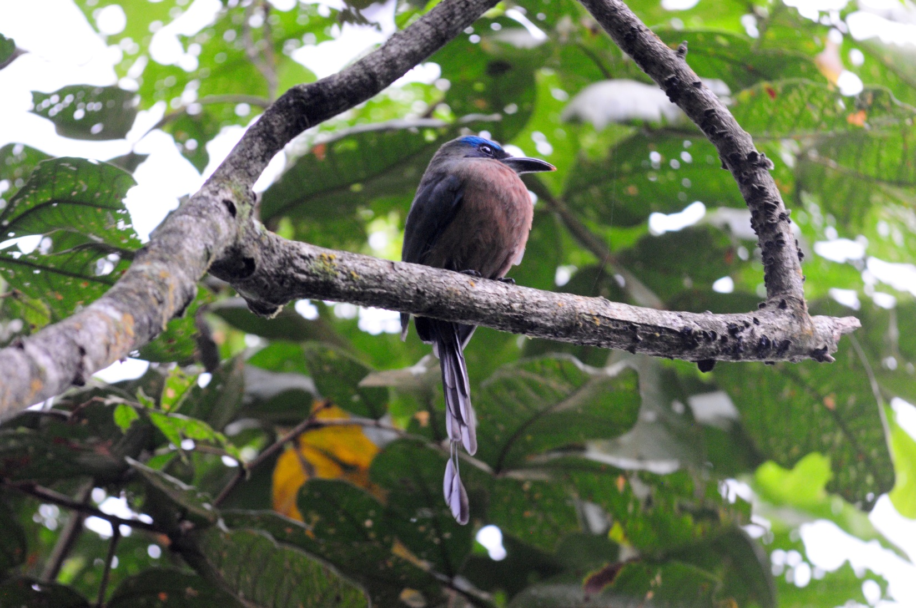
Keel-billed Motmot

winged Dove, Ruddy Ground Dove, Groove-billed Ani, Black Swift, Social Flycatcher, Tropical Kingbird, Barn Swallow, Tropical Mockingbird, Clay-colored Thrush (Robin), Blue-black Grassquit, White-collared Seedeater, Blue Grosbeak, Indigo Bunting, Tri-colored (Black-headed) Munia, Great-tailed Grackle, and Baltimore Oriole. Other species seen today included Great Egret, Cattle Egret, Osprey, Short-tailed Hawk, Ringed Kingfisher, White-shouldered Tanager, and Blue-gray Tanager. We turned in early so we would be ready for a 5:00 AM departure the next morning to travel to the other side of Lake Yojoa to search for Resplendent Quetzal and other cloud forest species.

Day 2, Sunday, February 3: Santa Barbara National Park, Los Naranjos National Park, Lake Yojoa
We set our alarm for 4:00 AM so we would be ready to leave by 5:00. We arrived at a small rural home at about 6:30 AM and enjoyed a full breakfast that was prepared by the family of Lionel, the owner of the property and our local guide for the day. Before we went inside to eat, Kenn found a Melodious Blackbird singing from the top of a tree at the far end of a field. Along the road and in the yard we saw Montezuma Oropendola, Great Kiskadee, House Wren, Black-throated Green Warbler, Wilson's Warbler, Yellow-faced Grassquit, White-collared Seedeater, Great-tailed Grackle, and Golden-fronted Woodpecker. We feasted on fresh fruit, pastries, eggs, and other delicious food before starting up a trail that led to Alex's most reliable spot for Resplendent Quetzals. As we started down the road toward the trail, a few of us at the end of the group spotted a White-eared Hummingbird feeding on a small flowering tree; the rest of the group saw the bird on the way back to the house at lunch time. At the beginning parts of the trail, along the only flat portion of the morning's walk, we added Magnificent Hummingbird. As we started the climb, the trail became difficult to navigate with large rocks making for uneven footing. After awhile, the middle of the trail turned into a river of thick boot-sucking mud where cattle had kept things stirred up. As we made our way higher, Alex and Lionel assisted anyone who needed help staying on the firm soil at the edge of the muddy flow, which was sometimes very narrow and often required taking huge steps upward. We all helped each other as much as we could, and everyone managed to make it to the end point without taking an involuntary mud bath. As we passed an open area, Alex heard Bushy-crested Jays in the distance. We all managed to see the birds, but I must admit I'd have liked a better look. I saw a Jay through the scope, but his head was buried in greenery, totally obscuring my view of any bushy crest that might be present.

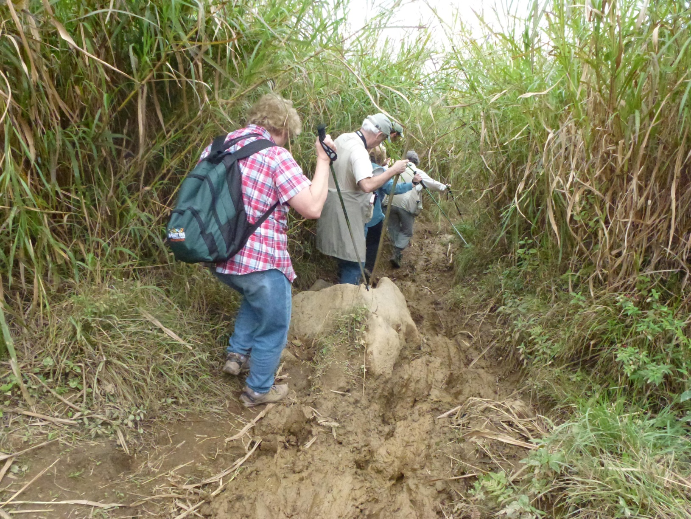

In a small patch of woods we picked up Eye-ringed Flatbill and Slate-colored Solitaire. Jim and I stayed back a while with Lionel to get a better view since the solitaire was another life bird for us. By the time we caught up with the group, they had a gorgeous male Resplendent Quetzal in their sights. A life bird for many of our group and a real thrill no matter how many times you've seen this beauty before. Just beyond the spot where we saw the Quetzal, we stepped through a narrow opening in a fence and emerged into a more open area overlooking a valley. Here we spent quite a bit of time getting everyone on a couple of Rufous-browed Wrens that were hopping around in the undergrowth. From the same vantage point, we also saw Golden-crowned Warbler, Slate-throated Redstart, and Common Bush-Tanager. Most of the group was able to get on a very active Cinnamon-bellied Flowerpiercer, but I totally dipped on that bird. I tried to blame the narrow trail, my height disadvantage, bad luck, etc. but it was just one of those times when I wasn't on top of things. Luckily, it was not a life bird for me.

We made our way back down the treacherous hill which was nearly as difficult as the ascent had been and was most certainly harder on our not-so-young knees. We had a nice lunch at Lionel's home and then made our way to the shore of Lake Yojoa. Northern Jacana, Fulvous Whistling Duck, American Wigeon, American Coot, Common Moorhen, Blue-winged Teal, Little Blue Heron, Great Blue Heron, Least Grebe, Pied-billed Grebe, and Purple Gallinule were all seen in the water and Lesser Yellow-headed Vulture, Snail Kite, and Osprey soared overhead. A Lesser Kiskadee was found at water's edge before White-throated Flycatcher, Common Yellowthroat, Yellow Warbler, and Common Tody-Flycatcher all responded to Alex's imitation of a Ferruginous Pygmy Owl. As we entered Los Naranjos Archaeological Park, we saw a pair of Rufous-naped Wrens displaying and feeding near a small storage shed. Also seen here were many Clay-colored Robins (Thrushes) and a female Baltimore Oriole.

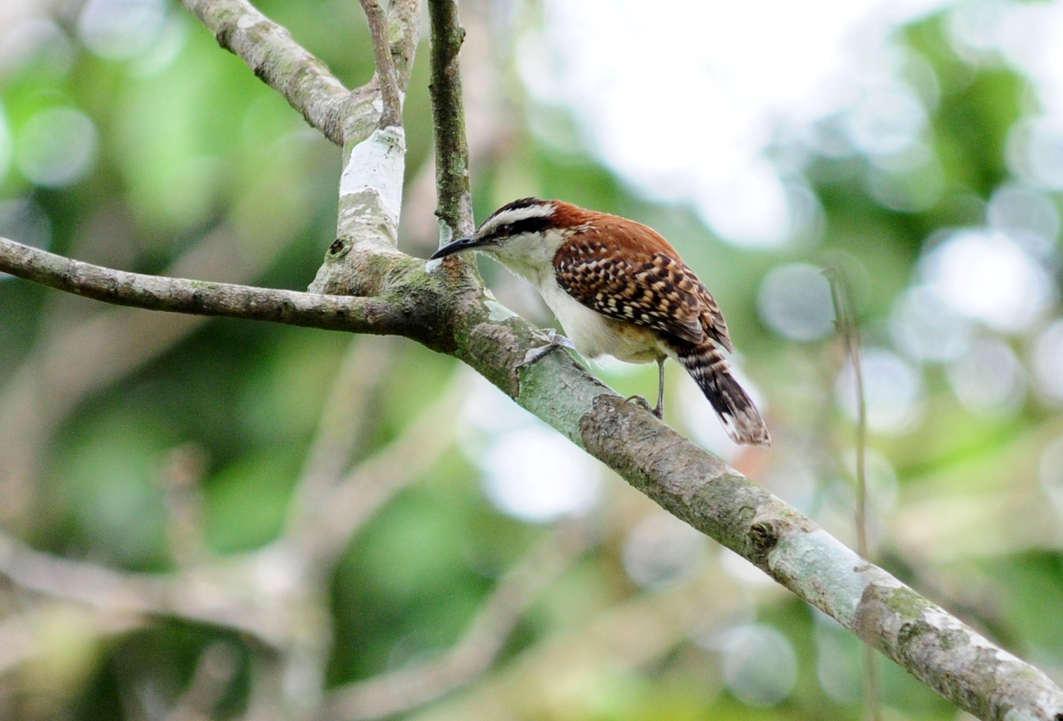
Rufous-naped Wren
Naranjos features 6 km of trails, including a 1 km boardwalk that takes you over protected marshland. Here we found Summer Tanager, Boat-billed Flycatcher, Yellow-bellied Flycatcher, Streak-headed Woodcreeper, Ivory-billed Woodcreeper, Fork-tailed Flycatcher, Yellow-bellied Elaenia, Northern Rough-winged Swallow, Groove-billed Ani, Olivaceous Piculet, Yellowish Flycatcher, Social Flycatcher, Wood Thrush, Orchard Oriole, Brown-crested Flycatcher, Great Egret, and Muscovy Duck. In one little clump of trees we observed Yellow-throated Vireo, Gray Catbird, Golden-winged Warbler, Black-and-white Warbler, Common Yellowthroat, Hooded Warbler, American Redstart, Magnolia Warbler, Chestnut-sided Warbler, Yellow-rumped Warbler, Yellow Warbler, Black-throated Green Warbler, Yellow-breasted Chat, and Black-headed Saltator. Just as we approached the part of the boardwalk that goes along the lake, it began to sprinkle lightly. The sky looked threatening, so Alex recommended that we return to the bus since the light rain could turn into a downpour in an instant. It had been hot and sunny when we left the vehicle, and most people did not bring their rain gear with them. We started back, but it was difficult to move quickly with all of the activity around us. By the time we made it back to the entrance, the rain had almost stopped and the group spread out in search of new species. Part of the group went to the lake's edge where they found Black-bellied Whistling Duck, Northern Shoveler, Bare-throated Tiger Heron, White-tailed Kite, Limpkin, and Black-necked Stilt. Another part of the group birded behind some buildings, drawn there by a very cooperative pair of Squirrel Cuckoos. Also in the area were Yellow-winged Tanagers. Everyone made their way back to the bus just as the rain picked up, and we left to return to Panacam.

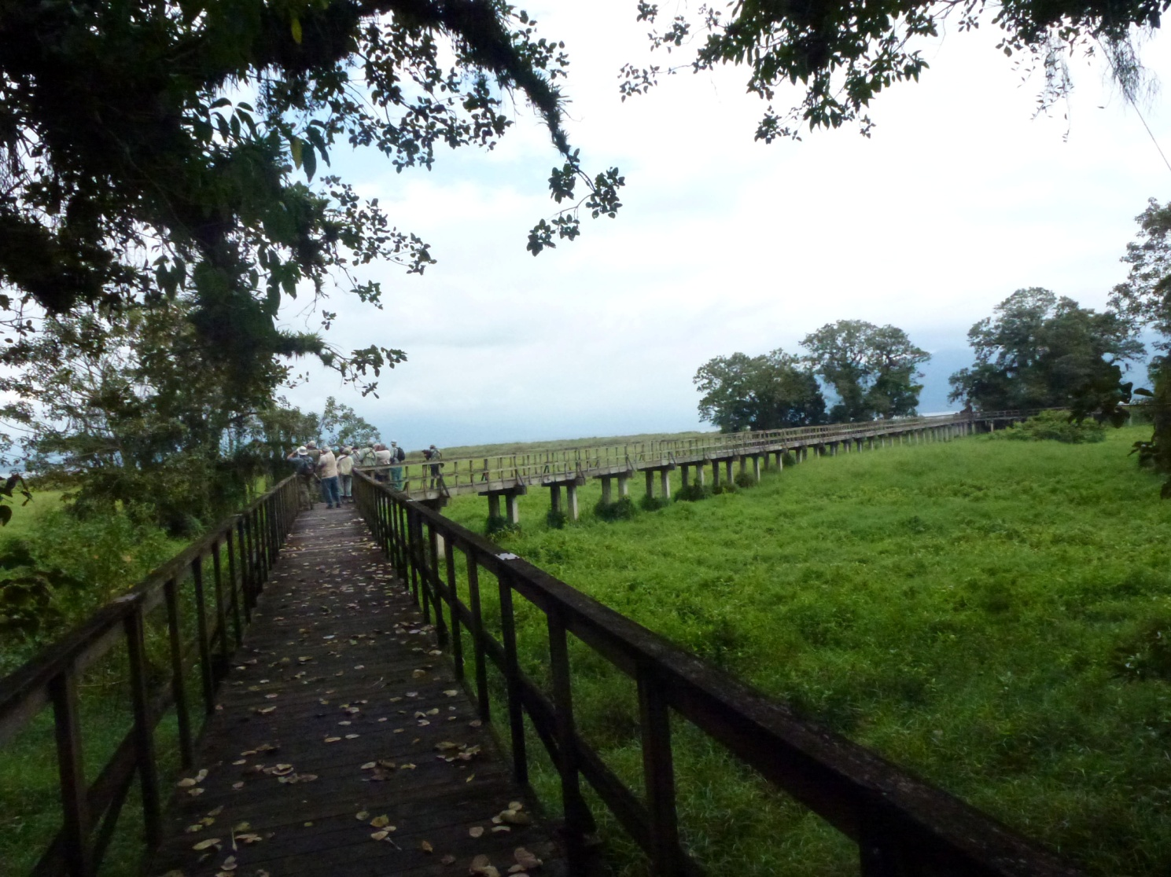

As we drove down the entrance road to Panacam Lodge, Paul called out from the back of the bus. He had spotted a large bird that turned out to be a Collared Trogon. Other birds seen today included Black Vulture, Turkey Vulture, Swallow-tailed Kite, White-tailed Kite, Roadside Hawk, American Kestrel, Rock Dove, Pale-vented Pigeon, Common Ground Dove, White-fronted Parrot, Green-breasted Mango, White-bellied Emerald, Rufous-tailed Hummingbird, Blue-crowned Motmot, Turquoise-browed Motmot, Keel-billed Toucan, Brown Jay, Acorn Woodpecker, Tropical Kingbird, Chestnut-headed Oropendola, and Tri-colored Munia. We finished the day with 100 species with an additional 12 species heard but not seen. Our trip total stood at 121 with an additional 15 species heard.

Day 3, Monday, February 4: Panacam Lodge, Lake Yojoa, Agua Azul, Transfer to the Lodge at Pico Bonito
We left the lodge at 6:00 AM to bird an area where we might be able to observe Prevost's Ground Sparrow. On the walk to the site, we saw Buff-throated Saltator, Red-throated Ant-Tanager, Black-headed Saltator, and heard Little Tinamou. Once we arrived at the spot where Alex expected to find the bird, we remained stationary waiting for an opportunity to see our target species. A very cooperative Green Kingfisher entertained us for awhile and Alex heard the Ground Sparrow but it was deep in the ground cover. As we searched for the Sparrow, we saw Yellow-olive Flycatcher, Red-billed Pigeon, Northern Waterthrush, Dusky-capped Flycatcher, Passerini's Tanager, Barred Antshrike, Golden-olive Woodpecker, and listened to the beautiful vocalizations of a Plain Wren. A man driving a team of two oxen came through and moved into the field behind us to begin plowing. After the bird activity slowed down a bit, we moved on to try to locate "our" bird in the field where the local man was working. Jean commented on the incongruity of watching a man working a field with a wooden plough and two oxen pull out his cell phone to have a conversation with someone. It wasn't long before we found a couple of Prevost's Ground Sparrows working the edge of the field. Also spotted from this spot were White-tipped Dove, Crimson-collared Tanager, Least Flycatcher, Bronzed
Cowbird, Yellow-winged Tanager, Plain Chachalaca, Ferruginous Pygmy-Owl, and Chestnut-headed Oropendola.

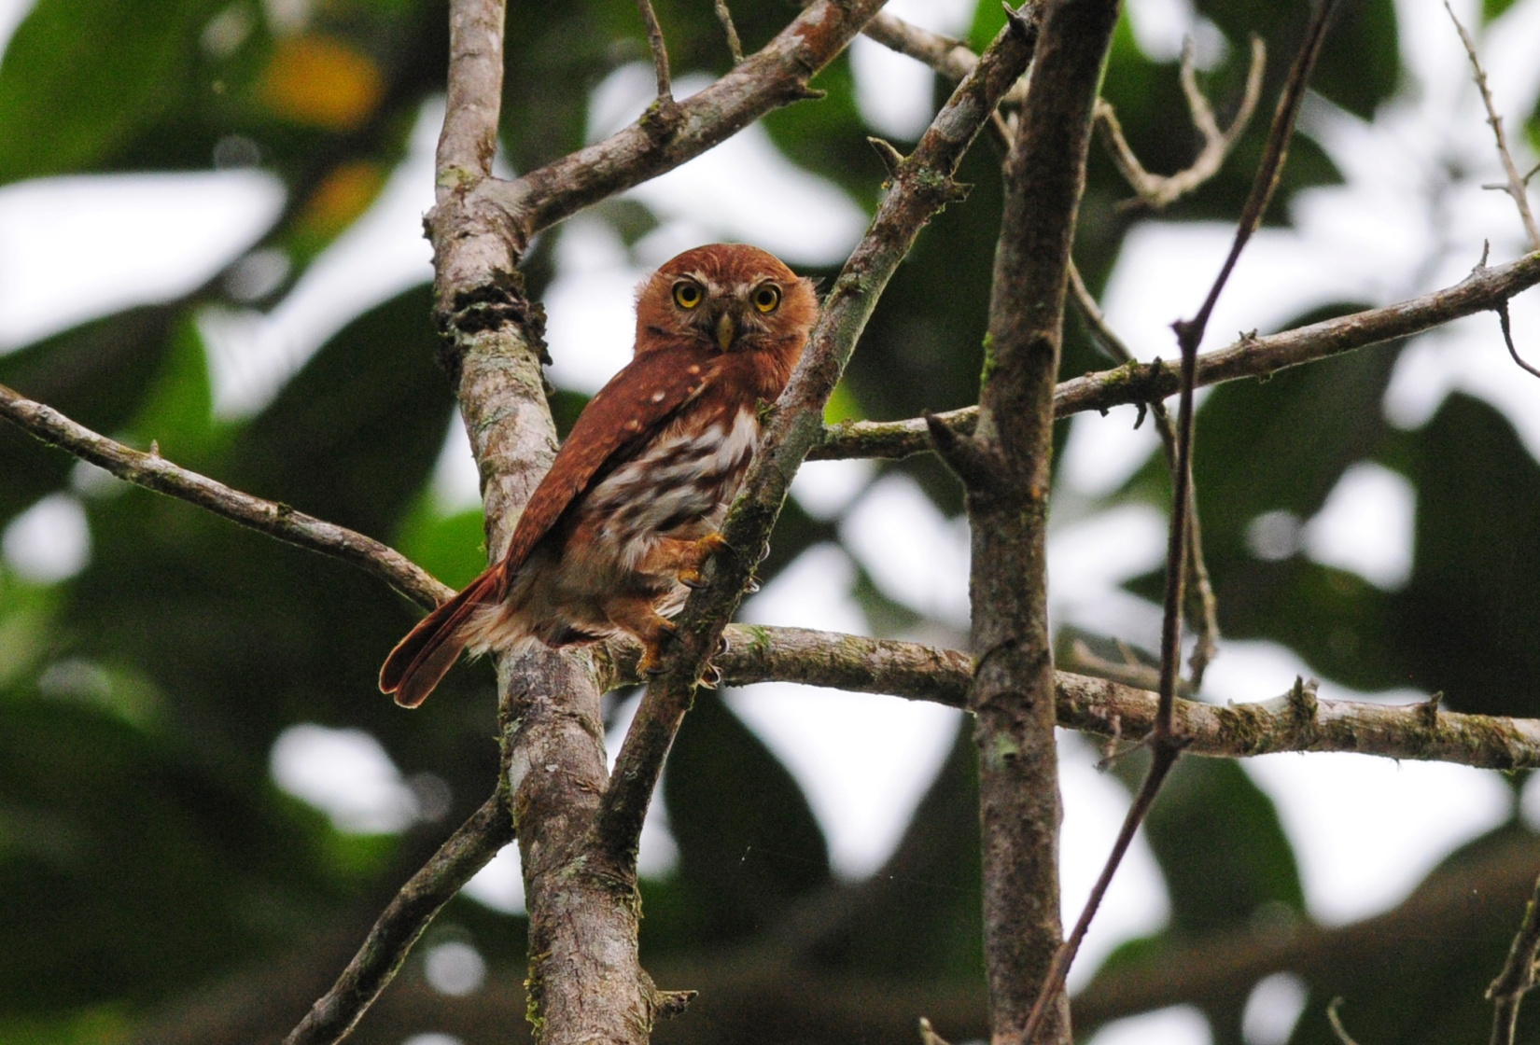
Ferruginous Pygmy-Owl

As we walked back to the bus, we met another group of birders led by Robert Gallardo, a well-known birder who is trying to have a "Birds of Honduras" field guide published. Alex introduced him as the man who taught him about birds, and we joined them for a few minutes to search for a Slate-headed Tody-Flycatcher that was in the bushes nearby. Only a few of us saw the diminutive flycatcher before we had to move on. We returned to the lodge for lunch with a few stops for birds along the way, one of which yielded Cinnamon Hummingbird, and were surprised to see Robert and his group at the hummingbird feeders when we arrived. Some Collared Aracaris and Keel-billed Toucans were foraging in the trees over the roof of the dining room while we waited for our food to be prepared. Violet Sabrewings were the most significant birds at the feeders.

Our original plan called for us to begin our drive to Pico Bonito so we would arrive in time for lunch. We needed to pick up John's missing luggage at the airport at 1:30, so we adjusted our plans to include some additional morning birding and lunch at Panacam before we left the area. After lunch, we drove to an area on Lake Yojoa called Agua Azul, an old resort that was no longer operational, for another chance to see Ruddy Crake. This gave us exceptional views of the lake, and we were stunned by the huge number of Snail Kites at this site. They seemed to be everywhere! Ruddy Crakes could be heard but not seen, and we got excellent looks at Crested Caracara and Lesser Yellow-headed Vultures as they swooped low to the water nearby. Many of the species we had seen yesterday were observed at closer range, including Purple Gallinule and Common Moorhen, and we added Snowy Egret and Wood Stork to our trip list. This spot was so beautiful that it was difficult for us to leave when Alex said it was time to go. As the last of us slowly made our way to the bus, we noticed the rest of the group observing a Spot-breasted Oriole as it foraged in a nearby tree.

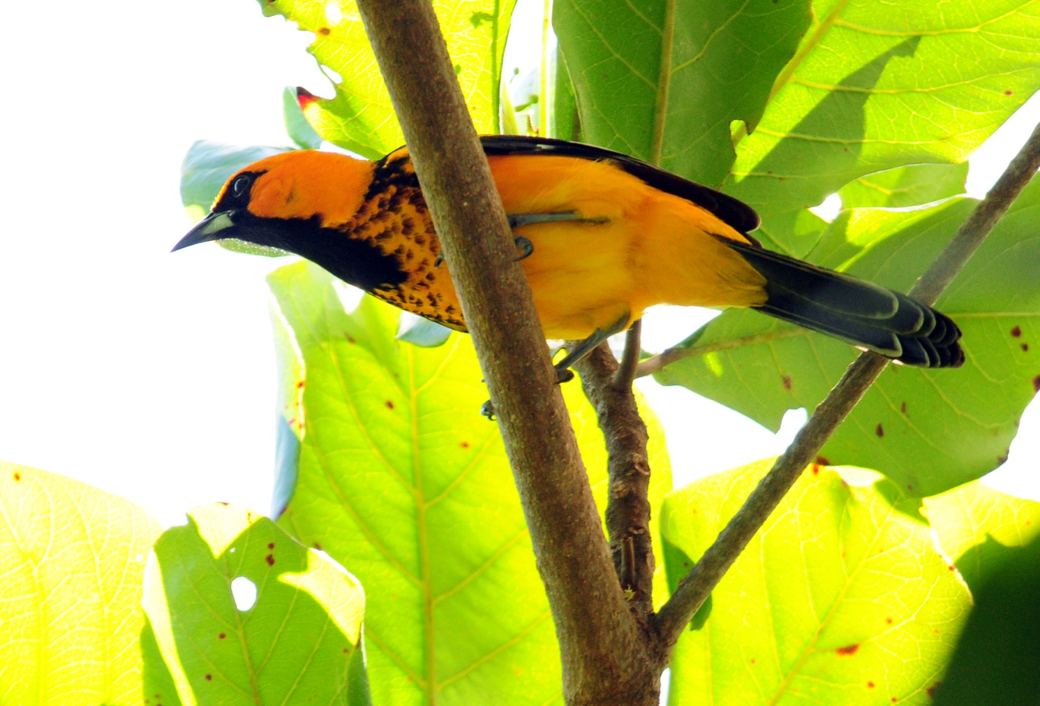
Spot-breasted Oriole

We arrived at Pico Bonito just after sunset, so we had no time to bird there. Staff greeted us with an ice-cold welcome drink and offered to add rum for anyone who wanted it. The check-in process was well-organized and went very quickly, and in no time we were settled in our luxurious cabins. Our species tally for the day was 92, with 34 species that were new to the trip bringing our trip total to 155. Other birds seen today included Cattle Egret, Olive-throated Parakeet, Yellow-olive Flycatcher, Green Heron, White-collared Manakin, Masked Tityra, Rose-throated Becard, Philadelphia Vireo, Tennessee Warbler, Yellow-throated Warbler, Buff-throated Saltator, and Grayish Saltator.

Day 4, Tuesday, February 5: Lodge at Pico Bonito
We met at 6:00 AM for breakfast and began to bird the trails at Pico Bonito Lodge immediately afterward. As we waited in front of the reception area for everyone to gather, we observed Olive-backed Euphonia, White-crowned Parrot, Golden-fronted Woodpecker, White-necked Jacobin, Rufous-tailed Hummingbird, and Montezuma Oropendola. Olive-throated Parakeets flew by, then a group of Chestnut-headed Oropendolas. Once everyone was ready, we started down a trail where Yellow-crowned Night-Herons were roosting in trees. We stopped briefly at a white sheet set up under a light that attracts moths and other insects. It took a few minutes for everyone to get their fill of the insects, and I cautioned them that we needed to get to the cotinga feeding area before the day began to heat up. At a corner where the trail to the left led to the tower and the trail to the right followed the river, Alex pointed out a Great Potoo. A couple of Ovenbirds and a Wood Thrush were found in the same area, which caused a little confusion about which bird with spots on its chest we were seeing until we realized both species were present. I pointed out what I thought was a female Lovely Cotinga on a branch over the trail, but upon closer inspection we could see some blue coming out on its chest, proving that it was a young male. Nearby we found a White-throated Robin. We came to a spot where there was a blind in a tree overlooking a lush valley. This was the spot where we expected to see Lovely Cotingas come to feed on the fruiting trees. As we waited for the Cotingas to arrive, we observed a female Violet-crowned Woodnymph. Far, far in the distance a Bat Falcon perched, surveying the valley below. Soon, the Cotingas
arrived and everyone oohed and aahed at the sight. After enjoying the spectacle of the brilliant blue and purple birds, we moved on down the trail. Chestnut-colored Woodpecker, Wedge-billed Woodcreeper, Green Honeycreeper, and Ochre-bellied Flycatcher were all seen in one area. Philadelphia Vireo, Chestnut-sided Warbler and Baltimore Oriole were the next birds to appear. A short distance farther down the trail we saw Red-throated Ant-Tanager and Masked Tityra. Alex imitated a Ferruginous Pygmy-Owl and brought in a flock of warblers (Chestnut-sided, Magnolia, Black-and-white, American Redstart) and a Yellow-throated Vireo, Tropical Gnatcatcher, Red-capped Manakin female, and a few Lesser Greenlets. On the way back to the lodge, we saw Gartered Trogon, Black-headed Saltator, Long-billed Hermit, and Yellow-winged Tanager. As we started to walk down the entrance road, some people detoured to the lodge for a restroom break. Some Olive-throated Parakeet flew by just before we left the road to see a Vermiculated Screech-Owl that was roosting near the road. We waited quite awhile for the others to return from their break but finally walked back to the lodge when some of them didn't return to the group. It was time for lunch, and we figured the owl would still be around when we went back out in the afternoon.

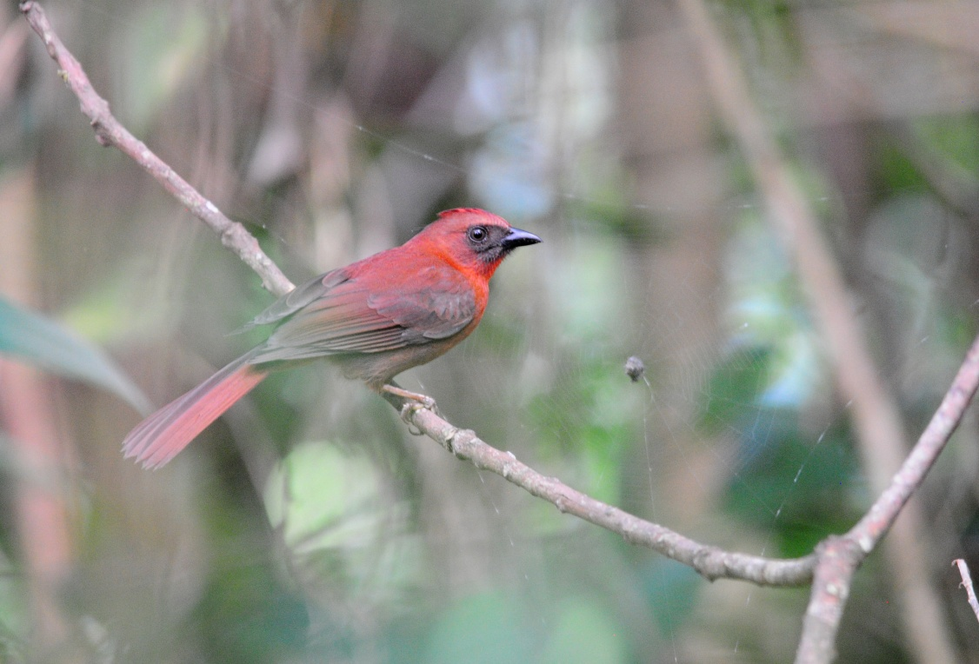
Red-throated Ant-Tanager
When we went back out to bird at 3:00, a pair of Ferruginous Pygmy-Owls were the first birds we saw. As we approached the entrance road from the parking area, we saw two White-crowned Parrots and watched as the parent fed its fledgling. Alex had found a second Vermiculated Screech-Owl while we were eating lunch and led us off the path to get a much better look at this cute little owl. We saw many species we'd seen the day before, including several Warblers and both species of Oropendola. Kenn alerted us to a huge flock of White-collared Swifts overhead. A Gray Hawk flew close enough for a positive ID. In a small pond/large puddle, we observed a Wood Thrush and a Kentucky Warbler bathing. A short distance away, a Turquoise-browed Motmot hawked insects. Other birds seen today that were new for the trip included Brown-hooded Parrot, Ruby-throated Hummingbird, Black-headed Trogon, Black-cheeked Woodpecker, Golden-hooded Tanager, Green Honeycreeper, and Scrub Euphonia. We finished the day with 72 species seen and 12 heard only, with nearly half of the seen species new for the trip. Our trip total now stood at 185 species with an additional 24 heard but not seen.

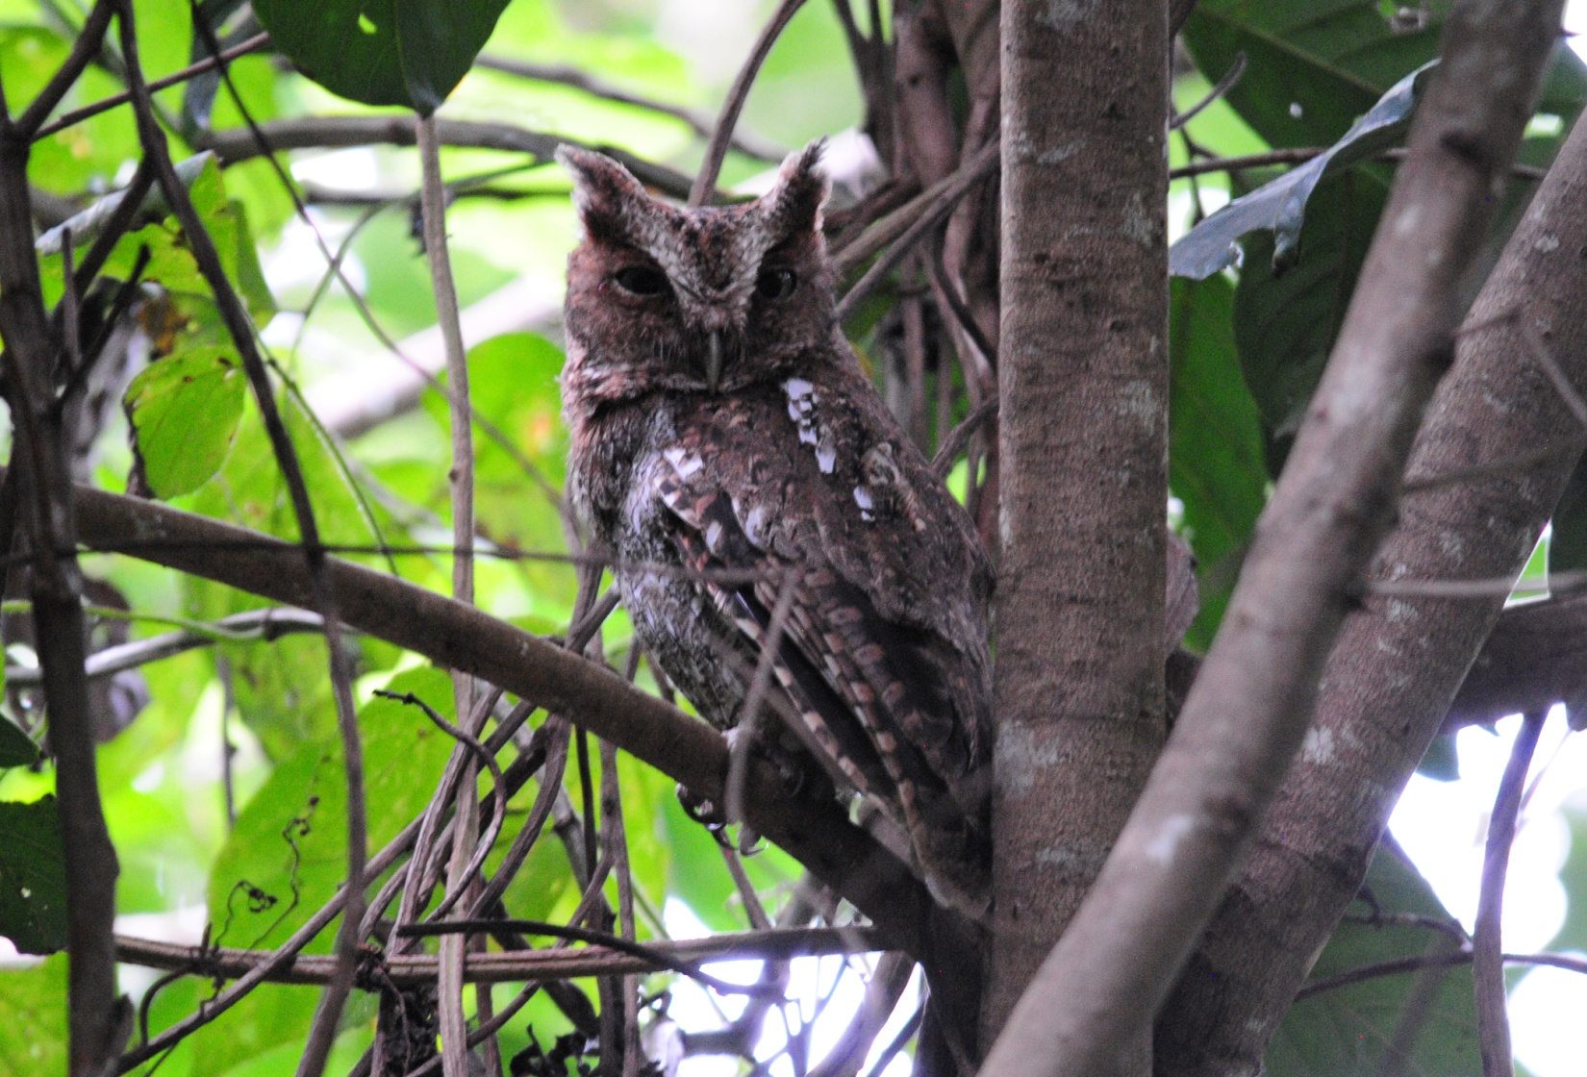
Middle American (Vermiculated) Screech-Owl

Day 5, Wednesday, February 6: Cuero y Salado National Park, La Union, grounds of the Lodge at Pico Bonito
We had breakfast at 5:30 for a 6:00 departure. We drove to the small town of La Union where we boarded a miniature train to go to Cuero y Salado National Park. The train was once used to haul sugar cane out of the fields but is now run as a service to locals and to take visitors into the national park. While waiting to board the train in La Union, we saw Inca Dove and got excellent views of a Mangrove Cuckoo. Other birds seen from the tracks were Summer Tanager, Spot-breasted Oriole, White-winged dove, Turquoise-browed Motmot, and lots of Brown Jays. The train moved very slowly and allowed for some birding, but we didn't stop as much as we did on our last trip . From the train we saw Red-lored Parrots fly by, Least Sandpiper, Green Heron, Groove-billed Anis, Purple Gallinule (juvenile), Little Blue Heron, Killdeer, Variable Seedeater, White-tailed Kite, Wilson's Snipe, Crested Caracara, Bare-throated Tiger Heron, Solitary Sandpiper, Blue Grosbeak, Wood Stork, and Roadside Hawk, among others.

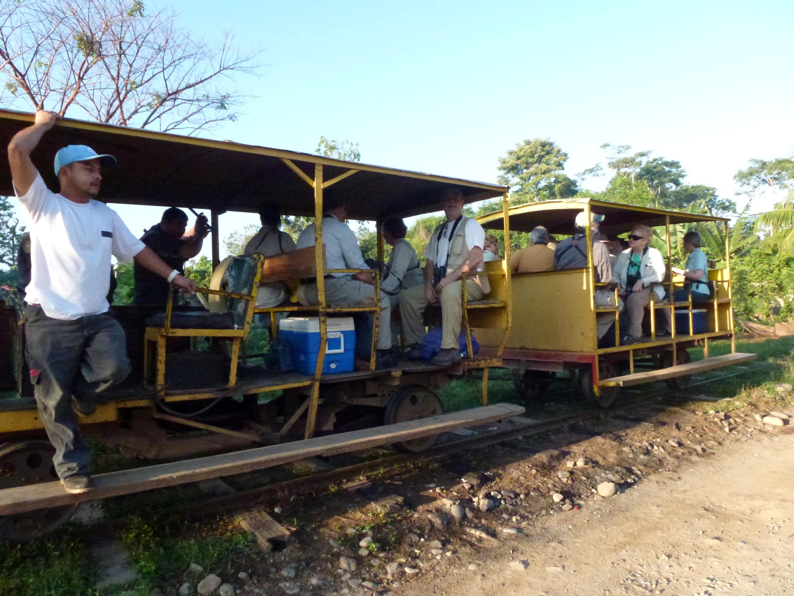

When we arrived at the national park headquarters, I was concerned to see only 2 boats waiting for us. With 13 birders, 2 tour leaders and 2 birding guides, there was absolutely no way people could sit comfortably in that amount of space. After a brief discussion with Jose, another boat was readied and we all grabbed a life jacket and climbed aboard. Each of two boats carried a birding guide and the third boat had Kenn Kaufman on board, so we were confident that everyone would have the assistance they needed in identifying birds in the event the boats got separated. It was also quite helpful that Kenn's Spanish was good enough to communicate with our boat driver. Tricolored Heron and Solitary Sandpiper were hunting on the bank opposite the dock as we waited for the other boats to load. Our driver pointed out an American Crocodile that was floating in the vegetation. We cruised slowly around the lagoon and made our way toward the mangroves where we hoped to see nesting Boat-billed Herons. Unfortunately, the herons were not present this year, but we enjoyed many sightings on our way in and out of the area. A Bare-throated Tiger Heron posed among the lush vegetation, an Anhinga perched with its wings stretched out, a Gray-headed Kite soared high overhead, a Lesser Nighthawk sat motionless on a diagonal branch over the water, and an immature Common Black Hawk watched us pass under him from a branch that stretched across the stream. We saw four species of Kingfisher: Pygmy, Ringed, Belted, and Green. A group of Long-nosed Bats were resting on the trunk of a tree at the edge of the water. Howler Monkeys moved about in the trees at the edge of the lagoon, some carrying young babies as they moved through the branches. One of the guides spotted a Northern Jacana nest in the vegetation. We were disappointed at not seeing the Boat-billed Heron rookery or an Agami Heron, but we were more than compensated with these sightings.

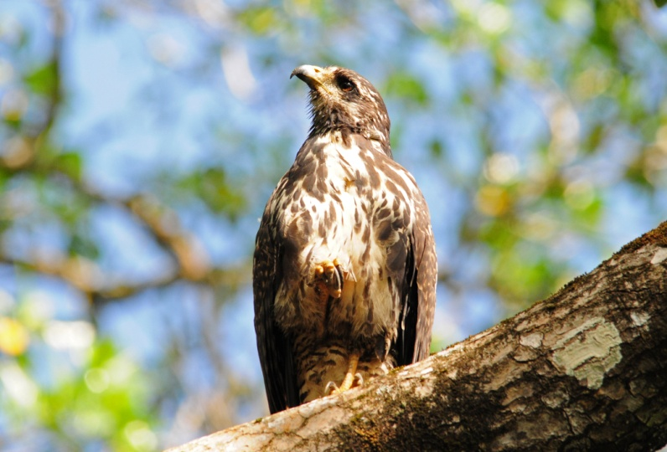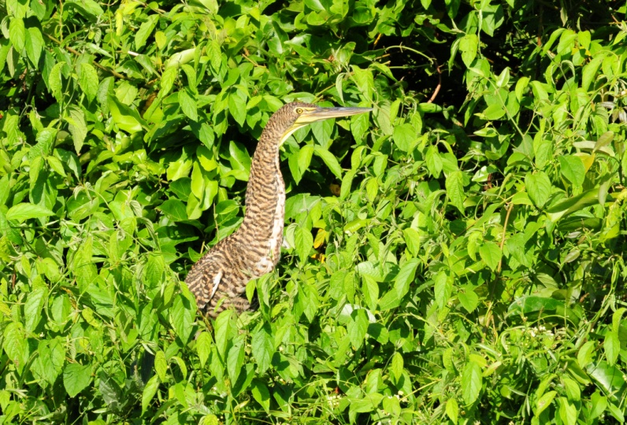
Black Hawk Bare-throated Tiger Heron

Back on land, we were served fresh fruit under some shade trees. At the picnic site we enjoyed a patient Black-headed Trogon at close range. As we were leaving to walk to the beach, I heard things hitting the ground and looked up to see two White-crowned Parrots feeding in the branches over our heads. The group moved on to the beach as I was still trying to get good photographs of the parrots. A Spot-breasted Oriole flew in to feed and distracted me even further, and I ended up still standing under the tree when the group returned from the beach where they had seen Brown Pelican, Royal Tern, Sanderling , Whimbrel, and Willet.
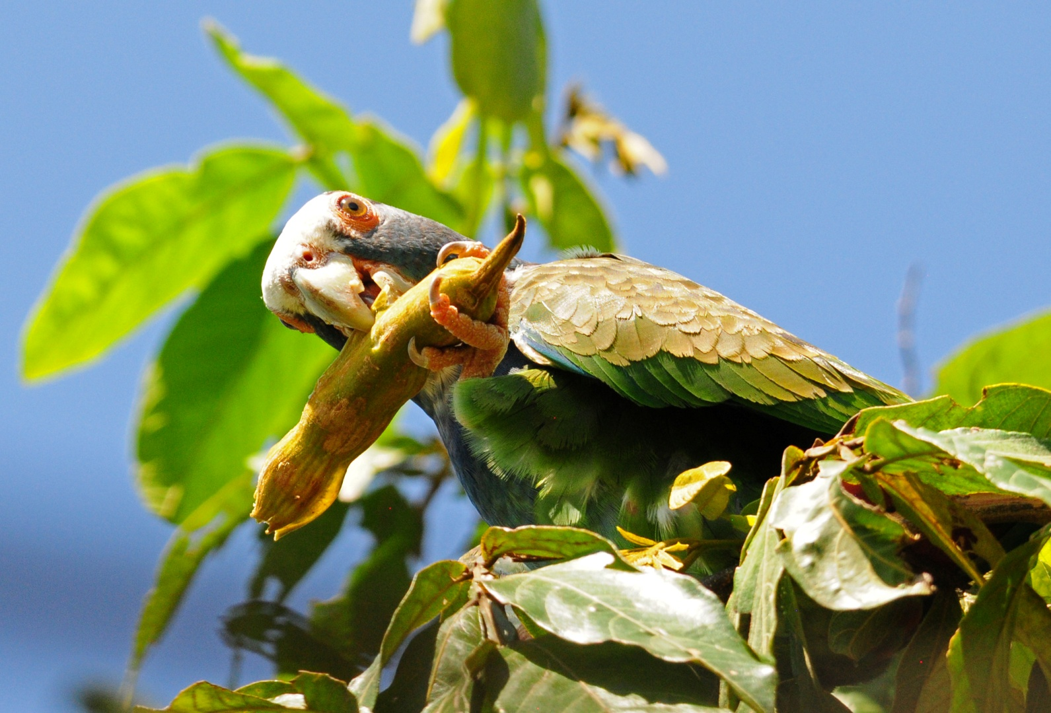
White-crowned Parrot
Other species seen for the first time included Broad-winged Hawk, Stripe-throated Hermit, and Black Phoebe. Janel and Michael reported a Black Guan near their cabin. We came close to breaking 100 with a daily count of 98 plus 9 heard-only species. Our trip total went to 209 with an additional 23 species heard but not seen.

Day 6, Thursday, February 7: Rio Aguan Valley, Olanchito
Today was our earliest day with a 4:30 AM departure. Our destination was the Rio Aguan Valley, where the endemic Honduran Emerald can be found. We drove for over two and a half hours before stopping at a gas station for a restroom break and breakfast. There was a nice garden area with concrete picnic tables where we ate the sandwiches that Jose had brought for us. We spotted several birds from the gas station, including House Sparrow, Gray-breasted Martin, Tropical Kingbird, Social Flycatcher, and a few other common birds. As we were preparing to leave, a team from a local television station asked if they could interview us. We waited as they interviewed first Jose, then Kenn, and finally me with Jose translating. We drove on and stopped at some small ponds where we spotted Wood Storks and one Roseate Spoonbill flying away. Our next stop was a riparian area that can be quite productive, but we didn't see much of interest other than Mangrove Swallows and Amazon Kingfisher. Another roadside pond yielded Lesser Scaup and Little Blue Heron.

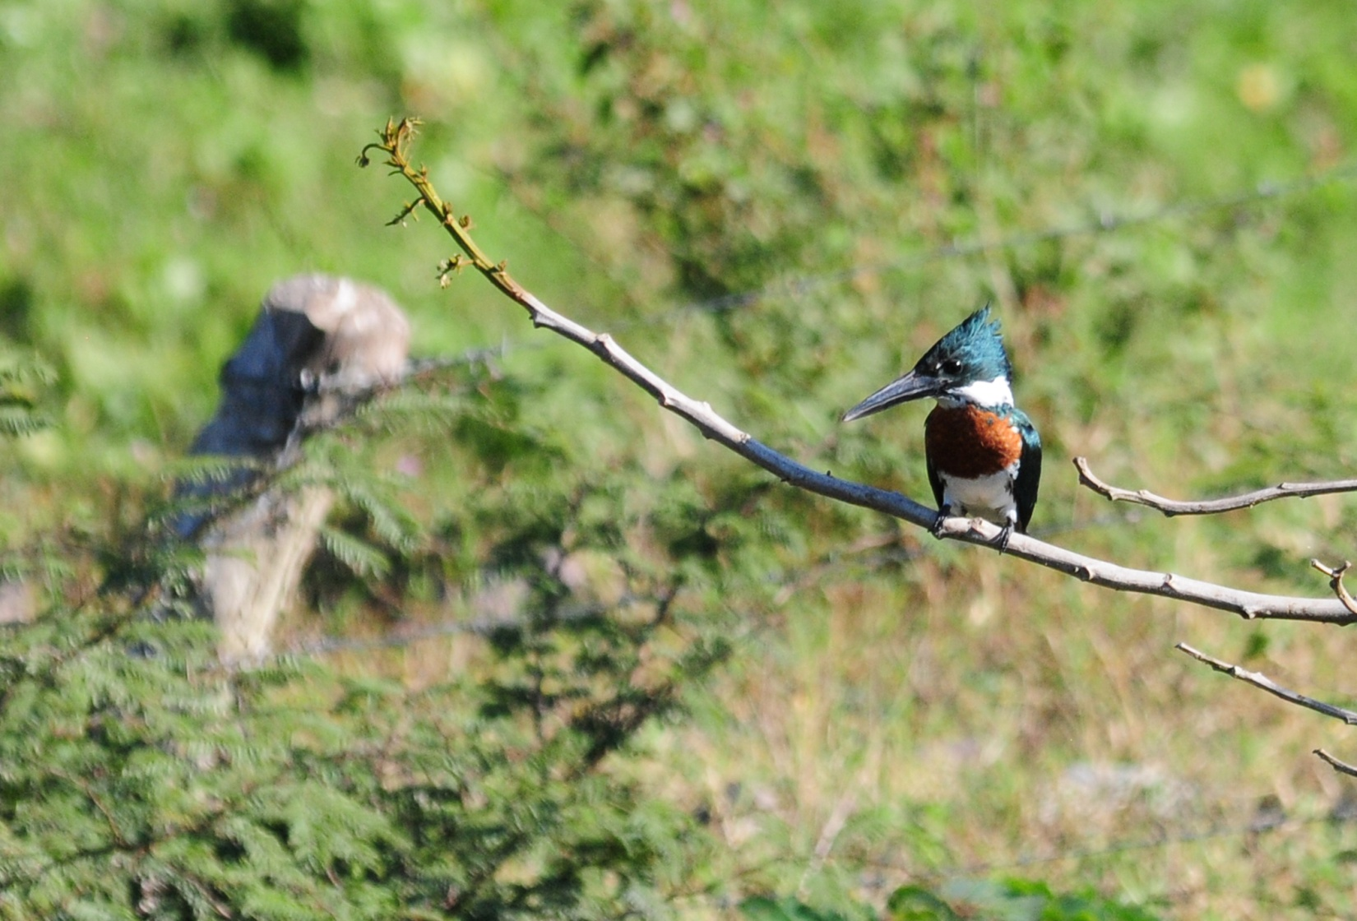
Amazon Kingfisher

We finally arrived at the hummingbird reserve at 9:30 and it was already blazing hot. We were stopped by police acting as rangers as we entered, and Jose had to give a lengthy explanation before we were permitted to pass, something that did not happen on our previous visit. He explained that they were training new officers and there was really no problem. As the bus moved forward to the area where we would park, we were stopped by a couple of women who were promoting a new lodge in the area. All of this took time, and as the bus moved forward again, Kim called out from the back of the bus, "Roadrunner!" We all told the driver to stop, but he kept going until the front of the bus could not see the Lesser Roadrunner as it ran behind a rock. At some point, Kim saw a Honduran Emerald from her seat in the bus, and joked about having a bird on her life list that wasn't on Kenn's. He didn't seem to mind at all, probably because he felt confident that he would be adding the bird to his life list in a matter of minutes. As soon as we started walking, a female Honduran Emerald was spotted on her perch, so Kim had a lifer that Kenn did not have for only about 10 minutes. Kenn shared the story of the Honduran Emerald with us after our outing. It was believed to be extinct, with no sightings between 1950 and 1988 when it was found to be fairly common at two sites just 16 km apart near Olanchito in the upper Rio Aguan Valley. The population is estimated to number under 1000 mature individuals and it is the only species that is endemic to Honduras. It qualifies as endangered owing to its very small and severely fragmented range and population, both of which are suspected to be declining in response to habitat loss. If you visit one of these small arid havens, this endangered species is relatively easy to find. We saw many individuals during our time in this interior valley. Two other target species for this area, White-lored Gnatcatcher and White-bellied Wren, were also seen well. Paul spotted a Salvin's Emerald that was quickly displaced by a Honduran Emerald, causing some people to focus on the wrong bird and miss the Salvin's. The day was very hot and sunny, but there was a bit of a breeze that helped keep us comfortable. The heat did affect the birding activity, however, and we didn't see a wide variety of species. We thought we heard a Lesser Roadrunner and spent some time searching for it. After the others moved on, I saw a fairly large bird fly low across the trail. I searched for its landing spot and found a gorgeous Turquoise-browed Motmot. We also saw

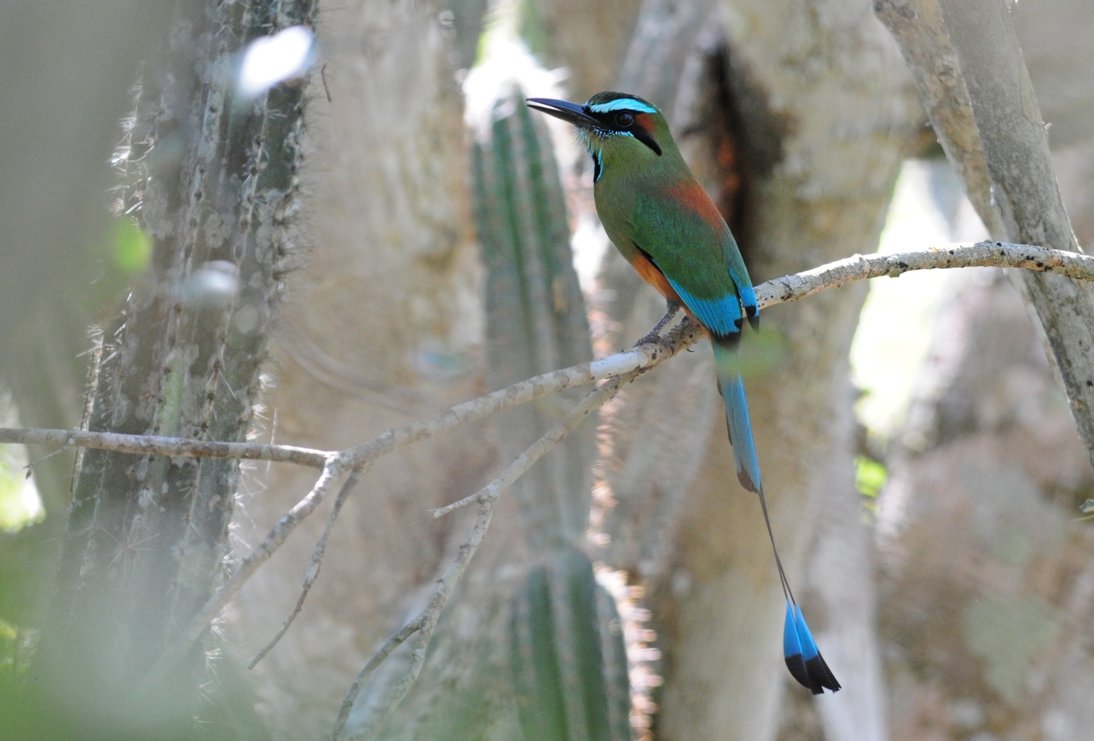
Turquoise-browed Motmot

female Rose-breasted Grosbeak and Magnolia Warbler before we returned to the bus to drive to a local ranch for lunch. When we arrived, we were treated like celebrities because the family had just watched us being interviewed on
the noon news! We were served chicken, beef, pork, rice, beans, and fresh fruit juices. On the property we saw Altamira Oriole. We left the ranch shortly after 1:00 PM and made only one restroom stop on the way back to Pico Bonito. We arrived in time for dinner and began to compile our list as we waited for the food to arrive. When we were served, we put our lists away and finished them after dessert. We had only 57 species for the day, but today was about quality, not quantity. Our trip list now stood at 224 species seen, 21 heard only, and 1 fly-by.

Day 7, Friday, February 8: Lancetilla Botanical Gardens, Tela, Rio Santiago nature Resort
We left Pico Bonito Lodge on time at 6:30, stopped for a restroom break around at a gas station about 30 minutes later. At our rest stop we noted Baltimore Oriole, Yellow-winged Tanager, and Yellow Warbler and got excellent looks at a Bat Falcon. We arrived at Lancetilla Botanical Gardens while it was still cool and the birding activity was good. We saw many of the species we'd seen earlier on the trip, which we always welcome because it gives those who missed a certain species earlier another chance, and it gives everyone the opportunity to see the bird in a different light, a different position, and perhaps a chance to observe some activity. We also added several new species to our trip list: Red-lored Parrot (perched, not a fly-by), Rufous-tailed Jacamar, Yellow-bellied Sapsucker, Yellow-bellied Tyrannulet, Paltry Tyrannulet, Louisiana Waterthrush, Blue-winged Warbler, Black-striped Sparrow, and Giant Cowbird.

After a morning of birding the gardens, we moved on to the beach town of Tela, where we went to a beachside restaurant for lunch. While we waited for our food to arrive, part of the group checked out the beach and saw Magnificent Frigatebird, a distant Brown Booby, and several shorebirds that were already on our trip list. We arranged to go to a new spot, one we had heard about only a few days ago. Rather than spend more time on the beach or going back to Pico Bonito, we drove to a new lodge called Rio Santiago that features at least 75 hummingbird feeders. The owners, Glenn and terry, visited with us as we watched the feeders, telling about how the birds didn't come to the feeders until they began to put out the very small, 2 - 3 oz. feeders with just one port. Now, the place was literally alive with hummers, with Violet-crowned Woodnymphs the most numerous. Twelve species of hummingbirds were

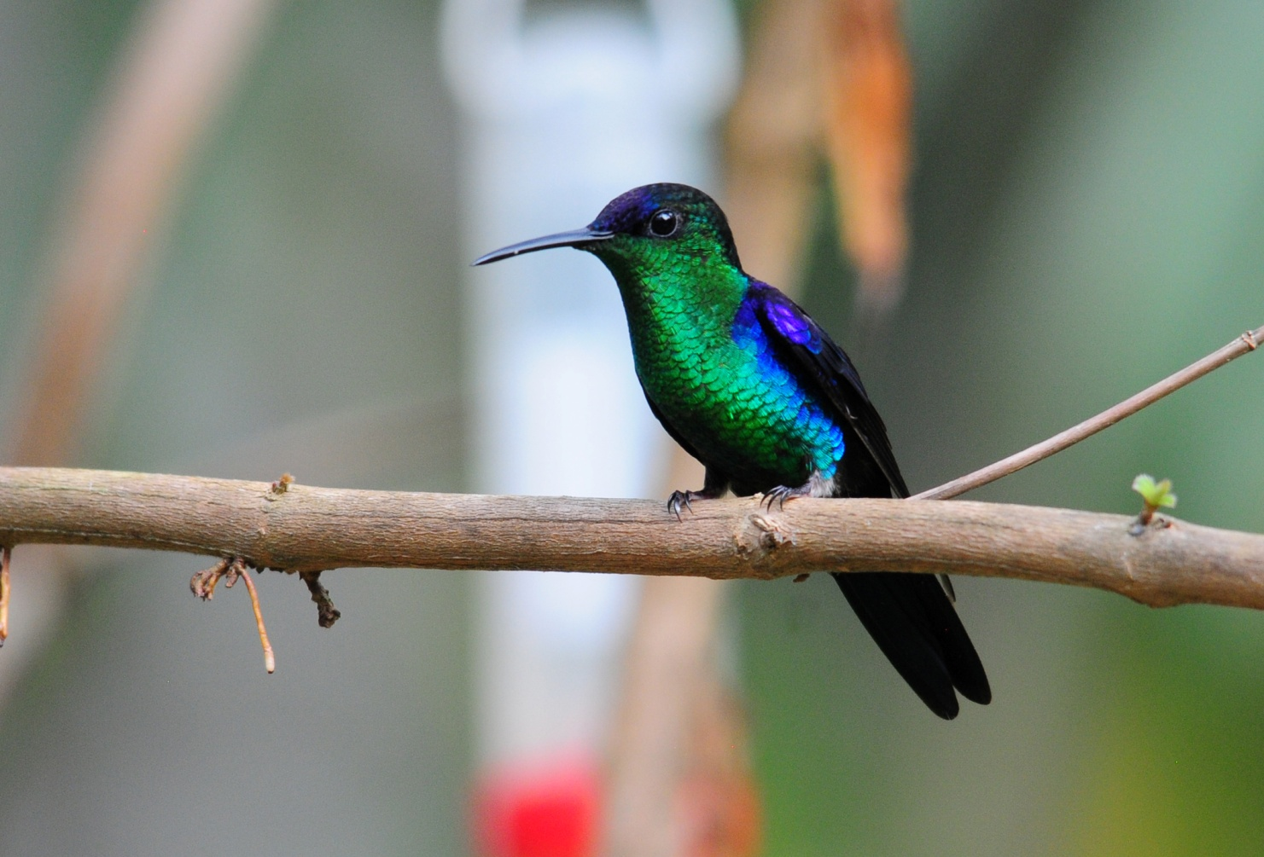
Violet-crowned Woodnymph
recorded, with Band-tailed Barbthroat, Brown Violetear, and Scaly-breasted Hummingbird new for the trip. Along a wooded path, Glenn and Terry pointed out a hummingbird nest with two chicks in it, but they weren't certain which species it was. We walked a short distance to a lovely shaded pond and waterfall, but by this time of day the group seemed more interested in conversation than searching for birds. On the way back to the deck, they showed us another hummingbird nest that was not quite finished yet.

We arrived back at Pico Bonito Lodge and enjoyed a presentation by the assistant manager, James Adams. He showed some wonderful slides of some of the animals and birds that can be seen at Pico Bonito and environs, and then we had our final dinner of the trip. James and his lovely girlfriend, Cindy, joined us, along with Glenn and Terry, the owners of Rio Santiago.

We finished the day with 100 species, bringing our trip total to 238 with another 21 heard only.

Day 8, Saturday, February 9: Departure
We had a nice breakfast and departed at for the San Pedro Sula Airport, about 2.5 hours away. Four of our group stayed on at Pico Bonito for a couple of extra days, and we learned that they were able to see Yellow-eared Toucanet at the lodge after we left. Four of our group stayed on to visit Copan, and we dropped them at the airport where they rented a car. Alex met them in the Copan area, where he lives, to show them a bird rehab facility that he supports. The rest of us headed back to the US.
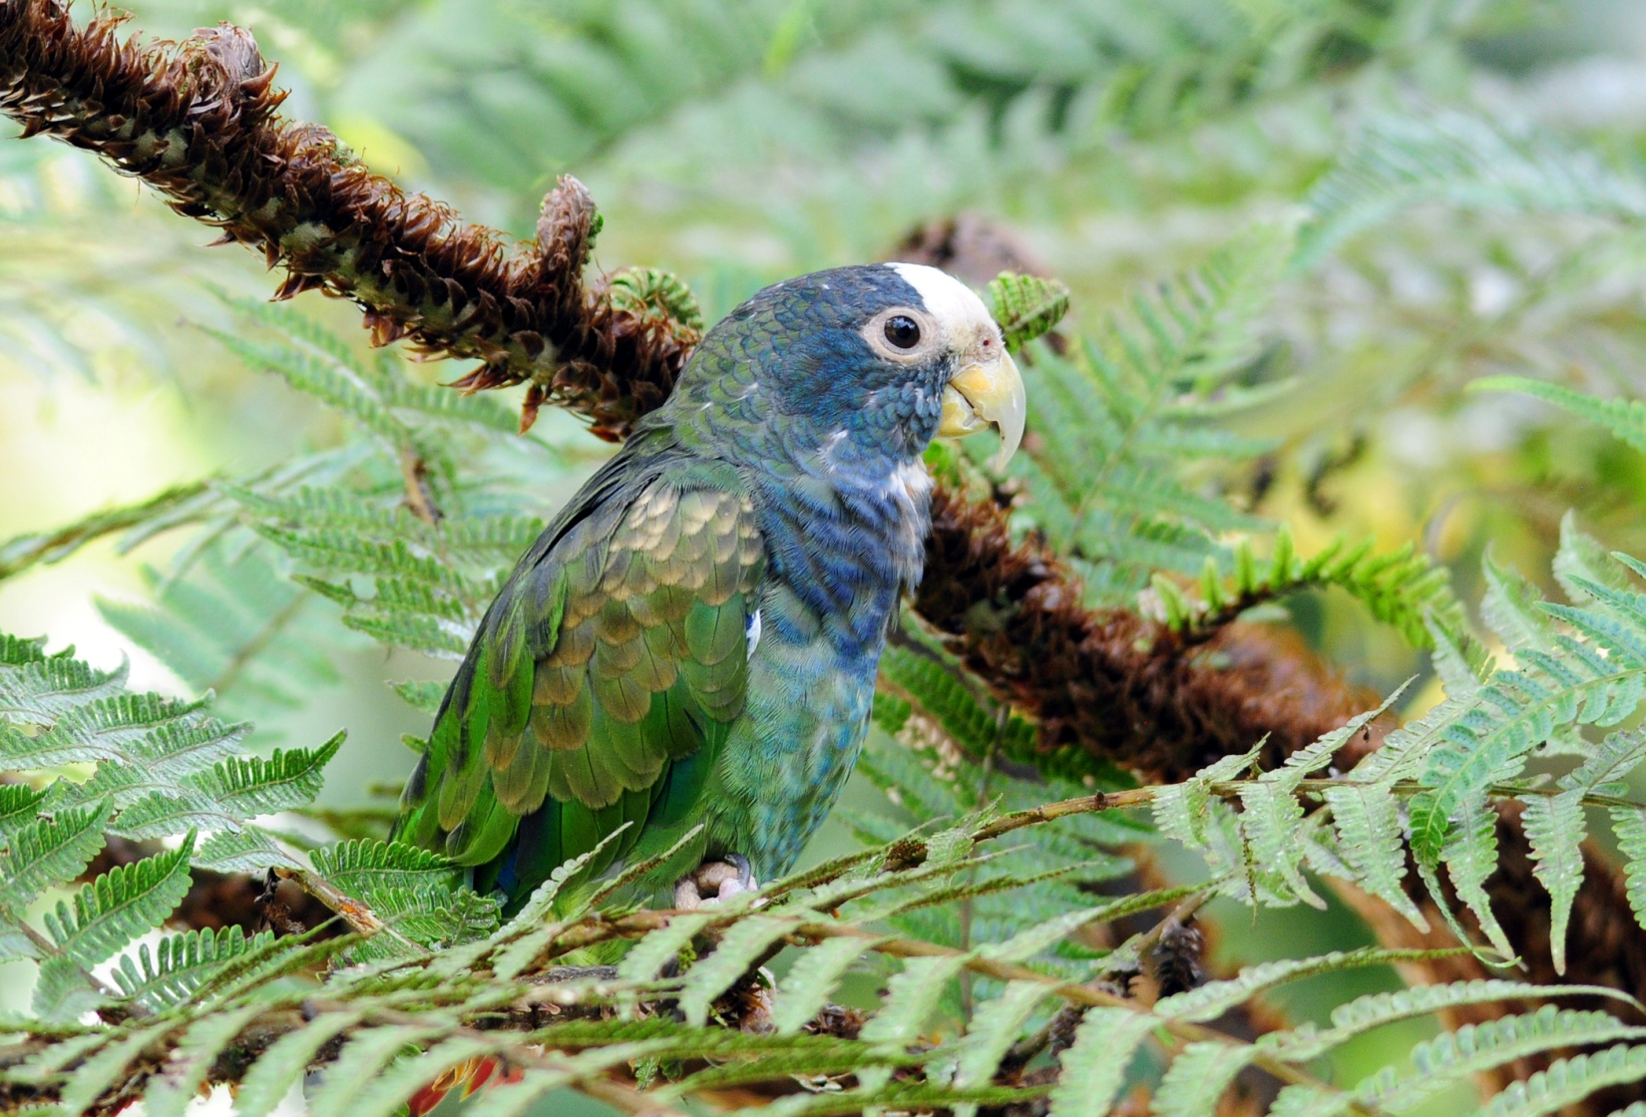
White-crowned Parrot

