GUYANA
November 28 – December 11, 2018
Participant Registration

Please complete in full and return with deposit of $800. Balance is due by July 28, 2018. Make checks payable to Cheepers! Birding on a Budget. Mail deposit and 4-page form to:
Cheepers! Birding on a Budget LLC
PO Box 385
Spring Valley, OH 45370

Name (as it appears on your passport)______________________________________________________________________________________
Address __________________________________________________________________________________
City, State, Zip _____________________________________________________________________________
Home Phone _____________________________________ Cell Phone________________________________
Email address______________________________________________________________________________
Birthdate ________ _________ ____________ Male_____ Female ______
Passport Number ___________________________________________________________________________
Place of Issue _______________________________________ Expiration Date _________________________

PRICING
Full price for the 14 day / 13 night Guyana tour is $5250 USD with a single supplement of $350. I understand that the price quoted is for a group of 8 – 10 participants, and a surcharge will apply for groups smaller than 8. I will have the option of withdrawing from the tour and receiving a full refund of any deposits and payments in the event the small group surcharge is more than I am willing to pay.

Signature______________________________________________________________________________

Page 1 of 4
PHYSICAL CONDITION
Excellent Good Average Poor
Dietary Restrictions _________________________________________________________________________
_________________________________________________________________________________________
Allergies __________________________________________________________________________________
Health concerns (blood pressure, heart condition, etc)____________________________________________
_________________________________________________________________________________________
_________________________________________________________________________________________
Personal Physician_____________________________________________ Phone _______________________

INSURANCE INFORMATION
I acknowledge that I am solely responsible for any hospital or other costs arising out of any bodily injury or property damage sustained through my participation in this voluntary travel. In this regard, my health and accident insurance policy is provided by the provider named below.

Health Insurance Provider____________________________________________________________________
Policy number or other ID ____________________________________________________________________

Signed__________________________________________________________________________
It is strongly recommended that trip participants purchase short-term traveler’s insurance covering medical, accident/life, lost baggage, and trip cancellations due to family emergencies and/or illness.

Do you have trip insurance? yes____ no_____
If yes, name of company_____________________________________________________________________
Policy number or other ID ____________________________________________________________________

EMERGENCY CONTACT INFORMATION

Name___________________________________________________________Relationship________________
Home Phone _____________________________________ Cell Phone_________________________________________

Page 2 of 4

ACCOMMODATIONS

I will be rooming with ____________________________________________ Number of Beds (1 / 2) ________

I prefer single accommodations and will pay the single supplement of $350.
I would like to be assigned a roommate. If none is available, I will pay the single supplement

Terms and Conditions
Reservations for the Guyana tour require a deposit of $800.00. Payment in full is due by July 28, 2018.
All cancellations must be notified in writing.
If notice of cancellation is received before May 28, 2018, your deposit is fully refundable.
If notice of cancellation is received between May 28 and July 28, 2018, 50% of your deposit will be refunded.
If cancellation is received after July 28, 2018, you will not be entitled to any refund of deposits.
If cancellation occurs after full payment is made, a refund will be given only if the vacant spot is filled.

Cheepers! Birding on a Budget LLC reserves the right to make changes in the itinerary if the need should arise due to unforeseeable circumstances such as weather, landslides, and other natural phenomena, as well as suggestions by local guides in order to take advantage of an unusual birding opportunity. Lodging is subject to change based on availability.

All participants are required to sign the following Release, Waiver of Liability and Covenant Not to Sue on page 4.

Page 3 of 4

RELEASE, WAIVER OF LIABILITY AND COVENANT NOT TO SUE
(Read carefully before signing)

The undersigned hereby acknowledges that participation in any travel involves some risk and assumes all such risks. The undersigned hereby agrees that he/she does hereby waive liability, release and forever discharge Cheepers! Birding on a Budget LLC, Jim Beckman, and Cindy Beckman from any and all claims, demands, rights and causes of action of whatever kind of nature, arising out of all known and unknown, foreseen and unforeseen bodily and personal injuries, damage to property and the consequences thereof, including death, resulting from undersigned’s voluntary participation in or in any way connected with such travel.

I further covenant and agree that I will not sue Cheepers! Birding on a Budget LLC, Jim Beckman, or Cindy Beckman for any claim for damage arising or growing out of my voluntary participation in travel.

Name of Participant (Please Print): ___________________________________________________
Signature / Date:
✘______________________________________ /______

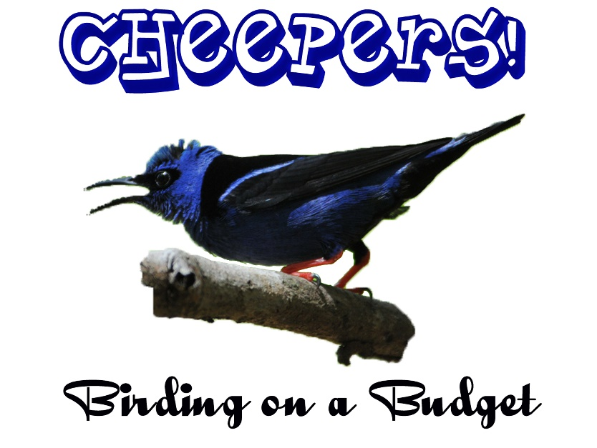

Page 4 of 4

