ECUADOR
Trip Report
November 20 - December 8, 2010

Northwest Ecuador, Eastern slope of the Andes, Amazon River Basin Extension
Disclaimer: Seeing 581 species in 17 days of birding is not only amazing, it is somewhat overwhelming. My report is as accurate as possible using limited notes taken in the field, but it is possible that the report contains some errors. Species have been reported on the proper day(s) but, with multiple sites visited on the same day, it is possible that some species are listed as being seen at the wrong location. Any such errors are unintentional.

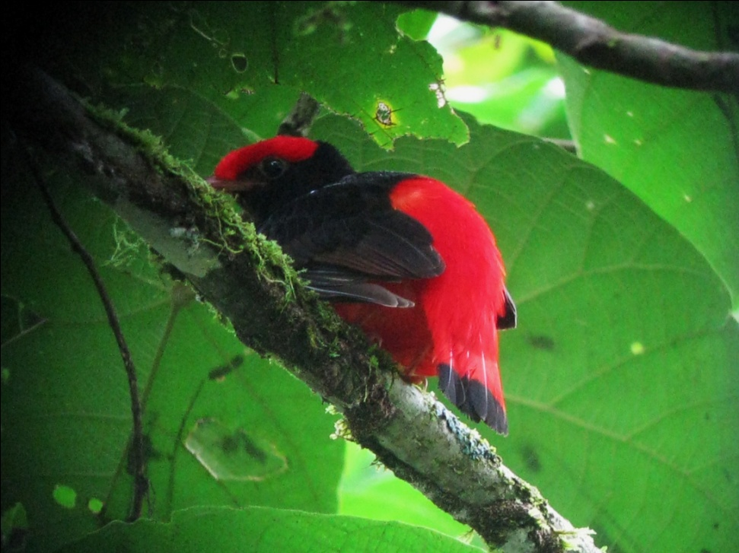
Species seen by group: 581
Additional subspecies seen: 15
Additional species heard: 59
Birding guides: Marcelo Andy, Galo Real
Tour leaders: Cindy and Jim Beckman (Cheepers! Birding on a Budget owners)
Group: 9 + 2 tour leaders and 2 guides
Highlights: Black-necked Red Cotinga; Zigzag Heron; Amazon Umbrellabird; Tanager-finch; Oilbirds in a sunlit gorge; Band-bellied, Black-banded and Mottled Owls; Wire-crested and Rainbow-bearded Thorntails, Moss-backed Tanager; Andean Condors (10!); Crested Eagle; Plate-billed, Gray-breasted and Black-billed Mountain-Toucans; Ringed, Scarlet-backed and Bar-bellied Woodpeckers; Yasuni and Dugand's Antwrens; Blackish, Rusty-belted, and Spillman's Tapaculos; Yellow-cheeked Becard; Andean, Rufous-brown, and Black Solitaires, Gray-breasted Crake

Above: Black-necked Red Cotinga
Right: Violet-tailed Sylph
Below: Flame-faced Tanager
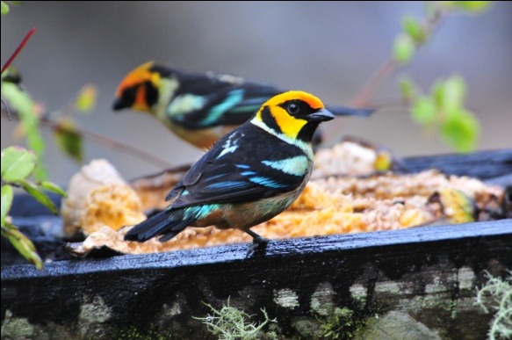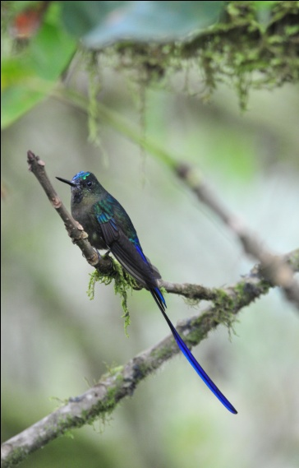
This trip report was written by co-leader Cindy Beckman

Pretrip, Thursday - Saturday, Nov. 18 - 20
Jim and I had met George Cruz, owner of San Jorge Magic Birding Circuit Ecolodges, at the Monterey Birding Festival in September. He told us a lot about his lodges in Ecuador, and encouraged us to visit when we had an opportunity. Because of the limited options in airline schedules when miles are used, we were scheduled to arrive two days ahead of the group. This seemed like a perfect time to check out some different sites that we might want to include in future tours. We arrived late on the 18th and were met at the airport by Jose, who drove us directly to San Jorge Quito lodge, a beautiful historic (circa 1780's) ranch house that has been converted to a lovely lodge. Additional buildings further up the slope were built in recent years using the same style, providing central heat in rooms with the same charming atmosphere as the older original house. A fire was burning when we entered our room, although it was still quite chilly inside. We climbed under the heavy wool blankets and went to sleep, although once the fire went out the temperature in the room dropped enough to keep me awake a large part of the night. There was a space heater located in the huge tiled bathroom (one of the largest bathrooms I've ever seen), but it did little to warm the immense square footage and I was reluctant to take a shower in what felt like Arctic temperatures when we woke at 6:00 AM for breakfast. We dressed quickly and headed to the dining room. After breakfast, we met George Cruz for a morning of birding. We were quite relieved when the early morning drizzle stopped and the sun came out to warm us up. We walked a trail behind the lodge before leaving for the San Jorge Tandayapa Lodge. At Tandayapa, there was quite a long walk from the road up to the lodge, but it was along a delightful forest trail and we birded along the way. We birded the rest of the afternoon and spent the night at Tandayapa. The lodge is beautifully situated on a hillside with stunning views of the surrounding area. The rooms feature local hardwoods and huge windows facing two directions. Birds were abundant at the feeders, so much so that it was difficult to focus on the delicious meals presented to us. We departed for George's San Jorge Milpe lodges the next day. Again, the lodges were built well away from the road and the noises associated with traffic. Huge decks outside lovely rooms make this a place anyone would want to just stay awhile to enjoy the atmosphere and the view. George explained his plans for expansion before he had to leave for an appointment in Quito. He left us with two native guides who were to lead us to an area where a Cock-of-the-Rock nest had been found. Neither of them spoke English, so it was a bit difficult to communicate with them as we walked down, down, down, down, down . . . . you get the idea. My thoughts were on the up, up, up, up, that was to come and after a couple of hours I finally managed to ask, "Quantos minutos mas?" I was told we had about another 20 minutes to go farther down, and I decided we should keep going since we had already invested so much energy in getting this far. When we got to the nest site at around 4:00 PM, there was no bird present. I'm pretty sure I understood the guide when he told me they show up at around 5:00 PM, so you can imagine my dismay at having come so far to see a bird that the guides presumably knew would not be there. The walk back up was as grueling as I had imagined, and more than once I had to stop to allow my trembling leg muscles to recover. As we approached the lodge, it began to rain. The guides snapped off a couple of huge leaves to use as umbrellas, and we made it back to the lodge just minutes before Jose arrived to drive us back to Quito. We arrived at the Hotel Sebastian in time for dinner, and planned to meet the Meyers at the airport a few hours later. Much to our surprise, they introduced themselves to us as we were waiting for our meals to arrive. Their flight had been changed, and they had taken a taxi to the hotel. We enjoyed getting to know them a little as we had our evening meal and then went to our room to rest before the others arrived. The last four people didn't arrive until after midnight, so we postponed our departure time for the next morning until 7:30 AM.

Most of the birds seen during the first two days with George at his San Jorge lodges were also seen later on the regular tour. Some that we observed that were not seen later include Red-billed Parrot, White-tipped Dove, Chestnut-collared Swift, Western Emerald, Crested Quetzal, Blackish Tapaculo, Grass Wren, Glistening-green Tanager, and Blue-and-yellow Tanager.

DAY 1, Sunday, Nov. 21: YANACOCHA, NONO-MINDO ROAD, SACHATAMIA LODGE
Everyone was in the dining room by 7:00 AM, and we departed on time for our first full day of birding. Leaving some of our luggage to be stored at the Sebastian, we loaded the stuff we would need for the next seven days into the bus and left Quito at around 7:30. We arrived at Yanacocha a little before 9:00 AM, making no real stops for birds but managing to see a few along the way nevertheless: Eared Dove, Southern Yellow Grosbeak, Rufous-collared Sparrow, Black Flowerpiercer, Great Thrush, and Rock Pigeon.

It was not as cold at Yanacocha as it had been when we were there in February, but it was very foggy and most of the time it felt like we were walking through a light mist. Occasionally it would rain for real; we were all prepared with raincoats, ponchos, and/or umbrellas to keep us dry.

As soon as we arrived, we began our walk toward the hummingbird feeders at over 11,000 feet elevation. As we walked along the old road, we heard the almost incessant call of the Tawny Antpitta. Galo and Marcelo assured us we would have the opportunity to see this bird at some point since it normally comes out into the open, unlike other members of its family. As we walked, Galo and Marcelo alerted us to the presence of any species they heard. Their skill at recognizing calls and then finding the birds in dense vegetation was nothing short of amazing. The fog and mist added to the difficulty of their task. I've been to Yanacocha two other times, and it was noticeably less active this morning. We didn't encounter any large mixed flocks moving through the area as we did on previous trips, but Galo, Marcelo and the group did manage to find several good species.

Masked Flowerpiercers were among the first species seen, and we continued to see more of them as we walked toward the feeders at the end of the road. White-throated and White-banded Tyrannulets gave everyone excellent close-up views, and some people caught a glimpse of a Rufous Antpitta. Galo and Marcelo located a Barred Fruiteater, but the fog was so thick we could barely see color, much less field marks. Pearled Treerunner, Superciliaried Hemispingus, Scarlet-bellied Mountain-Tanager, Spectacled Whitestart, and Rufous-naped (Yellow-breasted) Brush-Finch all made an appearance. As the fog increased, it seemed the bugs became more annoying. As I made a note on my recorder to remind myself to warn everyone to use bug spray for this day, a couple of sightings were called out - Chestnut-capped Brush-finch and Black-chested Mountain-Tanager. We saw so many Rufous Wrens today that I was surprised, as was Marcelo, that this was a life bird for Jim and me. Two Conebills, Cinereous and Blue-backed, were seen feeding together in the same area.

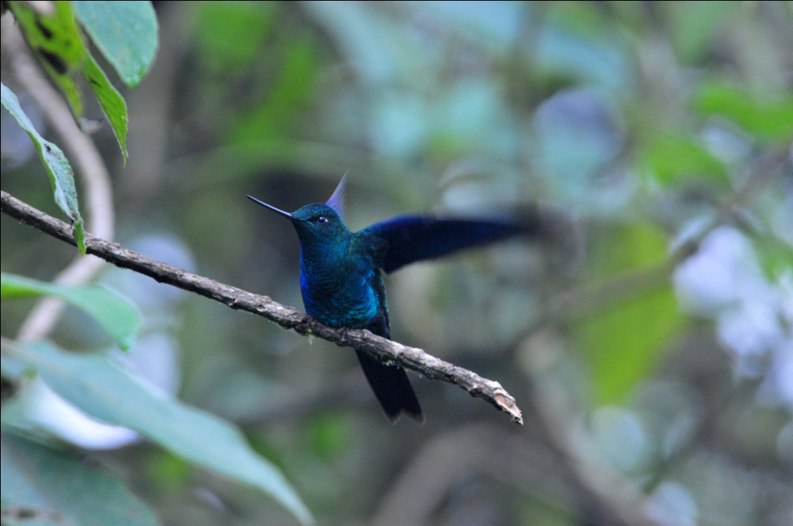
Great Sapphirewing

When we arrived at the main feeders, we were not disappointed. The rain stopped just as we approached, and the feeders were alive with hummingbirds. Most numerous were Buff-winged Starfrontlets, and they and the other common Yanacocha hummingbirds put on quite a show for us. Cameras were in rapid-fire mode as the Starfrontlets, Sapphire-vented Pufflegs, Tyrian Metaltails, Speckled Hummingbirds, Sparkling Violetears, and Golden-breasted Pufflegs jockeyed for position at the feeders. As always, the Great Sapphirewing and the Sword-billed Hummingbird elicited some oohs and aahs, but the best sighting at the feeders was undoubtedly the single appearance of a Rainbow-bearded Thornbill. It showed up just once, right after we arrived, and it lingered long enough for everyone to appreciate it thoroughly. Thanks to Jude for alerting us to this " different" bird!

As we walked back toward the parking lot, we spotted several other species, but not enough to please Marcelo. As we walked along, he commented that we had walked for over two hours and "hardly no birds". I don't think the rest of the group was disappointed in the morning's birding, as almost every species was a lifer for most of the group. Even as it started to rain, we added a few new species to the morning's list, Streaked Tuftedcheek, White-tailed Tyrannulet, Scarlet-bellied Mountain-Tanager, and Bar-bellied Woodpecker. But it was a slow morning by Yanacocha standards (or by Marcelo standards).

We ate lunch under a canopy near the park office, sheltered from the drizzle that continued into the afternoon, still pretty chilly. Everyone was almost done eating when Jean alerted us to a Tawny Antpitta - right at her feet! As we all jumped up to see the bird, we (of course) scared it away. We sat quietly and waited, and within minutes it returned, almost as if it were looking for scraps of food. A few photos were taken before it disappeared again, but it returned yet another time and allowed closer approach. Now, if only the lighting had been better . . . . People with cameras (I'm speaking of myself) are rarely satisfied.
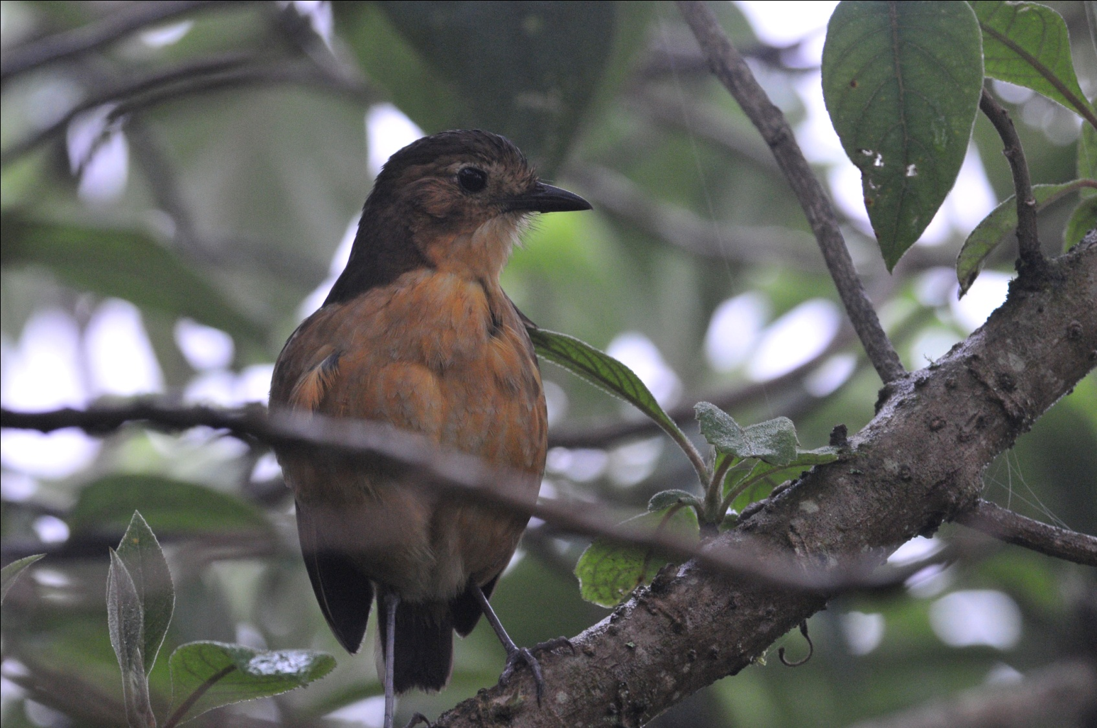
Tawny Antpitta

We drove on toward the Tandayapa Valley without making very many stops because of the rain. Everyone was watching for White-capped Dipper as we drove alongside a fast-flowing stream on Old Nono Mindo Road. It wasn't long before someone called out, "Dipper!" Luckily, the rain had stopped and we all bolted out of the bus for a better look. We watched as two dippers flew up and down the stream, calling as they flew by.

We had planned to go straight to Sachatamia Lodge, where we would be staying for the next three nights, but since the rain had stopped, we went to Bellavista Research Station Road for a little birding before the light faded. There, we added Yellow-bellied Chat-Tyrant, Spillman's Tapaculo, Blackburnian Warbler, Golden Tanager, White-tailed Tyrannulet, Masked Trogon, and Grass-green Tanager to the day's list before checking in at the lodge. We heard the Plate-billed Mountain-Toucan, a bird high on our wish list not only because it is so beautiful, but also because its likeness adorns the cover of the Field Guide to the Birds of Ecuador. This road is one of the best places to find this bird, but we ran out of daylight before we could locate it. Just as it was getting dark, we saw the rare and local Tanager-Finch, pretty much in exactly the same spot we saw it in February. Other birds seen today included Gray-rumped Swift, Crimson-mantled Woodpecker, Great Thrush, Streak-throated Bush-Tyrant, Plain-colored Seedeater, Stripe-headed Brush-Finch, Tropical Kingbird, Glossy and Black Flowerpiercers, and Stripe-headed Brush-Finch. We finished the day with just 48 species seen by the group. It was a great day of birding, but it fell short of expectations.

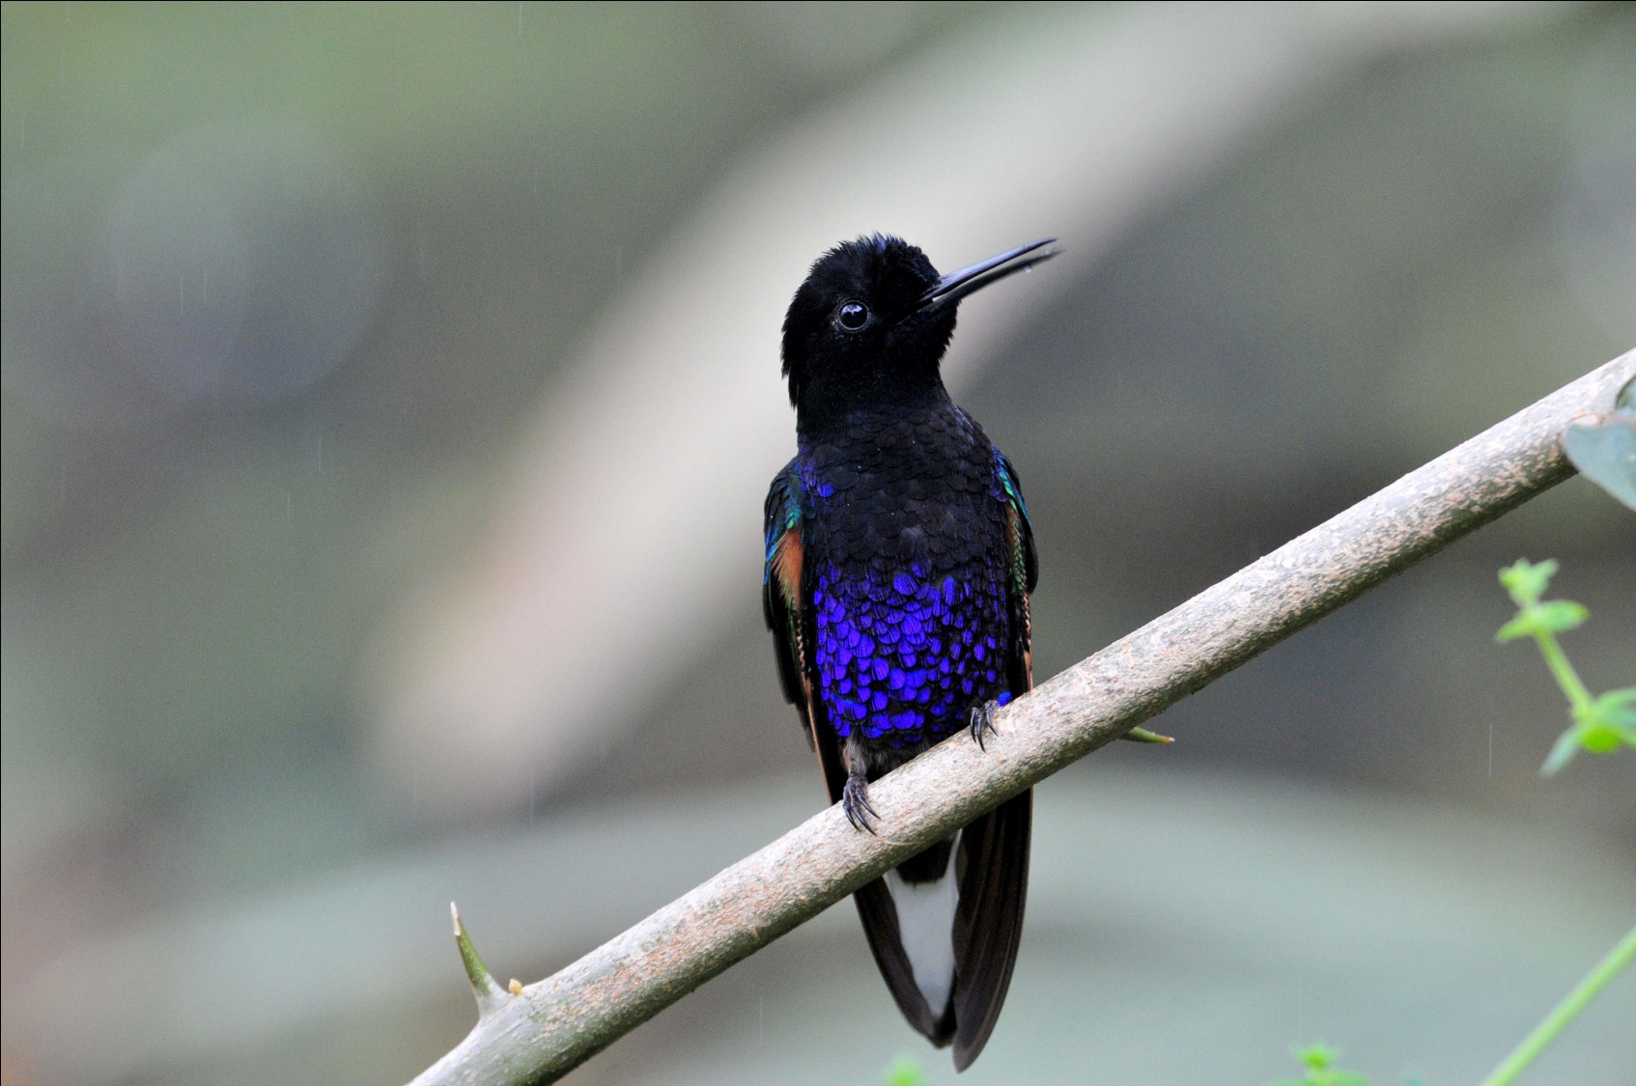
Velvet-Purple Coronet

DAY 2, Monday, Nov. 22: SACHATAMIA, BELLAVISTA ROAD & LODGE, NONO-MINDO ROAD
What a thrill it is to wake up at Sachatamia! By the time we finished breakfast, the feeders were humming (literally) with activity. New hummingbirds for the trip included Velvet-Purple Coronet, Fawn-breasted Brilliant, Violet-tailed Sylph, Purple-throated Woodstar, Rufous-tailed Hummingbird, White-whiskered Hermit, and Empress Brilliant. At the platform feeders we got better looks at Golden Tanager as well as a couple of new species for the trip, Flame-faced Tanager and Blue-winged Mountain- Tanager. In trees near the entrance we spotted Golden-crowned Flycatcher, Blackburnian Warbler, Strong-billed Woodcreeper, and Red-eyed Vireo.

Because the birding had been so good on Bellavista Research Station Road the night before (and we had not seen the Plate-billed Mountain-Toucan), we decided to return there this morning. We left Sachatamia at 6:30 for the short drive to our birding site for the morning. We made a single stop along the way to get a better look at the Tanager-Finch that we had seen the night before. This morning, we had better light and longer looks, satisfying everyone. Unfortunately, when we arrived at our destination, another birding group was just starting down the same path we had intended to take. We stalled for a short while at the intersection, allowing them to get ahead of us before we started our own walk. As we waited, we got some good looks at a Sierran Elaenia that was preening in a tree over the trail. Other birds seen before we actually began our walk included Spotted Barbtail, Turquoise Jay, Hooded Mountain-Tanager, Pearled Treerunner, Band-tailed Pigeon, Blue-black Tanager, Gray-breasted Woodwren, Great Thrush, and Glossy-black Thrush.

Again, the birding activity was not at the level we expected once we were finally able to proceed down the road. We did not encounter the other group for quite awhile, indicating that they were advancing along the trail fairly rapidly as well, presumably because there were not huge numbers of birds to stop and view. Nevertheless, we did manage to see quite a few remarkable birds for a "slow" morning: Crimson-mantled Woodpecker, Streaked Tuftedcheek, Spectacled Whitestart, Blue-winged Mountain-Tanager, Green-crowned Woodnymph, Dusky Bush-Tanager, Beryl-spangled Tanager, Marble-faced Bristle Tyrant, Grass-green Tanager, and the much sought-after Plate-billed Mountain-Toucan to name a few.

As the morning progressed, it began to drizzle, and we left the road earlier than we had planned. When we returned to Sachatamia Lodge, most of us went straight to the feeders to observe the hummingbirds that we had pulled ourselves away from earlier that morning. Now we could identify some of them, and as the day went on, more and more of the jeweled beauties became familiar to us. In time, most of us could identify most of them.

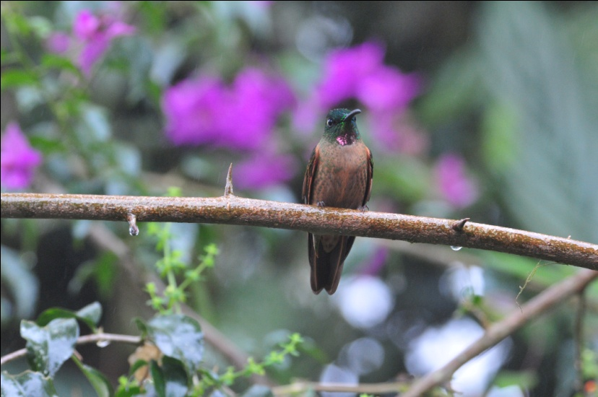 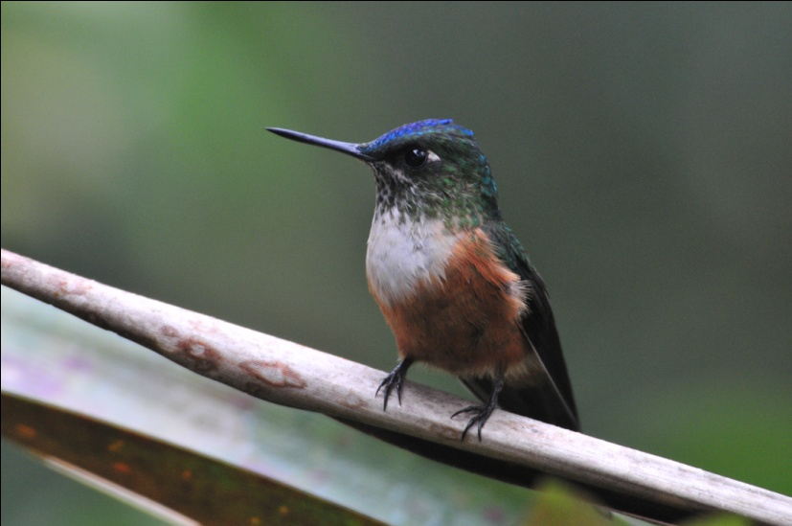 Fawn-breasted Brilliant Violet-tailed Sylph, female

Around the feeders and between the lodge and the cabins, people walking in groups of two, three, or four birders were finding different species: Azara's Spinetail, Russet-crowned Warbler , Streak-necked Flycatcher, and Southern Beardless-Tyrannulet were all seen by part of the group. As the drizzle continued, most of our group settled in under the shelter of a small gazebo that was well-positioned to view the platform feeders. From there, a parade of gorgeous birds appeared, including Blue-gray, Flame-faced, Palm, Golden, Summer, Golden-naped , Lemon-rumped and White-lined Tanagers. Immature Palm Tanagers and Flame-faced Tanagers were led to the feeders by adult birds, and both male and female White-lined Tanagers were seen. Other species at the feeders included Orange-bellied and Thick-billed Euphonias, and Dusky Bush-Tanager, while the hummingbird feeders continued to produce new species such as Brown Inca, Andean Emerald, Purple-bibbed Whitetip, and Tawny-bellied Hermit. In the trees near the feeders the birders spotted Tropical Parula , Beryl-Spangled Tanager, and Rusty-margined Flycatcher. A Roadside Hawk flew into view. A few lucky birders got to see a Tri-colored Brush-Finch in the low shrubs near the feeders, and I saw a female White-sided Flowerpiercer feeding in the bushes near one of the hummingbird feeders.

After a hearty lunch (honestly, it's a good thing we do a lot of hiking on this trip!), we started back up Nono-Mindo Road toward Bellavista Lodge. As we drove, someone spotted a large bird from their window and called out for Luis to stop. There, close to the side of the road, sat a female Golden-headed Quetzal. We all got good looks from the bus and then very carefully ventured out for better looks and to take some photographs from a position with less backlighting. We walked around the back of the bus and spoke in whispers to keep from spooking the bird, but we soon discovered this was not necessary. She sat there quietly as we moved about, snapped photos, and talked among ourselves until we finally piled back into the bus to move on. The bird didn't fly until we were beginning to move away.

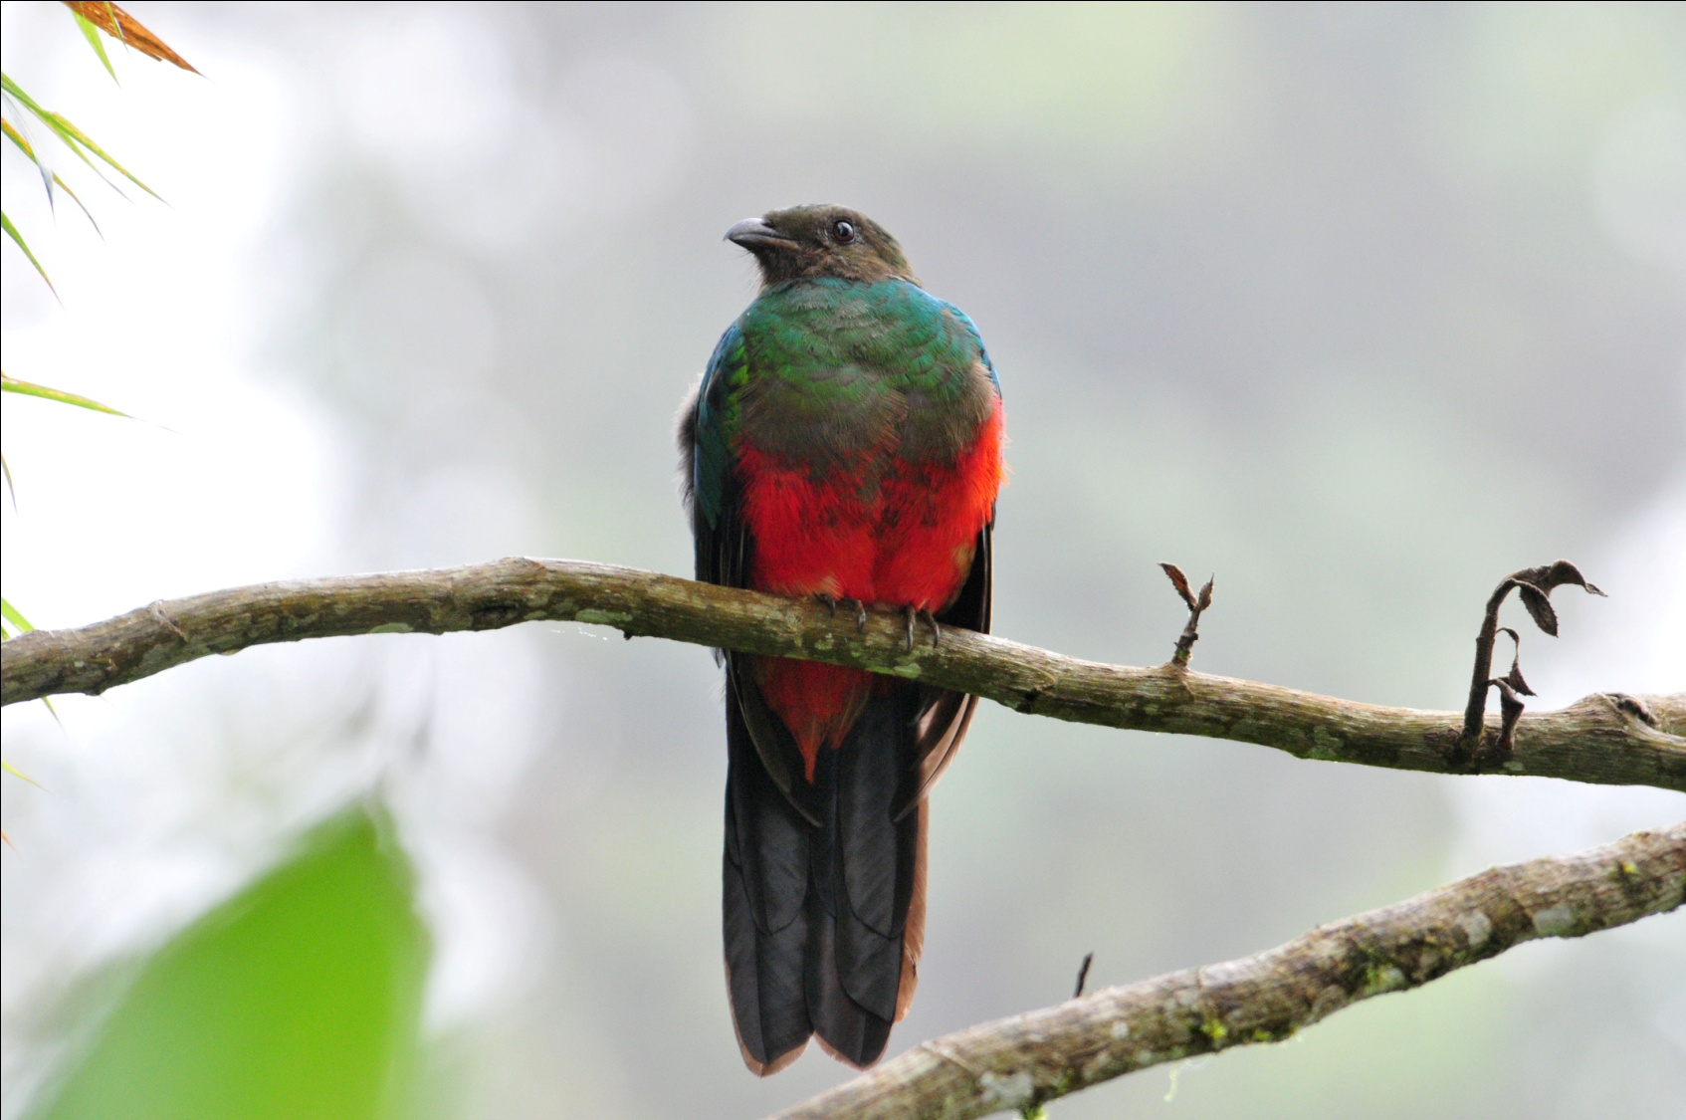
Golden-headed Quetzal, female

Our next stop was at Bellavista Lodge to check out their feeders and a short bit of one of their trails. We enjoyed a cup of hot coffee or cocoa as we watched the Booted Racket-tails and Violet-tailed Sylphs come and go at the feeders. Gorgeted Sunangel made an appearance, as well as Collared Inca, Buff-tailed Coronet, and White-necked Jacobin, all new species for the trip. A Southern Yellow Grosbeak landed on the roof of the lodge, and Striped Hummingbirds joined the throng at the feeders. The drizzle had stopped, and we made our way to a trail near the entrance to the property where we had seen White-throated Quail-Dove on previous trips. A short distance down this trail is a compost pile, and if you approach very quietly, almost anything might be feeding there. As we were searching for the Quail-Dove, Marcelo spotted a Chestnut-crowned Antpitta hop out of and behind the compost pile. Galo and Marcelo instructed us to be still and quiet, and sure enough, the bird returned to continue feeding. As we watched it, more birds appeared on the trail in front of us: Russet-crowned Warbler, Three-striped Warbler, Rufous-chested Tanager, Montane Woodcreeper, and a bit further down the trail, Powerful Woodpecker.
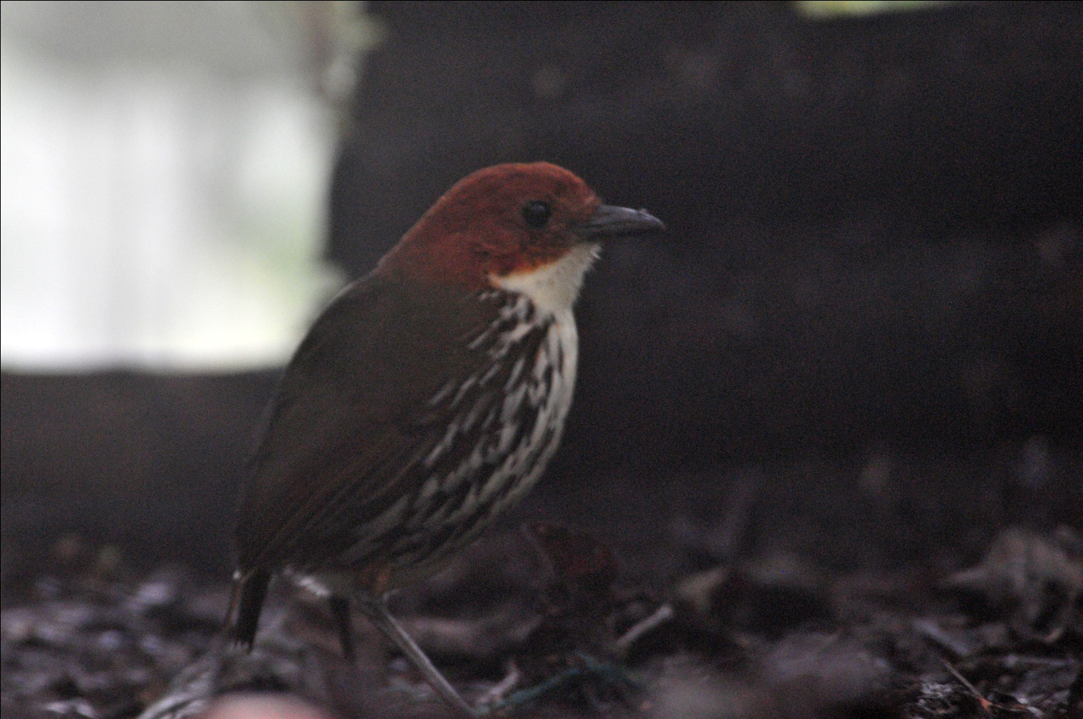
Chestnut-crowned Antpitta

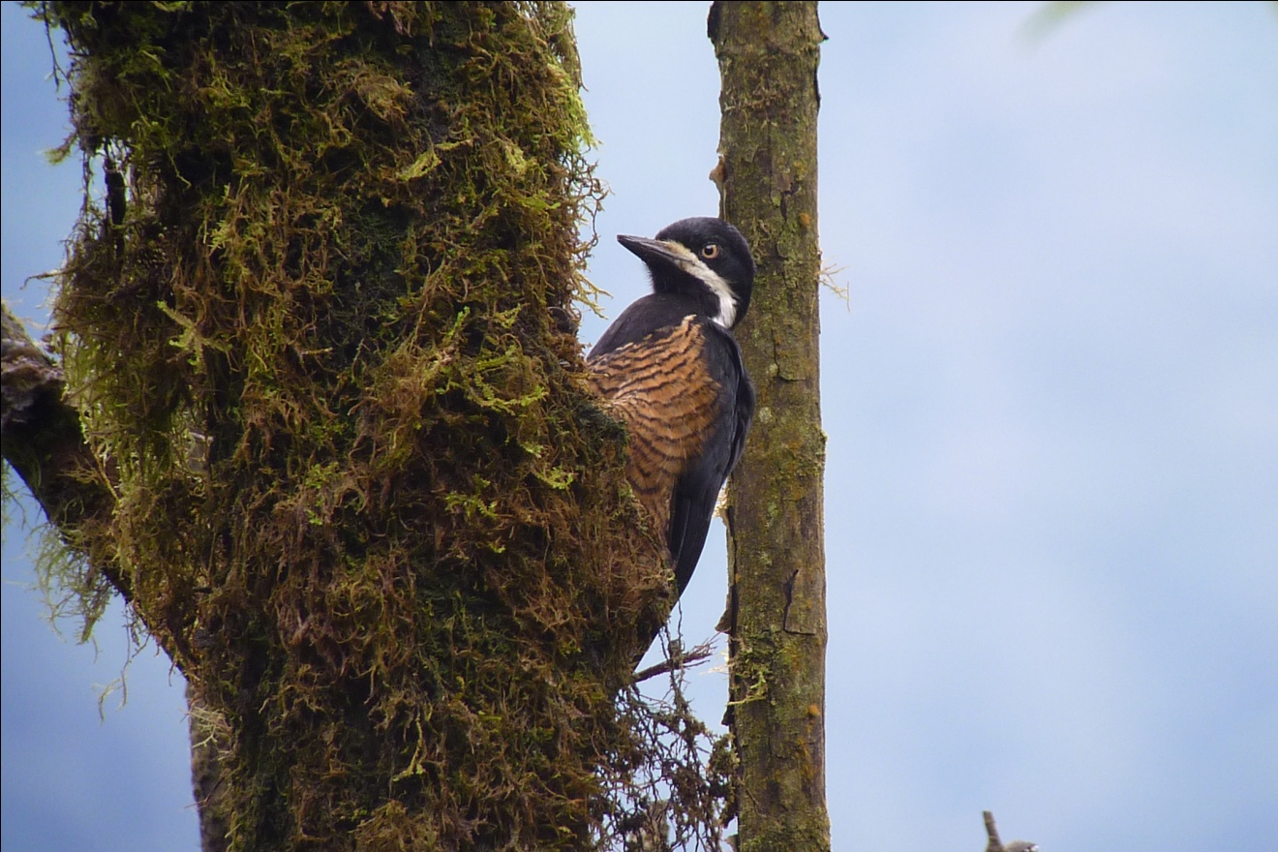
Powerful Woodpecker
Other species seen on Day 2 included Cattle Egret, Sickle-winged Guan, Brown-capped Vireo, and Shiny Cowbird. When we updated our checklists at the end of the day, we found we had seen 78 species for Day 2, 109 so far for the trip.

DAY 3, Tuesday, November 23: REFUGIO DE LAS AVES, OILBIRD ROOST
This morning the alarm went off at 3:15 to allow us time to get ready before meeting the group in the lobby at 4:00 AM for a 4:30 departure. We planned on the early meeting time so we could look for some resident owls before leaving. Jim and I were the first to arrive, and Galo motioned us to move down a path behind the lodge where Marcelo had a Mottled Owl in sight. When we got there, the owl was sitting lower than eye level in a light drizzle, and we both got decent looks as Marcelo shined the light on him. Before anyone else arrived, the owl took flight. After the others came, we continued to look for a short while, but we could not relocate the owl.

Our exceptionally early departure was to visit one of the most special spots on the trip, Angel Paz's famous refuge featuring "tame" Antpittas, a Cock-of-the-Rock lek, and fabulous feeders. Several years ago, when Angel was cutting a trail in his forest so birders could come to see his Cock-of-the-Rock lek, he started seeing antpittas as they came to eat the worms that he excavated. With a lot of patience and hard work (and a lot of worms), he succeeded in training these normally secretive antpittas to respond to the sound of his voice - they actually come when he calls their names! The first bird he "trained" was Maria, a Giant Antpitta who has since brought her offspring to take the worms offered by Angel. What a sight it is to see Angel stand on the trail with his container of worms calling, "Maria! Maria!" Other birds who have learned to trust Angel include Willie, a Yellow-breasted Antpitta; Jose, a Moustached Antpitta; and Shakira, an Ochre-breasted Antbird who was so named because she "shakes her tail".
We needed to be in a blind deep in the valley of the forest before daybreak in order to see these amazing birds as they performed on their lek at sunrise. We took a snack along since we knew that breakfast wouldn't be served until about 10:00 AM. The bus was unusually quiet as Luis drove us to our destination, where we emerged in total darkness to walk down a forest trail by the light of our headlamps or flashlights. We made it to the blind just as the Cock-of-the-Rock males began to vocalize. Quite an unusual sound and very un-birdlike in tone, it took awhile for all of the birders to realize this sound emanated from our target bird. In the dim light we could see some bright red males posturing and calling, but it was too dimly lit to take photographs. Angel has wisely prohibited flash photography, and we were happy to abide by the rule to protect this wonderful lek. As we were watching the Cocks-of-the-Rock, someone alerted us that "Maria" was present. Looking behind me, I saw a Giant Antpitta standing on the trail at eye level. Angel told us it was not Maria, but Manuela, one of Maria's offspring. Everyone turned their attention to her, but I kept my eyes on the Cock-of-the-Rock males that were still in the area, secure in the knowledge that the Antpittas would be seen later, in better light, when Angel called them out to offer worms. I shot off one quick, blurry photo and turned away.

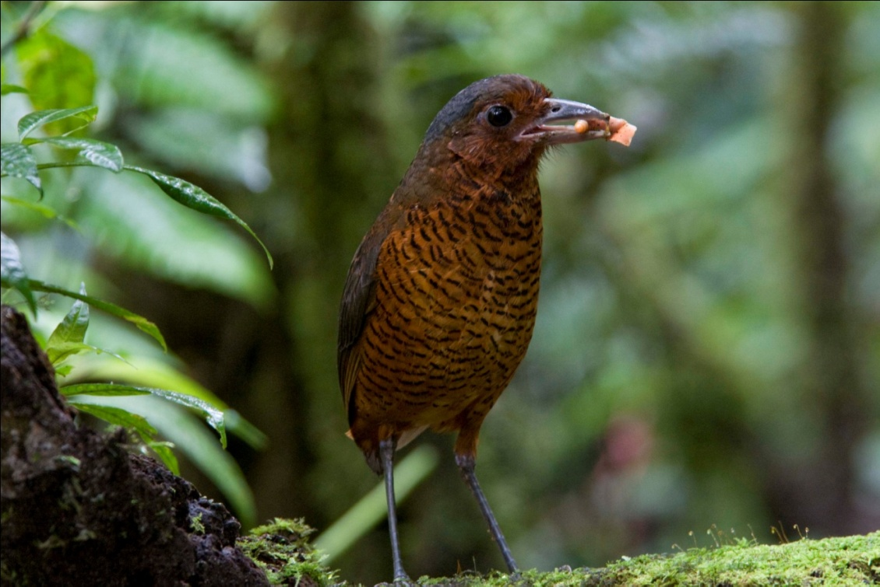
Maria, Giant Antpitta (2010)
A few minutes later, another group arrived at the blind. There was not enough room for both groups in the blind, so we gave up our spots and went uphill to the feeders, where we hoped to see several species up close, as had been the case on our last trip. This morning was not to be a good one for the feeder birds, however. As we waited, not much showed up at all. The other group joined us again, and once again it was much too crowded on the narrow trail. Jude spotted an Oilbird in a tree in the distance, much to the surprise of all of the birders as well as the guides. At first thinking the large brown lump was a mammal of some kind, she showed it to others and finally it was recognized as an Oilbird. Everyone got great looks through the scope before moving on to the spot where Angel feeds the Antpittas. As we walked the trails back to the area where we would see the Antpittas being fed, we came upon a fruiting tree that harbored some interesting females - both Cock-of-the-Rock and Golden-headed Quetzal were present. A male Cock-of-the-Rock came into view briefly, but it mostly stayed in the back of the tree where we couldn't see it and remained for only a short time, while the females of both species lingered for quite a while. As we stood watching the fruiting tree, other birds came into view, including a Rufescent Screech Owl. Collared Forest-Falcon and Red-billed Parrots were heard just before the parrots flew overhead. A Slate-throated Whitestart flitted about in the low trees in front of us while a Crimson-rumped Toucanet landed in the fruiting tree with the female Cock-of-the-Rock and Quetzal, which were joined by a male Golden-headed Quetzal. Flavescent Flycatcher, Tri-colored Brush-Finch, Fawn-breasted Brilliant, Spotted Woodcreeper, Masked Flowerpiercer, Andean Solitaire, and Golden-naped Tanager all made an appearance in the same area around the fruiting tree. We reluctantly moved on to the spot where Angel would call his antpittas, but today would not be a good day for seeing these birds. Maria and her offspring did not appear. In fact, the only Antpitta that came out for food was the Moustached Antpitta that Angel calls Susan. We were lucky to see a whole family of Dark-backed Wood-Quails come out to feast on the worms Angel offered.

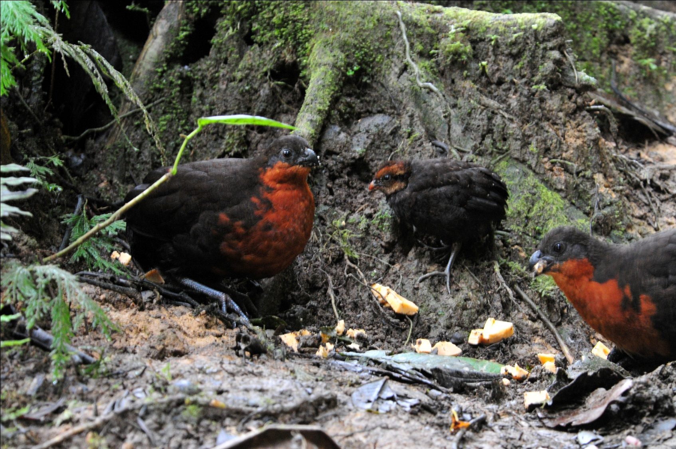
Dark-backed Wood-Quails
We moved on up the trail to head back to the bus and the authentic Ecuadorian breakfast that awaited us. Along the trail, Chestnut-capped Brush-Finch, Uniform Antshrike, and Long-tailed Antbird were spotted by the part of the group that was walking with Marcelo while others had gone ahead. At the hummingbird feeders, we enoyed seeing many of the familiar species and added Wedge-billed Hummingbird to our list. As we approaced the area where we would eat breakfast, we saw White-collared Swifts overhead. The other group of birders were finishing breakfast on the deck overlooking the valley, so our group took our seats near the kitchen. No one complained, but I was not pleased with the arrangement. I discussed with Galo how the overcrowding affected the birding as well as the comfort level and made arrangements to be the only group scheduled for the morning that we visit Angel's refuge on our next tour.

Regardless of the seating arrangement, breakfast was a special treat. A traditional Ecuadorian dish called "Bolones de Verde" was served first. Made from green plantains which are fried over medium heat until very tender, then mashed into dough, stuffed with chicken, and then fried again until crispy, the bolones were especially delicious when dipped in the hot salsa provided. (Bolon is a slang term that means large ball, so you could translate the name of this dish as big green balls) The bolones were quite large and filling, but just as we finished Angel brought out the next course, Empanadas de Queso. Freshly made and hot off the fire, these were absolutely wonderful! Our guide last year showed us the best way to eat them - smash them, put sugar in the depression you made, and yum! Even better!
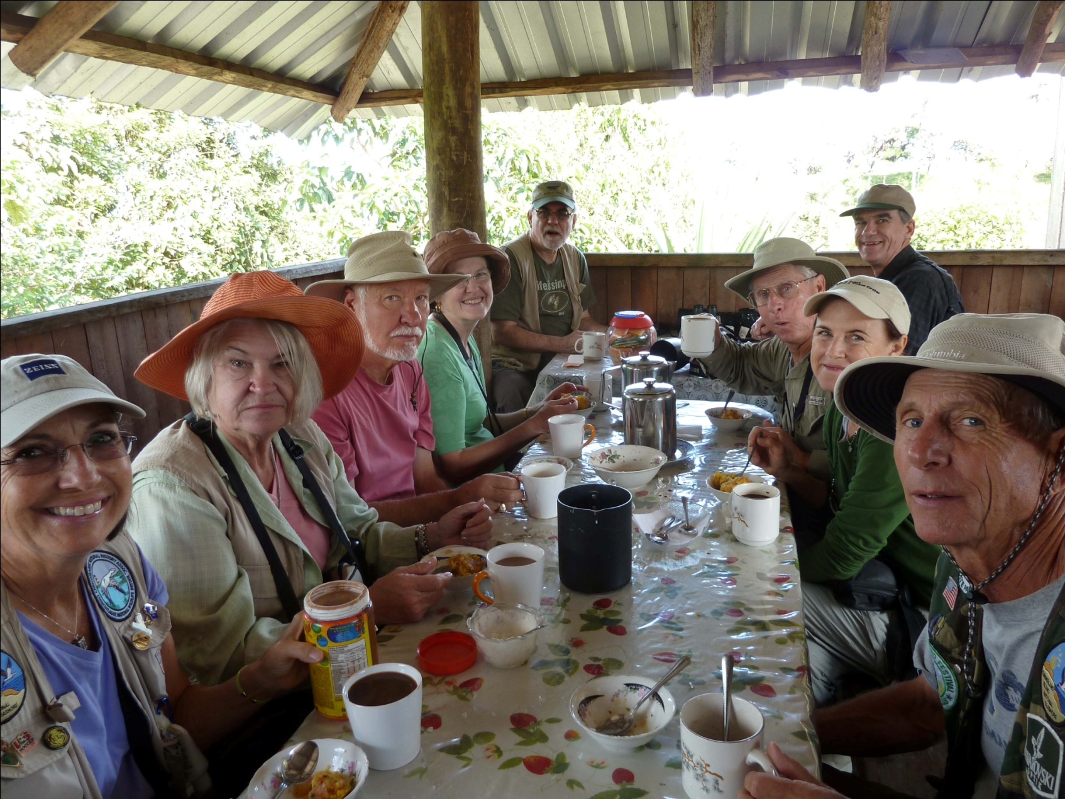
Breakfast at Refugio de las Aves

Angel graciously accompanied our group to an area of his land where he was certain we could find some special birds, most notably the Orange-breasted Fruiteater and Toucan Barbet. Walking down a gravel road, he helped us find the Fruiteater and Barbet as well as Black-chinned and Blue-winged Mountain-Tanagers, Flame-faced and GoldenTanagers, American Kestrel, Broad-winged Hawk, Barred Becard, Uniform Treehunter, Red-faced Spinetail, Golden-olive Woodpecker, Black Phoebe, Bronze-winged Parrots, Barred Becard, and Roadside Hawk.

We went back to Sachatamia for lunch and enjoyed watching the feeder birds for just a short time before leaving for a farm near Chontal where we would enjoy a bird sighting like none we've ever experienced. On Hugo's farm is a deep gorge where birders can descend into the world of the enigmatic Oilbird. The roosting site of Oilbirds is usually a cave, usually very dark with limited viewing. This roosting site is a deep narrow gorge where shafts of light break the darkness and allow for exceptionally clear views of the birds. Not only was the site special, but getting there was an adventure. Hugo says the birds have been on his family’s land for as long as he remembers and for several generations before that. They did not know what the eerie sounds coming from the gorge were for a long time, and named the area “Infiernilla” or “Little Hell” because of the frightening sounds emanating from the area. Only a few years ago did he become aware of how much birders would love to see his Oilbirds, so he has worked to make them accessible while still remaining protected. We started off for a ride in a wooden tractor-pulled wagon through fields of corn, citrus, and other crops. After about 1 kilometer, we disembarked and headed down a fairly steep trail. The trail was, I’m sure, at one time quite treacherous, but Hugo has cut steps out of the hillside to make the footing better and the trek easier. When we arrived at the top of the gorge, we were put in harnesses such as those used by rock climbers, and then we descended down a series of home-made bamboo ladders into the gorge. As we went down the first ladder, spray from a waterfall cooled us before we made our way through a stream to the top of the second ladder. At the second ladder another assistant waited to handle the rope as we ventured further into the crevice where a third ladder would take us even deeper into the narrow gorge. The third ladder was not needed, however, as roosting Oilbirds were visible at eye level just 25 feet away on the opposite side of the gorge. We went down in groups of six, and the first groups to arrive were lucky enough to hear the eerie calls of the Oilbirds. Occasionally an adult bird would fly out of the deeper gorge and swoop in front of us. An 18-inch bird with a 30-inch wingspan, this was indeed an impressive sight!

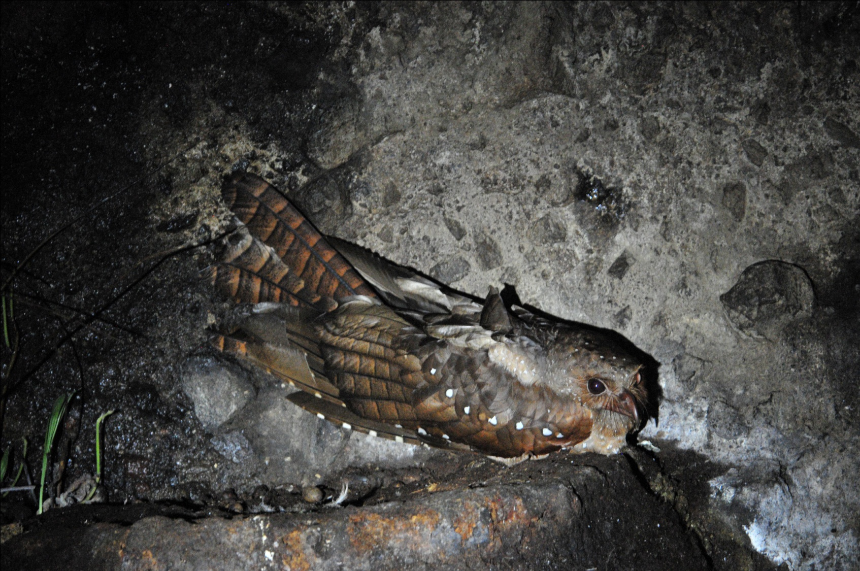
Oilbird
Walking back up the trail to the tractor, some of the birders who went down into the gorge first were able to find some good birds as they walked and even more in the area where they waited for the rest of us to be finished with the Oilbirds, including Pacific Antwren, Golden-winged Manakin, and Gray-crowned Flatbill. Riding back to the farmhouse, we saw several birds from the trailer, including Striped Cuckoo, American Kestrel, Dusky Pigeon, Smooth-billed Ani, Tropical Kingbird, Variable Seedeater, Yellow-faced Grassquit, and Blue-black Grassquit.

After riding our “chariot” back to the farmer’s house, we visited his “mini museum , an outbuilding that housed many artifacts found by his family over many years. Stones used for grinding grain, tools for starting fires and other ancient remnants were housed with interesting shells, rocks, and nests found on the farm. Some Yellow-bellied Siskins and a Pacific Hornero were seen just before we loaded back into the bus to leave. We left the farm and drove to Sachatamia, finishing the day with 83 species and enough "trip birds" (new species for the trip) to make our trip total 157.
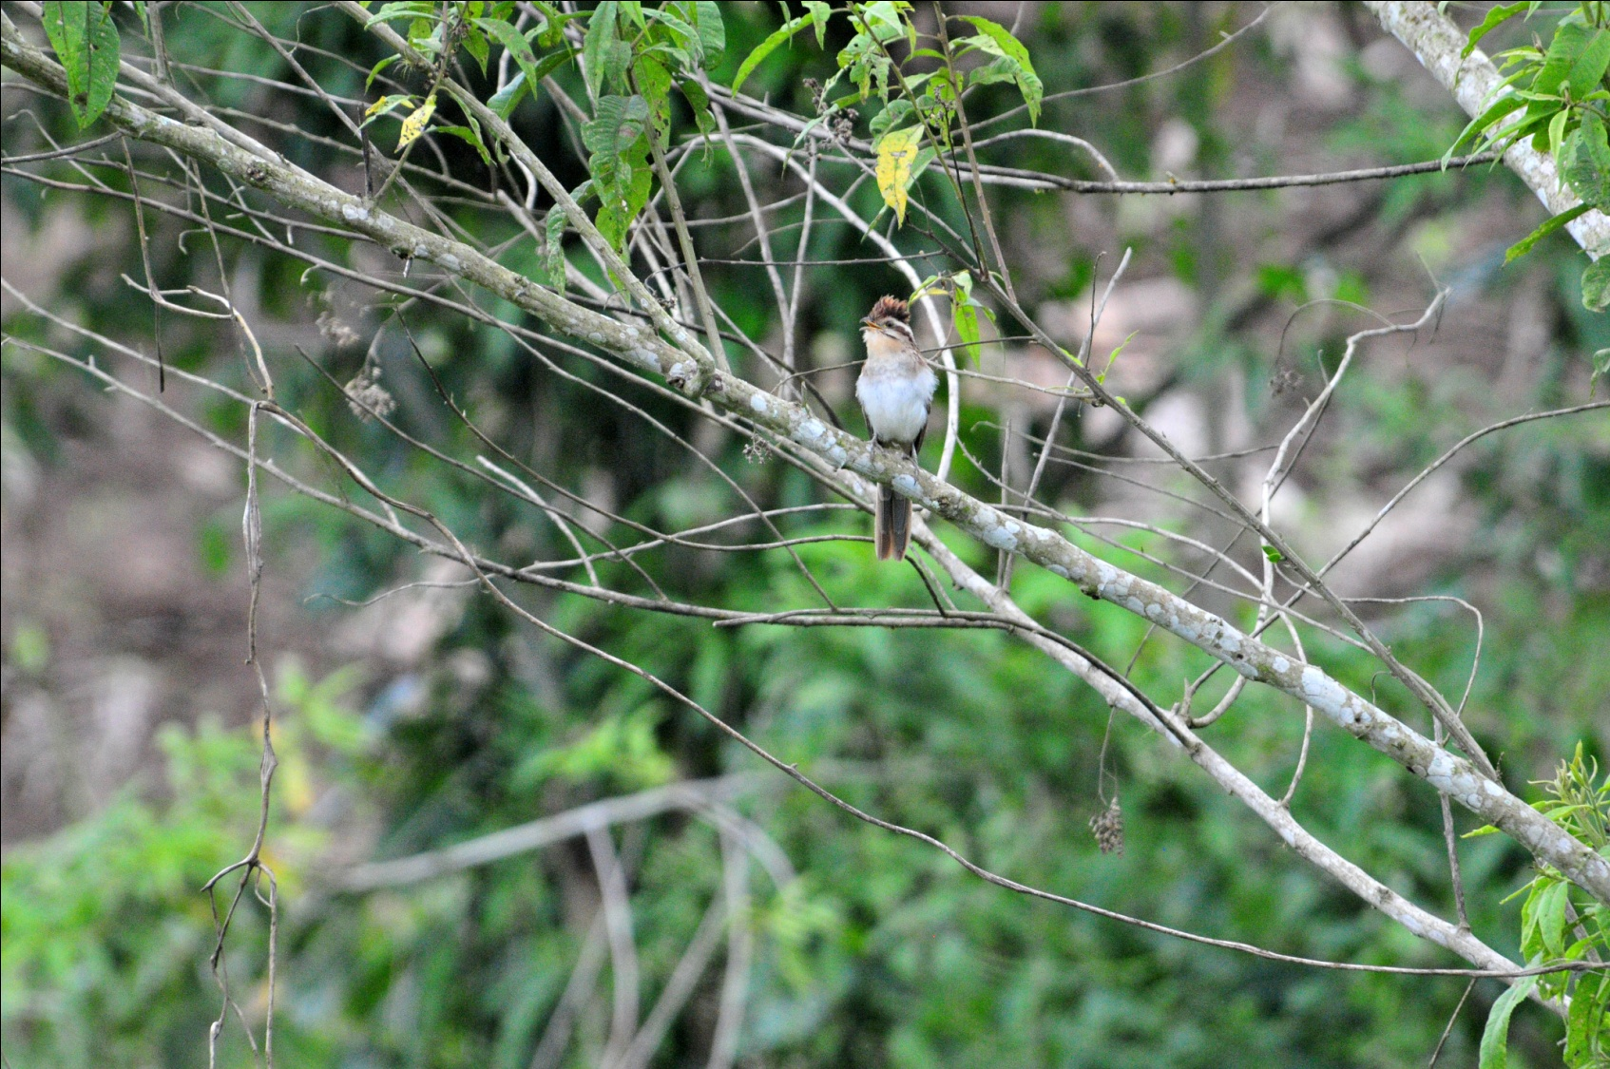
Striped Cuckoo

Other new species seen today included Black and Turkey Vultures, Eastern Wood-Pewee, Black Phoebe, Gray-capped Flycatcher, Andean Solitaire, Blue-and-white Swallow, Southern Rough-winged Swallow, House Wren, Slate-throated Redstart (Whitestart), Bananaquit, Metallic-green Tanager, Bay-headed Tanager, Black-chinned Mountain-Tanager, and Black-winged Saltator.

DAY 4, November 24: MASHPI RESERVE, SACHATAMIA, AYALIR
Another early departure, this time to head for Mashpi and Pacto-Pachijal Road. As we were sitting down for breakfast, Luis came in to tell us that Marcelo had an owl in front of the lodge. We all hurried out to get excellent views of a Black-and-white Owl. We gobbled down a hot breakfast and departed on schedule at 5:40 AM for the 2-hour drive to this special reserve that is often enshrouded in mist. Just before we made a sharp left turn to go into Mashpi Preserve, we got out of the bus to search for a very special bird, the rare and local Indigo Flowerpiercer. After playing the call for awhile, we could hear the birds responding but never got to see any of them. While trying to find the Flowerpiercer, we saw a Moss-backed Tanager in the mist. The fog was so thick that we could barely see the bright blue and yellow markings on the olive colored bird, an amazing sighting but a disappointing view. As we came to the small house that marked the entrance to the privately-owned preserve, Galo got out of the bus and had a conversation with the caretaker. It appeared that our permission to enter was not guaranteed, and we all heaved a sigh of relief when he returned to the bus and told us we could proceed. We walked past the house and immediately began to bird along the road. Black Solitaire and Rufous Brown Solitaire were the highlights of the day, both of which were lifers for Jim and me; the Rufous Brown Solitaire was a lifer for both Galo and Marcelo - quite a coup! The day was misty and cool with intermittent rain, one of the more difficult birding days of the tour. Most of the other birds sighted were ones already on the trip list, but we enjoyed seeing them again and did manage to add a few new birds to the list: Broad-billed Motmot, Ornate Flycatcher, One-colored Becard, Fawn-breasted Tanager, and Yellow-bellied Seedeater.

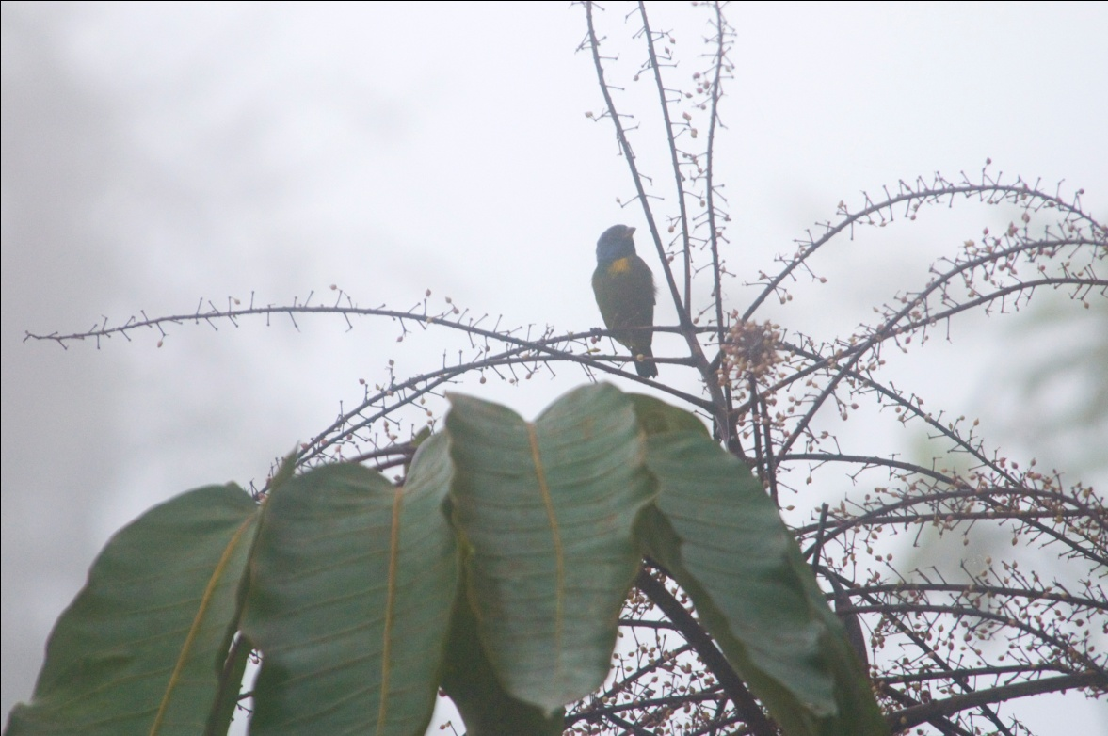
Moss-backed Tanager in the mist

We enjoyed a box lunch that had been provided by Sachatamia and then headed toward our next lodge, Ayalir, near the town of Pedro Vicente Aldonado. We arrived at Ayalir at about 3:00 PM, with plenty of daylight remaining to see some birds on the grounds of the hotel: Pacific Hornero, Black-cheeked Woodpecker, Ecuadorian Thrush, Choco Tyrannulet, and Yellow-capped Tyrannulet were all seen before we left the parking lot. After we settled into our rooms, we took a walk in the fields behind the hotel, where we saw Scarlet-backed Woodpecker, Masked Water-Tyrant, Black-crowned Tityra, Variable Seedeater, Yellow-bellied Seedeater, and Bananaquit.

Other new species seen today include Swallow-tailed Kite, Yellow-vented Woodpecker, Plain-brown Woodcreeper, and Boat-billed Flycatcher.

When we tallied our list before dinner, we had 73 species today with 22 new birds for the trip, making our trip total 179. We should hit 200 on Day 5!
DAY 5, November 25: RIO SILANCHE BIRD SANCTUARY, CELICA ROAD
Thanksgiving Day! As we left Ayalir shortly after 6:00 AM, we observed many of the same species we saw yesterday. We headed for Rio Silanche Bird Sanctuary, a reserve that was created to protect a remnant lowland forest and the many Choco endemics it holds . Many of these endemics are currently threatened by the significant clear-cutting of forest in the area. With no long drive to our destination this morning, we enjoyed the luxury of a birding stop along the way. At this first stop we observed Barred Puffbird, Chestnut-mandibled Toucan, and Buff-rumped Warbler as Cattle Egrets flew by. After awhile another birding group stopped and we left quickly so we could reach Silanche first, hoping that the tower would be available to us. When we arrived at Silanche, we hurried to the tower, where the birding was fast and furious for awhile. Marcelo instructed us to all stay with him instead of each of us finding a different bird and then asking the guides to identify it. I understood completely - How could they answer 12 birders with 12 different birds all at once? - but it proved to be a difficult instruction to follow as birds landed right in front of us, just begging to be admired and identified. Some of the many species seen from the tower included Streaked Xenops, Bay-headed Tanager, Slaty-capped Flycatcher, Stripe-headed and Spotted Woodcreepers, Golden-olive Woodpecker, White-shouldered Tanager, Masked Tityra, Lesser Greenlet, Yellow-tufted Dacnis, Pale-mandibled Aracari, Purple-chested Hummingbird, Green Honeycreeper, Lineated Woodpecker, Slaty-throated Gnatcatcher, Plain Xenops, Brown-capped Tyrannulet, Choco Tyrannulet, Bananaquit, Bronze-winged Parrots (fly-by), Dot-winged Antwren, Blue-headed Parrots (perched), Lesser Swallow-tailed Swift, Blue-necked Tanager, Guayaquil Woodpeckers (mating), Squirrel Cuckoo, Choco Toucan (fly-by), Masked Trogon (male and female), Red-headed Barbet, and Guira Tanager. After a few hours, we came down from the tower to find some birds that live in the understory. We immediately got much better, closer looks at the Yellow-tufted Dacnis, much to everyone's delight. Some of the species we found from the trail were Checker-throated Antwren, White-flanked Antwren, Tawny-breasted Flycatcher, White-whiskered Hermit, Dot-winged Antwren, Band-backed Wren, Ruddy Pigeon, Wedge-billed Woodcreeper, Golden-hooded Tanager, White-tailed Trogon, Orange-fronted Barbet, and White-bearded Manakin.

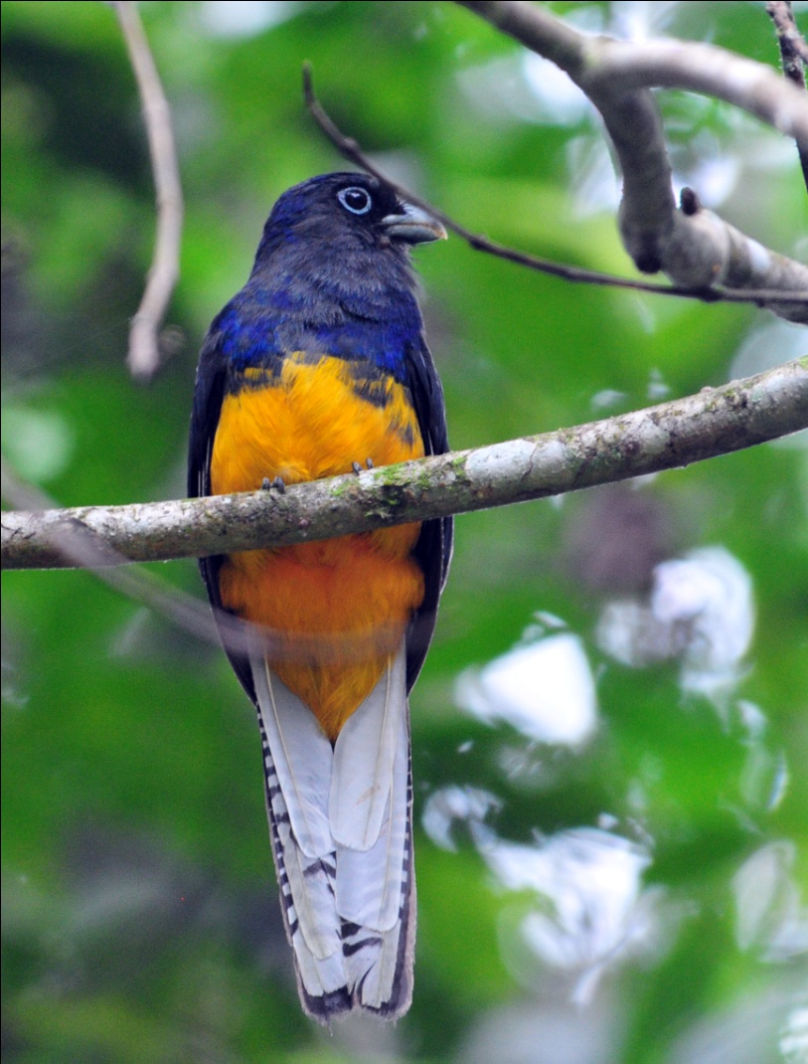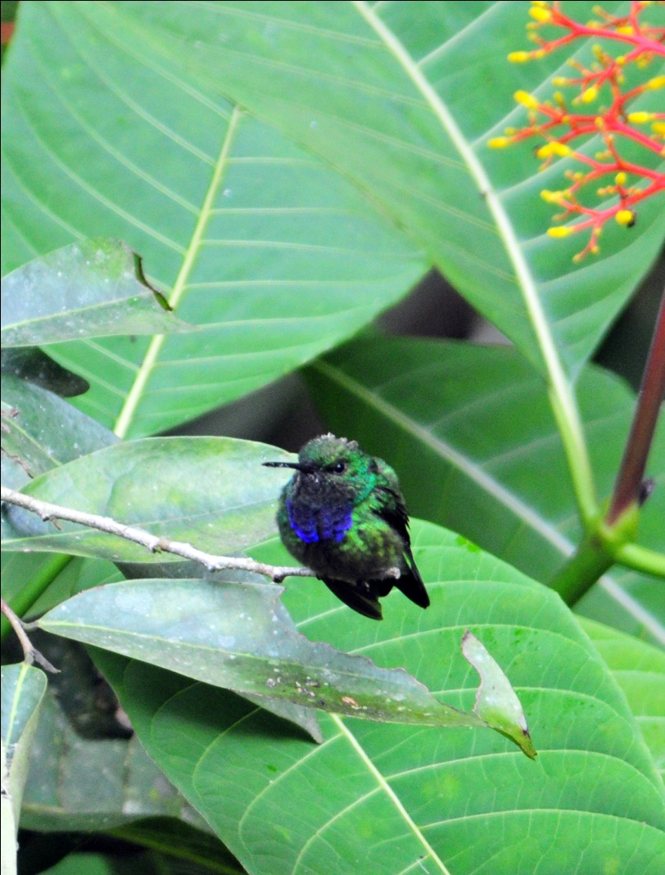
White-tailed Trogon Purple-chested Hummingbird
After a box lunch, we moved on to Celica Road for some easy road birding. Some of the new birds seen there were Scarlet-rumped Cacique, Gray and Gold Tanager, Yellow-bellied Siskin, Tawny-crested Tanager, Buff-fronted Foliage-Gleaner, Silver-throated Tanager, and Cinnamon Becard, White-thighed Swallows Pacific Parrotlet, Ruddy Pigeon, Brown-capped Tyrannulet, Gray-rumped Swift, Blue Dacnis female, Laughing Falcon, and Tropical Gnatcatcher.

We celebrated Thanksgiving with a very non-traditional meal served with couple of nice bottles of wine. Today's count, 95, was the best of the trip so far, and with 54 of them new for the trip, our trip total stood at 233.

DAY 6, November 26: MILPE BIRD PRESERVE, CALACALI AREA
This morning we drove to Milpe Bird Reserve, stopping to bird along the road before entering the reserve. From the road, we spotted some birds we've already seen, including Bronze-winged Parrot, Pale-billed Aracari, Swallow Tanager, Blue-and-white Tanager, Lemon-rumped Tanager, and House Wren, among others. We proceeded to the entrance where the feeders are located and spent a short time there before heading down the trails. There were several species of hummingbird present, most of which we had already seen, including, Andean Emerald, White-necked Jacobin, Empress Brilliant, Purple-throated Woodstar, Green-crowned Woodnymph, and Sparkling Violet-ear. New hummers here included Green Thorntail and Green-crowned Brilliant.

As we headed down the trail (and I do mean down), we listened for the strange sound of the Club-winged Manakin, which Galo had very entertainingly demonstrated for us earlier, complete with an imitation of the motion used to create the sound. These tiny birds use their wings for stridulation, a rubbing mechanism commonly used by insects such as crickets. One feather on each wing has seven ridges along its central vane. The stiff, curved tip of an adjacent feather strikes the ridges every time the bird raises it wings over its back and shakes its feathers. The repeated striking causes adjacent clubbed feathers to vibrate at high speed (1500 cycles per second), creating the unique high-pitched courtship song. While not believed to be part of the attraction to females, the movement needed to create the sound is entertaining in itself. Although many insects do this, manakins are unique among vertebrates in using stridulation.

It wasn't long before we located a few males performing, although we were not able to observe them for long before they flew off into the deeper recesses of the forest.

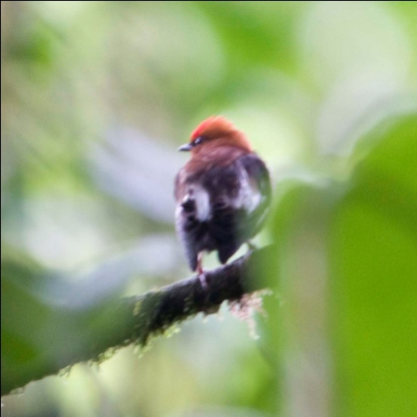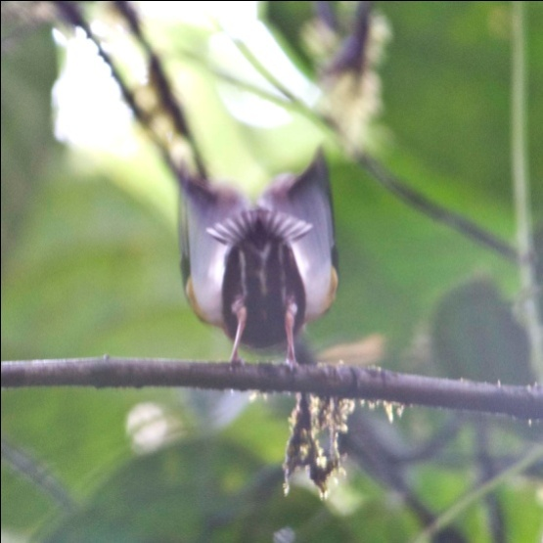

Male Club-winged Manakin performing at lek in Milpe Bird Sanctuary, 2010 photos
Along the trail, a steady stream of birds were seen. Some old species included Buff-fronted Foliage-Gleaner, Thick-billed Euphonia, Spotted Woodcreeper, Plain-brown Woodcreeper, Ornate Flycatcher, and several tanager species, among many others. The first Orange-billed Sparrow of the trip was seen, as well as Common Tody-Flycatcher (aka Tody-Tyrant), Choco Warbler, Immaculate Antbird, Sulfur-rumped Flycatcher, Russet Antshrike, Choco Trogon, and Choco Warbler. Jim and I both missed the Uniform Treehunter , while only a few of the group got good looks at the Esmeralda's Antbird. Several saw a Scaly-throated Leaftosser, and it responded well to taped calls. Even though I had not seen more than a dark blur flying low across the trail and would have loved to get a good look at the leaftosser, I told Marcelo that we needed to stop playing the tape because the birds appeared to be stressed by it. He agreed and we moved on down the trail. The trails at Milpe are narrow and in some places quite steep, so it was difficult to get every person on every bird here, something that we had been striving to do for the entire trip.

Back in the parking lot, as people were taking restroom breaks and purchasing some souvenirs at the gift shop, some interesting birds were seen just before we left, including Snowy-throated Kingbird and Rufous-throated Tanager. As we drove away from Milpe, we stopped several times to bird. Bronze-winged Parrots, Swallow-tailed Kite, Red-eyed Vireo, Bananaquit, Green Honeycreeper, Flame-faced and Silver-throated Tanagers , White-thighed Swallow, Smooth-billed Ani,
Purple Honeycreeper, Blue-necked Tanager, and Western Wood Pewee were added to our day's list.

After lunch, we drove on to Calacali, where we planned to bird some dry areas before visiting the Equator Monument and Museum. Because Luis needed to be back in Quito in time for an activity with his son, we were able to do only some quick birding and then head on to Quito without stopping at the museum. At Calacali, we managed to see a few good birds in a very short time, including Ash-breasted Sierra Finch , Vemilion Flycatcher, Black-winged Ground-Dove, Hooded Siskin, and Green-tailed Trainbearer.

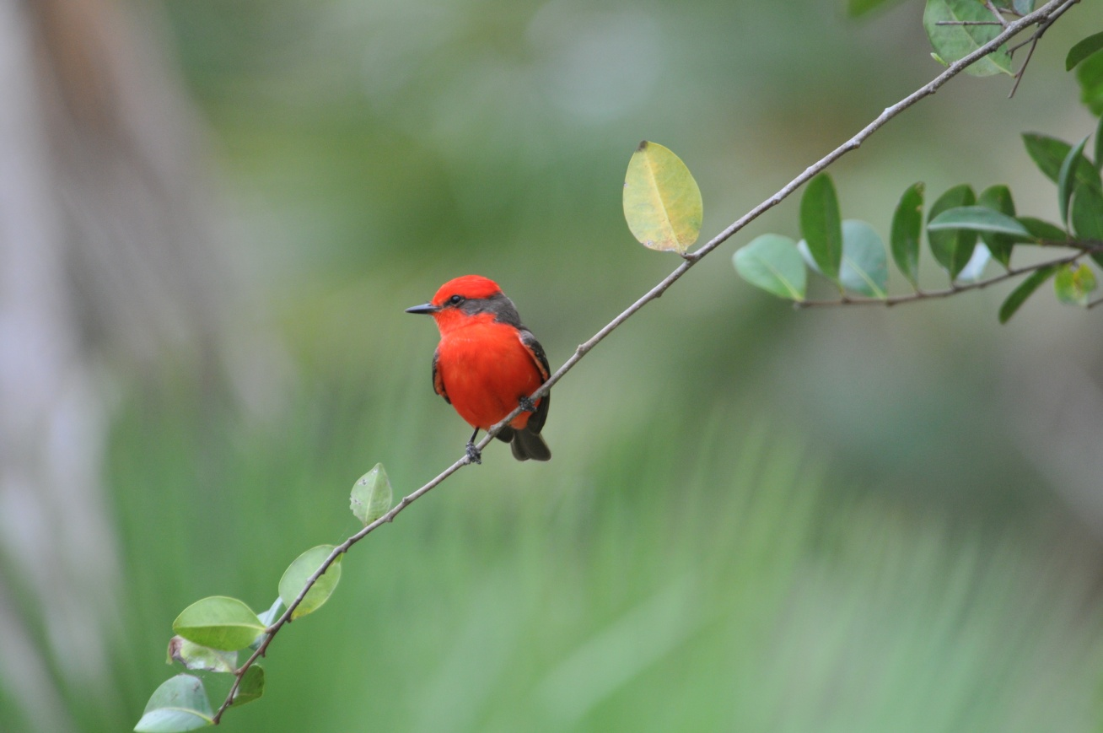
Vermilion Flycatcher

Others new species seen today were Rufous Motmot, Swainson's Thrush, Swallow Tanager, and House Sparrow. We arrived in Quito in time to have a break before dinner, which allowed us plenty of time to organize our luggage for the next leg of the trip. We finished the day with 89 species, a respectable number and a very good day of birding. We added 25 new species for the day, bringing our trip total to 258.
DAY 7, November 27: ANTISANA RESERVE, PAPALLACTA LAKE
As we left the hotel in Quito, we noted some "old" birds as we left town. Rock Pigeon, Eared Dove, and Great Thrush couldn't be missed. As we passed a huge statue of a Sparkling Violet-ear, Luis slowed down for us to take photographs, giving us time to notice the American Kestrel perched on the wing of the statue. A Southern Yellow Grosbeak got our attention from the bus.

Our first stop was at about 11,000 feet, where we birded a short section of the road. We were like kids in a candy store as one bird after another appeared on the hillside: Cinereous Conebill, Spectacled Whitestart, White-tailed Shrike-Tyrant, Brown-backed Chat-Tyrant, Tyrian Metaltail, Tufted Tit-Tyrant, Black-tailed Trainbearer, Sparkling Violet-ear, and three Flowerpiercers (Black, Glossy, White-sided).

Birding at Antisana is unlike other birding we had been doing - no long hikes down steep muddy trails and no heat and humidity to make the hiking feel more difficult than it is. At altitudes ranging from 9000 feet in Quito to over 14,000 feet, this day consisted mostly of short walks from the bus. The air was cool, but as the day went on we found ourselves removing our heaviest layers of clothing as the sunshine warmed us up.

Even though we had walked just a short distance on our first birding stop, we could feel the altitude and we were grateful that Luis would stay in the bus and wait for Galo to signal for him to move forward to pick us up and proceed to the next stop. Red-crested Cotinga was added at the next stop, and as we were driving along, someone spotted a Variable Hawk. We stopped and took some photos, then bit by bit moved closer to get better photographs of a very patient hawk.

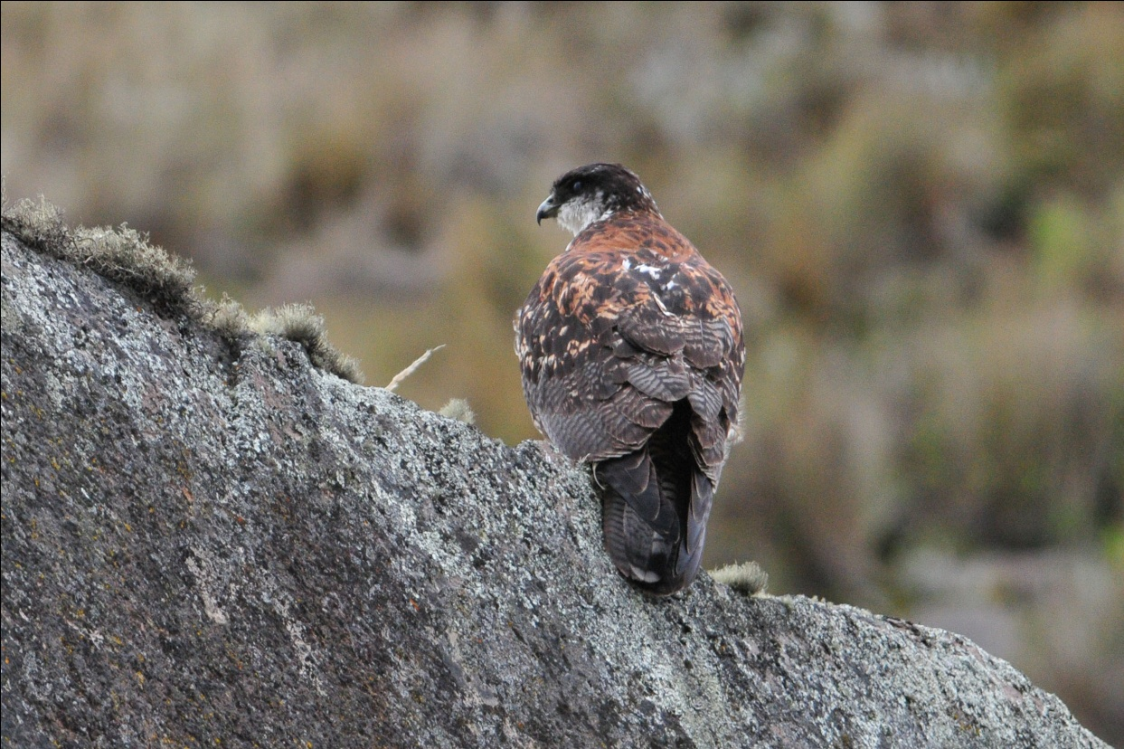
Variable Hawk

We made a stop at a small bridge to look for Ecuadorian Hillstars that are often found there. We located the impressive hummingbird, but most of us got good looks at only the female. Nearby, we found Bar-winged Cinclodes, and before we left the bridge we saw one of our primary target species, the Andean Condor, flying overhead. Much closer than on our last trip, we could even see the white on this bird! As the condor flew out of sight, we saw one more bird before moving on, a Yellow-bellied Brush=-Finch. Galo whistled and motioned for Luis to come forward, but the bus did not move. Galo and Marcelo both waved their hats, whistled, and called out to Luis, but we could see no movement inside the bus. Luis had fallen asleep! Everyone had a good laugh and teased Luis for awhile about falling asleep "behind the wheel".

As we drove higher, we saw Carunculated Caracaras literally all over the place: in the air, on the ground, at a distance and practically underfoot (well, that may be an exaggeration, but they were very close). Raptors provided much of the birding entertainment at these altitudes with Variable Hawks making numerous encores and single cameo appearances from an Aplomado Falcon.

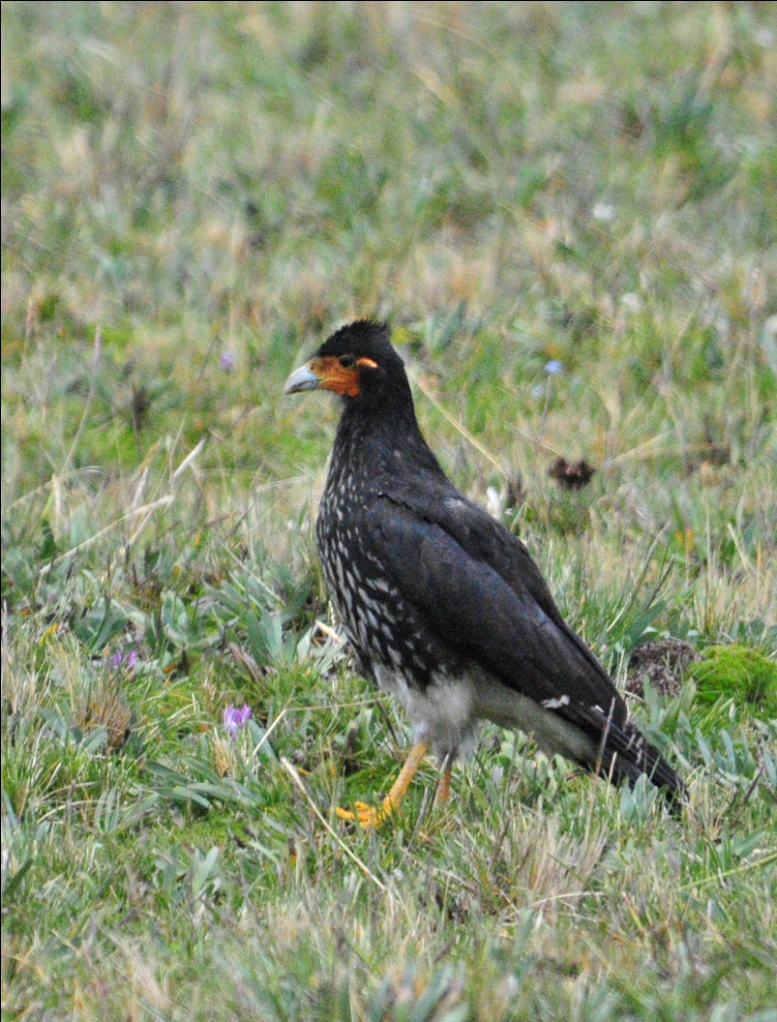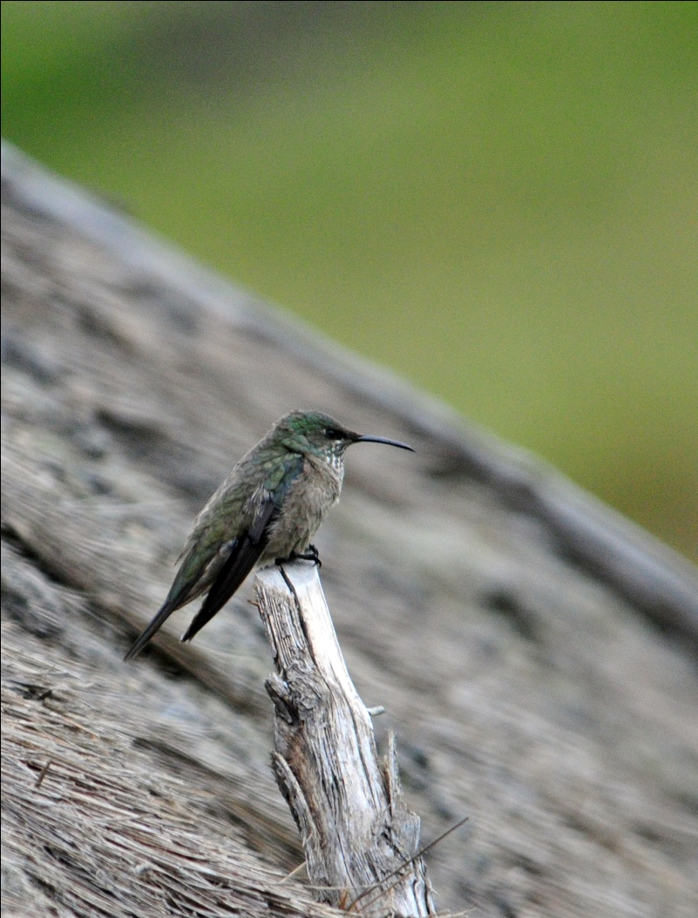
Carunculated Caracara Ecuadorian Hillstar, female

As we rounded a curve on the road, Marcelo called out for Luis to stop. He had spotted some Andean Condors on the ground! We all piled out of the bus quickly, and there, far in the distance was a group of FOUR Andean Condors! No one could agree on the approximate distance, but we heard everything from 1/2 mile to over a mile as estimates. I don't know how Marcelo spotted them from such a distance, but we watched in awe as a fifth bird flew in to join them. Apparently they were feeding on a carcass, and we could see through the scope the difference between the immature and mature birds. A bus filled with student s stopped, and we happily shared our binoculars and scopes with them. It was wonderful to see these young Ecuadorians marveling over the sight of the condors. We stayed for quite awhile, long enough to see the condors waddle awkwardly up the hill before taking off and landing on a rocky ledge. We stayed even longer, long enough to see a total of TEN condors in the air at the same time! Amazing!! Even with our attention focused on the Condors, we managed to see a couple of other birds in the area before driving on, Plumbeous Sierra Finch, Black-necked Ibis, and Stout-billed Cinclodes.

We were scheduled to have lunch in a ranch house in Antisana, but it was not yet time to go there when the first group of people asked for a restroom stop. Galo and Marcelo took pity on us, since the wide-open paramo offered little opportunity for "bushroom" break, and we drove to the farmhouse for a quick break. On a pond in front of the house were two Andean Teals and Brown-bellied Swallows were flying around the house. The rancher graciously allowed us to go in to use his facilities, and then we proceeded to Papallacta Lake. There, we saw Andean Coot, Andean Gull, Silvery Grebe, Spotted Sandpiper and Greater Yellowlegs. We stopped for some photo ops and enjoyed seeing some more individuals of species we had seen earlier in the day and then started back to the ranch for lunch. Just before we got there, we found Andean Lapwings and Paramo (Plain-capped) Ground Tyrant along the side of the road.

Lunch today was one of the highlights of the trip. The house was charming, the people delightful, and the food delicious. We were first served a "Tamal de mote", a delicious chicken tamale unlike any I've ever tasted. Next was a hearty potato and Quinua soup, followed by "Postre Tres Leches", a favorite traditional dish in Latin American countries. Literally "Three Milk Cake", this dessert is a sponge cake soaked in three kinds of milk (evaporated, condensed, and heavy cream). A brief tour of the ranch house gave us some insight into the lives of these people who maintain a traditional lifestyle far from the urban areas of Ecuador.

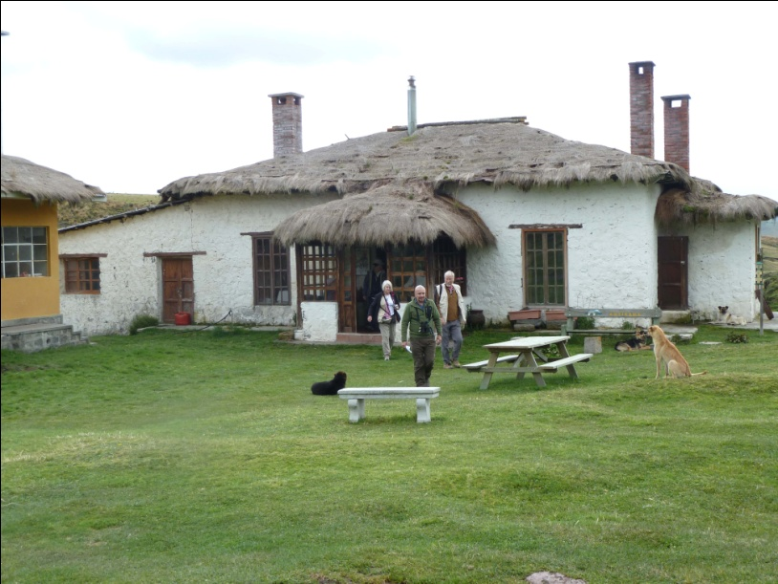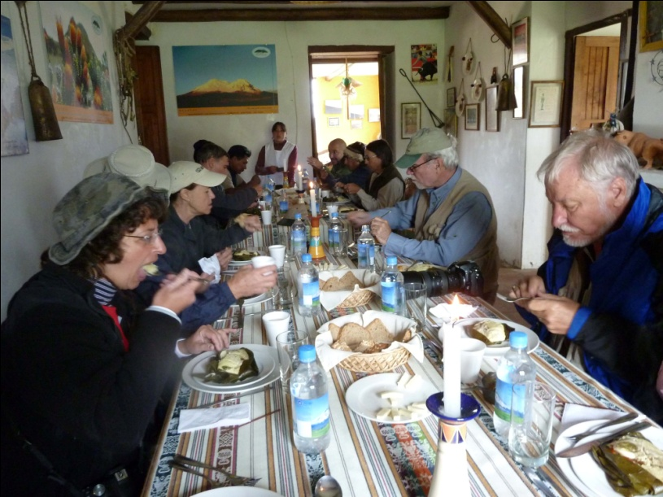

After lunch, we slowly birded our way down to Guango Lodge on the other side of Papallacta Pass. One stop gave us looks at three special hummingbirds, Giant Hummingbird, Shining Sunbeam, and Black-tailed Trainbearer.

We arrived with little daylight left at Guango, so we managed to see few of the birds known to visit their hummingbird feeders. We knew we would have plenty of opportunity tomorrow, however, because it is Census Day. On this day, no one in Ecuador is permitted to be on the road, so we will spend an entire day on the trails and roads around Guango Lodge.

As we were getting our things out of the bus, I asked Luis if he had binoculars. We had noticed that he seemed interested in seeing the birds, but we never saw him with a pair of bins. He told us he had never had any binoculars, so Jim and I made a decision on the spot to give him the pair we carry with us in case we have the opportunity to provide a child with optics. We've been doing this for the last several trips, after having met a couple of amazing talented kids who we knew would benefit from having some decent optics. The first child we encountered was Roberto Paz, who is the nephew of Angel Paz, although we didn't know it at the time. On our first trip to Ecuador in 2006, he took us to try to find a Cock-of-the-Rock in a river valley near his home, and he was so enthralled with what he saw when he used our binoculars that we wanted to give him a pair. Having no extras with us, we sent him a pair when we got home. It took nine months and the help of an Ecuadorian driver named Vladimir to get the bins to him, and I think it made us as happy as it made Roberto when we finally got the photograph of the binoculars being delivered. On a trip to Panama in January 2010, we encountered a young girl named Julid who was equally impressive in her skills and equally unequipped. We knew that having some optics would allow her to improve her skills dramatically, and regretted not having an extra pair with us to present to her. Since then, we've always carried a pair of decent waterproof binoculars with us just in case we meet a young birder who needs a pair. Although he might not be so young, we couldn't think of anyone we would rather give the binoculars to than Luis. He was very grateful, and the following morning he came with us when we left the bus to walk along the road in search of birds.

We finished the day with just 43 species, but more than half were new for the trip, bringing our trip total to 282.

DAY 8, November 28: GUANGO LODGE
We started out at 6:00 AM to bird the trails and roads around Guango Lodge. I was actually looking forward to this day, even though we were there for a full day only because the government of Ecuador was forcing us to do so. I've never felt like I had enough time at Guango, which is one of the best birding lodges in Ecuador. Located at an elevation of about 2700 meters and centered in a zone classified as humid temperate forest, Guango offers a distinct habitat characterized by stunted trees , thick canopy, and cool climate. The feeders are wonderful, and I've never even seen most of the trails there.

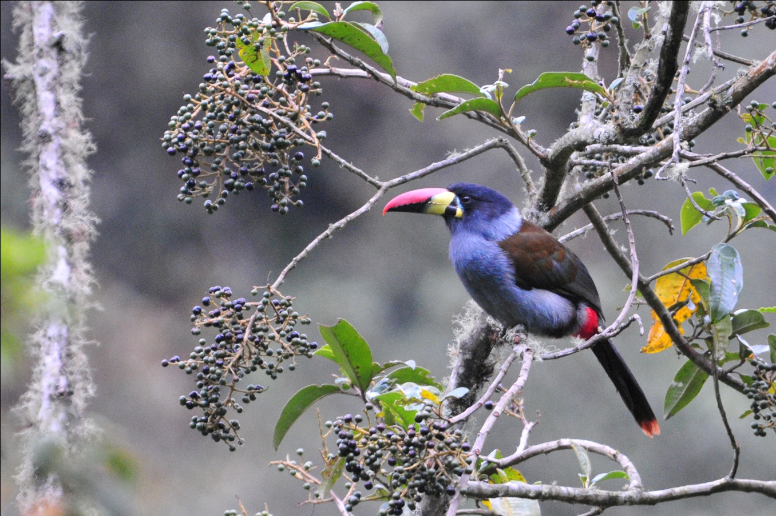
Gray-breasted Mountain-Toucan

Before we left the feeder area, we had Tourmaline Sunangel, Long-tailed Sylph, Chestnut-breasted Coronet, White-bellied Woodstar, Collared Inca, and Buff-tailed Coronet. As we walked around to the back of the lodge to begin our first walk, we saw Turquoise Jay, then proceeded down a grassy hill where we found Band-tailed Pigeon, Black-crested Warbler, White-banded Tyrannulet, Spectacled Whitestart, and Cinnamon Flycatcher. We made our way uphill to the road, which is normally so busy that it's dangerous to do much birding there. We hadn't gone far when a local alerted us to the presence of a Gray-breasted Mountain-Toucan. We watched the bird as it feasted on ripe fruit, then proceeded on to do some road birding. Today, because of the census, the road was deserted and the birding was wonderful. In a single spot, we observed a mixed flock move through with at least two dozen species, including Hooded Mountain-Tanager, Blackburnian Warbler, Gray-hooded Bush-Tanager, Capped Conebill, Plushcap, Black-capped Hemispingus, Slaty Brush-Finch, Black-eared Hemispingus, Blue-backed Conebill, Buff-breasted Mountain-Tanager, Hooded Mountain-Tanager, Mountain Velvet-Breast female Blue-and Black Tanager, and Pearled Treerunner. Another trail yielded Slaty-backed Chat-Tyrant, Masked Trogon, Rufous-breasted Chat-Tyrant, Plain-tailed Wren, and Mountain Wren. An Andean Guan was in the area, and although we all heard the bird, Marcelo was the only one who saw it. Going back to where we had started, we saw Inca Jay behind the lodge. We walked a short distance to a bridge over the Papallacta River to find Torrent Duck and also found Black Phoebe nearby.

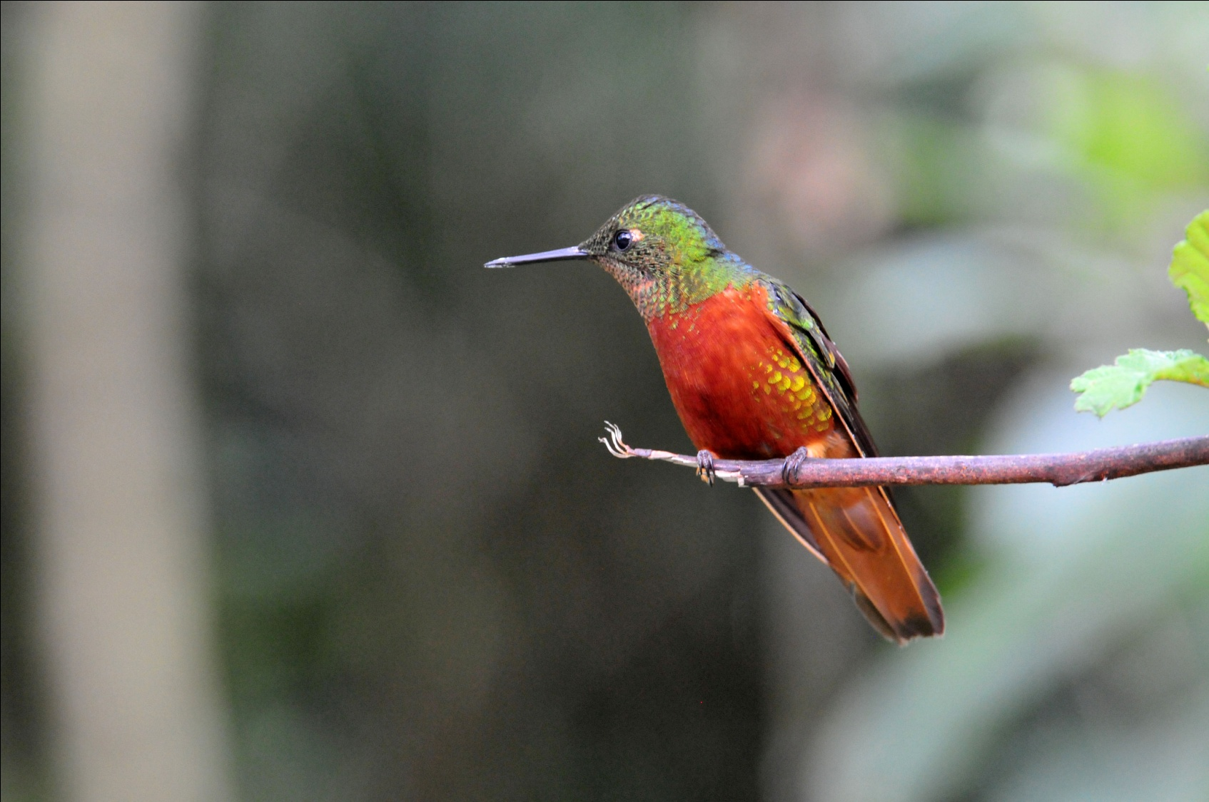
Chestnut-breasted Coronet

When I returned to the lodge, the census takers were there filling out forms for the employees and owners of the lodge. I had walked back a few minutes before the group so I could spend some time trying to get better photos of the hummingbirds, and was met by Census workers as I approached the lodge. Trying to answer their questions without speaking Spanish was quite a chore (and a bit comedic), but I attempted to answer the questions asked of me. When the others returned a short while later, Marcelo began to translate for me. After awhile, we all decided that the Ecuadorian census didn't really need to know how many children I had back in Ohio, or how old I was when I gave birth, so after some discussion between Galo and the supervisor for the high school students who were asking the questions, the rest of the group was permitted to answer just a few questions such as full name and place of residence.

We departed for Wild Sumaco as soon we were permitted to be on the road again at 5:00 PM. We arrived there after dark, checked into our rooms and then met to go over our checklists and have dinner. Because we had finished Day 7 with 282 species, we kept close track of the new species today and marked a Canada Warbler as our 300th bird for the trip. At day's end, we had seen just 48 species, 22 of which were new to the trip, bringing our trip total to 304.
DAY 9, November 29: WILD SUMACO
The logical place to begin birding at Wild Sumaco Lodge is on the massive deck that overlooks a lush valley. From here, not only can you see an entirely new assortment of hummingbirds at the feeders, but you are at eye level with treetops, providing an excellent vantage point to watch for anything that might fly in. The backdrop for this stunning setting is a wonderful view of Antisana on a clear day. I felt like I would be content to stay on that deck all day long, if not for several days in a row.

Our first new species were found easily at the hummingbird feeders. Although the most common species there was the familiar Sparkling Violet-ear, there were plenty of new species to see now that we were on the eastern slope of the Andes and at a different elevation. Golden-tailed Sapphires were in good numbers, but the Wire-Crested Thorntail, Gorgeted Woodstar, and Violet-headed Hummingbird were less common and more difficult to find.
The female thorntails came in first, but the male finally came in to feed on the purple flowers at the corner of the deck.

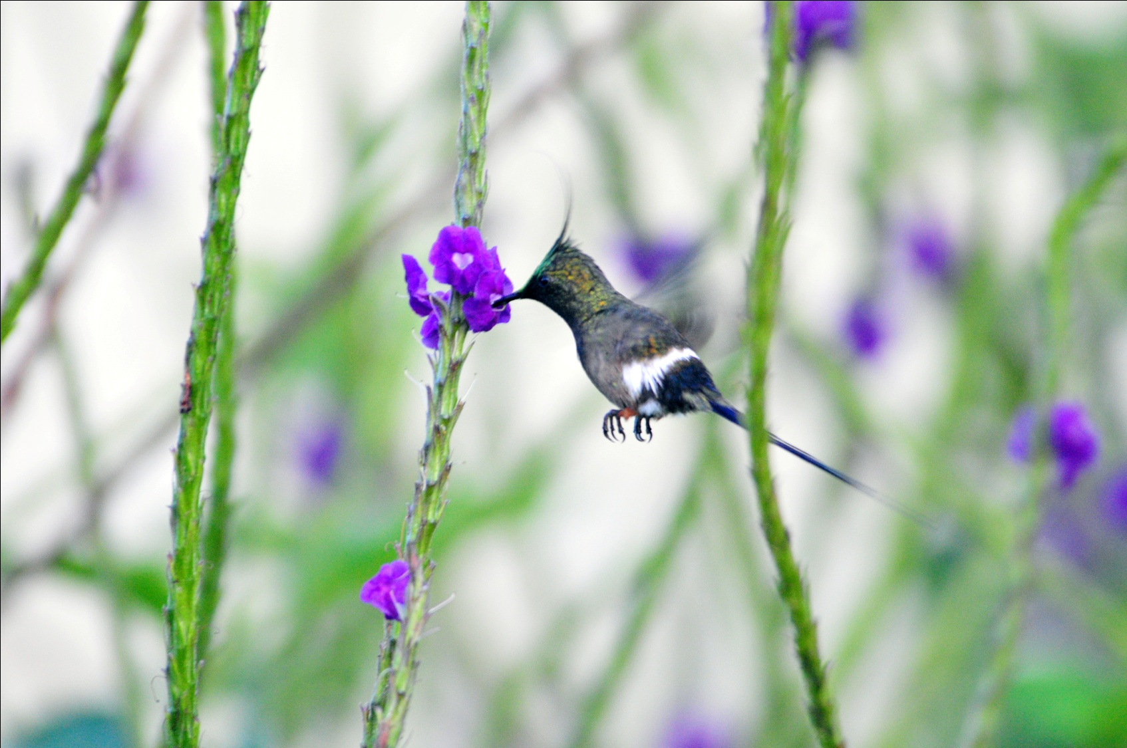
Wire-crested Thorntail

We tore ourselves away from the deck after breakfast to walk along the entrance road to a trail that would take us deep into the forest. From the road, we saw Yellow-browed Sparrow, , Bat Falcon , Magpie Tanager, Yellow-tufted Woodpecker, Squirrel Cuckoo (Eastern race), Blue-necked Tanager (Eastern Race), Crimson-crested Woodpecker, Roadside Hawk, Short-tailed Swift, and Scaled Pigeon. The morning was beautiful - bright blue sky, perfect temperatures, the only visible clouds in front of the volcano known as Sumaco. Some talked about leaving their rain gear behind, but the guides reminded them that the weather can change quickly in Ecuador. It wouldn't be long before we were all happy to have brought our rain gear with us!
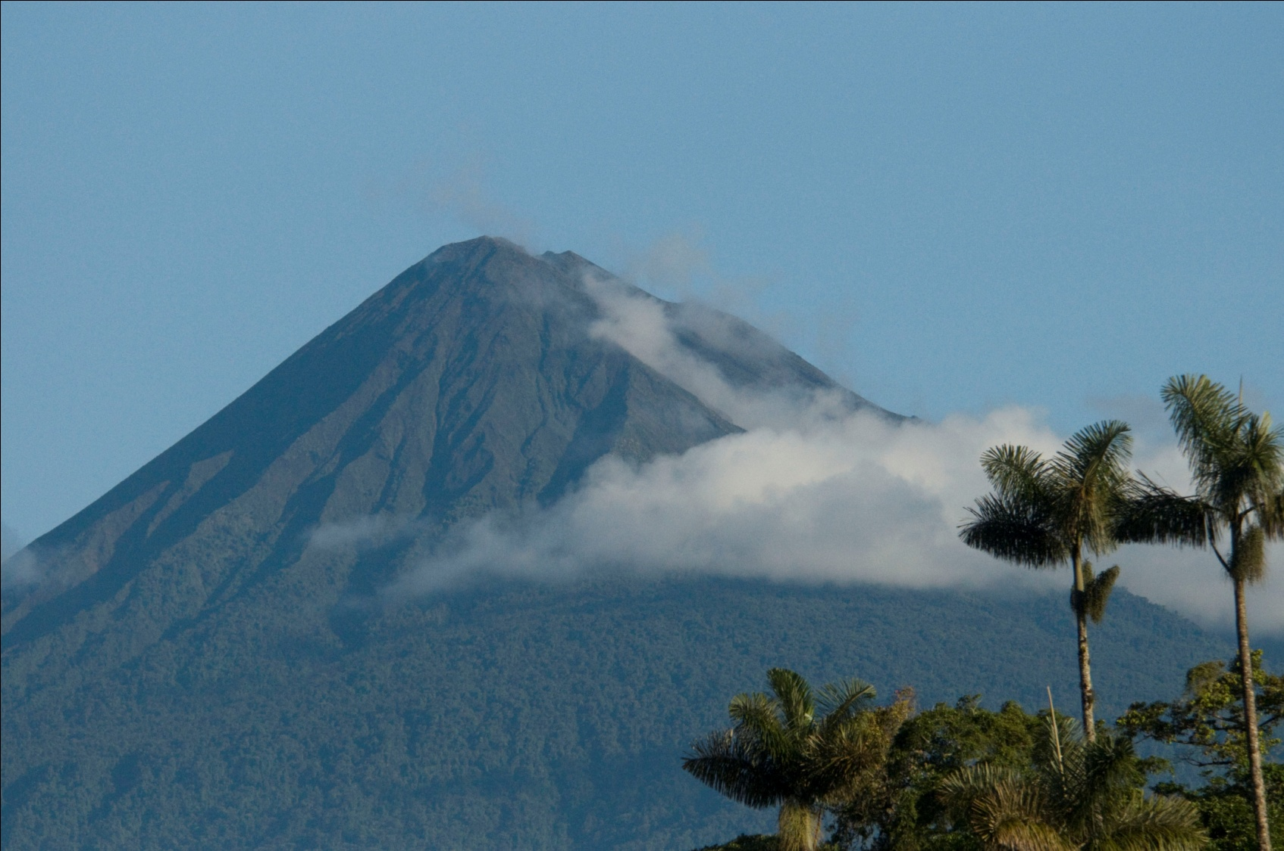
Sumaco

Once on the trail, we found lots of old species and plenty of new species such as Smoky-brown Woodpecker, Plain Antvireo, Wedge-billed Woodcreeper, Swainson's Thrush, Blue-rumped Manakin, White-streaked Antvireo, and White-breasted Wood-Wren. One of the best birds this morning was a Chestnut-crowned Gnateater that came out in the open multiple times, allowing all to see it very well. Marcelo spotted a Buff-tailed Sicklebill, but it flew away so fast that no one else saw it. The sky had been looking a bit threatening, and we decided we should head back even though the birding was still very good. It began to sprinkle a little, but the canopy kept us pretty dry. Then, just as we cleared the forest and got to the part of the path that had no cover, the sky opened up on us. We hurried back to the lodge and gathered on the deck.

Even during the brief downpour, the hummingbirds kept coming to the feeders, and there was enough of an overhang for us to stay dry and watch them. As soon as the shower ended, the entire area was alive with birds. Within a very short time, probably no more than an hour, we saw dozens of birds from the deck, including several new for the trip: Gilded Barbet, Red-headed Barbet, Paradise Tanager, Spotted Tanager, Scarlet Tanager, Lined Antshrike, Golden-collared Honeycreeper, and Many-spotted Hummingbird. The Gilded Barbets appeared to be building a nest, giving us all great looks through the scope. The Paradise Tanagers were probably the favorite (for this hour, anyway), moving through with a mixed flock that kept us all hopping for awhile. The colors on this bird are unbelievable!

We hated to leave the deck, thinking that another mixed flock might move in as soon as we departed, but Galo and Marcelo had another great spot they wanted to show us. A second area of hummingbird feeders was located at a slightly different elevation and attracted a different set of hummingbirds. Just a short drive from the lodge, it was amazing to see how such a small change in altitude can affect the bird life. As we approached a small cabin, we could see all the activity around the new set of feeders, and we all quickly found a spot to sit on the porch of the cabin.
At the feeders in front of us we saw Gray-chinned Hermit, Napo Sabrewing, Brown Violet-ear, Fork-tailed Woodnymph, Violet-bellied Hummingbird, Ecuadorian Piedtail, Violet-fronted Brilliant, Black-throated Brilliant, Gould's Jewelfront, Green Hermit, Golden-tailed Sapphire, Booted Racket-tail (Eastern race with rusty boots), and Gorgeted Woodstar. A Blackish Antbird was seen in the bushes behind the feeders, but most of us only heard the bird.

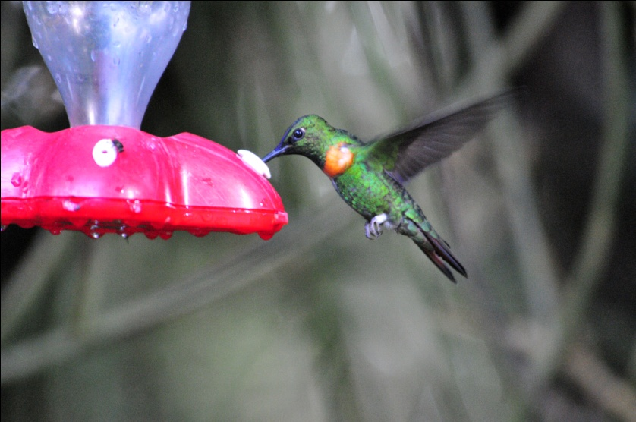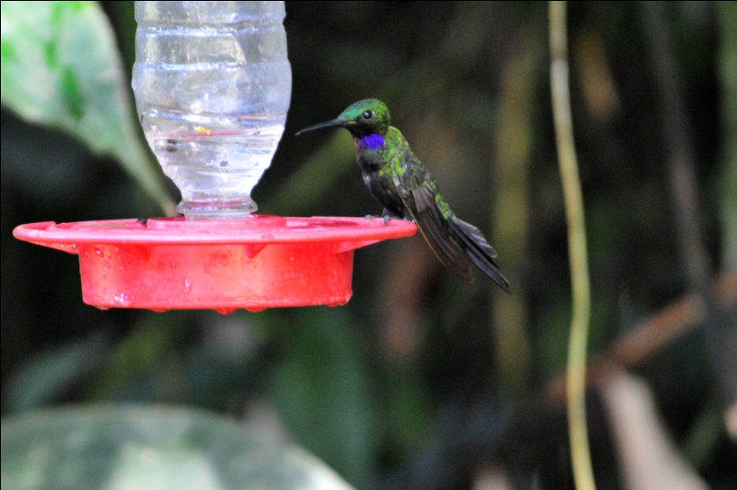
Gould's Jewelfront Black-throated Brilliant

After lunch, we went to an overlook where we were positioned higher than the treetops, looking down into a valley. We spent quite a bit of time there, just standing in one place as a parade of birds flew into the trees in front of us. Again, dozens of species were seen, but the ones that were new to the trip included Long-tailed Tyrant, Blue-naped Chlorophonia (flyby), Golden-eared Tanager, Crested Oropendola, Russet-backed Oropendola, Olive-sided Flycatcher, Gray-rumped Swift, Short-tailed Hawk, Thrush-like Wren, Channel-billed Toucan, Olivaceous Siskin, Black-and-white Seedeater, Black-mandibled Toucan, Grayish Saltator, Lineated Woodpecker (Eastern race), Dark-breasted Spinetail, Maroon-tailed Parakeet, Peregrine Falcon, and Yellow-throated Bush-Tanager.

When we returned to the lodge, we made a stop near a river where Galo and Marcelo knew Band-bellied Owls were resident. We lingered, waiting for sunset. Just as the light was beginning to fade, one of the huge owls flew right in front of our faces. We followed it and found it sitting in a tree, where everyone got wonderful looks.

Other birds seen today included Montane Foliage-Gleaner, Olivaceous Woodcreeper, Olive-backed Woodcreeper, Black Antbird, Golden-faced Tyrannulet, Chestnut-bellied Thrush, Black-billed Thrush, Cerulean Warbler, Lesser (Chestnut-bellied) Seedeater, and Olivaceous Siskin.

We finished the day with 88 species, with 61 (!) new species for the trip, bringing our trip total to 365. What a day! In addition, we saw 9 eastern subspecies of species we had previously seen on the western slopes. In addition to the eastern race of birds already mentioned, we also saw eastern subspecies of Gray-rumped Swift, Ornate Flycatcher, Dusky-capped Flycatcher, Golden Tanager, and Blue-gray Tanager. Most of them looked almost identical to their western counterparts, but the Blue-gray Tanager in the east has a big swatch of white on its wing that is absent in the western birds, and as previously mentioned) the Booted racket-tail has rusty pufflegs in the east, while the western birds have white feathers in their "boots".

DAY 10, November 30: WILD SUMACO - SAN ISIDRO LODGE
We planned on doing some road birding at Wild Sumaco first thing in the morning. On the trail leading to the road, we saw male and female Blackish Antbird, male and female White-lined Tanager, and Montane Foliage-Gleaner. This time, everyone got good looks at the Blackish Antbirds while most people missed them or only caught a glimpse yesterday. It was great to see both genders of the Tanagers together since the female looks so different from the male - very rufous without a spot of black or white on her, while the male is all black with just the tiniest bit of white on the front of the wing, which sometimes can't be seen at all.

As we walked on down the road, we added a new bird, Olivaceous Greenlet, to the trip list and saw many individuals of species we had seen yesterday or earlier on the trip. Before we had really even begun, we had to retreat to the lodge because of rain. As the rain eased up, a pair of Spotted Tanagers flew in, giving us better views than yesterday. After the rain stopped, we went back to the overlook that had been so active the day before. Not as active as the day before but still very productive, this spot gave us mostly "old" species today. But with 61 new species yesterday, we hadn't really left much to find! We watched as bird after bird came into the trees in front of us: Silver-beaked Tanager, Yellow-cheeked Becard (female), Black-and-white Seedeater, Blue-gray Tanager, Chestnut-bellied Seedeater, Dark-breasted Spinetail, Lineated Woodpecker, Eastern Wood-Pewee, Canada Warbler, Crested Oropendola, Thrushlike Wren, Southern Yellow Grosbeak, Maroon-tailed Parakeet, Black-mandibled Toucan, White-throated Toucan, Swainson's Thrush, Channel-billed Toucan, Scaled Pigeon, Smoky-brown Woodpecker, among others.

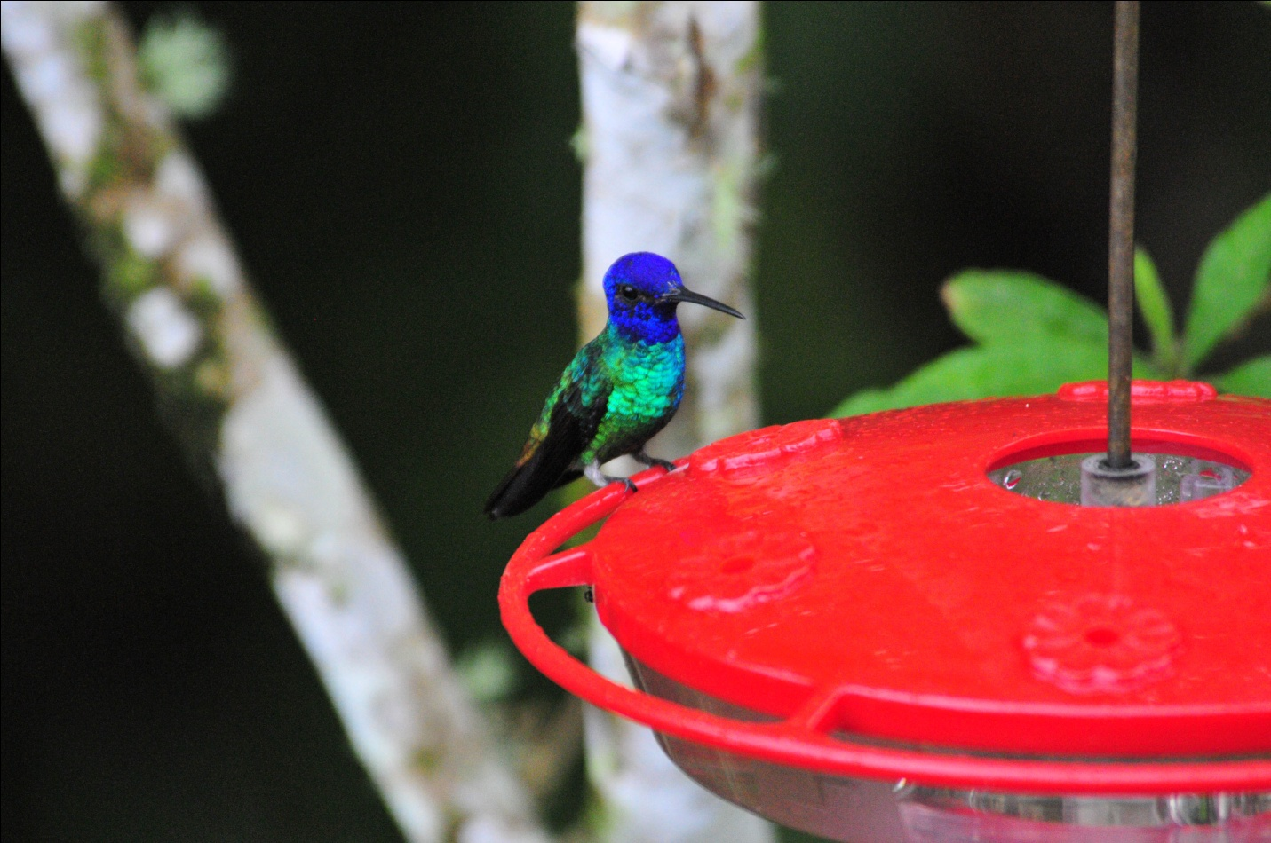
Golden-tailed Sapphire

We went back to the lodge for lunch and then gathered our things to leave for San Isidro Lodge. From the deck, we enjoyed repeat appearances from Paradise and Blue-necked Tanagers, Lined Antshrike, Bananaquit, as well as all the resident hummingbirds. Plain-backed Antpitta was heard for the second day in a row, and a Green-and-gold Tanager was spotted, although I must admit I don't remember where, nor do I remember where we saw a Common Paraque. One of the hazards of waiting too long to write your trip report!

We made several stops along Loreto Road and Highway 45 to bird on our way to San Isidro, the first for Cliff Flycatcher in an area where they can almost always be found. Also seen from various road stops were Blue-and-white Swallow (Eastern race), Golden-eyed Flowerpiercer, Giant Cowbird, Black Caracara, Yellow-rumped Cacique, Spot-breasted Woodpecker, Violaceous Jay, Russet Oropendola, Coppery-chested Jacamar, and Southern Rough-winged Swallow (Eastern race).
We arrived at San Isidro in time for dinner. As we were going to dinner, someone announced that Marcelo had the famous "Mystery Owl" for which this lodge is known. Most of us got there fast enough to see it, although a few did not get the message in time since we were all scattered out around the grounds. The owl has recently been identified as a Black-banded Owl although it has some characteristics of a Black-banded and other characteristics of a Black-and-white Owl.

Today's count was 86 species, almost as high as yesterday, but we added only 18 new birds to the trip list, which now stood at 383.

DAY 11, December 1: SAN ISIDRO LODGE, GUACOMAYOS RIDGE
We met at 6:00 AM this morning to bird the roads and trails around San Isidro. Before I even got three steps out of the cabin, I was looking at a gorgeous Inca Jay. Common at San Isidro and not particularly appreciated by the guides, this is one of my favorites here. We would see many today, including a family with three immature birds sporting some pretty wild "feather-dos".
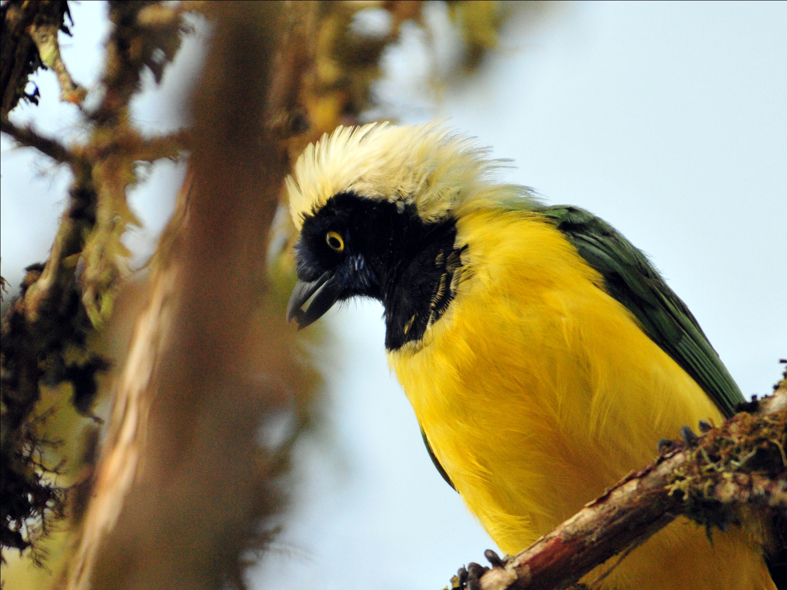
Inca Jay, immature

Our first stop was a light post located near the dining room. Because the lights attracted insects, and the insects attracted birds, this was a great place to spend a little time before breakfast. We stood there for over an hour without moving more than a few feet as the birds literally came to us. Some landed in the trees and bushes around us while others were spotted in nearby trees, and a few like Black-capped Tanager landed, as Marcelo said "in the way way back". Russet-backed Oropendola, Masked Trogon, Crimson-mantled Woodpecker (flyby) , Subtropical Cacique, Pale-edged Flycatcher, Brown-capped Vireo, Blue-winged Mountain-Tanager, Rufous-collared Sparrow, Barred Becard, Golden-crowned Flycatcher, White-crested Elaenia, Saffron-crowned Tanager, Black-billed Peppershrike, Streak-necked Flycatcher, Common Bush-Tanager, and White-sided Flowerpiercer were all seen. As we walked to a path beyond the dining room to see Galo feed the resident White-bellied Antpitta, we stopped to see a Smoke-colored Pewee perched in the distance. Following the feeding of the Antpitta, we were all ready for the big breakfast served in the dining hall, but we weren't too hungry to stop for good looks at a couple of Mountain Wrens along the way.

After breakfast, we proceeded to the road to bird for awhile. Here, we saw Beryl-spangled Tanager, Rufous-crowned Tody-Flycatcher, Black-eared Hemispingus, Blue-winged Mountain-Tanager, Rufous-breasted Flycatcher, and Grass-green Tanager. One of the guides saw an Emerald Toucanet but it escaped everyone else's view. We were disappointed, but we knew the birds were in the area and hoped we would find one later.

During our break after lunch, most of the group visited a set of feeders near a gazebo. Andean Solitaire was seen in the trees nearby. Hummingbirds at the feeders included Chestnut-breasted Coronet, Speckled Hummingbird, Green Violet-ear, Bronzy Inca, Green Violet-ear, and Long-tailed Sylph.

At around 3:30, we left for Guacomayos Ridge. From the parking area, we got good looks at Green-and-black Fruiteater before going down the trail (actually first up, then down). This trail was built hundreds of years ago by the Incas, and the stones had shifted a lot over time. The footing was a bit tricky and the trail was very quiet, with fog beginning to settle in. It was a privilege to walk this historic trail, but after some time, I decided to go back to the bus. The group had been

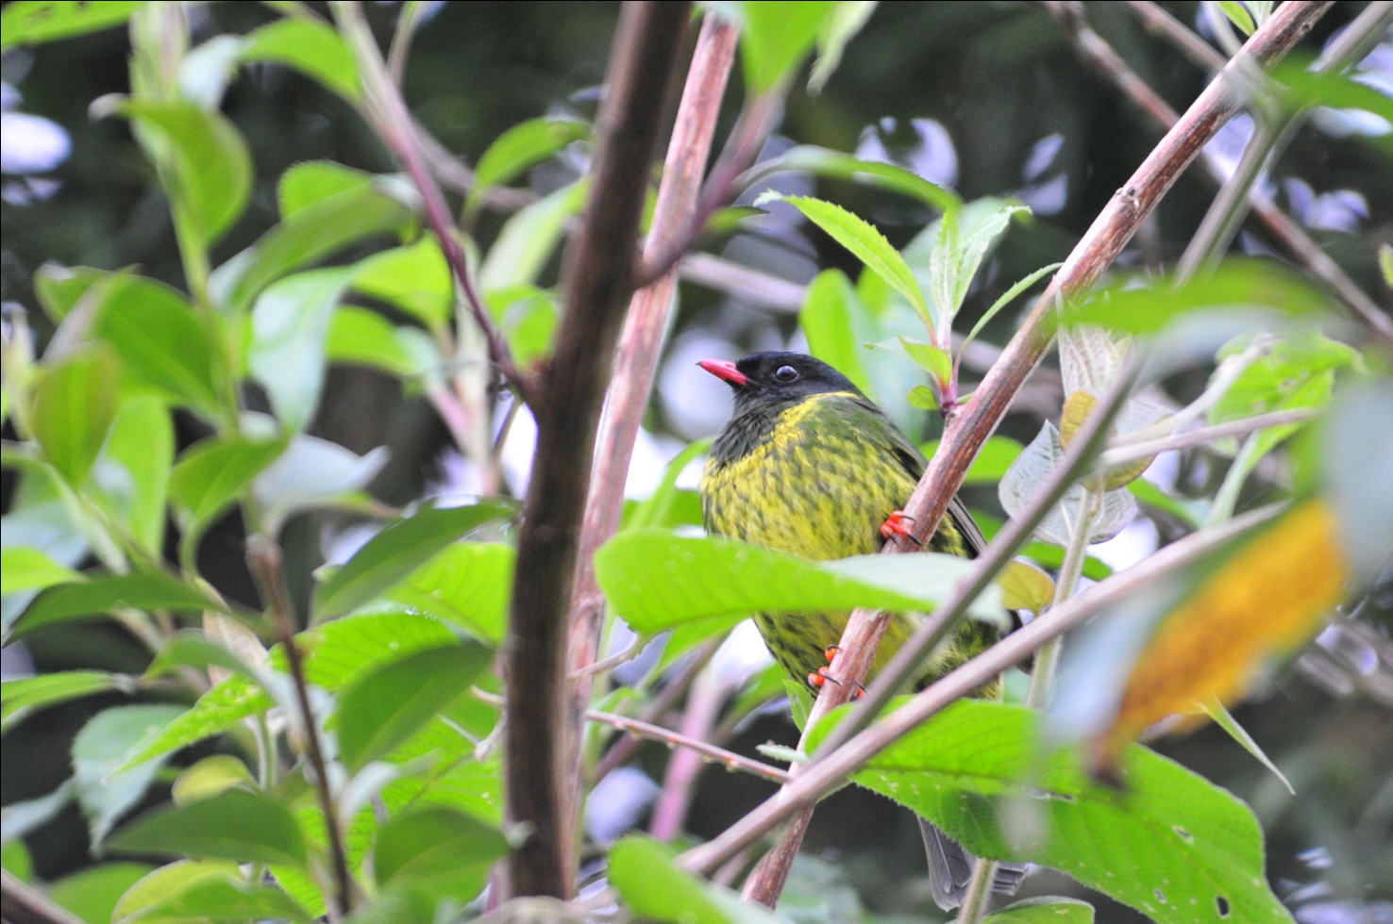
Green-and-black Fruiteater

hearing a Tapaculo and we were trying to get a visual on this bird that sounded like it was right in front of us. I had grown weary of the (relative) inactivity and started back alone as the trail started a serious decline. When I got back to the bus, I stood at the guard rail and watched for birds over the ridge. At some point, my mind wandering, I heard an odd sound and caught some motion out of the corner of my eye. When I put my binoculars up, there on top of a broken-off tree was a Black-billed Mountain-Toucan. As it called another came to join it, and then I watched in amazement as they mated. I had never seen this species before, so I was frantically vocalizing field marks so I could ask Marcelo and Galo when they came back to identify this beautiful bird. The toucans were too far out for a photo, but I had excellent views and good color in spite of the fog that somehow seemed to be everywhere and yet not affecting my vision. The only disappointing thing about this sighting was that everyone had not seen it.

Just before the group got back, I heard what sounded like one of the Tapaculos in a bush just on the other side of the guard rail. I only got a glimpse, but the vocalization was that of a Blackish Tapaculo. When the group got back, I learned that some had seen the Blackish and the Ocellated Tapaculos. Other birds seen on the ridge included Northern Mountain Cacique, Blue-and-black Tanager, Broad-winged Hawk, and Slate-crowned Antpitta. As the sun got low, we began to look for some nightjars, successfully finding Rufous-bellied Nighthawk and Swallow-tailed Nightjar, although the nightjar was female and didn't have the outrageous tail feathers we were hoping to see. Galo and Marcelo tried to call out a White-throated Screech Owl, and we all saw it as it flew through the beams of their flashlights.

After a wonderful dinner featuring some traditional Ecuadorian recipes, we went over the checklist. We finished with 60 species, 20 new ones for total of 403 for the trip.

DAY 12, December 2: SAN ISIDRO LODGE
As we walked to the dining hall for breakfast, we were entertained by a family of Inca Jays, who were obliging subjects for photographs. Also in the area were Common Bush-Tanager, Montane Woodcreeper, Saffron-headed Tanager, and Crimson-backed Woodpecker.

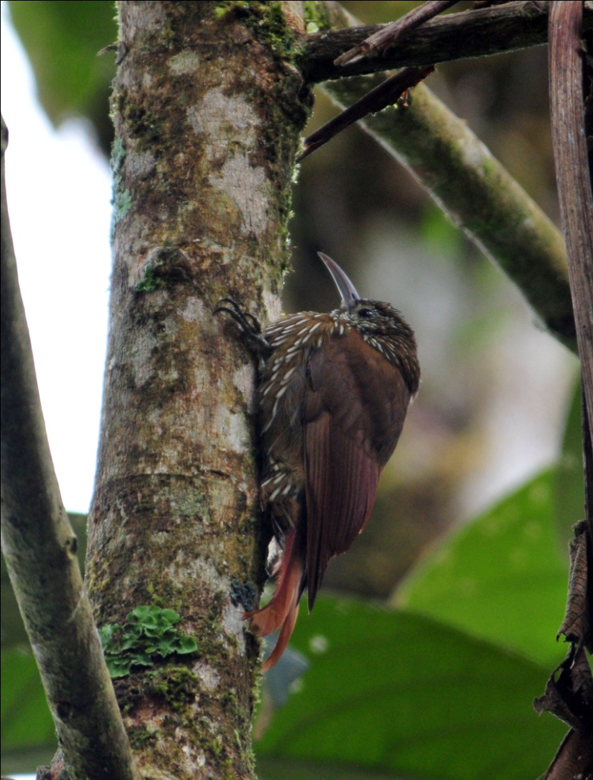
Montane Woodcreeper
After breakfast, we started off on the road for some birding. It didn't take long to find several species - Marble-faced Bristle-Tyrant, Blue-winged Mountain-Tanager, Long-tailed Antbird, Rufous-crowned Tody-Flycatcher, Beryl-spangled Tanager, Broad-winged Hawk, Russet-backed Oropendola, Fawn-breasted Tanager, to name but a few. Almost every bird was one we had already seen, and although we were happy to observe them again, we wanted some new species. Long before we were ready to stop birding, a shower moved in and we retreated to the lodge or our cabins. We enjoyed the nice morning break, but by the time lunch rolled around, we were all itching to get back out on the trails.

By 2:30 we were back on road, this time going farther from the lodge. Southern Lapwing were seen in a grassy field, Torrent Tyrannulet and Black Phoebe near a stream, and Russet-backed Oropendola flew over. We approached a side road that was to be our route, but the main bridge was out and Luis didn't think his bus could make it through the path across the stream that was being used by vehicles (probably not right after a rain, though). We all got out of the bus and proceeded to walk up the side road, birding along the way. On both sides of the road were a lot of downed trees, part of the work being done to install new power lines. We had some pretty good birding along this road, but I think it would have been nothing short of amazing if the area had not been disturbed. On this walk we saw, among other things, Bluish Flowerpiercer, Grass-green Tanager, Spectacled Whitestart, Masked Flowerpiercer, Saffron-crowned Tanager, Blue-winged Mountain-Tanager, Ashy-headed Tyrannulet, Flame-faced Tanager (Eastern race),Beryl-spangled Tanager, Slaty Brush-Finch, White-capped Parrot, Slaty-backed Chat-Tyrant, Sickle-winged Guan, and Yellow-vented Woodpecker. We all got much closer and better looks at Green-and-black Fruiteater and today everyone got to see the Emerald Toucanet

We finished the day with 59 species, of which only 7 were new to the trip, which brings our trip total to 410 with just one day left for the main tour.

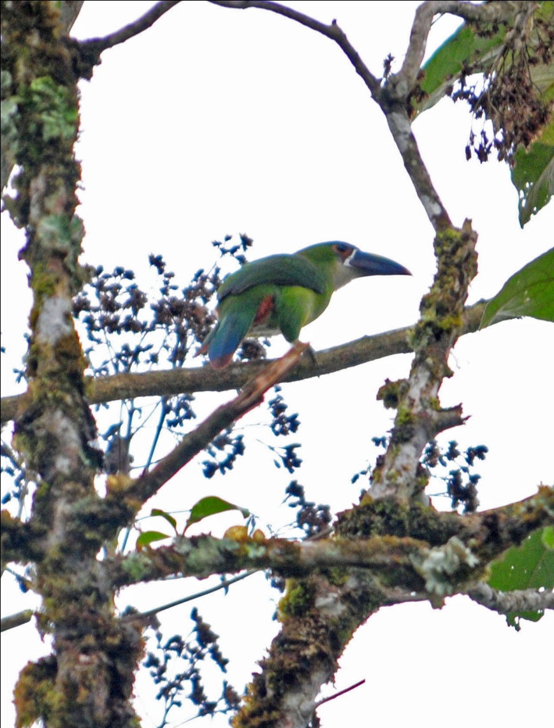
Emerald Toucanet
DAY 13, December 3: SAN ISIDRO LODGE - COCA - NAPO WILDLIFE CENTER (OR HOME)
Today we left before dawn to drive to Coca, the stepping stone to the Amazon River Basin. Because we left so early, most of our drive was in darkness. Even after the sun came up, we couldn't make a lot of stops or we might not get to the airport in time for Robin, John, and Diane to catch their flight back to Quito. These three were not going on the Amazon extension, and would return to Quito today and then fly home tomorrow.

However, some stops you just have to make whether you have time for it or not. As we were cruising down the highway, Luis came to a fast stop as he began to talk excitedly in Spanish to Galo. I don't speak Spanish, but I know "eagle" when I hear it. After a lot of agitated conversation, Galo told the group that Luis had seen a Crested Eagle on the ridge above the road. We all piled out, with Luis in the lead. As Galo was setting up the scope for us to get good views of the eagle, Marcelo and Luis charged down the road. The ridge was pretty high above the level of the road, but Luis was already making tracks to the top of the ridge for a better view, and our guide was taking off with him. I saw Bernie follow, then Galo sprinted down the road to the rough trail that led to the top of the ridge. Camera in hand, I just had to go as well, just in case I could get a better shot from there. Anyone who knows me knows I'm no fan of steep muddy trails, and here I was trying to run up what was probably the steepest trail I'd encountered on the entire tour! When I got to the top, I found the eagle, while closer, was not in any better position for photography with obstacles between the camera and the bird. I fired off a few shots and then waved to my fellow birders below. In his excitement, our new birder Luis had run off without turning the bus off or turning the flashers on. Diane and Jude had taken care of that for him, and no one criticized this behavior that marked his transformation into a true birder. We all cheered for him and secretly wished we could be around when he told his older brother, who is a working birding guide, that HE, Luis, was the one who found a Crested Eagle for our group!

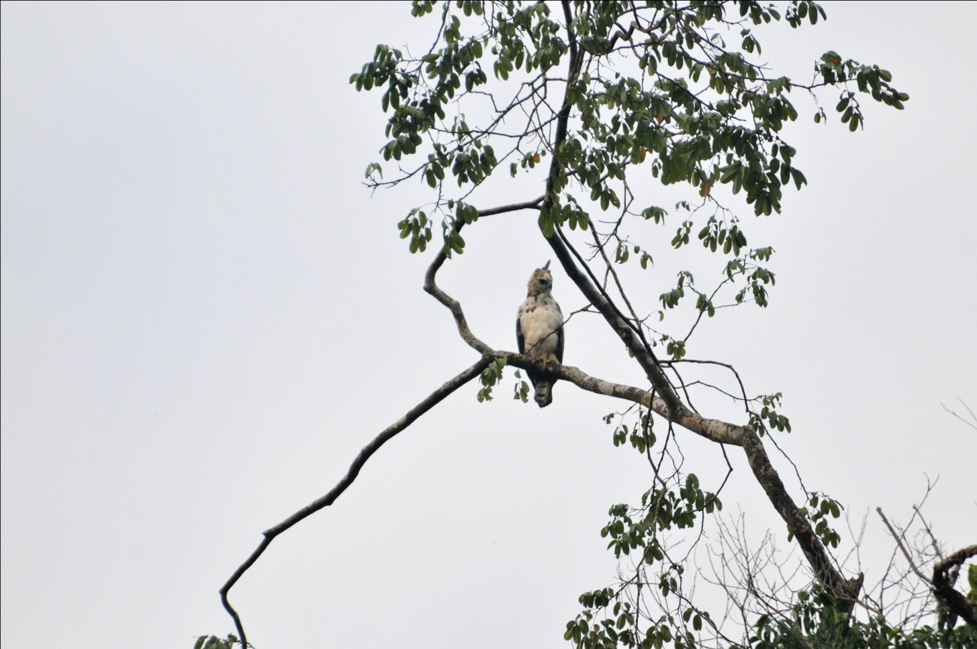
Crested Eagle, immature
When we arrived at the dock in Coca, we had some time to wait for the boat to be ready for us to load. As we entered the building, a captive White-throated Toucan sat on the railing above us calling for all it was worth. On the other side, a Blue-headed Parrot peered out from deep within a short shrub while an Orange-winged Parrot nonchalantly nibbled in a bush just a few feet from us. Even though the birds were technically pets, it was great to be able to see them at such a close range so we could appreciate the markings.

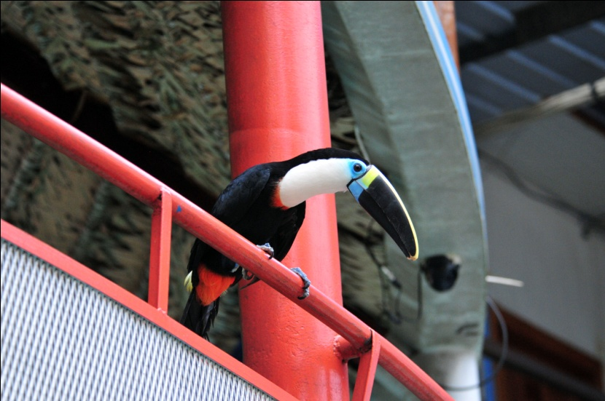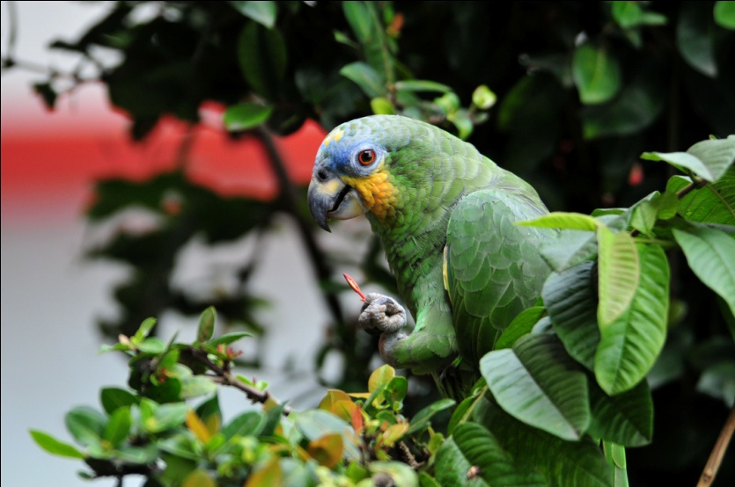
White-throated Toucan Orange-winged Parrot

From the dock, we saw White-winged Swallow and Gray-breasted Martin. Later in the day, we would add White-banded Swallow and Brown-chested Martin to the day's list. We had lunch at the dock before boarding and took some time to look around at the small menagerie owned by the hotel there. Marmosets, Squirrel Monkeys, and other animals roamed around freely as we tried to photograph them. A male peacock strutted his stuff for some peahens who were none too impressed.

Finally it was time to board the boat. This was my third trip down the Napo River, each time to a different lodge, and this was by far the most comfortable boat I've had the pleasure to ride. Cushy seats with tall backs made the two-hour trip seem much shorter than it had in the past. From the boat, we spotted Osprey, Great Egret, Ladder-tailed Nightjar, Yellow-billed and Arctic Terns, Black Skimmer, Neotropical Cormorant, Blue-winged Teal, Cocoi Heron, Greater Yellow-headed Vulture, and Yellow-headed Caracara.

After a few hours, we came to a landing where we disembarked in order to take smaller boats down the stream that would lead us to Napo Wildlife Center. A nice bodega with seating was situated on high ground away from the river bank, and across from it were restrooms with running water. We took a quick restroom break and then boarded our canoes to go deeper into the forest and to our final destination. Each canoe seated four of the eight birders with a boatman in the back, a native guide in the front, and one of our two guides right behind him. They paddled the boats silently up the stream, and the world around us was transformed into a paradise where the only sounds were the gentle sound of the water moving against the canoes and the birdsong coming from all directions.

Aaaah . . . . . . . .

Until the guides got settled and started finding one bird after the other, calling out directions and identifications faster than we could keep up with, that is. Almost immediately, Marcelo saw an Amazonian Umbrellabird fly by, but the bird disappeared and no one was able to relocate it. A Black-throated Hermit was also too fast for everyone but Marcelo.
Pale-vented Pigeon on your left! White-throated Toucan straight ahead! Oilbird roosting in a tree over your head! We stopped at one fruiting tree that held Lettered Aracari, Many-banded Aracari, and Channel-billed Toucan.
Orange-winged Parrots and Cobalt-winged Parakeets flew by. Black-fronted Nunbird! Black-tailed Tityra! Buff-throated Woodcreeper! Black Caracara! Each time a new species was found, the two canoes would have to be positioned and re-positioned so everyone could see the bird clearly. It was great for those of us sitting there letting others do all the work, but it looked pretty difficult for the ones trying to maneuver the boats to please everyone.

At our first sighting of a Hoatzin, another bird that I really admire and the locals hold in low esteem, Marcleo informed us that the locals call it "Stinky Turkey". I did a little research when I got home and learned that the birds really do stink and that the bad odors are produced by the fermentation of leaves in the bird's crop. Unlike most birds, Hoatzins eat the leaves of plants, and to a lesser degree the fruits and flowers. The Hoatzin’s digestive system is unique among birds. Hoatzins use bacterial fermentation in the crop to break down the green leafy materials they consume, much like cattle and other ruminants do in their specialized stomachs. The aromatic chemicals produced by fermentation smell bad – giving the bird its common name, as well as a low ranking on the desirability scale for local native hunters. Another interesting fact about the Hoatzin is that the chicks have claws on their wings. This allows a chick who is threatened in the nest by a predator to jump to safety and then use the claws to climb back into the nest. This is a throw-back to the dinosaurs, and something I've always found very interesting about these birds. And, since the nests are usually built over water, the chicks actually have the ability to swim underwater to avoid predation! How can you not like a creature as unusual as this?!

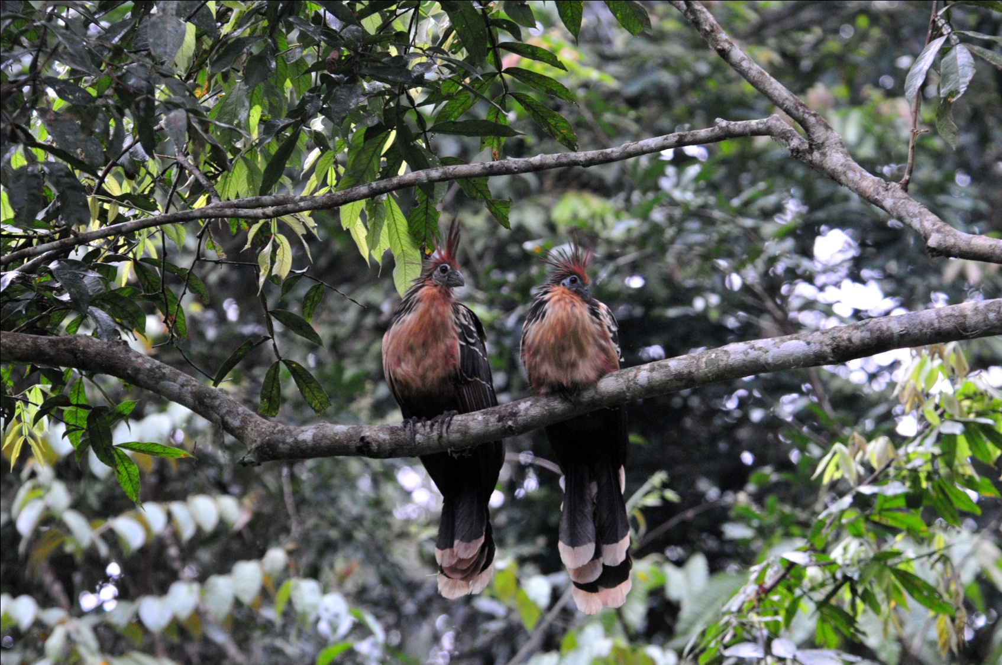
Hoatzins

OK, moving along now . . . . As we continued down the stream, we found more and more birds. Because we were in a new habitat, most of them were new species for the trip, or at least a new subspecies. At the end of the day, we had seen 74 species with 47 of them new for today, bringing our trip total to 457. WOW! But back to the birds we saw - Yellow-rumped Cacique, Russet-backed Oropendola, Eastern Wood-Pewee, White-eared Jacamar, Scarlet-crowned Barbet, Cinnamon Attila, and - - - - - Oh, wait! We stopped to see an Anaconda for a few minutes - - - - - Palm Tanager, Crimson-crested Woodpecker, Chestnut-fronted Macaw (flyby), Gray-headed Tanager, Greater Ani, Boat-billed Heron, Red-rumped Cacique, Silver-beaked Tanager, Cream-colored Woodpecker, Yellow-tufted Woodpecker, White-chinned Jacamar, Black-capped Donocobius, Bare-throated Fruitcrow, Great Antshrike, Dot-backed Antbird, American Pygmy Kingfisher,White-shouldered Antbird (female), Rufous-breasted Hermit, Lesser Kiskadee, Great Kiskadee, Swallow-winged Puffbird, Snail Kite, Ringed Kingfisher, Amazonian White-tailed Trogon, Red-bellied Macaw (flyby), lotsa Hoatzins, Neotropical (Fork-tailed) Palm Swift, Ruddy Pigeon. What a day!!

We did have to interrupt our birding to stop to watch a family of Squirrel Monkeys, a couple of troops of Red Howler Monkeys, and a Black Caiman at various points along the way, but we didn't mind too much. As we approached the dock at Napo Wildlife Center, two Red-capped Cardinals were hopping around the pilings. As we stepped onto the dock, a gentleman greeted us with a tray of fruit juices. We were immediately led to our cabanas where we found a level of luxury we did not expect. Our luggage was delivered, and we had a short time to settle in and explore the grounds before meeting to go over our impressive checklist.

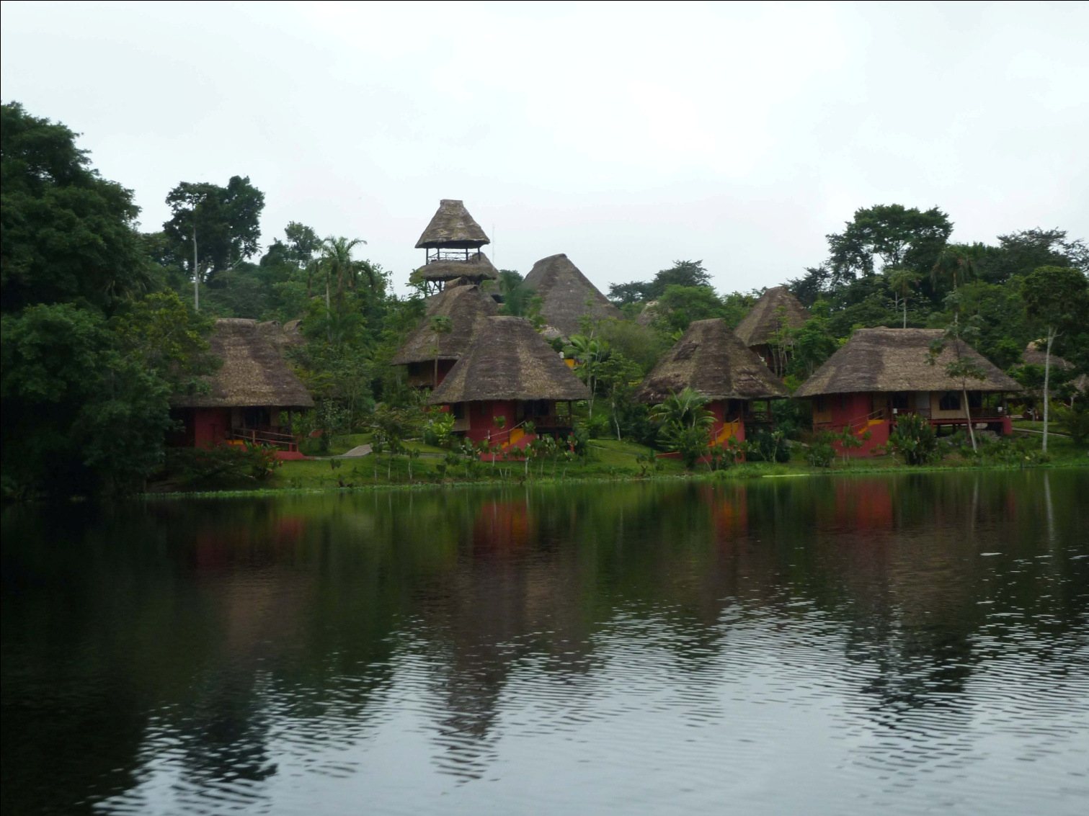
Napo Wildlife Center

Day 14, DECEMBER 4: NAPO WILDLIFE CENTER, CANOPY TOWER, CARI ANANGU CREEK
After such a wonderful and productive trip in to the lodge, we were eager to begin birding the next day. We planned to get started after a 5:00 AM breakfast, but rain delayed our departure until about 8:00 AM. As I rested in our cabana, I got more and more restless, ready to go find some new birds! I learned later that most of the group was equally restless and had ended up in the tower at the lodge. Marcelo, always full of energy and always ready to bird, was with the group. They saw some pretty good birds from there - without me! Some of the species seen from the tower were Casqued Oropendola, Capped Heron, lots of Yellow-rumped Caciques and what seemed like an equal number of Great Kiskadees. The casqued Oropendola would have been a lifer for Jim and me, and I was disappointed that we weren't able to find another one before we left. I guess we have to leave something for next time!

We climbed into our canoes and headed back across the lake and up the Cari Anangu Creek. We saw many birds, most of which we had seen yesterday. New from the canoes for today was a Crimson-masked Tanager. Once we reached land, we had a short walk to the tower, arriving there at about 8:45. The tower is built on the top of a huge Ceiba Tree with galvanized metal stairs leading to a huge wooden platform that stretches across the top of the tree like an enormous nest. At 36 meters, we were looking down on most of the other trees in the forest, giving us an excellent vantage point for our morning of birding.

We didn't get a huge mixed flock as hoped for, but we did get some great birds, especially considering how late in the morning we arrived. From a distance, we spotted Spangled Cotinga and Plum-throated Cotinga. Orange-winged Parrots flew by close enough for us to see field marks and several pairs of Blue-and-yellow Macaws flew by, with a few of them landing where we could watch them through the spotting scope. A Slate-colored Hawk landed in a treetop about a hundred yards out and gave us great unobstructed scope views as it sat and preened. Closer to our tree, we found Opal-crowned Tanager, Yellow-margined Flycatcher (aka Zimmer's Flatbill), White-fronted Nunbird, Great Potoo, Violaceous Jay, Slender-billed Kite, Yellow-bellied Dacnis (Eastern race), White-necked Puffbird, and both Ivory-billed and Many-banded Aracaris. After a lull in the activity, we spotted a mixed flock moving through one of the trees below us. We watched as Red-eyed Vireo, Black-tailed Tityra, Piratic Flycatcher, Blackpoll Warbler, Purple-throated Fruitcrow, Red-stained Woodpecker, Laughing Falcon (eastern race), Yellow-crowned Tody-Flycatcher, White-lored Tyrannulet, Gilded Barbet, Lineated Woodcreeper, LaFresnaye's Piculet, Pygmy Antwren, Citron-bellied Attila, and Black-faced Dacnis passed before us. Other birds seen from the tower included Mealy Parrot, Black-capped Becard, White-browed Purpletuft, Dwarf Tyrant-Manakin, and Rufous-bellied Euphonia.

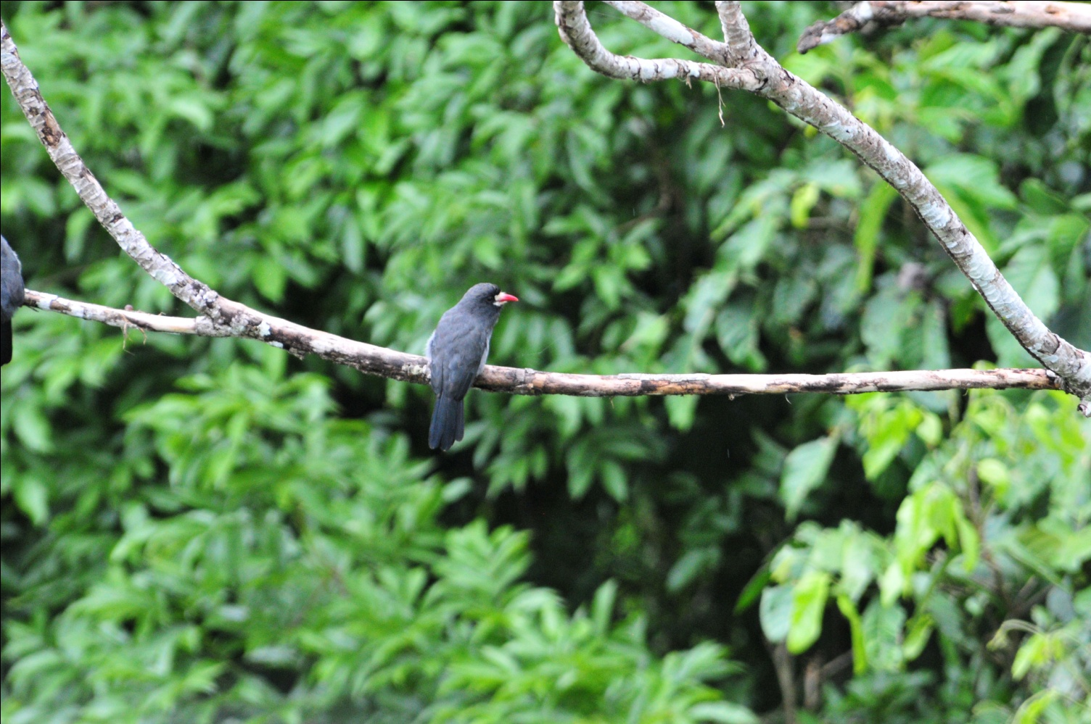
White-fronted Nunbird
As we walked back through the forest and traveled back down the creek in our canoes, we added several species to the day's list: Yellow-billed Jacamar, Dusky-throated Antshrike, Speckled Chachalaca, Limpkin, Black-headed Parrot, Scaly-breasted Woodpecker, and Lineated Foliage-gleaner. We returned to the lodge for lunch and a short break and were back in our canoes at 3:30 to bird along the creek. This is a very relaxing way of birding, with the natives doing all the rowing, but it can be frustrating when you are in the back of a canoe with no bird in sight while those in the front have a clear view (and vice versa). Our guides were so patient and skilled that they were able to get most of the birders on most of the birds while in the canoe as well as on the trails. Among the dozens of species seen this afternoon were some interesting or new species, including Anhinga, Amazon Kingfisher, Hoatzin (I know they're common, but I never get tired of seeing them!), Rufescent Tiger-Heron, Lineated Woodpecker (in nest), Long-billed Woodcreeper, and Black-tailed Trogon (male and female).

For the day, we saw 87 species, 44 of which were new to trip, for a trip total of 501. We had been trying to keep track of total trip numbers so we would know what our 500th bird was, and by our calculations we had 499 birds at the end of the day today. This demonstrates how difficult it is to keep track of numbers while on a trip and is one of the reasons why we now maintain the list on a laptop as we go over the day's list each evening.

Day 15, DECEMBER 5: NAPO WILDLIFE CENTER, YASUNI NATIONAL PARK, PARROT LICKS, RIVER ISLANDS, QUICHA COMMUNITY INTERPRETIVE HOUSE
This morning we had a very early breakfast (4:30 AM) so we could depart by 5:00 AM. Our plan was to go back out to the Napo River, board a larger boat and visit Yasuni National Park, famous for the most accessible parrot licks in Ecuador. Moving almost silently through the darkness, we noticed Glowworms along the edge of the water just as we entered the creek on the far side of the lake. In the darkness, we could hear Common Potoo , and as sunrise approached, we saw a Common Paraque fly away. Just as the day got light enough for us to see details, we saw what we thought was our 500th bird, a Green-and-Rufous Kingfisher . In dim light we also saw Ferruginous Pygmy-Owl, Boat-billed Heron; a Short-tailed Nighthawk flew by.

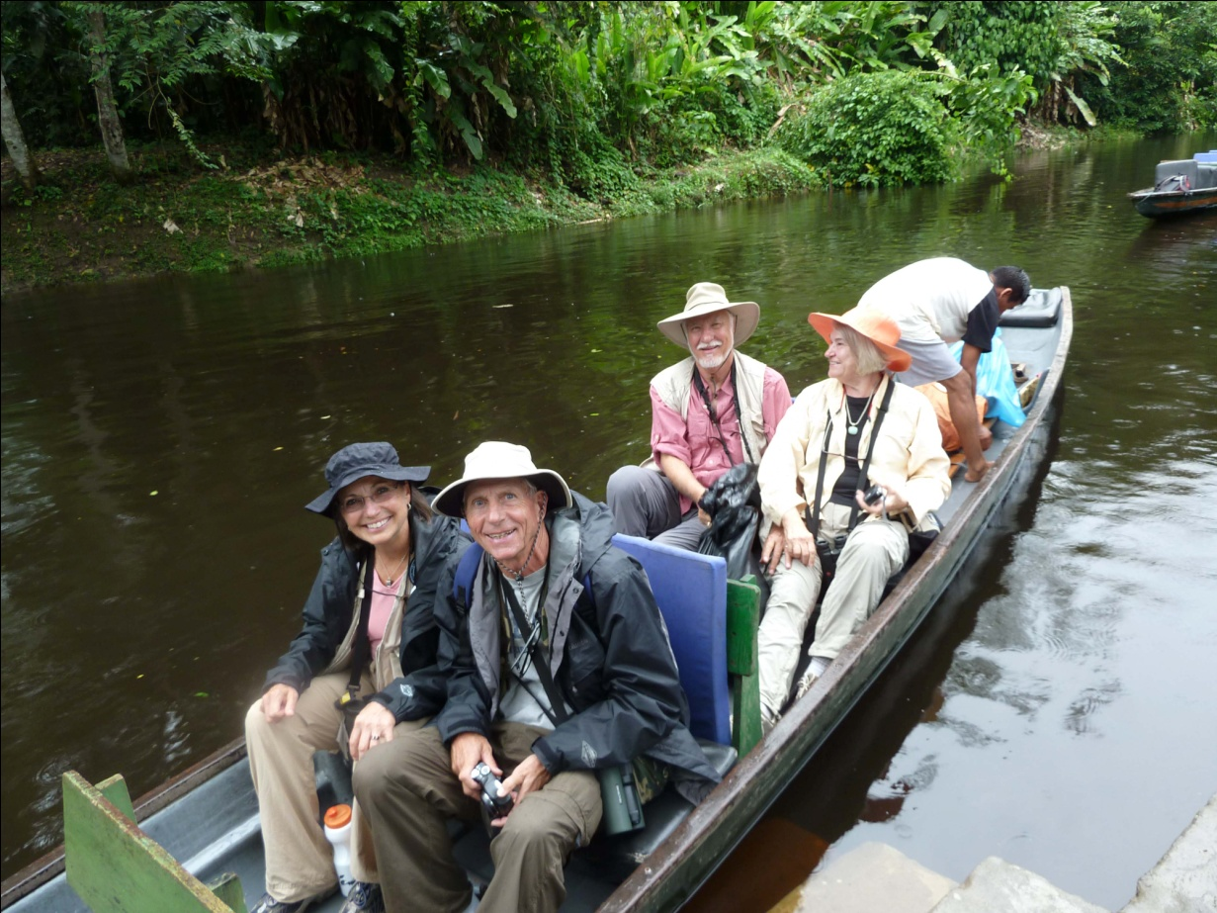
Birders in NWC Canoe
When we got to the Napo, we quickly boarded a larger boat, one that would hold all of us, and headed farther downstream to Yasuni National Park. From the boat we saw a Black-fronted Nunbird pumping its tail, and a Chestnut Woodpecker in a large tree on the bank. Marcelo was, as always, the first to spot Amazonian Umbrellabird. The bird was difficult to see and pretty far away, but we all helped each other get on the bird. Finally, after the Umbrellabird changed its position, we all felt like we had satisfactory looks. Stopping near a small island, we saw Yellow-headed Caracara, Snowy and Great Egrets, Spotted Sandpiper, Oriole Blackbird, Pied Plover, Mottle-backed Elaenia, Pale-vented Pigeon, and Little Woodpecker. Drab Water-Tyrants were found hunting near the bank farther down the river.

Next, we stopped at one of the river islands where species that are endemic to just these Napo River islands can be found. With the water so high, we weren't able to bird as much on the island as in the past, but we still managed to find some pretty good birds, including, Least Sandpiper, Collared Plover, Lesser Hornero, Chestnut-winged Hookbill, Barn Swallow, Bank Swallow, Lesser Wagtail-Tyrant, and Brown-backed (Yasuni) Antwren. White-bellied Spinetail was heard only and the tiny Gray-breasted Crake was seen after the group formed a circle around the area where we heard it calling. Running along the ground, this tiny bird seemed more like a mouse than a bird at first glance.

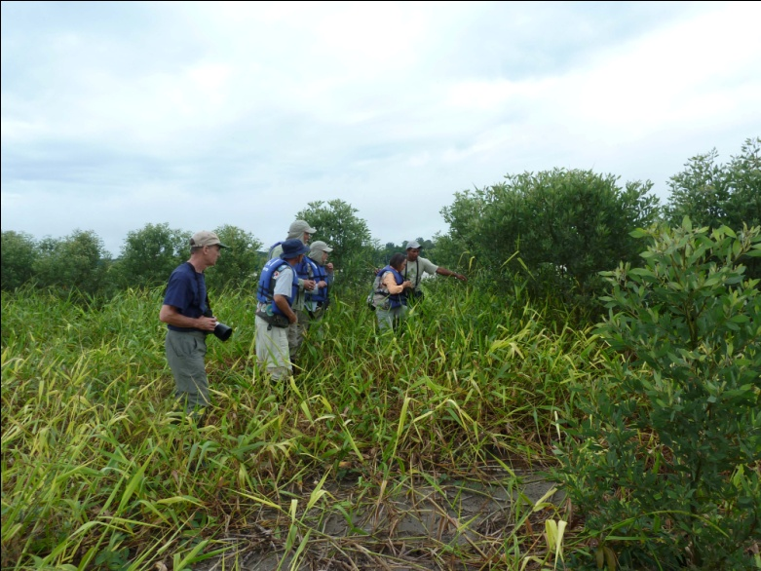 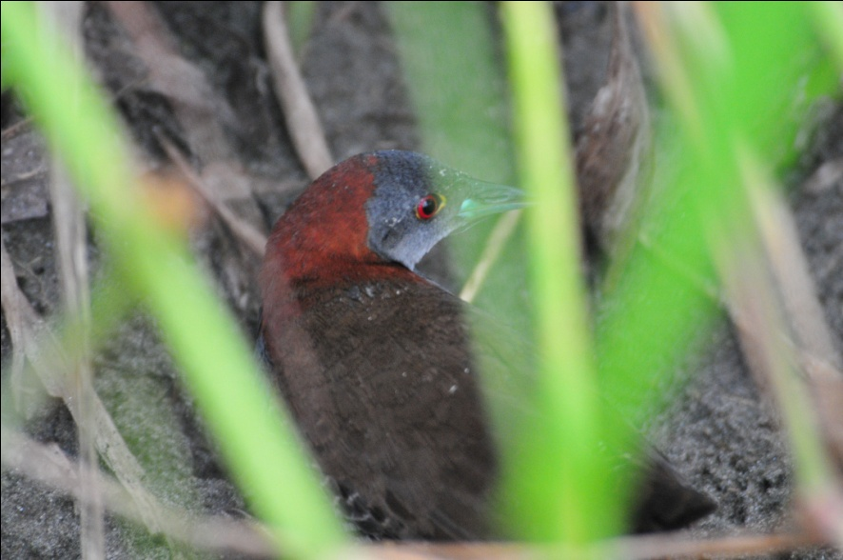 Hunting for Crakes on River Island Gray-breasted Crake

When we reached Yasuni National Park, we docked the boat on a bank at the far end of the area where one parrots lick is found. We hiked a trail that led to this lick, which to me looks like a miniature cave. This was where I saw Scarlet Macaws up close in February, and I was eager to get there. The trail , which was not difficult and had a concrete path part of the way, proved to be very productive. We heard both Little and Undulated Tinamous but could not get a visual on either bird.
Other birds were more cooperative, including Ruddy Ground-Dove, Black-throated Trogon, Lanceolated Monklet, Black-faced Antthrush, Lawrence's Thrush, Wire-tailed Manakin, Tawny-faced Gnatwren, and Rusty-belted Tapaculo, who stuck around quite awhile and gave everyone good looks. The forest was full of song this morning, and although we would have like to have seen every bird, some of the vocalizations were great to hear. Gray-fronted Dove and Sapphire Quail-Dove were heard multiple times, as well as Lemon-throated Barbet and Blue-crowned Manakin. But the most impressive vocalization had to be the Screaming Piha, which we heard for the first time today. What a sound!

When we finally reached the parrot lick, we learned that a Black Hawk was in the area, and the parrots, although they could be heard, were not coming down to the licks. Because of this, we stayed in the shelter facing the lick only long enough for our mid-morning snack and then we headed up a steep trail where we could find some new species. At this point I should say "they" instead of "we" because I stayed at the lick, partly because I was hoping some parrots would come in the absence of humans, partly because the day was so hot that I didn't really want to face a steep climb, and partly because I copped a little attitude because the mid-morning snack was a tuna sandwich. I'll try not to sound like a high-maintenance prima donna here, but the fact is I don't eat fish. In addition, one member of our group, Jean, requires a gluten-free diet, so this menu choice was inappropriate for 25% of our group, which did not make me happy. Keep in mind that breakfast was at 4:30 AM, so everyone was pretty hungry by the time we stopped. I expressed my displeasure and Galo immediately suggested that we go back to the bodega where we would have lunch. Of course, this would have been ridiculous, and I told him I had brought a snack and they should go on, but Jean, Jim and I remained in the shelter while the others took the difficult hike. Their efforts were rewarded with Golden-headed Manakin and Striped Manakin, two members of one of my favorite families in the tropics. They also added Mouse-colored Antshrike, Rufous-tailed Antwren, and Gray Antbird to their list and got to see a Scarlet Macaw fly over. Down below, our patience didn't win us any great views of parrots, but we did see the Macaw above us and had a nice time relaxing and chatting in the shelter, playing with a friendly Blue Morpho butterfly that kept landing on us, and photographing a small lizard. When the others were done, we joined them at the riverbank to get on the boat an move on to our next spot.

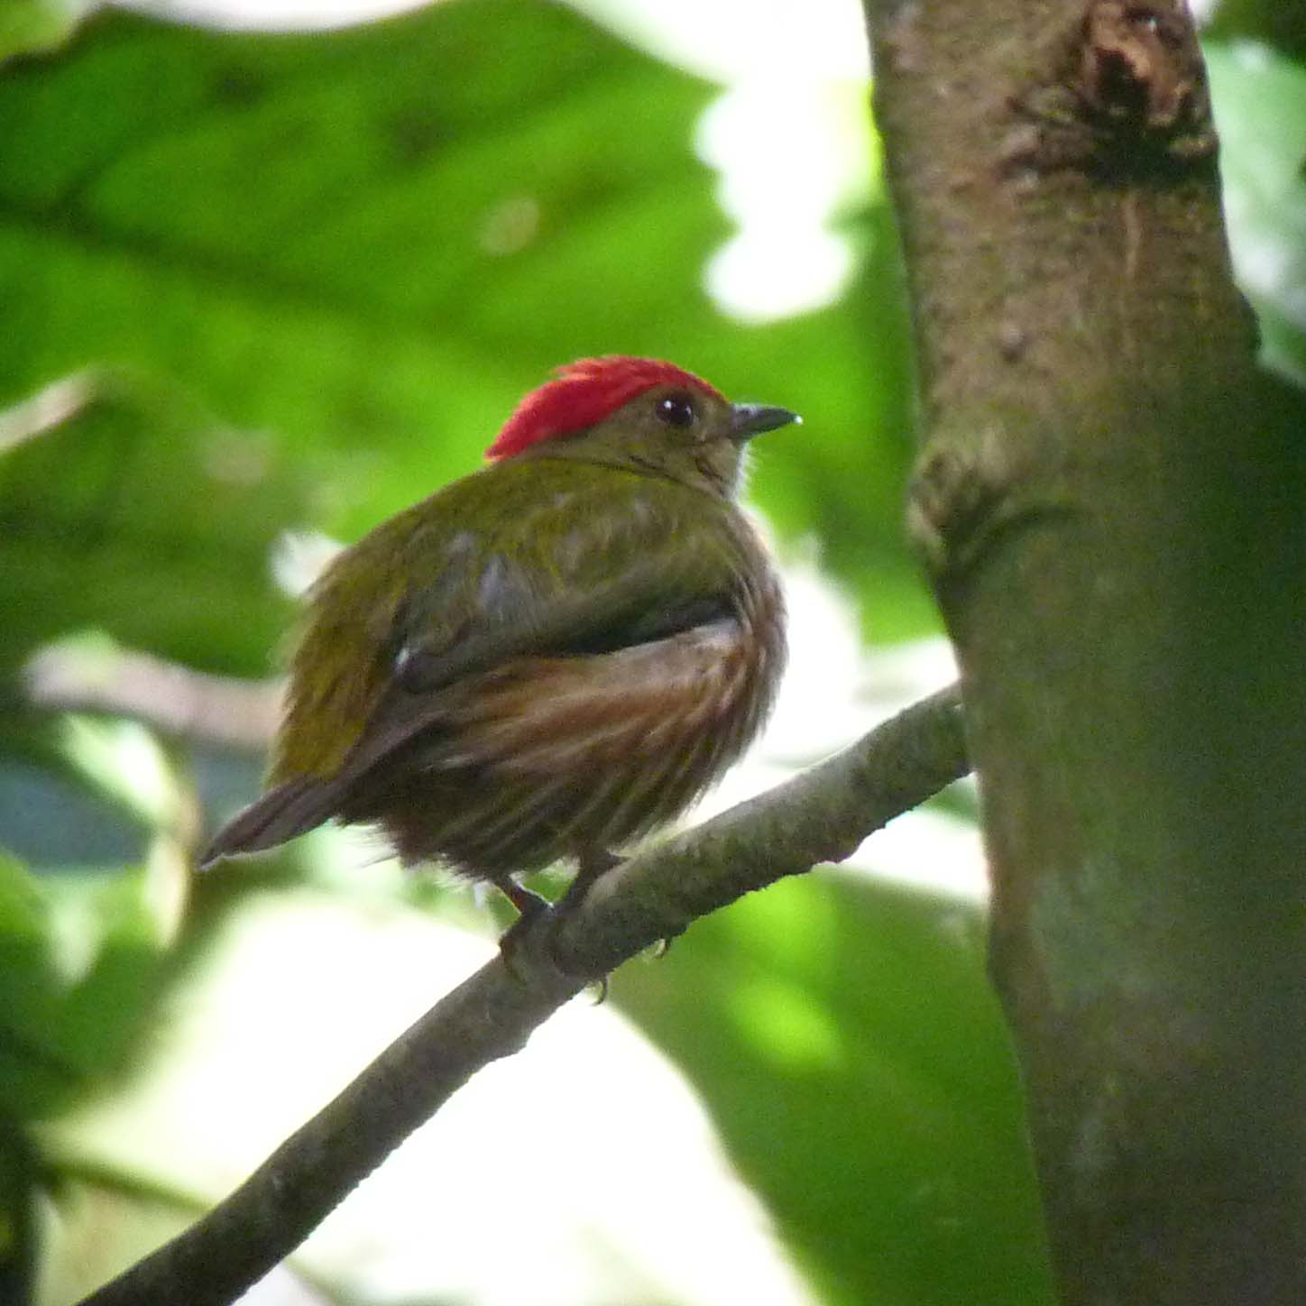
Striped Manakin (Feb 2010 photo)

As we made our way along the river, the boat paused at a lick that is best viewed from the river. Here, we saw Dusky-headed Parakeet, Blue-headed Parrot, Yellow-crowned Parrot, and Mealy Parrot. We continued on and made our way back to the bodega that marks the entrance to the creek leading to Napo Wildlife Center. There we enjoyed a huge lunch (with no fish) and a short break before going on to the next item on our agenda, a new interpretive center where we would learn a bit about Quichua culture. We were led to a building made of timber from the forest with a thatched roof, a typical Quichua dwelling. A group of girls and women performed a traditional dance for us, and then invited the men to join them in the dance. Most of our guys agreed and did a pretty good job imitating the dance done by the women. Next we were led to a typical home where Marcelo, who is himself a Quichua, translated as one of the women of the village told us about daily life. We weren't sure how much of the practices she talked about are still used, but we were charmed by the experience. It was wonderful to see how proud Marcelo was as he related the information given by the woman. A shaman was next, and after hearing an explanation of his position and duties within the village, he offered to "cure" anyone who had an ongoing malady. Bernie volunteered that his knees gave him trouble, and we observed as the shaman performed his cure. Our last stop was a small gift shop, which everyone enjoyed. By the time we left, it was after 5:00 PM and the

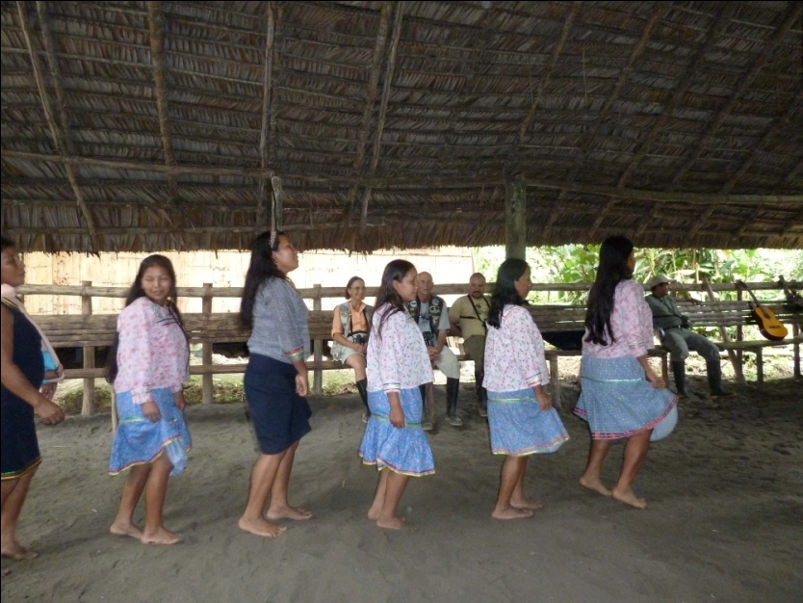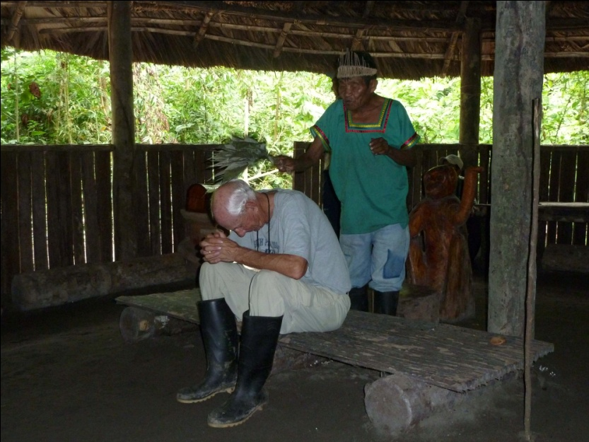
Traditional Quichua Dance Bernie's "Cure"

sun was getting low. We went back to our waiting canoes and headed back up the creek to the lodge. From the creek we saw Solitary Cacique and Spectacled Owl. Just as the light was beginning to fade fast, we stopped along the bank of the lake and found Zigzag Heron.

Somewhere along the way today, and I cannot tell you where, we saw a great variety of Ant - somethings. In addition to those already mentioned, sightings included Cinereous Antshrike, Long-winged Antwren, Gray Antwren, , Black-faced Antbird, Plumbeous Antbird. Also seen without memory of place were Spotted Tody-Flycatcher, Eastern Kingbird, Dusky-capped Greenlet, Fulvous Shrike-Tanager, Chestnut-eared Aracari, and Great-billed Hermit. In my defense at such poor record-keeping and/or poor memory, let me state that we saw 106 species today- our first day over 100! In addition, we heard another 32 species and had 4 fly-bys. With exposure to a total of 142 species, I did not manage to use my little voice recorder as often as I should have. Of the 106 species seen today, 49 were new for the trip, bringing our trip total to 550.

Day 16, DECEMBER 6: TIPOUTINI TRAIL, CANOPY TOWER
We left the lodge at around 6:00 AM to head for a terre firme forest trail called the Tipoutini Trail, where one of the target species would be Black-necked Cotinga. Before we even made it all the way across the lake we had our first new bird for the day, a Wattled Jacana followed quickly by an Azure Gallinule. We took our time going down the creek and saw many birds, most of which we had seen earlier on the trip. Chestnut Woodpecker and Ringed Woodpecker were a couple of new ones we chalked up. The backlighting on the Ringed Woodpecker made it difficult to appreciate the beauty of the bird, and we hoped we'd get another chance to see it. The water was pretty high, so we were able to go farther by canoe than is often the case. At one point, we had to lay back as low as we could to get under a low branch that was stretched across the water in front of us - birding limbo!

Once we started walking, the birding was excellent. Bat Falcon perched in a tree a short distance away, then we saw Ochre-bellied Flycatcher, White-crowned Manakin, and lots of species already on our list from the past few days. When we came to the area where Marcelo know Black-necked Red Cotinga was normally found, it didn't take him long to find the resident male for us. Sitting quietly and preening, we were amazed again at Marcelo's ability to find birds that are not moving or singing. We spent quite a bit of time admiring and photographing this beauty before moving on, and almost everyone agreed that it was the highlight of the day.

As we went further down the trail, Marcelo pointed out the nest of a Salvin's Currasow. Looking closely, we could just see the bill emerging from the nest. A bit farther, and we were able to see the Screaming Piha whose vocalizations we could hear since climbing out of our canoes. Some of the other birds seen on the trail included Cinereous Antshrike, Yasuni Antbird, Brown Nunlet, Olive-backed Foliage-gleaner, Warbling Antbird, Great Tinamou, Ruddy Quail-Dove, Dugand's Antwren, Spot-backed Antbird, Sooty Antbird, Striated Antthrush, Thrush-like Antpitta, Eastern Sirystes, and Dwarf Tyrant-Manakin.

As we traveled by canoe back to the lodge for lunch, Red-throated Caracara announced its presence and then allowed us a brief view. Pretty much everything else we saw on the way back were birds that were not new for the trip. As we gathered for lunch, Jude asked me to see if I could try to get a thorn out of her head with some tweezers. Apparently, she had stepped back on the trail at just the right angle to allow a thorn from a tree to go into her scalp. It was causing her a lot of discomfort, so Bernie had been trying to get it out and could not. I took my best shot at the task, but such a small amount of the thorn was emerging from her head that I couldn't get a grip on it. Finally, we asked if there was any medical staff present, and a guest volunteered that he was trained in wilderness medicine. He had in his kit a pair of tweezers designed for such a task, and in short order had removed the thorn. It was over an inch long, and was completely buried in Jude's scalp!

There was some rain after our lunch break, and we took advantage of some down time to begin organizing for our departure the next day. At about 4:00 PM, we headed back for one last visit to the tree tower, hoping to see birds that were moving to their roosting sites as sunset approached. We had a few sprinkles on the tower but not enough to force us to retreat to the lodge. A King Vulture flew by in the distance. Pied Puffbird and Opal-rumped Tanager were new for the trip. Our time at the tower didn't provide much in the way of new species, and this time the number of birds, old or new, was very low. But we stuck it out, always hoping that a flock would move through or something rare might appear. We enjoyed a beautiful sunset on the tower, which meant it was pretty dark by the time we came down and began to walk the trail back to the creek. Marcelo was on the hunt for owls as we exited the forest, and by the time we were able to view Tawny-bellied Screech Owl and Black-banded Owl, it was pitch black in the forest. We were very weary by the time we returned to the lodge time for dinner. Today's count was just 71 species with 28 additional birds heard only. We added 25 new species for the trip, bringing our trip total to 575.

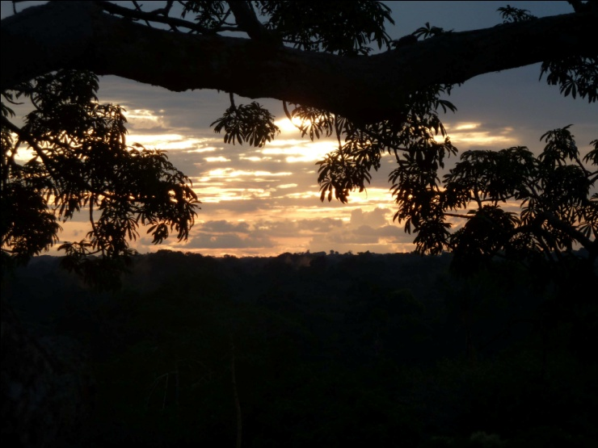
Day 17, DECEMBER 7: NAPO WILDLIFE CENTER - COCA - QUITO, QUITO MARKET
We said goodbye to Napo Wildlife Center at 6:00 AM and began the journey back to Coca and then on to Quito. We added what we thought was our 575th bird, a Black-crowned Night-Heron, as we moved silently down the creek. It struck me again how magical this place is as we glided along with only the sound of the paddles in the water to disturb the forest sounds. Howler Monkeys were vocalizing, birds of all kinds beginning to come to life for a new day, and the

Although today was primarily a travel day, we did manage to bird along the way, adding a total of 6 new species for the trip. The Night-Heron, Green Kingfisher and White-bearded Hermit were seen on the creek. Roseate Spoonbill and Striated Heron were seen on the Napo River. As we disembarked in Coca, we noticed a Cattle Tyrant near the docks. This brought our trip total to 581 species, not counting the additional 59 species that were heard only, the 11 species that flew by too quickly to count, the 6 species that were seen only by the guide, or the 15 subspecies seen.

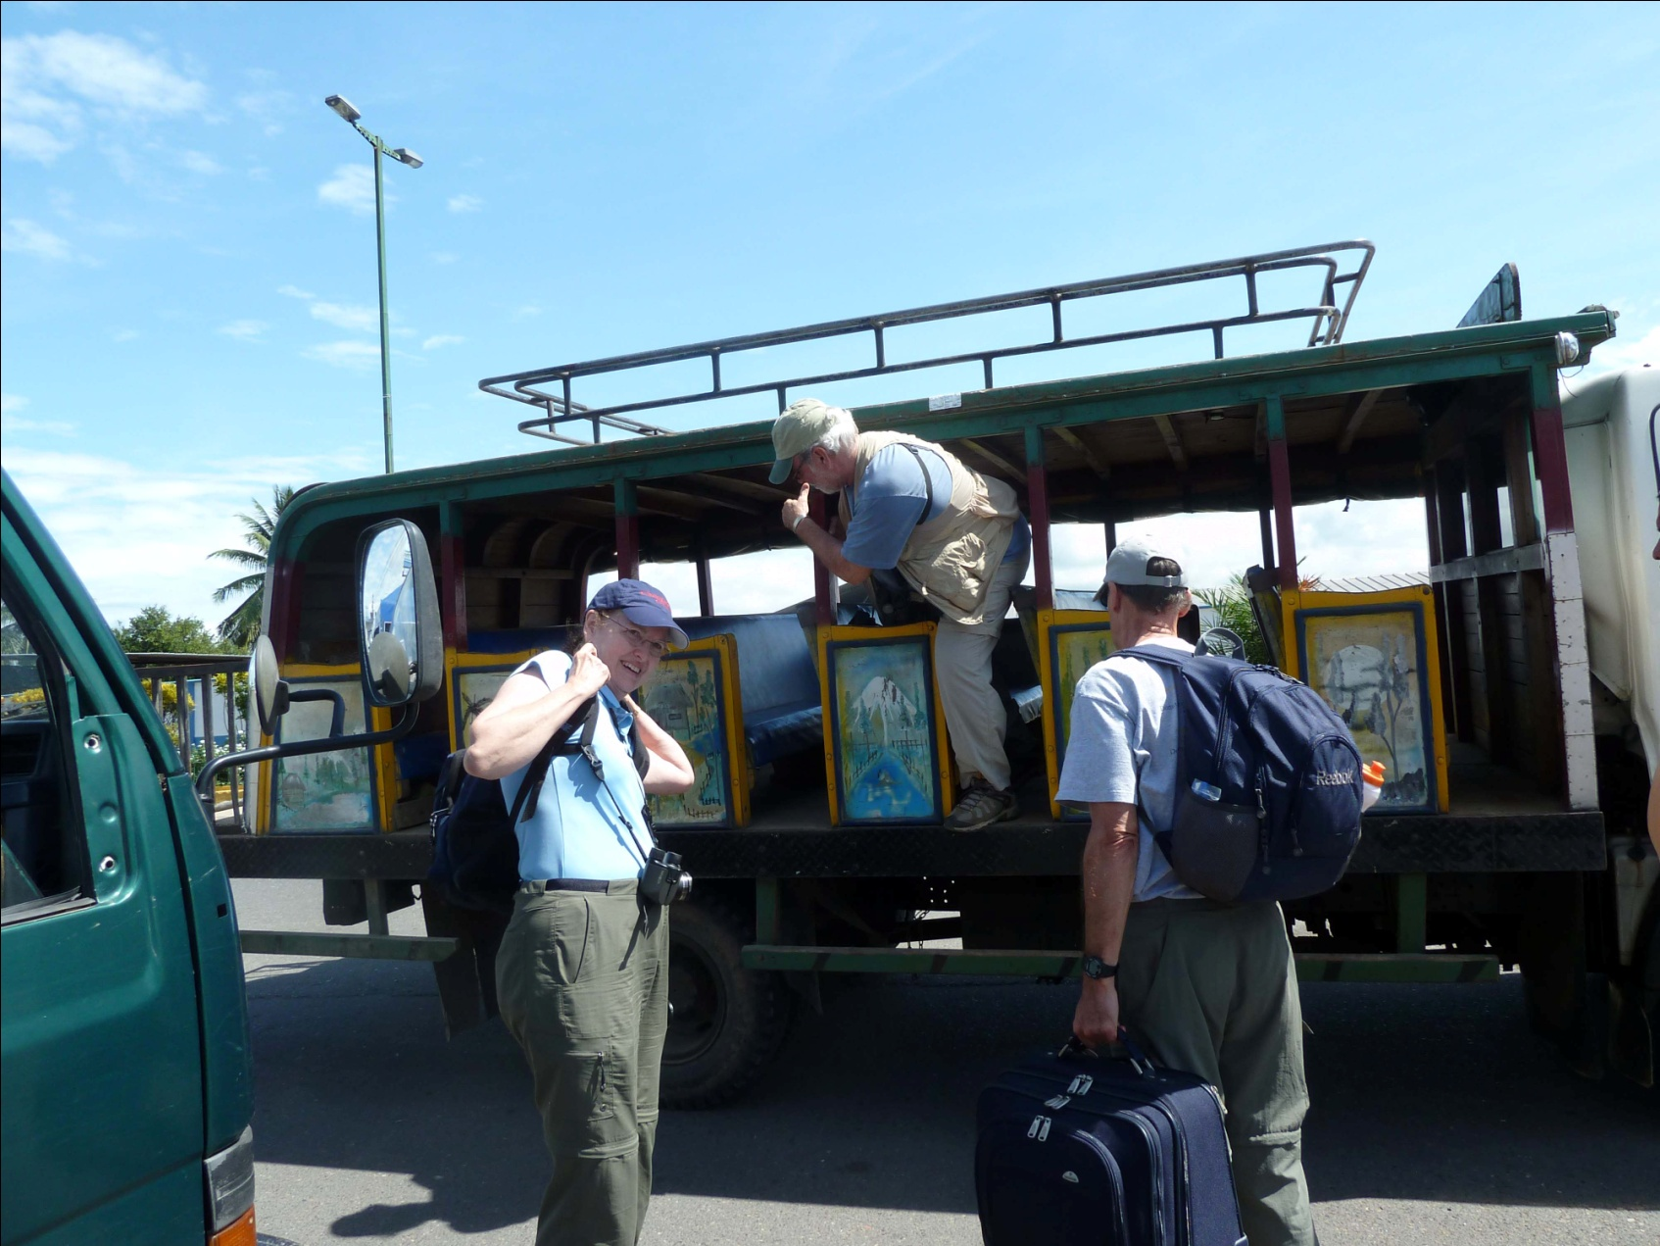

In Coca, we boarded the strangest open-air bus we'd ever seen for the ride to the airport. The check-in process was simple and the flight was short and uneventful. We arrived back in Quito around 1:00 PM and immediately went to the restaurant for lunch. For some reason, it took an inordinate amount of time for our food to be delivered, so it was 3:30 by the time we left to walk several blocks to an artisan market to shop for souvenirs. The group enjoyed this last adventure and many of us found some treasures to take home with us. After completing the list and having dinner, we all said our goodbyes as we knew our varied departure schedules meant that we all wouldn't see each other in the morning. This was a wonderful group of people with whom to travel, and I sincerely hope we'll be able to travel and bird together again soon.
Day 18: DECEMBER 8: DEPARTURE
Each couple was transported to the international airport in Quito at a time that was appropriate for their departure flights. Our flights were very early, as were Bernie and Jude's, so we rode to the airport together. After paying our departure tax, we parted ways to check in at different airlines. Luckily, four of the group of nine who traveled with us to Ecuador will be going to South Africa with us this October, and one has signed up for our Peru trip in August.

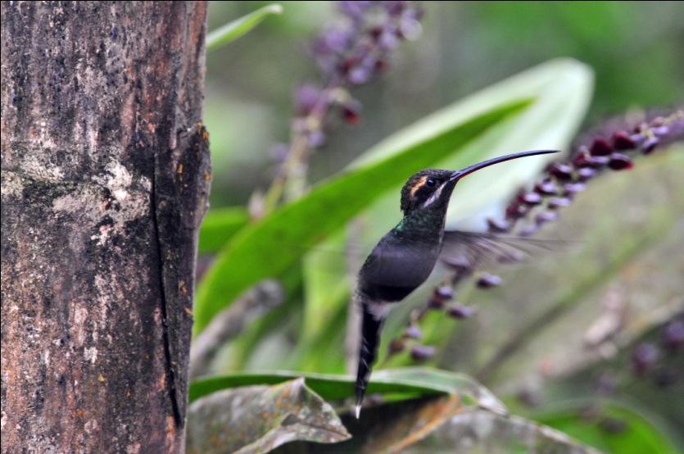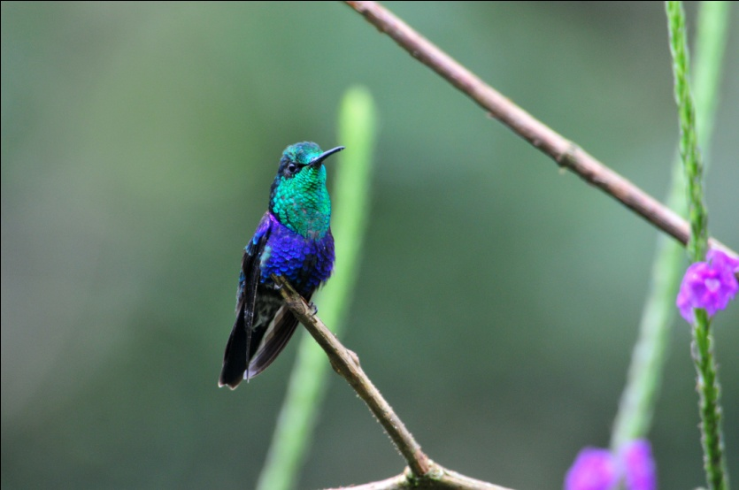
White-whiskered Hermit Green-crowned Woodnymph

Our next trip to northern Ecuador, scheduled for November 2011, is sold out. We have another Northern Ecuador tour scheduled for February 2012 and a new tour to the southwestern part of Ecuador (Tumbesian Endemics) scheduled for March, 2012. We are also accepting registrations for Galapagos island-hopping tours slated for November 2011 and March 2012. The March Galapagos tour can be taken in conjunction with the SW Ecuador (Tumbesian Endemics) Tour. Please visit our website for details and pricing.
www.cheepersbirding.com

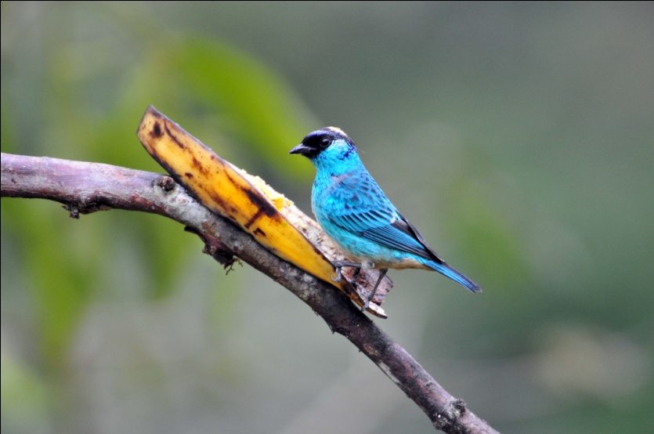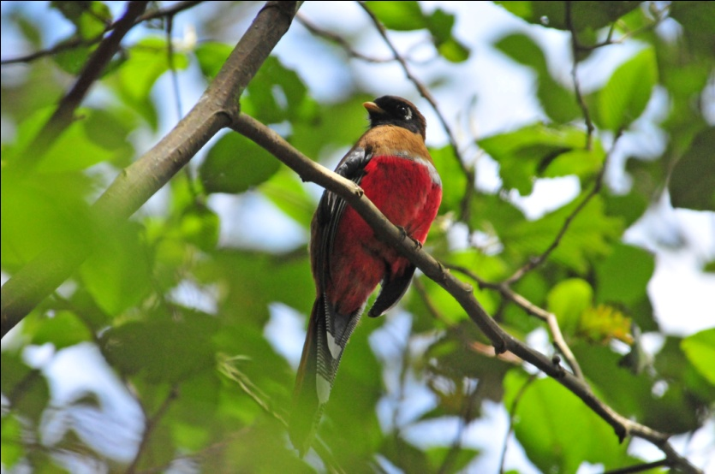
Golden-naped Tanager Masked Trogon, female

