Trip Report
ECUADOR, February 6 – 25, 2010
Northwest Ecuador, Eastern slope of the Andes, Amazon River Basin Extension
Disclaimer: Seeing 662 species in 17 days of birding is not only amazing, it is somewhat overwhelming. My report is as accurate as possible using limited notes taken in the field, but it is likely that the report contains some errors. Species have been reported on the proper day(s) but, with multiple sites visited on the same day, it is possible that some species are listed as being seen at the wrong location. Any such errors are unintentional.

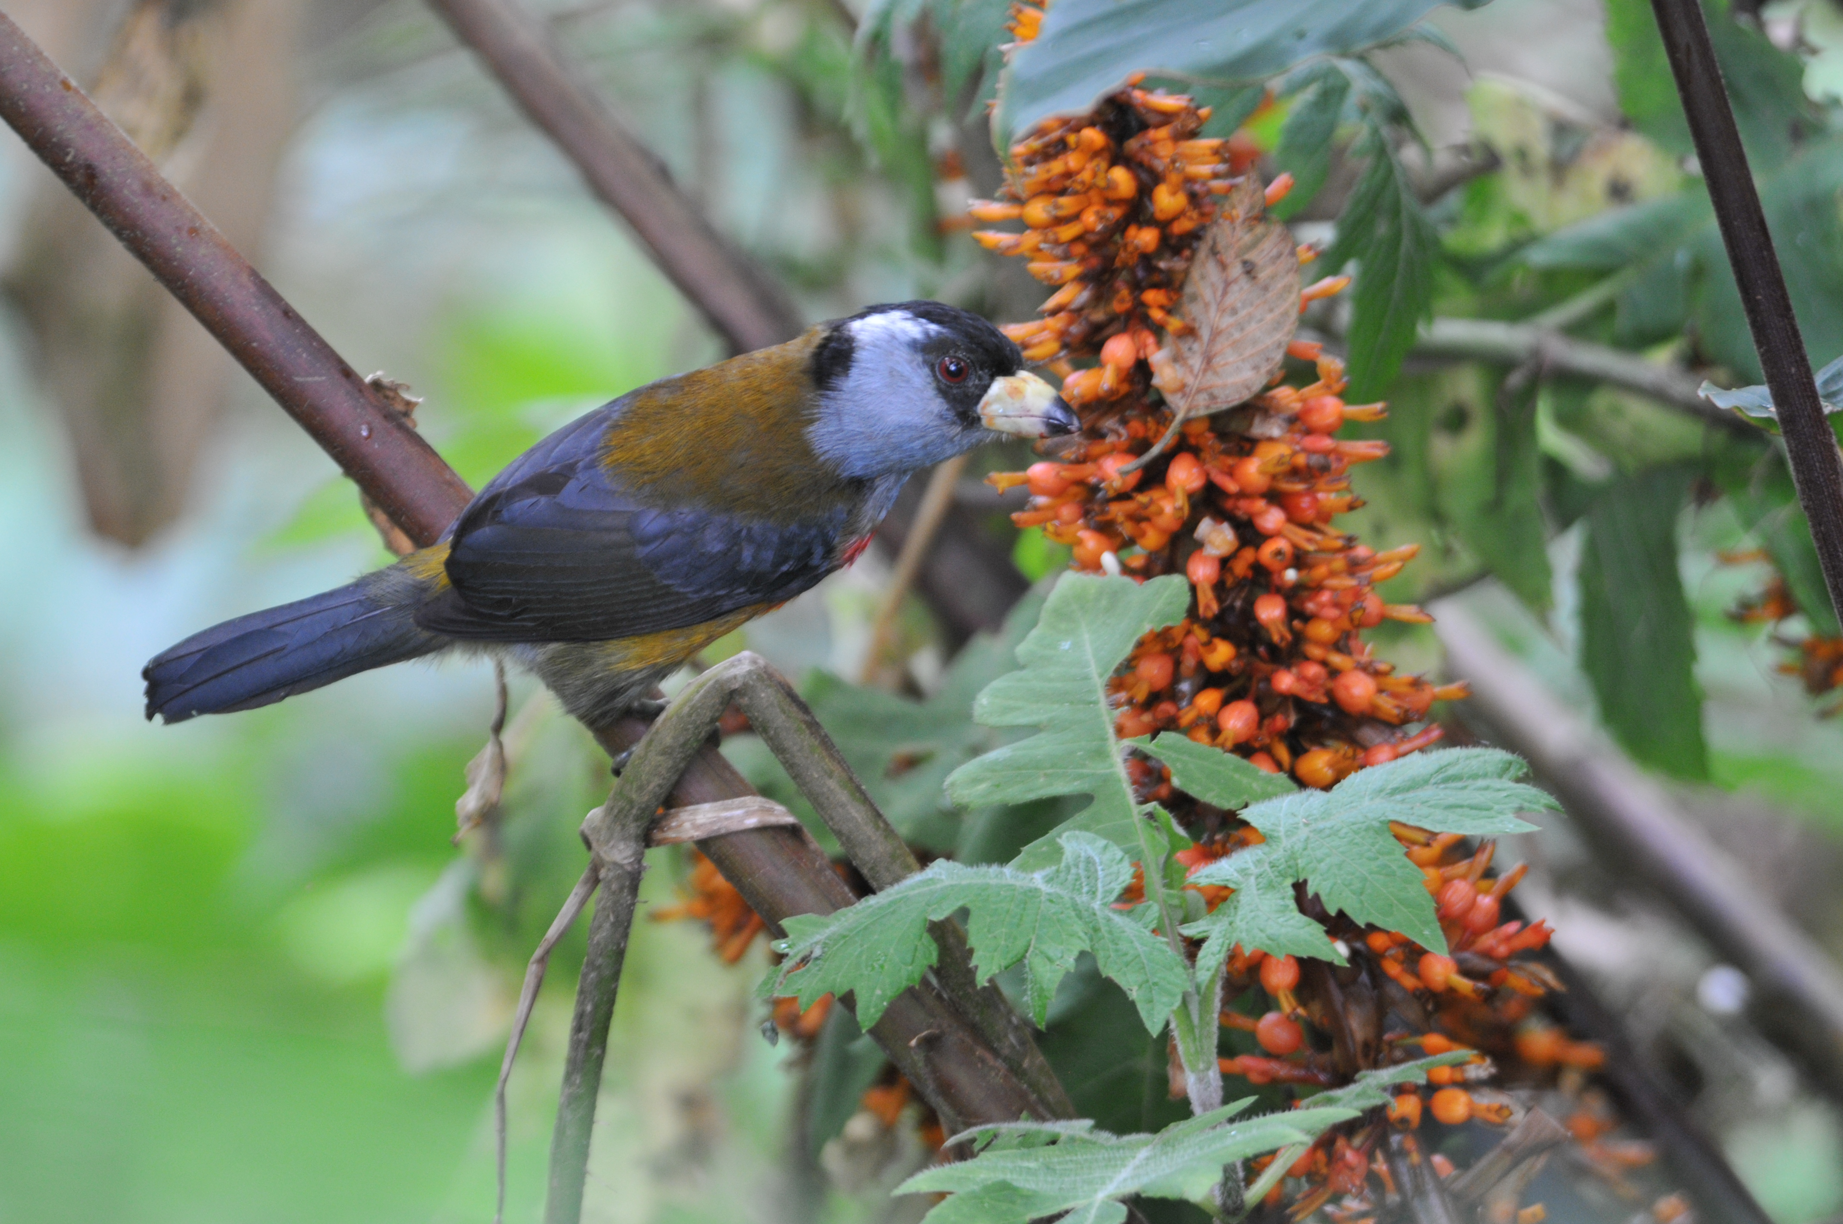
Species seen by group: 662
Additional subspecies seen: 19
Additional species heard: 66
Birding guides: Andres Vasquez
Marcelo Andy
Tour leaders: Cindy and Jim Beckman (Cheepers! Birding on a Budget owners)
Group: 10 + 2 tour leaders and 2 guides
Highlights: Amazon Umbrellabirds, Tanager-finch, Fiery Topaz, Oilbirds with young in sunlit gorge, Crested Quetzal, Cocha Antshrike male and female, Masked Mountain-tanager, Andean Condor, Cloud-forest Pygmy Owl, Crested Eagle (dark morph, perched), Orange-fronted Barbet, Toucan Barbet, Plate-billed Mountain-Toucan, Guayaquil Woodpecker, Castlenau's Antshrike, Beautiful Jay, Indigo Flowerpiercer

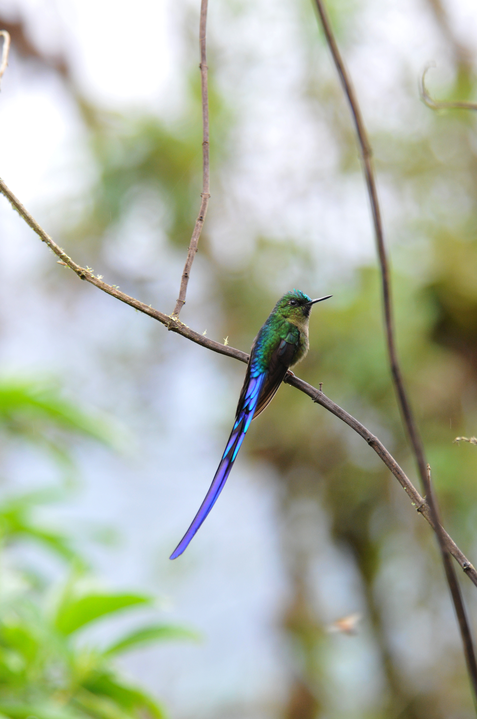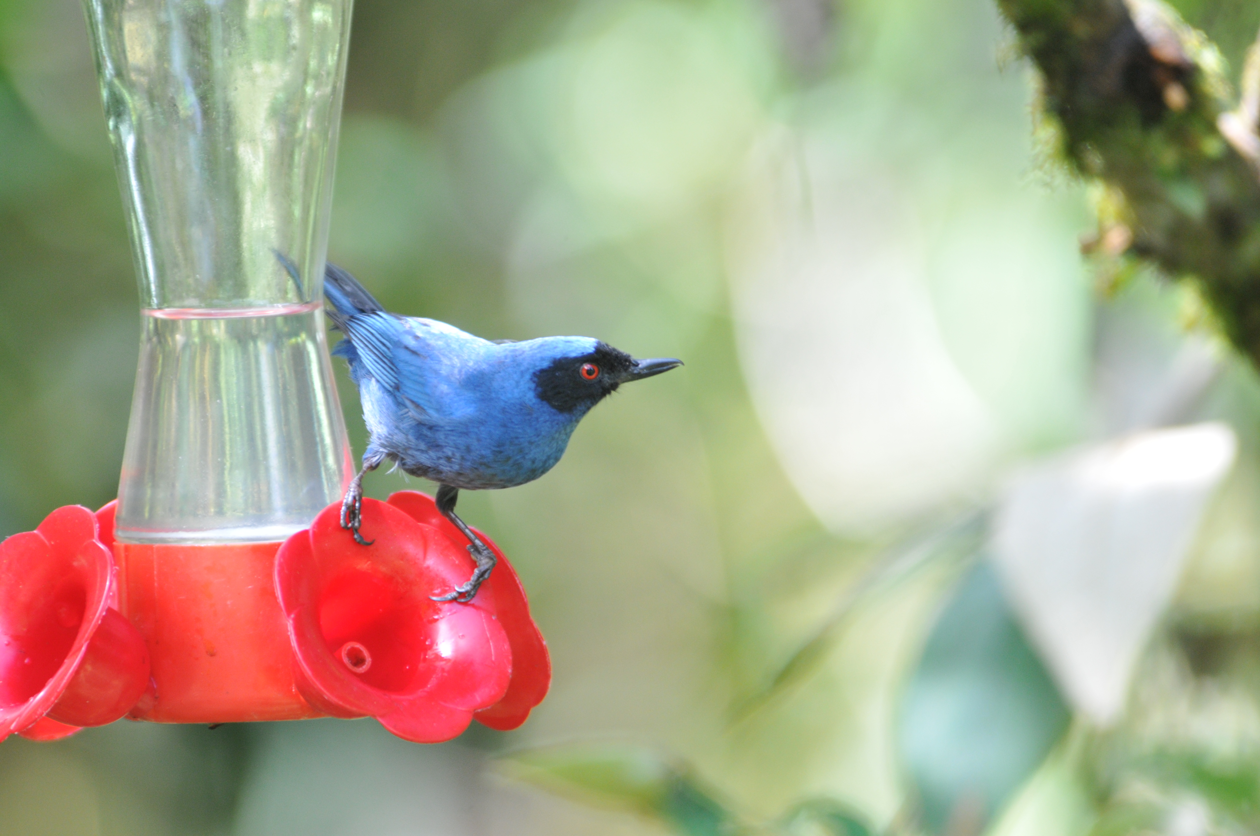
Above: Toucan Barbet
Left: Violet-tailed Sylph
Below: Masked Flowerpiercer
This trip report was written by co-leader Cindy Beckman

DAY 0, Friday, Feb. 5: EARLY ARRIVALS
Six of the twelve birders arrived in Quito a day early. Karen Chiasson was already at the Mercure Grand Hotel Alameda in Quito when our guide Andres Vasquez picked up Tony Baldoni, Jim and me at the airport. Tony had flown in on the same flight from Miami with us. Jim and I met with Andres to discuss details of this and future trips until Libby Schreiner and Victor Glick arrived at the hotel, escorted by Andres' brother who picked them up at the airport. After brief introductions, we all turned in for the night.

DAY 1, Saturday, Feb. 6: QUITO AND ENVIRONS
The six early arrivals were escorted on a tour of the Quito area arranged by Andres at the request of Cheepers! owners. Our driver, Johnny, took us to the old part of the city and had plans to take us to the Equator Monument and museum near Calacali, but the group, anxious to see some birds, requested to go to the Botanical Gardens instead. After lunch at Pim’s overlooking the city, we drove to the gardens in a steady rain. After some futile attempts at birding in the rain, we were directed to a covered shelter with adjoining orchid hothouses. From there we enjoyed excellent views of Black-tailed Trainbearer and Sparkling Violetear. Other birds seen on the first day included Eared Dove, Great Thrush, Vermilion Flycatcher, Brown-bellied and Blue-and-white Swallows, Cinereous Conebill, Rufous-collared Sparrow, American Kestrel, and a Peregrine Falcon seen from the balcony of one birder’s room at the Hotel Mercure in Quito.

The early group of 6 enjoyed dinner with our guides at the Hotel Sebastian, where the entire group had reservations for the first official night of the tour. The remaining 6 participants (Dan Sanders, Doreene Linzell, Deb Johnson, Jean Novotny, Annie Balash, and Robin Tener) arrived at various times during the evening, with the last person arriving after midnight. With a 5:30 AM breakfast scheduled, no one wasted time going to sleep once they settled in their rooms.

DAY 2, Sunday, Feb. 7: YANACOCHA, NONO-MINDO ROAD, BELLAVISTA LODGE
After an early breakfast, we headed toward Yanacocha. With a few stops along the way, birding for such species as Grassland Yellow-finch, Rufous-capped Brush-finch, Black Flowerpiercer, and Southern Yellow (Golden-bellied) Grosbeak, we arrived at the entrance shortly after daybreak and began our walk toward the hummingbird feeders at over 11,000 feet elevation. As we walked along the old road, we heard the almost incessant call of the Tawny Antpitta. Andres assured us we would have the opportunity to see this bird at some point since it normally comes out into the open, unlike other members of its family. As we walked, Andres and Marcelo alerted us to the presence of any species they heard. Their skill at recognizing calls and then finding the birds in dense vegetation was nothing short of amazing. At many times along the old road, we were trying to get our binoculars on several birds simultaneously as mixed flocks moved through the area. We enjoyed stunning views of a Crimson-mantled Woodpecker perched in open branches of a Cecropia tree in plain view and in perfect lighting. Before we were finished admiring the beauty of the woodpecker, Andres pointed out a group of Blue-winged Mountain Tanagers, and said they are often flock leaders. We watched as Spectacled and Slate-throated Whitestarts (Redstart); White-tailed, White-banded, White-throated and Southern Beardless Tyrannulets; Scarlet-bellied, Black-chested and Hooded Mountain-Tanagers; Grass-green, and Black-capped Tanagers; Blue-backed Conebill and Glossy Flowerpiercer made their way through the trees around us. Andres and Marcelo were particularly patient as they managed to get everyone on a Superciliated Hemispingus that for awhile was making itself difficult to see. A Plushcap had everyone asking for the rest of its name - difficult to stop at one word after all of the multisyllabic, 4-word hyphenated names we had heard all morning! A pair of Barred Fruiteaters sat patiently while each birder got a good view through the scope. With binoculars, the birds were badly backlit and not overly impressive, but in the scope their field marks became clear and their beauty remarkable. A Cinereous Harrier flew over, but only a few birders were able to see it before it flew over the hill and out of sight. Luckily, Andres was able to get a look at it before it disappeared. Some birders also got a quick look at a Squirrel Cuckoo, but others didn't pursue the bird because we all were aware that it's pretty common in the tropics and we would get more opportunities later in the trip. Furnariids were well represented along the road, with White-browed and Red-faced Spinetails, Streaked Tuftedcheek, and Lineated Foliage-gleaner making an appearance in the company of a Montane Woodcreeper. By late morning we arrived at the famous hummingbird feeders to find dozens of colorful “Colibris” flitting around: Shining Sunbeam, Great Sapphirewing, Buff-winged Starfrontlet, Sword-billed Hummingbird, Golden-breasted Puffleg, Tyrian Metaltail, Sparkling Violetear, Mountain Velvetbreast, and Sapphire-vented Puffleg were seemingly unconcerned about our presence as they fed, preened, and foraged in the area around the feeders. Masked Flowerpiercers dominated some of the feeders, with as many as five individuals on a single feeder a few times. Although I'm sure that people who maintain hummingbird feeders consider them a nuisance, we were taken with the brilliant blue plumage and the bright red eyes peering from black masks. One member of the group saw a hummer no one else saw. From her description, Andres believed she had seen a Rainbow-bearded Thorntail. After a box lunch near the Yanacocha Visitors’ Center, where we added Stripe-headed Brush-finch and Blue-and-black Tanager to our list, we traveled along the Old Nono Mindo Road to Bellavista, our lodge for the night. Of course, we birded along the way and found several new species, including Golden-headed Quetzal, Crowned Chat-tyrant, Smoky Bush-tyrant, Rusty-margined and Golden-crowned Flycatchers, Tropical Kingbird, Southern Rough-winged Swallow, and Yellow-bellied and Plain-colored Seedeaters. As we approached the village of Tandayapa, we searched the river and were rewarded with excellent views of Capped Dipper near the bridge. Beyond the main intersection, we found a fruiting tree that hosted Summer, Silver-throated, Blue-gray, Palm, Lemon-rumped, and Golden Tanagers, Black-winged Saltators, Bananaquit, and Orange-bellied Euphonia. Beneath the tree were a pair of nesting House Wrens and nearby a Black Phoebe hawked for insects. In the distance we were able to identify a Band-tailed Pigeon, a species that would present itself on many future days of the trip. Brush-finches were prominent today, with sightings of Yellow-breasted (aka Rufous-naped), Tri-colored, White-winged, and Stripe-headed Brush-Finches.

At some point today, Robin brought introduced the group to a friend she had brought along, a small toy monkey that, when you pulled its arms apart and let go, would fly to the ground screaming. She had "kidnapped" it from a friend and co-worker who is suffering from terminal cancer. As a way to keep her friend's spirits up, she was taking photographs of the monkey in some of the many scenic and historical sites in Ecuador. Upon her return to the states, the monkey was to be "ransomed" and its owner could enjoy a vicarious trip through Ecuador with her "pet".

As we entered Bellavista, we were delighted to see some of the same hummingbirds we had seen earlier in the day in the company of several new species: Andean Emerald, Speckled Hummingbird, Fawn-breasted Brilliant, Collared Inca, Buff-tailed Coronet, Gorgeted Sunangel, and my two favorite Ecuadorian hummers, Booted Racket-tail and Violet-tailed Sylph. Booted Racket-tails are tiny compared to many of the other hummers in the area, but their spunky attitude ensures them a spot at the feeders. The "rackets" at the end of their tails flash blue if the light catches them, and their tails form graceful arches as they fly. Their "boots" are huge tufts of snow-white downy feathers at their thighs that are sometimes so full they cover part or most of their feet, making them whimsical in appearance as they perch near the feeders. The Violet-tailed Sylphs are as elegant as any bird I've ever seen. The adult males sport an extremely long, deeply forked tail made up of metallic violet feathers, tipped with blue. One of a few hummingbirds that is more striking from the rear than the front, it also has a splash of iridescence on its head and throat, a brilliant teal on the crown and a deep blue gorget.. Also at the lodge entrance were resident Masked Trogons who would be present nearly every time we passed through in daylight hours during our two-day stay there.
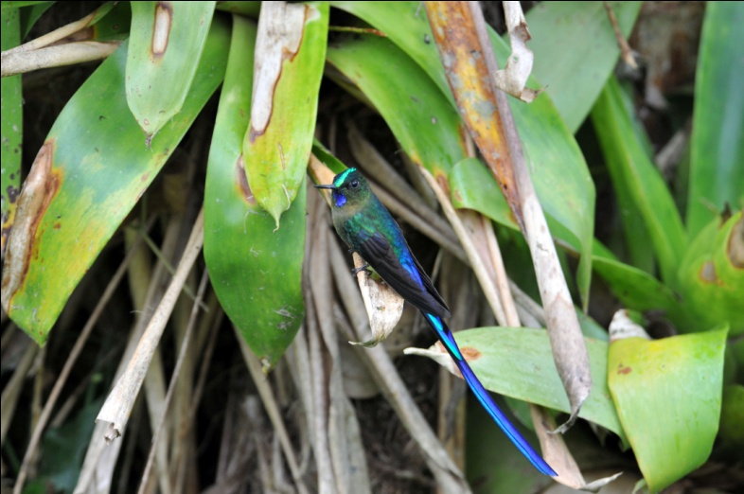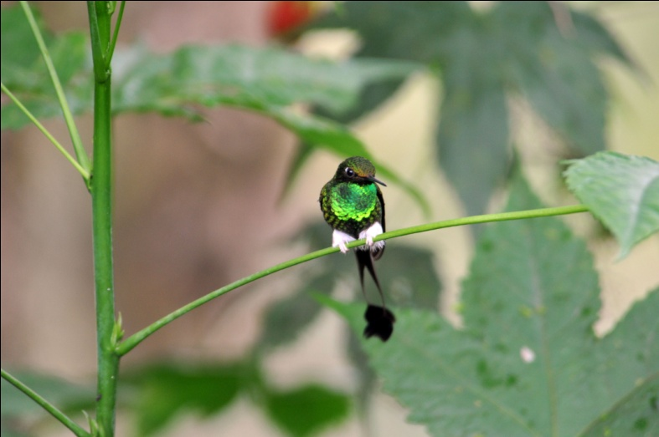
Violet-tailed Sylph Booted racket-tail
After settling in our rooms and having a short time before dark to view the feeders, we gathered to go over our checklist before dinner. We finished our first full day of birding with 90 species, including 20 species of hummingbirds!
DAY 3, Monday, Feb. 8: TANDAYAPA VALLEY, TONY NUNNERY'S GARDENS, BELLAVISTA We spent this day birding in one of the most bird-rich areas of the world, the Tandayapa Valley where Bellavista Lodge is located. As we drove to the first site where our guides wanted to bird, Andres and Marcelo spotted Turquoise Jays from the bus. Everyone tumbled out of the bus as quickly as possible to see these striking jays. Unlike our North American jays, these birds were somewhat elusive and did not make it easy for every member of the group to get a satisfying look.
Andres and Marcelo first took us to a very special "corner" where they said we could find the very rare Tanager-finch. According to them, this small area located on a sharp curve of a road in the rain forest was virtually the only place in Ecuador to find this species. After playing the call a few times, it seemed that we were not going to be lucky enough to find this rare gem, but then from high on the hillside we heard an answer, then two. We waited patiently as the birds came closer and closer until finally Marcelo and Andres were able to point the birds out to each of us. Once the Tanager-finches were perched and singing, they stayed in view for fairly long periods of time, but the early morning lighting under cloudy skies allowed for only dim photos.
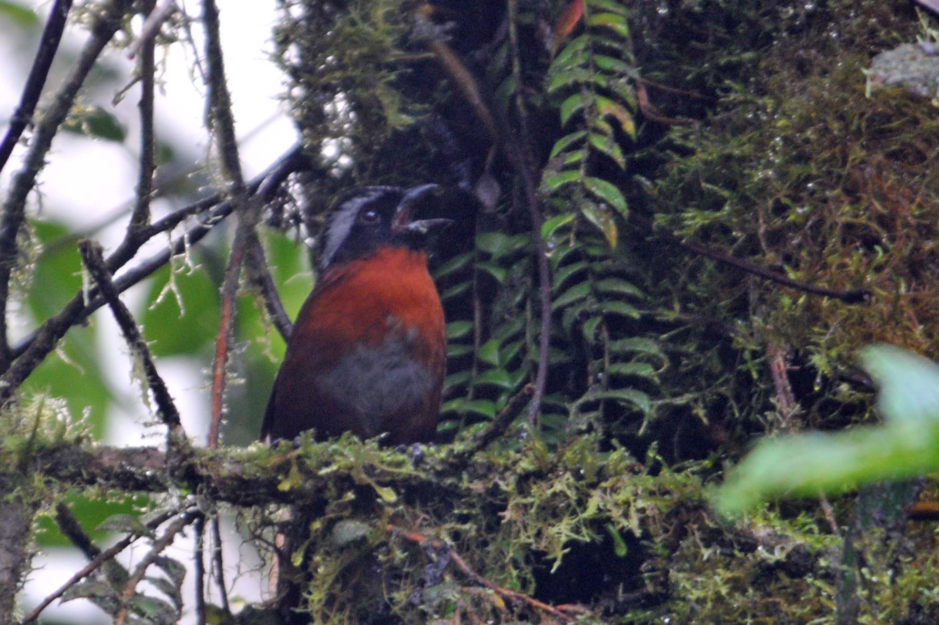
The rare and local Tanager-Finch
Our driver Luis, who is a bit of a birder himself and always cheerful and helpful, next dropped us off at Research Road to bird along the road. The morning was filled with one sighting after another under cloudy skies. We were happy to have dry weather, but we really appreciated the better lighting when the sun peeked through. Raptors spotted on Day 3 included Black vultures, Hook-billed Kite, and Plain-breasted Hawk. Besides the raptors, some species we were able to see only in flight were Red-billed Parrot and White-collared and Chestnut-collared Swifts. Walking the roads we were able to see Red-headed and Toucan Barbets, Azara's and Rufous Spinetails, Pearled Treerunner, Spotted Barbtail, Striped Treehaunter, Strong-billed Woodcreeper, Black-capped Tyrannulet, Yellow-bellied Elaenia, Streak-necked and Cinnamon Flycatchers, Green-and-black Fruiteater, Beautiful Jay, White-tipped Doves, Brown-capped Vireo, Plain-tailed and Whiskered Wrens, Black-crested and Russet-crowned Warblers, Capped Conebill, White-sided Flowerpiercer, Thick-billed Euphonia, Beryl-spangled and Blue-capped Tanagers, Dusky Bush-tanager, Black-eared Hemispingus, Buff-throated Saltator, and Yellow-breasted and Tri-colored Brush-finches. Of course, we also saw many of the species spotted on previous days, but I have not listed them here. Throughout the remainder of this report, I will mention only those species that are new for the trip, with a few exceptions.
One birder who was walking ahead of the group saw a Glossy-black Thrush on a limb over the trail in front of us. She could not give directions for others in the group to find the bird and, unfortunately, it flew before she could give directions to the guides. Andres identified the bird from her description. Luckily, before the trip ended, all members of the group were able to get excellent views of this thrush through a spotting scope on three different days.
Probably the sighting that excited us the most for today was the bird that many members of the group identified as a high priority because it is featured on the cover of the field guide, the Plate-billed Mountain-toucanet. Our first sighting of this bird was at a distance and in pretty bad light, but we were able to see most of its 7 colors through the scope. As we continued to walk, we were able to spot two more pairs of the Mountain-toucanets, each time in better light and each time a little closer, so that by the end of the day we had very satisfying views of the birds.
After lunch back at the lodge, we visited the private home of Tony and Barbara Nunnery. The Nunnerys moved to Ecuador in 1997, purchasing land near Bellavista that had been used to graze cattle. After the difficult task of eliminating the alien grass that had been planted to feed livestock, they began replanting native species of trees, bushes, and flowers, creating a haven for birds. Boasting one of the largest "yard lists" in the world, the Nunnerys maintain dozens of hummingbird feeders that regularly attract 15 - 20 species of hummingbirds per day and hold the world record for total number of hummingbird species seen in one site - 40 species! In their yard we were able to get terrific looks at some of the hummingbirds we had seen at other sites as well as add several new species of hummers to our list: Brown and Green Violet-ears, Western and Andean Emeralds, Purple-bibbed Whitetip, Empress Brilliant, White-tailed Hillstar, Brown Inca, Purple-throated Woodstar, and the amazing Wedge-billed Hummingbird that uses its oddly shaped bill to pierce the base of flowers to get the nectar. We also had excellent views of Chestnut-capped Brush-finches in the bushes near some of the hummingbird feeders.
After dinner back at Bellavista, we went back out to try to find some birds that are active at dusk, including some owls and perhaps some nightjars. We had beautiful views of a Cloud-forest Pygmy-Owl but we were not successful in finding other target species, specifically Lyre-tailed Nightjar. Our guides were as surprised as we were to find an Oilbird in flight, and we were all able to get fairly good looks through our binoculars as they shined a light on the huge relative of the smaller nightjars.
DAY 4, Tuesday, Feb. 9: OILBIRD ROOST, ELL CHONTAL
Day 4 started off a little slow (by tropical standards, anyway). The bus took us to a birding spot near Bellavista only to find that we had driven into rain. Andres instructed our driver, Luis, to stay there for 10 minutes instead of going back to have our luggage loaded as planned to see if the shower would be temporary. After several minutes, the rain picked up and we headed back to the lodge. Along with a break in the rain, "our" pair of Masked Trogons greeted us as we entered the Bellavista gateway. We watched as the male caught a huge moth and devoured it. Minutes later, the female caught an equally impressive Katy-did and stayed on the ground trying to eat it. After a few minutes of wrestling with the insect and finally getting it into "swallow-able" pieces, the male swooped down from his nearby perch and grabbed part of the female’s catch. As I was still trying to get some good shots of the trogons in the poor light, someone said Andres had located a White-throated Quail-Dove nearby. The entire group gathered at the end of the trail and watched as the huge dark bird wandered on and off the path. I thought poor lighting was the reason we couldn’t see detailed field marks on the bird, but we soon saw a second bird that had much brighter plumage, so I guess it wasn’t the lighting after all.
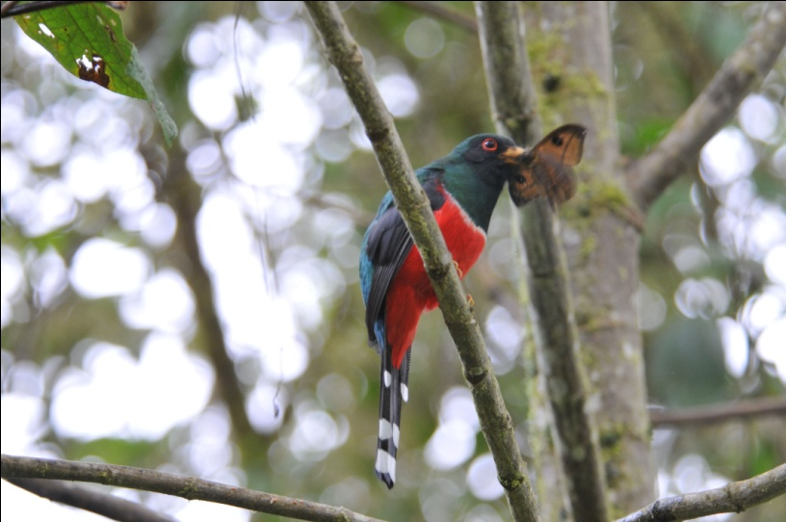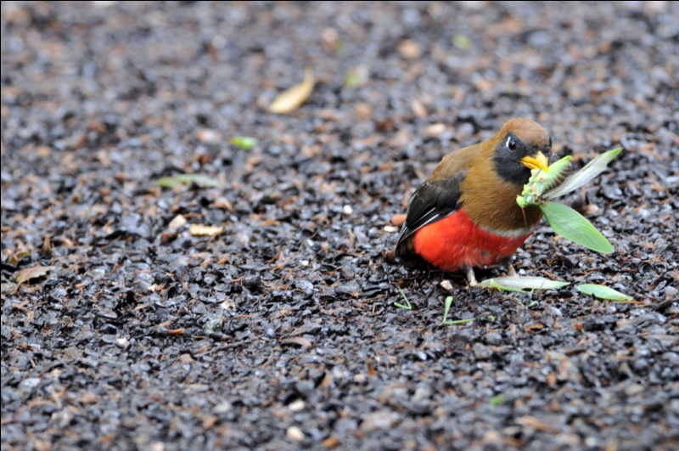
Masked Trogon male Masked Trogon female
Since the rain had now stopped and we could not continue to our next site until all the luggage had been loaded and our box lunches were ready, we headed on down the trail. We got good looks at some birds that had eluded part of the group earlier, including Gray-breasted Wood-Wren, Rufous Spinetail, and Smoke-colored Pewee.
The most striking find of the morning was a pair of Powerful Woodpeckers on a tree about a hundred feet from the trail. Because the trail went along the side of a steep slope, the woodpeckers were at eye level, giving us great looks as they fed in the moss-covered bark of the tree. Smoky Brown Woodpecker was also seen by everyone in the group, and the previous “heard-only” Yellow-bellied Chat-Tyrant made an appearance.
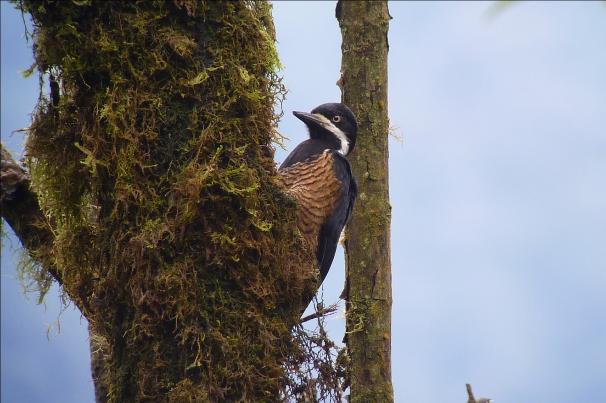
Powerful Woodpecker
At 9:00 AM, we left for a 3-hour drive to a location where Andres knew of an Oilbird roosting site. Although we had seen an oilbird in flight last night, this was to be an experience unlike any that any member of our group had ever had. The roosting site of Oilbirds is usually a cave, usually very dark with limited viewing. This roosting site is a deep narrow gorge where shafts of light break the darkness and allow for exceptionally clear views of the birds. Not only was the site special, but getting there was an adventure. The farmer who owns the land where the gorge is located says the birds have been on his family’s land for as long as he remembers and for several generations before that. They did not know what the eerie sounds coming from the gorge were for a long time, and named the area “Infiernilla” or “Little Hell” because of the frightening sounds emanating from the area. Only a few years ago did he become aware of how much birders would love to see his Oilbirds, so he has worked to make them accessible while still remaining protected. We started off for a ride in a wooden tractor-pulled wagon through fields of corn, citrus, and other crops. After about 1 kilometer, we disembarked, grabbed a bamboo walking stick and headed down a steep trail. The trail was, I’m sure, at one time quite treacherous, but this farmer has cut steps out of the hillside to make the footing better and the trek easier. At one point, his helper had a scope on some Oilbirds so that anyone who felt they could not participate in the final part of the adventure would still get to see the birds. In the final step, we were put in harnesses such as those used by rock climbers, and then we descended down a series of home-made bamboo ladders into the gorge. As we went down the first ladder, spray from a waterfall cooled us before we made our way through a stream to the top of the second ladder. At the second ladder another assistant waited to handle the rope as we ventured further into the crevice where a third ladder would take us even deeper into the narrow gorge. The third ladder was not needed, however, as nesting pairs of Oilbirds were visible at eye level just 25 feet away on the opposite side of the gorge. Fuzzy little white babies rested near their parents, and occasionally an adult bird would fly out of the deeper gorge and swoop in front of us. An 18-inch bird with a 30-inch wingspan, this was indeed an impressive sight!
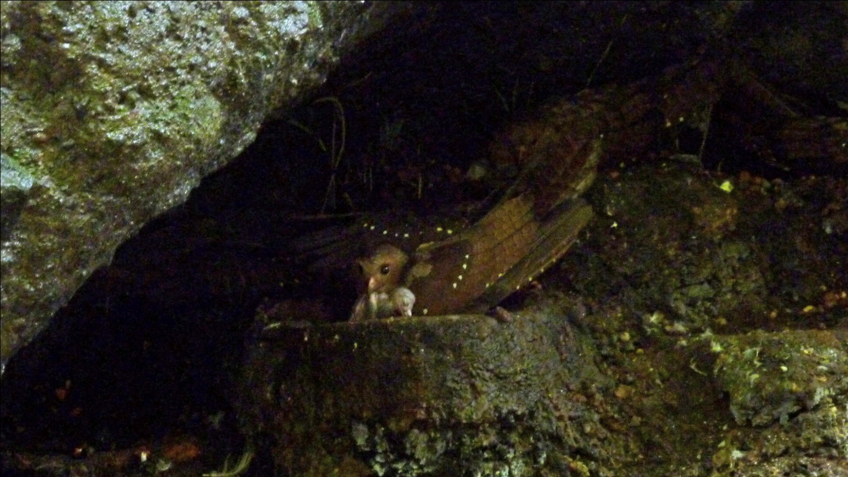 Oilbirds with chick
After riding our “chariot” back to the farmer’s house, we visited his “mini museum , an outbuilding that housed many artifacts found by his family over many years. Stones used for grinding grain, tools for starting fires and other ancient remnants were housed with interesting shells, rocks, and nests found on the farm.
We left the farm and drove to Sachatamia, our lodge for the night. Even though it was raining when we arrived, the hummingbird feeders were swarming with some familiar hummers and some new ones as well such as Velvet-Purple Coronet, Green-crowned Brilliant, White-necked Jacobin, Green-crowned Woodnymph, and Empress Brilliant (which was missed by some birders on Day 3).
Sachatamia's fruit feeders were visited by several tanager species, most notably (for me, anyway) the Flame-faced Tanager. Even in a steady rain and poor lighting, you couldn't help but gasp at the beauty of the brilliant yellow and almost iridescent orange face accented by rich black patches on the throat and around the eye. Add to that some striking blue streaks in the black wings, an opalescent rump, and subtle blending of orange, yellow, and teal on the body and I can truthfully say it just doesn't get much better than this! Other new species at the feeders included Golden-naped, Blue-necked and Bay-headed Tanagers as well as many species seen earlier in the trip.
For dessert on this day, we were treated to birthday cake and ice cream in honor of the birthdays of two birders who turned 50 before the beginning of the trip (Robin in December and Deb just a day before the trip start date) and Jim, who will turn 65 in one week. After updating our check list, we walked outside in a drizzle to view two stunning Black-and-white Owls who regularly perch in trees near the lights in the parking area in front of the lodge. What a perfect way to end a great day of birding!
Although Andres seemed disappointed that we did not add dozens of new species to our list, as is usual for a trip in this area, we were quite pleased with our adventure and the addition of over 20 species to our list, including Pacific Hornero, Plain-brown Woodcreeper, Sooty-headed Tyrannulet, Flavescent Flycatcher, Yellow-bellied Chat-tyrant, Masked Tityra, Swainson's Thrush, White-winged and White-lined Tanagers, Blue-backed and Yellow-faced Grassquits, Variable and Yellow-bellied Seedeaters, Russet-backed Oropendola, Shiny Cowbird, Scrub Blackbird, Turkey Vulture, Swallow-tailed and Double-toothed Kites, Roadside Hawk, Striped Cuckoo, and Smooth-billed Ani, in addition to the species previously mentioned.
DAY 5, Wednesday, Feb. 10: REFUGIO PAZ DE LAS AVES, AYALIR LODGE
On this day we had to arise quite early so we could be in a blind before the Cock-of-the-Rock males would begin displaying at dawn. Since no lodge offers breakfast at 4:00 AM, we took a snack with us to eat on the bus before we arrived at our destination, the world-famous Paz de las Aves. Most of us found it easy to doze as we drove through the dark, eating our early-morning snack just before we arrived at the very muddy turn-off that would lead us to Angel Paz's place. Our driver, Luis, had been told the day before that vehicles were getting mired in the mud and that he should not attempt to drive our group to the reserve. Andres contacted Angel Paz, who assured him that he had made the necessary modifications that would make it possible for Luis to drive us in. Unfortunately, it rained much of the night before so the road was very treacherous. As we ascended the very muddy slope, the skills of our driver were very much needed, and at more than one spot I wondered if he would be able to deliver us to Angel's parking area. Finally, with Angel directing him, he backed the bus into a small pull-off and we all piled out of the bus into the still-dark morning.

We used headlamps and flashlights to descend into a deep valley where the Cock-of-the-Rock lek was located. The birds had recently changed the location of their lek, and Angel had built a new blind, one that did not yet have a roof on it. Just before daylight, the males started calling. Having never heard the call of a Cock-of-the-Rock, I started looking for the source of the unusual sounds, but fellow birder Libby told me the sounds were made by owls. I had never heard of an owl making a sound anything like this, but it was impossible to talk about it as we needed to be silent while we waited for the birds to appear. As Deb and I kept looking toward the sounds, with lighting so dim you could barely make out the colors, a Cock-of-the-Rock landed on a branch right in front of us, about 60 feet away at eye level. Only a few of us were able to see the bird at this point and the birds did not return to this perch once they saw us in the blind. We were able to see that the strange sounds were, indeed, made by the target birds, so as the day grew brighter, the group dispersed and started following the sounds. Marcelo, Andres, Angel, and his brother Rodrigo all assisted birders as each of us worked to get good views of the birds. Although we all were able to get satisfactory views of this incredible species, we were somewhat disappointed that the males were not "performing" for the females. Andres and I discussed it later, and we decided to change the date for our next trip from February 2011 to November 2010 so we will be there when the Cock-of-the-Rock males are in breeding season.
After everyone was satisfied with their views of the Cock-of-the-Rock (a few were even lucky enough to find a female or two!), we started back up the trail and to the waiting bus. I didn't think it possible, but the road looked even worse in daylight! We boarded the bus and headed farther up the hill toward the area of Angel Paz's reserve for which he is best known - the trails where he feeds antpittas. However, just as we approached the final crest it appeared that even the best driver might not be able to make it to our final destination as the bus started to swerve in the thick mud near the edge of a steep drop-off. Some of the passengers, Jim, Andres, Victor, and Libby, got off the bus and pushed from behind to allow Luis to make it through that last perilous spot. Everyone cheered as the bus roared to the top and into its parking spot.
Several years ago, when Angel was cutting a trail in his forest so birders could come to see his Cock-of-the-Rock lek, he started seeing antpittas as they came to eat the worms that he excavated . With a lot of patience and hard work (and a lot of worms), he succeeded in training these normally secretive antpittas to respond to the sound of his voice - they actually come when he calls their names! The first bird he "trained" was Maria, a Giant Antpitta who has since brought her offspring to take the worms offered by Angel. What a sight it is to see Angel stand on the trail with his container of worms calling, "Maria! Maria!" Other birds who have learned to trust Angel include Willie, a Yellow-breasted Antpitta; Jose, a Moustached Antpitta; and Shakira, an Ochre-breasted Antbird who was so named because she "shakes her tail".
Before attempting to call the antpittas, we first walked to a feeding area where Angel puts out bananas and grapes to bring in a wide variety of birds. Sickle-winged Guans were waiting for him as we approached the blind, and they quickly multiplied in number as bananas were offered. A Crimson-rumped Toucanet landed very close, poised to take advantage of the large grapes that were offered next. As the guans would approach and try to eat the grapes that were meant for smaller species, Angel would toss a banana peel at them to discourage them. Because we had spent so much time following the Cocks-of-the-Rock around, these were the only two species we saw before having to leave to find the antpittas.
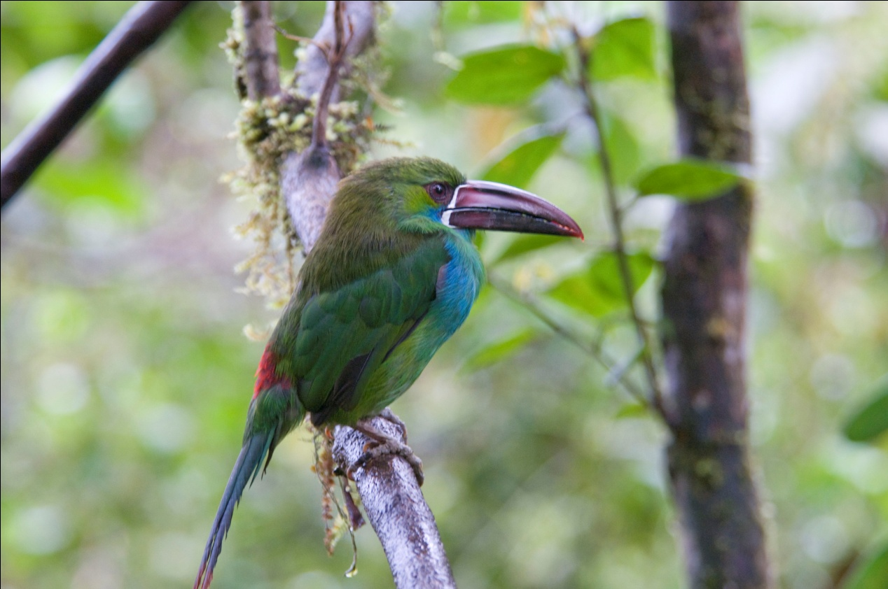
Crimson-rumped Toucanet
An offspring of Maria, the Giant Antpitta who Angel believes is at least 7 years old, was the first to respond, and we were all delighted to see him gobble down the worms offered by Angel. We had to descend further into the deep valley to find Willie, the Yellow-breasted Antpitta, who was a little more reluctant to expose himself. After several minutes of Angel calling his name near a rushing stream at the bottom of the narrow valley, he came out and stayed long enough for excellent views. As we walked uphill, Maria herself made an appearance, taking worms right out of Angel's hand. With Angel's encouragement, I walked along the path just a few feet from Maria, with no reaction at all from her until the entire group of 12 started up the path. Although we could hear Shakira (the Ochre-breasted Antpitta) calling, Angel thought she was sitting on a nest, and she did not make an appearance for us.I Jose, the Moustached Antpitta, also called back when Angel called, but he didn't emerge from the forest.

Climbing up the steep slope, we stopped to see other birds such as Ruddy and Plumbeous Pigeons, Buff-fronted Foliage-gleaner, Acadian Flycatcher, Three-striped Warbler and Barred and Cinnamon Becards. A few people saw Ornate Flycatcher, Olivaceous Piha, Andean Solitaire, Ecuadorian Thrush, and Tropical Parula.
Just before we reached the top of the last hill, Angel pointed out an Orange-breasted Fruiteater. It seems like each fruiteater we saw was just a little more beautiful than the last! Bright green plumage accented with brilliant orange throat, yellow belly and bright yellow eyes accented by a pure black face, this bird has to be a winner in any Fruiteater beauty contest! The nearby hummingbird feeders hosted many of the species we'd already seen, but we were able to add White-whiskered Hermit to our list.

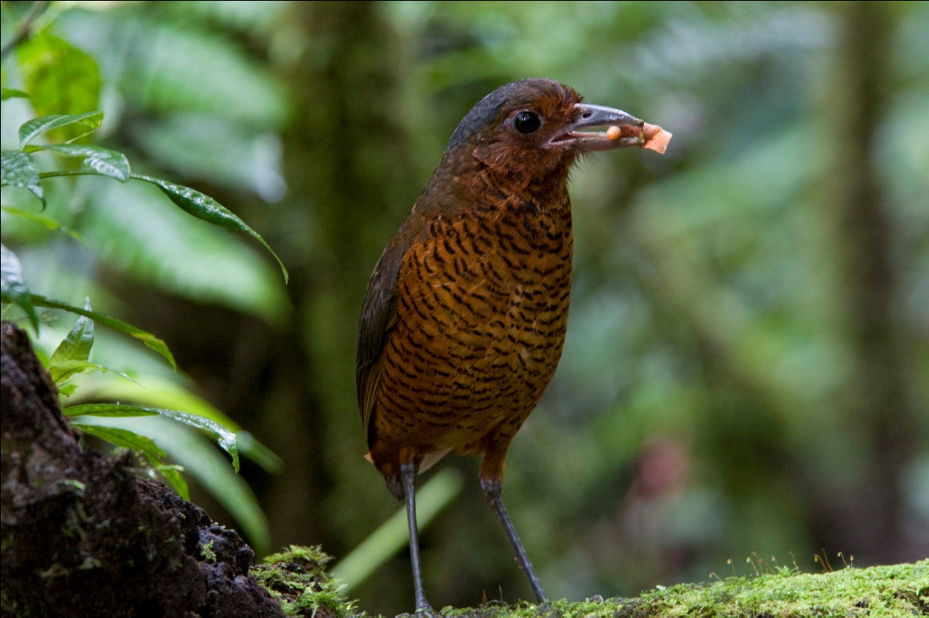
Maria, Giant Antpitta
Although we had been scheduled to eat breakfast at 9:30, it was nearly 11:00 AM by the time we made it back to the bus, which was parked near Angel's kitchen and shop. There, our muddy boots were washed by his son and nephew while we waited for breakfast to be served on the deck that overlooked a beautiful valley. And what a treat breakfast was! A traditional Ecuadorian dish called "Bolones de Verde" was served first. Made from green plantains which are fried over medium heat until very tender, then mashed into dough, stuffed with chicken, and then fried again until crispy, the bolones were especially delicious when dipped in the hot salsa provided. (Bolon is a slang term that means large ball, so you could translate the name of this dish as green balls) The bolones were quite large and filling, but just as we finished Angel brought out the next course, Empanadas de Queso. Freshly made and hot off the fire, these were absolutely wonderful! Andres showed us the best way to eat them - smash them, put sugar in the depression you made, and yum! Even better!
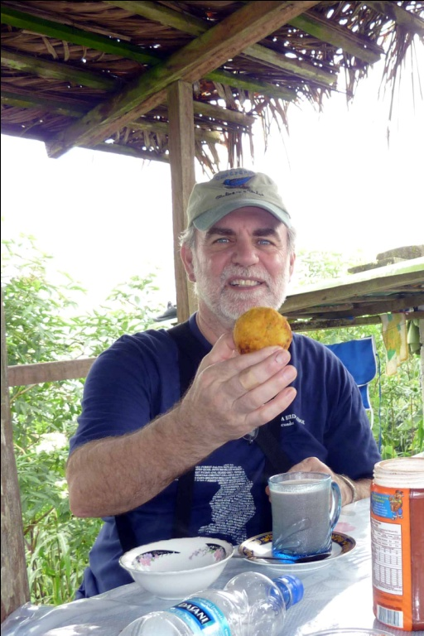
Jim with his "big ball" - Balon Appetit!
After an early morning snack and a hot Ecuadorian breakfast at 11:00 AM, we weren't too eager to return to Sachatamia for lunch. Luckily, Andres knew we would not be as hungry as normal and ordered a light lunch. Instead of hot soup that usually started every meal, we had a light salad of Hearts of Palm and corn. In spite of the volume of food that day, everything was so delicious that most of us managed to eat every bite.
After lunch we had a short time to finish packing up to leave for Ayalir, our next lodge. Although it was raining, a few people tried to bird a little during this time and added a few new species to the group list: Fawn-breasted Tanager and Slaty Spinetail.
Before we left Sachatamia, as everyone was gathering on the front porch where the feeders were located, we were entertained by a series of hummingbirds who were bathing in the rain. A stunning Velvet-purple Coronet led the show, followed by a Green-crowned Brilliant and both male and female Violet-tailed Sylphs. Although most of us had been admiring the coronet every time we saw it , it wasn't until it was bathing that we saw the brilliant rufous underside of its wings.
It was too rainy to stop to bird on our way to Ayalir Lodge in Pedro Vicente Aldonado , but we did see some Cattle Egrets on the way there.
At Ayalir, with plenty of daylight remaining but quite a bit of rain, we saw Masked Water-tyrants as we walked to our rooms. Later on, as the rain eased up, several people came to our room to watch birds out the window. In addition to the Water-tyrants, there were numbers of Variable Seedeaters and Pacific Horneros visible. Deb spotted some parrots in a tree, and we caught Marcelo as he was going to his room with his scope over his shoulder. The next thing we knew, most of the group was in our room, Doreene with a towel around her just-washed hair, looking through the scope out our window trying to find two small green spots in a mass of leaves the same color. Most of us managed to find the two Pacific Parrotlets as they huddled together in the rain. After a bit of drama over some rooms being larger than others, we gathered to complete the day's checklists and had dinner. We fell asleep to the sound of rain on the roof.
DAY 6, February 11: MASHPI RESERVE, PACTO-PACHIJAL ROAD
Another early departure, this time to head for Mashpi and Pacto-Pachijal Road. Just as it was getting light, Karen spotted a raptor in flight. Having been in the bus for quite awhile, we took this opportunity to get out and look for the bird. Deb was the first to find the Laughing Falcon perched in a nearby tree. Other birds started moving around as the day grew lighter, and we were able to get excellent looks at a few birds such as Olive-crowned Yellowthroat and Lesser (Thick-billed) Seedfinch, before we climbed back into the bus to continue our journey. Andres had thought the drive would take a little over an hour, but after two hours' drive we were nowhere near the preserve. Luis stopped in a small village where Andres and Marcelo asked for directions - they usually approached Mashpi from the other side and the route we were on was a "short cut". Realizing that we were getting restless and that the morning was slipping away, Andres instructed Luis to stop at the next likely spot so we could get out to stretch our legs and do some birding. What a serendipitous stop it was! Maroon-tailed Parakeets and Bronze-winged Parrots flew overhead in the company of Gray-rumped Swifts. A Cinnamon Woodpecker landed nearby where everyone could admire its rich color and beautiful scalloped chest. Everyone got on the Gray-and-gold Tanagers feeding overhead and got brief glimpses of Glistening Green Tanagers as well, and a few lucky people saw a Purple-crowned Fairy. A pair of Yellow-collared Chlorophonias were seen, but better views were desired by most people.
Continuing on our journey, we approached a left turn in the road that was swarming with big equipment and workers. There was a virtual river flowing down from the hillside on the right. The torrent flowed across the road, creating a temporary waterfall as it cascaded over the steep hillside on the left. As we waited for the workers to move the equipment to a spot that would allow us to pass, I'm sure we were all thinking of all the warnings we've heard about not crossing through water on the road since it can carry cars away with its force.
Luis finally drove our heavy bus through without incident, but we then encountered more heavy construction equipment on the road, delaying our arrival at Mashpi a little more.

Just before we made a sharp right turn to go into Mashpi Preserve, we got out of the bus to search for a very special bird, one that would be a life bird for both Andres and Marcelo, the rare and local Indigo Flowerpiercer. After playing the call for just a few seconds, the birds flew into open view, surprising all of us with how easy it was to find them. We continued up the hill toward the newly-created preserve and stopped at the park warden's house. From there we walked across a bridge (which was just two metal planks spanning a large ditch) with some children following along. Robin, a child psychologist, always enjoys meeting children and she took some photos that she showed to them on her LCD screen. At one point, Jean, Deb's sister-in-law, held the children up to the scope so they could see what we were all looking at and getting so excited about. A little further up the trail we could hear their father calling, and the children ran back to their house. As we walked along an old road through this pristine forest known for its abundance of Choco endemics, we encountered dozens of highly sought-after species: Pallid Dove, Green Thorntail, Choco Trogon (aka Blue-tailed or White-eyed Trogon), Broad-billed Motmot, Rufous-tailed Jacamar, Orange-fronted Barbet, Toucan Barbet, Pale-mandibled Aracari, Choco Toucan, Guayaquil Woodpecker, Spotted Woodcreeper, Western Slaty Antshrike, Chestnut-backed Antshrike, Choco Tyrannulet (recently split from Golden-faced Tyrannulet), Brown-capped Tyrannulet, Olive-striped, Olive-sided and Tawny-breasted Flycatchers, Scale-crested Pygmy-tyrant, Pacific Flatbill, Western Wood Pewee, White-bearded Manakin, Pale-vented Thrush, White-thighed Swallow, Purple and Green Honeycreepers, Yellow-tufted Dacnis, and Yellow-bellied Siskin, as well as many species seen earlier on the trip. Yellow-collared Chlorophonia and Glistening-green Tanager were observed in better light and more openly than we had earlier in the morning, and tanagers were abundant, with many previously-seen species such as Golden-naped and Flame-faced (who at least one birder missed at Sachatamia's feeders) mingling with Emerald, Moss-backed, Ochre-breasted, and Dusky-faced Tanagers and Black-chinned Mountain-tanagers. Some who missed the Ornate Flycatcher the day before were treated to stunning views of it today and everyone was pleased to get a repeat look at Orange-breasted Fruiteater. Club-winged Manakin was missed by most, but Andres assured us that he would be taking us to a place where we would see the birds on their lek in a few days. A Purple-chested Hummingbird darted about, but few of us got good looks of it.
Driving home, we stopped at the site that had been so productive in the morning. A nice Plumbeous Kite posed for our viewing plesure in a nearby tree. We were also able to spot a Boat-billed Flycatcher and some other species while there.
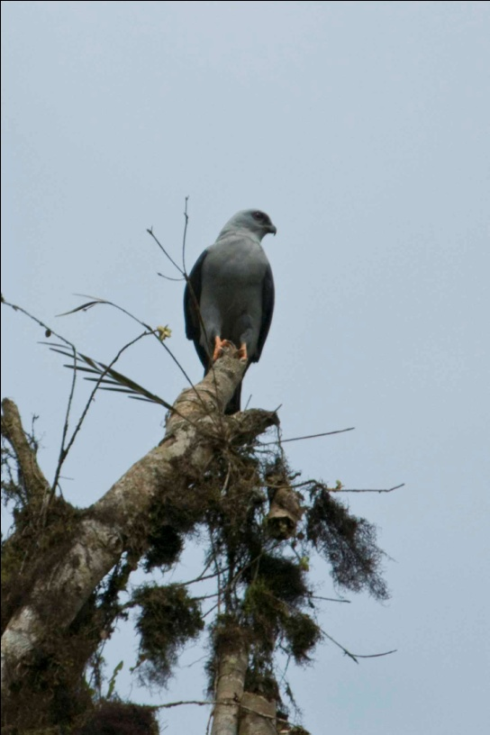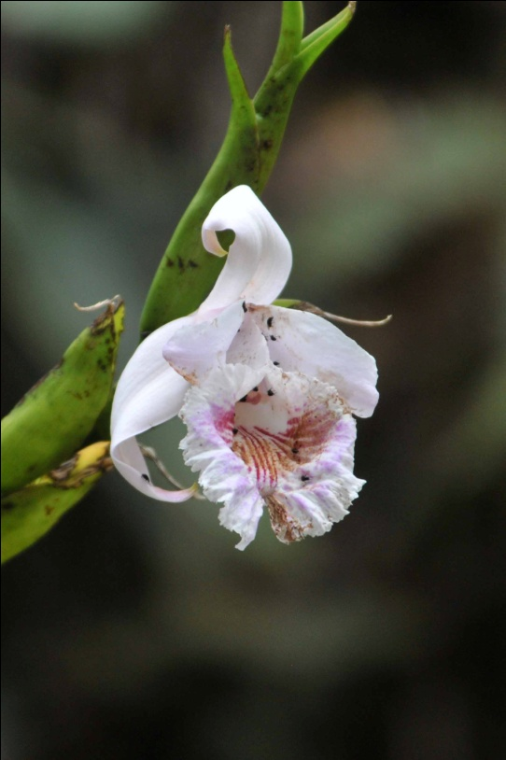
Plumbeous Kite One of many orchids seen at Mashpi
As we approached Ayalir Lodge, the rain returned. We were all basking in the glory of an amazing day of birding, so we didn't mind the late afternoon rain. As the afternoon went into evening, the rain picked up and it was as if the heavens had opened up by the time we gathered at the poolside shelter to go over our lists. We could hear the rain pounding on the tin roof as we ate dinner, and borrowed umbrellas from the hotel to use as we made a dash through the downpour to our rooms. When Jim and I arrived at our covered entry, I noticed a puddle forming at the door. Still under construction, our building had stairs leading up to a future second floor that was currently just a flat-topped roof. Water was flowing down the steps like a waterfall, and a slight slant on the tile floor channeled the water to our side of the entry and away from the room on the opposite side where Doreene and Dan were staying. I commented that I hoped none of the water had leaked into the room as Jim opened the door. Inside, we found the entire room flooded with about 3/4 inch of water covering the tile floor. With little time to prepare for dinner after we returned from our day of birding, we had tossed dirty clothes on the floor next to our open suitcase. Everything was completely soaked! Jim went to tell the management about the problem while I tried to get some things picked up. A worker came in with a broom expecting to brush the water from our room and became very agitated when she saw the volume of water on the floor. As she tried to communicate with us in Spanish, I managed to ask "mas despachio, por favor" but slowing down wasn't possible in her current state of agitation. I could make out that we were to be moved to a different room, but it wasn't until an English-speaking representative came that we would learn that we could take just what we needed for the night to a different room and we could then gather our remaining items the next afternoon, or return to that room if it was dry enough. The temporary manager, a visitor from Switzerland who was there to assist the hotel staff for a few weeks, was very friendly and helpful. We moved into the slightly smaller room and settled into a comfortable bed for a good night's sleep.

DAY 7, February 12: RIO SILANCHE BIRD SANCTUARY
While packing up for the day's outing, I realized that I had left my binoculars in the flooded room the night before. As I approached the building that housed our first room I saw two trucks parked in front, an indication that workers had already been busy trying to fix the drainage problem. I could not find the binoculars, went back to the new room to look for them, returned to look once more in the old room. By now I had missed breakfast and the group was loading on the bus, so I went to the bus and asked Marcelo if I might borrow the pair of binoculars we had brought from the states for his son. Jim quickly went back to our old room and found the binos hidden under the bedspread that I had thrown on the bed the night before to keep it from getting soaked. Whew!

We headed for Rio Silanche Bird Sanctuary, a reserve that was created to protect a remnant lowland forest and the many Choco endemics it holds . Many of these endemics are currently threatened by the significant clear-cutting of forest in the area. We walked to the observation tower first where we found several hummingbirds feeding on the flowering shrubs nearby. Purple-chested Hummingbird, Green Thorntail, and Violet-bellied Hummingbirds entertained us at the base of the tower and again from the top once we climbed up. Some of our best views of the hummers were actually from the top looking down at them. Libby alone spotted a Stripe-throated Hermit.

As the cloudy sky threatened to open up on us, we stood on the platform gazing out into the canopy, waiting for activity. A Dusky-headed Flycatcher drew a lot of attention as it was the only bird present for awhile. Birds were not in the numbers expected for this sanctuary, but we were able to view, either from the tower or one of the trails: Western White-tailed and Black-throated Trogons, Orange-fronted and Red-headed Barbets, Plain Xenops, Wedge-billed, Black-striped, and Streak-headed Woodcreepers, Slaty-capped, Ruddy-tailed, Black-tailed, Social, and Sulfur-rumped Flycatchers, Black-capped Pygmy Tyrant, Black-headed and Common Tody-flycatchers, Purple-throated Fruitcrow, Lesser Greenlet, Red-eyed Vireo, Blue Dacnis, and Dusky Pigeon.

Woodpeckers were common in this sanctuary, with several species making an appearance at one birding stop or another: Cinnamon, the western subspecies of Lineated, Black-cheeked, Red-rumped, and Guayaquil in addition to the tiny Olivaceous Piculet, one of the smallest members of the woodpecker family, measuring just 3.5 inches. Karen was able to see a Western Woodhaunter that no one else was able to observe. Other furnarids seen today have been listed for previous days.

On the trail leading back to the bus, we birded a little as the rain lightly fell. We saw Spot-crowned Antvireo, Pacific, Checker-throated, White-flanked, and Dot-winged Antwrens, and the only Orange-billed Sparrow of the trip. We sought shelter from the increasing rain under the overhang of the roof of the caretaker's residence, where we received many bites from insects I dubbed "Elbow Bugs". These minute insects seemed to hover around everyone's elbows, and more than a few people had polka-dotted elbows for several days to come. From our shelter, we were able to see several "old" species and added White-shouldered Tanager to our list. Some people caught a glimpse of a Buff-rumped Warbler under a bush, but it went deeper into the forest before everyone could get on the bird.

After having a box lunch on the bus, we walked down a different trail where Andres knew of a Bandtailed Barbthroat lek. Along the trail we found several other species, including both Rufous and Broad-billed Motmots, as well as some of the species mentioned in the third paragraph of Day 7 (above).

On our way back to Ayalir Lodge, we did some roadside birding, with one spot in particular that Andres wanted us to search. This spot was known as one of the few places around where you could find Rose-faced Parrots. Among the Rose-faced Parrots were many Bronze-winged Parrots and Maroon-tailed Parakeets. Although the tree they were feeding in was quite a distance away, we all enjoyed good views through the scopes. While at this stop, Blue-headed Parrots flew in and perched at the top of a different tree, providing good views of a species that had previously only been "fly-bys". Chestnut-fronted Macaws and Mealy Parrots flew over our heads, along with a Gray-breasted Martin. A very cooperative Golden-olive Woodpecker paused in a tree right next to the road, giving us all something to "ooh" and "aah" about before heading back to the lodge for dinner. Scarlet-thighed Dacnis was seen in the distance.

Our original room was dry when we returned, so we opted to move the few things we had taken with us instead of moving all of our stuff to the new room for the last night at Ayalir. The staff was so helpful that, in addition to laundering the wet clothing that had been left on the floor of the flooded room, they also took the plastic bag with dirty clothes from the day before and the plastic bag holding my waterproof Keen shoes from the room we had slept in the night before. When our clothing was returned to us, my shoes had been laundered along with the clothes, and it would be days before they would dry out.
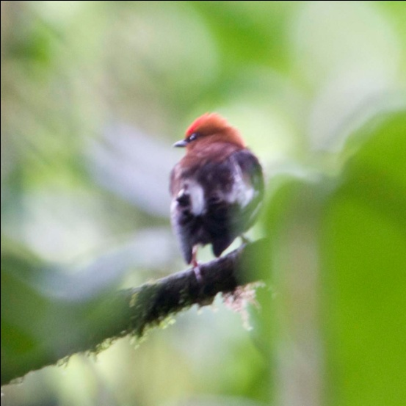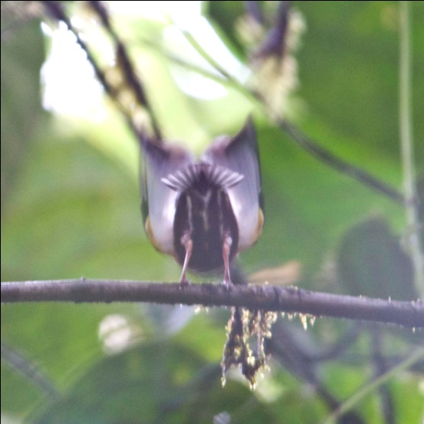

Male Club-winged Manakin performing at lek in Milpe Bird Sanctuary

DAY 8, February 13: MILPE BIRD SANCTUARY, CALACALI AREA, EQUATOR MONUMENT
Once again birding with alternating periods of sunshine and rain, we spent the morning at Milpe Bird Sanctuary. A beautiful area in the foothills at a little over 3000 to almost 4000 feet in elevation, it harbors many Choco endemics, including a lek of Club-winged Manakins who performed for us in grand fashion. These tiny birds use their wings for stridulation, a rubbing mechanism commonly used by insects such as crickets. One feather on each wing has seven ridges along its central vane. The stiff, curved tip of an adjacent feather strikes the ridges every time the bird raises it wings over its back and shakes its feathers. The repeated striking causes adjacent clubbed feathers to vibrate at high speed (1500 cycles per second), creating the unique high-pitched courtship song. While not believed to be part of the attraction to females, the movement needed to create the sound is entertaining in itself. Although many insects do this, manakins are unique among vertebrates in using stridulation.
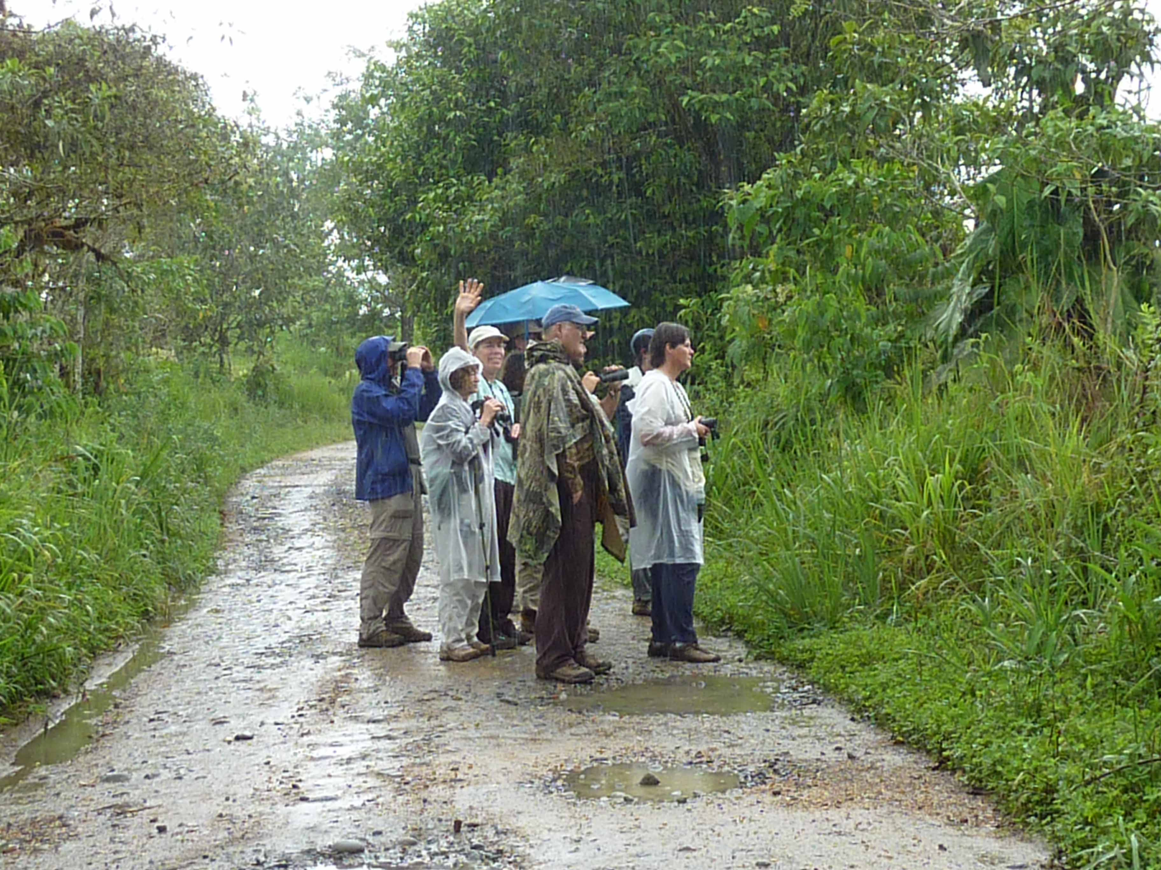
Neither rain nor sleet nor snow . . . . How does that go?
As we disembarked from the bus at the visitor's center, we were greeted by a mixed flock in a fruiting tree in the parking lot. New birds included Guira Tanager, Golden-rumped Euphonia, and Blue-and-yellow Tanager. The hummingbird feeders were active with several species present, but the only species new to us was the very common Rufous-tailed Hummingbird. Easily seen in most Central and many South American countries, this was our first visit to the proper habitat and elevation for this species. Other birds seen on the roads and trails of the sanctuary included many previously-seen species, as well as some new species: Scaly-throated Foliage-gleaner, Snowy-throated Kingbird, Golden-winged Manakin, Band-backed and Bay Wrens, Collared Trogon, Choco Warbler, Yellow-throated Bush-tanager, Hooded Siskins, Immaculate Antbird, and one of the most difficult birds for the entire group to see, Esmeralda's Antbird. After hiking down a long narrow trail, with barely room for two people to stand side-by-side, Andres heard the call of the Esmeralda's Antbird. Lined up on the trail as it led down to a ravine, we all stood silently waiting for the birds to appear in one of the tiny openings in the forest floor. Andres and the people at the front of the line were standing at the lowest point of the trail with the remainder of the group along the slope and Marcelo at the highest point. Discouraged about my position at the end of the line and what I thought were miniscule chances of seeing the bird, I gazed across the ravine at an open area at eye level on the other side. Suddenly, the female antbird hopped into view. By the time I said, "I've got it," it was gone and Marcelo and I were the only two to see it at that time. With a lot of patience and everyone standing their ground rather than moving about, every person in the group was able to see both male and female Esmeralda's Antbirds. We walked away feeling quite satisfied with ourselves, and I was not unhappy to bring up the rear of the line from that moment forward.

After enjoying our boxed lunch in Calacali near the original Equator Monument, where we saw our first House Sparrows (Oh, no!), we drove to Calacali Pass where the habitat was much different from any site we had visited so far. Looking out over a dry landscape with few trees and vegetation that reminded us of the desert southwest of the US, we were certain we would be seeing new species here. Rusty Flowerpiercers darted in and out of the short scrubby bushes and Tufted Tit-Tyrants flitted across the slope below us. Everyone was pleased that Black-tailed Trainbearers made an appearance for those who had not seen it earlier in the trip. A few people saw Band-tailed Seedeater, but Karen was the only birder lucky enough to see the White-tailed Shrike Tyrant that Andres said was present in the area.

Andres left us at around 4:00 PM to attend a friend's wedding - he was actually serving as the witness, the equivalent to the best man in the US! As he departed in a private vehicle, the bus went on to the newer Equator Monument and the outdoor museum adjacent to it. We saw our first Common Ground-doves as we approached the monument and most people got excellent looks at a species that up to this point had given only glimpses of itself, the Southern Yellow Grosbeak (aka Golden-bellied Grosbeak).

After visiting the museum, we drove back to Quito where we checked in at the Hotel Sebastian for the night. We updated our lists with Marcelo and then had some time to organize our luggage before dinner. We could leave part of our luggage at the Sebastian while we went on the second half of the tour on the eastern slope of the Andes, and many of us took advantage of the opportunity. As we turned in for the night, it became quite apparent that we were in a big city hotel on the Saturday night of the four-day celebration known as Carnival.

DAY 9, February 14: ANTISANA RESERVE, PAPALLACTA PASS
Birding at Antisana is unlike other birding we had been doing - no long hikes down steep muddy trails and no heat and humidity to make the hiking feel more difficult than it is. At altitudes ranging from 9000 feet in Quito to over 14,000 feet, this day consisted mostly of short walks from the bus wearing our warmest clothing.

During our ascent, we saw Carunculated Caracaras literally all over the place: in the air, on the ground, at a distance and practically underfoot (well, that may be an exaggeration, but they were very close). Raptors provided much of the birding entertainment at these altitudes with Black-chested Buzzard Eagles and Variable Hawks making numerous encores and single cameo appearances from an Aplomado Falcon and an American Kestrel. It wasn't until after lunch that we saw the bird that was perhaps highest on our wish list for the day, the Andean Condor. The bird was in flight and at quite a distance, but we felt privileged just to see one under any conditions.

We stopped at an area that Andres knew where Giant Hummingbirds regularly feed. After just a few moments, the largest hummingbird in the world appeared, feeding at flowering bushes, returning repeatedly until all were satisfied with the looks they got. Along a nearby river we saw Andean Gulls.

It didn't take long to pass the treeline and Paramo vegetation dominated the scenery. At a bridge, we were able to see
an Ecuadorian Hillstar female with one or two birders getting a glimpse of a male. Nearby, there was at least one Streak-backed Canastero, but only those who were approaching at the front of the line of birders were able to get good views.

I asked Luis to stop the bus so I could take a photograph of some Carunculated Caracaras that were very close to the road. Before I could even get the camera focused on the birds, Andres called out that there were some
Black-faced Ibis directly ahead of us. As we looked at the Ibis through our binoculars, we also spotted a group of Andean Lapwings.

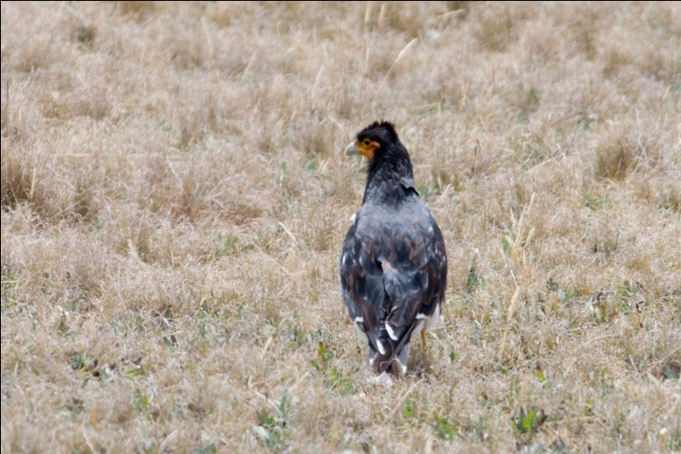
Carunculated Caracara
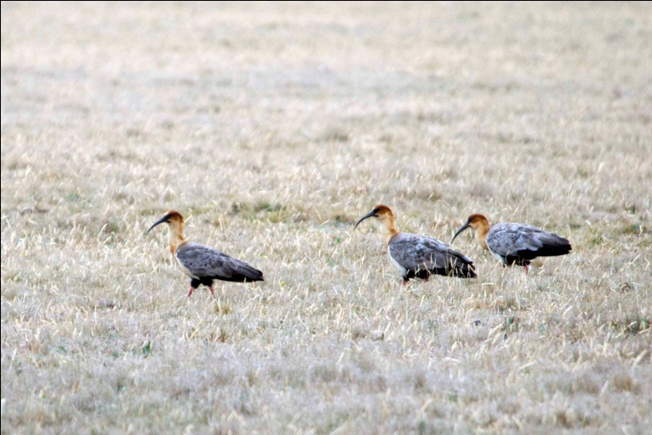
Black-faced Ibis
Near an old deserted house and a flock of grazing sheep tended by a couple of very sleepy dogs and a few shepherds, we got good looks at Bar-winged and Stout-billed Cinclodes. As we were watching Paramo (Plain-capped) Ground-Tyrants ( small brown birds) on the ground near the bus, Libby insisted that she was seeing a Pipit. With all of the movement of the earth-colored birds on the bare ground (think of Horned Lark flocks in plowed fields in the winter), it took awhile before we were able to get on the bird she was referring to. When at last Andres and the rest of the group found the bird in the field (with no discernible field marks to indicate location), it was indeed a Paramo Pipit.

Another roadside stop yielded Black-winged Ground-doves and both male and female Plumbeous Sierra-Finches.

At a mountain lake we saw Silvery Grebe, Andean Teal, Andean (Ruddy) Duck, Slate-colored (Andean) Coot, and Greater Yellowlegs. Because we were unable to locate any Yellow-billed Pintail at this lake, we later walked up a short trail to a second lake to find it. On the hike back from the lake, we saw Brown-backed Chat-tyrant, Sedge Wren, Andean Tit-Spinetail and White-crested Elaenia.

It was almost dark when we arrived at Guango Lodge, but there was still a lot of activity at the hummingbird feeders. Several species we had seen before were in the company of Chestnut-breasted Coronet, Tourmaline Sunangel, Long-tailed Sylph, and White-bellied Woodstar. Just before the light faded completely, I saw a Sword-billed Hummingbird drop down from a tree branch to take its last sip of nectar for the evening from a hummingbird feeder hanging just above and to the right of my head. The Masked Trogons seen at Guango were not a new species, but they were a new subspecies for us since we were now on the eastern slope of the Andes.

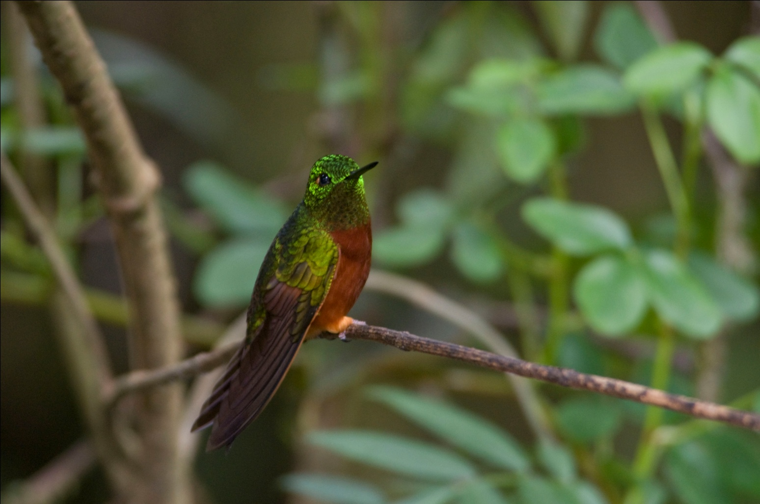
Chestnut-breasted Coronet
DAY 10, February 15: GUANGO LODGE TRAILS, PAPALLACTA PASS, TERMUS DE PAPALLACTA
We spent this morning on the trails at Guango, one of the best birding lodges in Ecuador. Located at an elevation of about 2700 meters and centered in a zone classified as humid temperate forest, Guango offers a distinct habitat characterized by stunted trees , thick canopy, and cool climate,. As we hiked down a trail on the lodge's property, our first stop was at an old bridge overlooking a fast-flowing river. It didn't take long for us to locate a single Torrent Duck. While watching the duck, two White-capped dippers flew across the river in front of us.

From there, we walked along the road, birding the edges of the rich forest. Admittedly a bit scary as traffic came around the curves, the route proved worthwhile as we saw many species, including several that were new for the trip such as Dusky Piha, Northern Mountain-Cacique, Red-crested Cotinga, and Yellow-tufted Woodpecker (seen by some).

After walking down a steep hill searching for new species, Andres noticed a mixed flock moving toward the area we had just left. We quickly moved back to the top of the hill where several tall bushes and a row of short trees hosted a mixed flock with so much movement that it was difficult to keep up with all the species being seen: Agile Tit-tyrant, Lacrimose and Masked Mountain-tanagers, eastern subspecies of Blue-gray Tanager, Gray-hooded and Black-backed Bush-tanagers, Mountain Wren and Black-capped Hemispingus were the new species among the throng. We also enjoyed better views of the remarkable Plushcap than we had seen earlier in the trip.

As we walked back up the trail to the lodge for lunch, the last birds we encountered were a small group of Inca (Green) Jays. Among the familiar hummingbirds at the lodge feeders as we entered the dining room was one new species, Viridian Metaltail.

After lunch, we headed back toward Papallacta Pass primarily to find one special target species, Rufous-bellied Seedsnipe. We proceeded beyond the pass to the highest elevation for the trip (14,300+ feet) in search of this unusual bird. Heading up a dirt road toward some radio towers located at the top of a peak, Luis' driving skills were again very much appreciated. With many steep drop-offs on the narrow road, it was comforting to know we were in the hands of an excellent and experienced driver. Upon exiting the bus, everyone began to look for the ground birds, knowing that they would blend well into their environment. After searching for a time, Andres and Marcelo began walking a trail leading to the next ridge with Libby and Karen following behind. The rest of us remained near the parked bus, huddling behind some buildings for protection from the cold wind. Karen quickly learned that hiking at that elevation was quite strenuous and soon returned to join the group. As we all searched the hillside, Luis happened to look back at the road behind us. He called out to the rest of us, and there on the open road were two Seedsnipes! We called to Andres, Marcelo and Libby and the three of them rushed back. The pair of Seedsnipes were unconcerned with the humans on their mountain and proceeded to walk around feeding, at one point coming within just a few feet of the group.
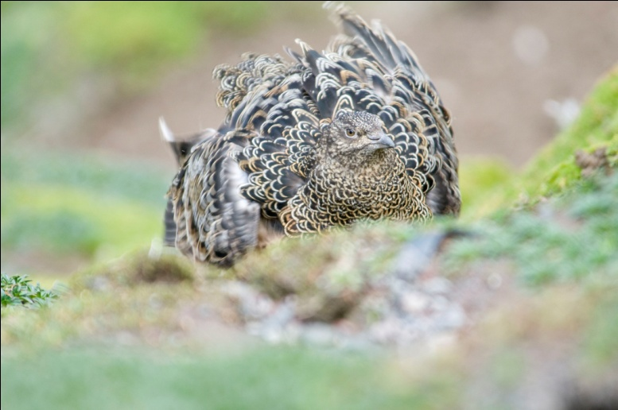
Rufous-bellied Seedsnipe
We headed back down the road toward our next destination, San Isidro Lodge. We naturally had many birding stops along the way, adding Many-striped Canastero, Neotropical Cormorant and Paramo Seedeater to the group trip list. We were also lucky enough to get good views of the male Ecuadorian Hillstar that most missed yesterday when the female was visible at the bridge. Andres planned the route so we would be positioned to see Lyre-tailed Nightjar at a place along the road where they are known to roost and hunt. As we were waiting here for the time to be right for the nightjars, we were able to find Pale-naped Brush Finches in the bushes along the side of the road.

By the time we arrived at San Isidro, we had just enough time to check in before dinner. With an early morning departure scheduled, we were glad that we would be returning to this lovely lodge in a few days, at which time we would be able to bird the surrounding area.
DAY 11, February 16: LOW GUACAMAYOS RIDGE, LORETO ROAD, GARENO LODGE
We left San Isidro Lodge after an early breakfast and headed for the lower reaches of the Guacamayos Ridge, an unusual outcrop of the eastern Andes that creates a small area of temperate forest surrounded by the subtropical forest of the lower valleys . Our first stop in the (very early) morning was at a spot where Andres and Marcelo knew to harbor Swallow-tailed Nightjars. After finding a male sitting on a low rock ledge, we watched as it flew out to catch an insect with the long, forked tail gracefully flowing behind. When the bird took off the second time, it disappeared and we did not try to relocate it.

During the day, we made many stops along the road to bird, but a couple of places stand out in my mind. One was early in the morning, soon after we had seen the nightjar. We found shelter from a light drizzle standing near a building that was near the road. At first, we saw little in the trees around the building, but soon we were treated to good views of one bird after another, with a couple of small groups moving through that made for exciting bursts of birding. Among the new species seen here were Eastern Wood Pewee, Saffron-crowned and Rufous-crested Tanagers, Blue-fronted Lancebill and Scaly-naped Parrot, along with excellent views of several species we had already seen.

Another memorable stop was at a site where Andres said he regularly saw dozens of Cliff Flycatchers along a rocky wall that rose straight up from the road. As I exited the bus onto loose gravel, I lost my footing and came crashing down on the curb. After 10 days of hiking steep, muddy, slippery trails with vines, branches and stumps to trip you up, I lost my footing on a perfectly civilized roadside! There was too much activity for me to nurse my bleeding hand as we immediately began seeing birds, but none of the expected flycatchers showed up. Little Woodpecker, Rufous-tailed Tyrant and Lined Antshrike were the new species among the many birds we saw here. Finally, Andres and Marcelo walked to a little rise that overlooked a valley, and there at the top of a slender tree in the valley below us was a single Cliff Flycatcher.

Other stops along Loreto Road yielded more new species: Greater Yellow-headed Vulture, Speckled Chachalaca, Spotted Sandpiper, Blackish Antbird, Golden-faced Tyrannulet, Thrush-like Wren, Canada Warbler, Blue Dacnis, Black-faced Dacnis, Chestnut-bellied Seedeater, Yellow-browed Sparrow, Yellow-rumped Cacique, Crested and Russet-backed Oropendola, and Magpie Tanager.

After a brief stop in Tena, where we were privileged to meet Marcelo's wife and son, we continued on our way to Gareno Lodge. Jim and I were particularly pleased to meet Marcelo's family because we had brought a new pair of binoculars to give away to a young birder on this trip. We had encountered youngsters on previous tropical trips who we wanted to provide with optics, so we are now making it a practice to bring along a pair in case we run into a budding birder in need of binoculars of their own. Earlier in the trip, we talked to Marcelo about his son birding with him, and when he told us they were sharing binoculars, it was an easy decision as to where the binoculars would go.

As we left Tena, we were quite suddenly surprised by a huge splash of water coming through one of the windows onto one of the members of our group (I think it was Tony, but he was sitting behind me so I didn't actually see it). As we drove along the outskirts of Tena, we saw groups of children along the side of the road (sometimes with adults standing by with huge smiles on their faces) with huge buckets of water, homemade water blasters made of pvc pipe, or some other means of hurling water at passing cars. Each time we would approach, everyone would quickly close their windows to avoid an unscheduled bath. Judging from Marcelo's, Luis's, and Andres' reactions - huge grins, laughing, some remarks showing admiration for technique - we were certain that they had pulled similar pranks when they were younger. At one point I saw a tiny girl standing alone with a small watergun. As I smiled at her, her older cohorts rushed from the bushes behind her and, before I could react, a flood of water hit the left side of my head! Gleeful laughter came from our Ecuadorian friends as I checked to see that my camera was dry and then started laughing myself. It seems that today was the final day of Carnival in Ecuador, and this was one of the traditional games that children play as part of the celebration. Even as we drove through less populated areas with houses farther and farther apart, we still occasionally saw children prepared to douse us as we passed. Finally we were so far out into the wilderness we could let our guard down and concentrate on watching for birds instead of buckets.

Continuing on the road to Gareno Lodge, we sometimes had to stop and back up to a wider place in the road to allow other vehicles to pass. At one point a full-size bus loaded with passengers (including two on the top of the bus!) came barreling around a blind curve in front of us. As both drivers slammed on their brakes, I cringed and braced myself for a head-on collision. The two buses came to a stop with the front drivers' sides corners just inches away from each other, and I was amazed at how calm both drivers seemed. As we drove by the oncoming bus to continue on our way, I noticed the passengers on the top of the other bus tightening the ropes that were holding down some belongings. They were smiling as if they had been on an amusement park ride instead of just avoiding a deadly crash!

As Luis pulled over at our final destination, all we saw was a rough sign that said "Gareno Lodge" at the entrance to a steep trail leading down into the rain forest. The trail had been improved with steps cut into the hillside which were covered with what looked like bamboo stalks cut in half. There was a railing part of the way down the trail, which came in very handy since many of steps sloped downward and the wet algae-covered bamboo covering on the steps was very slippery. Each of us carried as much of our belongings as we could as we walked down, down, down to the lodge. As we approached a narrow footbridge, we were told that there could be just one person on the bridge at a time. After what seemed like a very long walk in the tropical heat, we finally reached the lodge. Built of rough-hewn wood on land that belongs to the Waorani tribe, Gareno reminded me of the Embera village of La Marea in the Darien of Panama that we visited just a year ago. Each of us were given rubber boots to wear on the trails and assigned a cabin. Once we put our belongings into our cabins, we were to report back to the dining area for orientation. We were told how the lodge came into being, how the owner had an agreement with the Waorani to use a portion of their land. We also heard the story of some loggers who, after poaching lumber on Waorani land, were found with spears through their bodies.
From http://www.lastrefuge.co.uk/data/articles/waorani_p1.html
The Waorani tribe of Amazonian Ecuador first became world famous in 1956, when they speared to death five American missionaries who had landed their light plane on a riverside sandbank and were trying to explain their plans to build an airstrip. Outsiders may have been shocked by the manner of the missionaries' departure, but to the Waorani, no way of dying could have been more ordinary. Spearing accounts for 40 per cent of deaths, usually in interfamilial vendettas; 20 per cent are shot or kidnapped by outsiders-a fact that may have influenced their way of greeting missionaries; and snakebite and other accidents account for most other deaths. Only about 1 per cent are 'natural'.
Waorani; to the Waorani, means 'people'. But to Ecuador's predominant indigenous group, the Quechua, they are Aucas, 'savages'. Indeed, there is much about their life-style that would invite the label. They have no writing, no reason to count higher than 10 and no history other than a tribal recollection that their ancestors came from "downriver; long ago". They roam naked in the jungle, hunting monkeys and birds with wooden blowguns and curare-tipped darts; for pigs they use spears. They also use spears to deal with the incapable elderly, and unwanted babies are strangled with vines, burnt or buried alive. And by and large their contacts with the Quechua or any other outsiders have not been notably peaceable.

After our brief orientation, we began our first walk at Gareno, feeling very fortunate to be birding in an area so far removed from civilization. As we were now in a lower altitude and many miles east of the Andes, we would be seeing many species typical of the Amazon Basin. Some of these species would be seen on our extension to Sani Lodge on the Napo River, but some species could be seen only here.

We were joined by a native guide, Rudolpho, for our birding walks while at Gareno. The son of Pedro, the owner, he was very familiar with the location of target species, and he was able to lead us directly to the roosting spot of a Rufous Potoo. We had to leave the trail and go down into a gully to get good views, so we took turns with two people at a time going into the brush to take a look through Marcelo's scope. Although the lighting was too poor for good photographs, we had terrific views through the binoculars. Other species seen on our first day at Gareno included Squirrel Cuckoo (eastern subspecies), Short-tailed Swift, Green-fronted Lancebill, Gray-breasted Sabrewing, Blue-tailed Emerald, Coppery-chested Jacamar, Many-banded and Lettered Aracaris, Channel-billed Toucan, Buff-throated and Olive-backed Woodcreepers, Gray-capped and Piratic flycatchers, Black-capped Becard, Bare-necked Fruitcrow , Tawny-bellied Screech Owl, and Rufous-bellied Nighthawk. A large selection of tanagers brightened the forest with their stunning colors: Orange-eared, Golden, Golden-eared, eastern subspecies of Flame-faced, Paradise, Spotted, Silver-beaked, and Masked Crimson. Libby was the only member of the group to report seeing Tawny-bellied and Gray-chinned Hermits.
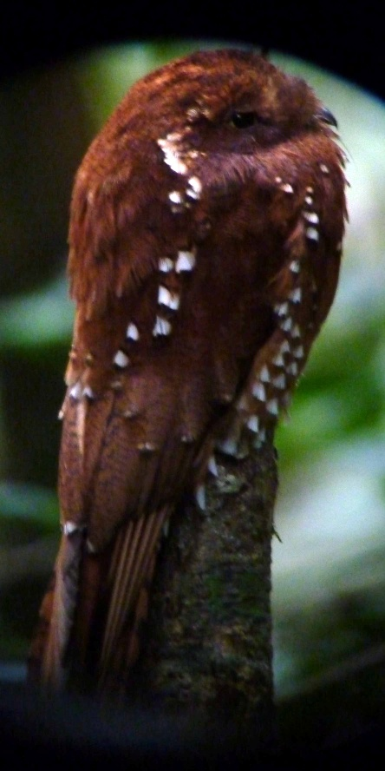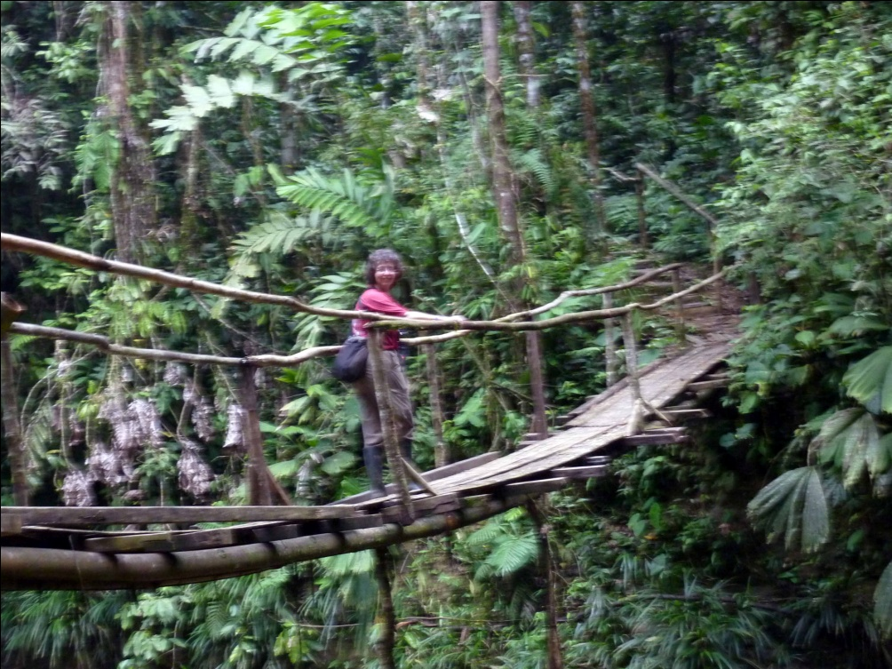
Rufous Potoo Robin on the bridge on the trail to Gareno Lodge
(through Marcelo's scope)
Since Gareno Lodge has no electricity, we had dinner and checked our lists by candlelight (aided by flashlights). After our first day in real tropical heat, the lack of hot water was not an issue as a cool shower felt pretty good. We knew we were housed in considerable luxury considering our location - comfortable beds, screened windows to keep the mosquitoes away, private bathroom with cold and colder running water, and the best feature of all: the sounds of the rain forest uninterrupted by traffic noise and other sounds of civilization.

DAY 12, February 17: GARENO LODGE
Although the sounds of the generator running in the early hours of the morning broke the silence before we were ready, we didn't mind because we knew it was needed to cook breakfast for us. After a candlelit breakfast, we headed for the Harpy Trail in twilight. Tony and I learned yesterday that our boots had leaks in them - both of us had one water-filled boot after a stream crossing. In addition, the poorly-fitting boots were giving me a blister, so I opted to forego the leaky rubber boots today and wear my water-proof hiking shoes instead. I had hoped that we would not have to cross anything too deep today, but I needn't have worried. When we came to stream crossings, Marcelo and Rudolpho helped me balance on rocks and logs, and otherwise assisted me when we came to particularly deep mud. While I didn't expect the extra attention, I certainly appreciated it. Others who had difficulty on the steep trails covered in slippery (sometimes boot-sucking) mud were also appreciative of the extra attention our guides gave.

We didn't know it at the time, but our guides were taking us to a roosting spot of two Crested Owls. We kept our distance so we would not disturb them, and everyone was able to get excellent looks. This was a stellar day for one of my favorite families of birds, Manakins. We got great looks at Golden-headed and Blue-crowned Manakins. But the prize bird of the day for me was the adorable little Striped Manakin. It took quite awhile for Marcelo to find the little guy, but once he did, the bird remained stationary long enough for everyone to have excellent views through the scope. As a matter of fact, after everyone had a second, longer look through the scope, the bird remained long enough for Marcelo to get some shots through his scope.

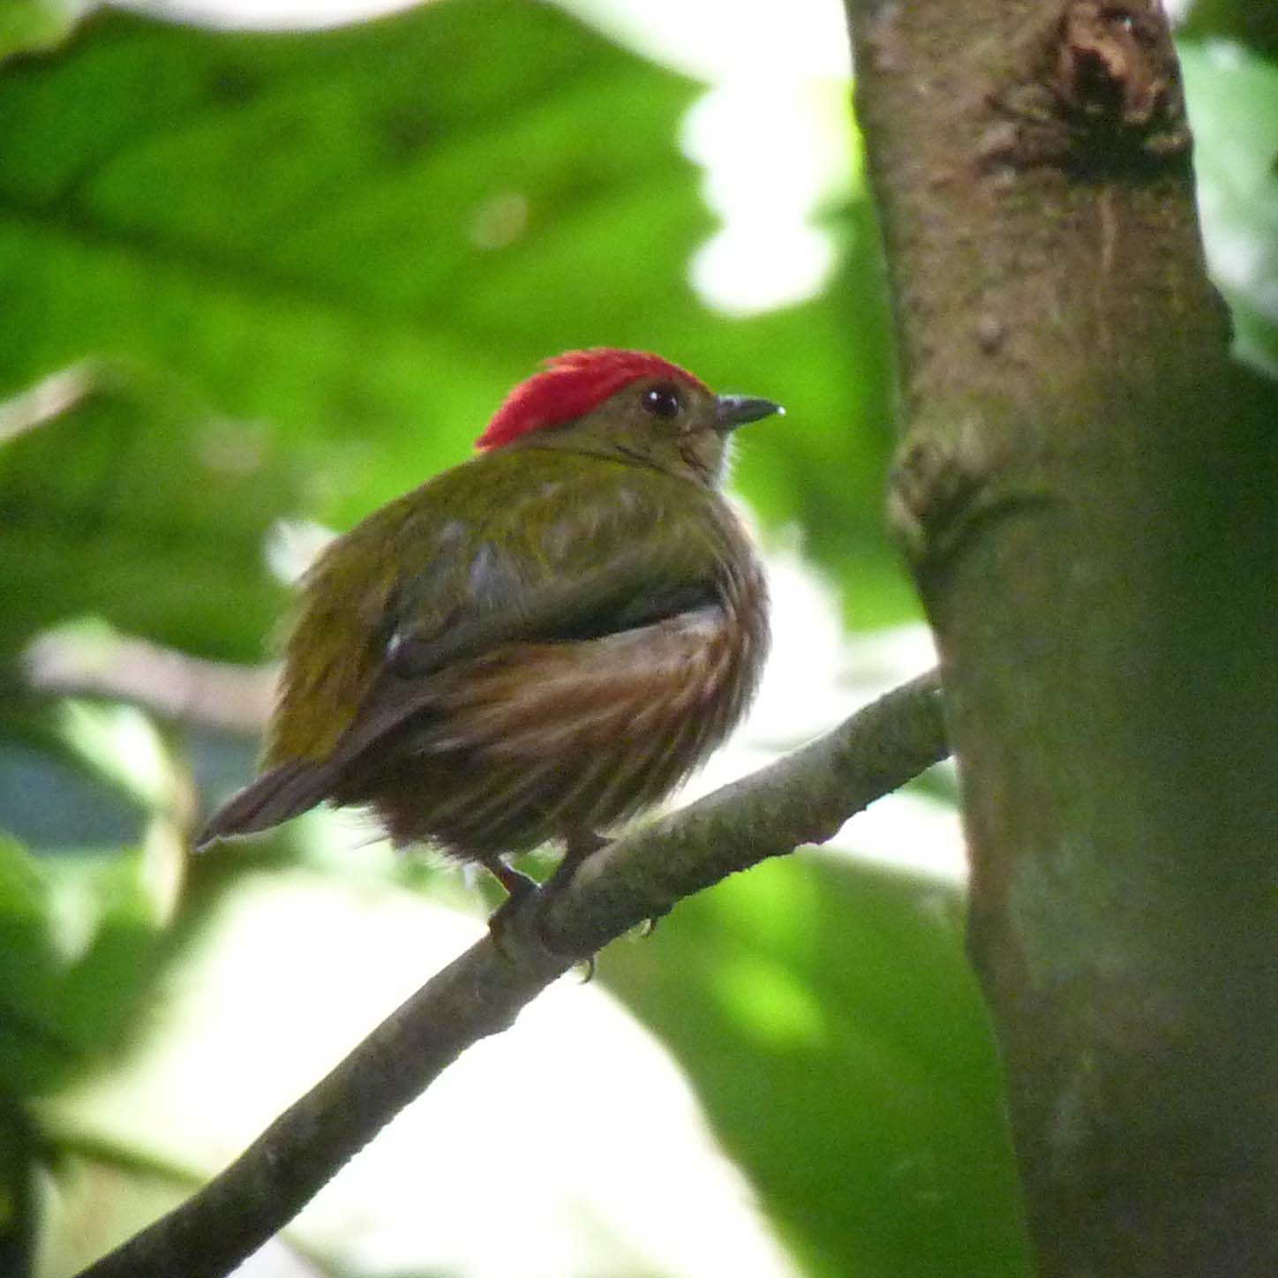
Striped Manakin
We continued birding at various locations near the lodge and finished the morning with quite a few new species including "fly-over" views of White Hawk, Double-toothed Kite, Black Hawk-Eagle, Ornate Hawk-Eagle, and Barred Parakeet. Other new species seen were Common Nighthawk, White-chested and Great-billed Hermits, Amazon White-tailed and Amazonian Violaceous Trogons, Broad-billed Motmot (eastern subspecies), White-fronted Nunbird, Lemon-throated Barbet, Golden-collared Toucanet, White-throated and Cream-colored Woodpeckers, Plain-winged and Dusky-throated Antshrikes, Long-winged and Gray Antwrens, Olivaceous Flatbill, Gray-crowned Flycatcher (Flatbill), Grayish Mourner, Streaked Flycatcher, Rufous-bellied Euphonia, Green-and-rufous Kingfisher, Black-faced, Warbling, Yellow-browed, and Scale-backed Antbirds, and Swallow, Scarlet, and Flame-crested Tanagers. Yellow-backed Tanager was seen by Karen only.

After lunch at the lodge we began another walk that was aborted due to rain. Not long after we got back to the dining area, the rain let up and the group got ready to go back on the trails. With the strenuous hiking from the trails in the Andes followed by equally strenuous trails here, my legs were pretty tired. When you factored in the heat and humidity, I made a decision I've never before made in a situation like this: I opted to stay back at the cabin instead of going birding. Even the lure of seeing one of the target birds for the afternoon, Crested Quetzal (a life bird for me), did not influence me to tough it out. Jim and Doreene opted out of the afternoon walk as well. I wished the group the best of luck in finding Crested Quetzals as well as other new species and walked with Jim to our cabin for a refreshing shower and much-needed rest. When it came time for dinner, I sent Jim without me and took advantage of the extended rest period to "recharge my batteries".

I learned the next day that the group had dipped on the quetzal, but we would have one more chance to see it on our last morning at Gareno. Species that the group saw while Jim and I rested included Pale-rumped Swift, Fork-tailed (Neotropical) Palm Swift, Fiery Topaz, Green-and-rufous Kingfisher, Gilded Barbet, Yellow-tufted Woodpecker, Chestnut-winged Hookbill, Chestnut-winged Foliage-gleaner, Wedge-billed, Cinnamon-throated, and Spix's Woodcreepers, Black-tailed Tityra, Dusky-capped Greenlet, Fulvous Shrike-tanager , Masked , Opal-crowned, and Yellow-bellied Tanagers, and Blackpoll Warbler. While I suffered some momentary angst over not seeing the Fiery Topaz, even though some of the people explained that their looks had been poor at best, the extra rest from the day before had refreshed me and I was better prepared to enjoy the remainder of the trip.

DAY 13, Februaru 18: GARENO LODGE, GUACOMAYOS RIDGE, SAN ISIDRO LODGE
We brought all of our things to breakfast this morning and took them back up the steep trail to the bus. We birded along the gravel road leading out to the main road that would take us toward San Isidro. A Snail Kite hunted on one of the small wetlands we passed, and we saw Semicollared and Black-faced Hawks overhead. Other species seen between our departure at Gareno and arrival at San Isidro include Wattled Guan, Ruddy Ground-dove, Maroon-tailed Parakeet (eastern subspecies) , Brown Jacamar, Red-stained, Yellow-vented and Scaly-breasted Woodpeckers, Sooty Antbird, Mouse-colored Tyrannulet, Dusky-chested Flycatcher, Great Kiskadee, White-browed Purpletuft, Screaming Piha, Purple-throated and Spangled Cotingas, White-banded Swallow (gym), Tropical Gnatcatcher, Yellow and Black-and-white Warblers, eastern subsp Blue-winged Mountain-Tanager, Fluvous-crested Tanager, and Southern Rough-winged Swallow (eastern subspecies). Perhaps the best bird of the morning was a species that, technically, the group had already seen. We watched in amazement as a male and female Fiery Topaz cavorted at the top of a tree within sight of the bridge where we were standing. Although the lighting did not do the bird justice, we were able to watch through the scopes as the male flew around the female, its tail in stunning detail and short displays of its shining fiery body when it turned just right. In a perfect world the bird would have been closer, but we were all thrilled with the action we were privileged to see.

We stopped in Tena to eat the box lunch provided by the cooks at Gareno Lodge. Luis drove us to a community center there, a large covered structure that looked like a gymnasium without walls above the bleachers. As we ate our lunch sitting on the bleachers, we spotted White-breasted Swallows nesting in the eaves. While we enjoyed lunch, Luis drove the bus to have a tire repaired. He had had four flats so far on this trip and had the tires repaired at times when he was not needed (during or after dinner, etc). This time, we would need to wait for about 30 minutes while he had the tire fixed. After we finished our lunch, most of us walked a few blocks to a nearby river to see if we could find any birds. Robin and I were enjoying the company of some children when I decided to go back to the shelter to get some water. When I arrived, Jim and Andres had been playing soccer with some neighborhood children. Jim had kicked the ball out of the gymnasium, and the children and Andres were trying to locate it by climbing as high as they could to look out into the streets. When the ball was finally recovered, they continued their game. Soon Robin returned and we both enjoyed watching the children and taking photos of the game. Birds sighted by the group birding along the river included a few new species such as Striated Heron, Mouse-colored Tyrannulet, Yellow Warbler, and Spot-breasted Woodpecker.

When we arrived at San Isidro lodge, we checked in and headed for the hummingbird feeders to see if we might find any new hummers. Sure enough, two new species mingled with the now-familiar hummingbirds: Golden-tailed Sapphire and Bronzy Inca. A Rufous-crowned Tody-flycatcher was spotted darting in and out of the bushes near the hummingbird feeders, but Andres gave up calling the bird after a few minutes. He told us that this individual is so often called by people that we would have better chances of a good view the next day. The afternoon was absolutely gorgeous, and we were reveling in the relative absence of heat and humidity. From there we took a short walk and added several more new species to our list: Pale-eyed Thrush, Common Bush-tanager, Bluish Flowerpiercer, Subtropical Cacique, Olivaceous Siskin, Sulfur-bellied Tyrannulet, and Pale-edged Flycatcher. A lucky few birders got the chance to see Chestnut-breasted Chlorophonia.

On our way to dinner, Jim and I saw a group of birders going in the opposite direction to see the lodge's "Mystery Owl", presumably a hybrid of Black-and-white and Black- banded Owls. With members of the group arriving at the dining room at different times, not everyone knew that the owl had been sighted, so we went back out after dinner. Although the owl could not be relocated, we did find White-throated Screech Owl before retiring for the evening.

DAY 14, February 19: SAN ISIDRO LODGE, travel back to QUITO
We started the morning birding the entry and gardens of San Isidro Lodge. The garden was so alive with activity and the birds were coming so close, I hated to leave. Inca Jays were particularly active and close at hand.
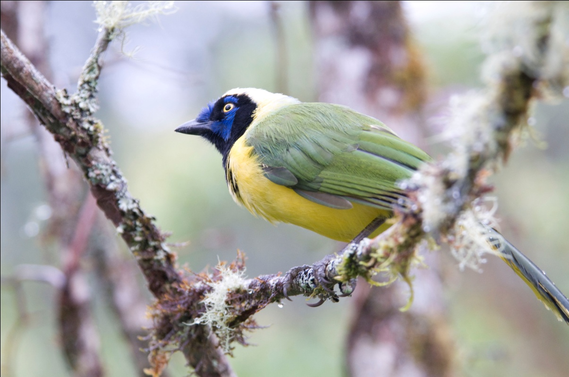
Inca (Green) Jay
With Angel Paz becoming so famous and getting so many birders to pay to see his Antpittas, one of the employees at San Isidro decided he could do the same. We stayed closed to the lodge waiting for our opportunity to accompany him as he fed a White-bellied Antpitta. Just like Angel, he called to the bird, but instead of calling a name, he whistled an imitation of the bird's voice. He has habituated another species but was unable to call it out in the open while we were there, and I don't remember which species it was.

Once we had seen the antpitta feeding, we ventured out onto the entrance road to bird on our way out. Luis drove past us in the bus, and we would walk to his new position, get in and ride to the next good spot, repeating the process a couple of times before we had to move on to Quito. Using this method, we were able to find many birds and make some progress in the long trip to Quito at the same time. Many of the species we saw were new for the trip, most notably the targeted Crested Quetzal. Andres and Marcelo heard the very distinctive call many times before they were able to call the bird in for us to see. A stunning male perched beyond the first row of trees lining the road, and each of us had to take turns getting in exactly the right spot to be able to see through an opening in the trees to where the bird was sitting. Marcelo once again used my little point-and-shoot camera to try to get some shots through the scope, but none were very good quality this time.
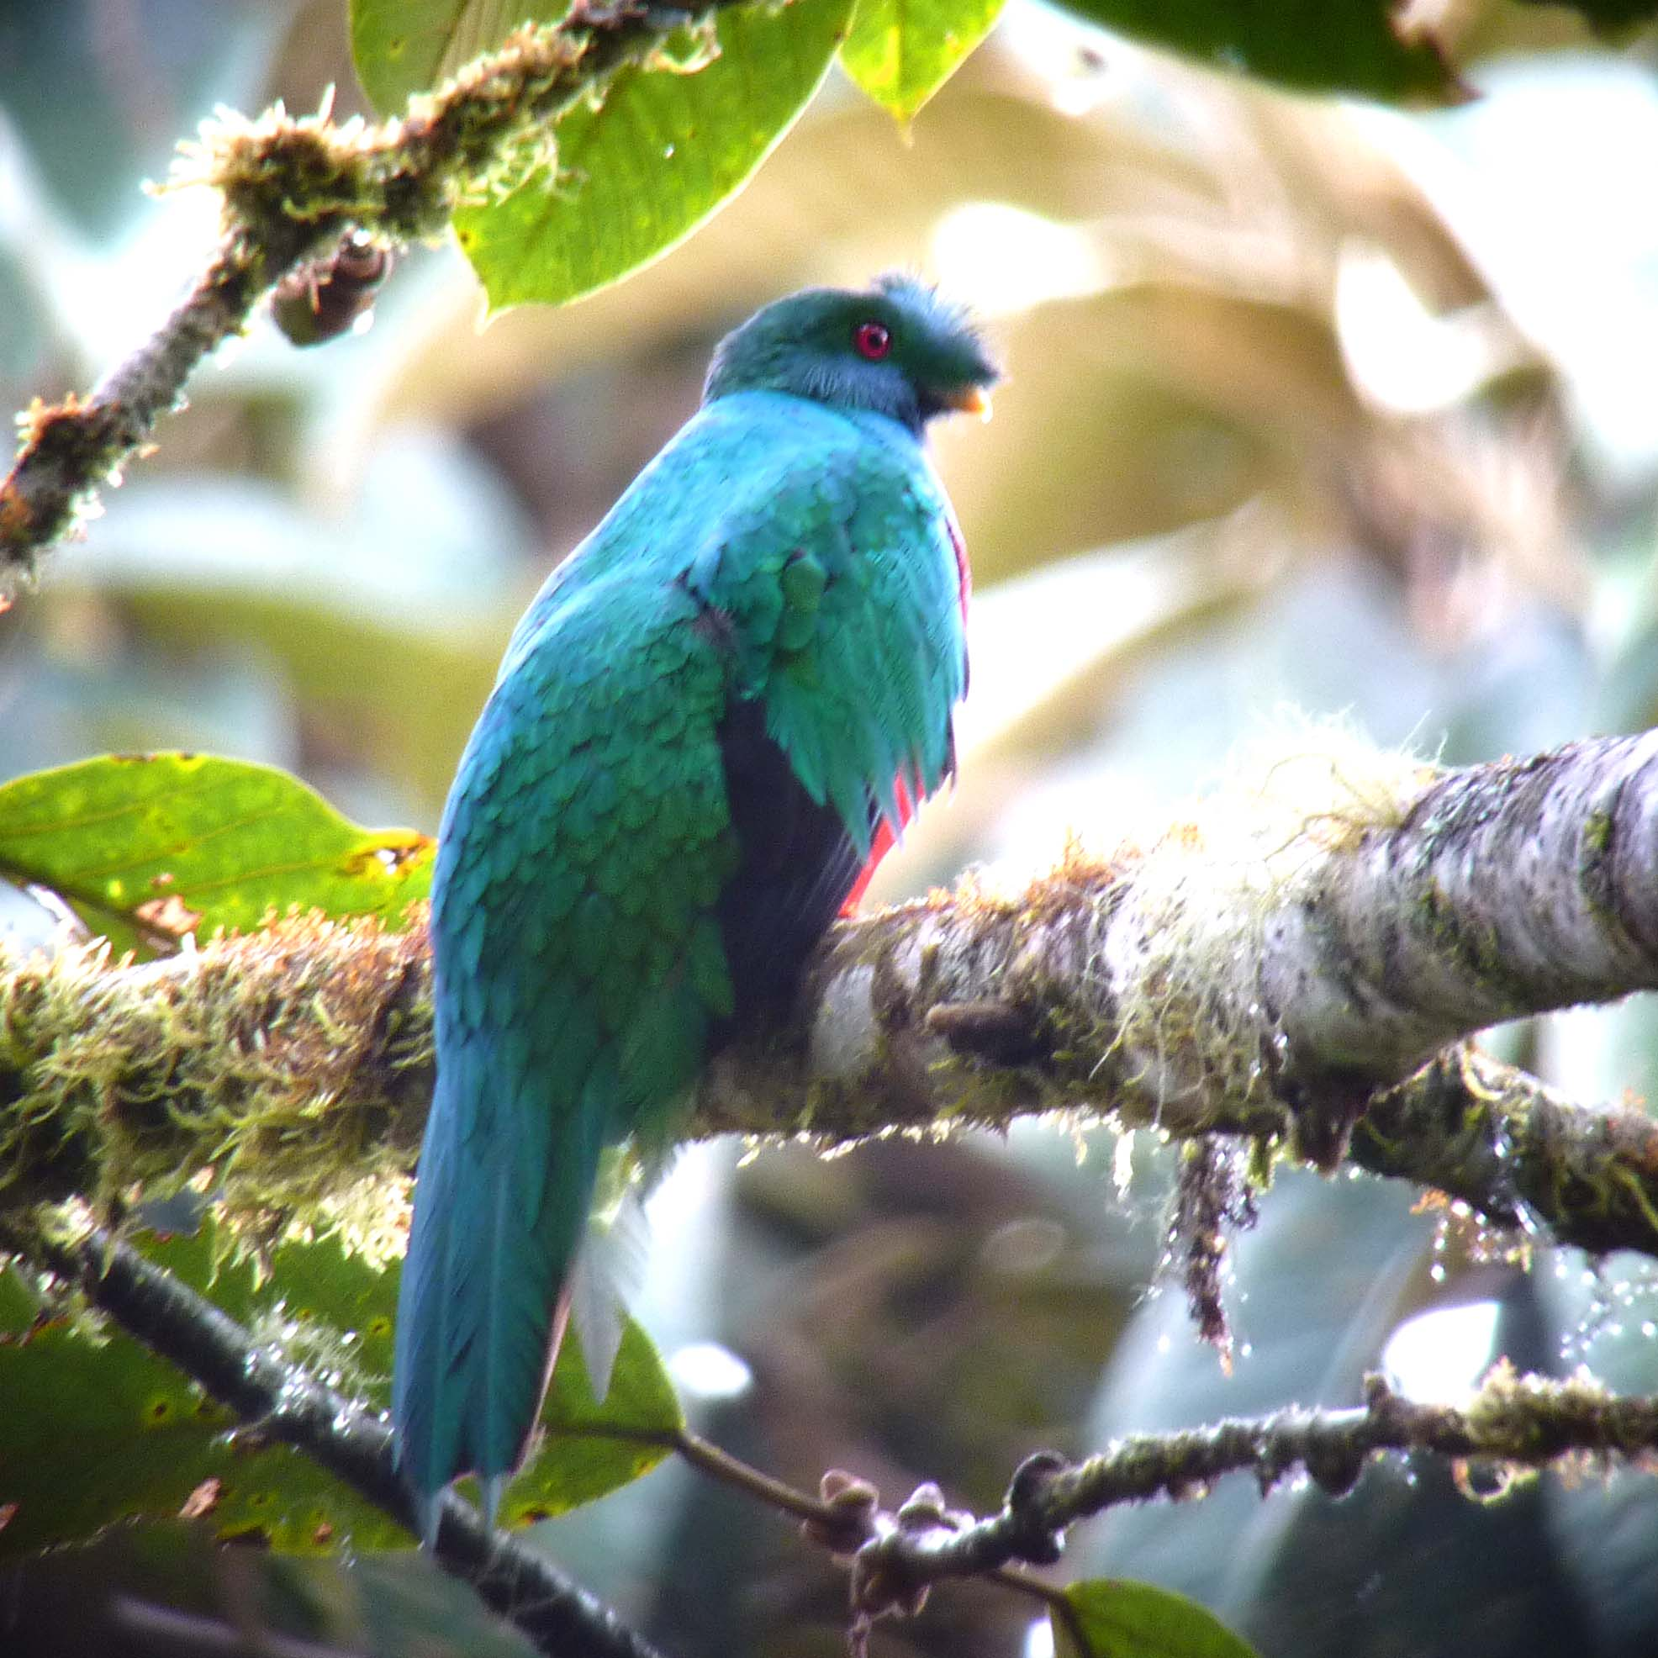
Crested Quetzal
Just a bit further down the road we came upon a group of Emerald Toucanets. After watching for a few moments, it became clear that the group consisted of two adults and two immature whose bills were considerably smaller.
The road we were on was perfect for raptors. We had good views of Barred, White-rumped, Broad-winged, White-throated, Variable, and Roadside Hawks within just a few hours on the road. The White-throated, an immature bird, presented quite a difficult puzzle for our guides. First seen in flight, Marcelo located it in a distant tree. After putting it in the scope, Andres and Marcelo had to consult field guides (including one that was co-authored by Andres!) to make a correct identification. After much deliberation and discussion, they concluded the bird was an immature White-throated Hawk.
As we were driving along, Libby said she thought she had seen a tiger-heron. The bus screeched to a stop and we were able to find a Fasciated Tiger-heron lurking about. Apparently this bird is uncommon in this area, so Luis hopped out to get a look at his first Fasciated Tiger-heron. Habitat changed dramatically as we drove, providing some chances for grassland species such as Southern Lapwing. Of course, we couldn't look too long because one of the many hawks we saw that day distracted us from this plover relative.

From the first day of our trip we had been hearing Tapaculos calling. Ash-colored was heard on Day 1, plus 6 more species in between. Today, as we were searching for a bird Andres was trying to get us on, things got interesting. Thinking they were on the target species (the name of which I don't remember), Karen and Deb were giving directions to the Rufous-browed Tody-flycatcher they were watching. Jim was trying to follow their directions and got on a small dark bird in the thick undergrowth. As the mixed flock flew off and out of sight, field guides were opened to confirm the sightings. It was then that Deb and Karen realized they had not been looking at the same bird Andres had been describing, and Jim discovered he had become the only birder in our group to actually see a tapaculo. The small dark bird he had been watching was a Blackish Tapaculo.

Other new species seen at San Isidro and on our way to Quito included White-capped Parrot, Black-throated Mango, Highland Motmot, Montane Foliage-gleaner, Black-billed Peppershrike and Black-eared Hemispingus. We were able to get good views of a Slaty-backed Chat-Tyrant, a species that we had only seen in flight on Day 9. We also saw Sickle-winged Guan, Red-eyed Vireo, and Russet-crowned Warbler, all eastern subspecies that are counterparts of birds we had seen earlier in the trip on the western slopes of the Andes.

Last, but not least, some birders had views of Spot-fronted Swift and Handsome Flycatcher.

Our species total for the first 12 full days of birding (Days 1 and 2 were primarily travel days) was an impressive 528 including 59 hummingbirds!

DAY 15, February 20: DEPARTURE FOR USA or
BEGINNING OF AMAZON EXTENSION (QUITO - COCA - SANI LODGE)
Today Robin, the only person who was not going on the extension, had to be in the lobby and ready to go at 4:45 AM to make her 7:20 AM flight back to Ohio. She had been told that a taxi had been arranged for her, but when a driver in an unmarked car offered to take her to the airport, she was a little spooked by the idea that it might not be the car that had been arranged for her. Traveling alone, she decided to err on the side of caution and called our room to make sure it was safe to get into an unmarked car with this strange man with whom she could not communicate. At first, half-asleep, I told her I would call Andres. As I was looking for his number it dawned on me that this was probably the person he sent for her, so I suggested to Robin that she ask the desk clerk to talk to the driver in Spanish to see who had sent him. Sure enough, Andres had arranged everything as promised and Robin was on her way to the airport.

We enjoyed a later-than-usual breakfast since we did not have to be at the airport until around 9:00 for our 10:30 AM flight to Coca. The amount of luggage each of us could take on the small plane that was to carry us over the Andes was limited, so we left part of our things at the Hotel Sebastian and would retrieve them when we returned from the Amazon in five days, which would be our last night in Ecuador. Our small prop plane departed on time and we landed in Coca as scheduled.

The trip report for the Napo River extension, Feb. 20 - 25, will be published later.
We saw 134 new species on this portion of the trip, bringing our total to 662.

