PANAMA
Trip Report
Canopy Tower and Lodge April 5-16, 2011
Disclaimer: This report is as accurate as possible using limited notes taken in the field; any errors regarding species seen at specific sites are unintentional. On any given day, not all species that were seen are reported, especially those that were seen on previous days.

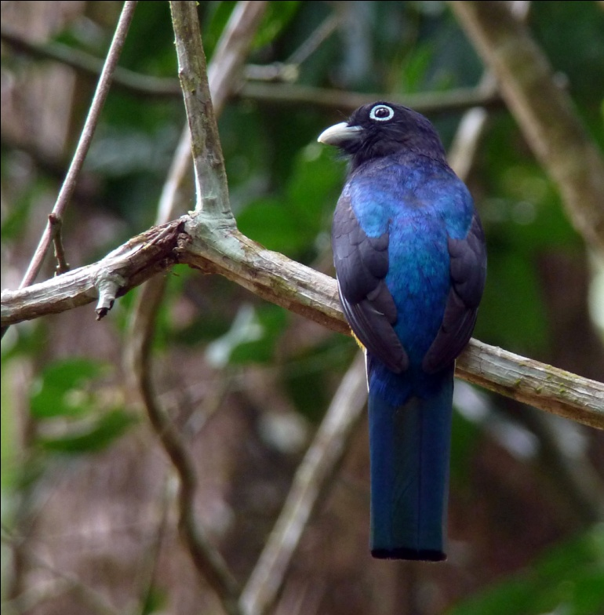
Species seen by group: 317
Additional species heard: 26
Birding guides: Carlos Bethancourt, Danilo Rodriguez Tour leaders: Cindy and Jim Beckman,
Cheepers! Birding on a Budget
Group: 8 + 2 tour leaders and guides
Highlights: Pheasant Cuckoo, Tody Motmot, Snowcap, Great Potoo, Marbled Wood-Quail, Tiny Hawk, Spectacled Owl, Mottled Owl, 21 species of Hummingbirds including White-tipped Sicklebill and Veraguan Mango, Barred Puffbird, Yellow-eared Toucanet, Blue-throated Toucanet, 14 species of Antbird including Dull-mantled Antbird, Brownish Twistwing, Scale-crested and Black-capped Pygmy-Tyrants, Lance-tailed Manakin, Rufous-browed Peppershrike, Rosy Thrush-Tanager, Sulphur-rumped Tanager, Emerald Tanager
Day 1, Tuesday, April 5, ARRIVAL: Today was a travel day for the eight participants and two tour leaders, with the first arrivals shortly after midday and the last arriving at the Canopy tower well after 11:00 PM due to some flight delays.
Day 2, Wednesday, April 6, SEMAPHORE HILL, AMMO DUMP: We started our day at 6:30 AM on the observation deck of the Canopy Tower. When Jim and I climbed to the deck, others were already there and had seen Green Shrike Vireo and Golden-hooded Tanager - what a great start! Collared Aracari, Palm Tanager, Scarlet Tanager, Keel-billed Toucan, Green Honeycreeper, Scaled Pigeon, Mealy and Red-lored Parrots quickly followed. In the distance, a Blue Cotinga sat at the top of a tree for all to see through the scope. It never ceases to amaze me to see our guides spot these beauties from so far away. A kettle of migrating Mississippi Kites entertained us for awhile, and we spotted the first of many Turkey Vultures for the trip. Other migrating raptors seen from the tower included Broad-winged, Short-tailed and Swainson's Hawks. We enjoyed the birds from the tower, including a Red-rumped Cacique on a nest at ground level in the parking area below and a pair of Piratic Flycatchers that were checking out the Cacique nest, until breakfast was served at around 7:30. Following breakfast, we had an orientation meeting with Carlos Bethancourt, our guide for the next ten days.

When we exited the tower to leave for our first outing, we spent some time at the entrance observing the hummingbirds at the feeders. Violet-bellied Hummingbird is my favorite here, with its stunning purple belly and feisty personality. Blue-chested Hummingbirds and White-necked Jacobins were numerous. A White-shouldered Tanager flitted about in the trees near the parking area as we left to begin our walk down Semaphore Hill, the private entrance
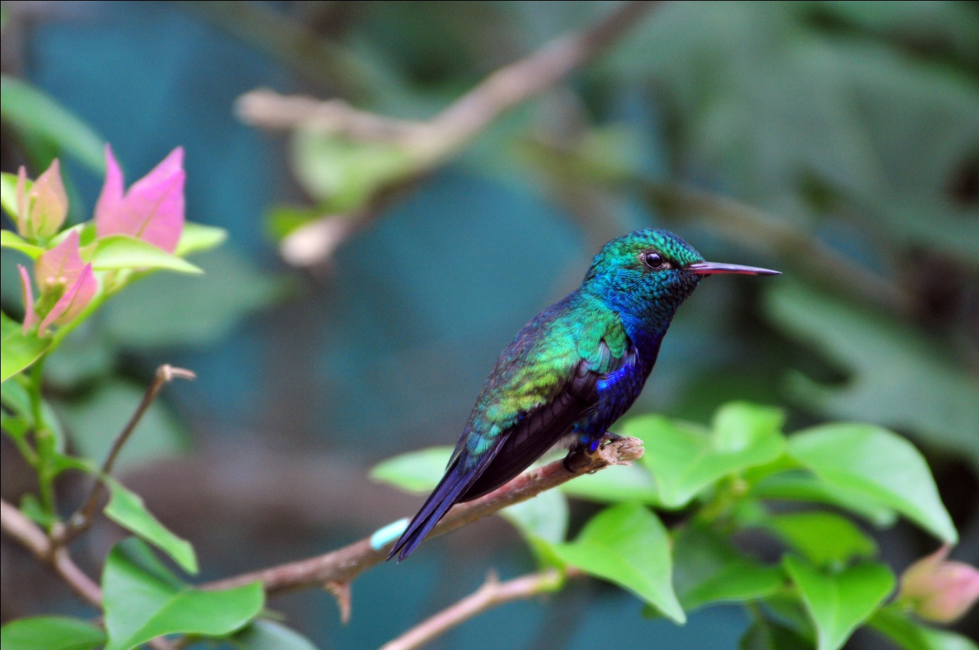
Violet-bellied Hummingbird

road to the Canopy Tower. Before we had walked very far, Carlos pointed out a Black-breasted Puffbird and then put the cooperative bird in the scope for better views. While some were still enjoying the view of the Puffbird, a Slaty-tailed Trogon was located, followed immediately by Great-crested Flycatcher. As we were searching the understory for a Red-capped Manakin that had been vocalizing, we spotted an Ocraceous Flatbill. Southern Bentbill and Blue-crowned Manakin were heard only this morning, but we got good looks at Dusky-capped Flycather, Squirrel Cuckoo, Ochre-bellied Flycatcher, and Broad-billed Motmot before taking a mid-morning break. Among the many great things about visiting the Canopy Tower is the thoughtfulness shown by such things as providing snacks nearly every morning as we bird along one trail or another. They also provide a cooler with cold water and juices when we're away from the lodge, snacks and wine at 6:00 PM every evening, and wine with dinner each night. Little things like this make your overall experience so much more pleasant.

After our break, we heard the Red-capped Manakin again and managed to find a female. A distinctive call, reminiscent of the jungle background vocalizations in old movies, enabled us to find Western Slaty Antshrike. As we continued down the hill other birds came into view, including Yellow-margined Flycatcher, Lesser Greenlet, Red-eyed Vireo, and Bay-breasted Warbler. White-tailed Trogon was one of the highlights of the morning. Some of the group was able to get on a Rufous Motmot that, although quite large, remained difficult to see in the recesses of the forest. We had not reached the bottom of the hill before it started to rain lightly. Although the rain was not coming down hard enough to prevent us from birding, the accompanying thunder prompted our departure from the forest. Carlos called the tower on his cell phone, and within a few minutes the Rainfo-mobile arrived to drive us back up the steep hill to the shelter of the Canopy Tower. Just as we approached the entrance, the rain picked up, and we were glad to be back, although nearly an hour earlier than planned.
We enjoyed lunch and then retired to our rooms for a midday break. We could hear the sound of rain falling on the metal building, and wondered if our afternoon outing would be affected by the weather. Some of the group continued to bird from the windows and the observation deck, where Geoffrey's Tamarin was seen foraging. We met at 3:00 as scheduled, shortly after the midday shower ended. The gray clouds overhead looked like another shower was imminent as we drove toward the Ammo Dump in the open-air Rainfo-mobile, and we felt certain that we would not finish the day without getting wet. As we approached the bridge into Gamboa, rain began to fall lightly. Sitting in the back of the Rainfo-mobile, waiting for our turn to cross the 100+ year-old, one-lane bridge, we saw female Variable Seedeater, Yellow-bellied Seedeater, Great-tailed Grackle, Tropical Kingbird, and Southern Rough-winged Swallow. As soon as we were able to cross the bridge, Carlos detoured to a nearby site where he knew we could find shelter under the overhang of a large storage building across the street from the back yard of a friend who maintains bird feeders. He had brought some bananas to freshen the feeders and had planned to stop here after we visited the Ammo Dump, but took advantage of this opportunity for us to bird out of the rain. Just as we arrived, the skies opened up. At first, no birds were moving around in the heavy rain except for a single Clay-colored Thrush seen just as we arrived, but eventually the rain eased up and we started seeing birds. First, a Blue-gray Tanager, then a beautiful male Crimson-backed Tanager. When I directed Carlos to a Blue-gray Tanager in a large tree, he found instead a resting Lesser Nighthawk. Gray-breasted Martins and Barn Swallows flew by in substantial numbers. Standing under the awning, we observed a female Flame-rumped Tanager and Social Flycatcher. We watched as a White-necked Jacobin spread its tail feathers and wings, enjoying a bath in the shower as the torrent changed to a light rain. As the rain stopped, we turned our attention to the feeders, but no birds had found the fresh food yet except for a pair of Plain-colored Tanagers. Large flocks of swallows continued to pass overhead, and we marveled at the number of migrating birds. Short-tailed Swifts joined the spectacle in the sky as they darted about like flying cigars.

As the sun popped through the clouds, we piled into the Rainfo-mobile and headed toward the Ammo Dump, just a few miles away. As we drove away, I knocked on the roof of the cab, a signal for Carlos to stop. I had seen a small bird near one of the houses and wanted to stop to see what it was. It turned out to be a Ruddy Ground-Dove, and as we watched it and its mate, an Agouti wandered into view. Birds started moving in the bushes around us, and before we drove on we spotted Yellow Warbler, Lesser Elaenia, Summer Tanager (female), Snowy-bellied Hummingbird, Fork-tailed Flycatcher, and a Tityra species that couldn't be identified as Masked or Black-headed before it flew away. We could hear Chestnut-mandibled Toucan on the hillside but couldn't locate it. Variegated Squirrel was added to our mammal list for the day. We finally pulled ourselves away from this little hotspot and moved on to the Ammo Dump.

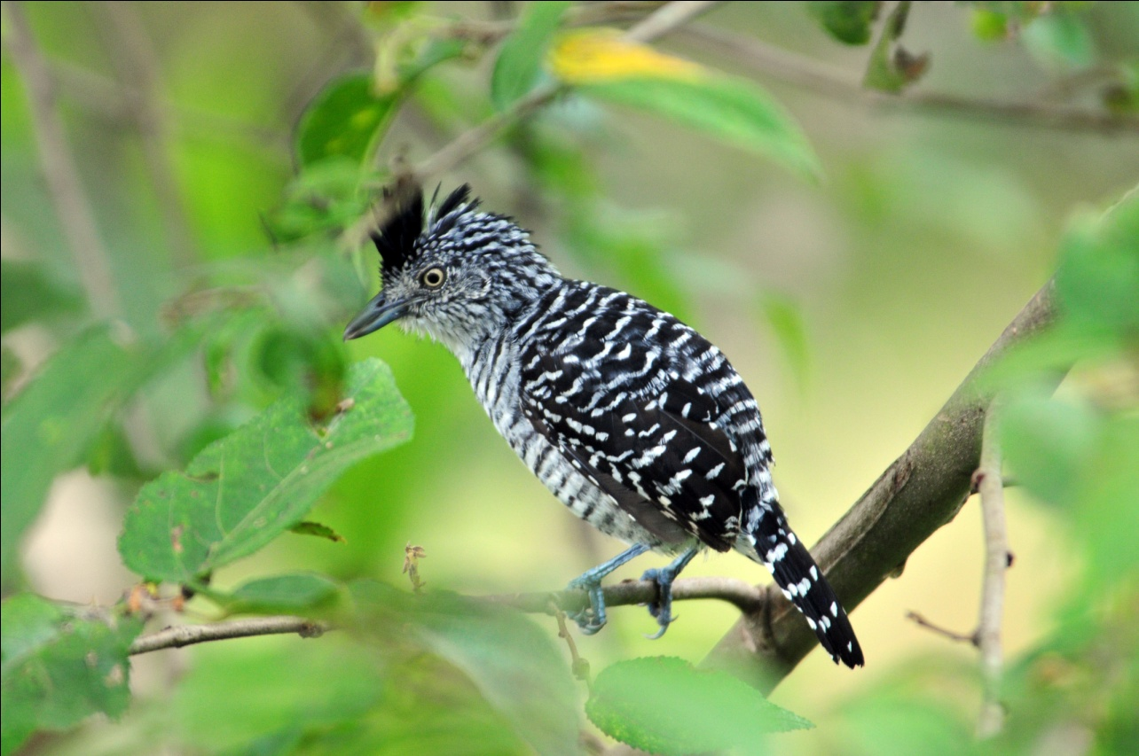
Barred Antshrike
It was hot and steamy by now, but no one complained as one bird after another presented itself for our enjoyment.
Greater and Smooth-billed Anis, Pale-vented Pigeon, Black-throated Mango, Yellow-olive Flycatcher, Rufescent Tiger-Heron, Buff-breasted Wren, Barred Antshrike (male and female), Common Tody-Flycatcher, House Wren, Lesser Kiskadee, Wattled Jacana, Red-crowned Woodpecker, Great Kiskadee, Green Heron, Tricolored Heron, Yellow-crowned Euphonia, Masked Tityra, Thick-billed Euphonia, Northern Waterthrush, and Panama Flycatcher were all seen along the short road outside the guarded gates of the Ammo Dump. White-breasted Crake was heard by everyone, but only Carlos caught a glimpse of the elusive bird. As we were looking into the marsh at the herons, a Capybara stepped out of the high reeds where it could be seen. Then, as someone was looking down on a stream at the side of the road, a Basilisk was found resting on a log.

On our way back to the Canopy Tower, Gene cried out for Carlos to stop and I tapped the roof of the cab to relay the message. He had seen an immature Rufescent Tiger-Heron near the road, close enough for an excellent photographic opportunity. Carlos backed up, and we all enjoyed marvelous views of this stunning bird and then watched as it flew to the other side of the road. Before we drove away, a Yellow-olive Flycathcher was found, and a Gray-headed Chachalaca flew across the road in front of us. As we waited to cross the bridge, Southern Lapwings strutted along the edge of the road, everyone got to see the slow-flying Black-bellied Whistling Ducks as they flew overhead, and we finally saw the Osprey that had been expected all day, every time we were near water. Other species seen today included Black Vulture, White-tipped Dove, Band-rumped Swift, Olivaceous Flatbill, Whooping (Blue-crowned) Motmot, Eastern Wood-Pewee, and Boat-billed Flycatcher.
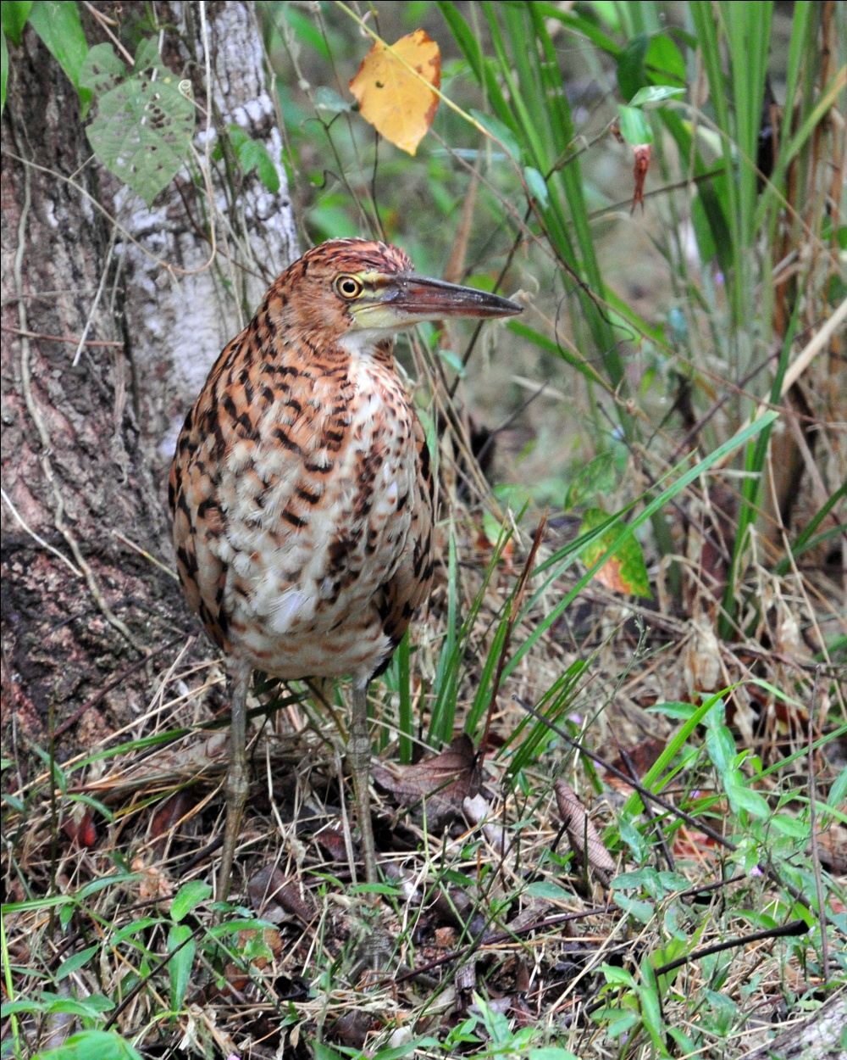
Rufescent Tiger-Heron
We arrived back at the Canopy Tower in time for 6:00 hors d'oeuvres and wine. When we went over our list, we found that our first day of birding, although affected by a late start and interrupted by rainy weather, had yielded us 93 species with an additional 18 species heard only, another 4 seen only by Carlos, and 1 "fly-by" (Orange-chinned Parakeet) that was seen by the group but identifiable only to Carlos.

Day 3, Thursday, April 7, RAINFOREST DISCOVERY CENTER, PIPELINE ROAD (ENTRANCE), SUMMIT GARDENS:
I heard rain at around 1:30 AM, so I was relieved to see that the weather had cleared up by daybreak. We had scheduled breakfast at 5:30 AM this morning so we could leave at 6:00 AM to make the short drive to the Rain Forest Discovery Center, which would put us on the canopy tower early enough to see the most activity. The Discovery Center's 100-foot tall tower is just a few years old and offers an excellent opportunity to see canopy species, especially early in the morning. By midday, most of the activity that can be seen from there has died down, so we planned to head straight to the tower with just a short detour for a restroom break at the visitors' center. Although we didn't spend much time there, the center's hummingbird feeders attract species we haven't yet seen, and we managed to add some new species before moving toward the tower: Long-billed Hermit, White-vented Plumeleteer, and Rufous-tailed Hummingbird.

We didn't even make it to the top of the tower before we spotted a new species for the trip. Tropical Gnatcatchers were flitting about the tree branches midway up as we climbed past them. Once on the tower, the species were called out quickly: Blue Dacnis, Gray Hawk, Gray-headed Kite, Chestnut-mandibled Toucan, all seen through the scope. Blue-headed Parrots flew by, and Scaled Pigeons were seen perched in the treetops in perfect light. In the distance, Carlos found a Blue Cotinga. As we moved from one side to the other, we found Purple-throated Fruit-crow, Short-billed Pigeon, Yellow-tailed Oriole, Yellow-headed Caracara, Yellow-backed Oriole, Yellow-rumped Cacique, Sulphur-bellied Flycatcher, Great Black Hawk, Black-chested Jay, Black-throated Mango (male), and Cinnamon Woodpecker. Someone located a Three-toed Sloth that was quite a distance away, but seen well in the scope. Also in the scope and later soaring overhead was a magnificent Gray-headed Kite.
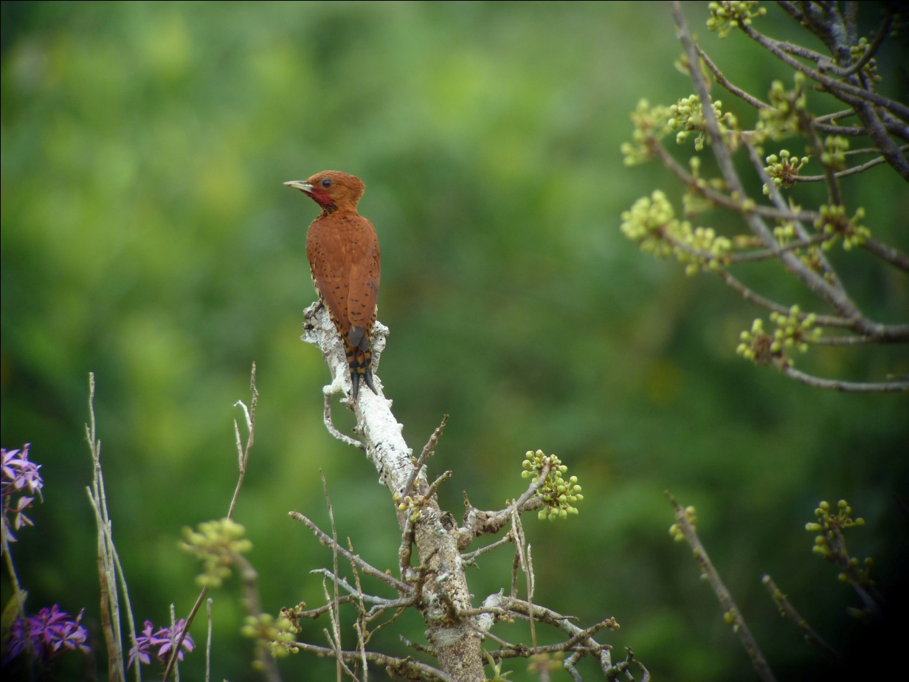
Cinnamon Woodpecker
While on the tower, another group came up to enjoy the vista and the birds of the canopy, and we were delighted to see our old friend, Venicio Wilson, guiding the group. Now the Director of Sustainable Tourism for the Rainforest Discovery Center, Beny was one of the two young guides who led us on our very first trip to Panama in 2003. We've traveled with him on several occasions, and we always enjoy visiting with him.

Around midday, as the action slowed down on the tower, we descended and walked the short distance to the visitor's center. Before reaching the bottom of the tower, we came eye-to-eye with a female Slaty-tailed Trogon perched at eye level and a female Blue Dacnis that was sitting it a nest, also at eye level. At the center, we spent some time enjoying the spectacle at the hummingbird feeders, adding Stripe-throated Hermit to the trip list and allowing time for everyone who wanted to do so to take photographs. When we left the center, we took a short trail to a small lake where we hoped to find some new species, but there wasn't much bird activity while we were at the lake. Coming back to the area where the car was parked, Carlos thought he heard a Pheasant Cuckoo. We all watched anxiously as he played its call and were rewarded with excellent views of the elusive bird as it sat on a low branch in the understory. It sat long enough for all of us to get a good look through the scope, and then flew across the path right in front of us, displaying its impressive tail.
As we started down the entrance road, walking away from the parking lot, some members of the group noticed a small bird moving about. We all watched as a Southern Bentbill moved about with nesting material in its mouth. After a few moments, we realized that the beginnings of the bird's nest was right in front of us and that we were interfering with its activities. We quickly moved away to allow the diminutive flycatcher to resume his nest building project.
We walked a short distance down the road in the opposite direction, first coming across a group of six Song Wrens, then a gorgeous male Black-throated Trogon, one of our target species for this area. We all enjoyed viewing the bird, photographing it, and watching it vocalize while Carlos went back to bring the van to us. We took scores (hundreds?) of
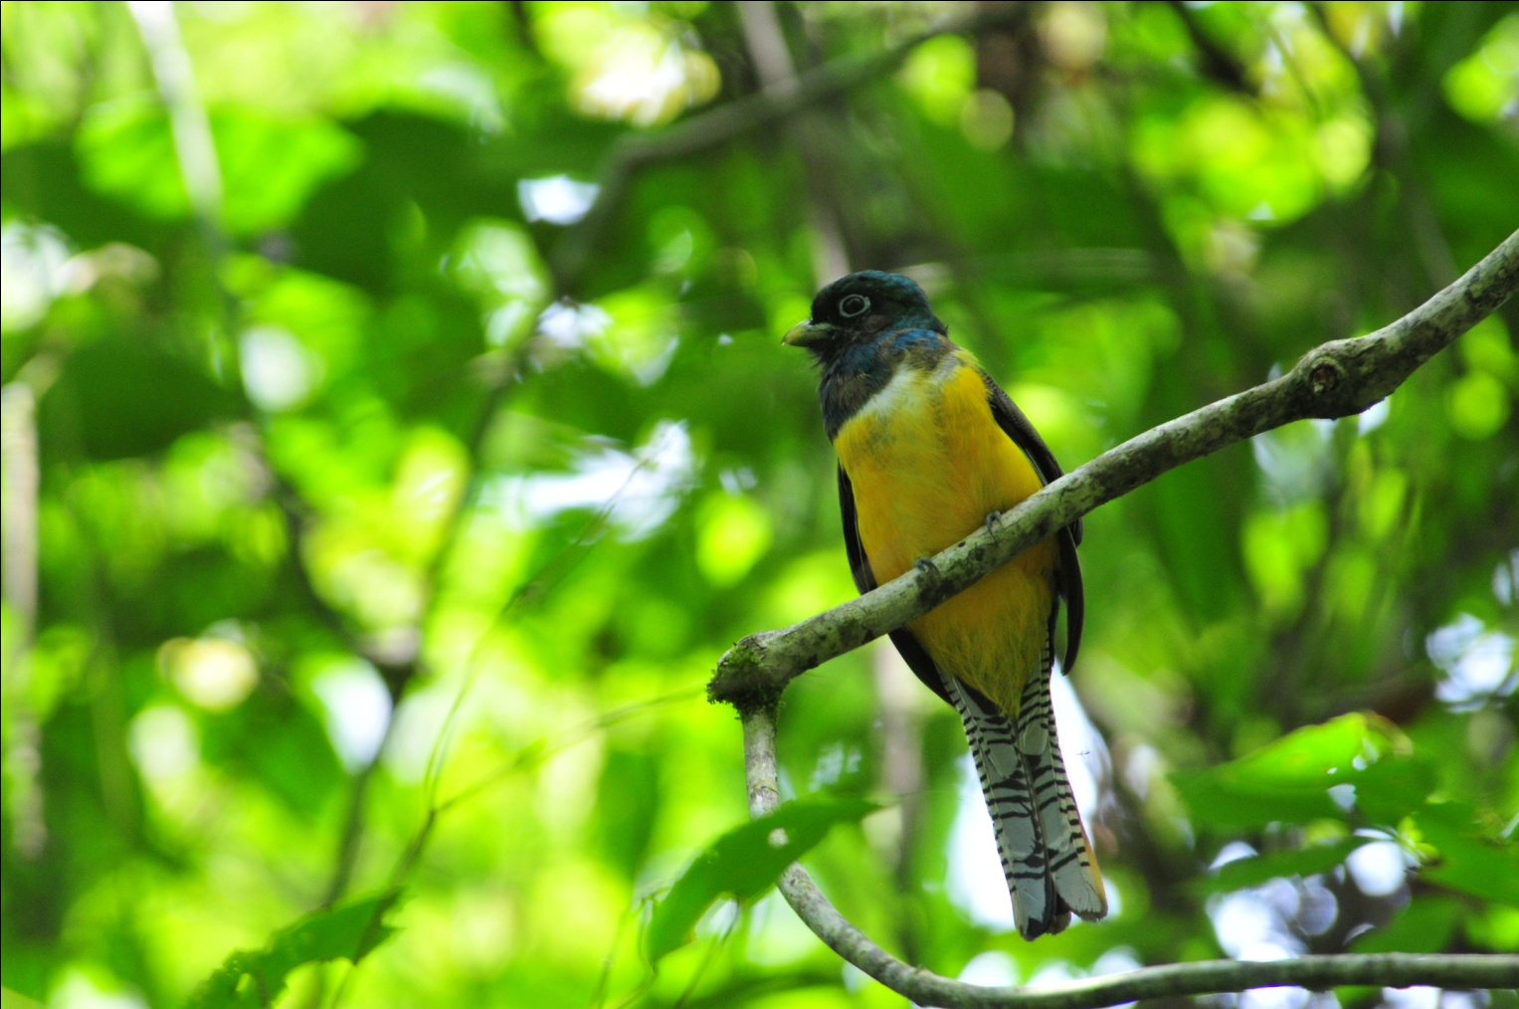
Black-throated Trogon
photos, chatted with some other people as they took scores of photos, and finally realized Carlos had been gone quite awhile for such a short walk. I thought he had probably run into someone he knows (which is almost everyone) and didn't think too much of it. More time passed, and still no Carlos. Could something have happened? Just as I was about to express my concern to Jim, the van appeared. Carlos had put his keys into a different pocket than normal and had been unable to locate them. When he reached into the pocket where he normally puts his keys and could not find them, he began to search the area around the van in the parking lot, walked back to the visitor's center to see if he dropped them there, searched a portion of the trails we had walked, all to no avail. Finally, he felt the keys in their hiding place and realized he had just dropped them into a different-than-normal opening on a two-layer pocket on his pants leg. Whew! We all had a good time kidding him about his "lost" keys.
We returned to the Canopy Tower at around 12:30 for lunch. Waiting at the bridge that crosses over the Chagres River, we saw an Osprey hunting over the Panama Canal on our right. Brown Pelicans flew low over the canal and a Magnificent Frigatebird soared high above. Southern Lapwings foraged in the grass at the edge of the road. There are good birding opportunities in Panama even when you're stuck in traffic! After lunch at the tower, we had a nice rest for a few hours before leaving for Summit Gardens at 3:00 PM. There was a gentle rain that was perfect for sleeping, but not everyone slept, of course. It's hard to stop birding when there are so many birds right outside your window!
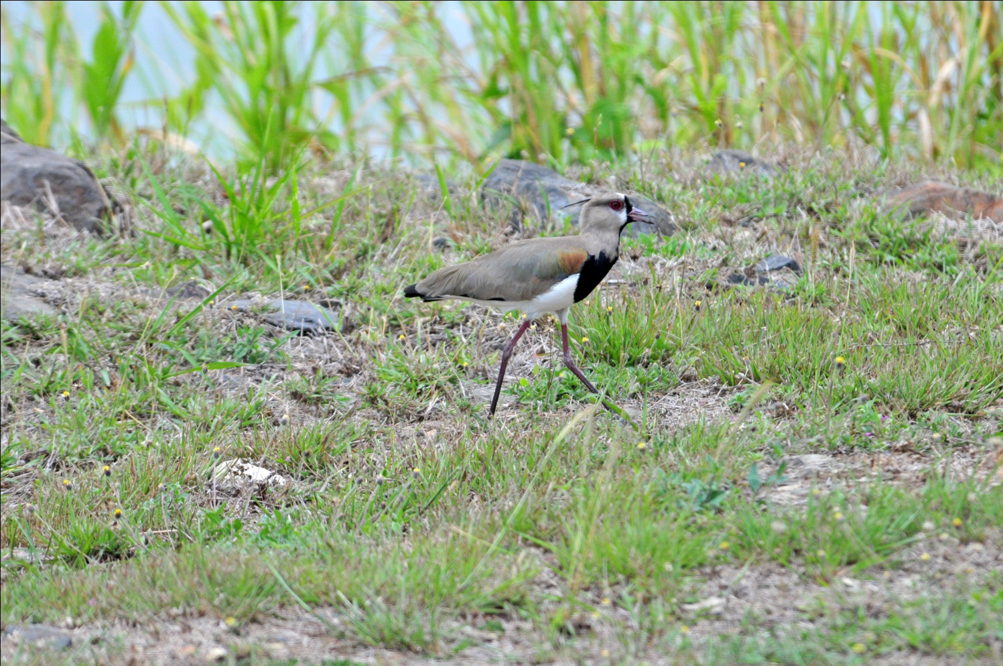
Southern Lapwing

When we left at 3:00 PM, there was so much activity on Semaphore Hill that it took us a full hour to reach the gate! First, Carly spotted our first Howler Monkeys. As we watched the monkeys, Gray-headed Tanagers appeared. Before we could get back into the van, a Double-toothed Kite flew overhead. Next, a Chestnut-backed Antbird's call alerted us to his presence in close proximity, so we spent some time finding that bird. Checker-throated Antwren and White-whiskered Puffbird added to the entertainment before we drove on. A Two-toed Sloth was moving about, and when we stopped to look, more White-whiskered Puffbirds showed up and stayed around long enough for everyone to be satisfied with the views they got. Black-bellied Wrens were singing, but they would not respond to the recorded songs. Carlos had noted that there is a Black-headed Tody-Flycatcher's nest visible on the way out, but we completely forgot to look for it in the midst of all this activity.

Finally, an hour later, we arrived at the entrance gate, less than a mile down the road from where we started. There, before Carlos could get the gate shut, FOUR Slaty-tailed Trogons, a Crimson-crested Woodpecker, a Cinnamon Woodpecker, and a group of Purple-throated Fruitcrows delayed our departure. Just as everyone was piling into the Rainfo-mobile to leave, someone spotted a Three-toed Sloth with a baby - you have to take a nice long look at that! While admiring the sloth family, we noted a Squirrel Cuckoo and then walked to the main road to see the Great Potoo that Carlos had located for us.

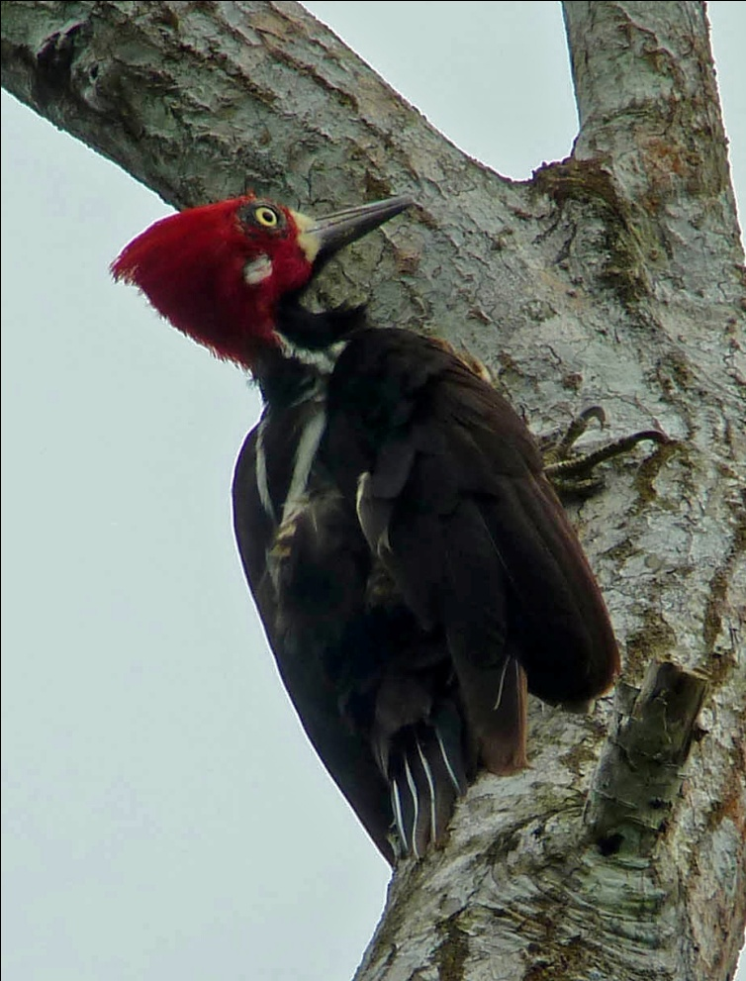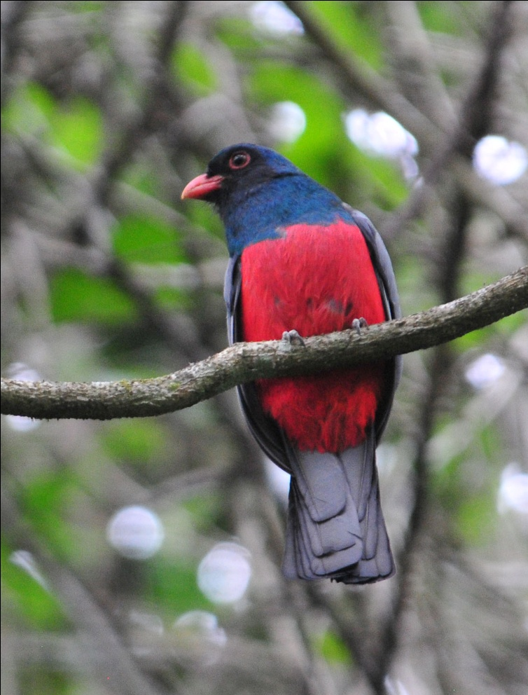
Crimson-crested Woodpecker Slaty-tailed Trogon

We arrived at Summit Gardens just as it was closing. Carlos spoke to a friend who is the director of the zoo and park, who graciously permitted us to enter. Just as we drove through the gate, it began to rain, so Carlos stopped the Rainfo-mobile at one of the many shelters in the park. We sat at picnic tables, hoping the rain would end quickly. But in such good habitat, you don't have to roam far to find birds. From our dry haven, we saw Shiny and Bronzed Cowbirds feeding on the grass across the road. Above them, Orange-chinned Parakeets flew in and out of a nest cavity. We watched a Great Kiskadee on its nest on a power pole as common birds such as Blue-gray and Crimson-backed Tanagers, a Buff-throated Saltator and a Red-crowned Woodpecker flew from bush to bush or tree to tree nearby. Gray-breasted Martins didn't let the rain stop them from moving about, so we got to observe them well. Jeanie spotted a Lesser Nighthawk roosting on the branch of a tree near our shelter. Carlos heard the familiar sound of a Cocoa Woodcreeper nearby, and we saw both the Cocoa and the Streak-headed Woodcreepers working the small tree trunks nearby. We finally headed back to the Tower when the rain eased up, and the rain stopped altogether as we drove out of Summit Gardens. Not a bad day of birding for a rainy afternoon!

Other birds seen today included Short-tailed and Band-rumped Swifts, Sulphur-bellied and Social Flycatchers, Giant Cowbird, and many other common species. Our bird count for the day was 81 species with an additional 13 species heard only. What a day!

Day 4, Friday, April 8, SUMMIT PONDS AND OLD GAMBOA ROAD, CHAGRES RIVER: Today we started birding at 6:30 on the observation deck. I got up to the deck a little early, and Charlie was the only other person there. Heavy fog made it difficult to see the two Keel-billed Toucans that landed close to the tower's railing, followed by two equally difficult to see Mealy Parrots. As the fog cleared, the Green Shrike-Vireo that had been eluding some of us for the first three days was finally seen by everyone. Although the Red-legged and Green Honeycreepers, Palm Tanagers, and Blue Dacnis were not new for us, we really enjoyed seeing the brightly colored birds among the deep purple blooms of the Jacaranda trees. Carlos found a dark morph Short-tailed Hawk and put it in the scope for all to see at leisure as it sat for a long time. A bright male Scarlet Tanager moved about at eye level, and we watched a Piratic Flycatcher checking out the nest of a Scarlet-rumped Cacique below us. We went downstairs for breakfast at 7:30 and departed for Summit Ponds as soon as everyone was finished.

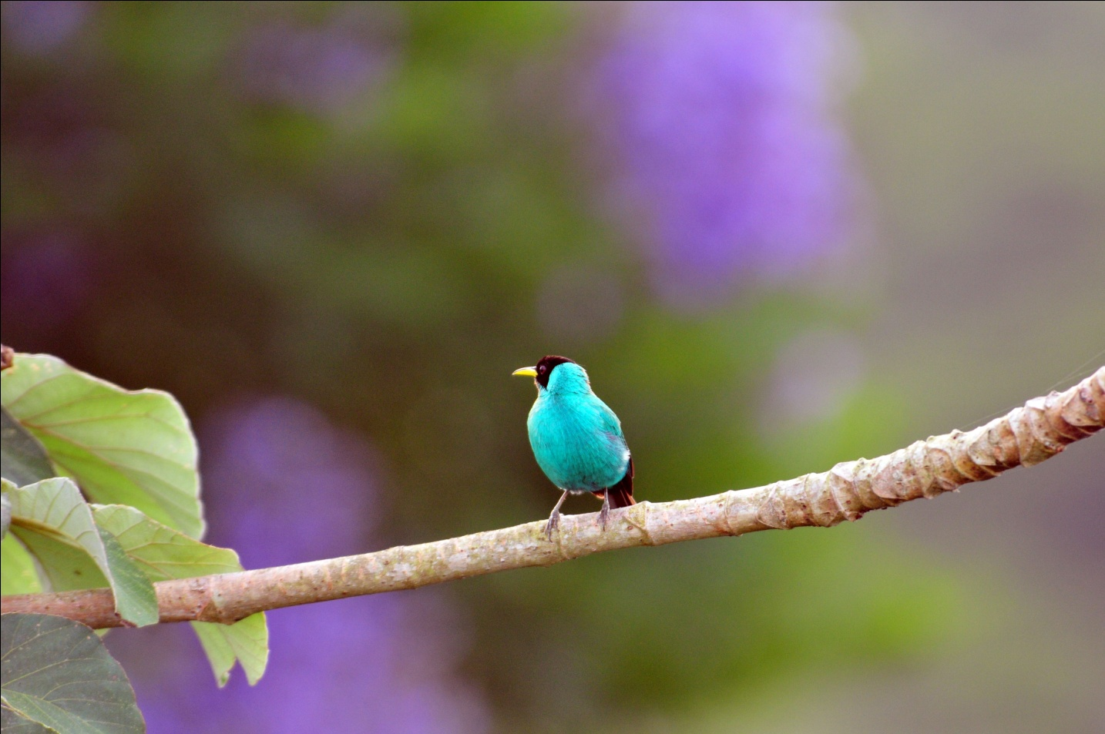
Green Honeycreeper

Since ownership of the land near Summit Ponds was transferred to the Canal Authority a few years ago, people can no longer drive all the way to the ponds. Instead, parking is available about a quarter mile away, and this area is where we started our morning's birding. Common species like Crimson-backed Tanager, White-tipped Dove, and Southern Rough-winged Swallows were obvious. A Scrub Greenlet was spotted in a branch overhead and as we looked up at the greenlet, Blue-headed Parrots flew by. In the grassy area we found Variable Seedeaters and Blue-black Grassquits. Jim found a Rose-breasted Grobeak that no one could relocate, but a few minutes later several more grosbeaks, male and female, flew in to the trees around us. A large flock of migrating Eastern Kingbirds flew overhead. We got our first looks at a Streaked Saltator before we began our walk down the road that leads to the ponds. Just as we started down the road, we found Common Tody-Flycatcher, one of my favorite tropical species and one who, unfortunately, I missed this time. Shortly after that, I pointed out a small dove that surprised Carlos, who said Plain-breasted Ground-Doves are more likely to be seen in the Lodge portion of our tour, and we had great opportunities to compare it to the more common Common Ground-Dove. As we walked, we watched the trees and shrubs along the side of the road for movement and listened for birdsong, although Carlos was the only one among us who could identify any of the sounds we heard. How strange it is to bird without using your ear to help with identification! He pointed out the three-syllable whistle of the Black-faced Antthrush and we spent a little time getting everyone on the bird. From the same vantage point, we watched a pair of Blue-black Grosbeaks fly in and out of tall brush at the road's edge. A Ruddy-breasted Seedeater was seen on the grassy side of the road. We took a short detour from the road to go up a dirt trail after Carlos heard and saw activity in that direction. Our efforts were rewarded with Streak-headed Woodcreeper, Rufous-breasted Wren, and Golden-fronted Greenlet, as well as some better looks at birds seen previously. Charlie spotted a Blue-Crowned Motmot (aka Blue-Diademed Motmot) on the slope of the hill below us, but not everyone was able to get on the bird before it moved.

At this point, it started sprinkling lightly and we moved on. Going back down the hill, Carlos spotted a Black-tailed Flycatcher but it vanished before anyone else could see it. As we approached the ponds, a Fulvous-vented Euphonia was seen. Now approaching 10:00 AM, the light rain continued and we all got our rain gear out. At the ponds, we found Spectacled Caiman floating lazily. One of our primary target species for this area, Boat-billed Heron, was found on the far side of the south pond. Three species of Kingfisher are possible here, and we found two of them, Green Kingfisher and Amazon Kingfisher.
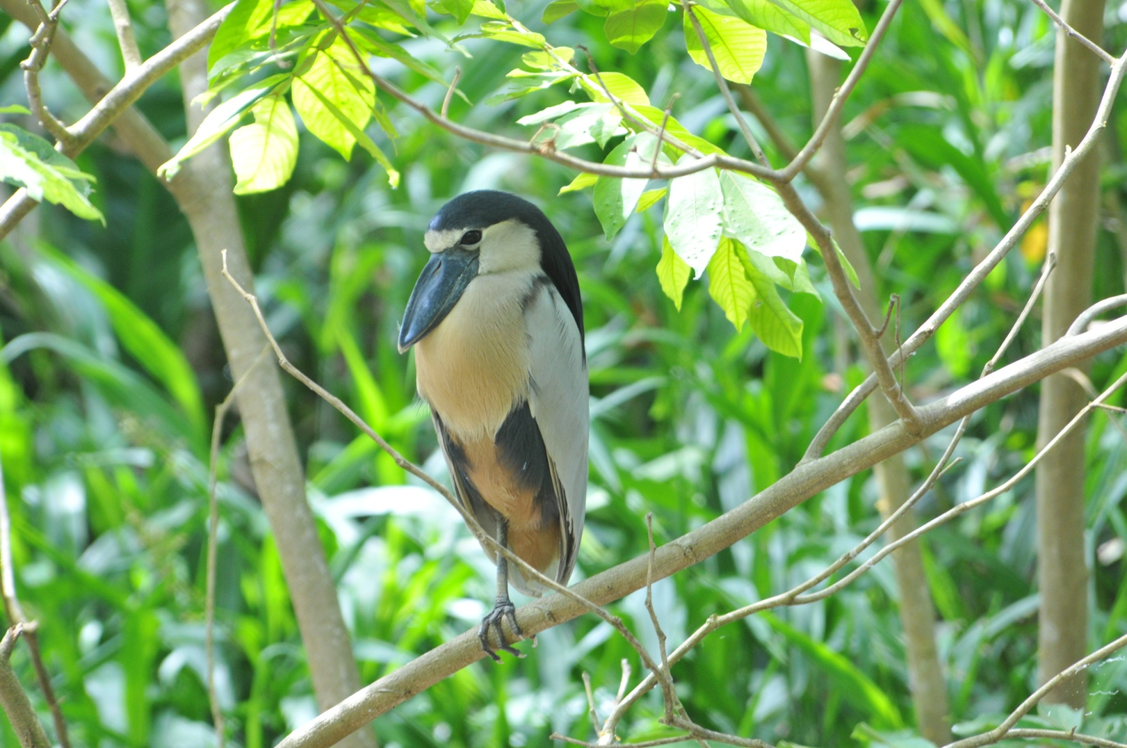
Boat-billed Heron (photo taken in Belize, 2010)
The scope was used to scan the outer edges of the pond, and it wasn't long before more Boat-billed Herons were spotted, individuals that provided better looks of their huge bills, as well as a pair on a nest with chicks and two others carrying branches to build or do maintenance on a nest. Charlie, Bill, and Gene reported to Carlos a strange bird they had seen flying across the pond. At first, he seemed a bit confused by their description, but soon a pair of Gray-necked Wood-Rails flew across pond for all to see and it was clear that this was the bird they had seen. We left the ponds and began to walk down Old Gamboa Road, once the main road between Gamboa and Panama City. Carlos left the trail to search for a Rufous Nightjar that is known to occupy a specific area, but he was unable to locate the bird. He theorized, from what he had seen in previous outings, that the chicks had grown enough to venture away from the nest, and the parents had followed them. This target species was missed, but another was yet to be found: Spectacled Owl. As we walked toward the area where the owls are known to occur, we continued watching for movement. In one tree we saw Chestnut-sided and Bay-breasted Warblers, Plain-colored Tanager, Plain Xenops, Green Honeycreeper, and Dusky-capped Flycatcher. Finally, we reached the spot where Carlos left the trail to search for the owls. In a short time, he reappeared and invited us to follow him in groups of 4 - 6 to see the impressive nocturnal predator as it slept on the branch of a tree not too far from the trail.

We had invited another birder who was staying at the Canopy Tower, Barbara B from Windsor, to come with us this morning because this owl was her #1 target species for her entire trip, and was a species she had not yet seen. With her departure scheduled for the next day, this was her last chance. What a thrill it was to see her excitement as she returned to the trail after seeing this beautiful owl!

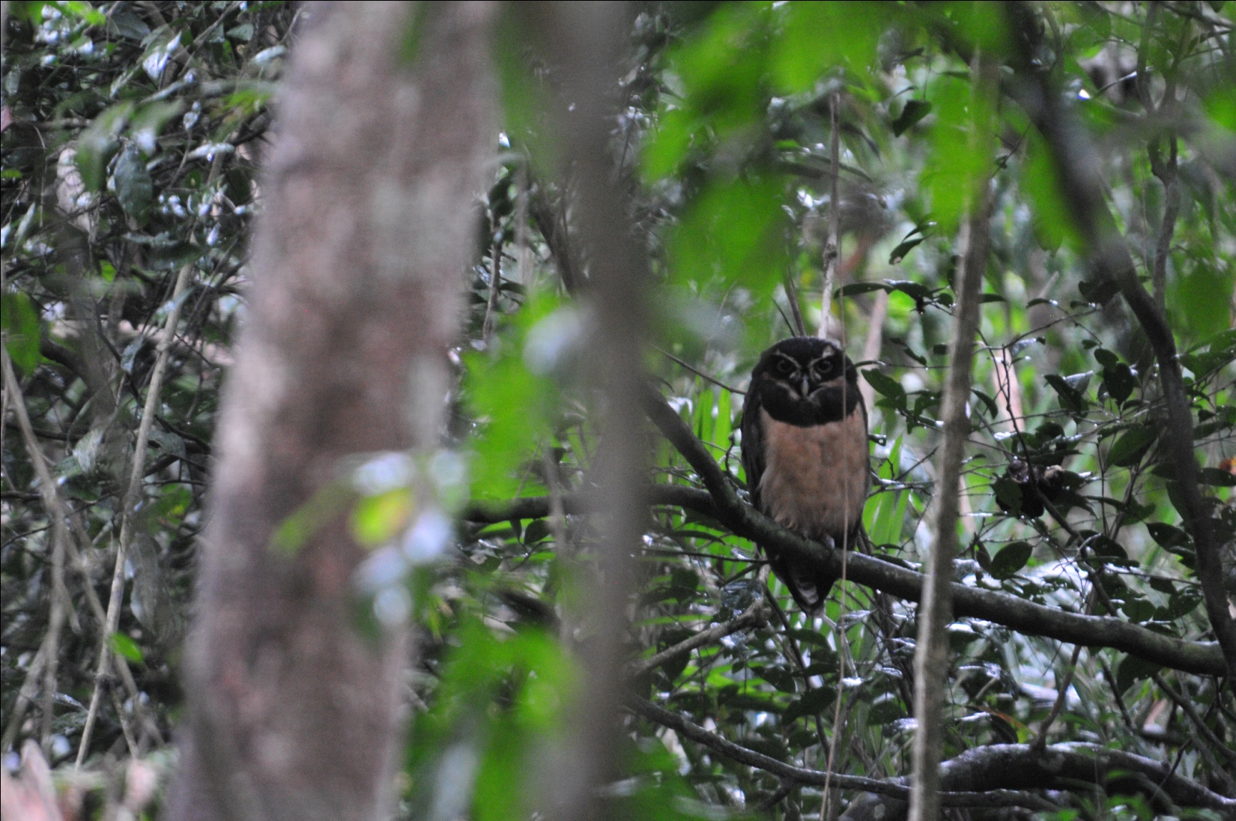
Spectacled Owl

The rain remained steady, although light, and we returned to the Canopy Tower a bit early, around 11:45. The rain worsened during our midday break, and we were not able to leave as planned at 3:00 PM. As we watched a Two-toed Sloth bathing in the downpour outside our windows, it looked like we were going to be socked in for the remainder of the day. I was quite surprised and pleased when the steady rain came to a stop and we were able to proceed with our afternoon plans at 3:45.

We drove straight to the gate, not bothering to bird along the road on the way out. A Yellow-headed Caracara flew from its perch as we turned off the entrance road and on to the road to Gamboa. When we reached the bridge, Gene was now to the point of taking bets on how many species we might see while waiting for our turn to cross. So plentiful are the birds in this area, almost everyone was guessing in double digits. While we did see several species while crossing the bridge, none were new for the trip.

As we drove along the road that leads to the entrance to the Gamboa Rainforest Resort, Charlie called out for Carlos to stop. There, perched in a tree very near the road, was a mature Rufescent Tiger-Heron, looking quite different from the tiger-striped juvenile we saw earlier. We proceeded through the entrance to the Gamboa Rainforest Resort and on to a narrow road behind the main facilities. We parked near an orchid nursery and climbed from our seats to begin the afternoon's birding. Right away, we saw some waders, including Little Blue Heron, at the water's edge. As we were scanning the bank of the Chagres River, Carlos heard Rosy Thrush-Tanager. We left the parking lot and walked up a small hill on the road and quickly found the vocalizing Rosy Thrush-Tanager. It was moving about in low vegetation across a ravine and occasionally popped out into the open where we could see it clearly. A Northern Waterthrush moved about in the same area, causing some of us to focus on the "wrong" movement as we searched for the Thrush-tanager. After everyone was satisfied with their views of the target species, we walked back toward the parking area and on down the road.

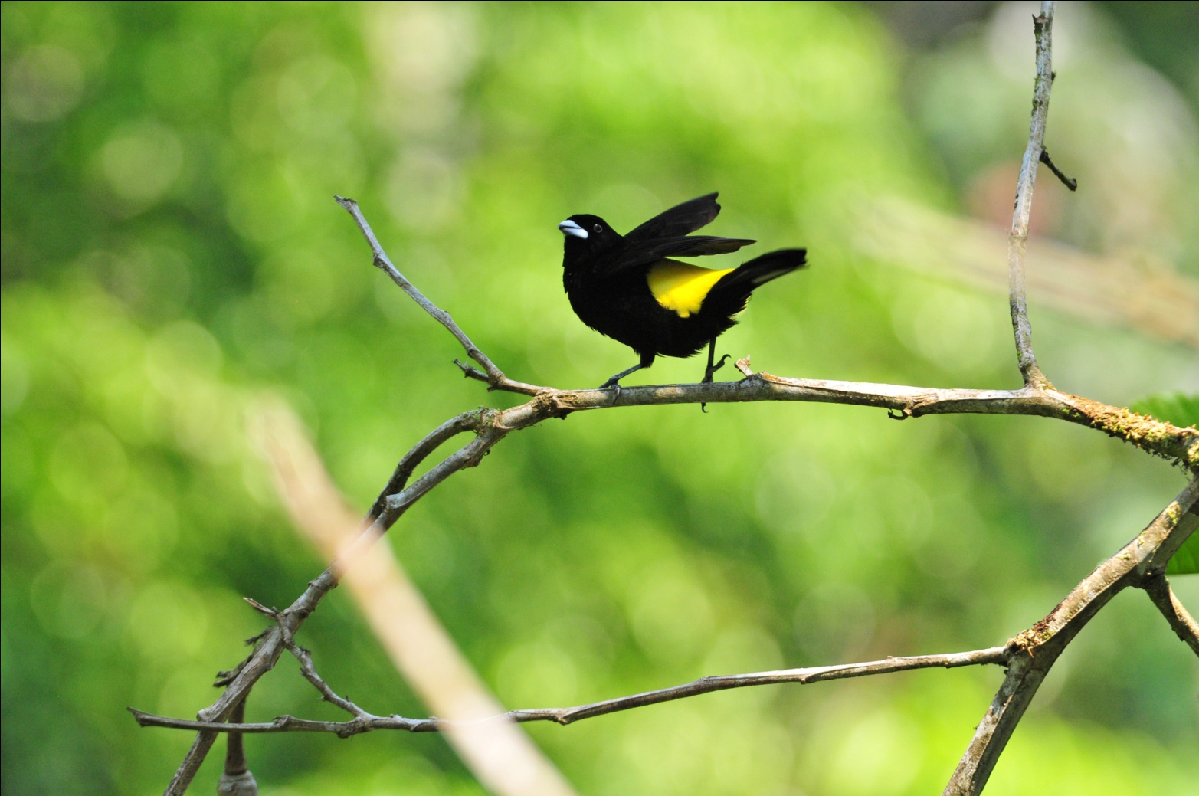 Flame-rumped Tanager

The birding along this road was very good, with Ruddy Ground-Dove, Golden-fronted Greenlet, Yellow-crowned Euphonia, Rusty-margined Flycatcher, Flame-rumped Tanager, Tropical Mockingbird, Yellow-tailed Oriole, Streaked
Flycatcher, Cinnamon Becard, and many other common species coming in rapid order. As we were making one more attempt to see a White-throated Crake, which seemed to be calling at every marshy area we visited, we saw Yellow Tyrannulet flitting about in the tall grasses near the boggy edge. A Plain Wren popped into view, and while still visible, was joined by a Buff-breasted Wren, allowing us to compare the two similar species. While examining the wrens, a
Yellow-billed Cacique flew in to the tall grasses above them. Masked Tityra, Barred Antshrike, Buff-throated Saltator, House Wren, Yellow-bellied Elaenia, and Summer Tanager all appeared as the sun was getting low on the horizon, when Carlos pointed out the sound of Marbled Wood-Quail a short distance away. We took a side road to go toward the sound, following it uphill until it seemed to be coming from the brush right next to us. As we waited and watched, some Gray-headed Chachalacas crossed the road in front of us. After quite some time our patience was rewarded as the group of Marbled Wood-quails came into the open. By now, the light was fading, and we returned to the Rainfo-mobile quite satisfied with the afternoon's remarkable birding.

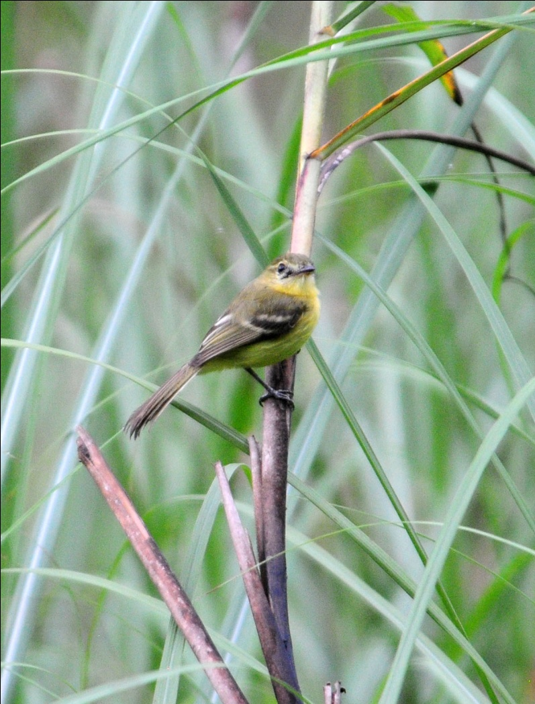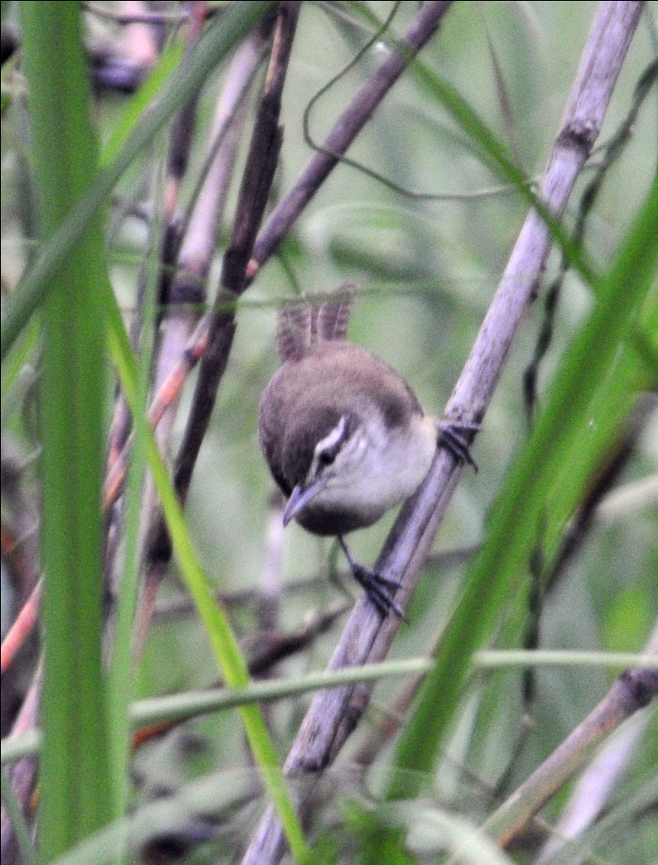
Yellow Tyrannulet Plain Wren

We arrived at the Canopy Tower shortly before 7:00 PM. Just as we turned off the main road onto the entrance road, Charlie and I saw the Great Potoo flying near the spot where we had seen it roosting. This was BBQ night at the Tower, normally enjoyed at picnic tables on the roof of a small outbuilding in front of the tower. But today was too wet for an outdoor BBQ so we enjoyed the grilled fare in the dining room.

What a great day of birding! Other new species seen today included Dusky Antbird, Panama Flycatcher, Cliff Swallow, and Gray Catbird (Jim only). We knew we had had a terrific day, but we were a bit surprised to learn that our bird count for the day was 110 with an additional 14 heard only and another 2 species seen only by Carlos. With 32 of the species new for the trip, it brought our trip count to 166. Would we hit 200 tomorrow, on just our 4th day of birding?

Day 5, Saturday, April 9, PIPELINE ROAD:
We started off early for our full day exploration of the famous Pipeline Road. Our first new species for the day, Cattle Egrets, were seen as we crossed the bridge to Gamboa. We made a brief stop at Ammo Dump Ponds for one more attempt to see the White-throated Crake - it's really difficult to drive past these ponds, which are located just before the entrance to Pipeline Road. We didn't want to delay our arrival at Pipeline Road for too long, and we didn't have to. The crake calls were constant as we found several different species within minutes of stopping: Yellow-rumped Cacique, Summer Tanager, Green Heron, Tropical Kingbird, Rufescent Tiger-Heron, and Wattled Jacana. We added Striated Heron to the trip list and watched as a pair of Common Tody-Flycatchers worked on their nest just a few feet in front of where we were standing. As we were photographing the Tody-Flycatchers, a White-throated Crake walked out into the open among the green plants of the marsh. Everyone got great looks, and we all drove away quite pleased with ourselves that we had made the decision to stop and give it one more try.

We drove the short distance to the entrance to Pipeline Road and pulled over, even though we intended to drive the first part of the road in order to get to the farther reaches before midday. Golden-collared Manakins are usually in this area, and many other species are often relatively easy to find near the entrance. Although we heard some manakins, we didn't see any there. Before we even walked away from the Rainfo-mobile, we spotted a Golden-winged Warbler in the low trees that lined the road. We walked a short distance from the road and enjoyed some lively birding: Keel-billed Toucan, Scarlet-rumped Cacique, Black-tailed Flycatcher, Golden-fronted Greenlet, Baltimore Oriole, Magnolia and Chestnut-sided Warblers, Forest Elaenia, Bright-rumped Attila, Streaked Flycatcher, Black-chested Jay, Orange-chinned Parakeets, Acadian Flycatcher, and several other more common species were seen within 30 minutes. Dusky Antbird, White-bellied Antbird, and Black-bellied Wren were seen together in the same brushy patch.

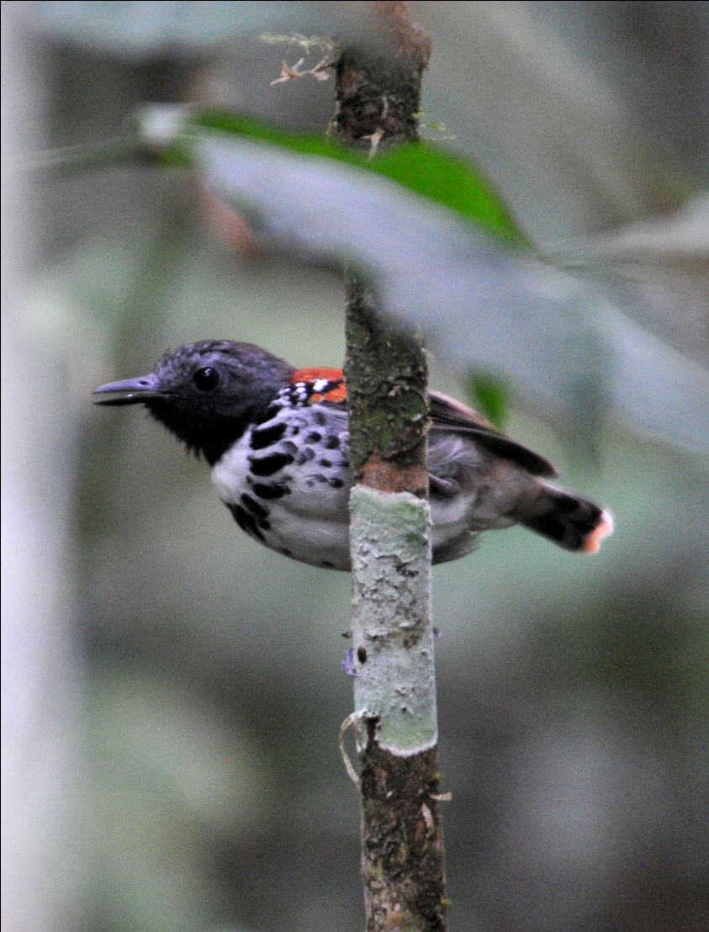
Spotted Antbird
We reluctantly left our little "hot spot", knowing that the birding on Pipeline Road promised to be even better. Part of our group was riding inside a pick-up truck with Hernando, our assistant guide for the day, and the rest of us took seats on the 8-passenger Bird-mobile for the day. Some of the people inside the truck asked if they could drive in front of Carlos to avoid the fumes, so Hernando took the lead. As we proceeded down Pipeline Road, Hernando got too far ahead of us and didn't see that Carlos had stopped to look for an Ocellated Antbird he had heard. So only part of the group was present when we found Southern Beardless Tyrannulet, Bicolored and Spotted Antbirds, and Plain Brown Woodcreeper. We caught up with the rest of the group at the gate and made sure the two vehicles stayed together for the remainder of the day.

Although we did not luck into finding an ant swarm, Pipeline Road did not disappoint us. We saw Dot-winged Antwren, Olivaceous Flatbill, and Brown Twistwing, all new species for the trip, along with dozens of species we had already seen before lunch. Helicopter Damselflies drew our attention from the birds, so beautiful and unusual their pattern in flight.

We had a wonderful picnic lunch at mile marker 8.8, complete with tablecloths and trail stools for comfortable seating. While we were eating, Gene spotted a Rufous Mourner perched over the trail, almost directly above the spot where Bill and Jo were sitting where they could watch a small stream as they ate lunch.

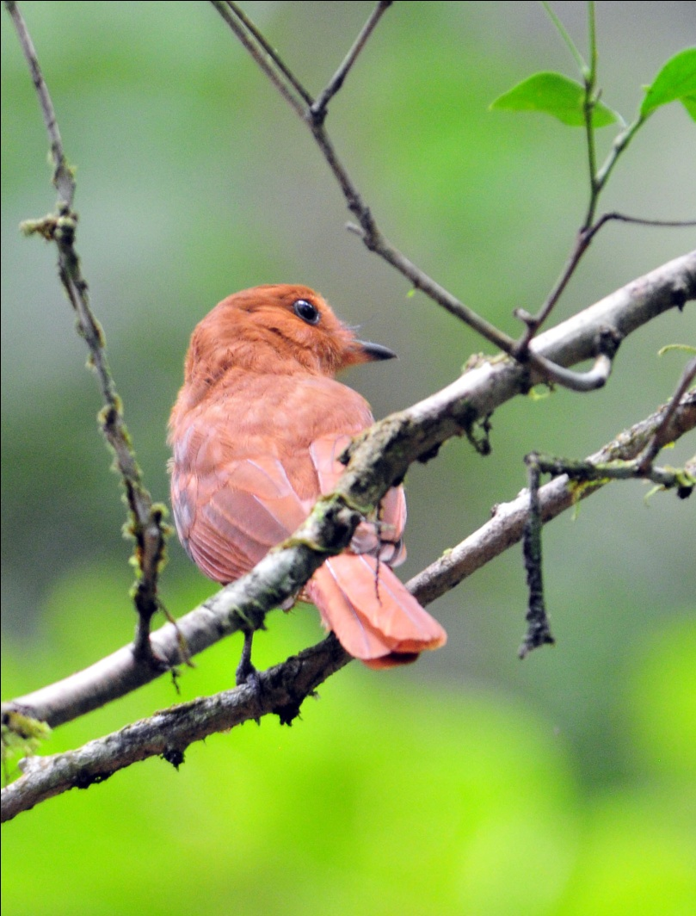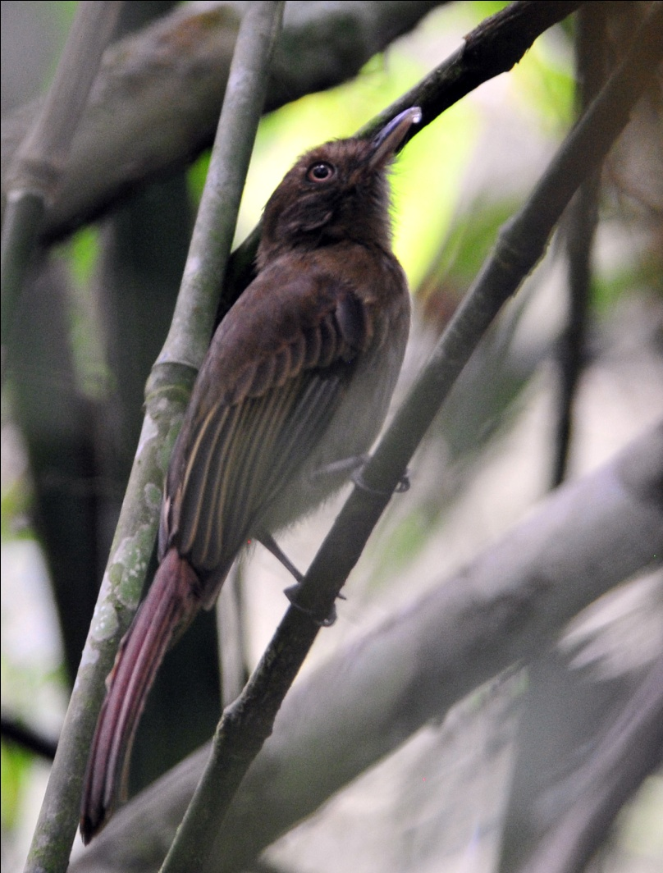
Rufous Mourner Brownish Twistwing

After lunch, the birding slowed a bit, but not enough to complain. White-flanked Antwren , both male and female, were seen well, as well as several "old" species such as Broad-billed Motmot and White-tailed Trogon, both always a treat to observe. A migrating kettle of Swainson's and Broad-winged Hawks and Mississippi Kites flew by. Slate-colored Grosbeak, a bird that had eluded us on two of the last three days as it was heard but not seen, was finally beckoned in for good views, although the bird remained quite high in the trees. Speckled Mourner was one of the more unusual birds seen, and we managed to find more Bicolored and Spotted Antbirds for the people who didn't get to see them earlier when the group had been separated. Little Tinamou was heard, but did not respond to the calls Carlos played. Two young male Red-capped Manakins performed part of their dance for us, while Canada Warbler, Violaceous Trogon (aka Gartered Trogon), Western Slaty Antshrike, Plain Brown Woodcreeper, and Spot-crowned Antvireo all made an appearance.

As we drove back toward the entrance, we came across a large troop of Howler Monkeys. They shook the trees on both sides of road as they moved about from branch to branch, all the while calling out in their deep howling voices. Along the way, a Double-toothed Kite was seen, first perched and then flying away. A group of Purple-throated Fruitcrows chased a Keel-billed Toucan from its perch and an Ornate Hawk-Eagle flew overhead.

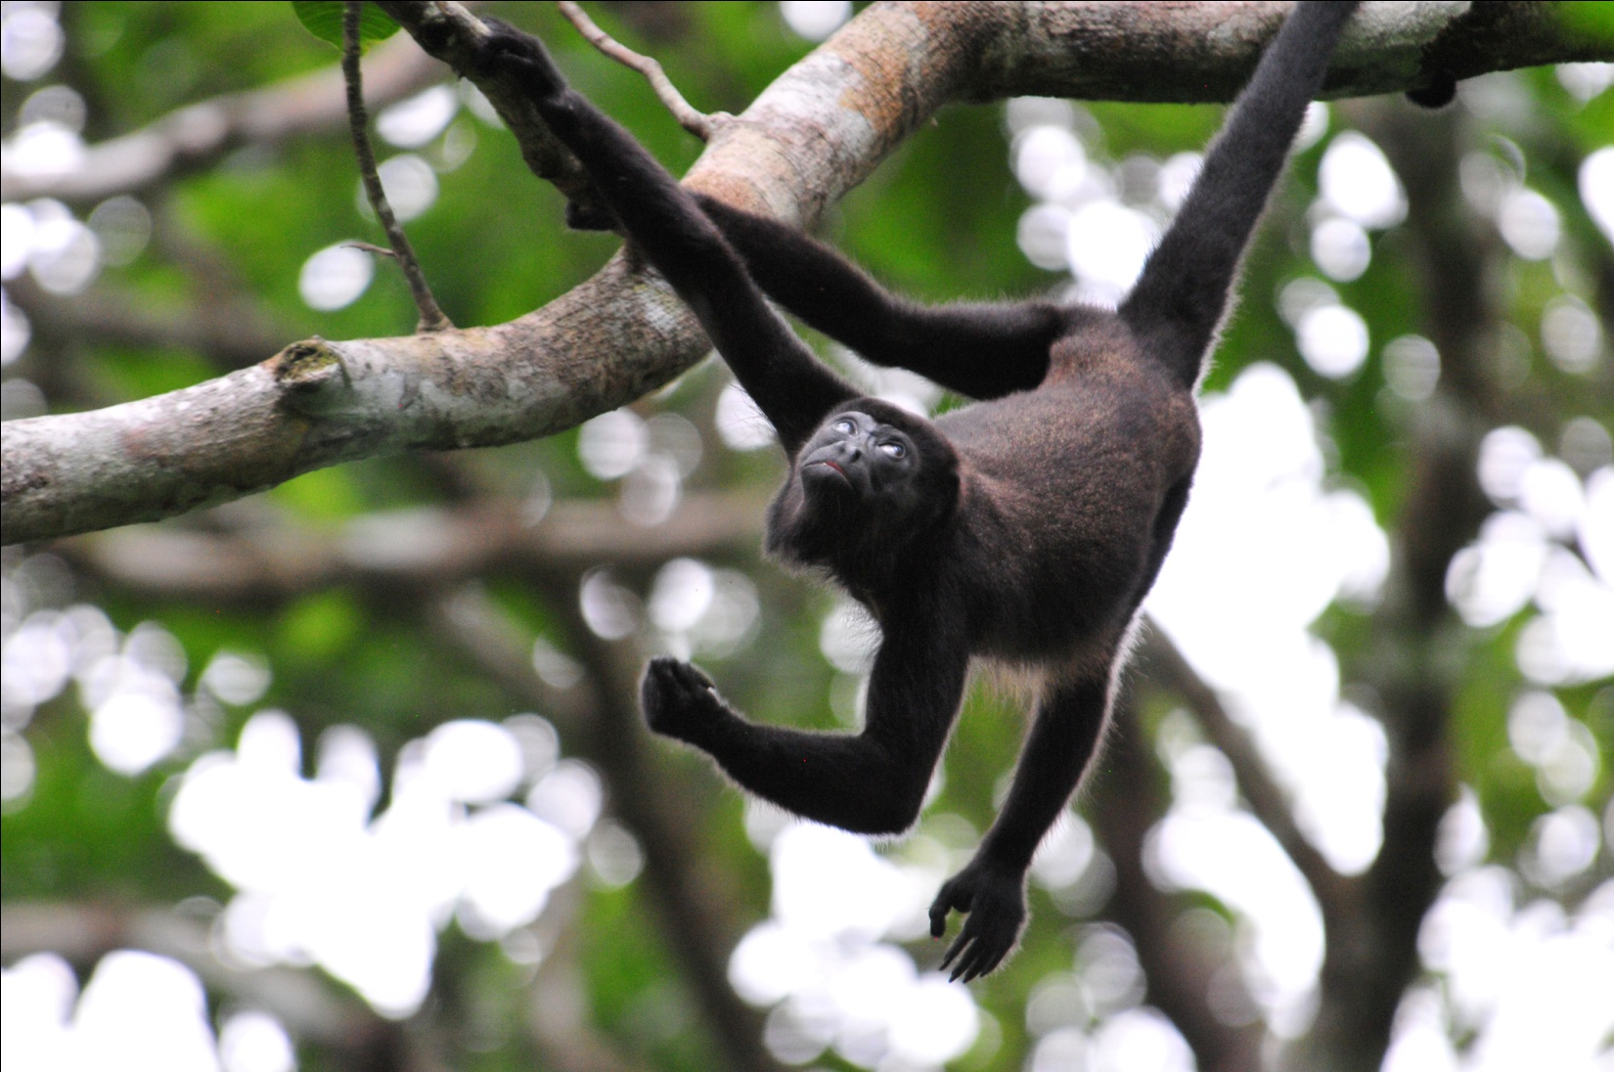
Howler Monkey juvenile

As Carlos crossed one of the small wooden bridges, we came to an abrupt and violent stop, momentarily tossing some of us out of our open-air seats in the back. There had been a large board, probably a 6 x 6, lying on the bridge, and when Carlos drove over it, it popped up, hitting the underside of the bumper and lodging there to stop forward movement when the other end became lodged against the floor of the bridge. Hernando was following us at this point, and he immediately saw what needed to be done to free the Bird-mobile. After a few moments we were moving again, with no real harm done to either birders or Bird-mobile.

When we came to the clearing near the first locked gate we had gone through that morning, Carlos spotted a raptor in a tree and at first thought it was a Barred Forest-Falcon. I was very excited, as this bird has so far eluded me on every trip where we visited areas with opportunities to see it. The hawk remained stationary for quite awhile, and on closer examination through the scope, Carlos realized it was a Tiny Hawk. A very good bird indeed, and quite a beauty, but not a lifer for me.

We returned to the Canopy Tower shortly before dinner and completed our list before eating. Tonight would be our night ride, which had been cancelled the previous two nights because the rainy afternoons weren't the best for finding animals moving around. But tonight was our last chance - now or never. A few "new" birds seen today but not already mentioned included Northern Rough-winged Swallow and Ringed Kingfisher. Our count for today came to 96 species with a whopping 30 species heard only and 1 species seen by Carlos only. With only 30 of the species new for the trip, our trip count came to 196, just a few shy of 200 - but what a fantastic achievement in just four days of birding.

When it came time to report for our night ride at 8:00 PM, all of the men except Charlie opted out, retiring early as the rest of us headed down Semaphore Hill in the Rainfo-mobile. It was a lovely night, but not too active. I found myself drifting off as we traveled downhill with not much to see. We came across two different Two-toed Sloths moving about, and were much impressed by the biggest moth any of us had ever seen, which remained unidentified. Other than that, the only other mammal we saw going all the way down the hill and back up was a bat (species unknown). Then, just before we reached the gate to return to the Tower, a Kinkajou appeared, giving us all terrific looks at its adorable face with huge eyes, making the outing worth the effort.

Day 6, Sunday, April 10, SEMAPHORE HILL ROAD, GAMBOA RAINFOREST RESORT MARINA, PLANTATION TRAIL ENTRANCE, TRANSFER TO CANOPY LODGE, LODGE FEEDERS, GROUNDS, AND ENTRANCE ROAD:
Today we had an early breakfast ( 6:30) so we could leave at 7:00 for some birding at the marina and the very beginning of Pipeline Road. After our three hours of morning birding, we would leave for the Canopy Lodge at 10:00 AM, which would have us arrive in time for lunch. Our bags were all packed and ready to be loaded into the van while we were out birding. We did a bit of birding in front of the Tower as we waited to leave. No new species were seen, but we enjoyed testing ourselves at the feeders as we identified White-necked Jacobins, Blue-chested Hummingbirds, and Violet-bellied Hummingbirds without assistance from Carlos. We were even able to identify some of the females! Standing in the parking area, it felt like we were birding at home with male and female Scarlet Tanagers, Red-eyed Vireo, and Chestnut-sided Warbler appearing in the same tree.

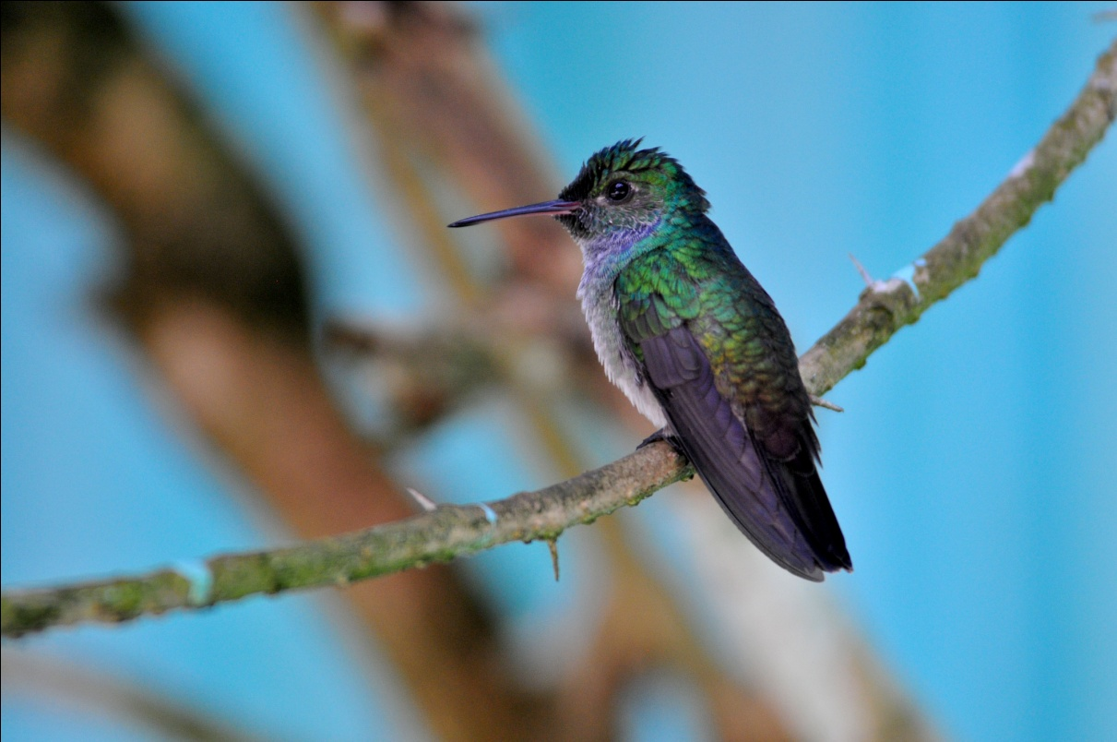
Blue-chested Hummingbird
The last bird I saw before leaving the Tower was a beautiful Golden-hooded Tanager, but no one else was around to see it. On the way down the hill, a large kettle of Mississippi Kites appeared over Semaphore Hill, headed back to their nesting grounds in North America. We stopped on the way down to see the Black-headed Tody-Flycatcher nest, which Carlos found easily, but no bird was present. As Carlos got out to close the gate at the bottom of the hill, he heard Lineated Woodpecker, so we got out to look for it. We had seen Crimson-crested Woodpecker, but the Lineated had not been found yet. As we observed the large woodpecker, some other birds came into view, as is almost always the case in the early morning hours here at the entrance to Plantation Trail. We heard and saw Greenish Elaenia, Green Honeycreeper, Eastern Wood-Pewee, Purple-throated Fruitcrows, and Red-legged Honeycreeper, among others, before Carlos heard the call of a Black-capped Pygmy-Tyrant. We followed the sounds and finally found a pair of the smallest passserine in Panama building a nest about 12 feet off the ground. We enjoyed watching these tiny little members of the flycatcher family as they worked diligently, calling to each other as they moved about.

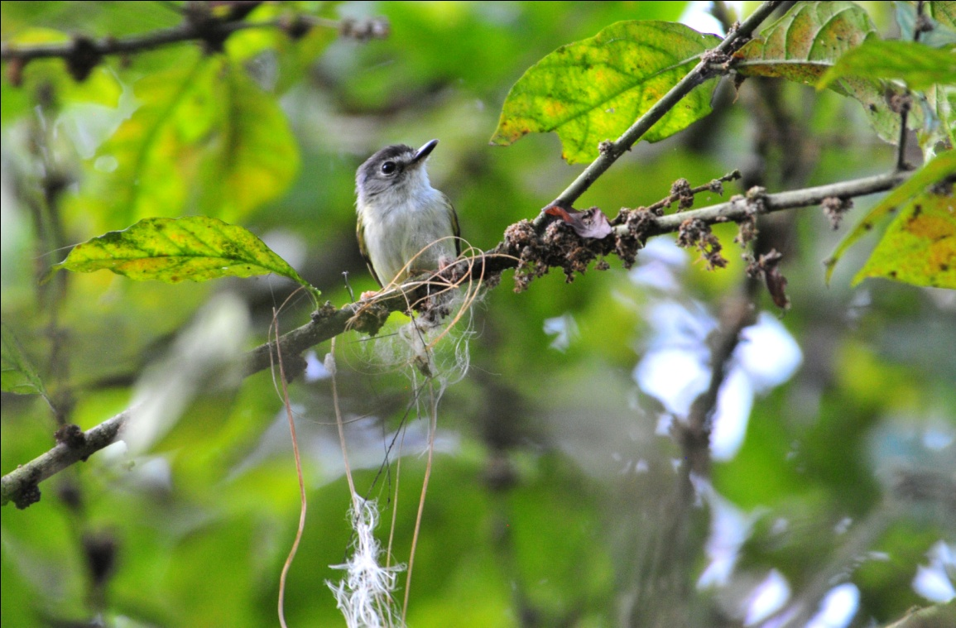
Black-capped Pygmy-Tyrant

At the bridge, we saw Fork-tailed Flycatcher, which only one person had seen on an earlier day, and Mangrove Swallow, a bird we had probably already seen but not taken the time to identify prior to this morning. When we arrived at the Marina, the first bird we saw was another Common Tody-Flycatcher building its pendulous nest in a flowering bush just a few feet off the ground. Because of the slope of the ground, we could stand and look at the nest at eye level or move a bit and actually look down on the nest and the activity around it. As this is one of my favorite species, I spent some time trying to get some decent photographs.

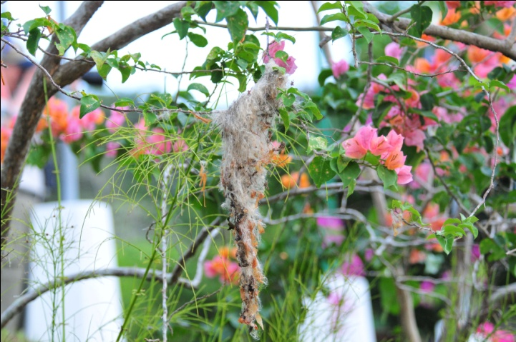
Common Tody-Flycatcher nest

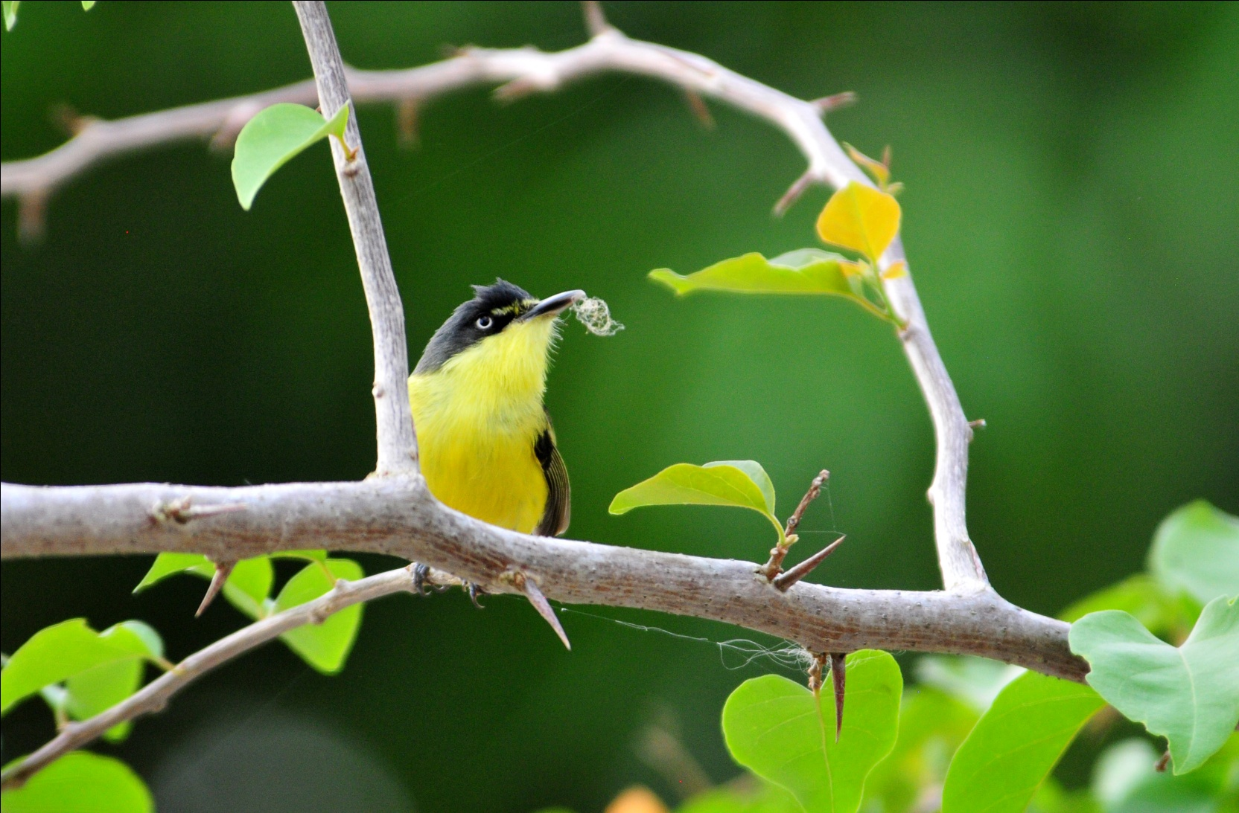
Common Tody-Flycatcher

As we were watching the nest-building, in the branches overhead we first heard, then saw, Yellow-crowned Tyrannulet. At the water's edge or in the water was Common Moorhen, Purple Gallinule, Spotted Sandpiper, and Northern Waterthrush. As we walked toward the back of the inlet, Streaked Flycatcher attracted our attention. Many common species made us aware of their presence, and we found a few more new species for the trip before moving on: Fasciated Antshrike (male and female), Dusky Antbird, Golden-fronted Greenlet, and Yellow Warbler. We managed to find a young male Golden-collared Manakin and got better looks at Black-bellied Whistling Ducks before we loaded up to go back to the Tower. We had spent so much time at the entrance to Plantation Trail and at the Marina that we didn't have time to revisit the beginning of Pipeline Road. New guests were waiting to get into the rooms we were vacating, and lunch would be waiting for us at the Lodge when we arrived. Time to go!

At the stop sign exiting the marina, we saw Yellow-bellied Seedeater, Social Flycatcher, and Crimson-backed Tanagers. As we crossed the bridge, two Osprey were hunting. Along the road we saw Coatimundi and Orange-chinned Parakeets, and just beyond the entrance gate were some Geoffrey's Tamarins. Even though we were running a bit late, we took the time to stop at the nest of the Black-headed Tody-Flycatcher on way back up Semaphore Hill, and this time the bird obliged us with an appearance.

When we got back to the Tower, we took a quick restroom break, quickly checked to make sure everything had been loaded, and then seated ourselves in the large comfortable minibus that had been hired to deliver us to the Lodge some 75 miles away. We snacked on some gorp and settled back in our seats for the 2-hour drive to our next home away from home. When we arrived at the lodge, there was a bit of light rain to greet us, but it didn't deter the birds from feeding nor us from watching them. Under the cover of the spacious dining /sitting room, we watched as Tennesse Warbler, Garden Emerald, Rufous Motmot, Thick-billed Euphonia, Blue-gray Tanager, Clay-colored Thrush, Red-crowned Woodpecker, and Red-legged Honeycreeper vied for position at the well-stocked feeders just a few feet away. We were shown to our (gorgeous!) rooms and then served a delicious lunch. After lunch, we had a short break, and I walked down the path to the building that housed the single rooms to visit with Carole and Janel. The rain picked up while I was there, and from under their porch we were able to observe Stripe-throated Hermit and a small flycatcher that we were unable to positively identify but we thought was an Ochre-bellied Flycatcher. We also spotted a Rufous-tailed Hummingbird that was missing its tail.

At around 3:00 PM, we met to walk with Carlos along the entrance road. Birds were active after the midday shower: Bay-breasted Warbler, Crimson-backed Tanager (male and female), Yellow-bellied Elaenia, Yellow-green Vireo, Mourning Warbler, House Wren, Rufous-capped Warbler, Bay Wren, Golden-hooded Tanager, Ochre-bellied Flycatcher, Violet-crowned Woodnymph, White-shouldered Tanager, Canada Warbler, White Hawk, Summer Tanager, and Yellow-billed Cacique were among the many species sighted on our walk.

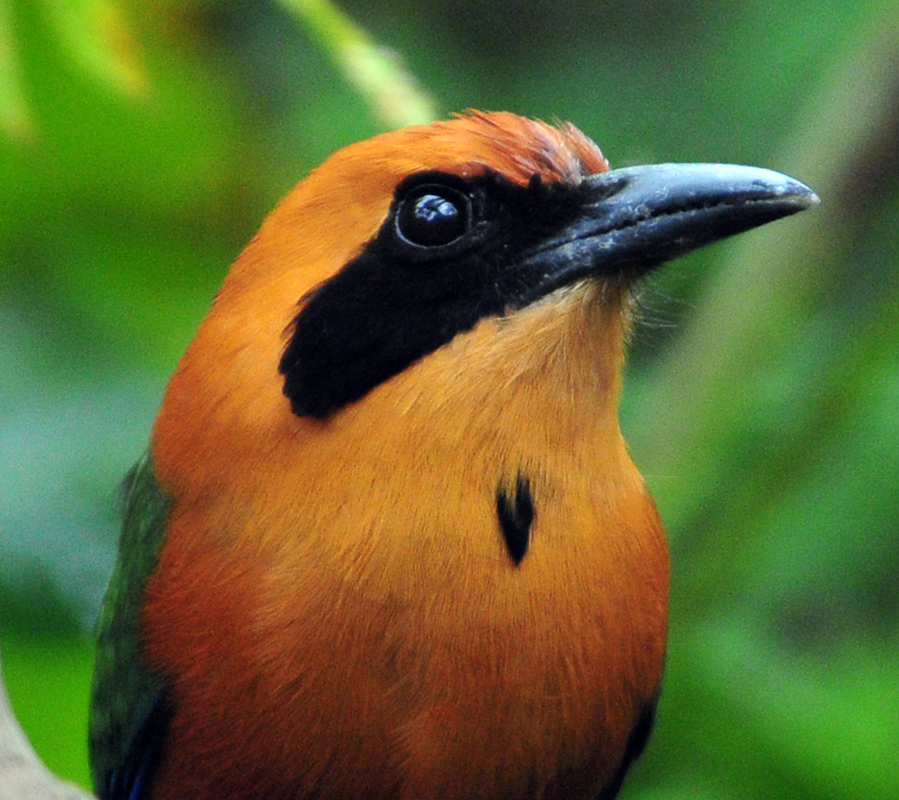
Rufous Motmot
We saw and heard many other species on Day 6, some of them new to the trip: Greenish Elaenia, Black-and-white Warbler, White-lined Tanager, Bay-headed Tanager, and Bananaquit. We finished the day with 106 species with an additional 14 species heard only, bringing our total trip count to an impressive 220.

Day 7, Monday, April 11, La Mesa, Canopy Adventure Trail:
We scheduled breakfast for 6:30 so we could leave by 7:30, but the group ran a little late this morning. The first "new" bird of the morning, which was not technically a new bird for the trip but felt like one since not everyone had seen it yet, was a Louisiana Waterthrush. Around the feeders we saw Violet-headed and Snowy-bellied Hummingbirds and lots of other "old" birds including Gray-necked Wood-Rail before we left to drive to an area called La Mesa. A bit higher in elevation than the lodge, this area is known for its huge chicken farms. Birding along the roads provides good opportunities for a wide variety of birds, especially if you find some fruiting trees as Carlos did within the first hour. When he spotted the trees, we stopped along the side of an unpaved road where we found Yellow-rumped Cacique, Palm Tanager, Scaled Pigeon, Shiny Cowbird, Yellow-faced Grassquit, and Yellow-bellied Seedeater. Jim and just a few others saw a Vermilion Flycatcher, and we all noted the tailless condition of a Crimson-backed Tanager and a Clay-colored Thrush, making us think about the "Rufous-tailless" Hummingbird we saw yesterday and wonder what kind of tail-grabbing critter was lurking in the area. A Spotted Woodcreeper flew by too quickly for anyone but Carlos to be sure of its identity. Carlos heard a Barred Forest-Falcon calling, and though we tried to locate it on the hillside below us, we could not. When the birds began to thin out in the area around the fruiting trees, we continued along the road. The group became separated when a few of us who were trailing a bit behind stopped to find the source of a song we heard coming from some bushes. As we searched for and finally found the singing Rufous-and-white Wren, we could see that the rest of the group had found something a short distance ahead of us. When we caught up with them, we learned that they had also been watching a Rufuous-and-white Wren.

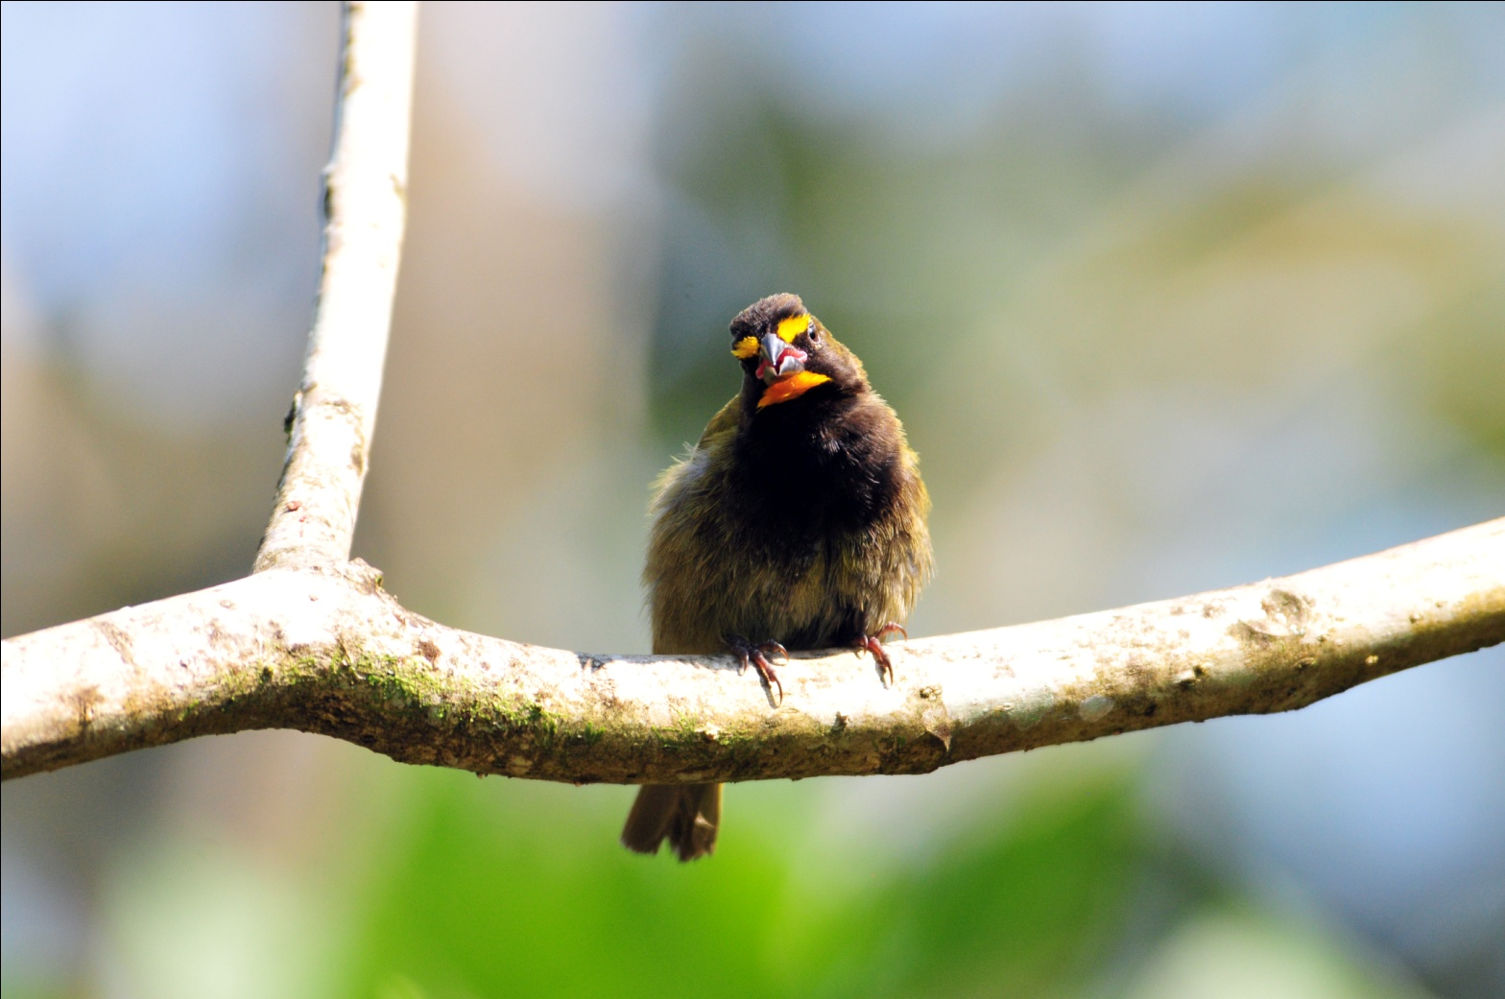
Yellow-faced Grassquit
A bit further along the road, Swallow-tailed Kites soared overhead as Cattle Egrets foraged in an open field. As we continued along the road that led to a windy meadow, we found Red-crowned Ant-Tanager (female), White-breasted Wood-Wren, and Silver-throated Tanager in the trees at the road's edge. Advancing into an area with more open land, we saw White-tipped Dove, Eastern Meadowlark, Thick-billed Seed-Finch, Plumbeous Kite, Paltry Tyrannulet, and Smooth-billed Ani. Jim found a Black-striped Sparrow sitting low in a bush far below us on the hillside, and we were all able to see it well in the scope.

Coming back from the top of the mesa, we began to bird along the roadside near a deep ravine with a creek at the bottom. Carlos pointed out the vocalization of a Long-billed Gnatwren, but we were unable to locate it. A Sulphur-rumped Flycatcher appeared while we were searching for the Gnatwren and we watched it until we were distracted by a Red-tailed Squirrel with a large piece of fruit in its mouth. In this same area we found Yellow-olive Flycatcher, Rufous-and-white Wren, Hepatic Tanager, and a noisy group of Tawny-crested Tanagers.

We returned to the lodge for lunch and a break. Before lunch, we observed two large and impressive species, Collared Aracari and Chestnut-headed Oropendola, at the feeders. Between them and a bold Basilisk that was helping himself to large chunks of fruit from the feeders, the smaller birds didn't stand a chance. After lunch, most of us stayed in the sitting area to enjoy the show at the feeders and Raul joined us there. Charlie spotted an Indigo Bunting on the far side of the creek which was, much to our surprise, a life bird for Raul!

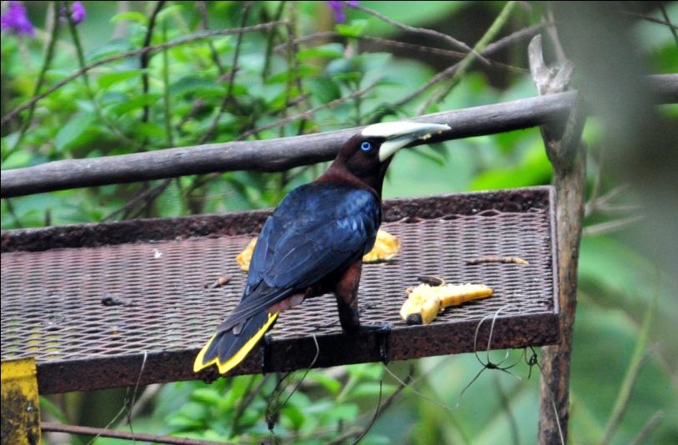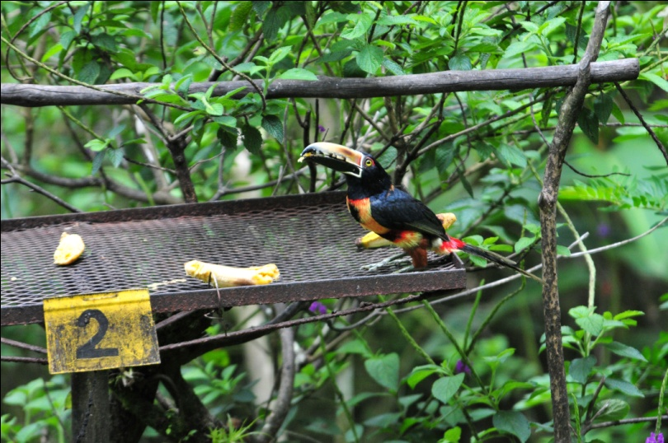
Chestnut-headed Oropendola Collared Aracari

During the midday break, Carly walked around the grounds and managed to get some stunning photographs of Yellow-olive Flycatcher, Fasciated Antshrike, and Black-chested Jay. The Jay was a bird that many of us had not had a good look at, so we hoped it would return for all of us to enjoy. At around 3:00 PM, we drove to the Canopy Adventure kiosk. The Canopy Adventure is a series of platforms connected by zip lines. Carole and Jeanie were the only two of our group who wanted to zip across the canopy, so the rest of the group watched for the reported Rufous-crested Coquette (to no avail) while they were fitted with gloves, helmets, and climbing gear. Once they were ready, we drove to higher ground and walked the first part of the trail that provided a shortcut to the first platform, hoping for Tody Motmot. Carlos meant for the whole group to bird the first part of the trail together before Carole and Jeanie went on to first platform with Danilo, but the Zipliners got ahead of us and were nowhere to be see when Carlos first heard the Tody Motmot calling. Although we spent quite some time in one short area of the trail where we could hear the bird calling almost incessantly from below, we were unsuccessful in sighting this elusive bird. While searching we did get excellent views of an active and vocal Scale-crested Pygmy-Tyrant, and a Keel-billed Toucan came in very close. White-winged Becard was seen and everyone finally got good looks at the Black-chested Jay.

We finished the day with 81 species, just 19 of them new for the trip, bringing our trip total to 239.

Day 8, Tuesday, April 12, Altos del Maria:
This morning we had breakfast at 6:00 AM and departed a little before 7:00 AM for our day at Montevalo and Altos del Maria. Our group divided ourselves into three 4WD vehicles for the drive that would at times be quite steep. Carlos drove the lead truck with Danilo and Enis following. Danilo is a birding guide for the Canopy Lodge, one of two guides who led our group at the lodge last year, and we were looking forward to spending the day with him. He is very knowledgeable and we enjoy his company. Enis is a local woman who frequently provides 4WD transportation for Canopy Lodge outings. Although she doesn't speak English, she is very friendly and fairly easy to communicate with.

Although we enjoyed watching the feeder birds before we left for the day, we didn't see any "trip birds" there. When we stopped for gas in town, we saw Blue-and-white Swallows flying over the streets and landing on the wires, our first new species for the day. Our first stop yielded Buff-throated Saltator and Yellow-faced Grassquit, both species that are fairly common and both species we had already seen. We were hoping for Orange-bellied Trogon and Yellow-eared Toucanet in this area, but we knew we would have more opportunities for these target species at other stops today. Our next stop provided looks at Rufous-capped Warbler, Paltry Tyrannulet, and Green Honeycreeper. A Barred Hawk flew by, but we didn't have a chance to catch any field marks. Also overhead were White-collared Swifts, easily identified with striking markings and large size compared to other swifts. At every stop we saw several species and many individuals: Rufous Motmot, Swallow-tailed Kite, Bay-headed Tanager, Silver-throated Tanager, Gray-breasted Woodwren, among others. Many of our target species appeared early in the day, including Orange-bellied Trogon, Scarlet-thighed Dacnis, and Black-and-yellow Tanager. Two of our primary targets for the day, Snowcap and Yellow-eared Toucanet, were seen within minutes of each other. As we were watching a female Snowcap zip in and out of view, Carlos and Danilo heard the sound of a Yellow-eared Toucanet. They played the call, and the Toucanet flew into a tree very near to our position alongside the road.

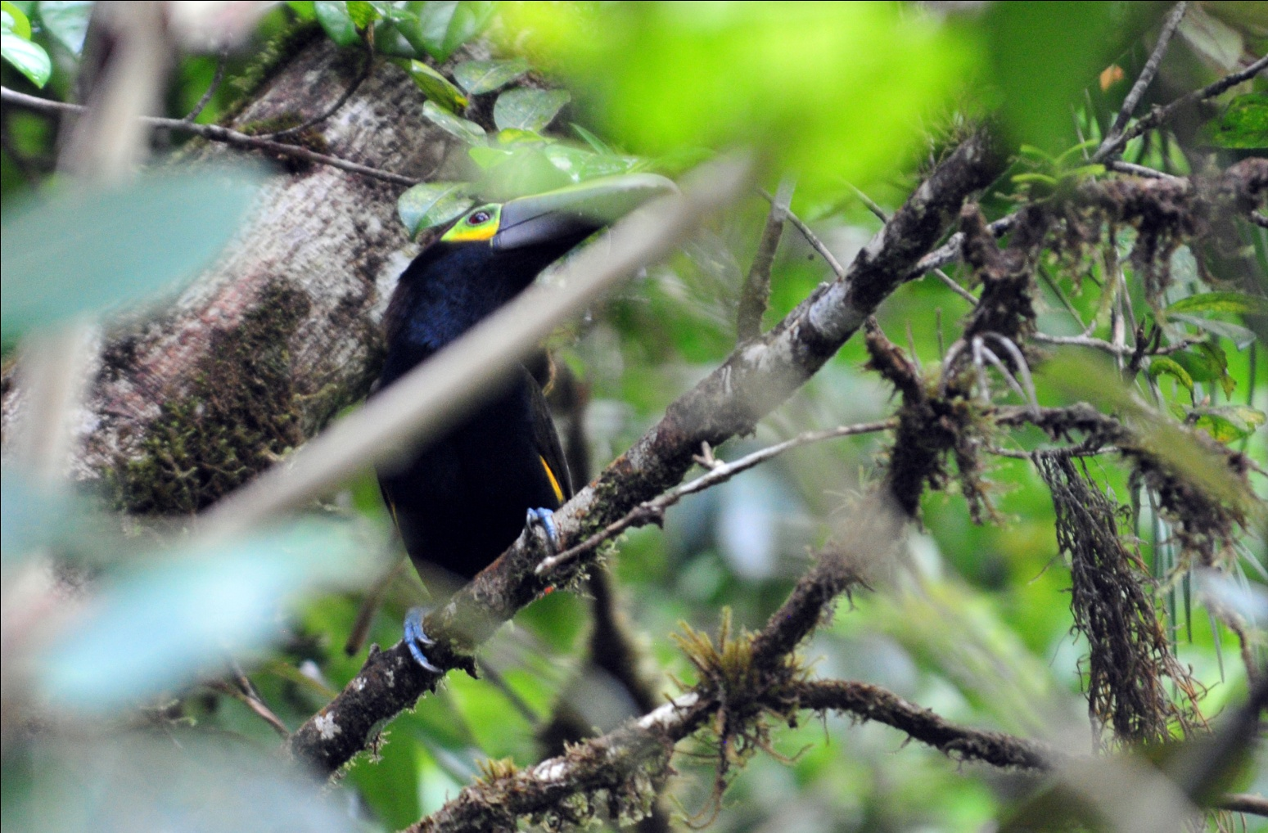
Yellow-eared Toucanet
Carlos spotted a White-tipped Sicklebill, but it zipped away before anyone else could get on it. Other hummingbirds seen in the area included Green Hermit and a male Snowcap that, although seen by many of the group, left us all wanting better and longer views. A Spotted Woodcreeper provided everyone with excellent views, along with Wedge-billed Woodcreeper, Tufted Flycatcher, Spotted Barbtail, and Pale-vented Thrush. A Blue-headed Parrot flew by as a
Pygmy Squirrel provided comic relief.

All of this before we even arrived at Altos del Maria at around 9:45 AM! Once inside the boundaries of Altos del Maria, an area that has been developed for new homes but has much forest remaining, we stopped for a break. After our midmorning snack, people were taking turns leaving the group for a "bushroom" break at the top of a steep hill. As Carly came out of the forest and onto the steep stretch of gravel road, she found herself going faster and faster as she came down the hill. Finally, when her momentum had her traveling at a speed that was out of her control, she fell forward onto the rocky surface. We all rushed to her assistance, helping her regain her composure and getting ice packs and bandages for the scrapes on her arms. I noticed a small spot of blood on the knee of Carly's pants, so we unzipped the bottom part of her pants leg and removed it so we could take a look. Expecting to see a small scrape on her knee, I was shocked to see the severity of the wound on her knee. A very deep cut extended about half way across her knee, and I knew at once that she needed stitches. We put an ice pack on the knee and got her into Carlos's vehicle to be transported to the hospital some 45 minutes away. Her good friend Carole went along for moral support. Because of the unusual three-vehicle arrangement for the day's outing, the rest of the group was able to continue birding with Danilo as our guide.

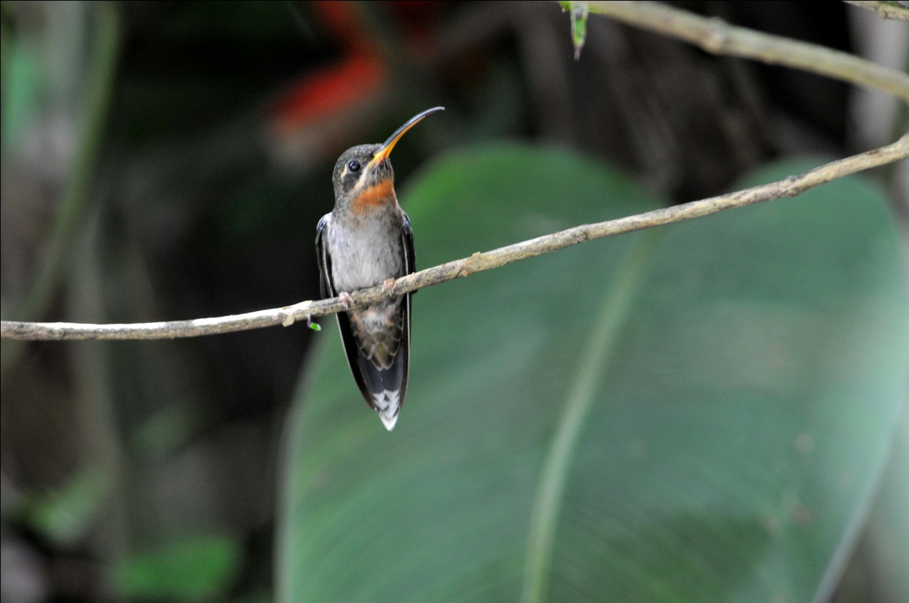
Band-tailed Barbthroat

At our very first stop, we found another of our target species, Blue-throated Toucanet. Although we were quite thrilled to see this spectacular bird, we were all saddened by Carly and Carole's absence. We found three species of Euphonia, Thick-billed, White-vented, and Tawny-capped Euphonia. Also seen before noon were Common Bush-Tanager and Band-tailed Barbthroat, among many other species previously seen. We stopped at a small lake and wetland that has
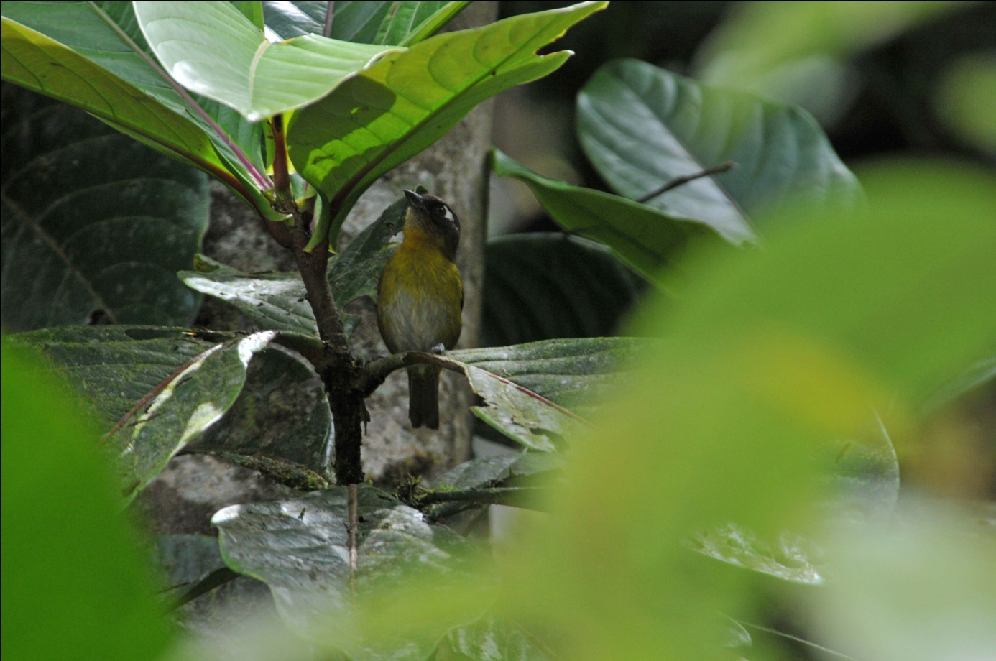
Common Bush-Tanager

been improved with a paved trail around a portion of it, leading to a dirt trail through the forest. At the lake's edge we
saw Green Kingfisher, Red-crowned Woodpecker, Long-tailed Tyrant, and Buff-throated Saltator. As we walked along the dirt trail through the forest, Danilo heard a Dull-mantled Antbird. He called to the bird, imitating its sound expertly, and the bird finally appeared, landing on a log in the open for several seconds. The splash of white on the bird was so bold that it didn't quite resemble the drawing in the field guide. Danilo told us that the bird shows more white when it is agitated. As we were watching the Antbird come in and out of sight, a Slaty Antwren came into view. A bit farther down the trail, Jim pointed out some movement to Gene, who snapped a photo thinking it was the Dull-mantled Antbird in his camera's viewfinder. When his digital image was examined, we saw that he had photographed a Chestnut-capped Brush-Finch moving about on the forest floor. Danilo heard a Thrushlike Schiffornis, but we could not get a visual on the bird.

As we exited the forest, we noticed that a tall tree in the back of a clearing attracted a variety of birds: Black-and-yellow Tanager, Common Bush-Tanager, Scarlet Tanagers (multiple males and a female), and Pale-vented Thrush. As we examined the tree for more species, a Short-tailed Hawk flew overhead and a Snowy-bellied Hummingbird hummed by our heads. At the end of the trail, now back on the concrete trail circling the lake, we came upon a fruiting tree that was hosting a bit of a thrush party - a few Swainson's Thrushes, a White-throated Thrush, and several Clay-colored Thrushes were all feasting on the ripe berries. A Bay-headed Tanager joined them for awhile before we walked on to the trucks to retrieve our lunch. Part of the group took their stools and lunches to sit near the fruiting tree, enjoying the avian feast while they ate. Before we packed up, we added Black-striped Sparrow, Squirrel Cuckoo, Indigo Bunting, Paltry Tyrannulet, Bran-colored Flycatcher, Plain-colored Tanager, and House Wren to the day's list.

As we finished lunch, Carlos called Danilo to let us know that Carly was fine and that he was taking her back to the lodge. He would meet us in a few hours. Continuing on, our next good sighting was a pair of Double-toothed Kites perched on a branch over the road. We watched as the male brought a snake and offered it to the female, who made sure it was dead before consuming it in what appeared to be one long gulp. Overhead, a Broad-winged Hawk appeared, followed by a Barred Hawk that allowed excellent views in good lighting, unlike the earlier hawk that had flown by so quickly we couldn't see any field marks. Violet-crowned Woodnymph and Violet-headed Hummingbird were also seen in this area.

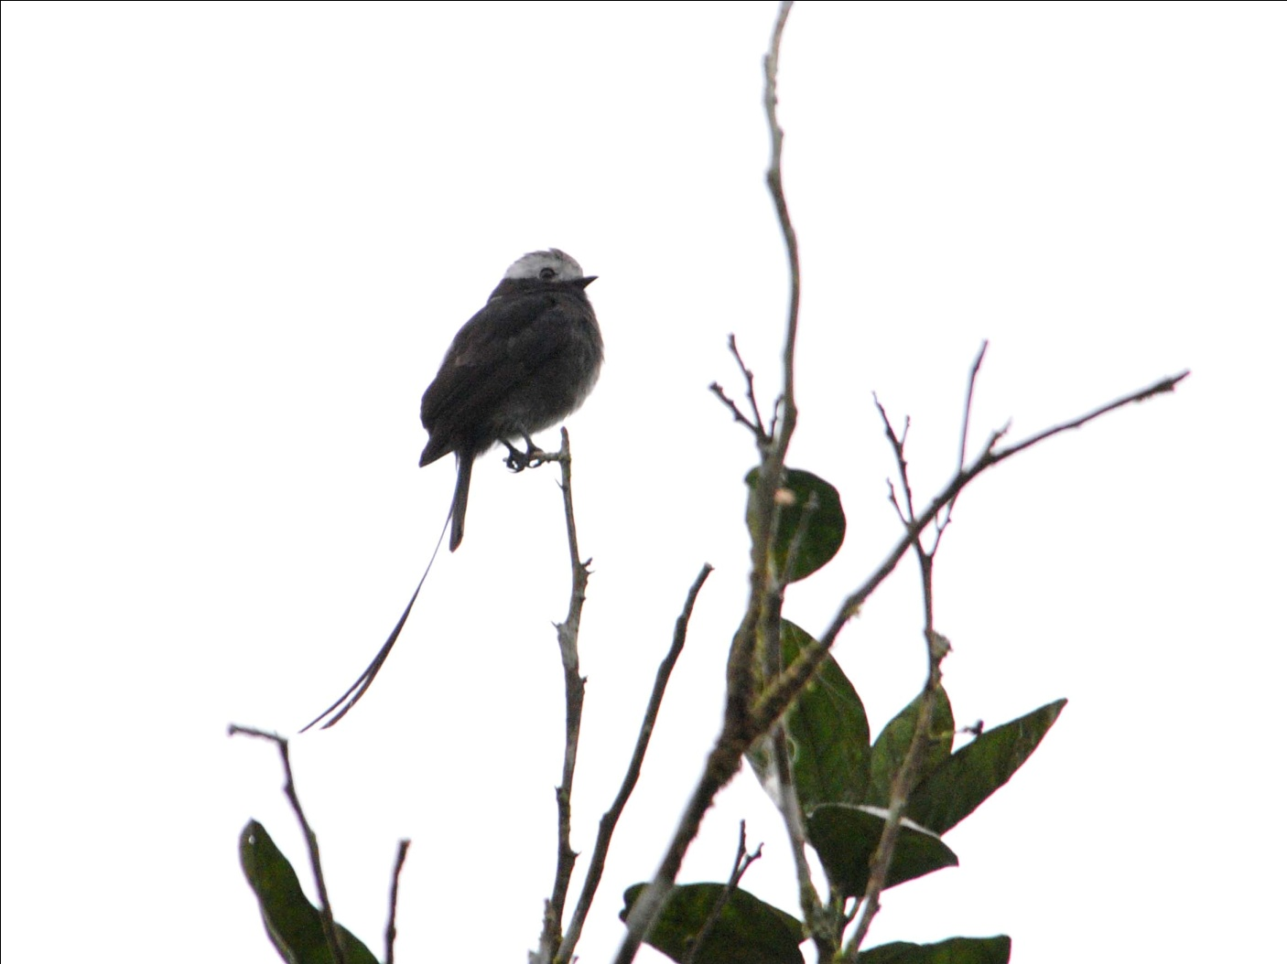
Long-tailed Tyrant

As we went up a hill on an unpaved side road, a Three-toed Sloth was seen at eye level. At the top of the hill, Danilo told us he knew of a place at the bottom of the valley below us where Snowcap was reliable. Although we had good looks at a female Snowcap early in the day, most of us were not satisfied with our looks at the male with its brilliant white cap. The day had become pretty warm with bright sunshine overhead on the trail leading to the Snowcap spot, so some of the group opted to remain in the shade at the top of the hill while Danilo led Jim, Charlie, Janel, and me down the steep hill. The enitire time we walked down the hill, my thoughts were on the trip back up. But I really wanted a photo of a Snowcap, and this seemed to be a good opportunity to achieve that, so I kept going. Once at the bottom of the hill, we spotted Canada Warbler. Other hummingbirds flew in and out, and each time we got excited thinking the Snowcap had arrived. After following several Violet-headed Hummingbirds and a few female Violet-crowned Hummingbirds, we finally got good looks at a male Snowcap. He did not, however, stick around long enough for photographs!

As we trudged back up the hill, we were greeted with excellent views of a White Hawk overhead. As we drove away, Danilo idenitfied a perched raptor as a Great Black Hawk. Other birds seen before Carlos returned included Green-crowned Brilliant, Dusky-capped Flycatcher, White-ruffed Manakin, and Hepatic Tanager. By the time Carlos returned, it was almost time to head back to the lodge. We arrived at the lodge at around 5:30, where we found Carly resting comfortably in a wheel chair that the staff at the lodge had found for her. She was OK, but not a bit happy that the doctor had told her to stay off her leg for the remainder of the trip.

Today's count was 91 species, with an additional 11 heard only. Of those, 30 were new for the trip, bringing our trip total to 269 species. We were confident that we would break 300 before the end of the tour.

Day 9, Wednesday, April 13, INDIO RIVER AND JORDANAL:
After a 6:30 breakfast, we once again loaded into 4WD trucks for an outing to the Indio River. The route covers some pretty rough roads, but the target species for the day are worth it: Barred Puffbird, Sulphur-rumped Tanager and Emerald Tanager were the primary targets. Carly stayed behind, planning to do some birding from the dining area from the comfort of a chair. We knew we would miss her today, and we felt her pain at having to miss the last two days' outings.

We made a few stops along the way, mostly finding birds we had already seen, including Gray-necked Wood-Rail, Chestnut-headed Oropendola, Blue-headed Parrot, Scarlet and Bay-headed Tanagers, Rufous-capped Warbler, White-winged Becard, Dusky-faced Tanager, Bananaquit, Barred Hawk, Keel-billed Toucan, and Plain-colored and Flame-rumped Tanagers. New for the trip was Tropical Pewee. At one point we had several species in one tree: Purple-crowned Fairy, Red-legged Honeycreeper, Golden-hooded Tanager, Rufous-tailed Hummingbird, Plain-colored Tanager, Boat-billed Flycatcher, Tropical Gnatcatcher, White-lined Tanager, and Tawny-capped Euphonia.

When we finally reached the area where Danilo and Carlos knew some of the target species could be found, it took just a few minutes for them to locate a group of Sulphur-rumped Tanagers. As we worked together to make sure everyone got a good look at this uncommon and very active species, including a good view of diagnostic field marks, our attention was distracted by a pair of Emerald Tanagers. One of the bright green birds was bathing in the fork of tree, high above the ground but at eye level for us from our position from the edge of the road.
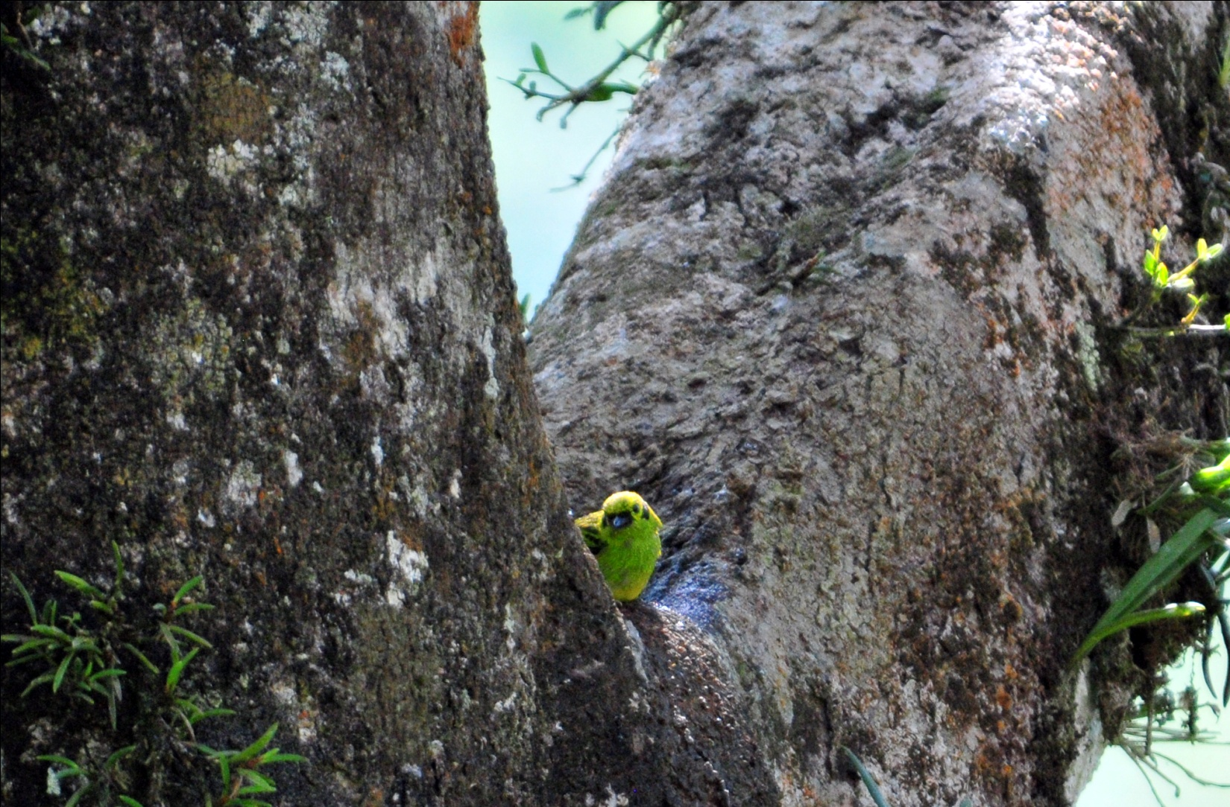
Emerald Tanager

Also seen here were Cocoa Woodcreeper, Cinnamon Becard and Wedge-billed Woodcreeper. After spending a little time at this spot, we drove on to the final destination, where the road deteriorated into ruts and deep puddles and mud. Here, we waited when Danilo heard the wolf-whistle-like call of the last of our target species for the day, Barred Puffbird. He called to them and soon not one, but two, Puffbirds flew into the tree directly in front of us.
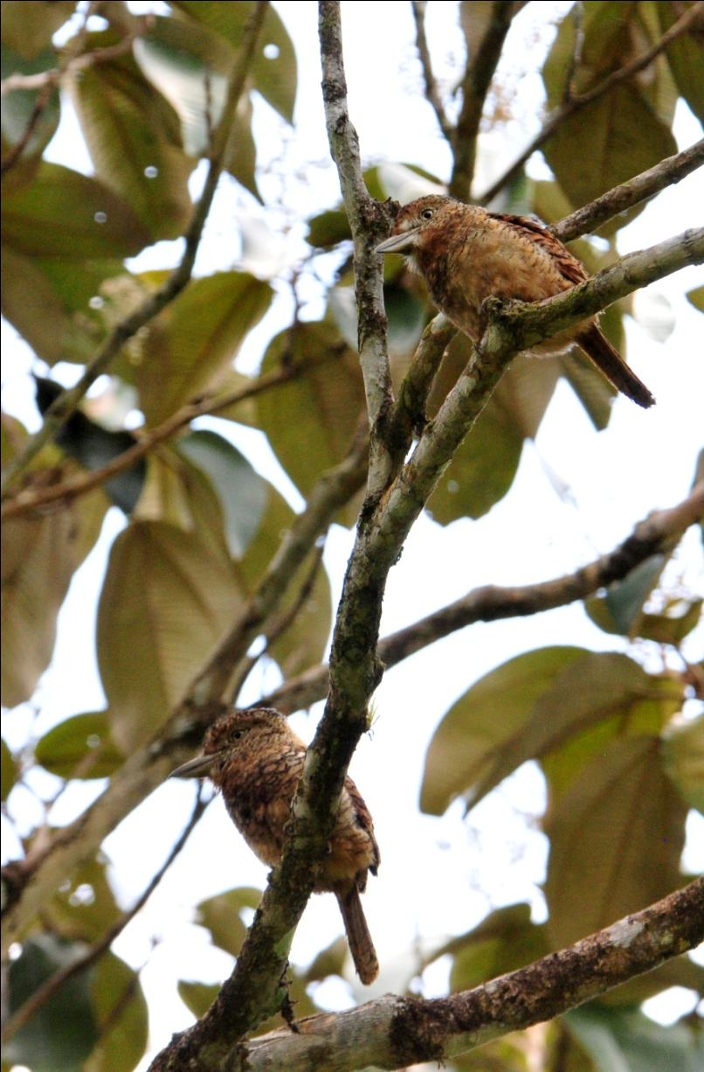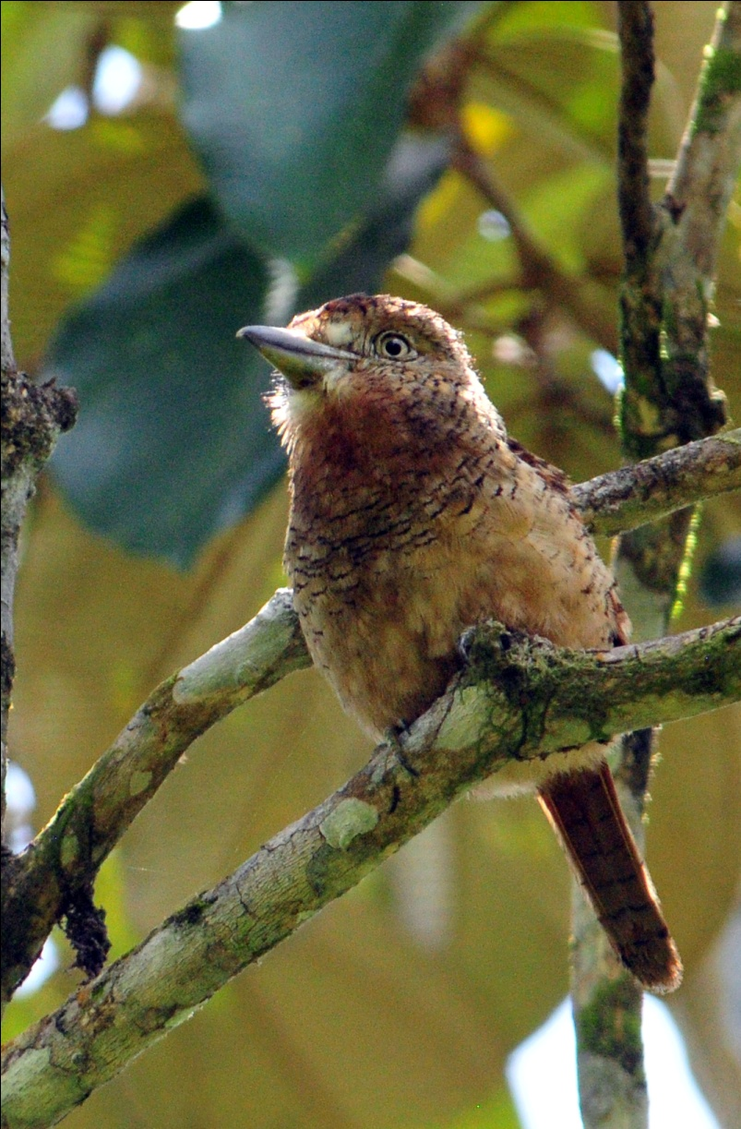
Barred Puffbirds

Finding all of the target species had us all feeling quite satisfied, but we stopped to see a Green Kingfisher as we drove away and took a little time to photograph Chestnut-headed Oropenolas on their nest tree as we approached the lodge. Giant Cowbirds were mixed in with the Oropendolas

We were back at the Canopy Lodge by 12:40, just a bit late for lunch. Carly had gone out with a different guide who was leading just one man, and she reported some good sightings for the day. Although we scolded her for not following doctor's orders, we were glad she had a good morning. After a midday break, we headed for the El Valle market at 3:00 PM with plans to search for the elusive Tody Motmot along the entrance road where we had seen it the year before after we got back from the market. Because the group planned to return to the lodge after visiting the market so we could take Carly along with us for our afternoon outing, I decided to stay back and try to get some photographs. Staying in one good spot and waiting for birds to come in often results in some good opportunities, and I rarely get a chance to do this when we're with a group. When the group returned a little after 4:00 PM, we loaded up in two vans, putting Carly in the second row of seats where she could easily get in and out and where she could put her leg up. We figured, since we would be birding along the road, there was no reason she couldn't go along.

Once on the entrance road, Carlos and Danilo parked the vans and we got out to walk a short distance uphill. Several people helped Danilo with Carly's wheelchair and we all watched carefully on the steep hill to make sure she was safe. We found several good species in the area near the spot where we found the Tody Motmot in 2010. Janel spotted a Broad-billed Motmot, and my heart skipped a beat when she said, "There's the Motmot." We saw lots of familiar birds like Flame-rumped and Bay-headed Tanagers and Red-crowned Woodpecker, and a few of us saw a White-tipped Sicklebill when it flew through at warp speed. Buff-rumped Warbler was seen by part of the group near a creek where we parked the vans, but we couldn't relocate it for the rest of the group. On the way back to the lodge, we stopped to make one last effort to see the Rufous-crested Coquette that had been frequenting the flowers near the kiosk, but it was nowhere to be found. Danilo saw a Little Hermit, and we all saw Violet-headed Hummingbird on the flowers. When we approached the lodge, we saw a Mourning Warbler beneath Feeder 2.

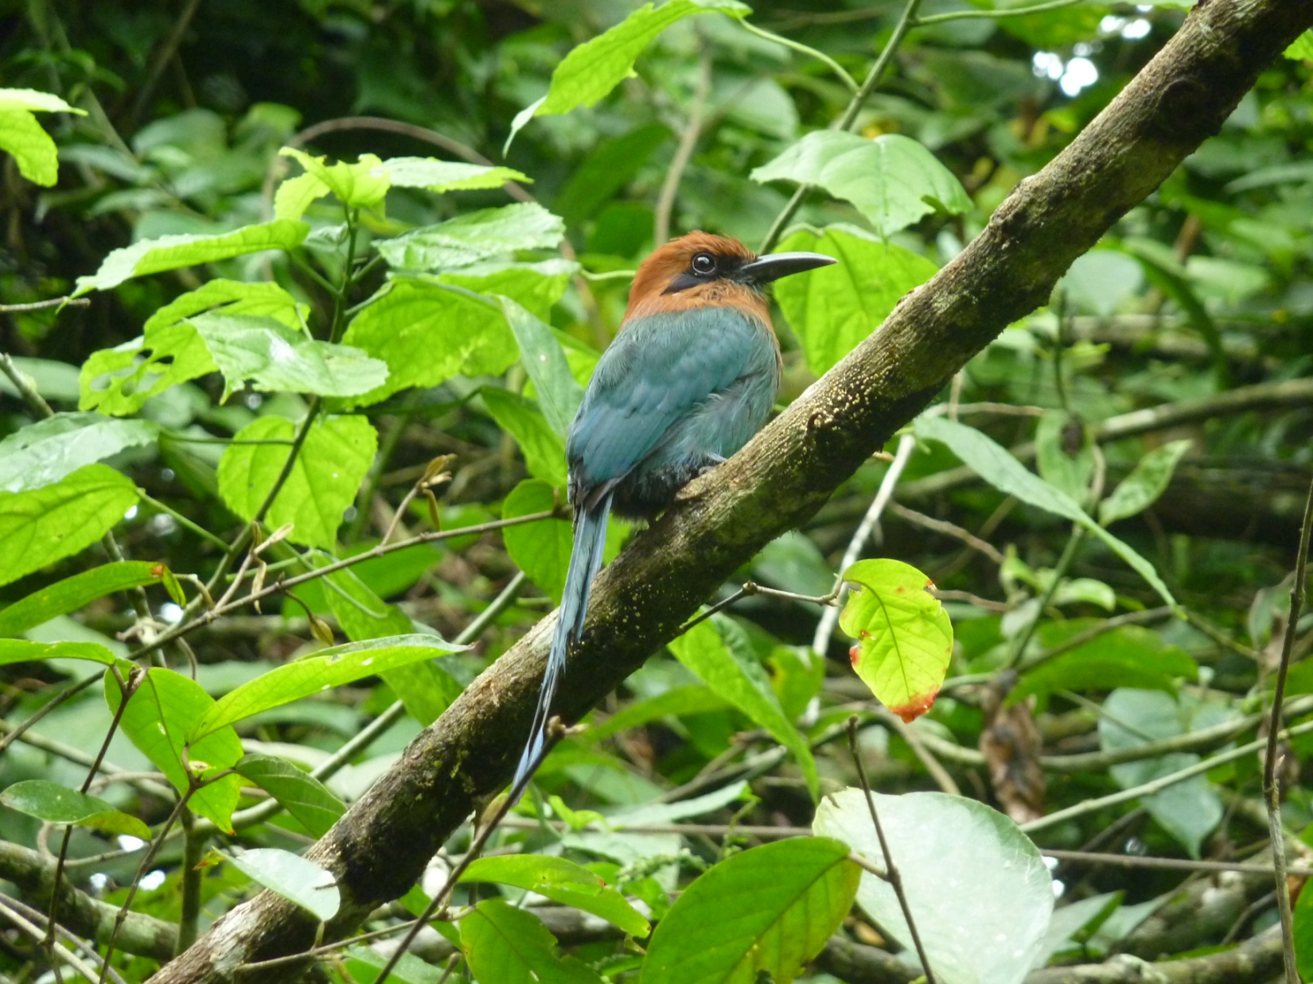
Broad-billed Motmot

At day's end we had observed 80 species, with an additional 9 heard only. Although we had seen just 7 new species for the trip, we were all quite pleased with the quality of those new species. Had we not traveled to the River Indio, we would have never seen the rare species found today.

Day 10, Thursday, April 14, El Chiru, Santa Clara
Breakfast was scheduled for 5:30 this morning so we could leave by 6:00, allowing us plenty of time to travel to an area called El Chiru before it got too hot. El Chiru is in a drier area with habitat different from anything we've visited so far. Nearby are some rice fields that attract many birds as the workers harvest the crop, and the Pacific Ocean is just a short drive from there. We actually departed at 6:15, arriving in El Chiru at around 7:20. The first new bird for the day was a Red-breasted Blackbird, quickly followed by a Thick-billed Seed-Finch.

Birds typical of dry open areas were easily found, including Eastern Meadowlark, Groove-billed Ani, Yellow-green Vireo, Scrub Greenlet, Tropical Kingbird, Yellow-bellied Elaenia, Blue-black Grassquit, Baltimore Oriole, Barn Swallow, Mourning Dove, Lesser Elaenia, Fork-tailed Flycatcher, and Eastern Kingbird. Along a side road we found some small flowering trees that attracted a number of hummingbirds, and we began watching for one of our targets for the day, the endemic Veraguan Mango. It wasn't long before we had great looks at this beautiful hummer, also identifying Garden Emerald and Sapphire-throated Hummingbird among some of the more common hummingbirds.

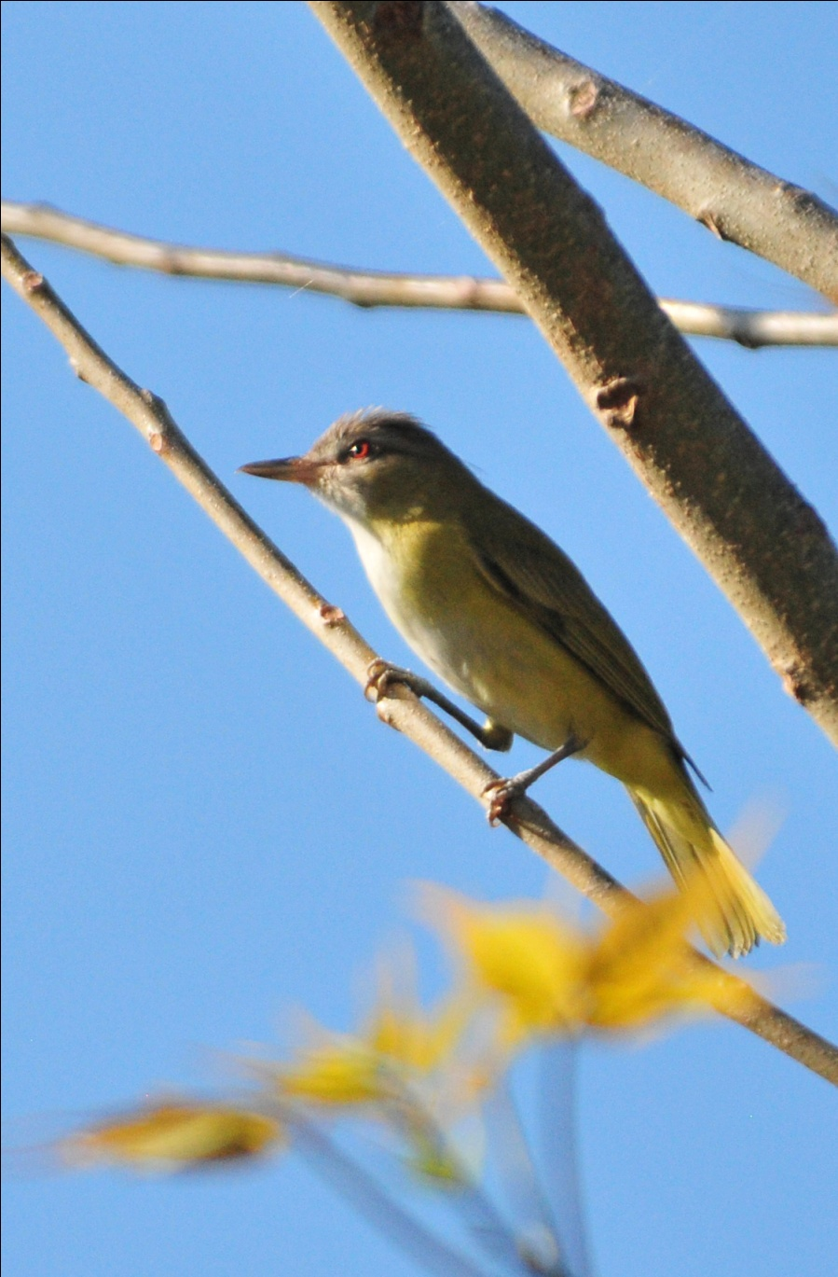
Yellow-green Vireo

Brown-throated Parakeets were somewhat difficult to see, even when they were in the trees right in front of us. They blend so well in the foliage that, if not for their vocalizations, we probably would have missed them. Rufous-browed Peppershrike put on a good show for us in flowering Cashew trees, and we observed a Red-crowned Woodpecker feeding chicks in nest cavity near the road. Panama Flycatcher and Mouse-colored Tyrannulet were also found in trees alongside the road. Raptors included both Great Black Hawk and Common Black Hawk; Carlos took the time to point out the differences between the two similar birds of prey to us.

We arrived at the rice fields by 9:00 AM where a plethora of wading birds were taking advantage of the wet area while others swarmed around the harvesting machines. Species seen included Green Heron, Great Egret, Wattled Jacana, Black-crowned Night-Heron, Purple Gallinule, Cattle Egret, Glossy Ibis, Snowy Egret, White Ibis, and Little Blue Heron. A White-tailed Kite was seen hovering over the fields, and Lesser Yellow-headed Vultures were seen soaring and on the ground. Crested and Yellow-headed Caracaras, Roadside Hawk, and Savannah Hawks were all present, as were many swallows, including Cliff, Barn, and Bank. Ruddy Ground-Doves were fairly common in this area, but Carlos was quite excited to find a Blue Ground-Dove while following the call of a Lance-tailed Manakin .

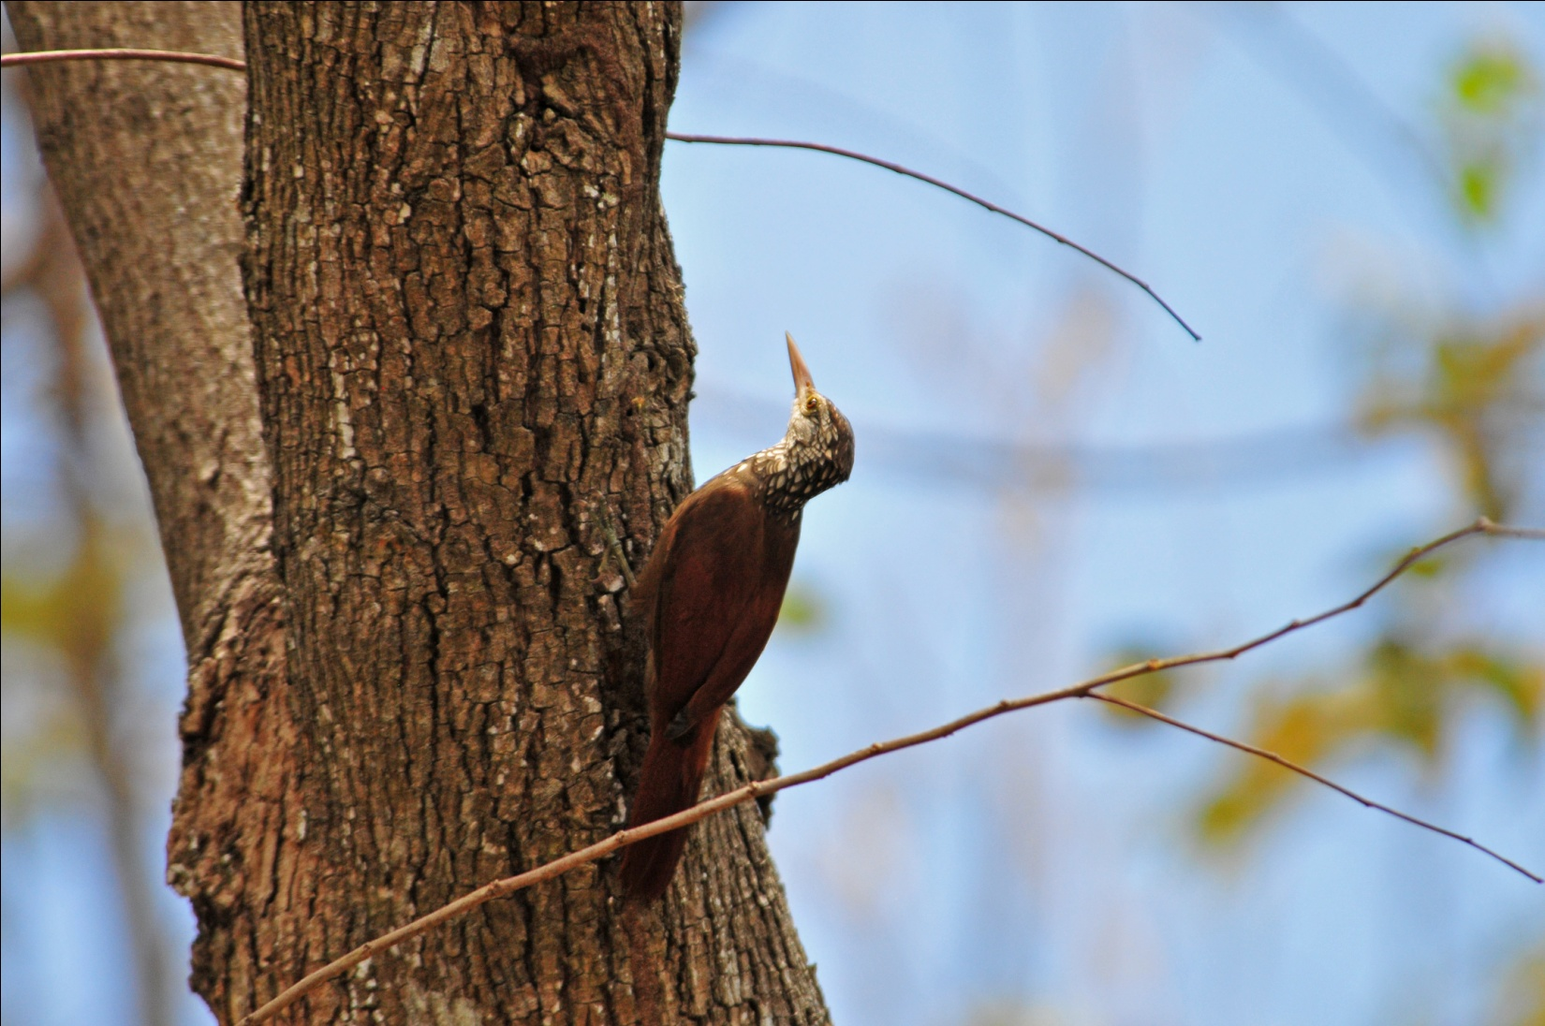
Straight-billed Woodcreeper

As we neared the coast, we saw Magnificent Frigatebird, Brown Booby, Whimbrel, Willet, Sandwich Tern, Laughing Gull, and Brown Pelican. As we drove up to Raul's beach house in Santa Clara for lunch, we noticed a Barred Antshrike in a low bush nearby. As we observed the Antshrike, a Sapphire-throated Hummingbird flew in to feed on the flowers there. We enjoyed a lovely lunch on the deck of the beach house. Charlie took a swim in the Pacific while some others walked along the beach looking for shorebirds and seashells. Others simply relaxed on the shaded deck. When it was time to go, we were all well-fed and very relaxed. On the exit road, we saw Straight-billed Woodcreeper. An impressive bird, we took some time enjoying prolonged looks. During that time, I could hear the voices of Orange-chinned Parakeets that sounded very close. They are not rare, but I had never been close enough to get a really good photograph, so I began to follow the sound. Much to my dismay, when I finally located the birds, I could see they had been trapped in a cage high in a tree, presumably to be sold as pets. I showed Carlos what I found, and he immediately called authorities. As we drove away a short time later, we passed the vehicle that was en route to investigate the illegal trapping of the birds.

We took a small detour near El Valle to look for Lance-tailed Manakin and some other birds that we had so far missed. We dipped on the manakin again, but we did hear them calling in the deep recesses of the forest. Here we saw Black-chested Jay, White-vented Plumeleteer, Cocoa Woodcreeper, Rufous Motmot, and Red-crowned Ant-Tanagers. Yet again, we heard Tody Motmot, an important target species for this area that had so far evaded us. And tomorrow would be our last chance!

We returned to the lodge at around 5:00 PM and compiled our list before dinner. 108 species (WOW!) for the day with another 7 species heard only. Our trip total now stood at 306 species.

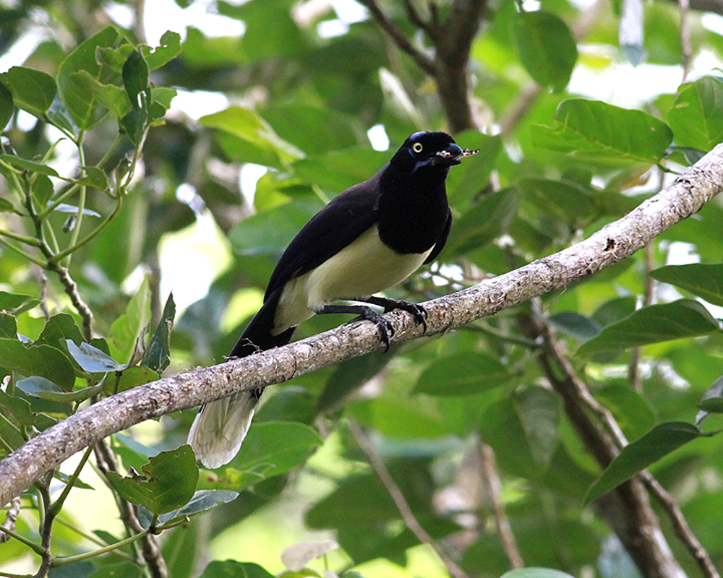
Black-chested Jay, photo by Carly Wainwright

Day 11, Friday, April 15, Cariguana Trail, Miraflores Locks
Our last day in Panama - the trip has gone so quickly! Following an early breakfast, we headed out to the Cariguana Trail, just a few minutes' drive from the Canopy Lodge. After we completed our checklist last night, I had mentioned to Carlos that we saw 323 species on last year's trip, and this morning he seemed intent on finding a minimum of 18 NEW species so we could beat last year's number. That would be quite a feat since we had only the morning to bird with departure scheduled for 1:00 PM. We were scheduled to drop Carly off for a 2:00 PM appointment with an orthopedist in Coronado, and planned to bird in the area while we wait on her to finish. After that, our next stop would be the Miraflores Locks to visit the museum and have dinner overlooking the locks.

Before we left the lodge, Carlos found an Orange-billed Sparrow, a species that has eluded us so far, near the dining area. When he tried to alert the nearest person in the group, the bird flew away. We spent a little time trying to find it again, but to no avail. Although we enjoyed seeing the feeder birds for the last time - Dusky-faced Tanager, White-tipped Dove, White-lined Tanager (male and female), Tennessee Warbler, Rufous Motmot, Red-legged Honeycreeper, Thick-billed Euphonia, Baltimore Oriole - we didn't add anything new to the trip list at the lodge this morning.

The first birds we found on the Cariguana Trail were Buff-throated Saltator and Lineated and Red-crowned Woodpeckers. All nice birds, and we were all pleased to observe them, but none were new to the trip. Moving on, we found some more "old" birds, Black-chested Jay, Yellow-olive Flycatcher, and Swainson's Thrush. Our first new bird of the day, a Long-billed Gnatwren, was a bird we had heard on FOUR previous days but had not been able to find. Today, a pair of them gave us great looks. When we found the nest cavity of a Yellow-crowned Euphonia, most of us were content to watch for awhile, but Carlos seemed a bit antsy - he needed to find 18 species and right now he was at ONE. Our next sighting was a Black-throated Green Warbler - cha-CHING! New bird #2. As we were watching a Snowy-bellied Hummingbird, I noticed a Hummer that looked different. I called Carlos's attention to it, and cha-CHING! Long-billed Starthroat - new bird #3. Carlos had called a friend for some assistance in finding 18 new species, so we now headed for a private residence where a Tropical Screech Owl was resident. We walked to the back of the property with Carlos's friend, who was the caretaker there, and he pointed out the roosting owl to us. New Bird #4. While standing in the thicket, Carlos heard a Lance-tailed Manakin, another bird that had eluded us for the entire trip. With a bit of work, we found the gorgeous male Manakin - New bird #5. Immediately following that, Jim and Carole found a Gray-cheeked Thrush, new bird #6. Maybe finding 18 new species in one morning of birding wouldn't be as difficult as I thought . . . .

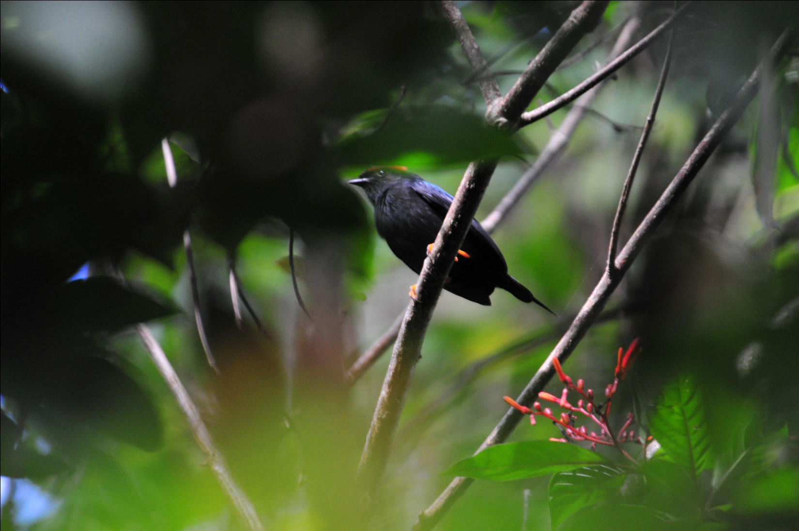
Lance-tailed Manakin
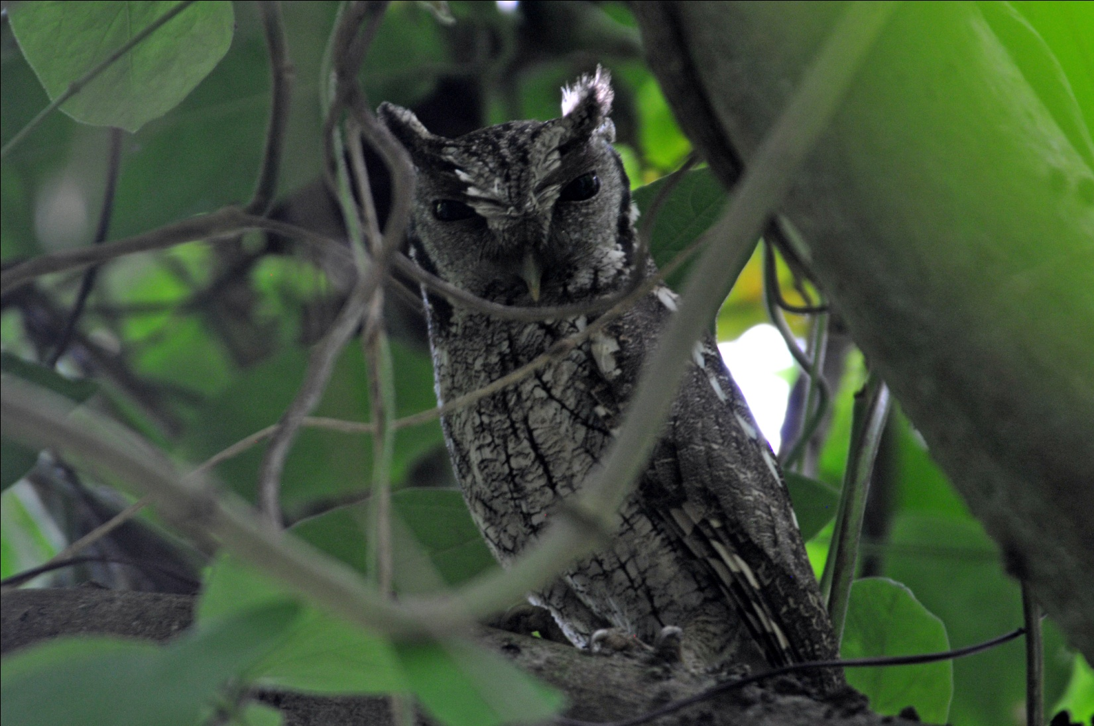
Tropical Screech Owl

Next, we decided to go back to the trail at the beginning of the Canopy Adventure to try to find the White-tipped Sicklebill, a bird that had so far only been seen in flight with no views of field marks and no chance to see that amazing decurved bill. Some of the group opted to stay at the trailhead since this trail is a bit difficult, but others braved the path. Again, it was Janel, Charlie, Jim, and I who accompanied Carlos. We approached the spot where the Sicklebill is normally seen and took turns sitting on a bench that had been positioned in front of the Heliconia plants where they feed. We waited, and waited, and waited. Carlos spotted a suspicious blob deep in the forest and put the scope on it for us - Mottled Owl! New bird #7. As we were watching the owl, Carlos heard a Tody Motmot. He turned to look the other way and immediately saw the well-camouflaged bird as its tail moved each time it called. Again, he provided perfect views of the bird through the scope. The target species that had been eluding us since we arrived was there, sitting on a low branch less than 100 feet from us, calling as we watched it through the scope. New bird #8. We focused our attention again on the Heliconia plants, hoping for a good look (and a photograph) of the Sicklebill. A Rufous-tailed Hummingbird came into feed on the flowers, and immediately, the White-tipped Sicklebill zoomed in to chase him away from his flowers! Alas, not a new trip bird because we had counted it when a few of the group had seen it on previous days, but it certainly felt like a new bird to us! We learned that this is one of those places where you could just sit for several hours and wait for the birds to come to you. As we waited, we saw Canada Warbler, Red-crowned Ant-Tanagers, Bay Wren, Rufous Wren, and Fasciated Antshrike, all within a 15-20-minute period of time.

Our time was running out now, but Carlos had one more place to look for Golden-collared Manakin, right on the grounds of the Canopy Lodge. Only a few of us followed him off the path when we returned because everyone was anxious to freshen up and finish packing before lunch. For the ones who went with him, the reward was perfect views of a member of one of my favorite families - Golden-collared Manakin. Not a new trip bird, but previous sightings had been females and immature males, so this was a great sighting.

Carlos had arranged for a late check-out for our group so we could freshen up before going to the Miraflores Lock Restaurant. I hurried so much that by the time I climbed into the bus to leave, I didn't feel like I had showered at all. We headed for Coronado for Carly's appointment, courtesy of the Panamanian government which now provides medical insurance for tourists for 30 days. There wasn't much in the way of birding opportunities in Coronado, so we opted to get some ice cream while Carly saw the doctor. She called to say she was done just as we were finishing, and we returned to pick her up. Luckily, the doctor saw no serious damage and sent her off with copies of the xrays to take home to share with her own doctors. We drove to Panama City, dropping Carlos off at his house to freshen up and pick up his wife Evelyn so he could meet us for dinner later. On the drive, we saw a Peregrine Falcon - New bird #9.

At the Miraflores Locks, we toured the museum and then gathered on the deck to watch ships go through the locks. From the deck, some birders found Lesser Goldfinch and Killdeer for New Birds # 10 and 11. Our morning of birding yielded 63 species, and our tour ended with 317 species, surely a number to be proud of!

After a nice seafood buffet at the restaurant overlooking the Miraflores Locks, we checked in to the Hotel Riande Aeropuerto. We said our goodbys in the lobby since each person's schedule for the next day would be different. This was truly a great group of people to travel and bird with, Jim and I sincerely hope to be able to host each and every one of them on a future tour.

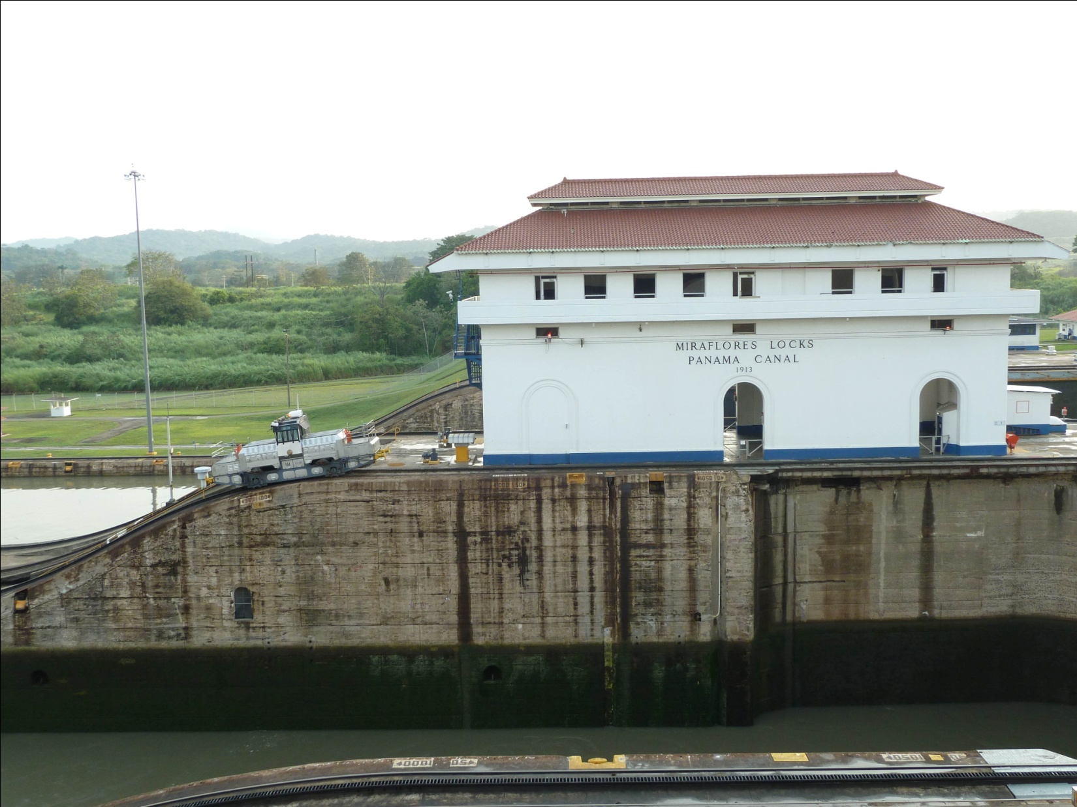
Miraflores Locks, Panama Canal

Day 12, Saturday, April 16, Departure
This morning, each person enjoyed breakfast at the Hotel Riande Aeropuerto and then took the shuttle to the airport at a time that was convenient for their flights back to the US.

Cheepers! Birding on a Budget is offering two tours to the Canopy Tower and Lodge in 2012. The first tour will follow the itinerary exactly as described in this trip report, and the second tour will visit the same birding sites in the opposite order. For tour II, we will spend the first five nights at the Canopy Lodge followed five nights at the Canopy Tower. Both tours will spend the final night at the Hotel Riande and will run April 23 - May 4, 2012. Tour I is full, but we have space on Tour II. Check our website for the bargain pricing and more details.

We also have a Panama tour in January 2012 that visits many of the same sites in the Canal Zone with 2 nights in the Chiriqui Highlands. Check our website for details on this exciting and affordable tour, as well as tours to Ecuador, Brazil, Australia, Alaska, and other destinations.

www.cheepersbirding.com

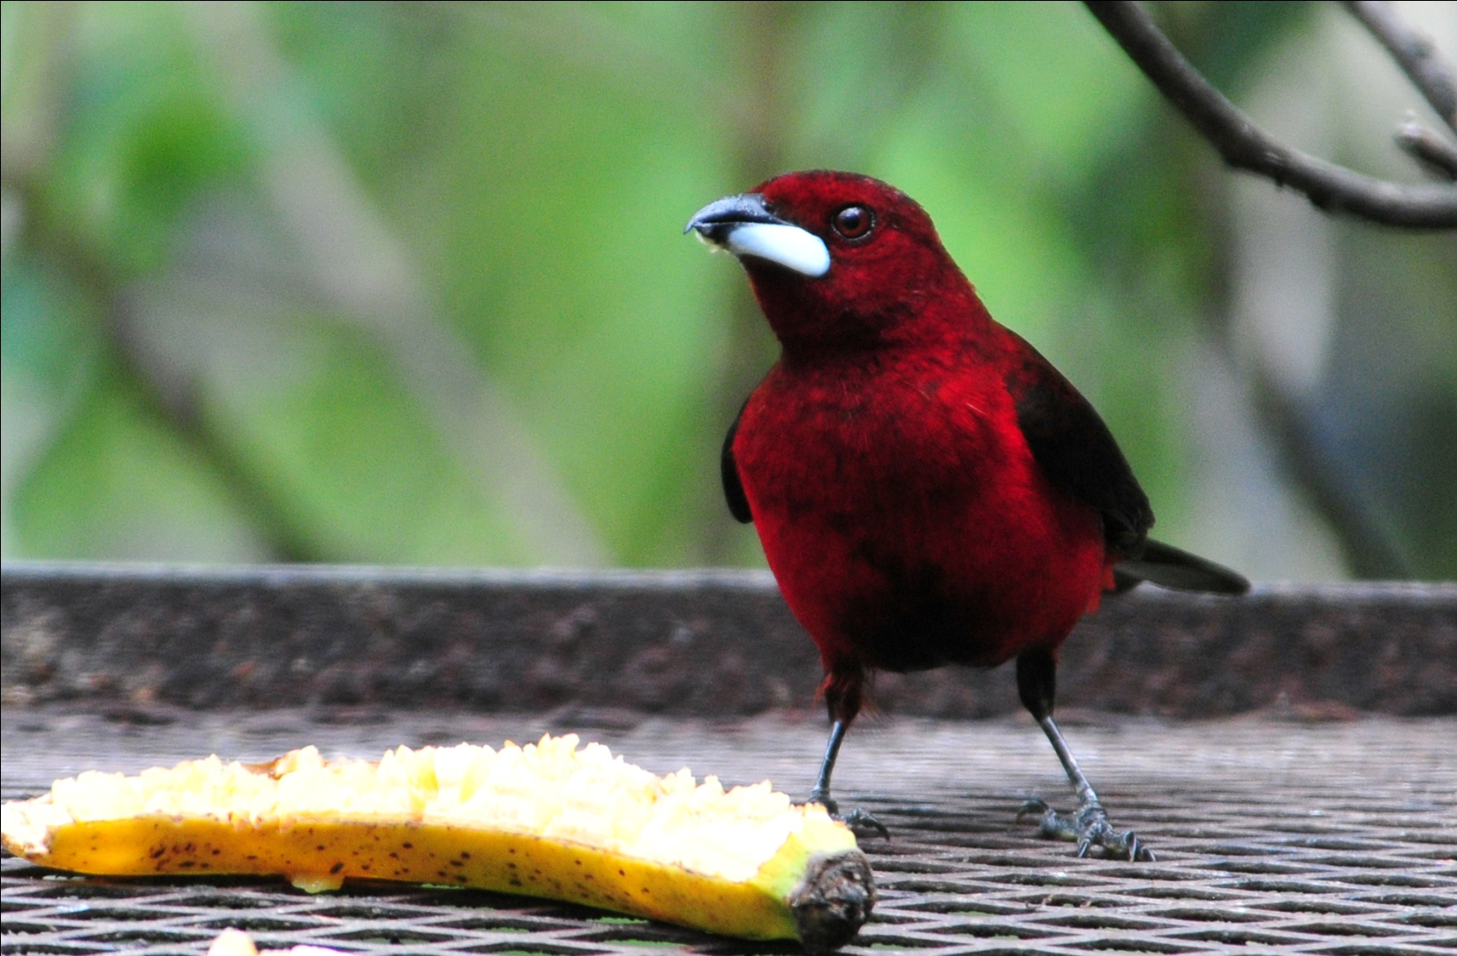
Crimson-backed Tanager at Canopy Lodge feeder

