BELIZE
Trip Report
March 19 - 28, 2010
Sponsored by the Dayton (OH) Audubon Society
Birding Guide: Glenn Crawford
Tour Leaders: Cindy and Jim Beckman, co-owners of Cheepers! Birding on a Budget
Birding group: 11 birders from 5 states
Statistics: 289 species seen, 12 heard, 2 guide only
Highlights: ACTION! A pair of Aplomado Falcons double-teaming a Barn Swallow, Jabiru catching and eating an eel, Orange-breasted Falcon in flight and then perched and preening, Common Tody-Flycatcher building a nest, Slaty-tailed and Black-headed Trogons perched within inches of each other, Laughing Falcon catching and eating a snake, Royal Flycatcher showing its bright red crest as it preened, Bat Falcon delivering a White-bellied Emerald to its mate at the nest - plus more!

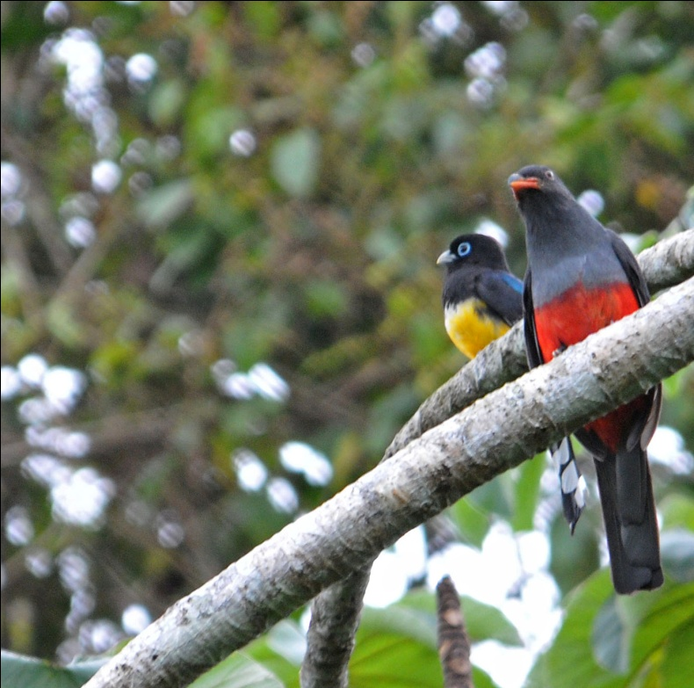

Note: Species seen on multiple days are listed only on the first day they were seen unless the sighting involved some-
thing out of the ordinary.

Day 1, Saturday, March 19: After arriving at the Belize City airport, the group gathered and met our guide, Glenn Crawford. Sybil had traveled from Oregon, Skip and Pam from California, and the rest of us - Jennifer, Becky, Brad, and Jim and I - had flown in from Ohio. We wasted no time in leaving the city and getting on the road to Crooked Tree. Three members of the group were already at the lodge: Chris from Michigan, who had arrived on March 17, and Steve and Myra from Missouri, who had arrived the 18th. Along the way, Glenn pointed out several birds, including a Magnificent Frigatebird as we left the city and a Roadside Hawk that was, appropriately, along the side of the road, but we didn't make any real stops until we were on the causeway leading to the village of Crooked Tree. There, on both sides of the man-made strip of land connecting the village to the main road, were thousands of water birds. We counted at least 20 Jabirus and as many Limpkins and Snail Kites. We didn't even try to count the other species present as it would have been futile. Great Blue, Green, Tri-colored, and Little Blue Herons, Cattle, Great and Snowy Egrets, Black-bellied Whistling Ducks, Blue-winged Teal, Pied-billed Grebe, American White Pelican, Neotropic Cormorant, Anhinga, White and Glossy Ibis, Roseate Spoonbill, Black-necked Stilt , American Coot, and Northern Jacana, all present in large numbers, delighted us as we moved the scope from one area of the water to the next. Ospreys hunted overhead as Snail Kites perched low to the water. Three species of vulture were seen: Black, Turkey, and Lesser Yellow-headed. As we enjoyed the spectacle before us, Glenn told us that the causeway had been built in 1982, and that prior to that time people had to use small boats to get to the village of Crooked Tree. The village did not have electricity until 1991.

Having traveled all morning, most of us had had no lunch, but the huge numbers of birds deflected our attention from our growling stomachs. Finally, satisfied but not sated by our causeway birding, we went on into the village for lunch at a local restaurant called Carrie's. As we got out of the van, we noticed a group of raucous Brown Jays in the yard adjacent to the restaurant. Thinking they were likely to stick around, we took a quick look and went inside to eat. We were served a delicious plate of chicken, rice, beans, and slaw and paid a grand total of $4, which included a soft drink. As we left the restaurant, Glenn spotted an American Pygmy Kingfisher perched on a barb-wire fence. We enjoyed great views at a close distance, but the sun was glaring from a position that made its colors wash out somewhat.

When we arrived at Crooked Tree Lodge, we quickly settled in and soon met our fellow travelers. Chris, Myra, and Steven had been birding on their own and had seen several species before we arrived. Most we were able to relocate, but the rest of the group never managed to find another Yucatan Woodpecker or Philadelphia Vireo during our stay. We birded a little around the lodge before meeting Glenn to go back out birding, this time among the pine savannahs on the south side of the village, at 3:30 PM. On our own, we found several common species, including Groove-billed Ani and Clay-colored Robin. But the most impressive birds found during our "break" were two members of the flycatcher family - Fork-tailed Flycatchers with their long black tails flowing behind them and the radiant Vermilion Flycatchers that were posted like sentries around the property. What a wonderful sight!
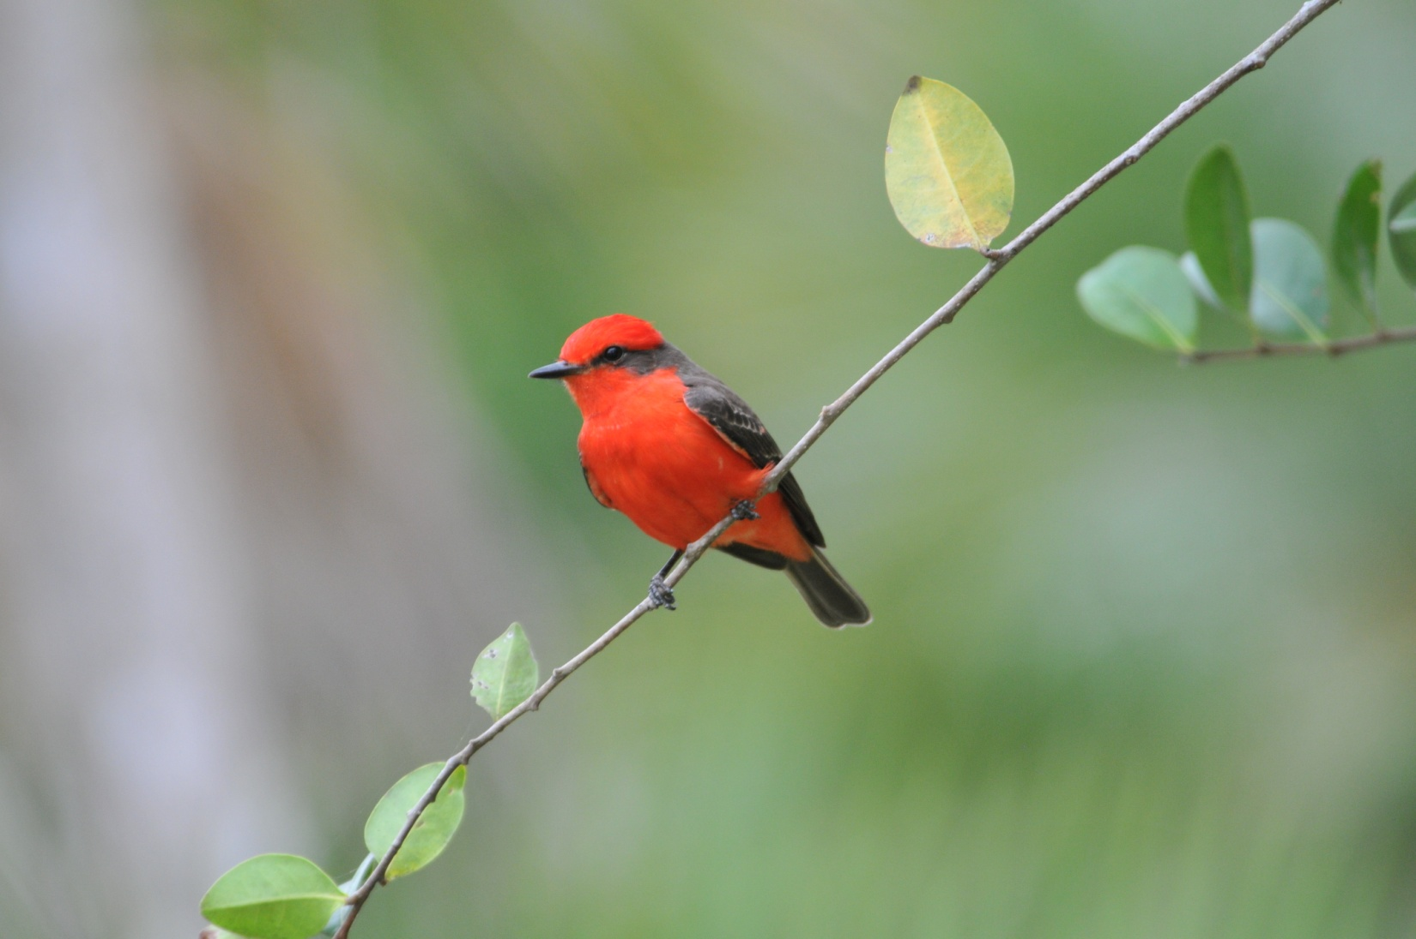
Vermilion Flycatcher

As we birded the south side of town, we continued to enjoy the show put on by water birds of every size and color. We added Fulvous Whistling Duck, Purple Gallinule, and Bare-throated Tiger-Heron to our already-impressive list of waders and swimmers. Shorebirds were not plentiful, but we did see Solitary and Spotted Sandpipers and Lesser Yellowlegs. We returned to the spot where we had seen the diminutive kingfisher earlier, and there on the same fence and in perfect light, sat a gorgeous little American Pygmy Kingfisher. Oblivious to our presence, he continued to watch the water below for prey as we took photographs and noted other species nearby: Pale-vented Pigeon, Ruddy Ground-Dove, Rufous-tailed Hummingbird, Ruby-throated Hummingbird, Common Tody-Flycatcher, Great Kiskadee and its smaller cousin the Social Flycatcher, Tropical and Couch's Kingbirds, White-collared Seedeater, and female Painted Bunting. Later that afternoon we added Ringed and Belted Kingfishers to our growing list, but the only tanager we saw on our first day of tropical birding was the very common (and very beautiful) Blue-gray Tanager. Other significant species found this afternoon included Great Black Hawk, Gull-billed and Caspian Terns, Acorn Woodpecker, Gray-breasted Martin, and Mangrove Swallow. Some species commonly seen in North America added to our day's list: Northern Rough-winged and Barn Swallows, House Wren, Blue-gray Gnatcatcher, Gray Catbird, Yellow, Magnolia, Black-and-White, Hooded, Yellow-throated, and Grace's Warblers, Great-tailed Grackle, Chipping Sparrow, Orchard and Baltimore Orioles, and American Redstart.

Just before the light began to fade, we followed a group of noisy Yucatan Jays as they made their way through the small trees and shrubs along a dirt road. Most of us were able to see the jays pretty well, but we all agreed we hoped to see more of these beautiful corvids. Later, as evening light forced us to retreat to the van, we saw some Olive-throated Parakeets and Yellow-lored Parrots, but we all agreed they were "BVD"s - Better View Desired. Mealy Parrots flew overhead, making their way to a safe roosting spot for the night. Also at the end of the day, in very poor light, was a Collared Aracari and a Lesser Nighthawk. We finished our first day of Belize birding with 100 species for the group, and couldn't wait to see what tomorrow would have in store for us!
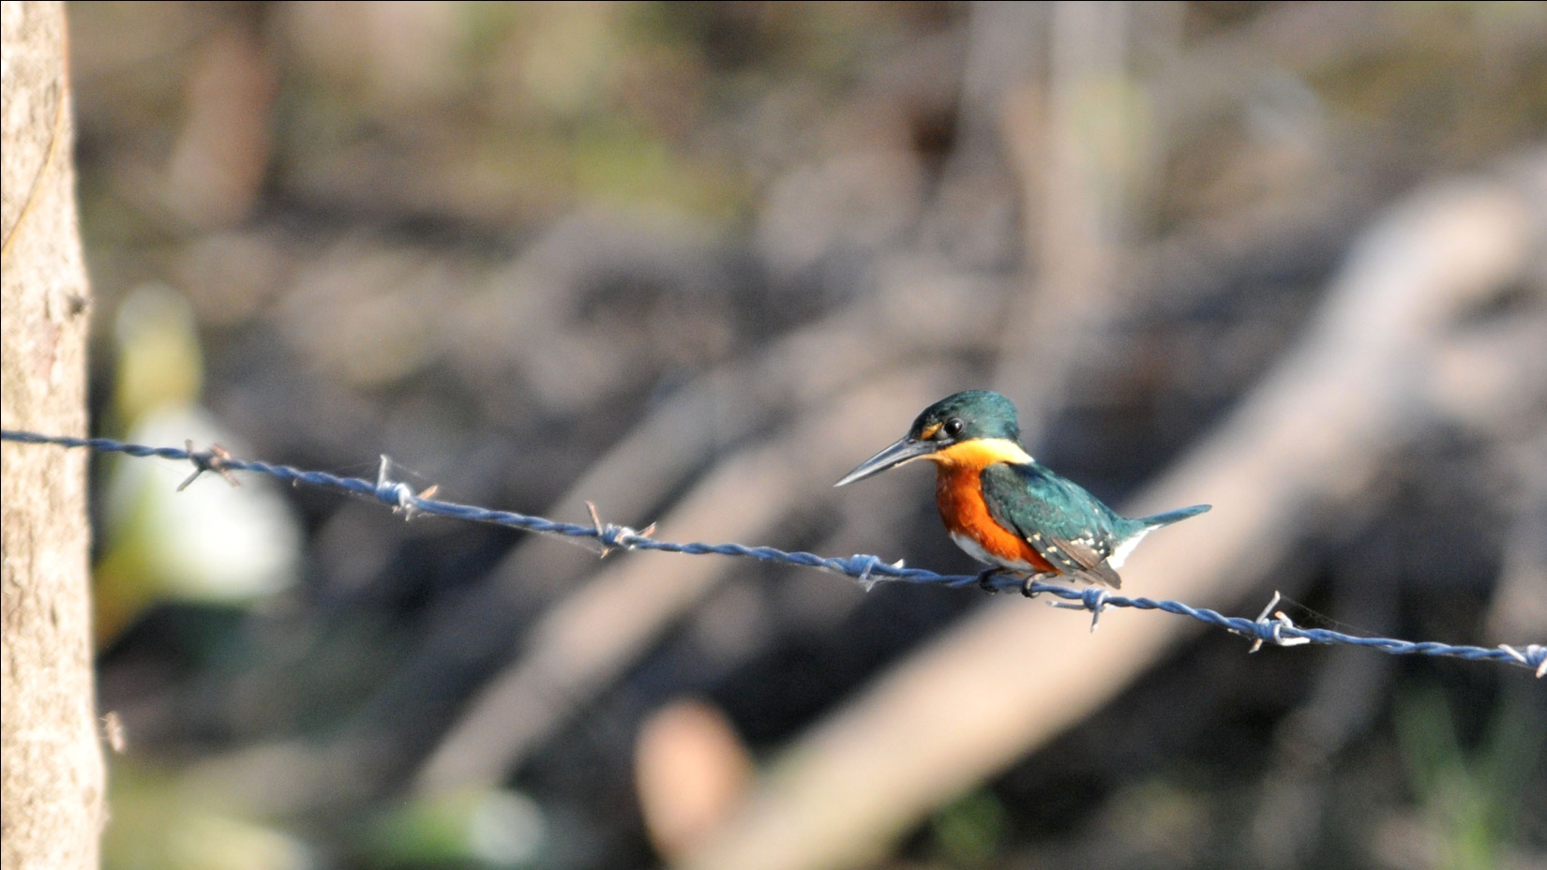
American Pygmy Kingfisher

Day 2, Sunday, March 20: We were not able to take a morning boat trip on the lagoon as scheduled due to the extremely low water levels, so we planned to spend the day birding the New River Pine Savannah and the southern lagoon. But first, we headed off to search the area around Crooked Tree Lodge for the Black-collared Hawk that normally frequents the area but had eluded us so far. We walked a short distance along the edge of the lagoon, enjoying good looks at some new species, including Lesser Yellow-headed Vulture, Great Black Hawk and Ringed Kingfisher. We marveled at the spectacle that is Crooked Tree with hundreds of birds wading in the shallow water, and forced ourselves to return to the lodge for breakfast without having seen our target bird, but quite pleased with our "consolation prize" birds.

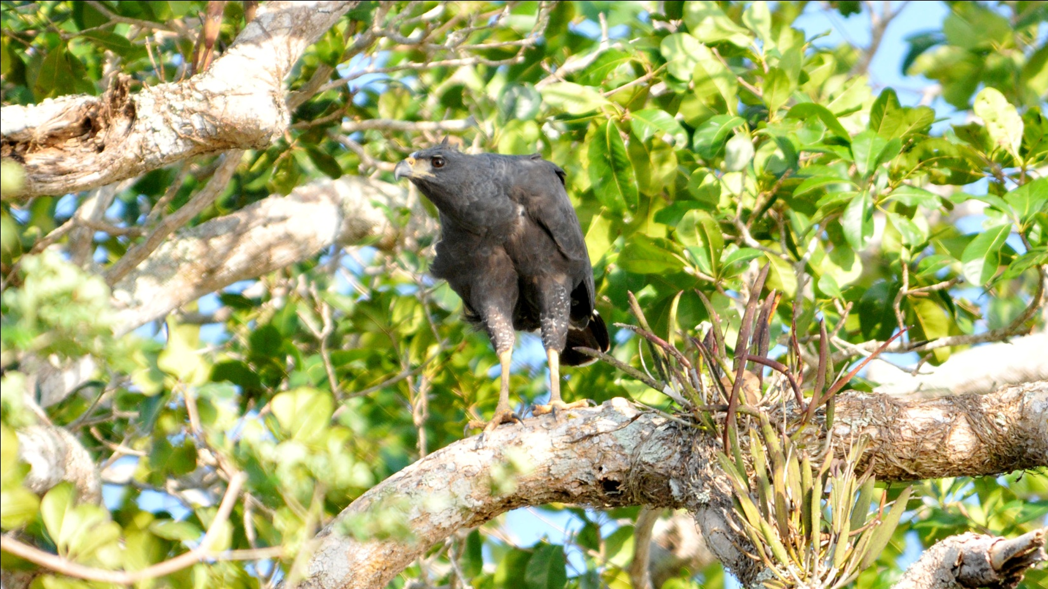
Great Black Hawk

Glenn knew of a spot where Black-throated Bobwhite can usually be found, so we drove as far as we could and then walked to an area with tall grasses and scrubby bushes - perfect habitat for quails. As we approached the spot where he expected the birds to be, he spotted one a short distance from us. We all stood frozen, waiting for the birds to flush, until Glenn finally decided to approach them from the other side to get them to move. As he did, some of the birds flew a short distance, but only after he came within inches of stepping on them! We worked hard to get a good view of the birds for everyone without stressing them, finally succeeding before moving on.

For the rest of the morning we drove some, walked some along a gravel and dirt road that allowed us access to the savannah habitat. After a midday break, we went back and repeated the procedure along a different road, one that had obviously been much wetter during other seasons. The ruts and indentations on the baked mud road were difficult to navigate without keeping your eyes on the ground in front of you. Even with our eyes diverted to maintain our balance, we manage to finish the day with an impressive 102 species for the group. Among the many species observed were Short-tailed Hawk, Laughing Falcon, Bat Falcon, Gray-necked Wood-Rail, Black-bellied Plover, Killdeer, Pectoral Sandpiper, White-fronted Parrot, Yellow-headed Parrot, Common Paraque, Plain Chachalaca, Buff-bellied Hummingbird, Green Kingfisher, Golden-fronted Woodpecker, Greenish Elaenia, Yellow-olive and Dusky-capped Flycatchers, Rose-throated Becard female, White-eyed, Mangrove, and Yellow-throated Vireos, Tree Swallow, Black-throated Green and Prothonotary Warblers, Ovenbird, Northern Waterthrush, Common Yellowthroat, Summer Tanager, Eastern Meadowlark, Black-cowled and Hooded Orioles. Glenn was enthusiastic when he heard a Northern Cardinal, and he explained that they are uncommon in Belize, which is its most southerly range. We observed some unusual behavior among migrant species, with Yellow-throated Warblers feeding on insects in the window sills and Yellow Warblers foraging on the ground. At one point in the afternoon, Jim and Becky heard a sound along the edge of the scrubby wooded area we were walking along. They alerted Glenn, who caught a glimpse of a Rufous-breasted Spinetail as it worked its way parallel to the road, about 12 feet in. We struggled, one by one, to find the bird each time it popped into view, and then helping others to get a good view. While it wasn't easy, everyone in the group was rewarded with excellent views of a bird that is quite often seen for a split second before it disappears into the understory. We were not able to locate a couple of target species for the day, Black Catbird and Black-collared Hawk, and we only heard the Rufous-browed Peppershrike and Yellow-billed Cacique.

Day 3, Monday March 21: Everyone was up and on the dock before sunrise this morning - what a beautiful sight! With significant winds, the parade of birds right in front of the lodge wasn't as impressive as it had been a few days earlier, before the main group arrived, but having coffee with the sun coming up over the lagoon and the wading birds flying in to start their day's activities is an experience well worth a few hours' sleep.

Although we were eager to get to Lamanai, we couldn't resist spending a few minutes checking things out around the lodge. A couple of Gray-necked Wood-Rails were strutting nearby, and a Ringed Kingfisher and Little Blue Heron shared a perch in a tree at the lagoon's edge. A short stop along the causeway gave us one more opportunity to marvel at the hundreds of wading birds on either side. We moved on to the Northern Highway toward Shipyard, and made a few brief stops for grassland birds that are common in the farmlands of the Mennonite communities that thrive there. Fork-tailed Flycatchers perched on fences along the fields of sorgham and Blue-black Grassquits were numerous in the grasses along the road. We were lucky to find a cooperative Gray-crowned Yellowthroat at one stop. As we searched the tall grasses for the singing bird that Glenn had identified as a Gray-crowned Yellowthroat, a beautiful male flew to a tall reed and sang as if his objective was to please his human audience. The bird remained in full view for several minutes.

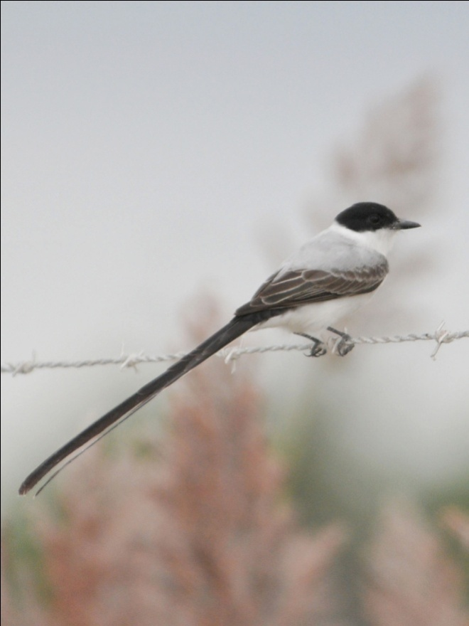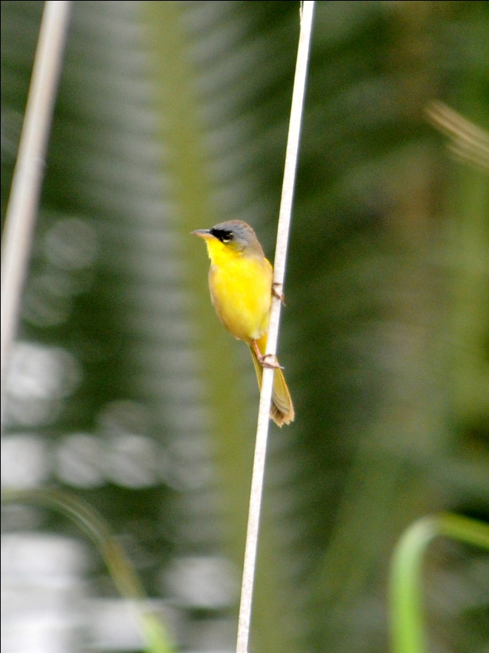
Fork-tailed flycatcher Gray-crowned Yellowthroat

As we were driving through the dusty countryside, where everything seemed to be coated with a layer of limestone dust from the road, someone in the back spotted a raptor. Glenn backed the van to the spot where the bird had been seen, and we were rewarded with excellent views of a Laughing Falcon. As we watched the bird, it suddenly dropped to the ground and quickly returned to its perch with a fairly large snake. We watched as it struggled to swallow a snake that was longer than its own body. Just seconds after devouring its prey, the falcon flew to a new perch in a dead tree even closer to us. What a thrill for us to witness this behavior!

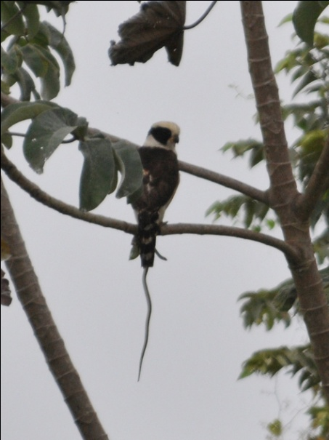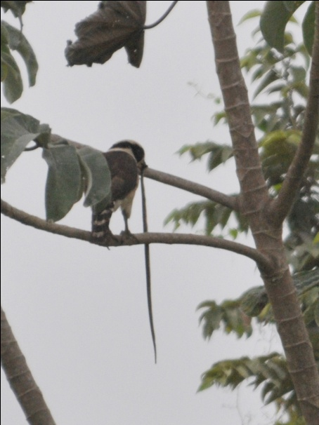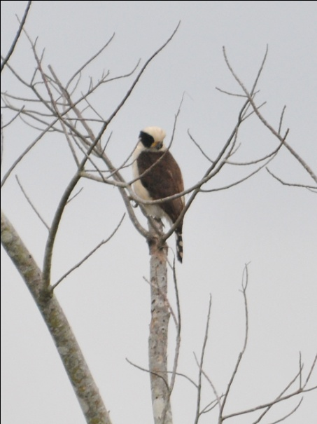
Laughing Falcon with lunch

When we reached Lamanai, we didn't even make it to the entrance before finding our first trogon of the trip - a beautiful male Violaceous Trogon sat quietly on a branch above our heads, tilting its head as if wondering what strange beasts were staring at him. A few steps further along the road, just before we reached the official Lamanai entrance sign, we heard our first howler monkeys calling in the distance. With the brilliant hues of the trogon and the howling of the monkeys as a backdrop, this was definitely one of those "You're not in Kansas anymore" moments.

We did not make it to the loop trail before coming across an Army Ant swarm. Everyone jockeyed for position while at the same time making sure they weren't blocking someone else's view as we watched Red-throated Ant-tanagers, Gray-headed Tanagers, Black-faced Antthrush, and some other species gorge on the insects scared up by the marauding Army Ants. With so many birds flitting about near the forest floor, I had a terrible time getting a good look at anything other than the Ant-tanagers. People were calling out directions to help each other, and I think the birders were much more frenzied than the birds or the insects. Squatting on the ground, it didn't occur to anyone that we might be positioning ourselves among chiggers or something else equally unpleasant until after the feeding frenzy had ended. Fortunately, no one sufffered any negative consequences from the experience other than mild frustration over species missed.
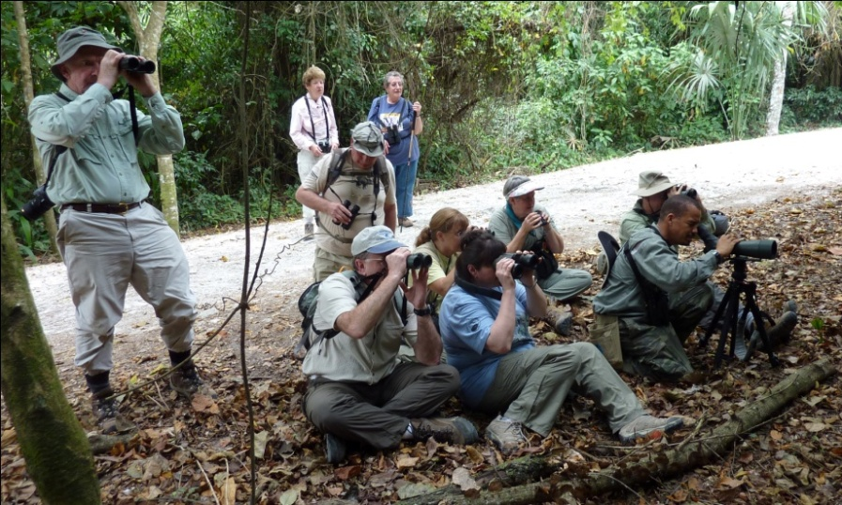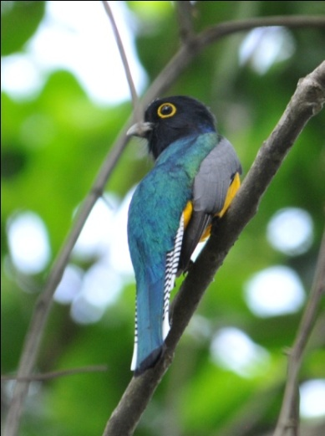
Getting down and dirty with the Army Ant swarm! Violaceous Trogon

We walked the entire loop around the Lamanai ruins, stopping our search for birds periodically to learn about the history of the site from Glenn. At the base of one of the structures, we got our first real looks at Howler Monkeys, and although we would see many more on this trip, this was an exciting moment for everyone, especially those for whom this was their first trip to the tropics. White-crowned Parrots drew us away from the monkeys, and later we saw a Black hawk-Eagle soaring overhead. Yellow-throated and Olive-backed Euphonias, Lesser Greenlet. Great-crested Flycatcher, and three different woodcreeper species - Tawny-winged, Ruddy, and Northern Barred - rounded off the morning. We were able to get good looks at our first Boat-billed Flycatcher from an angle that allowed us to admire the size and shape of the bill and compare it to that of the Great Kiskadee.

As we approached one of the ruins, we saw two men on top, one with a bag of something that created dust when shaken around the other man. As the first man removed his shirt, the second spoke some words and shook the bag around his shoulders and head. We had no idea what we were observing but assumed it was some kind of Mayan rite and that one of the men was a shaman. We felt privileged to witness this rite, even though we didn't fully understand what we were seeing.

We had a lovely catered lunch in a shelter near the river and the museum. As we relaxed for a short while after eating, we watched the birds flitting about near the shelter. Green-backed Sparrows came out into the open at close range. As we were commenting on their similarity to Olive Sparrows, a gorgeous male Blue Bunting came into view. We watched as it foraged on the ground, coming nearer and nearer to our picnic tables. I had seen Blue Buntings before, but never in lighting this good, and never this close. It was as good as seeing a life bird!

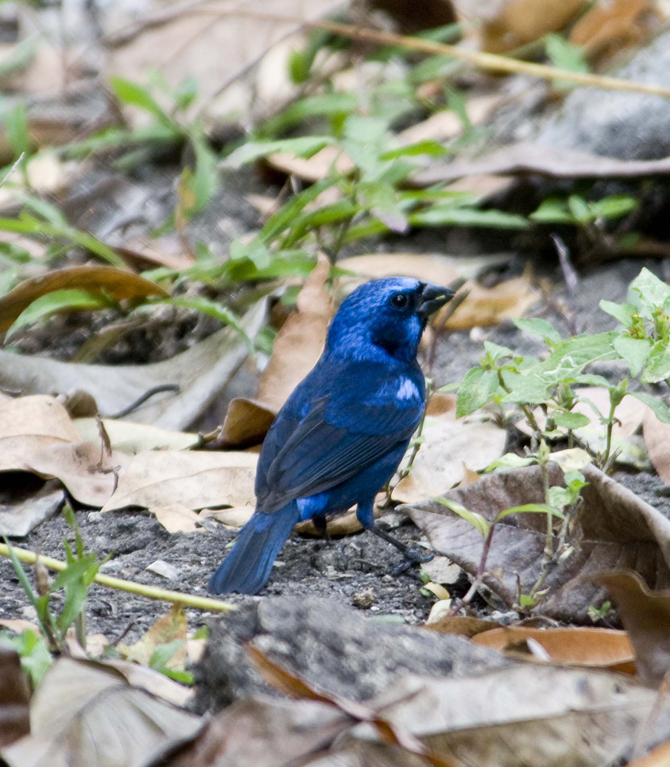
Blue Bunting
As we walked a short distance to the small museum, we spotted a Lineated Woodpecker working low in the trees near the path. The bird moved about, methodically searching for insects in the bark, remaining in view long enough for Glenn to be able to point out the differences between this species and the very similar Pale-billed Woodpecker.

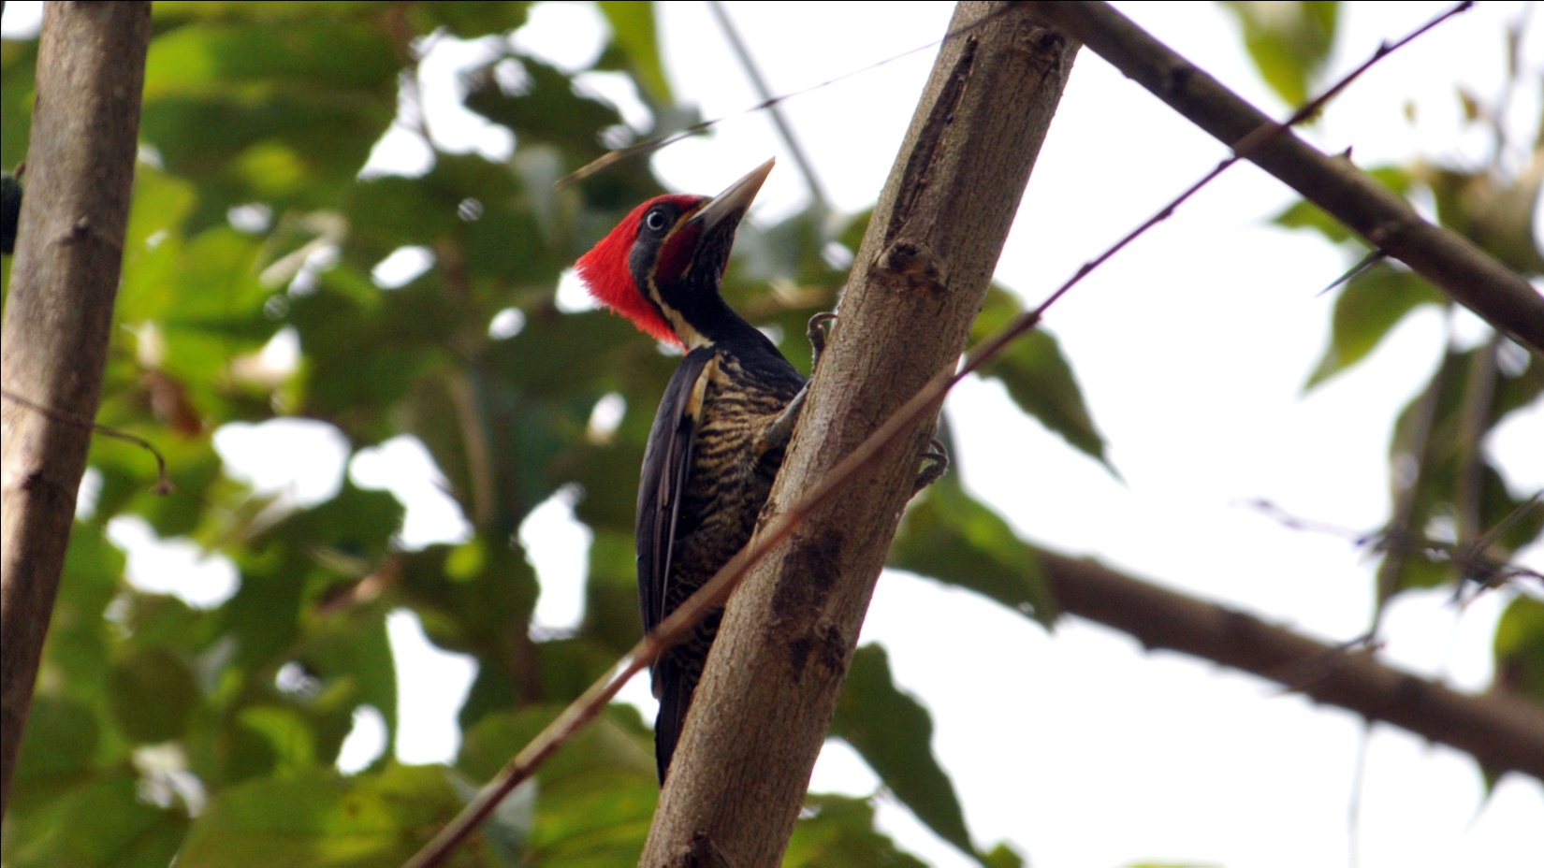
Lineated Woodpecker

As if that wasn't enough for our "lunch list", as we started down the trail for our afternoon walk, a pair of Royal Flycatchers caught our attention as they dashed from tree to tree, chased each other, hawked insects, and in general thrilled us all. We were hoping, of course, for the male to display his royal red crest, but even without seeing it, we could not be disappointed by the display we saw.

Other species seen in the afternoon inlcuded Gray Hawk, Red-billed Pigeon, and Bronzed Cowbird in addition to many species seen on Days 1 and 2. We made our way back to Crooked Tree in time for dinner. When we completed the checklist after dinner, we learned that the list for the day was a very impressive 110 species.

Day 4, Tuesday, March 22: We decided to make one last try for the Black-collared Hawk before breakfast. As we started to walk along the edge of the lagoon to investigate the same area we had searched a few days before, we were hoping to catch a glimpse of the bird before we had to leave for our next lodge. Knowing that it would be unlikely to find Black-collared Hawk at either of our next two destinations, we were eager to begin the search but a little worried that we would most likely be unsuccessful again. After all, we had been here for three days, and this reportedly common bird had been invisible since our arrival. As we neared the edge of the mown area in front of the lodge, we looked up to see a Black-collared Hawk sitting in a tree at the edge of the lagoon. We watched as it flew to a post at the mouth of the small creek that flows into the lagoon, displacing the Green Heron that normally occupied that spot. Shortly after it settled on its new perch, a Snail Kite landed in the bush right behind the hawk. We spent some time admiring the two raptors before tearing ourselves away to depart for Mama Noots Backabush in Mayflower- Bocawina National Park.

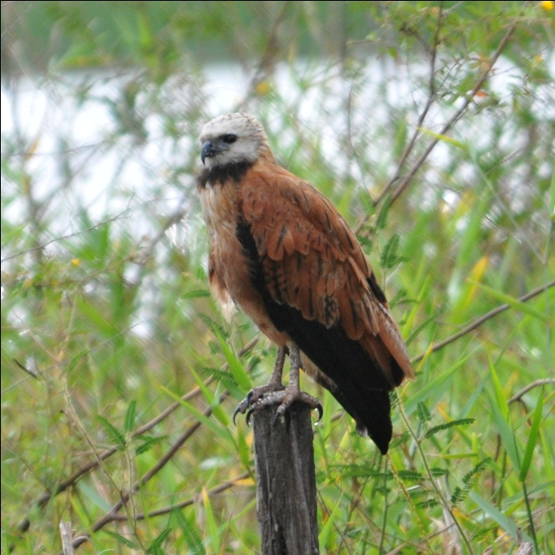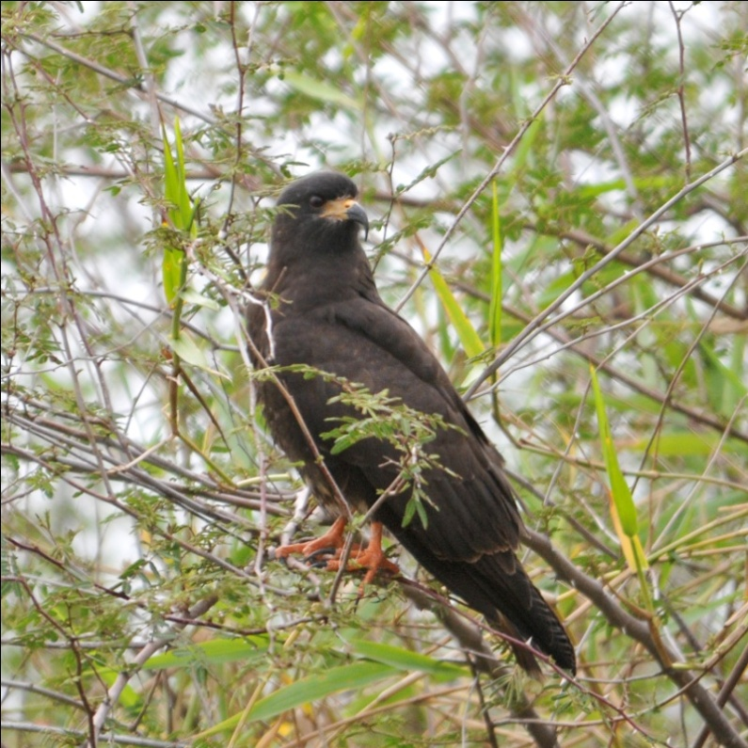
Black-collared Hawk Snail Kite

We left shortly after 8:00 AM, and expected to take most of the day to drive to Mama Noots as there would be several birding stops along the way. Our first stop was meant to be brief - just a quick look at a Jabiru nest on Grace Bank Road, an unpaved road off the main highway that led to the small village of Grace Bank. There was, indeed, a solitary Jabiru nest in a large tree about 150 feet from the unpaved road. We could see the fuzzy chick when we first arrived, but it quickly disappeared below the edges of the nest. While some of us were still looking at the parent stork on the nest, hoping for another glimpse of the chick, others were drawn to an Erythrina tree a little further down the road. In full bloom, it was attracting an impressive number of honeycreepers, orioles and hummingbirds. We watched the tree for what seemed like a few minutes but was actually more like a half hour as Black-cowled, Hooded, Baltimore, and Orchard Orioles feasted on the nectar and insects provided by the tree. Male and female Red-legged Honeycreepers joined with a Green-breasted Mango, White-bellied Emeralds, and Rufous-tailed and Ruby-throated Hummingbirds as they flitted from one bright orange flower to another. As we were watching the first tree, we heard a raucous group of Olive-throated Parakeets fly into another Erythrina tree a bit further down the road. As we moved on to get a better look at the parrots, a Squirrel Cuckoo caught our attention as it moved through the branches of the tall shrubs that lined the road. By now, we had proceeded quite a ways down the road and decided to continue for awhile since the birding was so good here. White-collared, Vaux's and Lesser Swallow-tailed Swifts darted in the sky above us as a Brown-crested Flycatcher called from a tree. Near the end of the road close to the Belize River, we ventured off the road and onto the grassy bank of the river to look at a Hepatic Tanager. I looked back toward the road and saw a large Brahma bull facing us. Knowing that Jim is uncomfortable with large livestock, I mentioned it to him and the others. As we were all reassuring each other that the bull was not a threat, Glenn advised that we move out of its way. As we moved toward the direction we had come from, it started running straight at us! Keeping our eyes on the bull, we quickly moved away from its path and watched as it proceeded to the bank of the river where it drank and then started rubbing its horns in the tall eroded bank. I don't think anyone was truly in danger from the animal, but I can assure you there were some elevated heart rates for a few seconds.

As we were watching a kingfisher along the bank of the Belize River, Pam asked for some assistance with her binoculars. Skip had already tried to work with them, and Glenn now checked to see if he could correct the problem she had been having for the last 20 minutes or so. Her brand new Swarovski binoculars had completely stopped focusing in one of the barrels! There was no way to fix the problem, and we were on just day 4 of our 10 day trip. Luckily, Jim and I carry an extra set of binoculars with us in case we meet a young birder who is in need of optics. While this may sound strange,
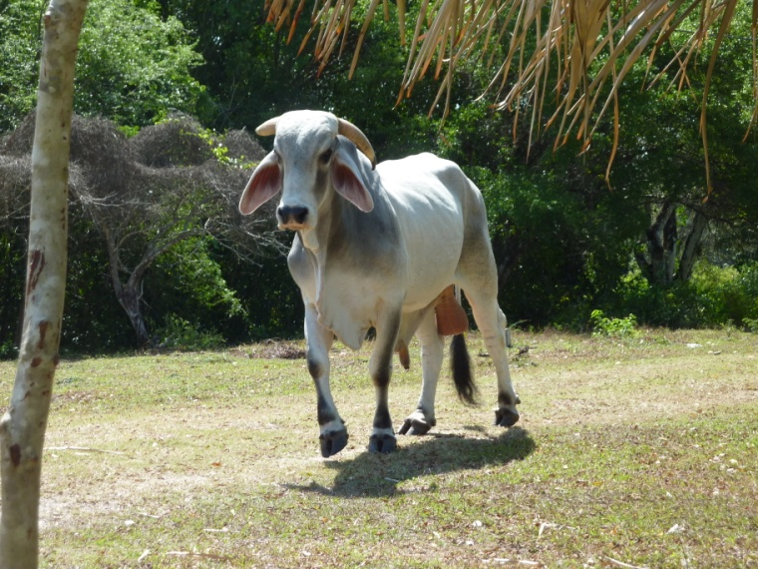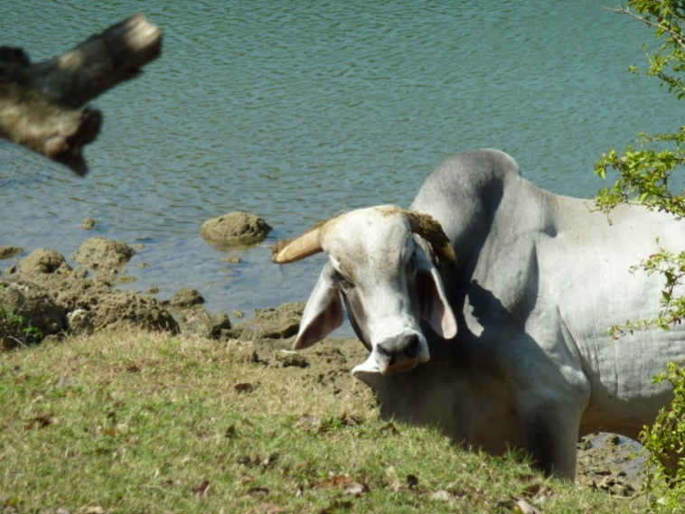

we first met just such a young birder on our first trip to Ecuador. So impressed were we by his interest and his skill in finding birds without benefit of optics that we sent him a pair of waterproof binoculars when we got home. It took a lot of effort and almost 9 months to get the optics to him, but we finally received a photograph of our driver presenting the binoculars to the boy's uncle. On our January 2010 trip to Panama, we met another young birder, this time a young lady, at Madden Dry Forest. She showed a strong interest in birds and was already an amazing birder- again without optics. It would have felt so good to be able to present her with a pair of binoculars of her own, that Jim and I decided right then and there that we would always have an extra pair with us on future trips, just in case. Although the quality of these binoculars, as you would imagine, could not compare with that of Pam's Swarovskis, they were good enough to salvage the trip for her. Her traveling partner, Skip, had also bought a new pair of Swarovskis before the trip, and his were working as expected. Being the considerate person he is, Skip volunteered to take turns with the inexpensive Bushnells so they would both have the opportunity to use the new Swarovskis every other day. What a guy!

Our next stop was a restaurant called Cheers! located on the Western Highway. After ordering our authentic Belizean meals, we noticed some birds near the outdoor dining area. A Yellow-throated Warbler foraged for insects along the eaves as Blue-gray and Crimson-backed Tanagers flitted around the garden. Some of us decided to walk around the garden area, and quickly found Variable Seedeaters and Yellow-faced Grassquits, as well as some species we had seen earlier on the trip.
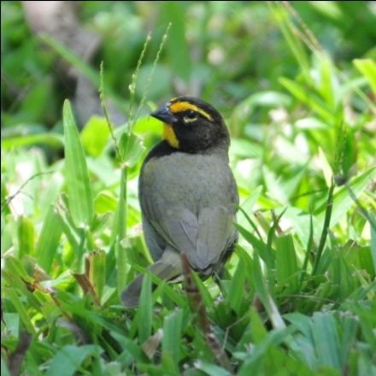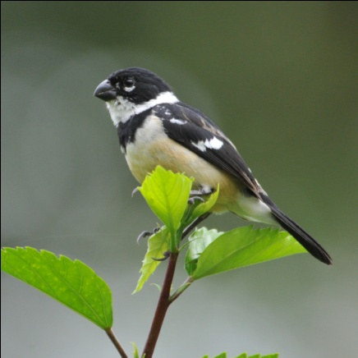
Yellow-faced Grassquit White-collared Seedeater

Our next stop was the Belize Zoo. Founded by Sharon Matola, this little zoo is a treasure. Filled with native species that have been rescued, the zoo first opened in 1983 when 17 animals were left from the filming of a natural history documentary. A staunch environmentalist, Ms. Matola led an unsuccessful movement to stop construction of the Chalillo Dam on the Macal River about a decade ago. The area affected by the dam was home to more than a dozen rare and endangered species, including the jaguar, tapir, howler monkey, and the Scarlet Macaw, of which fewer than 200 remained in Belize. Her campaign to stop the construction of the dam put her in grave danger, as described in the book "Last Flight of the Scarlet Macaw" by Bruce Barcott. According to the book, a corrupt government allowed the project to proceed despite all the scientific evidence that it would be detrimental to both the animals and the people of the area, and the Chalillo Dam was completed in 2005. Unfortunately, as predicted by the scientific community, the dam has provided little electricity for the people of Belize while resulting in an environmental nightmare. Last year, BELPO ( Belize Environmental Law and Policy) filed an application to Belize’s Supreme Court for an injunction to stop the sediment discharges from the dam. Those sediment discharges, which were first detected in July by the population downstream, have fouled the water, making it unsafe to use, and have threatened the downstream river ecology and the coastline where the river empties into the Caribbean Sea.

I had visited the zoo in 1996, before the Chalillo Dam project had been publicized. I deeply admire the work of Sharon Matola, even more since her efforts to save the Macal River Valley, and would gladly donate to assist in her efforts to save Belizean animals and educate the Belizean population about conservation. However, when I was asked to pay an extra $100 US to take my camera inside the zoo because it had a "professional lens", I decided I did not want to support the zoo even at the level of a $20 admission ticket. My sense of fairness being somewhat exaggerated, I often cut my nose off to spite my face, and this was a good example of just such behavior. I thought it unconscionable to gouge tourists who happen to carry nice cameras for this amount of money. What, exactly, was the reason for such a policy? So I (with my shortened nose) sat in the parking lot while the rest of the group toured the zoo. They were lucky enough to see Sharon Matola as she visited some of her favorite animals, including the jaguars, so I missed out on a rare opportunity due to my stubbornness. But I must admit I will most likely repeat the behavior the next time I see a policy that I view as unjust. Some people just never learn!

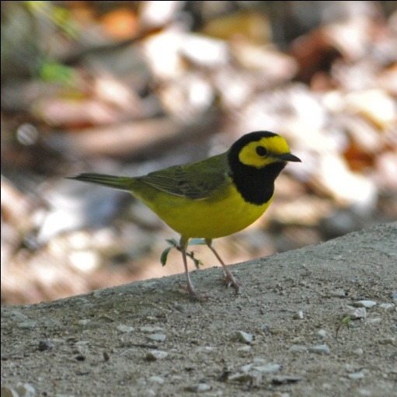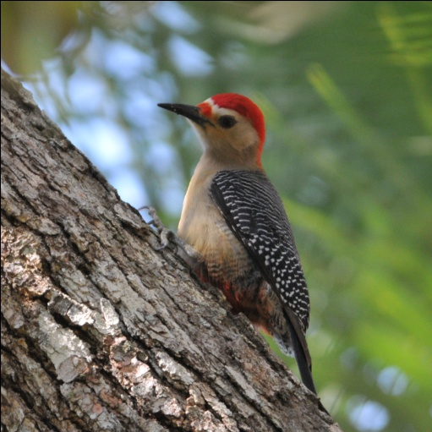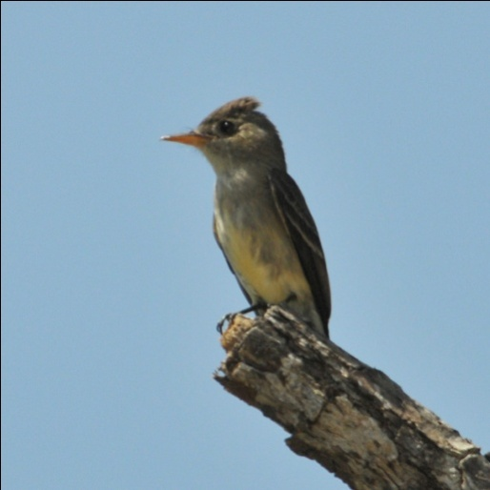
Hooded Warbler Golden-fronted Woodpecker Tropical Pewee

While I saw no new or unusual species sitting at a picnic table under a shelter in the parking lot, I enjoyed watching
Hooded Warblers and Ovenbirds hopping about at my feet. In a nearby tree was a Golden-fronted Woodpecker and a Tropical Pewee sang almost incessantly. Catbirds were numerous and came out of the shrubbery to investigate the picnic area. After about an hour and a half, the group came out of the zoo and we proceeded on our route to Monkey Bay Wildlife Reserve, a site better suited for morning birding, which I guess is true of almost any birding site. We arrived in mid-afternoon and didn't stay too long, birding just along the entrance road. New species seen included Stripe-throated Hermit, Pale-billed Woodpecker, Ivory-billed Woodcreeper, Great Antshrike, Couch's Kingbird, Rose-throated Becard (male), Masked Tityra, Tennessee Warbler, Grayish Saltator, Yucatan flycatcher, and Scrub Euphonia. We were able to see a Yellow-billed Cacique, which we had heard the past two days but couldn't get it in sight either day. We heard our first manakin of the trip - the snapping and popping of a White-collared Manakin had all of us searching the understory for a peek at this little cutie, but we were unable to locate the bird.

We arrived at Mama Noots Backabush after dark. A Common Paraque was the last bird seen today, but people in the back of the van were not able to see it as it crossed the road in front of us. We thought that dinner would be ready for us since our arrival was so late, but Nan, the owner, was waiting for us to arrive before finishing meal preparation. While we were waiting for dinner, we got our room assignments and Glenn drove the van as close as possible, first to the cabins and then the lodge, to make it easy for us to unload in the dark. We gathered in the dining room to complete our checklists with flashlights, and just as we finished, dinner was served. The entree was fish-kabobs, the fish replaced with chicken for me (I don't eat fish). While they were quite good, I found that the few bites of meat and pineapple didn't provide quite enough food to satisfy me after a long day of birding and traveling. After dinner, we all went to our rooms fairly quickly, with a few lingering at the bar for a drink.

The electricity at Mama Noots is provided by a generator and is normally turned off earlier than - whatever time it was when we went to our rooms. However, the generator was still running to allow us to settle in our rooms and get ready for bed. Because the very noisy generator was located just behind our cabin, I was quite relieved when it was turned off.

The combination of morning birding in the wetlands around Crooked Tree and the variety of stops on the way to Mama Noots allowed us to finish the day with a whopping 124 species, the highest single day count I could remember ever having.

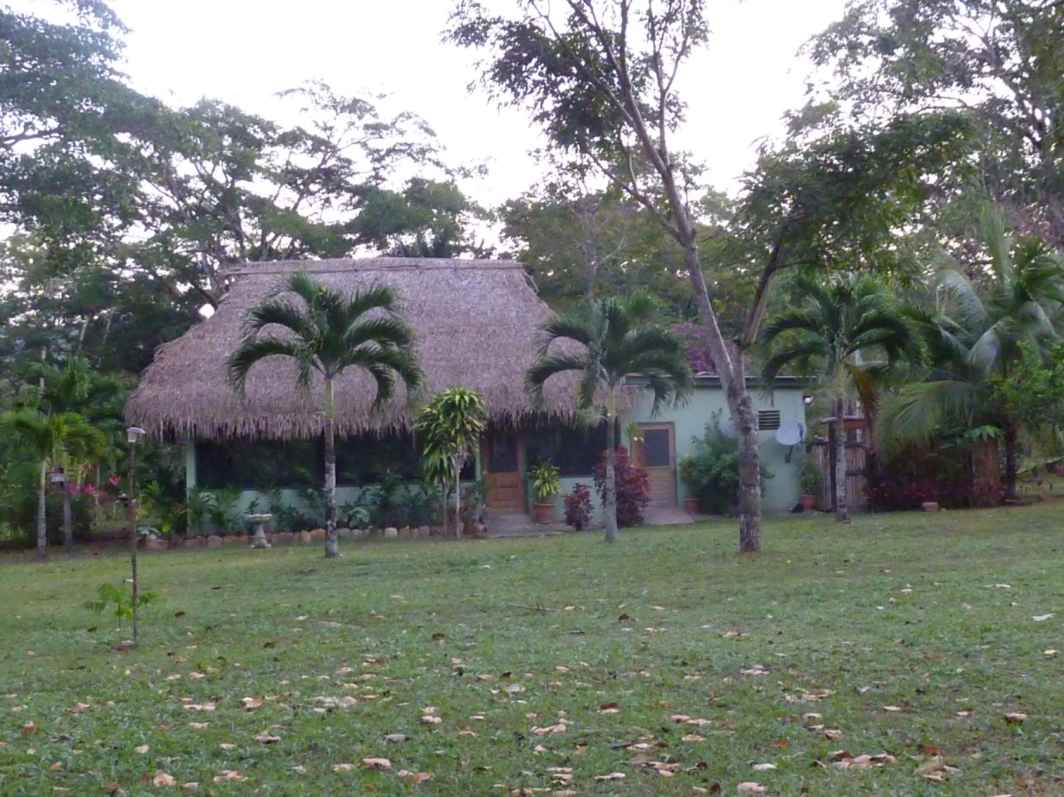
Dining Hall at Mama Noots Backabush

Day 5, Wednesday, March 23: Today's plan called for birding in Mayflower-Bocawina National Park: around the grounds of Mama Noots Lodges, the entrance road to Maybflower-Bocawina NP, the Bocawina Falls Trail, and the beginning of Antelope Falls Trail. Because Nan could not serve breakfast very early, we started our birding on the grounds of the lodge before breakfast. As I left my cabin, I saw a Striped Skunk meandering across the lawn. Others were already watching the little stinker, and we all kept a safe distance so as not to alarm him. As our four-footed friend strolled out of sight, I approached the dining room as some of the others went inside for coffee. As I walked toward the dining room, I noticed a lot of activity in a flowering tree right next to the dining room. I just stood there and waited to see what would come in to feed on the flowers. Baltimore, Orchard, and Black-cowled Orioles put on quite a show with an occasional visit by a warbler or flycatcher. A pair of Tropical Kingbirds feasted on insects attracted by the tree. A Buff-throated Saltator stuck around quite awhile and was still there when other birders came out of the building. Our group was gathered and ready to go shortly after our scheduled departure time of 6:30, and we started off on a trail that went behind the generators at the edge of the clearing that had been created for the cabins and dining hall.

We hadn't gone far when we first heard, then saw, Keel-billed Toucans. A pair of this spectacular symbol of the rainforest positioned themselves in our view, a pretty good distance away but allowing very good scope views. Each one would lift its enormous beak as it made a croaking sound totally unworthy of such an amazingly beautiful creature. We watched as they flew to a new perch in a different tree, looking like "flying bananas" with their huge beaks creating an unmistakable silhouette. Not a favorite of the guides because of its habit of taking young from other birds' nests to feed to its own young, the toucans are always appreciated by North American visitors. With a score of 20 on a scale of 1-10 in gaudiness, this bird will always be one of my favorites in spite of its nest-robbing habits. Collared Aracaris, another member of the toucan family, also made an appearance this morning. While everyone was enthralled with our sightings of these two magnificent birds, we were all looking forward to seeing them again, hopefully at closer range.
As we walked further along the trail, we again heard White-collared Manakins making their distinctive snapping and popping sounds with their wings. Although we could not locate the birds, Glenn didn't seem overly concerned so we knew we would probably have other opportunities to see this species. We made our way back to the dining hall, but with so many distractions we did not make it in time for breakfast as scheduled. Just walking back across the lawn took a considerable amount of time! On some logs in front of a large tree we noticed some small birds flitting around. Looking closer, we could see a female American Redstart flitting from spot to spot, spreading her tail as redstarts so often do. Near her in the woodpile was a Hooded Warbler, and a bit higher up were two birds hawking insects, a Least Flycatcher and a Tropical Pewee. Just in front of the dining room entrance, a pair of Brown Jays flew in to scold us. Olive-throated Parakeets came in to join the party, while a Tropical Kingbird, so common you don't often take the time to look, sat on a close branch as if asking for his photograph to be taken. With so many birds flitting about, agoutis scampering across the lawn, and the cacophony of birdsong that made you want to find the source of every unfamiliar sound, it was 9:00 by the time we reached the dining hall.
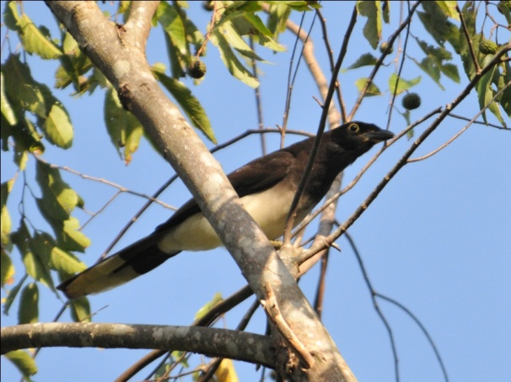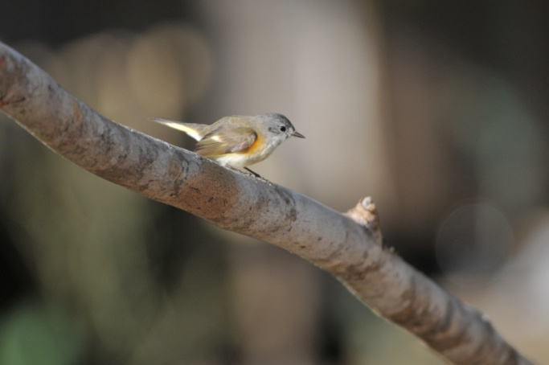
Brown Jay American Redstart Female
We were back to birding before 9:30 and once again had a hard time leaving the lawn. As we were crossing the manicured lawn, a pair of Yellow-winged Tanagers teased us with a glimpse. Some members of the group got excellent views but many of us just caught movement and no detail. We were all determined to get a better view later in the day In the garden area, we saw some White-collared Seedeaters. Again, a common bird that draws little attention after the first sighting, but these individuals were allowing me to approach so closely that I had to spend some time photographing them. By the time I left the Seedeaters, the group has spotted some hummingbirds feeding on flowers and had stopped to investigate. White-necked Jacobin perched high in a tree which would normally make it impossible to identify a bird as small as a hummingbird, but with its bright white plumage contrasted against the bold blue, it was an easy ID for Glenn. The bird sat still long enough for everyone to get a good look through the scope. The Scaly-breasted Hummingbird, although feeding lower, presented more of a challenge, with few distinctive field marks and constant movement that made seeing details almost impossible. It finally landed and Glenn immediately saw the combination of field marks that allowed him to identify the bird for us. White-bellied Emerald was also present, a bird we had seen earlier in the trip.

Once we finally got started on the trail to the Bocawina Falls, the birds came fast and furious. We heard Little Tinamou but could not get a glimpse of the secretive bird on the forest floor. The group saw a Long-billed Hermit, but I was bringing up the rear and missed it for the second time this trip (good thing it's not a lifer!). Slaty-tailed Trogons sat on branches overhead as Melodious Blackbirds sang in the background. With much effort we were finally able to actually SEE male White-collared Manakins as they snapped and popped and preformed for the females. With all the movement and all the brush between me and the birds, I found it impossible to focus my camera on the birds. I handed my camera to Glenn so he could try to get a shot of the tiny characters, and he was able to get some somewhat blurry shots. Not suitable for framing, but great memory shots (Thanks, Glenn). Violet Sabrewing drew a gasp from everyone as it moved through the forest on either side of the group. The brilliant purple was not as its most impressive without direct sunlight, but its size, behavior, and the color that could be detected were all appreciated by the birders. Someone pointed out a large raptor overhead - our first White Hawk!

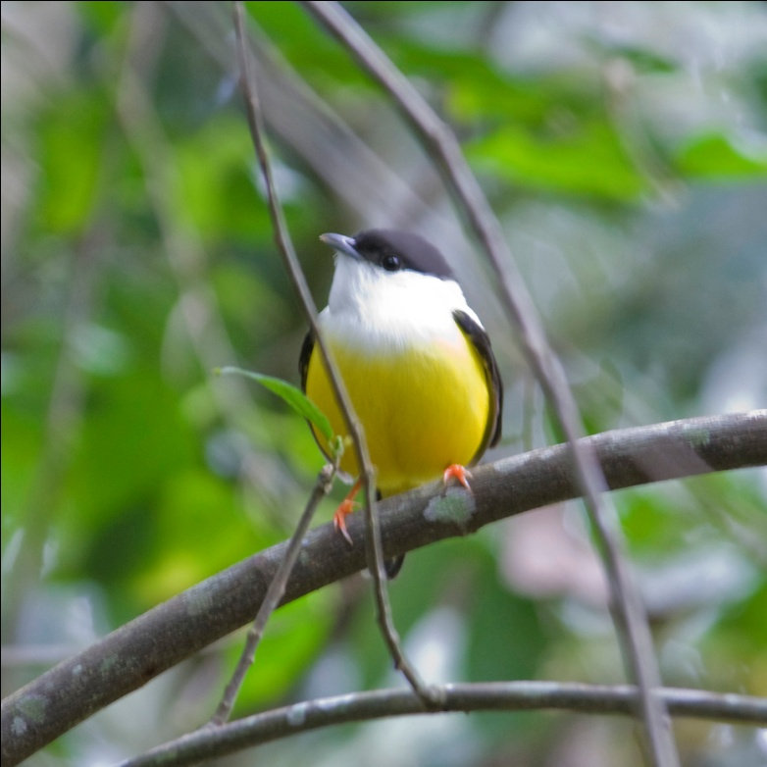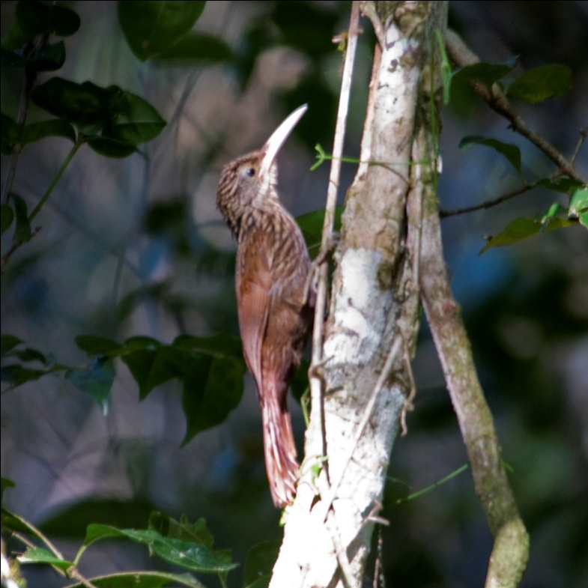
White-collared manakin Ivory-billed Woodcreeper

As we walked on toward the falls, we went through some spots with deep mucky mud. Logs had been placed where the mud was the deepest, and we had to walk across them to avoid having our boots sucked off our feet. Makeshift railings were present near some of the worst spots, and Glenn and Skip steadied the railings as some of the others crossed. Where there was no railing, people used walking sticks and any other means available to offer a steadying hand to those who needed it. Once again, the members of the group did all they could to assist their fellow birders.

We got a quick glimpse of one of my favorite tropical birds - the Common Tody-Flycatcher. Most of our group got great looks, but I wanted more. (Some people are never satisfied.) As we rounded a curve near a sunny clearing, someone spotted a flash of blue. As we stopped for everyone to get a look at the Blue-black Grosbeak, we also found some brightly-colored Black-faced Grosbeaks higher in the trees. It took a while to get everyone on both birds, and we enjoyed the song of the White-breasted Wood-wren as we searched. Other birds seen near this area were Black-headed Saltator, Golden-hooded Tanager, Bright-rumped Attila, and Yellow-bellied Elaenia. Woodcreepers were well-represented on our morning walk, with Tawny-winged, Olivaceous, Wedge-billed, and Ivory-billed all making an appearance. We saw a whole family of Pale-billed Woodpeckers but only a few of us got to see the Chestnut-colored Woodpecker (at least for now). Jim and Skip had fallen quite a ways behind the group, chatting as they walked, when one of the rusty-colored birds flew and landed at eye level on a tree right next to the trail. It started working on the tree, and Skip hurried forward to tell the others while Jim kept an eye on the bird. I was last in line and made it back to the spot Jim was watching just in time to see the bird fly away. A few others who were right behind me caught a glimpse of movement, but most did not see the bird at all. Buff-throated Foliage Gleaner came out and posed for us near the end of the trail, as well as Red-crowned Ant-Tanager. Other birds seen this morning included Sulfur-bellied Flycatcher, Cinnamon Becard, Red-eyed and Yellow-green Vireos, and Yellow-olive Flycatcher. Just as we approached the end of the trail and stepped onto the lawn behind Mama Noots' dining hall, an Orange-bill Sparrow allowed everyone in the group to admire his brightly colored schnoz.

As we were finishing lunch, Glenn heard a Chestnut-colored Woodpecker calling nearby. We all rushed outside, where a very accommodating woodpecker put on quite a show. We all enjoyed the beauty of the bird as well as the opportunity to observe behavior and hear the bird calling, and it was particularly nice for those of us who had missed the bird earlier in the day. We had a few hours to rest before beginning our afternoon/evening walk, but most of us birded around the garden for quite awhile. I was particularly interested in finding some birds close enough to get some good photos, but the bird activity was nothing like it had been in the morning. I got some reasonable shots of a Pale-billed Woodpecker and an Owl Butterfly before I finally gave up and went to my cabin to rest a bit before the group convened again at around 3:00 PM.
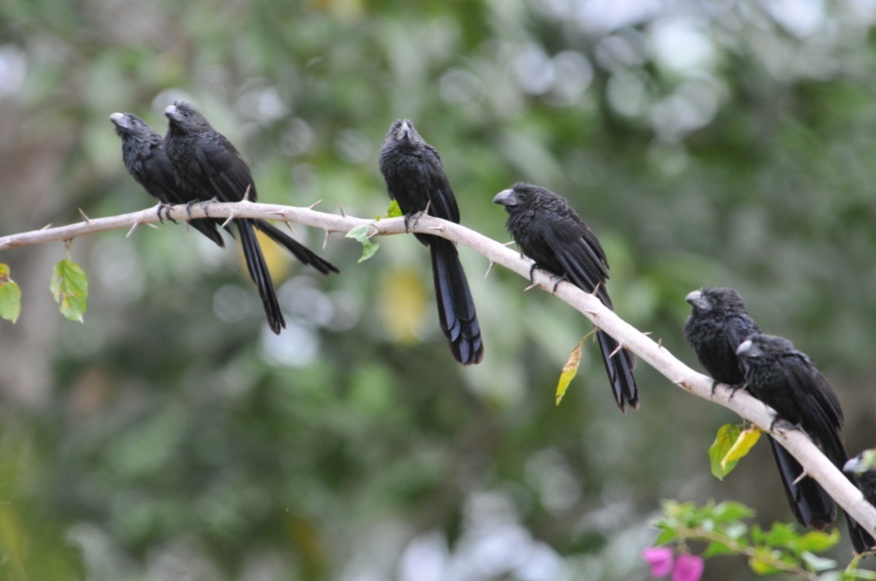
Groove-billed Anis
In the afternoon, we walked out the entrance road to the beginning of Antelope Falls Trail. At this time of day, none of us really expected to see much bird activity - BOY! were we wrong! One of the first sightings was a Black-headed Trogon sitting quietly in the open branches of a Cecropia tree. Its bright blue eyering contrasted sharply against its black head. As we walked a bit further, we saw a pair of Ruddy Ground-Doves perched on a branch side by side, all puffed up as if it was cold (it most certainly was NOT cold!). A few steps more, and an arching branch holding about eight Groove-billed Anis came into view. Next, we saw a Red-lored Parrot as it went in and out of its nest cavity. This is the species we had tried so hard to get a good look at while walking in Crooked Tree, and now here it was, out in the open in a tree just a few yards away. This all before we actually made it to the road from our starting point at the dining hall!

As we walked down the dirt road, we saw another Chestnut-colored Woodpecker, this time close enough to allow for some photographs. As we were watching Olive-backed Euphonias, someone noticed a Slaty-tailed Trogon land on a bare branch at the side of the road. As we watched the bird, another, smaller, trogon flew in and landed within inches of it. As we frantically tried to get photographs of the two species together, Glenn remarked about how rare it was to see two species of Trogon perched so close to each other. The Black-headed and Slaty-tailed Trogons sat together long enough for us to capture the moment on our digital cameras and then flew off in different directions, the Slaty-tailed lingering just a moment longer than the Black-headed.

We continued down the road, stopping for looks at some small birds such as Plain Xenops, Tawny-crowned Greenlet, and Northern Bentbill. Larger, more impressive birds such as Blue-crowned Motmot attracted our attention, even though we had seen them earlier on the trip. I mean, really, how do you NOT look at something as gorgeous as a Motmot? We were all thrilled to finally get a look, however brief, of a Green Shrike-Vireo after listening to its song all day. As we approached a small bridge that took you from the road to the trailhead, Glenn heard puffbirds. It didn't take long for him to locate the female White-whiskered Puffbird and get the bird in the scope. Puffbirds typically sit still for quite awhile, so it was easy for everyone to get a good look at the bird through binoculars, scope, and then second, third, and fourth looks through the scope. While we were still watching the dull brown female, her chestnut mate flew in and allowed equally good looks at him.

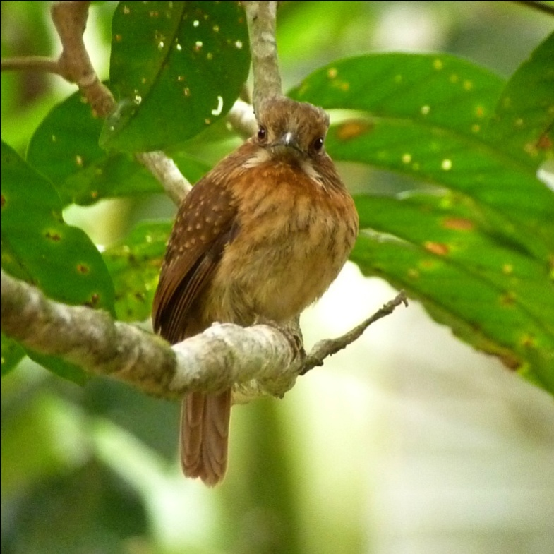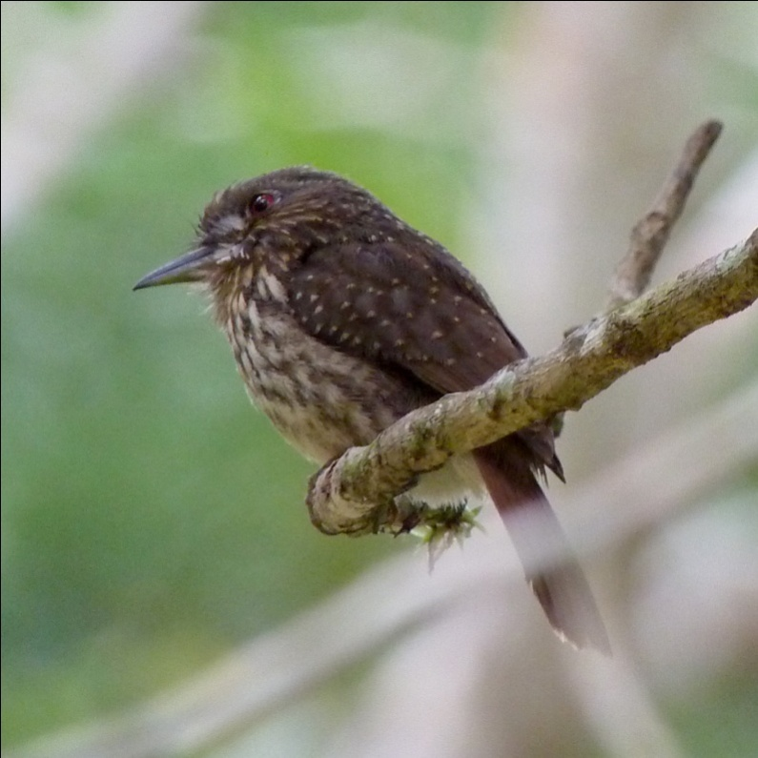
White-whiskered Puffbird (Male) White-whiskered Puffbird (Female)

On the other side of the bridge a small flycatcher was hawking insects from its low perch on a vine hanging over the water. It took Glenn's expertise to nail the identification as a Yellow-bellied Flycatcher. The sun was getting pretty low in the sky when we finally started walking back to the lodge. The last bird we saw as we ended our walk was a White-bellied emerald silhouetted against the darkening sky, singing away. I walked toward my cabin thinking it just doesn't get any better than this. While Jim went inside to freshen up, I heard the call of a Common Paraque. I followed the sound to the back of the cabin, and there was the Paraque, sitting on the buttress root of a large tree right behind our cabin! I watched it through my binoculars in the fading light as it called over and over and finally decided it might stick around long enough for others to see. I ran back to the cabin to alert Jim, Jennifer and Sybil and grabbed my camera. By the time we got back outside, the bird had stopped vocalizing and was nowhere to be found. Other new (for the trip) birds seen today included Short-billed Pigeon, Blue Ground-Dove, Gray-chested Dove, White-crowned Parrot, Black-cheeked Woodpecker, Rufous Mourner, Spot-breasted Wren, and Orange-crowned Warbler. With 119 species seen today, I can't honestly tell you exactly when and where we saw each bird. What a day!

Day 6, Thursday, March 24: So how do you hope to top two consecutive days with counts in the 120 range? You go to one of the most wildlife-rich sites in Central America, Cockscomb Basin Wildlife Preserve. Comprised mostly of second-growth broadleaf forest, the preserve is believed to harbor the highest concentration of jaguars in Central America. We started off before dawn, taking a packed breakfast with us to eat when we arrived at the reserve, eta 8:00 AM. Glenn wanted us to arrive early enough to see the Crested Guans that are normally active along the Cockscomb entrance road for a short time after sunrise each morning. We did spot some guans, and everyone piled out of the van as quickly as possible to see them, but the birds flew across the road so quickly that many of us were not satisfied with the looks we got, and some of us were unable to see the birds at all. Before we got back into the van, however, Glenn heard some Red-capped Manakins nearby. We were able to locate some male manakins and watched them for a short time as they performed for the females. We could see every detail on the jet-black birds with bright red caps, right down to the matching yellow eyes and thighs. Pretty good "consolation prize" for missing the guan!

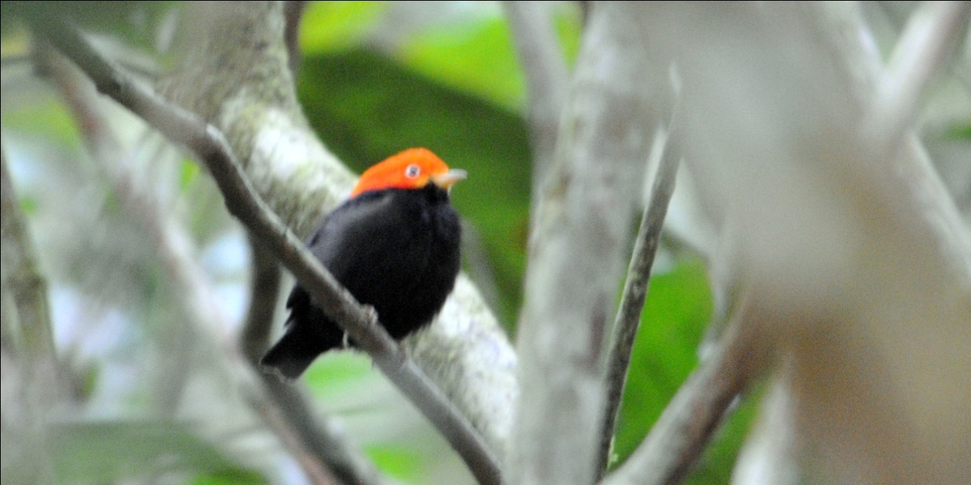
Red-capped Manakin

We kept to our schedule and settled in at the picnic tables in front of the housing units that are available to research scientists and tourists at around 8:00 AM. Birdsong filled the air as boiled eggs, fresh fruit, bread and jams were laid out on the picnic tables as we all began to search the nearby trees for bird. It was difficult to eat when movement around you kept demanding that you put your food down and pick your binoculars up, especially when the birds are coming so close that they present perfect photographic opportunities! The first bird to pose for pictures during breakfast was a Roadside Hawk that flew into the trees along the edge of the clearing where we were sitting, giving us our best looks yet at this common predator.
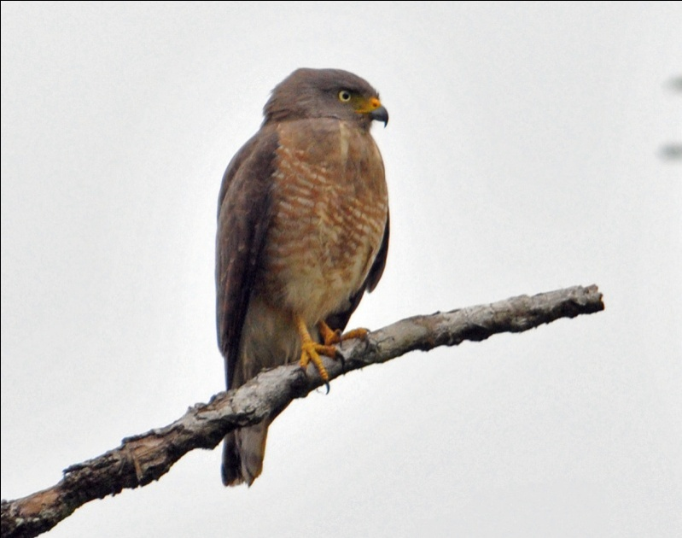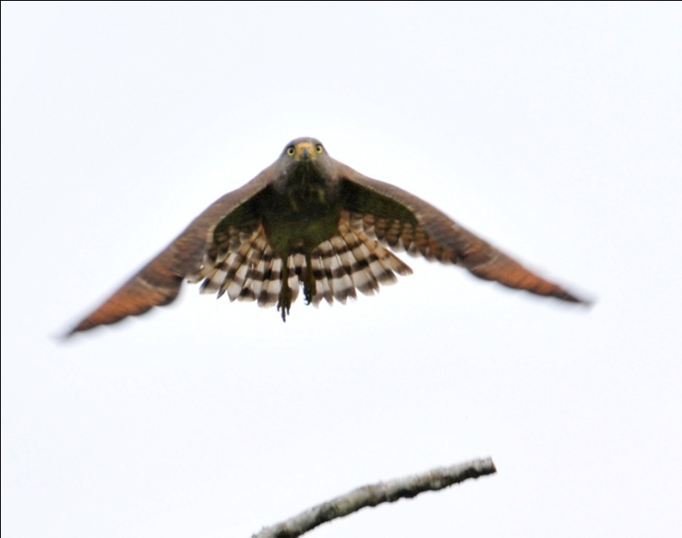
Roadside Hawk

Next, some Crested Guans flew into the clearing right in front of us! No one was dissatisfied with their view of the massive birds this time as they perched precariously on branches that looked far too thin to support their weight.

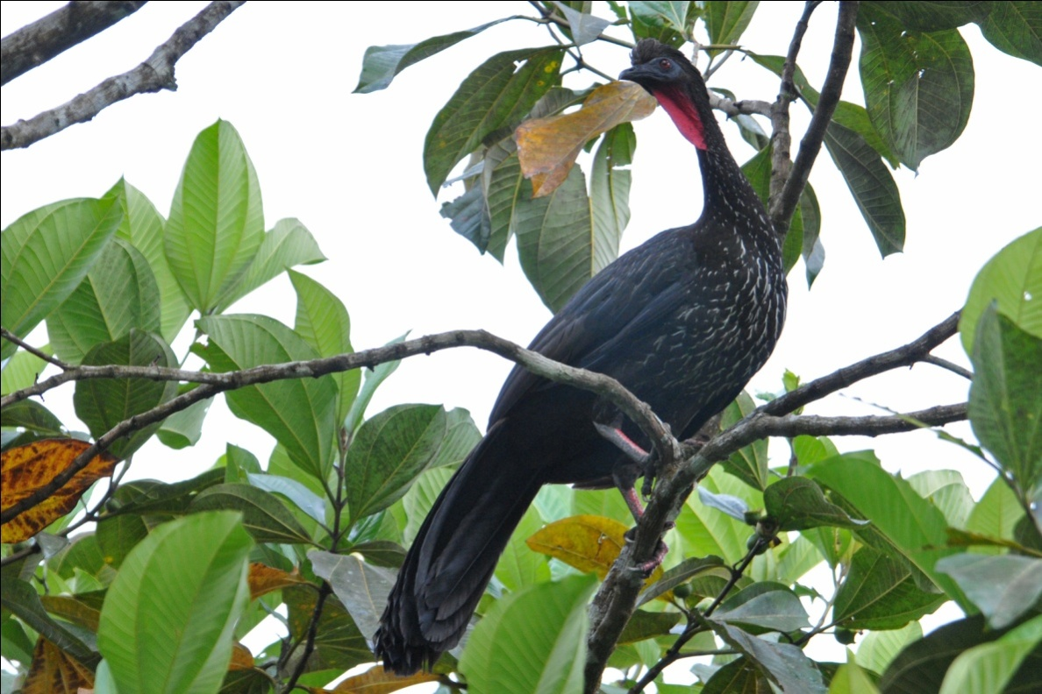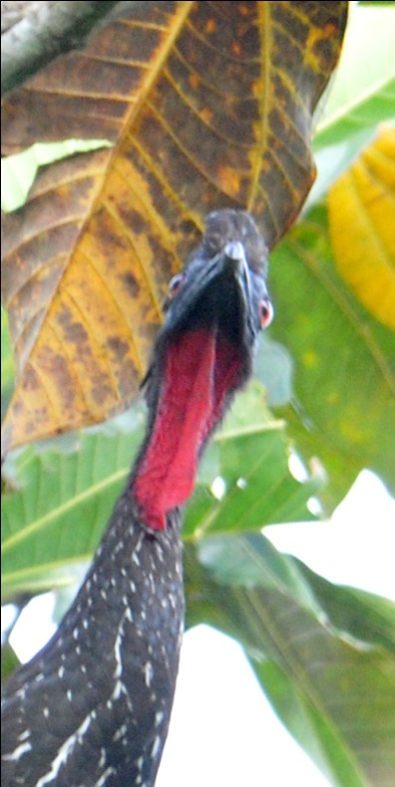

We saw many other birds while we were trying to eat breakfast, most of which we had already seen on this trip. A Green-backed Sparrow darted in and out from under one of the buildings (which was built on stilts), Tropical Kingbirds and Social Flycatchers hawked for insects from saplings, and hummingbirds (no new species for the trip) flitted from one flower to the next. Blue-gray Tanagers flew in and out of the clearing. We saw our first White-tipped Doves of the trip, as well as Ruddy Ground-doves. The ever-present Clay-colored Robins (aka Thrushes) hopped about on the mowed lawn in the clearing. A male Red-throated Ant-tanager joined the parade of photograph ops as it settled onto a low branch in some shrubs near our picnic tables.

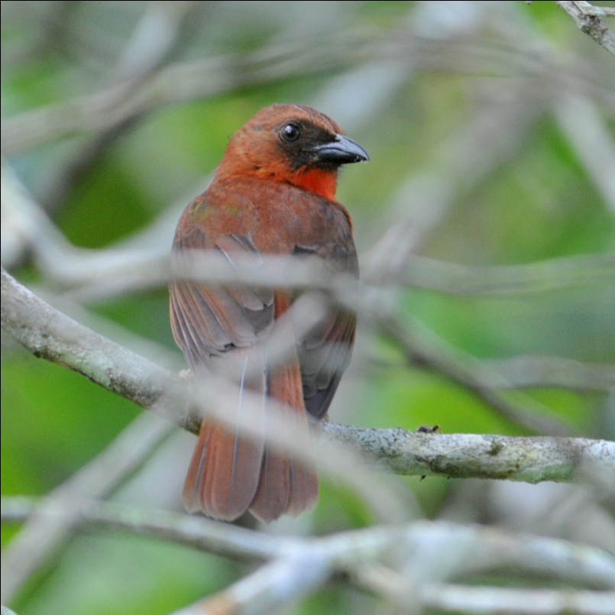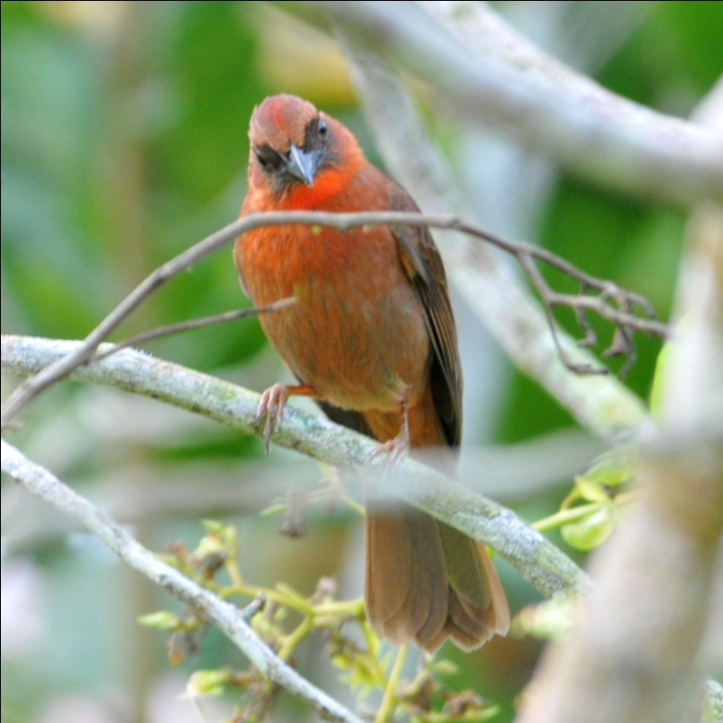
Red-crowned Ant-Tanager

When Glenn finally said we should go, I had hardly eaten a thing, my time completely consumed by the spectacle of birds. I gulped down the rest of the egg I had put on my plate and we all went back to the van to put the coolers away, put on sun screen and generally prepare for our first walk at Cockscomb. Glenn had left the driver's window open a little so the van wouldn't get too hot in the sun. As we approached the van, we could see a small yellow bird flying around frantically inside the van, searching for a way to escape. Glenn hurried over to open the door, and all you could see was a flash of yellow as the Social Flycatcher regained its freedom.

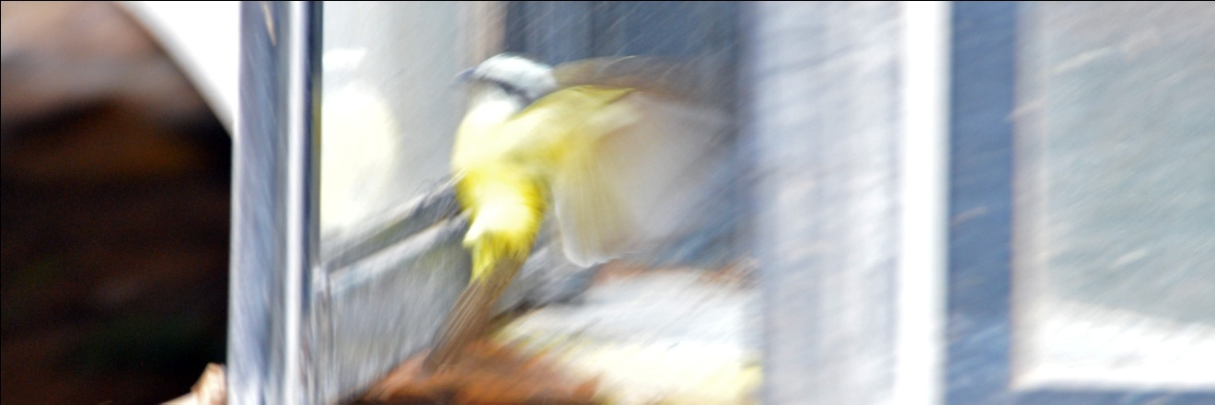

We walked back to the picnic area for a restroom break before starting on a trail, and as I was waiting my turn, I saw some others watching something in front of one of the buildings. They had spotted a Common Tody-Flycatcher nest and were watching the adult bird as it came in and out of the nest. Obviously, I had to stop with my camera to see if I might get a photo. The others watched for a few minutes and then went on to meet Glenn behind the building, and I lingered for just a little more. I waited for a short while that seemed like a long time, and then went to catch up with the others. Glenn already had a Passerini's Tanager in the scope, and I fired off a few shots before taking my turn at the end of the line for a stunning view of this amazingly gorgeous bird. Since everyone had seen the tanager through the scope (and I knew the bird was too far for me to have a good shot with a 400mm lens on my dslr), I handed my small Lumix to Glenn for him to try to digiscope a photo. While he did that, I ran back to the front of the building to see if the Tody-Flycatcher had returned. Maybe, with all the humans gone . . . . This time it paid off! This tiny little flycatcher, less than four inches long, had long been one of my favorites tropical species, and I had resigned myself to the fact that getting a good photo of such a small and highly active species wasn't likely. He paused for an instant before going inside the pendulous nest, and - wonder of wonders! - I got the photo!
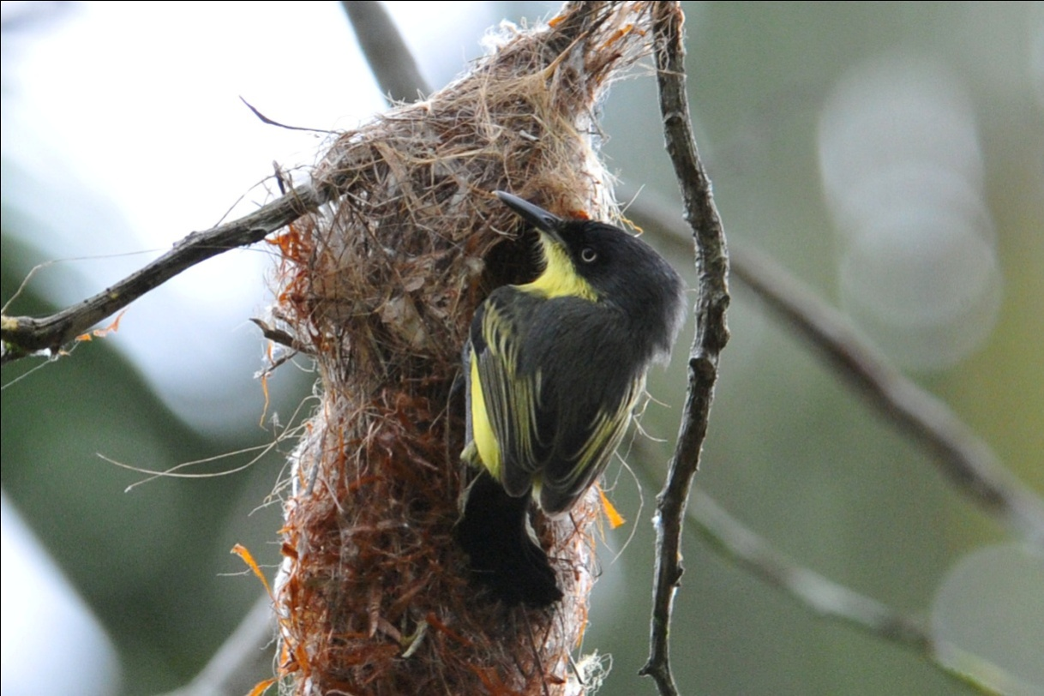
Common Tody-Flycatcher

And so did Glenn!
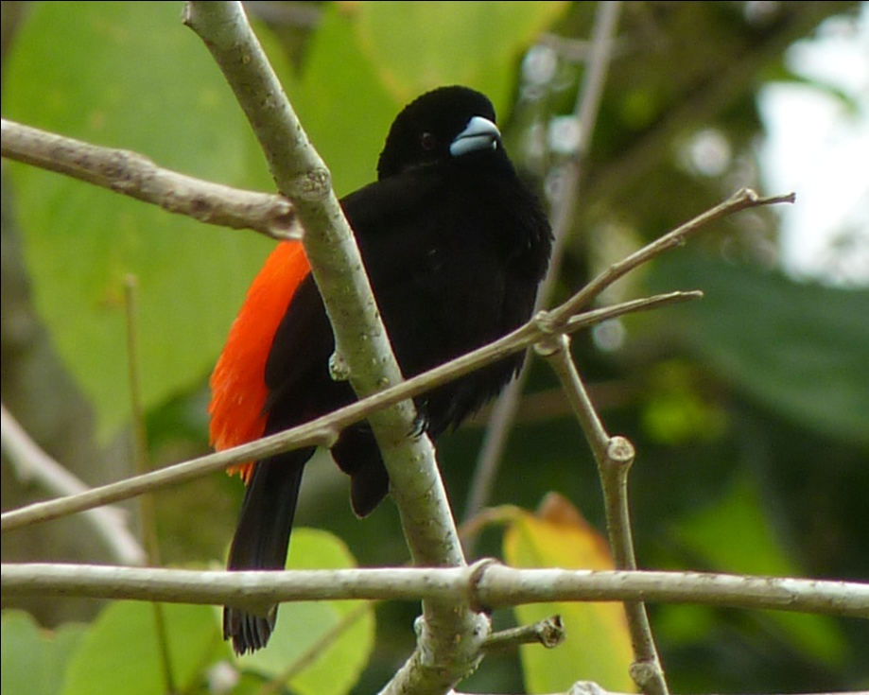
Passerini's Tanager

We were finally ready to begin our walk, but not before a Great Kiskadee offered us views of the bright yellow stripe on the top of his head. Again, a very common bird, but when it is so close and poses almost as if it wanted you to see this not-often-seen field mark, you really must take a few minutes to get a photo.
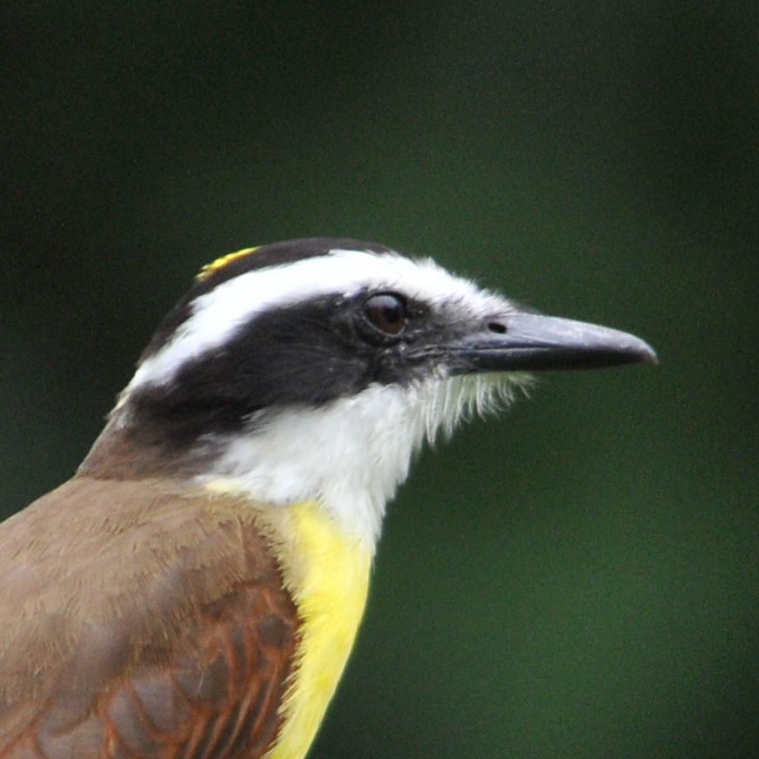
Great Kiskadee

As we walked the trails at Cockscomb, we saw several first-of-trip species, including Dot-winged Antbird, Northern Bentbill, and Slate-headed Tody-Flycatcher. We also got some great looks at birds we had seen before, like Masked Tityra, Cinnamon and Rose-throated Becards, and Blue-black and Rose-breasted Grosbeaks. Glenn saw an eye-ringed Flatbill, but none of us were able to get on the bird before it flew out of sight. Surprisingly, we had just one trogon for the day, a Black-headed. Although we had Wood Thrush on the daily list for just about every day, I saw my first one for the trip at Cockscomb. As we walked into an open area at the intersection of two trails, someone looked up and saw a large raptor soaring above us. A beautiful White Hawk was easily identified, and as we watched it, another White Hawk glided into view. To our amazement, a Great Black Hawk joined the White hawks, and we had all three raptors in one binocular view for several minutes. In the same open area a little further down the trail, we saw our first Plumbeous Kite of the trip.
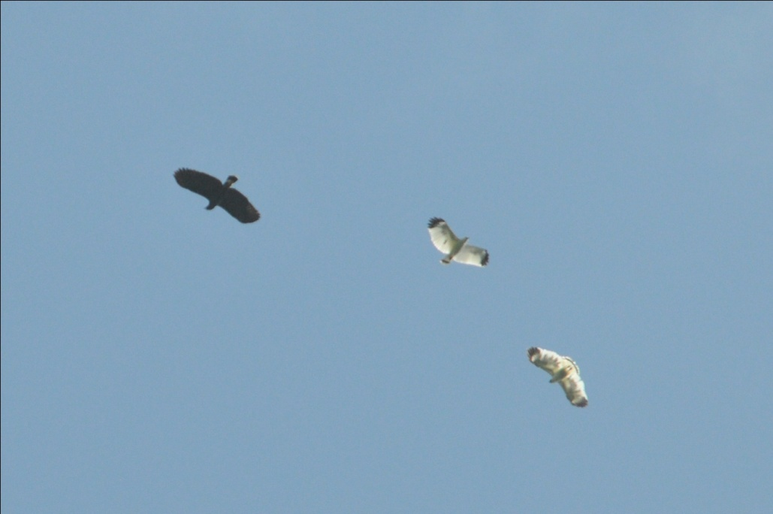
Great Black Hawk with White Hawks

Glenn was taking us to a special place, but did not tell us about it until we got there. As we approached a small creek, he directed our attention to some large birds on a nest in a low branch in a tree along the bank. I've seen Boat-billed Herons before, but always tucked in behind vegetation and almost always a good distance away. Now, here in front of me, at eye level less than 40 feet away, were two Boat-billed Herons sitting on their nest! After taking dozens of photos of what turned out to be pretty much the same shot (Boat-billed Herons don't move much), I looked around and saw that there were dozens of other nests in the surrounding area. We silently watched in awe, and I actually got a shot of one of the herons with its huge bill agape - amazing! Other birds around the creek included Amazon and Green Kingfisher, and there was a massive American Crocodile on the far bank, but I couldn't take my eyes off the herons.

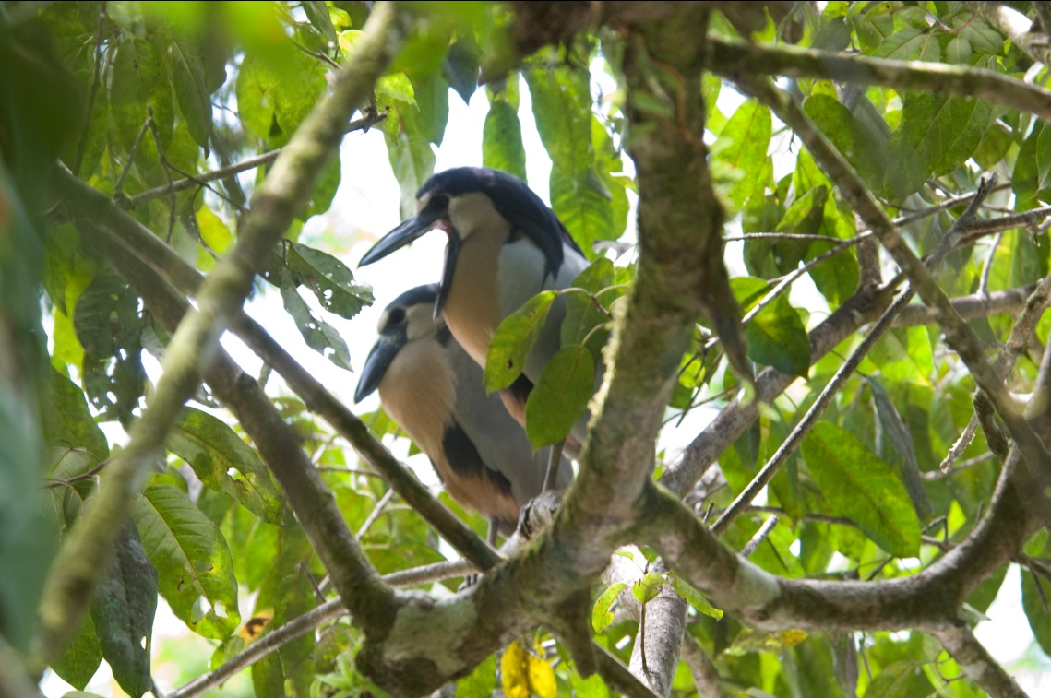
Boat-billed Herons

As we headed back for lunch, we came across some fairly fresh jaguar tracks in some sandy soil. Glenn thought they had probably been made that morning. We had been impressed with the "Jaguar Crossing" signs along the entrance road, but seeing the tracks and knowing that a jaguar had been right where we were standing that morning was a great feeling. Cockscomb is the oldest jaguar preserve in the world, established in 1986 after Allan Rabinowitz conducted research showing that this area had the highest concentration of jaguars in Central America. He spent two years trapping jaguars, attaching radio collars to them and then tracking them from a small airplane. He actually crashed his plane into a guamwood tree while taking off during a thunderstorm in . He and his two passengers suffered only minor injuries.

The last bird we saw before lunch was our first Rufous-tailed Jacamar of the trip. Sitting perfectly still on a stub of a branch over the trail, we almost walked right under it. Glenn's keen eye and his knowledge of where to expect the bird prevented us from walking right past it.

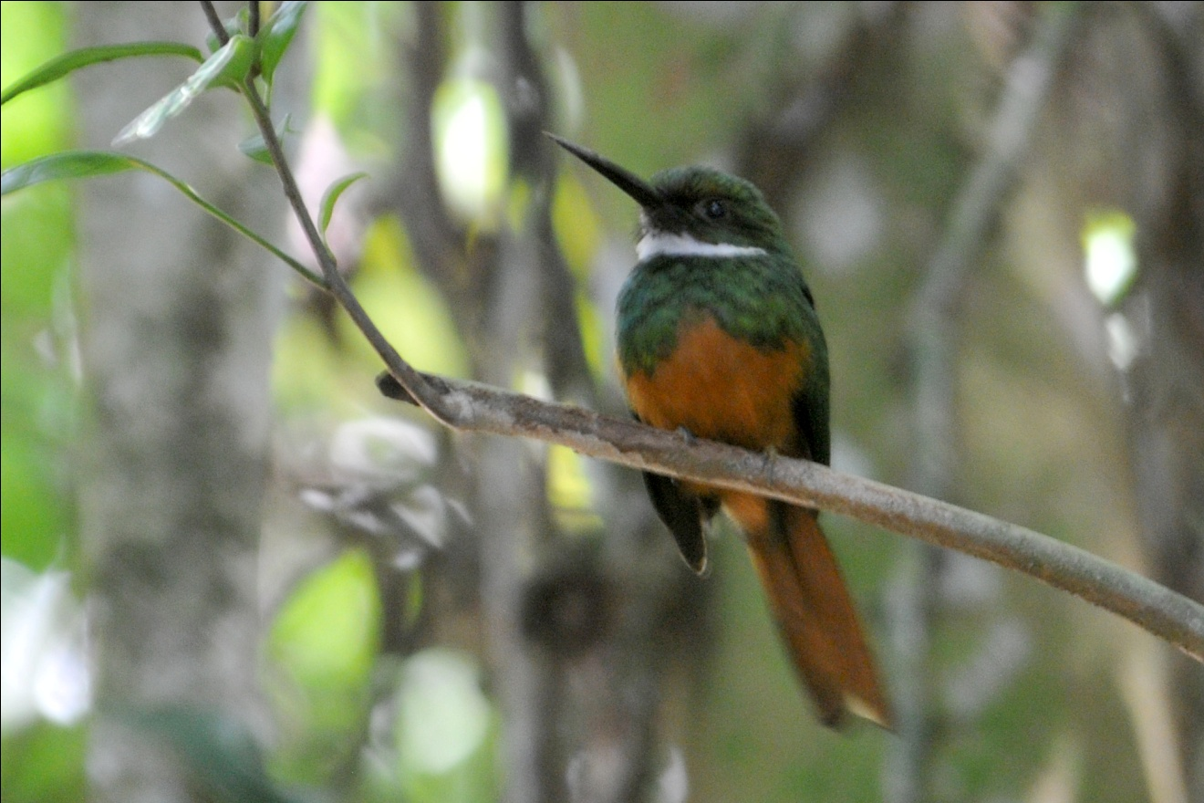
Rufous-tailed Jacamar

We had lunch under the shade of a palapa near the parking lot, sharing our space with a very forward Ovenbird. It hopped around on the ground, practically under our feet, as we ate our box lunches and cooled off a bit. We were impressed with how much cooler we felt beneath the thatched roof of the palapa, and found ourselves lingering after our midday meal, enjoying the cool spot in what had become a scorcher of a day. We were having a hard time motivating ourselves to get up and start the afternoon hike until someone heard a Tropical Gnatcatcher calling from a nearby tree. Amazing how a tiny bird can make humans get up and on their feet so quickly! Not an uncommon species, but our first for the trip, the gnatcatcher flitted around in the tree long enough for everyone to get it in their binoculars.
We visited the small museum for a few minutes before starting on a new trail for the afternoon. This time, we hiked toward a different area of Stann Creek and saw a lot of bird activity along the way, including Olive-backed Euphonias on a nest, a group of Collared Aracaris foraging for food, and a Yellow-tailed Oriole moving about. We heard both Great and Barred Antshrikes but were unable to see the birds in the dense undergrowth where they are most typically found. When we got to the stream, we could see some movement about 200 feet downstream. Looking through our binoculars, we could see a bright male Passerini's Tanager bathing along the shore, soon joined by a female. We all watched until they were done, and then continued on. I took the opportunity to cool off by removing my shoes and socks and soaking my feet in the cool water. Skip and Pam followed suit, and everyone enjoyed resting along the stream. When I got up to put my footwear back on, Glenn picked two huge leaves and laid them on the ground in front of me. I used the leaves like a bath mat, stepping on them instead of onto the dirt and gravel that would have stuck to my wet feet. Skip and Pam then used the leaves to get out of the water with clean feet (Reduce, Reuse, Recycle). As I walked away from the stream, I felt like my body temperature had gone down several degrees because of the cooling footbath I had indulged in. As we started back to the parking lot, a Golden-Olive Woodpecker landed on a diagonal branch over our heads. We stopped to admire the bird before walking past the wreckage of Allan Rabinowitz's plane and on to the parking lot.

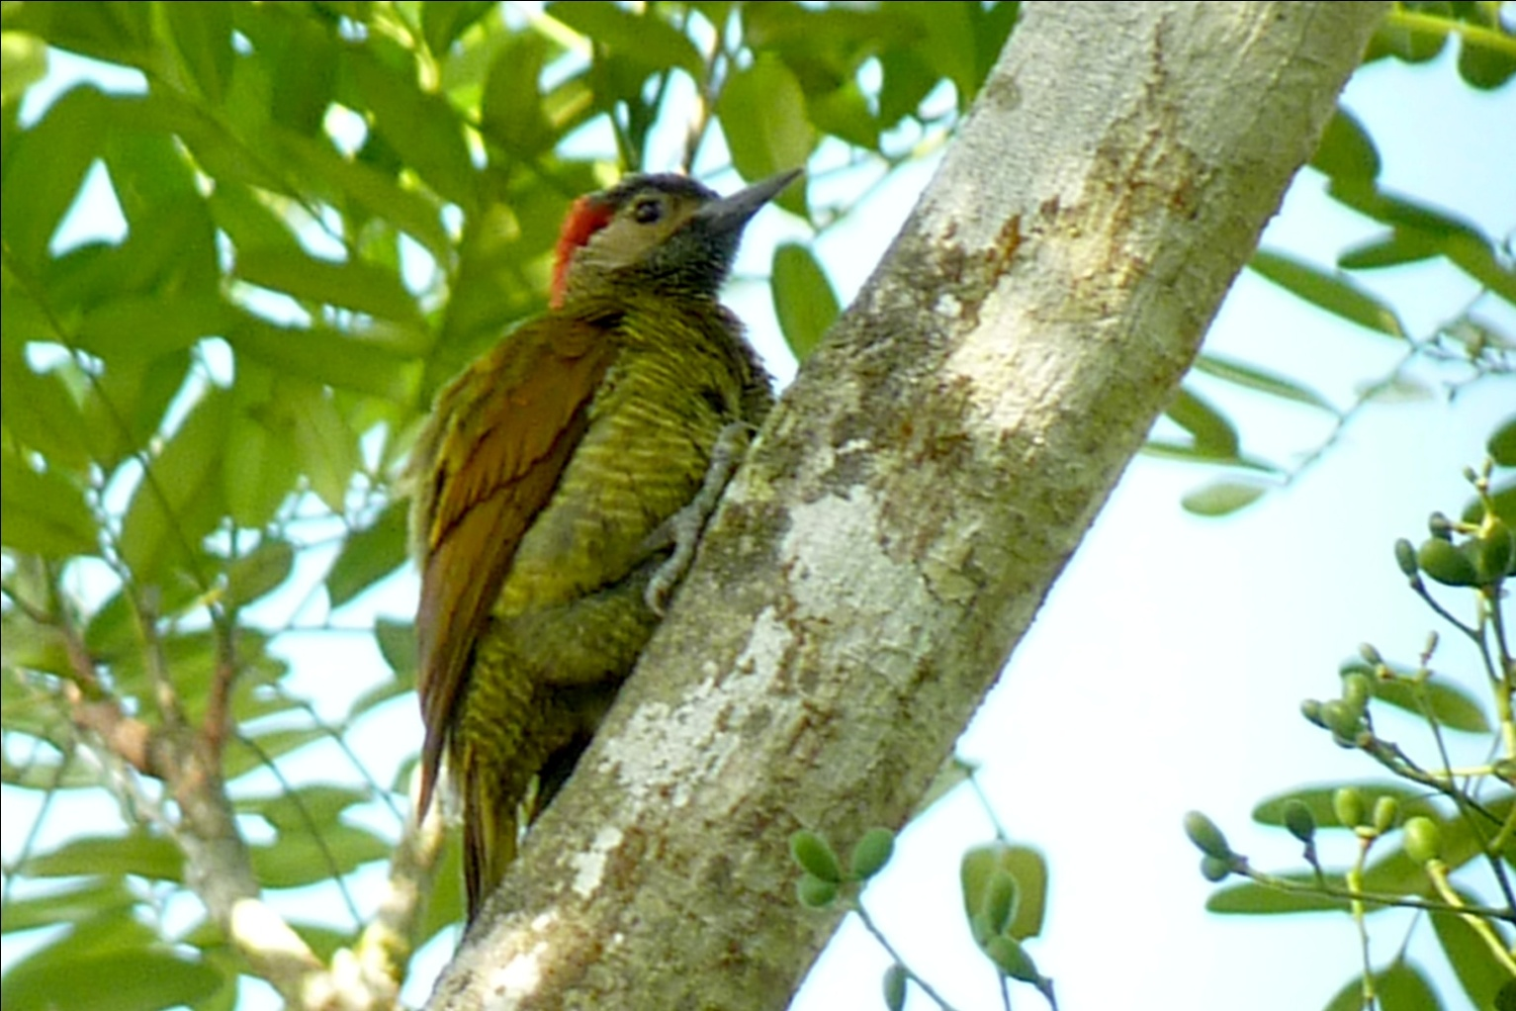
Golden-Olive Woodpecker

As good as the birding was at Cockscomb, we were happy to climb in the van and head back to Mama Noots. Hiking in the heat after such an early start had made all of us pretty tired, and we settled down in the air conditioned van for the drive back to our cabins and a cool shower. As we were driving along, someone pointed out a Rock Pigeon - not much reaction from the crowd even though it was a trip bird. With everyone cooled off and relaxing, we were brought back to life when Glenn screeched the van to a stop and called out "Aplomado!" We all hurried out of the van to see a pair of Aplomado Falcons double-teaming a Barn Swallow. As the barn swallow would dip and turn, the falcon on its tail would go off in a different direction only to have the second falcon zoom in to resume the chase. We stood at the side of the road and watched several changes of position, first one and then the other right on the tail of the hapless swallow. Glenn had my camera trying to get some shots, and I ran back to the van to get my Lumix camera in hopes of getting a video clip. In the fraction of a minute that I was gone, one of the falcons snatched the swallow from the air and the pair took off with their hard-earned dinner in talon. Although tracking a falcon at who knows what speed with a 400 mm lens is almost impossible, Glenn did manage to get a few shots with the birds actually in the frame.

I guess we just thought the Golden-Olive Woodpecker was a good finish for the day - but I was pretty sure we wouldn't top this sighting for a long time and many trips into the future!

We finished the day with 101 species, a bit less than the previous two days, but the day was so consistently filled with activity that it didn't seem like we had a lower number of sightings.

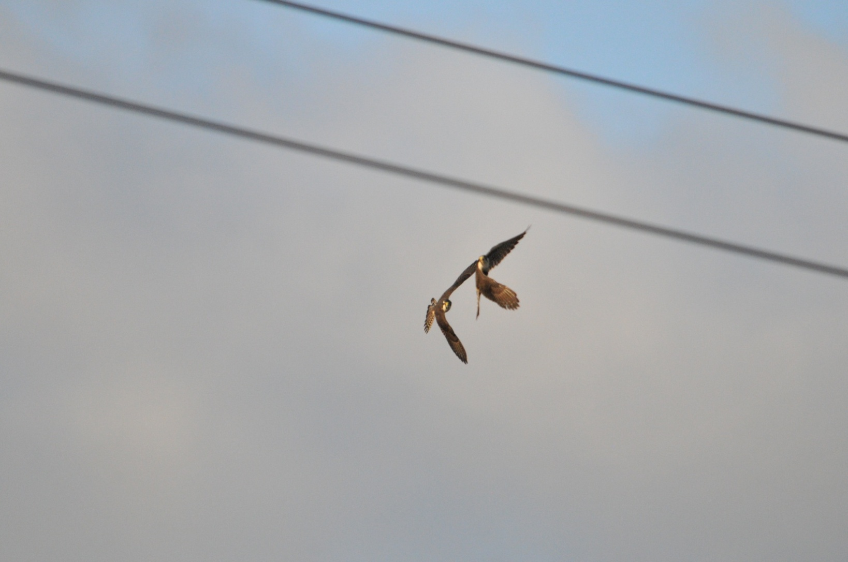
Aplomado Falcons

Day 7, Friday, March 25: This morning we started early. I was out of the shower, packed, and taking a photo of our resident gecko on the lampshade by 6:00 AM.
As soon as there was enough light, the group did a little birding on Mama Noots grounds before breakfast, one last time before departure for Five Sisters Lodge in the highlands. As others walked toward the dining hall, I went toward the road to see if I might be able to get a better shot of the nesting Red-lored Parrots now that the light was in the eastern sky. Some agoutis scampered across the lawn as I walked back to the dining hall, so I stopped for a few photos, but the now-familiar sight of Yellow-winged Tanagers made me pause only for a moment. As soon as breakfast was over, we loaded everything into the van and headed for Blue Hole National Park. Not to be confused with the famous Blue Hole that's located several

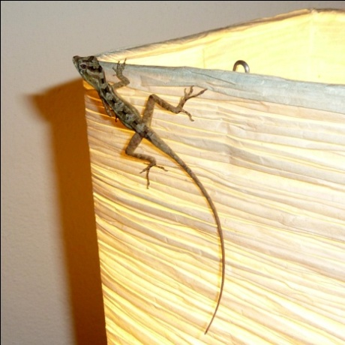
miles off shore near Lighthouse Reef, this Blue Hole is a land-locked cenote, or surface collapse feature caused when a limestone cave collapsed many many years ago. The river running through the original cavern still flows through the cave system and forms a clear deep pool at the bottom of the cenote, where it appears to be a light shade of aqua in the deepest parts. The park has a small trail network, particularly good for birding because the forest canopy is low here.

It was over an hour's drive, so we didn't get to the Blue Hole as early as we would normally want to begin birding. Shortly after we arrived, we saw a Black-cheeked Woodpecker, a species which some had seen on Day 5 but I had missed. We started on the trail to Herman's Cave, where after a short walk you can normally position yourself in a clearing near the cave entrance and wait to see what species come in. I say "normallly" because on this day, just after we arrived at the destination "hot spot", a group of school children arrived to tour the cave. About 10 - 15 kids went into the cave at a time, leaving the remaining group of about 60 kids and chaperones to share our space around a couple of picnic tables. As delightful as the kids were, it definitely impacted the birding there. While they didn't actually scare everything away, it was almost impossible for Glenn to hear any birdsong with the background noise. However, while we might not have seen as many species as we would have otherwise, we had some priceless moments inviting the kids to look through the scope. Glenn found a Royal Flycatcher sitting and preening, showing its bright red crest during the process. The dim lighting in the dense growth didn't allow for good photos, but we all had great views through the scope. Some of the kids were quite excited to see the flycatcher and other birds, and all of them really enjoyed using el scopo. We stayed there for quite awhile before walking back toward the visitors' center and parking area for lunch.

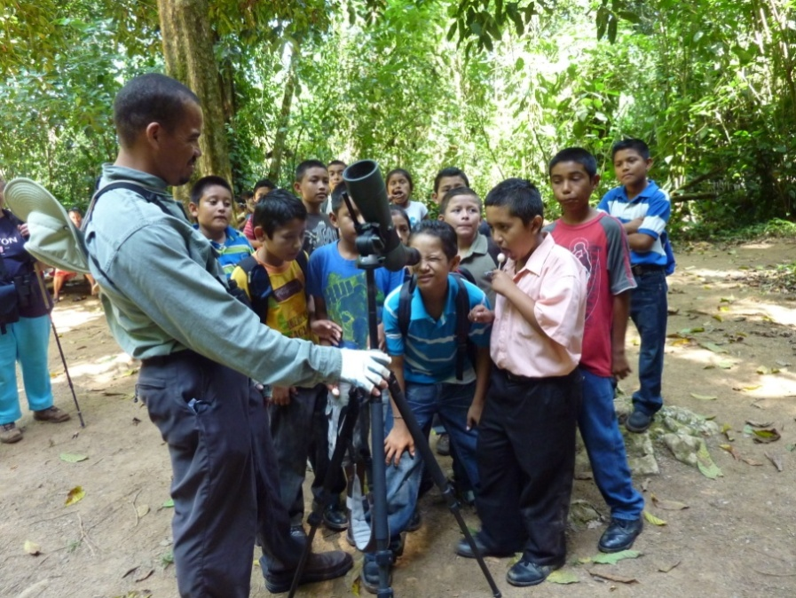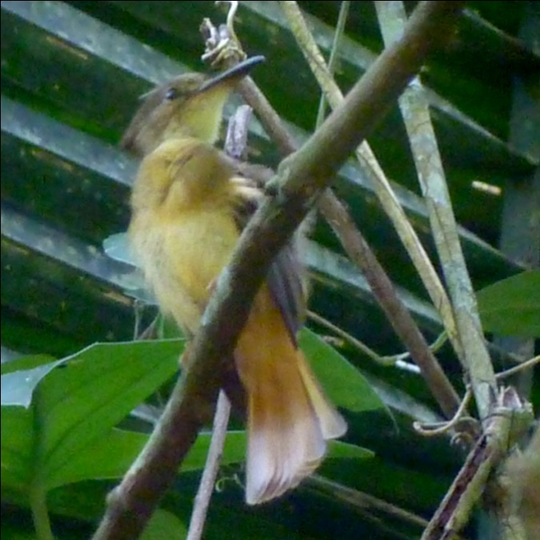
Glenn with school children Royal Flycatcher

On the short trail back to the parking lot, we saw a few new birds for the trip: Acadian Flycatcher and Gray-chested Dove. When we got back to the van, some visited the gift shop while others visited the restroom. After doing both, I ended up in an area beyond a row of bushes near a small building. There, flitting around the huge Hybiscus bushes was a Purple-crowned Fairy. We got the coolers with our lunch provisions inside, and took them to a picnic area near the entrance to Hummingbird Trail. As we ate lunch, Red-throated Ant-Tanagers, both male and female, approached the picnic benches to beg for food. Some other common birds hopped around in the area, but the surprise (for me, anyway) was a normally secretive Wood Thrush approaching us as if begging for food! We watched for birds in the wooded area as we ate, and soon the group of school children showed up to have their lunch in the same area. After we ate, we walked around the area searching for some birds and quickly found a Blue-crowned Motmot at eye level just beyond the clearing. As we called to each other to see the Motmot, some of the children came over to see what we were looking at. Glenn put the bird in the scope, and as they were waiting their turn, I handed my binoculars to one of the boys to look, in case the bird flew away before he got his turn at the scope. The kids shared the binoculars as we found one bird after another for them, first a Black-cowled Oriole, then a White-bellied Emerald and a Golden-hooded Tanager. There was one young man who was more enthused about the birds and more adept with the binoculars than the others, and I had to remind him to allow others to have a turn. He was having a ball seeing these birds and didn't want to give the binoculars up! He would certainly have been a candidate for the binoculars we brought to give to a young birder, but we had already promised the pair we had with us to Glenn's son, and the bins were being used by Pam at the moment, anyway. It was a bit disappointing to have planned for such an occasion and then not be able to deliver, but it was very uplifting to see these youngsters show so much enthusiasm for the avian life of the forests that surround their homes, the forests they will soon have the opportunity and obligation to protect for future generations.
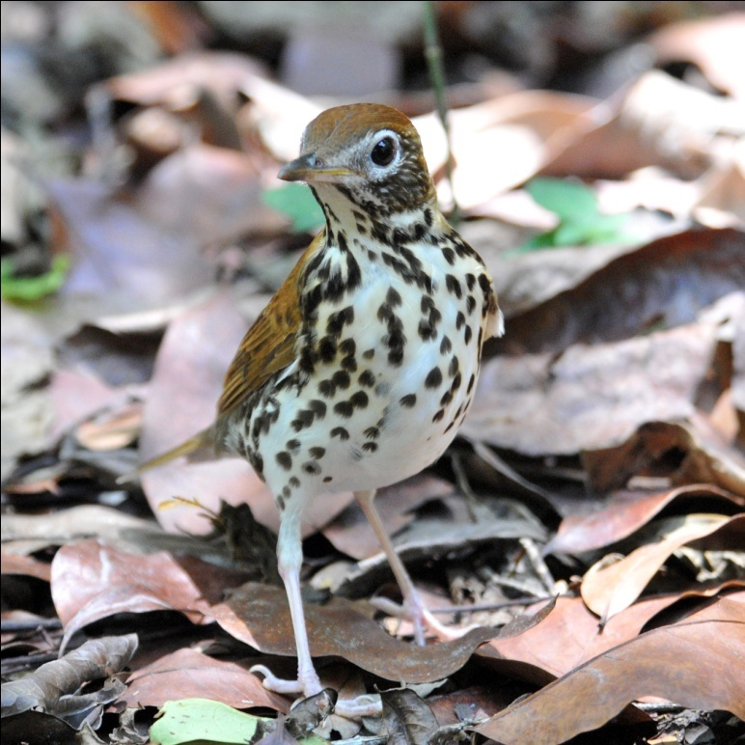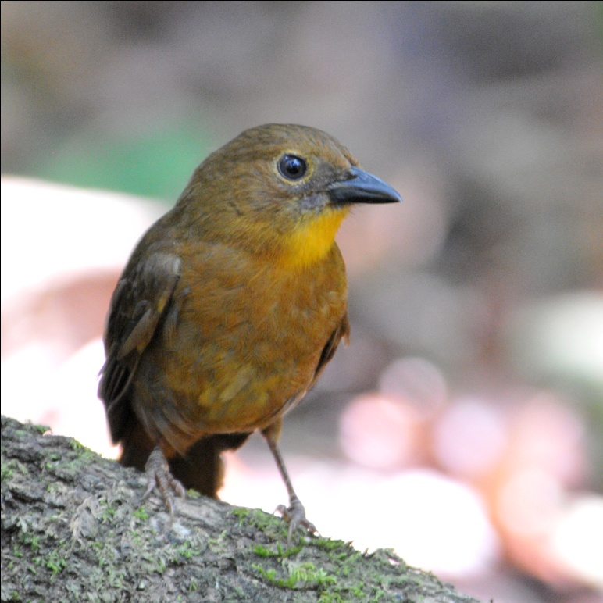
Wood Thrush Red-crowned Ant-Tanager female

After lunch, we walked down the steps to the azure pond known as the Blue Hole. What an appropriate name for this place, which actually looks like a huge hole in the ground with a pond at the bottom. We enjoyed wading in the cool water, and I tried to get a photo of everyone, their feet in the crystal clear water with the vibrant blue surface of the deeper pool and the limestone wall covered in vines, ferns, and epiphytes behind them. Our time in the water was not completely tranquil, since this site is home to many birds. We watched a pair of Rufous-tailed Jacamars perched on a vine watching their nest in the mud bank alongside the sidewalk below them, an Ochre-bellied Flycatcher hunting insects from a low perch along the water's edge, a Long-tailed Hermit leave his perch above the water and dive straight into the water, and Ridgeway's Rough-winged Swallows clinging to the rock wall. As we went back up the stairs to continue our birding on the Hummingbird Trail, we saw a young Basilisk Lizard basking on the concrete steps. It allowed us to approach very closely for some excellent photos. We left the cavity just as the school group was approaching.

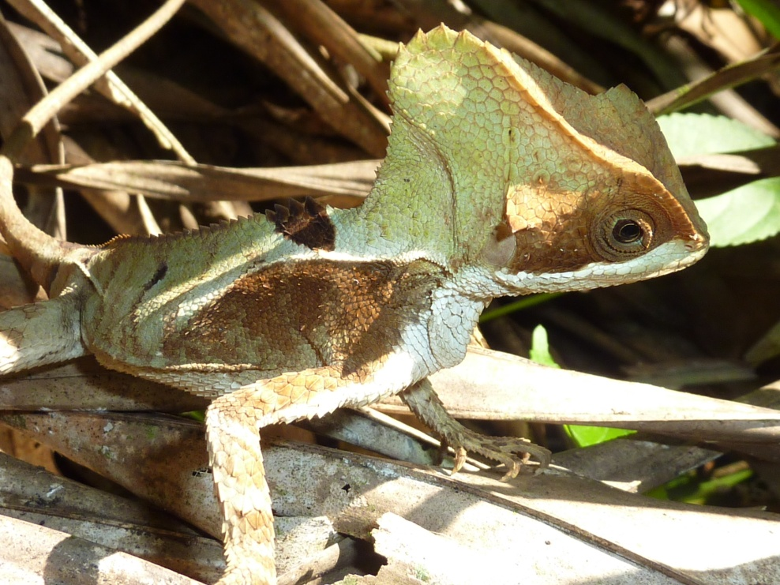
Basilisk Lizard
On the Hummingbird Trail, the birding returned to a more normal state. Chris spotted a Smoky-brown Woodpecker that no one else was able to find before it flew away. We spent quite a few minutes trying to catch a glimpse of a Scaly-throated Leaftosser about 75 feet off the trail. We could see the leaves flying about on the forest floor, but every time the bird started to come into view, we could see only part of it. Glenn was able to id the bird by putting the parts together, but we all walked away thinking "BVD". We heard the beautiful song of, but did not see, White-bellied Wren. Band-backed Wren was more cooperative and everyone was able to see it. Some of the group got to see White-winged Becard, but I missed it. Dot-winged and Dusky Antbirds, Sulphur-rumped, Piratic, and Brown-crested Flycatchers, and Swainson's Thrush all made an appearance. Glenn helped the entire group get good looks of a tiny Stub-tailed Spadebill, not an easy feat! Golden-crowned Warblers were present, and I was able to see a Black-throated Blue that I had missed on day 3. Probably the best sighting of the day was the Great Tinamou. We had heard tinamous on other days, but the bird was always at a distance. Today, Glenn heard not the call, but the footsteps of the Tinamou in the forest to the left of the trail we were on. He left the trail, found the bird, and then motioned for us to follow him off the trail. One by one we stood by Glenn as he pointed out the well-camouflaged chicken-like tinamou.

We left Blue Hole a bit begrudgingly, but we had a long drive to get to Five Sisters and wanted to get there before dark. Along the way, we stopped for a King Vulture in the air, but otherwise drove straight to our destination. We arrived after dark and were led to our lovely cabins, where we quickly freshened up before going to the main lodge for dinner. We went over our checklists while waiting for our meals to arrive, and learned we had the exact same count as yesterday - 101. Our lowest daily count for the entire trip was 100 on day 1 (half day of birding!); we were seeing more than 100 species every day of the trip!

Day 8,Saturday, March 26: We started the morning birding from the balcony of the dining hall of Five Sisters Lodge. Named for the five waterfalls that can be seen from the balcony, Five Sisters is located in the Mountain Pine Ridge Forest, the largest protected area in Belize. We met on the balcony shortly before 7:00 AM to have coffee and take the opportunity to search the surrounding treetops at eye level. Grace's Warbler, Plumbeous and Red-eyed Vireos, and Green Jays all made an appearance. Blue Grosbeak flew in and out of view. We could see Plumbeous Kites soaring overhead, the orange patches in their wings showing in perfect light. After a short while, our breakfast was ready and we reluctantly went inside.
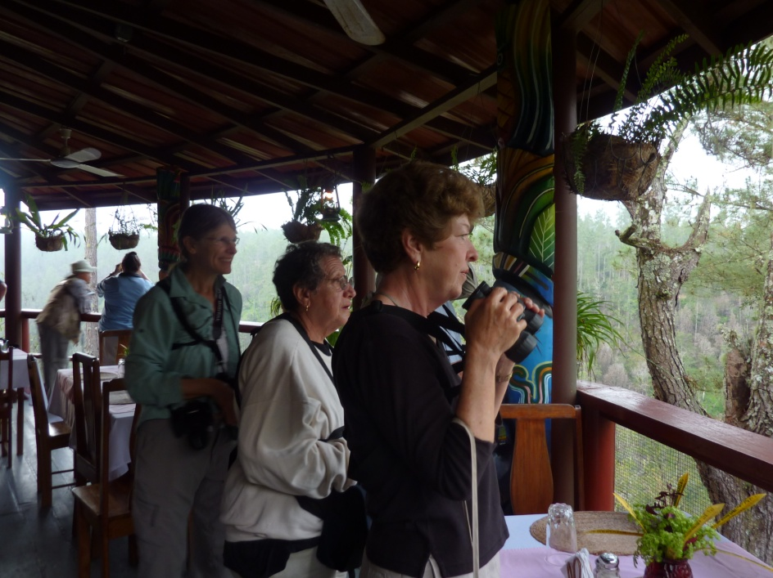

By 8:00 AM, we were on the orange dirt entrance road, in search of Ferruginous Pygmy-Owls that often roosted in the area. It wasn't long before Glenn's vocalizations brought the owl out into the open, and we all enjoyed scope views of the tiny owl. We walked a bit further down the road, this time looking for a Rusty Sparrow, a fairly common species in this area. Along the way, we found White-collared Seedeater and Yellow-bellied Elaenia, among other species. As we were following our first Rufous-capped Warbler, Glenn heard a Rusty Sparrow calling from a short distance away. We followed the sound, leaving the dirt road to walk through some tall weeds. There was the bird, sitting on a fence post, singing his heart out. After everyone got good views of the bird through their binoculars and the scope, Brad and I slowly approached to try for some better photographs. We would walk a few yards, take a shot or two, advance a little further and take a few more shots, repeating the process until we were within 30 feet of the sparrow. As we turned to leave the area, Acorn Woodpeckers also gave us a photo op.
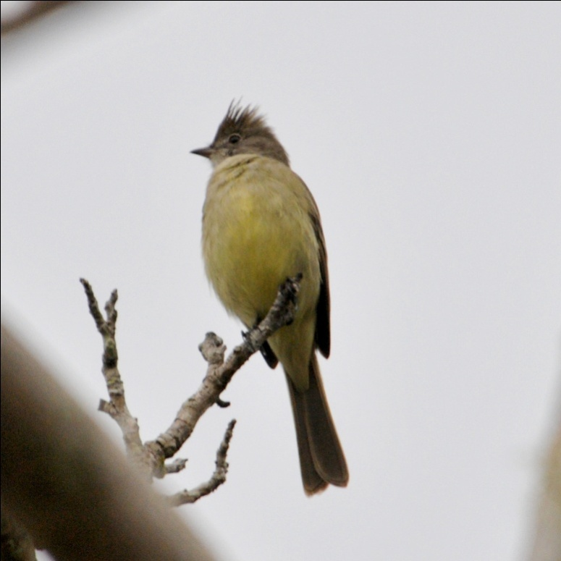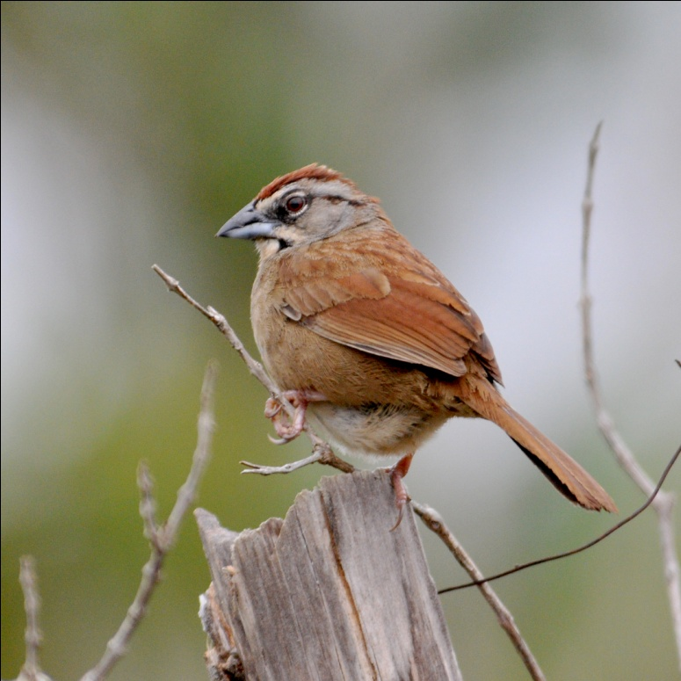
Yellow-bellied Elaenia Rusty Sparrow

After about an hour of birding along the road, we went back to the garden area of Five Sisters to get ready for our main activity for the day: travel to Thousand Foot Falls to search for the very rare Orange-breasted Falcon. After getting our things together for the daytrip, we had some time to spend in the garden before our departure. In the garden, I was able to photograph Azure-crowned Hummingbird, a life bird for me. Other garden birds included Hepatic Tanager and Chipping Sparrow.

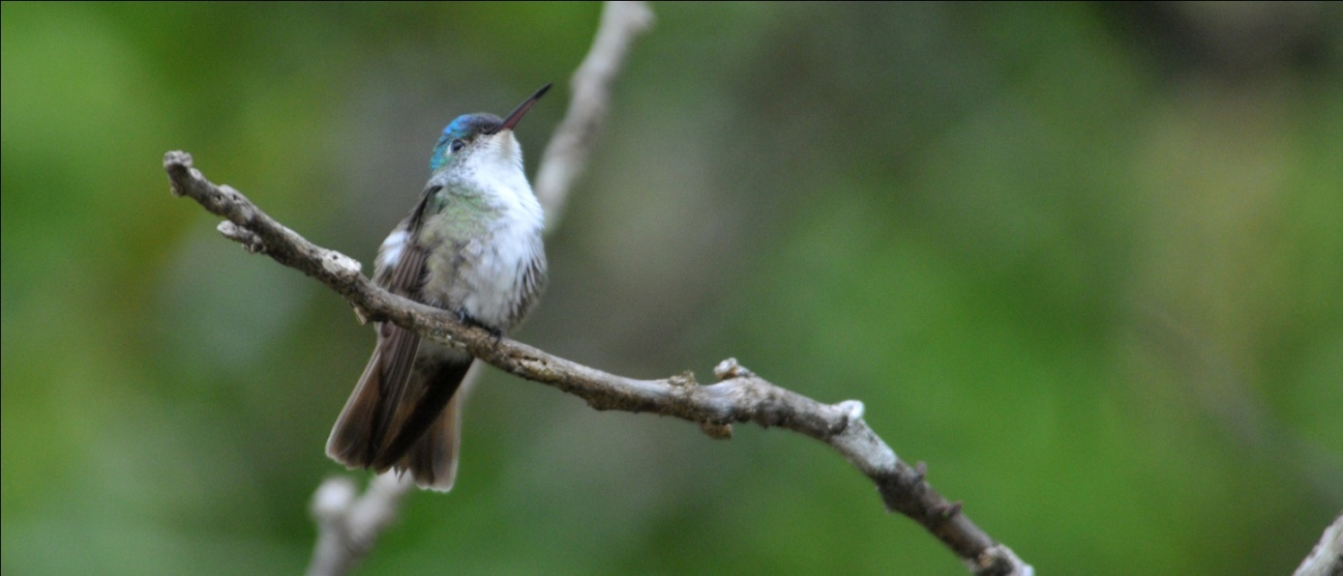
Azure-crowned Hummingbird

We left as soon as our box lunches were ready, and started driving out the dirt road we had birded earlier that morning. Along the way, of course, we had to stop for some birds, most notably a Yellow-backed Oriole that was seen flying through some tall bushes on the side of the road. We hopped out of the van, expecting to get on the bird fairly easily since it had been seen from the van, but the bird went further away from the road and we followed. We kept going just a little farther, a little farther, until Jim finally had to go back and move the van from the middle of the road as it was clearly going to take more than just a minute or two! The oriole finally came out into the open where we all got great looks, and then disappeared. In the same area, we saw Yellow-tailed Oriole and Black-headed Siskin, so the stop was well worth it, getting two new species for the trip as well as chance to compare the two similar oriole species.

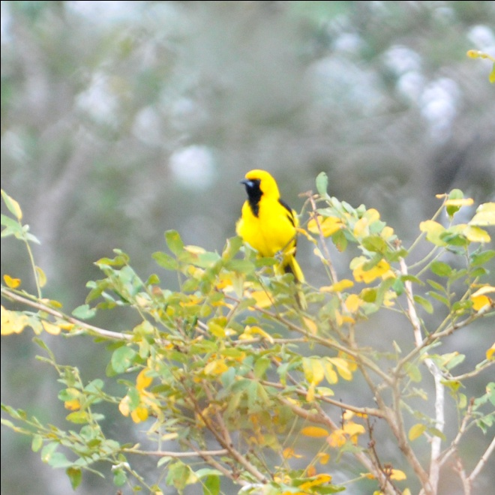
Yellow-tailed Oriole
We arrived at the falls mid-morning. We wasted no time and headed straight down the steep stairs that led to the overlook where the falcons are usually seen flying over a deep valley at this time of day.
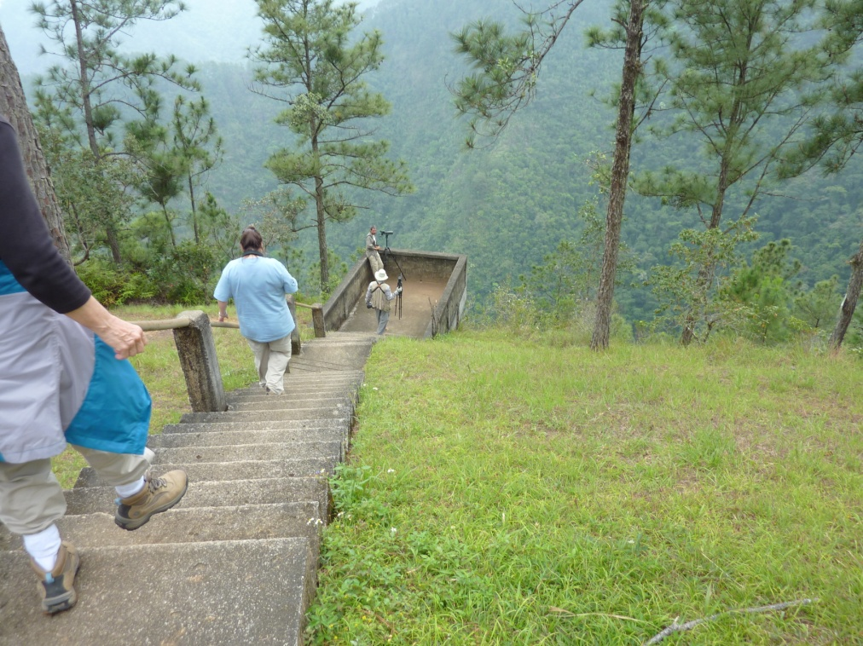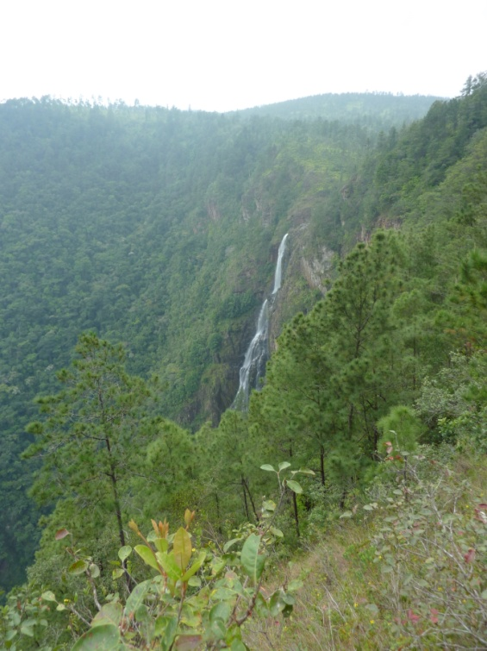

As we descended, we saw a man with a scope on the platform and learned that he is a researcher with the Peregrine Fund who is tracking the Orange-breasted Falcons in Belize. Orange-breasted Falcons, one of the most sparsely distributed falcons in the world, were estimated to have a population of fewer than 35 pairs in all of Central America when the Peregine Fund released some captive-bred birds into the wild in Belize in 2007. This came after a 21-year effort to effectively propagate the rare falcons in captivity, one of the most difficult species the Peregrine Fund had ever tried to breed. We talked with him for awhile as we all looked and listened for the falcon, but no falcon appeared or called. White-collared Swifts darted about and made us take a second look a few times, but no falcon. After awhile, the researcher left and some tourists came to see the view of the falls from the platform. We chatted with them awhile and told them about the falcon. They seemed interested but left without seeing the bird. After about an hour on the platform, one of us (I can't remember who) saw a shape in the sky over the valley ---- YES! There was the Orange-breasted Falcon soaring just above eye level, although quite a distance away. We all were able to see the diagnostic field marks, including the orange belly, although we would have preferred that the bird stick around longer and fly closer. (Like I said, some people are never satisfied!) We watched for a while longer, hoping the falcon would reappear, but we finally gave up and climbed back up the steep stairs, feeling good about our determination (and luck) that resulted in us finding this rare species. We went into the gift shop where some of us got a snack or soda, and wandered about the area without seeing much of any birdlife. Part of our group was resting beneath the shelter at the top of the stairs when I saw what I thought could be the falcon dart by in the valley below, from left to right. Chris decided he would go back down the steep slope to see if the falcon was there. Jennifer, not wanting to climb the stairs again, but also not wanting to miss the bird should it fly by as Chris stood there alone, followed. They were there for a few minutes when Jennifer found the falcon sitting on a branch to the right of and below the platform, hundreds of feet above the valley floor below. I had apparently caught a glimpse of the bird as it flew to its perch, and now it sat there, preening. Everyone rushed back down the stairs, and we spent the next twenty minutes watching and phtotographing this rare and endangered species casually preen as it sat some eight hundred feet above the ground.
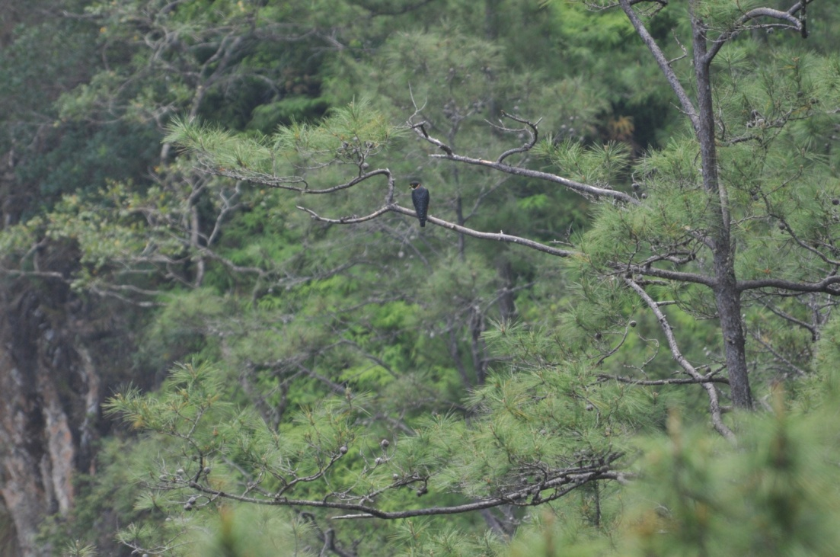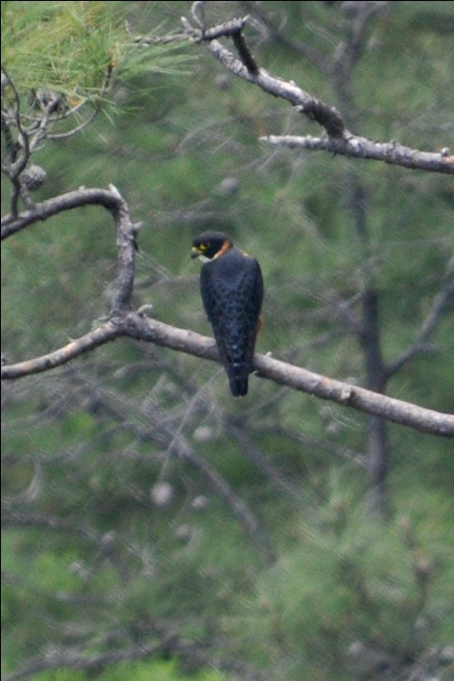

When we climbed back up the steep, steep stairs (they get worse as the day goes on) this time, we felt extremely satisfied with our sighting of one of the rarest birds of the trip. Only a few other birds were seen before we got back to the lodge, including a Mealy Parrot seen by some and a Swallow-tailed Kite seen from the road. When we returned to the lodge, we had a short break before planned to meet for an afternoon walk. It was fairly hot and Glenn assured us that the hike would be in the shade with only moderate elevation changes, and he offered the option of swimming in the ponds at the base of the falls for those who would rather not walk. With the tram to the bottom of the valley where the pools were located broken, no one took him up on that offer (although a few energetic souls hiked down during our break just to see the area). Before we began the hike, we saw Orchard, Black-cowled, and Baltimore Orioles feeding in flowering trees in the garden, bringing our oriole species count to 5 for the day. We walked down a path that Glenn said was normally pretty good, even in the afternoons when birds are less active. Besides hearing a Plain Wren and Black-throated Shrike-Tanager, the trail was lifeless. We took a shortcut back to the lodge that was quite a bit more than the "gradual incline" Glenn had mentioned earlier, and had some time to rest before dinner. Our bird count for the day was the only day we had fewer than 100 birds - just 68 species for the day, attributable to the amount of time we spent on one species (the falcon) and the bummer of a trail we had that afternoon. Nonetheless, we were all quite content with our day's achievements, placing a higher value on quality rather than quantity today.

Day 9, Saturday, March 27: We needed to start early on this, our last day of birding, since we were going to travel to Caracol, just a few miles from the Guatemala border. We made our departure even earlier than needed so we could spend a little time trying to locate a Stygian Owl that was known to roost near the lodge. I was leaving my cabin when someone alerted me that Glenn already had the owl. I broke into a sprint and hurried as quickly as I could, but when I got there, the owl had just flown. Several members of our group got some really good looks before it spooked, and I was thrilled that our group saw the owl, but I have to admit I was pretty disappointed in missing this life bird.
We took a packed breakfast and hit the road before daybreak, arriving at Caracol shortly after 7:00 AM.

Caracol, the largest archaeological site in Belize and one of the largest of the Mayan world, features the tallest man-made structure in Belize. Because of recent problems with people crossing the Guatemalan border to rob tourists, an armed police officer must be present when visitors are on the property. So we stopped outside the ranger station several miles before the Caracol entrance and Glenn went inside to check our group in. The truck normally used to transport one police officer and one ranger to the main visitor area had a flat tire, so the two armed men rode with us in our van. While we waited for them to get ready, we (of course) birded the area around the building. Glenn got a Red-billed Pigeon in the scope, enabling us to see the bird well enough to ponder over its name - it does not have a red bill.

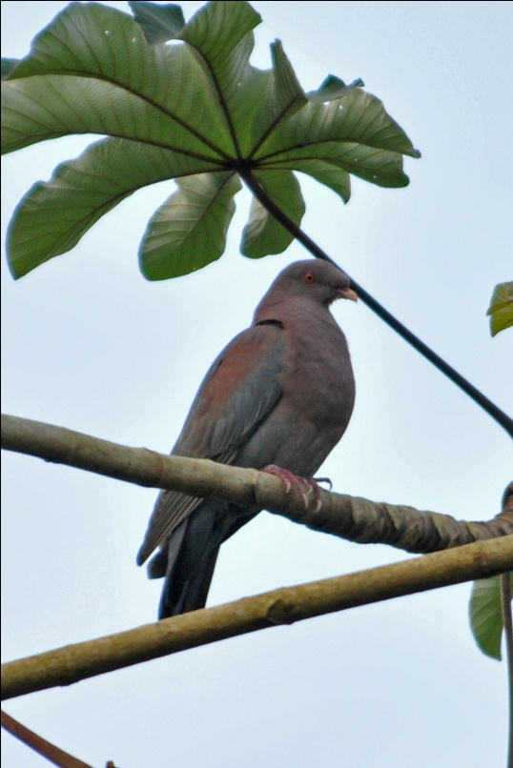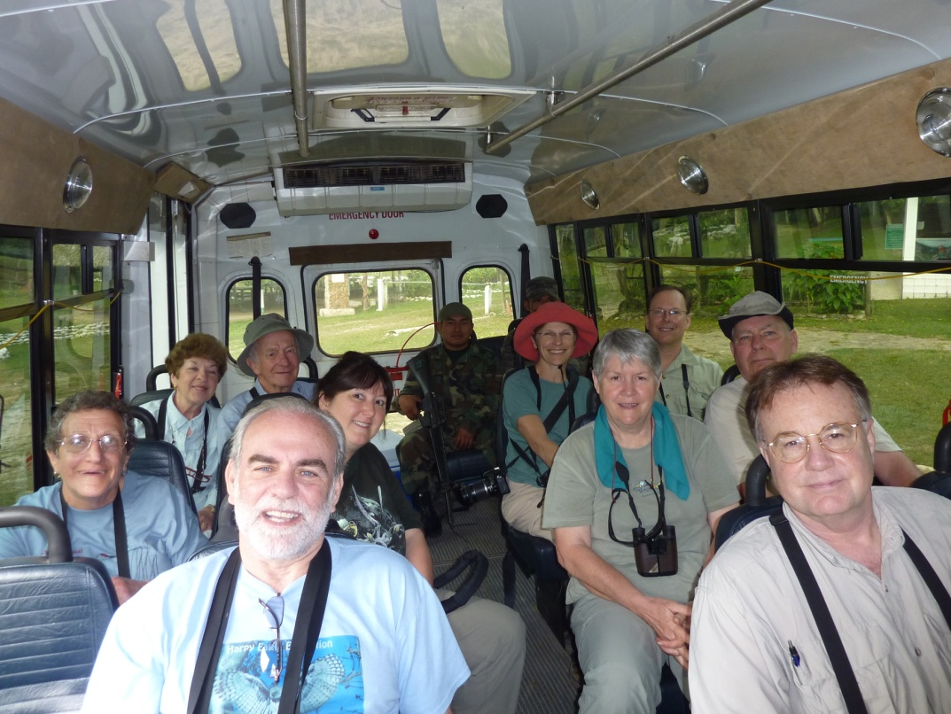
Red-billed Pigeon Our armed escorts in the rear of the van

We ate our breakfast in one of the shelters provide for visitors, with no people in sight other than our group and the two officers accompanying us. As soon as we finished eating, we began to notice a lot of activity in the trees surrounding our clearing. We stood about 40 feet away from the row of trees and called out to each other each time we spotted a new bird, trying to give directions to put others on the bird we spotted. With so much activity, it was a riot listening to everyone at once all the while trying to tell others where YOUR bird was! We had Plumbeous and Red-eyed Vireos, Red-legged and Green Honeycreepers, our first Bananaquit, and at least 10 warbler species - Golden-winged, Tennessee, Chestnut-sided, Magnolia, Black-throated Green, Blackburnian, Black-and-White, American Redstart, Kentucky, and Wilson's. The Kentucky Warbler repeatedly disappeared almost as fast as it appeared, and each time Skip would try to get on the bird, it would vanish. It took several attempts for Skip to get on this life bird but, in the end, the Kentucky came out and allowed Skip to drink it in with great looks in good light. It was difficult to move on with so much activity, but Glenn wanted us at the top of the highest Caracol monument in time for "Hawk O'clock", and we had to go.

A quick restroom stop proved to be a little time consuming when we noticed a lot of movement in the trees at the entrance to the facilities. A White-fronted Parrot landed in a tree near the path, and a Red-billed Pigeon perched not too far from the parrot. It was hard to decide which one to photograph first! More birds flew in, including a Cinnamon Becard, a Red-crowned Woodpecker, and several of the same species we had been watching earlier on the other side of the road. We were finally able to move on the Mayan ruin, and we were all really pumped to see what we would find there. If it's this good in the picnic area, who could tell what we might see in the main part of the park?

As we walked to the tallest of the Mayan structures, Caana (Sky Place), Glenn told us some of the history of the site. Discovered in the late thirties by loggers, it was named "Snail" because of the numerous snail shells found there, but excavatiion did not begin until the 1980s. There is evidence in carved stelae that Caracol defeated Tikal, and archaeologists believe that Caracol was occupied by over 200,000 people circa 700 AD. As we approached the massive structure, rising 140 feet in front of us, Glenn pointed out the large stucco masks depicting jaguars and Tlaloc, the Mexican god of rain and lightening on the opposite structure. Glenn recommended that we all climb to the top of Caana, where birders are often treated to a show of raptors in the surrounding skies, as well as tree-top views of Blue Cotinga and other canopy species that are often difficult to see. The steps were not designed for climbing, most of them quite tall and some of them higher than your knee. Jim started out ahead of the rest of us, thinking he might need to take more time on his two new partial knee replacements, but he made it to the top with no trouble. We slowly, achingly climbed toward the top as Glenn sprinted past with his scope balanced on his shoulder. At the top, Glenn showed off the calf muscles that he said allowed him to climb the ancient monument so effortlessly, but I don't know. . . it seemed to be my thighs, not my calves, that were screaming when I reached the top.
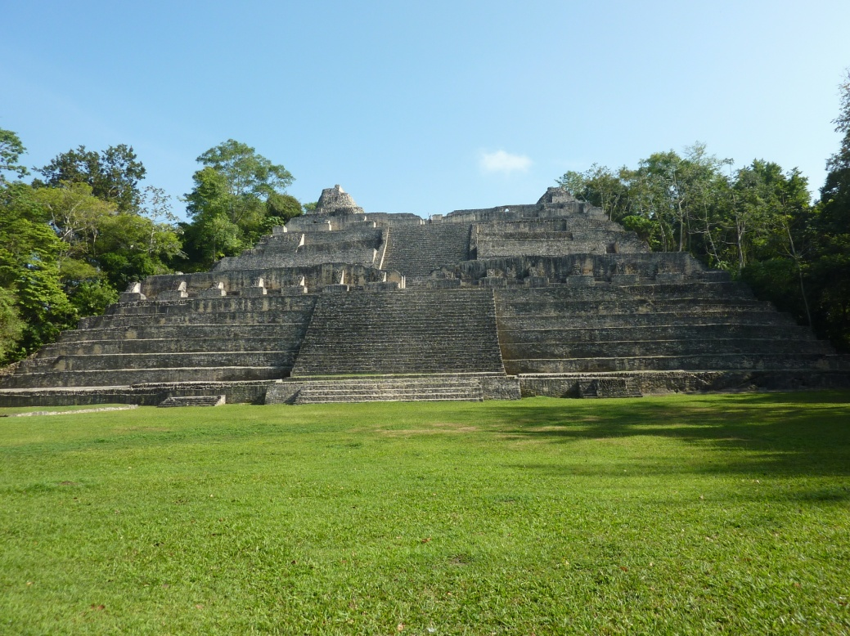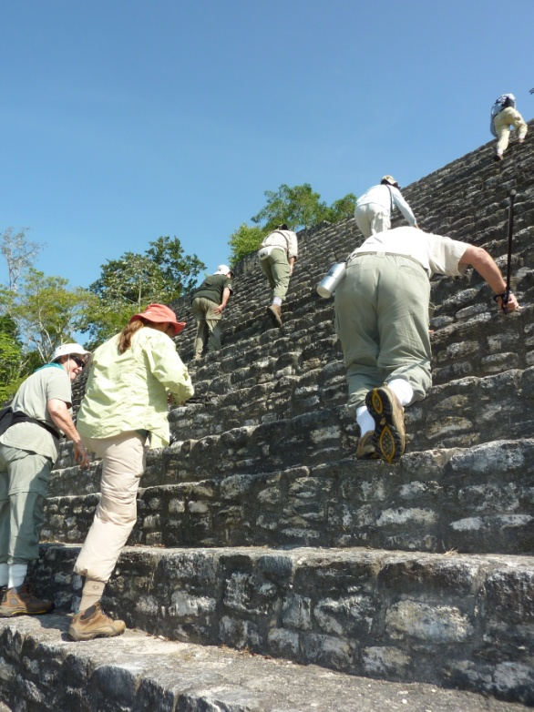
We searched the sky and the surrounding trees for birds, but it wasn't impressively active that day. Turkey and Black Vultures floated lazily in the sky, but no King Vulture joined them. A White Hawk and Plumbeous Kite showed up, followed by a very close Bat Falcon. We followed the falcon with our binoculars as he flew in and out of a nest in a palm tree where his mate waited. When he returned the second time, he carried in his talons a White-bellied Emerald to offer to his mate. We saw some passerines from the top of Caana, but nothing new or unusual. We walked around the top of the structure, taking photos and investigating cubby holes, until one by one we gave up and started down the front of the monument to do some ground level birding.
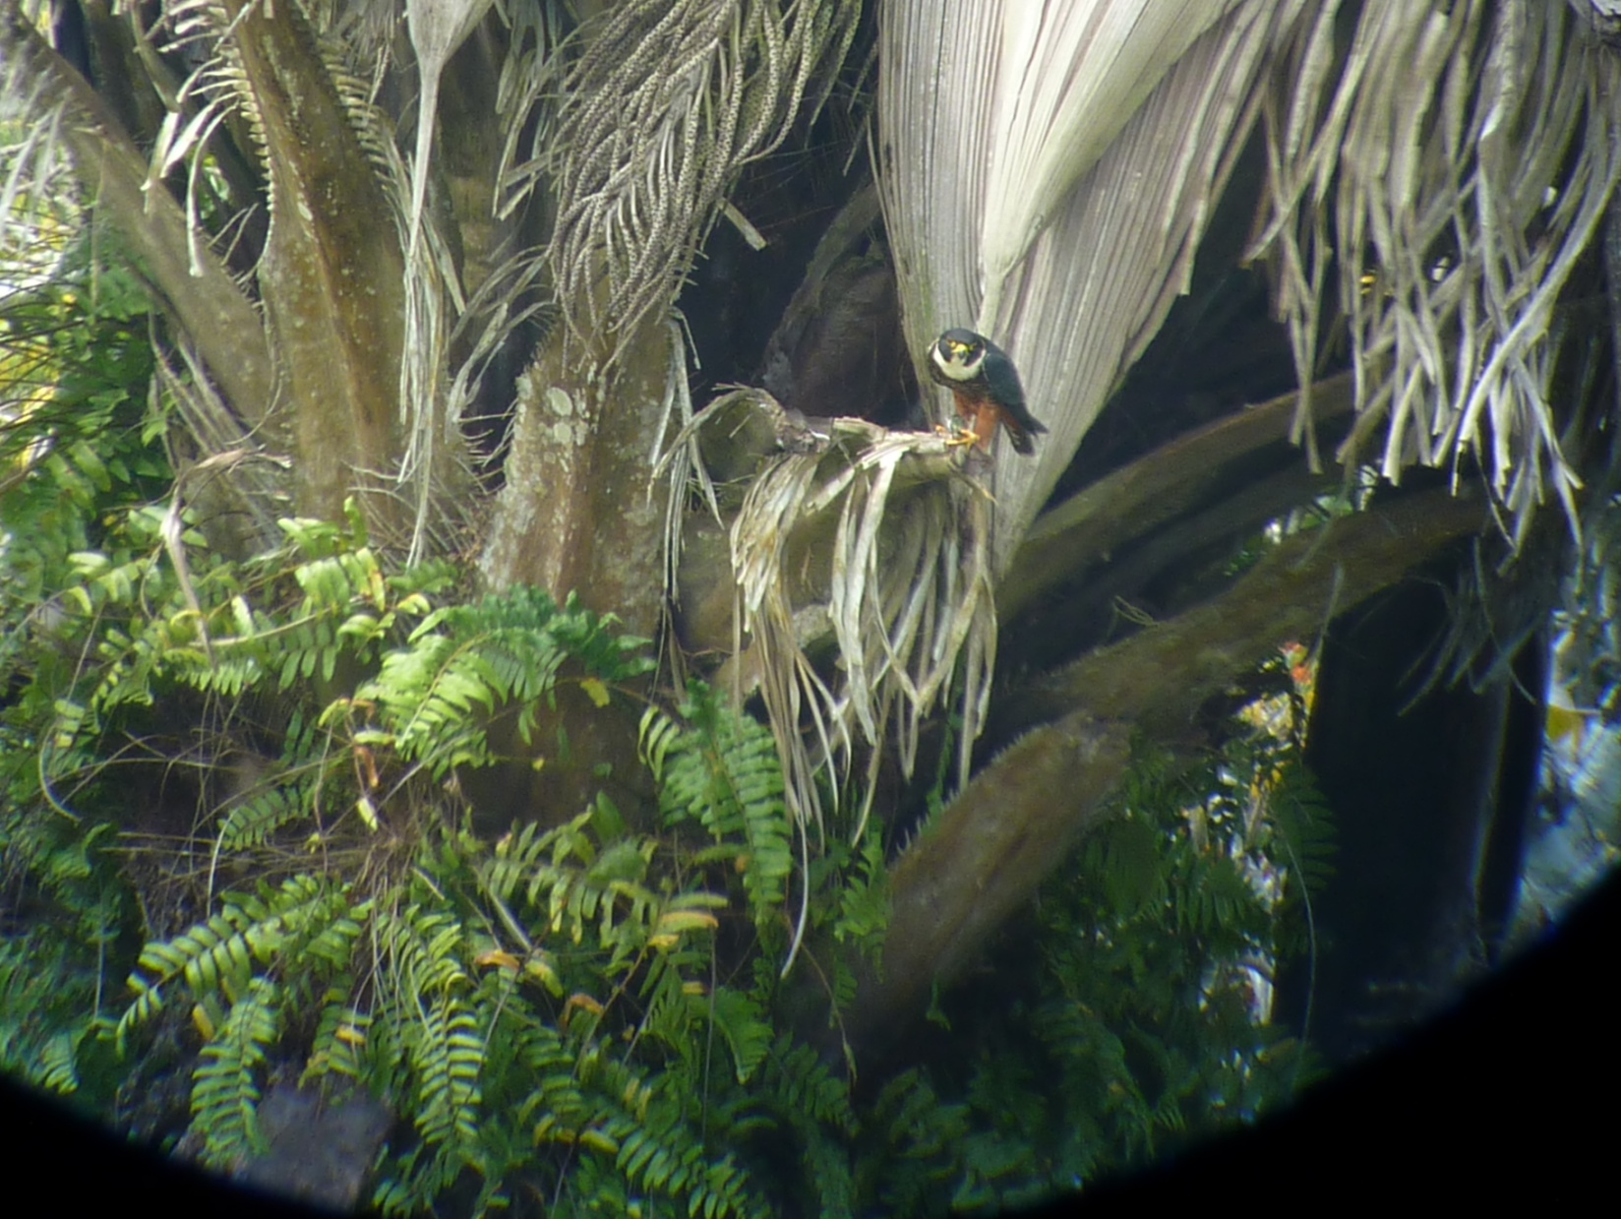
Bat Falcon with White-bellied Emerald "snack"

Some of the birds seen on our morning walk at Caracol included White-necked Puffbird, Scaled Pigeon, Olive-backed Euphonias building a nest, Sulphur-bellied Flycatcher, Streak-headed and Ivory-billed Woodcreepers, and Double-toothed Kite. Some birders in the group saw Scrub Euphonia and Black-faced Antthrush while everyone in the group was able to get on a Mealy Parrot, previously seen by just a lucky few. Some of the best action occurred toward the end of our walk, as we approached the picnic area for lunch. First were the Montezuma Oropendolas clamoring about in the branches overhead, followed by a Pale-billed Woodpecker who landed pretty close and personal. As we came out into a clearing, Glenn called for me to hurry to the front of the line. A Black-cheeked Woodpecker was working furiously on an excavation, with wood chips flying and the bird so preoccupied that he did not seem to mind humans approaching very near. As Glenn took photos with the Lumix, I snapped off some shots with my "big gun". We continued walking, but not for long as a Blue-Crowned Motmot swooped low in front of us to land on a low vine on the left side of the wide path.
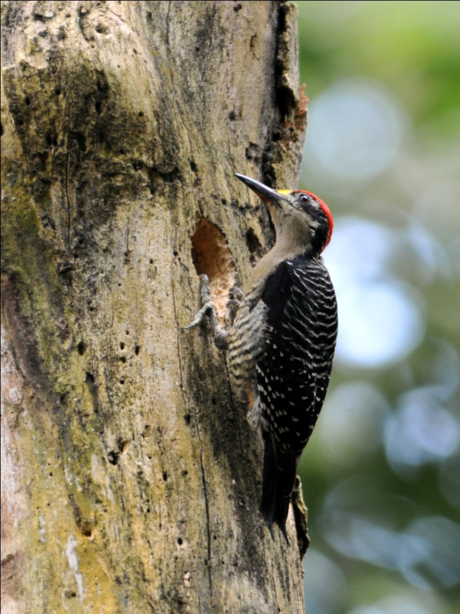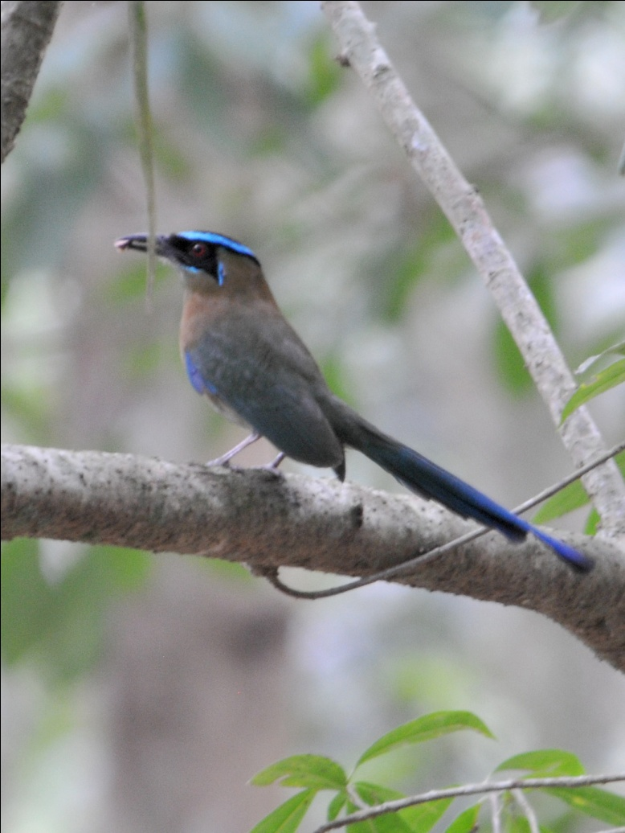
Black-cheeked Woodpecker Blue-crowned Motmot

A bit further, we saw the Army Ant swarm that we had noticed on our way in that morning, still active and beginning to attract birds. We wanted to stay and watch, but our stomachs demanded that we take care of lunch and restroom breaks first, so we moved on to the picnic area, promising each other to return there right after lunch. Before we could finish the final hundred yards to the shelter, a Collared Trogon appeared, our fourth trogon for the trip, as well as our fourth trogon for the day - ALL of the possible trogon species possible in Belize in a single day! A Chestnut-colored Woodpecker aped the behavior displayed by the Black-cheeked Woodpecker as it excavated a hole, oblivious to our presence. All right, already! We need to EAT! We walked on to the picnic tables with only quick glances at the activity around us, enough to be sure the birds around us were members of species we had already seen.

After lunch, some of us visited the small museum while others visited the gift shop. All of us took a few moments to rest in the shade before going back out for a short afternoon walk. Because the armed escorts we had with us needed to get back to the ranger station, we could not spend much more time at this amazing site, so we opted to check out the antswarm right away. You could hear the sounds of insects hopping around on the dry leaves as we approached the area, all of them scrambling to escape the Army Ants. The birds are attracted to Army Ant swarms, not because they want to eat the ants, but because the ants scare up the insects they do want to eat. We stood quietly for a few moments, and watched as Hooded, Kentucky, and Worm-eating Warblers feasted on the insects. Normally "skulkers", these birds were as open for viewing as your average front yard Robin in spring! Northern Barred, Tawny-winged, and Wedge-billed Woodcreepers sat poised for action on three consecutive tree trunks, providing us a rare opportunity to compare size, field marks, and bills of three species of one of the most difficult tropical families to identify in the field. By the time we finished with the antswarm (or at least we were willing to pretend to be finished with it), we had time for just a very short walk. We saw a troop of Howler Monkeys with young ones hanging onto their mothers, occasionally venturing bravely off by themselves a few branches away. We did manage to find several species on our short walk, despite the afternoon heat, but the Golden-crowned Warbler was the only one that was new for the trip. Just before we got back to the parking area, we stopped by some pretty amazing buttress roots for a group photo. Unfortunately, Sybil wasn't with us as she had decided to stay at the shelter with the officers while we hiked a bit more. She had a nice afternoon swapping stories with the young Belizeans, and I think they enjoyed her company as much as she enjoyed theirs.
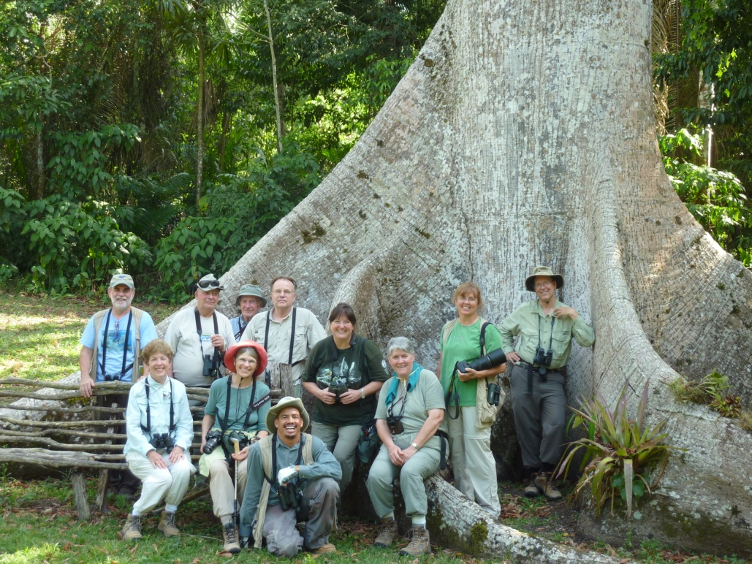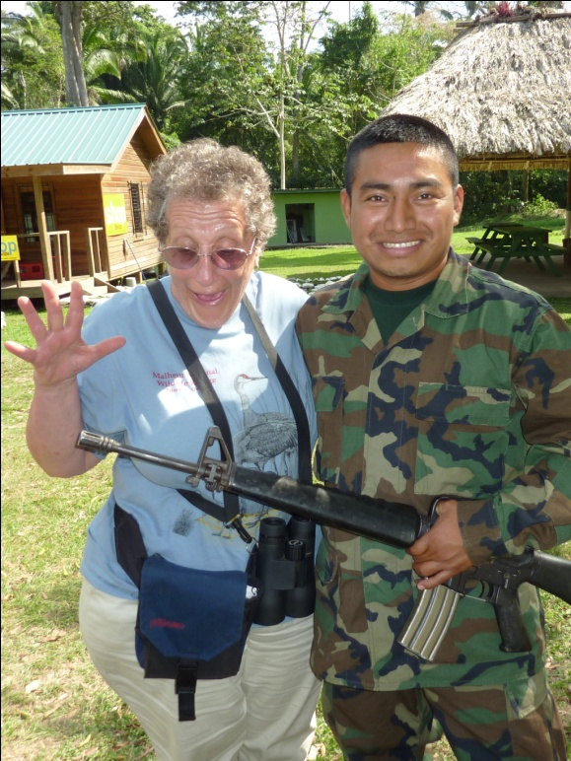
We dropped the officers back at their station and headed "home" to Five Sisters Lodge. We needed to pack everything for our trip home tomorrow, so we didn't mind (too much, anyway) calling it quits a bit early today. We made just a few stops on the way back, once along a bridge where we saw Black Phoebe, and again when someone spotted a Bare-throated Tiger-Heron. We went to our rooms to do some packing before going to dinner and completing or checklist. We were almost back into the hundreds today with a total of 98 species seen. For the entire 8 1/2 days of birding, our grand total was 289 with an additional 12 species heard and 2 species seen just by Glenn. We saw almost half of all the bird species in Belize in a little over a week, and we did it without the use of audio tapes.
Day 10, Sunday, March 28: Most of us had early flights, so we left for the Belize City International Airport immediately after an early breakfast. Much of the drive was in the dark, and we did very little birding even after the sun came up since we had little time to spare. Sybil, Stephen, and Myra had later flights than the rest of us, so Glenn took them to tour some sites near the coast after he dropped the rest of us off at the airport rather than force them to spend hours at the airport. We all said our goodbyes and gave hugs to our newest friends, hoping that our next birding adventure would bring us as impressive a list of birds and as good a group of birders with whom to see them.

OUR NEXT TRIP TO BELIZE IS SCHEDULED FOR MARCH 11 - 20, 2011.
Contact us for details (cheepers@sbcglobal.net or 937-862-4505) or visit our website at www.cheepersbirding.com

