SOUTH AFRICA
Subtropical Tour
Trip Report
October 14 - 29, 2011

Disclaimer: This report is as accurate as possible using limited recordings and notes taken in the field. Species have been reported on the proper day(s) but, with multiple sites visited on the same day, it is possible that some species are listed as being seen at the wrong location. Any such errors are unintentional. All photos were taken by the author on this trip or the Cape extension immediately preceding this trip, but not necessarily in the order shown.

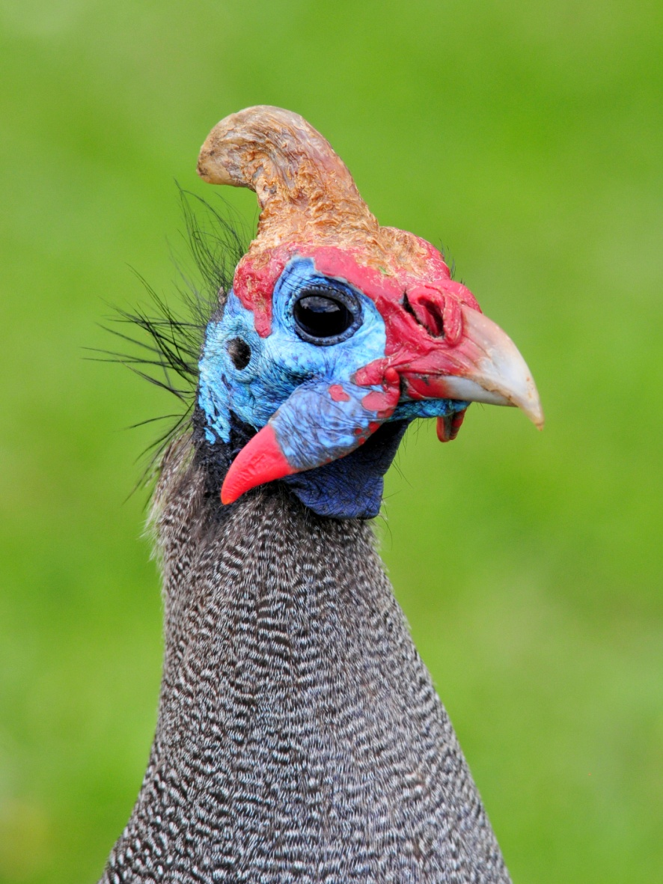
Species seen by group: 418
(Subtropical Tour only)
Note: 491 species were seen during the combined Cape and Subtropical Tours. See the trip report for the 12-day CapeTour at www.cheepersbirding.com)
Additional species heard: 15
Birding guides: Errol de Beer, John Davies
Tour leaders: Cindy and Jim Beckman, owners of
Cheepers! Birding on a Budget
Group: 10 + 2 tour leaders and 2 guides
Highlights: Marabou and Yellow-billed Storks; African Cuckoo Hawk; Bateleur; Grey-crowned and Blue Cranes; African Rail; African Finfoot; African and Painted Snipes; Double-banded Sandgrouse; African Green Pigeon; Knysna, Purple-crested, and Livingstone's Turacos; 7 species of Cuckoo, including Red-chested, Diderick, African Emerald, and Klaas’s; African Barred Owlet; Narina Trogon; 4 Bee-eater Species, incuding European and White-fronted; Lilac-breasted, Broad-billed, and Purple Rollers; African Hoopoe; Green Wood-Hoopoe; Common Scimitarbill; 6 species of Hornbill, including Southern Ground-Hornbill; Yellow-fronted and Red-fronted Tinkerbirds; All 7 possible species of woodpecker, including Ground Woodpecker; 9 species of Larks, including Botha’s; Paradise and Blue-mantled Crested Flycatchers; 12 species of Sunbirds; Long-tailed Widowbird; Green and Pink-throated Twinspots
Helmeted Guineafowl

Day 1, Friday, October 14: John and Errol met our group of seven at the Durban airport. Bernie & Jude, Andre &Jean, David, and Jim & I had just finished the 12-day Western Cape pre-tour extension and flew from George to Durban this morning. We learned that Skip and Pam, who were scheduled to arrive on the 13th but had been delayed in Senegal, would not arrive this afternoon as we had been told - their plane was still stuck in Dakar and they should arrive tomorrow morning. We could only imagine how frustrated they must be to have planned on arriving a day early and end up arriving a day after the tour begins!

Stephen was by the pool at the Gateway Country Lodge when we arrived at around 2:00 PM. Myra and Don were resting in their rooms. Stephen and Myra had traveled to Belize with us last year, and we were very happy to have them with us in Africa. We had met Don at the Sierra Vista Birding Festival in August of 2010 and were looking forward to getting to know him better. This B&B was a wonderful place to stay with a lovely garden area, some good birding right outside the gate, roomy accommodations, and excellent food. We all wished we could be here longer, but the best birding was not in Durban and our plans called for us to leave the next morning.

We decided to allow everyone time to settle in and rest a bit, so we set 3:30 as our time to go birding at a couple of nearby spots. While we waited, some of the group rested while others patrolled the grounds in search of something new. A few people were rewarded with some good garden birds, including Speckled Mousebird, Kurrichane Thrush, Southern Black Flycatcher, and Cape Wagtail.

We left the B&B on schedule and started birding at the mouth of the Umgeni River, where we quickly found Blacksmith Lapwing (Plover), Woolly-necked Stork, Indian Mynah, Yellow-billed Kite, Common Whimbrel, and Pied Kingfisher. A Giant Kingfisher flew by, and a Purple Heron flew by twice, leaving us all wishing for better views. Also seen at the river were Gray-headed Gulls, Swift Terns, Wood Sandpiper, Common Sandpiper, Gray Heron, White-breasted Cormorant, Little Egrets, and African Palm Swift.

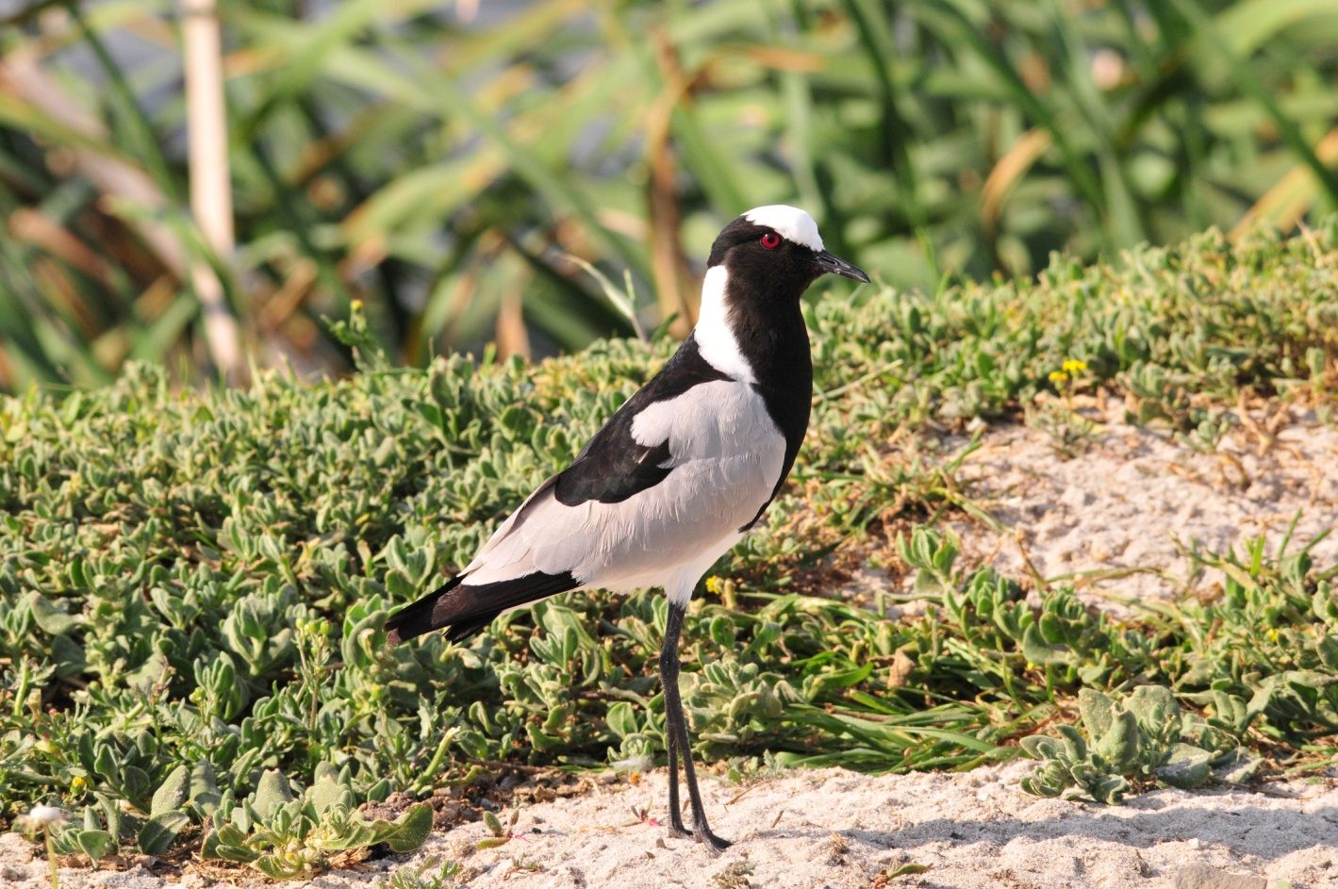
Blacksmith Plover

Next we drove to Umhlanga (pronounced Oom - schlanga) Ponds. Here we found a boardwalk that was being repaired, making for some challenging walking across posts laid horizontally on the ground. We didn’t mind, though, and were thankful that the area had not been closed off during construction. Along the marsh grasses we spotted Spectacled Weaver, Thick-billed Weaver, Yellow Weaver, Dark-capped Bulbul, Somber Greenbul, and Black-collared Barbet. As we entered the small woods, we could hear Yellow-bellied Greenbuls vocalizing and our two guides found them quickly. As we walked along the path we saw Rufous-winged Cisticola, Olive and Collared Sunbirds, Green-backed Cameroptera, Southern Boubou, Dark-backed Weaver, Red-capped Robin-Chat, and Crested Guineafowl. A Green Twinspot was seen by only those in front of the line and only for an instant. Again, only part of the group got on the Terrestrial Bulbuls that were along the path. We heard Burchell’s Coucal as we were leaving and wanted to search for it, but Errol and John told us they are easier to see in the mornings so we planned to come back tomorrow morning before breakfast. Skip and Pam were scheduled to arrive at around 10:00 AM, so our previously-planned early departure was delayed and this would be a good opportunity to find a few new species before departing the Durban area.

The daily count was a bit confusing today as we were trying to keep separate those species seen in the morning as part of the Cape Tour from those seen after our arrival in Durban, making them the first birds to be seen on the Subtropical Tour. To make it even more fun, some birds were seen both in the morning and in the afternoon, but we managed to keep the listings straight and came up with a total of 76 birds seen on the first day of the Subtropical Tour, not a shabby number considering we didn’t really start birding until 3:30 in the afternoon! Of the 76 species seen, 22 were new for the people who had completed the Cape Tour with 247 birds, bringing their trip total to 269.

Other birds seen today included Reed Cormorant, Hadedah and Sacred Ibises, Egyptian Goose, Spur-winged Goose, Palm-Nut Vulture, Yellow-billed Kite, African Fish Eagle, Rock Pigeon, Laughing and Red-eyed Doves, Little and White-rumped Swifts, Little Bee-Eater, Wire-tailed, Lesser Striped and Barn Swallows, Brown-throated Martin, Fork-tailed Drongo, Fiscal Flycatcher, Familiar Chat, Neddicky, African Pipit, Black-bellied and Violet-backed Starlings, Cape White-eye, House Sparrow, Common (European) Starling, and Common Greenshank.

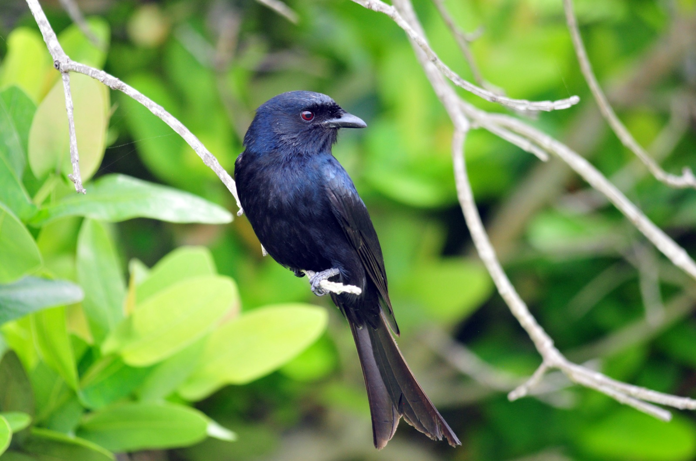
Fork-tailed Drongo
Day 2, Saturday, October 15: As planned, we returned to Umhlanga Ponds at 6:00 AM, but this time the gate was closed. We watched from the van as John talked a guard into letting us in. As we entered the marsh, the front of the line saw Burchell’s Coucal fly over the grasses. Later, the whole group got the bird as it sat on a branch and posed for good long looks. As we walked the path, we saw many of the same birds as yesterday and got better looks at Crested Guineafowl, which had remained in the shadows yesterday. We added Olive Bush-Shrike to the list, although the individual we saw was a juvenile. A pair of Terrestrial Brownbuls also provided better looks than we had yesterday. We all saw Lesser Double Collared Sunbird, and more of the group were able to see Green Twinspot on the path. This time, I got it, along with a few others, after I had turned and gone back on the trail for just a few steps as the group advanced. I quickly called the others at the end of the line and we were able to see the field marks on this little beauty before it hopped back into the undergrowth. We found Tambourine Dove, and everyone got excellent looks at the ever-vocal Green-backed Cameroptera. Other birds seen included Olive Sunbird and Dark-capped Bulbul. As we left Umhlanga Nature Reserve, we spotted a couple of Vervet Monkeys sitting on top of a building.

We returned to the B&B at 8:00 AM for breakfast. The morning meal was excellent, but it took so long for our eggs or omelets to be served that many of us went out to bird the grounds while we waited. Myra showed us the Hadeda Ibis nest that she had found behind the building. I got photos of Kurrichane Thrush and was photographing a Southern Black Flycatcher when a Purple Crested Turaco flew through the yard. Jim and I tried to chase it, going outside the locked gate to follow it. We learned later that Bernie had an African Hoopoe on the lawn while we were outside the fence. Finally, after everyone had eaten, we began to bird in the area around the lodge at about 9:30. The Turaco was not cooperating, although it was still in the area. While looking for it, I found a Yellow-rumped Tinkerbird, which reminded me a little of a Tody Flycatcher, one of my favorite birds in the American tropics. Yet another male Paradise Flycatcher eluded my camera, flitting away as soon as I lifted the lens toward its perch. The group found Yellow-fronted Canary, Southern Black Tit (I missed it, probably stalking a Paradise Flycatcher), Speckled Mousebird, White-eared Barbet, Rose-ringed Parakeeet, and Black-collared Barbet in a short time. We were birding at the end of the driveway

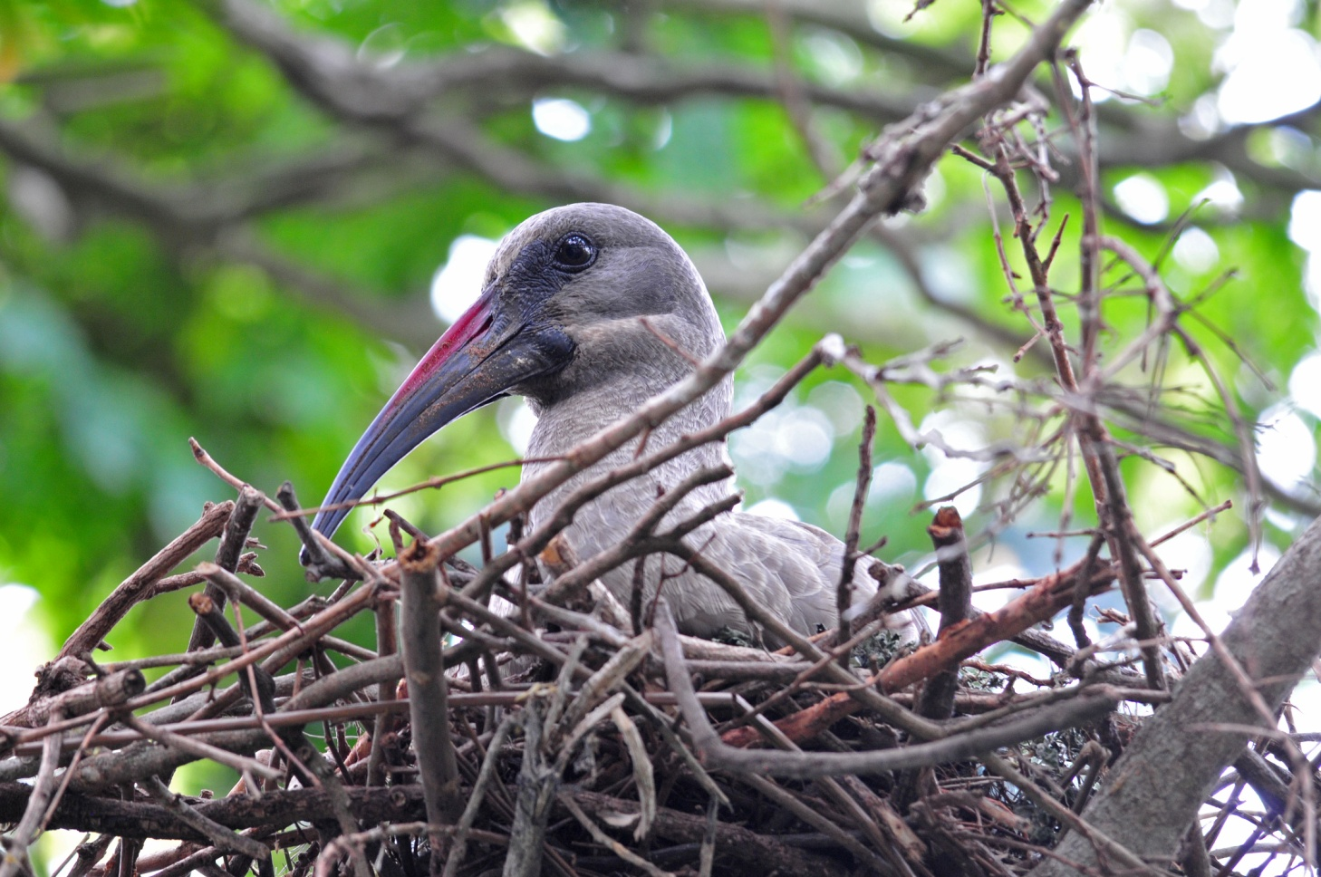
Hadedah Ibis on nest
when Skip and Pam arrived shortly after 10:15 AM. They had also been on our Belize tour last year, so they already knew Stephen and Myra. They were welcomed into the group, promising to tell us their Dakar stories once we had more time. We quickly loaded up the two 14-passenger vans and left for Creighton. With the two 14-passenger vans and just 10 participants and 2 tour leaders, there was plenty of room for all of the luggage, and everyone had a window seat for the entire trip. Since much of the birding and wildlife viewing is done from the vans, we would soon discover that the windows were not large enough to always allow clear viewing, and the group had to find ways to compensate as the tour progressed. Our guides drove the vans away from Durban under cloudy skies, but we all felt sunny, excited to begin this new adventure. Although the weather didn’t make for great birding along the way, we did manage to find Jackal Buzzard and Lanner Falcon from the vans. We stopped at a curve with a stream, an area that John and Errol knew the secretive Starred Robin could sometimes be found. We dipped on the robin but found Lesser Striped Swallow and Southern Black Flycatcher in the area. An African Olive-Pigeon flew over, luckily allowing good enough views to see field marks since this proved to be the only one of its kind that we saw during the trip. When we stopped to allow David to give his leftover sandwich to a youngster on the side of the road, we found White-throated Swallows. Other kids were nearby, so I offered them some hard candy. Immediately several other kids appeared and gathered around the van, open hands extended in hopes of getting some candy. I tried to make sure that every child got at least one piece, but with all those little hands wiggling in front of your face, it’s a pretty difficult task. Also found en route were Village Weaver, House Martin, Martial Eagle, Dark-capped Bulbul, Green-backed Cameroptera, White-bellied Sunbird, and Yellow-fronted Canary.

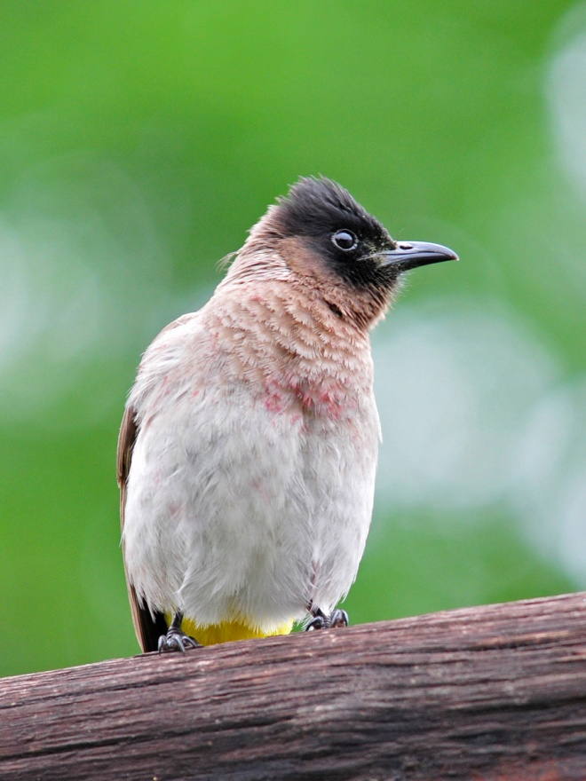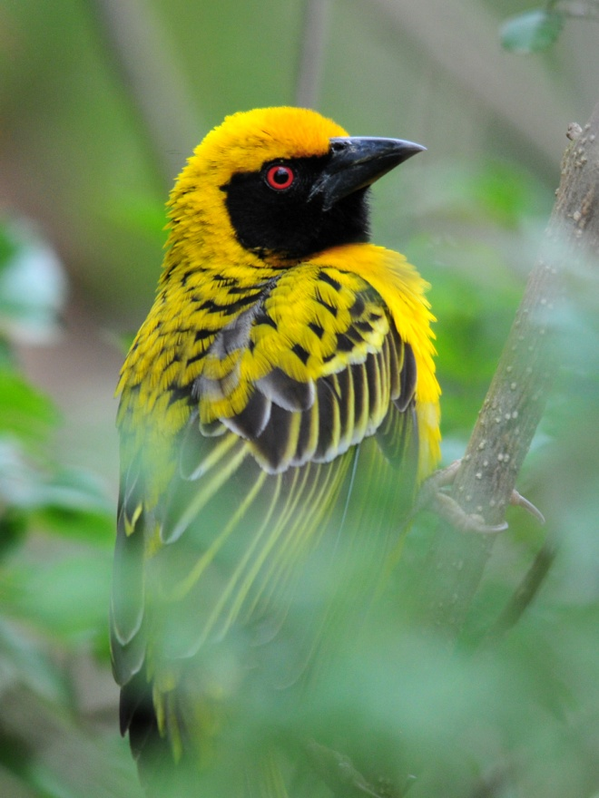
Dark-capped Bulbul Village Weaver

We made a stop at a place called Highover Nature Lodge, a jumping off point to see the highly endangered Blue Swallow. The road up to the reserve was narrow and winding, with many areas close to the edge of a significant drop-off, so I was happy to jump out of the van when we pulled into the parking area. As we waited there while John and Errol spoke with the caretaker, we found Cape White-eye and both Village and Yellow Weavers. A pair of Paradise Flycatchers were working on a nest, but once the group got close to the nest tree they stopped coming for awhile. Jean went down the road a short distance and found some Impala. It proved to be too foggy for us to see the swallows, so we went on down the road on the other side, which was a much better road than the one we had been on (thank goodness!). While we were stopped at a spot for some kind of Quelea, David called out that he had seen a bird with a really long tail – Long-tailed Widowbird! Among the cattle in the field, we also identified Fan-tailed Widowbird, Red-collared Widowbird, African Stonechat, Black-throated Canary, Cape Longclaw, Three-banded Plover, and Cape Weaver. I was so enthralled with the Long-tailed Widowbird that I missed the Canary and Longclaw.

Shortly after we drove away from the field, we spotted a Long-crested Eagle on a utility pole alongside the road. It flew as soon as the first person opened the door of the van, so everyone didn’t get to see it, but there would be several more to come. The people in the second van saw Common Moorhen and Steppe Buzzard while both vans got good looks at Red-billed Quelea, Egyptian Goose, Spur-winged Goose, and Cape Crow. Wattled Lapwings were seen chasing the Steppe Buzzard, so the group approached a fence near the road for better views. This seemed to upset the birds as much, if not more, than the Buzzard had, so we didn’t linger long. At a pond near the road we found Yellow-billed Duck, Dabchick (Little Grebe), White-faced Duck, and Helmeted Guineafowl.

When we arrived at Smithfield Guest House, we learned that one of the rooms reserved for us does not have a private bath, and the proprietor asked which couple I wanted her to put in that room. Of course, any time there is a room that is inferior to the others, Jim and I take it. That meant that we would have two nights of sharing a bathroom (with no shower) with the two guides. Not the kind of surprise I enjoy.

As we settled into our rooms, some went out to bird around the grounds with the guides, but I did not go out. There was a light mist falling and the temperature was cool, so it didn’t seem too appealing; I also had some computer work to do and this provided an opportunity to get some of it done. After spending some time to sort through a couple of weeks of laundry, I didn't get much work done on the computer.

Other species seen today that were new to the Subtropical tour included Black-headed Heron, Cattle Egret, Southern Bald Ibis, Red-billed Teal, Helmeted Guineafowl, Three-banded Plover, Speckled Pigeon, Alpine Swift, Malachite Kingfisher, Greater Striped Swallow, Rock Martin, Common House-Martin, Square-tailed Drongo, Cape Crow, Pied Crow, Somber Greenbul, Cape Grassbird, Bar-throated Apalis, Yellow-breasted Apalis, Levaillant’s Cisticola, Cape Batis, Common Fiscal, Red-winged Starling, Grey Sunbird, White-bellied Sunbird, and Cape Sparrow.

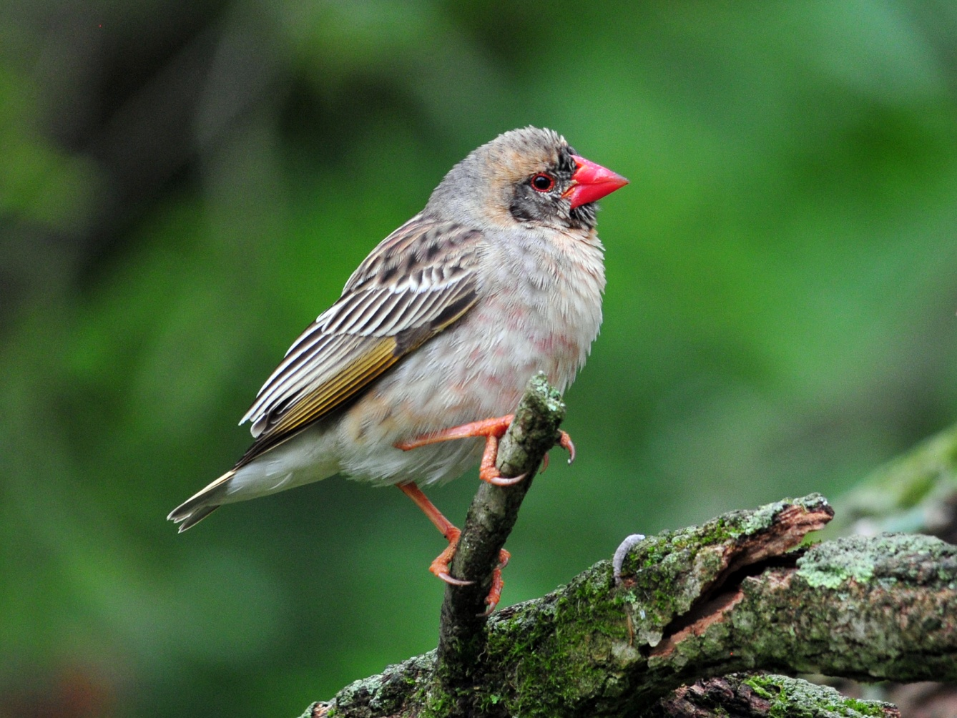
Red-billed Quelea
We finished the day with 98 species, bringing the trip total for the Subtropical tour to 122. Only 21 were new to the people who had been on the Cape tour, bringing the total for the two-part tour to 290.

Day 3, Sunday, October 16: We set the alarm for 4:15 to meet at 5:00 to go across Sani Pass into Lesotho. We were to be transported on a steep unpaved road in three 4WD vehicles. With a group of 14 (10 birders, 2 tour leaders, 2 guides), the plan was to put 5 people in each of two SUVs and 4 people in the remaining SUV. There were three seats in each vehicle, but one of the seats would hold the equipment and a cooler with lunches and drinks. The truck holding 4 people would need to have three people in the middle seat, giving one person an uncomfortable ride with low visibility. It would be imperative that the three people sharing that seat be as small as possible, which most likely meant that Bernie, Jude, and I would occupy that seat. People in other vehicles would trade places for better views, but the three "narrowest" people would remain in the same place. Using the same principle we use for room assignments, I would be in the middle, over “the hump”. Having just been on a very scary road in Peru and being prone to motion sickness just by riding in the back seat of smooth-riding vehicles on paved roads, I decided not to participate. Taking into account the nearly certain motion sickness, then factoring in cold and wet weather, no bathrooms, and a species count of perhaps 20 new birds, I came up with time better spent at the lodge catching up on that computer work. In addition, if I stayed back, Bernie and Jude would not be relegated to the same 3-person seat all day and could join the rest of the group in alternating seats throughout the day.

Of course, I was wide awake with the group at 4:30 AM, not because I planned it, but because my internal clock was still whack-o. I asked Pam and Skip if I could use their shower while the group was gone and they graciously said I could. After the group left, I organized our laundry, put it in a bag marked "Beckman laundry" and placed it in the hallway outside my door so the ladies would have it early enough in case I fell asleep. I tried to go back to sleep, but I couldn’t do it because by now there were lots of sounds outside my window. I worked on the computer for awhile, then went out around 7:00, back in at 7:30 when it began to rain. I repeated this pattern several times: worked on the computer a bit, then back out for about an hour. In and out all morning and afternoon, work a little, bird a little. On one of my “outings”, I walked around the back of the property on a dirt drive and was surprised by a lone Grey Crowned Crane as it flew very low over my head – wow! The only other new bird for me was a Southern Black Tit. Three of the small black birds were flitting about and I took photos, knowing that the shots would not be good quality at that distance through misty air, but thinking I would need help in identifying the birds later, in which case even a poor photo would help. After watching them and listening to their fussy chickadee-like sounds for a short while, I figured out what they were and then verified it with the field guide. I saw a woodpecker I could not positively identify – green back with barring across the wings, red crest, bigger than a Downy, spots on chest. Later, Malcom (owner of the B&B) confirmed that it was a Cardinal Woodpecker. The prize of the day was a pair of Paradise Flycatchers building a nest right in front of the B&B. The male was very timid, but the female allowed close approach and I was able to get some decent photos in spite of the poor lighting. Other birds I saw on my own at Smithfield that day included Dark-capped Bulbul, Yellow-fronted Canary, Cape Weaver, Village Weaver, Pin-tailed Whydah, Red-billed Quelea, Amethyst Sunbird, Common Fiscal, Speckled Pigeon, Laughing Dove, and Cape Turtle-Dove.

The group was scheduled to return at 5:00 PM, and I was somewhat dismayed when Gail, Malcom's wife, informed me that they would be late because they were going to another area to try for the Cape Parrot. I didn’t mind so much missing the specialty birds at Sani Pass, but I was crushed to think I would miss my only chance to see the Cape Parrot! They finally rolled in at around 6:45 PM, weary from a long day of birding in less than perfect conditions. The following is Jim’s report for the Sani Pass day trip:

The 4WD vehicles were an absolute necessity on the road into Lethoso, and while I was disappointed
that Cindy chose to pass on this part of the trip, I quickly realized that she had greatly reduced her level
of stress for the day by staying behind. Parts of the road were as bad or worse that our experiences on
Peru's Manu Road just 8 weeks ago: very bumpy roads, steep drop-offs and clouds/fog that often had
visibility limited to 20-30 feet or less (definitely not Cindy's version of fun).

Clearing the border crossing into and out of Lethoso was interesting. Each driver collected the passports
of his passengers and took them to the control point. Going in, each person's name and passport number
were hand-written in a log, passports returned and then we drove through the gate into Lethoso. On the
return, passports were collected, our names were checked against the entry log and we departed the
country. No million dollar scanners like in the airports, no personal inspections, no checking hand-carried luggage, didn't have to remove shoes, belts, coins, metal, knives, etc.

Birds seen today that are new for the Subtropical Tour included Bearded and Cape Vultures, Southern Bald Ibis, Rock Kestrel, Grey-winged Francolin, Grey Crowned Crane, Red-knobbed Coot, Whiskered Tern, Cape Turtle-Dove, Half-collared Kingfisher, Ground Woodpecker, Red-throated Wryneck, Red-capped and Large-billed Larks, White-necked Raven, Layard's Tit-Babbler, Cape Rock-Thrush, Sentinel Rock-Thrush, Mountain Wheatear, Sickle-winged Chat, Buff-streaked Chat, Drakensburg Rockjumper, Wailing Cisticola, Drakensburg Prinia, Fairy Flycatcher, Mountain Pipit, Bokmakierie, Pied Starling, Gurney's Sunbird, Amethyst and Malachite Sunbirds, Pin-tailed Whydah, Cape and Yellow Canaries, Streaky-headed Seedeater, Drakensburg Siskin, and Cape Bunting.

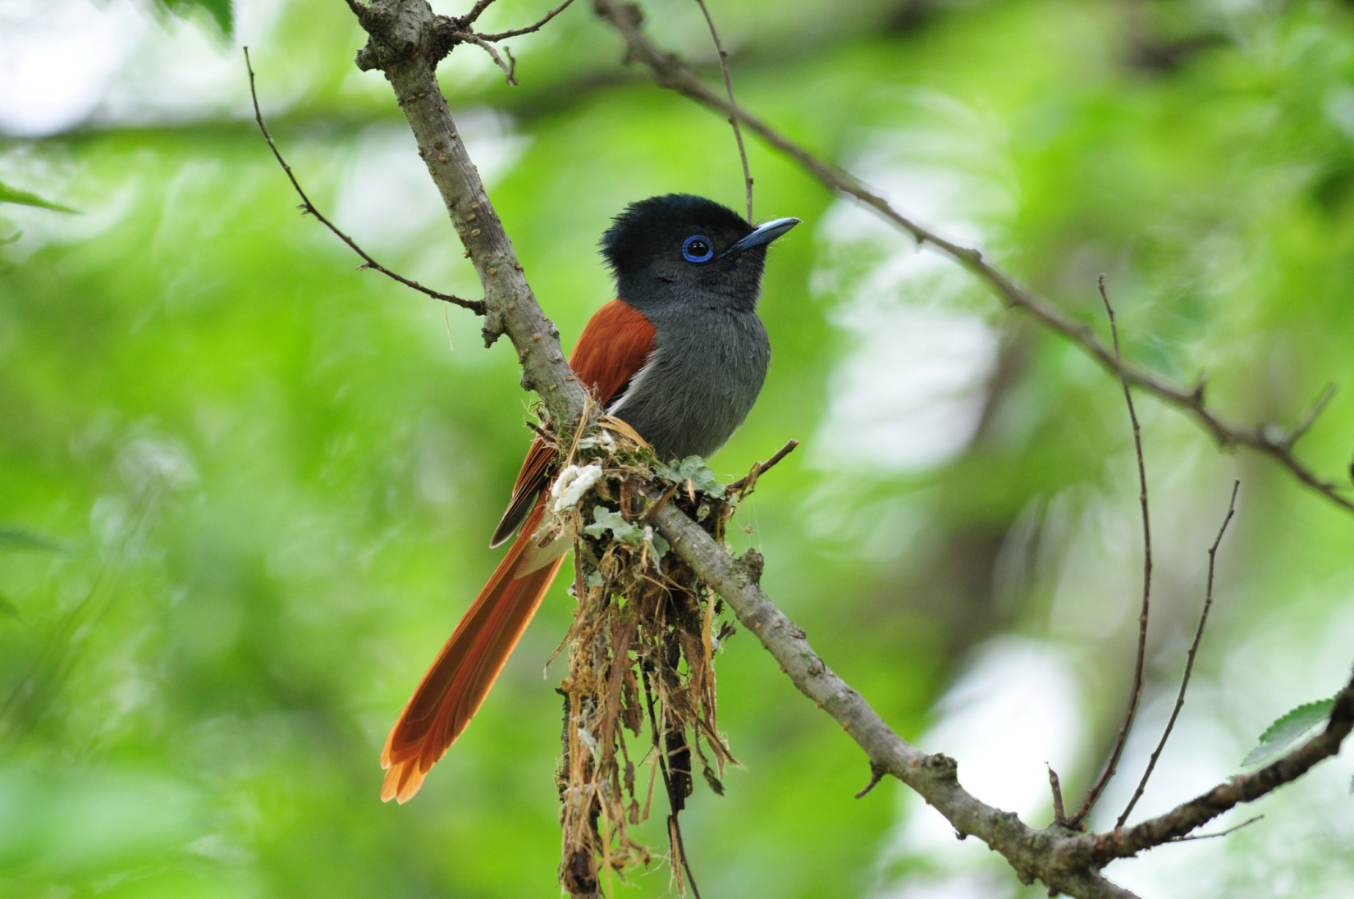
Paradise Flycatcher , female

The group finished the day with 80 species, about a dozen of which were seen only by me back at Smithfield Guest House. Nearly half of the 80 were new for the Subtropical Tour, bringing that trip total to 160. For the birders who had been on the Cape Tour, 14 birds were new, so the combined trip total now stood at 304. Of the 14 life birds that I missed by opting out of the day in Lesotho, I was lucky enough to see 8 species later in the tour, but I must admit that I was sorry to have missed the Bearded Vulture, Half-collared Kingfisher, Drakensburg Rockjumper, and Drakensburg Siskin.

Day 4, Monday, October 17: Plans called for us to depart in our vans at 6:00 AM to drive to the point where the road becomes too bad for those vehicles. There, Malcolm would shuttle 7 people at a time in his 4WD vehicle to the spot where we might be able to see Blue Swallows if the weather permits. The group will also position themselves where they will wait for performing Denham’s and Black-bellied Bustards. I once again opted out of this portion of the tour, so Jim has provided a report on the 2.5 hour excursion:

We departed on time to drive in the vans to the spot where we would go in shifts in Malcom's 4WD,
but it was so foggy at that point that we knew the Blue Swallows would not be visible today. Since
we were unable to see the swallows, we positioned ourselves to see the expected Denham's and
Black-bellied Bustards, both of which were seen after just a short wait.

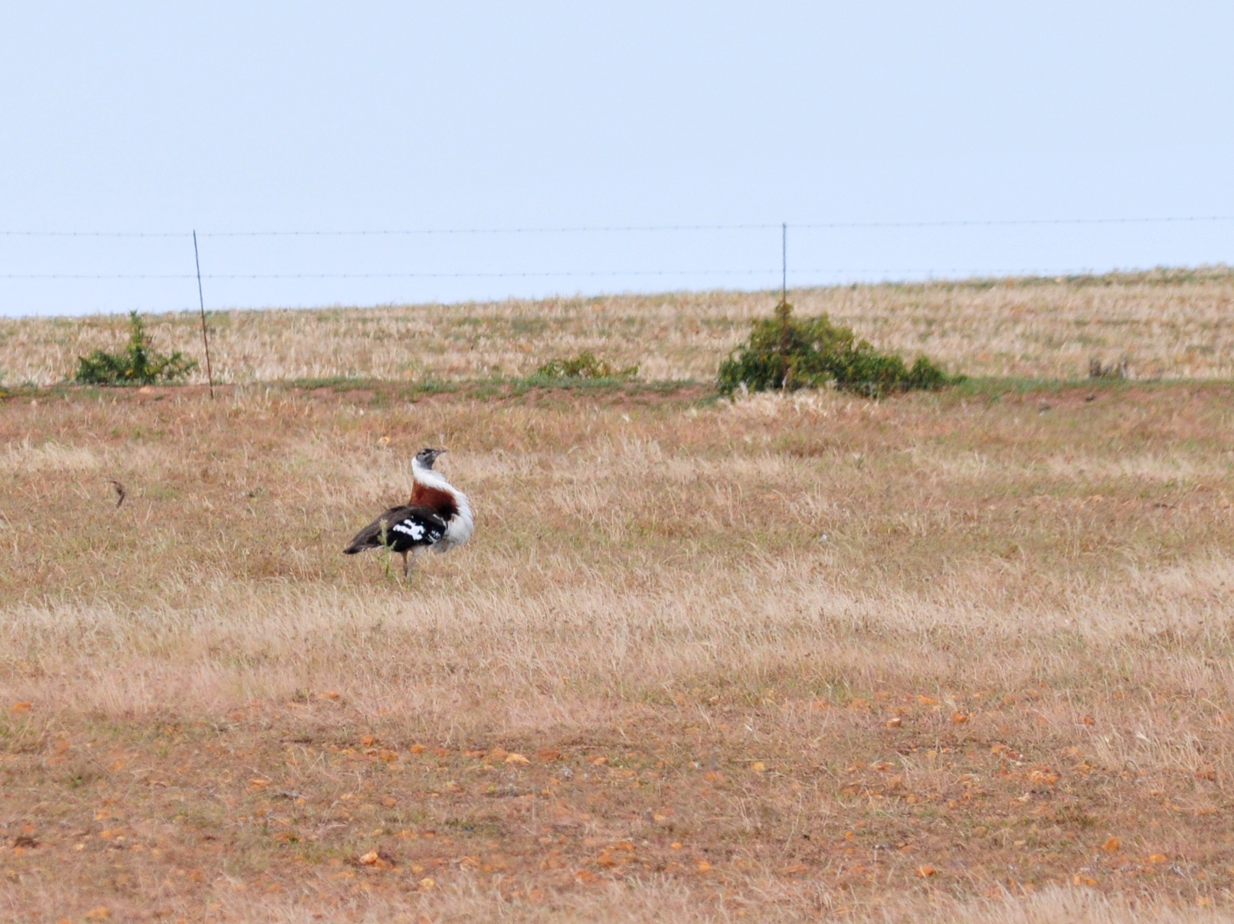
Denham's Bustard (photo taken on the Cape Tour)

The group returned for breakfast at 8:30, then after a bit of time for packing, we were to load up the vans and head out to Eshowe for our next two days. By the time we finished breakfast, I was still waiting for my laundry to be returned, but Gail assured me that it would be delivered before we left. As some of us were birding in the garden while others finished packing, we again heard the often-heard, seldom-seen Red-chested Cuckoo in the distance. Errol and John searched the distant trees and soon had the elusive bird in the scope. We rushed around to get everyone outside to see it before the bird disappeared, and David came running with one untied shoe on his foot and the other in his hand. Sadly, the bird flew seconds before Skip made it to the scope.

My laundry was delivered just before our departure - soaking wet! I think I had about a dozen t-shirts, all neatly folded, all not just damp, but WET. There was nothing I could do but pack them and hope to get them dried at the next place. I only hoped that, with a full day of travel, nothing would mildew before I could get the stuff back out of the luggage. I was stunned to learn later that Gail had charged Jim 540 Rand for the partially completed laundry - about US$70!

Shortly after our 9:30 departure, we turned onto a gravel road and immediately saw a Long-tailed Widowbird flying along next to us. No matter how many times I see this bird, it still has a lot of "WOW" factor. I had not yet gotten a good photo of this species, and I was hoping the next site would give me some good, well-lit photo ops. Fan-tailed Widowbirds were also in the area. As we drove on, a Yellow-crowned Bishop flew across the road in front of us, so we stopped to get better looks. We could not relocate the Bishop but found Cape Canary. We drove by a Jackal Buzzard sitting low on a utility pole, and then observed the white wing patches of a Long-crested Eagle as it soared overhead.

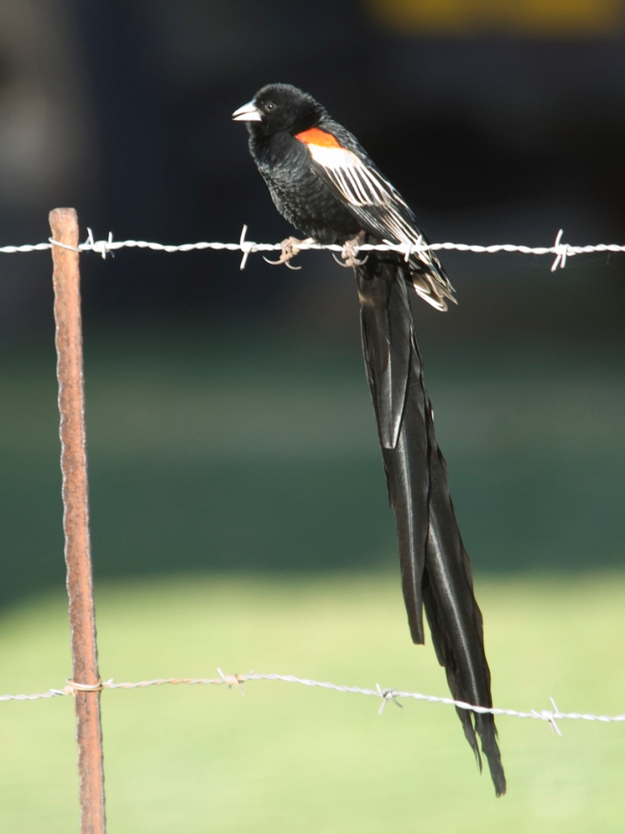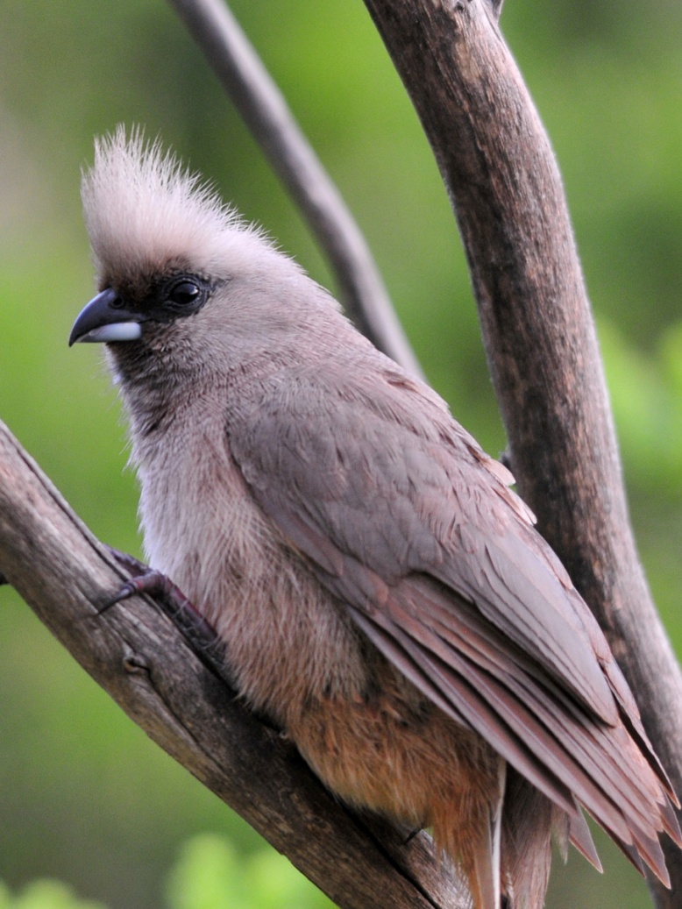
Long-tailed Widowbird Speckled Mousebird

Our last chance (although a slim one) for Cape Parrot before leaving the area was Marutswa Forest, where we arrived at about 10:30. As we waited for the guides to pay admission fees, David spotted a bird perched in a tree on the hillside. It was pretty far away, so we were in the middle of a discussion about whether it was, in fact, a bird at all when it flew away - definitely a bird. As we moved up the path, we were able to relocate the bird to see that it was a Long-crested Eagle. As we were looking at the eagle, a Yellow-billed Kite flew through the area. A Swee Waxbill was spotted along the path, followed by an uncooperative Olive Woodpecker, a group of Speckled Mousebirds, and a Greater Double-collared Sunbird. Lots of Dark-capped Bulbuls drew our attention as we walked along a narrow pathway, and the group began to spread apart as each person looked at different birds, plants, and/or bugs. The forest was fairly active, and we racked up African Dusky Flycatcher, Bar-throated Apalis, Knysna Turaco, Olive Sunbird, Forest Canary, Cape Batis, another (more cooperative) Olive Woodpecker, and Black-headed Oriole in rapid succession. As I caught up with the front of the group, I saw that they had left the path to find a singing White-starred Robin. Everyone took turns getting in position to see the bird, but not everyone was able to see it well, including (much to his dismay) Bernie, who had missed it when we saw it on the Cape Tour. A new bird for the members of our group who had not been on the Cape Tour, Southern Lesser Double-collared Sunbird, was found, as was Green-backed Cameroptera and Black-backed Puffback. A Bush Blackcap flew by, too quickly to count as a "seen" bird. Next, we spent about 20 minutes trying to find an Orange Ground-Thrush that was singing very near the trail. John managed to catch sight of the bird, but it was impossible for the rest of the group to see it in the dense undergrowth, and we finally gave up and moved on, hearing the beautiful song in our heads as we made our way back to the vans. Just before exiting the forest, a Yellow-throated Woodland Warbler responded to Errol's tape, landing right over our heads in search of the interloper he heard in his territory. We left the forest at about 12:30, and by then everyone was getting pretty hungry. I asked Errol when we would have lunch, and I could have sworn he said "in a week". Actually, he was naming the next town we would see on our way to Eshowe. Errol was very good-natured when I kidded him about his accent when it was actually he who could (should) have said we have accents. We all enjoyed a good laugh, but let him know in no uncertain terms that we couldn't wait a week to eat! As we exited the parking area, we saw a Red-collared Widowbird in full breeding plumage, and a Cape Robin-Chat.

As we drove along, Errol and John watched for places where we might eat, but many restaurants in South Africa are closed on Mondays. We were disappointed to find this to be the case at one restaurant where we could have eaten on a deck overlooking a wetland. We had all pretty much resigned ourselves to the fact that we were going to have a late lunch, and probably not a great lunch, when Errol spotted a sign for the Pickle Pot and radioed John that we should try it out. Neither of them had ever stopped here before, but what a fortunate choice! Not only was the food terrific, but behind the restaurant was a lovely flower garden and a path leading to a wetland and a forest walk. We sat at picnic tables near the garden and, after ordering our food, most of the group took advantage of the birding opportunities. I even picked up a lifer there - Dark-capped Yellow Warbler. Also seen at the marshy area were Little Reed Warbler and both Cape Glossy and Pied Starlings. Near the garden we found Amethyst Sunbird and Cape Robin-Chat. Cape Canaries foraged on the ground near picnic tables as we ate.

With the birding stops, we didn’t arrive at Eshowe Bed & Breakfast until after 8:00 PM. It was drizzling as we unloaded the vans by flashlights, and the cabins were spread out a little. Here, it happened that there were not enough rooms, so someone (guess who) had to go a short distance down the road to stay at Fleurdale B&B. Jim and I would be shuttled to Eshowe B&B for breakfast each morning before heading out to our birding sites for the day.

Other birds seen today that were new to the Subtropical Tour included Common Waxbill, Southern Grey-headed Sparrow, Pale-crowned Cisticola, Olive Thrush, Rufous-naped Lark, African Goshawk, Black-shouldered Kite, South African Shelduck, and Black-winged Lapwing. We finished the day with 93 species, 23 of which were new for the Subtropical Tour, bringing that trip count to 183. Only 8 species were new to the combined tour, bringing that total to 312.

Day 5, Tuesday, October 18: Jim and I were to be picked up at 6:30 AM to have coffee at Eshowe at 6:45 so we could depart early for Ongoye Forest. We planned to complete yesterday's list before breakfast since we didn't have time to take care of it the night before, so we decided to take breakfast with us rather than spend the extra time on a hot breakfast. I awoke very early to no bird song - zip, nothing. I stepped out of our Rondavel at about 5:30 AM to take some photographs of our humble abode. I had taken several steps before I noticed the Brown-hooded Kingfisher sitting on a knee-high light post just a few feet away from me. I froze in my tracks and just stared at him as he looked at me - so close, and I had only my point-and-shoot pocket camera with me! He flew to a tree, and I rushed inside to get my Nikon, announcing to Jim as I ran in, "There's a Brown-hooded Kookaburra out there!" I had commented earlier in the trip that I wanted to see a Brown-hooded Kingfisher because it looked like a little Kookaburra with a red bill, so I guess that stuck in my head. I was laughing at myself as I rushed back outside and saw that the bird had moved to the tin roof of a small shelter in the clearing. As I watched, it swooped down on the ground to catch a huge beetle and then flew back up to its perch. Not only did it look like a Kookaburra, it also behaved like one!

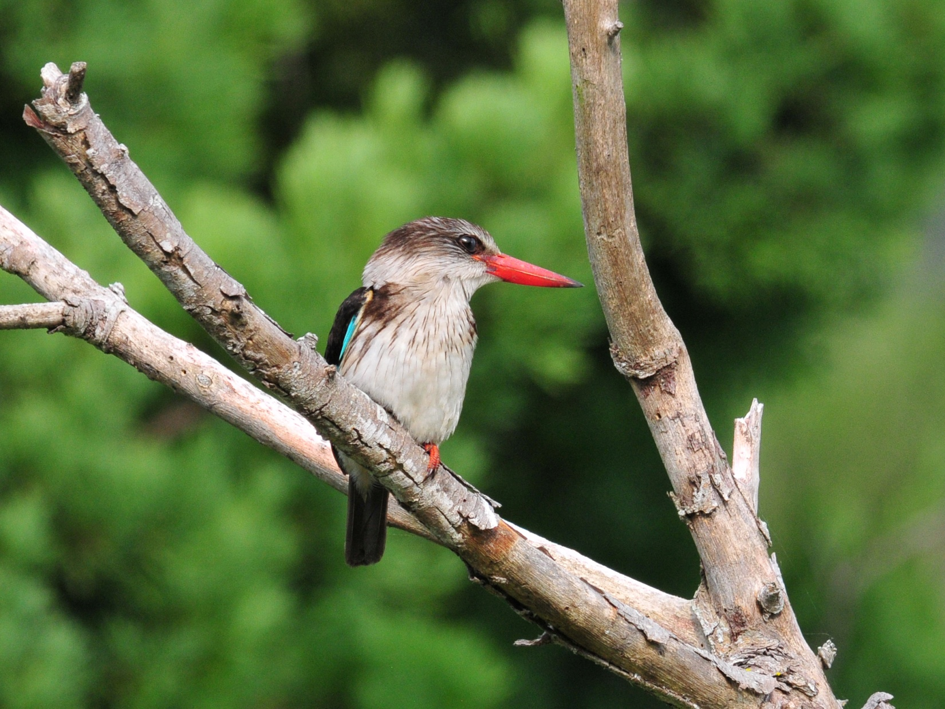
Brown-hooded Kingfisher

Jim went to a common area to use the internet at around 6:00 AM, and I used the time to explore the grounds a little. I didn't find anything new, but the activity increased as it grew lighter. I found Village Weaver, Southern Black Tit, Southern Black Flycatcher, and Speckled Pigeon before the van arrived at around 6:30. We had coffee or tea as we completed yesterday's list in the home of the owner of Eshowe B&B, Hugh Chittenden, who is currently working on the latest edition of Roberts Field Guide. After finishing our checklist, he pulled out some of the original plates that are to be used in the next publication of the field guide and discussed with us some of the challenges of an endeavor as massive and complicated as revising a field guide to a region with over 950 species of birds.

We didn't leave Eshowe B&B until about 8:00 AM to begin the drive to Ongoye Forest. We spotted a few unimpressive birds along the way: Pied Crow, Fan-tailed Widowbird, one of the Striped Swallows, Cattle Egret. We stopped when Errol saw a Yellow-throated Longclaw and while we were out of the van, a Lanner Falcon flew overhead. Also in this area we found Tambourine Dove and African Firefinches. The day had started off very cloudy and we thought we were in for a day of rain, but it began to clear off and bright blue sky was peeking through the clouds. By the time we stopped along the side of the road for breakfast, it was still pretty cloudy and very windy, but the sun was peeking through and it looked like we might have a good day after all. As we ate breakfast in and around the vans, someone spotted a Red-faced Cisticola. Shortly after that, Jean and both guides saw the Gorgeous Bush-Shrike that had been calling since we stopped, but no one else was able to get on the bird before it flew away. At the bottom of a hill a dirt lane ended at a small pool of water where a local woman was doing her laundry. In that area, David found a gorgeous Pin-tailed Whydah that practically posed for portraits in perfect light while I was preoccupied with two Little Bee-eaters that were hawking insects from low branches on the far side of the water. When we walked back up to the road, the Gorgeous Bush-shrike returned, giving everyone great views, if not perfect photo ops. We saw a Hamerkop soaring in the air, which surprised us all, even though we had no prior knowledge of Hamerkop habits - it just doesn't look like a soaring bird!

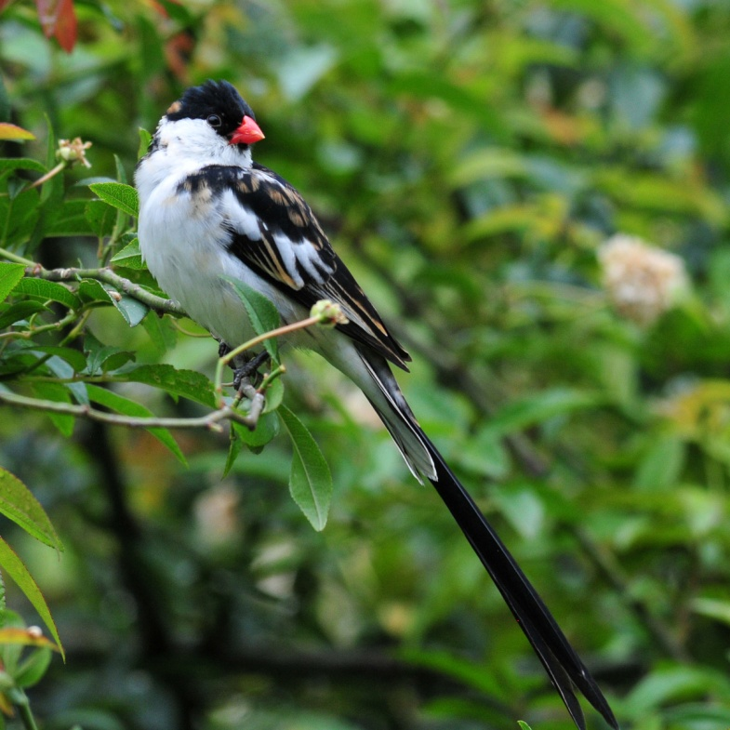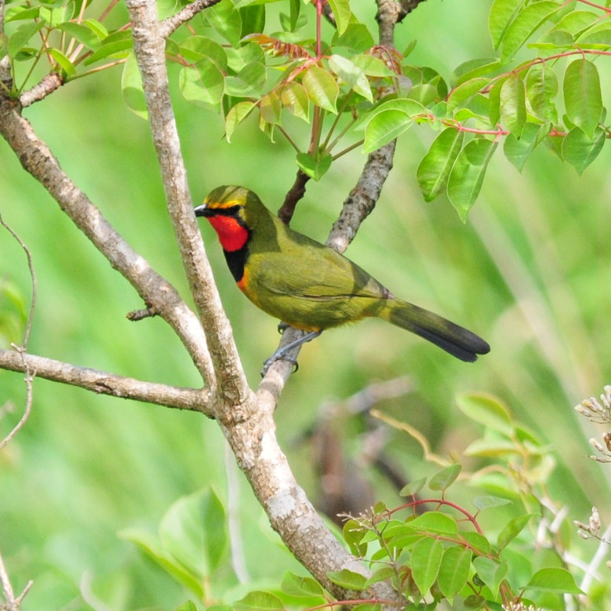
Pin-tailed Whydah Gorgeous Bush-Shrike

As we drove on, Errol and John discussed the turn-off and although I couldn't understand most of the radio conversation, I'm pretty sure that Errol followed John's directions when he turned left off the main road. After quite some time, the guides realized that they had taken a wrong turn, but it proved to be a serendipitous error. As we drove through the rolling hills of Zululand, everyone thoroughly enjoyed seeing the small clusters of homes, the people of the region, and a glimpse of a way of life that is so unfamiliar to us. Although the drive wasn't particularly "birdy", we did find some interesting birds as we did some sightseeing, including Scarlet-chested Sunbird and Rufous-naped Lark.

When we finally reached the small stream and bridge where Errol and John had originally planned for us to have breakfast, the only species we found there was Grey-rumped Swallow. We didn't linger long since we had planned on arriving at our final destination much earlier, and headed on to the entrance to Ongoye Forest, reportedly the best place in the area to find Green Barbet. Near the entrance, we saw Cape Wagtail, Dark-backed Forest Weaver, Yellow-bellied Greenbul, and Square-tailed Drongo. We watched for several minutes as two Brown Scrub-Robins each proclaimed an area as their territory. As soon as we parked the vans, we immediately set off to walk uphill to access an open field that bordered the forest. As we walked along the road, we heard some commotion from birds in the trees which led us to a Forest Cobra slithering along in the grass at the road's edge. Yikes! We all enjoyed safe looks from a distance and walked on to the field. Jean and Andre stayed behind for a few minutes to grab a couple of photos and told me later that they had approached close enough to cause the cobra to flare its hood at them - double yikes!! We walked in tall grass along the forest edge, and it occurred to me that there could be more snakes in the grass. At the top of this hill, the wind was howling and the guides thought this might be the reason the cobra had been on the ground instead of up in a tree. I found a path through the grass and followed it, but Errol told me later that any snakes that might be present would have sensed the movement and fled long before we reached them. We didn't find the Green Barbet at the forest edge as expected or hoped for. The belief was that the wind was keeping the birds down, so we walked downhill at the far end of the field and entered a patch of forest. Errol and John played the Barbet's calls, but to no avail. As we walked out of the forest and back across the field, two Trumpeter Hornbills landed in full view. They were on the opposite side of the field, and with the wind blowing my 150-500 mm lens, it was nearly impossible to get a reasonable shot of them. We walked back to the vans and had a quick lunch before walking down to another part of the forest where John and Errol knew Narina Trogons frequented. They had a hard time finding the trailhead because everything was so overgrown. As they searched different spots along the road's edge, they came across another Forest Cobra as it moved placidly in the grass at the edge of the road - good grief! As much as I wanted to see a Narina Trogon, I pretty much wanted to live to tell about it, so when Jean, Myra and Stephen said they didn't want to walk the forest trail that might harbor more cobras, Jim and I decided to stay back at the vans with them. The group that went down the trail found the Narina Trogon pretty quickly and were back within the hour.

We left Ongoye and headed back toward Eshowe. We saw a Jackal Buzzard on our way to a spot that Errol and John knew to be good for Palm-nut Vulture. Sure enough, we pulled off the road and immediately had a vulture sitting at the top of a Norwegian Pine Tree for nice scope views. While we were there, John received a phone call from Eshowe B&B to let us know that the laundry some people had left to be done had not yet been washed and, because of a water problem, was not likely to get done during our two-night stay. The people who had left laundry to be done had also left their laundry on their beds as directed at Smithfield, but no one picked it up as promised. So this was their second attempt in the last three days to send clothes to be washed. A quick survey let us know how many people were in dire need of laundry, and when we realized that some of us would be without any clean clothing for tomorrow, we headed back to the B&B to gather the laundry to take to a laundromat. On the way back, we saw African Goshawk, and Errol saw a Black Sparrowhawk fly by. It was about 3:30 PM when we arrived at Eshowe, and when David and Don found clean clothes in their room, we were all surprised. It seems the staff had finished one load before the water problems started, and since the other people having laundry done said they could wait a few days, we decided to go on to Dlinza Forest for the afternoon. Jim and I hurried back to Fleurdale B&B to gather the wet shirts I had hung all over the room so they could be put in the Chittenden's dryer. While we were gone, the group did some garden birding at Eshowe and found Greater Honeyguide, Olive Sunbird, Amethyst Sunbird, and Purple-banded Sunbird.

It was getting pretty late by the time we arrived at Dlinza so we headed straight to the boardwalk and tower. Purple-crested Turaco was spotted right away, although at this hour there wasn't a great deal of other bird activity. The tower here gives a nice view of the canopy without 100+ steps leading up to it. The boardwalk goes out over land that is gradually dropping beneath it so that by the time you arrive at the base of the tower, you have only a few dozen steps to climb to the top. Three White-eared Barbets sat on an open branch at eye level once we were at the top, and a group of Black-bellied Starlings flew in. Below us, Andre and Jean had Golden-tailed Woodpecker on their way up the stairs. Some of us had begun to go back down the steps when a Trumpeter Hornbill flew in and landed just above the platform. It was vocalizing, sounding for all the world like a human baby crying. Although the backlighting made photography difficult, no one could have asked for better views of this bird. The sound effects were the icing on the cake!

We left Dlinza at about 5:15 with plans to return early the next morning when we hoped bird activity would be at its best. We decided to have an early dinner and complete the list while waiting for our meal orders to come so that everyone would have some free time in their rooms before retiring for the night. Other birds seen today that were new for the trip included Brimstone Canary, Rattling Cisticola, Black Saw-wing, and a Hamerkop that wasn't a "fly-by".

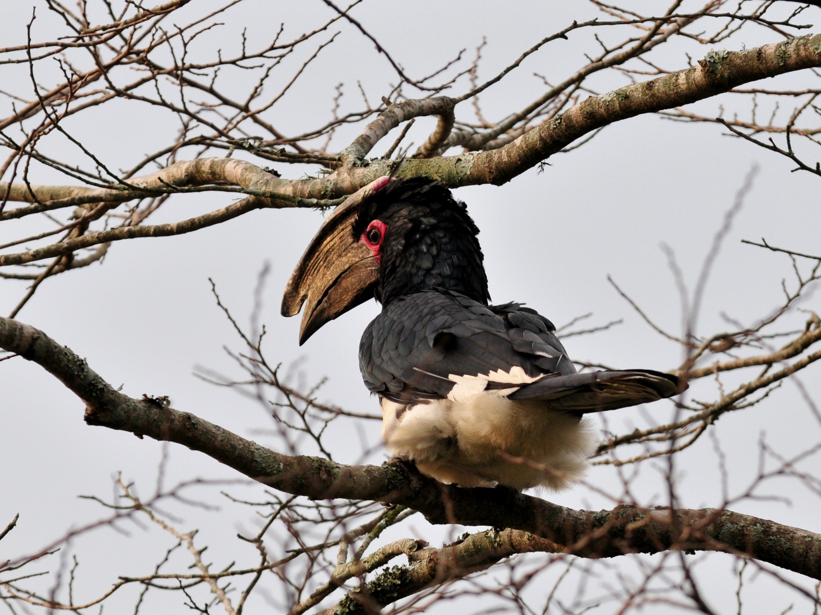
Trumpeter Hornbill

We finished the day with just 62 species, the lowest daily count for the trip so far. We didn't think that was too bad, though, because we had to deal with a later-than-planned departure that morning, high winds that kept the birds down, missed turns that cost us some birding time, and dirty laundry that changed our plans for the afternoon. Of the 62 species, 16 were new for the Subtropical tour, and 13 were new for the combined tours, bringing trip totals to 199 and 325, respectively.

Day 6, Wednesday, October 19: Common Mynahs and Village Weavers were obvious as we left our B&Bs this morning at 5:45 AM. The first bird we spotted at Dlinza Forest was a Spotted Ground-Thrush, one of the target species for this area. We went straight to the tower, but a family of four was already sitting there when we arrived. From the tower we saw Eastern Bronze-necked Pigeon along with some species we had seen there yesterday, Purple-crested Turaco, White-eared Barbet, Trumpeter Hornbills, and Black-bellied Starling. Someone spotted a perched African Goshawk in the distance, visible only from one spot on the platform through a tiny window in the vegetation. The raptor stayed in one place for a long time, providing everyone with good looks through the scope. Some Black-headed Orioles landed in the treetops, and a Little Sparrowhawk flew through the canopy very rapidly, but there really wasn't much more action than there had been yesterday afternoon. We left the tower shortly before 7:00 AM and walked a trail in the lower part of the forest. Here, we saw Grey Cuckoo-Shrike, Chorister Robin-Chat, and Lemon Dove before Errol and John heard the call of the Narina Trogon. It didn't take them long to locate a pair of the trogons, and while we watched them from a small clearing, we saw a lot of bird activity in the surrounding area, including a Black-backed Puffback on a nest. We returned to Eshowe B&B for breakfast at 8:30. We saw Red-capped Robin-Chat and White-eared Barbet on wires as we left the Chittenden home after breakfast. When Errol dropped Jim and me off at Fleurdale so we could finish packing, we saw a Black-collared Barbet on the wire, in very good light that allowed us to see the detail in the wings.

We had decided to return to Ongoye Forest for one final try for the Green Barbet, thinking that our lack of success yesterday was due to the extremely strong winds. Hoping for better conditions, we drove back (without taking the detour through Zululand) and arrived at around 11:20. Along the way we spotted Woolly-necked Stork, Red-breasted Swallow, Bronze Mannikin, and Jackal Buzzard. We went through the same process as the day before, walking along the forest edge, but the wind hadn't subsided much and once again we dipped on the Barbet. Walking back to the car, we saw Tambourine Dove and witnessed another pair of Brown Scrub-Robins displaying. Yellow-streaked Greenbuls were seen in the same area as the Scrub-Robins, but not by everyone. As we departed Ongoye, we saw Red-collared Widowbird. An African Harrier-Hawk (Gymnogene) flew by too quickly for good looks. Farther down the road, a Long-crested Eagle sat on a low utility pole.

We stopped for lunch at the Clay Oven in Mtunzini. We watched as the sky grew darker and were very pleased that our timing put us inside the restaurant when it began to pour. By the time our pizzas were baked and eaten, the rain had passed and we moved on.

Our final birding stop was at the St. Lucia boat ramp where thousands of Little Swifts were coming to roost for the night. Here we saw our first African Pied Wagtail, and as people were starting to call off names of birds, Jim pointed out a sign to me that warned people to beware of Hippopotamus. Purple Heron, Wire-tailed Swallow, African Jacana, African Purple Swamphen, and then our first big mammals - Hippos! We could see the snouts and eyes of the hippos, sometimes a back would come above the water. They were pretty far away, but we were thrilled to see our first large African mammal. Other birds seen from the boardwalk at St. Lucia included Green-backed Heron, Yellow and Thick-billed Weavers, and both White-rumped and Wire-tailed Swifts. Andre and Jean went to the other side of the bridge and found African Pygmy Goose.

We went on to the St. Lucia Wetlands B&B, a lovely home with guest rooms that were not only spacious but also beautifully decorated. Situated near iSimangaliso Wetland Park and Cape Vidal, as well as some other birding hotspots, this would be our home away from home for the next two nights. Our tally at the end of the day showed that we had seen 76 species, 16 of which were new to the Cape Tour for a trip total of 215. The Combined Tour total now stood at 337, an increase of 12 species over yesterday's count. Other birds seen today that were new to the trip included Tawny-flanked Prinia and African Emerald Cuckoo.

Day 7, Thursday, October 20: We met for coffee at around 5:30 - 5:40 with plans to depart for Cape Vidal at 6:00 AM. As we left, Skip saw an Amethyst Sunbird in the yard, and a Crested Guineafowl was seen as we pulled away from the B&B. As Errol paid admission to iSimangaliso Wetlands Park, a troop of Vervet Monkeys caught our attention. Before we could move away from the entrance, several Impala came into view. Burchell's Zebras with their attendant Cattle Egrets were visible as soon as we cleared the entry kiosk - this was definitely going to be a good day!

As we drove slowly through the park, we spotted familiar birds quickly: Dark-capped Bulbul, Speckled Mousebird
Brown-hooded Kingfisher, Yellow-throated Longclaw, Rattling Cisticola, among others. By now we were beginning to see Dung Beetle fly-bys. Seriously, these beetles are so large that they look like small birds as they zip past the vans. David, in particular, was thrilled to see them, but we were all excited by the prospect of seeing them on the ground, hopefully with a nice round ball of dung. As we went deeper into the park, the bird list grew: Barn Swallow, Fan-tailed Widowbird, African Pipit, Black-headed or Grey Heron (the light was too bad to tell which one), and Kudus crossed the road in front of us. Black-collared Barbet, Woolly-necked Stork, Spur-winged Goose, Black-crowned Tchagra appeared in quick succession. We almost left Bernie behind when he lingered for more photos near the Tchagra, but as we drove away the bird moved and we all got better looks. We stopped by a small pan where we found African Wattled Lapwing, Blacksmith Lapwing, Zitting Cisticola, and a distant perched Black-chested Snake-Eagle that was at first identified as a Brown Snake-Eagle until it flew, giving us a view of diagnostic field marks. One very large Waterbuck lounged at the opposite side of the pan, where Hippos remained mostly submerged. Also at this pan, after the first van pulled away, we found Water Thick-Knees, Squacco Heron, African Jacana, Red-breasted Swallow, Sacred Ibis, and White-faced Duck. Dave saw a Glossy Ibis, but no one else was able to locate the bird in the tall reeds. As we drove slowly away, we spotted a Yellow-billed (Intermediate) Egret. A few Egyptian Geese were seen at about the time John radioed that the people in his van were getting hungry, so we moved on. On our way to Mission Rocks, where we would have breakfast, we saw some Black Saw-wings, but we were hurrying to catch up with John's van. When David yelled "Whoa, whoa, whoa!" from the back of the van, Errol braked immediately. There, in a grassy field to our right was a Spotted Hyena. Errol radioed John, and John drove back for everyone to see the hyena. After we were all satisfied with our sighting and photos, we drove on until David again cried out for Errol to stop. On the opposite side of the road David had spotted a large raptor that turned out to be a juvenile Martial Eagle. Never mind eating, David! Just keep spotting like that!

Even though we were pretty much driving straight to Mission Rocks, we couldn't help but observe three Brown-hooded Kingfishers sitting on a wire. The Croaking Cisticola and Rattling Cisticola weren't as obvious as the kingfishers, but we had to stop for a look at them also. A Red Duiker was seen at the edge of the road, and a Brown Scrub-Robin greeted us in the parking lot as we arrived at the picnic grounds at Mission Rocks. Eager to get back to birding, it took us just a little over a half an hour to wolf down breakfast, taking note of the Barn and Lesser Striped Swallows and Grey Sunbird as we ate.

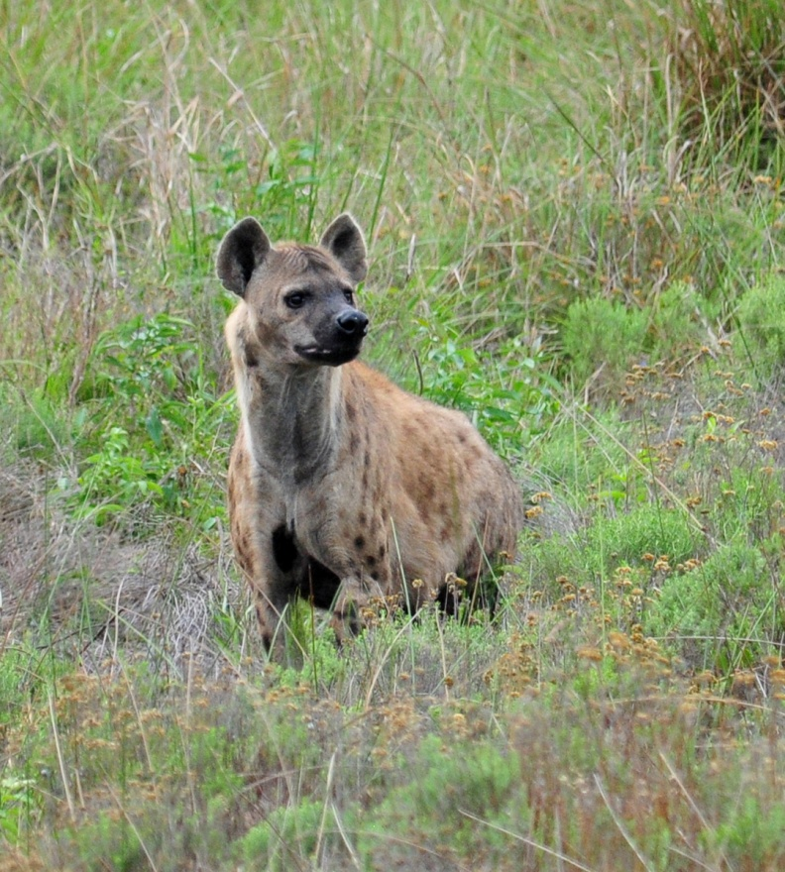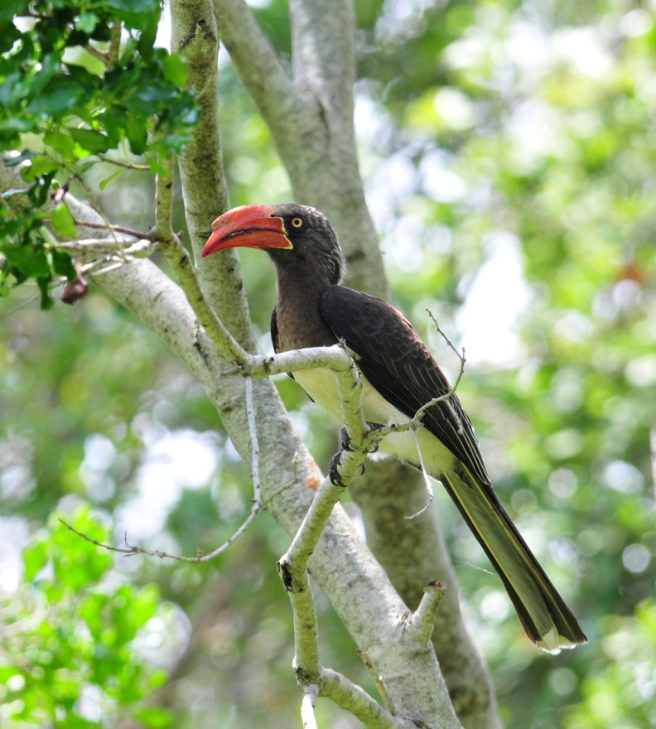
Spotted Hyena Crowned Hornbill

We continued to drive slowly through iSimangaliso, stopping for birds and/or other animals frequently: African Fish Eagle, Rock Monitor, Fork-tailed Drongo, Waterbuck, Kudu, Rufous-naped Lark, Burchell's Zebra. At one point, as we stopped for a photo of a very close female Waterbuck, we noticed a male approaching. We waited and watched as the male chased the female for a short while, with little kicks and bucks that we assumed were part of courtship. In the end, the female ignored his advances and he gave up. We viewed Blue Wildebeest, White Rhinos, and Common Reedbuck in one short stretch of the road, and then one of our target species - Dung Beetles on the ground! There were dozens, if not hundreds, of them crawling all over a couple of huge piles of manure on the road. We watched and photographed them for several minutes before driving on, but it would be another 45 minutes before we observed some beetles that were actually rolling up the dung and moving backwards to move the perfectly round ball along the ground. Back to birding, we found Yellow-fronted Canary, Dark-back Weaver (aka Forest Weaver), Square-tailed Drongo, and Collared Sunbird. By now we had arrived at Cape Vidal and we stopped for a restroom break at the first available spot. Near the restrooms we noticed a lot of activity and went to investigate. In a small brushy area right next to the road, a couple of Crowned Hornbills, Black-bellied Starlings, and Sombre Greenbuls were feeding. A short distance down the road, we saw our first Samango Monkey, with its soulful expression and intelligent eyes. With all of this bird activity, we hated to leave, but we were near the picnic area where we would have lunch later, so we tore ourselves away, hoping that the area would still be good when we returned in a few hours. We drove a bit farther into the park, parked the vans, and walked to the ocean. There, on a beautiful long stretch of white sandy beach we found Swift Tern and Yellow-billed Kite. John assumed that we would all want to stick around awhile on the beach, maybe wade into the Indian Ocean, but as a group we decided that we would rather bird while it was still early and come back after lunch to explore the beach and put our toes in the ocean. John led us on a trail through a pine forest that would have led to whale overlook but was so overgrown that we couldn't get through. The woods was very quiet, and we saw only a few birds on the walk, making us wish we had stayed a bit longer at the picnic area that had been so active a short while ago. Southern Black Flycatcher and Black-backed Puffback were about the only birds seen on the trail, and we saw Southern Grey-headed Sparrow, House Sparrow, and several Dark-capped Bulbuls as we exited near some camping cabins. We took a few minutes to bird along the edge of a path as we left the camping area, and found Green Twinspot - this time more people got good looks.

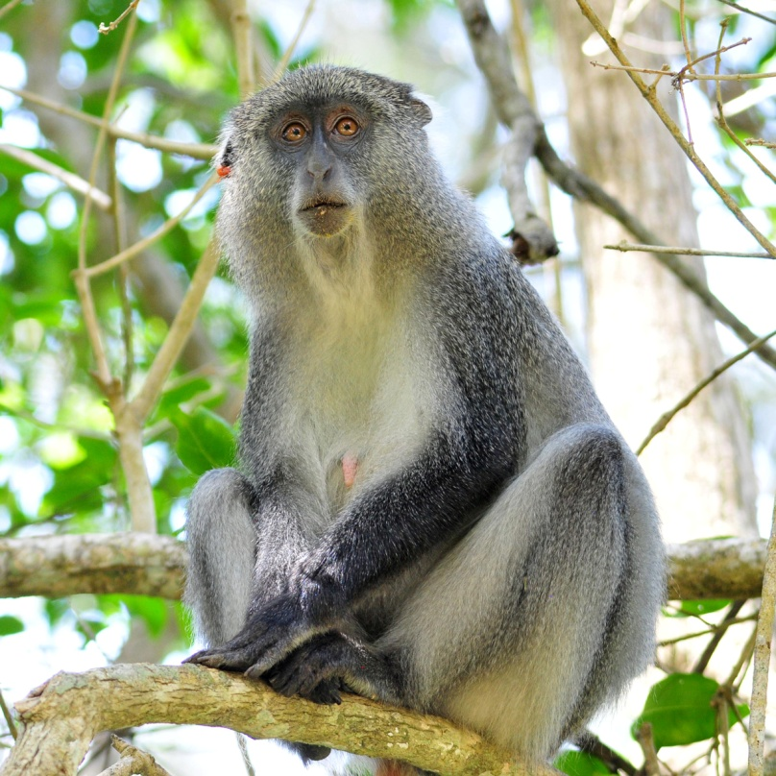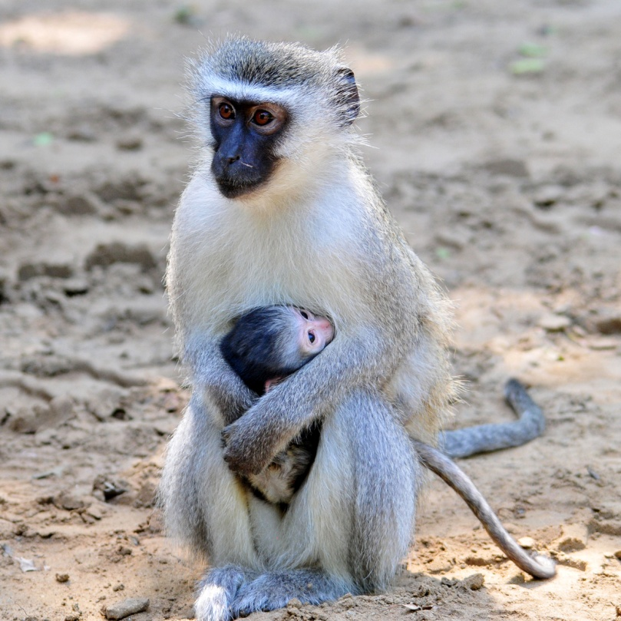
Samango Monkey Vervet Monkeys

For lunch, we returned to the picnic area that had been so active in the morning, but there wasn't a lot to see at midday. We ate our noon meal among a large troop of Vervet Monkeys. One female carrying a baby was particularly difficult to ignore as the group begged for food. Some Samango Monkeys joined in the effort to steal food, keeping John and Errol pretty busy chasing them away. After lunch, the group split up, with John taking a group who wanted to put their feet in Indian Ocean (Myra, Jean, Andre, David, Skip, Pam) and Errol taking a group to bird around the campgrounds (Don, Bernie, Jude and me). Jim and Steve stayed in van to rest a short while. The group that went birding were rewarded with close-up views of a gorgeous Blue-mantled Crested Flycatcher. The bird was flitting about in low vegetation at close range, a great distance for photos but remaining in the shadows most of the time. At one point, Bernie was trying to find the tiny flycatcher through the viewfinder of his camera, which he had pointed at eye level at the spot where the bird had just been. He couldn't see the flycatcher just a few feet in front of him - at his knees! I got his attention, told him to look down, and he got some great shots.

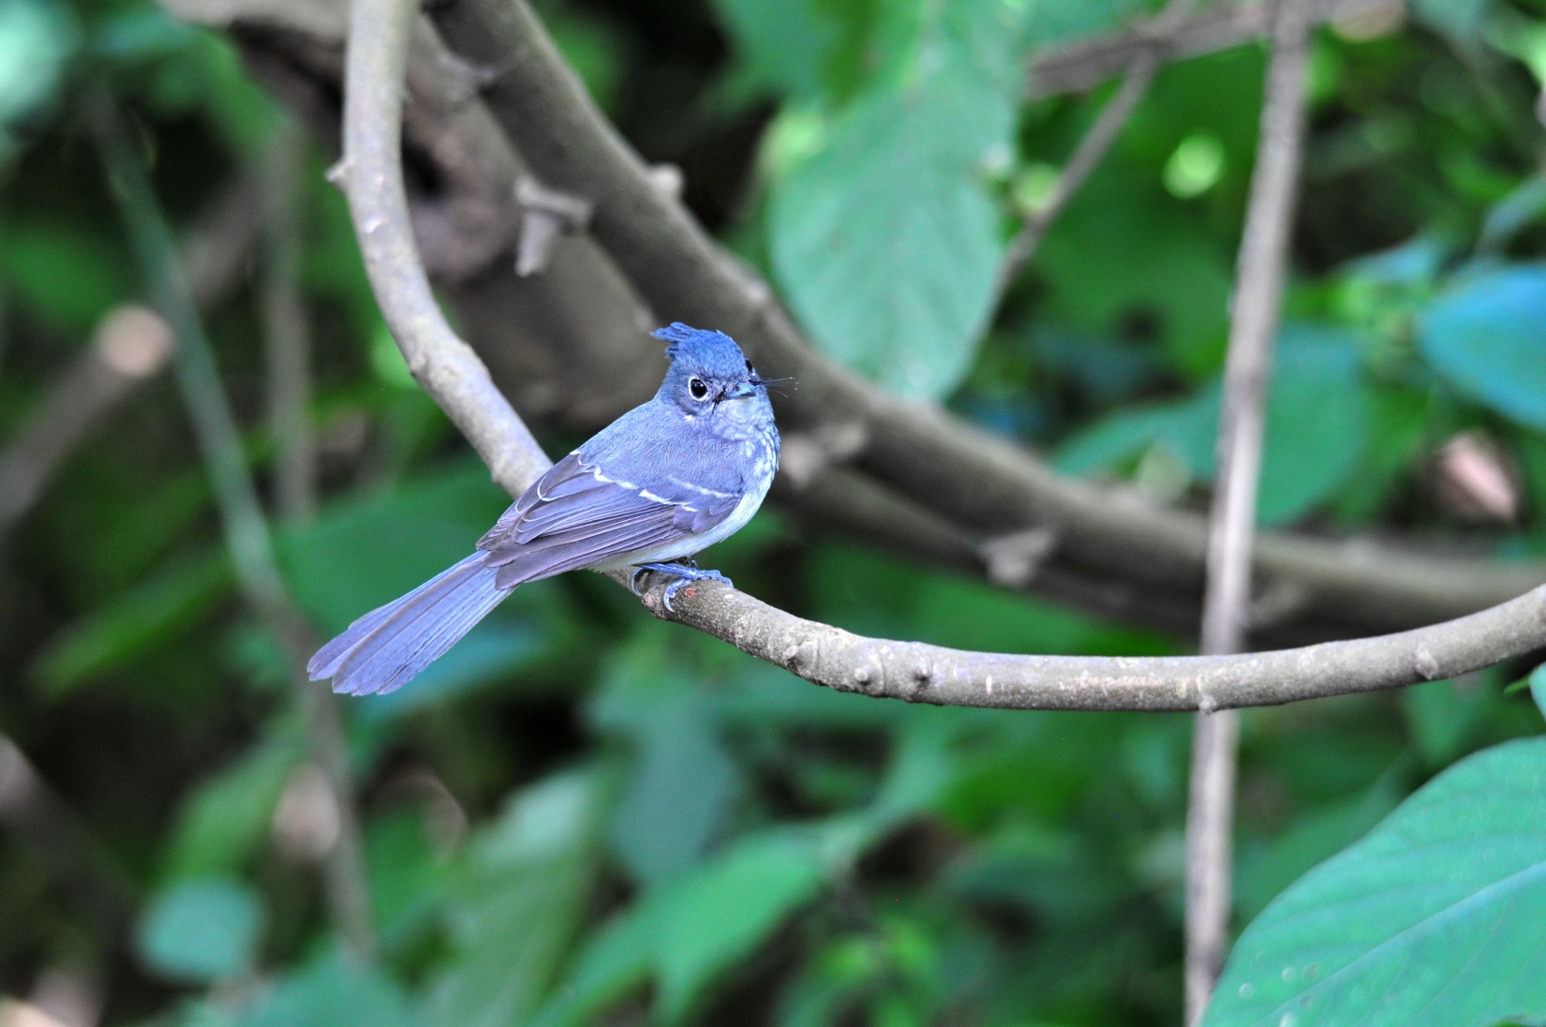
Blue-mantled Crested Flycatcher

As we left the picnic area, we found a Woodward's Batis, a target species for everyone in Errol's van since the people in John's van had already seen it twice today. Farther down the road, we gazed upon a scene that looked like it came straight out of a movie. Kudu, Blue Wildebeest, Reedbuck, African Buffalo, Burchell's Zebra, White Rhinos, Warthogs with two babies - all in one view. Wow! Before we drove on, someone spotted a Rock Monitor in the same area. When we finally departed, we found a troop of Chacma Baboons just a short distance down the road.

Our next stop was the Mfazana Hide, an interesting structure that was obviously quite new. Overlooking a waterhole, each part of the two-part building was entered via semi-circular steps. Once inside, there was comfortable seating at a narrow window allowing unobstructed, elevated views of the water below. The water hole wasn't very busy while we were there - Wattled Lapwing with a chick and three Warthogs were about all we saw from the blinds. As we left, we saw Crowned Hornbills. Errol and John pointed out their nest that was situated in a tree between the two parts of the hide. We left the park slowly, watching for new species as we drove out. Although we had already seen a Red Duiker, we were entertained by one when Jean made some "smooching" sounds at it. It looked completely shocked by the sound as it looked up at us, wagged its tail, kicked its back feet straight out, and then jumped out of sight. A Tsessebe was our last mammal of the day, and we noted Hadedah Ibis and Trumpeter Hornbill flying overhead as we drove into town.

We went straight to dinner without going to the B&B to freshen up. When we arrived at the Braza Portugese Grill in St. Lucia, the electricity was off and our selections were limited to those items that aren't deep-fried. Most of us ordered a huge skewer of assorted grilled meats called an Espitada - much too much food, but we couldn't resist trying it! When the electricity came back on, no one wanted to change their side orders to include French Fries. While we waited on our orders to arrive, most of the group enjoyed some wine tasting in the area immediately outside the restaurant - nice ending to a wonderful day!

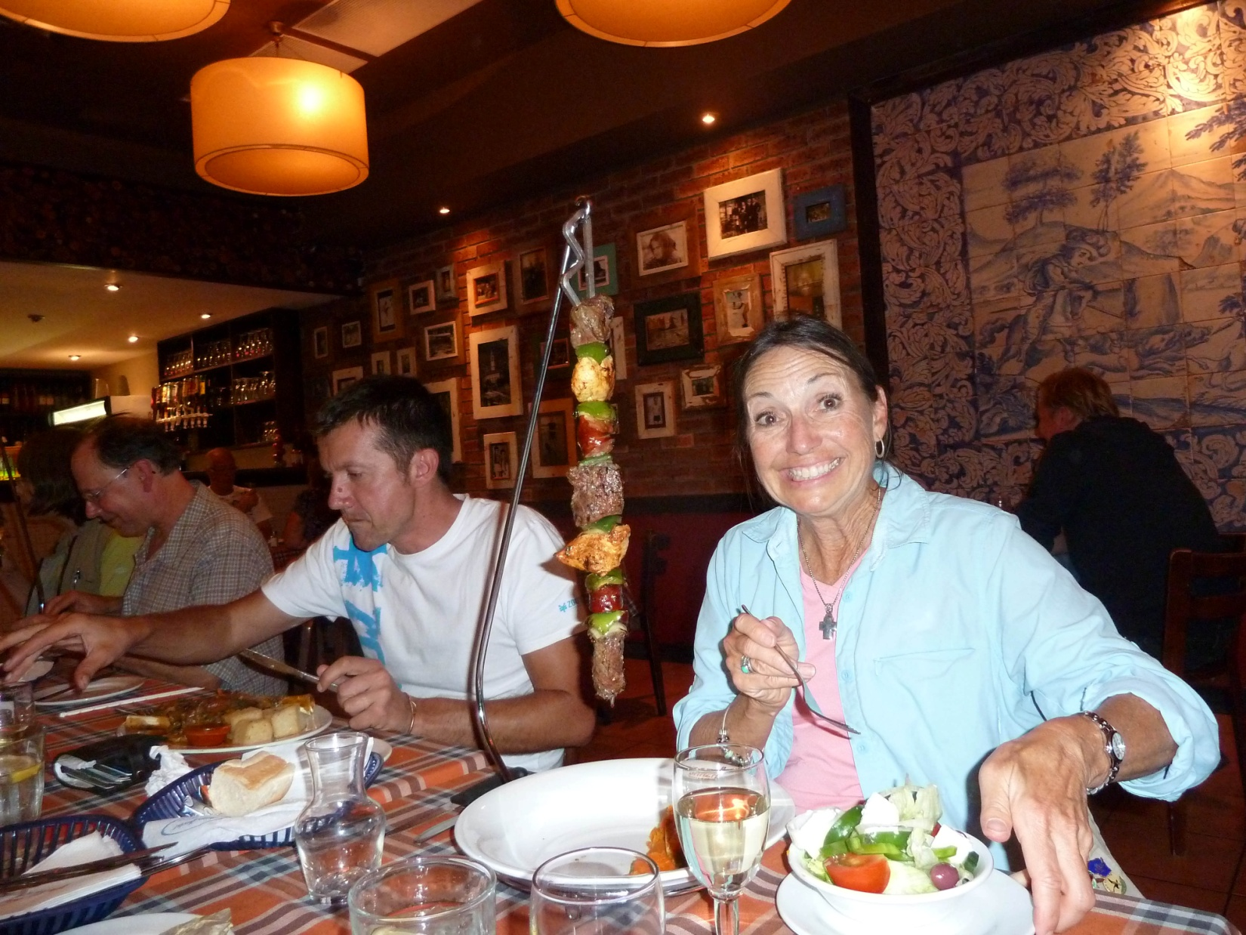
Jude with her Espitada at Braza's Portugese Grill

Other birds seen today that were new for the Subtropical tour included Kittlitz's Plover, Collared Pratincole, Livingstone's Turaco, Zitting Cisticola, and Yellow-throated Longclaw. Our count for today was just 82 species, but with all of the mammal sightings, it sure felt like a more productive day. Of those, 15 were new for the Subtropical Tour and 10 were new for the combined tour, bringing trip totals to 230 and 347, respectively.

Day 8 Friday, Oct. 21: We started birding at 6:00 AM in the gardens of St. Lucia Wetlands B&B. We had noticed a lot of activity there the previous morning, and we wanted to see what the garden and neighborhood had to offer on our last day there. We weren't disappointed with the outcome: Purple-crested Turaco, Ashy Flycatcher, Yellow-rumped Tinkerbird, Black-backed Puffbird, Red-eyed Doves, Olive Sunbirds, Bronze Mannikin, White-eared Barbet, and Scarlet-chested Sunbird were all spotted in the short time before we went inside for breakfast.

After breakfast, we headed for the nearby Gwala-Gwala Trail. Before we even started down the trail, we saw two Red-capped Robin-Chats at the entrance, hopping around on the trail in front of us. A Grey-headed Bush-shrike flew by us as we proceeded down the trail, not once but twice. When we finally got a decent view of the bright yellow, almost orange bird with olive wings and a huge white spot in front of the eye, we had to wonder if "Grey-headed" was really the best name it could have been given. As we walked down the path we added Brown Scrub-Robin, Rudd's Apalis, African Goshawk, Green-backed Cameroptera, and Collared Sunbird. A Blue-mantled Crested Flycatcher, a bird that was missed by part of the group at Cape Vidal, presented everyone with great views. Somber Greenbul, Yellow-bellied Greenbul, and another Yellow-rumped Tinkerbird were seen before we came out into an open grassy area that bordered a lake. Most of the group saw Little Bittern before I rejoined them after attempting to photograph the Tinkerbird. At the lake we found Pygmy Goose, Common Moorhen, African Jacana, Egyptian Goose, Reed Cormorant, Pied Kingfisher, Purple Swamp Hen, and Squacco Heron. A large Crocodile was sunning itself on the opposite bank. In the trees that bordered the open grassy area we found two African Green Pigeons, horribly backlit and leaving us wanting better views. One of the guides heard a Livingstone's Turaco, so we followed them up a wooded hillside to look for it. There, we found Lesser Masked Weaver, but no Turaco, which had been seen by only part of the group yesterday. Back near the lake, we found Golden-tailed Woodpecker, Black-bellied Starling, and Yellow-breasted Apalis. One last look at the lake yielded Southern Brown-throated Weaver, Purple Heron, and Goliath Heron, the latter being a fly-by for me, but others saw it well before it flew. In addition to Woolly-necked Stork and Water Thick-Knee, we saw an atypical Darter that was very pale and golden. The Green-backed Heron we saw here (and elsewhere in South Africa) is the same species as the Striated Heron seen in Central and South America (Butorides Striata).

We left the lake and shortly after, Andre spotted a Livingstone's Turaco as we went up a hill; we didn't end up with great looks this time, but we did get good looks of it flying across a wide clearing later in the day. I finally got a good enough look at a Square-tailed Drongo to be able to differentiate it from the more common Fork-tailed Drongo. Both have forked tails, just in different degrees. We returned to the B&B and took a few minutes to pack up and load the vans, noting the Cape White-eyes as we were doing so. We departed at around 10:45 and soon afterward made our next stop at the St. Lucia estuary. We were distracted by some locals who were selling carved souvenirs near the parking lot, but not for long. A few of us made some quick purchases and we followed Errol and John along the edge of the estuary to a boardwalk that provided excellent views of the wildlife along the water's edge. The birding here was very good: Yellow-billed Stork, Ruff, Curlew Sandpiper, Three-banded Plover, Terek Sandpiper, White-fronted Plover, Ruddy Turnstone, African Pied Wagtail, Pied Kingfisher, Purple-banded Sunbird, Blacksmith Lapwing, Lesser Swamp Warbler, Grey Heron, Common Sandpiper, Purple Heron. When we got to the end of the boardwalk, we ventured out onto the sand to find Little Stint, Sanderling, and Ringed Plover. As we retraced our steps on the boardwalk, we added Giant Kingfisher, Pink-backed Pelican, Grey-headed Gull, and a Brown-hooded Kingfisher that had just caught a lizard. Some of us voiced our hope that it wasn't the same lizard we noticed on our way in - the one that had been sitting in an odd position on the boardwalk with its feet held up on its back.

We left the estuary shortly after 12:30 and headed for Mkuze, making a brief restroom stop at the dock on our way out. Much to Errol and John's dismay, some of us did some souvenir shopping there, delaying our departure more than they would have liked. On our way to Mkuze, we stopped at a Pan along Rt. 22 where we found Black Heron, Cattle Egret, Reed Cormorant, Pied Kingfisher, Squacco Heron, Red-eyed Dove, Three-banded Plover, Wood Sandpiper, Dabchick, Barn Swallow, and Great White Pelican.

As we drove along, people would sometimes call out to Errol or John to stop for a bird they had seen, and often it would be a common bird. This made us all a bit shy about asking the guides to stop, but they were very patient with us. One of these times, I had hesitated to say anything about the shape I had seen on a wire, so when I finally spoke up, Errol had to turn around and drive back a short distance. I was apologizing all the way back, but I thought the bird I had seen might be something good based on size and shape, and I just couldn't stand to drive on without knowing. When we got back to the spot, the bird was still there - a gorgeous Lizard Buzzard! Errol radioed John to bring other van back, and we all enjoyed excellent views that got even better when the bird repositioned itself on the other side of the road in good light. Andre, who was in the other van, said he had seen it also but hadn't said anything for fear it was just another Yellow-billed Kite or Rock Kestrel. Lesson learned - from now on we would speak up!

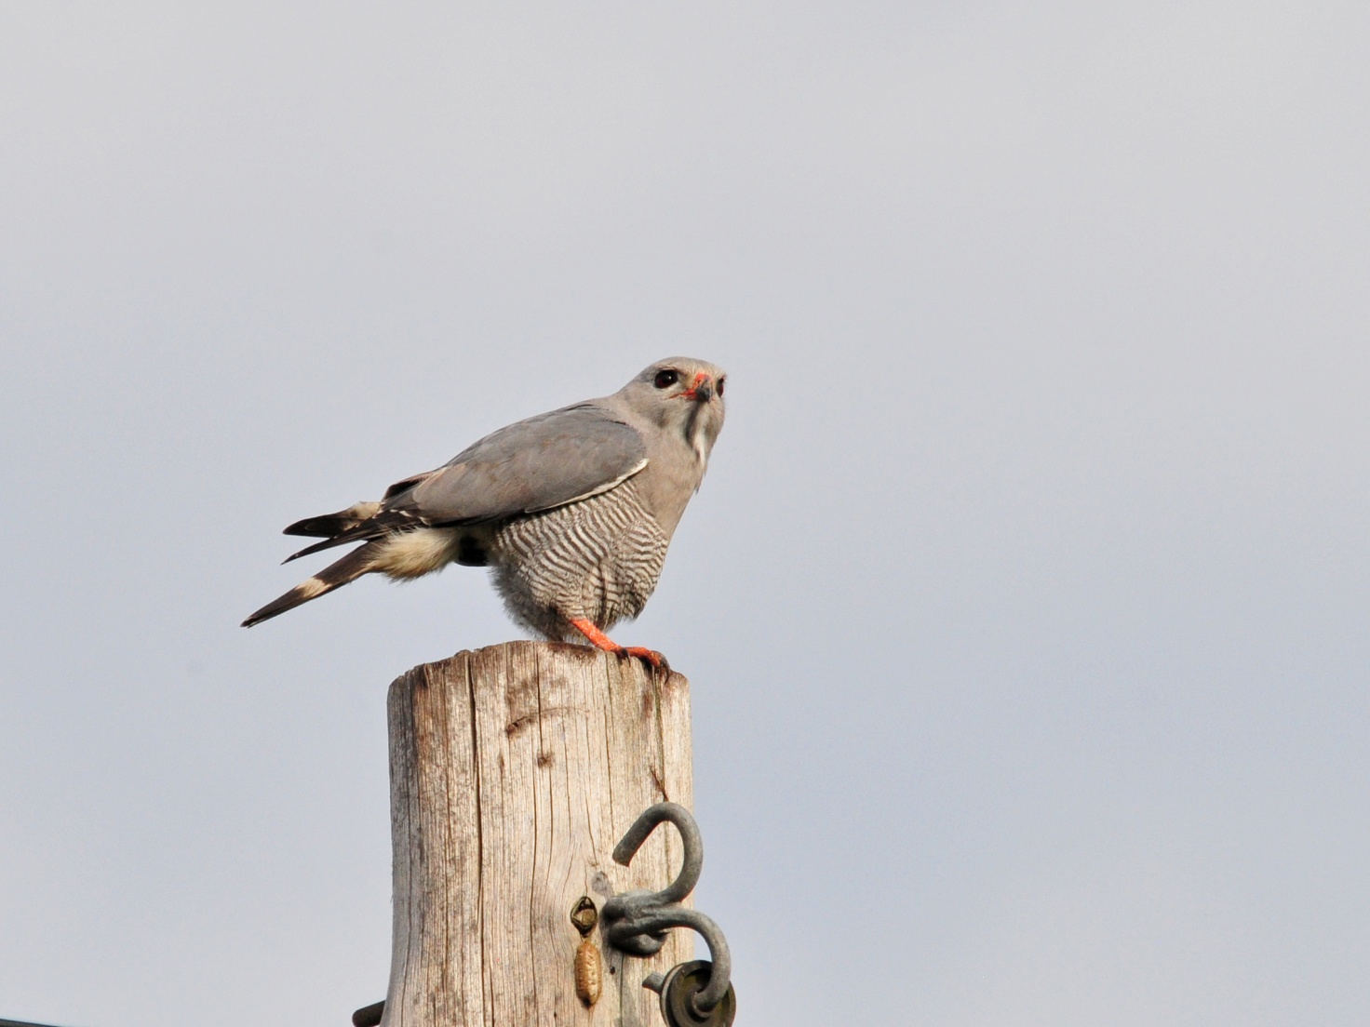
Lizard Buzzard

As we neared the entrance to Mkuze, we stopped at Mkuze Pan for a few minutes where we saw Blue-cheeked Bee-eater, Great Egret, Spur-winged Goose, Yellow-billed Egret, Black-winged Stilt, African Pipit, Red Bishop females, Red-billed Teal, Lesser Striped Swallows, Ringed Plover, and White-faced Duck. We could have spent more time here, but we had to be inside the gate of our camp before 6:30, so we had to move on. It was still pretty early, so I didn't see the rush, but I had no idea how long it would take to get from the Mkuze entrance to our camp.

As we sat in the van while Errol registered at the Mkuze entrance gate, a guy walked over to the van and told us "if you're interested", there was a group of elephants just a few feet behind us along the side of the road. If we're interested!? We all jumped out quickly and went back to see our first African Elephants! The second van arrived just a few minutes later and the entire group was enjoying the very (almost too) close elephants when a flock of about eight Red-faced Mousebirds flew in. As soon as we started moving, we began spotting animals. Impala, Nyala, Warthog right away, with Purple-banded Sunbird, Long-billed Crombec, Yellow-throated Petronia, and Pale Flycatcher representing the new bird species. It was impossible to drive straight in to camp, there were so many birds and animals to see. We made it to the gate just minutes before the deadline. When we arrived, we learned that three of our six cabins were actually cabins, while the other three were tent cabins. Obviously, Jim and I would take one of the tent cabins, but we needed a couple of volunteers for the other two - this is NOT something you want to assign to people! After some hesitation, Bernie & Jude and Skip & Pam agreed to join us in the tent camp, and I think they were quite satisfied with their decision. The tent cabins were very roomy with separate outdoor kitchens, full en suite bathrooms, and clean as a pin. What's more, we really felt like we were on a safari in these structures, even though we had all the comforts of a normal hotel room or cabin.

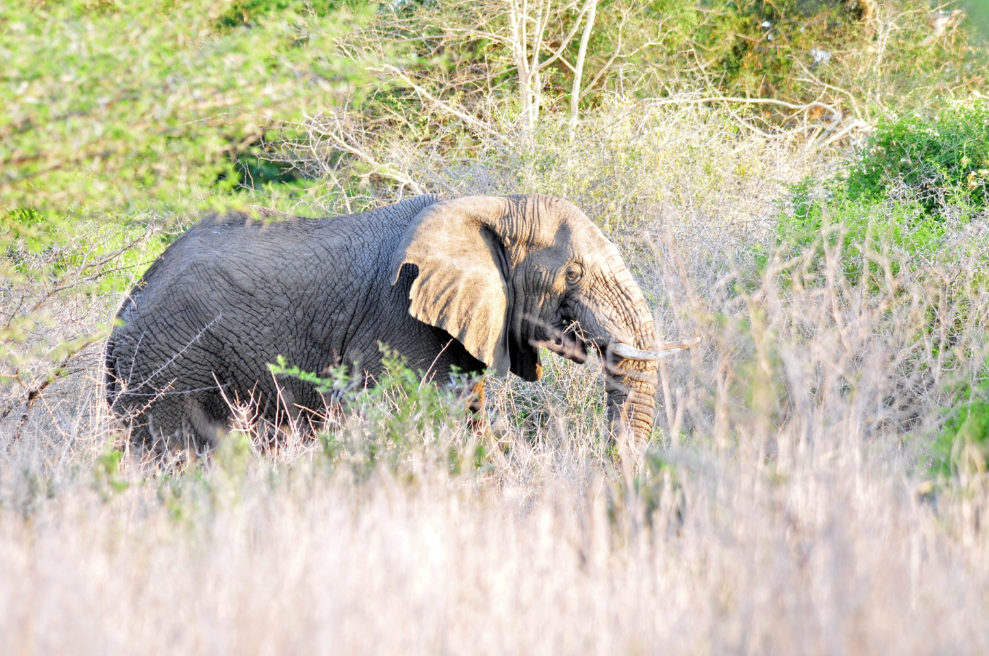
Our first Elephant!

Other species seen today that were new for the trip were African Spoonbill and Little Stint. When we gathered at the Rhino Diner for dinner and checklist, we discovered that today's count was the highest for the trip so far- 129 species! This brought the Subtropical tour total to 263 (30 new species today) and the combined tour trip total to 365 (18 new species today). What a day! We could hardly wait for tomorrow!

Day 9, Saturday, Oct. 22: Some kind of Scrub-Robin started singing at 4:00 AM outside our tent cabin. A beautiful song, to be sure, but I couldn't go back to sleep once it started serenading the camp. I got up, showered, and finally went outside to bird once there was (almost) enough light. This was about 5:40 and the bird was still present (and still singing) so I took some photos. Later, Errol identified it as a Bearded Scrub-Robin from the photos. On my solo jaunt, I found Southern Black Tit, Southern Black Flycatcher, White-browed Scrub-Robin, Yellow-throated Petronia, Golden-tailed Woodpecker, Violet-backed Starling, Collared Sunbird, Chin-spot Batis, and heard Purple-crested Turaco.

The group gathered to leave about an hour later, and we quickly found most of the birds I had already seen before getting into the vans to begin our day's drive through Mkuze. We quickly added White-rumped Swift, Scarlet-fronted Sunbird, Crowned Hornbill, and Black-backed Puffback to the day's list. Purple-banded Sunbirds were seen when we stopped to try to find the Gray Tit-Flycatcher that John and Errol heard. Our sighting of a Brubru instigated a light-hearted conversation about how easily misunderstood are the names brubru, boubou, and bulbul (especially with Errol's South African accent). Several other previously-seen species, and then we came upon a pair of African Green Pigeons that were in much better light than the ones we 'd seen before. We watched as the male chased the female from perch to perch, each time displaying as pigeons do, puffing his neck out presumably to impress the female. Each time she would fly away, he would follow her and start over. After several repeat performances, Jude commented from the seat behind me, "Doesn't he know that 'no means no!' ?" to which Bernie replied, "Oh, I don't know. That looks like 'maybe' to me." We all howled at this remark, but noted as we drove away that he was right, at least in the case of these two pigeons. Moving on, we found Wattled Starling, Rattling Cisticola, Village Weaver, and got good looks at a Brown-crowned Tchagra. We saw an Emerald-spotted Wood-Dove building a nest, a Scarlet-chested Sunbird dazzling in the sun, a couple of Gray Tit-Flycatchers in a flock with Southern Black Tits, and a Bateleur in the distance. We ticked off several species for the day including Kurrichane Thrush, Pale Flycatcher, and Neergaard's Sunbird, and spotted some new birds for the trip such as Stierling's Wren Warbler, Eastern Nicator, and Blue Waxbill. I saw what must have been a Common Scimitarbill fly by, but no one else saw it. We added White-backed Vulture just before we came across a mixed flock mobbing a small owl right at the edge of the road. Neergaard's Sunbird, Yellow Canary, Green-backed Cameropteras, and several Dark-capped Bulbuls were raising quite a fuss around an African Barred Owlet. The owlet was buried pretty deep in the undergrowth and we probably (no, definitely) would have driven right by it if the smaller birds hadn't been making such a fuss. We maneuvered the car so everyone got good looks and then moved on so the van behind us could do the same. David was the only one to get a somewhat clear photo of the owlet, for which Errol and John were thankful since they needed photographic evidence to report the bird, which is not normally found in this area.

Our next stop was Kumasinga Hide, where some of the group saw Gorgeous Bush-Shrike on the way in. Once we traveled through a long tunnel created by two rows of tall fencing to reach the hide, we settled in to observe the wildlife that might come to the waterhole that it overlooked. A Giraffe was drinking from the waterhole when we arrived, about a dozen Red-billed Oxpeckers moving about all over its neck and head at any given time. Other mammals that came in the short time we were there included Nyala, African Buffalo, Blue Wildebeest, Impala, Burchell's Zebra, Warthogs, and White Rhino, each with its own group of Oxpeckers tending to its coat. Paradise Whydah and White-winged Widowbird were seen, but neither of them were in breeding plumage. An Emerald-spotted Wood-Dove landed at the water's edge in light that illuminated the iridescent emerald spots beautifully.

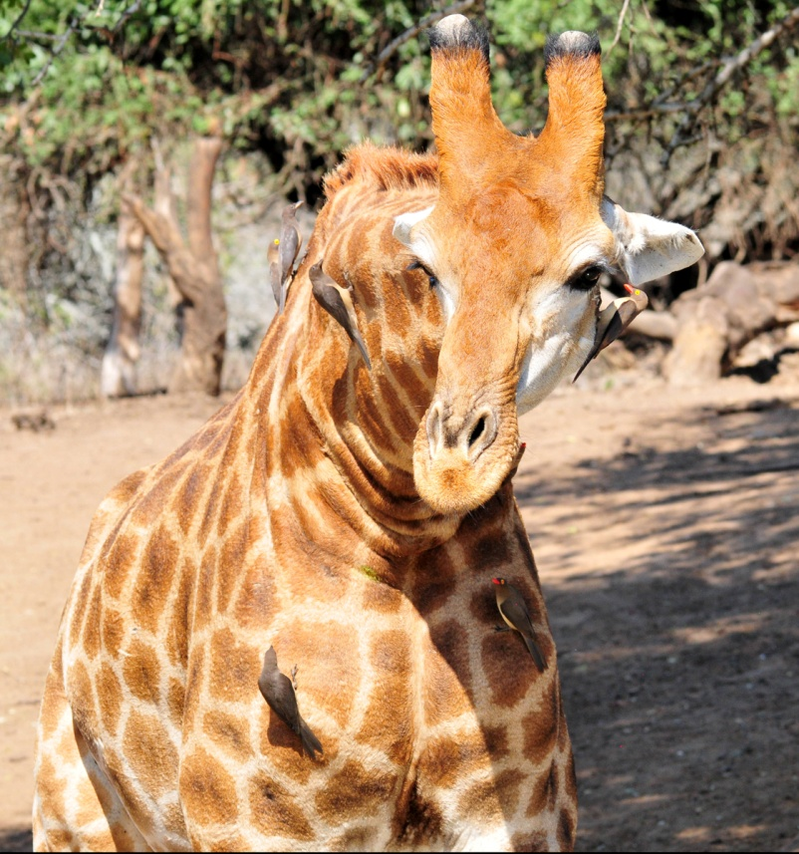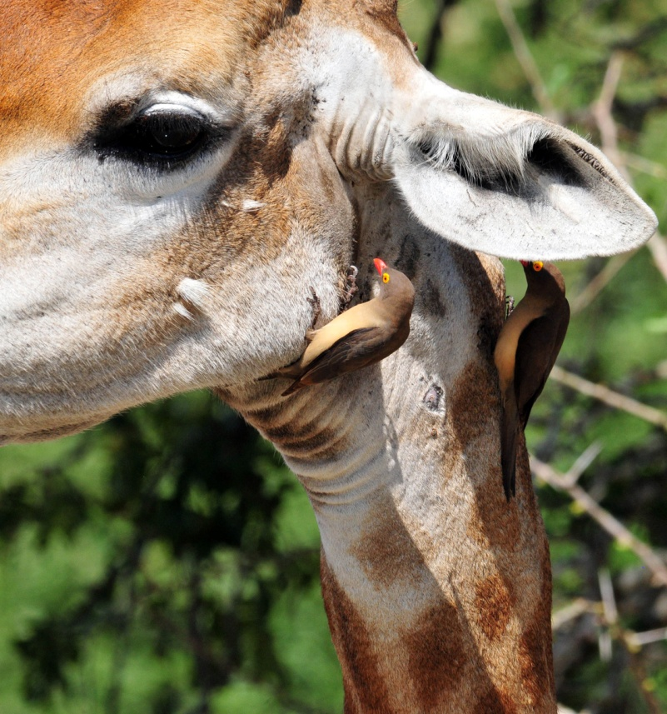
Red-billed Oxpeckers on Giraffe

No one wanted to leave when John announced that it was time to go, but if we didn't return to camp before 9:30 when they stop serving breakfast at the Rhino Diner, we wouldn't get any breakfast, or anything else to eat for that matter, because they wouldn't reopen until noon. The "Rhino Dino" is the only show in town, and their hours were limited. We reluctantly headed back to camp, and the group agreed that we would like to start at this hide tomorrow morning and spend the full morning there. Even though it wasn't the best place for birds, what a wonderful place it was for observing mammals!

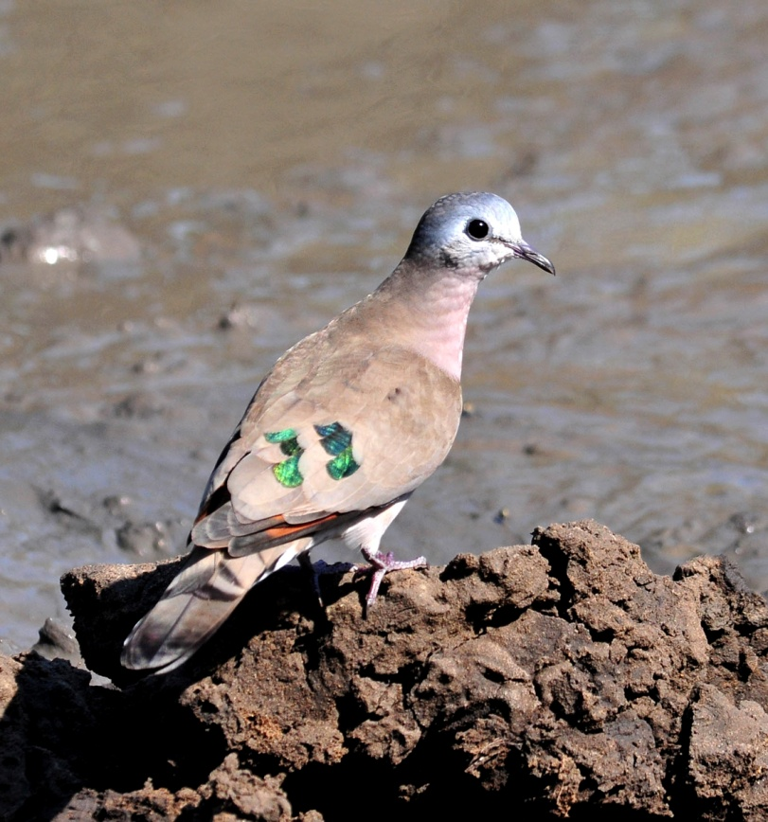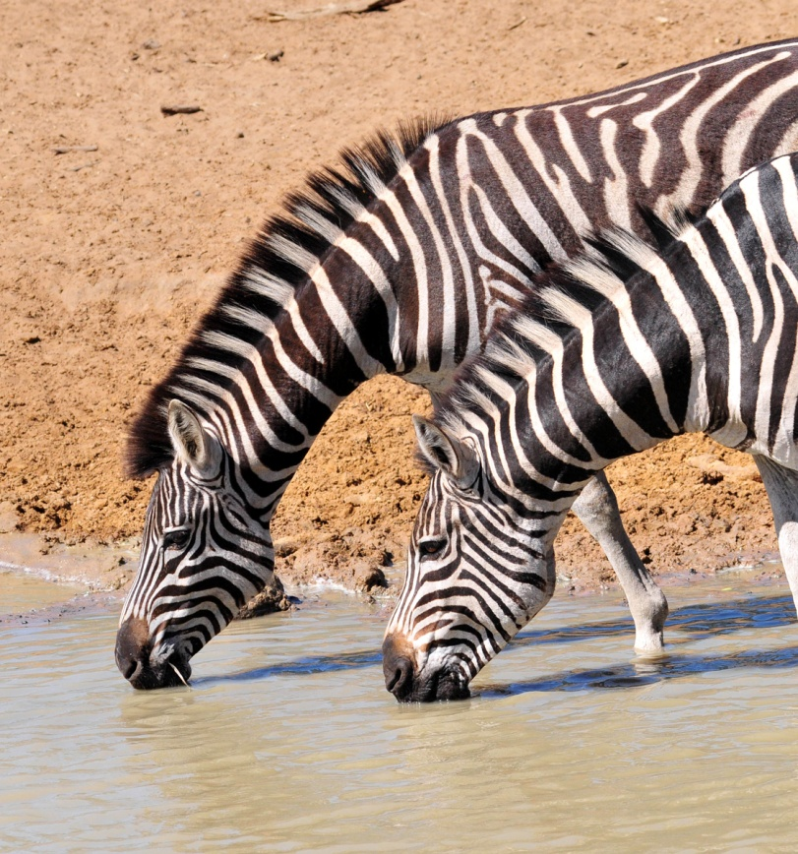
Emerald-spotted Wood-Dove Burchell's Zebras

We enjoyed our breakfast at the Rhino Diner much more than we had anticipated based on Errol's and John's critiques of the place. The food was actually quite good, and the setting couldn't be beat. We observed some butterflies and birds from our seats in the covered dining area and enjoyed watching the Impala roam around the cabins. When we finished eating, we first heard and then saw a Red-fronted Tinkerbird nearby. We went back to the vans to continue our exploration of Mkuze. The first animal we saw was a pair of Nyala, the ram much larger than the ewe. Errol explained to us that the Nyala is the only antelope in Africa in which the male is called a bull and female is called a ewe. In all of the smaller antelopes, the males are rams and the females are ewes; for the remainder of the African antelopes, males are bulls and females are cows.

For the rest of the day we drove along the roads of Mkuze in search of whatever wildlife might be around. We found White-throated Robin-Chat, Red-billed Quelea, and yet another Purple-banded Sunbird. An African Hoopoe landed very close to the road, giving us the best looks yet of this species that had been a target for so many of us. We stopped to admire some Golden-breasted Buntings and spotted a Wahlberg's Eagle at a distance. When we came upon a tree filled with European Bee-eaters, we stopped to try to get photographs but they were too far for good photos. A Crested Barbet was feeding under the bee-eater tree, a new bird for the trip. As we started to drive away, Skip spotted one of the Bee-eaters very close to the road. When we stopped for the photo op, we found Acacia Pied Barbet. Later in the day we observed Diderick's Cuckoo, Striped Kingfisher, and Common Scimitarbill, and I was able to verify that my earlier flyby sighting was, in fact, a Scimitarbill.

Our next stop was Msumo Pan, where we found a group of Hippos in the water. On the sandbar in the middle of the pan were Goliath Heron, African Open-bill (Stork), Egyptian and Spur-winged Geese, Hadedah Ibis, and both Grey and Black-capped Herons. Pied Kingfisher, African Pied Wagtail, Glossy Ibis, and Whiskered Tern were also seen here.
We found it interesting to watch Little Egrets as they hunted from the backs of Hippos. Water Monitors also used the Hippos as rafts.

Driving on, we stopped when Errol noticed a pair of Water Thick-Knees very close to the road. We observed one of the birds sitting on a nest right next to the road, panting fiercely under the hot African sun. A soaring Steppe Buzzard was seen on our way to Mkuze Pan, the wetland where we stopped on our way in to Mkuze the day before. It was VERY windy there, making it difficult to use the scope and long camera lenses. We saw Great White Pelicans and Pink-backed Pelicans next to each other, allowing us to see the huge difference in size. A Greater Painted Snipe was partially hidden in some short grasses on an island in the pan. We saw lots of birds we'd already seen, but the Collared Pratincole felt like a new bird when we observed it through the scope - much better views, even with the wind battering the scope around! We added Marsh Sandpiper to the trip list, although those who had been on the Cape Tour had seen it one time before.

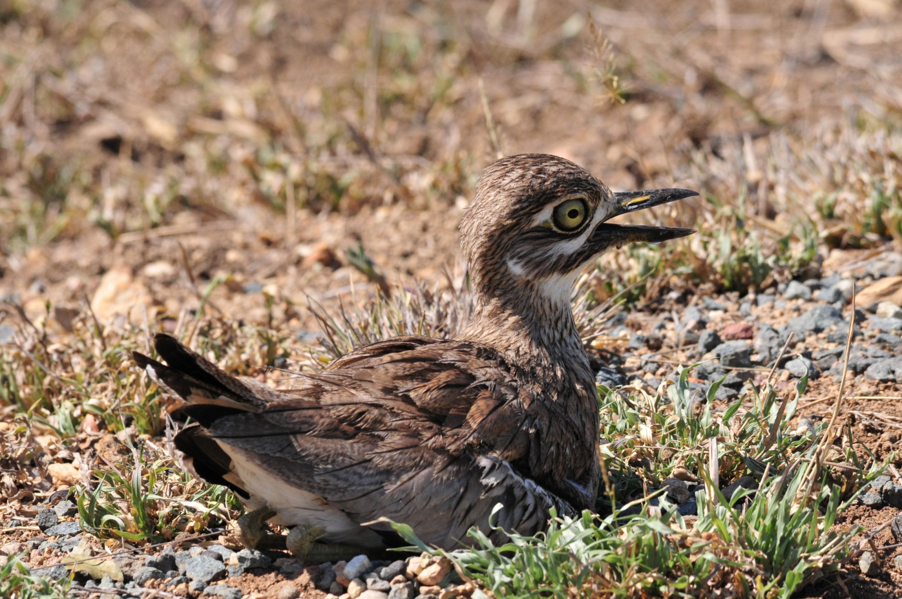
Water Thick-Knee on nest

When we left the pan, we went to area known for Pel's Fishing Owl, where we met a local man who guided us to the site. The river was very low, nonexistent in some spots, so we think he probably knew the birds were not there, but he led us around the area anyway. There was a difficult crossing over a small stream that sent a few people back to the van. By the time we got to the end, where a ridiculously decrepit hanging bridge led to the parking are, we had seen no owl, or any other new species, although we did get super looks at Green Woodhoopoes. Feeling a little irritation at the thought of tramping around when the guy probably knew the owls weren't there, our spirits were lifted when we saw two Cheetahs walking near the dirt road as we exited. Now that's what I call Serendipity with a capital S!

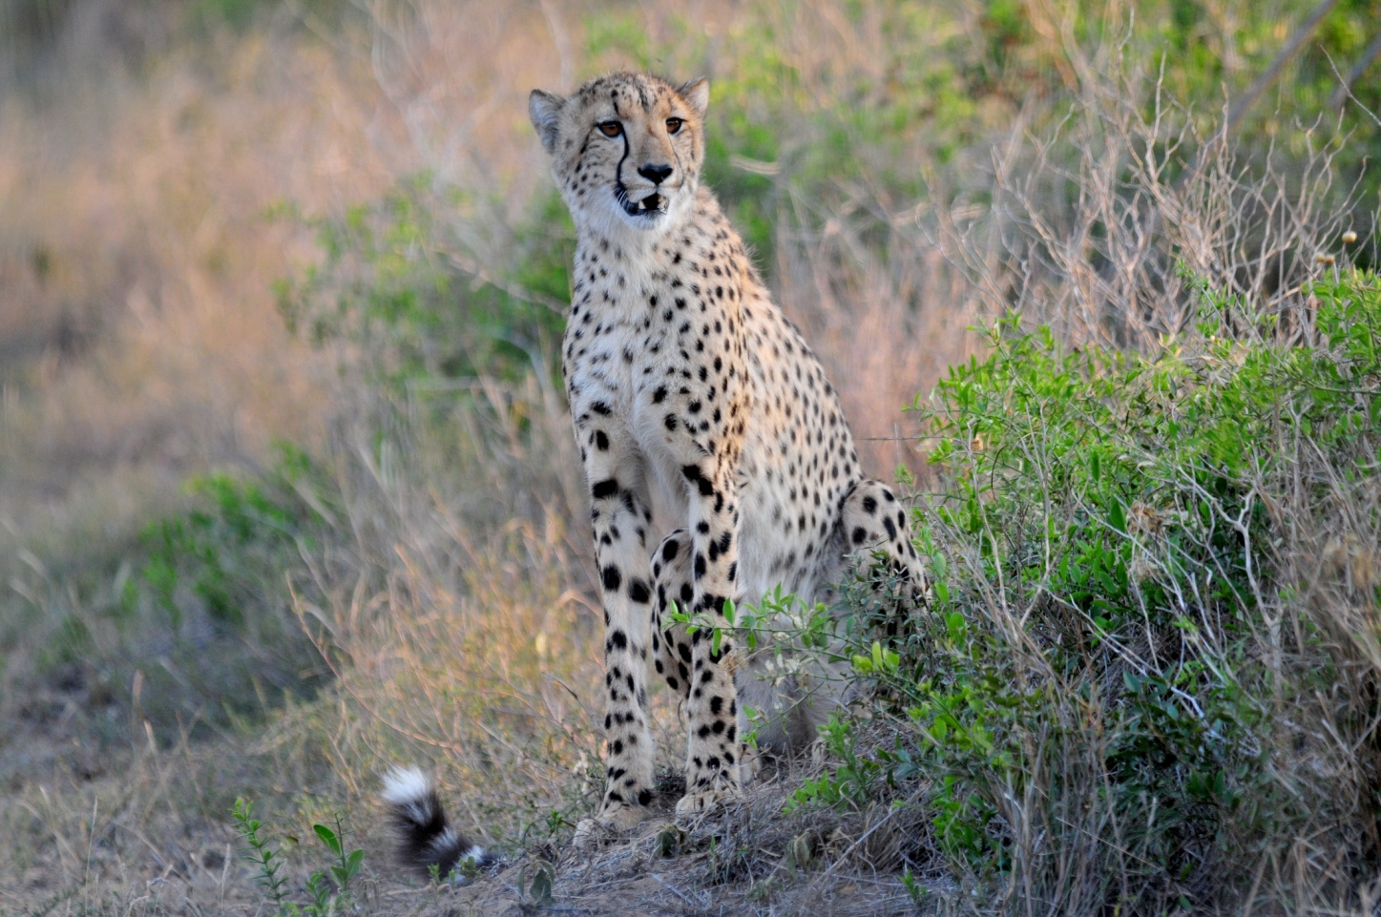
Cheetah

Still basking in the thrill of seeing the Cheetahs, we saw Black-bellied Bustard. A bit later we were amused when we saw a group of Helmeted Guineafowl running alongside the road, moving at a pretty good speed, their heads and bodies seemingly gliding along on rollers, their feet apparently the only body part moving. Trumpeter Hornbills flew over the vans as we returned to the paved road, and we headed back to dinner at the Rhino Diner (which would be closing soon).

We just thought yesterday was as good as it gets - our count today was 151 species! And that didn't count all the mammals and reptiles and insects we observed along the way! A whopping 41 were new to the Subtropical trip, taking that trip total beyond the 300 we had hoped for and finishing at 304. The combined trip racked up 35 new species bringing that trip total to a nice round 400, also beyond our expectations for the day. Some of the other birds new to the trip included African Yellow White-eye, Black Cuckoo-shrike, Bearded Woodpecker, Lilac-breasted Roller, Barn Owl, Black Cuckoo, White-backed Vulture, Southern Pochard, and Hotentot Teal.

Day 10, Sunday, October 23: We started at 6:00 AM, planning to bird around the tent cabins for about 30 - 40 minutes before going to the hide for the morning. The people who were staying in the regular cabins found Black Cuckoo-shrike and Klaas's Cuckoo as they walked from their cabins to the area where our tent cabins were located. There was some bird activity in the camp (lots of Crowned Hornbills, Willow Warbler, Fork-tailed Drongo, Cape Turtle-Dove, and an absolutely brilliant Orange-breasted Bush-shrike, to name a few), but everyone was very eager to get to the hide, so as soon as the group was together, we agreed to move on to the blinds ---- but not before the rest of the group got on the Black Cuckoo-shrike and Klaas's Cuckoo. The birds were easily and quickly relocated and we piled into the vans and headed out. We planned to drive straight to the hide without any stops, but it is virtually impossible to drive anywhere in Mkuze without seeing something that is worthy of stopping for a better look.

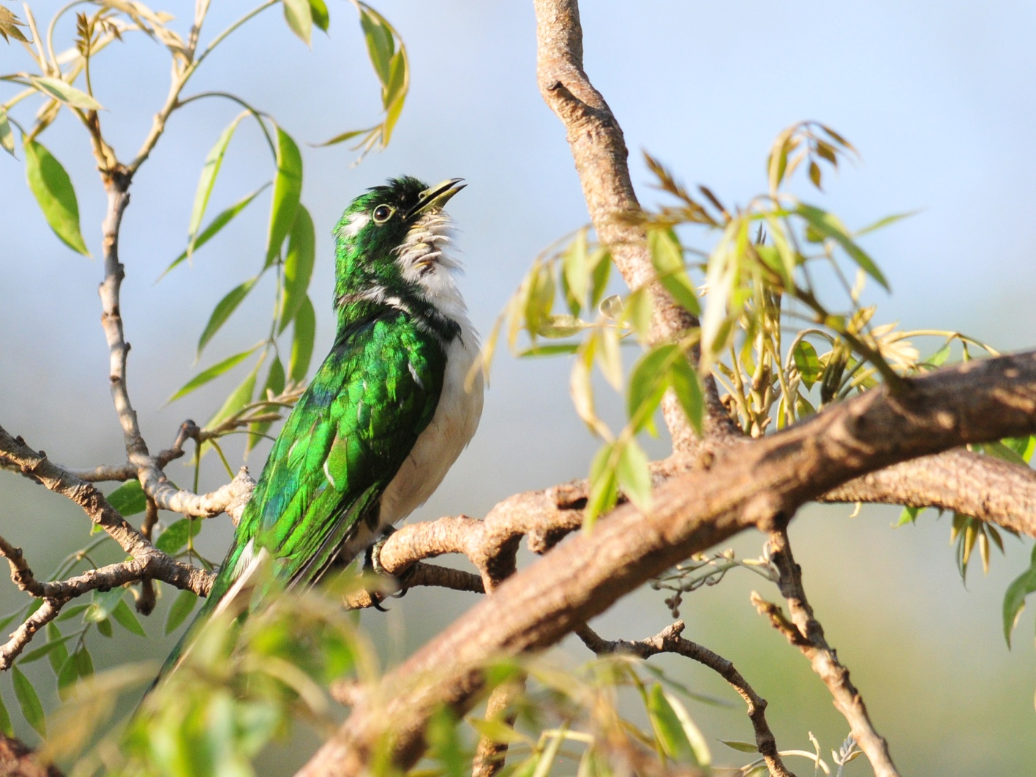
Klaas's Cuckoo

On the way to the hide, we saw a White Rhino sleeping peacefully. We stopped to identify Black-crowned Tchagra, Yellow-throated Petronia, and Blue Waxbill. A group of at least four White-crested Helmet-Shrikes flew off the road in front of us, so we stopped to get everyone on them. Flocks of small birds had to be inspected, and among the assorted Waxbills we found Pink-throated Twinspot and Green-winged Pytilia. When we arrived at the hide at about 7:15, a White-browed Scrub-Robin was hopping about in the parking area as we pulled in. The hide was different earlier in the morning, hosting more birds than had been there the previous day. A Purple-crested Turaco was moving about in the thicket next to the blind, coming very close but keeping at least partially hidden from sight in the branches.

Overlooking the water hole was a small bare tree that provided perches for a series of Passerines: Black-backed Puffback, , Emerald-spotted Wood-Dove, Cape Turtle-Dove, Red-eyed Dove, Dark-capped Bulbul, Yellow-fronted Canary, Long-tailed Paradise Whydah, Southern Grey-headed Sparrow, and Red-billed Quelea. A group of Purple-crested Turacos came in to drink on the other side of the hide, giving us wonderful sunlit views of their iridescent feathers. A group of Crested Guineafowls appeared, and the lighting showed off the blue in their plumage. A Grey Sunbird worked on its nest inside the hide, and a Greater Honeyguide was observed drinking at the water's edge. We didn't see as many mammals as we had yesterday, but the Blue Wildebeest were entertaining to watch as they galloped up to the water, shaking their heads as if to make sure they had enough room. Warthogs of all sizes showed up, from tiny babies to an old fellow who had apparently come there to die after a bad run-in with a predator. One family of Warthogs had apparently found some different type of mud to wallow in, resulting in a bright orange tint from heads to toes. We had hoped for more activity, perhaps a family of Elephants like the one we heard had been there yesterday afternoon, but the only other mammals that showed up were Impala, Nyala, and Zebra. Nevertheless, I don't think anyone was ready to leave when John again announced that we should depart. It would be a long drive out of Mkuze, and then we had quite a drive to get to Wakkerstroom. As we left the hide, someone spotted a francolin in the low growth at the edge of the parking area. John hadn't seen it, but thought by the description that it was most likely a Natal Francolin, a bird that would be seen in substantial numbers in the coming days. We moved on without everyone trying to see the bird, and then later learned from those who had had a good look and consulted the field guide that it was a Crested Spurfowl, also a common bird in the area.

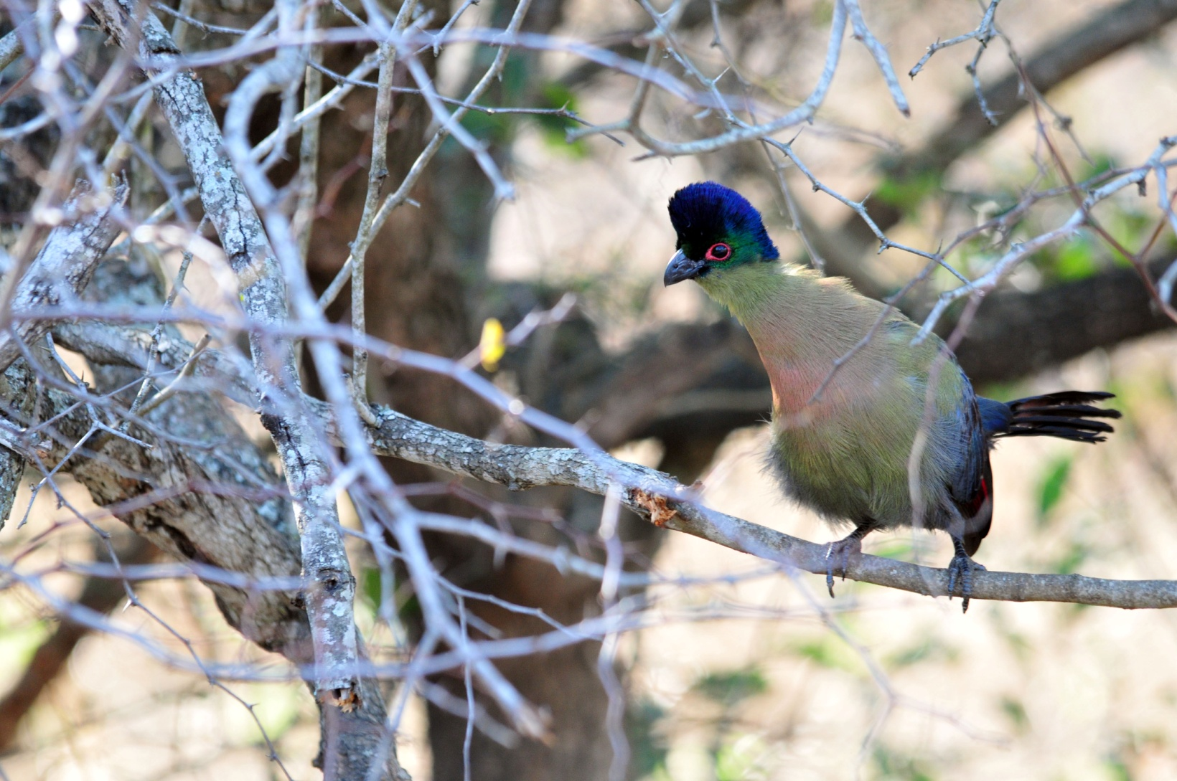
Purple-crested Turaco

We returned to camp for breakfast at the Rhino Diner and observed a huge Luna Moth and Long-horned Beetle on/in the lamp in the dining area while we waited for our food. We left Mkuze shortly before 11:00 AM and headed toward Wakkerstroom to the southwest. We (of course) watched for wildlife along the way and saw many of the same species we had seen before, and part of the time we just kicked back and relaxed and let others do the spotting. Jude spotted a raptor that turned out to be a blond form of a Wahlberg's Eagle. Very near the road we saw a Sabota Lark and the other van spotted a Lesser Honeyguide. A couple of Golden-breasted Buntings were seen in better light. A Brown-hooded Kingfisher flew in front of van, flashing so much turquoise that at first we thought it was something else. A second, darker Wahlberg's Eagle soared over our heads.

When we stopped to refuel, we saw Common Mynah and House Sparrow (oh, no!) at the gas station. Soon after lunch in Pietretief, we began to see a lot of raptors, including Steppe Buzzard, Black-shouldered Kite, and an immature Jackal Buzzard on the ground. When we stopped to find a White-bellied (aka Barrow's) Korhaan, we found an Ant-eating Chat that allowed a close approach. A Black-bellied Bustard was found by scanning the fields with a scope, and then finally someone found the Barrow's Korhaan, but it was so far away that even scope views weren't good enough to mark it as a life bird. Finally, a second Barrow's was found on the other side of the road, and part of the group walked across the field for closer looks and photos.

We arrived at Wakkerstroom Country Inn after dark. Having dinner at the place we were staying seemed like a real treat, but it actually didn't take any less time than we had been spending at restaurants every evening (which had become a pet peeve for me). It was after 9:00 PM by the time we finished eating our evening meal. Our list for the day had 96 species, bringing the Subtropical Tour count to 315 (11 new birds) and the Combined Tour count to 409 (9 new birds).

Day 11, Monday, October 24: Before leaving Wakkerstroom Country Inn at 6:00 AM, we found a few common species in the garden and the area near the hotel: Common Fiscal, Hadedah Ibis, Red-winged Starling, Red-billed Quelea, Southern Masked Weaver, Red-eyed Dove, Dark-capped Bulbul, and Speckled Pigeon. As we drove out of town, Long-tailed Widowbirds could be seen in small vacant lots. Our first stop was at nearby wetland where we found all the usual suspects as well as some unexpected prizes, including an African Purple Swamp Hen and an African Snipe that, after eluding some of us for awhile, eventually came out into the open preened for quite some time.

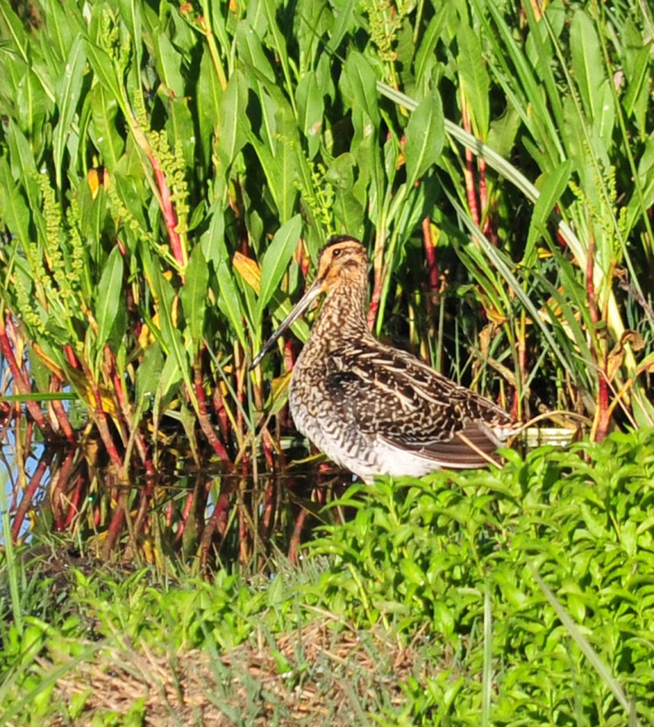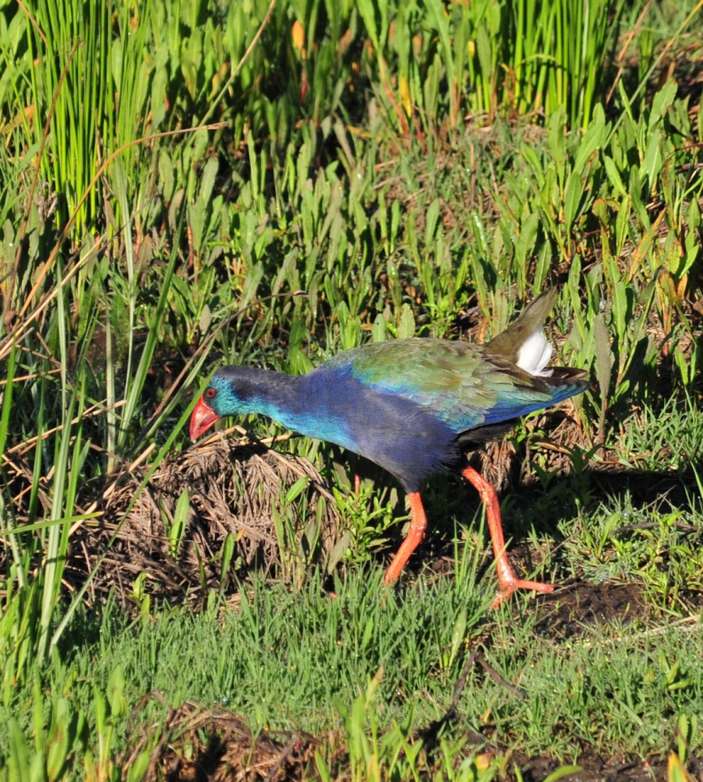
African Snipe African Purple Swamp Hen

We were now at a higher elevation and, as we explored the grasslands north of town, we began to see some species we hadn't seen for a few days, such as Mountain Wheatear, Greater Striped Swallow, Grey Crowned Crane, Cape Longclaw, Malachite Sunbird, and African Stonechat. As we drove slowly along country roads that cut across wide open spaces, we found several species new to both tours, including South African Cliff Swallow, Red-winged Francolin, Blue Korhaan, Eastern Clapper Lark, and Crowned Lapwing. John found a group of Meercats (!!) on a hillside - very exciting, but if only they could have been closer! We birded our way to a ranch where the local guide we hired for the day knew the owners who would allow us to search their property for two rare species of Larks that were known to exist there. As we walked across the fields in a straight line to try to flush the birds, I thought about how much I prefer brightly colored, vocal, in-your-face birds - our Ecuadorian guides would call them "sexy birds". We saw lots of African Pipits but dipped on the Rudd's Lark. David saw an African Rock-Pipit. After switching to the field on the opposite side of the road, we finally managed to get great looks at a Botha's Lark. While tramping across the pastures, we also flushed a Common Quail. Banded Martins flew low across the fields as we walked back to the vans.

When we stopped to look at some Blue Cranes, a new species for the Subtropical Tour, David noticed a Blesbok on the hill overlooking us. Errol told us that there really aren't any Blesbok remaining that are considered wild any more, although this one certainly appeared to be.

Other birds seen this morning included Purple Heron (best looks so far), Black-shouldered Kite, Levaillant's Cisticola,
Bald Ibis, Spike-heeled Lark, African Marsh Harrier, Red-capped Lark, and Sentinel Rock-Thrush. We returned to the hotel at around 10:00 AM and decided that, with the heat and bright sunshine, we would wait until after lunch to continue birding. Some people used the "down time" to check emails and glean information from the internet, others walked into town for a bit of shopping, some just rested in their rooms, and of course some continued to bird around town.

When we went back out after lunch shortly after 2:00 PM, the first bird we spotted, sitting on a fence post just as we were leaving town, was a Red-throated Wryneck. I was thrilled because this was one of the birds I hadn't seen when I opted out of the day at Sani Pass. A short while later, we found another bird that the group had seen in Lesotho, a Buff-streaked Chat, again sitting on a fence, providing (according to the others) better views than at Sani Pass and a nice male to boot. Common birds such as Cape Sparrow and Cape Crow were plentiful as we made our way to Zaaihoek Dam, where we found Cape Shoveler, South African Shelducks, Greenshank, Three-banded Plover, African Wattled Lapwing, another African Marsh Harrier, Swainson's Spurfowl, and most of the expected water birds.

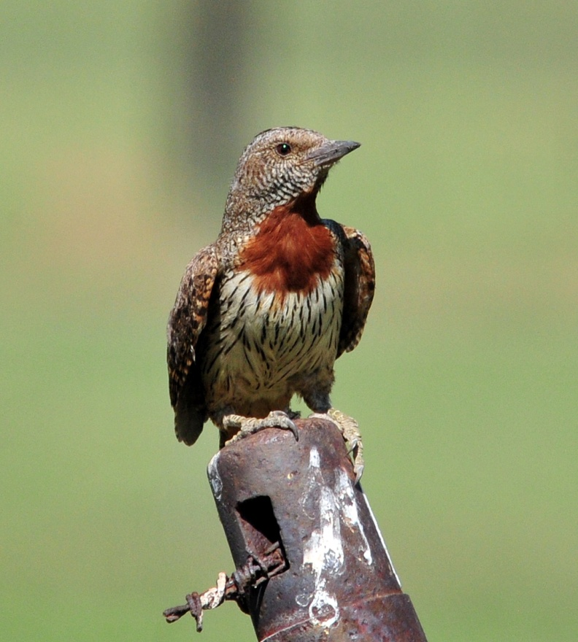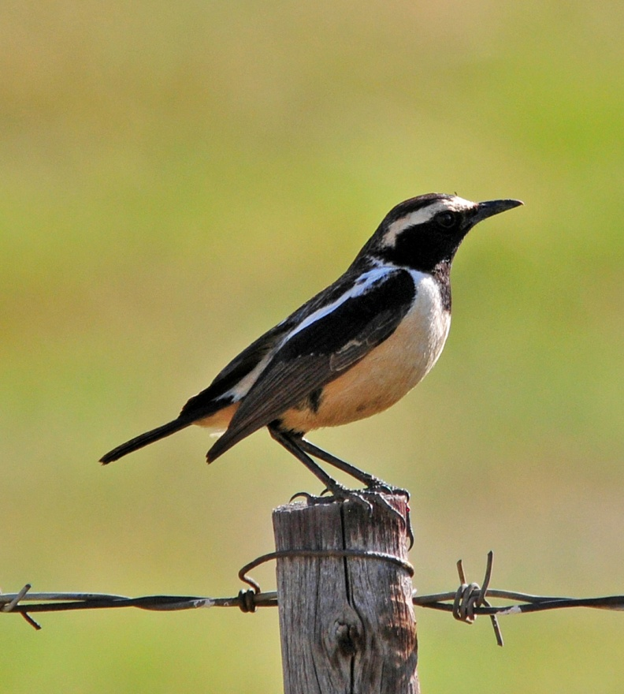
Red-throated Wry-neck Buff-streaked Chat

Next we moved to a small hide near another wetland, called WOW (Wetlands of Wakkerstroom). We didn't find much in the way of new species here, but we wanted to be here when the sun began to set so we could watch for African Rail and Black Crake in the marsh on the opposite side of the highway, where both species were known to live. As we left the hide to move into position for the two target species, I spotted a Little Bittern at the edge of the wetland. After everyone got satisfying looks of the bittern, we moved to the other side of the road. As we were staring at the wetland, searching for movement among the reeds, Jean called out excitedly - she had spotted two Clawless Otters swimming through the water a short distance down the road. We all watched as they swam and ate, and a few more otters joined them - what a treat! As the light began to fade, first one, then another, and another, and another Black-crowned Night-Heron flew from one side of the road to the other, settling in for the night. We didn't actually count, but dozens of Night-Herons flew over our heads as we appreciated one of the most beautiful sunsets I've ever witnessed. In this dim lighting, a few people were able to spot the Crake, a few others saw the Rail.

We didn't leave the roadside until there was virtually no light to see the crakes or rails if they ventured out from their cover. We finished the day with 103 species, 20 of which were new birds for the Subtropical trip (total 335) and 10 were new species for the Combined Tour (total 419).

Day 12, Tuesday, October 25: This morning, we were up at 3:45 AM for a 5:00 AM departure, which the group had requested so we could arrive at Kruger as early as possible. The entire group was ready early, with luggage lined up for loading behind the van, and we were actually able to leave a few minutes early. Of course, at this hour, there wasn't much to see during the first part of our drive. As the sun rose, we found a group of Blue Cranes much closer than the ones we had seen yesterday. A Lanner Falcon sat on a utility pole as we passed by, but the next "raptor" we saw on a pole turned out to be a Helmeted Guineafowl - what was he doing up there, anyway? The second van spotted Blue Korhaan, Swainson's Spurfowl, and Black-headed Heron. We stopped along the side of the road near a pan to have our boxed breakfasts shortly after 7:00 AM, but there wasn't much to see on the backlit water while we ate, so we didn't stay long. Shortly after, we pulled to the side of the road to scan a wide pan below us and found Lesser Flamingo, a trip bird for both groups, and Macoa and White-backed Ducks, trip birds for the Subtropical Tour. We watched a Steppe Buzzard chase a Black-headed Heron, and then someone spotted an African Harrier-Hawk soaring high above us. Our next stop was near John's home town of Witrivier (White River) to try to find a Bat Hawk at a favorite roosting spot that he knew of. We walked down some railroad tracks for a better vantage point to observe the Bat Hawk (which never made an appearance) and found Common Waxbills and Long-crested Eagle. As we were returning to the vans, we spotted some activity in some trees at the opposite corner and went to investigate. There we found two new species, Golden Weaver and Arrow-marked Babbler (which I had to ask Errol to repeat at least three times before I could translate "Aramok" into "Arrow-marked"). We didn't search farther down the road since everyone was eager to get to Kruger National Park, which was still about an hour and a half's drive away.

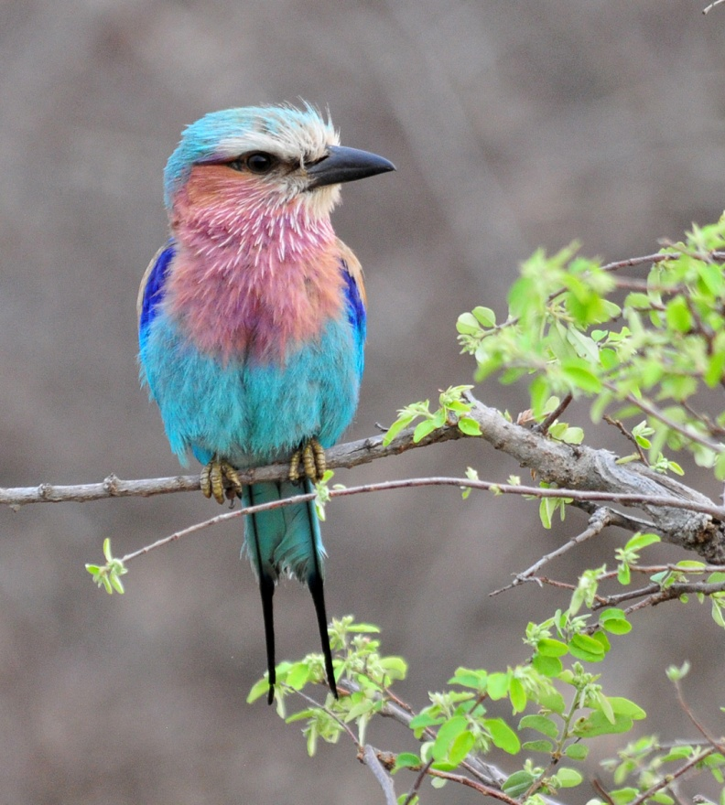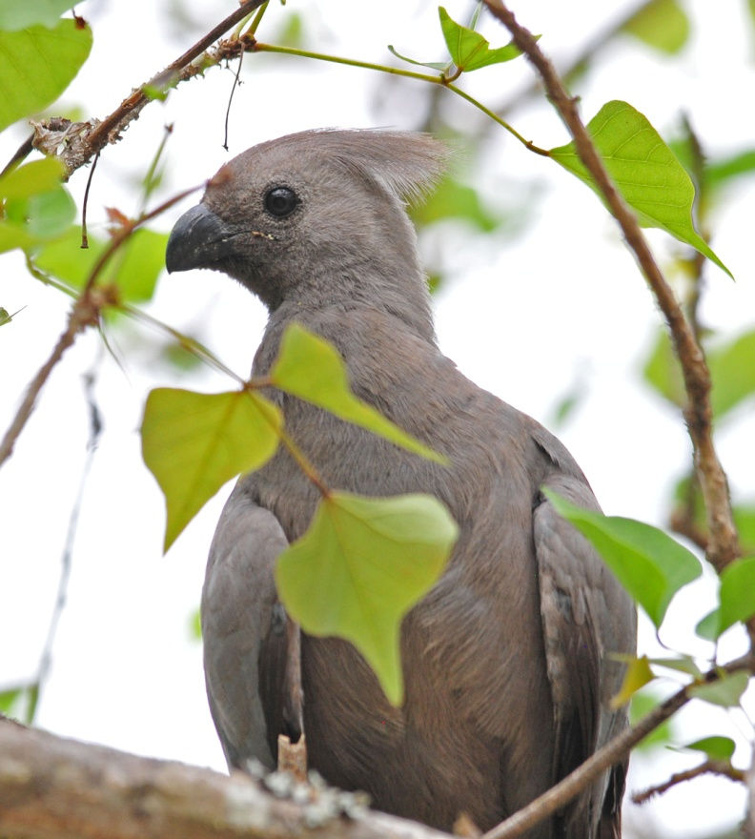
Lilac-breasted Roller Grey Go Away Bird (Lourie)

We arrived at the Nimbi Gate entrance to Kruger at about 12:30 and excitedly began to scour the roadsides in search of anything that moved. We spotted Lilac-breasted Roller, one of what I consider to be Africa's most beautiful birds, African Cuckoo-Hawk, Scarlet-chested Sunbird, African Hoopoe, Bearded Woodpecker, Southern Black Tit, Gray Penduine Tit, Golden-breasted Bunting, African Grey Hornbill, Chin-spot Batis, Scimitarbill, White-backed Vulture, Steppe Buzzard, and a Leopard Tortoise, before arriving at Pretoriuskop Camp for lunch about an hour later. In the area around the restaurant and gift shop, we found a Grey Lourie or "Go Away Bird" and Brown-headed Parrots feeding among low branches just a few feet from us. After lunch, we found Rattling Cisticola and Yellow-throated Longclaw.
Greater Blue-eared Starling and Laughing Dove allowed close approach in the parking lot. Driving on to Skukuza, the camp where we would spend the night, we moved slowly and watched in every direction for birds and animals. Kruger did not disappoint! Green-capped Eremomela proved to be a difficult bird, but the Violet-backed Starlings posed in the open. We stopped at the Visitors' Center to arrange for night ride for both tonight at Skukuza and tomorrow at Satara. Some people were considering just going on the ride at Satara and changed their minds several times before the decision to go on tonight's ride became unanimous. We each purchased our own tickets, but we couldn't buy tickets for Satara here. We would have to wait until we got there tomorrow and buy them just before the ride began.

Moving on toward Skukuza, where we were required to arrive before 6:30, we continued to watch for birds and animals. The people in the lead van were viewing a perched light phase Wahlberg's Eagle, but the bird flew away as our van approached. We saw Black Cuckoo-shrike and European Bee-Eater before we saw two African Elephants, then two more, come into view. An assortment of antelope was seen today, including Waterbuck, Common Duiker, Springbok, Bushbuck, and Kudu. White Rhinos, Burchell's Zebra, Warthog, Hippopotamus, Giraffe, Cape Buffalo, and Blue Wildebeest were also seen, most more than once.

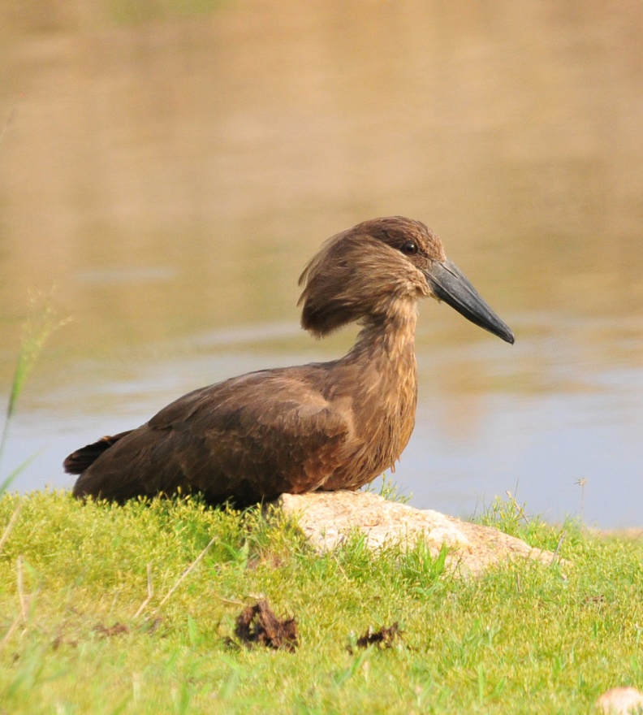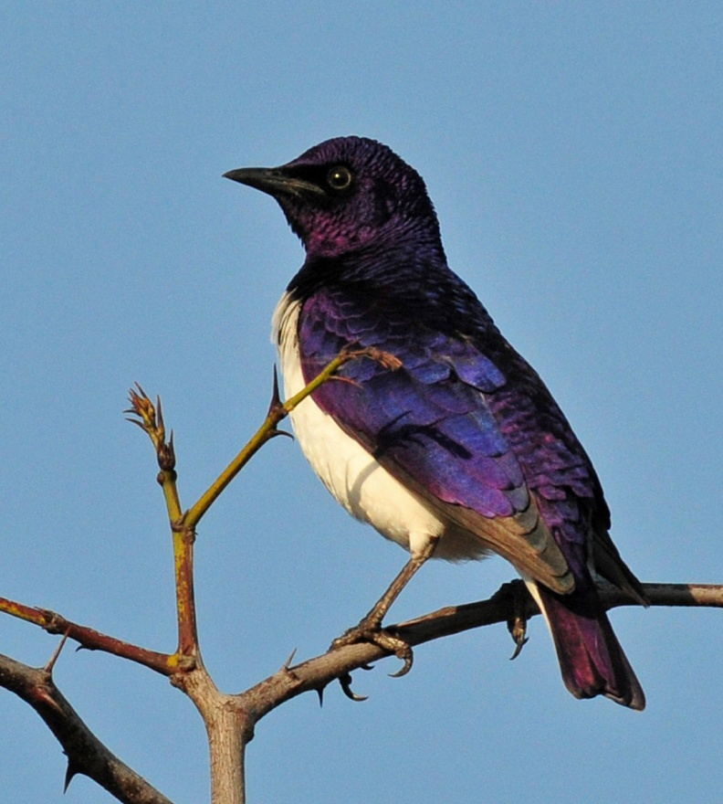
Hamerkop Violet-backed Starling

As the sun began to get low, John kept reminding Errol that we needed to hurry - if we weren't inside Skukuza Camp by 6:30, there would be penalties. We tried to hurry, but there was so much to see along the way that eventually the first van pulled away from us and we are no longer even attempting to stay together. We pulled in to observe a small pond just as the first van was leaving. There, we saw a perched African Fishing Eagle and found a Hamerkop standing at the water's edge. Another car was parked in the best spot for good views of the Hamerkop, but when the bird flew to a new location, we were able to position ourselves well. Unfortunately, it was at this time that the bird decided to crunch his neck down, tuck in his bill, and go to sleep, hiding all his best qualities. Errol played a few seconds of the Hamerkop's call, and he stood at attention for perfect profiles of that hammer-shaped crest and massive bill. Also seen at the water's edge were Water Thick-Knee, Three-banded Plover, and Green-backed Heron.

As we drove on, we knew that tonight's checklist would be a bit confusing with the two vans spotting different birds. We quickly added Black-headed Oriole, Burchell's Starling, Brown-crowned Tchagra, Arrow-marked Tit-Babbler, Magpie Shrike, Red Hornbills, another Grey Lourie, a mystery woodpecker, and Crested Francolin. A pair of Violet-backed Starlings posed on bare branches right next to the road in perfect light, their iridescent purple feathers absolutely brilliant. While appreciating the Starlings, a Yellow-billed Hornbill flew in and landed for great views, and then, as we started to drive away, we saw a Natal Francolin. We knew we had to move on, so we didn't take time to try to relocate a little green ufo that flew by us, but when we came upon a Dark Chanting Goshawk that was perched in a bare tree at the road's edge, we had to take some time to appreciate it fully. As much as we tried to hurry, opportunities that were too good to pass up kept presenting themselves: an African Hoopoe on the ground just a few feet from the van, a pair of Banded Sandgrouse taking a dust bath, two Klipspringers poised on a huge rock.

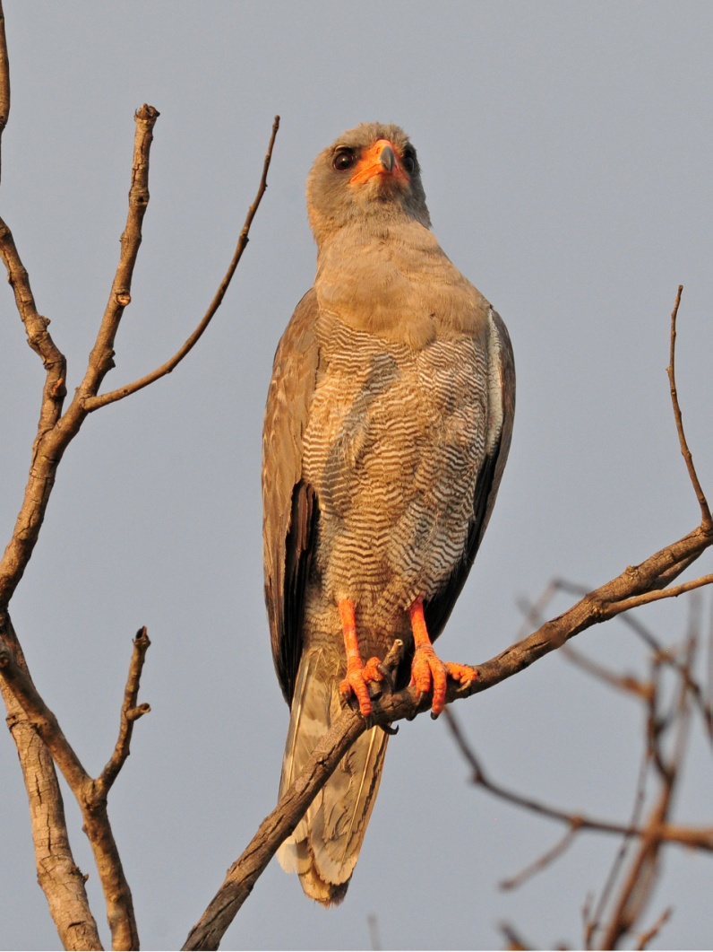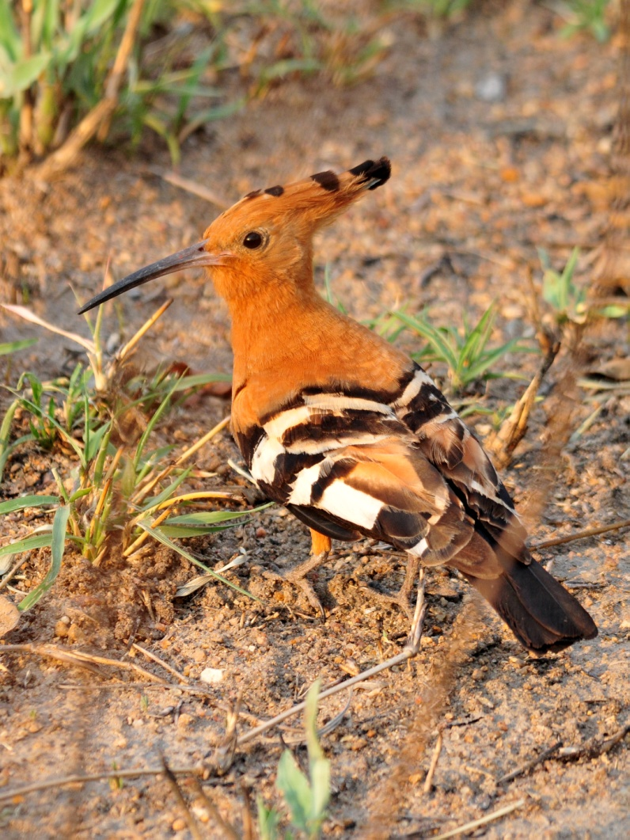
Dark Chanting Goshawk African Hoopoe

We made it to the gate in the nick of time and went straight to the little store to get a quick bite to eat. After we got everyone settled in their cabins, we got ready for our night ride. The cabins weren't far, but it was dark when we arrived and we were unfamiliar with the area, so Errol and John delivered us to the starting point in the vans. They went back to their cottages to rest, but they returned to pick us up at 10:00 when the ride was over. The ride was so boring at first that I almost fell asleep. Gentle movement in the dark, very little noise, it was very relaxing after a long day of birding and travel. My eyes were closed when a Leopard was spotted, and I was able to get only a glimpse of it before it disappeared into the brush. We came across a male Lion sleeping on the pavement, allowing everyone some good close views. We found two sleeping Green-capped Eremomelas, a Chameleon, lots of Scrub Hares, a Hippo, a small group of Elephants, and a White-tailed Mongoose. There was a small snake on the road that wasn't identified, and Myra spotted a Genet when she looked at the road behind us. Apparently, though, the best sighting of the night was the Aardvaark, which the guide went on and on about being so rarely seen. I honestly thought he was exaggerating until I saw the reaction we got from Errol and John when we told them we had seen one.

We didn't make it to bed until 11:00 with tomorrow's departure scheduled for 5:30. Whew! Our list had us at153 birds for the day, bringing the trip totals to 359 and 441 for the Subtropical and Combined Tours respectively. Other birds seen today that were new for the trip included Marico Sunbird, Southern White-crowned Shrike, Groundscraper Thrush, Red-crested Korhaan, and Hooded Vulture. We also had 27 mammal species, making our first day in Kruger by far the best day of the trip so far.

Day 13, Wednesday, Oct. 26: We were out of bed at 4:45 for a 5:30 departure. I had heard a strange sound in the middle of the night but ignored it. Apparently, Jude and Bernie were in the cabin next to ours, and the commotion was louder and more annoying from their place, so they went out to investigate. They shined their lights toward the noises coming from the tree right next to their cabin and found two Bush Babies raising the dickens around a Python that had apparently come too close to their nest. We drove out of camp at the earliest time permitted, and drove slowly toward the Skukuza Nursery and Golf Course. Along the way we heard a loud "keck, keck, keck, keck" that to me sounded almost Koodaburra-ish. We easily found the source of the sound, a Green Woodhoopoe. When we parked at the

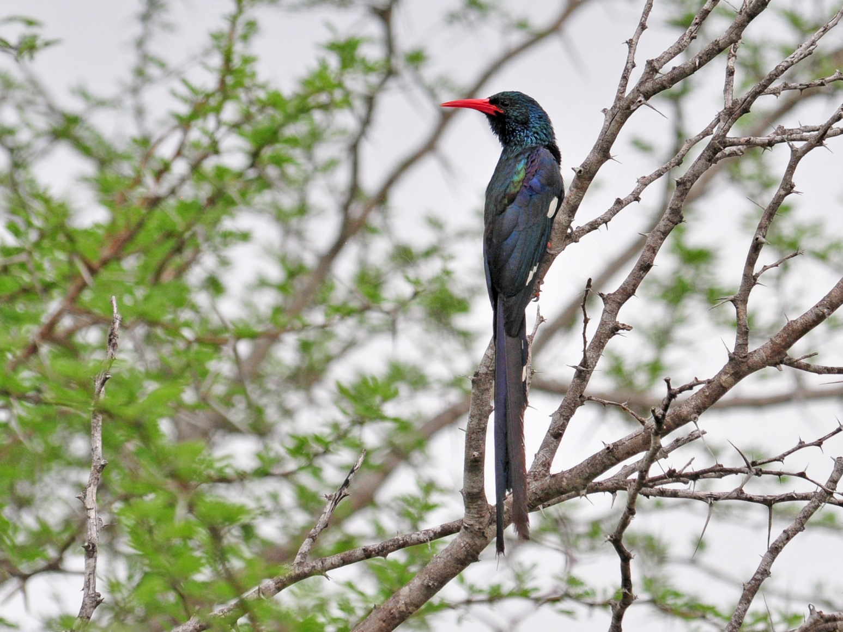
Green Wood-Hoopoe

nursery, we saw Red-backed Mannikins and a White-browed Robin-Chat, whose name is so similar to White-browed Scrub-Robin and White-throated Robin-Chat that David and I nearly missed it because we didn't realize at first that it was a new bird and didn't divert our attention from whatever birds we were trying to photograph at the moment.

We walked toward the nursery along a boardwalk that crossed over a small wetland. We had stopped to look for birds at a spot where there was small amount of standing water about three feet below the boardwalk. There was a lot of vegetation in the water, and it appeared to be no more than a big puddle, really. As Jude and I stood there talking quietly, all of a sudden a Hippo burst up and out of the tiny puddle of water, snorting and thrashing as if it were very angry that we had disturbed its sleep. We were so thankful that we were above it rather than next to it! I was so stunned that I didn't even lift my camera until the episode was almost over, and then I only got a few seconds of video of the animal stomping away into the vegetation.

We moved on to the entrance of the nursery, where Jim found a Black-collared Barbet. John's father managed this nursery when John was young, so he knew the place very well. Behind the nursery we found Terrestrial Brownbul and Kurrichane Thrush. Leaving the nursery to walk over to the nearby golf course where we would have breakfast, we saw
White-fronted Bee-eater, Ashy Flycatcher, and Red-capped Robin-Chat. As we approached a small bridge, one of the Bee-Eaters flew in and landed on the railing and proceeded to use this as its perch for hawking insects for the next several minutes. Across the water from us were two Broad-billed Rollers on high branches in a large tree.
As we crossed the end of the golf course, we got a kick out of reading the signs at each hole: Par 4, Beware of hippos; Par 5, Beware of crocodiles. The lake was full of hippos, and the golf course went right up to the edge of the water. Bernie and Jude are avid golfers, and we had to wait for Bernie to talk to a couple of South African golfers. He enjoyed getting some photos on the African golf course, and even managed to find a tee and ball to take home as souvenirs. Before we went inside for breakfast, we found both Little Rush Warbler and Lesser Swamp Warbler in the vegetation at the edge of the water.

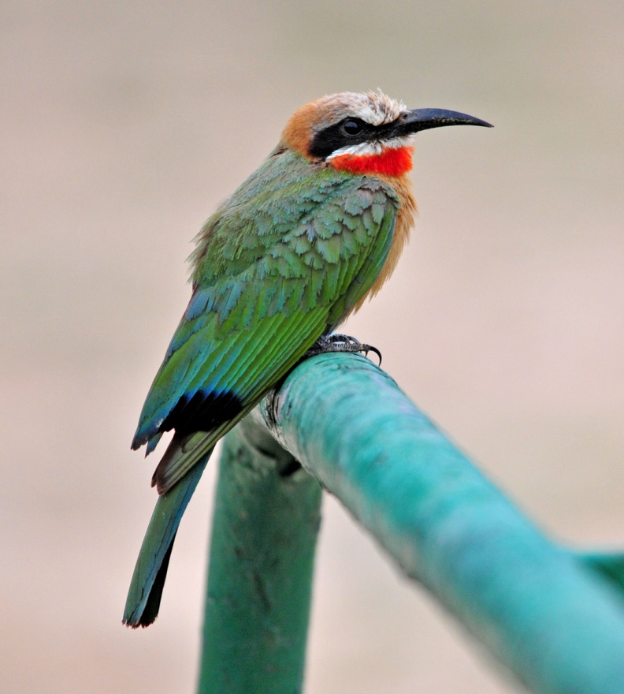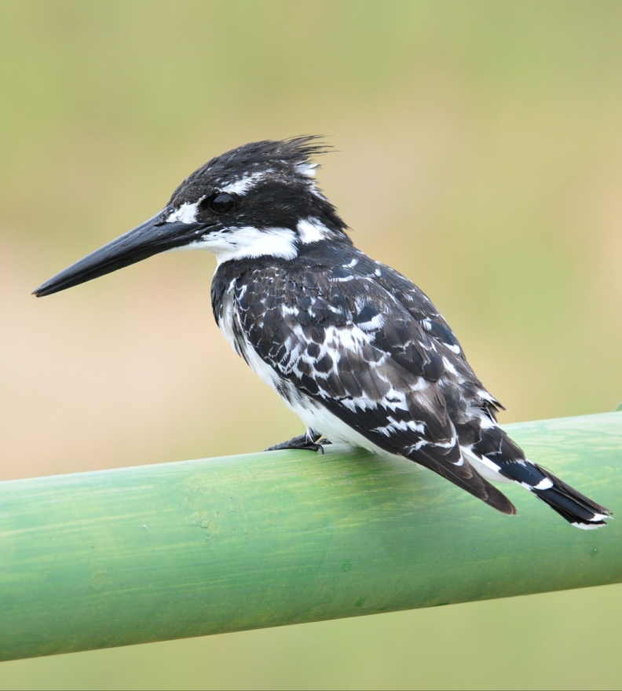
White-fronted Bee-Eater Pied Kingfisher

As we walked back to the vans, we saw more White-fronted Bee-Eaters, a Scarlet-chested Sunbird in very poor light, and some Red-faced Mousebirds. We drove back to camp, checked out and left Skukuza at a little after 10:30. We, of course, birded the entire way out of the park, finding European Bee-eaters, Red-billed Firefinches, and Levaillant's Cuckoo, among others. When we stopped at a small pan, we found a plover that confused our guides for awhile. They had us take photos so we could zoom in on the bird and they were finally able to identify it as a young Blacksmith Plover. Also seen at the water was African Black Duck. Someone told us there was an African Finfoot on a bridge somewhere on our route, so we continued but didn't rush - we kept birding along the way. John got a little ahead of us, so when we got to the bridge, a few of the people in his van saw the Finfoot just as it disappeared, but no one in our van got on the bird. From the bridge we saw Giant Kingfisher, Saddle-billed Stork, Brown-headed Parrot, Wood Sandpiper, and a young Crocodile. A Pied Kingfisher flew back and forth under the bridge and finally landed on the railing very close to the van.

Moving on, we observed Bateleur, White-crested Helmet-Shrike, Retz's Helmet-Shrike, and Yellow-breasted Apalis. A Lilac-breasted Roller was perched right next to road at eye level. Other sightings along the way included Dwarf Mongoose, Red-billed Buffalo Weaver, Orange-breasted Bush-shrike, Giraffe, and then we came upon something that did not make us happy - a dead lion. At first we thought the animal was sleeping, but we didn't have to approach too closely to see otherwise. A short distance down the road, we saw three lions crossing the road and wondered if they had been part of the same pride. Black-headed Oriole, African Grey Hornbill, Cardinal Woodpecker, Brown Snake-Eagle, Ground Hornbill, one bird after another as we drove slowly toward Sakara Camp. We saw two Giraffes feeding in an acacia close to the road and watched as their tongues maneuvered around the sharp thorns to grab the tiny leaves.

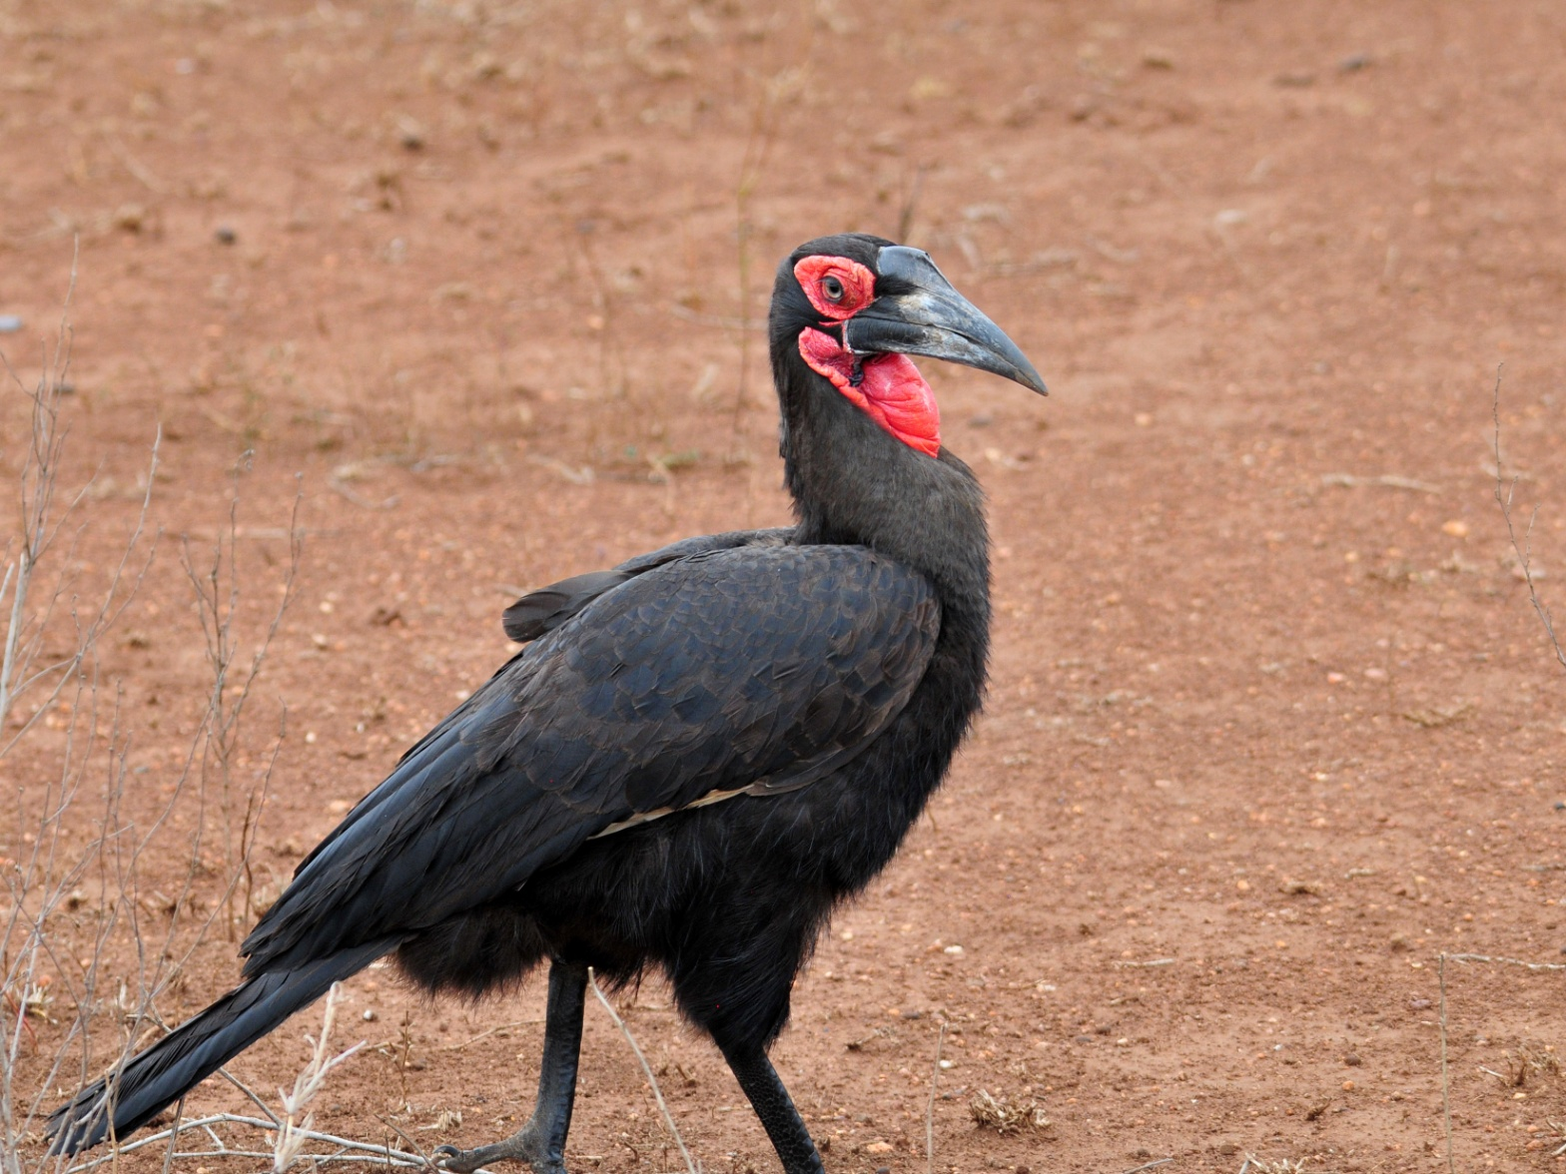
Ground Hornbill
We stopped at a terrific lunch spot - not terrific because of the food, but because of the setting. The shop at Tshokwane offered everything from Kudu to Ostrich on the menu, but the best thing about it was that birds were everywhere! We saw Yellow-billed Hornbills and Burchells' and Blue-eared Starlings begging for food when we drove in. I was dismayed to see some of the tourists tossing things like French Fries to the Hornbills, but I was thrilled to be able to get so close to these birds who were obviously completely acclimated to humans. I grabbed a meat pie for lunch and ate it quickly so I could explore the area more thoroughly. Bennett's Woodpeckers hopped along the branches of a huge tree that shaded the picnic area. Behind the buildings, a Crested Barbet pounded a huge caterpillar on the ground before gulping it down. Across the fence I could see a group of Green Woodhoopoes as they hunted. African Mourning Doves and Red-eyed Doves foraged around the tables. Yellow-billed Hornbills allowed people to walk right up to them - my kind of bird!

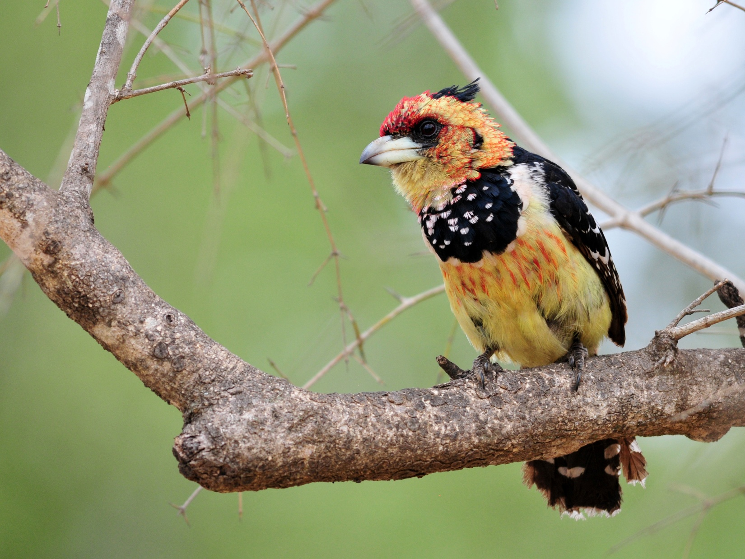
Crested Barbet

As we departed, Errol pointed out a Golden-breasted Bunting and again waxed poetic about how brilliant it is when the light hits it just so. Wildebeest on the left, Giraffe on the right, a Burnt-necked Ermomela (not showing much of a burnt neck), Yellow-throated Longclaw, lots of Impala, Kudu, Black-shouldered Kite, Marico Sunbird, Brown Snake-Eagle, Slender Mongoose - this is what it's like driving through Kruger. You barely finish with one sighting when you're presented with another.

We stopped at another pan where we found Curlew Sandpiper, Egyptian Goose, Wood Sandpiper, Little Stint, Hamerkop, African Fish-Eagle, Saddle-billed Stork with young, and Grey Heron. It seemed like we saw raptors everywhere we looked: Martial Eagle, White-backed Vulture, White-headed Vulture, Black-chested Snake-Eagle, Little Sparrow-Hawk, and more. But you couldn't focus just on the treetops or watch for birds soaring overhead or you would miss the show on the ground: Crowned Lapwing, Wattled Starling, Crested Francolin, Black-bellied Bustard, to name a few. Mid-level wasn't half-bad either, with Levaillant's and Thick-billed Cuckoos among the passerines. I loved every minute of Kruger! And, with 140 species seen for the day, what's not to love? Our trip totals at the end of day 13 were 377 for the Subtropical Tour, 458 for the Combined Tour. Would we be able to make 400 for the Subtropical Tour and 500 for the Combined Tour with just three days of birding remaining?

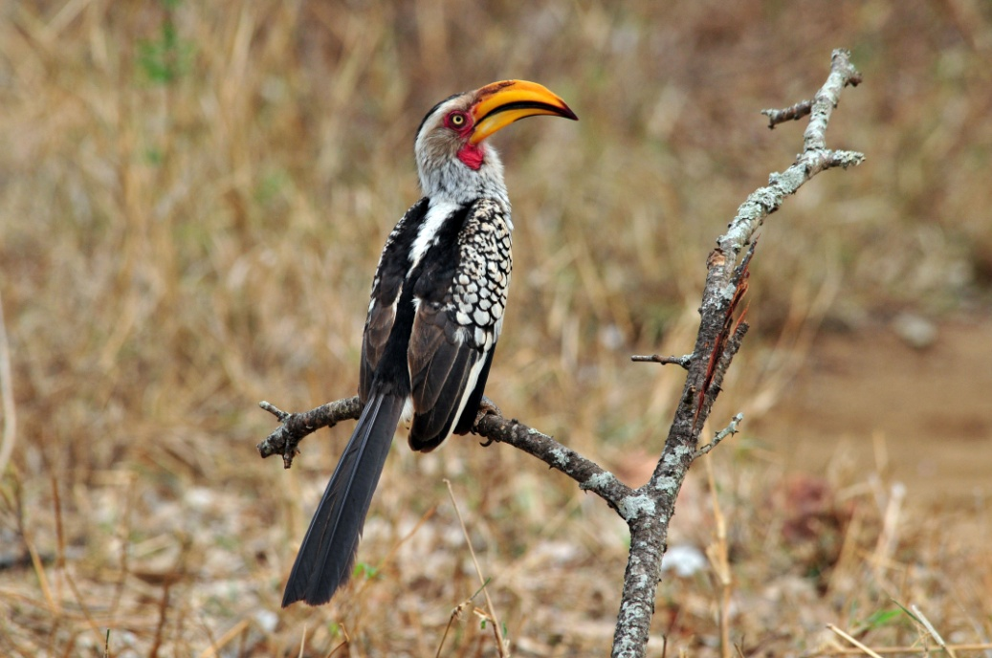
Yellow-billed Hornbill

Day 14, Thursday, Oct. 27 Most of us heard the huge thunderstorm during the night, with thunder so strong that it almost felt like an earthquake as the buildings trembled. Surprisingly, though, there were a few of the group who slept through it. We again started at 5:30, the earliest you are permitted to leave camp, to bird around Kruger. Before we left the cabin, we saw African Mourning Doves, House Sparrows, and Southern Grey-headed Sparrows. Across the street were some Brown-headed Parrots and a Scimitarbill; Natal Francolins were everywhere.

One of the first birds seen on our drive this morning was a Lilac-breasted Roller, but with the early hour and the cloudy skies, the lighting didn't do it justice. We weren't far from the camp when we saw four Lions on the left side of the road. We advanced slowly for better looks, and ended up right next to them. They sauntered alongside the van for a short distance, then crossed in front of us to the other side of the road. The second van pulled up behind us as we watched them disappear into the tall amber grasses.

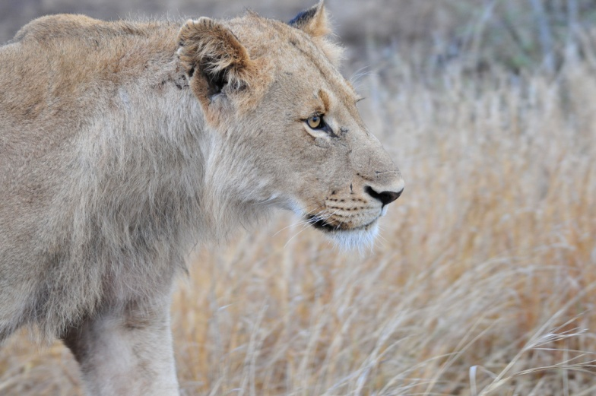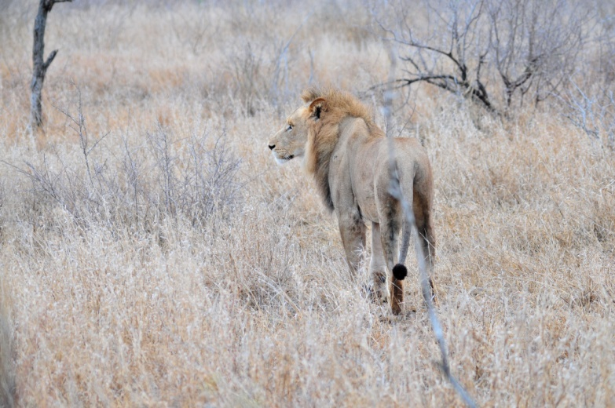
The morning wasn't as productive as we had hoped, probably because of the weather, but we did find the first Ostrich for the Subtropical group. Other birds were of the more common variety, such as Rufous-naped Lark, Rattling Cisticola, Sabota Lark,Red-billed Hornbill, Red-billed Quelea, and non-breeding Paradise Whydahs. We came across a Kori Bustard that was displaying, had our first Tawny Eagle and our first Purple Roller, and spotted a couple of Burchell's Coucals very close to the road. We got better looks at White-backed Vulture as it sat in a dead tree, just like in the cartoons. We were back at camp by 8:30 and went to the visitors center for breakfast. A man in the parking lot approached us to let us know there was an African Scops-Owl roosting low in a tree right in front of the center. After breakfast, we packed up and headed out for Dullstroom

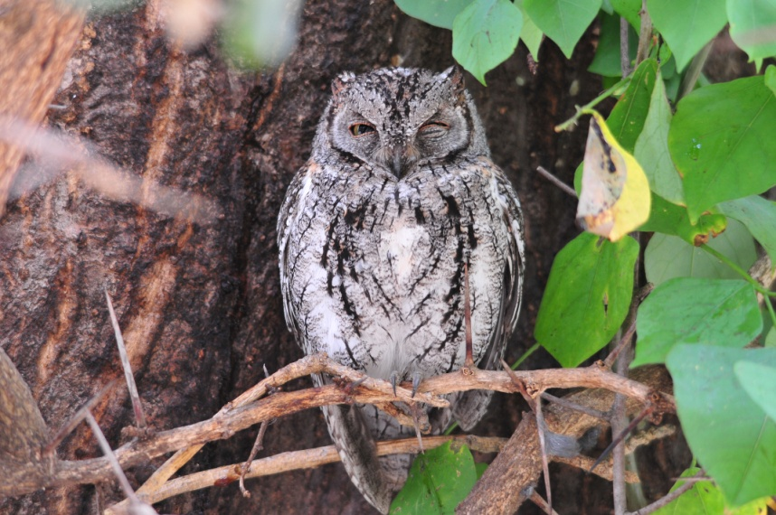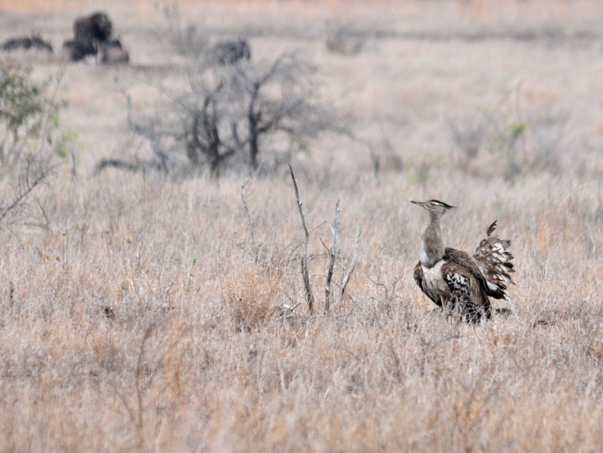
African Scops-Owl Kori Bustard

Soon after we drove out of camp, we had in the air at the same time a probable Lappet-faced Vulture, two White-backed Vultures, and four Maribou Storks - quite a sight! We saw several species that had only been previously seen by one or the other van, evening out the list pretty well: Brown-crowned Tchagra, Red-crested Korhaan, Southern White-crowned Shrike. From the back of the van, Bernie and Jude spotted a Honey Badger but it was gone before they could direct others to it. We caught up with John's van where they had stopped for a herd of hundreds of African Buffalo crossing the road. We searched for and found a few Yellow-billed Oxpeckers among the many Red-billed Oxpeckers that were traveling with the Buffalos. We came across a small feeding flock that reminded me very much of mixed-flock birding in the American tropics - fast and furious! Black Southern Tit, Black-crowned and Brown-crowned Tchagras, Tawny-flanked Prinias, Scimitarbill, Fork-tailed Drongo, Burnt-necked Eremomela, Arrow-marked Babblers, Rattling Cisticolas, and Chin-spot Batis all foraged together in one small area. Crested Francolin and Yellow-billed Hornbill seemed to be observing from behind the flock. A short distance away we found Marico Flycatcher and Blue Waxbills.

We decided that we didn't want to take a long time for lunch, so we stopped at the park store at the Orpen Camp, where we exited Kruger. The power had just gone out when we arrived, but everything in their refrigerated cases was still cold, so we selected some items and ate at the picnic tables in front of the store. Nothing appealed to me at this point, so I passed on lunch and spent the time walking around the cabins, where I found Red-billed Hornbill, Jameson's Firefinch, and Marico Sunbird.

Shortly after we left Kruger, we stopped for some raptors in the air and watched as a Wahlberg's Eagle dropped straight down to the road. In the sky, Cape Vultures, White-backed Vultures, Steppe Buzzards, and Lesser Spotted Eagle
were picked out among some other raptors we couldn't identify. A bit further down the road, we found a Lizard Buzzard.
We stopped at Abel Erasmus Pass, a site that is well-known for Taita Falcon sightings. We watched and waited for quite awhile without seeing a falcon, but the wind was howling fiercely, so we thought perhaps it wasn't flying today. This was the first time Errol had come to this spot and not found the target species! As a consolation prize of sorts, we found
Cinnamon-breasted Rock Bunting, Mocking Cliff-Chat, and Cape Rock-Thrush on the cliffs where the falcon should have been.

We arrived at the Linger Longer Bed & Breakfast near Dullstroom after dark, where each of us was driven to our own little house on the property. Some of the houses housed two couples, but this time, we were assigned the honeymoon suite - wow! It was a gorgeous stone house - too big to be considered a cabin by a long stretch. The furnishings were luxurious, with a king bed, a sitting room with fireplace, a full kitchen, and an inviting bathroom complete with Claw-foot bathtub and both indoor and outdoor showers. We barely had time to organize before John picked us up to go down to the main house for dinner.

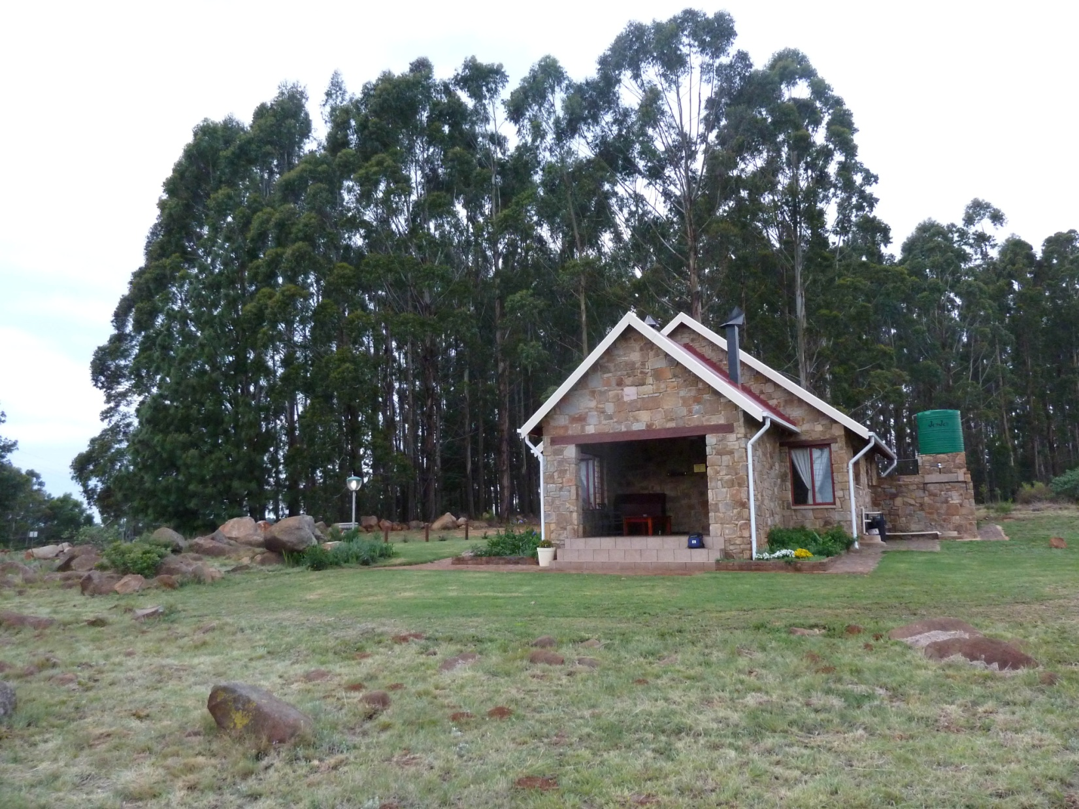
One of the houses at Linger Longer - our "Honeymoon Suite" for one night

We started to complete the list before dinner but paused when our hosts brought out the wine and appetizers. When we finished the list after dessert, we had marked only 116 species (See what happens when you have 4 of the last 6 days of 129+ bird lists?). The trip totals now stood at 391 for the Subtropical Tour, 469 for the Combined Tour. We were pretty confident that we would make 400 for the Subtropical Tour, but we wondered if we could find another 31 new species in two days to make the 500 for the Combined Tour.

The evening meal was as wonderful as the accommodations. The appetizer was a dish featuring Portobello mushrooms, followed by a huge platter of lamb and all the fixings. I was relieved to see a plate of roasted chicken offered as an alternative since I don't eat lamb. When Errol commented on how tender the meat was, I jokingly said that it was because it was a "baaa by". Another big storm moved through while we ate, and when we returned to our house, there was no electricity. We assumed that this was the case for the entire property because of the storm, so we went straight to bed and fell asleep quickly. I woke up a couple of times during the night, and each time I checked to see if the electricity had come back on, I found that it had not.

Day 15, Friday, October 28: When there was still no power in the morning, we got dressed by flashlight and candlelight and waited for John to pick us up at 5:30. Our primary target species today was Wattled Crane, and we needed to be out early to see it. John was surprised to learn that we had been without electricity, and I was surprised to learn that he was surprised. This was the first we knew that none of the other buildings had been without electricity. John asked if we had checked the main circuit-breaker (as if we knew where to look). The owner was quite upset that we had been without power and said, "You should have come told us so we could take care of it." I don't think she thought that through, considering that it would have meant walking down a muddy hill in a downpour in pitch dark about a half mile. Even if we were not opposed to such a walk, we had no reason to believe anyone could do anything about it because we thought the storm had caused a power outage for the entire property. I was somewhat irritated at the whole situation, but mostly disappointed that we hadn't had the opportunity to enjoy the amenities of the nicest room we had been given for the entire trip.

We went out to bird and went directly to the area where Errol expected to find the Wattled Crane. We dipped on the crane, much to Errol's (and our) disappointment. He told us he has found the crane there on almost every other tour he's brought to this spot. We found a lot of birds this morning, but most were species we had already seen at other locations.

We returned to Linger Longer for breakfast at around 8:30 AM. I had Errol take me to our house after he dropped the others off at the main house for breakfast - my need for a hot shower trumped my need for food. When he finished breakfast, Jim brought back some bacon for me, but he ate the bread the group had instructed him to bring. Man, did he take a lot of teasing for that for the next couple of days! There was enough time before departure for Jim to shower, so I unpacked some things for him and then repacked when he was done.

We departed around 10:00 AM, and made some stops along our way to Genius Loci Lodge near Rust de Winter, our final stop before our departure tomorrow. We saw many birds at various stops, including Reed Cormorant, Cape Crow, Helmeted Guineafowl, Long-tailed Widowbird, Pied Starling, Buff-streaked Chat, Bokmakierie, Eastern Long-billed Lark, Wattled Lapwing, Denham's Bustard, Yellow-breasted Pipit, Malachite Sunbird, and Pin-tailed Whydah. John's van had a look at a Rufous-chested Sparrow-Hawk but the bird was gone by the time the other van caught up. Gray Rhebuck and Blesbok were the only two mammals seen on our route, as was expected now that we were outside a reserve. We had surprisingly good looks at Wing-snapping Cisticola and Cloud Cisticola, and also saw Levaillant's and Wailing Cisticolas. Other birds of note were Sentinel Rock-Thrush, African Snipe, Long-billed Pipit, Black-winged Lapwing, Yellow Bishop, Cape Canary, and Cape Longclaw. Errol made a special effort to find a Gurney's Sugarbird for me, since he remembered that I hadn't seen it in Lesotho with the others. I really appreciated how the others in my van took the time to help me find this life bird.

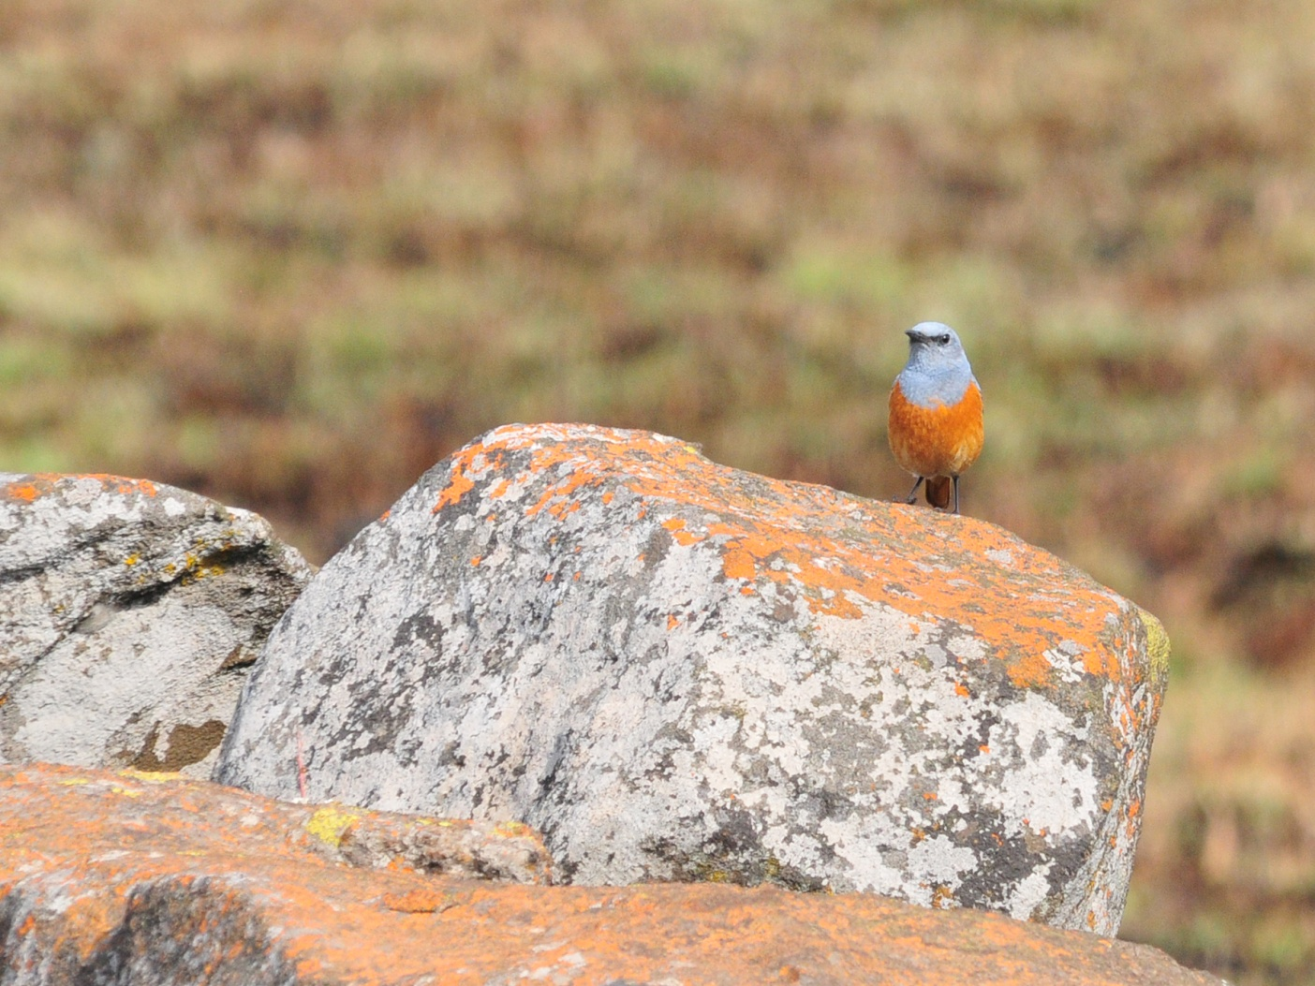
Sentinel Rock-Thrush

We were moving along a paved road at a pretty good clip at about 4:00 PM when John radioed that he had a flat tire. Errol backtracked and pulled over to help him. While the guys were changing the tire, we started watching birds in the scrubby fence line behind us. Southern Masked Weaver and Red Bishop were easily identified, but then I found a bird that I didn't know, but I knew enough to know it was new (say that three times fast!). I called Errol over to identify it - Scaly-feathered Finch. Bernie was helping with the tire and somehow missed the information so he didn't come to look for the finches, but the guides assured him that they were fairly common and we could find others.

We arrived at Genius Loci Lodge a little before 5:00 and did a little birding on the grounds after we settled in our rooms. Some new birds were present there, including Black-cheeked Waxbill, Mocking cliff-Chat, and Crimson-breasted Shrike (Boubou),as well as some now-familiar species such as Speckled Mousebird and Laughing Dove. We completed our list as we waited for dinner to be served and found that we had crossed the 400 mark for the Subtropical Tour - a total of 405 with 14 of the 100 species seen today new for that tour. The Combined Tour gained only 12 species and now stood at 481. Could we possibly find 19 new birds in just one morning of birding? John and Errol thought it possible, considering the sites we would bird tomorrow morning before heading to Johannesburg.

Day 16, Saturday, October 29: After picking up three new species right outside our doors last night, we were all eager to bird the area this morning and no one complained about the 5:00 departure. Our destination was the Kgomo-Kgomo Flood Plain via Zaagkuilsdrift Road. There had been some rain in the area recently, and there was a bit of concern that one spot in the dirt road might be too muddy to cross, but since the birding along the road was very good, we were going to try it anyway. This road was awesome, if a bit difficult to get in and out of the van without coating yourself in mud. Most of the birds we had seen earlier, and although we really wanted to get those 19 new species, we were more than happy to have last looks at some of the more beautiful and interesting birds in South Africa: Orange-breasted Bush-shrike, Red-billed and Jameson's Firefinches, Arrow-marked Babbler, Green-winged Pytilia, Blue and Common Waxbills, European Bee-Eater, Crimson-breasted Shrike (Boubou), and Magpie Shrike, to name a few. We had the best looks at the Pytilia of the entire trip, and after seeing the little beauty in good light and at close range, I felt like I really hadn't seen it earlier. There were lots of Go-Away Birds, one of my favorites even though they are quite drab. Every time I see one, I think of the story about how they got their name and a silly video I once saw that showed the bushmen becoming frustrated because the Grey Lourie would cry "Go way" each time they approached a prey animal. Pearl-breasted Swallow and Chestnut-vented Tit-babbler were new for the Subtropical Tour, and the people on the Combined Tour enjoyed seeing them again. A Black-chested Snake-Eagle was sitting very close to the road not too much above eye level for incredible views of this magnificent hunter. We did pick up nine birds that were new to the Combined Tour on the dirt road: Violet-eared Waxbill, Barred Wren-Warbler, Kalahari Scrub-Robin, White-browed Sparrow Weaver, Southern Pied Babbler, Black-chested Prinia, and Northern Black Korhaan. Jude spotted an Ovambo Sparrow Hawk sitting low on a scrubby branch in the middle of a field as we were driving out to go back to the lodge for breakfast.

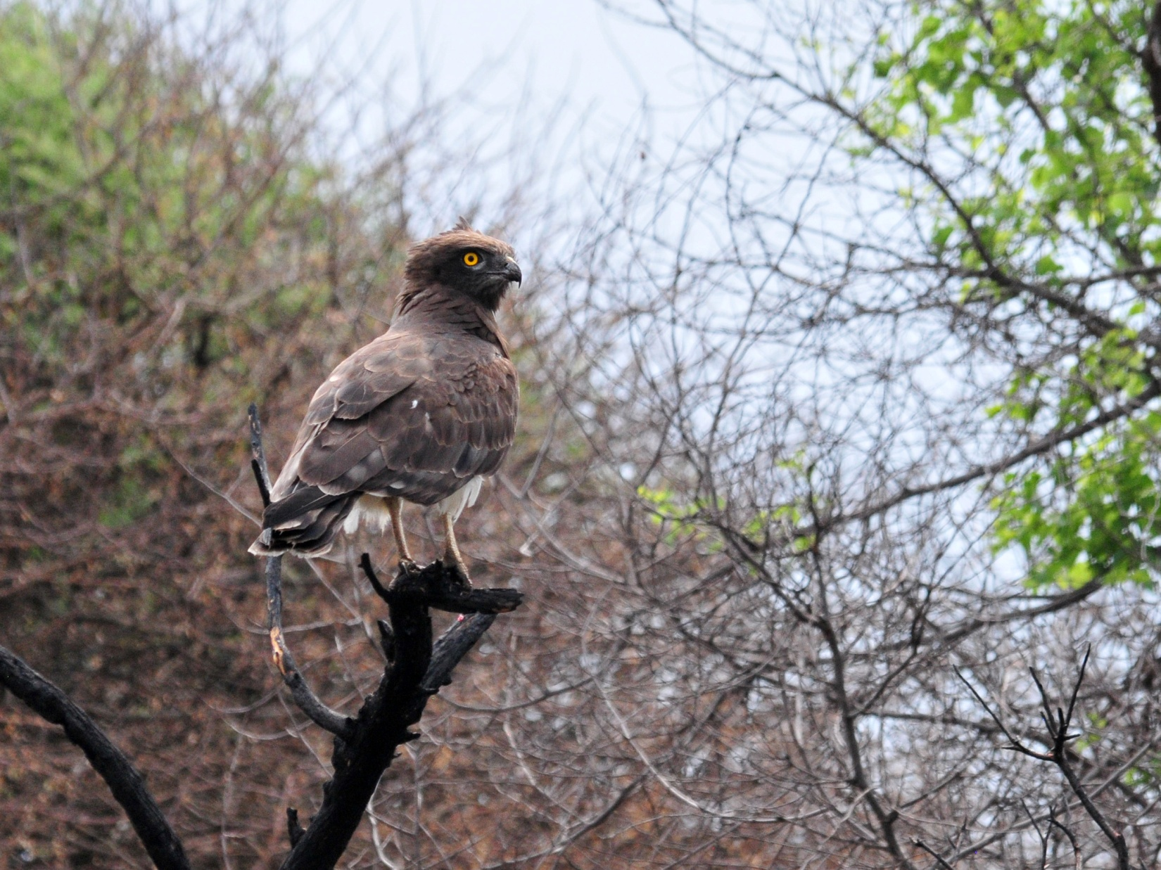
Black-chested Snake-Eagle

We packed to leave after breakfast, and it took much longer than I had anticipated to reorganize everything for travel back to the states. Jude knocked on our door to let us know that there was a Red-headed Weaver on our roof - new bird #10!

We were back on the birding road shortly before noon and picked up a Black-shouldered Kite right away. We debated over whether to stay here to bird the dirt roads or drive 45 minutes on paved roads to the flood plain that had been our goal for the morning. I didn't want to spend 90 minutes of the little time we had left driving instead of birding, but the guides recommended we try the flood plain since it had so much potential. We followed their advice and relaxed for the 45-minute highway ride. When we reached the flood plain, there was very little water, which meant very few birds. We did find another new bird for the Subtropical tour, a Capped Wheatear. We went on some side roads to try to find Scaly-feathered Finch for Bernie and were successful.

When we completed our checklist at the lunch stop we showed final counts at 417 for the Subtropical Tour and 491 for the Combined Tour. We made one last stop at a wetland near the airport in Johannesburg. As we drove by a parking lot for an apartment complex, I saw a bird that was shaped like a Thick-Knee. I didn't say anything right away because it seemed out of place, but I mentioned it to Errol as we stood scanning the water. I looked for it on the way out, and there it was - Spotted Thick-Knee! We stopped for better looks and also found its mate and chicks . We hadn't found anything new at the wetland, but the Thick-Knee on the pavement was new for Subtropical group, bringing their trip total to 418.

We said our good-bys to Errol and John at the airport entrance, and checked in for our late afternoon flights home. It was hard to believe that we had been gone for a total of 27 days, longer than any other travel we've done. This trip had flown by, with each day a new adventure with new birds and new animals. Our guides did everything they could to make the trip the best it could be, and the group of people with whom we traveled were fantastic. I hope to return some day, and I hope Errol and John will still be guiding when I do!

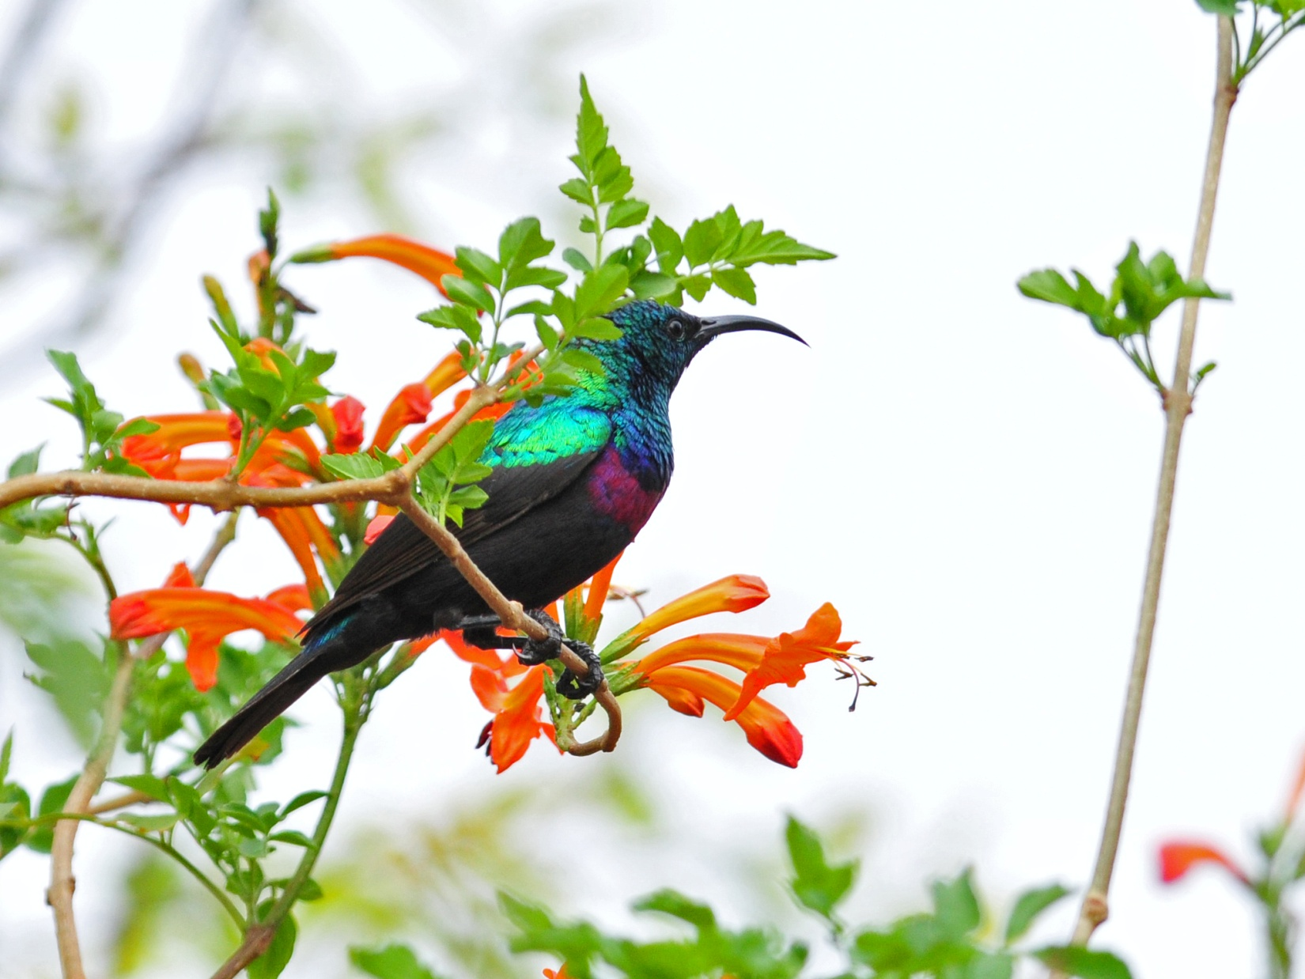
Neergaard's Sunbird

