BEST OF COSTA RICA
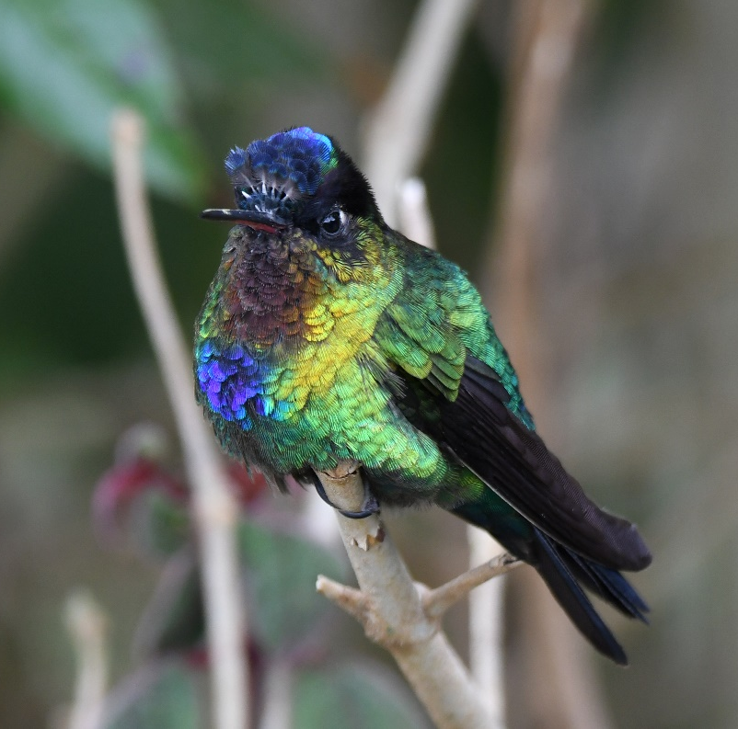
February 8 - 17, 2023
10 Days / 9 Nights
$TBA*
Single Supplement $TBA
Lowest per-day price among US tour companies!
Register early!
*Price will be announced when lodges provide 2023 prices, hopefully by April, 2022.

Costa Rica has been a favorite spot for nature lovers and birders for decades, and for good reason. About 25% of the country is made up of protected national parks and rain forests which hold 5% of the world’s diversity. Over 900 species of birds have been recorded there, and you are likely to encounter other wildlife as you search the forests for avian life. Agoutis, Coatis, at least 3 different species of monkeys, and 2 species of Sloth are but a small portion of the myriad of species that inhabit this naturalist’s paradise. You can expect comfortable lodging and good food while exploring one of the best birding locations in Central America.

Day 1, February 8
You will arrive in Costa Rica and transfer to the Hotel Robledal via the hotel shuttle, which runs from 5:30 AM until 11:00 PM. For those who arrive early, there are good birding opportunities on the hotel grounds. We will enjoy a welcome dinner in the hotel’s restaurant at around 7:00 PM. An after-dinner owl prowl could produce Tropical Screech-Owl and Ferruginous Pygmy-Owl.
Hotel Robledal (D)

Ferruginous Pygmy-Owl

Day 2, February 9
Pre-breakfast birding will offer an opportunity to become acquainted with some of Costa Rica’s most common and widespread birds, including Rufous-tailed and Cinnamon Hummingbirds, Tropical Kingbird, Blue-gray Tanager, Great-tailed Grackle, and the country’s national bird, the Clay-colored Thrush. Other likely species are Inca Dove, White-winged Dove, Squirrel Cuckoo, Lesson’s Motmot, Grayish Saltator, Spot-breasted Oriole, and Melodious Blackbird.

After breakfast, we will begin our journey to Monteverde, where we should arrive in time for lunch. Once we’ve checked in and unloaded our luggage, we’ll waste no time in getting to a trail for some fantastic mid-elevation birding.
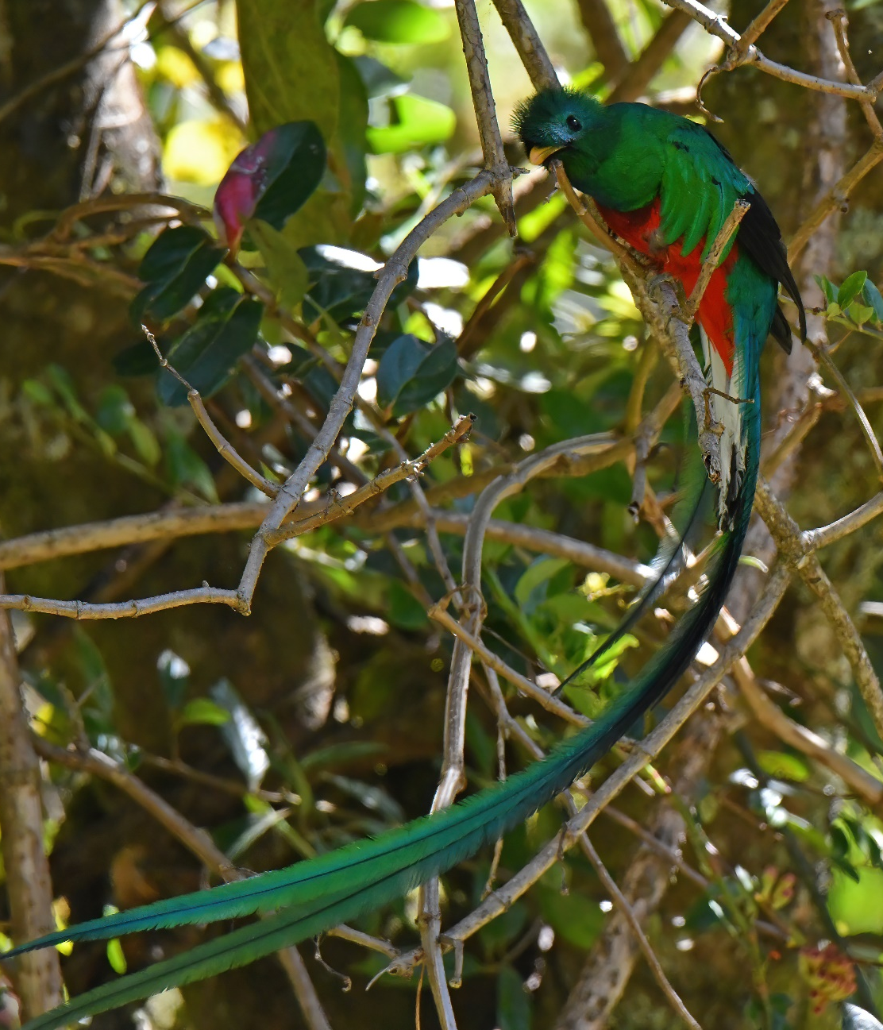
Due to a sharp decline in moisture from the top of the ridge down through the level of the community and below, there are four different life zones crowded into a short straight-line distance on the Pacific side of the ridge. With two days to explore the area, we’ll have time to cover all of them fairly thoroughly, though the exact order will depend on several factors and will ultimately be the guide’s call.

In the lower, drier areas where little moss or other epiphytic vegetation grows on the trees’ trunks and branches, we’ll search for species such as Chiriqui Quail-Dove, Olivaceous and Ruddy Woodcreepers, Long-tailed Manakin, Rufous-and-white Wren, Orange-billed Nightingale-Thrush, White-naped Brushfinch, and Golden-crowned Warbler. We’ll also be especially attentive to any loud “bonking” noises that will signal the whereabouts of the amazing Three-wattled Bellbird and their display perches. As we work our way upwards in elevation, the lushness of the forests will increase with each new increment. New bird species will also begin to appear and could include Ruddy Pigeon, Prong-billed Barbet, Gray-throated Leaftosser, White-throated Spadebill, Azure-hooded Jay, Gray-breasted Wood-Wren, Slaty-backed Nightingale-Thrush, Elegant Euphonia, and Slate-throated Redstart. Without a doubt, however, we’ll be anxiously awaiting our first views of the Resplendent Quetzal—arguably one of the most beautiful birds in the world!
Hotel de Montana (BLD)

Day 3, February 10
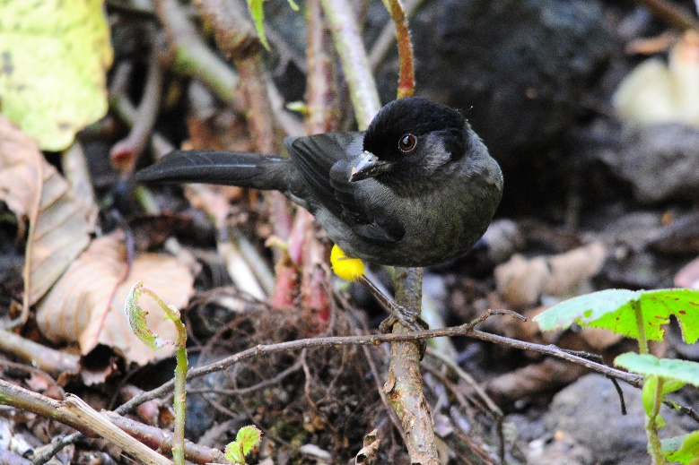
A full day in the Monteverde area will offer us more opportunities to discover the fascinating birdlife associated with this region, including numerous highland species endemic to the mountains of Costa Rica and adjacent western Panama. Among the possibilities are Black Guan, Yellow-thighed Finch, Black-breasted Wood-Quail, Buff-fronted Quail-Dove, Purple-throated Mountain-gem, Collared (aka Orange-bellied) Trogon, Silvery-fronted Tapaculo, Streak-breasted Treehunter, Ruddy Treerunner, Golden-bellied Flycatcher, Ochraceous Wren, Black-faced Solitaire, Golden-browed Chlorophonia, Wrenthrush, Costa Rican Warbler, Collared Redstart, and Spangle-cheeked Tanager. And then there’s the tiny Coppery-headed Emerald, a hummingbird whose entire range is restricted to middle-elevation forest in northern and central Costa Rica.
Yellow-thighed Finch

Hotel de Montana (BLD)
Day 4, February 11
We’ll have another morning of birding at Monteverde before leaving for Cerro Lodge near the world-famous Carara National Park. The drive will be broken up with a lunch stop, but most likely not too much in the way of birding en route so we can arrive in time for our afternoon boat ride on the Tarcoles River. This leisurely river cruise is always a favorite among birders, with many species of water birds, kingfishers, and mangrove specialists likely. Huge American crocodiles bask on the banks while Magnificent Frigatebirds and Brown Pelicans soar overhead. Osprey and Common Black Hawk hunt along the river, and we are likely to see both. As the sun starts to get low, we’ll have good chances to see a variety of parrot species, as well as the magnificent Scarlet Macaw.
Cerro Lodge (B/L/D)

Bare-throated Tiger-Heron
Day 5, February 12
We’ll have a full morning to bird the nearby Carara National Park. Here we will hope for a variety of “ant things” that include Black-hooded Antshrike, Dot-winged Antwren, Chestnut-backed Antbird, Black-faced Antthrush, and Streak-chested Antpitta. Fascinating flycatchers such as Stub-tailed and Golden-crowned Spadebill, Greenish Elaenia, Northern Bentbill, Slate-headed Tody-Flycatcher, and Bright-rumped Attila also inhabit the forest. However, the star attraction here is the raucous Scarlet Macaw. We’ve been fortunate in the past to find nesting Macaws, and we’ll make an effort to get great looks at these impressive birds.

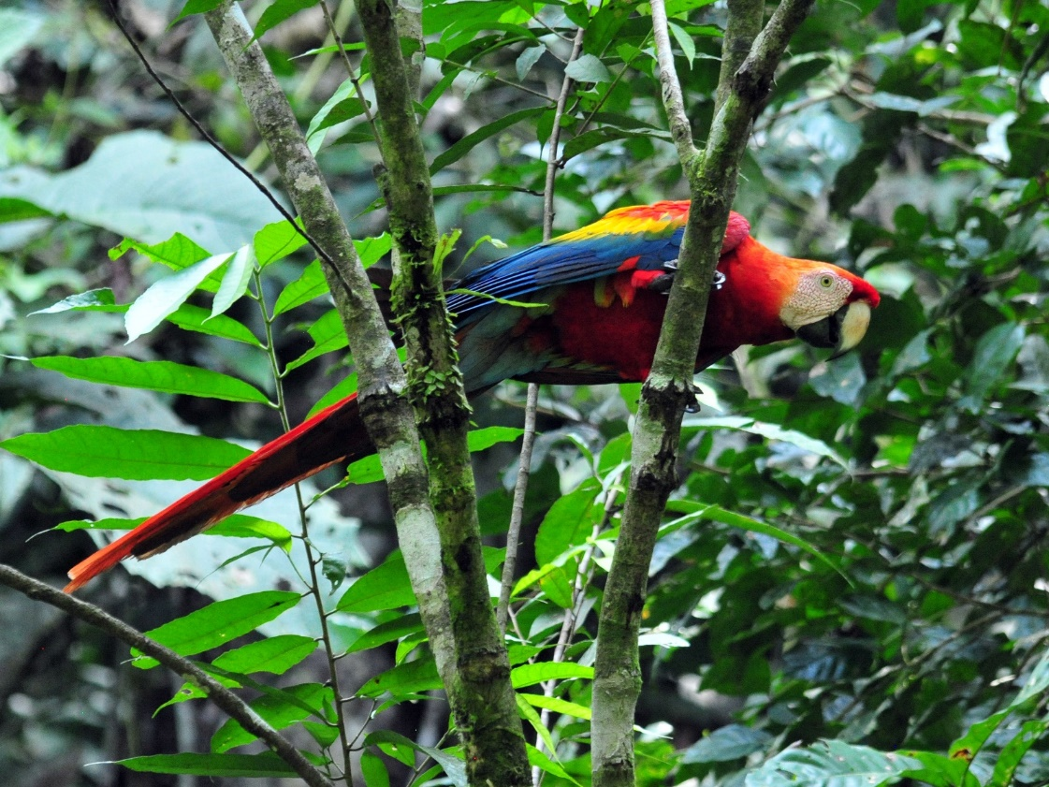

Scarlet Macaw

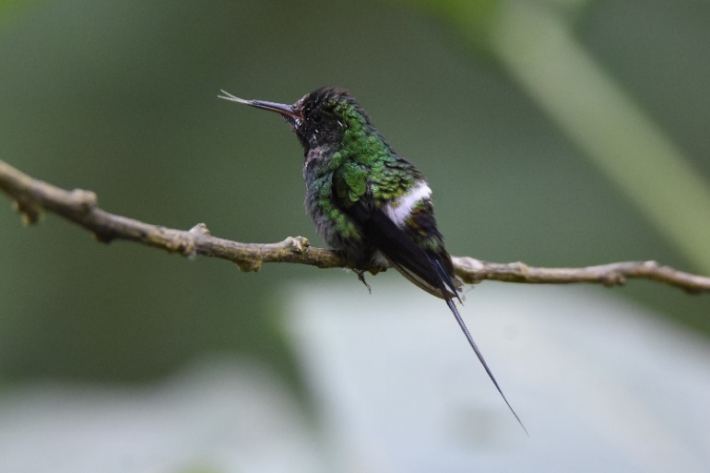
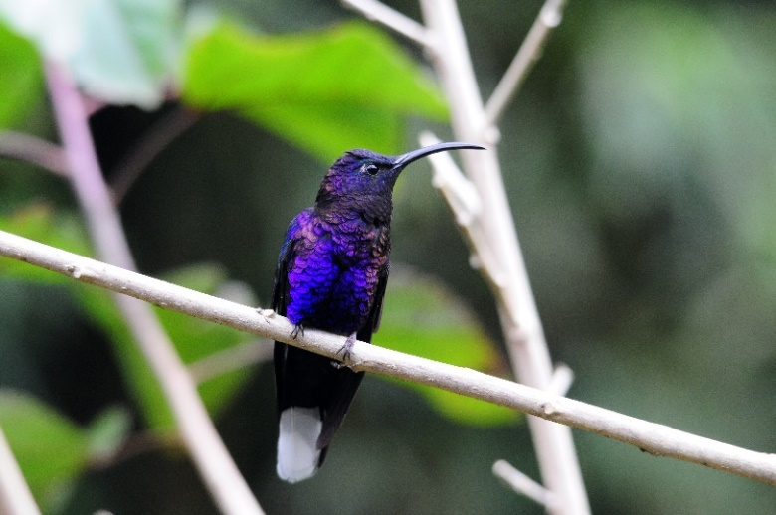
Later in the morning we’ll head for the Caribbean lowlands. We’ll make a stop at a middle elevation site with a spectacular waterfall. Hummingbird feeders here will provide a chance at species such as Green Thorntail, Coppery-headed Emerald, White-bellied and Purple-throated Mountain-gems, and Violet Sabrewing. Fruit eaters that come to feeding trays here include Prong-billed and Red-headed Barbets, Northern Emerald Toucanet, Common Chlorospingus, and several species of Tanager such as Crimson-collared, Blue-gray, Palm, and Silver-throated.
Violet Sabrewing
Green Thorntail
By afternoon, we’ll reach our destination: La Selva Biological Station, where research projects are carried out on every conceivable aspect of the tropical forest system. Perhaps at the dinner table a young researcher will be glad to discuss their own studies with you.
La Selva (B/L/D)

Day 6, February 13
It can often be difficult to get to the cafeteria before the end of the breakfast mealtime as so many birds can get in the way. The clearings around the main buildings are typically alive with birds ranging from the diminutive Bananaquit to the turkey-sized Great Curassow. As we walk the trails at La Selva, we hope to encounter species such as Slaty-breasted and Great Tinamous, Green Ibis, Olive-backed Quail-Dove, Chestnut-colored and Cinnamon Woodpeckers, Rufous and Broad-billed Motmots, Red-legged and Shining Honeycreepers, Black-capped Pygmy-Tyrant, Snowy Cotinga, and Scarlet-rumped, Dusky-faced and Plain-colored Tanagers, to name but a few. We can expect to see some parrots and parakeets as well as Keel-billed Toucans and Collared Aracaris. Great Green Macaws are sometimes seen flying over the area, but we’ll make a special effort to see them near their nesting site in more open areas nearby.
La Selva (B/L/D)
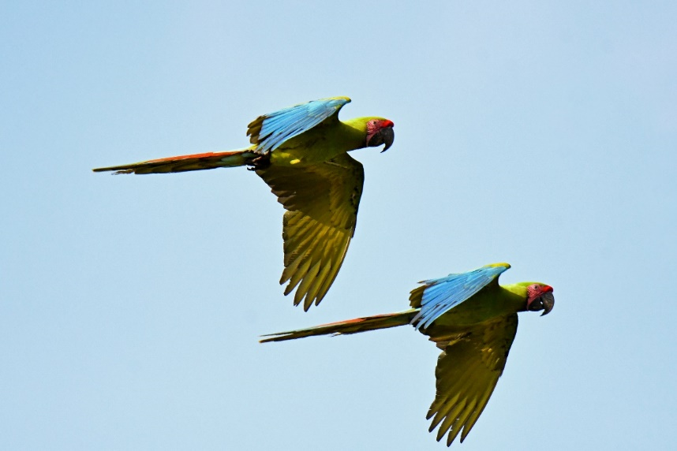

Great Green Macaws

Day 7, February 14
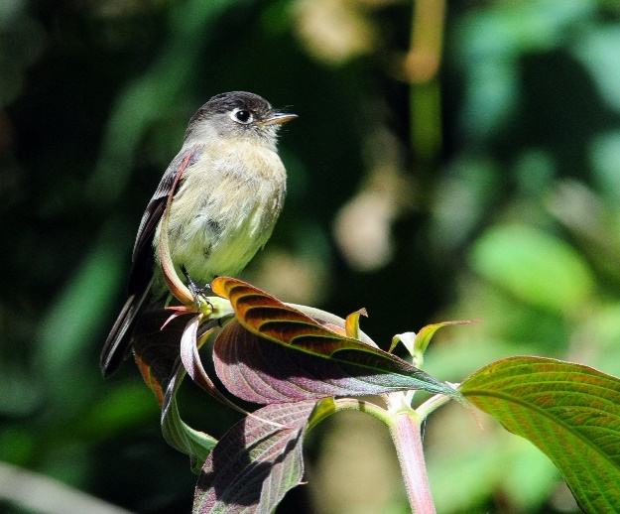
Today we’ll travel across the Central Valley and up into the Talamanca highlands. As we gain elevation the vegetation will change and the air temperature will become a bit cooler. Any given birding stop could yield highland endemics such as Black-capped Flycatcher, Black-and-yellow Silky-flycatcher, Yellow-winged Vireo, Flame-throated Warbler, and/or Yellow-thighed Finch.
Yellow-winged Vireo
Black-capped Flycatcher
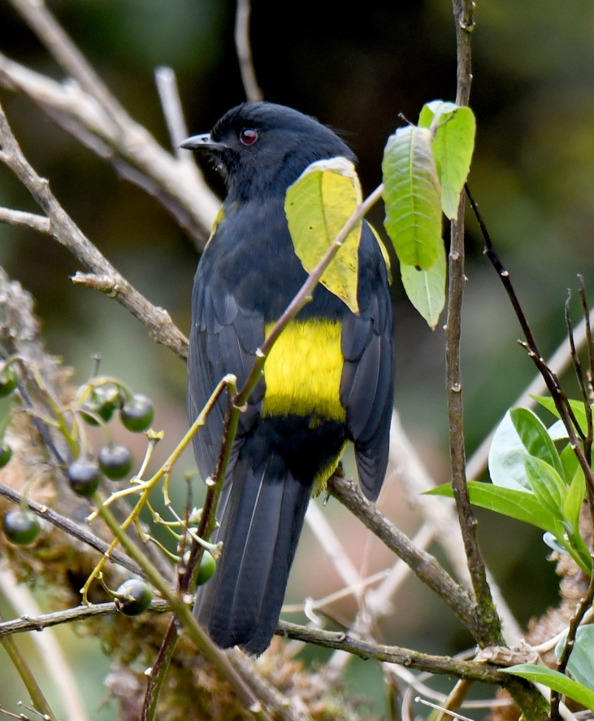
There are many special montane birds whose company we will enjoy, perhaps foremost among them the bustling hummingbirds at the feeders—Fiery-throated Hummingbird, Lesser Violetear, Talamanca Hummingbird, Scintillant Hummingbird, and Volcano Hummingbird. But the true object of our quest here in the highlands is another chance to see the Resplendent Quetzal. We were lucky enough to see a pair excavating a nest hole in this area in 2022. After dark, we may go in search of Dusky Nightjar, Bare-shanked Screech-Owl, and Unspotted Saw-whet Owl.
Sueños del Bosque Lodge (B/L/D)

Day 8, February 15
We’ll visit more hotspots in the highlands today, including the highest point along the Pan American Highway, where we’ll look for Timberline Wren, Volcano Junco, and Peg-billed Finch, among others.
Sueños del Bosque Lodge (B/L/D)

Black-and-yellow Silky-flycatcher
Day 9, February 16
Our final day in the field will give us one last opportunity to add a few more species to our by-now bulging species list, which, in addition to hundreds of birds, should include a dozen or more mammals along with numerous reptiles and amphibians. We’ll travel back along the Pan American highway to San Jose, stopping to bird along the way as time permits. Dropping down into the Valley of El General, we’ll begin spotting species such as Smooth-billed Ani, Red-crowned Woodpecker, Fork-tailed Flycatcher, Tropical Mockingbird, and Cherrie’s subspecies of Scarlet-rumped Tanager, while keeping an eye out for perched raptors, including Pearl Kite and Laughing Falcon. Eventually, we’ll return to the Central Valley
and overnight at the Hotel Robledal, where
we’ll enjoy our farewell dinner and say our
Volcano Junco
goodbyes to our guide and driver.
Hotel Robledal (B/L/D)

Day 10, February 17
Take the hotel shuttle to the airport for your departing flight.
End of services (B)

PRICING DETAILS
Price includes:
~ Lodging in comfortable hotel/lodges/B&Bs
~ All meals as indicated
~ All land transportation
~ Airport Transfers during Hotel Robledal’s shuttle operation service hours
~ Mangrove Boat Tour on the Tarcoles River
~ Entrance fees to all parks and reserves
~ Expert local birding guide Leo Garrigues
~ Pre-trip gift package
~ Post-trip electronic group checklist
Price does NOT include:
~ International airfare to San Jose, Costa Rica
~ Airport transfers if arrival or departure is outside of normal shuttle operation service hours
~ Alcoholic drinks
~ Travel insurance
~ Gratuities
~ Expenses of a personal nature such as laundry, phone calls, extra drinks and snacks, etc.
PAYMENT INFORMATION:
Deposit of $600 with registration (registration form can be downloaded from a link on the Cheepers! Birding on a Budget website). Balance is due on or before October 8, 2022 (4 months prior to trip start date).
Checks should be made payable to Cheepers! Birding on a Budget and mailed with the registration form to:
Cheepers! Birding on a Budget
Post Office Box 385
Spring Valley, OH 45370

Questions? Contact us:
cbeckman4505@gmail.com
jamesdbeckman@sbcglobal.net
937-862-4505 (land line with robocall filter; just say your name when prompted)
937-974-0803 (Cindy’s cell)
937-974-0802 (Jim’s cell)

